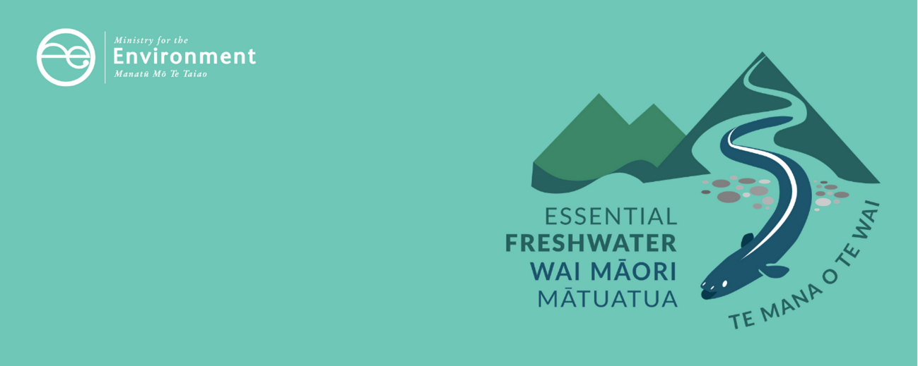

Threatened species factsheet
Essential Freshwater is part of a new national direction to protect and improve our rivers, streams, lakes and wetlands. The Essential Freshwater package aims to:
- stop further degradation of our freshwater
- start making immediate improvements so water quality improves within five years
- reverse past damage to bring our waterways and ecosystems to a healthy state within a generation.
Te Mana o te Wai is fundamental to all freshwater management
Te Mana o te Wai recognises the vital importance of water. It expresses the special connection that New Zealanders have with freshwater. By protecting the health of freshwater, we protect the health and well-being of people and our ecosystems. When managing freshwater, Te Mana o te Wai ensures the health and well-being of the water is protected before providing for human needs or enabling other uses of water. Through discussions with regional councils, tangata whenua and communities will have a say on how Te Mana o te Wai is applied in freshwater management locally. More information can be found in the Te Mana o te Wai factsheet.

Who should read this factsheet
This factsheet is part of a series and provides information on the new policies for threatened species. It is intended for council staff, land users, iwi, the wider agricultural industry, farm advisors and consultants, and anyone else with an interest in freshwater policy.

What are the policies?
The National Policy Statement for Freshwater Management 2020 (NPS-FM 2020) introduces a new compulsory value for threatened species.
Threatened species means any indigenous species of flora and fauna that rely on fresh water bodies for at least part of their life cycle, and that meets the criteria for nationally critical, nationally endangered or nationally vulnerable species in the New Zealand Threat Classification System Manual.
Regional councils are required to:
- identify the location of habitats of threatened species in regional plans
- set an environmental outcome for threatened species in each freshwater management unit, and include the outcome as an objective in their plan. The objective must:
- be such that the effectiveness of regional policy statements and plans can be assessed against it; and
- when achieved, fulfil relevant long-term visions set for the region
- identify attributes relevant to achieving the outcome, set targets for those attributes, and set limits on use of resources to meet those targets. Councils must then identify how the outcome and target states will be achieved. This may include rules in regional plans about discharges, water takes and disturbing the beds and banks of water bodies, methods in action plans such as habitat restoration, methods in regional pest management plans such as exclusion or eradication of pest plants and animals, or some combination of these).
Regional councils are also required to map natural inland wetlands under 0.05 hectares known to contain threatened species (wetlands larger than this must be mapped regardless).
More information about identifying the location of habitats of threatened species is available on our website.
Some of these aspects will be managed as part of the compulsory value of ecosystem health, including the components that make up ecosystem health: water quality, water quantity, habitat, aquatic life and ecological processes. Specialised habitats, or conditions needed for part of the life cycle of the threatened species, may also need to be managed specifically for the threatened species.
More information about other values in the NPS-FM 2020 is available in the Values and attributes factsheet.

When do the policies apply?
Councils need to notify plans that give effect to these provisions by 31 December 2024, with final decisions made and plans operational no more than two years after notification (or three years if they are granted an extension).

Why these policies?
Many of New Zealand’s freshwater species, both fauna and flora, are threatened with extinction. Freshwater fish are highly valued as taonga and mahinga kai, and for supporting cultural, recreational and commercial fisheries. Despite their importance, 22 of New Zealand’s native freshwater fish species are threatened. Eight threatened native birds live in or around freshwater bodies (particularly braided rivers and wetlands). Wetland and riparian environments are also home to a range of native plants, including taonga species that Māori use in rongoa (medicine), raranga/ahatu (weaving) and mahinga kai.

More about the Essential Freshwater package
An overview of the Essential Freshwater package, including when different aspects commence or must be implemented, can be found in this summary and milestones.
The package includes several new national rules and regulations including:
- new National Environmental Standards for Freshwater
- new stock exclusion regulations under section 360 of the Resource Management Act 1991 (RMA)
- amendments to the Resource Management (Measurement and Reporting of Water Takes) Regulations 2010
- the National Policy Statement for Freshwater Management 2020, which replaces the NPS-FM 2017
- amendments to the RMA, to provide for a faster freshwater planning process
- amendments to the RMA, to enable mandatory and enforceable freshwater farm plans, and the creation of regulations for reporting nitrogen fertiliser sales.
Factsheets in this series
The full set of Essential Freshwater factsheets is available on our website.
Find out more and give us feedback
Contact us by emailing freshwater@mfe.govt.nz, or visit the Essential Freshwater page on our website.

Disclaimer
The information in this publication is, according to the Ministry for the Environment’s best efforts, accurate at the time of publication. The information provided does not alter the laws of New Zealand and other official guidelines or requirements. Users should take specific advice from qualified professional people before undertaking any action as a result of information obtained from this publication.
The Ministry for the Environment does not accept any responsibility or liability whether in contract, tort, equity or otherwise for any action taken as a result of reading, or reliance placed on the Ministry for the Environment because of having read any part, or all, of the information in this publication or for any error, or inadequacy, deficiency, flaw in or omission from the information provided in this publication.
Published in December 2020 by the
Ministry for the Environment
Publication number: INFO 1000
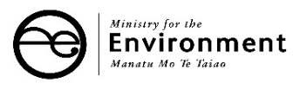


Dunn NR, Allibone RM, Closs GP, Crow SK, David BO, Goodman JM, Griffiths M, Jack DC, Ling N, Waters JM, Rolfe JR. 2017. Conservation status of New Zealand freshwater fishes. New Zealand Threat Classification Series 24. Wellington: Department of Conservation.

