
The Fast-track Approvals Act 2024
Review of Operations 2026

Disclaimer
The information in this publication is, according to the Ministry for Cities, Environment, Regions and Transport’s best efforts, accurate at the time of publication. The Ministry will make every reasonable effort to keep it current and accurate. However, users of this publication are advised that:
- the information does not alter the laws of New Zealand, other official guidelines, or requirements
- it does not constitute legal advice, and users should take specific advice from qualified professionals before taking any action based on information in this publication
- the Ministry does not accept any responsibility or liability whatsoever whether in contract, tort, equity, or otherwise for any action taken as a result of reading, or reliance placed on this publication because of having read any part, or all, of the information in this publication or for any error, or inadequacy, deficiency, flaw in, or omission from the information in this publication
- all references to websites, organisations or people not within the Ministry are for convenience only and should not be taken as endorsement of those websites or information contained in those websites nor of organisations or people referred to.

This document may be cited as: Ministry for Cities, Environment, Regions and Transport. 2026. The Fast-track Approvals Act 2024: Review of Operations 2026. Wellington: Ministry for Cities, Environment, Regions and Transport.

Published in October 2026 by the
Ministry for Cities, Environment, Regions and Transport
PO Box 10362, Wellington 6143, New Zealand
mcert.govt.nz
ISBN: 978-1-997358-20-6
Publication number: MCERT 22
© Crown copyright New Zealand 2026

Contents
Summary 5
Introduction 7
How does the Fast-track Approvals Act work? 8
The amendments 9
Purpose of the review 10
What it covers 11
What it doesn’t cover 11
What we found 13
Overall findings 13
Set up of the process 14
Operation 14
Impact 23
Future reviews 25
How we did it 26
Data analysis 26
Governance 26
References 27

Tables
Table 1: Actual volumes compared to original volume forecasts 19
Table 2: Comparison of Fast-track Approvals speed of processing with standard RMA timeframes 21
Table 3: Summary of changes introduced in the Amendment Act 24

Figures
Figure 1: Fast-track at a glance 6
Figure 2: Geographical distribution of applications 15
Figure 3: Distribution of applications by sector 16
Figure 4: Number of applications lodged per month 19
Figure 5: Decision timeframes for substantive applications from the completeness decision to the final approval (at 30 April 2026) 20
Figure 6: Decision timeframes for project referral from the date the application was lodged to the Minister’s decision on referral 21

Summary
Purpose
Cabinet required a review after the first 12 months of operation to assess the implementation and early performance of the Fast-track Approvals regime. This review:
- considers whether the regime has been implemented and is operating as intended
- identifies lessons from the first year of operation
- highlights opportunities to strengthen implementation.
While the review also considers the implementation of the Fast-track Approvals Amendment Act 2025 where practicable, it is too early to draw conclusions about the effectiveness of many amendments.
Overall findings
The review found the regime has been successfully established and is operating broadly as intended. It is attracting the types of regionally and nationally significant projects it was designed to support and is delivering materially shorter decision timeframes than comparable Resource Management Act processes. Stakeholders reported that the regime provides greater certainty, supports more coordinated decision-making across multiple approval processes, and has been implemented through constructive, responsive engagement by administering agencies.
Areas for improvement
The review also identified opportunities to strengthen implementation. These include:
- continuing the transition away from Resource Management Act-style practices
- improving the transparency and administration of cost recovery
- reducing unnecessary duplication between referral and substantive applications
- continuing to enhance the digital portal and supporting administrative processes.
Most operational issues identified during the first year had already begun to improve as participants became more familiar with the regime.
Looking ahead
Most amendments introduced by the Fast-track Approvals Amendment Act 2025 respond directly to implementation experience, but for many amendments it is too early to assess whether they have achieved their intended effect. As the regime matures, future reviews should move beyond implementation and operational performance to assess longer-term outcomes, including how the regime operates alongside wider reforms to Aotearoa New Zealand’s planning, local government and infrastructure funding systems.

Figure 1: Fast-track at a glance
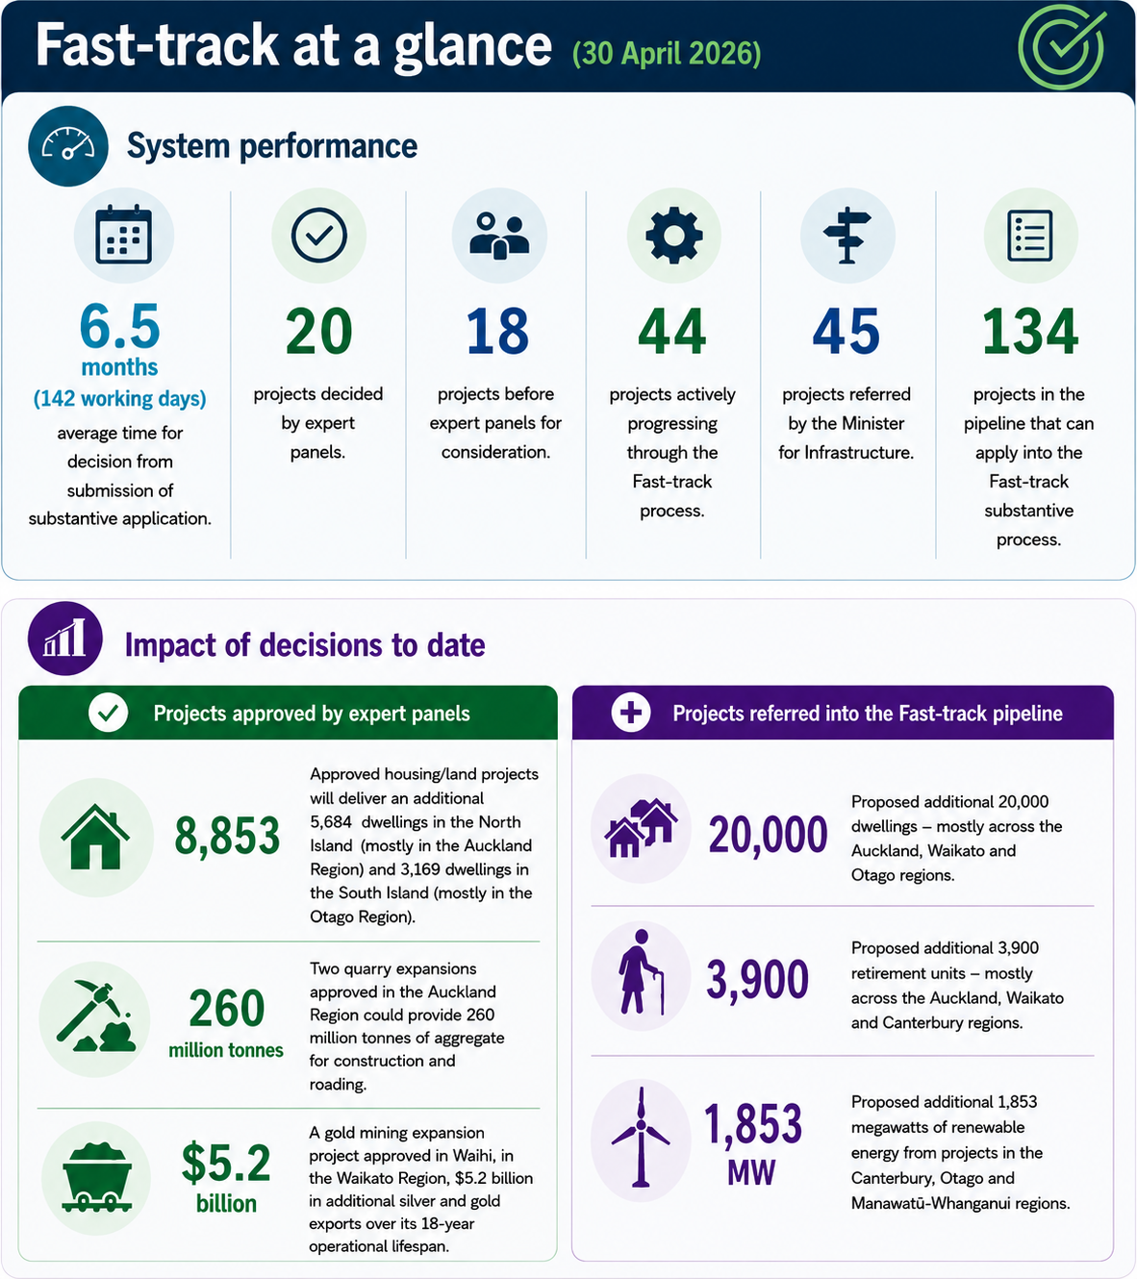

Introduction
The Fast-track Approvals Act 2024 (the Act) established an optional approvals process for infrastructure and development projects with significant regional or national benefits. Applications opened on 7 February 2025.
The Fast-track Approvals regime was introduced in response to longstanding concerns that Aotearoa New Zealand’s resource management system is fragmented, with separate approval processes under multiple statutes resulting in lengthy decision-making, duplicated processes, increased costs and reduced investment certainty. It was intended to provide a faster, more integrated approvals process for projects with significant regional or national benefits, while giving greater recognition to the positive economic and social benefits of development alongside environmental and other statutory considerations.
A distinguishing feature of the Fast-track Approvals regime compared with previous fast-track regimes established under the COVID-19 Recovery (Fast-track Consenting) Act 2020 and the Natural and Built Environment Act 2023 is its integrated "one-stop shop" approach.
In addition to approvals under the Resource Management Act 1991 (RMA), including resource consents, notices of requirement and certificates of compliance, the Act enables approvals under the Conservation Act 1987, Wildlife Act 1953, Reserves Act 1977, Freshwater Fisheries Regulations 1983, Crown Minerals Act 1991, Heritage New Zealand Pouhere Taonga Act 2014, Economic Zone and Continental Shelf (Environmental Effects) Act 2012, Public Works Act 1981 and other specified legislation to be considered through a single process.
The policy intent was to improve decision-making timeframes, provide greater investment certainty and establish a clear and efficient pathway for well-designed projects with significant regional and national benefits.
The need for reform was supported by evidence from Te Waihanga New Zealand Infrastructure Commission, which estimated that consenting processes cost infrastructure projects approximately $1.3 billion annually and that the time taken to obtain resource consents for major projects had nearly doubled over a five-year period.
As part of introducing the Act, Cabinet required a review of implementation after 12 months of operation and a report back.
During the review period, Parliament enacted the Fast-track Approvals Amendment Act 2025 (the Amendment Act). Many of the amendments apply only to applications lodged on or after 31 March 2026. The Ministry for Regulation also requested that this review consider the implementation of selected amendments where practicable. However, because many of the amendments apply only to applications lodged on or after 31 March 2026, the review is necessarily limited in its ability to assess their implementation and effectiveness.

How does the Fast-track Approvals Act work?
The Act establishes a single entry point that brings together the approvals required for a project. These may include:
- a resource consent under the Resource Management Act 1991
- a certificate of compliance under the Resource Management Act 1991
- a notice of requirement under the Resource Management Act 1991
- a concession under the Conservation Act 1987
- a concession and other permissions under the Reserves Act 1977
- Crown Minerals Act 1991 section 61 land access provisions
- an approval under the Wildlife Act 1953
- an archaeological authority under the Heritage New Zealand Pouhere Taonga Act 2014
- an authority under the Public Works Act 1981 to take or deal with land
- an approval under the Freshwater Fisheries Regulations 1983
- marine consents under the Exclusive Economic Zone and Continental Shelf (Environmental Effects) Act 2012
- aquaculture decisions under the Fisheries Act 1996.
The process has two stages. Schedule 2 of the Act lists 149 named projects that may apply directly for substantive approval. Projects not listed in Schedule 2 may also apply under the Act but must first obtain a referral decision from the Minister for Infrastructure (the Minister). When granting a referral, the Minister may impose restrictions on the project or specify requirements for the substantive application. Unless the Minister specifies otherwise, referred projects must lodge a substantive application within two years.
The Ministry for the Environment (the Ministry) administers the referral process by coordinating advice from relevant government agencies and other parties, and provides advice to the Minister to support referral decisions.
Once a project has been referred, or is automatically eligible under Schedule 2, the applicant can lodge a substantive application with the Environmental Protection Authority (EPA), which administers the approvals process. The EPA assesses the application for completeness and scope, checks for competing applications or existing resource consents for the same activity. Where appropriate and consistent with the Act, the EPA then refers the application to the Panel Convener. The Panel Convener then establishes an independent expert panel to consider and determine the application.
Expert panels are independent decision-making bodies established for each Fast-track Approvals project. They may request reports or advice, consider applications and notices of requirement, and decide whether a hearing is required.
The Act does not provide for full public notification of applications. Instead, it specifies certain people and organisations that must be invited to provide written comments and, under section 53(3), enables panels to invite comments from any other person or organisation they consider appropriate. Where a hearing is held, participation is limited to the applicant, commissioned report writers and those invited to comment under the Act.
The panel may approve an application, approve it subject to conditions, or decline it. Before issuing a final decision, the panel must first consult on any proposed conditions with the applicant, relevant local authorities and administering agencies, specified Ministers, and invited commenters. Where the panel proposes to decline an application, it must first provide a draft decision to the applicant and other parties specified in the Act. The applicant may propose modifications or conditions, or withdraw part of the application, before the panel makes its final decision.
A panel’s decision may be appealed to the High Court on a question of law only.
The costs of the process are met by applicants. Government agencies and local authorities may recover their actual and reasonable costs of processing applications. Contributions are also provided to specified Māori groups to support their participation in commenting on applications.

The amendments
The Amendment Act introduced a range of changes to clarify definitions, adjust statutory timeframes and refine consultation and process requirements. Collectively, the amendments were intended to streamline the approvals process, improve certainty and reduce assessment timeframes.
The Amendment Act also enables government policy statements on regional or national benefits (for example, grocery competition) to be issued and considered by the Minister at the referral stage and by expert panels when determining substantive applications.
Key changes at the referral stage included:
- reducing the referral comment period from 20 to 15 working days and introducing a requirement for the responsible agency to provide its Treaty settlement and other obligations report to the Minister within 20 working days after the close of the comment period. Previously, no statutory timeframe applied to the Ministry providing advice to the Minister
- replacing mandatory consultation requirements with notification requirements in most circumstances. For both referral applications and substantive applications for listed projects, applicants are generally required to notify specified parties rather than consult with them, reducing the consultation burden during the early stages of the process. Notified parties have a minimum of 20 working days to provide comments.
Key changes at the substantive stage included:
- moving the Minister’s discretion to prioritise applications until after a substantive application has been lodged
- enabling applicants for listed projects to apply to the Minister to lodge applications for specified stages of a project. Each stage must satisfy the same criteria as a referral application before entering the fast-track approvals process
- enabling panels to seek a Ministerial decision on a proposed reduction in scope where an applicant wishes to withdraw or modify one or more approvals sought
Other amendments:
- clarified the regulation-making powers for cost recovery, including regulations prescribing recoverable costs and excluding specified categories of costs from recovery
- amended the descriptions of 20 listed projects and introduced a regulation-making power to amend the descriptions of other listed projects.
Most of the amendments refined the operation of the regime rather than changing its underlying policy settings.

Purpose of the review
The broad objectives of the Fast-track Approvals regime are to provide faster, simpler and less costly approvals processes for infrastructure and development projects with significant regional or national benefits.
The regime seeks to reduce the complexity of approvals across multiple regulatory systems, provide greater recognition of the positive economic and social benefits of development alongside environmental and other statutory considerations, and uphold existing Treaty settlement and other statutory obligations. It is intended to improve investment certainty and support the timely delivery of major projects, helping to reduce New Zealand’s infrastructure deficit and increase the supply of quality housing.
The regime was designed to address two broad issues arising from the complexity of the existing approvals system:
- the time and cost associated with existing approval processes were delaying decisions and creating barriers to the timely delivery of major projects
- existing approval processes placed insufficient weight on the positive economic and social benefits of development alongside environmental and other statutory considerations.
This review assesses whether the regime is operating as intended after its first 12 months of operation. In particular, it considers whether the regime is addressing the key implementation issues it was designed to resolve, whether the core elements of the regime are functioning effectively, identifies operational issues that have emerged during implementation, and recommends practical improvements where appropriate. The review recognises that the regime remains relatively new and that both administering agencies and applicants have continued to develop their understanding of the new processes during the review period.
The review draws on operational data together with stakeholder feedback from applicants, local authorities, administering agencies and other participants in the Fast-track Approvals process.

What it covers
The review assesses the performance of Fast-track Approvals during its first 12 months of operation. It considers whether the regime has been implemented and is operating as intended, whether it is delivering value for money, and how it is experienced by applicants, administering agencies and other participants.
The review also considers the implementation of selected amendments introduced by the Amendment Act where practicable. However, as many amendments apply only to applications lodged on or after 31 March 2026, the review is necessarily limited in the conclusions it can draw about their implementation and effectiveness.
The review is structured around four themes:
Implementation
- Was the regime implemented as intended?
- Is it attracting the types of projects it was designed for?
- Are high-quality applications being submitted?
- What implementation issues or bottlenecks emerged, and how were they addressed?
Operation
- Is the regime operating as intended?
- Is it reaching its intended users and sectors?
- Is it improving decision timeframes, responsiveness and system performance?
- What operational issues or bottlenecks have emerged, and how are they being addressed?
Cost and value for money
- Is the regime delivering value for applicants and government?
- Are implementation and administration costs reasonable and proportionate?
Implementation of the Fast-track Approvals Amendment Act 2025
- What early observations can be made about the implementation of the amendments?

What it doesn’t cover
One objective of Fast-track Approvals is to provide greater recognition of the positive economic and social benefits of projects with significant regional or national benefits alongside environmental and other statutory matters. This review focuses on the implementation and early operation of the Fast-track Approvals regime. It does not assess all of the longer-term policy outcomes the regime is intended to achieve.
Similarly, the review does not assess the wider social, economic and environmental outcomes of the regime. These outcomes are expected to emerge over many years and, in many cases, will be influenced by the characteristics of individual projects rather than the operation of the regime itself.
Accordingly, this review does not assess whether the regime is:
- contributing to economic growth
- reducing New Zealand’s infrastructure deficit
- contributing to raising incomes
- enhancing resilience
- delivering broader environmental outcomes.
These matters are more appropriately considered through longer-term evaluations, once a larger body of decisions has accumulated and sufficient time has elapsed for the broader outcomes of the regime to become measurable.

What we found

Overall findings
The design of Fast-track Approvals is sound and is generally reported to improve transparency, predictability and confidence in the approvals process. Feedback from applicants, agencies and other participants indicates that the regime is largely operating as intended, while identifying several areas where implementation could be strengthened.
Strengths identified through the review include:
- the regime provides greater certainty for applicants by streamlining procedural complexity, improving planning for complex projects and supporting investment confidence
- Panel Conveners have brought structure, momentum and consistency to the process. Applicants, agencies and Panel Conveners also identified an ongoing need to continue shifting practice away from RMA-style approaches towards the more integrated intent of the Act
- agency engagement was consistently described as constructive, responsive and solution-focused. User research found proactive communication and a willingness to problem-solve were frequently identified as strengths, with agencies described as helpful, pragmatic and committed to making the regime work
- statutory timeframes are being met 99 percent of the time
- the centralised digital portal is supporting administration of the regime. While users identified opportunities for further functionality improvements, there is evidence the system continues to improve, although some requested enhancements involve trade-offs between user expectations, cost and technical complexity.
The review also identified several opportunities to improve the operation of the regime:
- while users generally considered the process to be transparent, concerns remained about the transparency and predictability of cost recovery. Applicants reported limited visibility of the work undertaken, why it was required and how costs were calculated. Stakeholders considered the regulation-making powers introduced by the Amendment Act could improve transparency in this area
- aspects of implementation continue to reflect RMA-style approaches rather than the more integrated approach envisaged by the Act
- inflexible completeness assessments early in implementation were resulting in applications being rejected for relatively minor issues. The Amendment Act now enables requests for further information during completeness assessments, which is expected to address this issue
- duplication of effort can occur where applicants are required to resubmit information following referral, creating unnecessary delay and administrative burden
- implementing the Amendment Act required significant redevelopment of the digital portal, resulting in unplanned development costs and delays to planned functionality improvements.
Most amendments introduced by the Amendment Act came into force on 31 March 2026. As at 30 April 2026, six referral applications and six substantive applications had been received under the amended regime. The review is therefore necessarily limited in the conclusions it can draw about the impact of the amendments. Nevertheless, early stakeholder feedback has been generally positive.

Set up of the process

The system was set up as required, and as well as possible within the time available
The regime was successfully established within the required implementation timeframe. The core governance, operational processes, digital systems and supporting arrangements were put in place, enabling applications to be accepted from 7 February 2025.
The first referral and substantive applications were lodged in February 2025. The first expert panels were established in May 2025, and, by the end of the review period, the initial substantive applications had progressed through the approvals process.
Given the breadth of legislation integrated by the regime, the number of agencies involved and the complexity of establishing a new approvals system, implementation within the available timeframe was a significant achievement. This was further complicated by the need to continue administering applications under both the COVID-19 Recovery (Fast-track Consenting) Act 2020 and the Natural and Built Environment Act 2023 while implementing the new regime. The differences between the regimes also limited the extent to which existing systems and processes could be adapted.
Administrative processes have continued to mature during the first year of operation, with refinements introduced in response to operational experience and stakeholder feedback. Stakeholders generally reported that the regime is operating successfully and represents an improvement on previous fast-track processes. There is also evidence that efficiency and consistency are improving over time as participants become more familiar with the regime and a body of precedents develops.

Operation

The process is operating as planned, but some adjustments will take time
Overall, the regime is operating broadly as intended. Stakeholders recognised that a system of this scale and complexity would require a period of adjustment and generally considered it to be functioning satisfactorily.
Early operational issues included inconsistencies in the timing of document release and notifications, differing expectations about application completeness, and the level of detail required in management plans. Stakeholders reported that these issues have reduced over time as agencies, applicants and expert panels have become more familiar with the regime.
Although one of the regime’s objectives is to reduce decision-making timeframes, some statutory timeframes remain challenging, particularly for technical specialists and iwi representatives. Meeting these timeframes depends on adequate resourcing, early engagement, effective communication and high-quality applications.
Fast-track projects vary considerably in scale and complexity, but the same statutory timeframes generally apply across the regime. This can create pressure where multiple large or technically complex applications are received at the same time. Application demand has also been uneven, with projects tending to arrive in clusters rather than as a steady pipeline. While there is some visibility of the substantive application pipeline, referral applications remain difficult to predict, reinforcing the importance of early engagement and communication to support resource planning.
Experience to date also suggests that the most technically complex projects are not necessarily those that take the longest to determine. Application quality, project readiness and early engagement appear to have a greater influence on overall timeframes than technical complexity alone.
Application volumes have also been concentrated in a small number of geographic areas (figure 2), placing additional pressure on local authorities, iwi and other participants. Panel Conveners have some flexibility to respond to project complexity by setting an appropriate timeframe for expert panel decisions, up to the statutory maximum of 90 working days (or longer with the applicant’s agreement).
Figure 2: Geographical distribution of applications
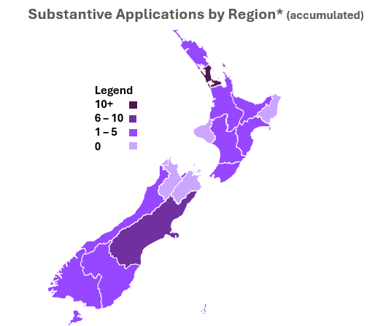 | 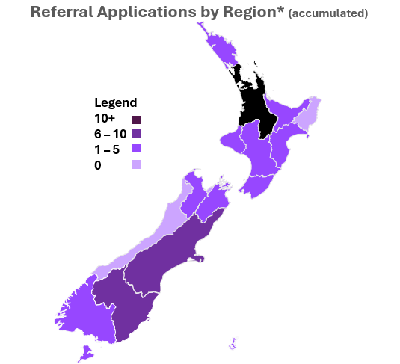
Stakeholders consistently identified the EPA’s administration of the regime as a strength. In particular, the EPA was recognised for maintaining statutory timeframes and assigning a dedicated processing lead to each application, which was reported to improve consistency, communication and responsiveness throughout the process.

Fast-track is generally reaching its target audience
More than half (59 percent) of referral applications, and 41 percent of substantive applications, relate to housing and land development projects, predominantly in the Auckland, Waikato and Otago regions. Renewable energy projects account for around one-fifth of all applications, with more than 80 percent located in the South Island.
Overall, the pattern of applications broadly reflects the composition of projects listed in Schedule 2 of the Act, suggesting the regime is attracting the types of projects it was intended to support. Applications have been received across a range of sectors, including regionally and nationally significant housing and land development, renewable energy, transport, industrial and other strategic infrastructure projects.
Figure 3: Distribution of applications by sector
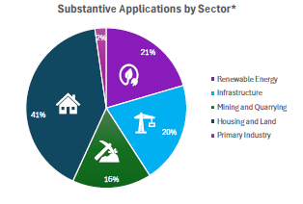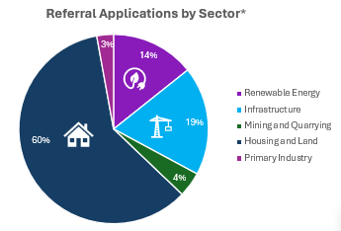
* Information represents applications checked as eligible and complete, and those approved. It does not include applications lodged but still to be checked, or applications declined or withdrawn.

Relevant proposals are being received
The regime is attracting the types of large-scale and complex projects it was intended to support. Many of the applications received are projects that would likely have experienced significant delays, sequencing challenges, approval uncertainty or greater consenting risk under standard approval pathways.
While the projects themselves are generally well suited to the regime, the maturity of applications at lodgement has varied considerably. Applications supported by well-developed technical information, early engagement and clearly resolved issues have generally progressed more efficiently through the process. Conversely, less mature applications have required additional information and refinement, increasing both assessment costs and decision timeframes. As applicants, councils and administering agencies become more familiar with the regime and its expectations, both application quality and process efficiency are expected to continue improving.
The concentration of applications within particular sectors and regions also highlights a broader policy consideration. The regime assesses applications individually in the order they are received and is not designed to consider the relative merits of similar proposals within a region, except where there are competing or overlapping applications. For example, it does not assess how many wind farms or retirement villages may be appropriate within a particular area, or which proposals may deliver the greatest overall benefit. While this commercial risk appropriately sits with applicants, the approach raises broader questions about strategic planning and the assessment of cumulative economic benefits, which sit outside the scope and purpose of the regime.

The quality of applications is satisfactory and improving
Applicants and agencies are continuing to adapt to the different requirements of Fast-track Approvals. While many participants have experience with both the RMA and previous fast-track regimes, the integrated approach established by the Act requires different ways of working. Stakeholders reported that this transition has occasionally resulted in minor operational bottlenecks but considered these to be reducing as experience with the regime grows. Ongoing guidance and engagement by the Ministry, the EPA and local authorities is supporting this transition.
Overall, application quality has been satisfactory and is improving. Stakeholders consistently identified a strong relationship between application quality and processing efficiency. Applications requiring multiple requests for further information or significant refinement generally took longer to assess, despite statutory timeframes continuing to be met.
The strongest applications were typically those where applicants had undertaken substantial pre-lodgement engagement with councils, iwi, technical specialists and affected parties, and had resolved key technical issues before lodgement. Applications supported by mature technical assessments, draft conditions, draft management plans and clearly articulated environmental outcomes were consistently reported to be easier to assess within the statutory timeframes. Applicants are also increasingly recognising that investing in application quality before lodgement reduces overall costs and time to decision.
Operational data supports these observations. The proportion of applications requiring return in the early stages of assessment has reduced over time, indicating improving application quality and a better understanding of the regime’s requirements.

Some operational issues remain
As noted earlier, some stakeholders considered that aspects of implementation continue to reflect RMA approaches rather than the integrated intent of Fast-track Approvals. In particular, some respondents perceived that councils continued to approach applications as though they retained the primary decision-making role.
Respondents also identified inconsistent approaches across agencies and regions. While an amendment requiring council comments to be relevant to the decision came into force on 31 March 2026, it is too early to assess whether this will materially improve consistency.
Stakeholders also suggested there is an opportunity to better communicate both the requirements of the regime and the level of scrutiny applied by expert panels, to support public confidence in Fast-track decisions.
Several operational bottlenecks were identified during the first year of implementation, including:
- very compressed timeframes between the release of Panel minutes and response deadlines
- some applicants continued to prepare applications using RMA-style approaches, including submitting a single assessment across multiple approvals rather than addressing the statutory tests for each approval
- the limited pool of suitably qualified panel members for specialist projects. In some instances, panel members have been appointed to multiple applications. While this can support consistency and the transfer of knowledge between similar applications, it also reflects the relatively small pool of expertise available in New Zealand and places pressure on that capability
- limited opportunity for iterative technical discussions once statutory timeframes commence. The Amendment Act extended the cumulative period an applicant may request a suspension of the process from 50 to 100 working days, providing greater flexibility
- significant workload pressures where multiple large-scale applications are being considered concurrently
- the process of progressing from referral to substantive application was also reported to create unnecessary duplication in some cases, particularly where applicants were required to resubmit information already provided at referral, including material relating to regional or national significance.
Many stakeholders considered these issues had reduced over time as participants became more familiar with the regime and operational practices matured.
Cost recovery remains one of the more debated aspects of the regime. Stakeholders generally considered the issue to be one of transparency and administration rather than the overall level of costs. Applicants reported limited visibility of the work being undertaken, why it was required and how charges were calculated, making it difficult to forecast costs where additional technical work was commissioned. The Amendment Act includes a regulation-making power to establish a cost dispute resolution scheme. However, this would require further policy development, and many stakeholders considered that improvements to administrative practice could address a number of the concerns.
The invoicing process was also identified as administratively burdensome, particularly for local authorities. Stakeholders noted that the EPA’s quarterly payment cycle does not align well with council financial systems, increasing administrative effort. These issues have also been identified through the separate review of the cost recovery regime.
Smaller territorial authorities reported additional challenges responding within compressed statutory timeframes, particularly where additional technical expertise or staff were required. Uncertainty around cost recovery and funding arrangements could delay resourcing decisions, increasing pressure on existing teams and, in some cases, resulting in greater reliance on regional councils to provide technical support.

Application volumes have broadly aligned with the original assumptions
As at 30 April 2026, application numbers were tracking close to the low-volume scenario modelled by MartinJenkins in January 2025.
Table 1: Actual volumes compared to original volume forecasts
Application type | Scenario 3 (low) FY25/26 forecast | Applications received
 |  | 1 February 2025 to 30 April 2026 | After 12 months
Referral applications | 59 per year | 62 compliant  79 total received | 52 compliant  57 total received
Substantive applications (including relodged) | 50 per year | 47 complete  70 total received | 40 complete  65 total received
While application volumes have broadly matched expectations, there is some evidence that demand is increasing as the regime matures. Referral applications reached a monthly high of 16 in May 2026, and early indications suggest application volumes have remained elevated through June. It is too early to determine whether this reflects increasing confidence in the regime, pre-election activity or a sustained increase in demand. Continued monitoring will be important to understand the longer-term implications for system capacity and resourcing.
Figure 4: Number of applications lodged per month

Although overall volumes have been consistent with forecasts, the timing of applications has been less predictable. Applications often arrive in clusters, both geographically and temporally, creating short-term pressure on administering agencies, councils and technical specialists. This variability was not fully reflected in the original volume modelling and reinforces the importance of maintaining sufficient flexibility within the system to respond to peaks in demand. This suggests that overall application volumes are a less important driver of system performance than the pattern in which applications are received.

The regime is meeting its objectives of improving timeframes
One of the principal objectives of Fast-track Approvals is to reduce the time taken to obtain approvals for projects with significant regional or national benefits. Evidence from Sapere’s review of the cost of consenting infrastructure projects in New Zealand provides useful context for assessing whether this objective is being achieved. Sapere found that the cost of consenting infrastructure projects had increased by around 70 percent since 2014, and average decision-making timeframes had increased by around 50 percent. The report attributed this to a range of factors, including increasing evidential requirements, greater risk aversion and declining in-house capability within some consenting authorities.
Against this background, the available evidence indicates that Fast-track Approvals is delivering materially shorter decision timeframes for complex projects. The mean time from completeness to final decision for substantive applications is 142 working days (216 calendar days).
Figure 5: Decision timeframes for substantive applications from the completeness decision to the final approval (at 30 April 2026)

Referral decisions took an average of 81 working days (126 calendar days), or 71 working days (99 calendar days) when outlier applications are excluded. The outlier applications were those where the initial referral application was returned and subsequently resubmitted. The reported timeframes include the entire period from the original lodgement through to the final referral decision, including periods where applications were being revised before resubmission.
Figure 6: Decision timeframes for project referral from the date the application was lodged to the Minister’s decision on referral

Comparison with the Sapere estimates suggests Fast-track Approvals is providing substantially shorter decision timeframes for complex projects than would typically be expected under standard RMA processes. While the comparison is indicative only, as the project types are not directly comparable, it provides useful evidence that the regime is achieving one of its primary objectives.
Table 2: Comparison of Fast-track Approvals speed of processing with standard RMA timeframes
Project complexity | Sapere Estimates | Fast-track substantive process
Typical | 63–91 calendar days
Some complexities | 167–214 calendar days
Complex / unusual | 365–425 calendar days | 142 working days (216 calendar days)
Typical projects would not generally be expected to qualify for the Fast-track Approvals process. For non-listed projects, the referral stage adds an average of 99 calendar days, resulting in an average end-to-end processing time of approximately 249 calendar days. Even including the referral stage, the total time remains substantially below Sapere’s estimates for complex RMA applications.
Stakeholder feedback indicates that the regime has also created a greater sense of momentum and prioritisation around nationally and regionally significant projects, reducing many of the procedural delays commonly experienced under traditional consenting pathways.
However, the regime does not reduce the amount of technical work required to support robust decision-making. Instead, it shifts much of that work into the earlier stages of project development and assessment. Stakeholders noted that unresolved issues with non-regulatory parties can still result in significant suspensions and delays, despite technical and regulatory matters having largely been addressed. The regime can accelerate regulatory decision-making, but it cannot eliminate delays associated with project readiness, stakeholder engagement or the commercial decisions that sit outside the statutory approvals process.
Some applicants entered the process expecting Fast-track to operate as a more permissive or ‘rubber stamp’ consenting pathway. In practice, the regime continues to require robust technical assessment, defensible conditions and sufficient information for expert panels to make well-founded decisions. Stakeholders consistently observed that applications progressed most efficiently where applicants viewed Fast-track as requiring greater preparation and earlier collaboration, rather than less. Stakeholders reported that, as experience with the regime has grown, applicant expectations have become better aligned with the purpose and operation of the Act.

Additional efficiencies are being realised
In addition to shorter statutory timeframes, the regime is delivering other efficiency benefits. Integrating multiple approvals into a single process has reduced duplication, improved coordination between agencies and provided applicants with greater certainty about approval pathways. Stakeholders also reported that the regime has encouraged earlier and more focused engagement between applicants, councils, iwi and technical specialists, enabling technical issues, information requirements and consenting risks to be identified and addressed before statutory timeframes commence.
Stakeholders nevertheless identified opportunities to improve administrative efficiency. Many of these reflected the challenges of establishing a new system within compressed timeframes while also implementing the Amendment Act. The majority of comments related to communication issues during the early stages of implementation, which stakeholders generally considered had improved over time, and to the functionality of the digital portal.
Feedback on the portal identified both technical and user-experience issues. Some reflected system functionality, while others related to how the portal integrates with applicants’ own document management processes. For example, document size limits were identified as creating additional administrative effort and cost for some users. Stakeholders also acknowledged that some issues could be mitigated through better document preparation, while recognising that other proposed enhancements would require significant investment and are unlikely to be justified in the short term.

The system can result in cost savings
Consenting processes have become increasingly complex and costly in recent years. While reducing direct consenting costs was not the primary objective of Fast-track Approvals, a more integrated process, greater certainty and shorter decision-making timeframes were expected to reduce overall project costs.
Stakeholder feedback suggests these benefits are beginning to be realised. Participants consistently identified greater certainty over process and timing, together with reduced duplication across approval processes, as delivering efficiencies that are expected to reduce the overall cost of delivering projects. While it is too early to quantify these savings, the available evidence suggests the regime is reducing project risk and improving planning certainty.
As discussed earlier, stakeholders also identified opportunities to improve the transparency and administration of cost recovery. These matters are considered in more detail in the separate review of the Fast-track cost recovery regime.
The regime is intended to recover the actual and reasonable costs of processing applications. Cost neutrality means that fee revenue broadly matches the costs of administering the regime over time. The separate cost recovery review concluded that the regime is broadly achieving this objective, while identifying several areas for ongoing monitoring and improvement as application volumes mature.

Strategic issues for future consideration
The review identified several broader issues that fall outside its scope but may warrant consideration through future strategic reviews. These issues do not affect the implementation findings of this review but are likely to become increasingly important as the regime matures and wider reforms are implemented.
The most significant is how Fast-track Approvals interacts with other system reforms. The regime provides an approvals pathway for projects with significant regional or national benefits, while broader reforms to the planning system, local government and infrastructure funding and financing will influence how those projects are planned, serviced and delivered. As these reforms are implemented, it will be important to consider how they operate together to support timely decision-making while maintaining a coherent overall system.
Other issues that may warrant future consideration include:
- cross-boundary issues, where projects have implications across multiple local authority jurisdictions
- infrastructure sequencing, where projects may be approved ahead of the infrastructure needed to support them
- cumulative effects where multiple Fast-track and other development proposals are concentrated within the same area
- development on highly productive land, which has been raised by stakeholders and is also emerging in current appeals.
These matters do not affect the overall implementation findings of this review but may become increasingly important as the regime matures and a larger number of projects progress through the approvals process.
Impact
The Amendment Act introduced a range of changes, some of which took effect immediately, with most substantive amendments commencing on 31 March 2026.
Table 3: Summary of changes introduced in the Amendment Act
 |  | 2025 Amendment Act
  Topic
  2024 Act
Government policy statements (GPS) | Other GPS existed outside Fast-track, but no specific ability to issue a GPS under FTAA directly to inform decision-making | GPS must be considered; wider Ministerial consultation
Scope of listed projects | - 149 listed projects bypass referral  - No staged application mechanism for listed projects | - Governor-General may amend descriptions; 20 updated  - Allows staged applications for listed projects
Pre-lodgement requirements | Mandatory consultation | Notification only; 20-day response
Referral process |  | Clarified roles; reduced comment timeframe to 15 days
Panel timeframes | General timeframes | Refined; some strict limits removed
Commenting and appeals | Invited commenters may comment | Appeals limited to mandatory invitees
Ministerial powers | Limited | Expanded powers including GPS, modification approval, with safeguards
Modification of applications | Limited options | Modifications allowed only if scope reduced
Infrastructure conditions | No specific reference to infrastructure-related conditions | Wording changed to explicitly clarify that expert panels can issue decisions subject to conditions that infrastructure “can be made adequate”
Given the limited implementation period and the relatively small number of applications affected, it is too early to draw firm conclusions about the impact of the amendments. As at 30 April 2026, only six referral applications and six substantive applications had been received under the amended regime. The observations below should therefore be regarded as preliminary.
The amendments are intended to improve the efficiency and operation of the regime in several ways. They:
- reduce pre-lodgement requirements by replacing mandatory consultation with notification in most circumstances
- streamline application processes by enabling staged applications for listed projects and providing greater flexibility to address incomplete applications
- refine statutory timeframes and panel processes to improve efficiency and certainty
- expand Ministerial powers in specific circumstances, including the consideration of Government Policy Statements and decisions on certain modifications to applications.
Early stakeholder feedback has generally been positive. In particular, replacing mandatory consultation with notification is expected to reduce the burden on applicants during the early stages of project development. However, some stakeholders questioned whether reduced engagement before lodgement could result in issues emerging later in the process, potentially requiring additional requests for information, hearings or conferencing. Whether these changes ultimately improve overall efficiency will require further assessment once a larger number of applications have progressed through the amended regime.
Similarly, several amendments were introduced in response to operational experience during the first year of implementation. For example, the ability to request further information during completeness assessments is expected to reduce unnecessary returns of applications, while staged applications and greater flexibility around modifications should improve the operation of the regime for complex projects. Although these changes are well aligned with issues identified during the review, there has not yet been sufficient operational experience to assess their effectiveness.
The introduction of government policy statements represents a more substantive policy change by enabling Ministers to identify regional or national benefits that must be considered during referral and substantive decision-making. At the time of this review, the Government Policy Statement on Grocery Competition was the only example, and it is therefore too early to assess how this new mechanism will influence decision-making in practice.
The impact of the amendments should be considered again as part of a future strategic review, once a larger body of applications has progressed through the amended regime and sufficient implementation experience has been gained.

Future reviews
As the regime matures, future reviews should move beyond implementation and operational performance to assess whether the regime is delivering its intended long-term outcomes. In particular, future reviews should consider:
- whether increasing application volumes and a larger body of decisions have resulted in greater consistency and predictability in decision-making, recognising the diversity and complexity of applications. Ongoing work to proactively share information and lessons learned should support this
- whether the regime continues to deliver reduced decision timeframes as application volumes increase
- how Fast-track Approvals operates alongside the reformed resource management system, including whether improvements to the wider system reduce demand for Fast-track approvals for relatively straightforward projects.
These longer-term measures could be incorporated into the system performance framework and the strategic review process proposed in the Planning Bill currently before Parliament.

How we did it
This review was designed to be pragmatic, proportionate and evidence based. It was intended to provide a concise assessment of the implementation and early operation of the regime using available operational data, comparable information where available, and stakeholder feedback.
A key principle of the review was to minimise any additional burden on the system while agencies and participants continued to implement the regime and adapt to the Amendment Act. Accordingly, the review relied primarily on existing operational reporting, performance data and tracking information held by the Ministry and the EPA.
While quantitative data provides an important picture of system performance, it does not capture the experience of those using and administering the regime. The review was therefore supplemented by qualitative feedback from a range of stakeholders through:
- a small reference group representing key stakeholder perspectives, including government agencies, local authorities, applicants and panel members
- targeted discussions with key agencies involved in administering the regime
- an opportunity for all project proponents to provide feedback through an online survey.
This mixed-method approach enabled the review to combine operational performance data with the experiences of those designing, administering and using the regime.

Data analysis
The analysis is based on data collected to 30 April 2026. This provided sufficient information to assess the implementation and operation of the regime, including the progression of applications through to the first substantive decisions. However, it did not provide a sufficient evidence base to meaningfully assess the impact of the Amendment Act, as only a small number of applications had been received under the amended provisions.
Operational reporting is supported through a combination of monthly dashboards and weekly reporting. At present, much of the analysis required to produce these reports is undertaken manually, presenting an opportunity to improve efficiency through greater automation over time. As the regime matures and a larger body of data becomes available, reporting should increasingly focus on identifying trends and performance over time, rather than monthly status alone.
The Fast-track website was consistently viewed positively by stakeholders. It provides comprehensive information on the approvals process, together with project documentation and progress updates, and was considered a useful resource for applicants, agencies and other participants in the regime.

Governance
This review was carried out by the Ministry for Cities, Environment, Regions and Transport and was signed out by the relevant General Manager. Stakeholder agencies have been involved in the process directly and through the expert group, but authorship remains with the Ministry.

References
Fast-track Approvals Amendment Act 2025
Fast-track Approvals Act 2024
Buddle Findlay. 2026. How fast is fast-track? Decision timeframes under the FTAA
Fast-track Panel Convener and Associate Panel Conveners. July 2025. Fast-Track Approvals Act 2024: Panel Conveners’ Practice and Procedure Guidance
Gazette notice 2025-sl7268 - Government Policy Statement on Grocery Competition
MartinJenkins. January 2025. Proposed Agency Fees and Team for Fast-track Approvals, Final Report
Ministry for the Environment. 2024. Supplementary Analysis Report: Fast‐track Approvals Bill (Updated 24 July 2024)
Ministry for the Environment. 2024. Treaty Impact Analysis: Fast Track Consenting Bill – briefing 1
Ministry for the Environment. Fast-track Approvals Programme Dashboard to 30 April 2026
Ministry for the Environment. January 2025. Fast-track Approvals Bill Programme Close Out and Handover to Implementation Report
Ministry for the Environment. March 2025. Regulatory Impact Statement: Replacing the Resource Management Act 1991
Sapere. July 2021. The cost of consenting infrastructure projects in New Zealand, A report for The New Zealand Infrastructure Commission / Te Waihanga
Simpson Grierson. 2025. Fast-track enters overdrive: A quick guide to the Fast-track Approvals Amendment Bill
Transcend Consulting. April 2026. MfE Fast-Track Approval Cost Recovery Review
Transcend Consulting. September 2025. System user feedback on the workability of the Fast-Track Approvals Act 2024

[CAB-24-MIN-0008].
Until 30 June 2026, and the Ministry of Cities, Environment, Regions and Transport thereafter.
These agencies include the Ministry for the Environment; Ministry of Business, Innovation and Employment, Ministry for Primary Industries; Department of Conservation; Heritage New Zealand; Te Tari Whakatau; Te Puni Kōkiri.
Supplementary Analysis Report: Fast-track Approvals Bill (Updated 24 July 2024).
Cabinet agreed that, in addition to Treaty settlements, other legislative arrangements would be upheld including those under the Marine and Coastal Area (Takutai Moana) Act 2011, Ngā Rohe Moana o Ngā Hapū o Ngāti Porou Act 2019, Mana Whakahono ā Rohe and joint management agreements under the RMA.
For example, two solar farm applications in the Mackenzie Basin are effectively being considered in parallel. While this arose through the timing of the applications rather than by design, largely the same expert panel members were appointed to both applications to support consistency in decision-making.
Proposed Agency Fees and Team for Fast-track Approvals, Final Report, Martin Jenkins, January 2025
Including relodged.
Time between submission date and granting of consent.
This does not include undocumented time for pre-application notification and consultative activities.
Simpson Grierson - Fast-track enters overdrive: A quick guide to the Fast-track Approvals Amendment Bill.

