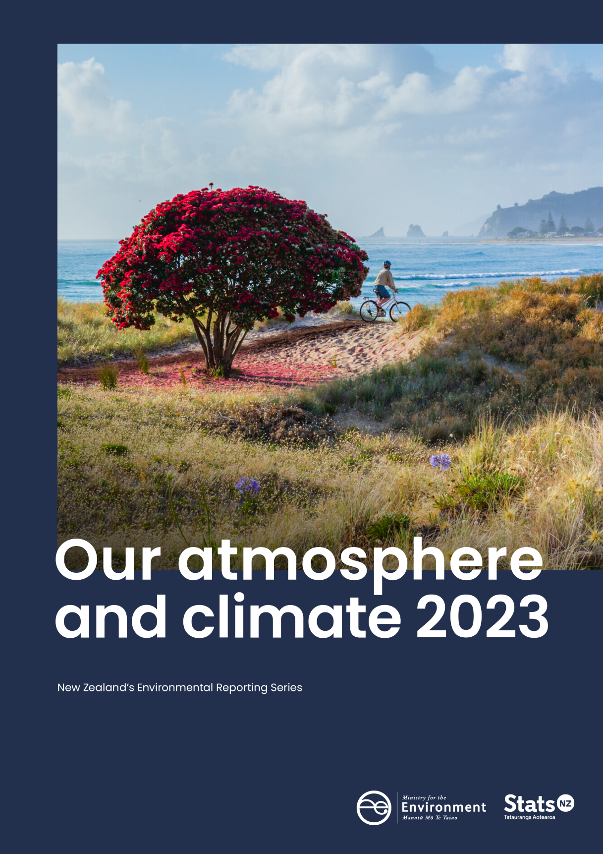

Crown copyright ©
Unless otherwise stated, this copyright work is licensed for re-use under a Creative Commons Attribution 4.0 International licence. Except for any photographs, in essence, you are free to copy, distribute, and adapt the work, as long as you attribute the work to the New Zealand Government and abide by the other licence terms. To view a copy of this licence, visit Creative Commons Attribution 4.0 International licence. To re-use a photograph please seek permission by sending a request to the stated image owner.
Please note that neither the New Zealand Government emblem nor the New Zealand Government logo may be used in any way which infringes any provision of the Flags, Emblems, and Names Protection Act 1981 or would infringe such provision if the relevant use occurred within New Zealand. Attribution to the New Zealand Government should be in written form and not by reproduction of any emblem or the New Zealand Government logo.
If you publish, distribute, or otherwise disseminate this work (or any part of it) to the public without adapting it, the following attribution statement should be used:
Source: Ministry for the Environment, Stats NZ, and data providers, and licensed by the Ministry for the Environment and Stats NZ for re-use under the Creative Commons Attribution 4.0 International licence.
If you adapt this work in any way, or include it in a collection, and publish, distribute, or otherwise disseminate that adaptation or collection to the public, the following attribution statement should be used:
This work uses material sourced from the Ministry for the Environment, Stats NZ, and data providers, which is licensed by the Ministry for the Environment and Stats NZ for re-use under the Creative Commons Attribution 4.0 International licence.
Where practicable, please hyperlink the name of the Ministry for the Environment or Stats NZ to the Ministry for the Environment or Stats NZ web page that contains, or links to, the source data.
Disclaimer
While all care and diligence has been used in processing, analysing and extracting data and information for this publication, the Ministry for the Environment, Stats NZ and the data providers give no warranty in relation to the report or data used in the report – including its accuracy, reliability and suitability – and accept no liability whatsoever in relation to any loss, damage, or other costs relating to the use of any part of the report (including any data) or any compilations, derivative works, or modifications of the report (including any data).
Citation
Ministry for the Environment & Stats NZ (2023). New Zealand’s Environmental Reporting Series: Our atmosphere and climate 2023. Retrieved from environment.govt.nz.
Published in October 2023 by
Ministry for the Environment and Stats NZ
Publication number: ME 1803
ISSN: 2382-0179
ISBN: 978-1-991077-93-6
Cover: Whangamatā
Photo: Spid Pye, Truestock

Contents
Message to readers 5
Introduction 6
Our climate, our biodiversity, our future 6
Te ao Māori, whakapapa and our connection to atmosphere and climate 7
About this report 10
Report structure 10
Pressures on our atmosphere and climate 11
State of our atmosphere and climate 21
Impacts on biodiversity, and our cultural, social and economic wellbeing 31
Outlooks 39
Data and research gaps 51
Appendix A: Additional technical information 53
Appendix B: Probabilistic and analytic confidence language used in this document 55
Additional information 56
Acknowledgements 57
References 58

Figures
Figure 1: Aotearoa New Zealand’s annual greenhouse gas emissions, 1990–2021 15
Figure 2: Aotearoa New Zealand’s gross greenhouse gas emissions, 2021 15
Figure 3: Aotearoa New Zealand’s gross methane emissions (as carbon dioxide equivalent), 1990–2021 16
Figure 4: Aotearoa New Zealand’s gross carbon dioxide emissions, 1990–2021 17
Figure 5: Aotearoa New Zealand’s annual average temperature anomaly, 1909–2022 24
Figure 6: Average annual rainfall trends, 1960–2022 25
Figure 7: Annual maximum one-day rainfall trends, 1960–2022 26
Figure 8: Frequency trends for medium-term droughts, 1972–2022 27
Figure 9: Annual maximum wind gust trends, 1980–2022 29

Message to readers

Tēnā koutou katoa
Aotearoa New Zealand is a unique country, with a spectacular variety of landscapes, ecosystems, and native species. But climate change is putting increasing pressure on our natural environment, and along with it our wellbeing, safety, security, economic prosperity and cultural identity. Many communities, iwi and hapū across Aotearoa had first-hand experience of this when cyclones and floods caused widespread damage across the East Coast and Auckland earlier this year. We can no longer take the stability of our environment for granted.
The evidence contained in this report, our third on our atmosphere and climate, highlights the pressures brought by a changing climate. For the first time, the report also considers what might lie ahead for our climate and atmosphere. This represents an important shift in our approach to environmental reporting and it is designed to improve public awareness and understanding of these issues, and support better environmental decision-making.
The report and recent events also highlight the shortcomings, gaps and fragility of our national environmental knowledge system, particularly at a local level. These shortcomings hamper our ability to take decisive action and to understand the likely impact of natural disasters on our environment and communities. In response, the Ministry for the Environment and Stats NZ, along with our system partners, are embarking on a significant project to reform the foundations of Aotearoa New Zealand’s environmental knowledge system. This is fundamental to developing evidence-based environmental stewardship. Having a reliable evidence base will also help to improve the effectiveness of environmental policy and support individuals, communities, hapū and iwi to achieve aspirations at a local level.
Being an effective environmental steward isn’t just about gathering evidence, but the actions we take based on that evidence. As this report shows, we know enough now to increase our action. While it’s clear there are challenges ahead, we have an opportunity to make a difference to our future by taking greater steps now. We hope this report will provide you with the information you need to take part.
Ngā mihi
James Palmer  Secretary for the Environment | Mark Sowden  Government Statistician

Introduction

Our climate, our biodiversity, our future
Tiakina te kura tū te whiwhianuku, te kura tū te whiwhiarangi,
kei roku te taiao
Protect the knowledge systems of above and below,
to prevent environmental decline
Over the past 10,000 years, Aotearoa New Zealand has experienced a largely stable climate. This has supported the development of species and ecosystems that are found nowhere else. This natural environment has formed the basis for where we have chosen to build cities and towns and live our lives. It has framed the development of our economy and influenced how and where we connect with the natural world.
But human activities, both historical and current, are putting pressure on the environment and stretching its capacity to adapt to change. Conditions are changing faster than ecosystems can adapt, making it difficult to restore the environment to a healthy state. Among many things, human activities have driven rapid increases in atmospheric greenhouse gas emissions, causing the Earth to warm. The global mean surface temperature is now 1.1 degrees Celsius above pre-industrial levels. Temperatures are continuing to increase and will likely exceed 1.5 degrees Celsius above pre-industrial levels by early 2030.
This may seem like a small increase in temperature, but these small changes are already having huge impacts. All parts of the Earth’s environment are interconnected, and each additional degree of warming has the capacity to drive increasingly significant changes to the natural environment.
As a result, temperature rise is only the beginning of the story. We are experiencing variations in rainfall patterns, more frequent medium-term droughts, ocean warming to record levels, and glacial ice retreat. Sea levels around parts of Aotearoa have risen twice as fast in the past 60 years as they did in the first half of the 20th century. Extreme weather events are increasing in frequency and severity, causing loss and damage to nature and people.
The biodiversity, or diversity of life, that underpins Aotearoa New Zealand’s unique ecosystems is under threat because of the changing climate. We see this through changes in where species live, their life cycles, population levels and physiology. Climate change also exacerbates the impacts of other threats including invasive species, land-use change, habitat fragmentation, fire risk and pollution. Heat extremes have driven local extinctions of species, and large die-offs on land and in the ocean.
These changes in the environment have consequences for the things we value most: our safety and security, the places we live and play, our livelihoods and economy and our wellbeing. Around 750,000 New Zealanders live near rivers and in coastal areas already exposed to extreme flooding. This includes major urban centres and 500,000 buildings worth more than $145 billion. Sites of cultural significance, taonga (treasured) species, and food security are also at risk in these areas.
The immediate costs from increasing severe weather events driven by warming atmospheric and ocean temperatures are likely to increase. Treasury has estimated the damage from Cyclone Gabrielle and the 2023 Auckland floods may total between $9 billion and $14.5 billion. Increases in extreme weather events, such as drought and extreme rainfall, affect agriculture, horticulture, fisheries, forestry, tourism and the snow sport industry. Food insecurity, loss of livelihoods and uncertainty around climate change have ongoing impacts on mental health. Changing seasons affect mātauranga Māori (Māori knowledge) and many important Māori practices, including the transfer of mātauranga Māori across generations. Climate change and biodiversity loss will make already vulnerable people more so, further reinforce inequalities, with harm falling disproportionately on minorities and indigenous peoples.
A rich biodiversity and resilient ecosystems have the potential to shield us from the worst consequences of climate change. They absorb some greenhouse gases and act as a buffer against extreme weather events and other climate impacts, protecting houses, crops, water supplies and vital infrastructure. Conversely, the continuing loss of biodiversity and degradation of ecosystems will weaken their ability to provide benefits and protection to the extent that we risk reaching points of irreversible change. Human activities are undeniably driving these losses. We are approaching environmental tipping points in many areas, beyond which large and often irreversible changes will be unavoidable.
The impacts we see from climate change will escalate with every increment of global warming – and every bit of warming we can prevent will bring benefits. The magnitude and rate of climate change and associated effects depend strongly on near-term mitigation and adaptation actions. We face a huge challenge, but we already know many solutions. We can draw strength by embracing the wisdom of our ancestors and holding their legacy close. ‘Kia whakatōmuri te haere whakamua: we walk backwards into the future with our eyes fixed on our past’. By working collaboratively, acknowledging the past and embracing innovative and transformative ways of thinking, we can walk into the future with a greater understanding of how to accept the wero (challenge) that is climate change.

Te ao Māori, whakapapa and our connection to atmosphere and climate
In te ao Māori (Māori worldview), the atmosphere and climate are observed through our connection with and effects on our moana (oceans), awa (rivers), roto (lakes), whenua (land), flora, fauna and people. The concept of hau (wind or breath) acknowledges the journey that the wind makes between different life forms, through the different spheres, connecting our hauora (health) with all the domains of te taiao (the environment) (Salmond, 2014).
When the mauri of the atmosphere and climate is unbalanced, it affects all other systems in te taiao, including people. Mauri is an ao Māori concept that describes the spark of life and active component of that life (Mead, 2003). It is the binding force that holds together the physical and spiritual components of a being or thing (Durie, 1998; Morgan, 2006).
In te ao Māori, many pūrākau (stories) are integral to understanding Māori views of the world, the relationships between people, the universe and atua (Hikuroa, 2017; Marsden, 1988/2003). Atua is a uniquely Māori understanding and personified form of natural realms. Connection to atmosphere and climate extend back to the creation of the world. In one version, Papatūānuku (Earth Mother) and Ranginui (Sky Father) were separated and brought Te Ao Mārama, the world of light. For many Māori, one of their sons, Tāwhirimātea is the atua of weather and the parent of kōhauhau (atmosphere) and āhuarangi (climate). Tāwhirimātea was angered by the separation of his parents and attacked the siblings who caused it with storms, cyclones, droughts and other extreme weather events (Phillips et al, 2016).
Our previous synthesis report, Environment Aotearoa 2022, framed the atmosphere and climate domains with Ururangi and Waipunarangi. Ururangi is the whetū (star) in Te Kāhui o Matariki (the Matariki cluster) that is connected to the winds, and Waipunarangi is the whetū that is connected to rain (see Environment Aotearoa 2022). Te Kāhui o Matariki signals the start of the Māori new year in some parts of Aotearoa and provides predictions for the year ahead. However, in areas such as the Far North, Taranaki, Whanganui, the South Island and the Chatham Islands, the appearance of the star Puanga or Rigel marks the start of the Māori New Year (Lyver et al, 2009).
Observations of the sky have informed specific tikanga Māori (customs and protocols). They are essential for reading the changing of the seasons, through observing the appearance of certain stars and the changing path of the sun and maramataka (Harris et al, 2013). The maramataka provides a framework for understanding te taiao and informing cultural practices (Hikuroa, 2017). Maramataka means ‘the moon turning’ and is the traditional Māori way that time was marked by observing the phases of the moon. It is commonly held that Matariki and the maramataka both inform our understanding of how the various lunar nights affect the world and all its inhabitants. In turn, this understanding informs planning and day-to-day activities (Matamua, 2017). Different maramataka across Aotearoa dictate how iwi engage with their local environment, forecasting timings for activities critical to the wellbeing of Māori. Interest is growing in revitalising and recalibrating the maramataka (Warbrick et al, 2023).
Climate change threatens the loss of culturally significant land and taonga species. These species are unquestionably treasured by Māori based on historical, cultural, spiritual and ecological significance. Taonga species vary among whānau, hapū and iwi, which can be due to whakapapa (genealogy) connection, identified kaitiaki (guardian) responsibilities and geographical distribution. Many taonga species have been gathered over generations and are connected to traditional Māori practices, such as mahinga kai and rongoā (healing). They are central to the intergenerational transmission of knowledge, including knowledge on the sustainable use and protection of these taonga species and their associated ecosystems (Awatere et al, 2021; Harmsworth & Awatere, 2013; Smith, 2011). The names of taonga can also vary according to their life-cycle stage, iwi and hapū dialect, and within different regions. Taonga species can also represent symbols of status, association with death, tohu (environmental indicators), predictions of weather, metaphors and stories (Keane-Tuala, 2015).

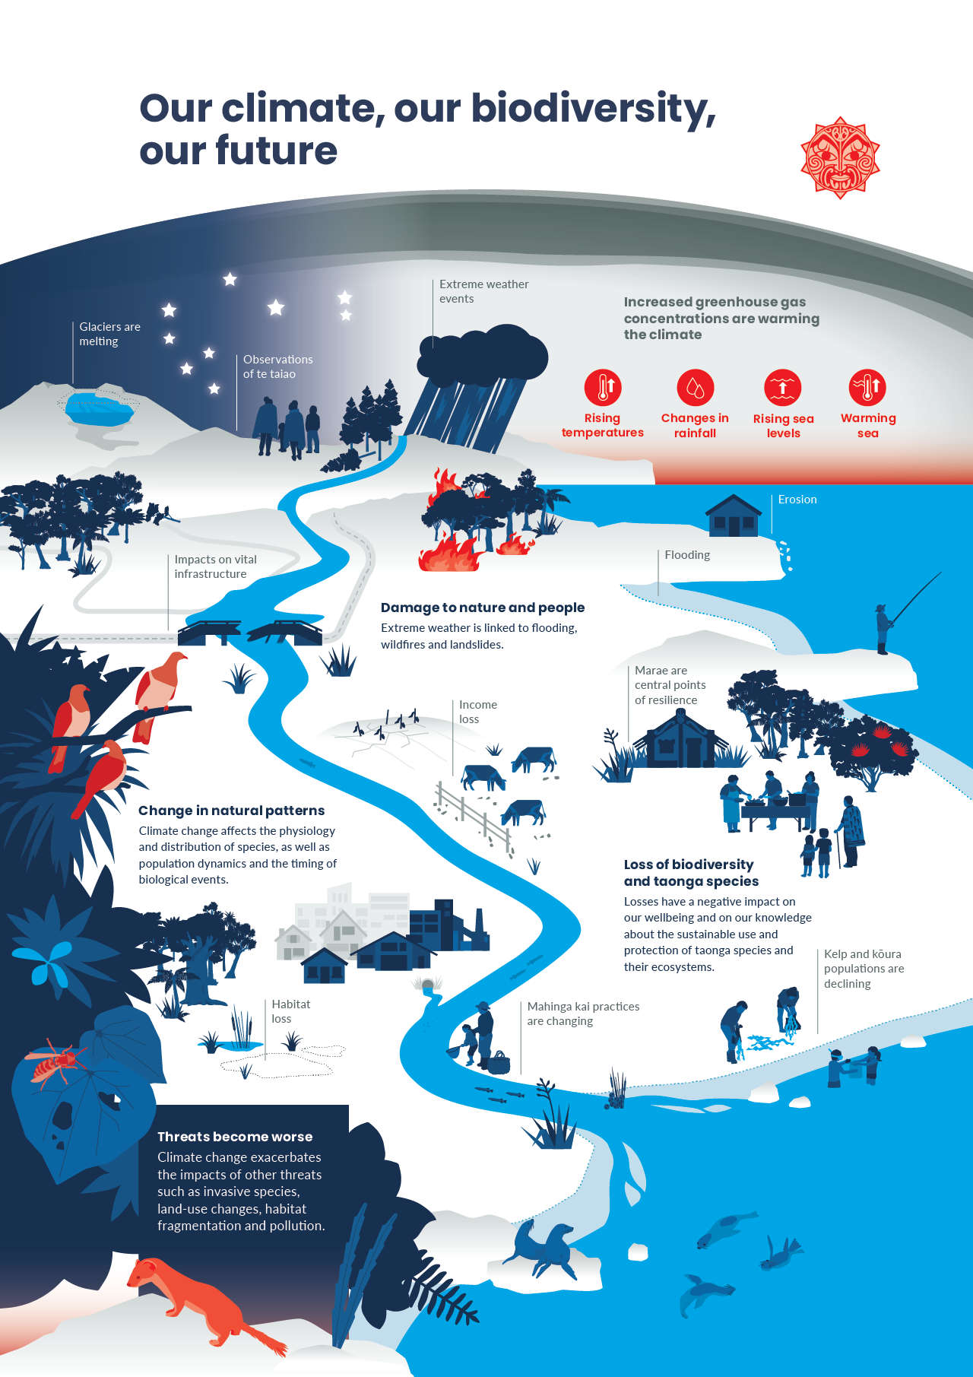

About this report
Our atmosphere and climate 2023 is the latest in a series of environmental reports produced by the Ministry for the Environment and Stats NZ. It is part of the third cycle of reports released under the Environmental Reporting Act 2015 (the Act), following our atmosphere and climate reports in 2017 and 2020.
In 2019 the Parliamentary Commissioner for the Environment (PCE) released a report (PCE, 2019) which identified how the environmental reporting system could be improved and recommended amendments to the Act. Implementation of these changes has started and will provide a stronger foundation to ensure we better understand te taiao and the effects people are having on it.
Our atmosphere and climate 2023 continues the scaled-back format for environmental reports first signalled in Our air 2021. It provides valuable information while we progress the changes needed to improve the reporting system, in line with recommendations from the PCE (PCE, 2019). This is an information-oriented release, with the main focus on updating recent indicators and scientific evidence about our atmosphere and climate.

Report structure
As required by the Act, we use the concepts of pressure, state and impact to report on the environment, and this forms the basis for the report’s structure. The logic of this framework is that pressures cause changes to the state of the environment, and these changes may affect our values. Aligned with the proposed amendments to the Act put forward by the PCE, this report also includes outlooks as part of the framework. Outlooks are a description of how the environment may change in the future. They are assessed based on current data and trends and likely future impacts on the environment and the things we value.
Due to the interconnected nature of the atmosphere and climate with other environmental systems, this report also documents the effects of climate change on biodiversity and ecosystems. It describes the impact of climate change on our public health, wellbeing, culture, economy, infrastructure and recreation. The evaluation of specific policy is out of scope for environmental reporting releases under the Act.
Mātauranga Māori represents a valuable record of our environment that is unique to Aotearoa and is integral to our reports. Our atmosphere and climate 2023 intentionally elevates te ao Māori, mātauranga Māori and promoting connections across knowledge systems. This included the use of te reo Māori and the continued inclusion of Māori concepts and pūrākau (stories) in our report products.
The data used in this report came from many sources including central and local government and Crown research institutes. Further supporting information was provided using a ‘body of evidence’ approach. This body of evidence includes peer reviewed, published literature, as well as mātauranga Māori and observational tools used to identify changes in our atmosphere and climate environment.
All data used in this report, including references to scientific literature, were corroborated and checked for consistency with the original source. The report was produced by a team of analysts and scientists from within and outside of the Ministry for the Environment and Stats NZ. It was also reviewed by a panel of independent scientists. The indicators related to our atmosphere and climate and the date they were last updated are available on the Stats NZ indicators web pages.

Pressures on our atmosphere and climate

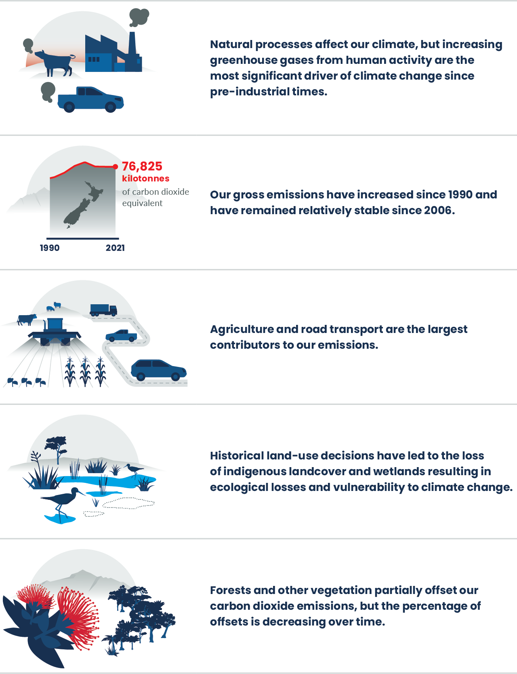

Ngā pēhanga ki te taiao
Pressures on the environment
Greenhouse gas emissions from human activities are accumulating in the atmosphere and are the most significant driver of climate change since pre-industrial times. Natural influences, such as climate oscillations, can also lead to climate fluctuations. However, by increasing the amount of greenhouse gases in the atmosphere, humans are having a profound impact on our climate.
Our domestic greenhouse gas emissions contribute to this global picture. Nearly half of our emissions come from agriculture, mainly methane from farm animals. Our energy sector is the second largest contributor, mainly carbon dioxide resulting from the combustion of fossil fuels for various purposes, like driving, air travel, manufacturing and coal-fired electricity generation. Although a significant portion of our electricity comes from clean, renewable sources, we still supplement it with coal and gas generation. Furthermore, we are heavily reliant on fossil fuels for transportation energy.
Trees and other vegetation partially offset some carbon dioxide emissions, although this is diminishing over time. Historical land-use decisions have led to the loss of indigenous land cover (with over half of the total land area modified for agriculture, forestry and housing) and wetlands (where only around 10 per cent of historic wetlands remain). This loss reduces their capacity to absorb carbon and support nature’s contribution to people, such as promoting ecological processes, mitigating flooding and landslides, and reducing erosion. The removal of this natural infrastructure not only results in ecological losses but also reduces climate resilience. As long as Aotearoa New Zealand’s net emissions (total emissions plus any emissions added or removed by the land use, land-use change and forestry sector) are greater than zero, we are contributing to further climate change.

Pressures on the atmosphere and climate also put pressure on the holistic system that connects landscapes, oceans, ecosystems and people
- A holistic view acknowledges the intrinsic connection between the atmosphere, climate and wider environmental system. It recognises the interdependencies and inter-relatedness of things, including between people and their environment.
- Science supports the view of an interconnected Earth system, with climate, biodiversity and humans interacting across complex networks (Levin, 1998; Marquet et al, 2019; Solé & Levin, 2022).
- A Māori perspective of the natural world recognises that non-human parts of the environment have mauri and are considered tupuna (ancestors) and taonga (treasured), with inherent rights, value and agency (see Te ao Māori, whakapapa, and our connection to atmosphere and climate, for a definition of mauri). When the mauri of the atmosphere and climate is unbalanced, it affects all other systems in te taiao (the environment), including people (Harmsworth & Awatere, 2013; Mead, 2003).
- The holistic and reciprocal connection between Māori and the natural world is formed through shared whakapapa (genealogy). The creation and ongoing balance of the natural world is interconnected through this web of kinship, and responsibility to care is reflected in pūrākau (stories) where these relationships shape connection to the environment (Forster, 2019; Harmsworth & Awatere, 2013).
- In one pūrākau, when humans change the balance established at the beginning with Te Ao Mārama (the world of light) by putting pressure on the atmosphere, Tāwhirimātea and his offspring (the atua that represent changes in meteorology and the atmosphere) protect Ranginui (the Sky Father) and respond by attacking the atua of the ngahere (forest), moana (ocean), and plants and animals with severe weather. These entities are not only considered personifications of the winds, or earth and sky, but also an expression of mauri (see Te ao Māori, whakapapa, and our connection to atmosphere and climate for a definition of atua) (Tunks, 1997).
- Within te ao Māori (Māori worldview), human activities that adversely affect the delicate balance of gases in the atmosphere can have cascading effects. When we put pressure on the atmosphere and climate, we shift the mauri of that part of the ecosystem, in turn putting pressure on all ecosystems including people and communities (Harmsworth et al, 2016; MfE, 2021a).

Our oceans, land and atmosphere are closely connected through
water, heat and carbon
- After their separation, the soft mists of Papatūānuku (Earth mother) rose to greet Ranginui, and the tears from Ranginui took the visible form of rain and dew that fell from the sky to give life to the land (Reed, 2021; Salmond et al, 2019). This recognises the holistic connection of water in the atmosphere, in groundwater and on land.
- Atmospheric circulation affects moisture transport and has a complex connection to precipitation in Aotearoa (Bennet & Kingston, 2022). Storm systems from the tropics can move south towards Aotearoa and evolve from tropical cyclones to take on the properties of mid-latitude storms (Sinclair, 2002).
- Aotearoa, surrounded by the ocean, has mid-latitude prevailing westerly winds. These winds control regional air temperature and moisture, and regulate ocean circulation, heat transport and carbon uptake (Bracegirdle et al, 2020; Goyal et al, 2021).
- Mountains down the length of the North Island and South Island, including the Southern Alps, interact with different air masses and the westerly airflow. This influences weather, climate and precipitation (Cullen et al, 2019; Little et al, 2019; Sturman & Spronken-Smith, 2001).
- Atmospheric rivers are long, narrow regions in the atmosphere that transport significant quantities of water vapour. Precipitation is often observed when atmospheric rivers reach land and interact with topography (Prince et al, 2021; Waliser & Guan, 2017).
- Aotearoa is in a region of high atmospheric river activity with a range of occurrences identified (Little et al, 2019; Prince et al, 2021; Reid et al, 2021; Waliser & Guan, 2017).
- Global oceans have absorbed nearly 25 percent of total human carbon emissions since the start of the industrial revolution (Friedlingstein et al, 2019) and captured 90 percent of the excess heat generated by these emissions (Lindsey & Dahlman, 2023).
- Water vapour is a naturally occurring greenhouse gas in the Earth’s atmosphere that has a strong warming effect, and its atmospheric concentration is closely linked to temperature (IPCC, 2007).

Emissions from human activities put the most pressure on our atmosphere and climate
- Emissions from human activities including agriculture, land use and burning of coal, oil and gas have caused an increase in the concentration of greenhouse gases in the Earth’s atmosphere (IPCC, 2023).
- Carbon dioxide, methane and nitrous oxide are some of the most significant of the greenhouse gases that human activities are emitting, with additional gases, such as hydrofluorocarbons, also causing pressure (Montzka et al, 2011, Prentice et al, 2001).
- Carbon dioxide has the biggest effect on climate warming from human activities. This is because it is emitted in large quantities by many different processes and stays in the atmosphere for a long time (EPA, 2023a, Prentice et al, 2001).
- Methane and nitrous oxide are emitted in smaller quantities but also make up a significant contribution to warming. Methane has far greater heat trapping potential than carbon dioxide but has a relatively short atmospheric lifetime of around 9 years. While methane is short-lived, reducing methane emissions could rapidly reduce the rate of warming in the near term. Nitrous oxide is also a powerful greenhouse gas that remains in the atmosphere for around 120 years (Montzka et al, 2011).
- Other greenhouse gases, like hydrofluorocarbons, are potent, sometimes thousands of times higher than carbon dioxide (EPA, 2023b). These gases are generally short-lived and emitted in much smaller quantities than carbon dioxide, methane and nitrous oxide (Montzka et al, 2011).
- The concentration of a greenhouse gas in the atmosphere depends on the rates of its emission into the atmosphere and the rates of processes that remove it from the atmosphere. Concentrations of some greenhouse gases decrease almost immediately in response to emission reduction, while others can continue to increase for centuries even with reduced emissions (IPCC, 2007).

Our gross emissions have increased between 1990 and 2021, though they have remained relatively stable since 2006
- Aotearoa New Zealand’s share of global greenhouse gases emissions is small, but its gross emissions per person are high. In 2021, our gross greenhouse gas emissions (or total emissions) were 19 percent higher than in 1990. Since peaking in 2006, our gross emissions have been relatively stable despite increases in population and economic activity (MfE, 2023a) (figure 1).
- The two largest contributors to our gross emissions in 2021 were the agriculture sector, at 49 percent, and energy sector (including transport), at 41 percent (MfE, 2023a).
- Methane and nitrous oxide, largely from agricultural sources, made up over half of our gross emissions (43 percent and 10 percent, respectively). The remaining emissions consisted mostly of carbon dioxide (45 percent), mainly from the energy sector and industrial processes and product use (IPPU) sector (MfE, 2023a) (see figure 2).
- The COVID-19 pandemic had an observable effect on our gross emissions in 2020, with a 3 percent reduction on 2019 levels. This reduction was primarily attributed to decreased fuel usage in road transport, manufacturing, construction, and domestic aviation (MfE, 2023a).
Figure 1: Aotearoa New Zealand’s annual greenhouse gas emissions, 1990–2021
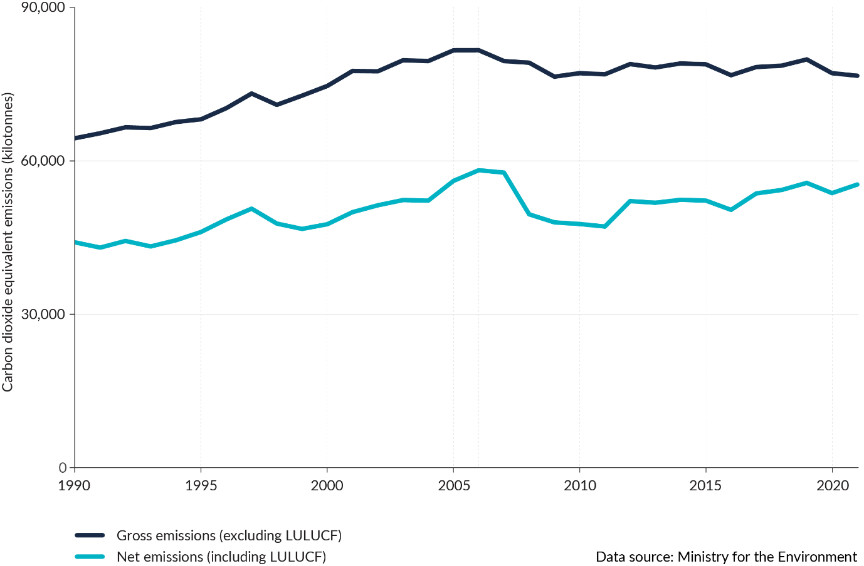
Note: Emissions presented here exclude emissions from Tokelau. LULUCF refers to the land use, land-use change and forestry sector.
- In 2021, gross emissions further declined by 0.7 percent, compared with 2020, largely due to decreases in emissions across the agriculture sector. COVID-19 continued to affect the energy sector in 2021, and emissions from other sectors largely rebounded to pre-pandemic levels (MfE, 2023a).
- Our net emissions (total emissions plus any emissions added or removed by the land use, land-use change and forestry sector) have increased by 25 percent between 1990 and 2021, due to the underlying increase in gross emissions (MfE, 2023a) (figure 2).
Figure 2: Aotearoa New Zealand’s gross greenhouse gas emissions, 2021
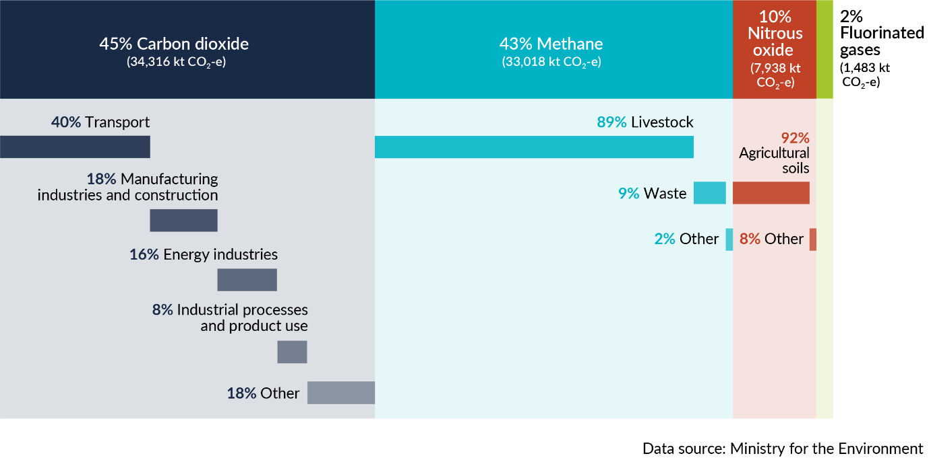
Note: Emissions presented here exclude emissions from Tokelau. CO₂-e = carbon dioxide equivalent.

Most of our methane emissions come from agriculture and are declining weakly due to a decrease in dairy cattle and sheep populations
- The agriculture sector accounts for nearly half (49 percent in 2021) of Aotearoa New Zealand’s gross emissions. Agricultural emissions were up 13 percent from 1990 and down 1 percent from 2018 (MfE, 2023a).
- In 2021, 89 percent of our methane emissions came from livestock (figure 2). Livestock methane emissions were up 6 percent from 1990 and down 1 percent from 2018 (MfE, 2023a).
- Methane emissions from dairy cattle decreased by 2 percent between 2018 and 2021, and emissions from sheep and pigs decreased by 6 percent and 13 percent, respectively (MfE, 2023a) (figure 3).
- In 2021, 92 percent of all nitrous oxide emissions were from agricultural soils (figure 2). These emissions mainly come from the urine and dung of grazing animals and synthetic nitrogen fertiliser, which is converted to nitrous oxide by soil microbes. Nitrous oxide emissions from agricultural soil were up 40 percent from 1990 and down 1 percent from 2018 (MfE, 2023a).
- Agriculture emissions most recently peaked in 2014 after which they have stayed relatively stable (MfE, 2023a). The peak in agriculture emissions coincided with a peak in the national dairy herd (see Indicator: Livestock numbers).
- Waste accounted for 9 percent of our methane emissions in 2021 (figure 2). Since peaking in 2002, emissions from the waste sector have generally decreased due to ongoing improvements in the management of solid waste disposal in landfills and wastewater treatment. Methane emissions from waste were down 5 percent from 2018 (MfE, 2023a).
Figure 3: Aotearoa New Zealand’s gross methane emissions (as carbon dioxide equivalent), 1990–2021
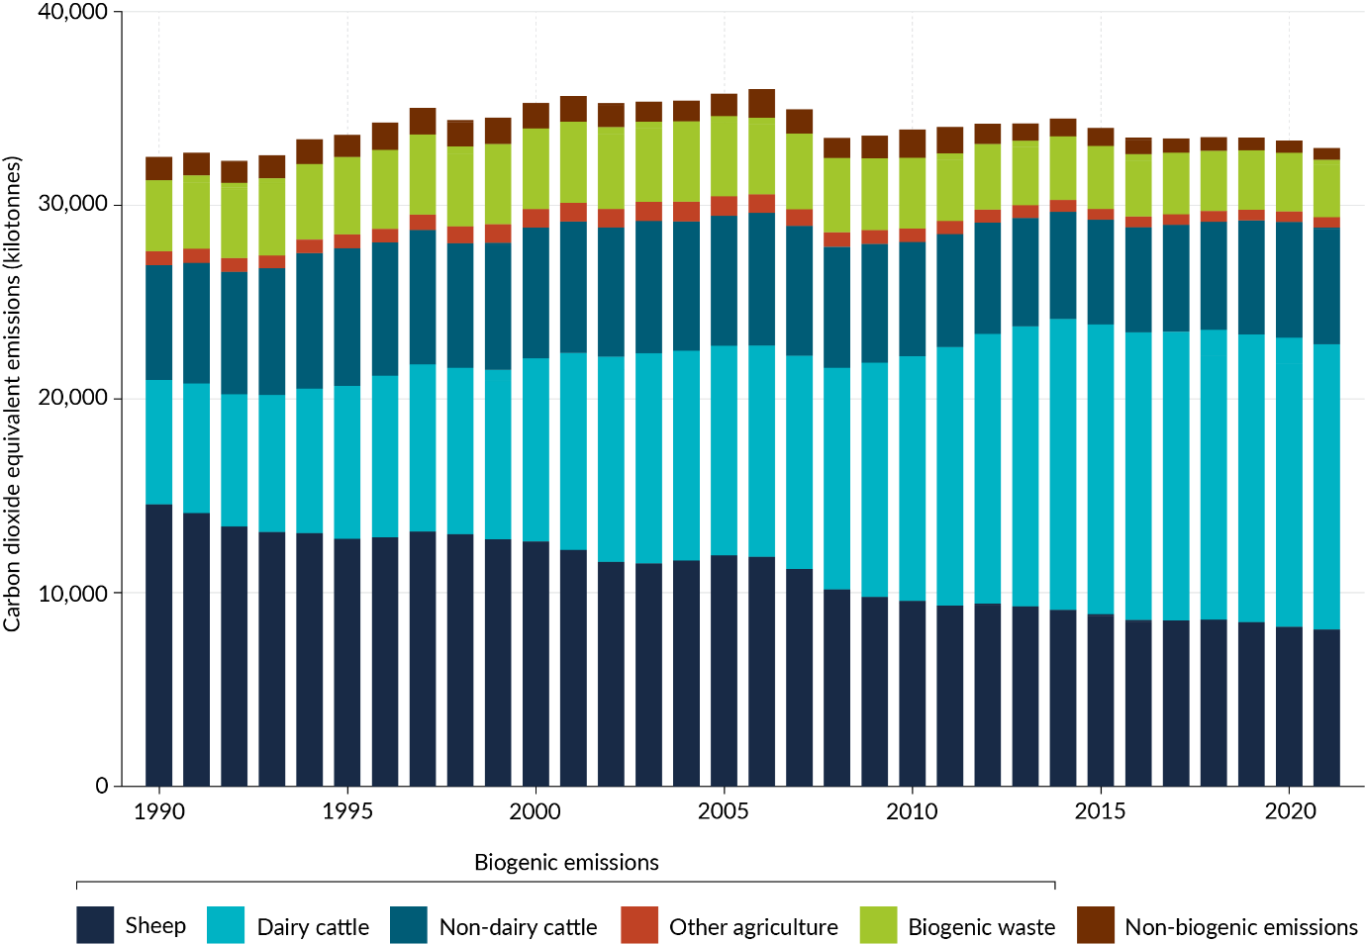
Note: Emissions presented here exclude emissions from Tokelau.

Transport is our largest source of carbon dioxide emissions, with electric vehicles accounting for only a small proportion of our light vehicle fleet
- Aotearoa has one of the highest per capita rates of carbon dioxide emissions from road transport, compared with other developed countries (MfE, 2023a).
- Emissions from road transport accounted for 37 percent of our gross carbon dioxide emissions in 2021. Nearly 64 percent of all transport carbon dioxide emissions are from cars and light-duty trucks (SUVs, utes, vans and light trucks and buses up to 3,500 kilograms) (MfE, 2023a).
- Carbon dioxide emissions from road transport increased by 89 percent between 1990 and 2021. Influenced by the COVID-19 pandemic restrictions, carbon dioxide emissions from road transport decreased by 7 percent between 2018 and 2021 (figure 4). Over the same period, emissions from cars, and heavy-duty trucks and buses were down 12 percent and 2 percent respectively, while emissions from light-duty trucks increased 0.5 percent (MfE, 2023a).
- The number of active electric vehicles (battery electric vehicle or plug-in hybrid electric vehicle) in Aotearoa has been growing rapidly in recent years. The electric vehicle fleet size was 85,593 by August 2023, which almost quadrupled, compared with August 2020. Despite the growing sales of electric vehicles, electric vehicle uptake accounts for only 2 percent of the total light vehicle fleet in Aotearoa in August 2023 (EVDB, 2023).
Figure 4: Aotearoa New Zealand’s gross carbon dioxide emissions, 1990–2021
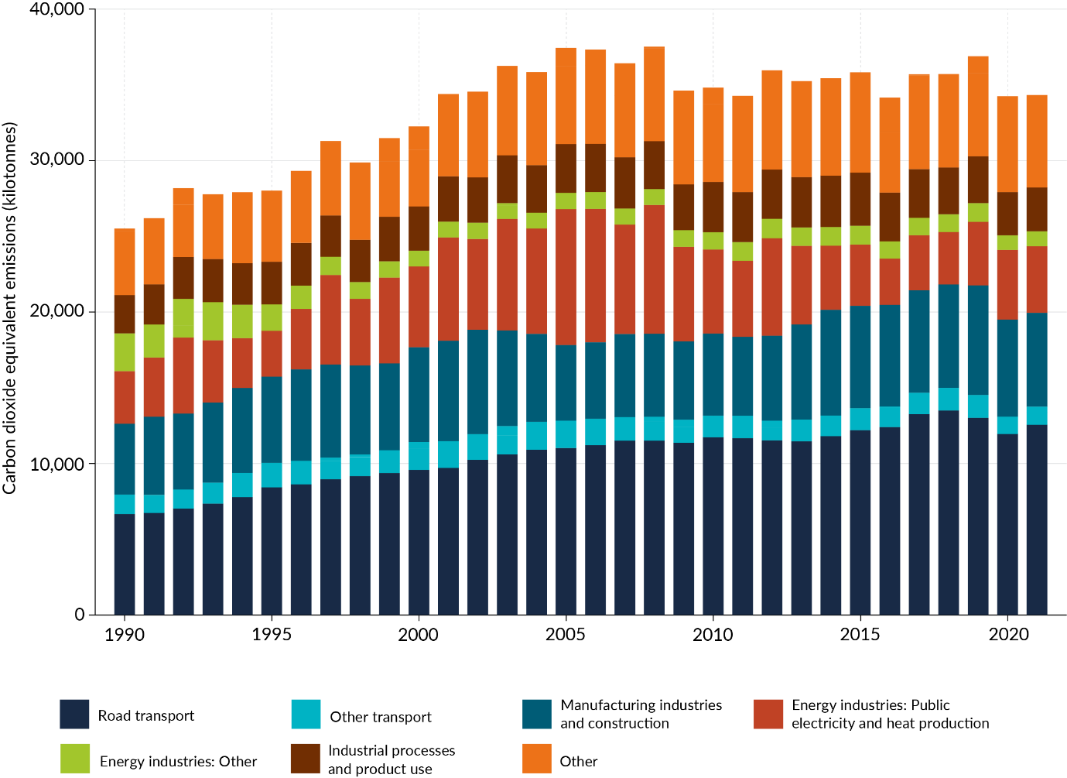
Note: Emissions presented here exclude emissions from Tokelau.

A large proportion of our electricity comes from renewable sources, but we rely heavily on fossil fuels for heat and energy for manufacturing and construction
- The manufacturing industries and construction sector was Aotearoa New Zealand’s next biggest source of gross carbon dioxide after transport, accounting for 18 percent of our gross carbon dioxide emissions in 2021 (MFE, 2023a) (figure 2).
- Carbon dioxide emissions from the manufacturing industries and construction sector were mainly from using fossil fuels to produce heat and energy. Carbon dioxide emissions from the manufacturing industries and construction sector were up 33 percent from 1990 and down 9 percent from 2018 (MfE, 2023a) (figure 4).
- The food processing, beverages and tobacco product subsector made up the largest portion of manufacturing emissions, mainly because fossil fuels are still used in many industrial boilers. In 2021, the subsector produced 8 percent of our gross carbon dioxide emissions. Carbon dioxide emissions from the food processing, beverages and tobacco product subsector were up 68 percent from 1990 and down 8 percent from 2018 (MfE, 2023a).
- Public electricity and heat production accounted for 13 percent of our gross carbon dioxide emissions in 2021. Carbon dioxide emissions from public electricity and heat production were up 26 percent from 1990 and up 27 percent from 2018 (MfE, 2023a).
- In 2021, the share of electricity generated from renewable energy sources in Aotearoa was 82 percent, compared with 81 percent in 1990 (MfE, 2023a). The percentage of Aotearoa New Zealand’s electricity generated from renewable energy sources varies each year, depending on the amount of rainfall and, to a lesser extent, wind. We still supplement electricity generation with coal and gas generation (EECA, 2023).
- The IPPU sector accounted for 8 percent of our gross carbon dioxide emissions in 2021 (figure 2). Carbon dioxide emissions from the IPPU sector were up 15 percent from 1990 and down 6 percent from 2018 (MfE, 2023a).

Carbon dioxide is removed from the atmosphere when plants grow and store carbon, which offsets some, but a decreasing percentage, of our emissions
- Land use, land-use change and forestry offset 27 percent of gross greenhouse gas emissions in 2021 in Aotearoa. This was 4 percent less than 1990, and 12 percent less than 2018 (MfE, 2023a).
- Net removals are variable because of the influence of forest planting and harvesting cycles. Net removals from land use, land-use change and forestry in 2021 were 4 percent more than in 1990, and 12 percent less than 2018, largely due to the increase in the harvest rate of planted forests (MfE, 2023a).
- Before human arrival, more than 80 percent of the land was covered with native forest (see Indicator: Predicted pre-human vegetation). Recently, indigenous land cover area losses have continued. These losses reduce the capacity of our native forests and other vegetation to absorb carbon. Between 2012 and 2018, indigenous land cover area decreased by 12,869 hectares, with Southland having the highest area of net loss (3,944 hectares) (see Indicator: Indigenous land cover).
- Modelling indicates that our forest ecosystems could be absorbing up to 60 percent more carbon dioxide than had been calculated, with much of this uptake likely occurring in native forests (Steinkamp et al, 2017).

Repo (wetlands) have unique biodiversity and are important for carbon storage
- Repo in coastal areas have unique biodiversity, such as saltmarshes, mangroves and seagrasses, which capture and store ‘blue carbon’ through photosynthesis and sediment accumulation (Mcleod et al, 2011; Ross et al, 2023).
- Healthy repo in coastal areas can also stabilise coastlines, purify water through filtering out nutrients and sediments, and increase climate resilience by buffering communities from storm surges and floods (Clarkson et al, 2013; McLeod et al, 2011).
- Globally, many human activities negatively affect repo (land-use change, draining, pollution, sedimentation) (Lotze et al, 2006; Murray et al, 2022). It is estimated around 90 percent of repo in Aotearoa have been lost since pre-human settlement (Dymond et al, 2021).
- When repo in coastal areas are degraded, their plants and soils are washed away, and their organic carbon is exposed to microbial oxidation, which increases greenhouse gas emissions (Lovelock et al, 2017; Pendleton et al, 2012).

Aerosols can have heating and cooling effects on the climate
- Aerosols are small solid or liquid particles in the atmosphere that can come from human and natural sources, including transport, coal fires, sea-salt and volcanoes (Ruiz-Arias et al, 2021; Sakai et al, 2016; Shi et al, 2022).
- Aerosols can absorb or scatter incoming solar radiation and be the seed on which cloud drops and ice crystals can grow. Through these processes, aerosols can influence the weather and climate (Hamilton, 2015; Ruiz-Arias et al, 2021; Spada et al, 2015).
- Black carbon strongly absorbs sunlight due to its dark colour and has localised warming effects in Aotearoa. It mostly comes from vehicles, domestic fires and wildfires (Bond et al, 2013; Lee et al, 2022).
- No inventory exists for black carbon emissions in Aotearoa, though nitrogen dioxide emissions can be used as a proxy for these (see Our air 2021). Over 2011 to 2020, nitrogen dioxide trends were improving at 6 out of 7 sites, and indeterminate at one site (see Indicator: Nitrogen dioxide concentrations).
- Wildfires and dust storms in Australia produce dust aerosols that can be transported to Aotearoa and have the potential to influence our climate (Brahney et al, 2019; Nguyen et al, 2019).

Global efforts to reduce the use of ozone depleting substances have seen the hole in the ozone layer reduce, but some substitutes are potent greenhouse gases
- The ozone layer stops potentially harmful ultraviolet radiation reaching the Earth’s surface, but damage to the ozone layer was discovered over Antarctica in the 1980s.
- The Montreal Protocol was established in 1987 to reduce the production of ozone depleting substances, which are human-made chemicals that destroy the ozone layer. Aotearoa does not manufacture any of the substances controlled under the protocol (MfE, 2021b).
- Methyl bromide is an ozone depleting substance that is notably still used in Aotearoa to fumigate logs for export, however, the Government is working with importing countries on accepting alternative treatments for logs.
- The size of the ozone hole naturally varies from year to year but is on track to recover, and in 2019, was at its smallest since 2002 (WMO, 2022).
- The annual average thickness of the ozone column decreased between 1979 and 2022. The average over this period was slightly thicker than the global average (see Indicator: Atmospheric ozone) (Liley & McKenzie, 2006).
- Hydrofluorocarbons and perfluorocarbons are potent greenhouse gases often used as substitutes for ozone depleting substances. Hydrofluorocarbon emissions accounted for 32 percent of the IPPU sector in 2021 and were up 8 percent since 2018 (MfE, 2023a). Hydrofluorocarbons and related compounds are being phased down under the Kigali Amendment to the Montreal Protocol (MfE, 2019).

State of our atmosphere and climate

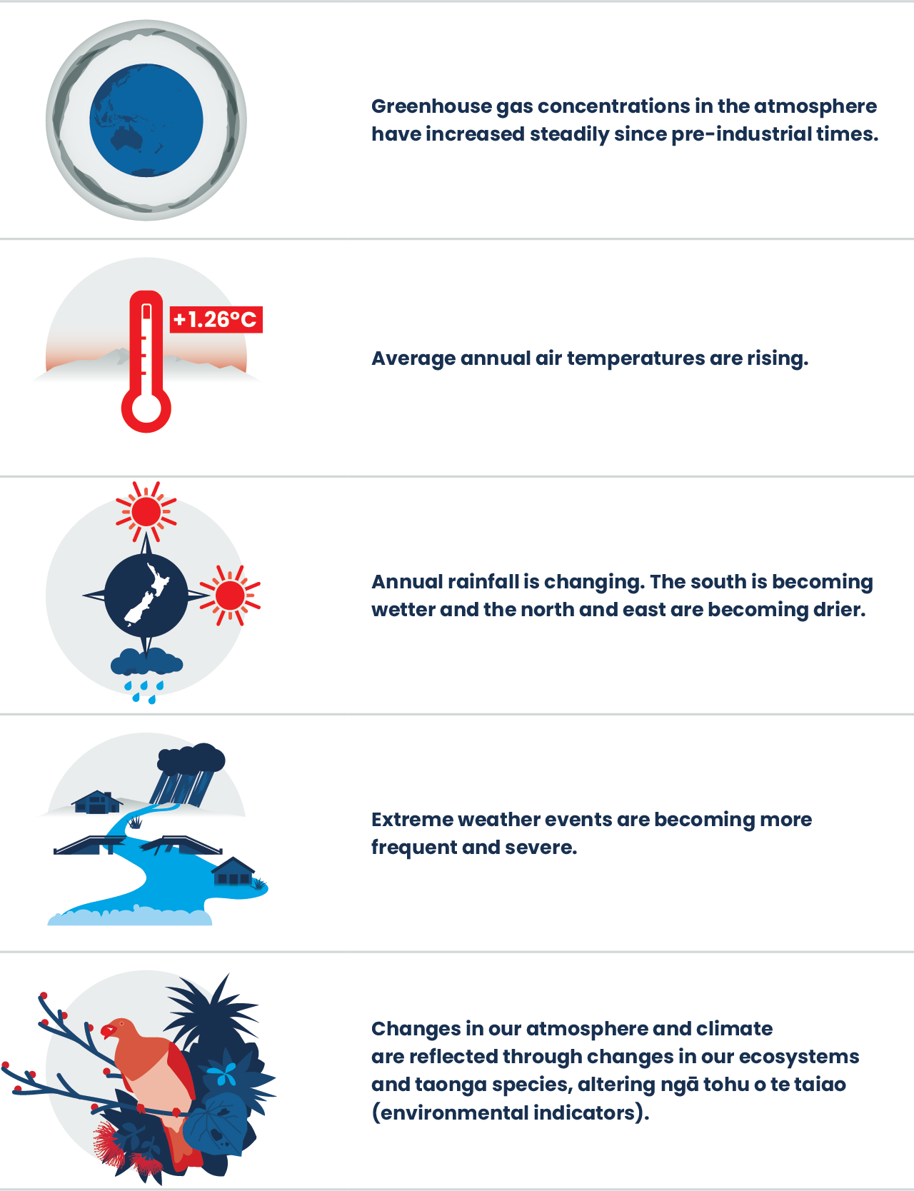

Whakarongo ki te taiao
Listen to the environment
Climate change is becoming increasingly evident in Aotearoa New Zealand. Our average and extreme temperatures have increased since pre-industrial times. The growing season has lengthened, and the number of frost days has decreased in most parts of the country. Annual rainfall is changing in most places in Aotearoa, with the south of Aotearoa becoming wetter and the north and east becoming drier. Medium-term droughts are becoming more frequent.
Extreme weather events, such as those leading to floods and slips in Tairāwhiti and Auckland, storms in Westport and Nelson, and droughts across the country, are becoming both more frequent and severe. Concern is increasing that changes in the frequency of events will lead to a higher risk of multiple severe weather events that overlap in time and/or space.
Gradual changes, such as increasing temperatures, may not be as noticeable in our day-to-day life, but can cause cascading effects through the environment and lead to irreversible changes. These changes in our atmosphere and climate are evident and reflected through changes in our ecosystems and taonga (treasured) species, altering ngā tohu o te taiao, or environmental indicators.

Changing state of our atmosphere and climate can be observed through changes in ngā tohu o te taiao
- Many Māori traditions of monitoring weather patterns and extreme events through oral communication are thought to provide insights into long-term climate trends, identify shifts in observations and warn of dangers related to climate change (King et al, 2007).
- Different winds and cloud formations can be indicators for short term weather patterns, incoming storms, fishing conditions and harvesting times. Iwi who travelled extensively on waka (canoe) relied on this specific knowledge of clouds and winds to forecast safe travel and fishing practices, adapting and maintaining resilience in the face of global change, including climate change (King & Skipper, 2006; King et al, 2007).
- Through observing the environment closely over time, Māori developed a deep knowledge of location-specific environmental indicators, or tohu, which help to monitor and forecast trends in te taiao (Harcourt & Awatere, 2022; King et al, 2005).
- Tohu are passed down generations through different forms, including pūrākau (stories) and whakatauākī (proverbs) (Harcourt & Awatere, 2022).
- Weather and climate variability and extremes can be monitored through tohu (environmental indicators), for example, behaviour of birds and blooming of flowers. The use of tohu reflects connection through whakapapa (genealogy) and the dependencies that exist throughout the atmosphere and wider environment (King et al, 2005).
- The timing of tohu is changing. Warming sea temperatures have changed the times when kina (sea urchins) are fat and ready for gathering, and this is no longer in sync with the traditional summer blooming of the pōhutukawa (see Our marine environment 2019 and Our atmosphere and climate 2020).
- The maramataka helps to monitor the weather, seasonal changes and migratory patterns of birds and fish (see Te ao Māori, whakapapa and our connection to atmosphere and climate for a definition of the maramataka) (Harris et al, 2013).
- Many hapū and iwi have developed their own rohe-specific maramataka through centuries of detailed observations. These observations can be used to track appropriate times for harvesting and planting crops, hunting and fishing, and gathering kai moana (seafood) (Harris et al, 2013).

Atmospheric concentrations of greenhouse gases have increased substantially since pre-industrial times and have continued to increase in recent years
- In 2019, global atmospheric carbon dioxide concentrations (410 parts per million (ppm)) were higher than at any time in at least 2 million years (IPCC, 2021).
- The highest atmospheric carbon dioxide concentration observed between 1972 to 2022 was 415.5 ppm in August 2022, which is up 6 percent since 2012 and around 48 percent higher than pre-industrial levels of 280 ppm (see Indicator: Greenhouse gas concentrations) (Ciais et al, 2013).
- The highest atmospheric methane concentration observed over 1989 to 2022 was 1881.4 parts per billion (ppb) in October 2022, which is around 169 percent higher than pre-industrial levels (see Indicator: Greenhouse gas concentrations) (Ciais et al, 2013).
- The highest atmospheric nitrous oxide concentration observed between 1996 to 2022 was 335.5 ppb in December 2022, which is around 24 percent higher than pre-industrial levels (see Indicator: Greenhouse gas concentrations) (Ciais et al, 2013).

Long-term annual average temperatures are rising in Aotearoa, with increasing temperatures across all seasons in most places
- Annual average temperature in Aotearoa has increased by 1.26 (± 0.27) degrees Celsius between 1909 and 2022 (114 years), with 8 of the 10 warmest years on record in the past decade (figure 5) (see Indicator: Temperature).
- From 1972 to 2022, when seasonal data are available, trends were increasing for 25 of 30 sites in spring, 28 sites in summer, 28 sites in autumn and 30 sites in winter.
- Trends in warm days increased at 25 sites, decreased at 3 sites (Taumarunui, Milford Sound and Dunedin) and were indeterminate at 2 sites (see Indicator: Temperature). A warm day occurs when the daily maximum temperature is above 25 degrees Celsius.
- Data from 30 of NIWA’s climate stations across Aotearoa support many of the environmental indicators by Stats NZ presented in this report (see appendix A, for more information on sites and trends).
- The hottest days of the year have increased by over 0.5 degrees Celsius during the past 20 years across many populated areas of Aotearoa (Harrington & Frame, 2022).
Figure 5: Aotearoa New Zealand’s annual average temperature anomaly, 1909–2022
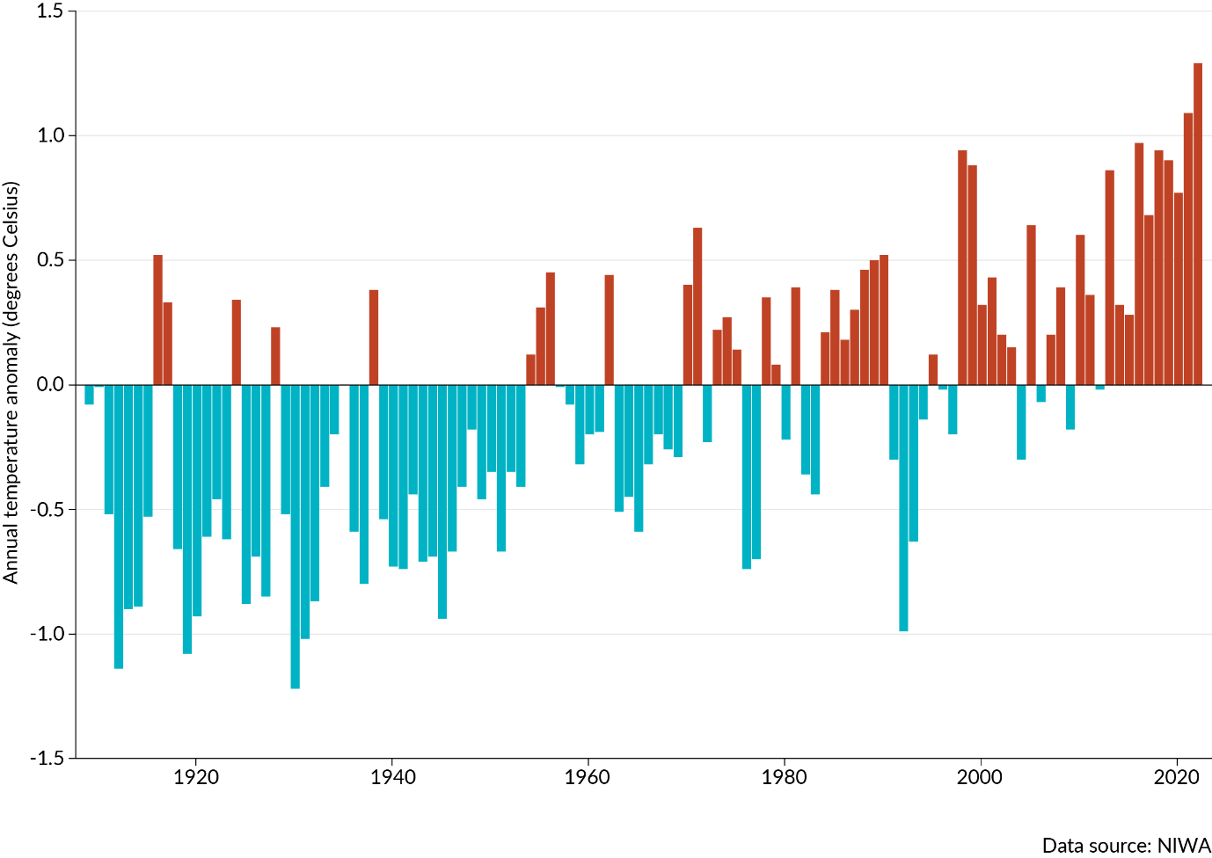
Note: The baseline for temperature anomalies is the average annual temperature for the 30 years from 1961 to 1990.

Growing seasons are lengthening and frost days are declining in most places in Aotearoa, changing ngā tohu o te taiao
- Trends in the number of frost days decreased at 20 of 27 sites, increased at 5 sites and were indeterminate at 2 sites, between 1972 and 2022. A frost day occurs when the daily minimum air temperature is below zero degrees Celsius, as measured 1.2 metres above the ground (rather than a day that has frost on the ground) (see Indicator: Frost and growing degree days).
- The observation of hukapapa, or severe frosts, can be used as an indicator for many Māori customary practices. Cold weather and frosts can indicate a good year ahead for the kererū (New Zealand pigeon) and tree production (Lyver et al, 2009).
- Some insect pests and certain plants (including invasive species) benefit from fewer frost days, while other plants rely on frosts for triggering processes like blossoming in fruit trees (Lyver et al, 2009, McGlone & Walker, 2011).
- Trends in the number of growing degree days increased at 29 sites, and one site had an indeterminate trend (Lake Tekapo) between 1972 and 2022 (see Indicators: Frost and growing degree days).
- Growing degree days is a measure that can be used to estimate the length of the growing season for agriculture and horticulture. The measure counts the total number of degrees Celsius that the average temperature is above a base temperature (commonly 10 degrees Celsius) each day.
- Growing degree days indicate the amount of warmth available for plant and insect growth and can be used to predict when flowers will bloom and crops and insects will mature. While some plants and animals may benefit from more growing degree days, it can also mean more water and heat stress and longer pollen and pest seasons.

Annual rainfall is changing in most places in Aotearoa, with the south becoming wetter and the north and east becoming drier
- Annual rainfall across 30 sites increased at 15 sites and decreased at 8 between 1960 and 2022. Seven sites had indeterminate trends (see Indicator: Rainfall).
- Annual rainfall increased at many sites in the southern South Island. Of the sites where rainfall decreased, many were in the northern half of the North Island (figure 6).
Figure 6: Average annual rainfall trends, 1960–2022
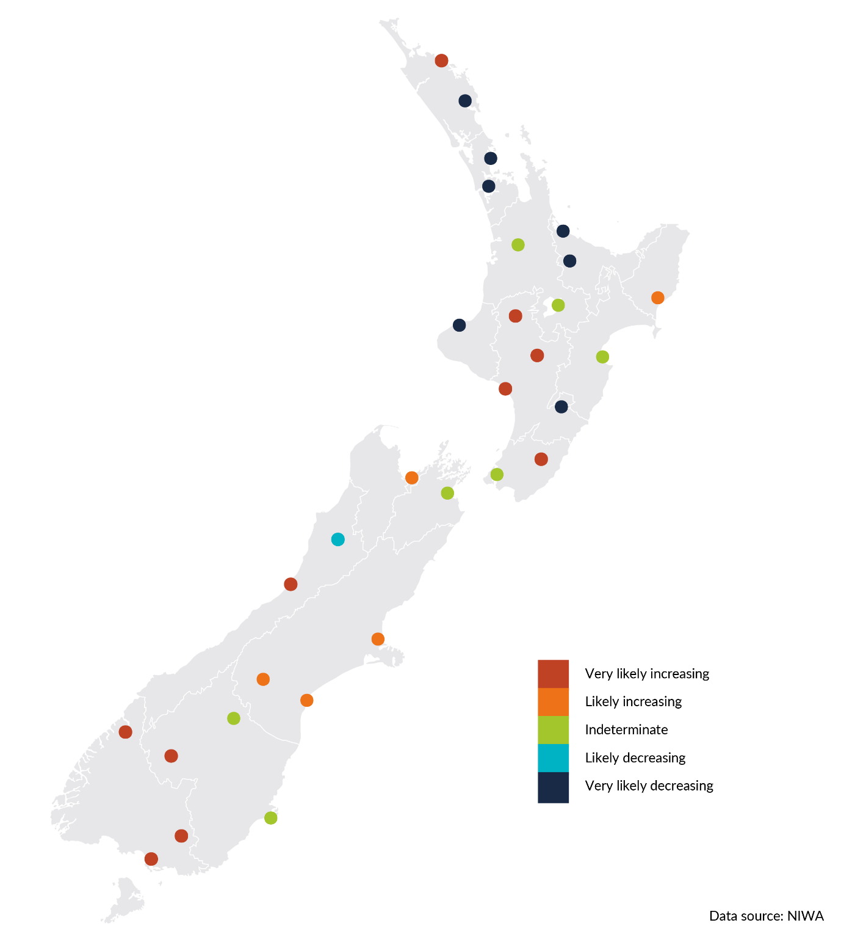

Extreme rainfall is changing in most places in Aotearoa, with spatial patterns somewhat similar to annual average rainfall trends
- Annual maximum one-day rainfall amounts decreased at 10 sites, 7 of which were in the upper half of the North Island. Annual maximum one-day rainfall increased at 12 sites, and 8 sites had indeterminate trends (figure 7) (see Indicator: Extreme rainfall and appendix A, for a definition of extreme rainfall).
- The percentage of annual rainfall from very wet days decreased at 8 sites and increased at 14. Eight sites had indeterminate trends.
- Most sites with increasing rainfall trends also had increasing trends in annual maximum one-day rainfall amounts. Most sites with decreasing rainfall trends also had decreasing trends in annual maximum one-day rainfall amounts (see Indicator: Extreme rainfall).
- Extreme rainfall measures the percentage of annual rainfall from very wet days, which are defined as days where rainfall exceeds the 95th percentile of daily rainfall totals (see appendix A).
Figure 7: Annual maximum one-day rainfall trends, 1960–2022
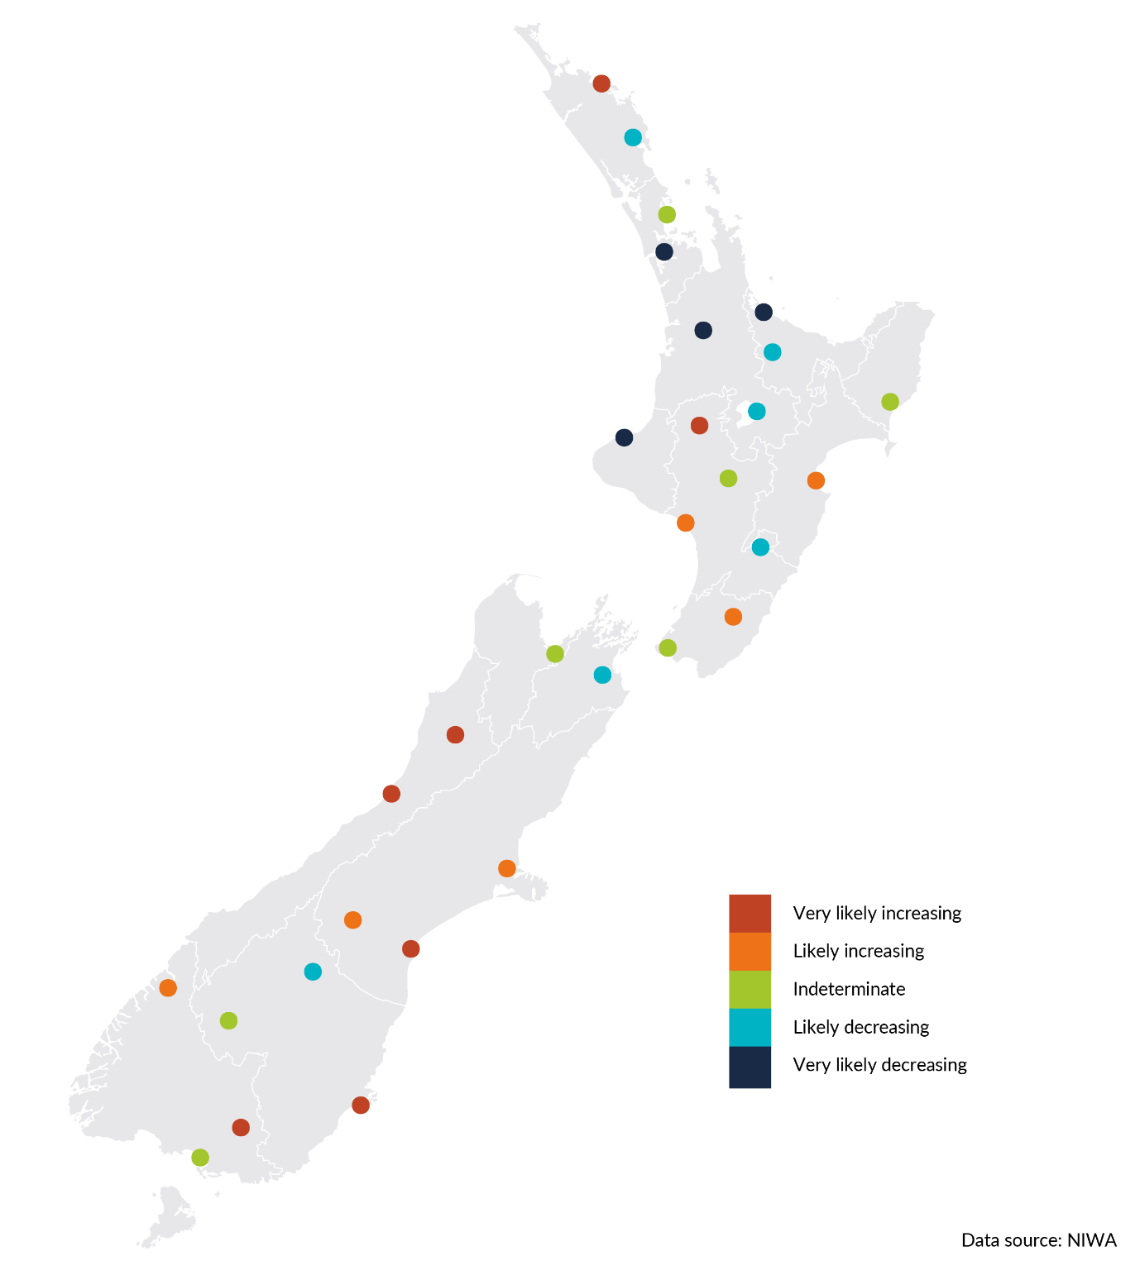

Frequency of medium-term (agricultural) drought is increasing in many places in Aotearoa
- A drought is a prolonged and marked shortage of moisture compared with what is expected. Drought is mainly caused by a lack of rain, but high temperatures and strong winds can contribute because they accelerate evaporation and water loss from soil, vegetation and waterways (see appendix A, for the method used to characterise drought).
- Trends in frequency of agricultural drought events (medium-term; across six months) are increasing at half of the total sites. Agricultural drought frequency increased at 15 sites and decreased at 6, while 9 sites had indeterminate trends (figure 8) (see appendix A, for more data on short- and long-term droughts, see Indicator: Drought).
- Trends in drought intensity are indeterminate at a majority of sites, though more sites showed decreasing rather than increasing trends across agricultural drought events. Agricultural drought intensity increased at 5 sites and decreased at 9, while 16 sites had indeterminate trends.
- Of 30 sites, 19 had extreme dryness from 1972 to 2022. Twenty sites spent at least 25 percent of the time in medium-term drought, with Dannevirke spending the most time in a drought event (56 percent of the time) (see Indicator: Drought).
Figure 8: Frequency trends for medium-term droughts, 1972–2022
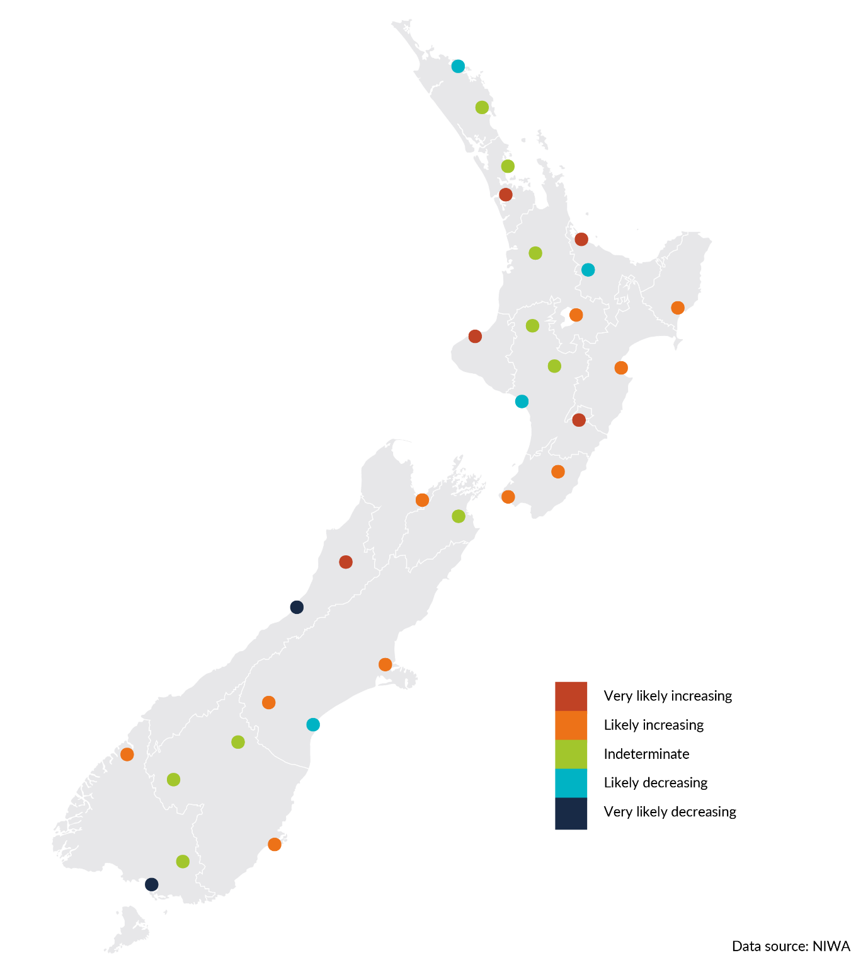

El Niño Southern Oscillation and Southern Annular Mode influence natural climate variability in Aotearoa
- Natural patterns of change (oscillations) influence the weather and climate in Aotearoa, including the El Niño Southern Oscillation (ENSO), Interdecadal Pacific Oscillation (IPO) and Southern Annular Mode (SAM) (see Indicators: ENSO, IPO, SAM).
- El Niño is a warm-water equatorial current across the Pacific Ocean that is associated with a fluctuation of a global-scale tropical and subtropical surface pressure pattern called the Southern Oscillation. This, coupled with atmospheric-ocean phenomenon, is known as ENSO. It influences global and national rainfall, temperature and wind patterns, and has three phases: neutral, El Niño and La Niña (NIWA, nd-a).
- In Aotearoa an El Niño phase in summer can bring increased westerly winds, more rain in the west and dryness in the east; in winter it can lead to more frequent, cooler southerly winds. During a La Niña phase, we may experience more north-easterly winds, wetter conditions in the north and east, and higher sea levels. We can also experience warmer than average air and sea temperatures.
- The most recent El Niño phase was from July 2015 to April 2016. This was one of the two strongest El Niño phases during 1990 to 2022, with the other occurring during 1997 to 1998. The most recent La Niña phase was from April 2022 to December 2022 (see Indicator: El Niño Southern Oscillation).
- The frequency and intensity of El Niño events between 1951 and 2000 were high relative to 1901 to 1950, but this does not necessarily reflect a long-term trend. The link between climate change and ENSO is still uncertain (Gulev et al, 2021).
- SAM is associated with the strength and position of westerly winds and storm tracks. Evidence indicates the positive trend of SAM over recent decades is an indirect response to ozone depletion and climate change (Goyal et al, 2021; King et al, 2023; Morgenstern, 2021).

Extreme winds are decreasing at most sites in Aotearoa, which may be due to a positive Southern Annular Mode phase
- Trends in annual average of the daily maximum wind gust decreased at 14 sites and increased at 3 sites (Gisborne, New Plymouth and Queenstown).
- Trends in annual maximum wind gust decreased at 12 sites, increased at 3 sites (Gisborne, New Plymouth and Queenstown) and were indeterminate at 2 sites (figure 9).
- Extreme wind measures the annual average of the daily maximum wind gust (a measure of windiness) and annual maximum wind gust (a measure of wind strength). Seventeen sites around the country had sufficient data between 1980 and 2022 to allow trends to be determined.
- The recent declines in extreme wind magnitude and frequency are likely to be related to SAM more often being in a positive phase that moves storm tracks further south (NIWA, nd-b; Thompson et al, 2011).
Figure 9: Annual maximum wind gust trends, 1980–2022
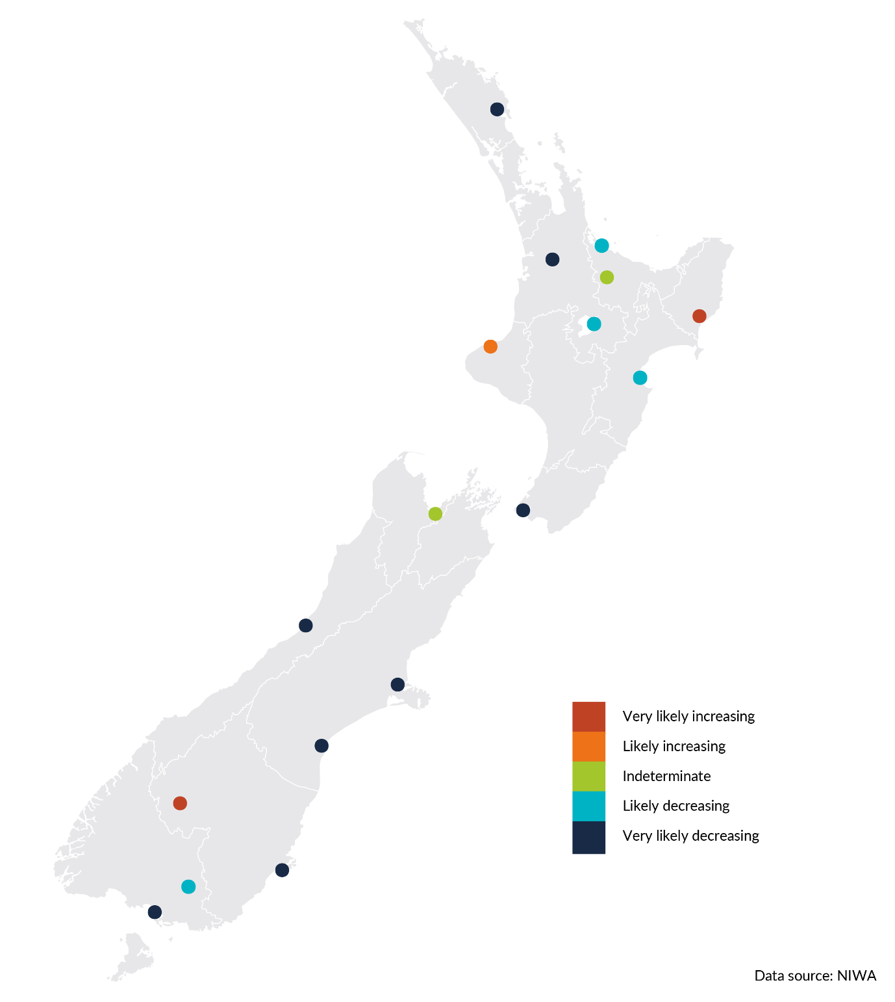

Extreme weather events are becoming more frequent and intense
with climate change
- A body of local evidence and research is growing that shows the intensity and/or frequency of extreme weather events we experience in Aotearoa is increasing with climate change (Harrington & Frame, 2022; Harrington & Renwick, 2014; Salinger et al, 2019; Thomas et al, 2023).
- The frequency of tropical cyclones is slightly decreasing over the South Pacific basin, but the cyclones that do form are more severe (Chand et al, 2022; NIWA, 2017; Roberts et al, 2020).
- We have recently seen multiple severe weather events that overlap in time and/or space. One example is the atmospheric river that delivered an unprecedented amount of rainfall to Auckland in January 2023, closely followed by the effect of Cyclone Gabrielle across much of the North Island in February 2023 (Macinnis-Ng et al, 2023).
- Nine of the ten most damaging floods in Aotearoa between 2007 and 2017 occurred during atmospheric river events (Reid et al, 2021). Evidence indicates that, in mountain areas and in northern Aotearoa, much of the rainfall total as well as extreme rainfall events could be related to atmospheric rivers, although with seasonal variation (Shu et al, 2021). In 2021, extreme rainfall events that caused flooding in Canterbury were 10 percent to 15 percent more intense because of climate change. Similarly, extreme weather, and associated flooding, on the West Coast in 2021 were nearly 10 percent more intense due to climate change (MfE, 2023b).
- Floods are some of Aotearoa New Zealand’s most frequent and damaging natural hazards (Frame et al, 2020; Officials Committee for Domestic and External Security Coordination, 2007). Floods are most commonly caused by heavy and/or prolonged rainfall but can be mitigated by other factors such as land use and infrastructure (Auliagisni et al, 2022).
- The frequency of extreme temperature events in Aotearoa has doubled due to human influence (Thomas et al, 2023).
- Wildfire risk is changing in Aotearoa, the number of days with very high and extreme fire danger increased at 12 sites and decreased at 8 of the 28 monitoring sites between 1997 and 2019 (see Indicator: Wildfire risk). Comparison of fire risk is complicated due to the difference in fuel type used for analysis between sites (see appendix A).
- Between 1 July 2020 and 27 June 2021, 4,586 fires burnt an area of 13,348 hectares (larger than the area of Hamilton), surpassing the 5-year and 10-year averages for the number of wildfires and area burnt (FENZ, 2022c).
- In 2022, the Awarua Wetland Ramsar site in Southland and Kaimaumau–Motutangi in Northland were significantly affected by wildfire (FENZ, 2022a, 2022b).

Impacts on biodiversity,
and our cultural, social and economic wellbeing

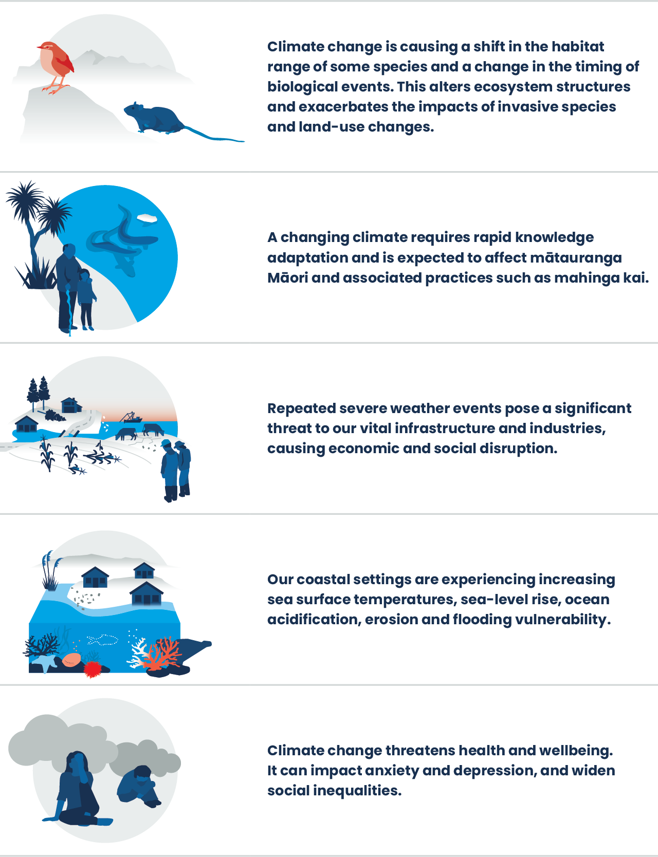
Ka ora te taiao, ka ora te tāngata
Healthy environment, healthy people
The interconnected nature of the environment means the impacts of our changing climate are cascading through ecosystems, compounding other pressures from human activities including past land use choices, habitat fragmentation and pollution. These compounding pressures are affecting our biodiversity and species ranges and disturbing ecosystem structures, as well as exacerbating the risk of other threats such as invasive species. Heat extremes have driven local extinctions of species, along with mass mortality on land and in the ocean. Biodiversity loss threatens the ability of our ecosystems to absorb carbon and limits their ability to provide protection and resilience against the impacts of climate change.
Climate change is also having widespread effects on humans and our communities and society. In some situations, climate change is increasing risks to our safety and security or exacerbating existing vulnerabilities. Climate-related risks are already affecting the financial system and broader Aotearoa New Zealand economy. Two-thirds of New Zealanders live in areas prone to flooding and rising sea levels. Food insecurity, loss of livelihoods and uncertainty around climate change have ongoing effects on mental health. Changing seasons affect mātauranga Māori (Māori knowledge) and many important Māori practices including the transfer of mātauranga Māori across generations. Māori practices, such as mahinga kai (traditional food gathering practices) and rongoā (healing), need to adapt to the changing availability of species and loss of taonga (treasured) species.

Climate change is already affecting sea levels, ocean temperatures,
ocean acidity, glacial ice melt and freshwater flows
- Climate influences the landscape of Aotearoa: our coasts, river valleys and mountains. It affects the distribution of plants and animals, and the way species interact with one another in their environment, which together form our ecosystems. Changes in our climate are affecting our marine, freshwater and land environments.
- Our oceans are warming, rising and becoming more acidic (see Our marine environment 2022 and Indicators: Ocean acidification and Coastal sea-level rise). Sea surface temperature increased between 0.1 degrees Celsius and 0.2 degrees Celsius per decade across our four oceanic regions between 1981 and 2018 (see Indicator: Sea surface temperature).
- Annual mean coastal sea levels rose faster (relative to land) between 1961 and 2020 than between 1901 and 1960 at all four longer term monitoring sites around Aotearoa (see Indicator: Coastal sea-level rise and Our marine environment 2022).
- Our glaciers are melting. Their volume has decreased by 35 percent and the rate of annual loss increased between 1978 and 2020 (see Indicator: Annual glacier ice volumes).
- Between 1969 and 2019, winter streamflow increased in the western South Island and significantly decreased in the northern North Island; summer streamflow has significantly decreased for most of the North Island. These changes may be influenced by both natural climate variations and anthropogenic climate change (Queen et al, 2023).
- Climate change exacerbates some land degradation processes, such as landslides and erosion, which increases sediment reaching downstream, including coastal and marine environments (Neverman et al, 2023; Smith et al, 2023).

Changes in our climate are causing shifts in the habitat ranges of species and ecosystem structures
- Rising sea surface temperatures can reduce the abundance of marine food or seabirds’ ability to access it. Population declines in seabirds have been attributed to this, such as tarāpunga (red-billed gulls), hoiho (yellow-eyed penguins) and kororā (blue penguin) (Mills et al, 2008; Salinger et al, 2023).
- Changing ocean currents and rising sea levels have led to a loss of nesting sites for various shorebirds, and declining populations of tītī (sooty shearwater or muttonbird) have been observed (Keegan et al, 2022). The quality and health of tītī were noticed to decline substantially in cycles aligned with the El Niño Southern Oscillation (McKechnie et al, 2020; Scott et al, 2008).
- Ocean acidification is changing calcification rates, making it difficult for species such as molluscs, crustaceans and corals to grow and maintain their calcium-based shells and skeletons (Anderson et al, 2022; Law et al, 2018).
- Habitat shift can occur across the wider environment (McGlone & Walker, 2011; Salinger et al, 2019). For example, some stream invertebrate communities are shifting their range towards higher latitudes, in response to climate and environmental changes (Mouton et al, 2020, 2022).
- Some species, already threatened with extinction, are highly vulnerable to climate change, including īnanga (whitebait) and kākahi (freshwater mussel) (Egan et al, 2020).
- Thermal squeeze is a particular risk for species with limited ability to move into new areas such as kiwi, whio (blue duck) and North Island kōkako (Walker et al, 2019).
- Warmer soil poses a problem for some species, including tuatara, which leads to an increase of male offspring, potentially leading to population decline as reproductive output decreases (Mitchell et al, 2006).
- Range expansion of invasive species can put additional pressure on native biodiversity. Rats and mice advance to higher altitudes in mountain areas and prey on species previously out of their reach like pīwauwau (rock wren) (Willkinson & Parsons, 2020).

Impacts of climate change are cascading through ecosystems and compounding other threats such as invasive species and human disturbances
- Heat extremes can lead to mass mortality and local extinction, favouring the spread of invasive species. The 2017–18 marine heatwave led to significant loss of rimurapa (bull kelp, Durvillaea). At locations where the kelp was completely lost, an invasive, non-native kelp took its place. This coincided with a dramatic decrease in kākahi (Awatere et al, 2021; Thomsen et al, 2019).
- Warmer sea temperatures and ocean acidification can intensify kina (sea urchins) overpopulation by affecting the lifecycle, reproduction and recruitment of kina predators, such as kōura (freshwater crayfish) and tāmure (snapper), which are already in decline from overfishing and other human activities (Gee, 2021; Heeringa, 2021).
- Changes in the timing of seasonal events can have large ramifications for the health of ecosystems. The frequency of natural events, such as masting (the intermittent and synchronous production of large seed crops) in forest and alpine environments, has been linked to changes in temperature (Barron et al, 2016; Kelly et al, 2013; Monks et al, 2016). Beech mast can lead to an outbreak of pests, such as rats, mice and stoats, which poses an increased threat to native forest birds and long-tailed bats (King, 1983; O’Donnell et al, 2017).
- Shifts in the timing and severity of frosts, along with a reduction in snowfall, can disrupt plant–insect pollinator interactions, affecting plant species and ecosystem functions (McGlone & Walker, 2011; Renwick et al, 2016). For example, warm temperatures and drought promote excessive honeydew production in mountain beech and kāmahi forests, which can lead to increases in platypus beetle and subsequent damage to mature trees that can transform forest structure (Awatere et al, 2021; Wardle, 1984).
- Droughts can threaten the survival of iconic species such as the critically threatened kōwaro (Canterbury mudfish) (Meijer et al, 2019) and our endemic kiwi, which find it difficult to extract food from hardened soils (Boffa Miskell, 2020). Droughts can also influence carbon cycling (Macinnis-Ng & Schwendenmann, 2015) and cause the death of trees in all types of forest (Wyse et al, 2013, 2018).
- Shifts in the timing of seasons can affect the life cycle of invasive species, leading to impacts on native species. Climate warming causes a change in flowering time of an invasive plant (heather, Calluna vulgaris) in alpine areas, causing an increased overlap with a native species (monoao, Dracophyllum subulatum). This increases competition for pollinators and causes a decline in reproductive output of the native species, potentially leading to its decline (Giejsztowt et al, 2020).
- Habitat loss and climate change interact to exacerbate population declines. For example, brown mudfish (Neochanna apoda) live in tip-up pools created when large trees fall, however, the combined impacts of reduced numbers of large trees due to logging and reduction in water availability due to droughts can cause population decline (Macinnis-Ng et al, 2021).

Extreme weather events have direct and damaging impacts on our ecosystems, as well as people
- The concurrent air–marine heatwaves in 2017–18 and 2021–22 caused migrations of northern warm-water fishes, early harvest of summer fruit, unprecedented levels of bleaching and necrosis of Aotearoa sponges, mass mortality of kororā in the Bay of Plenty and widespread loss of large habitat-forming intertidal southern rimurapa (Bell et al, 2023; Salinger et al, 2019, 2020, 2023; Thomsen et al, 2019; Thomsen & South, 2019). Aquaculture in the Marlborough Sounds was also affected, with a record number of salmon deaths due to warmer sea temperatures.
- Flooding in 2009 reduced a population of the nationally vulnerable scree skinks in the Canterbury high country by 84 percent. It took about eight years for the population to recover naturally (Lettink & Monks, 2019). Floods have also been shown to affect breeding sites of īnanga and bird nesting habitats in braided rivers (Goodman, 2018; Keegan et al, 2022). Floods are also causing a range of problems from erosion and landslides in hill country to further sedimentation of waterways in coastal plains (Neverman et al, 2023; Smith et al, 2023).
- Tara iti (fairy tern) is at risk of losing its breeding habitat to storm surges, because washouts already occur during storm events (DOC, nd). Strong wind and stormy weather events in 2018 wiped out an entire breeding season of kororā on Otata Island (Forest and Bird, 2018). Storms also increase the turbidity of coastal waters, posing challenges for visual foragers like penguins, gannets and shags (Crockett & Kearns, 1975; Powlesland, 1984 as cited in Whitehead et al, 2019).
- Most terrestrial ecosystems in Aotearoa are not adapted to fire (Kitzberger et al, 2016; Tepley et al, 2018). Recovery from fire events is slow and fires can disrupt the natural succession of ecosystems and favour non-native species over native ones. Furthermore, non-native species are often more flammable, increasing potential fire frequency and intensity (Case et al, 2023a; Perry et al, 2014; Richardson et al, 2018).
- Aotearoa forests are an important resource and a foundation of Māori identity (Waitangi Tribunal, 2011). Wildfire is a growing risk to Aotearoa forests, already under pressure from human disturbances and pests and diseases, such as kauri dieback and myrtle rust (Lambert et al, 2018).
- The wetlands remaining in Aotearoa, around 10 percent of pre-human extent (Dymond et al, 2021), are becoming more susceptible to fire under climate change, further endangering unique ecosystems (Scion, 2022).

Mahinga kai is affected by our changing climate
- The concept of mahinga kai runs much deeper than a ‘food gathering place’. Mahinga kai connects tangata with whenua (people with land), is intergenerational, and is a holistic and integrated value. It extends beyond food resources to encompass the use of many natural resources, including stones and trees used for fire making, tools, pounamu (greenstone), hāngī (earth oven) stones, mud used for dyes, rongoā and flaxes for weaving (Ruru et al, 2022).
- Mahinga kai remains one of the cornerstones of Māori existence and culture. Changes to our marine, terrestrial and freshwater environments due to climate change can have direct implications on the ability to carry out mahinga kai practices, affecting the transmission of mātauranga Māori and highlighting the importance of safeguarding the embedded knowledge within these practices (Awatere et al, 2021; Glavinovic, 2022; Harmsworth & Awatere, 2013; Phillips et al, 2016).
- Mātauranga Māori, as it applies to mahinga kai, is often in depth and localised, meaning Indigenous peoples have been able to put in context the effect of climate change at the local scale (Nursey-Bray et al, 2022).
- Mātauranga Māori has a past, present and future, and this knowledge is used and adapted to suit contemporary challenges such as climate change (Lambert & Mark-Shadbolt, 2021; Mead, 2022).

Changes in local climate affects the transmission of mātauranga Māori and associated practices
- The changing climate requires knowledge adaptation to happen faster and so is expected to affect mātauranga Māori. This can affect, and even sever, the connection to certain taonga species in climate-driven environmental contexts (Awatere et al, 2021; Bond et al, 2019; King et al, 2010; Paul et al, 2016; Penny et al, 2007a, 2007b; Warmenhoven et al, 2014).
- Climate-related impacts, such as severe weather events, can cause the loss of many Māori sites of signiﬁcance, which affects the mātauranga Māori associated to them (King et al, 2007). The names of these sites are important records of the past, some of which indicate risk and environmental change.
- Coastal erosion is a particularly serious threat to sites of significance because it permanently removes sites, erasing all contextual information important for archaeological preservation and investigation. Spatial mapping of sites in at-risk areas indicates locations of regional sensitivity in the North Island around Taranaki, Auckland, Coromandel and northern Hawke’s Bay, and in the South Island around Tasman and parts of Otago and Canterbury (Jones et al, 2023).
- Changes in local climates are causing tohu (environmental indicators) to change. This affects planting, daily decision-making, and activities like resource gathering and hunting (Skipper, 2018). However, understanding and monitoring tohu as they change over time can help to manage and adapt activities sensitive to climate conditions (King et al, 2005).
- Maintaining and rebuilding connections to customary harvesting of food (kai) reconnects people with whenua (land), repo (wetlands) and other ecosystems and supports the transmission of knowledge to future generations (Herse et al, 2021; Waitangi Tribunal, 2011).
- The changing seasons means the environmental signs are changing at a faster rate, which may affect the environmental observations of the maramataka. Mātauranga Māori, such as the maramataka (see Te ao Māori, whakapapa and our connection to atmosphere and climate), enable Māori and Pacific relatives to attune to the movements of the environment and ensure activities essential for survival and wellbeing are conducted at the optimal times (Warbrick et al, 2023).
- Māori communities are not passive victims of climate change and have a legacy of adaptation over centuries. Mātauranga Māori and other processes are being used to help adapt to climate change (Parsons, 2019 as cited in Nursey-Bray et al, 2022) through proven and sustainable methods. These are based on mātauranga Māori methods and values such as active kaitiakitanga (guardianship) (Benson et al, 2020).

A changing climate affects the ability for Māori to exercise kaitiakitanga and rangatiratanga
- Being able to exercise kaitiakitanga is both an expression and affirmation of rangatiratanga (chieftainship) (Jackson et al, 2017). Without rangatiratanga and the ability to lead on their own environmental matters at place through te ao Māori values, concepts and practices, it would be difficult if not impossible to practise kaitiakitanga (Blair, 2002 as cited in McAllister et al, 2023; Selby et al, 2010).
- The duty and practices to care for te taiao (the environment) are derived from whakapapa (genealogy) and governed by tikanga (customs and protocols), to maintain healthy mauri for current and future generations (see Te ao Māori, whakapapa, and our connection to atmosphere and climate for a definition of mauri) (Makey et al, 2022).
- Indigenous communities are often challenged with histories that complicate their climate change adaptation planning with authorities, such as land alienation and access (Mannakkara et al, 2023; Mead, 2003, p 130). These vulnerabilities are affecting Māori who now live in or near vulnerable locations.
- A changing climate is not new for Māori (Parsons, 2019 as cited in Nursey-Bray et al, 2022). Māori have always been scientists through navigating expansive oceans, applying a detailed regionally speciﬁc division of time, and being immersed with the natural rhythms of the environment (Whaanga et al, 2020).
- Māori approaches to wellbeing, are holistic, grounded in the mātauranga Māori, language and tikanga of distinct hapū and whānau. Māori adaptation plans form the basis of Māori resilience and are a potential significant means of Māori-led action on climate change (Awatere et al, 2022).

The primary sector is particularly vulnerable to extreme weather and climate change
- Many sectors of our economy rely on natural resources such as water, which depends heavily on rainfall and temperature (Ausseil et al, 2019; MPI, 2021). This includes the agricultural sector, which is particularly vulnerable to the extremes of high and low rainfall and often located on fertile flood plains, making it one of the highest risk sectors in relation to climate change (Arent et al, 2014; Case et al, 2023b; Craig et al, 2021).
- The two major drought events of 2007–08 and 2012–13 have been estimated to have incurred $4.8 billion in costs, including indirect losses, with human influence on climate change accounting for an estimated 15 percent to 20 percent of these costs, about $800 million (Frame et al, 2018, 2020).
- Droughts reduce the availability of water for agricultural production, which can negatively affect the overall economy, along with households, through reduced employment and income (Bell et al, 2021; Nguyen et al, 2022).
- Flooding events have affected dairy farms across Aotearoa, including in the lower South Island in February 2020, where farm land and infrastructure was damaged and revenue lost where milk tanker access was not possible (Griffin et al, 2023; Paulik et al, 2021).
- Our changing climate is already affecting the suitability of regions for producing different grape varieties (Ausseil et al, 2021). Ripening and harvest dates are advancing with increased temperatures (Salinger et al, 2019, 2020).
- The Māori economy is particularly vulnerable to climate change because Māori own a large share of assets in the primary sector: 50 percent of the fishing quota, 40 percent of forestry, 30 percent of lamb production, 30 percent of sheep and beef production, 10 percent of dairy production and 10 percent of kiwifruit production (MFAT, 2019).
- Forestry plantations are particularly vulnerable to extreme weather events such as storms, droughts and wildfires (Villamor et al, 2023; Watt et al, 2019).
- The decreasing volumes of ice in our glaciers affects tourism, with challenges such as alpine access and tourist safety (Purdie et al, 2020; Wang & Zhou, 2019). However, the rapidly expanding lake at the Tasman Glacier enables visitors to take boat tours to get close to the calving ice at the glacier edge, with shorter winter freezing allowing a longer tourist season (Carver & Tweed, 2021; Purdie et al, 2020).

Our infrastructure is vulnerable to climate change and extreme weather, causing significant economic and social disruption
- Around 750,000 people and 500,000 buildings, worth more than $145 billion, are near rivers and in coastal areas already exposed to extreme flooding in Aotearoa (MfE, 2023b).
- Culturally important sites and infrastructure, such as marae, urupā (burial grounds) and kainga (settlements), are vulnerable to damage from flooding, erosion and extreme weather (Awatere et al, 2021). Around Aotearoa, 191 marae are within 1km of the coast, and, in the Bay of Plenty alone, 41 urupā are within 1km (Bailey-Winiata, 2021).
- Infrastructure in low-lying and coastal communities is particularly vulnerable to climate change, including stormwater and wastewater networks, which are often located together underground (Kool et al, 2020; PCE, 2015). Impacts of climate change on wastewater networks vary between different locations and communities, but include spills, odour and worsened water quality from uncontrolled discharge and infrastructure damage (Hughes et al, 2021).
- Cyclone Gabrielle is an example of extreme weather that damaged fragile infrastructure, including water, transport, power and communication (Ministerial Inquiry into Land Use in Tairāwhiti and Wairoa, 2023). The wastewater treatment plant in Napier was seriously damaged and unable to operate, meaning untreated sewage was released into the sea (Jones et al, 2023).
- Immediate costs from extreme weather events can be significant, with Cyclone Gabrielle and the Auckland floods estimated damages to be between $9 billion and $14.5 billion (New Zealand Treasury, 2023a).
- Extreme weather events can also cause much economic and social disruption. They can damage homes, infrastructure, crops, and disrupt access to healthcare and essential supplies such as drinking water (Grout et al, 2022; Jones et al, 2023). These have long-term health and wellbeing implications for individuals and entire communities (Jones et al 2023).
- A high degree of social connectedness can help offset socioeconomic vulnerability to some extent by increasing adaptive capacity. This is because social capital, in the form of networks, neighbourhood cohesion and trust, can enable community members to act towards shared objectives and help each other overcome hurdles (Bixler et al, 2021).

Some diseases, illness and mental health problems are related to extreme weather events and climate change
- Extreme weather events can affect public health by causing disease outbreaks and toxic chemical contamination (Grout et al, 2022). Increases in waterborne diseases due to flooding can cause food insecurity and risks to health (Royal Society Te Apārangi, 2017).
- Extreme climate events have been associated with elevated levels of anxiety, depression and post-traumatic stress disorder. Increased frequency of extreme events can lead to exhaustion and emotional tolls on individuals and communities (Ministerial Inquiry into Land Use in Tairāwhiti and Wairoa, 2023).
- Higher temperatures and heat waves can cause illness and death, can worsen chronic health conditions (EHINZ, 2022; Royal Society Te Apārangi, 2017), have been associated with an increased incidence of assaults (Stevens et al, 2019), and are risks for those who work outdoors (Brown & Bryder, 2023; Royal Society Te Apārangi, 2017).
- Climate change contributes to food insecurity affecting health and wellbeing. Foods related to mahinga kai practices sustain more than physical health, so communities have to adapt food systems as part of a reciprocal relationship (Wehi et al, 2023).
- Climate change impacts are not distributed equally, exacerbating existing socioeconomic and ethnic health inequalities. Some communities, including some Māori, are more vulnerable due to geographical location, age, disability, employment, housing and other socioeconomic factors (Crengle et al, 2022; Gamble et al, 2016; Royal Society Te Apārangi, 2017; Smith et al, 2014).
- Climate anxiety, including feelings of hopelessness and frustration, particularly affects some groups. Young people face an uncertain future, and Pacific communities have connections to small island countries susceptible to climate-induced displacement (Burkett, 2011; Fritze et al, 2008).

Outlooks

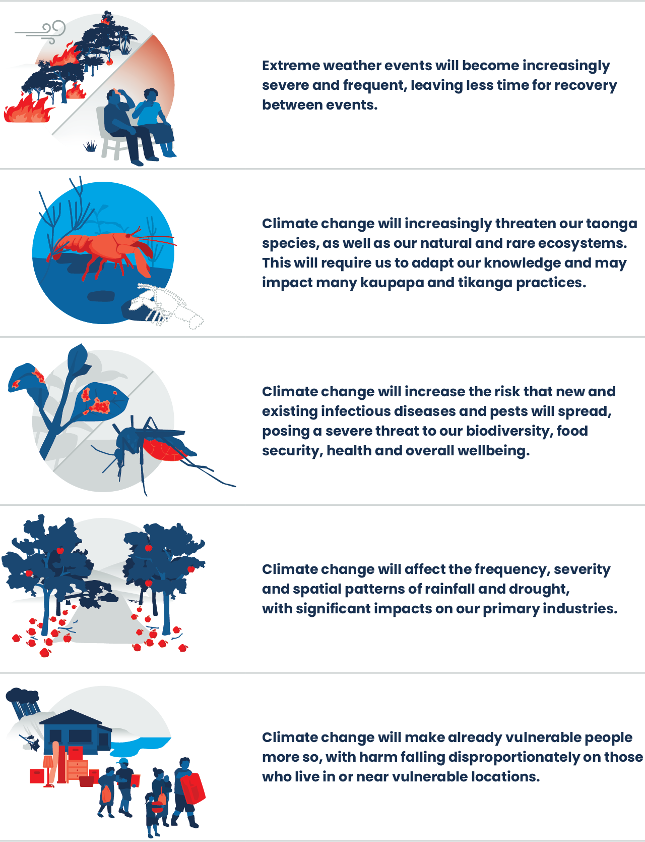

Mō ngā uri whakatipu
For future generations
In this section, for the first time in reporting, we have used structured analytical techniques to produce assessments about the outlook for our climate and atmosphere based on international and domestic evidence. This represents an important shift in our approach to environmental reporting. The shift is away from a focus on what has happened towards the inclusion of assessments about what may happen in future, to improve public awareness of issues and decision-making.
The future will always be uncertain. For this reason, the assessments in this section should not be read as statements of fact but as assessments of what may occur based on what we know now. To support this, we have used expressions of likelihood and confidence to help in interpretation. This ensures we can make assessments about current and emerging issues even when our confidence in them may be low due to the limitations of the evidence base. Expressions of likelihood are underlined in the text. Footnotes at the base of each page provide the associated quantitative values. Expressions of confidence, which give an indication of the reliability and level of corroboration of evidence used in an assessment, are presented in brackets at the end of each assessment (see appendix B, for further explanation).
Those familiar with the Intergovernmental Panel on Climate Change (IPCC) approach to climate outlooks will notice the expressions of likelihood and confidence in this section (while similar) represent a departure from that framework. The approach taken here recognises the need for Aotearoa New Zealand’s environmental reporting programme to align its outlooks assessment language with that used by other government departments, to support effective cross-agency decision-making. It also acknowledges the need for an assessment approach that can be applied across all environmental domains and knowledge systems, including mātauranga Māori (Māori knowledge). Importantly, the evidence and analysis produced by the international community and IPCC on climate change, along with other domestic evidence and knowledge, has been incorporated into the assessments contained here.
To support the development of assessments contained in this section, assumptions were required to be made about the future across a spectrum of issues. To ensure alignment with the international scientific community, the assumptions contained in the Shared Socioeconomic Pathway 2 (SSP2-4.5) were used, because they represent an intermediate pathway consistent with historic patterns of behaviour (Riahi et al, 2017). The scenario narrative and assumptions for SSP2-4.5 are that:
- the world follows a path in which social, economic and technological trends do not shift markedly from historical patterns
- development and income growth proceed unevenly, with some countries making relatively good progress while others fall short of expectations
- global and national institutions work toward but make slow progress in achieving sustainable development goals
- environmental systems experience degradation, although improvements occur and, overall, the intensity of resource and energy use declines
- global population growth is moderate and levels off in the second half of the century
- income inequality persists or improves only slowly and challenges to reducing vulnerability to societal and environmental changes remain.
The evidence in this section shows we have already had a profound impact on our climate, and the underlying drivers behind these changes are not evolving at the rate required to meet Paris Agreement targets. This means we should expect these impacts to become more significant and observable over time. In some contexts, impacts might present as slow and weak background signals that we do not notice in our day-to-day lives until they manifest in a significant event, such as species extinction. In other contexts, such as severe weather, impacts may be abrupt, severe and short-lived but profoundly affect our safety, security and economic wellbeing. Lowering global greenhouse gas emissions is the most effective way of reducing these risks.

The current global emissions rate means it is highly likely we will not meet the Paris Agreement long-term goals of limiting global temperature increase during the 21st century to well below 2 degrees Celsius above pre-industrial levels. It is also highly likely we will exceed the aspirational goal of limiting global warming to 1.5 degrees Celsius by 2040 (moderate confidence)
- The IPCC Sixth Assessment Report (AR6), Summary for Policymakers states that policies implemented by the end of 2020 are projected to result in higher global greenhouse gas emissions in 2030 than emissions implied by Nationally Determined Contributions (NDCs) (IPCC, 2023).
- The IPCC AR6 estimates that following current trajectories for greenhouse gas emissions will result in a best outcome of temperature increase ranging from 2.1 degrees Celsius to 3.5 degrees Celsius by 2100. Major reductions in global greenhouse gas emissions would be required to meet current temperature targets (Armstrong McKay et al, 2022; IPCC, 2023).
- The average global surface temperature between 2011 and 2020 was 1.09 degrees higher than between 1850 and 1900 (IPCC, 2023). Current trajectories will result in a best outcome of average temperatures ranging from 1.2 degrees Celsius to 1.8 degrees Celsius by 2040 (IPCC, 2023).
- Increasing global temperatures increase the chance of triggering climate tipping points, at which time some large-scale environmental changes will become irreversible (Armstrong McKay et al, 2022; Wang et al, 2023).

Aotearoa New Zealand’s short to medium term anthropogenic gross greenhouse gas emissions are likely to decline (moderate confidence)
- Based on Aotearoa New Zealand’s existing policies and measures, our gross emissions are projected to steadily decrease by 27.6 percent between 2020 and 2050 (MfE, 2022).
- Projected emissions reductions across all sectors are driving the projected decrease in gross emissions (Bodeker et al, 2022).
- The land use, land-use change and forestry sector offset around 30 percent of gross emissions in 2022, and this is projected to continue out to 2050 (New Zealand Treasury, 2023b).

It is highly likely Aotearoa will experience increased temperatures in the short to medium term, out to 2050 (high confidence)
- How changes in climate may vary across the country in the future is uncertain. This uncertainty is increased by patterns of natural variability, such as the El Niño Southern Oscillation, Southern Annular Mode and mid-latitude jet stream, which have a strong influence over Aotearoa New Zealand’s climate (Bodeker et al, 2022; IPCC, 2021).
- Aotearoa will warm at a slightly slower rate than the global average because of the influence of the ocean on our regional climate, but we will experience increased average air temperature over land and sea across the course of the century. The level of warming depends on global emissions pathways (Bodeker et al, 2022).
- Compared with recent decades (1995–2014), an increase in average air temperature over land and sea, in the range of +1 (0.60 to 1.32) degrees Celsius or higher +1.3 (0.91 to 1.66) degrees Celsius, is expected by mid-century if current emissions pathways continue (Bodeker et al, 2022).
- Summers are projected to have a more pronounced warming than springs and autumns, and some regions will experience greater warming than others (Bodeker et al, 2022).

It is highly likely Aotearoa will experience changing rainfall patterns in the short to medium term, out to 2050 (moderate confidence)
- Rainfall is projected to increase in the west and south of Aotearoa (Bodeker et al, 2022; Shu et al, 2021).
- Winter and spring rainfall is projected to follow the annual increase in the west and south, but with less rainfall in the east and north (Bodeker et al, 2022).
- More summer rainfall is expected in the east of both islands, with less rainfall in the west and central North Island (Bodeker et al, 2022).

It is highly likely extreme weather events will become increasingly frequent and severe (high confidence)
- While significant knowledge gaps exist regarding projections for extreme heat, research indicates Aotearoa will follow the global trend of extreme heat events increasing in frequency, duration and intensity (Harrington & Frame, 2022; Thomas et al, 2023).
- The frequency of tropical cyclones is projected to decrease slightly over the South Pacific basin, with a predicted increase in severity (Bodeker et al, 2022, Chand et al, 2022). Tropical cyclone activity in the southern hemisphere is expected to decrease overall (Roberts et al, 2020).
- Drought intensity is projected to markedly increase with the rise in greenhouse gas emissions. The most significant increases in drought intensity are predicted to be in the northern and north-eastern regions of the North Island (Bodeker et al, 2022).
- Atmospheric rivers near Aotearoa are projected to continue to get bigger and carry more moisture, which, upon landfall, can result in highly destructive precipitation (Espinoza et al, 2018; Payne et al, 2020; Shu et al, 2021).
- River flooding is projected to increase across the country (Bodeker et al, 2022).
- Extreme wind speed over the South Island and the southern part of the North Island is predicted to increase by mid-century, along with wind patterns becoming more north-easterly in summer, with westerlies becoming more intense in winter. These predictions are made with low confidence (Bodeker et al, 2022).
- The frequency of coastal overtopping and inundation due to storm surge and wave run-up will increase as sea levels rise. The potential for more frequent coastal flooding will increase as ground water table elevations change in response to sea-level rise. These effects will be highly variable at a local scale due to complicating factors including vertical land movement, sediment supply and landform resilience (Jones & Bickler, 2022; MfE 2017).

It is almost certain that changes in our atmosphere and climate will have significant and enduring effects on all other environmental domains (high confidence)
- Average sea surface temperatures around Aotearoa are warming at a faster rate than the global average (0.22 degrees Celsius per decade, compared with 0.16 degrees Celsius) and will continue to increase under current trajectories (Bodeker et al, 2022; IPCC, 2021; Law et al, 2018b; Sutton & Bowen, 2019).
- Marine heatwaves are projected to increase in frequency and severity. Heatwave conditions are forecast to become permanent by the end of the century under current conditions (Behrens et al, 2022; Bodeker et al, 2022).
- Global mean sea level has increased by an average of 1.5mm a year since 1900, due to ocean warming, and is predicted to rise by another 30cm by 2100 (Frederikse et al, 2020). Sea level around Aotearoa will rise by 5 percent to 10 percent more than the global average, due to local glacial isostatic adjustment. Local land subsidence or uplift will also have a significant effect on the rate and amount of sea-level change at a local scale (Ackerley et al, 2013; Kopp et al, 2014).
- Coastal areas are expected to experience worsening effects of more frequent and extreme flooding, caused by the compounding impacts of sea-level rise (Collins et al, 2013).
- Changes to ice melt around Antarctica are reducing the concentration of oxygen in the ocean. Estimates show that, with anthropogenic warming, global ocean oxygenation will decline by 1 percent to 7 percent in the next 100 years (Gunn et al, 2023; IPCC, 2021).
- Uptake of atmospheric carbon dioxide has decreased sea surface pH by 0.1 units since pre-industrial times. Sea surface pH will continue to decrease if the current rate of fossil fuel burning persists (Calderia & Wickett 2003; Hartin et al, 2015; Law et al, 2018a).
- Modelling shows increases in mean annual river flow along the west and south of the South Island and decreases in the north and east of the North Island by the end of the century (Collins, 2020).
- Regional snowlines are expected to continue to retreat to higher altitudes across Aotearoa. Snowlines in the Southern Alps could be displaced by an elevation of 200m higher in the next 20 years (Lorrey et al, 2022).
- Increase in total precipitation has been identified as a factor in the increased probability of landslides and rockslides occurring (Bodeker et al, 2022). Statistical modelling of landslide inventory and rainfall data has found that landslides in response to storm rainfall are anticipated to become more common with climate change (Smith et al, 2023).
- By the end of the century, some North Island soft-rock hill country catchments and a marginal number of South Island soft-rock hill country catchments (less than 1 percent to 28 percent and less than 1 percent to 8 percent, respectively) may experience increases of over 100 percent in sediment yield (Neverman et al, 2023).
- Wetlands in coastal areas are vulnerable to climate change impacts including rising sea levels, storm surges, coastal erosion, fire, and territorial and marine heatwaves. Our wetlands may release a large amount of their stored carbon if disturbed, which will amplify carbon emissions and global temperature rise (Lovelock et al, 2017; Ross et al, 2023).

It is almost certain climate change will continue to increase risk to Aotearoa New Zealand’s native and endemic species (high confidence)
- Native forest in Aotearoa is expected to change in distribution and composition, based on projected climate changes. Native tree species, such as tōtara and rimu, have shown some level of resilience to habitat changes and warmer temperatures (McGlone & Walker, 2011; Ryan, 2017).
- Climate change affects high-elevation species at a faster rate than other terrestrial habitats. Projections show a mean annual temperature increase of 3 degrees Celsius would result in the loss of 80 percent of the discrete alpine areas in Aotearoa, and extinction of between 200 and 300 species of indigenous vascular plants (up to half the alpine total) (Halloy & Mark, 2003).
- Rising temperatures will have increasingly negative effects on the habitats and range of native cold-adapted freshwater species. Increased temperatures allow cyanobacteria to take advantage of nutrient over-enrichment (eutrophication), which affects the underwater ecosystems needed for biodiversity (Boddy & McIntosh, 2017; Paerl & Huisman, 2008, 2009; Puddick et al, 2022; Wells et al, 2015).
- Ocean acidification will continue to directly affect marine organisms that build calcium carbonate shells. Habitat-forming marine organisms, such as oysters, bryozoans and deep-water corals, are likely to be particularly affected, though uncertainty remains due to spatial and seasonal variability in pH (Hartin et al, 2015; Law et al, 2018a).
- Sea-level rise puts native coastal ecosystems at risk of ‘coastal squeeze’ where habitats can be restricted by inundation from the sea. The effects of inundation will reduce nesting sites for shorebirds, habitat for wading birds, and further reduce suitable spawning sites for native freshwater fish (Rullens et al, 2022).
- Climate stress is likely to increase host vulnerability to pathogen infection (Wakelin et al, 2018) and ranges of plant pathogens will expand, for example, myrtle rust (Beresford et al, 2018).

It is almost certain climate change will continue to weaken ecological resilience to invasive species already present in the country (moderate confidence)
- Climate change will continue to trigger modifications to habitats across marine, terrestrial and freshwater ecosystems from shifting rainfall patterns, increasing temperature and extreme events, exacerbating vulnerabilities of native flora and fauna to invasive species. (Keegan et al, 2022; Macinnis-Ng et al, 2021).
- A warmer climate will expand habitable ranges of some existing pests and diseases, including possums and rats (Monks, 2022). These geographic range and distribution shifts will create competition between native and invasive species for habitat (Macinnis-Ng et al, 2021).
- Invasive plants and mammals, along with more frequent fire weather in some areas, will increase fire frequency and severity (Wyse et al, 2018). Native species may have limited adaptations for recovery after fire, which results in competitive advantage in fire-prone areas for invasive species, reducing the biodiversity values of these systems (Perry et al, 2014).

It is almost certain climate change will create more favourable conditions for new or novel pests being introduced and becoming established (high confidence)
- The northern districts of the North Island are projected to become more suitable for sub-tropical pest species, including those that pose threats to the primary sectors (Keegan et al, 2022).
- As temperatures increase and winters become milder, some pests that are currently temporarily established could become more permanent features of our landscape, although the establishment of some species could be limited by aspects of their lifecycle (such as requiring specific habitats for breeding) (Kean et al, 2015).
- A southward expansion of the habitable ranges of pests currently limited by winter cold is likely (Qin, 2019; Watt et al, 2019).

It is highly likely the indirect effects of climate change will become increasingly damaging to Aotearoa New Zealand’s flora and fauna (moderate confidence)
- Ecosystems are increasingly at risk from the indirect impacts of climate change. Indirect impacts manifest by interacting with other drivers of global change or by altering ecological processes such as predation, parasitism and pollination (Jaureguiberry et al, 2022; Ling, 2008; Macinnis-Ng et al, 2021; Pecl et al, 2017; Tylianakis et al, 2008).
- Warmer air temperatures may increase competition for pollination between native and invasive plants because of increased overlap in the timing of their flowering (Giejsztowt et al, 2020), potentially disrupting plant-pollinator networks and affecting broader ecosystems (Ruiz et al, 2019).
- Rising sea surface temperatures may reduce the abundance of marine food or impede seabirds’ capacity to access it, most likely due to complex food-web responses that are expected to occur more frequently in the future (Keegan et al 2022, Macinnis-Ng et al, 2021).
- Changes in drought frequency and severity affect forest tree recruitment, disease susceptibility, and mortality (Macinnis-Ng et al, 2021), favouring drought-tolerant species. This has flow-on effects for the biodiversity that forests and other vegetation types support (Batlori et al, 2020).
- Increased groundwater extraction for irrigation during droughts cause declines in groundwater dependent ecosystems including wetlands, springs and trees that access groundwater for their water needs (Eamus et al, 2015). This can result in plant water stress, crown dieback and eventual death of trees (Cooper et al, 2003; Eamus et al, 2015) and a wide range of impacts on spring and wetland ecosystems (Stevens et al, 2022).
- Although there are few cases of well documented indirect climate-change impacts in Aotearoa it is unclear if this is due to a paucity of data, the complexity of responses, or a lack of measurable effects (Macinnis-Ng et al, 2021).

It is highly likely reduced or restricted access to taonga species as a result of climate change will have an enduring effect on kaupapa and tikanga Māori (moderate confidence)
- Changing climatic conditions alter the occurrence and timing of traditional and seasonal tohu (environmental indicators) that forecast the onset of critical periods for many Māori practices (Matamua, 2017; Warbrick et al, 2023). The maramataka is one well-known example that will need to adapt to changing tohu, to continue to guide recreation as well as daily and seasonal activities, providing an opportunity to enact active kaitiakitanga (guardianship) over the local environment (see Te ao Māori, whakapapa and our connection to atmosphere and climate for a definition of the maramataka) (Kenney et al, 2023).
- It is expected any obstruction to accessing taonga (treasured) species may adversely affect the ability of whānau to manaaki (or host) visitors with customary resources and affect Māori customary practice, cultural identity and wellbeing (Awatere et al, 2021; Jones et al, 2014; Warmenhoven et al, 2014).
- Projected incremental and abrupt changes in climate this century are expected to exacerbate many of the risks facing different culturally important flora and fauna, and, in some cases, vulnerable taonga species may face extinction (Awatere et al, 2021; Egan et al, 2020; Reisinger et al, 2014; Renwick et al, 2016).
- Loss of taonga species will have a cascading effect on the transfer of customary practices and knowledge for future generations. It will also add to existing social and political risks for the maintenance and transfer of traditional skills, expertise and values relating to mahinga kai (traditional food gathering practices) (Awatere et al, 2021).

It is highly likely climate-related impacts will result in the displacement of Māori living in locations vulnerable to climate change, which could disrupt the transmission of location-specific mātauranga Māori and tikanga practices (moderate confidence)
- Māori culture and whakapapa (genealogy) are positioned geographically and will be affected by the impacts of climate change (Hakopa, 2011).
- Te ao Māori beliefs hold that all aspects of life are interrelated and interconnected, and the effect of a changing climate is expected to fundamentally alter the way many Māori interact with their environment, each other, and other communities (Awatere et al, 2021).
- Climate impacts, such as sea-level rise, will displace Māori from tūrangawaewae (a place to stand, where one has the right to stand), which will disrupt the geographic transmission of te reo Māori and tikanga (customs and protocols) (Awatere et al, 2021).
- As iwi, whānau and hapū need to relocate from their tūrangawaewae, opportunities to enact kaitiakitanga and actively manage resources and important sites will diminish (Awatere et al, 2021; Wehi et al, 2023).
- To maintain intergenerational mātauranga (knowledge) and tikanga practices, many Māori will have to adapt and plan the relocation of marae or culturally significant sites such as urupā (burial grounds) (Awatere et al, 2021).
- Climate change is likely to have both direct and indirect effects on the coordination of, and participation in, cultural arrangements such as tangihanga (funeral). It is highly likely that marae or coordinators will be burdened with mitigating risks when planning and managing such important ceremonies (Awatere et al, 2021).

It is almost certain climate change and repeated severe weather events will exacerbate risks to already vulnerable sectors of the economy (high confidence)
- The economic and fiscal impacts of climate change are expected to be extensive and unevenly felt, because some industries and sectors are more exposed than others, such as agriculture, forestry, fisheries, tourism, and energy and transport networks (New Zealand Treasury, 2023b).
- Increasing risks to the economy from both the physical impacts of climate change as well as transition risks have flow-on effects for the overall soundness of the financial system as a whole. Some impacts, such as more extreme weather events, are largely baked in for the next few decades. These impacts may also contribute to higher net core Crown debt (Reserve Bank of New Zealand, 2021).
- Important horticultural crops, such as apples, kiwifruit and grapes, are anticipated to have positive responses to the changing climate, with no compromised yield, fruit size or quality. Although, other factors that affect horticultural crops could pose increasing risks with climate change, such as water availability, pollination, pest and diseases, and extreme weather (Clothier et al, 2012; MPI, nd).
- Flowering and ripening of grapes is predicted to become earlier overall by mid-century, and further by the end of the century (Ausseil et al, 2021).
- It is almost certain dairy farming will be at increased risk from extreme weather events, with increased drought frequency, and a projected increased intensity of floods and heavy rainfall (Griffin et al, 2023; Nguyen et al, 2022).
- Irrigation schemes will become less efficient in warmer and windier climates. Water extraction will need to increase, to compensate for increased rates of evaporation, which affects source reliability and results in higher loss in both the storage and supply of water to crops (Collins et al, 2013).
- The Māori economy is projected to be severely affected by climate change because it has a high proportion of interests in the primary sector, including forestry and fisheries. Fisheries investment is dependent on resilient ecosystems and biodiversity, with hoki, pāua and kōura (freshwater crayfish) among the many at-risk commercial fishing species (Awatere et al, 2021; King et al, 2010).
- Replenishment of groundwater resources is integral to our primary sector and will be affected by changing rainfall and water demand patterns. These changes are likely to vary seasonally and regionally (Mourot et al, 2022).

It is highly likely our infrastructure and communities will continue to be adversely affected by climate change, with already vulnerable communities experiencing worse outcomes (high confidence)
- Remote communities, those with limited economic resources, populations that are under-represented in local and central government and those in vulnerable climatic areas will be disproportionately affected by climate change and extreme weather events globally and domestically (King et al, 2010).
- Sea-level rise will increasingly affect low-lying and coastal communities, including stormwater and wastewater services critical for health and sanitation. Wastewater services will be affected by climate change on short and long timescales, which will have social, environmental, economic, health and cultural consequences (Hughes et al, 2021; Kool et al, 2020; Lawrence et al, 2020).
- Other critical infrastructure, including built assets, transport links (for example, roads, railways, airports) and electricity (transmission lines, structures, sites), are also at risk of coastal flooding, which will increase through time (NIWA, 2019).
- Coastal properties and cultural sites will be affected by coastal erosion and flooding, which will accelerate with sea-level rise. Local variability and complicating factors will occur, including vertical land movement, sediment supply and landform resilience (Awatere et al, 2021; Bailey-Winiata, 2021; Bell et al, 2022; Jones & Bickler, 2022; Lawrence et al, 2020; New Zealand Archaeological Association, 2022; Wehi et al, 2023).
- Climate change induced drought conditions can also increase the risk of wildfires, which will pose risks for cultural infrastructure and kainga (settlements) (Awatere et al, 2021).

It is highly likely health and wellbeing outcomes will deteriorate because of climate change and biodiversity loss, including the introduction of infectious diseases and food insecurity (moderate confidence)
- Climate change is one of the most serious global threats for health and wellbeing, with potentially widespread effects, including introduced infectious diseases, food insecurity and reduced drinking water quality (Drew et al, 2020; IPCC, 2023; Jones, 2019).
- Complex health challenges reflect the interconnected nature of humans, animals and the environment. This is particularly important in Aotearoa due to our relatively isolated island ecosystem and the economic importance of agriculture (Harrison et al, 2020).
- Existing health and social system inequities will be exacerbated further by climate change. The already intersectionally disadvantaged, including young, elderly, disabled, Māori and Pasifika, will be disproportionately affected (Bennett et al, 2014; Jones et al, 2014; Masters-Awatere et al, 2023).
- The risk is increasing of arboviruses, such as the Zika virus and dengue fever, being introduced from overseas, with increased risk of local transmission as our climate becomes increasingly suitable (Ammar et al, 2021).
- Illness rates associated with pathogenic species from the dung of sheep and cows (Campylobacter and Cryptosporidium) may increase substantially with increased temperature and rainfall intensity, with children being the most vulnerable (McBride et al, 2014). In the Pacific Islands, food production and access to food will be adversely affected by climate change, including food from agriculture and fisheries. This puts at risk their basic need for access to sufficient, safe and nutritious food (Barnett et al, 2019).
- Emerging evidence indicates that children and young people are experiencing greater levels of mental distress due to climate change than any other age group, and research suggests they will be disproportionately burdened by the impacts of climate change (Gislason et al, 2021; Ma et al, 2022).

It is likely increasing extreme weather events will have a negative effect on health, wellbeing and the prevalence of disease and illness (moderate confidence)
- With increasing extreme events, an increase in related health and wellbeing effects is expected, including injuries and deaths, displacement, and significant damage to community infrastructure; vulnerable groups including children, elderly and disabled will be particularly at risk of this (Grout et al, 2022; Mason et al, 2021).
- Extreme weather events, such as extreme rainfall, drought, wildfires and floods are linked to worsened mental health and higher mortality among people with pre-existing mental health conditions, with increased psychiatric hospitalisations and suicide rates (Charlson et al, 2021). Globally, increased exposure to extreme heat correlates with higher cardiovascular conditions, heat stress and, in extreme cases, fatalities, particularly among the elderly and people with pre-existing conditions (Chaseling et al, 2023).
- Regions that experience increased extreme rainfall could be at higher risk of waterborne diseases, including through contaminated water supplies (Hales, 2019; Lai et al, 2020).

It is highly likely climate change will increasingly threaten wellbeing, connection to place, livelihood and identity for vulnerable communities (high confidence)
- Climate change is increasingly affecting daily life, for example, rising costs due to disrupted supply chains, power cuts caused by extreme weather, and the need to evacuate homes due to flooding or fires. This will continue, and lower income communities will be more susceptible these effects (MfE, 2022).
- Extreme weather events, such as flooding, pose threats to home security in Aotearoa. About 675,000 (or one in seven) people across Aotearoa live in areas prone to flooding (MfE, 2022). The costs of flooding will increase over time as the climate continues to change (NIWA, 2018).
- In Aotearoa, managed retreat may be necessary to reduce or eliminate exposure to intolerable risks caused by climate change. This displacement will disconnect people who are deeply connected to, and reliant upon, the security, networks and cultural values of their land, homes, communities and livelihoods (Hanna et al, 2019).
- Recreational activities and events will be affected by climate change both directly and indirectly, with changing climates dictating how, when and where activities can take place, if at all (Awatere et al, 2021).
- Climate change threatens to disconnect many Pasifika nations through voluntary or involuntary displacement. It is likely to be a catalyst for profound identity loss, fear and anxiety for many vulnerable communities and a loss of sense of place and belonging (Campbell 2010; Tiatia-Seath et al, 2020).

Data and research gaps
Climate change transcends boundaries and domains, affecting biodiversity, ecosystems, societies, economies, and our way of life. Addressing this interconnected nature is crucial, and having comprehensive data and research that reflect this holistic perspective becomes paramount to protect the environment for ourselves and future generations. In this section, our focus is not on individual or specific data gaps but on high-level themes essential for navigating the complexities of our changing climate. By recognizing the interdependence of various aspects of our environment and understanding how changes in one area ripple through others, we can better prepare and adapt to the effects of climate change.

Improving predictive capacity for future changes
It is particularly challenging to know what climate change impacts might look like in the future, because multiple pressures across different systems can interact and compound or cascade. Understanding how these complex climate risks will manifest is critical for identifying what is most at risk. This can inform decisions in the context of different community priorities and interests. These climate-induced changes will have different effects for the varying interests, goals, responsibilities, health and wellbeing of whānau, hapū and iwi, and their relationships with te taiao.

Integrating natural and social science to develop a better understanding of the adaptation of human systems
A determining factor for what will happen in the future is the human potential, both domestic and international, to respond appropriately to climate change by mitigation and adaptation activities. Our climate is influenced by the human choices that shape our institutions, economies and innovation processes. Conversely, our choices will be influenced by the climate because the greater intensity and frequency of climate-related events will increase the salience and urgency of climate issues among citizens and decision-makers. To formulate projections of the future, even regarding physical trends like global heating and biodiversity impacts, we need to better understand how societies, economies and institutions are likely to act. This will involve addressing knowledge deficits in the social sciences of climate action, which includes psychology, political science, new economic paradigms, complexity science and socio-technical transitions. These complex system dynamics can have substantial implications for future emissions trends, policy pathways and adaptive responses to climate impacts.

Maintaining and improving observations to ensure robust environmental monitoring and reporting
Aotearoa New Zealand’s environmental monitoring and reporting system is crucial in protecting te taiao (the environment). Its effectiveness depends on how well we collect and analyse data about the state of the environment, and this needs improving. Robust observation systems and long-term datasets are vital for understanding climate change and its effects. These data help us detect trends, compare observed changes to climate projections, and make necessary adjustments. The Ministry for the Environment, together with sector partners, is embarking on a significant programme of work to reform the foundations of the environmental monitoring and reporting system. This will include developing core indicators for monitoring our environment, designing the analytical architecture required to assess and interpret the data, and the blueprint design for a national monitoring network.

Improving the resourcing of and access to mātauranga Māori
Mātauranga Māori (Māori knowledge) represents a valuable record of our environment that is unique to Aotearoa. Our mātauranga Māori evidence base needs to be built on and strengthened to better understand effects on te ao Māori (Māori worldview). This requires improving the resourcing of Māori research and access to ngā tohu o te taiao (environmental indicators) drawing from mātauranga Māori. Our ability to access and share rohe- and place-based knowledge and evidence needs to be improved. This will enhance our understanding of localised pressures, state and impacts, and elevate the value of this knowledge in reporting.

Conducting more integrative and multidisciplinary science to improve our understanding of significant climate processes
Gaining a better understanding of the significant processes controlling the climate–Earth system is fundamental for improving climate projections. This would further reduce uncertainty in climate sensitivity calculations and enhance our understanding of the frequency and intensity of extreme weather events. This is particularly challenging because the environment is full of diverse and complex ecosystems. Integrative and holistic studies can help provide a more complete picture, as shown in te ao Māori. We need to build a more holistic understanding of the state of the climate and all its links to ecosystems, habitats, species and human systems.

Targeting research by learning from international research and evidence
International evidence is overwhelming that the risks and effects from increasing concentrations of greenhouse gases in the atmosphere are significant, affecting every aspect of the environment and human life. Aotearoa is only beginning to observe a subset of these effects, but whether this is due to limited research and monitoring, delayed onset or lack of impacts is unknown. Comparing international research and evidence within our local context is crucial to understanding our unique climate change sensitivities and challenges and developing effective and place-based strategies to mitigate and adapt to the impacts of climate change.

Improving assessments of climate change and extreme weather impacts on our biodiversity and ecosystems
Aotearoa lacks a comprehensive and holistic understanding of the effects of climate change on its unique biodiversity and ecosystems. This requires more integrated analyses of the data we have and investing in wider monitoring of, and research into, lesser understood components of the environment including natural–human sub-system interactions and mātauranga Māori.

Improving assessments of climate change and extreme weather impacts on the economy, health and wellbeing
Aotearoa is being increasingly confronted with climate impacts like flooding, including coastal flooding, drought and heat stress. As the effects of these changes become more frequent, we will have less time to recover and cumulative consequences will occur that could flow on to affect our social and economic activities. We need to better understand the interdependencies between our climate system, urban systems, infrastructure (including utilities), financial services (including banking and insurance) and governance systems.

Appendix A: Additional technical information

Greenhouse gas emissions for Aotearoa New Zealand
- Greenhouse gas emissions for Aotearoa New Zealand are presented from New Zealand’s Greenhouse Gas Inventory 1990–2021, published April 2023 (MfE, 2023a). The inventory estimates have been compiled by applying the 100-year global warming potential (GWP100) values from the IPCC Fourth Assessment Report (IPCC, 2007) to the non-carbon-dioxide gases when aggregating them together. Subsequent greenhouse gas inventories will apply the GWP100 values from the IPCC Fifth Assessment Report (IPCC, 2013), as required under the Paris Agreement. All projection estimates of greenhouse gases in this report apply the Fifth Assessment Report GWP100 values.
- Greenhouse gas emissions for Aotearoa presented in this report are not directly comparable with values presented in the previous Atmosphere and Climate report. In Our Atmosphere and Climate 2020, we used New Zealand’s greenhouse gas emissions as reported in the 2020 submission of the Greenhouse Gas Inventory but, in this report, we use the 2023 submission of the Greenhouse Gas Inventory because it contains the most up-to-date information. Inventory estimates are continuously improved. The whole inventory time series, from the base year (1990) to the latest year, is recalculated when the methodology or underlying data change. This means the emissions estimates are only up to date in the latest inventory, and previous inventories are not useful for comparisons. Changes made to the inventory are often related to improvements in activity data collection, emission factors and methodology, or the identification of additional emission sources.

Environmental indicators: Site description and trend assessments
- Stats NZ environmental indicator information in this report is based on data from 30 sites that use NIWA’s climate stations for the following indicators: Drought, El Niño Southern Oscillation, Extreme rainfall, Extreme wind, Frost and growing degree days, Rainfall, Temperature, and Wildfire risk. These sites are spread across Aotearoa, in locations designed to capture data in the areas where most people live, while also reflecting monitoring practicalities. As such, lower elevation coastal areas have a high representation and inland higher elevation locations have a low representation.
- For sites where trends could be determined, trends are classified as determinate when the probability of an increasing or decreasing trend is above 66 percent. The term ‘indeterminate’ is used when there is either no trend direction determined or not enough statistical certainty to determine trend direction (less than 66 percent certainty).

Environmental indicators: Additional information
- Extreme rainfall: Rainfall due to very wet days (R95pTOT) measures the percentage of annual rainfall from very wet days, where very wet days are defined as those where the daily rainfall exceeds the 95th percentile of daily rainfall totals. For this release, the latest climate normal (1991 to 2020 average) was used to determine the 95th percentile range, where daily rainfall total is greater than or equal to 1mm (Klein Tank et al, 2009). Climate normals serve as a benchmark against which recent or current observations can be compared (WMO, 2017). They can be used for determining how ‘abnormal’ the climate of a particular month, season or year is when compared against the 30-year climate normal. Like air temperature, rainfall can change over time; the latest climate normal period (1991 to 2020) helps us to understand the typical characteristics of our contemporary climate. R95pTOT provides information about extreme rainfall events relative to total rainfall over a period of time. For comparison, we also provide data based on the previously applied 1961 to 1990 climate normal period in the dataset. Maximum one-day rainfall total (Rx1day) measures the maximum amount of rainfall that fell in a single day over a period of time (Klein Tank et al, 2009). This provides information on the magnitude of extreme rainfall events (see Indicator: Extreme rainfall).
- Wildfire: Comparison of fire risk between sites is complicated due to differences in fuel type at each station used for analysis. A fuel type may be one of ‘forest’, ‘grass’ or ‘scrub’, and was derived for each station based on Land Information New Zealand geographic databases. Comparing between sites is therefore not appropriate, because the calculated wildfire risk is dependent on fuel type. Nevertheless, the data support the assessment of trends over time for each site (see Indicator: Wildfire risk).
- Extreme wind: Here, extreme wind measures the annual average of the daily maximum wind gust (a measure of windiness) and annual maximum wind gust (a measure of wind strength) (see Indicator: Extreme wind).

Environmental indicators: Drought information and data
- Drought: One method used to detect and monitor drought is the Standardised Precipitation Evapotranspiration Index (SPEI) (WMO and Global Water Partnership, 2016). Because SPEI accounts for the influence of temperature and precipitation on drought, it is a useful index for studying drought given our changing climate (Our atmosphere and climate 2020). SPEI can also be applied for different periods (like the past 3, 6 or 12 months) to provide information about the frequency and intensity (drought severity divided by its duration) of meteorological, hydrological and agricultural droughts. Extreme dryness refers to SPEI values below –2.
- Trends in frequency of short-term drought events (meteorological drought; across 3 months) are tending to increase, while trends in long-term drought events (hydrological drought; across 12 months) are mostly indeterminate. Short-term drought frequency increased at 18 sites and decreased at 7, while 5 sites had indeterminate trends. Long-term drought frequency increased at 6 sites and decreased at 6, while 18 sites had indeterminate trends.
- Trends in drought intensity are indeterminate at some sites, though more sites showed decreasing rather than increasing trends across short-, medium- and long-term events. Short-term drought intensity increased at 6 sites and decreased at 12, while 12 sites had indeterminate trends. Long-term drought intensity increased at 6 sites and decreased at 10, while 14 sites had indeterminate trends.
- For short-term drought, 21 of 30 sites had extreme dryness, and 13 sites had at least six unique drought events each from 1972 to 2022. Dunedin had the most drought events, at 10 events. Seventeen sites spent at least 25 percent of the time in short-term drought, with Dannevirke and Dunedin spending the most time in short-term drought (47 percent).
- For long-term drought, 14 of 30 sites had extreme dryness from 1972 to 2022. Twenty-three sites spent at least 25 percent of the time in a long-term drought event, with 10 sites in drought at least 50 percent of the time.

Appendix B: Probabilistic and analytic confidence language used in this document

Probabilistic language
Probabilistic language | Associated numeric probability
Almost certain | >90%
Highly / Very probable / Likely | 75–85%
Probable / Likely | 55–70%
Realistic possibility | 25–50%
Improbable / Unlikely | 15–20%
Remote / Highly unlikely | <10%

Analytic confidence
High confidence | Assessments are based on high-quality information, and/or the nature of the issue makes it possible to render a solid judgement. A ‘high confidence’ judgement is not a fact, however, and still carries a risk of being incorrect.
Moderate confidence | Assessments are based on credibly sourced and plausible information, but not of sufficient quality or corroboration to warrant a higher level of confidence.
Low confidence | Assessments are based on questionable or implausible information, the information is too fragmented or poorly corroborated to make solid analytic inferences, or significant concerns or problems with sources existed.

Outlooks assessments contained in this report should not be read as statements of fact and may be based on a variety of sources of differing reliability. Certain words in this document are used to convey the probability of analytical assessments. These words are underlined in this report, to clearly identify assessments. These are used in conjunction with expressions of confidence which provide an indication of the reliability and level of corroboration of sources used in an assessment. Our use of probabilistic language and analytic confidence levels is not the same or directly comparable with that of the Intergovernmental Panel on Climate Change. The language and probability ranges we use are the same as other government agencies, to maintain consistency.

Additional information

Environmental indicators
Listed below are the environmental indicators incorporated in this report, including nine updated indicators in bold:
- Annual glacier ice volumes
- Atmospheric ozone
- Coastal sea-level rise
- Drought
- El Niño Southern Oscillation
- Frost and growing degree days
- Extreme rainfall
- Extreme wind
- Indigenous land cover
- Interdecadal Pacific Oscillation
- Livestock numbers
- New Zealand’s greenhouse gas concentrations
- Nitrogen dioxide concentrations
- Ocean acidification
- Predicted pre-human land vegetation
- Rainfall
- Sea surface temperature
- Southern Annular Mode
- Temperature
- Wetland area
- Wildfire risk.

Acknowledgements
This report was compiled by the Ministry for the Environment and Stats NZ’s Environmental
Reporting team.

Data providers
We would like to thank the following for providing data and advice in the development of indicators used in this report:
Auckland Council, Environment Canterbury, Greater Wellington Regional Council, Land Information New Zealand, Manaaki Whenua Landcare Research, National Aeronautics and Space Administration, National Rural Fire Authority (now Fire and Emergency New Zealand), National Institute for Water and Atmospheric Research, United States National Oceanic and Atmospheric Administration, New Zealand Ocean Acidification Observing Network, Waka Kotahi New Zealand Transport Agency, Stats NZ.

Senior science advisors
We would like to thank the following people and organisation for providing advice and helping to shape this report:
Cate Macinnis-Ng, University of Auckland, New Zealand
David Hall, Toha, New Zealand
Gregor Macara, NIWA
Richard Levy, GNS Science.

External peer reviewers
We would like to thank the following people and organisations for providing advice and critical review of this report:
Adrian McDonald, University of Canterbury
Nick Cradock-Henry, GNS Science
Shaun Awatere, Manaaki Whenua Landcare Research.

Infographics
The infographic and icons were created by Dumpark Information Design.

References
Ackerley D, Bell RG, Mullan AB, & McMillan H. (2013). Estimation of regional departures from global-average sea-level rise around New Zealand from AOGCM simulations. Weather and Climate, 33, 2–22. https://doi.org/10.2307/26169734
Ammar SE, Mclntyre M, Baker MG, & Hales S. (2021). Imported arboviral infections in New Zealand, 2001 to 2017: A risk factor for local transmission. Travel Medicine and Infectious Disease, 41. https://doi.org/10.1016/j.tmaid.2021.102047
Anderson OF, Stephenson F, Behrens E, & Rowden AA. (2022). Predicting the effects of climate change on deep-water coral distribution around New Zealand: Will there be suitable refuges for protection at the end of the 21st century? Global Change Biology, 28(22), 6556–6576. https://doi.org/10.1111/gcb.16389
Arent D, Tol R, Faust E, Hella J, Kumar S, Strzepek K, Tóth F, & Yan D. (2014). Key economic sectors and services. In Intergovernmental Panel on Climate Change (IPCC), Climate Change 2014: Impacts, Adaptation, and Vulnerability. https://www.ipcc.ch/site/assets/uploads/2018/02/WGIIAR5-Chap10_FINAL.pdf
Armstrong McKay DI, Staal A, Abrams JF, Winkelmann R, Sakschewski B, Loriani S, Fetzer I, Cornell SE, Rockström J, & Lenton TM. (2022). Exceeding 1.5°C global warming could trigger multiple climate tipping points. Science, 377(6611). https://doi.org/10.1126/science.abn7950
Auliagisni W, Wilkinson S, & Elkharboutly M. (2022). Flood risk management in New Zealand: A case study of the Northland urban community. IOP Conference Series: Earth and Environmental Science, 1101(2). https://doi.org/10.1088/1755-1315/1101/2/022035
Ausseil AGE, Daigneault AJ, Frame B, & Teixeira EI. (2019). Towards an integrated assessment of climate and socio-economic change impacts and implications in New Zealand. Environmental Modelling and Software, 119, 1–20. https://doi.org/10.1016/j.envsoft.2019.05.009
Ausseil AGE, Law RM, Parker AK, & Teixeira EI. (2021). Projected wine grape cultivar shifts due to climate change in New Zealand. Frontiers in Plant Science, 12, 618039. https://doi.org/10.3389/fpls.2021.618039
Awatere S, King DN, Reid J, Williams L, Masters-Awatere B, Harris P, Tassell-Matamua N, Jones R, Eastwood K, Pirker J, & Jackson A-M. (2021). He Huringa Āhuarangi, he Huringa Ao: A Changing Climate, a Changing World. https://www.maramatanga.ac.nz/te-arotahi-07
Bailey-Winiata APS. (2021). Understanding the Potential Exposure of Coastal Marae and Urupā in Aotearoa New Zealand to Sea Level Rise. University of Waikato – Te Whare Wānanga o Waikato.
Batllori E, Lloret F, Aakala T, Anderegg WRL, Aynekulu E, Bendixsen DP, Bentouati A, Bigler C, Burk CJ, Camarero JJ, Colangelo M, Coop JD, Fensham R, Floyd, ML, Galiano L, Ganey JL, Gonzales P, Jacobsen AL, Kane JM, … Zeeman B. (2020). Forest and woodland replacement patterns following drought-related mortality. PNAS, 117(47), 29720–29729. https://doi.org/10.1073/pnas.2002314117
Barnett J. (2019). Global environmental change I: Climate resilient peace? Progress in Human Geography, 43(5), 927–936. https://doi.org/10.1177/0309132518798077
Behrens E, Rickard G, Rosier S, Williams J, Morgenstern O, & Stone D. (2022). Projections of future marine heatwaves for the oceans around New Zealand using New Zealand’s Earth System Model. Frontiers in Climate, 4. https://doi.org/10.3389/fclim.2022.798287
Bell J, Smith R, Mcrano V, Strano F, Balemi C, Caiger P, Miller K, Spyksma A, & Shears N. (2023). Marine heat waves drive bleaching and necrosis of temperate sponges. Current Biology, 33(1), 158–163. https://doi.org/10.1016/j.cub.2022.11.013.
Bell KM, Samarasinghe O, Riggs L, & Pourzand F. (2021). Empirical Effects of Drought and Climate Change on Farms and Rural Communities. https://deepsouthchallenge.co.nz/wp-content/uploads/2021/05/Empirical-effects-of-drought-and-climate-Final-Report.pdf
Bennet MJ, & Kingston DG. (2022). Spatial patterns of atmospheric vapour transport and their connection to drought in New Zealand. International Journal of Climatology, 42(11), 5661–5681. https://doi.org/10.1002/joc.7554
Bennett H, Jones R, Keating G, Woodward A, Hales S, & Metcalfe S. (2014). Health and equity impacts of climate change in Aotearoa-New Zealand, and health gains from climate action. New Zealand Medical Journal, 127(1406), 16–31. PMID: 25447246.
Benson M, McKay A-M, Ruru M, Ruru I, & Ruru R. (2020). Te Rūnanga o Ngāti Mutunga Mauri Compass Assessment of the Urenui River and the Mimitangiatua River. https://www.trc.govt.nz/assets/Documents/Environment/Consent-applications/Remediation2019/ Hearing/submitters/Remediation-NgatiMutunga-McKay-attachment.pdf
Beresford RM, Turner R, Tait A, Paul V, Macara G, Yu ZD, Lima L, & Martin R. (2018). Predicting the climatic risk of myrtle rust during its first year in New Zealand. New Zealand Plant Protection, 71, 332–347. https://doi.org/10.30843/nzpp.2018.71.176
Bixler RP, Paul S, Jones J, Preisser M, & Passalacqua P. (2021). Unpacking adaptive capacity to flooding in urban environments: Social capital, social vulnerability, and risk perception. Frontiers in Water, 3. https://doi.org/10.3389/frwa.2021.728730
Blair N. (2002). Tamaki Kaitiakitanga in the concrete jungle. In M Kawharu (Ed), Whenua: Managing Our Resources (pp 62–74). Auckland: Reed Books.
Boddy NC, & McIntosh AR. (2017). Temperature, invaders and patchy habitat interact to limit the distribution of a vulnerable freshwater fish. Austral Ecology, 42(4), 456–467. https://doi.org/10.1111/aec.12463
Bodeker G, Cullen N, Katurji M, McDonald A, Morgenstern O, Noone D, Renwick J, Revell L, & Tait A. (2022). Aotearoa New Zealand Climate Change Projections Guidance: Interpreting the Latest IPCC WG1 Report Findings. https://environment.govt.nz/publications/aotearoa-new-zealand-climate-change-projections-guidance/
Boffa Miskell. (2020). The big dry: What drought means for our indigenous biodiversity. https://www.boffamiskell.co.nz/news-insights/the-big-dry-what-drought-means-for-our-indigenous-biodiversity
Bond MO, Anderson BJ, Henare THA, & Wehi PM. (2019). Effects of climatically shifting species distributions on biocultural relationships. People and Nature, 1(1), 87–102. https://doi.org/10.1002/pan3.15
Bond TC, Doherty SJ, Fahey DW, Forster PM, Berntsen T, DeAngelo BJ, Flanner MG, Ghan S, Kärcher B, Koch D, Kinne S, Kondo Y, Quinn PK, Sarofim MC, Schultz MG, Schulz M, Venkataraman C, Zhang H, Zhang S, Bellouin N, Guttikunda SK, Hopke PK, Jacobson MZ, Kaiser JW, Klimont Z, Lohmann U, Schwarz JP, Shindell D, Storelvmo T, Warren SG, & Zender CS. (2013). Bounding the role of black carbon in the climate system: A scientific assessment. Journal of Geophysical Research: Atmospheres, 118(11). https://doi.org/10.1002/jgrd.50171
Bracegirdle TJ, Holmes CR, Hosking JS, Marshall GJ, Osman M, Patterson M, & Rackow T. (2020). Improvements in circumpolar southern hemisphere extratropical atmospheric circulation in CMIP6 compared to CMIP5. Earth and Space Science, 7(6). https://doi.org/10.1029/2019EA001065
Brahney J, Ballantyne AP, Vandergoes M, Baisden T, & Neff JC. (2019). Increased dust deposition in New Zealand related to twentieth century Australian land use. Journal of Geophysical Research: Biogeosciences, 124(5), 1181–1193. https://doi.org/10.1029/2018JG004627
Brown H, & Bryder L. (2023). Universal healthcare for all? Māori health inequalities in Aotearoa New Zealand, 1975–2000. Social Science and Medicine, 319(February), 11535. https://doi.org/10.1016/j.socscimed.2022.115315
Burkett M. (2011). In Search of Refuge: Pacific Islands, Climate-induced Migration, and the Legal Frontier Analysis from the East-West Center. https://www.eastwestcenter.org/publications/search-refuge-pacific-islands-climate-induced-migration-and-legal-frontier
Calderia K, & Wickett ME. (2003). Oceanography: Anthropogenic carbon and ocean pH. Nature, 425(6956), 365. https://doi.org/10.1038/425365a
Campbell JR. (2010). Climate-induced community relocation in the Pacific: The meaning and importance of land. In J McAdam (Ed), Climate Change and Displacement: Multidisciplinary Perspectives (pp 57–80). London: Bloomsbury Publishing.
Carver RE, & Tweed FS. (2021). Cover the ice or ski on grass? The dilemmas facing ski tourism in a deglaciating world. Geography, 106(3), 116–117. https://doi.org/10.1080/00167487.2021.1970926
Case B, Hall D, Day N, Hermans S, & Buckley H. (2023a). What is the role of biodiversity in mediating the effects of climate change on New Zealand’s future agroecosystems? New Zealand Economic Papers, 57(2). https://doi.org/10.1080/00779954.2023.2191613
Case BS, Forbes AS, Stanley MC, Hinchliffe G, Norton DA, Suryaningrum F, Jarvis R, Hall D, & Buckley HL. (2023b). Towards a framework for targeting national-scale, native revegetation in Aotearoa New Zealand’s agroecosystems. New Zealand Journal of Ecology, 47(1). https://doi.org/10.20417/nzjecol.47.3504
Chand SS, Walsh KJE., Camargo SJ, Kossin JP, Tory KJ, Wehner MF, Chan JCL, Klotzbach PJ, Dowdy AJ, Bell SS, Ramsay HA, & Murakami H. (2022). Declining tropical cyclone frequency under global warming. Nature Climate Change, 12(7), 655–661. https://doi.org/10.1038/s41558-022-01388-4
Charlson F, Ali S, Benmarhnia T, Pearl M, Massazza A, Augustinavicius J, & Scott JG. (2021). Climate change and mental health: A scoping review. Public Health, 18, 4486. https://doi.org/10.3390/ijerph
Chaseling GK, Morris NB, & Ravanelli N. (2023). Extreme heat and adverse cardiovascular outcomes in Australia and New Zealand: What do we know? Heart Lung and Circulation, 32(1), 43–51. https://doi.org/10.1016/j.hlc.2022.10.010
Ciais P, Chris S, Govindasamy B, Bopp L, Brovkin V, Canadell J, Chhabra A, Defries R, Galloway J, & Heimann M. (2013). Carbon and other biogeochemical cycles. In Intergovernmental Panel on Climate Change (IPCC), Climate Change 2013: The Physical Science Basis. Contribution of Working Group I to the Fifth Assessment Report of the Intergovernmental Panel on Climate Change (pp 465–570). https://www.ipcc.ch/report/ar5/wg1/
Clarkson B, Ausseil A, & Gerbeaux P. (2013). Wetland ecosystem services. In JR Dymond (Ed), Ecosystem Services in New Zealand: Conditions and Trends (pp 192–202). Manaaki Whenua Press. http://www.researchgate.net/profile/Anne-Gaelle_Ausseil/publication/260436894_Wetland _ecosystem_services/links/00b495314e583617c5000000.pdf
Clothier B, Hall A, & Green S. (2012). Chapter 6: Horticulture: Adapting the horticultural and vegetable industries to climate change. In AJ Clark, RAC Nottage, L Wilcocks, JM Lee, C Burke, E Kalaugher, … B Cowie (Eds), Impacts of Climate Change on Land-based Sectors and Adaptation Options. Ministry for Primary Industries. https://www.mpi.govt.nz/dmsdocument/26788/sitemap
Collins DBG. (2020). New Zealand river hydrology under late 21st century climate change. Water, 12(8), 2175. https://doi.org/10.3390/W12082175
Collins D, Woods R, Rouse H, Duncan M, Snelder T, & Cowie B. (2013). Water resource impacts and adaptation under climate change. Water Resources, 8.
Cooper DJ, D’Amico DR, & Scott ML. (2003). Physiological and morphological response patterns of Populus deltoides to alluvial groundwater pumping. Environmental Management, 31(2), 215–226. https://doi.org/10.1007/s00267-002-2808-2
Craig C, Ma S, Karabas I, & Feng S. (2021). Camping, weather, and disasters: Extending the Construal Level Theory. Journal of Hospitality and Tourism Management, 49, 353–363. https://doi.org/10.1016/j.jhtm.2021.10.005
Crengle S, Davie G, Whitehead J, de Graaf B, Lawrenson R, & Nixon G. (2022). Mortality outcomes and inequities experienced by rural Māori in Aotearoa New Zealand. The Lancet Regional Health – Western Pacific, 28, 100570. https://doi.org/10.1016/j.lanwpc.2022.100570
Crockett DE, & Kearns MP. (1975). Northern little blue penguin mortality in Northland. Notornis, (22), 69–72.
Cullen NJ, Gibson PB, Mölg T, Conway JP, Sirguey P, & Kingston, DG. (2019). The influence of weather systems in controlling mass balance in the Southern Alps of New Zealand. Journal of Geophysical Research: Atmospheres, 124(8), 4514–4529. https://doi.org/10.1029/2018JD030052
DOC (Department of Conservation). (nd). New Zealand fairy tern/tara iti. https://www.doc.govt.nz/nature/native-animals/birds/birds-a-z/nz-fairy-tern-tara-iti/

Drew J, Cleghorn C, Macmillan A, & Mizdrak A. (2020). Healthy and climate-friendly eating patterns in the New Zealand context. Environmental Health Perspectives, 128(1). https://doi.org/10.1289/EHP5996
Durie M. (1998). Te Mana, Te Kāwanatanga: The politics of Māori self-determination. Social Policy Journal of New Zealand: Te Puna Whakaaro.
Dymond JR, Sabetizade M, Newsome PF, Harmsworth GR, & Ausseil, A-G. (2021). New Zealand Ecological Society: Revised extent of wetlands in New Zealand. New Zealand Journal of Ecology, 45(2), 1–8. https://doi.org/10.2307/48621882
Eamus D, Zolfaghar S, Villalobos-Vega R, Cleverly J, & Huete A. (2015). Groundwater-dependent ecosystems: Recent insights from satellite and field-based studies. Hydrology and Earth System Sciences, 19(10), 4229–4256. https://doi.org/10.5194/hess-19-4229-2015
EECA (Energy Efficiency and Conservation Authority). (2023). The future of energy in New Zealand. https://www.eeca.govt.nz/insights/energys-role-in-climate-change/the-future-of-energy-in-new-zealand/
Egan E, Williams E, & Woolley J-M. (2020). Climate Change Vulnerability Assessment of Selected Taonga Species. https://waimaori.maori.nz/vulnerability-assessment-reports-for-freshwater-taonga-species-to-climate-change/
EHINZ (Environment Health Intelligence New Zealand). (2022). Monitoring the health effects of climate change. https://www.ehinz.ac.nz/indicators/climate-change/climate-change-is-a-health-issue/
EPA (Environmental Protection Authority). (2023a). Overview of greenhouse gases. https://www.epa.gov/ghgemissions/overview-greenhouse-gases
EPA (Environmental Protection Authority). (2023b). Greenhouse Gases. https://www.epa.gov/report-environment/greenhouse-gases
Espinoza V, Waliser DE, Guan B, Lavers DA, & Ralph FM. (2018). Global analysis of climate change projection effects on atmospheric rivers. Geophysical Research Letters, 45(9), 4299–4308. https://doi.org/10.1029/2017GL076968
EVDB. (2023). EVs in operation (the fleet). https://evdb.nz/growth-evs-nz
FENZ (Fire and Emergency New Zealand). (2022a). Ignite. (Issue 24). https://fireandemergency.nz/assets/Documents/News-and-media/IGNITE-Issue-24-Winter-2022.pdf
FENZ (Fire and Emergency New Zealand). (2022b). Waiharara Wildfire Investigation Report. https://fireandemergency.nz/research-and-reports/wildfire-investigation-and-reports/waiharara-wildfire-investigation-report/
FENZ (Fire and Emergency New Zealand). (2022c). New Zealand Wildfire Summary. https://www.fireandemergency.nz/research-and-reports/new-zealand-wildfire-summary/
Forest and Bird. (2018). New footage shows destroyed penguin habitat as storms hit native species hard. https://www.forestandbird.org.nz/resources/new-footage-shows-destroyed-penguin-habitat-storms-hit-native-species-hard
Forster M. (2019). He tātai whenua: Environmental genealogies. Genealogy, 3(3), 42. https://doi.org/10.3390/genealogy3030042
Frame D, Rosier S, Carey-Smith T, Harrington L, Dean S, & Noy I. (2018). Estimating Financial Costs of Climate Change in New Zealand. https://www.treasury.govt.nz/sites/default/files/2018-08/LSF-estimating-financial-cost-of-climate-change-in-nz.pdf
Frame DJ, Rosier SM, Noy I, Harrington LJ, Carey-Smith T, Sparrow SN, Stone DA, & Dean SM. (2020). Climate change attribution and the economic costs of extreme weather events: A study on damages from extreme rainfall and drought. Climatic Change, 162(2), 781–797. https://doi.org/10.1007/s10584-020-02729-y
Frederikse T, Landerer F, Caron L, Adhikari S, Parkes D, Humphrey VW, … Wu YH. (2020). The causes of sea-level rise since 1900. Nature, 584(7821), 393–397. https://doi.org/10.1038/s41586-020-2591-3
Friedlingstein P, Jones MW, O’Sullivan M, Andrew RM, Hauck J, Peters GP, Peters W, Pongratz J, Sitch S, Le Quéré C, Bakker DCE, Canadell JG, Ciais P, Jackson RB, Anthoni P, Barbero L, Bastos A, Bastrikov V, Becker M, … Zaehle S. (2019). Global carbon budget 2019. Earth System Science Data, 11(4), 1783–1838. https://doi.org/10.5194/ESSD-11-1783-2019
Fritze JC, Blashki GA, Burke S, & Wiseman, J. (2008). Hope, despair and transformation: Climate change and the promotion of mental health and wellbeing. International Journal of Mental Health Systems, 2(1), 1–10. https://doi.org/10.1186/1752-4458-2-13/TABLES/1
Gamble JL, Balbus J, Berger M, Bouye K, Campbell V, Chief K, Conlon K, Crimmins A, Flanagan B, Gonzalez-Maddux C, Hallisey E, Hutchins S, Jantarasami L, Khoury S, Kiefer M, Kolling J, Lynn K, Manangan A, McDonald M, … Wolkin AF. (2016). Populations of concern. In A Crimmins, J Balbus, JL Gamble, CB Beard, JE Bell, D Dodgen, RJ Eisen, N Fann, MD Hawkins, SC Herring, L Jantarasami, DM Mills, S Saha, MC Sarofim, J Trtanj, & L Ziska (Eds), The Impacts of Climate Change on Human Health in the United States: A Scientific Assessment. https://doi.org/10.7930/J0Q81B0T
Gee S. (2021). Abundant kina damaging reefs as fish numbers dwindle. Radio New Zealand (RNZ) News. https://www.rnz.co.nz/news/national/455110/abundant-kina-damaging-reefs-as-fish-numbers-dwindle
Giejsztowt J, Classen AT, & Deslippe JR. (2020). Climate change and invasion may synergistically affect native plant reproduction. Ecology, 101(1). https://doi.org/10.1002/ecy.2913
Gislason MK, Kennedy AM, & Witham SM. (2021). The interplay between social and ecological determinants of mental health for children and youth in the climate crisis. International Journal of Environmental Research and Public Health, 18(9), 4573. https://doi.org/10.3390/ijerph18094573
Glavinovic K, Eggleton K, Davis R, Gosman K, & Macmillan A. (2022). Understanding and experience of climate change in rural general practice in Aotearoa—New Zealand. Family Practice, 40(3), 442–448. https://doi.org/10.1093/fampra/cmac107
Goodman JM. (2018). Conservation, Ecology and Management of Migratory Galaxiids and the Whitebait Fishery: A Summary of Current Knowledge and Information Gaps. Nelson: Department of Conservation. https://www.doc.govt.nz/about-us/science-publications/conservation-publications/land-and-freshwater/freshwater/conservation-ecology-and-management-of-migratory-galaxiids-and-the-whitebait-fishery/
Goyal R, sen Gupta A, Jucker M, & England MH. (2021). Historical and projected changes in the southern hemisphere surface westerlies. Geophysical Research Letters, 48(4). https://doi.org/10.1029/2020GL090849
Griffin C, Wreford A, & Cradock-Henry NA. (2023). ‘As a farmer you’ve just got to learn to cope’: Understanding dairy farmers’ perceptions of climate change and adaptation decisions in the lower South Island of Aotearoa-New Zealand. Journal of Rural Studies, 98(February), 147–158. https://doi.org/10.1016/j.jrurstud.2023.02.001
Grout L, Hales S, Thornley L, & Wilson N. (2022). An Exploration of the Human Health Impacts Associated with Seven Decades of Severe Weather Events in Aotearoa New Zealand: The Need for Better Data. https://hwe.niwa.co.nz/
Gulev SK, Thorne P, Dentene AFJ, Domingues C, Gerland S, Gong D, Kaufman D, Nnamchi H, Quaas J, Rivera J, Sathyendranat S, Smith S, Trewin B, von Schuckman K, & Vose R. (2021). Changing state of the climate system. In Intergovernmental Panel on Climate Change (IPCC), Climate Change 2021: The Physical Science Basis. Cambridge University Press. https://doi.org/10.1017/9781009157896.004
Gunn KL, Rintoul SR, England MH, & Bowen MM. (2023). Recent reduced abyssal overturning and ventilation in the Australian Antarctic Basin. Nature Climate Change, 13(6), 537–544. https://doi.org/10.1038/s41558-023-01667-8
Hakopa H. (2011). The Paepae: Spatial information technologies and the geography of narratives (PhD thesis). http://hdl.handle.net/10523/1801
Hales S. (2019). Climate change, extreme rainfall events, drinking water and enteric disease. Reviews on Environmental Health, 34(1), 1–3. https://doi.org/10.1515/reveh-2019-2001
Halloy SRP, & Mark AF. (2003). Climate-change effects on alpine plant biodiversity: A New Zealand perspective on quantifying the threat. Arctic, Antarctic, and Alpine Research, 35(2), 248–254. https://doi.org/10.1657/1523-0430(2003)035[0248:CEOAPB]2.0.CO;2
Hamilton DS. (2015). Natural aerosols and climate: Understanding the unpolluted atmosphere to better understand the impacts of pollution. Weather, 70(9): 264–268. https://doi.org/10.1002/wea.2540
Hanna C, White I, & Glavovic B. (2019). Managed retreat in practice: Mechanisms and challenges for implementation. In Oxford Research Encyclopedia of Natural Hazard Science. https://doi.org/10.1093/acrefore/9780199389407.013.350
Harcourt N, & Awatere S. (2022). Chapter 14 – Rapua ngā tohu (seeking the signs): Indigenous knowledge-informed climate adaptation. Current Directions in Water Scarcity Research, 4, 267–297. https://doi.org/10.1016/B978-0-12-824538-5.00014-5
Harmsworth G, & Awatere S. (2013). Indigenous Māori knowledge and perspectives of ecosystems. In JR Dymond (Ed), Ecosystem Services in New Zealand: Conditions and trends (pp 274–286). Manaaki Whenua Press. https://www.landcareresearch.co.nz/uploads/public/Publications/Ecosystem-services-in-New-Zealand/2_1_Harmsworth.pdf
Harmsworth G, Awatere S, & Robb M. (2016). Indigenous Māori values and perspectives to inform freshwater management in Aotearoa-New Zealand. Ecology and Society, 21(4). https://doi.org/10.5751/ES-08804-210409
Harrington LJ, & Frame D. (2022). Extreme heat in New Zealand: A synthesis. Climatic Change, 174(1–2). https://doi.org/10.1007/s10584-022-03427-7
Harrington L, & Renwick J. (2014). Secular changes in New Zealand rainfall characteristics 1950–2009. Weather and Climate, 34, 50–59. https://doi.org/10.2307/26169744
Harris P, Matamua R, Smith T, Kerr H, & Waaka T. (2013). A review of Māori astronomy in Aotearoa-New Zealand. Journal of Astronomical History and Heritage, 16(3), 325–336. http://dx.doi.org/10.3724/SP.J.1440-2807.2013.03.08
Harrison S, Baker MG, Benschop J, Death RG, French NP, Harmsworth G, Lake RJ, Lamont IL, Priest PC, Ussher JE, & Murdoch DR. (2020). One Health Aotearoa: A transdisciplinary initiative to improve human, animal and environmental health in New Zealand. One Health Outlook, 2(1). https://doi.org/10.1186/s42522-020-0011-0
Hartin CA, Bond-Lamberty B, Patel P, & Mundra A. (2015). Projections of ocean acidification over the next three centuries using a simple global climate carbon-cycle model. Biogeosciences Discuss, 12, 19269–19305. https://doi.org/10.5194/bgd-12-19269-2015
Heeringa V. (2021). Troubled waters: Nick Shears appears on TVNZ talking about kina barrens. The Noises. https://www.thenoises.nz/2021/04/13/troubled-waters-nick-shears-appears-on-tvnz-talking-about-kina-barrens/
Herse MR, Tylianakis JM, Scott NJ, Brown D, Cranwell I, Henry J, Pauling C, McIntosh AR, Gormley AM, & Lyver POB. (2021). Effects of customary egg harvest regimes on hatching success of a culturally important waterfowl species. People and Nature, 3(2), 499–512. https://doi.org/10.1002/pan3.10196
Hikuroa D. (2017). Mātauranga Māori: The ūkaipō of knowledge in New Zealand. Journal of the Royal Society of New Zealand, 47(1), 5–10.
Hughes J, Cowper-Heays K, Olesson E, Bell R, & Stroombergen A. (2021). Impacts and implications of climate change on wastewater systems: A New Zealand perspective. Climate Risk Management, 31, 100262. https://doi.org/10.1016/J.CRM.2020.100262
IPCC (Intergovernmental Panel on Climate Change). (2007). Climate Change 2007: The Physical Science Basis. Contribution of Working Group I to the Fourth Assessment Report of the Intergovernmental Panel on Climate Change [S Solomon, D Qin, M Manning, Z Chen, M Marquis, KB Averyt, M Tignor, & HL Miller (Eds)]. Cambridge and New York: Cambridge University Press.
IPCC (Intergovernmental Panel on Climate Change). (2007). If Emissions of Greenhouse Gases are Reduced, How Quickly Do Their Concentrations in the Atmosphere Decrease? https://archive.ipcc.ch/publications_and_data/ar4/wg1/en/faq-10-3.html
IPCC (Intergovernmental Panel on Climate Change). (2013). Climate Change 2013: The Physical Science Basis. Contribution of Working Group I to the Fifth Assessment Report of the Intergovernmental Panel on Climate Change [TF Stocker, D Qin, G-K Plattner, M Tignor, SK Allen, J Boschung, A Nauels, Y Xia, V Bex, & PM Midgley (Eds)]. Cambridge and New York: Cambridge University Press.
IPCC (Intergovernmental Panel on Climate Change). (2021). Summary for policymakers. In Climate Change 2021: The Physical Science Basis. Contribution of Working Group I to the Sixth Assessment Report of the Intergovernmental Panel on Climate Change [V Masson-Delmotte, P Zhai, A Pirani, SL Connors, C Péan, S Berger, N Caud, Y Chen, L Goldfarb, MI Gomis, M Huang, K Leitzell, E Lonnoy, JBR Matthews, TK Maycock, T Waterfield, O Yelekçi, R Yu, & B Zhou (Eds)]. Cambridge and New York: Cambridge University Press. https://www.ipcc.ch/report/ar6/wg1/downloads/report/IPCC_AR6_WGI_SPM_final.pdf
IPCC (Intergovernmental Panel on Climate Change). (2023). Summary for policymakers. In Climate Change 2023: Synthesis Report. Contribution of Working Groups I, II and III to the Sixth Assessment Report of the Intergovernmental Panel on Climate Change [Core Writing Team, H Lee, & J Romero (Eds)] (pp 1–34). Geneva: IPCC. https://doi.org/10.59327/IPCC/AR6-9789291691647.001
IPCC (Intergovernmental Panel on Climate Change). (2023). Annex I: Glossary. In Climate Change 2023: Synthesis Report. Contribution of Working Groups I, II and III to the Sixth Assessment Report of the Intergovernmental Panel on Climate Change [Core Writing Team, H Lee, & J Romero (Eds)]. Geneva: IPCC. https://www.ipcc.ch/report/ar6/syr/downloads/report/IPCC_AR6_SYR_Annex-I.pdf
Jackson A-M, Mita N, & Hakopa H. (2017). Hui-te-ana-nui: Understanding Kaitiakitanga in Our Marine Environment. National Science Challenge: Sustainable Seas. https://www.sustainableseaschallenge.co.nz/tools-and-resources/hui-te-ana-nui-understanding-kaitiakitanga-in-our-marine-environment/
Jaureguiberry P, Titeux N, Wiemers M, Bowler DE, Coscieme L, Golden AS, Guerra CA, Jacob U, Takahashi Y, Settele J, Díaz S, Molnár Z, & Purvis A. (2022). The direct drivers of recent global anthropogenic biodiversity loss. Science Advances, 8, eabm9982. https://doi.org/10.1126/sciadv.abm9982
Jones R, Macmillan A, & Woodward A. (2023). Superheated storms: Climate drivers, health effects and responses. New Zealand Medical Journal, 136(1573). PMID: 37054452
Jones BD, & Bickler SH. (2022). Calculating heritage risks for the climate emergency in Aotearoa (New Zealand) (AINZ). Archaeology in New Zealand, 65, 52–66. https://www.researchgate.net/publication/364223847
Jones R. (2019). Climate change and Indigenous health promotion. Global Health Promotion, 26(Suppl 3), 73–81. https://doi.org/10.1177/1757975919829713
Jones R, Bennett H, Keating G, & Blaiklock A. (2014). Climate change and the right to health for Māori in Aotearoa/New Zealand. Health and Human Rights Journal, 16(1), 54–68. PMID: 25474611
Kean JM, Brockerhoff EG, Fowler SV, Gerard PJ, Logan DP, Mullan AB, Sood A, Tompkins DM, & Ward DF. (2015). Effects of Climate Change on Current and Potential Biosecurity Pests and Diseases in New Zealand. Prepared for Ministry for Primary Industries. https://www.mpi.govt.nz/dmsdocument/10979-Effects-of-climate-change-on-current-and-potential-biosecurity-pests-and-diseases-in-New-Zealand
Keane-Tuala,K. (2015). Ngā manu – birds. https://teara.govt.nz/en/nga-manu-birds/print
Keegan LJ, White RSA, & Macinnis-Ng C. (2022). Current knowledge and potential impacts of climate change on New Zealand’s biological heritage. New Zealand Journal of Ecology 46(1). https://doi.org/10.20417/nzjecol.46.10
Kelly D, Geldenhuis A, James A, Penelope Holland E, Plank MJ, Brockie RE, Cowan PE, Harper GA, Lee WG, Maitland MJ, Mark AF, Mills JA, Wilson PR, & Byrom AE. (2013). Of mast and mean: Differential-temperature cue makes mast seeding insensitive to climate change. Ecology Letters, 16(1), 90–98. https://doi.org/10.1111/ele.12020
Kenney C, Phibbs S, Meo-Sewabu L, Awatere S, McCarthy M, Kaiser L, Harmsworth G, Harcourt N, Taylor L, Douglas N, & Kereopa L. (2023). Indigenous approaches to disaster risk reduction, community sustainability, and climate change resilience. In S Eslamian & F Eslamian (Eds), Disaster Risk Reduction for Resilience (pp 37–59). Cham: Springer. https://doi.org/10.1007/978-3-031-22112-5_2
King D, & Skipper A. (2006). Understanding local weather and climate using Maori environmental knowledge. Water & Atmosphere, 14(2), 22–23.
King DN, Penny G, & Severne C. (2010). The climate change matrix facing Maori society. In RAC Nottage, DS Wratt, JF Bornman, & K Jones (Eds), Climate Change Adaptation in New Zealand: Future Scenarios and Some Sectoral Perspectives (pp 100–111). New Zealand Climate Change Centre. https://www.researchgate.net/publication/273737386_The_climate_change_matrix_facing_Maori_society
King D, Tawhai W, Skipper A, & Iti W. (2005). Anticipating Local Weather and Climate Outcomes Using Māori Environmental Indicators. NIWA. https://niwa.co.nz/sites/niwa.co.nz/files/niwa_report_akl2005-129.pdf
King C. (1983). The relationships between beech (Nothofagus sp) seedfall and populations of mice (Mus musculus), and the demographic and dietary response of stoats (Mustela erminea) in three New Zealand forests. Journal of Animal Ecology, 52, 141–166. https://doi.org/10.2307/4593
King DNT, Goff J, & Skipper A. (2007). Māori environmental knowledge and natural hazards in Aotearoa‐New Zealand. Journal of the Royal Society of New Zealand, 37(2), 59–73. https://doi.org/10.1080/03014220709510536
King DN, Penny G, & Severne C. (2010). The climate change matrix facing Māori society. In RA Nottage, DS Wratt, JF Bornman, & K Jones (Eds), Climate Change Adaptation in New Zealand: Future Scenarios and Some Sectoral Perspectives (pp 100–111). Wellington: New Zealand Climate Change Centre.
King J, Anchukaitis KJ, Allen K, Vance T, & Hessl A. (2023). Trends and variability in the Southern Annular Mode over the Common Era. Nature Communications, 14(1), 2324.
Kitzberger T, Perry GLW, Paritsis J, Gowda JH, Tepley AJ, Holz A, & Veblen TT. (2016). Fire–vegetation feedbacks and alternative states: Common mechanisms of temperate forest vulnerability to fire in southern South America and New Zealand. New Zealand Journal of Botany, 54(2), 247–272. https://doi.org/10.1080/0028825X.2016.1151903
Klein Tank AM, Zwiers FW, & Zhang X. (2009). Guidelines on Analysis of Extremes in a Changing Climate in Support of Informed Decisions for Adaptation. Geneva: World Meteorological Organization. https://www.ecad.eu/documents/WCDMP_72_TD_1500_en_1.pdf
Kool R, Lawrence J, Drews M, & Bell R. (2020). Preparing for sea-level rise through adaptive managed retreat of a New Zealand stormwater and wastewater network. Infrastructures, 5(92). https://doi.org/10.3390/infrastructures5110092
Kopp RE, Horton RM, Little CM, Mitrovica JX, Oppenheimer M, Rasmussen DJ, Strauss BH, & Tebaldi C. (2014). Probabilistic 21st and 22nd century sea‐level projections at a global network of tide‐gauge sites. Earth’s Future, 2(8), 383–406. https://doi.org/10.1002/2014ef000239
Lai H, Hales S, Woodward A, Walker C, Marks E, Pillai A, Chen RX, & Morton SM. (2020). Effects of heavy rainfall on waterborne disease hospitalizations among young children in wet and dry areas of New Zealand. Environment International, 145, 106136.
Lambert S, & Mark-Shadbolt M. (2021). Indigenous Knowledges of forest and biodiversity management: how the watchfulness of Māori complements and contributes to disaster risk reduction. AlterNative, 17(3), 368–377. https://doi.org/10.1177/11771801211038760
Lambert S, Waipara N, Black A, Mark-Shadbolt M, & Wood W. (2018). Indigenous biosecurity: Māori responses to kauri dieback and myrtle rust in Aotearoa New Zealand. The Human Dimensions of Forest and Tree Health: Global Perspectives, 109–137. https://doi.org/10.1007/978-3-319-76956-1_5
Law CS, Bell JJ, Bostock HC, Cornwall CE, Cummings VJ, Currie K, Davy SK, Gammon M, Hepburn CD, Hurd CL, Lamare M, Mikaloff-Fletcher SE, Nelson WA, Parsons DM, Ragg NLC, Sewell MA, Smith AM, & Tracey DM. (2018a). Ocean acidification in New Zealand waters: Trends and impacts. New Zealand Journal of Marine and Freshwater Research, 52(2), 155–195. https://doi.org/10.1080/00288330.2017.1374983
Law CS, Rickard GJ, Mikaloff-Fletcher SE, Pinkerton MH, Behrens E, Chiswell SM, & Currie K. (2018b). Climate change projections for the surface ocean around New Zealand. New Zealand Journal of Marine and Freshwater Research, 52(3), 309–335. https://doi.org/10.1080/00288330.2017.1390772
Lawrence J, Blackett P, & Cradock-Henry, NA. (2020). Cascading climate change impacts and implications. Climate Risk Management, 29, 100234. https://doi.org/10.1016/j.crm.2020.100234
Lee JE, Gorkowski K, Meyer AG, Benedict KB, Aiken AC, & Dubey MK. (2022). Wildfire smoke demonstrates significant and predictable black carbon light absorption enhancements. Geophysical Research Letters, 49(14). https://doi.org/10.1029/2022GL099334
Lettink M, & Monks, JM. (2019). Ecology of scree skinks (Oligosoma waimatense) in O Tu Wharekai Wetland, mid-Canterbury high country, New Zealand. New Zealand Journal of Ecology, 43(1). https://doi.org/10.20417/nzjecol.43.6
Levin SA. (1998). Ecosystems and the biosphere as complex adaptive systems. Ecosystems, 1(5), 431–436. https://doi.org/10.1007/s100219900037
Levy R, Naish T, Lowry D, Priestley R, Winefield R, Alevropolous-Borrill A, Beck E, Bell R, Blick G, Dadic R, Gillies T, Golledge N, Heine Z, Jendersie S, Lawrence J, O’Leary K, Paulik R, Roberts C, Taitoko M, & Trayling N. (2023). Melting ice and rising seas: Connecting projected change in Antarctica’s ice sheets to communities in Aotearoa New Zealand. Journal of the Royal Society of New Zealand. https://doi.org/10.1080/03036758.2023.2232743
Liley JB, & Mckenzie RL. (2006). Where on Earth has the highest UV? Paper presented at UV Radiation and its Effects: an update, Dunedin, 19–21 April. https://niwa.co.nz/sites/niwa.co.nz/files/import/attachments/Liley_2.pdf
Lindsey R, & Dahlman L. (2023). Climate change: Ocean heat content. https://www.climate.gov/news-features/understanding-climate/climate-change-ocean-heat-content#
Ling SD. (2008). Range expansion of a habitat-modifying species leads to loss of taxonomic diversity: A new and impoverished reef state. Oecologia, 156(4), 883–894. https://doi.org/10.1007/S00442-008-1043-9
Little K, Kingston DG, Cullen NJ, & Gibson PB. (2019). The role of atmospheric rivers for extreme ablation and snowfall events in the Southern Alps of New Zealand. Geophysical Research Letters, 46(5), 2761–2771. https://doi.org/10.1029/2018GL081669
Lorrey AM, Vargo L, Purdie H, Anderson B, Cullen NJ, Sirguey P, MacKintosh A, Willsman A, MacAra G, & Chinn W. (2022). Southern Alps equilibrium line altitudes: Four decades of observations show coherent glacier-climate responses and a rising snowline trend. Journal of Glaciology, 68(272), 1127–1140. https://doi.org/10.1017/jog.2022.27
Lotze HK, Lenihan HS, Bourque BJ, Bradbury RH, Cooke RG, Kay MC, Kidwell SM, Kirby MX, Peterson CH, & Jackson JBC. (2006). Depletion, degradation, and recovery potential of estuaries and coastal seas. Science, 312(5781), 1806–1809. https://doi.org/10.1126/science.1128035
Lovelock C, Atwood T, Baldock J, Duarte CM, Hickey S, Lavery P, Masque P, Macreadie PI, Ricart AM, & Steven A. (2017). Assessing the risk of carbon dioxide emissions from blue carbon ecosystem. Frontiers in Ecology and the Environment, 15(5), 257–265. https://doi.org/10.1002/fee.1491
Lyver PO, Jones CJ, & Doherty J. (2009). Flavor or forethought: Tuhoe traditional management strategies for the conservation of Kereru. Ecology and Society, 14(1), 40. http://www.ecologyandsociety.org/vol14/iss1/art40/
Ma T, Moore J, & Cleary A. (2022). Climate change impacts on the mental health and wellbeing of young people: A scoping review of risk and protective factors. Social Science and Medicine, 301, 114888. https://doi.org/10.1016/j.socscimed.2022.114888
Macinnis-Ng C, & Schwendenmann L. (2015). Litterfall, carbon and nitrogen cycling in a southern hemisphere conifer forest dominated by kauri (Agathis australis) during drought. Plant Ecology, 216(2), 247–262. http://dx.doi.org/10.1007/s11258-014-0432-x
Macinnis-Ng C, Mcintosh AR, Monks JM, Waipara N, White RSA, Boudjelas S, Clark CD, Clearwater MJ, Curran TJ, Dickinson KJM, Nelson N, Perry GLW, Richardson SJ, Stanley MC, & Peltzer DA. (2021). Climate-change impacts exacerbate conservation threats in island systems: New Zealand as a case study. Frontiers in Ecology and the Environment, 19(4), 216–224. https://doi.org/10.1002/fee.2285
Macinnis-Ng C, Ziedins I, Ajmal H, Baisden TW, Hendy S, Mcdonald A, Priestley R, Salmon RA, Sharp EL, Tonkin JD, Velarde S, Watene K, & Godsoe W. (2023). Climate Change Impacts on Aotearoa New Zealand: A Horizon Scan Approach. https://doi.org/10.21203/rs.3.rs-2950090/v1
Makey L, Parsons M, Fisher K, Te Huna A, Henare M, Miru V, Ruka M, & Miru M. (2022). (Un)heard voices of ecosystem degradation: Stories from the nexus of settler-colonialism and slow violence. Sustainability (Switzerland), 14(22). https://doi.org/10.3390/su142214672
Mannakkara S, Elkhidir E, & Matiu A. (2023). The journey towards understanding and valuing indigenous knowledge for climate change adaptation in Northland, Aotearoa-New Zealand. In GK Panda, U Chatterjee, N Bandyopadhyay, MD Setiawati, & D Banerjee (Eds), Indigenous Knowledge and Disaster Risk Reduction (pp 387–416). https://doi.org/10.1007/978-3-031-26143-5_17
Marquet PA, Naeem S, Jackson JBC, & Hodges K. (2019). Navigating transformation of biodiversity and climate. Science Advances 5(11). https://doi.org/10.1126/sciadv.aba0969
Marsden M. (2003). The natural world and natural resources: Māori value systems and perspectives. In C Royal (Ed), The Woven Universe. The Estate of Rev. Māori Marsden. (Original work published 1988.)
Mason K, Lindberg K, Haenfling C, Schori A, Marsters H, Read D, & Borman B. (2021). Social vulnerability indicators for flooding in Aotearoa New Zealand. International Journal of Environmental Research and Public Health, 18(8). https://doi.org/10.3390/ijerph18083952
Masters-Awatere B, Howard D, & Young P. (2023). Haumanu Hauora: Refining public health institution policy to include Māori and climate change. Climatic Change, 176(5), 58. https://doi.org/10.1007/s10584-023-03534-z
Matamua, R. (2017). Matariki: The Star of the Year. Huia Publishers.
McAllister T, Hikuroa D, & Macinnis-Ng C. (2023). Connecting science to Indigenous Knowledge: Kaitiakitanga, conservation, and resource management. New Zealand Journal of Ecology, 47(1). https://doi.org/10.20417/nzjecol.47.3521
McBride G, Tait A, & Slaney D. (2014). Projected changes in reported campylobacteriosis and cryptosporidiosis rates as a function of climate change: A New Zealand study. Stochastic Environmental Research and Risk Assessment, 28(8), 2133–2147. https://doi.org/10.1007/s00477-014-0920-5
McGlone M, & Walker S. (2011). Potential effects of climate change on New Zealand’s terrestrial biodiversity and policy recommendations for mitigation, adaptation and research. Science for Conservation 312. https://www.doc.govt.nz/documents/science-and-technical/sfc312entire.pdf
McKechnie S, Fletcher D, Newman J, Bragg C, Dillingham PW, Clucas R, Scott D, Uhlmann S, Lyver P, Gormley A, & Moller H. (2020). Separating the effects of climate, bycatch, predation and harvesting on tītī (Ardenna grisea) population dynamics in New Zealand: A model-based assessment. PLOS ONE, 15(12). https://doi.org/10.1371/journal.pone.0243794
McLeod E, Chmura GL, Bouillon S, Salm R, Björk M, Duarte CM, Lovelock CE, Schlesinger WH, & Silliman BR. (2011). A blueprint for blue carbon: Toward an improved understanding of the role of vegetated coastal habitats in sequestering CO₂. Frontiers in Ecology and the Environment, 9(10),
552–560. https://doi.org/10.1890/110004
Mead HM. (2003). Tikanga Māori: Living by Māori Values. Huia Publishers.
Mead HM. (2022). Understanding Mātauranga Māori. https://e-tangata.co.nz/comment-and-analysis/understanding-matauranga-maori/
Meade R. (2021). Role of Māori in the Transition to a Low-Emissions Economy. https://environment.govt.nz/publications/role-of-maori-in-the-transition-to-a-low-emissions-economy-discussion/
Meijer CG, Warburton HJ, Harding JS, & McIntosh AR. (2019). Shifts in population size structure for a drying-tolerant fish in response to extreme drought. Austral Ecology, 44(4), 658–667. https://doi.org/10.1111/aec.12709
MfE (Ministry for the Environment). (2017). Coastal Hazards and Climate Change: Guidance for Local Government. https://environment.govt.nz/publications/preparing-for-coastal-change-a-summary-of-coastal-hazards-and-climate-change-guidance-for-local-government/
MfE (Ministry for the Environment). (2019). Kigali Amendment to the Montreal Protocol. https://environment.govt.nz/what-government-is-doing/international-action/vienna-convention-and-montreal-protocol/kigali-amendment-to-the-montreal-protocol/
MfE (Ministry for the Environment). (2021a). Insight to the Rauora Indigenous Worldview Framework for the National Climate Change Adaptation Plan. https://environment.govt.nz/assets/publications/Exploring-an-indigenous-worldview-framework-for-the-national-climate-change-adaptation-plan.pdf
MfE (Ministry for the Environment). (2021b). Ozone depleting substances. https://environment.govt.nz/acts-and-regulations/acts/ozone-layer-protection-act-1996/ozone-depleting-substances/
MfE (Ministry for the Environment). (2022). New Zealand’s projected greenhouse gas emissions to 2050. https://environment.govt.nz/facts-and-science/climate-change/new-zealands-projected-greenhouse-gas-emissions-to-2050/
MfE (Ministry for the Environment). (2023a). New Zealand’s Greenhouse Gas Inventory 1990–2021. https://environment.govt.nz/publications/new-zealands-greenhouse-gas-inventory-1990-2021/
MfE (Ministry for the Environment). (2023b). The science linking extreme weather and climate change. https://environment.govt.nz/news/the-science-linking-extreme-weather-and-climate-change/
MFAT (Ministry of Foreign Affairs and Trade). (2019). The Māori Economy. https://www.mfat.govt.nz/assets/Trade-agreements/UK-NZ-FTA/The-Maori-Economy_2.pdf
Mills JA, Yarrall JW, Bradford-Grieve JM, Uddstrom MJ, Renwick JA, & Merilä J. (2008). The impact of climate fluctuation on food availability and reproductive performance of the planktivorous red-billed gull Larus novaehollandiae scopulinus. Journal of Animal Ecology, 77(6), 1129–1142. https://doi.org/10.1111/j.1365-2656.2008.01383.x
Ministerial Inquiry into Land Use in Tairāwhiti and Wairoa. (2023). Outrage to Optimism: Report for the Ministerial Inquiry into Land Uses Associated with the Mobilisation of Woody Debris and Sediment in Tairāwhiti/Gisborne District and Wairoa District. https://environment.govt.nz/what-government-is-doing/areas-of-work/land/ministerial-inquiry-into-land-use/
Mitchell NJ, Nelson NJ, Cree A, Pledger S, Keall SN, & Daugherty CH. (2006). Support for a rare pattern of temperature-dependent sex determination in archaic reptiles: Evidence from two species of tuatara (Sphenodon). Frontiers in Zoology, 3. https://doi.org/10.1186/1742-9994-3-9
Monks A, Monks JM, & Tanentzap AJ. (2016). Resource limitation underlying multiple masting models makes mast seeding sensitive to future climate change. New Phytologist, 210(2), 419–430. https://doi.org/https://doi.org/10.1111/nph.13817
Monks J. (2022). Climate change impacts in Aotearoa: Where we’re at and where to next. https://newzealandecology.org/climate-change-impacts-aotearoa-where-were-and-where-next
Montzka SA, Dlugokencky EJ, & Butler JH. (2011). Non-CO₂ greenhouse gases and climate change. Nature 476(7358), 43–50. https://doi.org/10.1038/nature10322
Morgan TKKB. (2006). Decision-support tools and the indigenous paradigm. Engineering and Sustainability, 159(4), 169–177. https://doi.org/10.1680/ensu.2006.159.4.169
Morgenstern O. (2021). The southern annular mode in 6th coupled model intercomparison project models. Journal of Geophysical Research: Atmospheres, 126(5). https://doi.org/10.1029/2020JD034161
Mourot FM, Westerhoff RS, White PA, & Cameron SG. (2022). Climate change and New Zealand’s groundwater resources: A methodology to support adaptation. Journal of Hydrology: Regional Studies, 40, 101053. https://doi.org/10.1016/J.EJRH.2022.101053
Mouton TL, Leprieur F, Floury M, Stephenson F, Verburg P, & Tonkin JD. (2022). Climate and land-use driven reorganisation of structure and function in river macroinvertebrate communities. Ecography, 2022(3). https://doi.org/10.1111/ecog.06148
Mouton TL, Tonkin JD, Stephenson F, Verburg P, & Floury, M. (2020). Increasing climate-driven taxonomic homogenization but functional differentiation among river macroinvertebrate assemblages. Global Change Biology, 26(12), 6904–6915. https://doi.org/10.1111/gcb.15389
MPI (Ministry for Primary Industries). (2021). Economic Costs of Pests to New Zealand. https://www.mpi.govt.nz/dmsdocument/48496-Economic-costs-of-pests-to-New-Zealand-Technical-report
MPI (Ministry for Primary Industries). (nd). Adapting the Horticulture Industries to Climate Change. https://www.mpi.govt.nz/dmsdocument/26788-adapting-the-horticulture-industries-to-climate-change-2012
Murray NJ, Worthington TA, Bunting P, Duce S, Hagger V, Lovelock CE, Lucas R, Saunders MI, Sheaves M, Spalding M, Waltham NJ, & Lyons MB. (2022). High-resolution mapping of losses and gains of Earth’s tidal wetlands. Science, 376(6594), 744–749. https://doi.org/10.1126/science.abm9583
Neverman AJ, Donovan M, Smith HG, Ausseil AG, & Zammit C. (2023). Climate change impacts on erosion and suspended sediment loads in New Zealand. Geomorphology, 427. https://doi.org/10.1016/j.geomorph.2023.108607
New Zealand Archaeological Association. (2022). New Zealand Archaeological Association Annual Conference 2022. https://nzarchaeology.org/wp-content/uploads/2022/11/NZAA-Conference-Programme-2022.pdf
New Zealand Treasury. (2023a). Impacts from the North Island Weather Events. https://www.treasury.govt.nz/sites/default/files/2023-04/impacts-from-the-north-island-weather-events.pdf
New Zealand Treasury. (2023b). Ngā Kōrero Āhuarangi Me Te Ōhanga: Climate Economic and Fiscal Assessment 2023. https://www.treasury.govt.nz/publications/climate-economic-fiscal-assessment/nga-korero-ahuarangi-me-te-ohanga-2023
Nguyen HD, Riley M, Leys J, & Salter D. (2019). Dust storm event of February 2019 in Central and East Coast of Australia and evidence of long-range transport to New Zealand and Antarctica. Atmosphere, 10(11), 1–34. https://doi.org/10.3390/atmos10110653
Nguyen TM, Stahlmann-Brown P, & Noy I. (2022). Past experience of drought, drought risk perception, and climate mitigation and adaptation decisions by farmers in New Zealand. Environmental Hazards, 22(3), 1–21. https://doi.org/10.1080/17477891.2022.2141179
NIWA (National Institute for Water and Atmospheric Research). (2017). Intensity of cyclones predicted to increase. https://niwa.co.nz/news/intensity-of-cyclones-predicted-to-increase
NIWA (National Institute for Water and Atmospheric Research). (2018). Fireweather. https://fireweather.niwa.co.nz/
NIWA (National Institute for Water and Atmospheric Research). (2019). Coastal flooding exposure under future sea-level rise for New Zealand. In NIWA Client Report No. 2019119WN prepared for The Deep South Challenge. https://deepsouthchallenge.co.nz/wp-content/uploads/2021/01/Exposure-to-Coastal-Flooding-Final-Report.pdf
NIWA (National Institute for Water and Atmospheric Research). (nd-a). El Niño and La Niña. https://niwa.co.nz/climate/information-and-resources/elnino
NIWA (National Institute for Water and Atmospheric Research). (nd-b). Southern Annular Mode. https://niwa.co.nz/climate/information-and-resources/southern-annular-mode
Nursey-Bray M, Palmer R, Chischilly AM, Rist P, & Yin L. (2022). Responding to climate change: Why does it matter? The impacts of climate change. In Old Ways for New Days: Indigenous Survival and Agency in Climate Changed Times (pp 11–24). Springer Nature Switzerland AG. https://doi.org/10.1007/978-3-030-97826-6_2
O’Donnell, CFJ, Pryde MA, van Dam-Bates P, & Elliott GP. (2017). Controlling invasive predators enhances the long-term survival of endangered New Zealand long-tailed bats (Chalinolobus tuberculatus): Implications for conservation of bats on oceanic islands. Biological Conservation, 214, 156–167. https://doi.org/10.1016/j.biocon.2017.08.015
Officials’ Committee for Domestic and External Security Coordination. (2007). National Hazardscape Report. Wellington: Officials’ Committee for Domestic and External Security Coordination. https://www.civildefence.govt.nz/assets/Uploads/publications/national-hazardscape-report-sept-2007-complete.pdf
Paerl HW, & Huisman J. (2008). Climate: Blooms like it hot. Science, 320(5872), 57–58. https://doi.org/10.1126/science.1155398
Paerl HW, & Huisman J. (2009). Climate change: A catalyst for global expansion of harmful cyanobacterial blooms. Environmental Microbiology Reports, 1(1), 27–37. https://doi.org/10.1111/j.1758-2229.2008.00004.x
Parsons M, Nalau J, Fisher K, & Brown C. (2019). Disrupting path dependency: Making room for Indigenous knowledge in river management. Global Environmental Change, 56, 95–113. https://doi.org/10.1016/j.gloenvcha.2019.03.008
Paul CM, Potter D, & Peterson A. (2016). Statement of Claim – Waitangi Tribunal, 30 May 2016. https://forms.justice.govt.nz/search/Documents/WT/wt_DOC_106784185/Wai%202607%2C%201.1.001.pdf
Paulik R, Crowley K, Cradock-Henry NA, Wilson TM, & McSporran A. (2021). Flood impacts on dairy farms in the Bay of Plenty region, New Zealand. Climate, 9(2), 1–18. https://doi.org/10.3390/cli9020030
Payne AE, Demory ME, Leung LR, Ramos AM, Shields CA, Rutz JJ, Siler N, Villarini G, Hall A, & Ralph FM. (2020). Responses and impacts of atmospheric rivers to climate change. Nature Reviews Earth and Environment, 1(3), 143–157. https://doi.org/10.1038/s43017-020-0030-5
PCE (Parliamentary Commissioner for the Environment). (2015). Preparing New Zealand for Rising Seas: Certainty and Uncertainty. https://pce.parliament.nz/publications/preparing-new-zealand-for-rising-seas-certainty-and-uncertainty/
PCE (Parliamentary Commissioner for the Environment). (2019). Focusing Aotearoa New Zealand’s Environmental Reporting System. https://www.pce.parliament.nz/media/196940/focusing-aotearoa-new-zealand-s-environmental-reporting-system.pdf
Pecl GT, Araújo MB, Bell JD, Blanchard J, Bonebrake TC, Chen IC, Clark TD, Colwell RK, Danielsen F, Evengård B, Falconi L, Ferrier S, Frusher S, Garcia RA, Griffis RB, Hobday AJ, Janion-Scheepers C, Jarzyna MA, Jennings S, … Williams SE. (2017). Biodiversity redistribution under climate change: Impacts on ecosystems and human well-being. Science, 355(6332). https://doi.org/10.1126/science.aai9214
Pendleton L, Donato DC, Murray BC, Crooks S, Jenkins WA, Sifleet S, Craft C, Fourqurean JW, Kauffman JB, Marbà N, Megonigal P, Pidgeon E, Herr D, Gordon D, & Baldera A. (2012) Estimating global ‘blue carbon’ emissions from conversion and degradation of vegetated coastal ecosystems. PLOS ONE, 7(9). https://doi.org/10.1371/journal.pone.0043542.
Penny G, Baker M, Skipper A, & Iti W. (2007a). Environmental Values and Observations of Change: A Survey with Ngati Whanaunga of Manaia. NIWA Client Report AQCC042. Wellington: Aranovus Research and NIWA.
Penny G, Thorne F, & Iti W. (2007b). Environmental Values and Observations of Change: A Survey of Ngati Hikairo ki Kawhia. NIWA Client Report AQCC042. Wellington: Aranovus Research and NIWA.
Perry GLW, Wilmshurst JM, & McGlone MS. (2014). Ecology and long-term history of fire in New Zealand. New Zealand Journal of Ecology, 38(2). https://newzealandecology.org/nzje/3198
Phillips C, Jackson A-M, & Hakopa H. (2016). Creation narratives of mahinga kai: Māori customary food-gathering sites and practices. MAI Journal, 5(1). https://doi.org/10.20507/MAIJournal.2016.5.1.5
Powlesland R. (1998). Gull and tern survey. OSNZ News, 88, 3–9.
Prentice I, Farquhar GD, Fasham MJR, Goulden ML, Heimann M, Jaramillo VJ, Kheshgi HS, Le Quéré C, Scholes RJ, & Wallace DWR. (2001). The carbon cycle and atmospheric carbon dioxide. In Intergovernmental Panel on Climate Change (IPCC), Climate Change 2001: The Scientific Basis. Contribution of Working Group I to the Third Assessment Report of the Intergovernmental Panel on Climate Change (IPCC) (pp 182–237). Cambridge University Press. https://hal.science/hal-03333974v1/preview/TAR-03.pdf
Prince HD, Cullen NJ, Gibson PB, Conway J, & Kingston DG. (2021). A climatology of atmospheric rivers in New Zealand. Journal of Climate, 34(11), 4383–4402. https://doi.org/10.1175/JCLI-D-20-0664.1
Puddick J, Kelly L, & Wood S. (2022). Climate Change and Toxic Freshwater Cyanobacteria in Aotearoa New Zealand. https://www.esr.cri.nz/assets/Environmental-reports/Climate-Change-and-Toxic-Freshwater-Cyanobacteria-in-Aotearoa-NZ-Cawthron-Report-3765.pdf
Purdie H, Hughes J, Stewart E, & Espiner S. (2020). Implications of a changing alpine environment for geotourism: A case study from Aoraki / Mount Cook , New Zealand. Journal of Outdoor Recreation and Tourism, 29(March), 100235. https://doi.org/10.1016/j.jort.2019.100235
Qin Y, Wong C, Zhao Z, Pan X, & Li Z. (2019). Climate change impacts on the global potential geographical distribution of the agricultural invasive pest, Bactrocera dorsalis (Hendel) (Diptera: Tephritidae). Climatic Change, 155, 145–156. https://doi.org/10.1007/s10584-019-02460-3
Queen LE, Dean S, Stone D, Henderson R, & Renwick J. (2023). Spatiotemporal trends in near-natural New Zealand river flow. Journal of Hydrometeorology, 24(2), 241–255. https://doi.org/10.1175/JHM-D-22-0037.1
Reed AW. (2021). He Atua He Tangata: The World of Māori Mythology (third edition). Oratia Books.
Reid KJ, Rosier SM, Harrington LJ, King AD, & Lane TP. (2021). Extreme rainfall in New Zealand and its association with atmospheric rivers. Environmental Research Letters, 16(4). https://doi.org/10.1088/1748-9326/abeae0
Reisinger A, Kitching R, Chiew F, Hughes L, Newton P, Schuster S, … Whetton P. (2014). Australasia. In Intergovernmental Panel on Climate Change (IPCC), Climate Change 2014: Impacts, Adaptation, and Vulnerability. Part B: Regional aspects. Contribution of Working Group II to the Fifth Assessment Report of the Intergovernmental Panel on Climate Change (pp 1371–1438). Cambridge University Press.
Renwick J, Anderson B, Greenaway A, Ngaru King D, Mikaloff-Fletcher S, Reisinger A, & Rouse H. (2016). Climate Change Implications for New Zealand. Wellington: The Royal Society of New Zealand.
Reserve Bank of New Zealand Te Pūtea Matua. (2021). Climate Changed: 2021 and Beyond. https://www.rbnz.govt.nz/hub/publications/reports/2021/climate-changed-2021-and-beyond---the-reserve-bank-climate-change-report.
Riahi K, van Vuuren DP, Kriegler E, Edmonds J, O’Neill BC, Fujimori S, Bauer N, Calvin K, Dellink R, Fricko O, Lutz W, Popp A, Cuaresma JC, Samir KC, Leimbach M, Jiang L, Kram T, Rao S, Emmerling J, … Tavoni M. (2017). The Shared Socioeconomic Pathways and their energy, land use, and greenhouse gas emissions implications: An overview. Global Environmental Change, 42, 153–168. https://doi.org/10.1016/j.gloenvcha.2016.05.009
Richardson SJ, King S, Rose AB, McGlone MS, & Holdaway RJ. (2018). Post-fire recovery of a dryland forest remnant in the Wither Hills, Marlborough. New Zealand Journal of Ecology, 42(2), 222–228. https://doi.org/10.20417/nzjecol.42.16
Roberts MJ, Camp J, Seddon J, Vidale PL, Hodges K, Vannière B, Mecking J, Haarsma R, Bellucci A, Scoccimarro E, Caron LP, Chauvin F, Terray L, Valcke S, Moine MP, Putrasahan D, Roberts CD, Senan R, Zarzycki C, … Wu L. (2020). Projected future changes in tropical cyclones using the CMIP6 HighResMIP Multimodel Ensemble. Geophysical Research Letters, 47(14). https://doi.org/10.1029/2020GL088662
Ross FWR, Clark DE, Albot O, Berthelsen A, Bulmer R, Crawshaw J, & Macreadie PI. (2023). A preliminary estimate of the contribution of coastal blue carbon to climate change mitigation in New Zealand. New Zealand Journal of Marine and Freshwater Research. https://doi.org/10.1080/00288330.2023.2245770
Royal Society Te Apārangi. (2017). Human Health Impacts of Climate Change for New Zealand: Evidence Summary. Wellington: Royal Society Te Apārangi.
Ruiz-Arias JA. (2021). Aerosol transmittance for clear-sky solar irradiance models: Review and validation of an accurate universal parameterization. Renewable and Sustainable Energy Reviews, 145, 111061. https://doi.org/10.1016/j.rser.2021.111061
Ruru I, Shivnan S, Kanz W, Afoa E, Clarke C, Farrant S, Lowe M, & Nutsford D. (2022). Implementing Mahinga Kai as a Māori Freshwater Value. Prepared for the Ministry for the Environment by Maumahara Consultancy Services Ltd and Awamoana Ltd. https://environment.govt.nz/assets/publications/Implementing-mahinga-kai-as-a-Maori-freshwater-value.pdf
Rullens V, Mangan S, Stephenson F, Clark DE, Bulmer RH, Berthelsen A, Crawshaw J, Gladstone-Gallagher RV, Thomas S, Ellis JI, & Pilditch CA. (2022). Understanding the consequences of sea level rise: The ecological implications of losing intertidal habitat. New Zealand Journal of Marine and Freshwater Research. https://doi.org/10.1080/00288330.2022.2086587
Ryan MT. (2017). Late Quaternary vegetation and climate history reconstructed from palynology of marine cores off southwestern New Zealand. http://researcharchive.vuw.ac.nz/handle/10063/6143
Sakai T, Uchino O, Nagai T, Liley B, Morino I, & Fujimoto T. (2016). Long‐term variation of stratospheric aerosols observed with lidars over Tsukuba, Japan, from 1982 and Lauder, New Zealand, from 1992 to 2015. Journal of Geophysical Research: Atmospheres, 121, 10283–10293. https://doi.org/10.1002/2016JD025132
Salinger MJ, Renwick J, Behrens E, Mullan AB, Diamond HJ, Sirguey P, Smith RO, Trought MCT, Alexander L, Cullen NJ, Fitzharris BB, Hepburn CD, Parker AK, & Sutton PJ. (2019). The unprecedented coupled ocean-atmosphere summer heatwave in the New Zealand region 2017/18: Drivers, mechanisms and impacts. Environmental Research Letters, 14(4). https://doi.org/10.1088/1748-9326/ab012a
Salinger MJ, Diamond HJ, Behrens E, Fernandez D, Fitzharris BB, Herold N, Johnstone P, Kerckhoffs H, Mullan AB, Parker AK, Renwick J, Scofield C, Siano A, Smith RO, South PM, Sutton PJ, Teixeira E, Thomsen MS, & Trought MCT. (2020). Unparalleled coupled ocean-atmosphere summer heatwaves in the New Zealand region: Drivers, mechanisms and impacts. Climatic Change, 162(2), 485–506. https://doi.org/10.1007/s10584-020-02730-5
Salinger MJ, Diamond HJ, Bell J, Behrens E, Fitzharris BB, Herod N, McLuskie M, Parker AK, Ratz H, Renwick J, Scofield C, Shears NT, Smith RO, Sutton PJ, & Trought MCT. (2023). Coupled ocean-atmosphere summer heatwaves in the New Zealand region: An update. Weather & Climate, 42(1), 18–41. https://doi.org/10.2307/27226713
Salmond A. (2014). Tears of Rangi: Water, power, and people in New Zealand. Journal of Ethnographic Theory, 4(3), 285–309. https://doi.org/10.14318/hau4.3.017
Salmond A, Brierley G, & Hikuroa D. (2019). Let the rivers speak: Thinking about waterways in Aotearoa New Zealand. Policy Quarterly, 15(3), 45–54. https://doi.org/10.26686/pq.v15i3.5687
Scion. (2022). Climate change presents increased wildfire risk for New Zealand. https://www.scionresearch.com/about-us/news-and-events/news/2022-news-and-media-releases/climate-change-presents-increased-wildfire-risk-for-new-zealand
Scott D, Scofield P, Hunter C, & Fletcher D. (2008). Decline of sooty shearwaters, Puffinus griseus, on The Snares, New Zealand. Papers and Proceedings of the Royal Society of Tasmania, 142(1), 185–196. https://doi.org/10.26749/rstpp.142.1.185
Selby R, Moore P, & Mulholland M. (2010). Māori and the Environment: Kaitiaki. Huia Press.
Shi J, Yan J, Wang S, Zhao S, Zhang M, Xu S, Lin Q, & Yang H. (2022). Determinant of sea salt aerosol emission in the southern hemisphere in summer time. Earth and Space Science, 9(11). https://doi.org/10.1029/2022EA002529
Shu J, Shamseldin AY, & Weller E. (2021). The impact of atmospheric rivers on rainfall in New Zealand. Scientific Reports, 11(1). https://doi.org/10.1038/s41598-021-85297-0
Sinclair M. (2002). How often is New Zealand hit by tropical cyclones? Water & Atmosphere, 10(1), 12–13.
Skipper A. (2018). Ka taki mai te māuru: When the nor’wester howls. Te Karaka, 78. https://deepsouthchallenge.co.nz/research-project/forecasting-weather-and-climate-extremes/
Smith KR, Woodward A, Campbell-Lendrum D, Chadee D, Honda Y, Liu Q, Olwoch JM, Revich B, & Sauerborn R. (2014). Human health: impacts, adaptation, and co-benefits. In Intergovernmental Panel on Climate Change (IPCC), Climate Change 2014: Impacts, Adaptation, and Vulnerability. Part A: Global and Sectoral Aspects, Contribution of Working Group II to the Fifth Assessment Report of the Intergovernmental Panel on Climate Change [CB Field, VR Barros, DH Dokken, KJ Mach, MD Mastrandrea, TE Bilir, M Chatterjee, KL Ebi, YO Estrada, RC Genova, B Girma, ES Kissel, AN Levy, S MacCracken, PR Mastrandrea, & LL White (Eds)] (pp 709–754). Cambridge and New York: Cambridge University Press.
Smith T. (2011) Traditional Māori Growing Practices: A Literature Review. Te Atawhai o te Ao.
Smith HG, Neverman AJ, Betts H, & Spiekermann R. (2023). The influence of spatial patterns in rainfall on shallow landslides. Geomorphology, 437, 108795. https://doi.org/10.1016/j.geomorph.2023.108795
Solé R, & Levin S. (2022). Ecological complexity and the biosphere: The next 30 years. Philosophical Transactions of the Royal Society B: Biological Sciences, 377(1857). https://doi.org/10.1098/rstb.2021.0376
Spada M, Jorba O, Pérez García-Pando C, Janjic Z, & Baldasano JM. (2015). On the evaluation of global sea-salt aerosol models at coastal/orographic sites. Atmospheric Environment, 101, 41–48. https://doi.org/10.1016/j.atmosenv.2014.11.019
Steinkamp K, Mikaloff Fletcher SE, Brailsford G, Smale D, Moore S, Keller ED, Troy Baisden W, Mukai H, & Stephens BB. (2017). Atmospheric CO₂ observations and models suggest strong carbon uptake by forests in New Zealand. Atmospheric Chemistry and Physics, 17(1), 47–76. https://doi.org/10.5194/acp-17-47-2017
Stevens HR, Beggs PJ, Graham PL, & Chang HC. (2019). Hot and bothered? Associations between temperature and crime in Australia. International Journal of Biometeorology, 63(6), 747–762. https://doi.org/10.1007/s00484-019-01689-y
Stevens LE, Aly AA, Arpin SM, Apostolova I, Ashley GM, Barba PQ, Barquín J, Beauger A, Benaabidate L, Bhat SU, Bouchaou L, Cantonati M, Carroll TM, Death R, Dwire KA, Felippe MF, Fensham RJ, Fryar AE, i Garsaball, RP, … Voldoire O. (2022). The ecological integrity of spring ecosystems: A global review. In DA DellaSala & MI Goldstein (Eds), Imperiled: The Encyclopedia of Conservation (pp 436–451). Elsevier. https:/doi.org/10.1016/B978-0-12-821139-7.00111-2
Sturman AP, & Spronken-Smith R. (2001). The Physical Environment: A New Zealand Perspective. Oxford University Press. https://ir.canterbury.ac.nz/server/api/core/bitstreams/470adf8c-be0a-4dfa-935d-cda0b1816e9e/content
Sutton PJH, & Bowen M. (2019). Ocean temperature change around New Zealand over the last 36 years. New Zealand Journal of Marine and Freshwater Research, 53(3), 305–326. https://doi.org/10.1080/00288330.2018.1562945
Tepley AJ, Thomann E, Veblen TT, Perry GLW, Holz A, Paritsis J, Kitzberger T, & Anderson-Teixeira KJ. (2018). Influences of fire–vegetation feedbacks and post-fire recovery rates on forest landscape vulnerability to altered fire regimes. Journal of Ecology, 106(5), 1925–1940. https://doi.org/10.1111/1365-2745.12950
Thomas A, McDonald A, Renwick J, Tradowsky JS, Bodeker GE, & Rosier S. (2023). Increasing temperature extremes in New Zealand and their connection to synoptic circulation features. International Journal of Climatology, 43(3), 1251–1272. https://doi.org/10.1002/joc.7908
Thompson DWJ, Solomon S, Kushner PJ, England MH, Grise KM, & Karoly DJ. (2011). Signatures of the Antarctic ozone hole in southern hemisphere surface climate change. Nature Geoscience, 4(11), 741–749. https://doi.org/10.1038/ngeo1296
Thomsen MS, & South PM. (2019). Communities and attachment networks associated with primary, secondary and alternative foundation species: A case study of stressed and disturbed stands of southern bull kelp. Diversity, 11(4). https://doi.org/10.3390/d11040056
Thomsen MS, Mondardini L, Alestra T, Gerrity S, Tait L, South PM, Lilley SA, & Schiel DR. (2019). Local extinction of bull kelp (Durvillaea spp.) due to a marine heatwave. Frontiers in Marine Science, 6. https://doi.org/10.3389/fmars.2019.00084
Tiatia-Seath J, Tupou T, & Fookes I. (2020). Climate change, mental health, and well-being for Pacific peoples: A literature review. Contemporary Pacific, 32(2), 400–430. https://doi.org/10.1353/cp.2020.0035
Tunks A. (1997). Tangata whenua ethics and climate change. New Zealand Journal of Environmental Law, 1(1), 67–123. http://www.nzlii.org/nz/journals/NZJlEnvLaw/1997/4.pdf
Tylianakis JM, Didham RK, Bascompte J, & Wardle DA. (2008). Global change and species interactions in terrestrial ecosystems. Ecology Letters, 11(12), 1351–1363. https://doi.org/10.1111/j.1461-0248.2008.01250.x
Villamor GB, Wakelin SJ, Dunningham A, & Clinton PW. (2023). Climate change adaptation behaviour of forest growers in New Zealand: An application of protection motivation theory. Climatic Change, 176(2). https://doi.org/10.1007/s10584-022-03469-x
Waitangi Tribunal. (2011). Ko Aotearoa Tēnei: A Report into Claims Concerning New Zealand Law and Policy Affecting Māori Culture and Identity (WAI 262 report). https://forms.justice.govt.nz/search/Documents/WT/wt_DOC_68356054/KoAotearoaTeneiTT1W.pdf
Wakelin SA, Gomez-Gallego M, Jones E, Smaill S, Lear G, & Lambie S. (2018). Climate change induced drought impacts on plant diseases in New Zealand. Australasian Plant Pathology, 47(1), 101–114. https://doi.org/10.1007/s13313-018-0541-4
Waliser D, & Guan B. (2017). Extreme winds and precipitation during landfall of atmospheric rivers. Nature Geoscience, 10(3), 179–183. https://doi.org/10.1038/ngeo2894
Walker S, Monks A, & Innes J. (2019). Thermal squeeze will exacerbate declines in New Zealand’s endemic forest. Biological Conservation, 237(July), 166–174. https://doi.org/10.1016/j.biocon.2019.07.004
Wang SJ, & Zhou LY. (2019). Integrated impacts of climate change on glacier tourism. Advances in Climate Change Research, 10(2), 71–79. https://doi.org/10.1016/j.accre.2019.06.006
Wang S, Foster A, Lenz EA, Kessler JD, Stroeve JC, Anderson LO, Turetsky M, Betts R, Zou S, Liu W, Boos WR, & Hausfather Z. (2023). Mechanisms and impacts of earth system tipping elements. Reviews of Geophysics, 61(1). https://doi.org/10.1029/2021RG000757
Warbrick I, Makiha R, Heke D, Hikuroa D, Awatere S, & Smith V. (2023). Te Maramataka: An Indigenous system of attuning with the environment, and its role in modern health and well-being. International Journal of Environmental Research and Public Health, 20(3). https://doi.org/10.3390/ijerph20032739
Wardle JA. (1984). The New Zealand beeches: Ecology, utilisation and management. New Zealand Journal of Ecology, 8, 137–138.
Warmenhoven T, Barnard T, Pohatu P, Garrett L, Porou T, Fitzgerald G, Harrison D, Barry L, & Ruru W. (2014). Climate Change and Community Resilience in the Waiapu Catchment. Report prepared for the Ministry for Primary Industries. https://www.mpi.govt.nz/dmsdocument/3344-Climate-Change-and-Community-Resilience-in-the-Waiapu-Catchment
Watt MS, Kirschbaum MUF, Moore JR, Pearce HG, Bulman LS, Brockerhoff EG, & Melia N. (2019). Assessment of multiple climate change effects on plantation forests in New Zealand. Forestry, 92(1),
1–15. https://doi.org/10.1093/forestry/cpy024
Wehi PM, Cox MP, Whaanga H, & Roa T. (2023). Tradition and change: Celebrating food systems resilience at two Indigenous Māori community events. Ecology and Society, 28(1). https://doi.org/10.5751/ES-13786-280119
Wells ML, Trainer VL, Smayda TJ, Karlson BSO, Trick CG, Kudela RM, Ishikawa A, Bernard S, Wulff A, Anderson DM, & Cochlan WP. (2015). Harmful algal blooms and climate change: Learning from the past and present to forecast the future. Harmful Algae, 49, 68–93. https://doi.org/10.1016/j.hal.2015.07.009
Whaanga H, Harris P, Matamua R, & Kahungunu N. (2020). The science and practice of Māori astronomy and Matariki. New Zealand Science Review, 76(1–2), 13. https://doi.org/10.26686/nzsr.v76i1-2.7828
Whitehead E, Adams N, Baird K, Bell B, Borrelle S, Dunphy B, Gaskin C, Landers T, Rayner M, & Russell J. (2019). Threats to Seabirds of Northern Aotearoa New Zealand. Auckland: Northern New Zealand Seabird Charitable Trust. https://www.nzseabirdtrust.com/threats-to-seabirds-of-northern-nz
Whitehead D, Leathwick JR, & Hobbs JFF. (1992). How will New Zealand’s forests respond to climate change? Potential changes in response to increasing temperature. New Zealand Journal of Forestry Science, 22(1), 39–53. https://www.scionresearch.com/__data/assets/pdf_file/0008/17747/NZJFS2211992WHITEHEAD39_53.pdf
Willkinson E, & Parsons S. (2020). Climate change impacts on our native wildlife. https://www.doc.govt.nz/our-work/climate-change-and-conservation/climate-change-impacts-on-our-native-wildlife/
WMO (World Meteorological Organization) and Global Water Partnership. (2016). Handbook of Drought Indicators and Indices. Integrated Drought Management Tools and Guidelines Series 2 (No. 1173). Geneva: Integrated Drought Management Programme.
WMO (World Meteorological Organization). (2017). WMO Guidelines on the Calculation of Climate Normals. WMO-No. 1203. Geneva, Switzerland.
WMO (World Meteorological Organization). (2022). Scientific Assessment of Ozone Depletion: 2022. https://csl.noaa.gov/assessments/ozone/2022/
Wyse SV, Macinnis-Ng CMO, Burns BR, Clearwater MJ, & Schwendenmann L. (2013). Species assemblage patterns around a dominant emergent tree are associated with drought resistance. Tree Physiology, 33(12), 1269–1283. https://doi.org/10.1093/treephys/tpt095
Wyse SV, Perry GLW, & Curran TJ. (2018). Shoot-level flammability of species mixtures is driven by the most flammable species: Implications for vegetation-fire feedbacks favouring invasive species. Ecosystems, 21(5), 886–900. https://doi.org/10.1007/s10021-017-0195-z

The Intergovernmental Panel on Climate Change (IPCC) defines mitigation as a human intervention to reduce emissions or enhance the sinks of greenhouse gases (IPCC, 2023).
The IPCC defines adaptation as the process of adjustment to actual or expected climate and its effects in human systems, in order to moderate harm or exploit beneficial opportunities, and the process of adjustment to actual climate and its effects in natural systems; human intervention may facilitate adjustment to expected climate and its effects (IPCC, 2023).
The likelihood of this occurring is between 75 percent and 85 percent.
The likelihood of this occurring is between 55 percent and 70 percent.
The likelihood of this occurring is between 75 percent and 85 percent.
The likelihood of this occurring is between 75 percent and 85 percent.
The likelihood of this occurring is between 75 percent and 85 percent.
The likelihood of this occurring is greater than 90 percent.
The likelihood of this occurring is greater than 90 percent.
The likelihood of this occurring is greater than 90 percent.
The likelihood of this occurring is greater than 90 percent.
The likelihood of this occurring is between 75 percent and 85 percent.
The likelihood of this occurring is between 75 percent and 85 percent.
The likelihood of this occurring is between 75 percent and 85 percent.
The likelihood of this occurring is greater than 90 percent.
The likelihood of this occurring is between 75 percent and 85 percent.
The likelihood of this occurring is between 75 percent and 85 percent.
The likelihood of this occurring is between 55 percent and 70 percent.
The likelihood of this occurring is between 75 percent and 85 percent.

