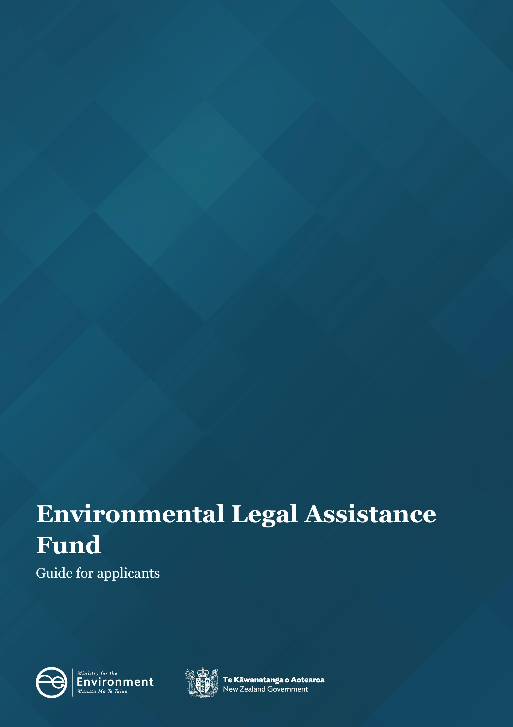
Title goes here
Subtitle goes here

Disclaimer
The information in this publication is, according to the Ministry for the Environment’s (Ministry) best efforts, accurate at the time of publication. The Ministry will make every reasonable effort to keep it current and accurate. However, users of this publication are advised that:
- the information does not alter the laws of New Zealand, other official guidelines, or requirements
- it does not constitute legal advice, and users should take specific advice from qualified professionals before taking any action based on information in this publication
- the Ministry does not accept any responsibility or liability whatsoever whether in contract, tort, equity, or otherwise for any action taken as a result of reading, or reliance placed on this publication because of having read any part, or all, of the information in this publication or for any error, or inadequacy, deficiency, flaw in, or omission from the information in this publication
- all references to websites, organisations or people not within the Ministry are for convenience only and should not be taken as endorsement of those websites or information contained in those websites nor of organisations or people referred to.

This document may be cited as: Ministry for the Environment. 2024. Environmental Legal Assistance Fund: Guide for applicants. Wellington: Ministry for the Environment.

First published in June 2017. Updated in January 2024.

Published by the
Ministry for the Environment
Manatū mō te Taiao
PO Box 10362, Wellington 6143, New Zealand
environment.govt.nz

Publication number: INFO 802

© Crown copyright New Zealand 2024.

Contents
About this guide 4
About the fund 4
How much funding is available? 4
What the fund covers 4
What the fund does not cover 5
Eligibility criteria 5
Funding maximum and multiple process applications 6
Timeframes 7
Board of inquiry timeframes 7
Assessment criteria 8
Primary criteria 8
Secondary criteria 8
Other considerations 9
Who makes the decision? 9
Complaints from third parties 9
Completing an application 10
Successful applicants 12
Confidentiality 12
Sending applications and more information 12

About this guide
This guide will help you determine whether your group is eligible for funding from the Environmental Legal Assistance (ELA) Fund, and will help you answer the questions in the ELA Fund application form.

About the fund
The ELA Fund is for not-for-profit groups advocating for matters of environmental public interest. Funding enables applicants to participate more effectively and efficiently in matters or issues affecting the environment or processes regulating the environment. The purpose of the ELA Fund is to promote access to justice in environmental litigation decision-making processes.
An Independent Advisory Panel (Panel) assesses applications against set criteria and makes recommendations to the Ministry for the Environment (Ministry).
Successful groups are required to enter into a deed of funding with the Ministry. Please refer to our website to view a copy of a draft deed.
More information about the fund, including an application form, is available on our website.

How much funding is available?
There is no minimum grant. The maximum grant is $50,000.00 (excluding GST) per group per application for any one case.
The ELA Fund has a total annual budget of $600,000.00 (excluding GST).

What the fund covers
Funding is available to cover the time and expenses of legal representatives and/or expert witnesses used in preparing for, resolving and/or presenting cases (including court-assisted mediation) before the Environment Court, higher courts, boards of inquiry and for first instance hearings (for example, before decision-making panels) where the right of appeal is likely to be restricted to points of law only.
As part of your application, you must include a short resume about your legal representatives and expert witnesses which outlines their relevant qualifications and experience, including the experience of your legal counsel in resource management or environmental matters. There is no guarantee any or all requested funding will be awarded. You must be eligible for funding and only reasonable costs will be considered for funding.
If you don’t provide enough information, a request will be made for additional information. Your application will not be assessed until all the required information has been provided.

What the fund does not cover
Funding is not available for:
- costs incurred before the original funding application was lodged
- assistance at council-level hearings where there is a right of appeal that is not restricted to points of law only
- costs of members of applicant groups in any event
- sundry costs of non-incorporated groups
- costs of establishing the group as a legal entity
- ongoing costs of the group, such as capital costs and rent
- costs awarded by a court against a group or individuals of the group
- costs of preparing submissions to the Minister for the Environment for board of inquiry hearings under the call-in process. This is a prior stage to the board of inquiry hearing.

Eligibility criteria
The ELA Fund eligibility criteria must be met before an application is submitted to the Ministry. Only complete and eligible applications will be forwarded to the Panel for assessment.
Note: Meeting the eligibility criteria does not guarantee your application will be granted funding.
- Applicant must be a not-for-profit group.
Eligible groups include:
- iwi and hapū groups
- incorporated societies
- community groups.
It is generally expected that groups are incorporated or a trust. The fund is not available to indivduals.
- The group must be party to a proceeding that is eligible for funding.
Before applying for funding the group must either:
- already be engaged in the proceeding by being a party to the case (eg, by having lodged a submission with the relevant authority or by participating in court proceedings as an initiator, respondent or interested party); or
- have demonstrated to a court that the group has standing to participate in the proceeding.
Note: Groups with shared interests who are parties to the same proceeding are encouraged to apply under one application.
- The group’s legal status must be verified by providing the required supporting documentation as requested in section 2 of the application form.
If your group is a legal entity: Many legal bodies are registered with the Ministry of Business, Innovation and Employment as a trust or incorporated society and will have an identifying registration number (see www.societies.govt.nz). Please attach a copy of your group’s mandate/rules to your application.
If your group is not a legal entity: You must:
- provide recognition from the Court that your group is a party before the Court in the proceedings
- document the membership of the group and provide proof of the members and history of the group
- have more than one individual who has authority to sign documents on behalf of the group, including the ELA Fund application form
- include a mandate from the group granting those members authority to sign
- provide information that the group has structures in place to act as a group (eg, evidence of regular meetings, bank account information)..
As a non-incorporated group, you should be aware incorporated groups can be protected from having to personally pay any award of costs against the group.
Iwi/hapū groups and other Māori groups:
If you are an iwi, hapū or Māori group and not an incorporated group or a trust, include the same information as required for a group which is not a legal entity.
- The group must submit a complete application and all required supporting documentation as specified in the ELA Fund application form.
Please contact the Ministry by emailing ela.fund@mfe.govt.nz if you have questions about your eligibility to apply to the ELA Fund.

Funding maximum and multiple process applications
The Ministry will fund up to a maximum of $50,000.00 (excluding GST) per group, per application, in respect of any one case. Where the applicant is involved in several cases arising out of the same plan process, we will only approve funding after considering all the cases that the applicant is involved in. In this context, the ‘plan process’ means appeals relating to regional policy statements, regional and district plan reviews, plan changes or variations.
Accordingly, applicants for funding involving more than one case arising out of the same plan process must make one application to cover all cases. This application must cover all the issues and cases that are the subject of the plan process involving the applicant. It should detail:
- how and to what extent any of these cases are interrelated
- the plan process the cases relate to
- the counsel to be engaged
- what evidence is proposed, and by whom
- all information relating to any interlocutory proceedings and other procedural matters that may have taken place
- where known, any related parties involved in supporting the issues for which the group seeks funding (eg, the council, other groups) and the issues they are contesting.
You will be expected to prioritise the cases and/or related issues. If funding is made available, it will be fixed in a sum that enables the applicant to participate in those cases with the highest priority. While the funding will not be limited to the maximum of $50,000.00 (excluding GST), the applicant should not expect to receive the maximum for each issue or case arising out of the same plan process.

Timeframes
Panel meetings are held approximately every six to eight weeks. The close-off date for applications for each Panel meeting is approximately four weeks before the meeting. The dates for upcoming Panel meetings are available on our website.
As it takes time for applications to be processed, you are advised to apply for funding early, preferably as soon as you have lodged your appeal or become a party to the proceeding. It is important you include all the required information or processing your application will be delayed.

Board of inquiry timeframes
If your group, as a submitter to a board of inquiry, is concerned about timeframes for receiving a decision on funding due to the board of inquiry’s evidence exchange timetable, contact the ELA Fund team to discuss by emailing ela.fund@mfe.govt.nz.

Assessment criteria
The primary criteria recognise whether the application impacts the environment or involves processes regulating the environment that are of consequence to the public. The secondary criteria provide other considerations which the Panel may take into account and therefore may also influence the level of funding, if any is recommended.

Primary criteria
The Panel will consider whether a group’s case is in the environmental public interest, including whether:
- it relates to or raises nationally or regionally important matters or issues affecting the environment or processes regulating the environment
- it relates to the relationship of Māori and their culture and traditions with their ancestral
- lands, water, sites, wāhi tapu, and other taonga
- it has the potential to create useful case law
- it has the potential to improve the administration and efficiency of the relevant resource management Act/environmental legislation
- involves issues of national or regional importance which will not be addressed in full before the relevant court or a board of inquiry or hearing authority without the expert evidence provided by the group
- the group and/or its members has a private interest in the outcome
- there is a degree of collaboration undertaken or proposed to be undertaken by the funding applicant with other parties in the case.

Secondary criteria
The Panel may consider:
- when considering the commitment of the group:
- the funding applicant’s demonstrated ability to manage the case (including any previous experience in legal cases)
- its history with the issue
- the time it has invested in the issue or case
- its financial contribution to the issue or case (having regard to the position of the group and the resources it can offer)
- its efforts to raise funds; and
- the pro bono contribution from lawyers and/or experts
- whether the case relates to Māori undertaking resource management/environmental
- duties and functions
- whether the group is open to mediation, and whether mediation is appropriate in the proceeding
- whether there is likely to be an imbalance between the quality of evidence and case management between the parties due to a lack of financial resources
- whether the case is vexatious or frivolous
- whether the case relates to a board of inquiry or a direct referral to the Environment Court or higher courts appeal
- whether the case improves the efficiency and effectiveness of policy and planning instruments
- any other matters arising out of the application.

Other considerations
These criteria are applied to the outcomes the applicant is seeking to achieve in its case, not to the whole legal proceeding.
Applicants that are predominantly made up of people who have a pecuniary interest in the case and would benefit materially from a decision in their favour, will only have funding provided if their case raises matters of high public interest, usually of precedent-setting value.
The fund has limited financial resources and priority will be given to cases of at least regional importance.

Who makes the decision?
Each application is assessed by an Independent Advisory Panel against the ELA Fund’s primary and secondary criteria. The Panel makes recommendations to the Ministry. Our Chief Legal makes the final decision on whether to fund an application, under delegated authority from the Minister for the Environment. Once final decisions have been made, a minute will be sent to you detailing the Panel’s recommendation and Ministry’s decision.
The Panel will only revisit a matter if exceptional circumstances are established.

Complaints from third parties
Where issues merit it, complaints or requests for review of decisions from third parties are submitted to the Panel for consideration. As with applications, our Chief Legal makes the final decision on whether to fund an application, under delegated authority from the Minister for the Environment.

Completing an application
Applications must be made on the official application form. This is available on our website.
The application form is divided into seven sections. Some sections require text to be provided in the form, while others require supporting information to be attached. When submitting an application, place the application form at the front and attach any supporting information grouped and named according to the seven sections set out on the following pages.
When filling out the application form, you should pay attention to the fund’s criteria.
- Contact details
- State the group's full legal name and physical address.
- Provide the contact details of the primary and secondary contacts for the group
- Group details
- Identify the type of group by ticking the relevant box (eg, iwi/hap?, residents and
- ratepayers group).
- State when your group began operating.
- State the objectives of the group.
- Provide the necessary supporting information depending on the legal status of the group (eg, incorporated society, trust or non-incorporated group).
- Application details
- Provide the case name and number.
- Indicate the type of case by ticking the relevant box.
- Briefly outline what your application relates to.
- Outline the group's legal argument and the history of its involvement in the case.
- Outline the procedural steps of the case to date and any key upcoming events. Clarify which steps you are seeking funding for.
- List all the parties involved in the case, and describe any collaboration with parties with the same interests as your group.
- Provide the necessary supporting information.
- ELA application details
- Explain how the application meets the primary criteria stated in the question:
- How does the case relate to national or regional matters affecting the environment or processes regulating the environment?
- Explain how the case relates to the relationship to M?ori, their culture, and traditions with their ancestral lands, water sites, w?hi tapu and other taonga.
- Explain whether the case will create useful case law.
- Explain whether the case could improve the administration or efficiency of relevant environmental law.
- Explain whether the evidence your group is providing in the proceedings will contribute to addressing the national or regional important environment issues in full.
- Funding details
- Complete all questions in section 5.
- Complete the table in question 5a to show for each witness and/or legal counsel you are engaging in your case:
- their name and firm/company
- their area of expertise
- their costs per hour, and the total value of their work. The value of future work should be confirmed in quotes that are provided as part of your application
- which of the witnesses/legal counsel you are seeking funding for
- please ensure total amounts are provided in the table. The table includes guidance about what information should be included in each column.
- Provide a summary of experience (eg, curriculum vitae) for each person listed in 5a.
- Provide a quote for each individual listed in 5a you are seeking funding for.
- Provide an itemised list of costs incurred and paid for by your group for the case to date (including costs incurred at council-level proceedings).
- Provide all the supporting financial information requested in section 5.
Other types of applications
In addition to the application form, we also have a variation application form and a reconsideration application form. These are available on our website.
The variation application form is for groups who applied to the ELA Fund in a previous round for the same case proceedings and are requesting additional funding due to changing circumstances of the case, and/or are requesting changes to legal counsel and/or expert witnesses. Groups can apply for funding for any costs incurred after the original application date listed on their deed of funding.
The reconsideration application form is for groups whose initial application was declined and who wish to request a reconsideration of the Panel's decision, or for groups who were awarded a rationed amount of funding initially and wish to apply for the remainder of the funding they missed out on. For the latter scenario, the group must apply in the same financial year.
Supporting information
Identify the supporting documents provided with your application by ticking the relevant boxes. In all cases, regardless of the type of case, you must provide a location map.
Group’s declaration
The application form must be signed by the primary and secondary contacts (or authorised members) and witnessed by a person authorised to make a statutory declaration (eg, Justice of the Peace).

Successful applicants
If successful, you will enter into a deed of funding with the Ministry setting out the terms and conditions of funding. You will sign the deed first, and once the Ministry’s Chief Legal has signed it we will return a finalised copy to you for your records. In addition, your group will be required to report back and provide:
- An interim report on the case’s progress by 1 June of each year until a decision on the case is reached.
- A final report once a decision is reached. The report will include an update on the outcome of the case, feedback about the value of funding received, a summary of money spent, and a copy of the decision.
We will only pay invoices from the group’s legal representatives and expert witnesses identified in the deed of funding. Invoices must be made out to the Ministry for the Environment. Please note the Ministry pays out GST. All invoices must be accompanied by a confirmation of work form, which must be filled out by a member of the group. You can find this on our website.
In general, the deed of funding begins from the date we first received the application. Costs incurred by the group before this date are not eligible for funding.

Confidentiality
Information presented to the Minister for the Environment or the Ministry is subject to disclosure under the Official Information Act 1982 (OIA). Therefore information provided in an application may be released upon request. Certain information may be withheld in accordance with the grounds for withholding information under the OIA. Further information on the OIA is available at www.ombudsman.parliament.nz.

Sending applications and more information
Send applications to ela.fund@mfe.govt.nz.
Note: we no longer accepted printed copies of applications.
For more information, please contact the ELA Fund or check our website:
Telephone: 027 218 4985
Email: ela.fund@mfe.govt.nz
Website: https://environment.govt.nz/what-you-can-do/funding/environmental-legal-assistance- fund/

