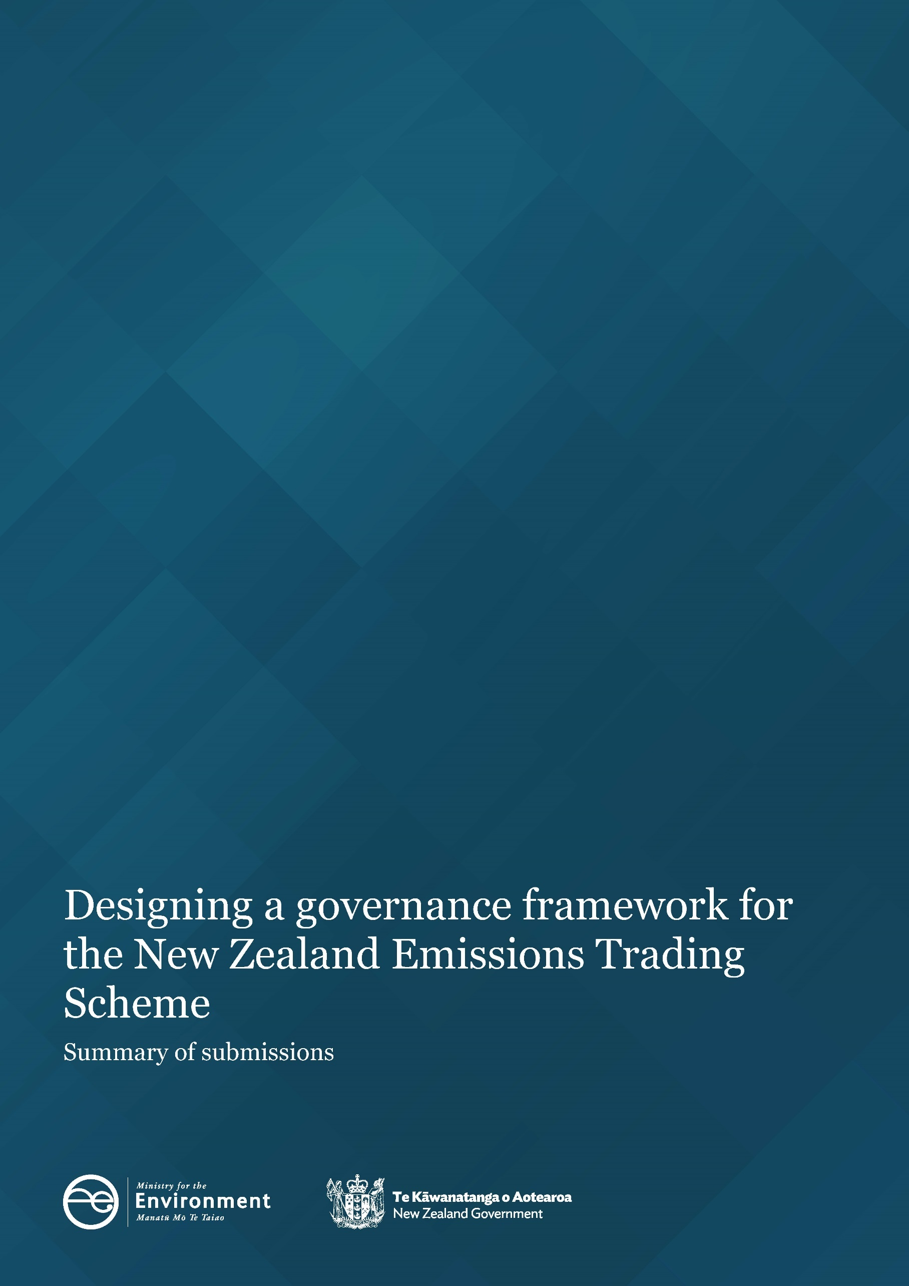

Disclaimer
While all care and diligence has been used in processing, analysing, and extracting data and information for this publication, the Ministry for the Environment and the data providers give no warranty in relation to the report or data used in the report – including its accuracy, reliability, and suitability – and accept no liability whatsoever in relation to any loss, damage, or other costs relating to the use of any part of the report (including any data) or any compilations, derivative works, or modifications of the report (including any data).

This document may be cited as: Ministry for the Environment. 2021. Designing a governance framework for the New Zealand Emissions Trading Scheme: Summary of submissions. Wellington: Ministry for the Environment.

Published in December 2021 by the
Ministry for the Environment
Manatū Mō Te Taiao
PO Box 10362, Wellington 6143, New Zealand
ISBN: 978-1-99-102502-9
Publication number: ME 1616
© Crown copyright New Zealand 2021
This document is available on the Ministry for the Environment website: www.mfe.govt.nz.

Contents
Contents 3
Tables 4
Figures 4
Executive summary 5
Background to the consultation process 5
Key findings 6
Consultation process 8
Webinars 8
Other engagement 9
Submission analysis and next steps 9
Who responded to the consultation 10
Written submissions 10
Summary of submissions by question 11
Governance of advice questions 11
Governance of trading questions 16
Governance of market conduct questions 21
Appointing a regulator questions 23
Risk analysis questions 26
Scenario analysis questions 27
Additional comments on topics outside of the questions asked 30
Appendix 1: Analysis of submissions 31
Appendix 2: Conventions used in this document 32
Glossary 33

Tables
Table 1: Number of submissions, by submitter group 10

Figures
Figure 1: Submissions on whether poor advice was received 11
Figure 2: Submissions on whether position reporting is supported 18
Figure 3: Submissions on whether exchange-based trading is supported 19
Figure 4: Submissions on whether position and purchase limits are supported 21
Figure 5: Submissions on whether appointment of a regulator is supported 23

Executive summary
From 8 July to 17 September 2021, the Ministry for the Environment (the Ministry) consulted on a range of options to improve the market governance framework of the New Zealand Emissions Trading Scheme (ETS).
This report summarises the views expressed in submissions received during this consultation process. It does not provide an analysis of those views, or recommendations in response to them. Any recommendations in response to these submissions will be made through policy development and advice to the Government.

Background to the consultation process
Over the last five years, New Zealand has made progress towards the institutional and governance frameworks we need to reduce greenhouse gas emissions and adapt to the impacts of climate change. This is evident in our recent consultation on New Zealand’s first Emission Reduction Plan and the Climate Change Commission’s report Ināia tonu nei: a low emissions future for Aotearoa which proposes emission budgets between now and 2035.
The ETS is one of the Government’s key tools to help Aotearoa New Zealand meet its emissions reduction targets. It does this by putting a price on greenhouse gas emissions and removal activities under the Climate Change Response Act 2002 (CCRA).
The Government is considering changes to the market governance framework for the ETS to ensure it has high integrity, promotes confidence in market trading, and is appropriately regulated to protect ETS users and prevent misconduct.
Good governance will help ensure the integrity and efficiency of the scheme, promote confidence in market trading, and reduce the risk of misconduct distorting the price of New Zealand Units. Creating a solid framework to govern the market will strengthen the scheme, in line with international best practice.
The consultation document ‘Designing a governance framework for the New Zealand Emissions Trading Scheme’ outlined seven market governance risks to the ETS and sought feedback from the public on a range of options for how these risks could be mitigated through a revised policy framework.
The seven market governance risks were structured into three key themes.
Governance of advice addresses:
- poor, false or misleading New Zealand Unit (NZU) advice
- conflicts of interest when trading NZUs.
Governance of trading addresses:
- poor transparency of market information
- counterparty risk when trading.
Governance of market conduct addresses:
- insider trading
- manipulation of the NZU price
- money laundering / financing of terrorism in the ETS.
The Ministry received a total of 59 written submissions throughout the consultation process.

Key findings

Governance of advice
The majority of submitters stated they had not received poor or misleading advice from advisers. Some submitters acknowledged that although they had not received poor or misleading advice, they were aware of poor advice in the market.
Submitters stated that an education campaign and information, if introduced to support governance of advice, must be easy to understand for all participants and would be beneficial for small ETS users.
Submitters were generally in favour of having voluntary guidelines, stating that guidelines for advisers would be useful if they assisted in mitigating potential bad advice as the market continued to evolve and mature.
Submitters stated any registration framework and code of conduct for advisers should consider linkages to similar frameworks. Consideration should be given to the Financial Markets Conduct Act 2013 (FMCA) and its Code of Professional Conduct for Financial Advice Services. Submitters also wanted to ensure double regulation is avoided for complementary frameworks such as the Forests Act 1949.

Governance of trading
Most submitters stated they would like to see more transparency in the ETS spot market. There were other submitters, however, who stated that an adequate level of transparency already exists.
Most submitters did not support position reporting because in their view it would have implications to their commercially sensitive information and would be an added layer of administration which would increase costs. Other submitters supported position reporting, claiming it would enable greater visibility, which was required when ETS participants had surrender obligations.
Submitters were generally opposed to mandatory exchange-based trading, stating it would add complexity to relationships and existing contracts, incur costs, and add barriers to entry for participants. Submitters were also concerned this could affect participants ability to meet NZU surrender requirements. These submitters were generally more open to a system where exchange-based trading is an option that traders can use on top of the current status quo.
Other submitters favoured a mandatory exchange and claimed this would give more transparency to all NZU trades and reduce financial harm.

Governance of market conduct
Submitters’ views on purchase and position limits varied. Most submitters did not support implementing purchase and position limits as a method to reduce misconduct, stating it would add another layer of complexity and increase compliance cost with minimal gain in reducing misconduct.
Other submitters favoured position and purchase limits, claiming this would prevent market price manipulation, reduce the risk of financial harm, prevent unfair dominance of the market by a few users, and provide smaller users a chance to compete.
Most submitters did not support full transaction reporting stating it could undermine business activity and impose undue costs. Some submitters were also concerned that the disclosure of position holdings to the market could have an adverse effect on smaller players, where business strategies rely on keeping position information confidential.
Some submitters noted that adequate frameworks already exist in the FMCA and Anti-Money Laundering and Countering Finance of Terrorism Act 2009 (AML/CFT) which were better suited to address misconduct.
On the other hand, a few submitters stated that they were comfortable with full transaction reporting to a regulator on a confidential basis.

Appointing a regulator
There were a range of views expressed by submitters on appointing a regulator for the ETS. A majority of submitters supported an appropriately skilled regulator that would ensure market compliance. Eleven submitters added that regulatory oversight by the Financial Markets Authority (FMA) should be considered. Alternatively, a regulatory body should complement the Commerce Commission and the FMA.
Conversely, other submitters argued that there is already confidence in the market and that a specific regulator is not needed.

Consultation process
From 8 July to 17 September 2021, the Ministry consulted on a range of options to improve the market governance framework for the ETS.
The consultation document consisted of 37 questions which gave the public, iwi, Māori, and ETS participants the opportunity to comment on specific design elements of the governance framework. For the full discussion document in electronic format, go to the Ministry’s website.
The 37 questions were divided into five broad areas, including the three key themes.
- Governance of advice.
- Governance of trading.
- Governance of market conduct.
- Options to appoint a market regulator to oversee the ETS.
- Risk coverage analysis and other.
Information about the consultation process was communicated through a variety of media channels, including a Ministerial press release, information on our website, and emails to iwi groups and groups of stakeholders, such as industry bodies.

Webinars
The public consultation strategy also included a series of Market Governance webinars conducted by Ministry officials, with assistance from officials from the Ministry of Primary Industries (MPI). There were also follow-up one-on-one engagement sessions with participants that requested them.
The webinars targeted three main groups:
- Iwi and Māori
- general public
- foresters.

Webinar with iwi and Māori
We held a webinar session with iwi and Māori on 2 August 2021. Understanding Māori interests and perspectives in climate change mitigation and adaptation is critical to developing effective policy responses.
Māori have a large interest in the ETS as landowners and foresters. This webinar session recognised our Crown obligation to adhere to the principles of Te Tiriti o Waitangi in partnership with our Te Tiriti partners in the design, delivery and implementation of the ETS governance framework. The webinar included themes that were specifically relevant to Māori groups, including the effects of these proposals on smaller ETS participants and forestry. MPI officials assisted with this session.
We worked with iwi and Māori organisations before and during the consultation to ensure that Māori had the time and capability to respond to the consultations.
A recording of this webinar can be found here: Iwi engagement for market governance.

General public webinar
On 3 August 2021, we held a general session on all the themes in the consultation document. This webinar focused on each of the proposals in the document and how they would affect various users of the ETS.
A recording of this webinar can be found here: Designing a governance framework for the NZ ETS.

Forestry specific webinar
On 4 August 2021, we held a session that focused on how these proposals would affect the forestry industry in particular. MPI officials assisted the Ministry on the forestry issues that arose during the webinar.
Questions from the webinars were summarised and responded to here: NZ ETS Market Governance Q & A from participants.
A recording of this webinar can be found here: Forestry specific engagement for market governance.

Other engagement
We held one-on-one meetings that were requested by some stakeholders, where their individual views on the consultation document were discussed.
In addition to the webinars held by the Ministry, some external stakeholders hosted independent workshops. These stakeholders included the Carbon Market Institute and Motu.

Submission analysis and next steps
This document summarises the feedback the Ministry received from the consultation phase.
Consultation closed on 17 September 2021. The Ministry will use the submissions received during consultation, alongside further policy analysis, as part of the evidence to inform its advice to Ministers on designing a governance framework on the ETS. The full set of redacted submissions can be found on the Ministry’s website.

Who responded to the consultation

Written submissions

Number and types of submissions
The Ministry received a total of 59 written submissions. All submissions received have been analysed and given equal weight in the analysis presented below.
This document summarises responses to the proposed improvements to the market governance of the ETS. It does not include analysis of proposed changes to the wider ETS settings or other matters. Two submissions which addressed issues broader than the governance framework of the ETS were relayed to the relevant teams in the Ministry. Therefore, the total number of submissions analysed here is 57 rather than 59.

Submitter groups
Submissions to the consultation were divided into the key groups identified in table 1.
Table 1: Number of submissions, by submitter group
Submitter type | Number
ETS industry participant | 20
ETS forestry participant | 13
Independent expert / industry expert / emissions consultant | 8
Individuals / member of public / other | 6
Financial service provider | 5
Trading platform | 4
Forestry consultant | 5
Iwi and Māori | 2

Summary of submissions by question

Governance of advice questions
- As an NZ ETS user, have you received poor, misleading or inaccurate advice on NZU prices or ETS trading? If so, how did this affect you, and what was the financial impact?

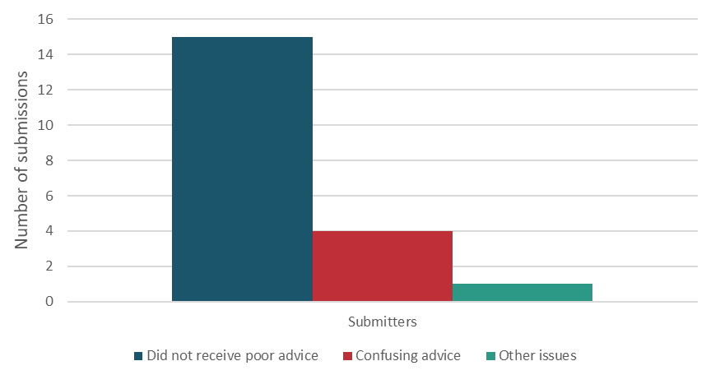
Figure 1: Submissions on whether poor advice was received
Most submitters had not received poor advice but were aware of poor advice
Fifteen submitters stated they had not received poor, misleading or inaccurate advice. However, seven additional submitters stated that although they had not received poor advice themselves, they were aware of instances of misleading advice for others.
Some submitters had received confusing or misleading advice
Four submitters stated that they had received confusing advice relating to the ETS. This advice ranged from general ETS rules to the actual trading of NZUs and included confusion on the qualifying criteria to participate in the ETS, failure to explain surrender liabilities, and a lack of care in detailing calculation methods for ETS participants. The submitters stated that the confusing advice, often with contradictions, made it difficult for laypersons to understand and this impacted their ability to engage with the ETS.
Other issues with advice
One submitter stated that the entire emission reduction policy landscape was filled with uncertainty which led to advice generally being uncertain. The submitter stated that although the advice received itself was not poor, it was constrained with the uncertainties of the ETS policy landscape.
- As an NZ ETS user, have you received advice with financial implications from an NZU adviser with a real, or perceived, conflict of interest? If so, how did this affect you, and what was the financial impact?
All submitters that answered this question stated that they had not experienced receiving advice from an NZU adviser that had a conflict of interest. One submitter stated that they were aware of the risk.
- To what extent would an education campaign and information pack improve decision making for users?
A majority of submitters indicated this would be useful for users
Half of the submitters responded to this question. Of this group, 23 submitters supported an education campaign and information pack. Submitters stated that the delivery of appropriate simple material would be of much value and that the material should be tailored to the different levels of ETS involvement. Others stated such information should be placed in one central location because the fragmented location of information makes it difficult for current or potential participants to find the information they need in a form that is understandable.
Five submitters did not think an information pack would add any significant value. These submitters stated there was ample information already available online and that this proposal would add unnecessary expenses.
- What information could help users and traders make informed decisions about engaging with the NZ ETS or selecting an adviser?
General information on ETS would be helpful for small users
Submitters mostly agreed that general information about the industry and its participants is useful – especially for new or smaller entities participating in the ETS. Submitter generally stated that if this option was considered, the information must be easy to understand for all participants. Suggested information included:
- costs and general requirements to be an ETS user
- how to identify good advisers and their relevant qualification(s)
- what to do if misleading advice is received
- key entities and the different types of advice they give
- accounting and tax practices
- guidance for small emitters
- how to access services to raise complaints
- rights under any applicable statutes.
Different information for different user types
Some submitters stated that different information on the various elements of the ETS will be relevant to different groups of users and traders.
For example, information intended for landowners would need to be specific for landowners. This would ensure landowners make informed decisions about the asset value of their land and the ramifications of their strategic land use. This information should include step-by-step processes for land evaluation and the steps required to register in an ETS. Similarly for businesses, the growing impact of the carbon price on their business model and the flow-through effects of the carbon price to their energy costs should be visible.
Other submitters stated that there was a need for more information for users interested in future NZU prices because the current available information was unhelpful and confusing. They suggested a need to engage with financial institutions, brokers and specialist advisers who already provide this type of information for their clients, and that engaging with these institutions would assist towards a more well-informed market.
Publicly available information is sufficient
Four submitters stated that the current information available on the Ministry’s website, as well as those published by the Environmental Protection Authority (EPA) on transactions and units transferred, was sufficient to understand the ETS.
- To what extent would voluntary guidelines for advisers improve the quality of their advice?
Submissions were generally in favour of having voluntary guidelines
Fifteen of the nineteen submitters who responded stated that guidelines for advisers would be useful if they assisted mitigating the potential for bad advice as the market continued to grow. This would also set a threshold for the expected level of service from advisers and promote a higher quality of service.
One submitter added that such guidelines were necessary for professionals who give advice on the ETS because of its complexity and the submitter’s experiences of incomplete or incorrect advice. The submitter stated there was a lack of knowledge for most sectors and their advisers. These sectors included accountants, lawyers and real estate agents.
Two submitters supported mandatory guidelines
Two submitters stated that voluntary guidelines would not work and that guidelines would only be beneficial to the industry if they were mandatory and codified in legislation. This would be supported by a register that advisers sign up to. It would include clear guidelines for raising concerns and complaints that to be independently reviewed and reported on.
- What should be included in the guidelines to improve the quality of advice?
Guidelines should outline accepted standards of best practice
Some submitters stated that guidelines should be substantive and provide advisers with clear roles, responsibilities, and expectations of all participants.
Submitters suggested the guidelines could also cover accepted standards of best practice and conflict of interest examples. They could further deal with specific issues such as compliance around ETS land use and other industry-specific issues.
Other submitters stated that a summary of already publicly available information was enough of a guideline for advisers due to the expectation that they should already have adequate knowledge on these issues.
Necessary to form a regulatory body before guidelines are considered
One submitter stated that it was too early for such guidelines to be considered and that the focus should be on forming a body that can work with market users and deliver their needs as the market evolves.
- To what extent would a code of conduct, registration and licensing framework for advisers improve the quality of their advice?
There was a mixed response from submitters to this option.
Most submitters favoured a framework for advisers
Thirteen submitters stated that a framework for advisers was the best mechanism to ensure compliance and improve overall quality of advice. In their view, a framework would ensure that the government set the necessary requirements and standards required for persons to be eligible ETS advisers. A code of conduct under the framework could then ensure that advisers abide by best practice standards.
Existing frameworks need to be considered
Four submitters stated that developing this framework alongside or under the FMA would ensure that there was consistency across frameworks. Submitters stated this would ensure there was a penalties framework if bad or misleading advice was given, and would result in better advice from advisers.
Four submitters also noted that any registration system would have to consider the ongoing changes to the Forests Act 1949, including that of the Forests (Regulation of Log Traders and Forestry Advisers) Amendment Act 2020 and potential double regulation of advisers.
Some submitters stated a code of conduct framework was unnecessary
Six submitters, including submitters involved in advisory services, stated that a registration and licensing system was unwarranted and that the current status quo was working adequately. These submitters thought a registration and licensing framework would be expensive and add costs to the system. There was a concern that these costs would eventually be passed out to users of the ETS.
One submitter stated, some financial institutions already have sufficient business rules covering their advisers, and this is sufficiently regulated by the organisations themselves. Therefore, implementing an additional framework on such advisers would be unnecessary.
Another submitter stated that similar regulations already exist, and it was necessary to establish an independent body first before such a framework was considered.
- What content would you expect in a code of conduct for advisers?
A code of conduct should align with other professional services
Submissions generally expected a code of conduct to be similar to those of other professional bodies. Some submitters suggested a linkage with the Code of Professional Conduct for Financial Advice Services under the FMCA. This would ensure an expected level of adviser expertise, minimum requirements for service agreements, and general service standards.
Other submissions stated that generally, there was an expectation that conduct principles include clear expectations on outcomes underpinned in the code. This would include registration, vetting, necessary expertise and experience, training, record keeping, and conflict management.
- Which licensing requirements and standards would you expect for an adviser?
A licensing framework for the ETS should align with financial markets obligations
Submitters in favour of licensing frameworks generally agreed that licensing requirements and standards should be similar to, if not integrated into, the licensing and registration system for advisers under the FMCA. This would ensure consistency across frameworks for advisers.
Submitters also cautioned against licensing requirements overlapping with the ongoing changes to the Forests Act 1949, including by the Forests (Regulation of Log Traders and Forestry Advisers) Amendment Act 2020.
- What other changes, if any, could improve the quality of advice in the NZ ETS?
A single governing entity over the adviser framework would improve the quality of advice
Some submitters stated that all areas of the ETS, including advisers, should be covered under a single governing entity, rather than the current situation where multiple frameworks oversee the market governance of the ETS. This regulator would have authority over the governance of advisers and ensure necessary requirements were met.
Encourage more participation in market analysis and information services
One submitter stated there was a need for a regulatory body to encourage banks, brokers and financial advisers to get more involved and produce market analysis. This would uplift the overall advice in the ETS.
Greater policy certainty and reduce complexity
One submitter had concerns that the ETS is frequently changing and suggested that stable policy and supporting legislation would lessen the complexity of advice required. Another submitter stated,
“One thing that would be helpful for advisers would be to stop signalling changes to the ETS rules before the specifics around the rules have been established. A good example of this is carbon averaging where clients are asking for advice on rules which are yet to be finalised”.

Governance of trading questions
- To what extent would more visibility on the price or volume of other NZU trades improve transparency in the NZ ETS, and better inform your decisions about buying and selling?
Submitters generally favoured more visibility
Twenty-five submitters stated that increased visibility of price or volume of NZU trades would improve transparency and assist users in decision making. Submitters claimed that improved transparency would lead to overall increased activity and could be achieved through trade platforms that could act as ’reporting entities’. Other submitters similarly stated that a form of ‘anonymous disclosure’ would be useful to avoid compromising competitive information of disclosing participants.
Submitters claimed that this visibility could be achieved through mandatory transaction reporting and transaction details being limited to quantities of NZUs traded and price per NZU.
Two submitters stated that if this information was given voluntarily, this could increase market confidence. It would provide more transparency on market liquidity and assist with informed decision making, which would in turn help minimise market manipulation.
Concerns that transparency might limit commercial freedom
On the other hand, 15 submitters stated that more visibility was unnecessary and would create more problems for businesses. Submitters claimed the current market was already transparent in the sense that accessing the spot price for carbon was very easy.
Submitters claimed that more visibility would create issues around commercially sensitive information being disclosed which could be exploited by other participants. Some submitters were also concerned that greater transparency would require creating more regulation which could further complicate the market. One submitter stated, “…we value our commercial freedom to transact NZUs as we see fit, to structure our own affairs, assess our own risks, and to engage the advisers of our choice”.
- What other types of information would make trades more transparent?
Some submitters claimed that there needed to be more price and volume data. This could include live prices, live quotes, price history and volume history. Some submitters stated there is a need to separate broker fees so that the actual unit fee is clear.
Other submitters stated that disclosure of the type of ETS participant was also essential, whether they are an ETS participant who has a compliance obligation, or an investor.
Trades that do not have ‘commercial arms’ length’ should be disclosed
One submitter stated,
“it would be useful for the [Environmental Protection Authority] to distinguish between true commercial arms’ length trades and trades between related parties (i.e. transfers rather than trades). Reporting on transaction volumes will only be useful where they relate to true trading. Otherwise liquidity will be over-estimated”.

Land connected to a NZU holder’s activities should be disclosed to assist lending institutions
One submitter stated that “lending institutions can become compromised in the collateral position they hold” if land information is not disclosed. The submitter stated,
“the lack of transparency of ETS obligations associated with land secured in favour of a lender, creates uncertainty and risk for lending institutions, both in terms of understanding the on-going value of the secured asset and the extent of ETS obligations associated with it. This is largely because, the ETS framework does not currently record the ownership of NZU’s, and land connected to a NZU holder’s activities under the scheme”.
- To what extent has credit and counterparty risk affected your ability to buy or sell NZUs? What was the financial impact on you?
Submitters see credit and counterparty risk as negligible
All submitters who responded stated that they had not been impacted by credit and counterparty risk. Although the risk had required some participants to adapt their procedures, it had not limited their ability to participate in the ETS. One submitter added these risks could be managed in private over-the-counter (OTC) carbon transactions and did not require any further information to be disclosed.
- As a NZ ETS user, what impact would voluntary transaction reporting have on your business or trading activity?
Submitters generally did not support voluntary transaction reporting
Sixteen of the twenty-nine submitters that responded stated that voluntary transaction reporting could lead to the disclosure of commercially sensitive information for trading which was information valuable to competitors. Some submitters stated they did not disagree with disclosure of information to a regulator in principle, but the specifics of users needed to be anonymised. If this was not the case, there would be little incentive for participants to report voluntarily.
Submitters added that only responsible companies would report, which would add a layer of complexity and risk that could undermine the purpose of voluntary reporting. This would lead to incomplete information being put out in the market, which could cause users to make incorrect decisions based on partial information. This was stated to be worse than having no information.
Some submitters also added that there was no need to voluntarily disclose information and that this would be an unnecessary burden on participants. It was these submitters view that voluntary disclosure would add an extra layer of administration that would increase staff time and costs. These extra costs would be passed on to clients or customers of entities with these obligations.
Some submitters stated voluntary transaction reporting would be beneficial
Eight submitters claimed voluntary transaction reporting would be beneficial. Submitters suggested voluntary disclosure of daily aggregate price and volumes could be collated from the EPA, or from traders and platform operators willing to provide data on a voluntary basis. One submitter stated anonymised voluntary reporting would enhance the existing status quo of OTC transactions and market platforms.
Voluntary transaction reporting would not have any impact
Four submitters stated a voluntary reporting requirement would have no impact on their trading activities. These submitters claimed that they were familiar with the processes having been involved with them in other frameworks.
Voluntary reporting would not be effective and would have limited engagement
Two submitters stated that given it was voluntary, it would have little impact on them and they would not engage with the reporting at all.
- As a NZ ETS user, what impact would position reporting have on your business or trading activity?
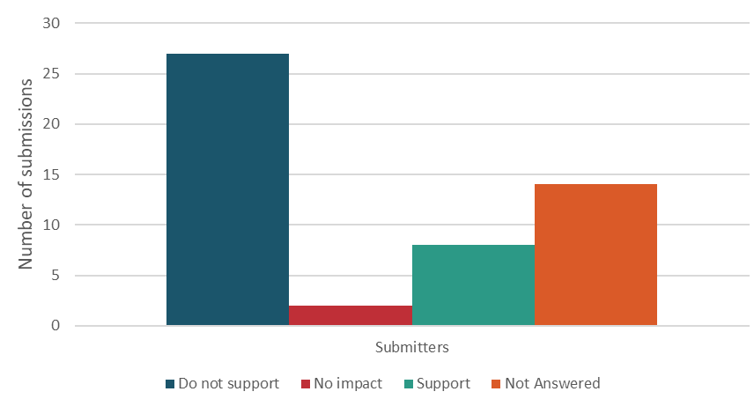
Figure 2: Submissions on whether position reporting is supported
Most submissions did not support position reporting
Twenty-seven submitters who responded did not support position reporting. These submitters generally stated it would lead to the release of commercially sensitive information. Submitters stated this would harm negotiating positions of participants and that the New Zealand Emissions Trading Register (NZ ETR) already had such information and was a more suitable platform to address this. One submitter added that if the concern was undue market power, the threshold to obtain such information must be based on a high volume of trade before there is a requirement to report. Position reporting would provide valuable information to competitors which could lead to anticompetitive behaviour.
Submitters also thought this would be an added layer of administration that would increase costs without adding much data value.
One submitter added that they held onto units in a personal capacity and would find this a personal privacy imposition.
Position reporting could lead to more transparency
Eight submitters supported position reporting. The submitters stated they would like to see greater disclosure on the NZ ETR to identify NZU holdings across different participants.
The submitters noted this could include forestry participants, parties with surrender obligations, and information on other ETS participants.
Position reporting should be made to a regulator
Submitters also stated that, if introduced, position reporting should be to an independent regulator.
Position reporting would have no impact according to some submitters
Two submitters stated that position reporting would have little impact on their trading activity. One of these submitters stated any position reporting should only be to a regulatory body.
- As a NZ ETS user, what impact would exchange-based trading have on your business or trading activity?
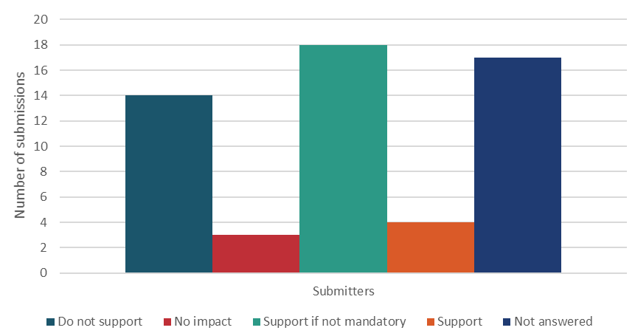
Figure 3: Submissions on whether exchange-based trading is supported
Most submissions supported voluntary exchange-based trading
Eighteen submitters who responded supported an exchanged-based trading system that is not mandatory. Submitters stated a mandatory exchange would add complexity, cost and barriers to entry for existing participants. Such a system if mandatory could also affect existing forward contracts, agreements and relationships between users. These submitters thought a mandatory exchange might also affect a participant’s ability to successfully meet NZU surrender requirements and complicate existing contractual obligations between ETS participants. This could also be difficult for smaller participants from an administration and cost perspective. Submissions stated that certain elements of the status quo should be retained, like OTC arrangements.
Other submitters claimed that if exchange-based trading was considered, the ideal scenario would be a combination of an exchange and OTC system. This would allow a combined approach of position reporting and a centralised clearing system, which would satisfy transparency requirements without restricting trading. However, some submitters claimed that an exchange-based trading system must be market led and not imposed by the Government.

Some submitters favoured a mandatory exchange-based trading
Four submitters who responded supported a mandatory exchange-based trading system and claimed this would give more transparency to all NZU trades. These submitters supported stronger regulations for financial reporting to reduce financial harm, and although this would increase costs, a mandatory exchange was necessary for this.
Some submitters opposed a mandatory exchange-based system
Fourteen submitters stated a mandatory exchange-based system was unnecessary for a market the size of the NZ carbon market. They felt the administrative and associated costs were likely to be greater than any benefits.
Submitters claimed that the status quo was working well and there was no evidence to suggest that regulatory intervention is required to improve liquidity and price discovery. These submitters thought a group of competing trading platforms could also improve liquidity, enable price discovery, and ensure a common set of rules instead of a mandatory exchange.
- What other options could increase transparency of trades, or reduce market risks associated with trading NZUs?
Submitters suggested a number of options to increase transparency. These options include that:
- participation in the ETS should be restricted to foresters and ETS participants with surrender obligations and “restrictions should be placed on investors and speculators”
- there should be an in-built escrow within the NZ ETR to mitigate counterparty risks
- transparency should be focused on identifying fraud in the market, and not making commercially sensitive information public
- brokers of NZUs should be required to disclose if they are buying or selling NZUs for themselves or on behalf of someone else
- NZU transactions should be reported and published within 24 hours of occurring.

Governance of market conduct questions
- To what extent would position and purchase limits protect all users against price manipulation, money laundering, and financing of terrorism?
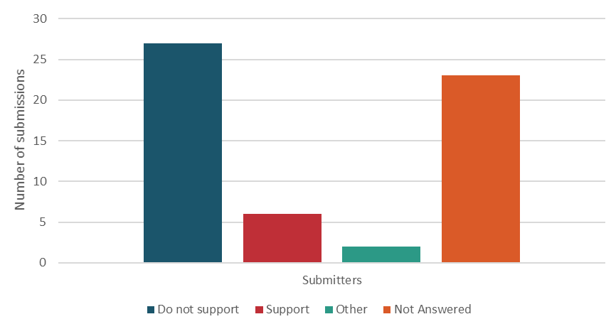
Figure 4: Submissions on whether position and purchase limits are supported
Majority of submitters did not support position or purchase limits
Twenty-seven submitters who responded did not support position or purchase limits, stating it would be unnecessary and complex, and increase compliance costs with minimal gain in reducing misconduct.
Some submitters stated it would hinder a financier’s ability to provide forward NZU sales to compliant entities, if the NZUs counted towards the financier’s position limit. Some submitters were concerned that placing purchase limits would therefore limit a broker’s ability to participate in the ETS.
Other submitters also stated position and purchase limits would have unintentional consequences on the market, would not address underlying issues and would lead to market inefficiencies. They recommended instead that an appointed regulator should have access to information that helps determine the existence, and materiality, of these risks in the market.
Other submitters claimed that position and purchase limits would fail to recognise the wide range of annual surrender obligations inherent in the ETS.
One submitter claimed position and purchase limits would likely lead to more small-scale speculators with a similar total quantity of units still being held and similar price effects for the NZU. They indicated that the value of the NZU would be primarily determined by predicted future abatement costs to achieve New Zealand’s climate targets. The submitter stated the current cost containment reserve on units is placed to ease the transition towards higher carbon prices and is priced such that transitions are smooth. As long as the expected future value of the units is greater than the current cost containment reserve price, then hoarding of NZUs may occur regardless of placing purchase or position limits.

Submissions also supported placing position and purchase limits
Six submitters claimed that position and purchase limits would prevent market manipulation, as is the case in stock markets which are overseen by a regulator. This could reduce the risk of financial harm, prevent unfair dominance of the market by a few users and in turn provide smaller users a chance to compete.
Adequate frameworks already exist which could address misconduct
Three submitters added that the FMCA and AML/CFT are best placed to protect users against price manipulation, money laundering and financing of terrorism. Submitters stated that these concerns should be addressed separately and without restrictions on entities with direct or indirect emissions obligations.
- As a NZ ETS user, what impact would full transaction reporting have on your business or trading activity?
Full transaction reporting could undermine business and impose undue costs
Seventeen submitters claimed transaction reporting would have a negative consequence, disclosing commercially sensitive information, and lead to anti-competitive behaviour. Submitters stated such reporting could undermine a business’ negotiating position in the market, reduce margins and ultimately lead to fewer funds being available for investment in decarbonisation initiatives. Submitters also added market platforms already provide price data and consideration should be given to develop this further.
Submitters also stated that this could cause additional compliance costs. There was concern as to how onerous reporting could potentially become given large reputable entities have already met their AML/CFT obligations, furthered by the fact that registration processes for an ETS participant are already robust. Submitters also questioned the material risk of money laundering or financing of terrorism in the ETS given there were other easier avenues available such as cryptocurrencies.
Full transaction reporting would be beneficial if anonymised
Conversely, six submitters stated that they were comfortable with full transaction reporting to a regulator on a confidential basis. This could include full transparency of all NZU trades including price and volume. These submitters generally agreed that this could be achieved with a regulator and would assist prevention of market manipulation and fraud.
- What information should be disclosed as part of full transaction reporting?
Submitters stated that the information that should be disclosed includes:
- public information that could be collated for all ETS participants to view
- NZ ETR volume movements as a ‘total’ per day
- open rates, closing rates and other data points that are at a public level
- the type of participants (eg, forestry participant, financial service provider) involved in transactions without disclosing participant names.
Submitters generally stated that specific identification of parties to a transaction should not be disclosed.
- What other options could reduce the risk of insider trading, price manipulation, money laundering, or financing of terrorism?
Incorporating the ETS into existing financial legislation frameworks
Two submitters stated that the application of the FMCA and AML/CFT could significantly reduce these market risks. This could include mandatory reporting of trading.

Appointing a regulator questions
- To what extent would appointing a regulator improve trust, efficiency and confidence in the ETS?
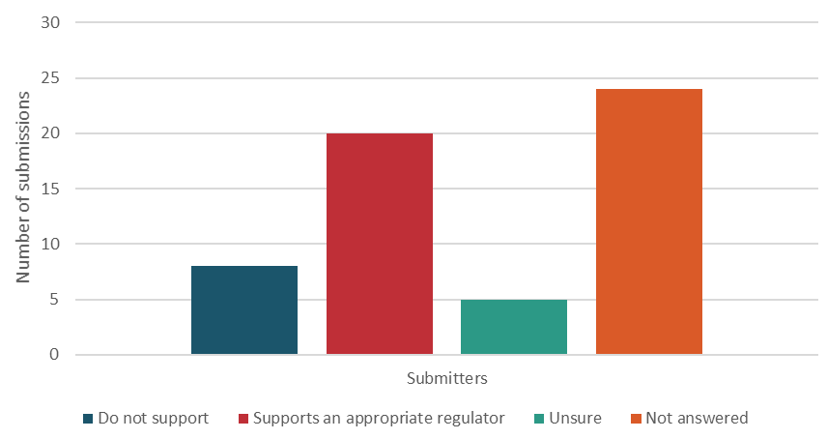
Figure 5: Submissions on whether appointment of a regulator is supported
Most submitters supported appointing a skilled regulator
Of the submitters who answered, twenty submitters supported appointing an appropriately skilled regulator to improve the ETS. Submitters stated a market regulator would improve the integrity of the market and the confidence that participants are behaving ethically. A regulated market would improve the market’s reputation and better support the potential for linking with other carbon markets in the future.
Eleven of these submitters mentioned that oversight by the FMA should be considered for the ETS. The submitters mentioned the FMA as an existing body that has the skill, expertise and structures in place to support all market participants and models.
A regulator would need to complement the Commerce Commission or the FMA
One submitter added that alternatively, if a new regulator was put in place, the regulator should complement other agencies that regulate some activity related to the ETS such as the Commerce Commission and the FMA. The submitter stated that this would be important as a regulator would be reliant on the Commerce Commission and the FMA for enforcement and compliance and would need to be able to share relevant information with them on an ongoing basis.
Some submitters stated appointing a regulator is unnecessary
Eight submitters stated a regulator would be an unwanted and unnecessary burden. These submitters stated there was no evidence the current market was working inefficiently and required a regulator. Submitters stated that the ETS had matured without a regulator and had proven those operating in the market were able to function effectively without the additional cost and compliance of a regulator.
Some submitters stated further analysis was needed before appointing a regulator
Five submitters stated they were unsure, and that further analysis was needed to be done before any form of regulator was appointed.
- What functions and powers would a regulator require to improve trust, efficiency and confidence in the ETS?
The submissions regarding the type of powers a regulator would need varied. They ranged from a self-regulatory model to a model where a regulator also oversaw design of the framework.
Some submissions stated that self-regulation would be most useful because compliance and market design models were too restrictive. Other submitters stated that a self-regulating industry body would not be useful if the intent was to improve trust, efficiency and confidence.
A regulator should be independent
Most submissions stated that a regulator needed to have a degree of independence.
A regulator would need some compliance powers
Some submitters stated that a regulator at the very least needed compliance powers to be effective. Consideration could then be given to establishing a regulator with wider powers, similar to that of a Reserve Bank. Submitters stated this would ensure the regulator had sufficient powers to collect the information it needed, and amend the system as required to align with New Zealand’s domestic and international climate obligations.
Other submitters had concerns with a market design regulator and the amount of power and influence such a regulator could exert.
A regulator could be integrated with or overseen by already existing frameworks
Again, some submitters stated that integration of a regulator within the FMCA and the FMA should be considered. Submitters considered that if NZUs were treated as ‘financial products’ under the FMCA and regulated by the FMA, the functions and powers of the FMA would not need to change for the purposes of the ETS industry.
One submitter stated the functions and powers required should be similar to those required by NZX RegCo to regulate the NZX, or by the FMA in relation to its market conduct function. The submitter stated that although not entirely similar, a regulator should still have the powers to regulate conduct and compliance within the ETS rules, including tools such as direction orders, warnings, enforceable undertakings, and pecuniary penalties.
- Do you agree with the definition of ‘material information’ as it relates to NZUs?
Most submissions agreed with the definition of ’material information’ but other definitions could be considered
Fifteen out of the 17 submitters who responded to this question agreed with the definition. Some submitters also suggested that it should also be aligned with the equivalent definitions in the FMCA to ensure that terms are interpreted consistently across different products in the market.
Another submitter suggested aligning the definition with the definition of material information in the NZX Listing Rules.
Some submitters wanted a more robust definition
Two submitters stated that the definition was insufficient and defined ’material’ as information that has a ’significant’ effect on price. The submitters stated that in effect, this merely transfers uncertainty from the word ’material’ to the word ’significant’. To these submitters, a much stronger definition and thresholds of what constitutes a significant effect would be required for the proposed definition to be credible.
- Do you agree that the Government should be required to disclose ‘material information’ about NZUs to the market in a way that encourages equal access to information?
Submissions generally supported requiring the Government to disclose ‘material information’ to encourage equal access to information. Submitters stated the current dissemination of information was inconsistent in timing and location and it would be useful to have clearer protocols for the release of material information on ETS policy matters, to guide all agencies and decision makers involved in announcing information.
Some submitters, however, stated that the Government could face some difficulty in managing and controlling the amount of information that is released in a fair and efficient way due to the amount of information available and the different avenues it comes from.
- What other types of regulator could the Government consider appointing?
The Government should only consider extending the functions of existing regulators
Nine submitters stated that the only regulatory body the Government should consider are regulatory bodies that already exist, and this includes the FMA. This would utilise an existing regulator to avoid unnecessary costs and delays in setting up a completely new regulator specifically for the carbon market. One submitter added that if NZUs became a ’financial product’, the FMA would be the ideal regulator.

Risk analysis questions
- Do you agree with the Government’s approach to assessing risk coverage analysis? If not, please provide your assessment of the risks.
Some submitters stated there was insufficient evidence in the analysis
Five submitters claimed their ability to evaluate the analysis was hindered by an insufficient evidence base. Submitters stated each issue must be properly assessed individually and cautioned against the document’s simplistic scenario approach which bundled quite separate issues together. Submitters also stated that market requirements of participants with surrender obligations lacked emphasis in the analysis.
Concern with the government overseeing all aspects of the ETS framework when it also is the primary issuer of NZUs
One submitter raised concern over NZUs being issued by the government and it then having a framework which oversaw its policy, administration and compliance. The submitter stressed concern over whether this was appropriate and suggested more consultation needed to happen with relevant government agencies that could potentially oversee the different aspects of the ETS and whether other viable options of independence could be considered.
Some submitters were happy with the status quo
Two submitters stated current markets are working effectively and efficiently in defining a fair carbon price and maintaining fair value. The submitters stated that issues with price discovery is only a perceived risk.
- Do you agree with the Government’s approach to assessing impact analysis? If not, please provide your assessment of the impact.
Insufficient evidence in analysis
Some submitters stated that there was an insufficient evidence base and further assessment was needed to ensure proper analysis. Consideration also needed to be given to the wider uncertainty of Government climate policy.
Other submitters were happy with the approach to assessing impact analysis, noting the criteria seemed appropriate.
- What other factors, if any, should the Government consider in its decision making?
Some submitters stated that any market innovation should consider the impact on the market's ability to innovate and be flexible in the way it solves current and future needs. These submitters stated it is important to avoid implementing regulations that could hinder participants’ commercial freedom to transact NZUs and affect ETS participants’ ability to meet surrender and transfer obligations.
Other submitters claimed that the Government should look to leverage existing systems and frameworks for that improvement. Other submitters stated that the current ETS is working well for the most part and would benefit from small adjustments to improve the robustness of the market.
Submitters also stated that the regulatory response must be proportionate and cautioned against over regulation of the ETS.
- What impacts do you see these proposals having on iwi or Māori in particular?
There is a need to consult iwi and Māori
Some submitters stated iwi and Māori are major land and forestry owners and likely to be benefactors of an ongoing well-functioning ETS, so this necessitated appropriate consultation. Other submitters stated because of the nature of the carbon holdings of some iwi, in particular the substantial holdings they have by way of pre-1990 forestry allocations, any application of position limits would have a negative impact. Consultation would be essential in keeping the scheme operating smoothly and any changes should focus on reducing complexity, costs, and encourage wider participation.
Same impact for all ETS participants
Two submitters stated that the impacts for Māori would be the same as other interested parties given the potential for great interest in the future value of NZUs. The submitters urged caution when differentiating impacts on different demographic users of the ETS and stated that the impacts from the ETS would be the same for all participants.

Scenario analysis questions
There were a variety of scenarios discussed in the following questions. There was one common theme that some submitters stated would be essential to whichever scenario was implemented.
Regular review of implemented scenario
Outside of the current options, submitters stated that it was essential that there be a regular review mechanism. This would ensure that the policies were being implemented appropriately.
- To what extent would the low-regulatory scenario address the market governance risks?
A low-regulatory scenario is beneficial
Nine submitters supported a low-regulatory scenario which allowed the trading status quo to be allowed to evolve with the inclusion of limited changes such as price reporting. However, caution needed to be given to the commercial sensitivities of information disclosure. Other submitters stated there was no market governance risk so this option should be the only acceptable outcome.
The low-regulatory scenario risks would not address market governance concerns
Six submitters stated that the low-regulatory scenario would unlikely be adequate to address the risks identified and would not address the wider transparency and market manipulation issues.
- What other non-regulatory options could be considered in this scenario?
Appointment of an independent committee of experts as a regulator
One submitter stated appointing a committee of experts to monitor the market would be desirable to fulfil the role of a regulator. Such an entity would need a mandate and would need to report to the Ministry or other government agencies on market governance concerns. This approach would be light handed and low in cost, but high in expertise.
- To what extent would the balanced scenario address the market governance risks?
Submitters stated the balanced scenario addresses risks of market manipulation
Seven submitters stated that the balanced scenario was their preferred option as it adequately balances the risks around market manipulation and regulation. The introduction of penalties would bring a higher level of compliance.
Of those submitters, views differed on certain aspects of the balanced scenario. Four submitters stated making exchange-based trading mandatory was not necessary, while three submitters agreed with the approach of having a mandatory exchange-based trading system. One submitter claimed the framework should consider the example of the electricity hedge disclosure system set up by the Electricity Authority and the financial transmission rights market which addressed transparency issues.
One other submitter stated that there was no need to impose position and purchase limits and disagreed with the option of implementing a regulator.
The balanced scenario will not address governance risks
One submitter stated that the balanced scenario and its options will not address the market governance risks that are present.
- What other options could be considered in this scenario?
All options proposed by submitters to this question have been raised in the responses to other questions in this document.
- To what extent would the risk mitigation scenario address the market governance risks?
The risk mitigation scenario is restrictive
Seven submitters against the scenario stated that certain elements of it were too excessive and would negatively impact the market and drown out smaller ETS users.
Although one submitter supported a mandatory exchange-based trading system, all other submitters stated it was unnecessary and would add complexities to an already complex system.
Two submitters stated that the scenario would not address the market governance risks and most of the considerations were unnecessary such as a mandatory exchange, position and purchase limits, and the appointment of a regulator.

Insufficient evidence in analysis
One submitter stated that the evidence base for the risk mitigation scenario was weak and this hindered their analysis.
- What other options could be considered under this scenario?
All options proposed by submitters to this question have been raised in the responses to other questions in this document.
- What other combination of options or scenarios could address the market governance risks?
One submitter proposed a scenario that had fewer regulatory options than the ‘non-regulatory scenario’. This included sector guidelines for advisers (A3), voluntary reporting (B2), status quo for trading (C1) and a self-regulating body (D2).
Some submitters were quite specific in their preferred combinations. These ideas have been summarised in the above questions.

Additional comments on topics outside of the questions asked
NZUs to be seen as a ‘financial product’ and be integrated into the FMCA
Eleven submitters (19 per cent of submitters) mentioned it was necessary that consideration be given towards treating NZUs as a ‘financial product’. Submitters stated this would ensure an easy transition and regulation by the FMA under the FMCA. The submitters added that should NZUs be treated as a ‘financial product’ under the FMCA, the functions and powers of the FMA would not need to change for the purposes of the ETS which would avoid costs and time delays in setting up a new regulator for the carbon market.
Multiple bids being allowed in primary markets affects the price of NZUs in the secondary market
One submitter mentioned that the auction process of NZUs allowed for price manipulation in the secondary market. The submitter thought that bidders should only be allowed to bid once and that bidders being allowed to bid more than once to ensure some of their bids are successful manipulates the price of NZUs in the secondary market.
This submission was noted although it is out of scope of the governance framework consultation.

Appendix 1: Analysis of submissions
We used an online tool to process submissions. Submitters either used the online submission form or emailed their submission directly to us.
One submitter sent more than one submission document. In this case, we logged all documents as a single combined submission to avoid duplication.
Our analysts received instructions and guidance to ensure their analysis was consistent across all submissions. We made every effort to ensure this document accurately summarises the overall feedback on the consultation document and its proposals. However, we cannot guarantee this report reflects all views.

Appendix 2: Conventions used in this document
Where we have used data or specific numbers when referring to the submitters who supported or opposed specific proposals, these are based on our interpretation of the submissions. We established protocols to ensure as much consistency in interpretation as possible.
Submitters did not always identify whether they agreed, disagreed or were ambivalent to proposals, even when they gave comments. When comments were ambiguous and appeared as such, we entered a selection of whether they supported or did not support in the data on their behalf.
We also tried to prioritise the presentation of different ideas by submitters regardless of whether this was the view held by the majority. We tried to avoid suggesting that ideas of the majority would outweigh the ideas of others.
This document also includes summaries of ideas and often quotations from submitters in their submissions. We selected quotations based on their value in illustrating issues or expressing points in a way that is difficult to paraphrase without losing the original meaning. Their inclusion does not mean we have given these submissions more weight than other submissions.

Glossary
Term | Meaning
Anti-Money Laundering and Countering Financing of Terrorism Act 2009 (AML/CFT) | This Act puts in place the legal framework to:  - detect and deter money laundering and the financing of terrorism  - maintain and enhance New Zealand’s international reputation by adopting, where appropriate in the New Zealand context, recommendations issued by the Financial Action Task Force  - contribute to public confidence in the financial system.
Climate Change Response Act 2002 (CCRA) | This Act puts in place a legal framework for New Zealand to meet its international obligations under the UN Framework Convention on Climate Change, the Kyoto Protocol, and the Paris Agreement.
Environmental Protection Authority (EPA) | A Crown Agent that helps the Government achieve its goal of growing the economy, while effectively protecting our natural environment. The EPA reports to the Minister for the Environment and the Minister for Climate Change on issues relevant to their portfolios.
Exchange-based trading | A regulated and licensed exchange, requiring users to register and meet conduct obligations. This increases oversight of trades, reduces counterparty risk, and helps detect market misconduct.
Financial Markets Conduct Act 2013 (FMCA) | This Act puts in place the legal framework to promote the confident and informed participation of businesses, investors, and consumers in the financial markets. It also promotes and facilitates the development of fair, efficient, and transparent financial markets.
Financial Markets Authority (FMA) | The New Zealand government agency responsible for enforcing securities, financial reporting and company law as they apply to financial services and securities markets. The FMA also regulates securities exchanges and financial advice providers.
Full transaction detail reporting | The introduction of a requirement for full transaction disclosure and reporting to the regulator. This would increase transparency, and protect against fraudulent activity, price manipulation, money laundering and financing of terrorism.
Market governance | The processes, policies and rules for managing risks of misconduct in the NZ ETS and protecting users from financial harm.
Market manipulation | Includes spreading false market information; cornering or squeezing the market; giving false impressions of market conditions – typically with the aim of influencing the market price for profit.
Nationally determined contribution (NDC) | NDCs represent efforts by each country to reduce national emissions and adapt to the impacts of climate change, as part of their obligations under the Paris Agreement.
NZU adviser | A person or entity that gives financial advice or guidance on NZUs in their ordinary course of business.
NZ ETS participant | A registered person or entity that carries out an activity listed in the CCRA.
NZU trader | A registered person or entity that buys and sells NZUs in the NZ ETS.
NZ ETS user | Any registered person or entity in the NZ ETS.
New Zealand Emissions Trading Register (NZ ETR) | New Zealand’s national registry for emission units, including those owned by the Crown. Anyone wanting to own or trade NZUs in New Zealand must have an account in the Register
New Zealand Units (NZUs) | One ‘emissions unit’ is equal to one tonne of carbon dioxide equivalent. NZUs can be traded among people and businesses participating in the NZ ETS
Over the counter (OTC) | Direct, bilateral trades between two NZ ETS users, without supervision or using an exchange.
Position reporting | A requirement where participants disclose the number of NZUs they are holding or borrowing. This increases transparency of the distribution of market power, counterparty risk, and market conditions.
Price reporting | A requirement for all NZU trades to disclose prices to the regulator. This increases transparency and protects against fraudulent activity and price manipulation.
Purchase and position limits | Position limits restrict the number of NZUs a user can hold at any one time, limiting their ability to exercise market power. Purchase limits restrict the maximum number of NZUs a user can buy at primary NZU auctions. Typically, ETS participants with surrender obligations can buy more units than speculative traders.
Voluntary reporting of trades | A mechanism for users to voluntarily report market transactions, for greater post-trade transparency, so that a regulator can monitor market developments and investigate suspected market abuse.

https://consult.environment.govt.nz/climate/designing-a-governance-framework-for-the-nz-ets/supporting_documents/MG%20consultation%20document%20%20FINAL.PDF
https://consult.environment.govt.nz/climate/designing-a-governance-framework-for-the-nz-ets/
An Australian industry group that has a role in regulating the Australian market.
A New Zealand economic research institute and think tank that deals with social and environmental issues.
Some submitters fitted into more than one category. We have acknowledged this by placing them into the different categories they fit into (eg, some ETS forestry participants were also forestry consultants). The table, therefore, does not total 57 submitters.
An NZU adviser is a person or entity that gives financial advice or guidance on NZUs in their ordinary course of business.
https://www.fma.govt.nz/compliance/guidance-library/code-of-professional-conduct-for-financial-advice-services/
New Zealand’s national registry for emission units, including those owned by the Crown. Anyone wanting to own or trade NZUs in New Zealand must have an account in the Register.
An escrow is an arrangement where a third party temporarily holds NZUs until the transaction is complete.

