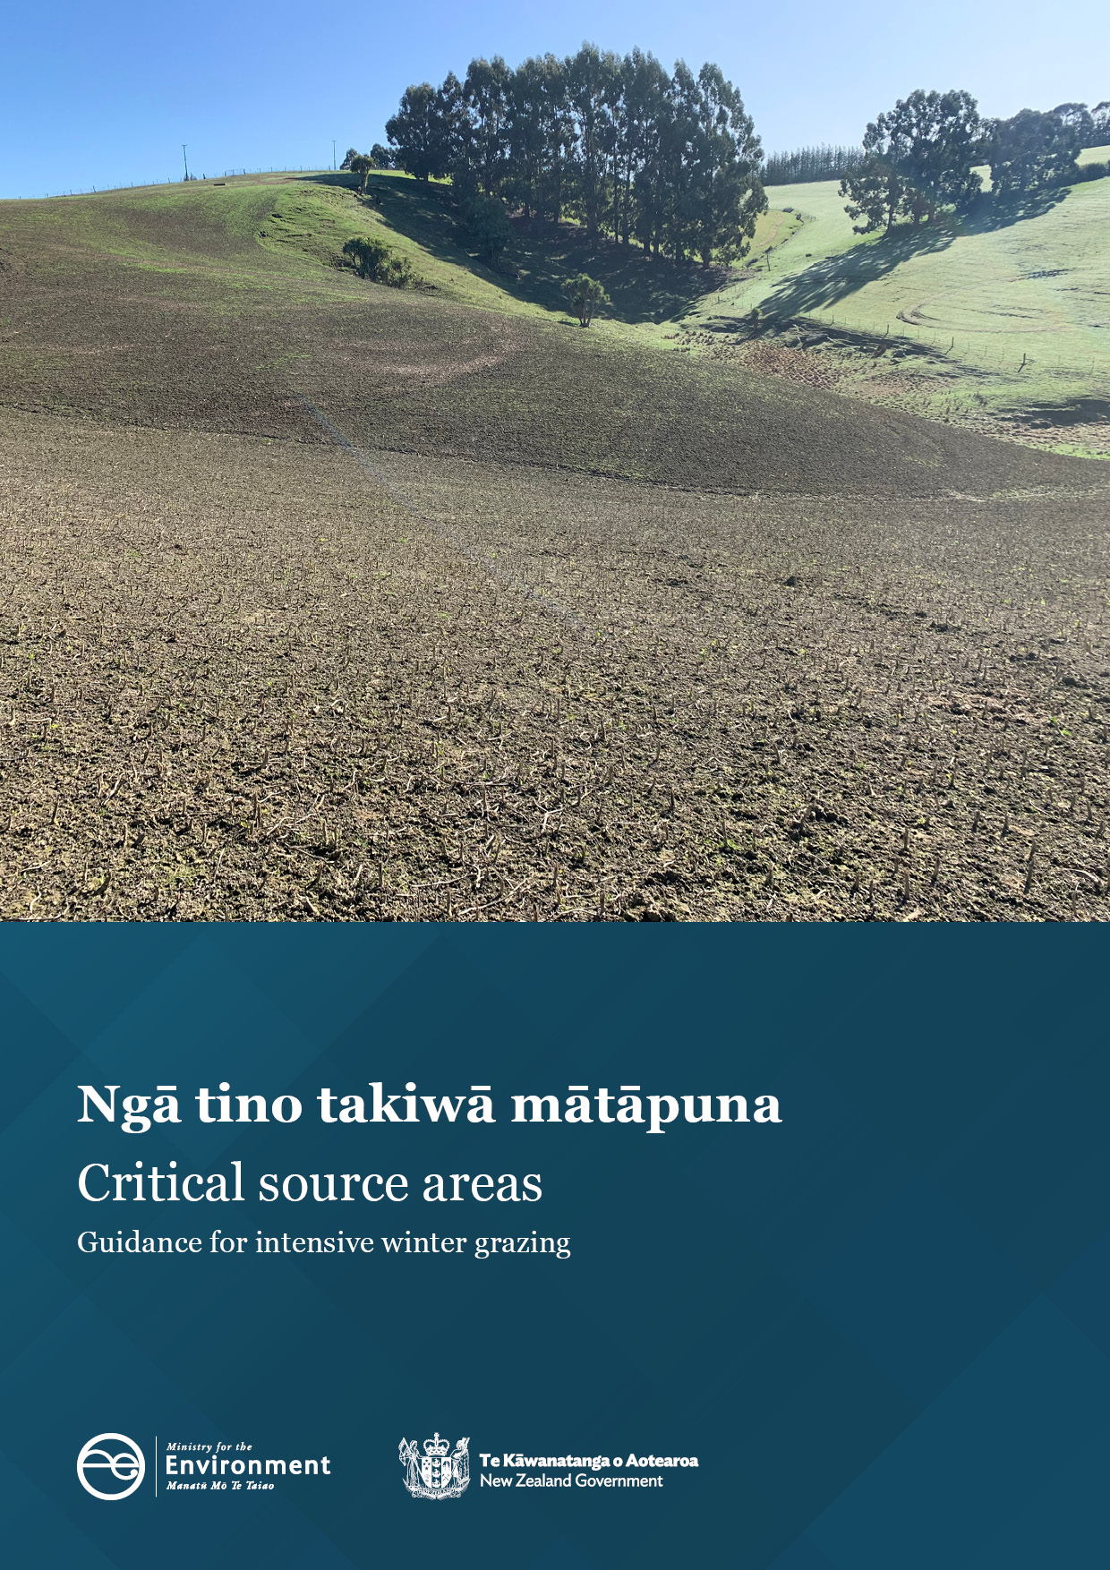

Disclaimer
The information in this publication is, according to the Ministry for the Environment’s best efforts, accurate at the time of publication. The Ministry will make every reasonable effort to keep it current and accurate. However, users of this publication are advised that:
- the information does not alter the laws of New Zealand, other official guidelines, or requirements
- it does not constitute legal advice, and users should take specific advice from qualified professionals before taking any action based on information in this publication
- the Ministry does not accept any responsibility or liability whatsoever whether in contract, tort, equity, or otherwise for any action taken as a result of reading, or reliance placed on this publication because of having read any part, or all, of the information in this publication or for any error, or inadequacy, deficiency, flaw in, or omission from the information in this publication
- all references to websites, organisations or people not within the Ministry are for convenience only and should not be taken as endorsement of those websites or information contained in those websites nor of organisations or people referred to.

Acknowledgements
Prepared for the Ministry for the Environment by Chandra Ghimire, Mike Rollo and Gina Lucci from AgResearch Ltd, October 2022 (RE450/2022/044). The authors would like to acknowledge the feedback from industry groups, councils, farmers, and AgResearch colleagues.
The Ministry for the Environment would also like to thank the regional council and Ministry for Primary Industries staff who provided feedback during the development of this guidance.

This document may be cited as: Ministry for the Environment. 2023. Critical source areas: Guidance for intensive winter grazing. Wellington: Ministry for the Environment.

Published in March 2023 by the
Ministry for the Environment
Manatū mō te Taiao
PO Box 10362, Wellington 6143, New Zealand
ISBN: 978-1-991077-33-2
Publication number: ME 1744
© Crown copyright New Zealand 2023

Contents
1. Executive summary 5
2. Introduction 6
2.1 Purpose 6
2.2 Document structure 6
3. What are critical source areas? 7
3.1 General concept of critical source areas 7
3.2 Critical source areas and intensive winter grazing 8
3.3 Other critical source areas 9
4. Regulation requirements 10
4.1 Intensive winter grazing regulations 10
4.2 Freshwater farm plans 11
5. Impacts on the environment 12
5.1 Critical sources and pathways 12
5.2 Intensive winter grazing and critical source areas 13
6. Implementing the regulations 16
6.1 Identifying critical source areas 16
6.1.1 Spatial and hydrological modelling approaches 16
6.1.2 Walkover surveys 17
6.2 Managing critical source areas 19
6.2.1 Management before winter grazing 19
6.2.2 Management between 1 May and 30 September 22
7. Integrating critical source area management with the winter forage crop cycle 23
7.1 Winter forage planning 23
7.2 Case studies of critical source area management 26
8. Knowledge gaps and limitations 32
Appendix 1: Walkover survey guide 33
Appendix 2: Other critical source areas 35
Appendix 3: Quick reference guide to critical source area guidance 37
References 41

Tables
Table 1: Contaminant sources in intensive winter grazing 12
Table 2: A decision framework for intensive winter grazing, covering the planning phase through to the review stage 24

Figures
Figure 1: The concept of a critical source area 8
Figure 2: An example of buffer strip on either side of a critical source area 21
Figure 3: Contaminant removal efficacy versus buffer width for: (a) sediment, (b) pesticide, (c) nitrogen and (d) phosphorus 21
Figure 4: Overview of the stages and key decision points in the grazed winter forage cropping cycle 23

1. Executive summary
This document synthesises scientific evidence into guidance to inform intensive winter grazing (IWG) activities in accordance with the Resource Management (National Environmental Standards for Freshwater) Regulations 2020 (NES-F). It provides recommendations on practical actions that farmers, land managers and councils can take to plan, manage and mitigate adverse effects from IWG activities, with a focus on critical source areas (CSAs).
Phosphorus, sediment and faecal microorganisms are the contaminants most susceptible to surface run-off from winter grazing. Nitrogen is mainly lost via drainage but can be found in surface run-off on heavy or compacted soils. Livestock treading damage due to winter grazing results in decreased infiltration capacity. This, in turn, leads to higher sediment and P losses in surface run-off and more chance that ponding of water on the soil surface will occur.
Critical source areas are areas within a paddock or catchment that contribute a disproportionately large (relative to their area) quantity of contaminants to water, negatively impacting water quality. The IWG regulations target critical source areas that accumulate surface run-off from grazed winter forage crops and deliver one or more contaminants to rivers, lakes, wetlands, surface drains or their beds. Targeting relevant mitigations specifically to critical source areas is an efficient and cost-effective approach to reduce nutrient loss from the whole farm.
The simplest way to assess potential critical source areas is to perform a visual inspection of contaminant sources and transport pathways. This ‘walkover survey’ involves walking around prospective IWG paddocks or a whole farm, usually during wet weather, looking for run-off-generating areas and their connectivity to waterways, and marking this information on a map.
The NES-F requires livestock to be excluded from critical source areas from 1 May to 30 September in order to meet permitted activity conditions. Even when lower stocking rates are used to graze forage crops in winter, wet conditions in critical source areas are usually sufficient to cause pugging and compaction. Critical source areas, therefore, can be significant sources of contaminant loss if left unprotected.
At the end of the season, reviewing the measures that functioned well, and what did not, is a vital step that is part of continuous improvement for future planning.

2. Introduction

2.1 Purpose
The purpose of this guidance is to help farmers, land managers and councils to manage and monitor intensive winter grazing (IWG) activities in a way that is consistent with IWG regulations and that minimises the impacts on the environment. This technical guidance will provide recommendations on practical actions that can be taken, within the context of different farm systems and conditions, to plan, manage and mitigate adverse effects from IWG activities.
The focus of this document is critical source area (CSA) management as part of IWG, in accordance with the NES-F regulations. However, it is important to remember that regional plans may also address IWG issues and if the plan rules are more stringent than the regulations, they will apply. Council rules should therefore also be checked.

2.2 Document structure
This document is structured as follows:
- Section 3 defines CSAs and the impacts of IWG on them.
- Section 4 presents the IWG regulations, as they relate to critical source areas.
- Section 5 summarises the impacts of critical source areas on contaminant losses to waterways.
- Section 6 provides guidance on implementing the regulations, as well as good practices for managing critical source areas before and during IWG.
- Section 7 presents a decision framework, which outlines the main steps in the IWG cycle, along with case study examples of critical source area management from different regions.

3. What are critical source areas?
Key points
- Critical source areas are areas within a farm or catchment that contribute a disproportionately large quantity of contaminants to water (relative to their extent), leading to poor water quality. Targeting relevant mitigations specifically to critical source areas is an efficient and cost-effective approach to reduce nutrient loss from the whole farm.
- Intensive winter grazing in critical source areas generates sources of nutrients through the deposition of dung and urine, while animal treading mobilises sediment particles and creates pugging and compaction, which can increase surface run-off.
- The IWG regulations target a specific group of critical source areas that accumulate surface run-off from adjacent winter cropped land and that deliver, or have the potential to deliver, one or more contaminants to one or more rivers, lakes, wetlands or surface drains, and/or their beds.

3.1 General concept of critical source areas
Not all locations on a farm contribute equally to the delivery of contaminants, and hence water quality degradation. Studies have found that a relatively small fraction of a farm or catchment can generate a disproportionate amount of contaminant load (Pionke et al, 2000; Gburek et al, 2000). Moreover, field observations have established that most stormflow (ie, run-off during and shortly after rainfall) is generated by a small proportion of the catchment area (often less than 10 per cent; Freeze, 1974). Identifying these hydrologically active areas is central to the design and implementation of water quality management.
Critical source areas are those areas within a farm or catchment that contribute a disproportionately large quantity of contaminants to water (relative to their extent). They are generally places where contaminant sources overlap with areas that are hydrologically active and connected to a waterway (Gburek et al, 2002; McDowell and Srinivasan, 2009). In other words, a critical source area is the combination of both a source of contaminants (eg, nutrients, sediment or faecal microorganisms) and a transport pathway (eg, surface run-off, ephemeral drainage) (see figure 1). Minimising either the source or the transport pathway will decrease the risk of contaminant losses.
Once sources and pathways have been identified, mitigation strategies can be more efficiently targeted to critical source areas than using ‘blanket’ approaches that restrict farming practice across entire catchments (Buczko and Kuchenbuch, 2007). However, it is important to incorporate a whole-farm management approach as the critical source area concept may not apply equally to all contaminants. For example, critical source areas are less relevant to reducing nitrogen losses as subsurface drainage is generally the main pathway for the transfer of nitrogen to water (Monaghan et al, 2016).
Figure 1: The concept of a critical source area
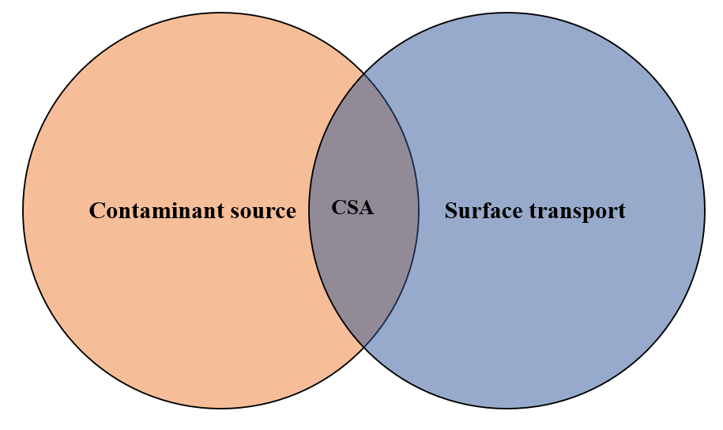
Critical source areas occur where a contaminant source in the landscape coincides with an active surface transport mechanism.
(CSA: after Walter et al, 2000)

3.2 Critical source areas and intensive winter grazing
Winter in Aotearoa New Zealand is an especially high-risk season for critical source areas because rainfall is high and evapotranspiration is low. This leads to frequent activation of surface transport pathways (Smith and Monaghan, 2003). Intensive winter grazing generates contaminants by depositing dung and urine in a concentrated area (Hively et al, 2005; Lucci et al, 2012), and via animal treading, which dislodges soil particles and creates pugging and/or compaction (Curran-Cournane et al, 2011; Monaghan et al, 2017). These effects are increased when a relatively large number of livestock is concentrated in a small area, resulting in stocking densities that can exceed 1000 cows/ha (Houlbrooke et al, 2009; Monaghan et al, 2017).
Winter grazing situations to avoid
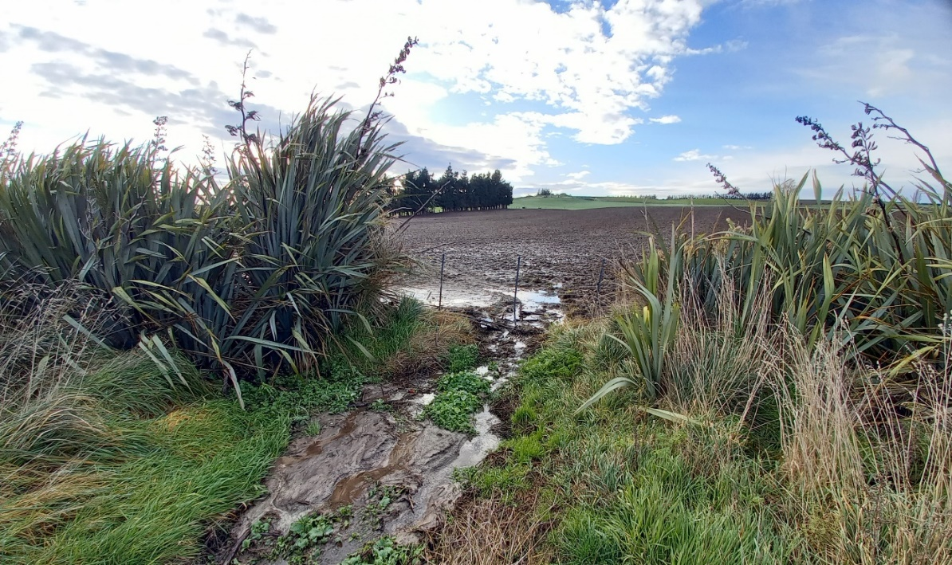
In the critical source area example above, sediment is visible running down the bank, and surface run-off (the transport pathway) which connects the wider contaminant source from IWG to a surface drain is clear. Contaminants invisible to the naked eye, such as phosphorus and faecal microorganisms, are also likely to be present in the surface run-off exiting this paddock. Next time, this area where surface run-off accumulates (ie, CSA) should be fenced off and left ungrazed to maintain vegetation during the winter.
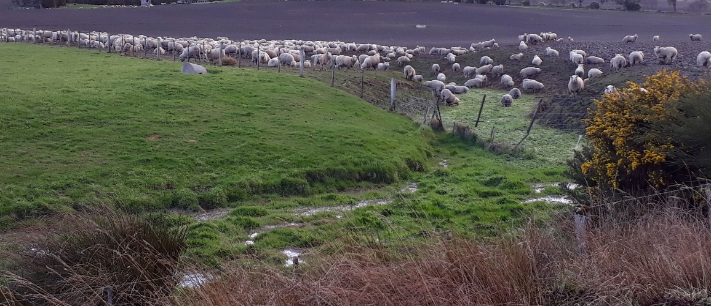
In the example above, livestock have access to a critical source area (CSA), directly contaminating an ephemeral waterway (surface transport) with dung and urine (contaminant source). Next time, livestock should be excluded from the critical source area to avoid the deposition of contaminants in the waterway. Livestock should be excluded from the steep, erodible edges of the critical source area using an approximately 5-metre buffer (see section 6.2).

3.3 Other critical source areas
Other critical source areas in and around the farm that are not covered by IWG regulations include:
- raceways or laneways (Lucci et al, 2010; Hively et al, 2005; Monaghan and Smith, 2012)
- in-paddock stock congregation sites (eg, feeding areas, stock campsites, water troughs and gateways) (Lucci et al, 2010; Hively et al, 2005)
- stream and river crossings (Davies-Colley et al, 2004)
- silage pits or feed bunkers (Gebrehanna et al, 2014)
- yards and animal holding areas (Hively et al, 2005).
These areas are proven sources of sediment, phosphorous, nitrogen and faecal contamination and should be noted in walkover surveys (see sections 6.2.1, 7.1 and appendix 1). Land managers should be mindful of any winter grazing activities adjacent to these areas to ensure surface run-off from them is not exacerbated by winter grazing. Appendix 2 has more information on these other critical source areas.

4. Regulation requirements

4.1 Intensive winter grazing regulations
The purpose of the Essential Freshwater package is to stop further degradation of Aotearoa New Zealand’s freshwater resources, start making immediate improvements and reverse past damage within a generation. In May 2022, amendments to the National Environmental Standards for Freshwater 2020 amended the requirements for land managers and regional councils relating to intensive winter grazing activities. The amendments include a new permitted activity condition requiring critical source areas (CSAs) that are within or adjacent to an area being used for IWG to be protected. For clarity in this document, the terms in the regulation are defined below (see box 1 and box 2), and taken from the Resource Management (National Environmental Standards for Freshwater) Regulations 2022 (NES-F).
Box 1: Definitions from the Resource Management (National Environmental Standards for Freshwater) Regulations 2022:
Annual forage crop: A crop that is grazed in the place where it is grown, but does not include either pasture or a crop that is grown for arable land use or horticultural land use.
Intensive winter grazing: The grazing of livestock on an annual forage crop at any time in the period that begins on 1 May and ends 30 September of the same year; includes activities on a farm that support intensive winter grazing and may occur year-round, such as the preparation and sowing of land for grazing and the cultivation of annual forage crops.
Critical source area: Means a landscape feature such as a gully, swale or depression that accumulates surface run-off from adjacent land; and delivers, or has the potential to deliver, one or more contaminants to one or more rivers, lakes, wetlands, or surface drains, or their beds (regardless of whether there is any water in them at the time).
The IWG regulations use the same concepts in their definition of critical source area, emphasising both the contaminant source and surface transport.
Three pathways can be followed when undertaking intensive winter grazing (Ministry for the Environment, 2022):
Pathway 1 – Permitted activities through satisfying conditions: IWG activities are permitted if a farmer complies with the default conditions set out in the NES-F IWG regulations. See Box 2.
Pathway 2 – Permitted activities through freshwater farm plan: IWG activities are permitted if a farmer obtains a certified freshwater farm plan (FW-FP) made under Part 9A of the RMA that applies to IWG and under which any adverse effects in relation to the IWG are no greater than would be allowed for by the default conditions set out in Pathway 1. Note that at this time FW-FPs made under Part 9A of the RMA have not yet been rolled out. See section 4.2.
Pathway 3 – Unable to comply with permitted activity standards: a resource consent is required (restricted discretionary activities) for IWG.
Although this document mainly provides guidance appropriate for following pathway 1, the recommendations in section 6 and section 7 could also help regional councils in evaluating resource consent applications for risk considerations and the appropriateness of IWG mitigation measures.
Box 2: Conditions for permitted IWG activities (pathway 1):
The area of the farm that is used for intensive winter grazing must be no greater than 50 ha or 10 per cent of the area of the farm, whichever is greater: and
The slope of any land under an annual forage crop that is used for intensive winter grazing must be 10 degrees or less, determined by measuring the slope over any 20-metre distance of the land: and
Livestock must be kept at least 5 metres away from the bed of any river, lake, wetland, or drain (regardless of whether there is any water in it at the time); and
On and from 1 May to 30 September of any year, in relation to any critical source area that is within, or adjacent to, any area of land that is used for intensive winter grazing on a farm:
- the critical source area must not be grazed; and
(ii) vegetation must be maintained as ground cover over the whole critical source area; and
(iii) maintaining that vegetation must not include any cultivation or harvesting of annual forage crops.
Resource consent or a certified freshwater farm plan (when available) will be required if you can’t comply with all Pathway 1 permitted activity conditions. For more information refer to the Ministry’s (2022) fact sheet.
Note that regional plan rules may cover IWG activities but may differ from the permitted activity conditions. These regional rules may be more stringent than national regulations. If they are, the more stringent rules must be followed — it is important to check with your regional council.

4.2 Freshwater farm plans
Pathway 2 is an alternative to following the conditions for permitted activities (pathway 1, box 2) or obtaining a resource consent (pathway 3). If the farm has a certified freshwater farm plan (ie, a freshwater farm plan under Part 9A of the RMA) that applies to intensive winter grazing, the activity must be undertaken in accordance with that plan. According to this pathway, any adverse effects allowed for by the freshwater farm plan must be no greater than those allowed for by the conditions for permitted activities (pathway 1).
Although freshwater farm plans are in the process of being rolled out, any data collected and plans made for managing critical source areas for IWG will help prepare future plans. This could include walkover surveys (see section 6.2.1) and other information captured in the template (see appendix 1), along with spatial elevation data such as LiDAR (see section 6.1.1). Over subsequent years, the plan would show emerging critical source areas across variable climatic conditions. More information about freshwater farm plans can be found on the Ministry’s website.

5. Impacts on the environment
Key points
- Phosphorus, sediment and faecal microorganisms are the contaminants of greatest risk to water bodies from IWG. Nitrogen is mainly lost via drainage but can be found in surface run-off in heavy or compacted soils.
- Livestock treading damage due to winter grazing results in decreased infiltration capacity, and higher sediment and P losses in surface run-off, and ponding of water at the soil surface is more likely to occur.
- Surface transport pathways that can connect contaminant sources with receiving waters include surface run-off, ephemeral waterways and springs.
- Contaminant sources without connectivity to a receiving water body pose a relatively low risk to water quality.

5.1 Critical sources and pathways
Most animals in Aotearoa are grazed outdoors year-round, which requires careful animal management, particularly over winter. This is the wettest time of the year, when the risk of soil treading damage is high, causing an increased risk of surface run-off losses of suspended sediment, phosphorus and faecal microorganisms (Monaghan et al, 2017; McDowell 2006).
The loss of nutrients and sediment from land can cause a decline in surface water quality due to effects like eutrophication (Carpenter et al, 1998). Most surface run-off is likely to originate within wet areas (eg, swales and gullies) where the soil is vulnerable to damage. Protecting and managing these critical source areas to minimise soil damage has been found to reduce the risk of surface run-off and contaminant transport to waterways. Understanding the transport pathway linkages between the contaminant sources and the waterways is an important factor in developing an evidence base for robust environmental management.
Table 1: Contaminant sources in intensive winter grazing
Contaminant | Description
Phosphorus (P) | Sources of phosphorus loss from winter grazing are mainly soil-bound phosphorus and dung (McDowell et al, 2003). Annual losses of up to almost 4 kg P/ha have been measured from winter grazing areas (Monaghan et al, 2017). Phosphorus in dung is especially mobile (McDowell and Sharpley, 2002), and phosphorus in cattle faeces may range from 10–23 g P/cow/day (Betteridge et al, 1986).
Sediment | Sediment losses of up to 3700 kg/ha/yr have been measured from winter forage grazing systems (McDowell, 2006; McDowell and Stevens, 2008; Monaghan et al, 2017).
Faecal microorganisms | Animal faeces and effluent are a source of faecal microorganisms, which are a public health concern (Ministry for the Environment, 2002). Surface run-off can transport large numbers of faecal micro-organisms (Muirhead et al, 2006).
Nitrogen (N) | Urinary nitrogen, rather than fertiliser nitrogen, is usually the source of nitrogen loss from winter grazing (Di and Cameron, 2002; Smith and Monaghan, 2003). Nitrogen is mainly lost via drainage but can be found in surface run-off on heavy, or compacted soils (Monaghan et al, 2017).
Surface transport
Surface run-off | Treading by livestock often leads to increases in soil bulk density, and decreases in soil porosity, macroporosity and hydraulic conductivity (Mulholland and Fullen, 1991; Singleton et al, 2000; Drewery and Paton, 2005; Curran-Cournane et al, 2010). Areas with treading damage have decreased infiltration capacity, higher sediment and phosphorus losses in surface run-off (Nguyen et al, 1998), and ponding of water at the soil surface is more likely to occur (Sheath and Carlson, 1998). Moreover, reduced soil infiltration due to cattle treading can persist for more than six weeks after the grazing (Monaghan et al, 2017).
Ephemeral waterways | Ephemeral waterways do not convey or retain water year-round but are only active during, or immediately following, rainfall events (Shanafield et al, 2021). Multiple run-off areas can converge in ephemeral waterways.
Springs and seeps | Springs originate where groundwater discharges to the surface, forming flow paths and small channels. A spring is commonly referred to as a seep when it discharges at a lower, and potentially ephemeral, flow rate (O’Driscoll et al, 2019).
Connectivity
The extent and efficiency of the pathways that transport contaminants to surface water bodies are measures of the connectivity to the surrounding landscape (Moloney et al, 2020). Conversely, dis-connectivity is the isolation of such landscape zones. Contaminant sources without connectivity to a receiving water body pose a relatively low risk to water quality. The extent or risk of connectivity will influence the size of the critical source area required.

5.2 Intensive winter grazing and critical source areas
During intensive winter grazing, surface run-off is likely to originate in areas that are typically wet during winter and where soil disturbance is high: eg, swales, gullies and depressions. These are critical source areas where seepage and infiltration-excess run-off flows converge and are thus targeted by the IWG regulations.
Swale:
- Swales are found in lightly sloping to rolling paddocks and concentrate water flows from the surrounding area into a shallow channel.
- Swales only conduct water during or after rainfall events and may act as ephemeral flow paths connecting contaminants with waterbodies.
- Soils in this part of the paddock are often very wet, possibly marshy and are thus at substantial risk of generating run-off during rain events.
Photo: Sheep grazing a winter forage crop, with an unprotected, grazed swale. The swale is evidenced by the ephemeral waterway snaking its way through the bare, grazed soil in the middle of the photo. (Note this photo was taken before IWG regulations came into effect.)
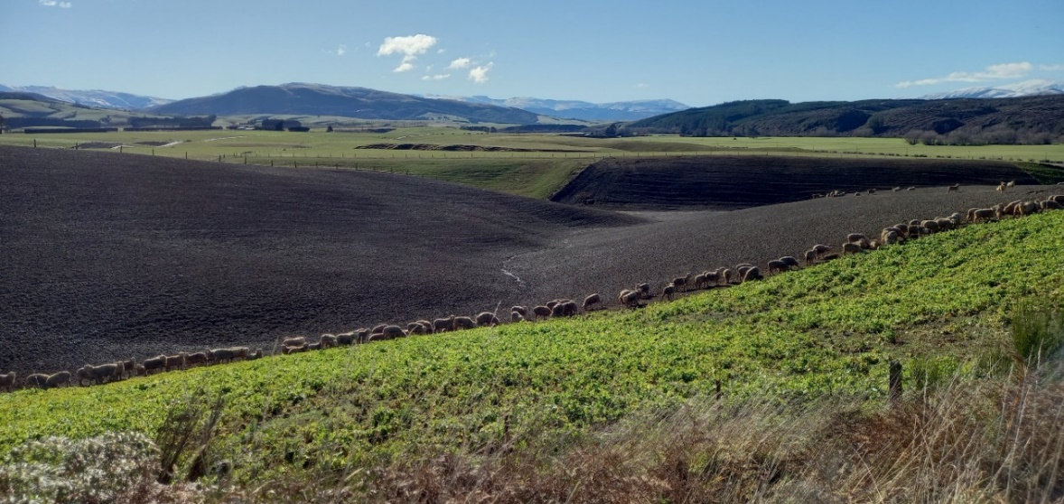

Gully:
- In contrast to a shallow swale, a gully is deep trench, or channel, where the soil has been carried away, exposing bare ground.
- On sloping land, shallow gullies sometimes form where surface run-off from vegetated ground flows onto patches of bare soil. The run-off picks up soil particles, initially rilling the bare surface (Hicks, 1995). With each subsequent rainfall event the rills deepen, eventually forming gullies which cut back and undermine surrounding earth. Very deep gullies can form on hill country if the underlying base is weathered rock, rich in clay.
- Small, shallow gullies are of main concern for grazed winter cropping, as deeper gullies are unlikely to be sown in a winter forage crop, and do not meet the permitted slope conditions of less than 10 degrees. However, if deeper gullies are adjacent to winter grazing areas, appropriate management should be in place to protect these areas from livestock grazing (see section 6.2).
Photo: Post-winter grazing of an unprotected gully. (Note this photo was taken before IWG regulations came into effect).
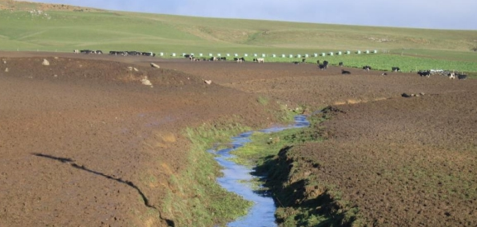

Depression:
- A depression is a low, possibly marshy area in the landscape that becomes saturated periodically.
- During and after rainfall events, depressions may become hydrologically connected to waterways via ephemeral flow paths and can be significant contributors of nonpoint source pollution to downstream waters.
- Depressions vary in both size and depth and are most easily identified by the presence of temporary standing water (or ponding) during wetter months.
Photo: A grazed depression with bare soil and erodible sediment in the centre of the photo. (Note this photo was taken before IWG regulations came into effect.)
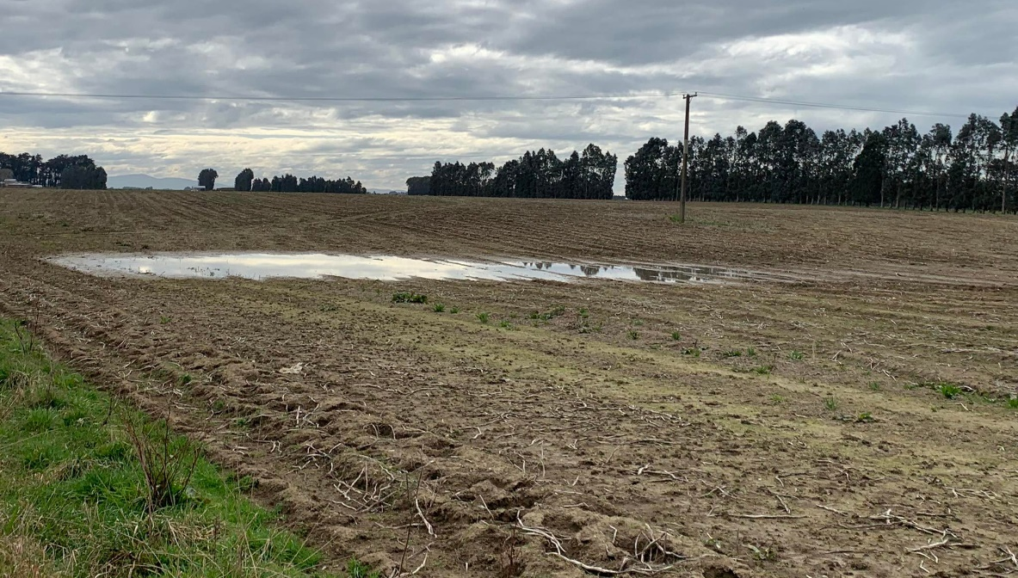

6. Implementing the regulations

6.1 Identifying critical source areas
Key points
- The simplest way to assess potential critical source areas is to visually inspect possible contaminant sources and transport pathways during or soon after heavy rain (ie, walkover surveys).
- Hydrological modelling can help delineate critical source areas and target areas for walkover surveys, but many catchments lack the resources and data to support this.
- Visually examining the soil moisture level after rainfall can help delineate the approximate extent of depressions and swales. One sign to look for is that soils in these areas often stay wet for prolonged periods after heavy rain. A soil moisture probe, or even gumboots, could be used to check if depressions fill up with water.
Approaches to identifying critical source areas range from simple inventories to complex models. The most basic and accessible way to identify them is to walk the farm while looking for sources and pathways (ie, walkover survey). Hydrological modelling can help to narrow down and identify specific farm areas likely to be critical source areas, but many farms or catchments lack the resources and data to support this approach. Where hydrological modelling cannot be performed, potential contaminant transport pathways can be identified by examining the following:
- farmer knowledge
- aerial photos
- maps of waterways
- information on soil types
- location of compacted areas
- topography.

6.1.1 Spatial and hydrological modelling approaches
A brief description of frequently used hydrological approaches used to delineate critical source areas is given below. All approaches vary in how applicable they are to delineating critical source area, and all have limitations (Srinivasan and McDowell, 2007). Several factors should be considered before choosing a method, including data availability, process represented, ease of implementation and economic impacts.

Topographic wetness index
Topographic wetness index (TWI) is an estimate of the potential for soil saturation of a land area (and therefore generation of surface run-off) based on slope and drainage area (Beven and Kirkby, 1979). TWI is calculated by using a digital elevation model in a geographical information systems (GIS) software programme (eg, ArcGIS), then using several tools within the programme to calculate the slope, flow direction, flow accumulation and TWI using a simple equation (Beven and Kirkby, 1979; Grabs et al, 2009). The resulting TWI spatial data layer depicts areas where water is likely to accumulate. Smaller TWI values indicate less potential for ponding while larger values reflect a greater risk due to the drainage from larger upslope areas, for example (Wolock and McCabe, 1995). TWI has been widely used as a conceptual tool to simulate saturation-excess run-off areas at a catchment scale. Simplicity and adaptability to various physiographic regions has allowed the topographic index concept to be widely applied.

Topographic wetness index plus impervious area
This approach includes both saturation-excess run-off as identified using TWI, and infiltration-excess run-off (ie, run-off generated when rainfall intensity exceeds soil infiltration capacity) (Srinivasan and McDowell, 2007). Compacted areas (eg, deer wallows) are considered as infiltration-excess run-off areas.

Phosphorus index
The phosphorus index approach assumes a fixed distance on either side of waterways as hydrologically active during rainfall events, and hence critical to contaminant transport (Gburek et al, 2000).

Drainage density
The drainage density (DD) method of delineating critical source areas is similar to the phosphorus index method and hence assumes that critical source areas occur in near-stream zones on either side of streams. Unlike the PI, which is independent of catchment and rainfall properties, the extent of critical source area calculated by a DD model is dependent on the size of rainfall event selected and antecedent rainfall conditions. This method allows for variable critical source areas with varying rainfall and catchment wetness conditions (Gburek et al, 2002).

Curve number
The curve number (CN) is empirically-based approach (Soil Conservation Service, 1972) and does not represent any specific surface run-off generation process. It uses hydrological soil group and land-use and/or land-cover information to calculate run-off. Thus, the transport areas delineated using this approach are specific to a land use and soil group.

Modified universal soil loss equation model
The universal soil loss equation (USLE) method delineates high-risk areas for sediment export (Sivertun and Prange, 2003) based on at least five landscape and climatic characteristics: (1) soil erodibility; (2) slope steepness and slope length; (3) proximity to watercourses; (4) land cover and (5) rainfall erosivity.

6.1.2 Walkover surveys
The simplest way to identify and assess potential critical source areas is to perform a visual inspection of contaminant sources and transport pathways during wet weather. During a so-called ‘walkover survey’, one is on the lookout for features which may accelerate or decelerate contaminant delivery to waterways (Reaney et al, 2019). Identifying such sources and sinks enables critical locations (ie, critical source areas) to be targeted with effective mitigation strategies.
Walkover surveys can provide useful, highly detailed, site-specific information on a range of potential sources and pathways of contaminants (see appendix 1 for a walkover survey guide). This method involves walking around a paddock, farm or catchment, usually during wet weather, looking for run-off-generating areas and their connectivity to waterways then marking this information on a map. A mobile-phone app has been used by Reaney et al (2019) to record features as either enhancing (a source/pathway) or decelerating (a sink/barrier) contaminant mobility. Such data can be mapped and analysed using computer software (eg, ArcGIS) (Reaney et al, 2019). These surveys provide a snapshot of water flows and the extent of ponding at the time during those conditions.
Gullies, swales and depressions (see section 5.2) should also be noted in the walkover survey and factored into the farm’s IWG strategy to comply with regulations (see section 4.1). Muddy conditions are more likely to occur in areas of low elevation (eg, swales and depressions) because surface run-off tends to accumulate in these areas. In lieu of a soil moisture probe being available, visually examining soil moisture levels after rainfall events can help delineate the approximate extent of depressions and swales. Some signs to look for are:
- soils in these areas often stay wet for prolonged periods after heavy rain. Gumboots could be used to check if depressions made fill up with water
- a lack of oxygen in frequently waterlogged soils may produce the smell of rotten eggs (Fraser et al, 2018).
- Wetter soil conditions can result in differences in vegetation leaf colour or plant composition (Clarkson, 2014).
Identifying the extent of a critical source area could depend on a number of factors, including weather conditions, topography and soil type. In certain landscapes, such as U- or V-shaped valleys where the boundaries of the critical source area may not be well defined (as opposed to gullies), identifying indicators such as differences in vegetation, leaf colour, plant composition and soil moisture could help identify the full extent of the critical source area.
Other areas to note in the walkover survey include:
- Bare soil: When exposed to a rain event, bare soil can become quickly eroded, leading to sediment movement into adjacent waterways. Significant areas of bare soil can be a major source of sediment. If the entire area of IWG is grazed to bare soil, especially where roots are also removed by grazing and trampling, the risk is increased.
- Pugged soils: These have low infiltration rates and hence high potential for surface run-off. Pugged areas with strong connectivity to waterways can act as a critical source area.
- In-paddock congregation sites and tracks: Sites of heavy stock use that are compacted or pugged (eg, troughs, gates, livestock camps and tracks) have high concentrations of nutrients and low infiltration rates.
- Farm machinery tracks: These are often compacted, unvegetated areas that are at high risk of run-off, especially when aligned up and down a slope.
- Surface drainage ditches: Drainage ditches that usually run perpendicular to the slope can act as a major conduit of agricultural contaminants (sediments, nutrients and faecal material) to receiving water bodies (Nguyen and Sukias, 2002; Moloney et al, 2020).

6.2 Managing critical source areas
Key points
- Planning and preparation, before the start of the IWG period on 1 May, includes considering site factors like slope and soil type, along with the proximity of IWG to waterways and critical source areas, to select appropriate locations for grazed winter forage crops.
- Protecting and fencing off critical source areas and waterways should be considered before intensive winter grazing. Cultivation methods will also reduce the risk of contaminant loss from grazed winter forage crops.
- During intensive winter grazing from 1 May to 30 September, there must be some form of vegetation covering the critical source area, and livestock must be excluded from critical source areas. A buffer around a critical source area acts as a filter to trap sediment from cultivated areas and slow surface run-off before it reaches the critical source area.
- Appropriate paddock selection for grazed winter cropping can be an effective way of minimising the risk of surface run-off and associated contaminant transport.

6.2.1 Management before winter grazing
Permitted activity conditions for critical source areas during intensive winter grazing relevant to the planning and preparation stage before 1 May are:
- Slope: The slope of any land under an annual forage crop that is used for IWG must be 10 degrees or less, determined by measuring the slope over any 20-metre distance of the land. Any areas of land that are at or below the slope threshold of 10 degrees can be used for IWG.
- Waterways: Livestock must be kept at least 5 metres away from the bed of any river, lake, wetland or drain. Selecting paddocks well away from any waterways will minimise the risk of contamination impacting water quality, and the need for additional fencing.
Other good management practices to consider during the planning and preparation stage are as follows.

Paddock selection
- Heavy soils: Heavy or poorly drained soils are at greater risk of pugging, compaction and structural damage, and increased surface run-off due to winter grazing (Drewry et al, 2008). Therefore, on heavy soils IWG should be on the flattest areas of the farm to minimise surface run-off and associated contaminant transport. Buffer areas around critical source areas on rolling, heavy soils will need to be larger to account for the increased surface run-off (see case studies 1 and 4 in section 7.2).
- Light soils: Lighter or more freely draining soils are at less risk of producing surface run-off. However, lighter soils may pose a risk of increased nitrogen leaching (Malcom et al, 2022). If the farm is in a nitrogen sensitive catchment, selecting a paddock with less free-draining soil will reduce the risk of nitrogen leaching.

Critical source area protection
- Fencing: Livestock grazing critical source areas risks soil damage and direct deposition of dung and urine. This risk is minimised by excluding livestock from critical source areas with either a temporary or permanent fence. Ideally, the critical source area should be permanently removed from production with a permanent fence. However, if the area is to be sown in crops and grazed outside the winter grazing period, a temporary fence is appropriate.
- Traffic: Machinery and stock access points are compacted areas frequently trafficked by vehicles or animals and can become muddy during winter, posing a significant risk of contaminant mobilisation (see case study 2 in section 7.2). Therefore, intensive winter grazing should be located safely away from these points to minimise the risk of surface run-off from these mobilisation areas.
- Vegetation cover: Bare, unprotected soil is at risk of sediment loss, especially in critical source areas during winter. Therefore, leading into autumn, efforts should be made to establish and maintain vegetation cover in critical source areas ahead of the intensive winter grazing period, although this will be difficult in gullies.
- Vegetated buffers: A buffer around a critical source area acts as a filter to trap sediment running off cultivated areas and reduces contaminant loads before they reach the critical source area (see box 3). The optimal buffer width required for nutrient and sediment removal can be highly variable (Zhang et al, 2010). In general, wider buffers are needed on steeper farms and poorly draining soils because these all tend to generate fast-flowing surface run-off. Concentrated flow of surface run-off from agricultural fields may limit the capability of buffer strips to remove contaminants (Dosskey et al, 2002). In such situations, performance may be boosted by simply redistributing the buffer area, ie, creating a larger buffer area where there is greater run-off load, or a smaller buffer area where the run-off load is less (Dosskey et al, 2005).
Box 3: What is a ‘buffer’?
In this context of this guidance, a buffer is the strip of land that surrounds a critical source area (figure 2), where the land-use activity is modified to prevent adverse effects on water quality (cf Parkyn et al, 2000). Buffers use vegetation to slow water movement and enhance the removal of sediment, nutrients and faecal microorganisms from surface water run-off through filtration, deposition, adsorption and infiltration (Dillaha et al, 1989).
New Zealand examples of vegetated buffers show benefits such as improved soil infiltration capacity (Cooper et al, 1995), reduced sediment and nutrient concentration in surface run-off entering the waterways (Smith, 1989) and elevated faecal microbe retention (Collins et al, 2004). Our literature review found very few studies relate to buffer widths for specific land uses or management. A meta-analysis by Zhang et al (2010) of how efficient vegetated buffers are in mitigating adverse effects on water quality (figure 3) has been widely cited as a source of data on buffer widths, including in the Government’s Action for Healthy Waterways (Essential Freshwater) decisions (Ministry for the Environment, 2020).
Despite wide data scatter, the meta-analysis shows that for a land slope less than 10 degrees, a buffer width of 5 metres can potentially remove more than 60 per cent of sediment and less than 50 per cent of nitrogen and phosphorus in surface run-off (figure 3). In all cases, the ability of the buffer to remove contaminants and sediment increases quickly as it gets wider with this rate of increase slowing as the buffer width increases until the effectiveness approaches a maximum value. Note, this meta-analysis was not considered in the context of IWG areas where contaminant run-off is typically higher than in areas of grazed pasture.
Figure 2: An example of buffer strip on either side of a critical source area
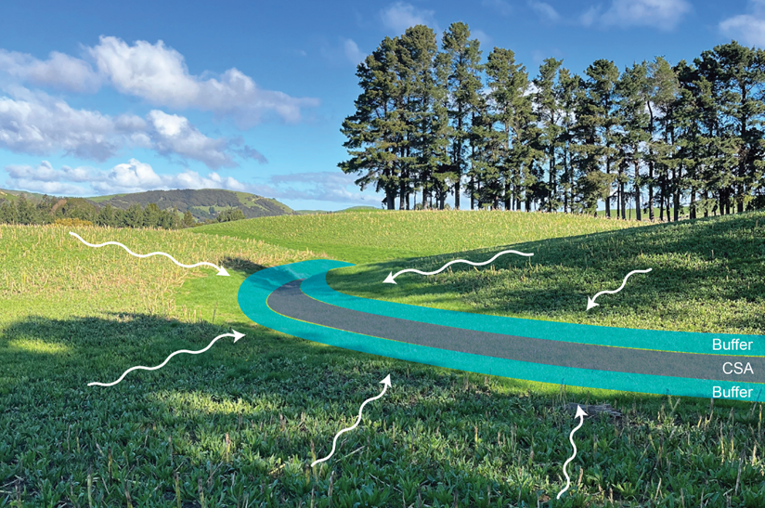
Figure 3: Contaminant removal efficacy versus buffer width for: (a) sediment, (b) pesticide, (c) nitrogen and (d) phosphorus
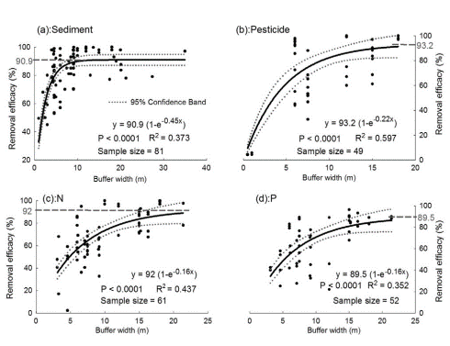
Black dots are data and solid lines are model predictions. Dotted lines indicate the 95 per cent confidence band. Grey numbers with dashed lines are maximum removal efficiency.
Source: Zhang et al, 2010.

Cropping methods
- Reduced tillage: Establishing winter forage crops with reduced tillage (eg, no tillage, shallow non-inversion tillage or strip tillage) can reduce the risk of pugging and compaction during winter grazing (Thomas et al, 2004; Hu et al, 2020).
- Cultivation: If cultivating on sloping land, cultivate across the slope. Cross-slope cultivation creates a barrier to surface run-off, thereby reducing flow velocity, and providing more time for water to infiltrate (Ghimire et al, 2021; Quinton and Catt, 2004). Soil loss from contour-cultivated fields is usually reduced by at least 30 per cent, and often 90 per cent or more, compared with fields that are cultivated downslope (Hudson, 1981).

6.2.2 Management between 1 May and 30 September
The NES-F includes permitted activity conditions for any critical source area that is within, or adjacent to, any area of land that is used for intensive winter grazing on a farm. These conditions include the following:
- CSA livestock exclusion: A critical source area cannot be grazed to reduce the risk of soil damage and contaminant run-off. Grazing outside this period is permitted but local councils may have additional regulations that must be complied with.
- CSA vegetation cover: Vegetation must be maintained over the entire critical source area during this period. This is to protect the soil and slow surface run-off.
- No CSA cultivation or harvesting: Critical source areas in land used for IWG should be left intact and not cultivated. Cultivation during this period could damage soil structure and further increase sediment losses.
Other good management practices to consider during winter grazing include:
- Grazing direction: Considering the direction of grazing can minimise the risk of contaminant loss from non-critical source area areas. Grazing towards the location of the critical source area will maximise the buffering opportunity of the un-grazed crops between the herd and critical source area (Monaghan et al, 2017).
- Fencing: Back-fence to confine areas of damaged soil as much as possible. A back fence will reduce animal pacing and therefore limit soil damage through unnecessary stock movement (Drewry and Paton, 2005). Back fencing is not appropriate for deer.
- Livestock: In general, heavy soils are at greater risk of pugging, compaction and structural damage. Consider only grazing lighter classes of stock on heavy soils during winter.
If critical source areas need to be grazed (requiring a resource consent), soil damage, surface run-off and contaminant loss could be minimised by limiting the extent of crop grazing. This could be achieved by delaying grazing of critical source areas until as late as possible in winter (thereby potentially avoiding rainfall events that are likely to produce surface run-off and associated contaminants loss), and by implementing a time-restricted (on-off) grazing regime (McDowell and Houlbrooke, 2009). Most surface run-off is likely to occur in winter when soil water content is at or above field capacity (Curran-Cournane et al, 2011).

7. Integrating critical source area management with the winter forage crop cycle

7.1 Winter forage planning
Best practice may be to integrate the management of critical source areas into the entire winter forage cropping cycle, from planning to execution as well as future planning of winter crops (figure 4). This section presents a holistic approach to grazed winter forage cropping. It integrates the relevant IWG regulations with the main decision points of the grazed winter forage cropping cycle. This process is focused on meeting the conditions for permitted activities (pathway 1; box 2). If the conditions for permitted activities (box 2) are not met, and IWG is not managed as a permitted activity under a certified freshwater farm plan (see section 4.2), then applying for a consent will need to be added to the planning stage of the cycle. Remember that regional plans may also address related issues, and whichever rules are more stringent apply.
Figure 4: Overview of the stages and key decision points in the grazed winter forage cropping cycle
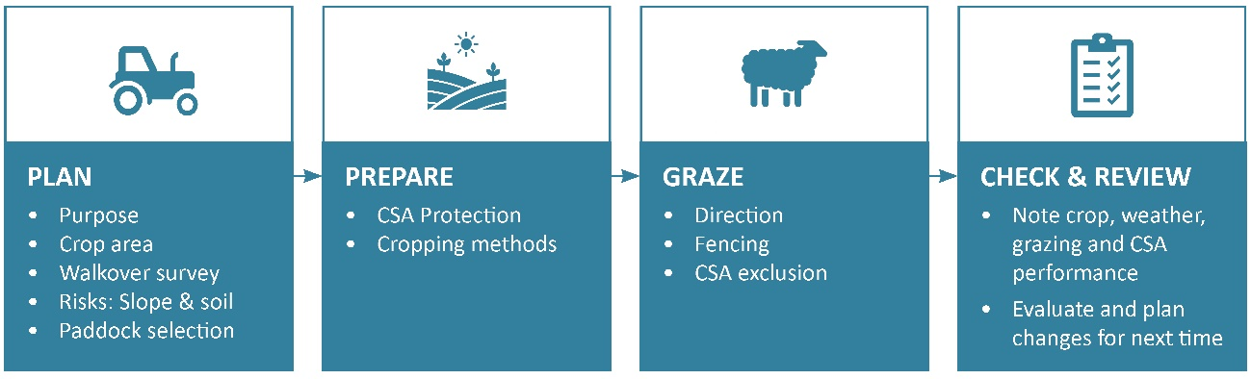
(These stages and key questions are expanded on in table 2.)
Planning begins with considering the purpose for planting a winter forage crop, how much feed is needed and therefore how large an area is required. Paddocks with a low risk of contaminant loss in surface run-off should be prioritised for winter forage cropping. Factors such as soil, slope, proximity and connection to water should all be considered.
Recommended actions for managing critical source areas before and during grazing is detailed in section 6.2 and in the framework below (table 2).
At the completion of the grazed winter forage cropping cycle, it is important to check and review outcomes to help improve future winter grazing plans. This includes documenting what worked well and any critical source areas that might have been missed in the initial planning.
Table 2 provides a framework to navigate the key decisions in IWG planning, from planning through to review (figure 4).

Table 2: A decision framework for intensive winter grazing, covering the planning phase through to the review stage
This template can be used to capture the decisions made at each step and could potentially be used for compliance checks.
 |  | Questions | Notes
PLAN | Purpose | 1. What is the purpose of your winter forage crop?  - Additional feed over winter?  - Keep livestock off the rest of the farm?  - Part of the pasture renewal cycle?
 | Crop choice | 2. What crop are you choosing to grow and why? | A high-yielding winter forage crop like fodder beet leads to higher intensity grazing and greater risk of soil damage.  Companion planting, such as plantain sown with a brassica, can reduce the period of bare soil after winter grazing (see also the Ministry’s groundcover guidance).
 | Area required | 3. What area of crop (Q2) do you need to meet your need and/or purpose (Q1)? | If this area is >50 ha or 10% of your farm, you will need to apply for a resource consent. The area must also be no greater than the maximum area of land used for IWG in the reference period (1 July 2014 and 30 June 2019).  Alternatively, revisit Q1 and Q2 and rethink crop choice based on purpose.
 | Walkover survey | 4. What features are in your prospective IWG paddocks that have the potential to accelerate contaminant delivery to waterways during intensive winter grazing?  (See section 6.2.2 for features to note and use the walkover survey guide in appendix 1.) | The walkover survey includes identifying critical source areas and waterways that are important for paddock selection. Critical source areas must be protected, and livestock must be kept at least 5 metres away from waterways from 1 May to 30 September (see section 4).
 | Risk factor: Slope | 5. What is the slope in the paddock you plan to crop? | If this is more than 10 degrees, you will need to apply for a resource consent.  Alternately, you can choose not to crop the steeper sections of the paddock.
 | Risk factor: Soil | 6. Is it a heavy soil in the paddock you plan to crop?  If yes:  6a. How do you plan to mitigate the risk of soil damage? | In general, heavy soils are more susceptible to damage from winter grazing compared with free-draining stony soils (Drewry et al, 2008). See also section 6.2.
 | Paddock selection | 7. Choose the location best suited to grow and graze your preferred crop with minimal impact on the environment. | Also check local regional plans that may address related issues, and whichever is more stringent applies.

PREPARE | Cropping methods | 8. What preparation does the selected paddock(s) require? How will you minimise the risk during the establishment period? | Ensure clear communication with any external contractors by indicating sites to protect or avoid.  Establishing winter forage crops with reduced tillage (eg, no tillage, shallow non-inversion tillage or strip tillage) can reduce the risk of pugging and compaction during winter grazing (Thomas et al, 2004; Hu et al, 2020). See section 6.2.1, and also the Ministry’s pugging guidance.
 | Critical source area protection | 9. What is your plan for protecting the CSAs identified in your walkover survey?  - Is it worth permanently fencing off the area?  - How large a buffer area around the CSA should you allow for based on site factors and previous experience?  - Is there good vegetation cover in the CSA? | Fence off CSAs temporarily to graze the area outside the winter grazing months (from 1 May to 30 September), or fence permanently.
GRAZE | Grazing | 10. How will you graze your forage crop to reduce the risk of contaminant loss? | Grazing during winter when soil is very wet can significantly increase the potential for contaminant loss in surface run-off. To reduce this risk, the stocking rate can be reduced, and lighter animals used on wetter areas.  Considering the direction of the grazing can be helpful. Grazing towards the CSA location will maximise the buffering opportunity of the un-grazed crop still standing between the herd and CSA.
CHECK | Crop | 11. How well did your crop choice and sowing methods work?  - Was the crop sown in the intended place?  - Was there good establishment?  - Did you use the right spray and fertiliser regime?  - Were there any animal welfare issues? | Note that vegetation must be established as groundcover on land used for intensive winter grazing as soon as practicable after livestock have finished grazing.  See also the Ministry’s groundcover guidance.
 | Weather | 12. What was the weather like during this winter, and how might that have influenced IWG outcomes?  - Was it wetter/dryer/warmer/colder than normal?  - Did it rain for longer than normal?
 | Critical source area | 13. Were the CSAs where you expected?  - Was the area fenced sufficient?  - Were there any ‘new’ surface flow paths or wet areas not marked on the map?  - Did any surface flow bypass the buffer or CSA?  - Did you take photos of the CSAs for next time and consider where they are stored?
REVIEW | Crop, fencing and critical source areas | 14. What would you change for next time?  - Was enough, or too much, feed grown?  - Did wet conditions result in low use of feed?  - Would it be better to fence in another place?  - Do you need a bigger or smaller buffer area?

7.2 Case studies of critical source area management
Critical source areas are not always easy to spot, and their size and extent will vary from year to year depending on climate conditions. Five case studies of critical source areas are presented below, representing protected and unprotected critical source areas on different soil types in different regions, evaluated according to the stages in the winter forage cropping cycle outlined in figure 4.
Case study 1: Protected critical source area on rolling slope
Plan and prepare: In this example of good practice, a critical source area has been identified in a low-lying area of the paddock where surface run-off collects.
Graze: The critical source area has been fenced to exclude livestock and protect the critical source area.
Photos: Pre-grazing (above) and post-grazing (below).
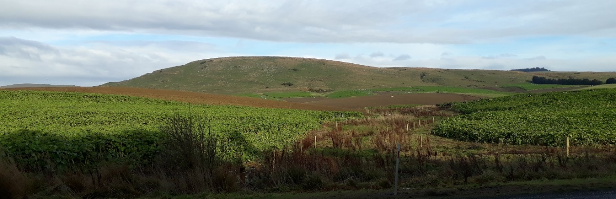
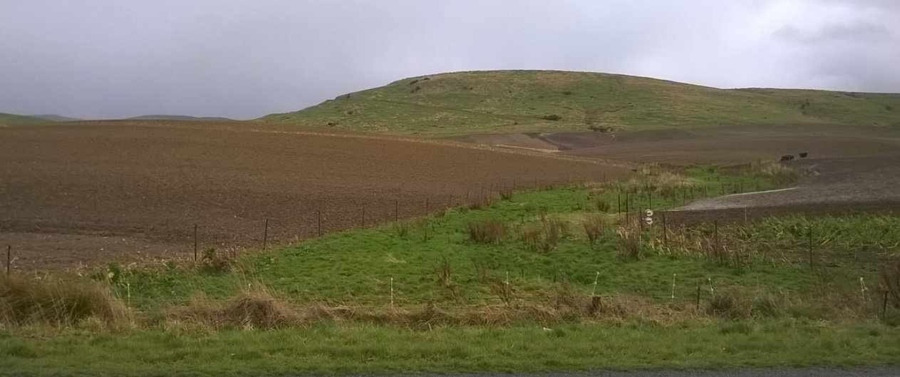
Case study 2: Unprotected critical source area on (mostly) flat slope
Prepare and graze: In this example, surface run-off has accumulated in the compacted margins of the paddock (ie, farm tracks), and surface flow runs through the paddock connecting the contaminants with a waterway in the distance (indicated by the blue line).
Check and review: Future plans for IWG should consider excluding livestock from the paddock margins to preserve ground and limit surface run-off. The critical source area where the surface runoff enters a waterway should also be protected from grazing, including a buffer area (see case study 1).
Photo: A grazed swale with bare soil and erodible sediment. The blue line represents the surface flow connecting the contaminants with a waterway. (Note this photo was taken before IWG regulations came into effect).
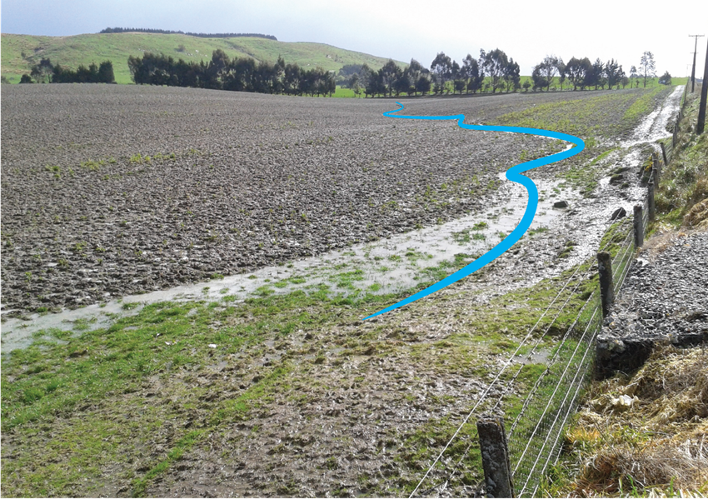

Case study 3: Flat, unconnected depression
Plan: In the example below, ponding and pugging is visible through the middle of the paddock. However, this area does not appear to be connected to surface water and therefore is a lower risk of becoming a critical source area, except in extreme weather.
Prepare and graze: Winter crop could be sown in this paddock, and the grazing strategy should take into account the wetter areas of the paddock, with grazing in drier weather. Be prepared to remove stock from this paddock if extreme weather occurs and there is any risk of critical source area connectivity.
Review: Reflect on the winter season: was the extent of ponding in the depression larger than expected? Were there periods when surface flow did connect, or was at risk of connecting, with a drain or other waterway? Mark out the extent of ponding and surface flow pathways and consider if during the next grazed winter crop rotation some areas might not be cropped. See also the Ministry’s pugging guidance.
Photo: Pasture with ponding and pugging running through the centre.
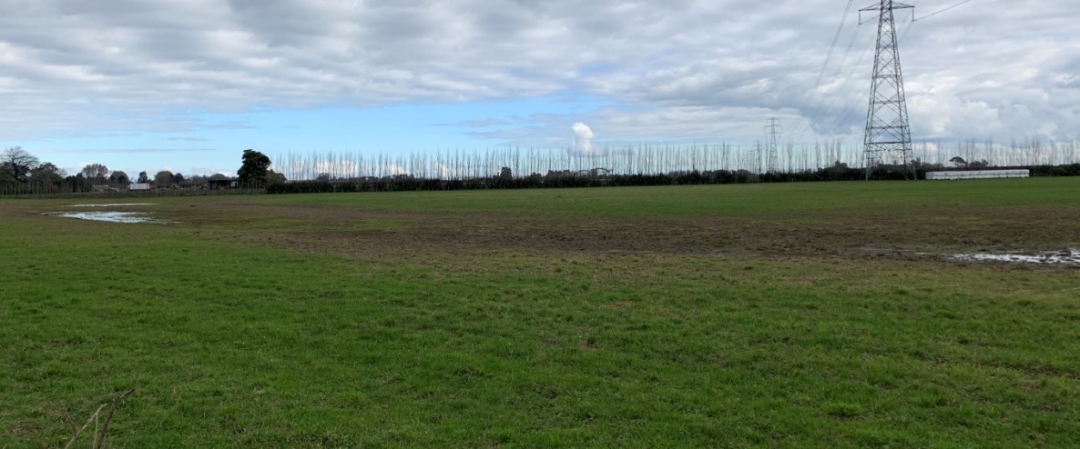

Case study 4: Unprotected critical source area on rolling slope
Plan: In this example, surface run-off is clearly visible, and the swale channels the run-off across a laneway and into a surface drain. Sediment and nutrients from winter grazing have a clear pathway to impact water quality during rainfall events. Note the slope is greater than 10 degrees in some areas of this paddock, and a resource consent would be needed (if there was no freshwater farm plan). Alternatively, the steeper areas of the paddock could remain in pasture while the rest is used for intensive winter grazing.
Prepare and graze: Protecting the critical source area through vegetation cover and by excluding livestock will minimise the loss of contaminants from winter grazing. The area shaded in blue the photo below represents an estimate of the critical source area that should have been protected from grazing within the IWG paddock.
Check and review: How well did the protected area stop the flow of sediment from the surrounding grazed area? For the next grazed winter cropping rotation consider if the protected area should be larger or smaller, based on the observations from this year.
Photo: A grazed winter forage with bare soil and erodible sediment. The area shaded in blue represents an estimate of the critical source area that should have been protected from grazing. (Note this photo was taken before IWG regulations came into effect).

Case study 5: Protected critical source area on rolling slope
Plan and prepare: In the example below, the low-lying areas of the paddock were left in pasture. This area will intercept contamination from surface run-off (blue arrows) from the cropped area, while excluding livestock will help protect this area from pugging and soil compaction.
Graze: This critical source area will remain ungrazed from 1 May to 30 September but can be opened for grazing afterwards using good management practices.
Check and review: Reflect on the winter season. Was the size of the area left in pasture large enough to cover the critical source area? Were there any unexpected ephemeral flow paths that bypassed the protected critical source area?
Photo: An ungrazed winter forage with critical source area in the foreground, left in pasture. The blue arrows represent the surface run-off that will occur when the winter forage crop is grazed.
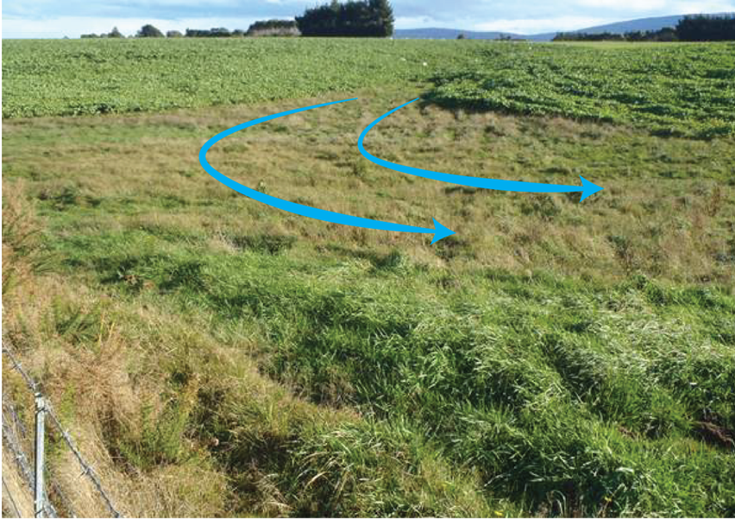

8. Knowledge gaps and limitations

Delineating critical source areas is challenging
Delineating critical source areas is challenging as the areas generating run-off expand and contract in response to rainfall. A practical approach may be to define areas that are active (ie, generate significant amounts of run-off) during much of the winter, but are small enough to retire to allow productive land use, without compromising surface water quality (eg, McDowell and Srinivasan, 2009). The optimum critical source areas for environmental outcomes need to be assessed for different soil types, topographies and climates.

More methods needed to identify critical source areas
Although the walkover survey is a more practical approach for identifying critical source areas, it is often challenging due to the need to collect data across seasons and in different weather conditions. Modelling approaches can help narrow down some of these challenges. For example, technology such as LiDAR can be used to create three-dimensional, digital, elevation models of a farm, which can be used to identify surface run-off pathways and waterway networks. However, to the best of the authors’ knowledge, no study has evaluated different techniques for identifying critical source areas in the context of IWG. Further research is recommended to evaluate different methods for identifying critical source areas and help confirm the optimum criteria.

Contaminant transport in run-off is spatially and temporally non-uniform
Contaminant transport in run-off is spatially and temporally non-uniform. Heavy rainfall can produce surface run-off that is funnelled through micro- and ephemeral channels which may limit the capability of buffer strips to remove contaminants (Dosskey et al, 2002). In such situations, performance may be boosted by redistributing the buffer area, ie, creating a larger buffer area where there is greater run-off load and a smaller buffer area where the run-off load is low (Dosskey et al, 2005). However, there is a lack of quantitative methods that enable evaluation of field surface run-off patterns and their impact on buffer effectiveness in the context of intensive winter grazing.

Cross-slope cultivation can be less effective on heavy soils in regions subject to intense rain
Cross-slope cultivation can be less effective on heavy soils (with high clay content and low infiltration rates) in regions subject to intense rain. In these cases, run-off can pond in furrows until it breaches the cultivation ridges, forming downslope rill erosion. In such situations, wider buffers may be needed around a critical source area. Further research under different soils and climates is recommended to determine the effectiveness of cross-slope cultivation.

Appendix 1: Walkover survey guide
Purpose
To observe and identify landscape features with the potential to accelerate contaminant delivery to waterways during intensive winter grazing. The main focus of this survey guide is sediment, as it is relatively easy to observe.
What to bring
A notepad and camera.
Tips
- The bank of a stream is a good place to start gathering observations, but any place on the farm can serve as a starting point.
- Make your observations during or directly after a significant rainfall event, when soils are saturated.
- Walk around the area intended for intensive winter grazing and record observations like: Is there muddy water running off the paddock and entering the stream? Include areas next to intensive winter grazing areas as these may contribute to or mitigate contaminant losses. (This should be done for the whole farm, but the focus of this guide is intensive winter grazing areas on farms.)

Farm walkover survey
Date and Time:
Weather during survey:
Has it rained in the past 24 hours? |  | ☐ No |  | ☐ Yes
NOTES
If the answer is yes, make a note of where and take a photo for later.
1. Intensive winter grazing critical source areas
Signs to look for: Often stay wet for prolonged periods after heavy rain (depression or swale) and steeply eroded banks (gully). (See section 5.2 for definitions.)
- Gully/gullies |  | ☐ No |  | ☐ Yes
b. Swale(s) |  | ☐ No |  | ☐ Yes
c. Depression(s) |  | ☐ No |  | ☐ Yes
2. Transport pathways/connectivity
Signs to look for: Evidence of flow or run-off — trace back to source and correct the problem. (See section 5.1 for definitions.)
- Waterways: rivers, lakes, wetlands, or surface drains |  | ☐ No |  | ☐ Yes
b. Ephemeral waterways |  | ☐ No |  | ☐ Yes
c. Springs and seeps |  | ☐ No |  | ☐ Yes
3. Sediment mobilisation — accelerating features
Signs to look for: Areas of frequent ponding or standing water, areas that are heavily trafficked either by livestock or machinery and bare soil. (See section 6.1.2).
- Bare soil |  | ☐ No |  | ☐ Yes
b. Pugged soil (see pugging guidance) |  | ☐ No |  | ☐ Yes
c. In-paddock congregation sites (eg, gateways, water troughs) |  | ☐ No |  | ☐ Yes
d. Concreted areas |  | ☐ No |  | ☐ Yes
e. Farm machinery tracks |  | ☐ No |  | ☐ Yes
f. Races or lanes |  | ☐ No |  | ☐ Yes
g. Stream crossings |  | ☐ No |  | ☐ Yes
4. Sediment mobilisation — decelerating features
Signs to look for: Vegetated areas that slow water flow, filter or trap sediment and protect waterways from contamination (see section 6.2.1).
- Buffer strips (could be unmanaged land) |  | ☐ No |  | ☐ Yes
b. Forestry or bush blocks |  | ☐ No |  | ☐ Yes

Appendix 2: Other critical source areas
The following critical source areas are outside the IWG regulations as they are not affected by management measures relevant to winter grazing. However, it is important to note these are also potential sources of contaminants to freshwater.
In-paddock stock congregation sites
Feed areas, stock campsites, water troughs and gateways. These areas often have a build-up of manure and compacted, exposed soil and are source areas of N, P, sediment, and E. coli (Lucci et al, 2010; Hively et al, 2005).
Raceways  Can directly transport or deposit (at crossing points) contaminants (bacteria, sediment and nutrients (mostly N and P) into surface waterways) (Lucci et al, 2010; Hively et al, 2005; Monaghan and Smith, 2012). | Waikato Regional Council, 2019
Stream and river crossings  Due to their immediate proximity to surface water, the risk of contamination from these critical source areas is high (Davis-Colley et al, 2004). | Waikato Regional Council, 2019
Silage pits or feed bunkers  Leachate from the storage of silage is a known source of nutrients and can contaminate ground and surface waters (Gebrehanna et al, 2014). Good design of pits and bunkers to capture and contain run-off will reduce the risk of these contaminants reaching waterways. | Waikato Regional Council, 2019
Yards and animal holding areas  Due to the high concentration of livestock and deposition of faeces and urine, surface run-off from these areas is enriched in nutrients (Hively et al, 2005). | Waikato Regional Council, 2019

Appendix 3: Quick reference guide to critical source area guidance
This is a plain language summary of the critical source area (CSA) guidance to help farmers identify and manage critical source areas.
Also refer to the intensive winter grazing module on the Ministry for Primary Industries’ website.

What is intensive winter grazing?
Intensive winter grazing (IWG) refers to the grazing of livestock on an annual forage crop (a crop that is grazed where it is grown, excluding pasture, or a crop that is grown for arable land use or horticultural land use) from 1 May to 30 September.

What are critical source areas?
The defining feature of a critical source area is the combination of a contaminant source (eg, nutrients, sediment or faecal microorganisms) and a transport pathway (eg, overland flow, ephemeral drainage or stream). Most surface run-off is likely to originate within wet areas (eg, swales and gullies) where the soil is vulnerable to damage.
According to the IWG regulations, a CSA is defined as a landscape feature that accumulates surface run-off from adjacent land; and delivers, or has the potential to deliver, 1 or more contaminants to 1 or more rivers, lakes, wetlands, or drains, or their beds.
Intensive winter grazing generates contaminants by livestock depositing dung and urine in a concentrated area and also via animal treading, which often causes pugging damage and the dislodging of soil particles.

What are the conditions for permitted activities?
Conditions for permitted intensive winter grazing activities must meet all the following conditions for slope, area and livestock exclusion:
- The area of the farm that is used for intensive winter grazing must be no greater than 50 hectares or 10 per cent of the area of the farm, whichever is greater.
- The slope of any land under an annual forage crop that is used for intensive winter grazing must be 10 degrees or less, determined by measuring the slope over any 20-metre distance of the land.
- Livestock must be kept at least 5 metres away from the bed of any river, lake, wetland or surface drain (regardless of whether there is any water in the waterway at the time).
- From 1 May to 30 September of any year, in relation to any critical source area that is within, or adjacent to, any area of land that is used for intensive winter grazing on a farm:
- the critical source area must not be grazed
- vegetation must be maintained as groundcover over the whole critical source area
- maintaining that vegetation must not include any cultivation or harvesting of annual forage crops.

Examples of critical source areas specific to intensive winter grazing
Swale
- Swales are found in lightly sloping to rolling paddocks and concentrate water flows from the surrounding area into a shallow channel.
- Swales only conduct water during or after rainfall events and may act as temporary flow paths connecting contaminants with waterbodies.
- Soils in this part of the paddock are often very wet, possibly marshy and are thus at substantial risk of generating run-off during rain events.
Photo: Sheep grazing a winter forage crop, with an unprotected, grazed swale. The swale is evidenced by the temporary waterway snaking its way through the bare, grazed soil in the middle of the photo. (Note this photo was taken before IWG regulations came into effect).
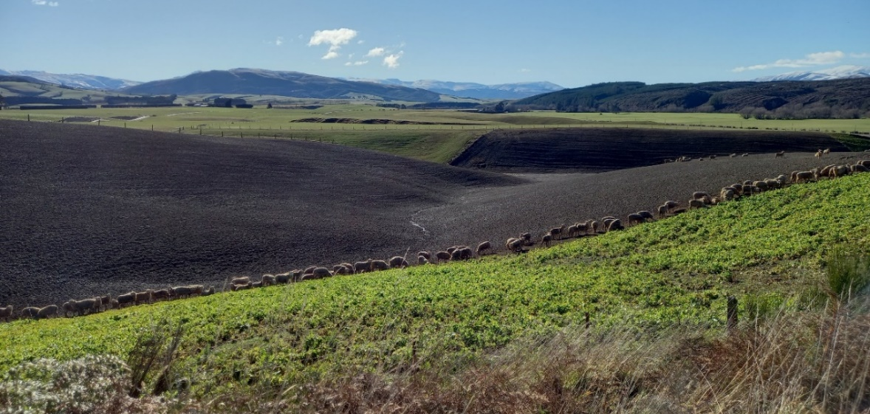

Gully
- In contrast to a shallow swale, a gully is a deep trench, or channel, where the soil has been carried away, exposing bare ground.
- On sloping land, shallow gullies sometimes form where surface run-off from vegetated ground flows onto patches of bare soil. The run-off picks up soil particles, initially rilling the bare surface (Hicks, 1995). The rills deepen with each subsequent rainfall event, eventually forming gullies which cut back and undermine surrounding earth. Very deep gullies can form on hill country if the underlying base is weathered rock, rich in clay.
- Small, shallow gullies are of main concern for grazed winter cropping, as deeper gullies are unlikely to be sown in a winter forage crop, and do not meet the permitted slope conditions of less than 10 degrees. However, if deeper gullies are next to winter grazing areas, appropriate management should be in place to protect these areas from livestock grazing (see section 6.2).
Photo: Post-winter grazing of an unprotected gully. (Note this photo was taken before IWG regulations came into effect).
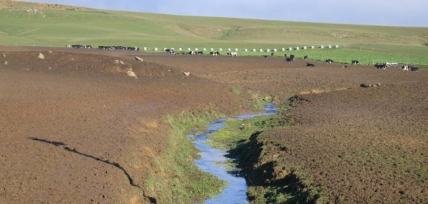

Depression
- A depression is a low, possibly marshy area in the landscape that becomes saturated periodically.
- During and after rainfall, depressions may connect to waterways through temporary flow paths. These can create pollution downstream.
- Depressions vary in both size and depth and are most easily identified by the presence of temporary standing water (or ponding) during wetter months.
Photo: A grazed depression with bare soil and erodible sediment in the centre of the photo. (Note this photo was taken before IWG regulations came into effect.)

References
Betteridge K, Andrewes WGK, Sedcole JR. 1986. Intake and excretion of nitrogen, potassium and phosphorus by grazing steers. The Journal of Agricultural Science 106: 393–404.
Beven K, Kirkby MJ. 1979. A physically based, variable contributing area model of basin hydrology. Hydrological Science Bulletin 24: 43–69.
Buczko U, Kuchenbuch RO. 2007. Phosphorus indices as risk-assessment tools in the USA and Europe—a review. Journal of Plant Nutrition and Soil Science 170(4): 445–460.
Carpenter SR, Caraco NF, Correll DL, Howarth RW, Sharpley AN, Smith VH. 1998. Nonpoint pollution of surface waters with phosphorus and nitrogen. Ecological Applications 8(3): 559–568.
Clarkson BR. 2014. A vegetation tool for wetland delineation in New Zealand. Manaaki Whenua – Landcare Research for Meridian Energy Ltd. Lincoln: Manaaki Whenua – Landcare Research.
Collins R C, Donnison A, Ross C, McLeod M. 2004. Attenuation of effluent-derived faecal microbes in grass buffer strips. New Zealand Journal of Agricultural Research 47: 565–574.
Cooper AB, Smith CM, Smith MJ. 1995. Effects of riparian set-aside on soil characteristics in an agricultural landscape: Implications for nutrient transport and retention. Agricultural, Ecosystems and Environments 55: 61–67.
Curran-Cournane F, McDowell RW, Condron LM. 2010. Do aggregation, treading and dung deposition affect phosphorus and suspended sediment losses in surface run-off? Australian Journal of Soil Research 48(8), 705–712. doi:10.1071/SR10043
Curran-Cournane F, McDowell RW, Littlejohn R, Condron LM. 2011. Effects of cattle, sheep and deer grazing on soil physical quality and losses of phosphorus and suspended sediment losses in surface run-off. Agriculture, Ecosystems & Environment 140: 264–272.
Davies-Colley RJ, Nagels JW, Smith RA, Young RG, Phillips CJ. 2004. Water quality impact of a dairy cow herd crossing a stream. New Zealand Journal of Marine and Freshwater Research 38: 569–576.
Di HJ, Cameron KC. 2002. Nitrate leaching in temperate agroecosystems: source, factors and mitigating strategies. Nutrient Cycling in Agroecosystems 46: 237–256.
Dillaha TA, Reneau RB, Mostaghimi S, Lee D. 1989. Vegetative filter strips for agricultural nonpoint source pollution control. Transactions of American Society of Agricultural and Biological Engineers 32(2): 513-519.
Dosskey MG, Eisnhauer DE, Helmers MJ. 2005. Establishing conservation buffers using precision information. Journal of Soil and Water Conservation 60(6): 349–354.
Dosskey MG, Helmers MJ, Eisnhauer DE, Franti TG, Hoagland KD. 2002. Assessment of concentrated flow through riparian buffers. Journal of Soil and Water Conservation 57(6): 336–343.
Drewry JJ, Cameron KC, Buchan GD. 2008. Pasture yield and soil physical property responses to soil compaction from treading and grazing – a review. Australian Journal of Soil Research 46: 237–256.
Drewry JJ, Paton RJ. 2005. Soil physical quality under cattle grazing of a winter-fed brassica crop. Australian Journal of Soil Research 43: 525–531.
Fraser S, Singleton P, Clarkson B. 2018. Hydric soils – field identification guide. Lincoln: Manaaki Whenua – Landcare Research.
Freeze AR. 1974. Streamflow generation. Reviews of Geophysics and Space Physics 12: 627–647.
Gburek WJ, Drungil CC, Srinivisan MS, Needelman BA, Woodward DE. 2002. Variable-source-area controls on phosphorus transport: Bridging the gap between research and design. Journal of Soil and Water Conservation 57(6): 534–543.
Gburek WJ, Sharpley AN, Heathwaite L, Folmar GJ. 2000. Phosphorus management at the watershed scale: A modification of the phosphorus index. Journal of Environmental Quality 29: 130–144.
Gebrehanna MM, Gordon RJ, Madani A, VanderZaag AC, Wood JD. 2014. Silage effluent management: A review. Journal of Environmental Management 143: 113–122.
Ghimire CP, Appels WM, Grundy L, Ritchie W, Bradley S, Snow V. 2021. Towards predicting the initiation of overland flow from relatively flat agricultural fields using surface water coverage. Journal of Hydrology 596: 126125.
Grabs T, Seibert J, Bishop K, Laudon H. 2009. Modelling spatial patterns of saturated areas: A comparison of the topographic wetness and a dynamic distributed model. Journal of Hydrology 373: 15–23.
Hicks L. 1995. Control of soil erosion on farmland. Wellington: Ministry of Agriculture.
Hively WD, Bryant BR, Fahey TJ. 2005. Phosphorus concentrations in overland flow from diverse locations on a New York dairy farm. Journal of Environmental Quality 34: 1224–1233.
Houlbrooke DJ, Paton RJ, Morton JD, Littlejohn RP. 2009. Soil quality and plant yield under dryland and irrigated winter forage crops grazed by sheep or cattle. Australian Journal of Soil Research. 47: 470–477.
Hu W, Beare M, Tregurtha C, Gillespie R, Lehto K, Tregurtha R, Gosden P, Glasson S, Dellow S, George M. 2020. Effects of tillage, compaction and nitrogen inputs on crop production and nitrogen losses following simulated forage crop grazing. Agriculture Ecosystems & Environment 289: 106733
Hudson NW. 1981. Soil Conservation: pp 161–189. Ithaca, New York: Cornell University Press.
Lucci GM, McDowell RW, Condron LM. 2010. Potential phosphorus and sediment loads from sources within a dairy farmed catchment. Soil Use and Management 26: 44–52.
Lucci GM, McDowell RW, Condron LM. 2012. Phosphorus source areas in a dairy catchment in Otago, New Zealand. Soil Research 50: 145–156.
Malcom BJ, Cameron KC, Beare MH, Carrick ST, Payne JJ, Maley SC, Di HJ, Richards KK, Dalley DE, de Ruiter JM. 2022. Oat catch crop efficacy on nitrogen leaching varies after forage crop grazing. Nutrient Cycling in Agroecosystems 122: 273–288.
McDowell RW. 2006. Phosphorus and sediment loss in a catchment with winter forage crop grazing by dairy cattle. Journal of Environmental Quality 35: 575–583.
McDowell RW, Drewry JJ, Muirhead RW, Paton RJ. 2003. Cattle treading and phosphorus and sediment loss in overland flow from grazed cropland. Australian Journal of Soil Research 41: 1521–1532.
McDowell RW, Houlbrooke DJ. 2009. Management options to decrease phosphorus and sediment losses from irrigated cropland grazed by cattle and sheep. Soil Use and Management 25: 224–233.
McDowell R, Sharpley A. 2002. Phosphorus transport in overland flow in response to position of manure application. Journal of Environmental Quality 31: 217–227.
McDowell RW, Srinivasan MS. 2009. Identifying critical source areas for water quality: 2. Validating the approach for phosphorus and sediment losses in grazed headwater catchments. Journal of Hydrology 379(1–2): 68–80.
McDowell RW, Stevens DR. 2008. Potential waterway contamination associated with wintering deer on pastures and forage crops. New Zealand Journal of Agricultural Research 51: 287–90.
Ministry for the Environment. 2002. Microbiological water quality guidelines for marine and freshwater recreational areas. Wellington: Ministry for the Environment.
Ministry for the Environment. 2019. National Planning Standards. Wellington: Ministry for the Environment.
Ministry for the Environment. 2020. Regulatory Impact Analysis: Action for healthy waterways Part II: Detailed analysis. Wellington: Ministry for the Environment.
Ministry for the Environment. 2022. Intensive winter grazing fact sheet. Wellington: Ministry for the Environment.
Moloney M, Fenton O, Daly K. 2020. Ranking connectivity risk for phosphorus loss along agricultural drainage ditches. Science of The Total Environment 703: 134556.
Monaghan RM, Laurenson S, Dalley DE and Orchiston TS. 2017. Grazing strategies for reducing contaminant losses to water from forage crop fields grazed by cattle during winter. New Zealand Journal of Agricultural Research 60(3): 333–348.
Monaghan RM, Smith LC. 2012. Contaminant losses in overland flow from dairy farm laneways in southern New Zealand. Agriculture, Ecosystems & Environment 159: 170–175.
Monaghan RM, Smith LC, Muirhead RW. 2016. Pathways of contaminant transfers to water from an artificially-drained soil under intensive grazing by dairy cows. Agriculture, Ecosystems & Environment 220: 76–88.
Muirhead RW, Collins RP, Bremer PJ. 2006. The association of E. coli and soil particles in overland flow. Water Science and Technology 54(3): 153–159.
Mulholland B, Fullen MA. 1991. Cattle trampling and soil compaction on loamy sands. Soil Use and Management 7: 189–193.
Nguyen L, Sukias J. 2002. Phosphorus fractions and retention in drainage ditch sediments receiving surface runoff and subsurface drainage from agricultural catchments in the North Island, New Zealand. Agriculture, Ecosystem & Environment 92(1): 49–69.
Nguyen ML, Sheath GW, Smith CM, Cooper AB. 1998. Impact of cattle treading on hill land: 2. Soil physical properties and contaminant runoff. New Zealand Journal of Agricultural Research 41: 279–290.
O’Driscoll M, DeWalle D, Humphrey C Jr and Iverson G. 2019. Groundwater seeps: Portholes to evaluate groundwater’s influence on stream water quality. Journal of Contemporary Water Research & Education 166: 57–78.
Parkyn S, Shaw W, Eades P. 2000. Review of information on riparian buffer widths necessary to support sustainable vegetation and meet aquatic functions. Auckland: Auckland Regional Council.
Pionke, HB, Gburek WJ, Sharpley AN. 2000. Critical source area controls on water quality in an agricultural watershed located in the Chesapeake. Ecological Engineering 14(4): 325–335.
Quinton JN, Catt JA. 2004. The effects of minimal tillage and contour cultivation on surface run-off, soil loss and crop yield in the long-term Woburn Erosion Reference Experiment on sandy soil at Woburn, England. Soil Use and Management 20: 343–349.
Reaney SM, Mackay EB, Haygarth PM, Fisher M, Molineux A, Potts M, Benskin MH. 2019. Identifying critical source areas using multiple methods for effective diffuse pollution mitigation. Journal of Environmental Management 250: 109366.
Shanafield M, Bourke SA, Zimmer MA, Costigan KH. 2021. An overview of the hydrology of non-perennial rivers and streams. WIREs Water 8: 1504.
Sheath GW, Carlson WT. 1998. Impact of cattle treading on hill land: 1. Soil damage patterns and pasture status. New Zealand Journal of Agricultural Research 41: 271–278.
Singleton PL, Boyes M, Addison B. 2000. Effect of treading by dairy cattle on topsoil physical conditions for six contrasting soil types in Waikato and Northland, New Zealand, with implications for monitoring. New Zealand Journal of Agricultural Research 43: 559–567.
Sivertun Å, Prange L. 2003. Non-point source critical area analysis in the Gisselö watershed using GIS. Environmental Modelling & Software (2003) 18: 887–898.
Smith CM. 1989. Riparian pasture retirement effects on sediment, phosphorus and nitrogen in channelised surface run-off from pastures. New Zealand Journal of Marine and Freshwater Research 23: 139–146.
Smith LC, Monaghan RM. 2003. Nitrogen and phosphorus losses in overland flow from a cattle-grazed pasture in Southland. New Zealand Journal of Agricultural Research 46: 225–237.
Soil Conservation Service. 1972. Hydrology. In: National engineering handbook, Section 4. Washington DC: USDA Soil Conservation Service.
Srinivasan MS, McDowell RW. 2007. Hydrological approaches to the delineation of critical source areas of run-off. New Zealand Journal of Agricultural Research 50(2): 249–265.
Thomas S, Francis G, Barlow H, Beare M, Trimmer L, Gillespie R, Tabley F. 2004. Winter grazing of forages – soil moisture and tillage methods impact nitrous oxide emissions and dry matter production. Proceedings of the New Zealand Grassland Association 66: 135–140.
Walter MT, Walter MF, Brooks ES, Steenhuis TS, Boll J, Weller K. 2000. Hydrologically sensitive areas: Variable source hydrology implications for water quality risk assessment. Journal of Soil and Water 3: 277–284.
Wolock D, McCabe GJ. 1995. Comparison of single and multiple flow direction algorithms for computing topographic parameters in TOPMODEL. Water Resources Research 31(5): 1315–1324.
Zhang X, Liu X, Zhang M, Dhalgren RA. 2010. A review of vegetated buffers and a meta-analysis of their mitigation efficacy in reducing nonpoint source pollution. Journal of Environmental Quality 39(1): 76–84.

Any artificial watercourse designed, constructed or used for the drainage of surface or subsurface water, but excludes artificial watercourses used for the conveyance of water for electricity generation, irrigation, or water supply purposes (Ministry for the Environment, 2019).
Excessive richness of nutrients in a lake or other body of water, frequently due to run-off from the land, which causes a dense growth of plant life.

