

Where to from here? How we ensure the future wellbeing of land and people
Have your say on the draft Long-term Insights Briefing 2022
The Ministry for the Environment is carrying out public consultation on its draft Long-term Insights Briefing.
The briefings are a requirement for all government agencies under the Public Service Act 2020. They identify and explore long-term issues that matter for the future wellbeing of people in Aotearoa New Zealand.
They present medium and long-term trends, risks and opportunities that may affect Aotearoa, as well as analysis and options for addressing these. The briefings aim to be thought provoking, but they are not government policy.
The topic of the Ministry for the Environment’s briefing is the future of land and people’s relationship with it.
Our draft briefing lays out examples of pressures on the land, the effects they’re having, and drivers that could influence what happens in coming years. The briefing also looks ahead to 2050 and outlines a possible vision for land and people’s relationship with it, and ways we could achieve that vision.
Your feedback will help us finalise the briefing before it is presented to Parliament.

What’s the connection between the wellbeing of both land and people?
Our draft briefing is called Where to from here? How we ensure the future wellbeing of land and people | He aha ngā mahi ka whai ake ināianei? Me pēhea te whakarite i te toiora o te whenua me te tangata ā muri atu.
Land is a taonga. It is intrinsically linked with the environment and provides us with essential needs like food, jobs and places to live and play.
Land is also an integral part of Aotearoa New Zealand’s culture and identity, for both Māori as tangata whenua and many other New Zealanders.
A healthy whenua is fundamental to all aspects of people’s wellbeing: economic, physical, mental, cultural and social.
And because land is connected to the air, water, plants, animals and every part of the environment, its health affects theirs and vice versa.

Pressures on the land
For many years, Aotearoa New Zealand’s land has been under pressure from things like more intensive agricultural practices, pollution, urban sprawl, rural subdivision, invasive species and climate change.
The effects of these pressures include:
- threats to native plants, animals and ecosystems
- a shrinking amount of highly productive land
- degrading soil and water quality
- pollution and waste in urban areas
If current trends continue, pressures on the land could increase – affecting both its health and the wellbeing of future generations.

What will shape the future?
It’s difficult to predict the future of land in Aotearoa New Zealand. It will be shaped by local and global drivers of change. For example:
- climate change is changing weather patterns and raising sea levels
- population growth creates demand for resources
- economic and consumer demands influence what New Zealanders make and use
- geopolitics and international dynamics affect the local environment and economy
- policy and regulation shape how land is used
- technology and innovation influence the way we live and work
- social and cultural values shape what is acceptable on the land.
The drivers are complex and interconnected. Some could increase pressures and demands on the land, while others could improve conditions.
These trends are not set in stone. But either way, challenges lie ahead for the land, and for the aspects of people’s wellbeing that depend on it.
We need to change course – and to do so in a coordinated and meaningful way. If we don’t, pressures on the land could disrupt the economy, increase inequalities, and harm unique species and ecosystems.
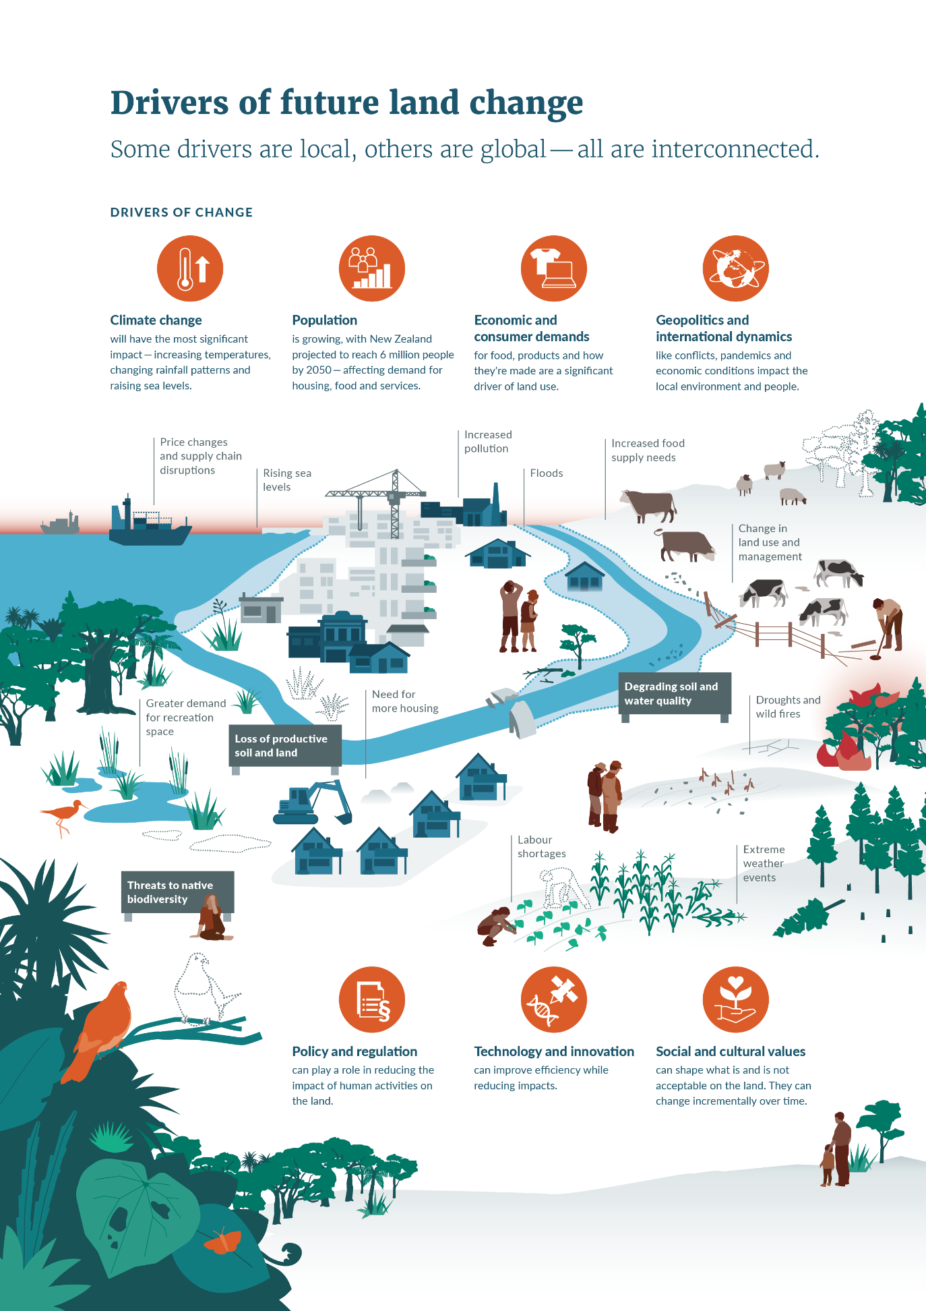
Along with the seven drivers of change outlined above, are there any others that could affect the state of the land over the coming years?
See chapter 2 in the full draft briefing for more details.

What might the future look like?
We began by coming up with an aspirational vision for what the land – and people’s relationship with it – could look like in 2050 and beyond.
In this vision, all New Zealanders would share a sense of deep environmental responsibility and reciprocity. It means the relationship between people and whenua would be stronger, and people would give back to the land as much as it provides.
This view of environmental responsibility aligns in many ways with Māori understandings of te taiao. The following whakataukī (saying) sums up this connection:
Ko au te whenua, ko te whenua, ko au | I am the land, and the land is me.
The Briefing poses four main challenges that could reshape people’s relationship with the land. It outlines what the future could look like and asks how we could:
- empower tangata whenua to exercise kaitiakitanga
- protect, revitalise and make the land more resilient
- enable action and responsibility for improving the land
- ensure all New Zealanders are connected with nature.

How well does the way we describe what the future could look like align with your aspirations for the land and New Zealanders’ relationship with it? Do you:
Strongly agree | Agree | Somewhat agree | Somewhat disagree | Disagree | Strongly disagree | Don’t know
Would you add to or change anything about the descriptions of what the future could look like?
See chapter 3 in the full draft briefing for more details
Achieving this vision would involve major transformations of our politics, economy and society. Existing initiatives can only get us part way there. So we identified nine pathways to a more resilient future for the land and every generation. They include:
- empowering communities to drive sustainable land use
- increasing the effectiveness of policy and legislation
- investing in sustainable infrastructure and technology
- investing in science and mātauranga Māori
- promoting environmental education and sharing knowledge, ideas and skills
- embracing collaborative governance and coordination
- embedding environmental responsibility in our institutions
- enhancing equities
- building resilience to global pressures.
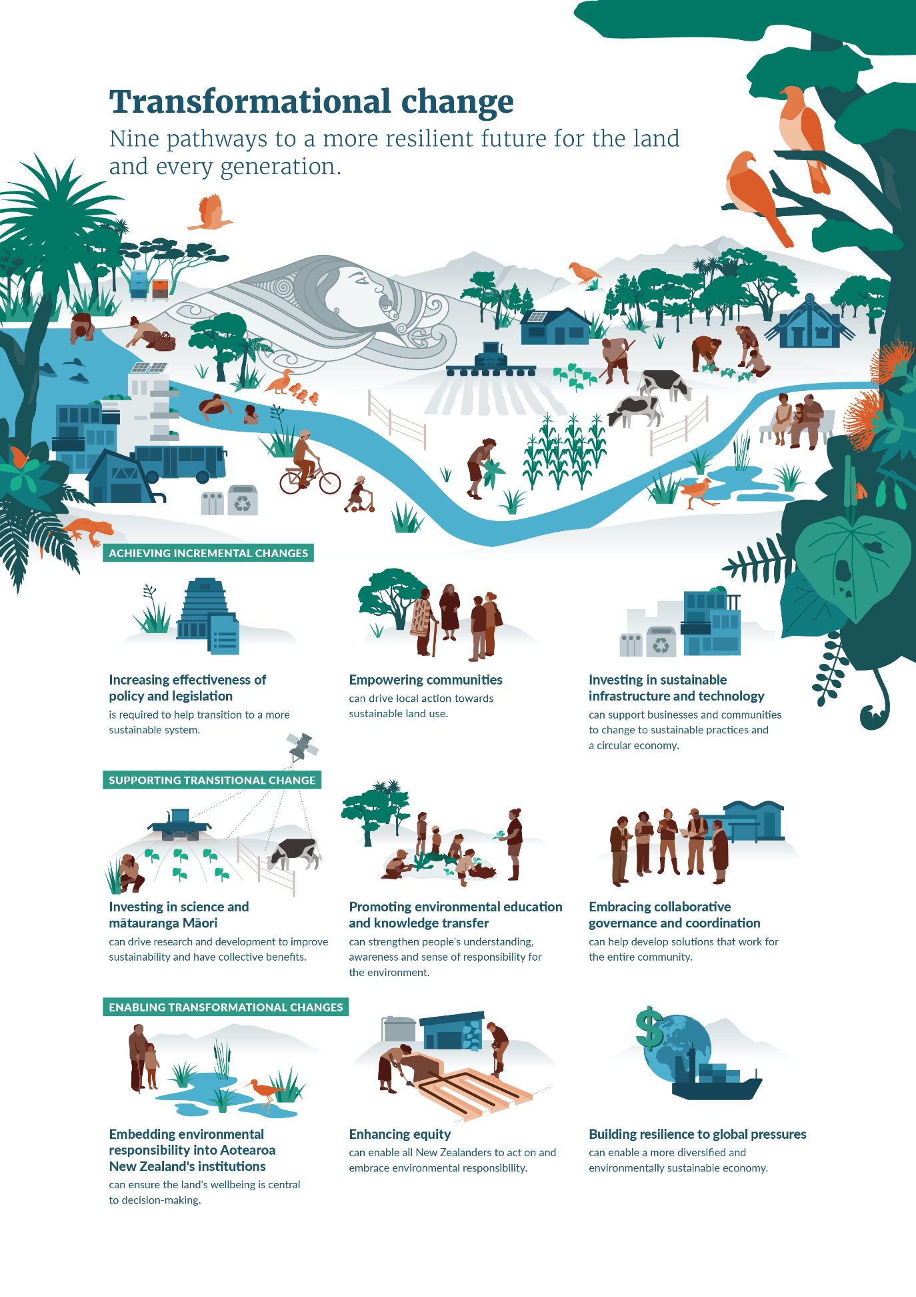
For each of the nine pathways, what could be done to make them effective?
Are there any other leverage points you think should be included?
See chapter 4 in the full draft briefing for more details

Have your say
This is just the start of an ongoing conversation about the long-term future of the land.
This draft briefing was developed based on input from subject matter experts, youth organisations, the Ministry’s leadership team, and the results of an online survey.
Now we’d like to know what you think New Zealand can do to secure a bright future for both the land and the generations that follow us.
The input and feedback we receive will help inform and develop this Long-term Insights Briefing and future ones.
The final briefing will be published when it is submitted to Parliament. It will be considered by a Parliamentary select committee and will influence the Ministry’s upcoming work.
Government agencies are required to produce LTIBs every three years, so this will an ongoing conversation.

To read the full draft Long-term Insights Briefing 2022 and have your say, visit: https://consult.environment.govt.nz/insights/future-wellbeing-land-and-people
For more information about the briefings, see He Puka Whakamārama i te Pae Tawhiti | Long-term Insights Briefings on the Te Kawa Mataaho Public Service Commission website.

Published in October 2022 by the  Ministry for the Environment – Manatū Mō Te Taiao  Publication number: INFO 1099 | 