Staff commuting survey decision tool and templates

# Purpose of this document

This document enables each Carbon Neutral Government Programme (CNGP) organisation to self-assess the most adequate staff commuting survey methodology and plan for their survey.

* Staff commuting survey decision tool
* Commuting survey template: Version A
* Commuting survey template: Version B

# Staff commuting survey decision tool

## Before you begin

Consider the rationale for your organisation embarking (or not) on measuring staff commuting emissions. Reporting commuting emissions is not mandatory under the Carbon Neutral Government Programme (CNGP). However, commuting emissions are the reverse to emissions from working from home (WFH), which is mandatory. By choosing to report your organisation’s commuting emissions you can contrast them against your WFH emissions. This can enable a more balanced reporting outcome.

## Determine your approach by completing this self-assessment

| Decision determinants | Factors | Scoring guide | Self-assessed level |
| --- | --- | --- | --- |
| **Reporting maturity** | Reported (on commuting) already?  If yes, what is your ratio of knowns to unknowns - eg, do you have any data on the proportions of staff with:   * intra-daily commute variation * inter-daily variation * seasonal variation * multi-modal commuting * abnormal modes eg, plane. | Likely 'high' maturity if you've reported on commuting emissions already, unless your methodology has left you with a lot of unknowns (in which case consider scoring as 'medium'). | **high / med / low** |
| **Emissions materiality** | Office locations: are your workplaces solely in main centres with good active and public transport options? Or are some or all workplaces outside main centres where staff are more likely to commute by private motor vehicle?  Full-time equivalent (FTE) numbers: organisations with more than 500 staff may find that commuting emissions are a more significant proportion of their footprint than for small-to-mid-sized organisations. | Commuting emissions are likely to be material for most agencies but consider the factors and rate accordingly.  For a quick estimate of annual commuting emissions, multiply your FTE by 0.5 tCO2-e if your workforce is mostly urban and local. Multiply by 0.8 or 1 if your workplace is spread across rural and urban locations. If this number represents more than 5% (or any threshold you have set) of your total emissions, it is material. | **high / med / low** |
| **Change appetite** | If this work may require re-baselining, is this something you're willing to contemplate?  What levers do you have to reduce mandatory emissions in line with targets? Eg, will it give you a welcome additional lever to report on commuting emissions under 'mandatory plus'?  Are you looking to address commuting emissions with interventions or initiatives? | If you have low likelihood to be willing to re-baseline and/ or to attempt commuting emissions reduction, consider scoring as 'low' on the change appetite metric. If you need to bring commuting emissions within your 'mandatory plus' scope (ie, because you have few other levers to reduce your footprint), consider scoring as 'high'. | **high / med / low** |
| **Complexity tolerance** | Do you have drivers to help ensure a good response rate? Eg, will your senior leaders push staff to respond? Can you offer an incentive such as a prize draw to encourage responses?  Can you access capability to support or undertake analysis of survey results?  Do you have operational or field staff who are not commonly based at a desk? If yes, this may be a practical barrier to anything other than a basic survey. | Consider scoring as 'high' if you have drivers to help push or pull responses and you feel able to cope with some analytical complexity. If you have a significant proportion of staff who work away from a desk (eg, court staff, police officers), consider scoring as 'low' as you will want to make the survey quick and easy to try and get a decent response rate from staff who are only rarely in front of a computer.  It’s important to speak to your auditors about the response rate they consider sufficient. | **high / med / low** |

## Select your survey template and make any desired amendments

### Suggested survey scope if you have one or more 'low' scores

We suggest that you keep your survey basic, at least in the first year, as per the notes below.

Version A of the survey template is a good starting point as the simplest survey solution. You could use it as is or pull across any of the extra detail from version B that feels useful and aligned with your organisational context.

These are the key considerations when keeping a commuting survey simple:

* **Journey variation:** Without differentiating the trips to and from work, you're assuming that any variation in emissions on return journeys is unlikely to be material. This assumption needs to be documented for auditors. Emissions of the recorded trips will need to be doubled in your analysis to account for return journeys and extrapolated across the year as per the analysis workbook in the survey pack.
* **Multimodal journeys:** When asking respondents about their main mode of transport only and skipping secondary modes, there is a chance of underestimating active modes (eg, walking, cycling) as they typically cover a shorter distance.
* **Typical vs actual commuting behaviour:** To keep things simple, ask respondents about their 'typical' or 'most common' commute and the number of days per week they usually commute vs WFH. Multiply the emissions accordingly and note for your auditor that you're assuming that any variation in emissions from atypical journeys is unlikely to be material. This approach is more subject to respondent bias than asking about actual travel in the past week for example, but better suited for small sample sizes where atypical responses may have a disproportionate effect on calculated emissions.
* **Transport modes:** Provide respondents with a basic list of transport options and calculate your emissions based on default averages, for example using the average petrol car rather than differentiating by car size and age. Default or average vehicle emission factors can be found in the Ministry for the Environment ‘Measuring Emissions Guide’ ([Measuring emissions: A guide for organisations: 2024 detailed guide | Ministry for the Environment](https://environment.govt.nz/publications/measuring-emissions-a-guide-for-organisations-2024-detailed-guide/)).
* **Distance measurement:** Ask respondents to estimate the distance they commute to work (either via entering a number or selecting the most appropriate banding).

### Suggested survey scope if you have mostly 'high' scores

We suggest that you can consider adding some complexity to your survey, to seek a higher degree of data accuracy and to seek insights that can help inform potential interventions or initiatives, as per the notes below.

Start with Version B of the survey template. You could use it as is or remove some of the detail in favour of a more basic approach (refer to version A) wherever it feels like overkill for your information needs or organisational context.

* **Journey variation – return journeys:** Ask respondents about their journey to **and** from work so that your calculations will capture any variation in emissions on return journeys.
* **Journey variation – seasonality:** Consider asking respondents to provide further detail if their commute varies between seasons. Alternatively, consider running your survey more than once per year, or running the main survey once and supporting it with 'snapshot surveys'. See the [Waka Kotahi survey guide](https://www.nzta.govt.nz/assets/resources/travel-planning-toolkit/docs/resource-6-workplace-travel-survey-guide.pdf), section 13 for more information about these follow up surveys.
* **Multimodal journeys:** Ask respondents about their main and secondary modes of transport. If your survey platform allows it, consider doing this in a matrix format that allows them to enter the distance travelled for each mode.
* **Typical vs actual commuting behaviour:** Unless your sample size is small, for example below 100, consider asking respondents to report on their actual commuting behaviour during the survey period (eg, the past week), rather than asking them to describe a typical commute. This will allow you to capture variations in commute between days and tends to be more accurate. However, if your pool of respondents is small, note that emissions calculations based on actual commuting data can be skewed in small sample sizes by a relatively small number of respondents who happen to have atypical behaviour during the survey period.
* **Transport modes:** Consider providing respondents with a comprehensive list of transport options. For any responses that include private motor vehicles consider asking for further detail that will allow you to more accurately calculate the emissions - ie, engine size, vehicle year and fuel type, as well as passengers. Consider including 'airplane' as an option for self-funded remote commuting.
* **Distance measurement:** Consider asking respondents to measure the distances within their commute (you could provide a link to [google maps](https://www.google.co.nz/maps/@-36.8345088,174.751744,10z?entry=ttu&g_ep=EgoyMDI0MDkxOC4xIKXMDSoASAFQAw%3D%3D)). Consider also asking respondents for the location of their home and workplace. This will show you if and where you have any commuter clusters and help you to target interventions or initiatives. You can ask for this data at different levels of detail depending on your approach to privacy (for example, asking for home address vs postcode vs town/city vs landmark). Some organisations may want to also consider asking respondents to be precise about where they are located within a particular workplace – for example, universities or others with a sprawling campus may want to know exactly where on campus each respondent ends their journey, as this could influence interventions such as end-of-trip facility provision.
* **Additional survey themes:** Consider whether it is relevant and appropriate to your context to expand the scope of your commuting survey to also include questions on other areas of sustainability that will help you to plan initiatives or interventions. Consider whether the extra information you are collecting might make someone identifiable (ie, when combining the bits of information). This would make it personal information, with much higher security requirements for handling this information. It is important that agencies are not collecting information unless it is essential to the purpose of the reporting.

### Suggested survey scope if you have a mix of 'high' and 'medium' scores

We suggest you work from the basic survey (version A) as your starting point and bring across any additional or alternate questions that are important for your informational needs or context.

We suggest starting with version A rather than version B, as some medium scores may mean that you will already need to work hard to generate a good response rate, so additional complexity may be counter productive.

* **Assumption testing:** You could consider including a simple question set in your survey to check the assumptions in Version A and inform any areas where you may want to expand your survey in future years. An example of assumption testing is a question that asks: 'In a typical week, on days that you’re commuting to and from the office, is there a repeating daily pattern to your commute?' A high proportion of 'yes' answers would help validate the assumption in survey version A that any daily variation is not materially significant.

## Independent third-party verification

The CNGP requires that Greenhouse Gas inventories must be “verified by an independent third-party organisation in accordance with ISO14064-3 (2019) or ISAE34101.” Version A template is presented as a minimum viable version of a survey for the purposes of calculating commuting emissions and seeking verification at the level of limited assurance. It is strongly recommended that the organisation’s final survey template and associated resources are shared with the auditors (independent third-party verifiers) prior to using the survey. Specifically, check that the auditors agree this minimum viable survey is an appropriate approach for both the context of your organisation and your desired assurance level; and check the response rate that they will consider acceptable for your desired assurance level.

## Consider when to run your survey

| Factor | Consideration |
| --- | --- |
| **Holidays** | Avoid school and public holidays |
| **Survey fatigue** | Consider timing of other staff surveys that may be taking place in your organisation. To reduce survey fatigue and give respondents a sense of urgency, do not leave the survey open for longer than two weeks. One week may be enough if communications are well targeted. |
| **Internal stakeholders and union engagement** | Think about the relevant stakeholders in your organisation who will want to know about the commuting survey (eg, HR, research team). Engaging with your relevant unions and operating on a 'no surprises' approach helps avoid issues and opens the door for constructive input. |
| **Season** | People are less likely to take active transport during winter and more likely in warmer weather. Therefore, running your survey in Autumn or Spring may be best if you are only going to do one survey in a year. If twice yearly, consider one in summer and one in winter. Going forward, you will want to run the survey at the same time each year to make the results comparable. |
| Reporting timelines | Consider and plan around busy periods for the sustainability team (eg, greenhouse gas inventory audit dates) so that there is time to analyse the data before it's needed for reporting purposes. |

## Send and promote your survey

| Factor | Consideration |
| --- | --- |
| **Comms channels** | Chat to the comms team (in advance) to line up the channels that can be used, for example, all staff email, Teams channels, internal newsletters, lock screens or desktop backgrounds, IT notifications, intranet, etc. |
| **Executive support** | Get the Chief Executive or a member of the Strategic Leadership Team to send the survey link in an email and/or to remind employees to fill it out. |
| **Messengers** | Identify and prepare stakeholders who will relay the survey and remind their staff: team leaders, union representatives, employee-led networks, office managers, etc. |
| **Reminders** | Line up reminder comms in advance (prepare content of the message and which channels are going to be used for chasing). If your survey runs for two weeks it's a good idea to chase four working days after the survey is launched, and then three to four days before it closes. A ‘last chance’ message on the day the survey closes is useful too. Chasing via multiple channels will help reach staff who are more receptive to certain channels. |
| **Extending the deadline** | When planning the survey, make sure to allow for an extension. You can then look at the response rate a day before closing the survey and decide to extend for another week if required. If doing so, make sure to let staff know that the survey was extended. The majority of responses to surveys come right at the start, with little bumps up after a reminder. Extending a survey does not usually make much difference in participation unless there was a reason why initial comms failed to reach potential respondents or unless you are bringing in additional comms channels. |

## Analyse your results and calculate your emissions

If you are using survey version A, the resource pack includes an analysis workbook (refer to Commuting survey - version A: Analysis workbook) to make it easy for you to analyse your data and calculate your commuting emissions. The workbook contains instructions for how to use it, including the specific updates that you will need to make to the ‘assumptions’ so that the analysis is appropriate to your organisation.

If you are using version B or a custom survey template, you will need to develop your own calculations and analysis workbook.

# Commuting Survey Template: Version A

**Purpose:** [Insert organisation name] is responsible for reporting on the carbon emissions of its employees at work, getting to work and when working from home. These questions are to help estimate these emissions and identify opportunities to support emissions reductions.

**Anonymous:** Your answers are anonymous and you cannot be identified.

**Time to complete:** It should take no more than five minutes to complete this survey. Responses are due by [insert deadline date and time].

### Q1. Thinking about a typical working week when you are not on leave, how many days do you usually:

|  |  |
| --- | --- |
|  | **Dropdown list of responses** |
| Travel to work – eg, commute to the office or other workplace | Shape0-7 |
| Work from home | Shape0-7 |

### Q2. How far do you estimate you travel (one way) on your usual commute?

*If unsure, you can check the distance of your commute on Google Maps: https://www.google.com/maps*

|  |
| --- |
| **Dropdown or tick box list of responses – restrict to one answer only** |
| Under 2km |
| 2km to 4.9km |
| 5km to 9.9km |
| 10km to 19.9km |
| 20km to 29.9km |
| 30km to 39.9km |
| 40km to 49.9km |
| 50km to 99.9km |
| 100km to 199.9km |
| 200km and above |
| Work from home only |

### Q3. What mode of transport currently makes up most of your distance travelling to work?

*Example: if you drive to the station for 3km then catch the train for 15km, select ‘train’ as this makes up the greatest part of your commute. If you use different modes on different days, select the one you use most.*

| **Dropdown or tick box list of responses – restrict to one answer only** | **Skip logic** |
| --- | --- |
| Car/ van – by myself | Show Q4 |
| Car / van – with someone | Show Q4 |
| Taxi or app-based ride hailing | Skip to end statement |
| Motorcycle / moped | Skip to end statement |
| Bus | Skip to end statement |
| Train / tram | Skip to end statement |
| Ferry | Skip to end statement |
| Bicycle / e-bike | Skip to end statement |
| Scooter / e-scooter | Skip to end statement |
| Walk or run | Skip to end statement |
| Work from home only | Skip to end statement |
| Other | Show Q5 |

### Q4.  Since you selected “Car / van”, please select the vehicle’s fuel type below:

|  |
| --- |
| **Dropdown or tick box list of responses – restrict to one answer only** |
| Petrol |
| Diesel |
| Petrol hybrid |
| Diesel hybrid |
| Petrol plug-in hybrid |
| Fully electric |

### Q5.  Since you selected “Other”, please explain

*Note: if you use an airplane for commuting please explain how often and what distance you commute by plane. Flights are only considered employee commuting if you pay for them yourself.*

Free text

To keep this survey version basic and streamlined, no question about commuter preferences or barriers was included. You can add one based on the examples in version B if needed.

**Thank you so much. You’re all done!**

# Commuting survey template: Version B (Detailed survey)

**Colour coding:** Notes to organisations using the template

[Insert organisation name] is responsible for reporting the carbon emissions of its staff, getting to and from work and when working from home. These questions are to help estimate these emissions and identify opportunities to support emissions reductions.

**Anonymous by default:**  You cannot be identified unless you choose to provide your email address (eg, for a prize draw). There is a question on this at the end of the survey, where we also remind you that choosing to provide your email address makes you identifiable to the Sustainability team. Regardless, no individuals will be identified in survey results. See the privacy statement for more information [insert link].

**Survey results:** The sustainability team will analyse the responses and present key findings to our senior leaders, as well as sharing insights and outcomes with all staff [insert when/ how]. Alongside this, we will share information on what we are doing or going to do differently in future because of the insights gained from this survey.

**Time to complete:** The time it will take you to respond depends on your answers. The average response time is [insert details].

**Deadline:** Please respond by [insert time and date].

## Part one – commuting and working from home

### Q1. What workplace are you based at? [delete if your organisation only has one place of work]

|  |
| --- |
| [Drop down list of workplace locations]   * Remote worker (permanent arrangement) * Workplace 1 * Workplace 2 |

### Q2. Thinking about the past week, please enter the primary and secondary modes of transport that you used for your commute to and from work:

Top tips:

* Primary mode means the transport type that you used for the longest distance, or a flexible working arrangement. Secondary mode means the transport type used for the next furthest distance.
* For the purposes of this question, ‘car’ includes vans, SUVs etc and ‘motorbike’ includes mopeds.

|  | Primary mode | Secondary mode | Skip logic |
| --- | --- | --- | --- |
| Mon – to work | Dropdown of mode options | Dropdown of mode options | Any non-electric private vehicles selected = show Q4-Q5  Any ‘car (with other/s)’ option chosen = show Q4 - Q6    Any “Airplane” could trigger a clarifying question (not in this template) |
| Mon – from work | Dropdown of mode options | Dropdown of mode options |
| Tue – to work | Dropdown of mode options | Dropdown of mode options |
| Tue – from work | Dropdown of mode options | Dropdown of mode options |
| Wed – to work | Dropdown of mode options | Dropdown of mode options |
| Wed – from work | Dropdown of mode options | Dropdown of mode options |
| Thu – to work | Dropdown of mode options | Dropdown of mode options |
| Thu – from work | Dropdown of mode options | Dropdown of mode options |
| Fri – to work | Dropdown of mode options | Dropdown of mode options |
| Fri – from work | Dropdown of mode options | Dropdown of mode options |
| Sat – to work | Dropdown of mode options | Dropdown of mode options |
| Sat – from work | Dropdown of mode options | Dropdown of mode options |
| Sun – to work | Dropdown of mode options | Dropdown of mode options |
| Sun – from work | Dropdown of mode options | Dropdown of mode options |

If your survey platform doesn’t allow structuring the question as above you may find the two alternatives in the appendix useful. They are ways to gather the same or similar information by breaking this question down into multiple questions.

Mode options dropdown for Q2.

Notes:

* this is a full list but you may decide to simplify it by grouping certain modes
* items in bold are only included in the primary mode dropdown menu

|  |
| --- |
| * Non working day * Worked from home * On a work-related trip (paid for by [org name]) * Car (just me) – petrol * Car (just me) – diesel * Car (just me) – hybrid * Car (just me) – plug-in hybrid (PHEV) * Car (just me) – fully electric vehicle (EV) * Car (with other/s) – petrol * Car (with other/s) – diesel * Car (with other/s) – hybrid * Car (with other/s) – plug-in hybrid (PHEV) * Car (with other/s) – fully electric vehicle (EV) * Taxi or ride-share app – petrol * Taxi or ride-share app – hybrid * Taxi or ride-share app – electric * Motorbike – petrol * Motorbike – electric * Bus – electric * Bus – standard (select if unsure re electrification) * Train – electric * Train – standard (select if unsure re electrification) * Tram/ cable car * Ferry – electric * Ferry – standard (select if unsure re electrification) * Airplane (self-funded – not paid by [insert org]) * Bicycle, scooter, skate – non-motorised * E-bike * E-scooter * Walk or run |

### Q3. Thinking about the past working week, please enter the distances travelled for each mode (primary and secondary) for your most common commuting journey:

Please provide your best estimate of the distance in kilometres to one decimal place, for example, 4.7. Feel free to use <https://www.google.com/maps> or similar tools to know distances. If you never use a secondary mode, enter 0 distance.

| **Most common mode** | **Distance travelled (one way)** |
| --- | --- |
| Primary | Numerical data entry |
| Secondary | Numerical data entry |

### Q4. What year is the vehicle you use for your commute?

Tip: you can put the registration/licence plate number into [https://rightcar.govt.nz](https://rightcar.govt.nz/) to find the year.

[optional]

|  |
| --- |
| Numeric entry only |

### Q5. What is the engine size?

Tip: you can put the registration/licence plate number into [https://rightcar.govt.nz](https://rightcar.govt.nz/) to find the engine size.

|  |
| --- |
| * less than 1350cc * 1350cc – 1599cc * 1600cc – 1999cc * 2000cc – 2999cc * greater than 3000cc * Motorbikes only – less than 60cc * Motorbikes only – greater than 60cc * Don’t know |

### Q6. When sharing your car journey with other/s, how many people are typically in the vehicle in total?

Notes to the organisation:

* School-aged children count as carpoolers too (their commuting emissions would technically sit with the school).
* If a passenger only travels part of the distance this can still be considered a carpooling trip for the whole distance driven.
* You can either leave respondents to decide what they consider to be carpooling or explain the above.
* If you are trying to assess levels of carpooling strictly between employees (i.e. excluding externals) you may need to ask a more specific question.

|  |
| --- |
| * 2 * 3 * 4+ |

### Q7. Please select your top two reasons for commuting as you do.

[Optional question trying to test broad categories of reasons. Response options to be adjusted as required by the organisation.]

|  | **1st Reason** | **2nd Reason** |
| --- | --- | --- |
| Logistics eg, carrying passengers or loads |  |  |
| Comfort |  |  |
| Distance/time |  |  |
| Financial cost |  |  |
| Wellbeing – positive addition eg, gain fitness, time outdoors, social contact |  |  |
| Wellbeing – negative avoidance eg, avoid stress, discomfort, safety |  |  |
| Environmental/ethical reasons |  |  |
| Mobility needs related to a disability/bodily imperative |  |  |
| No alternative on offer – eg, lack of public transport |  |  |

### Q8. Please tell us how likely you would be to take up the following if it was available to you.

[Optional question. Response options should be specific to your organisation, i.e. offerings which are already in place or being considered.]

|  |  |  |  |  |
| --- | --- | --- | --- | --- |
|  | **Likely** | **Somewhat likely** | **Unlikely or wouldn’t** | **Not sure** |
| Carpool trial with other [insert org name] employees |  |  |  |  |
| Public transport fare scheme or free trial period |  |  |  |  |
| Cycle purchase scheme |  |  |  |  |
| Cycle safety – free kit or classes |  |  |  |  |
| Cycle maintenance – free support or classes |  |  |  |  |
| Walk, run or cycle peer support – eg, join a peer ‘run together’ cohort or free guided cycleway familiarisation |  |  |  |  |
| Travel planning support – bespoke public transport or walk/run/cycle route planning |  |  |  |  |

### Q9. Is there anything else you would like to tell us or suggest, related to how you get to work?

## Part two – about you

[This part is optional: Consider whether the extra information you are collecting in this section might make someone identifiable (ie, when combining all of the information). This would make it personal information, with much higher data protection requirements. It is important that organisations do not collect information unless it is essential to the purpose of the reporting.]

Some of the questions in this section are to further inform our carbon emissions calculations and some are to help with sustainability communications planning, including operating the prize draw [if applicable].

### Q10. What best describes your employment relationship with [organisation name]?

|  |
| --- |
| * Permanent employee * Fixed term employee * Contractor |

### Q11. Is your role frontline/operational?

Examples of frontline roles for the purposes of this question could include police officers, court staff, call centre staff.

[This question mainly aims to assess whether responses were skewed towards staff who have easy access to a computer during their working day, ie, underrepresenting staff who don’t. This could allow weighting the results as well. Consider how you will use this information and whether it is worth adding the question.]

|  |
| --- |
| * Yes * No * Not sure |

### Q12. Which business group are you in?

Drop down list

### Q13. Please tick all that apply or skip this question:

[optional]

|  |  |
| --- | --- |
| * I am happy to be contacted for a follow up on my responses/suggestions/comments * I want to enter the prize draw | Display Q14 if any are ticked |

### Q14. Please provide your email address:

[optional]

Email address

**Thank you so much. You’re all done!**

# Appendix: Alternative approaches to question 2

## 1) Ask about each mode in a separate question

This approach repeats the same question (15) for each mode and makes the follow up questions (16 and 17 if required) appear if the respondent selects “Yes”. This approach has broader implications for how the rest of the survey is structured.

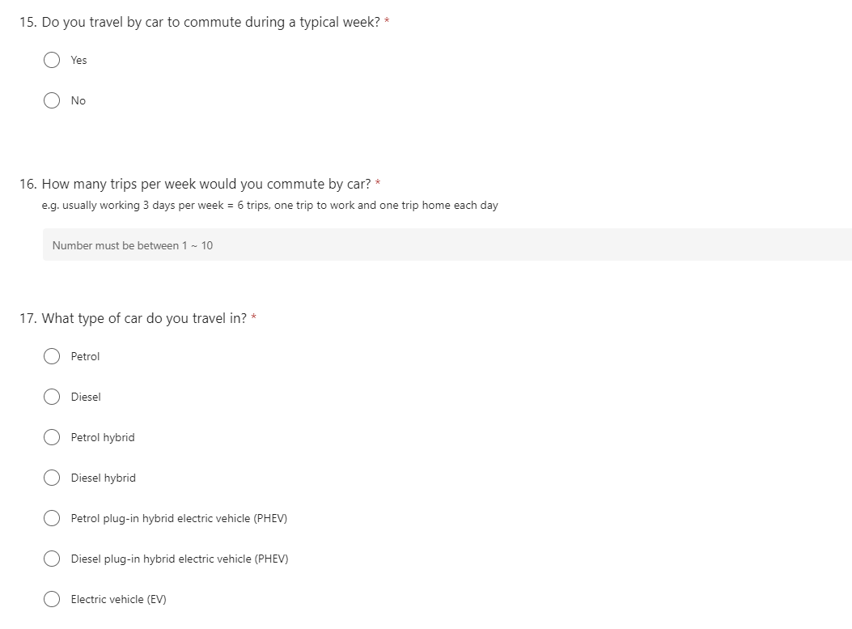

## 2) Ask about each day in a separate question

This approach repeats the same question for each day of the week including weekends.

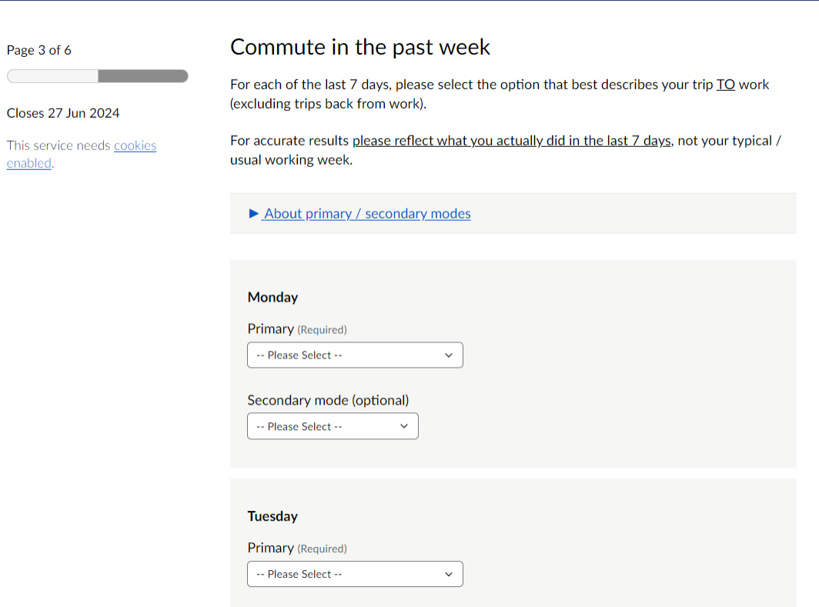

|  |  |
| --- | --- |
| Published in March 2025 by the  Ministry for the Environment – Manatū mō te Taiao on behalf of the Carbon Neutral Government Programme Publication number: INFO 1282 |  |