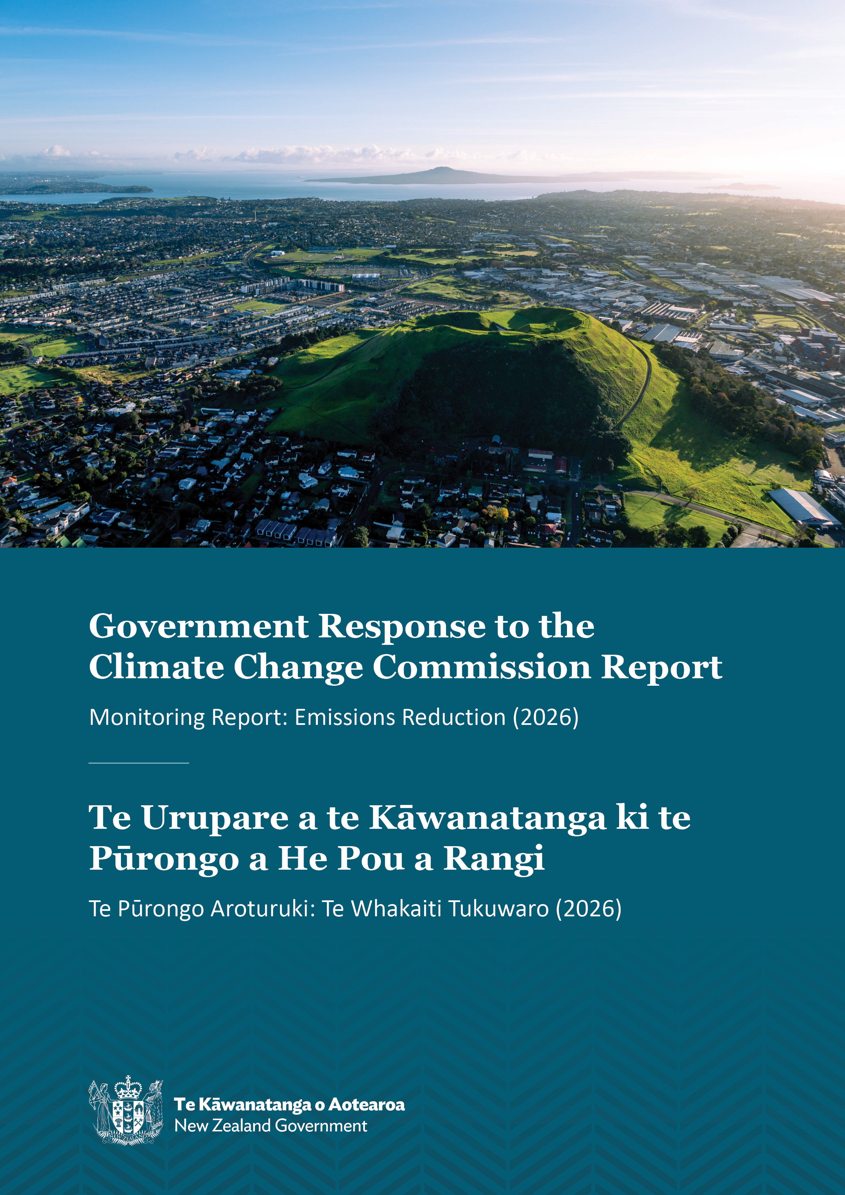
J.23

Disclaimer
The information in this publication is, according to the Ministry for Cities, Environment, Regions and Transport’s best efforts, accurate at the time of publication. The Ministry will make every reasonable effort to keep it current and accurate. However, users of this publication are advised that:
- the information does not alter the laws of New Zealand, other official guidelines, or requirements
- it does not constitute legal advice, and users should take specific advice from qualified professionals before taking any action based on information in this publication
- the Ministry does not accept any responsibility or liability whatsoever whether in contract, tort, equity, or otherwise for any action taken as a result of reading, or reliance placed on this publication because of having read any part, or all, of the information in this publication or for any error, or inadequacy, deficiency, flaw in, or omission from the information in this publication
- all references to websites, organisations or people not within the Ministry are for convenience only and should not be taken as endorsement of those websites or information contained in those websites nor of organisations or people referred to.

This document may be cited as: Ministry for Cities, Environment, Regions and Transport. 2026. Government Response to the Climate Change Commission Report: Monitoring Report: Emissions Reduction (2026). Wellington: Ministry for Cities, Environment, Regions and Transport.

Presented to the House of Representatives pursuant to section 5ZK(4) of the Climate Change Response Act 2002.

Published in September 2026 by the
Ministry for Cities, Environment, Regions and Transport on behalf of the
Climate Change Chief Executives Board
PO Box 10362, Wellington 6143, New Zealand
mcert.govt.nz
ISSN: 3021-3460
ISBN: 978-1-997358-10-7
Publication number: MCERT 12
© Crown copyright New Zealand 2026

Contents
Executive summary 5
Introduction 6
Government strategy to reduce emissions 7
New Zealand’s domestic climate change targets 7
Government Target 9 8
Implementing the second emissions reduction plan 8
Managing progress towards EB2 9
Response to the ERM report recommendations and key findings 10
Projecting emissions to 2050 10
Our approach to the projections 11
Meeting EB1 13
Meeting EB2 and EB3 14
Recent government action that increases confidence in delivery 16
Supporting Māori participation in emissions reductions 18
Conclusion 19

Tables
Table 1: New Zealand’s first three emissions budgets 7
Table 2: Updated 2025 emissions projections (Mt CO₂e) (central estimate) 11

Figures
Figure 1: 2026 ERM report and government response timeline 6
Figure 2: The five pillars of the Climate Strategy 7
Figure 3: Target 9 – Reduced net greenhouse gas emissions 8
Figure 4: Annual adaptive management cycle 9
Figure 5: 2025 biogenic methane and long-lived gas emissions projections and targets to 2050 11
Figure 6: Gross and net emissions (in Mt CO₂e), 1990–2024 13
Figure 7: Updated 2025 projections for EB1 14
Figure 8: Updated 2025 projections for EB2 and EB3 15
Figure 9: Emissions intensity, Statistics New Zealand 16

Executive summary
In July 2026, He Pou a Rangi Climate Change Commission (the Commission) published its third annual report, Monitoring report: Emissions reduction – Assessing progress towards meeting Aotearoa New Zealand’s emissions budgets and the 2050 target (2026).
Findings from the Commission’s assessment of progress towards emissions budgets and targets include:
- “The first emissions budget [2022–25] is likely to be met”.
- “Projections show that the second emissions budget [2026–30] could still be met by 3.6 MtCO₂e but more than half of the reductions planned, 12.4 MtCO₂e, are at significant risk” .
- “Current plans and policies are insufficient to meet the third emissions budget (2031-2035) or the 2050 target, and the window for action is closing”.
These findings and the Commission’s broader analysis underpin its two recommendations to the Government. The Government’s response to each recommendation is summarised below and set out in more detail in this report.
The Commission’s recommendations are:
- That the Government takes action to address market barriers and failures within the next year to ensure it can meet its emissions goals.
The Commission considers this action necessary to address the risk that expected emissions reductions may not be delivered. The Government acknowledges this recommendation and has since announced further policies that improve delivery confidence. We will continue to monitor delivery risks as we implement the second emissions reduction plan (ERP2), alongside work on strategic options to close the projected emissions gap for the third emissions budget (EB3).
- That the Government updates the approach to emissions projections to ensure they provide a robust indication of likely future policy impact.
We acknowledge the recommendation and will continue to refine how we produce the projections, using the best available evidence. We note that recent developments have strengthened the evidence base although we recognise that future projections are inherently uncertain.
Overall, the Government’s updated 2025 emissions projections indicate that Aotearoa New Zealand is on track to meet the first emissions budget (EB1), and the second budget (EB2) can be met with a 3.6 Mt CO₂e buffer. However, EB3 remains off track, with an 8.7 Mt CO₂e shortfall.

Introduction
The Government welcomes the Commission’s 2026 Emissions Reduction Monitoring Report (ERM report), received in July 2026. The Commission provides regular, independent monitoring and reporting on progress towards meeting emissions budgets and the 2050 target. As part of this, the Commission produces an annual ERM report that includes:
- how Aotearoa New Zealand’s emissions and removals are tracking
- the latest projections for current and future emissions and removals
- an assessment of the effectiveness of the Government’s current emissions reduction plan (ERP) and its implementation.
The Climate Change Response Act 2002 (the Act) requires that, within three months of receiving the report, the Minister of Climate Change must present a report to the House of Representatives that:
- sets out the response to the ERM report and recommendations
- describes the progress in implementing the current ERP
- notes any amendments to that plan.
Figure 1: 2026 ERM report and government response timeline
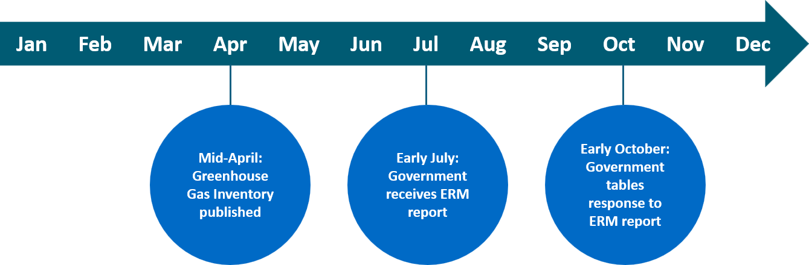

Government strategy to reduce emissions
We are committed to delivering on New Zealand’s climate change commitments while growing the economy. Our approach is set out in the Climate Strategy and its five pillars (figure 2).
Figure 2: The five pillars of the Climate Strategy
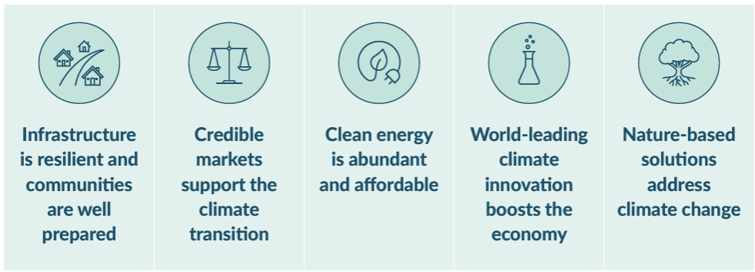
Our approach to meeting New Zealand’s climate targets is:
- cost-effective and efficient
- net-based – reducing gross emissions and increasing removals
- technology-led, so that production can keep growing while emissions come down.
The New Zealand Emissions Trading Scheme (ETS) remains at the core of our response, supported by policies that reduce the barriers to investment in reducing and removing emissions.

New Zealand’s domestic climate change targets
New Zealand has legislated domestic emissions reduction targets under the Act:
- net zero emissions of all greenhouse gas emissions other than biogenic methane by 2050
- 14 to 24 per cent reduction below 2017 biogenic methane emissions by 2050, including 10 per cent reduction below 2017 levels by 2030.
Table 1 sets out the first three budgets that step New Zealand towards these targets. EB1 has now concluded, and New Zealand is in the first year of EB2.
Table 1: New Zealand’s first three emissions budgets
 | Emissions budget period
 | EB1: 2022–25 | EB2: 2026–30 | EB3: 2031–35
All gases, net | 290 Mt CO₂e | 305 Mt CO₂e | 240 Mt CO₂e
Annual average | 72.5 Mt CO₂e | 61 Mt CO₂e | 48 Mt CO₂e
The Act requires the Minister of Climate Change to prepare and publish emissions reduction plans, which set out the policies and strategies for meeting the corresponding emissions budget.
The second emissions reduction plan (ERP2) was published in December 2024 and amended in January 2026. It sets out the Government’s approach to meeting New Zealand’s climate targets and is underpinned by the Climate Strategy. The third emissions reduction plan, for meeting EB3, is due for publication by the end of 2029.
The Government was due to set EB4 by the end of 2025. Following changes to the 2050 target in 2025 we requested the Commission to review its advice on EB4 to reflect the amended target. The Commission’s updated advice is due by 31 March 2027, and we are required to set EB4 by 31 December 2027.

Government Target 9
In April 2024, Cabinet set nine government targets. The aim is to focus the public sector on improving results in health, law and order, work, housing, and the environment.
Target 9 is focused on reduced net greenhouse gas emissions. It aligns with EB1 and EB2, and the 2050 net zero target.
The Minister for Climate Change reports quarterly to the Prime Minister (via the Department of the Prime Minister and Cabinet) advising on progress towards Target 9.
Figure 3: Target 9 – Reduced net greenhouse gas emissions
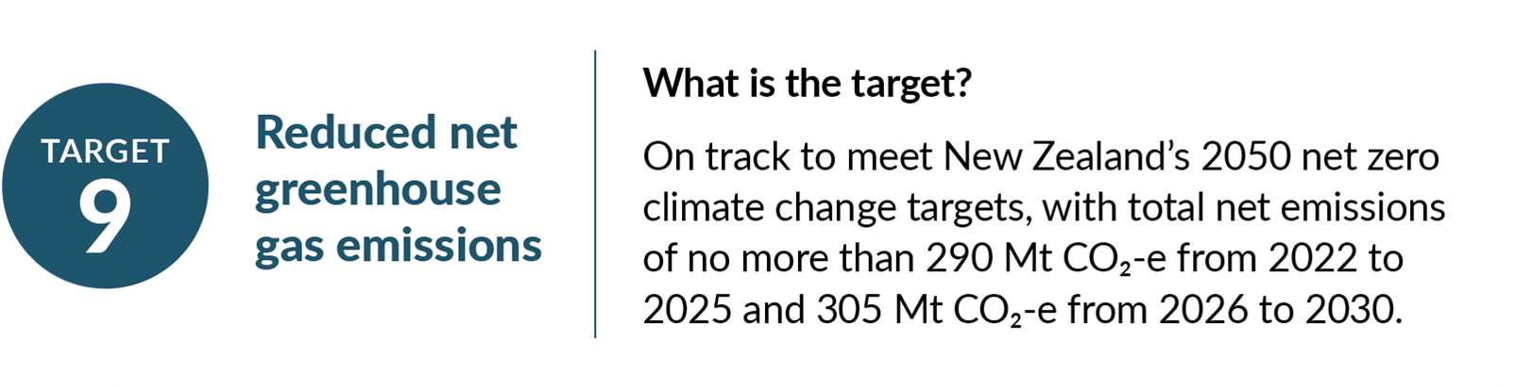
Previous Target 9 reports are on the Ministry for Cities, Environment, Regions and Transport (MCERT) website. The latest publicly available report, for the quarter ending 30 June 2026, shows New Zealand is on track to meet Target 9.

Implementing the second emissions reduction plan
ERP2 includes a range of policies and initiatives to reduce emissions, speed the uptake of new technologies and encourage innovation. It came into effect on 1 January 2026, with the start of EB2.
The Climate Change Chief Executives Board monitors and reports on progress in implementing ERPs and publishes its reports on the MCERT website. The most recent ERP2 progress report for the period ending 30 June 2026 shows that nearly all ERP2 policies and actions are on track.

ERP2 amendment
In October 2025, the Government announced that it would not progress an on-farm emissions pricing system by 2030. We expect this to have a minor impact during EB2, since pricing was planned to start in the last year of EB2 in 2030. We do not expect it to affect New Zealand’s ability to meet EB2.
ERP2 was amended in January 2026 to reflect this revised approach to reducing agricultural emissions.
The Government agrees that the market barriers the Commission identifies are real. This includes uncertainty about whether market drivers and industry incentives will support enough uptake of new technologies, and reduce absolute emissions at the scale required. In this context, we have decided to take a technology and market-led approach to reducing agricultural emissions. Over the next four years, $437 million has been allocated to accelerate the development and availability of new tools and technology to help farmers reduce their on-farm emissions.

Managing progress towards EB2
ERP2 outlined an adaptive management approach to actively monitor how New Zealand is tracking toward its climate targets, and respond to changing circumstances. This process enables the Government to monitor developments closely and, if needed, make timely corrections to stay on track for EB2.
Adaptive management will apply annually through a three-stage cycle (figure 4). Chapter 3 of ERP2 outlines more on this. The Minister of Climate Change is expected to consider 2026 adaptive management advice by the end of 2026.
Figure 4: Annual adaptive management cycle
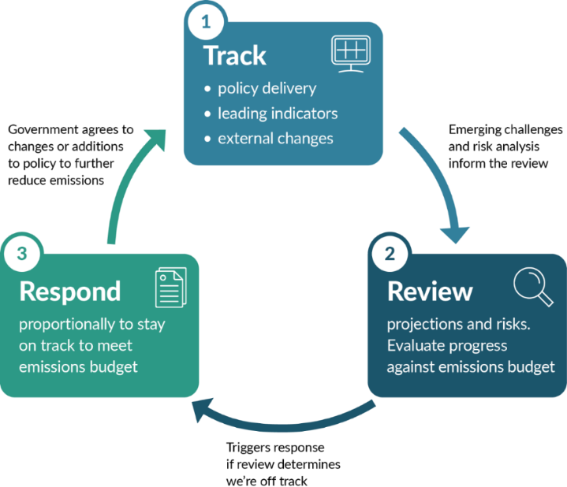

Response to the ERM report recommendations and key findings
The Commission made two recommendations:
- That the Government takes action to address market barriers and failures within the next year to ensure it can meet its emissions goals.
- That the Government updates its approach to emissions projections to ensure they provide a robust indication of likely future policy impact.
The report also found that:
- Climate disruption and economic impacts in Aotearoa New Zealand are growing – greater and more durable emissions reductions are needed to manage these risks.
- Greenhouse gas emissions are gradually falling, but the reductions are unlikely to be enduring, and the pace needs to more than double.
- The second emissions budget (2026–2030) is at increasing risk.
- Current plans and policies are insufficient to meet the third emissions budget (2031–2035) or the 2050 target, and the window for action is closing.
- Acting earlier to reduce emissions can strengthen resilience, reduce exposure to shocks, and lower costs for households, businesses and the country.
For a summary of its findings and recommendations, see the Commission’s report (pp 5–6). Pages 18 and 19 set out the methodology.

Projecting emissions to 2050
Emissions projections assess how future emissions are expected to change under current policies and assumptions.
The updated 2025 projections indicate that New Zealand is on track to meet EB1, with a high level of confidence, given that much of the budget period is now covered by the 2026 Greenhouse Gas Inventory (the Inventory) data. They also indicate that EB2 can be met, but EB3 remains off track.
The updated 2025 projections remain the latest available projections. They provide the Government’s current assessment of New Zealand’s emissions pathway and are referred to in this response.
Table 2: Updated 2025 emissions projections (Mt CO₂e) (central estimate*)
Emissions budget limits | Updated 2025 projections | 2025 difference from EB
EB1  290 Mt CO₂e | 282.3 | -7.7
EB2  305 Mt CO₂e | 301.4 | -3.6
EB3  240 Mt CO₂e | 248.7 | +8.7
*‘Central estimate’ refers to the value believed to be most likely, based on the current understanding of relevant assumptions.
New Zealand is projected to meet both components of the 2050 target, but the 2030 biogenic methane target remains off track (figure 5).
Figure 5: 2025 biogenic methane and long-lived gas emissions projections and targets to 2050

Our approach to the projections
Emissions projections are inherently uncertain but are based on the best available information to understand how New Zealand is tracking towards its emissions budgets and targets. The Government’s projections are produced annually and reflect the latest available information on economic conditions, polices and other key assumptions at that point in time.
The overall context and level of uncertainty for modelling projections is shifting:
- Global uncertainty and volatility are increasing.
- Government actions and decisions by businesses, industry groups and consumers shape how sectors develop, with implications for future emissions.
- Different sectors face varying levels of uncertainty, depending on how they are affected by factors such as market conditions, geopolitical developments, weather, technology development and uptake or consumer behaviour.
- The stage of policy development also plays a role. In some cases, details of how a policy will be implemented have yet to be decided (eg, afforestation on Crown-owned land).
Together, these factors can make future emissions outcomes more difficult to project.
The 2025 projections used a mix of modelling approaches to reflect uncertainty, depending on what is appropriate for each sector. This includes uncertainty ranges and providing multiple plausible future scenarios to illustrate how different assumptions and developments could affect future emissions.
We take a continuous improvement approach to emissions projections, reviewing the process each year and identifying improvements for future updates. Improvements already made to the projection processes include better visibility of major assumptions and strengthened quality assurance and quality control processes.
We have considered the Commission’s recommendation on emissions projections in this context. In recommendation 2, the Commission raised concerns about relying on scenario-based modelling to represent likely policy impacts. It considers some assumptions behind the projections to be insufficiently grounded in current policy, particularly for agriculture technology, afforestation on Crown-owned land and landfill gas capture.
We acknowledge the Commission’s recommendation that projections need to provide a robust indication of the likely future policy impact. Our response to the concerns is set out below.
We will continue to be transparent about the assumptions underpinning projections in key publications, including biennial transparency reports and ERPs. We will refine methodologies and assumptions as new evidence and policy decisions become available. In the agricultural sector, for example, this may include:
- availability and cost of emissions reduction technology
- fluctuations in the market, climate and weather patterns
- actual uptake of technology
- uncertainty about predicted productivity improvements.
Some policies were still in development at the time of the Commission’s 1 April information cut-off and were not reflected in the 2025 projections. We expect that current policy settings, alongside the actions, investment and strategies of other market participants, will support us to achieve our emissions budgets and targets and strengthen the policy and evidence base for our projections. This includes the Early Adoption Accelerator to support the early use of technology to mitigate agricultural emissions announced on 10 June 2026 and consultation on reducing organic waste emissions in June/July 2026.
The 2026 projections were already in development when the Commission’s report was released and are expected to be published by the end of 2026, alongside an updated assessment of New Zealand’s emissions pathway and progress towards budgets and targets. Further refinements will be considered through this process, including the Commission’s recommendation.
The 2026 projections could not be completed in time for this response given the required cross-sector compilation, review and assurance process. Proposed changes through the Climate Change Response Amendment Bill will better align the timing of the Commission’s ERM report, and the Government’s emissions projections and response. This will provide greater flexibility to consider the latest available evidence in future responses.

Meeting EB1
The Commission finds that EB1 is likely to be met. The 2026 Inventory data support this assessment, showing that net emissions continued to fall in 2024.
- Gross emissions peaked in 2006 and have generally declined since 2019. They fell by 0.1 per cent in 2024 as increased fossil fuel electricity generation during a dry year slowed the rate of decline.
- Net emissions continued to decline, falling 2 per cent between 2023 and 2024 (figure 6).
Figure 6: Gross and net emissions (in Mt CO₂e), 1990–2024

Note: LULUCF = land Use, land-use change and forestry.
More recent provisional emission estimates from Statistics New Zealand indicate that gross emissions continued to decline in the beginning of 2026.
As outlined above, the updated 2025 projections also indicate that New Zealand remains on track to meet EB1, with projected emissions of 282.3 Mt CO₂e – 7.7 Mt CO₂e below the budget limit of 290 Mt CO₂e. As much of the budget period is now covered by Inventory data, the Government agrees, with a high level of confidence, that EB1 will be met (figure 7).
Figure 7: Updated 2025 projections for EB1

The Government also acknowledges the Commission’s finding that changes to the Inventory methodology, which are then reflected and updated in the historical time series, have reduced the emissions reduction effort needed to meet EB1. Proposed changes through the Climate Change Response Amendment Bill will explicitly allow the current emissions budget to be amended to reflect methodological changes. It also provides for the creation of a consistent approach for measuring, and accounting for, methodological improvements that will be used by Climate Change Commission, government agencies and the Minister of Climate Change.

Meeting EB2 and EB3
The Commission finds that EB2 is likely to be met, but is now at significant risk. It states that the pace of emissions reductions needs to more than double. It also finds that current policies and plans are insufficient to meet EB3. Recommendation 1 of its report therefore calls on the Government to address market barriers and other constraints on investing in emissions reductions over the next year.
For EB2, the Commission estimates that 12.4 Mt CO₂e of projected emissions reductions are at significant risk of not being achieved due to policy and programme delivery risks, particularly across the electricity generation, agriculture and transport sectors. This represents net reductions that may not be delivered as assumed, rather than a predicted 12.4 Mt CO₂e shortfall.
In the Commission’s assessment, the risk to policy or programme delivery has also increased for EB3. It states that there are significant risks across forestry, industry and the ETS. It also assessed planned agricultural policies as insufficient to deliver projected reductions.

Current projections
The updated 2025 projections indicate that we can meet EB2, with projected emissions of 301.4 Mt CO₂e – 3.6 Mt CO₂e below the budget limit (305 Mt CO₂e). EB3 remains off track, with projected emissions of 248.7 Mt CO₂e – 8.7 Mt CO₂e above the budget limit (240 Mt CO₂e).
Figure 8: Updated 2025 projections for EB2 and EB3

Confidence in meeting EB2
The Government acknowledges the delivery risks the Commission raises. However, subsequent policy and implementation progress not available to the Commission at the time of its assessment provides additional confidence in achieving EB2 (see government action below).
Risks and circumstances change over the course of an emissions reduction plan. Rather than responding to individual risks as they emerge, the Government uses adaptive management to monitor progress and assess whether further action is needed to stay on track. The 2026 assessment will occur in tandem with the development of the 2026 projections, so that both processes can draw on the latest evidence. Given the projected EB2 buffer, the early stage of the budget period and progress in ERP2 implementation, we have greater confidence that EB2 can be met.
Moreover, recent economic and emissions trends provide further confidence in meeting EB2. GDP growth and emissions have decoupled consistently since the December 2024 quarter, indicating that the economy can continue to grow while emissions decline (figure 9).
Figure 9: Emissions intensity, Statistics New Zealand

Looking ahead to EB3
We acknowledge the Commission’s finding that current policies and plans are insufficient to meet EB3. Recommendation 1 also raises concerns about the ability of the ETS to incentivise sufficient emissions reductions in the 2030s. We acknowledge that the ETS will not be able to achieve EB3 on its own. Our current provisional estimates have ETS auctions ceasing in 2032, after which the Government will have a reduced ability to directly influence emissions reductions using the ETS. This places greater emphasis on other policy tools to drive the reductions necessary to meet EB3 and the 2050 target.
Work is currently underway to identify strategic options for closing the EB3 gap. This will support reductions in the 2030s and may also lead to additional reductions during EB2.

Recent government action that increases confidence in delivery
In considering recommendation 1, we have taken into account recent policy and implementation developments that increase confidence in the delivery of future emissions reductions. These are outlined below.
Agriculture
The Government is taking a technology and market-led approach to reduce agricultural emissions. Following the removal of agricultural emissions pricing from ERP2, we have committed $437 million over four years, alongside industry investment through the Accelerating New Mitigations programme, to support the development and uptake of agricultural mitigation technologies. In Budget 2026, we confirmed a further four years of funding for AgriZeroNZ (AgriZero), the Ag Emissions Centre and wider technology investment programme, providing certainty for this programme of work.
A strong pipeline of technology is in development in New Zealand and globally. While research and development is inherently uncertain, New Zealand continues to trial and test technology advances and new mitigations. AgriZero monitors and publicly reports on its assessment of the future availability of this pipeline each quarter, through the Scorecard on its website.
The Early Adoption Accelerator, announced in June 2026, provides up to $51 million of Crown funding over three years, matched by industry. It addresses barriers and promotes the uptake of mitigation technology. This new investment will build confidence in the use of proven technologies on farms in New Zealand. We expect this will support farmers to adopt mitigations projects at scale. Early feedback from the sector is that it will enable them to act earlier and take on projects with more confidence. This is an important contribution to the technology and market-led approach, and is consistent with the Commission's recommendations.
Energy
New Zealand has expanded its renewable electricity capacity with 3.74 terawatt-hours of new generation built in the three years from 2023-25, which is more than double the 1.65 terawatt-hours built in the previous eight years. A robust pipeline of projects remains, and fast-track consenting supports further development.
The Government recognises that a declining domestic gas supply presents an increasing challenge for electricity security, affordability and industrial transition planning. Alongside enabling investment in renewables, we are progressing a range of measures to improve system resilience during dry years, including work related to LNG.
Budget 2026 also introduced a Gas Transition Loan Guarantee Scheme to support businesses transitioning away from natural gas.
Transport
The Government continues to support the shift to low-emissions transport. We have recently removed consenting barriers for public charging infrastructure, making it faster and easier to install new chargers. We have also recently allocated $52.7 million in zero-interest loans. Alongside private sector co-investment, we expect this to accelerate the roll-out of the public charging network.
We expect the loans to more than double the public charging network to around 4,550 charge points, supporting continued electric vehicle uptake. We have announced a second round of zero-interest loans, allocating up to $21 million.
Officials have also completed a first-principles review of the Clean Vehicle Standard, which the Government has decided to retain.
Forestry
Forestry plays an important role in reducing net emissions and meeting New Zealand’s climate change targets. We have made policy decisions to enable voluntary nature and carbon market activity on public conservation land and are progressing legislative change to enable a wider range of activities on Crown pastoral land alongside farming. As part of this we are exploring measures to support native afforestation.
The Government also acknowledges the Commission’s concerns about forest management accounting, and the need to maintain confidence in emissions budget reporting. We are considering options on how to treat forest management accounting in New Zealand’s domestic emissions accounting framework, including how it applies to emissions budgets.
Waste
The Waste Minimisation Fund is making progress towards projected emissions reductions. Emerging evidence indicates less food waste is being sent to landfill, and more is being diverted elsewhere.
We have also finished consulting on changes to the ETS to improve landfill gas capture. Emerging evidence points to an increased potential to generate energy from captured landfill gas.
New Zealand Emissions Trading Scheme
The Government has sought to improve confidence and stability in the ETS through:
- largely stable settings over recent years
- reducing the cap for EB2 and EB3
- deliberately constraining auction volumes, to manage the risk the stockpile poses to meeting the budgets.
ETS settings in the last two years have set more constrained auction volumes than the Commission recommended. Regular updates to ETS regulations have also supported confidence in the scheme.

Supporting Māori participation in emissions reductions
The Government also acknowledges the Commission’s areas for attention relating to iwi, hapū and other Māori groups, including barriers to accessing funding and finance, and emission data.
Through the Māori Climate Platform, we are providing more than $12.1 million in funding to support initiatives across 77 marae throughout the motu. The platform is currently funded through to June 2027. We will consider any future funding beyond June 2027 through the normal government budget process.
The Government’s Māori Development Fund, focused on Māori economic growth initiatives, is another source of funding for Māori-led climate projects. Budget 2026 allocated $38.21 million per annum to the fund from 1 July 2026.
We are also progressing several initiatives in agriculture that were not captured in the Commission’s report. For example, the Accelerating New Mitigations programme has a workstream with dedicated funding to support Māori entities and agribusinesses to reduce on-farm emissions. This provides advice, support and funding for projects that cover research, development, extension and adoption of low-emissions agriculture. It recognises the unique structures and investment horizons of Māori entities.
Similarly, the Ag Emissions Centre has a dedicated Māori research strategy which funds a range of research, particularly on ‘whole of whenua’ farm systems.

Conclusion
The Government thanks the Commission for its third annual ERM report, and its independent assessment of New Zealand’s progress towards meeting its emissions budgets and targets.
We will continue to monitor implementation progress and delivery risks through the annual adaptive management assessment. We will consider corrective action through that process, if risks materialise or the outlook for meeting the current budgets changes. At this early point in the EB2 period (and based on the updated 2025 emissions projections and further policy progress since the Commission’s information cut-off), the Government has confidence that EB2 can be met.
Alongside this, we are progressing work to identify options for closing the projected gap to EB3 and supporting achievement of New Zealand’s longer-term climate change targets. This will provide increased confidence that EB3 can be met.

The net emissions are expressed in million tonnes of carbon dioxide equivalent (Mt CO₂e).
He Pou a Rangi Climate Change Commission. 2026. Monitoring report: Emissions reduction – Assessing progress towards meeting Aotearoa New Zealand’s emissions budgets and the 2050 target (2026). Wellington: He Pou a Rangi Climate Change Commission.
Climate Change Response Act 2002, sections 5ZJ and 5ZK.
Climate Change Response Act 2002 section 5ZK (4).
The 2026 Greenhouse Gas Inventory includes actual emissions and removals data for 1990 to 2024.
Refers to how many Mt CO₂e under or over the emissions budget limit the projected emissions may be.
Emissions pathways are based on the central estimate.
Net emissions are shown for 2021–24 only. The Land Use and Carbon Analysis System - Calculation and Reporting Application (LUCAS CRA) model used to generate LULUCF target accounting forestry estimates has currently produced results for this period only (per the 2026 Inventory).
Stats NZ’s quarterly emissions estimates are based on the production of greenhouse gases by ANZSIC06, and by households on a residence basis.
The historical data for 2022 and 2023 are denoted as estimated historical, due to adjustments to the baseline data which impacts on emissions in 2020–23. Adjustments were made to be consistent with the 2025 Ministry for the Environment projections, which account for updates to the waste emissions methodology.
Figure 9 shows change in industry emissions (CO₂e) and gross domestic product, seasonally adjusted and indexed to 2010 for the March 2010–March 2026 quarters. Emissions intensity is defined as the ratio of industry emissions per unit of GDP.
AgriZero^{NZ}. 2026. Progress. Scorecard: Retrieved 15 September 2026.

