Aotearoa New Zealand climate change projections
Quick reference guide

Why have we released this guidance?
This info sheet provides a summary of the Aotearoa New Zealand climate change projections guidance, published in April 2022. The guidance focuses on and interprets information relevant to Aotearoa from the Working Group 1 (WGI) contribution to the Intergovernmental Panel on Climate Change (IPCC) Sixth Assessment Report (AR6), published in August 2021.
The AR6 features the most up-to-date physical understanding of the climate system and climate change, based on an updated set of climate models and projections. The full guidance provides advice on which climate models to use (eg, CMIP5 or CMIP6), when to wait for updated climate scenarios and under what circumstances, and the greatest uncertainties or impacts in using modified AR5 scenarios.

How should this guidance be used?
The Aotearoa New Zealand climate change projections guidance should be used as the source of truth for projections at a national scale, based on the latest IPCC report and climate change projections for Aotearoa. This info sheet acts as a summary for the full guidance.
More information on deciding which emissions scenario to use can be found in Aotearoa New Zealand’s first national adaptation plan which recommends the middle-of-the-road emissions scenario (SSP2-4.5, RCP4.5) and the fossil fuel-intensive development scenario (SSP5-8.5, RCP8.5) be used for detailed hazard and risk assessments in both coastal and non-coastal areas.
It is appropriate to consider more than one scenario for stress testing due to the complexity of being a projection and not forecast. More information on this can also be found in the national adaptation plan and emissions reduction plan: resource Management Act 1991 guidance note.

Key differences between AR5 and AR6

SSPs vs RCPs
Shared Socio-economic Pathway (SSP) scenarios further refine the previous greenhouse gas concentration scenarios known as Representative Concentration Pathways (RCPs).
IPCC published its Fifth Assessment Report (AR5) in late 2013, which used projections of future climate change associated with RCPs. These RCPs were based on greenhouse gas emissions, aerosol emissions and changes in land-use patterns over time. The AR6 used SSPs instead of RCPs. The SSPs base their emission scenarios on a wide array of socio-economic drivers, including gross domestic product, population size, urbanisation, economic collaboration, and human and technological development. Scenarios are projections, not predictions or forecasts. They have been developed to provide narratives of a broad range of possible futures (table 1). Some SSP- and RCP-based scenarios reach the same radiative forcing* by 2100, but the greenhouse gas concentration pathways taken to reach that radiative forcing are different (figure 1). SSP1-1.9 was introduced in AR6 to explore the possibility of limiting warming to 1.5°C by 2100 (table 1).
Table 1: Social action and scenario names for the new Shared Socio-economic Pathways described in AR6
Social action | Scenario name | Temperature increases by 2100 (°C)
Sustainability | SSP1 | SSP1-1.9 – 1.4  SSP1-2.6 – 7.8
Middle-of-the-road | SSP2 | SSP2-4.5 – 2.7
Regional rivalry | SSP3 | SSP3-7.0 – 3.6
Inequality | SSP4 | -
Fossil fuel-intensive | SSP5 | SSP5-8.5 – 4.4
Note: Temperature estimates for 2100 are from AR6 Summary for Policy Makers, table SPM.1.
*Radiative forcing is the difference between the energy entering our atmosphere and the energy leaving it. If that number is greater than zero, our atmospheric temperature can increase. For example, SSP1-1.9 would mean that the “sustainability” path was taken, and the radiative forcing resulting from these emissions by 2100 is 1.9 W m², leading to an increase in atmospheric temperature (table 1).
Figure 1: Global, annual mean CO₂ gas concentrations for SSPs and RCPs
Notes: SSPs = solid lines. RCPs = dashed lines. Data is sourced from Meinshausen et al. (2011) and Meinshausen et al. (2020). Figure from the full Aotearoa New Zealand Climate Change Projections guidance (2022).

CMIP5 vs CMIP6
The Coupled Model Intercomparison Project (CMIP) is a World Climate Research Programme project that coordinates climate model experiments, with the goal to improve scientific knowledge about the Earth system. The AR6 assesses results from CMIP Phase 6 (CMIP6).
CMIP6 is the next generation of climate models – it has finer spatial resolutions, additional Earth system processes including biochemical systems and ice sheets, and better constrained parameters of cloud processes.
Additionally, SSPs determined the emission scenarios which were put into CMIP6, whereas the inputs for CMIP5 were solely emission scenarios. This extra step resulted in the improvement of the simulation of large-scale indicators of climate change and many other aspects of the climate system in CMIP6.
What do IPCC levels of confidence and likelihood mean?
The IPCC uses two metrics to communicate its degree of certainty: confidence and likelihood. Confidence is a qualitative measure that refers to the validity of a finding. It is based on the type, amount, quality and consistency of evidence. If confidence is sufficient and there is quantitative evidence, these findings can be expressed with likelihood statements. Likelihood is a quantitative measure of uncertainty and is established through statistical analysis of observations or model results (or both) and the judgement of experts.

Trends and projections of Aotearoa New Zealand’s climate

Mean surface air temperature
Temperatures globally and locally have been rising over the last few decades and are projected to keep rising. The AR6 WGI report pulls together various sources of historic global climate data. According to this report, mean global surface temperature was 1.09°C (0.95 to 1.2°C) higher between 2011 and 2020, relative to the period 1850–1900. During the period 1909–2016, Aotearoa experienced a similar increase in surface temperature of 1.1°C (MfE and Stats, 2020). Since 1909, a rate of increase of 0.09 ± 0.01°C per decade has been observed (table 25-1, IPCC AR6). The difference in date ranges for these measurements is due to different sources of the data.
SSP1-2.6 projects mean air temperature in Aotearoa to be 0.75°C warmer by mid-century, and 0.8°C warmer by end of century, relative to 1995–2014. Under SSP2-4.5, these projections are 1.0°C (0.6 to 1.32°C) warmer by mid-century, and 1.6°C (1.03 to 2.26°C) by end of century. Under SSP5-8.5, the projected increase is 1.3°C (0.91 to 1.66°C) by mid-century and 3.1°C (2.2 to 4.05°C) by end of century.

Hot extremes and cold extremes
Hot extremes are projected to increase and cold extremes are projected to decrease. Since the 1950s, Aotearoa has experienced an increasing frequency and severity of hot extremes. The number of annual heatwave days increased at 18 of the 30 monitoring sites across the country during the period 1972 to 2019 (MfE and Stats NZ, 2020). AR6 projects a continuing increase in the intensity and frequency of the annual hottest daily maximum temperatures for Aotearoa (table 2).
Aotearoa has experienced less frequent and intense cold extremes since the 1950s. A decrease in the number of frost days was reported at 12 out of 30 monitoring sites around the country between 1972 and 2019, and AR6 projects that frost days will continue to decrease in the future (table 3). The confidence and likelihood of a decrease in the intensity and frequency of the annual coldest daily minimum temperature for New Zealand is shown in table 2.
Table 2: Confidence and likelihood of an increase in intensity and frequency of the hottest daily maximum temperature and the coldest daily minimum temperature
Warming (global mean) | Compared to 1972–2019 | Compared to pre-industrial
+1.5°C | High confidence | Likely
+2.0°C | Likely | Very likely
+4.0°C | Extremely likely | Virtually certain
Note: Relative to 1972 to 2019 and pre-industrial times. Source: AR6 WG1, table 11.10.
Table 3: Approximate decreases in frost days
 | 2040 | Compared to 1972–2019 | 2090
RCP2.6 | 20–40% decrease | High confidence | 20–40% decrease
RCP8.5 | 30–50% decrease | Likely | 70–90% decrease
Note: Relative to 1986–2005, projected to 2040 and 2090 for RCP2.6 and RCP8.5. Data from MfE (2018).

Precipitation
Annual mean precipitation is projected to increase in the south and west of Aotearoa both in the near- and far-future (medium confidence and high agreement, respectively (IPCC AR6 box, page 1)). Projected winter and spring rainfall follows the annual increase in the west and south, but with less rainfall in the east and north. It projects more summer rainfall in the east of both islands, with less rainfall in the west and central North Island (medium confidence). The findings of AR6 are broadly consistent with projections reported in AR5 (figure 2).
Figure 2 Projected changes in precipitation (%) by the end of the 21st century under RCP4.5 (left) and projected changes in precipitation (%) for summer and winter for the ensemble-mean of six climate models under the RCP8.5 (right)
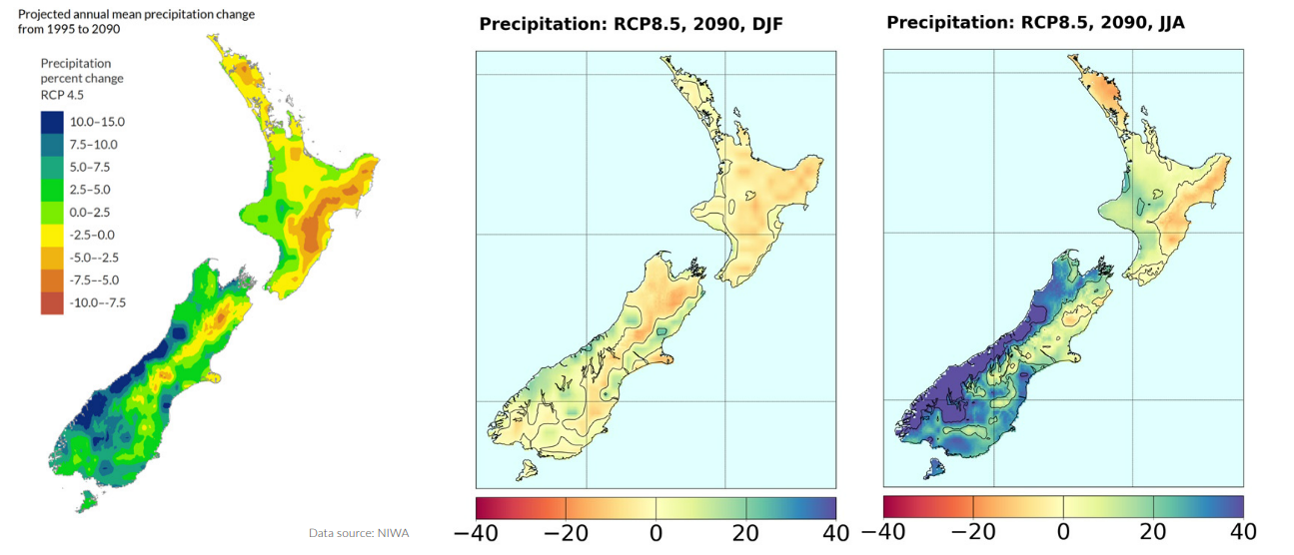
Notes: Based on regional downscaling of CMIP5 global model data associated with RCP4.5. DJF = December, January, February. JJA = June, July, August. Source: MfE and Stats NZ (2020) and NIWA.

Flooding
Projections for Aotearoa indicate that the 1-in-50-year and 1-in-100-year flood peaks for rivers in many parts of the country may increase by five to ten per cent by 2050 and more by 2100, with a corresponding decrease in return periods for specific flood levels (medium confidence). Rising sea levels due to climate change also significantly impact flooding and river flooding. For more information on sea-level rise projections, see the coastal hazards and climate change guidance published in 2017, and the interim guidance on the use of new sea-level rise projections, published in 2022.

Wind
Mean wind patterns are projected to become more north-easterly in summer, with westerlies projected to become more intense in winter over the next few decades (low confidence). This aligns with the strengthening of the southern hemisphere storm tracks. For all RCPs, an increase in extreme winds over the South Island and the southern part of the North Island is projected.

El Niño Southern Oscillation (ENSO) and Southern Annular Mode (SAM) patterns
Climate model performance in AR6 simulating ENSO has not changed significantly between CMIP5 and CMIP6. The nature of sea surface temperature variability associated with ENSO is found in AR6 to exhibit no systematic change through the 21st century, which suggests that ENSO might continue to behave the same as it has in the past. However, the tropical precipitation variability associated with ENSO is projected to systematically increase. AR6 concluded there is high confidence that under SSP3-7.0 and SSP5-8.5 the SAM will become more positive in all seasons. SSP1-1.9 shows a decrease of positive occurrences during the austral summer.

Drought
In the north and east of Aotearoa, aridity is projected to increase with medium confidence by 2090, while a decrease is projected with medium confidence in the south and west of the country for the same time period. Drought severity is projected to increase in most areas of the country, except for Taranaki-Manawatu, the West Coast and Southland. Weather that causes conditions conducive to fire is also projected to increase by 2090 in many parts of Aotearoa (medium confidence), particularly with respect to extreme fire.

Glacier volume
The number of annual snow days in Aotearoa is projected to decrease by 30 days or more by 2090 under RCP8.5 (MfE, 2018), resulting in a decrease in glacier volume by the end of the century. The decline is projected to be 36 ± 44%, 53 ± 33%, and 77 ± 27% under RCP2.6, RCP4.5, and RCP8.5, respectively.

Marine heatwaves
Over the past century, regional sea surface temperatures have increased in the northern Tasman Sea/Aotearoa region, resulting in an increase in the frequency of marine heatwaves. AR6 concludes that it is very likely there will be further increases in frequency, duration, spatial extent, and intensity of marine heatwaves under future global warming in the 21st century. Globally, the frequency of marine heatwaves is expected to increase by between four (SSP1-2.6) and eight (SSP5-8.5) times (IPCC AR6 box 9.2); for Aotearoa SSP1-2.6 doubles the occurrence of marine heatwaves, whereas SSP5-8.5 quadruples it (NIWA, 2022).

Groundwater
While climate change impacts the availability, recharge and water table elevation of groundwater, projections of this are not provided in AR6. Projections for Hawkes Bay and Otago show a decrease in groundwater available under RCP4.5 and RCP8.5, although due to the influence of topography on the regional variability of precipitation, Otago shows more variability. The modelled rainwater recharge and water table projections generally follow rainfall projections.

What is next?
Regional-scale climate projections for Aotearoa based on global CMIP6 data will be provided in 2024, following national adaptation plan action 3.1. Projections for temperatures, wind patterns and other datasets might change when this is completed. Until this downscaling is completed, regional climate projections reported in climate change projections for New Zealand (MfE, 2018) can continue to be used with reasonable confidence.
Published in February 2023 by the
Ministry for the Environment – Manatū Mō Te Taiao
Publication number: INFO 1142

