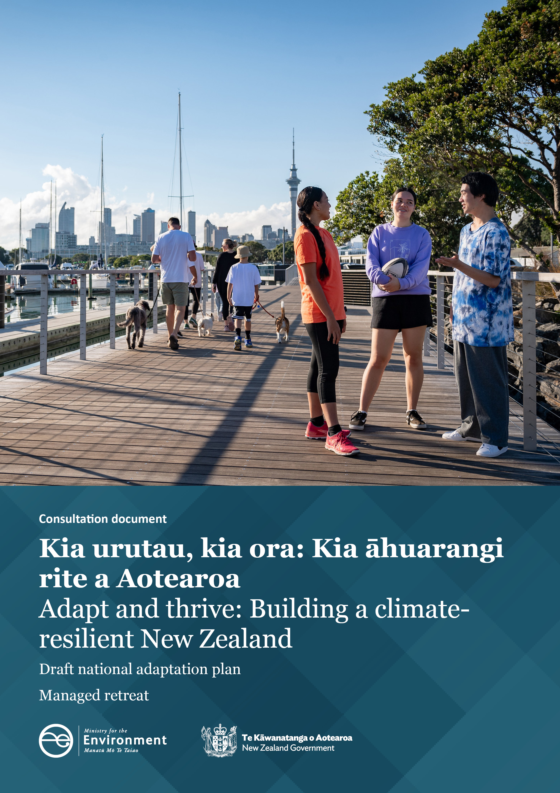
Disclaimer
The information in this publication is, according to the Ministry for the Environment’s best efforts, accurate at the time of publication. The Ministry will make every reasonable effort to keep it current and accurate. However, users of this publication are advised of the following.
- The information does not alter the laws of New Zealand, other official guidelines, or requirements.
- It does not constitute legal advice, and users should take specific advice from qualified professionals before taking any action based on information in this publication.
- The Ministry does not accept any responsibility or liability whatsoever whether in contract, tort, equity, or otherwise for any action taken as a result of reading, or reliance placed on this publication because of having read any part, or all, of the information in this publication or for any error, or inadequacy, deficiency, flaw in, or omission from the information in this publication.
- All references to websites, organisations or people not within the Ministry are for convenience only and should not be taken as endorsement of those websites or information contained in those websites nor of organisations or people referred to.

This document may be cited as: Ministry for the Environment. 2022. Adapt and thrive: Building a climate-resilient New Zealand. Wellington: Ministry for the Environment.

Published in April 2022 by the
Ministry for the Environment
Manatū Mō Te Taiao
PO Box 10362, Wellington 6143, New Zealand
ISBN: 978-1-99-102518-0 (online)
Publication number: ME 1636
© Crown copyright New Zealand 2022
This document is available on the Ministry for the Environment website: www.mfe.govt.nz.

Contents
Why we are consulting 5
Timeframes 5
How to provide feedback 5
More information 6
Publishing and releasing submissions 6
Draft national adaptation plan 7
Managed retreat 8
Context 8
Policy considerations 11
Full list of questions 20
National adaptation plan 20
Managed retreat 32

Tables
Table 1: Objectives and principles of legislation 11
Table 2: Objectives and principles of funding responsibilities 12

Figures
Figure 1: Adaptation options 9
Figure 2: Stages of a managed retreat process 13

Why we are consulting
We are seeking your input on a number of government proposals to address the risks Aotearoa New Zealand faces from climate change. Within this consultation package you will find:
- information on the early development of a managed retreat system for Aotearoa New Zealand, emerging issues relating to residential home insurance for flood risk, and questions related to these issues
- a full list of questions related to the draft national adaptation plan and managed retreat and flood insurance.
The full draft national adaptation plan is published separately.
What we hear through consultation will be considered in the finalisation of the national adaptation plan, which will be published in August 2022.
Your feedback on managed retreat and flood insurance will inform initial stages of policy development for the Climate Adaptation Act, which is one of the key actions included with the draft national adaptation plan.
The responses to this consultation will be published on the Ministry for the Environment website, alongside submissions made.

Timeframes
This consultation starts on 28 April 2022 and ends on 3 June 2022. When the consultation period has ended, officials will analyse submissions and provide advice to the Government about the views received on the strategies and policies to include in the national adaptation plan.

How to provide feedback
The questions included in this document seek your responses to two consultations (the draft national adaptation plan and managed retreat) These questions are a guide only, and all comments are welcome.
- You may wish to respond to one consultation or both. You do not have to answer all the questions.
- To ensure your point of view is clearly understood, you should explain your rationale and provide supporting evidence where appropriate.
There are two ways you can make a submission:
- Via Citizen Space, our consultation hub, at https://consult.environment.govt.nz/climate/national-adaptation-plan
- Write your own submission.
If you want to send your own written submission you can provide this as an uploaded file in Citizen Space.
We request that you don’t email or post submissions, as this makes analysis more difficult. However, if you need to, please send written submissions to National adaptation plan consultation, Ministry for the Environment, PO Box 10362, Wellington 6143 and include:
- your name or organisation
- your postal address
- your telephone number
- your email address.
If you are emailing your feedback, send it to adaptation@mfe.govt.nz as a:
- PDF, or
- Microsoft Word document (2003 or later version).
Submissions close at 11.59pm, 3 June 2022.

More information
Please send any queries to:
Email: adaptation@mfe.govt.nz
Post: National adaptation plan consultation, Ministry for the Environment, PO Box 10362, Wellington 6143

Publishing and releasing submissions
All or part of any written submission (including names of submitters), may be published on the Ministry for the Environment’s website, environment.govt.nz. Unless you clearly specify otherwise in your submission, the Ministry will consider that you have consented to website posting of both your submission and your name.
Contents of submissions may be released to the public under the Official Information Act 1982 following requests to the Ministry for the Environment (including via email). Please advise if you have any objection to the release of any information contained in a submission and, in particular, which part(s) you consider should be withheld, together with the reason(s) for withholding the information. We will take into account all such objections when responding to requests for copies of, and information on, submissions to this document under the Official Information Act.
The Privacy Act 2020 applies certain principles about the collection, use and disclosure of information about individuals by various agencies, including the Ministry for the Environment. It governs access by individuals to information about themselves held by agencies. Any personal information you supply to the Ministry in the course of making a submission will be used by agencies working on the national adaptation plan (the Ministry for the Environment; Ministry of Business, Innovation, and Employment; Ministry of Transport; Ministry of Primary Industries; Ministry of Housing and Urban Development; Te Puni Kōkiri; Treasury; Te Arawhiti; Te Waihanga) only in relation to developing the national adaptation plan, including assessing policies within the plan. Please clearly indicate in your submission if you do not wish your name to be included in any summary of submissions that the Ministry for the Environment may publish.

Draft national adaptation plan
This is a plan for all New Zealanders. Climate change affects us all and we all have a role to play. Impacts will be felt by different people and regions in different ways. We are releasing this draft national adaptation plan now so that you have an opportunity to shape it.
The national adaptation plan will set the direction for how as a nation we will:
- adapt to the unavoidable impacts of climate change, and
- address key climate risks up to 2028.
It does this by outlining the Government’s objectives to address these risks, and the strategies, policies, and proposals New Zealand will take over the next six years to adapt to priority risks from climate change.
Actions in this first national adaptation plan are centred around:
- Focus area one: Reform institutions to be fit for a changing climate.
- Focus area two: Provide data, information and guidance to enable everyone to assess and reduce their own climate risks.
- Focus area three: Embed climate resilience across government strategies and policies.
We are asking for your feedback in general as well as the actions across these main areas:
- System-wide actions
- The natural environment
- Homes, buildings and places
- Infrastructure
- Communities
- Economy and financial system
Read the full draft national adaptation plan
Read the full list of questions on the draft national adaptation plan

Are you already taking action to adapt to climate change?
We know that there are already great initiatives taking place across the country to build resilience to climate change within our communities, businesses and organisations. As part of this consultation, we would like to hear about the action you are taking to address climate risks to include in the national adaptation plan in August 2022.
If there is a climate change adaptation initiative taking place within your community, business or organisation that you want to tell us about, please send information through to adaptation@mfe.govt.nz by 11.59pm, 3 June 2022.

Managed retreat

Context

How does this link to the national adaptation plan?
This work relates to the following critical actions within the national adaptation plan:
- reform the Resource Management System
- pass legislation to support managed retreat
- develop options for home flood insurance issues.
This section of the consultation material outlines the specific problem in relation to managed retreat and flood insurance, and the key policy issues this work will need to address.

What is the problem?
Due to its geography and location, New Zealand is prone to a range of natural hazards, including earthquakes, volcanoes, erosion, landslides and extreme weather events. The effects of climate change mean the intensity and frequency of extreme weather events is only going to increase. We are already experiencing flooding and coastal erosion that threaten our essential infrastructure, valuable ecosystems and the safety of whole communities.
Most of our major urban centres and population are located on the coast or on floodplains of major rivers. This also makes us vulnerable. For example, if sea levels rise by half a metre, 36,000 buildings, 350 square kilometres of land and an extra 48,900 people would be exposed to flooding during extreme events0F – that’s around the population of Nelson.
Over the last ten years, climate change related floods have cost the New Zealand economy at least $120 million for privately insured damages. Economic losses from droughts have cost a further $720 million.1F There will also be costs associated with adapting to climate change. The Government has not yet decided on a preferred policy option to address this problem. Central government will not bear every risk and cost of climate change, including climate change adaptation. Risk and cost will fall across different parts of society, including asset or property owners, their insurance companies, their banks, local government and central government. The Government has choices about the role it plays and how it influences the way these costs and risks fall. Care will need to be taken to manage any perverse or unintended outcomes such as moral hazard (that is, inappropriate incentives to continue developing in at-risk areas).

What is managed retreat?
Managed retreat is an approach to reduce or eliminate exposure to intolerable risk. It includes the idea of strategically relocating assets, activities and sites of cultural significance (to Māori and non-Māori) away from at-risk areas within a planned period of time. Managed retreat might be used in response to any climate change impact or natural hazard, whether or not that hazard is caused or exacerbated by climate change. It is an option that may be considered throughout Aotearoa.
Retreating from at risk areas is one way of managing the risks of climate change and natural hazards. This option will need to be considered alongside other approaches, including those to increase the resilience of assets in situ. Actions in the national adaptation plan and resource management reforms will help support these other options.
Figure 1: Adaptation options
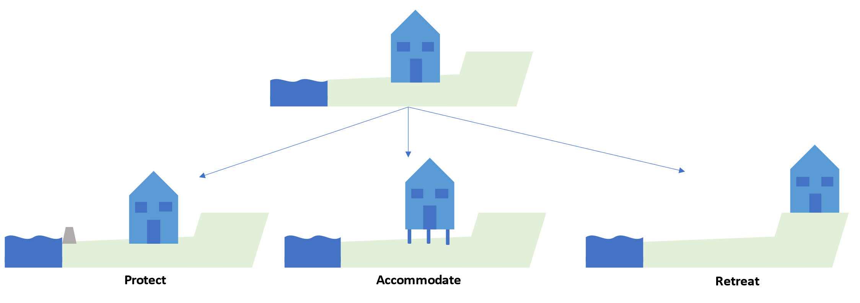

Why do we need legislation?
Managed retreat raises unprecedented governance issues and complex policy and funding challenges. These cannot be adequately addressed as part of other legislation. Given the scale of the issues (geographic, economic and social), these challenges also require central government involvement. Currently there are no dedicated tools or processes to guide how individual households or communities might permanently shift away from areas of intolerable risk. While there have been some instances where people have been supported to retreat, these have often come with significant costs.
Different processes and legislation have been used to respond after natural disasters. For example, after the Canterbury earthquakes special legislation was introduced to support the recovery and rebuilding. However, after an extreme weather event caused significant damage in Matatā, managed retreat was achieved through voluntary acceptance of purchase offers with supporting changes to regional and district plans.
Managed retreat at Matatā is now largely complete, 16 years after the original debris flow event. It has come at a total cost of approximately $16.8 million and has caused years of stress and uncertainty for the community. It required cooperation and funding from Whakatane District Council, Bay of Plenty Regional Council and central government. The Matatā experience highlighted the need for a national framework for managed retreat, with clearly defined roles and responsibilities for individuals, central and local government (including a consistent approach to central and local government cooperation), national direction and changes to existing land use protections.
The proposed Natural and Built Environments Act (NBA) and Strategic Planning Act (SPA) will help enable long-term, proactive planning for managed retreat. In most cases, much of the planning process that could result in a managed retreat will be done through the NBA and SPA processes.
Separate legislation, currently being referred to as the Climate Adaptation Act (CAA), is intended to provide tools and processes to plan and implement managed retreats. For example, additional powers and processes will be needed to address issues of ownership of property that is retreated from. See the system wide actions chapter for more detail on these proposed Acts.

Policy considerations

Aspects of a managed retreat system
The matters outlined below make up a high-level framework for a managed retreat system. The Government has not yet decided on a preferred policy option for a managed retreat system. This material outlines key policy issues that are being considered. Your feedback will help inform the more detailed policy work that will follow this consultation.

Objectives and principles
We have identified five key objectives and six principles to guide the development of legislation.
Table 1: Objectives and principles of legislation
Managed retreat
Objectives | - To set clear roles, responsibilities and processes for managed retreat from areas of intolerable risk  - To provide stronger tools for councils to modify or extinguish existing uses of land  - To provide clarity on tools and processes for acquiring land and related compensation  - To clarify local government liability for decision-making on managed retreat, and the role of the courts  - To provide clear criteria for when central government will intervene (or not) in a managed retreat process
Principles | - Managed retreat processes are efficient, fair, open and transparent  - Communities are actively engaged in conversations about risk and in determining and implementing options for risk management  - Social and cultural connections to community and place are maintained as much as possible  - There is flexibility as to how managed retreat processes play out in different contexts  - Iwi/Māori are represented in governance and management and have direct input and influence in managed retreat processes, and outcomes for Iwi/Māori are supported  - Protection of the natural environment and the use of nature-based solutions are prioritised
We have identified four key objectives and nine principles to guide our approach to funding issues, including central government’s funding responsibilities.
Table 2: Objectives and principles of funding responsibilities
Funding and financing adaptation
Objectives | - To reduce hardship due to the impacts of climate change  - To incentivise better long-term investment decisions concerning climate change risk  - To reduce liabilities, including contingent liabilities to the Crown  - To support the role of banking and insurance in facilitating risk management
Principles | - Limit Crown’s fiscal exposure  - Minimise moral hazard  - Solutions are designed to be as simple as possible  - Ensure fairness and equity for and between communities, including across generations  - Beneficiaries of risk mitigation should contribute to costs  - Minimise cost over time by providing as much advance notice as possible  - Solutions support system coherence and the overall adaptation system response  - Risks and responsibilities are appropriately shared across parties including property owners, local government, central government, and banking and insurance industries

Questions: (questions 1–51 are within the draft national adaptation plan)
- Do you agree with the proposed principles and objectives for the Climate Adaptation Act? Please explain why or why not.

- Are there any other principles or objectives you think would be useful? Please explain why.

Establishing a process for managed retreat
Figure 2 below outlines the possible stages of a managed retreat process and how they might link to different parts of the proposed resource management system.
We do not expect the process to be identical for every retreat. For example, a retreat that responds to a natural hazard event (eg, a severe flood) is likely to differ from a retreat that is planned to avoid a future natural hazard or gradual changes that will make an area unsafe in the future. In these scenarios, the various stages – including the timing and sequencing of individual steps – may look quite different.
Figure 2: Stages of a managed retreat process
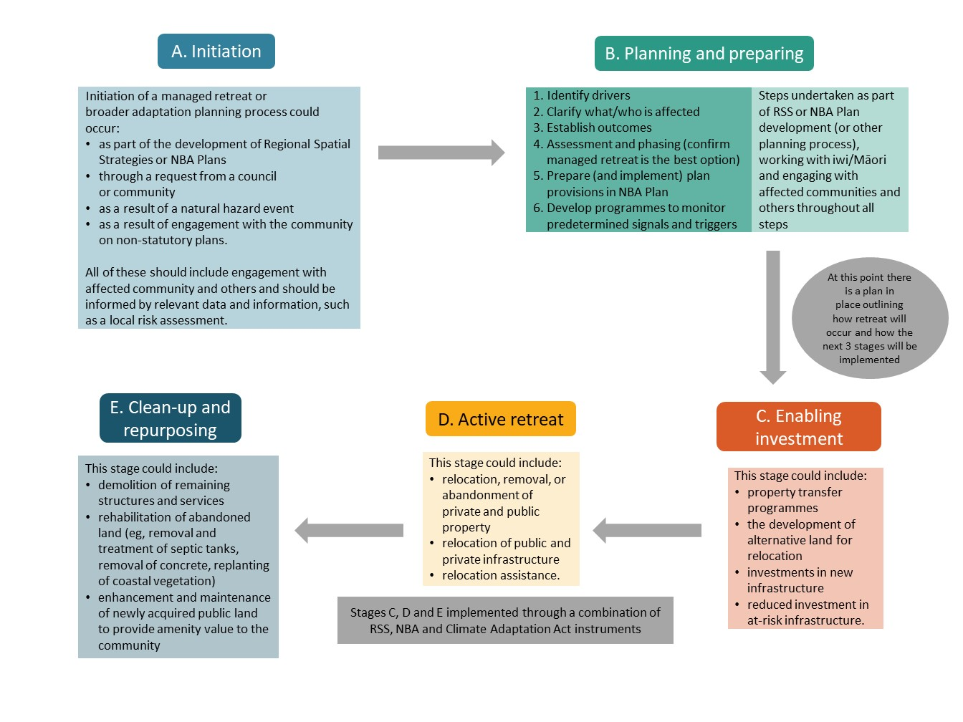
To illustrate how this could play out – councils in a region undertake a risk assessment and gather other data and information to inform regional spatial strategy (RSS) development. The RSS:
- shows different levels of risk throughout the region
- identifies areas which are at high risk from flooding (or other natural hazards) and where adaptation actions, such as managed retreat, are likely to be needed in the future
- identifies low-risk areas where development could occur, including to accommodate communities that may need to retreat.
The councils, iwi/Māori, the community in the affected area and the wider community can then explore options for reducing risk in the area. Together they would determine when certain properties would need to retreat – either at a particular time or when a particular threshold is reached – and develop a plan.
Planning for retreat could include:
- provisions in the NBA Plan restricting what can be done on the properties before retreat
- plans to develop new low-risk areas for people to retreat to
- processes and mechanisms to transfer property and provide assistance to those who have to retreat
- agreements as to what will happen with the area after retreat and who will be responsible for it.

Questions:
- Do you agree with the process outlined and what would be required to make it most effective?

- What do you think should trigger the process? What data and information would be needed?

- What other processes do you think might be needed, and in what circumstances?

How can we work together?
Climate change will affect all New Zealanders. Everyone needs to assess and manage their risk and consider what climate change might mean for them. The government can’t bear all of the risks and costs, so we will have to work out how these can be shared across a range of different groups. There are several groups who each have responsibilities for adaptation, such as asset owners, banks, insurers, the private sector, local government and central government.
Early investment in resilience can, in many cases, reduce the need for more challenging adaptive responses like managed retreat. The benefits of greater resilience will be shared across society, so we should work together to share the costs fairly too.

Roles and responsibilities
There are several groups of actors who will have responsibilities and costs in a managed retreat system. Currently, homeowners and asset owners are responsible for managing their own risks.
Local government has various statutory roles in managing the risks of natural hazards and climate change, for example:
- The Local Government Act 2002 requires local government to provide long-term infrastructure strategies that identify and manage natural hazard risk
- The Resource Management Act 1991 requires local government to control land uses and their effects
- The Civil Defence Emergency Management Act 2002 requires local government to manage the risks of hazards from communities and, in particular, to plan for and manage response to and recovery from emergencies.
- The Building Act 2004 makes local government responsible for permits and consents, which requires certain natural hazards to be taken into account when determining whether to grant a building consent.
In practice, large events have involved central government playing an ad hoc role. As case studies (including one from Hawke’s Bay2F) show, there is some uncertainty around the specific roles of district councils and regional councils and how adaptation responses are funded. This uncertainty can stall councils’ ability to make and implement decisions.
We will develop a managed retreat system with more clearly defined roles and responsibilities.
In many cases, it is likely that local government will continue to play a leading role in managed retreat. In others, however, central government may need to be involved, for example where a large area is affected, there is a high level of risk, the area is facing particular urgency, or there is significant hardship. This does not mean that it is appropriate for central government to fund managed retreat processes or local infrastructure. Clarity on when central government will intervene (or not) in a managed retreat process can help guide this.
Iwi/Māori and affected communities, individuals and businesses will also have roles to play in a managed retreat. These roles could include providing data and information as well as leading, or contributing to, local risk assessments. and taking all practicable steps to manage or reduce their own risks. The role of insurance in managed retreat is discussed below.
There will be a range of costs associated with managed retreat which different parties will face. It is important that a managed retreat system does not create financial or economic incentives that would stop individuals from taking action to reduce their risks.
Well before a retreat process is initiated, the different groups mentioned above should also share the costs of taking steps to reduce risks and build resilience. This is particularly important where they may benefit from those investments through increased asset values and avoiding retreat.

Questions:
- What roles and responsibilities do you think central government, local government, iwi/Māori, affected communities, individuals, businesses and the wider public should have:
- in a managed retreat process?
- sharing the costs of managed retreat?

- What support may be needed to help iwi/Māori, affected communities, individuals, businesses and the wider public participate in a managed retreat process?

- A typical managed retreat will have many costs, including those arising from preparation (including gathering data and information), the need to participate in the process, relocating costs and the costs of looking after the land post-retreat. In light of your feedback on roles and responsibilities (question 57), who do you think should be responsible for or contribute to these costs?

- What do you consider the key criteria for central government involvement in managed retreat?

- There may be fewer options for homes and community buildings (eg, schools, churches, community halls) to move than businesses (eg, retail and office buildings, factories, utilities) for financial, social, emotional and cultural reasons. That may suggest a different process for retreat, and different roles and responsibilities for these actors. Should commercial properties/areas and residential properties/areas be treated differently in the managed retreat process? Please explain why or why not.

- Even in areas where communities are safe, local services and infrastructure such as roads, power lines and pipes may become damaged more frequently and be more expensive to maintain because of erosion or increases in storms and rainfall. Local councils may decide to stop maintaining these services. Are there circumstances in which people shouldn’t be able to stay in an area after community services are withdrawn?

Property transfer
In many circumstances, managed retreat will require the transfer of land. While planning rules can stipulate that the current use of land cannot continue (for example, residential use), this is not likely to be sufficient. This could create practical issues relating to access, rates, public health and ongoing management of the land (including responsibility and liability for harm caused by structures left on the land or inadequate clean-up of existing soil contamination).
Careful consideration should be given to Māori land (as described under Te Ture Whenua Māori Act) and land acquired through Treaty settlement processes. Preventing the use of these lands could be viewed by Māori as land confiscation and a serious breach of Te Tiriti by the Crown.
Separate processes providing for Māori land and Treaty settlement land may need to be considered to ensure these unique legislative arrangements are protected and the Crown’s Te Tiriti obligations are upheld.
Consideration should also be given to other land with historical, cultural, social or religious significance (eg, cemeteries or churches) to recognise their value to communities.
This raises several issues which will be worked through as part of detailed policy development for the Climate Adaptation Act. Your feedback on the questions below will help inform this work.

Questions:
- In what situations do you think it would be fair for you to be required to move from where you live?

- Many residential communities are made up of a combination of renters, owner-occupiers and people who own a property and use it as a second/holiday house. Do you think there are reasons for these groups to have different levels of involvement in a managed retreat process?

- It is not always obvious that an area is at high risk from natural hazards or the impacts of climate change. However, council risk assessments and increased data and information should make these risks clearer. Do you think different approaches should be taken for those who purchased properties before a risk was identified (or the extent or severity of the risk was known) and those who bought after the risk became clear?

- Under what circumstances do you think it would be fair or necessary for government to take approaches with a greater or lesser degree of intervention or support?

- How do you think land with historical, cultural, social or religious significance (eg, cemeteries or churches) should be treated?

Implications for Māori
Māori, whānau, hapū, iwi, communities and business entities have unique economic, social, and cultural systems that are strongly connected to the land and natural environment.
The broader social, economic, and cultural impacts of natural hazards and climate change on Māori communities are also expected to be disproportionate, due to the remote location and the economic status of many communities.
Many coastal Māori communities will be vulnerable to climate change impacts such as sea-level rise, high tides, and widespread coastal inundation as well as natural hazards including earthquakes, volcanic eruptions, flooding, landslides, storms and drought.
These changes will result in the erosion or loss of coastal infrastructure (eg, roads, homes and utilities) and the loss of inter-tidal food gathering areas and sacred places (eg, urupā and marae situated close to the coast).
There is the need to seek perspectives from Māori to understand more about how managed retreat will impact many of the Māori businesses and communities that rely on land, water, and natural resources for economic, social and cultural reasons.
Further understanding on how Māori see a managed retreat system working for Māori, and what partnership means in this context, is important for future policy work and for ensuring the Crown’s Te Tiriti obligations are upheld.

Questions:
- Some Māori communities have needed to relocate as a result of events (including natural disasters) that have impacted their marae and wāhi tapu. These examples show that Māori communities are aware of the ways that climate change is affecting their marae, papa kāinga and wāhi tapu, and how relocation can be approached as a community, with engagement from iwi, hapū and whānau. The examples also demonstrate that climate change and natural hazard events are impacting coastal communities as well as inland communities located closer to rivers and lakes. How do you think managed retreat would affect Māori?

- Managed retreat has rarely occurred in Aotearoa, especially within Māori communities. However, there are examples of Māori proactively working to protect their marae, papa kāinga and wāhi tapu by either relocating or protecting and developing their current sites. In these instances, the focus was on protecting and preserving their taonga for future generations. What do you see as being most important in developing a managed retreat system for Māori?

- Māori land and Treaty settlement land have unique legislative arrangements. Restrictions and protections are placed on Māori land to meet a clear set of principles and objectives that recognise the cultural connection Māori have with the land and focus on land retention and use. Land that has been acquired through Treaty settlement processes is most likely to have cultural significance to a particular iwi or hapū and used to support the aspirations of their people. How do you think Māori land (including Treaty settlement land) should be treated?

The interaction with insurance
Insurance currently plays an important role in supporting New Zealand’s resilience and recovery from natural hazards. However, sea level rise and increasing extreme weather due to climate change are likely to affect the ability to insure assets (particularly residential buildings). This may lead to ‘insurance retreat’ in some cases, which can include higher premiums, reduced quality (eg, higher excesses or lower cover limits), and ultimately loss of access to insurance.
As described earlier, managed retreat is a process to strategically relocate assets, activities and sites of cultural significance away from at-risk areas within a planned period of time.
We seek feedback on how insurance could interact with a managed retreat policy. The interaction between insurance and managed retreat may differ depending on whether a retreat is pre-emptive or in response to a natural disaster.

Post-disaster managed retreat and the interaction with insurance
Insurance payments compensate parties for loss or damage resulting from an event covered by their insurance policy. While there may also be an opportunity for these payments to support a managed retreat, insurance payments typically only cover the value of the loss or damage to the building. This means that insurance may not cover the full cost of a managed retreat. Climate change may also exacerbate insurance retreat, in turn reducing the opportunity for insurance to support managed retreat post-event.
Insurers generally do not put restrictions on how claimants use insurance payments. This may enable insurance payments to be used to fund post-event managed retreat. However, insurers may limit their liability (eg, refuse future cover) if a property is highly likely to suffer similar damage again. Options for managed retreat may be limited if an insurer decides to manage repairs for a property.

Question:
- How do you think post-event insurance payments could support managed retreat?

Pre-emptive managed retreat and the interaction with insurance
As insurance becomes increasingly expensive or unavailable in at-risk locations, it may provide an important signal to better manage the underlying risk. Accordingly, insurance premiums and availability could influence decisions about managed retreat and may also encourage relocation decisions by individuals and communities outside the managed retreat process. However, as insurance contracts are typically for only one year, insurance premiums and availability may not provide a useful signal about increasing risks in the future.

Question:
- Should insurability be a factor in considering the option of managed retreat from an area?

Full list of questions
You can answer as many or as few questions as you wish.

National adaptation plan

General questions

- Climate change is already impacting New Zealanders. Some examples include extreme weather events such as storms, heatwaves and heavy rainfall which affects lives, livelihoods, health and wellbeing, ecosystems and species, economic, social and cultural assets, services (including ecosystem services) and infrastructure. How is climate change impacting you? This could be within your community and/or hapū and iwi, and/or your business/organisation, and/or your region.

- The national adaptation plan focuses on three key areas. Please indicate which area is most important for you (tick box).
focus area one: reform institutions to be fit for a changing climate. This means updating the legislative settings so that those who are responsible for preparing for and reducing exposure to changing climate risk will be better equipped.
focus area two: provide data, information and guidance to enable everyone to assess and reduce their own climate risks. This means that all New Zealanders will have access to information about the climate risks that are relevant to them
focus area three: embed climate resilience across government strategies and policies. This means that Government agencies will be considering climate risks in their strategies and proposals.
other? Please explain.

- We all have a role to play in building resilience to climate change, but some New Zealanders may be more affected and less able to respond. There is a risk that climate change could exacerbate existing inequities for different groups in society. Appendix 3 sets out the full list of actions in this national adaptation plan.
a) What are the key actions that are essential to help you adapt? Please list them.

b) Which actions do you consider to be most urgent? Please list them.

c) Are there any actions that would help ensure that existing inequities are not exacerbated? Please list them.

d) Are there any actions not included in this draft national adaptation plan that would enable you to assess your risk and help you adapt?

- Central government cannot bear all the risks and costs of adaptation. What role do you think asset owners, banks and insurers, the private sector, local government and central government should play in:
- improving resilience to the future impacts of climate change?
- sharing the costs of adaptation?
- The National Climate Change Risk Assessment recognised that there may be economic opportunities in adapting to a changing climate.
- What opportunities do you think could exist for your community or sector?
- What role could central government play in harnessing those opportunities?

System-wide actions
- Do you agree with the objectives in this chapter?
Yes
No
Partially
Please explain your answer.

- What else should guide the whole-of-government approach to help New Zealand adapt and build resilience to a changing climate?

- Do you agree that the new tools, guidance and methodologies set out in this chapter will be useful for you, your community and/or iwi and hapū, business or organisation to assess climate risks and plan for adaptation?
Yes
No
Partially
Please explain your answer.

- Are there other actions central government should consider to:
- enable you to access and understand the information you need to adapt to climate change?
Yes
No
Unsure
Please explain your answer.

- provide further tools, guidance and methodologies to assist you to adapt to climate change?
Yes
No
Unsure
Please explain your answer.

- remove barriers to greater investment in climate resilience?
Yes
No
Unsure
Please explain your answer.

- support local planning and risk reduction measures while the resource management and emergency management system reforms progress?
Yes
No
Unsure
Please explain your answer.

- What actions do you think will have the most widespread and long-term benefit for New Zealand?

- Are there additional actions that would strengthen climate resilience?
Yes
No
Unsure
Please explain your answer.

- There are several Government reform programmes underway that can address some barriers to adaptation, including the Resource Management (RM) reform. Are there any additional actions that we could include in the national adaptation plan that would help to address barriers in the short-term before we transition to a new resource management system?

- In addition to clarifying roles and providing data, information, tools and guidance, how can central government unlock greater investment in resilience?

a) Would a taxonomy of ‘green activities’ for New Zealand help to unlock investment for climate resilience?
Yes
No
Unsure
Please explain your answer.

The natural environment
- Do you agree with the actions set out in this chapter?
Yes
No
Unsure
Please explain your answer.

- What else should guide central government’s actions to address risks to the natural environment from a changing climate?

- Are there other actions central government should consider to:
- support you, your community, iwi and hapū, business and/or organisation to build the natural environment’s climate resilience?
Yes
No
Unsure
Please explain your answer.

- strengthen biosecurity in the face of climate change?
Yes
No
Unsure
Please explain your answer.

- identify and support New Zealand’s most vulnerable ecosystems and species in a changing climate?
Yes
No
Unsure
Please explain your answer.

- What do you identify as the most important actions that will come from outside of central government (eg, local government, the private sector or other asset owners, iwi, hāpu and/or other Māori groupings such as: business, forestry, fisheries, tourism, urban Māori, the private sector) to build the natural environment’s resilience to the impacts of climate change?

- Are there additional actions that would advance the role of Māori as kaitiaki in a changing climate?
Yes
No
Unsure
Please explain your answer.

Homes, buildings and places
- Do you agree with the outcome and objectives in this chapter?
Yes
No
Partially
Please explain your answer.

- What else should guide central government’s actions to increase the resilience of our homes, buildings and places?

- Do you agree with the actions set out in this chapter?
Yes
No
Partially
Please explain your answer.

- Are there other actions central government should consider to:
- better promote the use of mātauranga Māori and Māori urban design principles to support adaptation of homes, buildings and places?
Yes
No
Unsure
Please explain your answer.

- ensure these actions support adaptation measures targeted to different places and respond to local social, cultural, economic and environmental characteristics?
Yes
No
Unsure
Please explain your answer.

- understand and minimise the impacts to cultural heritage arising from climate change?
Yes
No
Unsure
Please explain your answer.

The following questions are about existing buildings. These can include housing, communal residential (hotels, retirement village), communal non-residential (church, public swimming pools), commercial (library, offices, restaurant), industrial (factory, warehouse).
- Do you think that there is a role for government in supporting actions to make existing homes and/or buildings more resilient to future climate hazards?
Yes
No
Unsure
If yes, what type of support would be effective?

- From the proposed actions for buildings, what groups are likely to be most impacted and what actions or policies could help reduce these impacts?

- What are some of the current barriers you have observed or experienced to increasing buildings’ resilience to climate change impacts?

Infrastructure
- Do you agree with the outcome and objectives in this chapter?
Yes
No
Partially
Please explain your answer.

- What else should guide central government’s actions to prepare infrastructure for a changing climate?

- Do you agree with the actions set out in this chapter?
Yes
No
Partially
Please explain your answer.

- The national adaptation plan has identified several actions to support adaptation in all infrastructure types and all regions of Aotearoa.
- Do you see potential for further aligning actions across local government, central government and private sector asset owners?
Yes
No
Unsure
Please explain your answer.

- Do you see any further opportunities to include local mana whenua perspectives and mātauranga Māori in infrastructure adaptation decision-making?
Yes
No
Unsure
Please explain your answer.

- Do you see any further opportunities to include local community perspectives in infrastructure adaptation decision-making?
Yes
No
Unsure
Please explain your answer.

- Do you see any further opportunities to ensure that groups who may be disproportionally impacted by climate change, or who are less able to adapt (such as those on low incomes, beneficiaries, disabled people, women, older people, youth, migrant communities) have continued and improved access to infrastructure services as we adapt?
Yes
No
Unsure
Please explain your answer.

- Do you think we have prioritized the right tools and guidance to help infrastructure asset owners understand and manage climate risk?
Yes
No
Unsure
Please explain your answer.

- Are there additional infrastructure actions that would help to strengthen Māori climate resilience?
Yes
No
Unsure
Please explain your answer.

- Are there any other tools or data that would help infrastructure asset owners make better decisions?

Communities
- Do you agree with the outcome and objectives in this chapter?
Yes
No
Partially
Please explain your answer.

- Do you agree with the actions set out in this chapter?
Yes
No
Partially
Please explain your answer.

- What actions will provide the greatest opportunities for you and your community to build climate resilience?

- Are there additional actions central government should consider to:
- support your health and wellbeing in the face of climate change?
Yes
No
Unsure
Please explain your answer.

- promote an inclusive response to climate change?
Yes
No
Unsure
Please explain your answer.

- target support to the most vulnerable and those disproportionately impacted?
Yes
No
Partially
Please explain your answer.

- What do you think are the most important actions that will come from outside of central government (eg, local government, the private sector or other asset owners, iwi, hāpu, non-government organisations, community groups) to strengthen community resilience in the face of climate change?

- Are there additional actions could be included in the national adaptation plan to help strengthen climate resilience for iwi, hāpu and whānau?
Yes
No
Partially
Please explain your answer.

The economy and financial system
- Do you agree with the outcome and objectives in this chapter?
Yes
No
Partially
Please explain your answer.

- What else should central government do to realise a productive, sustainable and inclusive economy that adapts and builds resilience to a changing climate?

- Do you agree with the actions set out in this chapter?
Yes
No
Partially
Please explain your answer.

- Are there other actions central government should consider to:
- support sectors, businesses and regional economies to identify climate risks and adapt?
Yes
No
Unsure
Please explain your answer.

- promote a resilient financial system in the face of climate change?
Yes
No
Unsure
Please explain your answer.

- What do you think are the most important actions that will come from outside of central government (eg, local government, the private sector or other asset owners, iwi, hāpu and/or other Māori groupings such as: business, forestry, fisheries, tourism, urban Māori, the private sector) to reduce the economic and financial risk they face from climate change?

- Are there additional actions within the financial system that would help strengthen Māori climate resilience?
Yes
No
Unsure
Please explain your answer.

- In the context of other risk management options (eg, flood barriers, retreat from high-risk areas), what role should insurance have as a response to flood risk? Please explain your answer.

- Should the Government have a role in supporting flood insurance as climate change risks cause private insurance retreat?
Yes
No
Unsure
Please explain your answer.

- Does your answer to the above question depend on the circumstances? (For example, who the owner is (eg, low income), the nature and characteristics of the asset (eg, residential or commercial property, contents and vehicles), what other risk management options are available and their cost/benefit, and where the asset is located?) Please explain your answer.

- If you think the Government should have a role in supporting flood insurance as climate change risks cause private insurance retreat, how do you envision the Government’s role, and how is this best achieved (eg, direct support and/or indirect support such as reducing underlying flood risk)?

- If the Government were to directly support flood insurance:
- what is the best way to provide this direct support?

- should the Government’s focus be to support availability or affordability of insurance, or both?

- how should the costs of that support be funded, and by whom?

- what are the benefits and downsides of this approach?

- should this support be temporary or permanent?

- if temporary, what additional measures, if any, do you think would be needed to eventually withdraw this support (eg, undertaking wider flood protection work)?

- what would the risks or benefits be of also including non-residential property, such as commercial property?

- what design features or complementary policies are needed so any flood insurance intervention retains incentives for sound flood-risk management (eg, discouraging development in high-risk locations)?

- How effective do you think the insurance “price signal” (eg, higher premiums or loss of insurance) is for providing incentives to reduce flood risk?

- In your view, should a scheme similar to Flood Re in New Zealand be used to address current and future access and affordability issues for flood insurance? Why or why not?

- How do you think a scheme similar to Flood Re in New Zealand could support or hinder climate change adaptation initiatives in New Zealand?

Closing general question
- Do you have any other thoughts about the draft national adaptation plan that you would like to share?

Managed retreat
- Do you agree with the proposed principles and objectives for managed retreat? Please explain why or why not.

- Are there other principles and objectives you think would be useful? Please explain why.

- Do you agree with the process outlined and what would be required to make it most effective?

- What do you think could trigger the process? What data and information would be needed?

- What other processes do you think might be needed, and in what circumstances?
- What roles and responsibilities do you think central government, local government, iwi/Māori, affected communities, individuals, businesses, and the wider public should have in
- a managed retreat process?

- sharing the costs of managed retreat?

- What support may be needed to help iwi/Māori, affected communities, individuals, businesses and the wider public participate in a managed retreat process?

- A typical managed retreat will have many costs, including those arising from preparation (including gathering data and information), the need to participate in the process, relocating costs and the costs of looking after the land post-retreat. In light of your feedback on roles and responsibilities (Q57), who do you think should be responsible for or contribute to these costs?

- What do you consider the key criteria for central government involvement in managed retreat?

- There may be fewer options for homes and community buildings (eg, schools, churches, community halls) to move than businesses (eg, retail and office buildings, factories, utilities) for financial, social, emotional and cultural reasons. That may suggest a different process for retreat, and different roles and responsibilities for these actors. Should commercial properties/areas and residential properties/areas be treated differently in the managed retreat process? Please explain why.

- Even in areas where communities are safe, local services and infrastructure, such as roads, power lines and pipes may become damaged more frequently and be more expensive to maintain because of erosion or increases in storms and rainfall, for example. Local councils may decide to stop maintaining these services. Are there circumstances in which people shouldn’t be able to stay in an area after community services are withdrawn?

- In what situations do you think it would be fair for you to be required to move from where you live?

- Many residential communities are made up of a combination of renters, owner/occupiers and people who own a property and use it as a second/holiday house. Do you think there are reasons for these groups to have different levels of involvement in a managed retreat process?

- It is not always obvious that an area is at high risk from natural hazards or the impacts of climate change. However, council risk assessments and increased data and information should make these risks clearer. Do you think there different approaches should be taken for those who purchased properties before a risk was identified (or the extent or severity of the risk was known) and those who bought after the risk became clear?

- Under what circumstances do you think it would be fair or necessary for government to take different approaches with a greater or lesser degree of intervention or support?

- How do you think land with historical, cultural, social or religious significance (eg, cemeteries or churches) should be treated?

- Some Māori communities, both inland and coastal, have needed to relocate as a result of events (including natural disasters) that have impacted their marae and wāhi tapu. These examples show that Māori communities are aware of the ways that climate change is affecting their marae, papa kāinga and wāhi tapu, and how relocation can be approached as a community, with engagement from iwi, hapū, and whānau. The examples also demonstrate that climate change is impacting coastal communities as well as inland communities located closer to rivers and lakes. How do you think managed retreat would affect Māori?

- Managed retreat has rarely occurred in Aotearoa, especially within Māori communities. However, there are examples of Māori proactively working to protect their marae, papa kāinga and wāhi tapu by either relocating or protecting and developing their current sites. In these instances, the focus was on protecting and preserving their taonga for future generations. What do you see as being most important in developing a managed retreat system for iwi/hapū/Māori?

- Māori land and Treaty settlement land have unique legislative arrangements. Restrictions and protections are placed on Māori land to meet a clear set of principles and objectives that recognise the cultural connection Māori have with the land and a specific focus on land retention and utilisation. Treaty settlement land that has been acquired through Treaty settlement processes is most likely to have cultural significance to a particular iwi or hapū and used to support the aspirations of their people. How do you think Māori land (including Treaty settlement land) should be treated?

- How do you think post event insurance payments could help support managed retreat?

- Should insurability be a factor in considering whether the Government should initiate managed retreat from an area?

Paulik R, Stephens S, Wadhwa S, Bell R, Popovich B, Robinson B. 2019. Coastal Flooding Exposure Under Future Sea-level Rise for New Zealand. Wellington: NIWA.
Frame D, Rosier S, Carey-Smith T, Harrington L, Dean S, Noy I. 2018. Estimating Financial Costs of Climate Change in New Zealand: An Estimate of Climate Change-Related Weather Event Costs. New Zealand Climate Change Institute and NIWA.
Ministry for the Environment and Hawke’s Bay Regional Council partnership project. 2020. Case study: Challenges with implementing the Clifton to Tangoio Coastal Hazards Strategy 2120.

