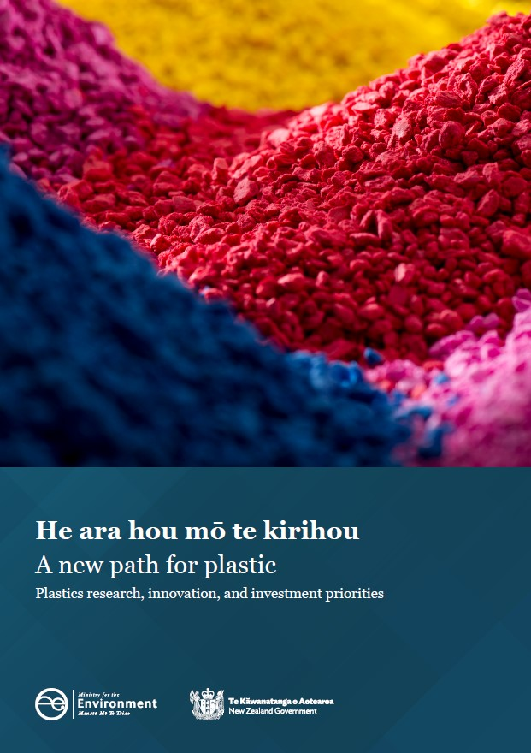
Disclaimer
The information in this publication is, according to the Ministry for the Environment’s best efforts, accurate at the time of publication. The Ministry will make every reasonable effort to keep it current and accurate. However, users of this publication are advised that:
The information does not alter the laws of New Zealand, other official guidelines, or requirements.
It does not constitute legal advice, and users should take specific advice from qualified professionals before taking any action based on information in this publication.
The Ministry does not accept any responsibility or liability whatsoever whether in contract, tort, equity, or otherwise for any action taken as a result of reading, or reliance placed on this publication because of having read any part, or all, of the information in this publication or for any error, or inadequacy, deficiency, flaw in, or omission from the information in this publication.
All references to websites, organisations or people not within the Ministry are for convenience only and should not be taken as endorsement of those websites or information contained in those websites nor of organisations or people referred to.

This document may be cited as: Ministry for the Environment. 2021. He ara hou mō te kirihou | A new path for plastic: Plastics research, innovation, and investment priorities. Wellington: Ministry for the Environment.

Published in December 2021 by the
Ministry for the Environment
Manatū Mō Te Taiao
PO Box 10362, Wellington 6143, New Zealand
ISBN: 978-1-99-003375-9 (online)
Publication number: ME 1591
© Crown copyright New Zealand 2021
This document is available on the Ministry for the Environment website: www.environment.govt.nz.

Contents
Plastics research, innovation and investment priorities 5
Purpose 5
Why we need to ‘rethink’ plastics in New Zealand 5
New Zealand plastic use 5
Further considerations 6
New Zealand plastics research, innovation and investment priorities 7
Three principles for plastic use in a circular economy 13
Less plastic – reduce the scale of plastic use to a sustainable level 13
More circular – use plastic in ways that allow it to circulate around the economy 13
Better for the environment – minimise plastic uses harmful to the environment 14
Discussion of circular economy opportunities and challenges for biobased and biodegradable plastics in New Zealand 15
Biobased biodegradable plastics in New Zealand 17
Biobased non-biodegradable plastics (conventional recyclable plastics) 17
Summary 19
References 20

Table
Table 1: Plastics research, innovation and investment priorities 7

Figure
Figure 1: Conventional and biobased plastics 15

Abbreviations
bioPET bio polyethylene terephthalate
bioPP bio polypropylene
HDPE high-density polyethylene
PA polyamide (nylon)
PBAT polybutylene adipate terephthalate
PBS polybutylene succinate
PCL polycaprolactone
PE polyethylene
PET polyethylene terephthalate
PHA polyhydroxyalkanoates
PLA polylactic acid
PLS plasticised starch
PP polypropylene
PS polystyrene
PTT polytrimethylene terephthalate
PVC polyvinyl chloride
rPET recycled polyethylene terephthalate
rPP recycled polypropylene

Plastics in New Zealand

Purpose
The plastics research and innovation priorities are intended to inform and guide investment across government agencies (from research funds to infrastructure and industry investment) towards more sustainable use of plastics. The priorities are supported by three principles:
- less plastic – reversing the exponential growth in plastic use
- more circular – ensuring plastics cycle within our economy
- better for the environment – minimising harm to us and our environment.

Why we need to ‘rethink’ plastics in New Zealand
Plastic is used throughout Aotearoa New Zealand’s economy, and its benefits mean we will continue to use it for many applications. However, the way we now use many plastics causes harm and pollutes our environment. Plastic is present in our soils, water, food and even the air we breathe, harming our wildlife through entanglement, ingestion and toxicity, and posing risks to health.,
Research and innovation in plastic use is needed to address problematic uses and move us towards a sustainable model of plastic use.
Plastics
Plastics are a broad group of materials generally made of long chains of carbon and hydrogen often combined with other elements. These long-chain polymers give plastics their strength and flexibility. The building blocks for polymers are usually fossil hydrocarbons (conventional plastics) but can be from sources such as carbohydrates, lignin, cellulose, starch and oils (biobased plastics). The properties of plastics, for example, whether they biodegrade or not, are dependent on the polymer structure rather than the source of the raw material used to make them.

New Zealand plastic use
New Zealand manufactures about half a million tonnes of plastic products each year from imported resins and plastic materials. More than half is made into plastic packaging, mainly intended for a single use. Most of the rest is split between products for agricultural uses and the building and construction sector.
In addition to these identified plastic imports, New Zealand is likely to import as much again as packaging on other products, textiles and as plastic parts in other products. While single-use plastic packaging has a high profile, all plastic uses are within the scope of these priorities because all will require an end-of-life, or better yet, a renewal-of-life solution.
New Zealand sends about 400,000 tonnes of plastic to landfill each year, while an unknown amount of plastic escapes into our environment. Only 45,000 tonnes were collected for recycling in 2017, with less than half of that recycled here.
Investing in plastics research and innovation will help us move to more sustainable plastic use. Innovation can find ways to end problematic uses and keep the volume of plastic manageable. Ready access to cost-effective offshore processing has limited investment in our own systems. As the harms are recognised from exporting poorly sorted plastic waste, the case grows for expanding our own processing capabilities and innovating to find plastics that are safer for us and our environment.

Further considerations
While this document focuses on plastics, the research, innovation and investment priorities must also be considered alongside:
- the waste hierarchy
- the New Zealand Waste Strategy, including circular economy principles
- climate change targets and the emissions reduction plan.

Overview of priorities for plastics research, innovation and investment
Table 1 sets out focus areas for plastics research and innovation and provides immediate and longer-term priorities. These priorities are loosely grouped under the principles: Less plastic use, More circular, Better for our environment.
These principles align with similar principles arrived at domestically and internationally and are discussed further following the table. The discussion includes a section on circular economy opportunities and challenges of bio-sourced and biodegradable plastics.
Table 1: Plastics research, innovation and investment priorities
Principle | Research and innovation focus areas | Immediate priorities (2022–24) | Medium to long-term (2025+) sustainable system priorities | Examples of current actions, resources, issues or potential projects
Less plastic use | Understand plastic flows through the economy. | Quantify household plastic packaging and product flows, from production through to recycling and landfill.  Quantify main business and industrial plastic uses.  Develop robust estimations for currently unknown areas, such as imported products and incidental packaging. | Identify all other major business-to-business and industrial uses.  Identify significant losses and leakage to the environment.  Identify, quantify and plot New Zealand-wide plastics material flows (including products and packaging). | - Rethinking Plastics and National resource recovery, industry bodies.  - Building industry wrap and products, wine bladders, agricultural plastics, textiles, medical plastics.  - Mechanisms may include packaging accords, barcode information and modelling.
 | Adopt innovative business models: rethink, redesign, reuse, refill, reduce. | Fund feasibility and business case development for reuse, refill, share and repair systems and infrastructure (including for materials that displace plastics).  Accelerate uptake of innovative business models, eg, reuse, refillable, share and repair services.  Provide access to tools and a New Zealand-specific impacts database for common materials to allow businesses and non-governmental organisations to undertake comparative LCAs. | Identify and implement infrastructure as required for systems change.  Comprehensive standardised life-cycle assessment (LCA) information will inform more complex plastics and alternative options for different logistics models, eg, distribution, reuse and recovery options within and across supply chains. | - Concentrated, no, low and returnable packaging products.  - Bring your own containers for bulk and deli-style items from retailers.  - Moving to reusable supply chain secondary packaging and systems that reduce the use of shrink wrap.  - Refillable beverage containers (existing beer flagons, bottles and crates, refill milk and water, and cleaning product stations).  - Tackling plastic in New Zealand’s fin-fishing industry .
 | Behaviour change | Learn by doing. Support collaborative projects, create change and uncover New Zealand’s social and cultural values around plastic and impacts, including:  - drivers, barriers and benefits to shifting from single-use plastics  - public perception and disposal of compostable plastic  - public willingness to move to reusable, refillable options  - differences in values and behavioural constraints for different segments of society. | Use the full suite of behaviour-change tools to bring people along on the circular economy journey; shift the debate, values and attitudes.  Include appropriate regulatory and policy levers.  Provide guidance and support for businesses to implement system changes and facilitate business-to-business learning. | - Reusable shopping bags.  - What drives packaging choices, including reusable packaging?  - Recycle right behaviours; knowing what happens to materials at end of life and the appropriate pathway for them.  - Plastic (synthetic) clothing and interior textiles; understanding how to reduce, reuse, recycle.  - Projects with community, businesses and Māori.
More circular resource flows | Simplify the system. | Maximise recovery and value of most common, easily recycled plastics recovered for processing in New Zealand. | Build common understanding of appropriate role and function for different plastic material types in New Zealand economy, including uses and disposal. | - National guidance for sustainable packaging design.  - National consistency of kerbside recycling.  - National standards and definitions for material types and uses, including clear distinctions between biodegradable and biobased plastics, improved labelling of compostable and non-compostable plastics.
 |  | Address less common, hard-to-recycle plastics that cause confusion, and plastic design and uses that contaminate and devalue other recycling streams. | Change system to move towards fully sustainable and circular design.  Investigate tools to build in cost of end of life into upfront choices for materials. | - Phase out hard-to-recycle or problematic items, eg, polyvinyl chloride (PVC) and polystyrene food packaging.  - Regulated product stewardship.
 | Increase recycled content | Ensure food safety guidelines support full-circle recycled content.  Fund feasibility investigations and, where appropriate, business-case development for recycled content infrastructure.  Understand business-to-business opportunities for closed-loop recycling.  Investigate opportunities for greater recovery and recycled content in commercial, industrial and building applications. | Understand maximum or optimal recycled content for particular applications.  Develop options for material that cannot be recycled closed loop,  Invest in onshore systems and infrastructure to encourage greater uptake and use of recycled content products.  Investigate minimum recycled content instruments. | - Scale up novel systems to clean and recycle plastics, eg, insects and fungi.  - Pilot projects in textiles, construction and demolition.  - Procurement projects and standards enabling use of recycled content materials.  - Projects to address onshore capacity and system constraints, eg, rPET washing plant capacity upgrades, HDPE and PP processing and manufacturing infrastructure.  - Commercial plastics recycled content systems and infrastructure.  - Projects to increase demand for recycled content.
 | Design the system we need for long-term sustainability instead of reacting to waste arising. | Coordinate with key stakeholders and align with New Zealand Waste Strategy and emission reduction plan values, principles, objectives and targets (consultation on both in 2021).  Understand New Zealand strengths, weaknesses, opportunities and threats, social and cultural values. | Optimise system while leveraging New Zealand strengths and opportunities, eg, primary industries biomass production, bio-plastics research capability, high-tech manufacturing and renewable energy.  The role of plastics in a multi-material circular economy. | - New Zealand Waste Strategy, and National plastics action plan.  - Plastics New Zealand – Advancing the new plastics economy in Aotearoa.  - Sustainable Business Network New Zealand plastic packaging system diagnosis.  - New Plastics Economy Global Commitment.  - Ministry of Business, Innovation and Employment industry transformation plans.  - Emissions reduction plan.
 | Infrastructure investment*  *Some infrastructure investment may be more about increasing capacity than innovation. It is included here for completeness and to acknowledge the current rapid pace of innovation in plastic processing technology around the world. | Address identified capacity and value-recovery constraints within current recycling system. | Invest in transformational infrastructure to enable New Zealand-appropriate circular plastic economy. | - Washing and sanitisation for reusable packaging.  - Network of resource-recovery centres.  - Sharing, repair and service hubs for durable products.  - Optical and artificial intelligence sorters, plastics reprocessors, North and South Island washing plants, weigh bridges, PVC recycling.
 | Appropriate materials: safe plastics, durable plastics for technical cycle, fully biodegradable for biological cycle. | Remove or replace uses of biodegradable plastics that contaminate and prevent the technical recycling of other plastics.  Improve ability to sort plastics, eg, biodegradable and non-biodegradable. | Develop biodegradable materials for applications where leakage to the environment is inevitable, eg, fishing gear (marine biodegradable), agricultural wrap.  Develop standards for microplastic residues. | - Consider removing PLA from use for commonly recycled items that are usually PET (reduce contamination).  - New Zealand industry work on appropriate materials for aquaculture, fishing gear and cold-chain packaging.
 |  | Adopt appropriate materials already developed in New Zealand and overseas, including sustainable, biobased additives that are benign when returned to the natural environment. | Develop new materials that are appropriate for the use and receiving environment. | - Biodegradable vine net clips, biospife, abraded trye granules, shoe soles.
 |  | Identify and confirm appropriate uses for recyclable plastics, eg, only where recovery and circulation through the technical cycle is practical. | Consider technology to renew recycled polymers to required food safe and mechanical property standards. | - Test and adopt rPP purifying technologies for New Zealand.  - Automotive, agricultural and construction plastics.  - Closed-loop rPET meat trays, milk bottles, clothing-to-clothing and so on.
 |  | Replace problematic plastics uses with better alternatives. | Identify and develop options for more difficult to replace problematic plastics. | - Phase out single-use plastics items that leak to the environment and are impractical to recycle.
Better for the environment less harm, more beneficial, regenerative | Understand the impacts: toxicity and physical accumulation of plastics. | Human health: track international research and identify areas where New Zealand may differ. | Human health: understand chemical and physical impacts on New Zealander’s health. | - Risk profile: Microplastics in the diet.  - Plastics and Health: The Hidden Costs of a Plastic Planet.  - Impacts of food contact chemicals on human health: A consensus statement.
 |  | New Zealand environment: major losses, leakage and accumulation in oceans, waterways, soil, air and living organisms.  Compostable plastics and soil health. | New Zealand environment: impacts of accumulation in oceans, waterways, soil health, air and living organisms. | - Plastics in the Environment, UV-328 found in New Zealand seabirds; Aotearoa Impacts and Mitigation of Microplastics research programme.
 |  | Understand potential productive and economic threats, eg, impact of contamination of soils and water on agriculture, horticulture and fisheries, and potential to disrupt productive ecosystem services | Economic and productive impacts: primary industries, tourism and New Zealand’s international reputation. | - Contamination of horticultural land, invalidation of organic production, extent of plastics and residues in human food products, eg, seafood.
 | Design for positive impacts. | Investigate New Zealand renewable feedstocks for plastics (biological or greenhouse gas capture).  Evaluate positive use cases for both biodegradable plastics and biobased recyclable (non-biodegradable) plastics. | Develop New Zealand’s renewable plastic industry (may feed precursors into offshore plastic industry or adapt small-scale onshore processing). | - 100 per cent bioPET or bioPP: switches to a renewable source and stores biogenic carbon.  - Biodegradable ‘plastic’ mulch that builds soil carbon.  - Edible seaweed noodle-flavour sachet replaces plastic and provides dietary iodine.
 | Remediation technologies. | Track international research and identify technologies able to filter and concentrate dispersed plastic pollution from the environment, also other remediation technologies for existing plastics pollution. | Test technologies relevant to New Zealand’s main areas of environmental plastic pollution. | - Stormwater gross-pollutant traps.  - Wetland filtration.  - Semi-autonomous biological and mechanical collection devices.  - Biological (microbes and invertebrates) or enzymatic processing of plastics of all sizes.

Three principles for plastic use in a circular economy

Less plastic – reduce the scale of our plastic use
to a sustainable level
Reducing plastic use is essential but will be challenging. The most effective methods require rethinking and redesigning our collective behaviours, as well as our products and services. It will require eliminating unnecessary plastic use, designing plastic out of our systems, increasing the uptake of reuse and refillable models, replacing plastic with other materials while avoiding unintended consequences from impacts of other material use, and reducing how much plastic is used for particular applications.
Plastic use is growing exponentially and is expected to double again in the next couple of decades. The link between large-scale plastic use and environmental harm is clear. With the high proportion of plastics manufactured into single-use items, continuing to increase the flow of plastics into the economy will have ongoing consequences.
The more plastic used, and the shorter the time it is used for, the more likely it is the amount of plastic waste will exceed our ability to effectively collect, sort and return these materials to the economy. The more plastics used, the greater the likelihood they will escape into the environment or be dumped in landfills.
New Zealand does poorly on both these counts, with most plastic ending in landfill or leaking into our environment. Only a small fraction is recycled and much of it into lower-grade mixed-materials where the next stop is landfill.

More circular – use plastic in ways that allow it to circulate around the economy
In a circular economy, materials are recoverable. The complex tangle of plastics and additives used is difficult to efficiently return to use. A simplified system means materials can be more easily and practically collected, sorted and recirculated. Products need to be designed to be recoverable and reworkable for reuse. Investment in appropriate technology, infrastructure and education is also essential.
A start can be made immediately to remove some of the most problematic and hard-to-recycle plastics, including particular uses that prevent the recovery and recirculation of other plastics and resources. For example:
- clear rigid polyethylene terephthalate (PET) is highly recyclable in New Zealand, but large amounts are landfilled or downcycled because small amounts of other clear rigid plastics (for example, polyvinyl chloride (PVC), polystyrene (PS), polylactic acid (PLA)) are unnecessarily used for the same purposes
- items such as produce labels and plastic plates, forks and takeaway containers frequently contaminate food waste and prevent the circular use of compost or contribute to plastic build-up in soils, the food chain and our wider environment.
We can also learn from overseas examples about the most effective ways to increase demand for recycled content and support businesses to innovate and invest in circular systems.
Better information about what purposes plastics are being used for will help identify opportunities to design for more circular systems. While packaging is the single largest use of plastic, it is highly variable and dispersed. Immediate opportunities exist in business and primary production sectors to make improvements, for example, where large volumes of a known type of plastic are used, such as temporary building wrap used during renovation.

Better for the environment – minimise plastic uses harmful to our environment
Better for the environment focuses on the known and probable harms from plastics, specifically toxic and mechanical harms from the accumulation of plastic and plastic additives in the environment and our bodies. Preventing leakage to the environment is covered under ‘less plastic’ and ‘more circular plastic use’.
Improper use and disposal of plastics is a global concern and, in many areas, New Zealand will rely on international research about environmental and human impacts as well as potential remediation technologies. New Zealand should initiate and collaborate on projects for which our expertise or information will be particularly useful. New Zealand-specific research is also needed to clearly understand the situation here, for example, te ao Māori perspectives and understanding the impacts of plastics in our environment.
One major need is to increase monitoring for plastic and plastic derivatives in our environment to understand plastic pollution locally. Where is it? What is it? How much of it is there? Where has it come from? How is it changing over time?
We also need to track the rapidly expanding body of international research on probable human health impacts and environmental harms. This will identify findings most relevant for the New Zealand context and specific gaps that we ought to research and collaborate in international projects as appropriate.
Environmental remediation and plastic-recovery research will also be required. Even with the best-designed systems, some non-biodegradable plastic will continue to make its way into the environment from legacy plastics, misadventure or abrasive wear and tear, such as tyre particles. Technologies that can filter and concentrate dispersed plastic pollution will be needed to restore environmental health and return recyclable plastics to the technical cycle, although plastic pollution is best avoided in the first place.

Discussion of circular economy opportunities and challenges for biobased and biodegradable plastics in New Zealand
Increasing volumes of single-use plastics waste are a highly visible symptom of the linear take-make-waste economy. But plastic can be a useful part of the circular economy. Conventional plastics are generally regarded as a technical material (see Circular economy cycles below) creating durable long-life and reusable products, as well as lightweight materials that can be recycled.
Circular economy cycles
A circular economy has two main material cycles: biological and technical.
- Biological materials are derived from living things and will generally rot, decompose or biodegrade to become nutrients for plants, animals and other living organisms. Biological materials can be renewable at the right scale and with the right systems. For example, food, timber, biofibres, bio-oils, biopolymers, sewerage and animal wastes.
- Technical materials are derived from non-living things, such as minerals and gases. These resources are generally recycled through human technology and processes. Technical materials are typically extracted from finite stocks, for example, steel, glass, cement, petrochemicals, including almost all plastic polymers in use, metals, rare earth elements.
Some materials can cross from one cycle to the other: synthetic fertilisers enter the biological cycle, trace minerals can go either way, and some technical materials are derived from biological sources, such as biobased non-biodegradable plastics.
Around the world, research and innovation are under way to make plastics a better fit for the circular economy. Developments are progressing in three main areas:
- better recyclability of plastics and technology to safely renew recovered plastics
- biodegradable plastics
- sustainable feedstocks for making plastics (biomass or atmospheric carbon).
These developments mean conventional plastics are now joined by an array of biobased and biodegradable plastics (see bioplastics matrix below). Increasingly, plastics are crossing over from the technical cycle to the biological cycle and vice versa, leading to some of the current problems, looming challenges and opportunities.
Figure 1: Conventional and biobased plastics
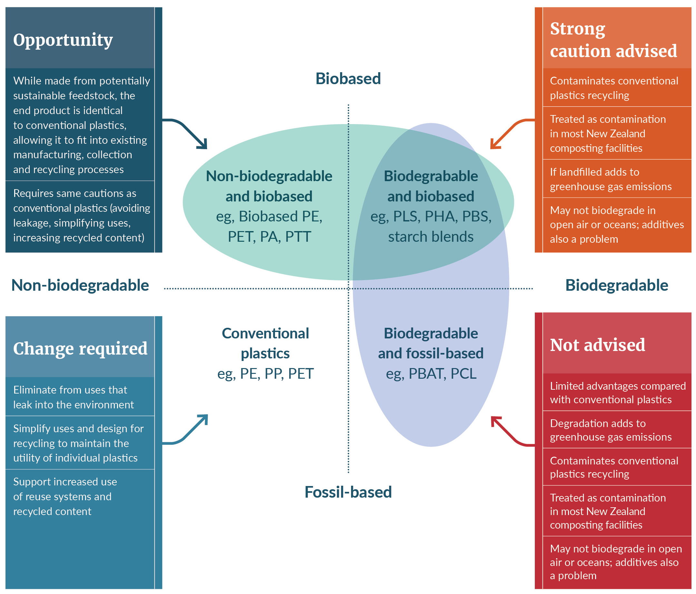
When approached in an ad hoc way, some developments can work against other sustainability goals. For example, fossil-based biodegradable plastic has an increased climate impact over non-biodegradable plastic, due to the emission of fossil-carbon as the plastic biodegrades.
Sustainable plastics have two paths to circularity: one path aims to make plastic a biological material circulating in the biological cycle, the other seeks to keep it contained within the technical cycle to be repeatedly recycled. In the long term, both paths will need to move to renewable feedstocks.
New Zealand has the opportunity to use its strengths in primary industries, biological sciences and high-tech manufacturing to develop renewable biobased plastics. New Zealand may need to focus resources on one path and choose between developing biobased biodegradable plastics or biobased non-biodegradable plastics (conventional recyclable plastics). Some of the challenges and opportunities of these two paths are discussed in the next section.
New Zealand will need to consider what sort of system works for us, the appropriate uses for different types of plastics, how to signal this to businesses and households, and when to build infrastructure to recirculate these types of plastics. This conversation is still in its early stages. Broader choices that are yet to be made about our pathway to a low-emissions circular economy are likely to influence our choices for a sustainable plastic system.

Biobased biodegradable plastics in New Zealand

Challenges
Many single-use plastics items are now available in biodegradable plastics, but in New Zealand few end-of-life collections are available for biodegradable plastic. This means most biodegradable plastic ends up causing more problems than it solves.
- In landfill it degrades anaerobically and contributes to methane emissions
- In our environment it often will not degrade because most biodegradable plastics require specific conditions to breakdown, such as high heat and humidity. This means it still harms wildlife and accumulates in our environment
- In our recycling system it is a contaminant that is difficult to sort from recyclable plastics and ends up degrading the quality of recycled plastics.
In addition, while the base plastic material may be biodegradable it is rare that in practice each final product, including inks and additives, has been tested and shown to be biodegradable in a range of environments and non-toxic in the biological cycle.
At present, few biodegradable plastics breakdown in ambient environments. Where certified to a recognised overseas standard, most are either industrially or home compostable. A positive end for compostable plastic requires it is recognised, sorted, and placed into an appropriate composting system.
In practice, this is difficult to achieve. The proportion of New Zealanders who home compost is falling and many choose not compost plastics. New Zealand does not have any widespread collection services that accept compostable plastic, and few New Zealand industrial composting facilities accept compostable plastic because it is a low-value input (seen as ‘empty carbon’ with no nutrient value) and poses significant risks. It is difficult to distinguish from non-compostable plastic so is often removed along with other plastic contamination. It may devalue the quality of a facility’s compost product due to uncertainties about how well various compostable plastics will breakdown and risks around microplastics, inks, additives and conventional plastic that looks like compostable plastic.

Opportunities
Biodegradable plastics may have beneficial uses in specific situations. For example, where it helps to divert organic waste from landfill, such as food waste bin-liners, and in controlled situations where the types of biodegradable plastic used, how it is collected and where it is sent can all be specified.
Other opportunities may be in uses where the plastic will unavoidably escape into the environment due to the nature of the use. For example, particles from shoe soles and tyres, or lost fishing gear and disintegrated horticultural plastic mulch mat. To realise these opportunities, the plastic will have to biodegrade in the receiving environment: waterways, oceans and soil. Biodegradation of plastics in these ambient environments remains a challenging bar to meet.

Biobased non-biodegradable plastics (conventional recyclable plastics)

Challenges
Biobased conventional plastics such as bioPP (bio polypropylene) face many of the same challenges as fossil-based conventional plastics including:
- minimising leakage to the environment, especially small, light items, abraded particles and plastics primarily used in biological production systems, such as horticultural plastic film and fishing gear
- small items, scraps and offcuts are difficult to collect efficiently and more difficult to sort into plastic types to be remade. Separation of mixed materials poses similar challenges
- additives are used to give plastics specific properties. Recycled plastic from mixed sources may contain unknown additives affecting its properties and restricting its uses, especially because some additives can be harmful to human health. Coloured plastics are an example of the additive problem. Colourless plastics can go to any use, but coloured plastics are on a downward spiral to brown or black, unless the colours can be removed.
In New Zealand and around the world, work is under way to address these challenges. It is essential to find solutions if conventional plastics are to be a part of the circular economy.

Opportunities
Biobased conventional plastics, such as bioPP, move plastics to a renewable feedstock and have the advantage of being able to drop into existing systems. The plastics have known properties and fit into existing manufacturing and recycling systems.
Perhaps most promising, as well as avoiding carbon emissions associated with fossil-fuel extraction, these plastics move biological carbon into long-term storage in the technical cycle. Especially with our strong renewable energy sector, they have the potential to sequester carbon and be positive for our climate.
New Zealand does not, however, have an existing plastic production industry that could accept or refine biobased precursors to plastic. In the medium-term, New Zealand could consider options such as supplying Australian or other nearby plastic producers.
New Zealand has an opportunity to capitalise on its strengths in primary production and the biological sciences to find innovative ways to convert the biomass it grows (food and organic waste, forestry residues, straw and animal products), or could grow (seaweed), into renewable climate-positive plastics.

Summary
New Zealand faces significant challenges in rethinking the way we make, use and dispose of plastics. Many of these challenges are global, and we can learn from other progress, while some are particular to New Zealand, requiring our own solutions. The plastics research and innovation priorities outlined in this document are intended to inform and guide the investment needed to move New Zealand towards more sustainable use of plastics:
- less plastic – reversing the exponential growth in plastic use
- more circular – ensuring plastics cycle within the economy
- better – minimising harm to our environment and risks to human health.
In the short term, many of the main priorities focus on better understanding the plastics we use, where they end up and their impacts on our environment and our health. Quick action could also be taken to increase capacity to deal with existing plastics and remove problematic plastic uses that disrupt our recycling systems or leak into our environment. More challenging will be to turn around the trend of ever-growing plastic use and shrink this to a manageable scale.
In the medium term, priorities are likely to be updated as a better idea is gained of appropriate uses and systems for different types of plastics, behaviours are better understood, products are redesigned and barriers to change are removed. Advances in biobased plastics will also start to paint a clearer picture of the long-term pathway to truly sustainable and circular plastics.

References
Center for International Environmental Law (ed.). 2019. Plastics and health: The hidden cost of a plastic planet. Washington DC: Center for International Environmental Law.
Croft F and Farrelly T. 2021. Tackling the problem of marine plastic pollution in New Zealand’s fin fish industry. Case Study: Moana NZ. London: Association of Commonwealth Universities (ACU).
Commonwealth Universities (ACU), Commonwealth Scientific and Industrial Research Organisation. 2021. National circular economy roadmap for plastics, tyres, glass and paper. Canberra: Commonwealth Scientific and Industrial Research Organisation.
Ellen Macarthur Foundation. Plastics overview. Retrieved from https://ellenmacarthurfoundation.org/topics/plastics/overview (15 August 2021).
Environmental Science and Research. 2018-2023. Aotearoa impacts and mitigation of microplastics national research programme.
Ministry for Primary Industries. 2019. Risk profile: Microplastics in the diet. Wellington: Ministry for Primary Industries.
Ministry for the Environment. 2021. Phasing out hard-to-recycle and single-use plastics. Retrieved from https://environment.govt.nz/what-government-is-doing/areas-of-work/waste/plastic-phase-out/ (30 August 2021).
Ministry for the Environment. 2021. National plastics action plan. Wellington: Ministry for the Environment.
Ministry for the Environment. 2018. National resources recovery project situational report. Wellington: Ministry for the Environment.
Muncke J, Andersson AM, Backhaus T, et al. 2020. Impacts of food contact chemicals on human health: A consensus statement. Environmental Health 19(25). doi: 10.1186/s12940-020-0572-5.
Office of the Prime Minister’s Chief Science Advisor. 2019. Rethinking plastics in Aotearoa New Zealand. Wellington: Office of the Prime Minister’s Chief Science Advisor.
Royal Society Te Apārangi. 2019. Plastics in the environment: Te ao hurihuri – The changing world. Wellington, Royal Society Te Apārangi.
Simon N, Raubenheimer K, Urho N, Unger S, Azoulay D, Farrelly T, Sousa J, van Asselt H, Carlini G, Sekomo C, Schulte ML, Busch PO, Wienrich N, Weiand L. 2021. A binding global agreement to address the life cycle of plastics. Science 373(6550): 43–47.
Takada, H. 2020. Long-range transport of UV-328 through marine plastics and bioaccumulation of UV-328 in seabirds on remote islands. Premeeting Presentation at the Sixteenth Meeting of the Persistent Organic Pollutants Review Committee (POPRC.16).

Royal Society Te Apārangi. 2019. Plastics in the environment: Te ao hurihuri – The changing world. Wellington: Royal Society Te Apārangi.
Center for International Environmental Law (ed.). 2019. Plastics and health: the hidden cost of a plastic planet.
Office of the Prime Minister’s Chief Science Advisor. 2019. Rethinking plastics in Aotearoa New Zealand. Wellington: Office of the Prime Minister’s Chief Science Advisor. p 211.
Australia estimates that two-thirds of the plastic used in its economy is from imported finished products and packaging. Commonwealth Scientific and Industrial Research Organisation. 2021. National circular economy roadmap for plastics, tyres, glass and paper. Canberra: Commonwealth Scientific and Industrial Research Organisation. p 14.
Ministry for the Environment. 2018. National resources recovery project situational report. Wellington: Ministry for the Environment. p 3.
For example, a 2021 policy paper in Science magazine emphasises: minimising virgin plastic, safe circularity and eliminating plastic pollution; and the Ellen McArthur Foundation’s New Plastics Economy uses the three principles for plastics: eliminate, circulate, innovate.
Office of the Prime Minister’s Chief Science Advisor. 2019. Rethinking plastics in Aotearoa New Zealand. Wellington: Office of the Prime Minister’s Chief Science Advisor.
Ministry for the Environment. 2018. National resources recovery project situational report. Wellington: Ministry for the Environment.
Croft F and Farrelly T. 2021. Tackling the problem of marine plastic pollution in New Zealand’s fin fish industry. Case Study: Moana NZ. London: Association of Commonwealth Universities (ACU).
Ministry for the Environment. 2021. National plastics action plan. Wellington: Ministry for the Environment.
Ministry for Primary Industries. 2019. Risk profile: Microplastics in the diet. Wellington: Ministry for Primary Industries.
Muncke J, Andersson AM, Backhaus T, et al. 2020. Impacts of food contact chemicals on human health: A consensus statement. Environmental Health 19(25). doi: 10.1186/s12940-020-0572-5.
Center for International Environmental Law (ed.). 2019. Plastics and health: The hidden cost of a plastic planet. Washington DC: Center for International Environmental Law.
Royal Society Te Apārangi. 2019. Plastics in the environment: Te ao hurihuri – The changing world. Wellington, Royal Society Te Apārangi.
Takada, H. 2020. Long-range transport of UV-328 through marine plastics and bioaccumulation of UV-328 in seabirds on remote islands. Premeeting Presentation at the Sixteenth Meeting of the Persistent Organic Pollutants Review Committee (POPRC.16).
Environmental Science and Research. 2018–2023. Aotearoa impacts and mitigation of microplastics national research programme.
Royal Society Te Apārangi. 2019. Plastics in the environment: Te ao hurihuri – The changing world. p 10.
In 2021 the Government decided to phase out some of these problematic plastic uses. Ministry for the Environment. 2021. Phasing out hard-to-recycle and single-use plastics. Wellington: Ministry for the Environment.
The Ellen Macarthur Foundation butterfly diagram is also frequently used to illustrate these cycles https://ellenmacarthurfoundation.org/circular-economy-diagram

