Regulatory Impact Statement: Regulation of deposit of jettisoned material from space vehicle launches under the Exclusive Economic Zone and Continental Shelf (Environmental Effects) Act 2012

Agency Disclosure Statement
This Regulatory Impact Statement (RIS) has been prepared by the Ministry for the Environment (MfE). It provides an analysis of options for regulating the deposit of jettisoned material from space vehicle launches under the Exclusive Economic Zone and Continental Shelf (Environmental Effects) Act 2012 (the Act). The consultation document proposes to classify the deposit of jettisoned material from space vehicle launches in a wider area of the EEZ and continental shelf than currently authorised as a “permitted activity” under the EEZ Act.

There are a number of limitations associated with the analysis. There is uncertainty about some of the quantifiable benefits and costs of the options assessed in the RIS. Benefits and costs have been quantified as far as possible but depend on a range of unknown factors. The environmental risk assessment used to inform the assessment of environmental effects in the RIS has a number of limitations arising from the limited data on habitats and biota in the EEZ. Public consultation will help further inform our understanding of the risks and information limitations.

Given the minor or less than minor environmental impacts of space vehicles launches, there is likely to be no difference in environmental outcomes between the different options considered. Compared to the status quo, the options proposed are likely to reduce costs to businesses and improve the economic benefits to New Zealand from the development of a space launch industry. They are not likely to impair incentives for businesses to innovate, override fundamental common law principles, or impact on market competition in New Zealand.

Government agencies have been consulted on the proposal and the RIS.

Glenn Wigley, Director, Ministry for the Environment

Date:

Background and Context
- The Government is consulting on a proposal to make the deposit of jettisoned material from space vehicle launches on the seabed in the wider Exclusive Economic Zone (EEZ) and continental shelf a permitted activity under the Exclusive Economic Zone and Continental Shelf (Environmental Effects) Act (the Act). This Regulatory Impact Statement (RIS) summarises the regulatory impacts of all policy options considered for managing the activity under the Act. .

Legislation
- The area of jurisdiction covered by the Act is New Zealand’s Exclusive Economic Zone (EEZ) and continental shelf. The EEZ is the water column extending from 12 to 200 nautical miles offshore and the continental shelf is the seabed and subsoil beneath the EEZ, extending to the outer edge of the continental margin (the point where the shelf drops into deeper water).
- The purpose of the Act is to promote the sustainable management of the natural resources of the EEZ and continental shelf. The Act is restricted to managing those environmental effects of activities that were not previously subject to environmental regulations, including depositing anything in, on or under the seabed.
- Last year, the Exclusive Economic Zone and Continental Shelf (Environmental Effects—Permitted Activities) Regulations 2013 (Permitted Activities Regulations) were amended to provide for the deposit of material jettisoned from space vehicle launches on the seabed in the EEZ and on the extended continental shelf as a permitted activity, within four authorised zones (two test trajectories and two launch trajectories) which are subject to conditions.

Space vehicle launches
- Space vehicle launches are a new activity in New Zealand. New Zealand’s location provides access to particular launch angles, relatively uncongested seas and airspace to enable frequent launches.
- The Government has developed a new regulatory regime for outer space and high-altitude activities conducted from New Zealand or by New Zealanders overseas. The Outer Space and High-altitude Activities Act (the OSHAA Act) was passed into law in July 2017 and will come into force on 21 December 2017.
- The new regulatory regime will enable the development of a peaceful, safe, responsible and secure space industry that meets New Zealand’s international obligations.
- The first company set to undertake commercial launches in New Zealand is Rocket Lab, a US aerospace business with a New Zealand subsidiary, with plans to deliver lightweight, cost-effective commercial launch services from New Zealand. Rocket Lab’s launch operation is regulated by the United States Federal Aviation Authority (FAA) which is responsible for licensing launch activities for US registered companies even for launches in New Zealand.
- Commercial launch vehicles will primarily deliver satellites into orbit. Satellites enable the provision of every day services and infrastructure including banking, transportation, electricity, telecommunications, navigation, remote sensing (with applications ranging from agriculture and land-use monitoring to disaster management and climate change) and national security.
- Rocket Lab has a private orbital launch range in Mahia which can accommodate a launch rate of 120 flights per year (see Figure 1). Rocket Lab aims to scale up its launch activities over time towards the maximum of one launch per week. In comparison, there were 22 launches in 2016 from the United States and 82 internationally.
- The only test launch in New Zealand so far took place on 25 May 2017. The final post-activity report will be submitted to the EPA on 24 August 2017. Early information from Rocket Lab indicates that while the space vehicle followed the predicted flight path, it did not reach orbit and part of the material was jettisoned slightly earlier than expected. Rocket Lab’s information indicates no materials were known to have landed in the Bounty Islands marine reserve or other marine reserve areas.
- Rocket Lab accurately predicted the flight path of the launch vehicle and was able to reasonably estimate where jettisoned material fell, which will be helpful information for understanding the scale and impacts of the activity in the future.
- The maximum amount of material that could have been deposited from the launch (assuming nothing burned up) is significantly less than the volume assumed in the latest risk assessment and the materials deposited were those assessed in the risk assessment.
- Systems for notifying vessels of potential hazards are managed by Maritime NZ and operated for the test launch on 25 May 2017. A Notice to Mariners (NOTMAR) was published on the Land Information New Zealand (LINZ) website on 12 May with details of the launch. In addition, the Rescue Coordination Centre NZ (RCCNZ) and Maritime NZ broadcasted navigation warnings to shipping in the area six times per day for five days before launch and published the warning online. Two vessels inside or near the area in the NOTMAR were contacted by Royal NZ Air Force aircraft on 23 May, but none were known to be in the vicinity on the day of launch. Rocket Lab and relevant authorities are reviewing aspects of the launch, including how well the notification system operated.

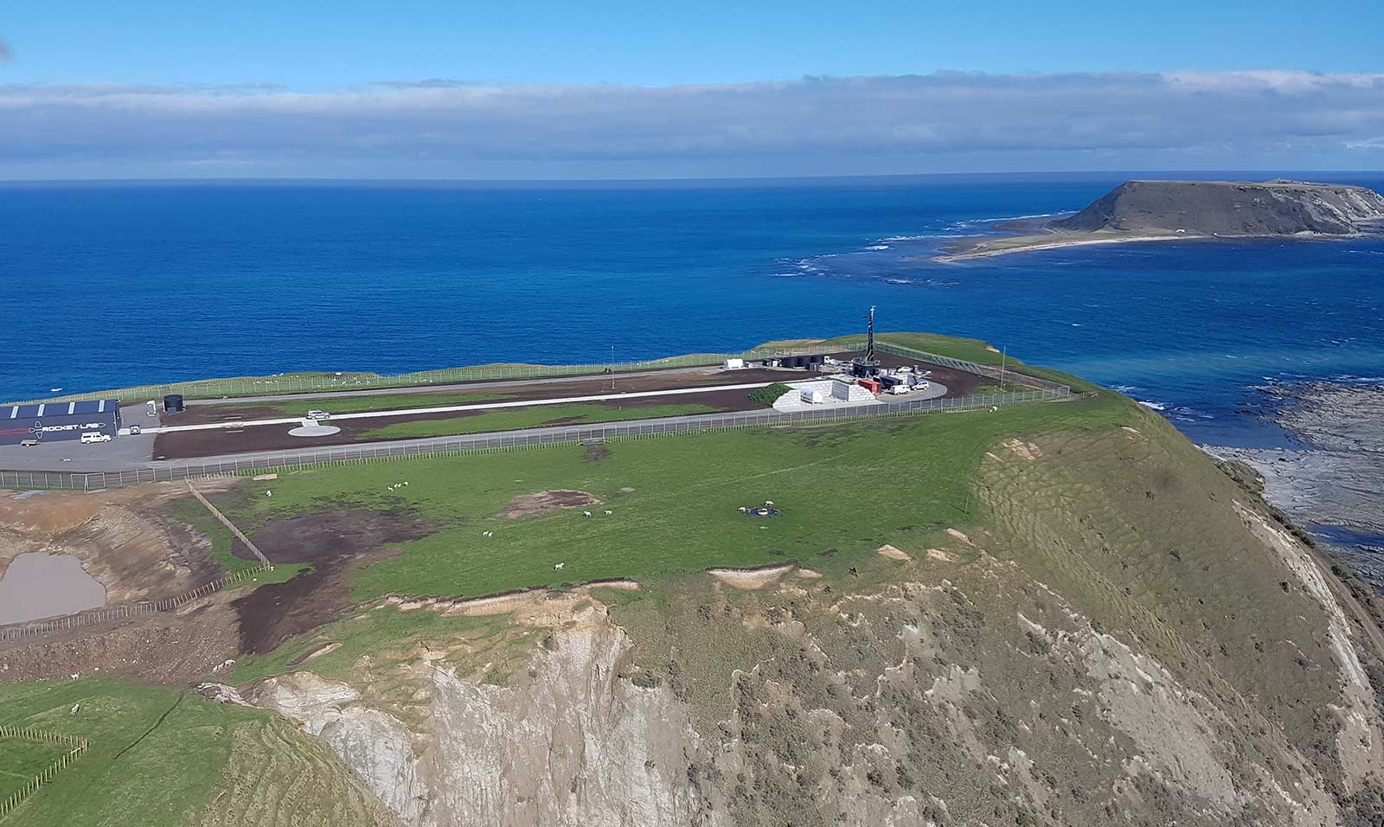
Figure 1: Rocket Lab Launch Complex on the Mahia Peninsula, Hawkes Bay, New Zealand

Status Quo and Problem Definition
- After lift-off, rockets generally jettison parts, which fall back towards the Earth. The jettisoned material may burn up in the atmosphere but some of it may reach the earth’s surface. Any jettisoned material that lands in the sea is likely to sink, either immediately or over time, to the seabed. The jettisoned material that reaches the seabed constitutes a deposit under the EEZ Act. Deposit of material on the seabed is a restricted activity under section 20 of the Act.
- Under the EEZ Act, regulations can classify activities in four different ways:
- Prohibited activities must not be undertaken. For example, dumping of waste not listed in the Act is prohibited.
- Discretionary activities require marine consent. The marine consent can set out conditions to manage the way the activity is undertaken. Marine consent may be either notified or non-notified. A fully-notified marine consent is the default requirement for activities that have not been otherwise classified. Regulations may provide for the consent for a discretionary activity to be non-notified—exploration drilling for petroleum is managed under this classification.
- Permitted activities may be undertaken without a marine consent, and the regulations can specify terms and conditions that apply to the activity. Marine scientific research, and prospecting and exploration for petroleum (excluding exploration drilling) are managed under this classification, as is the deposit of jettisoned material from a space vehicle, within authorised zones.
- Figure 2 shows the framework for classifying activities.
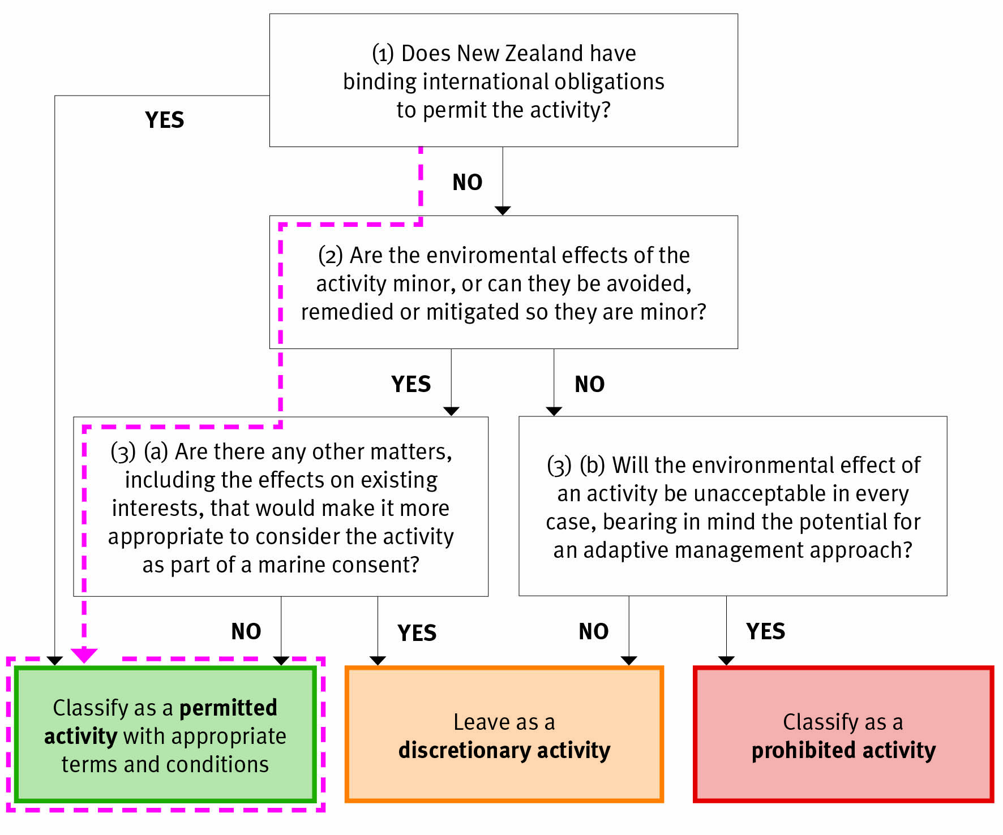
Figure 2. Framework for classifying activities under the EEZ Act
- On 21 October 2016, the EEZ Permitted Activities Regulations were amended to permit the deposit of material on the seabed from space launch vehicles (section 8A). There are conditions on the activity, including pre- and post-activity reporting requirements and caps on the number and frequency of launches. There is also a restriction on where the activity may occur—deposits are permitted only in two test launch deposit areas and two launch deposit areas, shown in Figure 3.
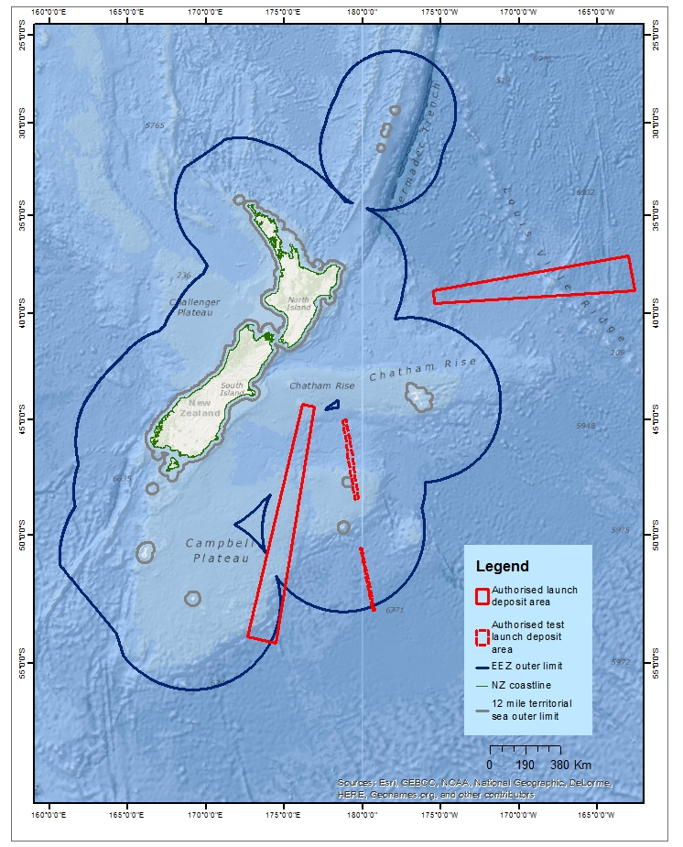
Figure 3: Authorised launch deposit areas under the Permitted Activities Regulations
- Based on best available information on future flight paths at the time, the areas were delimited to account for test and some commercial launches from Rocket Lab’s facility on Mahia Peninsula. It is anticipated that, as the space industry develops, operators will undertake launches on other flight paths, which could deposit material outside the authorised areas.
- Because the deposit of jettisoned material outside the authorised areas has not been classified, it is a discretionary activity requiring a fully notified marine consent. A marine consent can be sought for a programme of launches, rather than each launch being individually consented. The process for a marine consent can take up to 9 months and costs the applicant anywhere from $350,000 to $1.2 million, dependent on number of submissions and hearing process. A marine consent is designed to enable consideration of activities that have the potential for significant and ongoing adverse effects.
- Table 1 below sets out the steps and potential costs involved in the marine consent process:

Table 1: Steps and potential costs of the marine consent process
Process | Potential cost
The applicant submitting an environmental impact assessment (EIA) to the EPA outlining the likely impacts of the activity and proposals to mitigate them | $100,000 - $500,000 (all costs met directly by the applicant)
The EPA assessing the adequacy of the EIA and requesting further advice if necessary | $250,000 - $700,000 (costs met initially by the EPA and recovered from the applicant)
The EPA publicly notifying the application for consent

Hearings if deemed necessary by the EPA or requested by the applicant or a submitter
The EPA deciding to grant or decline a marine consent.
 | Total: $350,000-$1,200,000

Benefit of space vehicle launch activity
- Sapere have undertaken an economic impact analysis of the development of a space vehicle industry in New Zealand. They estimate that in the base case scenario establishing a space vehicle launch industry could contribute between $400 million to $1,150 million of value add to New Zealand over a twenty year period.

Objectives
- This analysis concerns the deposit of jettisoned material from space vehicle launches on the seabed in New Zealand’s Exclusive Economic Zone and on the extended continental shelf (“the activity”). The current regime deals with a narrow instance of the activity—previous analysis considered only two commercial flight paths and one type of small rocket (the Electron).
- We seek to ensure that the regime appropriately manages the environmental effects of the activity well into the future, including deposits from new trajectories and from larger vehicles.
- Through public consultation, a set of objectives have previously been developed for regulations under the Act. These objectives draw on the purpose of the Act and matters required to be considered when making regulations under the Act.
- In order to meet these objectives, this analysis seeks that the deposit of jettisoned material from space launch vehicles on the seabed in New Zealand’s EEZ and continental shelf is appropriately managed, now and into the future, such that—
- New Zealand fulfils its obligations under relevant international conventions relating to the marine environment, such as United Nations Convention on the Law of the Sea (UNCLOS),
- the natural resources of the EEZ and continental shelf are sustainably managed,
- activities are regulated in a manner proportionate to the level of effects and processes are cost-effective, and
- non-environmental impacts are considered—including impacts on existing interests, iwi and other matters set out in the EEZ Act—in a manner proportionate to the scale and effects of activities.

Options and Impact Analysis

Approach
- This RIS presents the assessment against the high level objectives. The options were also assessed for their impacts (costs and benefits). Where possible, quantitative analysis was used to determine the magnitude of the impacts. Where this was not possible, qualitative analysis and judgement were exercised. Policy conclusions were based on a combination of assessment of impacts and assessment against objectives.
- The environmental effects and impacts on other users are the same for the status quo and the other options (further analysis below). The status quo and all options fulfil New Zealand’s international obligations (further analysis below). For these reasons, the first two objectives provide the only distinctions between the options.

Scope
- It is very unlikely that rockets will be launched westward (due to the effects of the rotation of the Earth), but rockets could feasibly be launched on flight paths to the north, east and south of New Zealand. We have considered what the likely effects of the activity would be throughout the area of the EEZ and extended continental shelf over which space vehicle launches could reasonably occur in the future. The area considered in NIWA’s ecological risk assessment is shown in Figure 4.
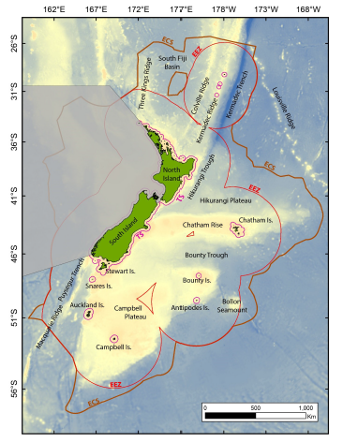
Figure 4. Area considered in assessment (shaded area not included). Source: NIWA

Options
- The possible options to manage the environmental effects of deposits of jettisoned material outside the currently authorised launch deposit areas are set out below. With the exception of status quo, the other two options would require implementation through the promulgation of new regulations.
- Classify the activity as permitted, subject to conditions in regulations under the EEZ Act—the regulations enable any operator to launch rockets on new trajectories with potential to deposit jettisoned material in the EEZ and extended continental shelf to the north, east, and south of New Zealand. Conditions are set out in regulations to manage any potential adverse effects.
- Classify the activity as non-notified in regulations under the EEZ Act—a marine consent is still required but does not require public notification or hearings. Rocket Lab or any future operator would apply for a marine consent, costing around $350,000 and taking up to 60 working days (roughly three months), after regulations have been put in place. The EPA may impose conditions on the marine consent to manage any potential adverse effects.
- The status quo is allowed to continue—the activity is a fully notified discretionary activity requiring a marine consent from a Board of Inquiry. Rocket Lab would apply for a marine consent and this would cost them somewhere between $350,000 and $1,200,000 and take up to 140 working days (roughly nine months). The BOI may impose conditions on the marine consent to manage any potential adverse effects.
- Under either the non-notified or status quo options, if a marine consent were not applied for or not granted, Rocket Lab would be confined to launch in the current approved trajectories under the Permitted Activities Regulations. Rockets could not be launched from any other facility without a marine consent.
- For the purposes of the analysis, we have assumed that a marine consent is granted under the options that require one.
- Under all options, there would be pre- and post-activity reporting to the EPA to monitor compliance with conditions of the activity.

Classifying new activities
- As described in paragraph 16, new activities are treated by default as discretionary (and fully-notified), and the Act provides for regulations to be made to classify activities as prohibited, non-notified discretionary, or permitted, on the recommendation of the Minister.
- The Act allows that regulations may classify activities as permitted if they are not likely to have adverse effects on the environment or existing users that are significant in the circumstances.
- To be classified as non-notified a section 20 activity (restricted activity other than discharge or dumping) must:
- have a low probability of significant adverse effects on the environment or existing interests, and either
- be routine or exploratory in nature, or
- be brief in duration.
- In developing regulations, the Minister must take into account the matters set out in section 33 of the Act.
- The Act requires the Minister to take a precautionary approach to decisions—favouring caution and environmental protection when information is uncertain or inadequate.

Environmental effects
- To better understand the environmental effects from the deposit of jettisoned material in the EEZ and extended continental shelf, the Ministry for the Environment commissioned the National Institute of Water and Atmospheric Research (NIWA) to undertake two marine ecological risk assessments of the effects of future launching activities—in 2016 and 2017.
- The 2016 report assessed the risk to ecosystem components of multiple launches within two specific jettison zones: The sun synchronous and eastern jettison zones. This study considered a single splashdown to consist of 1 tonne of debris, the most that could be deposited by an Electron-type vehicle if none of it burned up in descent.
- The 2017 report assessed the risk to ecosystem components for a single splashdown of jettison material in a wider geographic area of the EEZ and extended continental shelf (to the north, east and south of New Zealand, as shown in Figure 4), and estimated the cumulative effects of multiple launches and combined effects with other activities. This study considered a single splashdown to consist of 40 tonne of debris, the most that could be deposited by the largest space vehicle proposed to be launched in the foreseeable future if none of it burned up in descent.
- Both studies considered a range of threats that deposited material could pose (direct strike causing mortality, noise disturbance, toxic contaminants, ingestion of debris, smothering of seafloor organisms, provision of biota attachment sites, floating debris).
- They considered the risk that these posed to a number of ecosystem components (benthic invertebrate community, demersal fish and mobile invertebrates, air-breathing fauna, sensitive environments, and/or pelagic community) of the environmental classes found in the assessment area (shelf, upper slope, northern mid-depths, southern mid-depths, deep and very deep waters, and/or seamounts).
- Both reports concluded that the risk to all ecosystem components from a single deposit was low. This was mainly because the consequence from a single splashdown of 40 tonnes of debris at any point was not severe—on a scale of 0 to 5, the consequences of potential effects were scored as either 0 (negligible) or 1 (minor).
- The main aspects of risk were direct strike and smothering impacts on sensitive benthic environments, and the effects of noise on marine mammals. The study found that although some threats are likely to occur, the consequences to the various ecosystem components at a population, community or habitat scale would be negligible to minor.
- The studies acknowledged that there is considerable uncertainty about the way the environmental effects would accumulate with repeated launches, since this is a new activity, and recommended reviewing the effects when more data is available (i.e. when a number of actual launches and deposits have taken place).
- However, the 2016 study estimated that, in the two zones considered and for the small deposits considered, the ecological risk was low for all ecosystem components for up to 100 launches. For some components of the ecosystem, the risk was low even up to 10 000 launches (or 200 years of once-weekly launches, the limit of the study). The assessment panel identified some potential thresholds, where risks were anticipated to become moderate and then high.
- The lowest of these thresholds was for noise and disturbance to marine fauna above and below water, which was expected to pose a low risk for up to 100 and a moderate risk for up to 1000 launches.
- The 2017 study considered that 10 repeated launches, each depositing 40 tonnes of debris in the same area of the wider EEZ and continental shelf would still have a minor risk, but at 100 launches the risks could be moderate, and with 1,000 launches could become high.
- This report recommended reviewing any management system when more data are available but before the 100-launch threshold was reached in any area, for instance, by requiring a reassessment of the environmental effects after 50 launches.

Effects on Existing Interests
- The effects of the activity on existing interests will most likely be limited to shipping and fishing vessels, where there is a very low risk of impact from falling fragments.
- We consulted Maritime New Zealand (MNZ) and the Ministry for Primary Industries on whether broadening the deposit area will impact any lawfully established existing activity, whether or not authorised by or under any Act or regulations, including rights of access, navigation, and fishing.
- Maritime New Zealand (MNZ) has created maps designating vessel tracks and density in New Zealand waters between July 2016 and June 2017. The density map (Figure 5) indicates that vessel density is highest at the ports (between 1,321 and 4,326 ships per grid section on a 5 nautical mile grid) and the territorial sea (between 19 and 109 ships). Ship density is generally lower in the EEZ, with most areas receiving fewer than 18 vessels per grid section annually. This low density, along with good existing warning systems, indicates that the scale of the effects will be small.
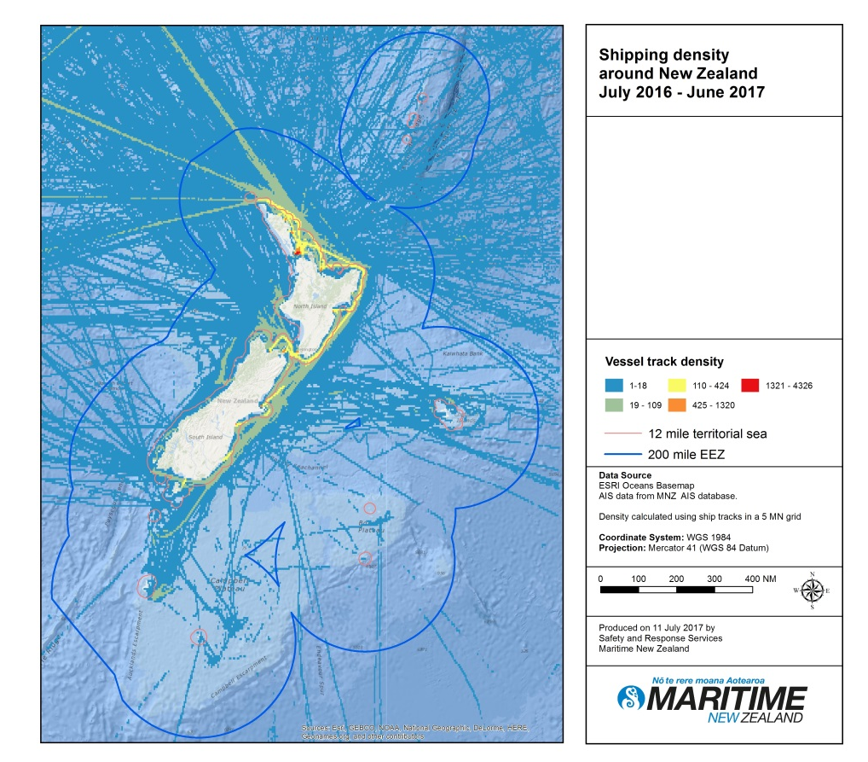
Figure 5. Shipping density around New Zealand July 2016 - June 2017

- The jettison zone for each space vehicle launch is long and very narrow. On the narrow axis, it will be no more than 30 nautical miles wide, although some of the jettison zones will be narrower than this. Rocket Lab has modelled the risk of a vessel in the jettison zone being directly impacted by a fragment from launch of an Electron vehicle as less than 1 in 100,000. Modelling of impacts in the jettison zone is based on NASA’s Debris Assessment Software suite, which meets the requirements of the United States’ Federal Aviation Authority and is based on NASA’s experience over the past 50 years.
- Confidence in the impact modelling is supported by the fact no one has ever been injured by space debris or jettisoned material, even though more than 5400 tonnes of it is believed to have reached Earth’s surface over the past 40 years.
- There are already systems in place to notify other users of the sea of potential hazards.
- MNZ (through the Maritime Operations Centre) is responsible for sending out coastal navigational warnings, while Land Information New Zealand (LINZ) coordinate, collect and issue long range radio navigational warnings that are broadcast to ships in New Zealand waters.
- LINZ publishes fortnightly New Zealand notices to mariners to advise mariners of matters affecting navigational safety. These notices are available on the LINZ website and can be received via email. Rocket Lab also communicates directly with vessels in the vicinity of the launch site directly by radio using publically notified marine VHF channels. On the day of a launch, local authorities periodically notify maritime traffic of the current status of the marine exclusion zones.
- Even though the possibility of impact with a vessel is extremely remote, vessels may choose to move out of the jettison zone during the brief period of time that fragments are expected to reach Earth’s surface. This could result in some relocation of fishing effort over time if the same jettison zone were continually used.

Costs to the Crown
- The costs to the EPA of monitoring would be cost recovered. The costs of monitoring of activity are 80% cost recovered. The 20% cost accruing to the EPA is likely to be too small to require any adjustments to the EPA’s Crown funding.
- There is obviously also a cost to government of making regulations. While it is difficult to estimate, a group of researchers have developed a methodology which gives an average of $530,000 to develop a set of regulations, and an estimate of $50,000 per page of regulations in New Zealand. Further, opportunity costs are also borne by Government in undertaking regulation development.

International Obligations
- There are no relevant international conventions that specifically regulate the deposit of material jettisoned from space vehicles on the seafloor. There are relevant international obligations under UNCLOS, the Convention on Biological Diversity and the Noumea Convention.
- In our view, all the options comply with these international obligations because:
- the probability of significant adverse effects from the activity is low, and conditions can be set in either a marine consent or regulations to avoid, remedy or mitigate effects on the environment, biodiversity and existing interest
- for the purpose of the Noumea Convention, the Minister needs to consider whether the activity is a ‘major project’. Through consultation with experts, including NIWA, officials have assessed the routine environmental effects of the activity as not significant, and concluded that the activity is therefore unlikely to be considered a major project
- although public participation is low with regulations or non-notified marine consents, this is proportionate to the likely level of effects on the interests of the public and iwi/Māori.

Options analysis
Option | Assessment against objectives | Net impact
Option A: Classify the deposit of jettisoned material from space vehicle launches in a wider area of the EEZ as a permitted activity, subject to conditions | Sustainable management  The potential for adverse environmental impacts from the activity is low. However, there is uncertainty about the likely scale of the cumulative effects of repeated launches. This uncertainty can be appropriately managed by conditions on the activity set in regulations including, as appropriate:  - Pre-activity reporting  - Post-activity reporting  - Estimate of volume of material deposited  - Estimate of location of material deposited  - Conditions for limiting the activity to either 50 or 100 repeated launches in a general area or a limit of 100 launches total in the area shown in Figure 4.  - A requirement to avoid seamount closure areas in the vicinity of the Kermadec Ridge and the eastern Chatham Rise.  This option would best provide for sustainable management, as it would pose fewer unnecessary barriers to use the area for economic activity than either the status quo or a non-notified classification, while sustaining the potential of the environment to meet future needs and safeguarding its life-supporting capacity, and managing any potential adverse effects of the activity.  Cost effectiveness and proportionality  This option is cost effective for Government to monitor and would impose only low compliance costs on users such as Rocket Lab.  Non-environmental impacts  Non-environmental impacts, including on existing interests, iwi and other matters set out in the EEZ Act, are considered only during the preparation of regulations. As described in this analysis, the effects on existing interests are not likely to be significant in the circumstances.  This option allows for public participation only through government consultation on the regulations. This is considered to be proportionate to a low level of public interest and likely level of effects on existing interests. | Option A will provide a good level of environmental protection. It has limited opportunity for public involvement, and the lowest compliance costs of the three options considered. The costs are considered to be most proportionate to the level of likely effects of the activity.
Option B: Activity remains discretionary but is classified as non-notified | Sustainable management  Option B would allow any potential adverse effects on the environment to be managed, as in option A. In this case, conditions would be imposed by the EPA on a marine consent for a launch or number of launches, rather than across all instances of the activity. There is less certainty for both applicants and the public about what conditions might be imposed.  The resulting costs of applying for and deciding marine consent applications are higher than for option A, in terms of both time and money. There will be costs to both the government and the applicant.  Conditions may be imposed on a marine consent at the discretion of the EPA. These may be either more stringent than those proposed in option A (and therefore impose a greater compliance burden) or less stringent (and therefore provide a lesser degree of environmental protection). The uncertainty this creates for both the public and the applicant is considered to outweigh the benefits of the added flexibility.  This option will likely sustain the potential of the environment to meet future needs, safeguard its life-supporting capacity, and manage any potential adverse effects of the activity just as well as option A. However, it will impose some barriers on the use of the area for economic purposes, so is considered to promote sustainable management to a lesser extent.  Cost effectiveness and proportionality  The cost involved in applying for and deciding marine consent is considered to be disproportionate to the likely effects, which are not expected to be significant in the circumstances.  Non-environmental impacts  The non-environmental impacts, including effects on existing interests, are considered by the EPA when making a decision on a marine consent under s59 of the Act.  This option offers no additional public involvement over option A, as the consents are not publically notifiable. | Option B will provide a good level of environmental protection. It has limited opportunity for public involvement, and significant compliance costs. The costs are considered to be disproportionate to the level of likely effects of the activity.
Option C: Status quo | Sustainable management  Option C would allow any potential adverse effects on the environment to be managed, as in the options above. In this case, conditions would be imposed on a marine consent for a launch or number of launches by a Board of Inquiry, rather than the EPA. There is a similar level of certainty for applicants and the public about what conditions might be imposed as in option B.  Cost effectiveness and proportionality  This option is the most costly to both industry users (such as Rocket Lab) and the government, in terms of time and money. The notification and BOI process add both time and expense to the process of obtaining marine consent, compared with option B. The scale of the cost is considered to be disproportionate to the level of the likely effects of the activity.  Non-environmental impacts  The non-environmental impacts, including effects on existing interests, are considered by the BOI when making a decision on a marine consent under s59 of the Act.  This option allows for more additional public involvement than either option A or option B, as the consents are publically notifiable, and the public will have the opportunity to submit on every application for marine consent. It is considered that the insignificant likely effects of the activity do not warrant this degree of public involvement. | Option C will provide a good level of environmental protection. It has considerable opportunity for public involvement, and the highest compliance costs of the three options considered. The costs are considered to be disproportionate to the level of likely effects of the activity.

Conclusions and Recommendations
- The effects on the environment and existing interests of the deposit of material jettisoned from space launch vehicles on the seabed in the EEZ and extended continental shelf are not expected to be significant in the circumstances. At this stage of the analysis, the preferred approach is to make the activity permitted in regulations under the EEZ Act, and officials recommend inviting public consultation on that proposal.
- Since this is a new activity, there is some uncertainty about the potential for effects to accumulate over time, and officials recommend that, if the activity is made permitted, the management approach favours caution and environmental protection by imposing appropriate conditions on the activity in regulations.
- Appropriate conditions could include, at a minimum:
  - Pre-activity reporting at least 14 calendar days before a launch.
  - Post-event reporting to the EPA including:
    - Confirming the final date and time of the launch no more than 5 working days after the launch.
- Reporting quarterly or after 10 launches on the date and time of each launch, observed flight path(s), volume of material and the area where jettisoned material landed, and summary of any complaints of breach of conditions that were received and how they were addressed.
  - A requirement for the EPA to publically publish the post-activity reports.
  - A requirement to avoid seamount closure areas in the vicinity of the Kermadec Ridge and the eastern Chatham Rise.
- Conditions similar to those in the current classification (requirements for pre- and post-activity reporting, and publication of reports)
- Conditions for addressing uncertainties of how much material is likely to be deposited by limiting the number of launches that can deposit material on the seabed to either
- a number of launches that deposit material within the same general area – either 50 or 100, or
- limited to 100 launches in total in the area shown in Figure 4
- The proposals for conditions should be developed further through the public consultation and consultation with the EPA.

Consultation
- MfE consulted with the following agencies to discuss the problems identified with the status quo and the proposals in this RIS:
- Ministry of Business, Innovation and Employment
- Environmental Protection Authority
- Maritime New Zealand
- Department of Conservation
- Ministry of Primary Industries
- Ministry of Foreign Affairs and Trade
- Te Puni Kōkiri
- Treasury
- All are broadly supportive of the proposal. The Department of Prime Minister and Cabinet have been informed about the proposals.
- DOC suggested the Cabinet paper, Discussion document and RIS more clearly describe how the likelihood and consequence contributes to the overall risk assessment score of ‘minor or less than minor’. This clarification has been made in the documents.
- The EPA requested that the Cabinet paper include a recommendation to share the draft regulations with the EPA. This recommendation has been included in the Cabinet paper.
- In response to a proposed condition to identify and avoid sensitive environments, the EPA noted implementation challenges with that condition, and as a result, we have modified the proposed condition to avoid sensitive seamount environments in the Bay of Plenty, the Kermadec Ridge, and the eastern Chatham Rise, as noted in the 2017 NIWA assessment.
- Following public consultation, any submissions will be reviewed and taken into account in policy decisions.

Implementation
- The EPA would incur administrative costs if the deposit on the seabed of jettisoned material from space launch vehicles in the wider EEZ and continental shelf is classified as a permitted activity. Costs would include evaluation of reports and notification of activities on the EPA website, and would partly be recovered from the person undertaking the activity. These costs are not likely to be greater than the costs of administrating the discretionary process for marine consent decisions, which the EPA would be required to do under the current system.
- The costs to the person undertaking the activity of complying with conditions are unlikely to be significant given that much of the necessary information would be produced as part of normal business operations.
- This analysis concerns the deposit of jettisoned material from space vehicle launches on the seabed in New Zealand’s Exclusive Economic Zone and on the extended continental shelf. If, after consultation, it is decided to continue with the preferred option, work will continue to develop regulations to classify the activity as permitted, subject to conditions in a wider area to the north, east and south of New Zealand in regulations under the Exclusive Economic Zone and Continental Shelf (Environmental Effects) Act 2012.

Monitoring, Evaluation and Review
- As the responsible policy agency, MfE monitors the effectiveness of the overall EEZ regime. Part of this ongoing monitoring, evaluation and review may include:
- evaluation of costs and the effectiveness of all EEZ functions including permitted activities
- evaluation of how effective the EPA and other management agencies are in meeting the purpose of the Act.
- As this is a new activity, the Government considers more information on the activity will be available after 50 launches to help inform future assessments of the scale and impact of the activity.
- As the regulator, the EPA will be gathering information on the impacts of space vehicle launches through post-activity reporting.

Moore, D; Ryan, M and Davies-Colley, M Report prepared for the Ministry of Business, Innovation and Employment: Economic Impact Analysis of the Development of a Rocket Industry in New Zealand Updated Report 9 June 2016. http://www.mbie.govt.nz/info-services/sectors-industries/space/new-zealand-space-agency/document-image-library/folder-pdf-library/Sapere%20Economic%20Impact%20Analysis%20of%20the%20Development%20of%20a%20Rocket%20Launch%20Industry%20-June%202016.pdf
Ministry for the Environment. 2012. Managing our oceans: A discussion document on the regulations proposed under the Exclusive Economic Zone and Continental Shelf (Environmental Effects) Bill. Wellington: Ministry for the Environment.
National Institute of Water and Atmospheric Research. April 2017. Ecological Risk Assessment of the impact of debris from space launches on the marine environment. Prepared for the Ministry for the Environment by the National Institute of Water and Atmospheric Research. Wellington: Ministry for the Environment.
(MacDiarmid, et al., August 2016)
Wilson, N et al Estimating the Cost of New Public Health Legislation Bulletin of the World Health Organization 2012;90:532–539

