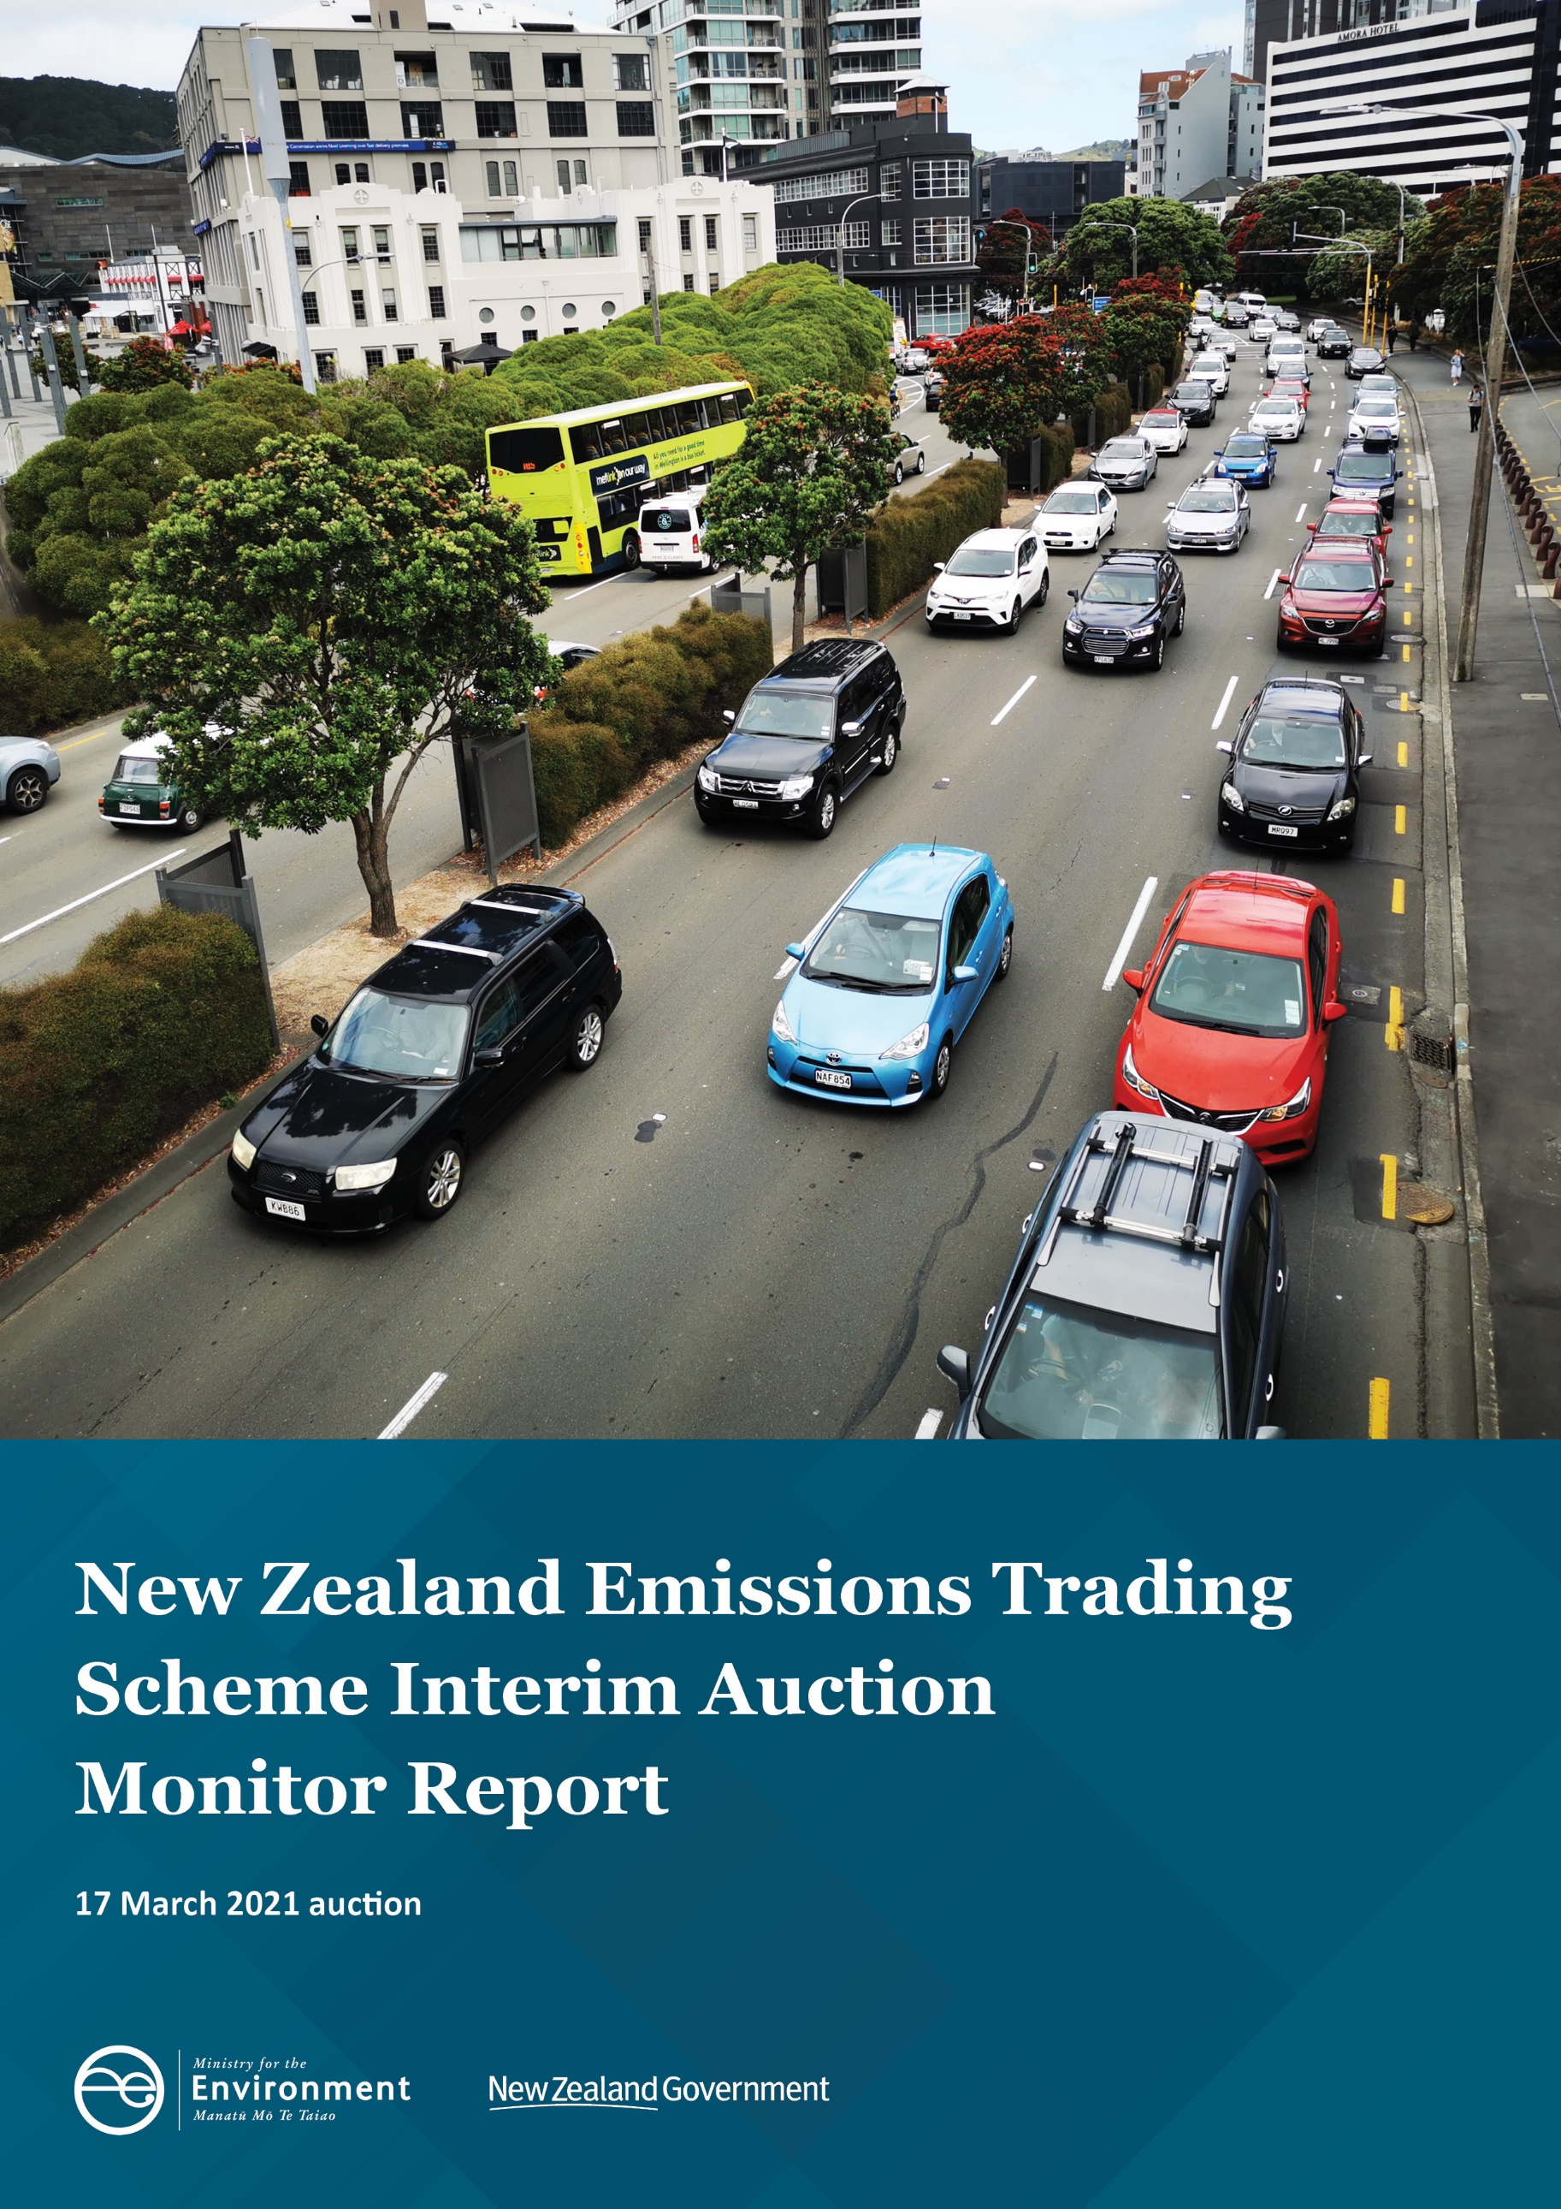

Disclaimer
The information in this publication is, according to the Ministry for the Environment’s best efforts, accurate at the time of publication. The Ministry will make every reasonable effort to keep it current and accurate. However, users of this publication are advised that:
- The information does not alter the laws of New Zealand, other official guidelines, or requirements.
- It does not constitute legal advice, and users should take specific advice from qualified professionals before taking any action based on information in this publication.
- The Ministry does not accept any responsibility or liability whatsoever whether in contract, tort, equity, or otherwise for any action taken as a result of reading, or reliance placed on this publication because of having read any part, or all, of the information in this publication or for any error, or inadequacy, deficiency, flaw in, or omission from the information in this publication.
- All references to websites, organisations or people not within the Ministry are for convenience only and should not be taken as endorsement of those websites or information contained in those websites nor of organisations or people referred to.

This document may be cited as: Ministry for the Environment. 2021. New Zealand Emissions Trading Scheme Interim Auction Monitor Report: 17 March 2021 Auction. Wellington: Ministry for the Environment.

Published in June 2021 by the
Ministry for the Environment
Manatū Mō Te Taiao
PO Box 10362, Wellington 6143, New Zealand
ISBN: 978-1-99-003358-2
Publication number: ME 1567
© Crown copyright New Zealand 2021
This document is available on the Ministry for the Environment website: environment.govt.nz.

Contents
Introduction and purpose of this report 5
Background 6
Auction monitor’s functions 6
Auction monitor appointment 6
Auction information: 17 March 2021 7
Auction metrics 7
The auction clearing price 8
The confidential reserve price 8
Information on resolved tied bids 8
Commentary on the auction operation 9
Collateral and settlement 9
Feedback about the auction monitoring report 10
Appendix 11
Graphical presentation of historical auction results and metrics 11
References 14

Tables
Table 1: Metrics for NZ ETS auction 17 March 2021 7

Figures
Figure 1: Total number of bids 11
Figure 2: Total number of participants 11
Figure 3: Average bid size 12
Figure 4: Average volume bid for and won per bidder 12
Figure 5: Average number of bids per bidder 12
Figure 6: Largest bid as a percentage of the total units sold 13
Figure 7: Distribution of successful bids among market participants with and without mandatory compliance obligations 13

Introduction and purpose of this report
This is the first report produced by the interim auction monitor on the first scheduled New Zealand Emissions Trading Scheme (NZ ETS) auction held on 17 March 2021.
Auctioning of New Zealand units (NZUs) will be undertaken at regular intervals throughout the year (currently quarterly) as prescribed by the Climate Change Response (Emissions Trading Reform) Amendment Act 2020 and the Climate Change (Auctions, Limits, and Price Controls for Units) Regulations 2020.
The purpose of this report is to record and provide details on the results of the auction and to provide an assurance that the auction was conducted properly and in accordance with the applicable rules and laws.

Background
Following the 2015/16 review of the NZ ETS, the Government agreed to introduce auctioning of NZUs to align the supply of units in the scheme with New Zealand’s climate change targets. Further public consultation on auctioning regulations took place between November and December 2019.
Following extensive regulatory and legislative development and an open market procurement process, an auction operator was appointed to run regular scheduled auctions through the NZ Managed Auction Service.
The first auction was successfully undertaken on 17 March 2021.

Auction monitor’s functions
Based on feedback from the 2019 consultation, the Government agreed that the auction monitor should:
- publish certain information about each auction as soon as practicable following the auction
- publish a report on the outcome of each auction before the next auction occurs
- review the auctioning system after the first year and every subsequent two years.

Auction monitor appointment
The appointment of an auction monitor requires regulations to be made prescribing the appointment process and the functions of the auction monitor.
Until the requisite consultations and regulation development have been concluded to appoint an auction monitor, the Minister of Climate Change has agreed that the Ministry for the Environment (MfE) will perform the function of the auction monitor.
The interim auction monitor function is performed independently of the MfE policy team who are responsible for developing the regulations for the auction monitor and auctioning.

Auction information: 17 March 2021

Auction metrics
Cabinet has agreed that the auction monitor must publish a report on the outcome of each auction before the next auction occurs [DEV-20-MIN-0047]. It must contain at least the following information:
- detailed volume statistics, eg, average volume per bidder (this is different from average bid size as one bidder can place multiple bids) and average volume won per bidder
- detailed statistics on the number of bids, eg, average number of bids per bidder, number of bids submitted, number of successful bids
- relevant aggregate information, eg, largest bids as a percentage of total volumes sold
- relevant distributional information, eg, number of units awarded to which winner, with bidder names withheld
- distribution of successful bids among market participants with and without mandatory compliance obligations
- relevant information on resolved tied bids.
The auction operator publishes information about NZ ETS auctions at www.etsauctions.govt.nz, which can be read in conjunction with this report. Table 1 provides the key information for the auction. The information is graphically presented in the appendices.
Table 1: Metrics for NZ ETS auction 17 March 2021
Number of participants | 40
Number of successful participants | 30
Average bid size | 28,496
Average volume bid for per bidder | 290,662
Average volume won per bidder | 158,333
Average number of bids per bidder | 10.2
Total number of bids submitted (not including withdrawn bids) | 408
Number of bids withdrawn | 37
Number of successful bids | 237
Largest bid as a percentage of the total units sold | 18.92%
Herfindahl–Hirschman Index (measure of market concentration) | 0.133
Percentage of bidders with mandatory compliance obligations | 50%

The auction clearing price
The auction operator is required to publish the clearing price following the auction.
MfE has calculated the clearing price using raw data provided by the auction operator and confirms that the clearing price of $36 is correct.

The confidential reserve price
The Climate Change Response Act enables the Minister of Climate Change to set a methodology for calculating a confidential reserve price for NZ ETS auctions. The confidential reserve price has the purpose of preventing NZUs from being sold at auction at a price significantly below the secondary market price. If the auction clearing price is less than the confidential reserve price, the auction will not sell any NZUs. Unsold NZUs will be rolled forward to be sold at the next auction in the same calendar year.
The auction operator has robust procedures and checks in place to ensure that the confidential reserve price is correct. MfE is satisfied that these checks are sufficient and that the clearing price was above the confidential reserve price.

Information on resolved tied bids
If more than one bid sets the clearing price, those bids are referred to as tied bids. If all tied bids together bid for more units than are left, each tied bid is allocated a proportional share of the remaining units, subject to rounding rules. Bids are only accepted in multiples of 100 units, known as lot size. Units are allocated to bids in multiples of lot size. Therefore, when tied bids occur and the operator calculates proportional shares, they apply the following rounding rules:
- the number of units allocated to a tied bid, if not a multiple of the lot size, is rounded down to the nearest 100 units (this may include being rounded down to zero)
- rounding down to the nearest 100 units means that there is no risk that the operator allocates more units to bids than there are units available for sale. However, it also means that unallocated units may remain after the first step is complete
- if unallocated units remain after tied bids are awarded their proportional share (rounded to the nearest 100 units), any remaining lots are randomly allocated to the tied bids, but only up to their original bid amount.
MfE has examined how units have been allocated amongst tied bids and confirms that the auction operator has correctly applied the rounding rules.

Commentary on the auction operation
The auction operator has informed MfE that the auction ran smoothly with no outages or delays.
MfE has no reason to believe that the auction rules were not followed.

Collateral and settlement
All potential participants lodged collateral on or before T-5 (10 March 2021). Almost half were lodged on T-5, and almost half were lodged on T-6.
All invoices were settled by T+4 (23 March 2021). Almost all invoices were settled on or before T+3. All NZUs were transferred to successful bidders’ registry accounts by T+5 (24 March 2021).
MfE notes that all participants lodged collateral within the prescribed timeframes, and all successful participants received their allocated units within the prescribed timeframes.

Feedback about the auction monitoring report
This is the first interim auction monitor report. If there is any information about ETS auctions that you would like to be included in future reports, please be in touch at etsconsultation@mfe.govt.nz.

Appendix

Graphical presentation of historical auction results and metrics
Figure 1: Total number of bids

Figure 2: Total number of participants

Figure 3: Average bid size

Figure 4: Average volume bid for and won per bidder

Figure 5: Average number of bids per bidder

Figure 6: Largest bid as a percentage of the total units sold

Figure 7: Distribution of successful bids among market participants with and without
mandatory compliance obligations

References
New Zealand Cabinet. 2018. Amendments to the Climate Change Response Act 2002: Tranche One. Cabinet Committee Minute of Decision CAB-18-MIN-0606.01. Wellington: Cabinet Office, Department of the Prime Minister and Cabinet.
Ministry for the Environment. 2019. Reforming the New Zealand Emissions Trading Scheme: Rules for auctioning: Technical consultation document. Wellington: Ministry for the Environment.
New Zealand Cabinet. 2020. New Zealand Emissions Trading Scheme: Regulatory Decisions on the Rules for Auctioning. Cabinet Economic Development Committee Minute of Decision DEV-20-MIN-0047. Wellington: Cabinet Office, Department of the Prime Minister and Cabinet.

https://environment.govt.nz/assets/Publications/amendments-to-ccra-tranche-1-cab-18-min-0606.01.pdf
https://environment.govt.nz/publications/reforming-the-new-zealand-emissions-trading-scheme-rules-for-auctioning-summary-of-submissions/
https://environment.govt.nz/assets/Publications/DEV-20-MIN-0047-Minute.pdf

