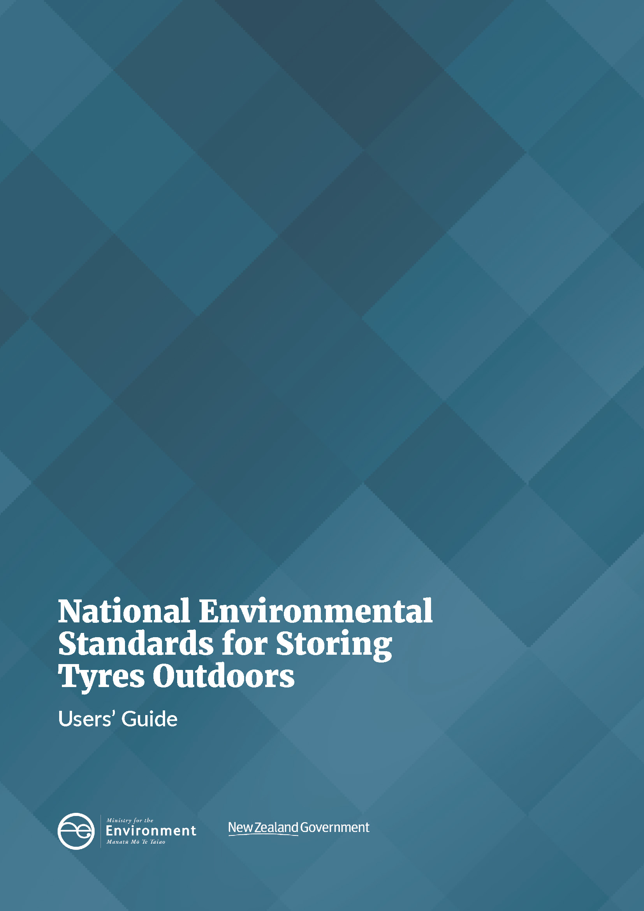

Disclaimer
The information in this publication is intended to assist with the interpretation and implementation of the regulations. However, users of this publication are advised that:
- The information does not alter the laws of New Zealand, other official guidelines, or requirements.
- It does not constitute legal advice, and users should take specific advice from qualified professionals before taking any action based on information in this publication.
- The Ministry does not accept any responsibility or liability whatsoever whether in contract, tort, equity, or otherwise for any action taken as a result of reading, or reliance placed on this publication because of having read any part, or all, of the information in this publication or for any error, or inadequacy, deficiency, flaw in, or omission from the information in this publication.
- All references to websites, organisations or people not within the Ministry are for convenience only and should not be taken as endorsement of those websites or information contained in those websites nor of organisations or people referred to.

Acknowledgements
This document was developed with the help of 4Sight Consulting, with input from Government agencies, regional council and industry stakeholders. The authors gratefully acknowledge the support and contributions of those who participated in this project.
This document may be cited as: Ministry for the Environment. 2021. National Environmental Standards for Storing Tyres Outdoors – Users’ Guide. Wellington: Ministry for the Environment.

Published in May 2021 by the
Ministry for the Environment
Manatū Mō Te Taiao
PO Box 10362, Wellington 6143, New Zealand
ISBN: 978-1-99-003354-4
Publication number: ME 1564
© Crown copyright New Zealand 2021
This document is available on the Ministry for the Environment’s website: www.environment.govt.nz.

Contents
1 Introduction 5
Purpose of document 5
Overview of the NES-STO 5
Background to the NES 7
Other legislation and regulations and the Treaty of Waitangi 8
Structure of document 8
2 Overview 9
Overview of regulations 9
Roles and responsibilities for NES 10
Businesses and landowners affected by the NES 10
Timeframes 10
3 Guide to understanding the NES 11
Application of regulations to storing tyres outdoors 11
Measuring volume of tyres 13
Storing tyres on a property 14
When a resource consent is required 17
4 Implementing the regulations 20
Implementing and complying with the NES-STO 20
Consent conditions to mitigate environmental risks 26
Risk-based approach to compliance monitoring 32
Relationship between NES, regional and district plan rules, and resource consents 33
Relationship with other legislation and regulations and the Treaty of Waitangi 36
Appendix 1 – Quick guide to the NES-STO for businesses and types of uses 40

Figures
Figure 1: Diagram on how to measure the volume of tyre bales 14
Figure 2: Determining if resource consent is required under the NES-STO 17
Figure 3: Tyres being stored next to an area where silage is stored 24
Figure 4: Tyres being stored adjacent to silage pit where silage is stored 25
Figure 5: Tyres covering silage stack in a single layer 25
Figure 6: Volume of tyres stored next to silage pit 26
Figure 7: Volume of tyres being stored prior to covering the silage stack 26
Figure 8: Two tyre-stacking arrangements A: Banded B: Laced 28
Figure 9: Generic risk matrix 33

Table
Table 1: Overview of NES-STO requirements 9

1 Introduction

Purpose of document
This guide supports users’ understanding and implementation of the Resource Management (National Environmental Standard for Storing Tyres Outdoors) Regulations 2021 (NES-STO). The NES-STO are regulations under the Resource Management Act 1991 (RMA) to address a regulatory gap in the management of the adverse effects of outdoor tyre storage.
This guide is targeted at regional councils (responsible for implementing the NES-STO), tyre businesses, farmers and other landowners who store tyres outdoors on their property. It aims to promote consistency and efficiency in applying the regulations, including cost-effective approaches to compliance monitoring and appropriate consent conditions to manage site-specific risks.
This guide provides:
- an overview of the NES-STO
- an overview of roles and responsibilities under the NES-STO and how it may affect different businesses
- further details on the NES-STO, including key definitions and thresholds and when resource consent is required
- advice on implementing the NES-STO, including assessing compliance with the regulations and storage practices to mitigate the risks and adverse effects from outdoor tyre storage.

Overview of the NES-STO
National environmental standards (NESs) are regulations prepared in accordance with sections 43–44 and 46A of the RMA. NESs can prescribe technical and non-technical standards, methods or other requirements relating to land use and subdivision, use of the coastal marine area and beds of lakes and rivers, water take and use, and the discharge of contaminants. NESs prevail over regional and district plan rules unless the standards expressly state that rules may be more stringent or lenient.
The NES-STO will address a regulatory gap in managing outdoor tyre storage under the RMA, through introducing nationally consistent rules and standards for this activity. The policy objectives of the NES are to:
- ensure the risks of harm to the environment, human health and local communities from outdoor tyre storage are appropriately managed
- support more consistent management practices across New Zealand, filling gaps in regulatory settings that create incentives to move tyres between regions.
Regulation 3 of the NES describes the purpose of the NES as follows:
3 Purpose relates to functions of regional councils
The purpose of these regulations is to deal with the effects of storing tyres outdoors that fall within the functions of regional councils under section 30 of the Act, particularly—
(a) the control of the use of land for the purpose of
i. the maintenance and enhancement of the quality of water in water bodies and coastal water; and
ii. the avoidance or mitigation of natural hazards; and
(b) the control of discharges of contaminants into land, air, or water.
The NES-STO supports this through nationally consistent rules and standards for storing more than 20 cubic metres of tyres within a property. It is based on the following thresholds, with specified exemptions:
- Outdoor tyre storage less than 20 cubic metres is a permitted activity and not subject to any permitted activity conditions of the NES-STO.
- Outdoor tyre storage 20 cubic metres or more but less than 100 cubic metres is a permitted activity subject to compliance with general conditions (Regulation 12) that control the height of tyre storage and proximity to sensitive areas through minimum setback distances. Non-compliance with the permitted activity conditions will require resource consent as restricted discretionary activity. A restricted discretionary activity status means the consent authority’s power to grant or decline a consent or impose conditions is restricted to the specified matters (as set out in Regulation 14 of the NES-STO).
- Outdoor tyre storage 100 cubic metres and greater requires resource consent as a restricted discretionary activity. Discretion is restricted to the matters set out in Regulation 13 of the NES-STO.
Regional councils are responsible for implementing the NES-STO in accordance with section 44A(7) and (8) of the RMA. These sections require regional councils to observe the NES and enforce it to the extent of their powers. Regulation 14 of the NES-STO allows the following rules and bylaws to be more stringent:
- regional rules
- district rules
- bylaws made by regional councils or territorial authorities.
Regulation 16 of the NES-STO allows regional councils to charge for monitoring permitted activities under the NES-STO in accordance with section 43A(8) of the RMA.

Background to the NES

Why the NES was developed
Approximately four million used car tyres and one million used truck and other tyres are generated annually in New Zealand, and the total number of tyres entering New Zealand each year is increasing. Many end-of-life tyres end up being stored outdoors in stockpiles due to the lack of markets for them. Storing or stockpiling tyres outdoors poses a risk of harm to the environment, human health and local communities through the discharge of contaminants, fire risk (a low probability event with significant adverse effects), visual and amenity effects and liability issues.
There is a very limited market for resource recovery of tyres once they reach the end of their usable life. This means end-of-life tyres accumulate, and there are incentives to dispose of tyres in the cheapest way possible. There has been a lack of effective regulation to deal with the outdoor tyre storage of end-of-life tyres and the associated risks. Government intervention is needed to introduce nationally consistent rules to address the risks of outdoor tyre storage.
The NES is part of a set of initiatives to help solve the waste tyre problem in New Zealand and create a circular economy for tyres. The key initiative is regulated product stewardship, which involves the tyre industry taking responsibility for the whole-of-life environmental impact of tyres. The NES will be a key environmental standard for participants in the scheme. The scheme will encourage more and better uses for end-of-life tyres and support best practice tyre collection and recycling.

Process to develop the NES
In 2017 the Government consulted on a proposed NES for Outdoor Storage of Tyres. Thirty-five submissions were received, most supporting the proposal in principle. Submissions identified a number of issues; in particular, there were concerns that the proposed threshold for resource consent (200 cubic metres) was too high and that the proposal did not adequately address the risks of smaller volumes of tyres.
The Ministry for the Environment carried out further research and analysis to address some of these issues leading to the development of the current NES. The Ministry consulted on a revised proposal from 25 February to 8 April 2020. Fifty submissions were received, with stakeholders generally supportive of the proposal and the proposed changes. Key changes included moving responsibility for implementation from territorial authorities to regional councils, introducing a permitted activity rule, reducing the resource consent threshold (from 200 to 100 cubic metres), and introducing an exemption from the discretionary activity rule for farm silage tyres and businesses where the primary activity is the supply or servicing
of tyres.

Other legislation and regulations and the
Treaty of Waitangi
The outdoor storage of tyres regulated under the NES-STO is still subject to other relevant legislation and regulations and the Treaty of Waitangi, which apply in addition to the NES-STO. Both councils and businesses storing tyres need to be aware of their continuing responsibilities under other legislation and instances where compliance with other legislation is also required.
Other legislation relevant to storing tyres outdoors typically focuses on the public health and safety aspects of tyre storage and other effects not covered by the RMA or this NES. The ‘Relationship with other legislation and regulations and the Treaty of Waitangi’ section discusses legislation and regulations particularly relevant to storing tyres outdoors.

Structure of document
This guidance document is structured as follows:
- Section 2 – Overview of NES-STO: This provides an overview of the NES-STO, including a summary of the key standards, roles and responsibilities under it, and how it is likely to impact on businesses and landowners.
- Section 3 – Guide to understanding the NES-STO: This section provides guidance on understanding the NES, including the scope and application of the regulations and how to determine when resource consent is required.
- Section 4 – Implementation of the regulations: Section 4 provides guidance on how to implement the NES-STO, including the relationship between the NES and existing regional plans, existing regional consents, existing legislation and other regulations and existing use rights. It also contains information about how to assess compliance, good storage-management practices, and considerations when imposing consent conditions under the NES.

2 Overview

Overview of regulations
The NES-STO is a set of regulations for the activity of storing tyres outdoors that deals with the adverse effects of tyre storage that fall within the functions of regional councils under section 30 of the Resource Management Act 1991 (RMA). The NES-STO requirements are summarised in table 1.
Table 1: Overview of NES-STO requirements
Quantity of tyres stored outdoors | Requirements
Total volume less than 20m³ on a property (Regulation 10) | Storing tyres on the property is a permitted activity and not subject to any conditions in the National Environmental Standard for Storing Tyres Outdoors (NES-STO). Outdoor tyre storage of less than 20m³ on a property is still subject to general restrictions in sections 12, 13(1)(d), 15(1) and 17 of the RMA, which may be used by councils to take enforcement action to deal with the disposal of end-of-life tyres in certain circumstances, including when tyres have been buried on a site. More information about the general restrictions in the RMA can be found in the ‘Relationship with other legislation and regulations and the Treaty of Waitangi’ section of this guide. Regional and district rules may also be more stringent than the NES-STO (Regulation 15) and include permitted activity conditions and consent requirements for outdoor tyre storage of less than 20m³.
Total volume 20m³ or more on a property (Regulation 11) | Storing tyres on the property is a permitted activity if:  (a) the general conditions in Regulation 12 are met; and  (b) one or more of the following apply:  i. the total volume stored on the property is less than 100m³  ii. The tyres are new or newly retreaded and are stored for the purpose of a business whose activities include the supply or servicing of new or newly retreaded tyres  iii. The tyres are awaiting retreading and are stored on a property that is owned or leased by the business that will undertake the retreading  iv. The storage of tyres is to weigh down covers on one or more silage stacks and the further conditions in Regulation 13 are met.  Tyre storage outdoors that does not comply with any of the conditions above requires a resource consent from the consent authority as a restricted discretionary activity. ‘Restricted discretionary’ means the discretion of consent authorities is restricted to the matters set out in the NES-STO (Regulation 14) when deciding on an application and imposing consent conditions.
Total volume 100m³ or more per property. | Resource consent is required as a restricted discretionary activity. However, the 100m³ limit does not apply to:  - new or newly retreaded tyres stored for the purpose of a business whose activities include the supply or servicing of new or newly retreaded tyres  - tyres that are awaiting retreading and are stored on a property that is owned or leased by the business that will undertake the retreading  - farm silage tyres stored next to areas and pits used for silage production and storage, in quantities no larger than needed to cover the silage in a single layer (Regulation 13).

Roles and responsibilities for NES
Regional councils are responsible for implementing the NES-STO as it deals with effects that fall within their functions under section 30 of the RMA. Regional councils are required to observe (ie, implement) the NES-STO and enforce it to the extent their powers allow (section 44A(7) and (8)). This will mean regional councils process resource consents required under the NES-STO and undertake compliance monitoring and enforcement to ensure compliance with the NES-STO. Under section 44A of the RMA, councils are also required to remove rules in their plan that duplicate or conflict with the NES-STO. Such changes are expected to be limited, as most regional plans do not have rules specifically dealing with outdoor tyre storage. Regional councils should still check whether they have previously provided guidance to communities about outdoor tyre storage (for example, whether outdoor tyre storage is captured by existing general waste provisions or otherwise) and ensure any messaging is updated to reflect the new NES-STO requirements.

Businesses and landowners affected by the NES
The NES-STO will affect a range of businesses and landowners that need to store tyres outdoors. See Appendix 1 for a summary of the types of businesses that are likely to be impacted by the NES and how the regulations are likely to affect them.

Timeframes
The NES-STO has been published on the New Zealand Gazette and will come into force on 20 August 2021. Under section 20A of the RMA (certain existing lawful activities allowed), owners of properties with existing piles of tyres stored outdoors that do not comply with the NES-STO will have six months from the date it comes into force to apply for a consent from the relevant regional council or comply with the NES-STO. More guidance about existing use rights and the potential resource consent requirements in the NES-STO is provided in the ‘Existing use rights’ section.

3 Guide to understanding the NES

Application of regulations to storing tyres outdoors

Tyres stored outdoors
Regulation 7(2) defines ‘storing tyres outdoors’ as:
‘Storing tyres outdoors occurs if the tyres—
(a) are, or have been, deposited on a property and are allowed to remain there for more than 72 hours; and
(b) are not indoors or buried in the ground; and
(c) the active use exception under regulation 8 does not apply to the tyres.’
If tyre storage on a property meets all three of these requirements, then the National Environmental Standard for Storing Tyres Outdoors (NES-STO) applies (although there are no consent requirements or conditions in the NES-STO for tyre storage where the total volume on the property is less than 20 cubic metres). This definition also applies to tyres that have been dumped on a site, as opposed to being deliberately stored.
Regulation 7(2)(a) refers to tyres that ‘are, or have been deposited on a property’. This phrase means tyres that have been deposited on a property in the past, so the NES-STO applies to both existing tyre piles and new tyre piles created after the NES-STO comes into force.
Regulation 7(2)(a) also defines the minimum period tyres need to be stored on a property to be considered ‘stored’ for the purposes of the NES-STO and applies to tyres deposited on a property prior to the NES-STO being gazetted, as well as new tyre storage that occurs post-gazettal. The 72-hour timeframe is intended to be long enough to allow for very short-term storage of tyres in transit but short enough to discourage the periodic movement of tyres from property to property in order to avoid compliance with the NES-STO.
Regulation 7(2)(b) should be read in conjunction with Regulation 7(3) to determine whether tyres are being stored indoors, as discussed further below. Regulation 7(2)(b) also makes it clear that the NES-STO does not cover tyres that have been buried. Tyres buried underground as a way of disposing of them may be a contravention of s15(1)(d) because of the high likelihood of contamination and lack of legitimate purpose.
In addition, some councils may have provisions in their plans that regulate burying tyres (eg, provisions that regulate the burying of waste and/or management of landfills), which could be used to take enforcement action with respect to buried tyres in addition to the general enforcement provisions in the RMA.
Regulation 7(2)(c) clarifies that tyres that meet the ‘active use’ test under Regulation 8 are not considered to be covered by the NES-STO, discussed further below.

Out of scope tyre-derived products
In order to define the scope of the NES-STO, the definition of ‘tyre’ excludes “any product derived from a tyre through a process that involves separating from each other the rubber and other materials that form the tyre”. This means crumb rubber is excluded from the scope, as are products that bond crumb rubber with other materials to make a new product (eg, rubber mats or roading surface material). This exclusion from the NES-STO is not an indication as to whether the environmental or health effects of these products or applications are acceptable or otherwise. Research into the effects of using crumbed tyre rubber for tyre-derived products (beneficial and adverse) is ongoing around the world.,

‘Active uses’
End-of-life tyres can be used for many purposes other than being fitted to something designed to use a tyre. These are deemed ‘active uses’ in the NES. The definition of ‘storing tyres outdoors’ could include tyres being used outdoors for other uses (eg, raceways). However, these alternative uses of end-of-life tyres would generally not require more than 20 cubic metres of tyres for a legitimate purpose. Regulation 8 specifies situations where tyres stored outdoors are considered to be in ‘active use’ and therefore not covered by the NES-STO.
Under Regulation 8(2)(a), tyres that are fitted to a vehicle, machinery, equipment or other thing that is designed to be fitted with a tyre are not being ‘stored outdoors’ and are therefore exempt from the NES-STO. For example, car yards storing large volumes of cars, that could otherwise exceed 20 cubic metres of tyres stored outdoors (if the tyres were considered collectively), would not need to comply with the NES-STO.
Regulation 8(2)(b) discusses the use of tyres for weights on silage stacks and clarifies that these are considered to be in ‘active use’ when they are physically being used on a silage stack. Tyres being stored outdoors when they are not currently in use as silage stack covers but have been set aside for that future use are covered by Regulation 11(2)(b)(iv) and Regulation 13.
Regulation 8(2)(c) covers the use of tyres outdoors ‘for sporting or recreation purposes, or for engineering, landscaping, drainage, or other construction purposes’. The intent is that tyres used for these types of activities are not covered by the NES-STO, provided they can meet the conditions in Regulation 8(3). Examples of activities that typically use end-of-life tyres that could be covered by this clause include:
- playground equipment
- equestrian arenas
- raceways
- gun ranges
- buffers and structures such as at wharves and jetties
- construction and landscape projects, for example as a building material for retaining walls
- civil engineering, for example as drainage material in a landfill.
Active uses covered by Regulation 8(2)(c) that were lawfully established prior to the NES-STO coming into force will not need a resource consent if they are attached to, or form part of a structure or are otherwise connected to each other (Regulation 8(3)).

Tyres stored indoors
Regulation 7(3) states that tyres are considered to be ‘indoors’ (and therefore exempt from the NES-STO) ‘if they are inside an immovable or a moveable construction that is fully enclosed by a roof, walls, and a floor’. Tyres stored indoors have a much lower risk of leaching contaminants as there is no direct contact with the land/soil and they are protected from the weather. They are also generally much more secure and less visible to the public, so the risk of a tyre fire (particularly from arson) and associated adverse environmental effects is often greatly reduced.
An indoor construction can have doors and windows, but the storage areas must be able to be fully closed and locked and must be water-tight to avoid water getting into the tyre storage area. Tyres in transit in a completely enclosed vehicle or container would also meet the definition of ‘indoors’, provided there was no exposure to the elements (eg, a shipping container). A three-sided shed or barn, a four-sided building with a dirt floor, or an open truck would not meet the definition of indoor tyre storage and so would be subject to the NES-STO.
Although indoor tyre storage is not covered by the NES, it can be a fire risk if not done safely. If Council staff or fire and emergency officers are alerted to a local indoor storage situation that is potentially a fire risk, they can take steps to inform the building owner and note any applicable regulations under the Fire and Emergency New Zealand Act 2017.

Measuring volume of tyres
Regulation 5 outlines how to measure the volume of tyres when assessing compliance with the thresholds in Regulations 10 and 11 of the NES-STO. Regulation 5 states:
In these regulations,—
(a) the volume of a tyre includes the air space (if any) that is within the tyre’s outer limits; and
(b) the volume of tyres in a tyre bale is the volume of the tyre bale as a whole; and
(c) the total volume of tyres stored on a property is the total volume of those tyres, regardless of whether the tyres are located together or on separate parts of the property.
As outlined in the Storing tyres on a property section below, whole tyres stored outdoors should be stacked wherever possible. Once stacked, the volume of the tyre pile should be calculated as for any three-dimensional shape; length x depth x height, if the tyre pile is in a rough cube shape. Some approximations may be required, as tyre piles are unlikely to be a homogenous shape. An estimate will generally be sufficient where a tyre pile is clearly larger or smaller than 20 and 100 cubic metres.
Another approach is to estimate the number of tyres. The 20-cubic metre threshold is approximately 250 standard passenger tyres (EPUs – equivalent passenger units) and the 100-cubic metre threshold equates to approximately 1,250 standard passenger tyres. This is less useful if there are larger trucks or heavy machinery tyres stored on the property as these approximations are based on standard passenger tyres only.
The size of 100 cubic metres is equivalent to 2.8 small shipping containers (six-metre/20-foot containers) or 1.32 twelve-metre shipping containers.
In the case of tyre bales, tyres are compressed into rough cuboid shapes, so the volume can be estimated by calculating depth x length x height (shown in figure 1). As tyre bales are compressed, the volume can’t be calculated on the number of tyres mentioned above.
Figure 1: Diagram on how to measure the volume of tyre bales
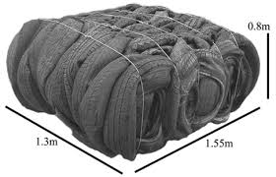

Storing tyres on a property
Regulation 11 applies to outdoor tyre storage with a total volume of 20 cubic metres or more on a property. Regulation 11(2) outlines the requirements for outdoor tyre storage of 20 cubic metres to be a permitted activity:
(2) Storing tyres outdoors on the property is a permitted activity if—
(a) the general conditions in regulation 12 are met; and
(b) 1 or more of the following apply:
(i) the total volume of tyres stored outdoors on the property (other than tyres of the kind described in any of subparagraphs (ii) to (iv)) is less than 100 m³;
(ii) the tyres are new or newly retreaded, and are stored for the purpose of a business whose activities include the supply or servicing of new or newly retreaded tyres;
(iii) the tyres are awaiting retreading and are stored on a property that is owned or leased by the business that will undertake the retreading;
(iv) the tyres are stored for use as weights to weigh down covers on 1 or more silage stacks and the further conditions in regulation 13 are met.
The sections below provide more guidance on how to understand Regulations 11–13 of the NES-STO.

Regulation 11(2)(b)(ii) and (iii) – New and retread tyre businesses
Regulation 11(2)(b)(ii) sets out an exemption from the 100 cubic metres tyre volume limit for new or newly retreaded tyres stored by businesses that supply or service such tyres. Regulation 11(2)(b)(iii) sets out an exemption for tyres awaiting retreading (or ‘tyre casings’) if they are stored by a retreading business on a property that is owned or leased by the business that will undertake the retreading. This exemption does not apply to end-of-life tyres that may be stored at a tyre supply or servicing business (100 cubic metres or more of end-of-life tyres stored at the business will require a resource consent).
This exemption is intended to focus the NES-STO on the storage of end-of-life tyres because they are more likely to cause adverse environmental effects. New and retread tyres are generally only stored outdoors when it is impractical to store them indoors and are generally stored more securely as the tyres are more valuable than end-of-life tyres. The 100 cubic metres tyre volume limit therefore does not apply to new and retread tyre supply and servicing businesses (unless they are storing end-of-life tyres) but compliance with the general conditions in Regulation 12 is required otherwise resource consent is required as a restricted discretionary activity under Regulation 14.
Businesses “whose activities include the supply or servicing of new or newly retreaded tyres” will primarily be tyre retailers, vehicle mechanics and specific retreading businesses. Tyre collectors, recyclers, or processors would not meet this definition.

Regulation 11(2)(b)(iv) and Regulation 13 – Storing tyres for use as weights on silage stacks
There is no requirement to seek consent for any volume of stored silage tyres, provided the conditions in Regulations 12 and 13 are met. This is because Regulation 11(2)(b)(iv) sets out an exemption from the 100 cubic tyre volume limit where:
- the tyres are stored for use as weights to weigh down covers on one or more silage stacks; and
- the further conditions in Regulation 13 are met.
As with tyre supply and servicing businesses, the general conditions in Regulation 12 apply to tyres being stored for weights on silage stacks, and non-compliance with any of the conditions requires resource consent is a restricted discretionary activity under Regulation 14.
The ‘further conditions’ for tyres stored for weights on silage stacks in Regulation 13 are:
(a) the tyres must be stored next to the pits or other areas where the silage stacks are regularly made; and
(b) the volume of tyres next to each pit or other area must be no more than needed to cover the silage stack in a single layer of whole tyres.
(2) For the purposes of subclause (1)(b),—
(a) the volume of tyres needed to cover a silage stack in a single layer of whole tyres is the volume needed to cover the largest silage stack that may reasonably be made in the pit or other area; and
(b) if some tyres are currently being used to weigh down the cover on a silage stack in the pit or other area, the volume of those tyres must be added to the volume of tyres being stored next to the pit or other area.
This exemption means tyres being stored for weights on silage stacks do not unnecessarily require resource consent when good management practices are followed (including compling with the general conditions in Regulation 12). Silage tyres are generally stored close to silage stacks which are already subject to regional plan setback rules to prevent silage leachate entering waterways, such as setbacks.
More information about good management practices and how to assess compliance with Regulations 12 and 13 can be found in section 4 below.

Regulation 12: General conditions
Regulation 12 of the NES-STO sets out the ‘general conditions’ that apply to all outdoor tyre storage with a total volume of 20 cubic metres or more on a property. Regulation 12 effectively outlines the permitted activity conditions that tyre storage above 20 cubic metres must comply with, otherwise resource consent is required as a restricted discretionary activity under Regulation 14. The intent of the permitted activity conditions in Regulation 12 is to control how close tyres can be to certain areas and sensitive receiving environments where there is a greater risk of adverse environmental effects.
Regulation 12(1)(a) states that tyres must not be piled more than 3 metres high, to manage potential fire risk and assist firefighting. This does not apply to tyres where the vertical height of the tyre itself is greater than 3 metres and it is being stored on its end (the maximum height would still apply if larger tyres are stored on their side).
Regulations 12(1)(b)–(g) outline required setbacks for tyre storage from the following areas and receiving environments:
(b) At least 50 metres from overhead transmissions lines and any other part of the national grid that is above the ground.
(c) At least 50 metres from any surface water body or bore (other than a river or stream) that is used to supply drinking water.
(d) At least 50 metres from the point of a river or stream where drinking water is abstracted.
(e) At least 20 metres from any other surface water body and any other bore that connects to an aquifer.
(f) At least 1 metre above the water table of any aquifer.
(g) At least 50 metres from the coastal marine area (CMA).
Further information on how to measure setbacks in Regulation 12 is provided in section 4.

When a resource consent is required
Where the volume of tyres stored on a property is 20 cubic metres or more, the NES-STO requires resource consent when either:
- any of the general conditions in Regulation 12 are not met; or
- the volume of tyres stored on the property is 100 cubic metres or more (although this 100 cubic metres limit does not apply to the exemptions in Regulation 11(2)(b)(ii) to (iv) discussed above).
Figure 2 shows whether a resource consent is required under the NES-STO for storing tyres outdoors. This applies to ‘storing tyres outdoors’ as defined in Regulation 7(2), that is, it involves storage of tyres for more than 72 hours on a property, where the tyres are not being stored indoors or buried in the ground, the tyres are not in active use under Regulation 8, and they are not being stored in the Coastal Marine Area (Regulation 9).
Note figure 2 identifies whether consent is required under the NES-STO – there may be other national direction instruments or regional/district plan provisions that also apply to the activity.
Figure 2: Determining if resource consent is required under the NES-STO
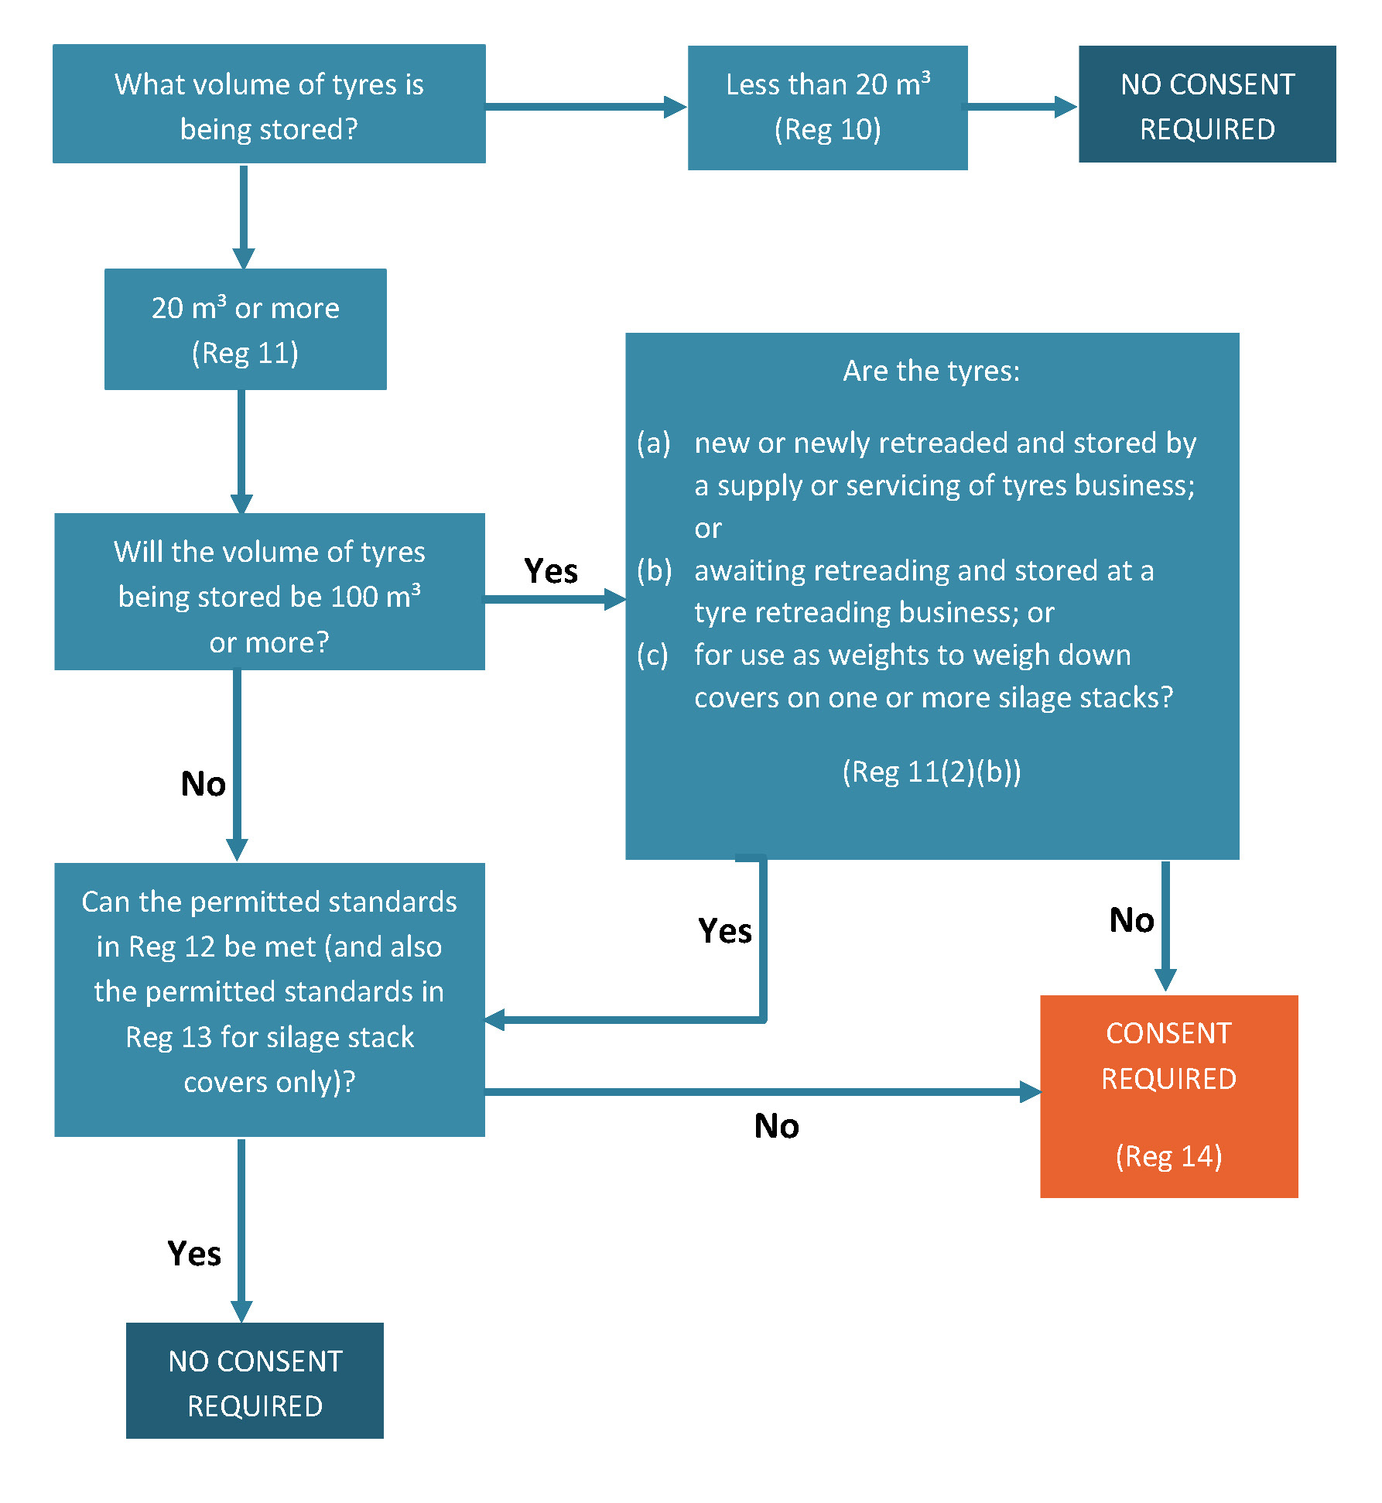

Regulation 14 – Restricted discretionary activity
Where storing tyres outdoors on a property is not a permitted activity under the NES-STO, resource consent is required for it to be a restricted discretionary activity under Regulation 14. As a restricted discretionary activity, the power of regional councils to decline or grant consent and impose conditions on the consent is restricted to the matters of discretion.
Regulation 14(2) outlines the matters of discretion that apply to any activity requiring a resource consent under the NES-STO. The matters of discretion are:
(a) the adverse effects of the activity on land, freshwater, ecosystems, and the coastal environment:
(b) the risk of fire associated with the activity and the adverse effects of any fire on—
i. air quality, freshwater, ecosystems, and the coastal environment; and
ii. the health, safety, and well-being of people and communities: and
iii. the economic, social, and cultural well-being of people and communities:
(c) the proposed measures to avoid, remedy, or mitigate the adverse effects referred to in paragraph (a):
(d) the proposed measures to mitigate the risk of fire associated with the activity and the adverse effects referred to in paragraph (b):
(e) the economic and environmental benefits (for example, those relating to the re-use, recycling, or recovery of tyre material) that may result from or be facilitated by the activity:
(f) the requirement for, and conditions of, a bond:
(g) the timing, and nature of, the review of the conditions on the resource consent:
(h) the duration of the resource consent.
Matters (a) and (c) in Regulation 14 ensure the consent process focuses on the actual or potential adverse effects on receiving environments (land, freshwater, ecosystems, and coastal environment) and the proposed measures to avoid, remedy or mitigate these adverse effects. Storage management practices and measures to manage the potential adverse effects are discussed further in section 4.
Matters (b) and (d) in Regulation 14 focus on the potential fire risk from the proposed outdoor tyre storage and the adverse effects that may result in the event of a fire on receiving environments and the health, safety and wellbeing of people and communities, and the proposed measure to mitigate fire risk and associated adverse effects.
Storage management practices and measures to mitigate the potential fire risk and associated adverse effects are discussed further in section 4.
Matter (e) of Regulation 14 gives regional councils discretion to consider the economic and environmental benefits of the proposed outdoor tyre storage. Such benefits could include reuse, recycling, or recovery of tyre material.
Matters (f)–(h) of Regulation 14 give regional councils discretion to manage the environmental effects and financial risks of outdoor tyre storage, by imposing conditions relating to bonds, review of consent conditions, and the duration of consent.
Section 108(2)(b) of the RMA states that a resource consent may include a condition requiring the provision of a bond in accordance with section 108A of the RMA. This section allows bonds to be required to ensure consent conditions are followed relating to adverse effects, removal of structures, remedial or restoration work or for ongoing monitoring of long-term effects. Bond conditions can be used in conjunction with review conditions to minimise some of the financial risks of large-scale storage of tyres outdoors. Review conditions can be imposed on the bond amount, which allows bonds to be increased at the end of the review to reflect inflation as well as increases in, say, disposal costs.
Section 128 of the RMA outlines the grounds on which councils may review consent conditions, which is often related to a review condition in the resource consent. Review conditions can be imposed to give regional councils some flexibility to review consent conditions to address adverse effects that may arise during the exercise of the resource consent. Consent holders have a legitimate requirement for a high level of certainty, however, so review conditions should only be used where there is uncertainty about the actual adverse effect, or degree of adverse effects, from the activity when the application is being assessed. The review process cannot be used to materially alter the consent's nature, or make the activity unviable. For general guidance on review conditions on resource consents, see Review conditions on the Quality Planning website.

4 Implementing the regulations
This section gives guidance on implementing and complying with the National Environmental Standard on Storing Tyres Outdoors (NES-STO) including:
- understanding and measuring the setbacks in Regulation 12
- the further conditions for tyres for silage stack covers in Regulation 13
- tyre-storage practices and conditions to mitigate the risk of a fire and adverse environmental effects
- the relationship between the NES-STO, plan rules and existing consents, and existing use rights.

Implementing and complying with the NES-STO

Measuring setbacks
Setbacks are a proven way to avoid or mitigate the adverse effects of activities on receiving environments, including storing tyres outdoors. The general conditions in Regulation 12 of the NES-STO set out requirements for tyres to be setback at least 50 or 20 metres from specified areas (National Grid infrastructure, different types of water bodies, and the Coastal Marine Area (CMA)). The term ‘setback’ is not defined in either the NES-STO or the Resource Management Act 1991 (RMA), but is typically understood to mean the distance measured horizontally from a feature or boundary, creating a buffer within which certain activities cannot take place.
Regulation 12(2) provides some guidance on how to measure setbacks:
(2) The distance between tyres and another thing is,—
(a) if the other thing is an overhead transmission line, the shortest distance between the centre line of the overhead transmission line and the edge of the closest tyre:
(b) if the other thing is an electricity substation that is part of the national grid, the shortest distance between the electricity substation’s outermost security fence and the edge of the closest tyre:
(c) in any other case, the shortest distance between the edge or boundary of that thing and the edge of the closest tyre.
Regulation 12(1)(b)–(g) sets out different types of setbacks in the NES-STO, outlined below.

Regulation 12(1)(b) – Transmission lines and National Grid infrastructure
Regulation 12(1)(b) requires tyres to be set back at least 50 metres from (the centre of) transmission lines and 50 metres from any other National Grid infrastructure above ground. In the case of electricity substations, the 50-metre setback is measured from the substation’s outermost security fence, to the edge of the closest tyre. National Grid and overhead transmission line are defined in the NES-STO as:
national grid means the network used or owned by Transpower New Zealand Limited for the purpose of conveying electricity, including—
(a) the electricity substations that are connected to the network; and
(b) the other infrastructure for the network
overhead transmission line—
(a) means the overhead conductors and other wires that are used to convey electricity on the national grid; and
(b) includes—
(i) the towers and poles that support the conductors and other wires; and
(ii) the cable transition stations for the conductors and other wires
The purpose of the setbacks in Regulation 12(1)(b) is to avoid or mitigate the potential risks of outdoor tyre storage to the National Grid, particularly during a fire; for example, smoke from burning tyres can cause power outages. This recognises the significance of the National Grid and the need to ensure outdoor tyre storage does not compromise its effective operation.

Regulation 12(1)(c)–(f) – Setbacks from surface water bodies and bores
Regulation 12(1)(c)–(f) outlines the required setbacks for tyres from surface water bodies and bores:
- At least 50 metres where the surface water body or bore (other than a river or stream) is used to supply drinking water
- At least 50 metres from the point of a river or stream where drinking water is abstracted
- At least 20 metres to any other surface water body or other bore that connects to an aquifer
- At least 1 metre above the water table of any aquifer.
The NES-STO includes the following definitions relevant to Regulation 12(1)(c)–(f):
aquifer means a permeable geological formation, group of formations, or part of a formation that is beneath the ground and capable of receiving, storing, transmitting, and yielding water
bore—
(a) means any hole drilled or constructed in the ground that is used to—
(i) investigate or monitor conditions below the ground surface; or
(ii) abstract gaseous or liquid substances from the ground; or
(iii) discharge gaseous or liquid substances into the ground; and
(b) excludes test pits, trenches, soak holes, and soakage pits
drinking water—
(a) means water intended to be used for human consumption; and
(b) includes water intended to be used for food preparation, utensil washing, and oral or other personal hygiene
registered drinking-water supply means a drinking-water supply that is recorded in the drinking-water register maintained by the chief executive of the Ministry of Health (the Director-General) under section 69J of the Health Act 1956
supply drinking water means to supply drinking water—
(a) to a registered drinking-water supply; or
(b) directly to a dwellinghouse
surface water body—
(a) means freshwater or geothermal water in the whole or any part of a river, lake, stream, pond, or wetland; and
(b) excludes freshwater or geothermal water that is—
(i) within the coastal marine area; or
(ii) in the whole or any part of an aquifer
The first two definitions are from the National Planning Standards; the definitions relating to drinking water are from the Resource Management (National Environmental Standards for Sources of Human Drinking Water) Regulations 2007, except for the definition of ‘supply drinking water’, which was drafted for the NES-STO. The definition of surface water body is a slight modification of the definition of water body in the RMA. The main difference is that the definition of surface water body in the NES-STO excludes aquifers. This is because it may be difficult to determine whether there is an aquifer located under an area where tyres are being stored outdoors. There is also a relatively low risk that tyres will leach containments throughout the soil to adversely affect an underlying aquifer.
Surface water bodies include a range of different types, including rivers, lakes, streams, ponds and wetlands, and some of these water bodies are defined in the RMA, other national directions or in regional plans. Many regional councils already have methods to determine the spatial extent and edge of surface water bodies and it is expected that councils will continue to define edges of surface water bodies for the purposes of Regulation 12 of the NES-STO as they do currently.
As a starting point, setbacks from rivers generally should be measured from the edge of the riverbank formed by the dominant channel-forming flow. Setbacks from lakes should be measured from the water high point on the lake’s shore or bank. In relation to a river or stream that is used to supply drinking water, Regulation 12(1)(d) requires tyres to be set back 50 metres from where the drinking water is abstracted.
Often the edges of wetlands are harder to define than other water bodies, as their boundary can respond significantly to changes in rainfall throughout the year and include intermittent wet areas. Regional councils may use their existing methodologies to define the edges of wetlands in line with the RMA definition of wetland and the definition for ‘natural inland wetland’ in the National Policy Statement for Freshwater Management 2020 where applicable.
Regulation 12(1)(c) of the NES-STO requires a setback of 50 metres from the edge of tyres to a surface water body or bore used to supply drinking water. This is to avoid potential contamination of drinking water from outdoor tyre storage. The Institute of Environmental Science and Research (ESR) maintains the register of drinking water supplies, which provides the public with information about community water supplies and suppliers. The register is available in four parts on the ESR website.

Regulation 12(1)(g) – Setbacks from the coastal marine area
Regulation 12(1)(g) requires that the edge of tyres be at least 50 metres from the Coastal Marine Area (CMA). The CMA is defined in the RMA, which states the landward boundary of the CMA is:
the line of mean high water springs, except that where that line crosses a river, the landward boundary at that point shall be whichever is the lesser of–
i. 1 kilometre upstream from the mouth of the river; or
ii. the point upstream that is calculated by multiplying the width of the river mouth by 5.
CMA setbacks for the purposes of Regulation 12(1)(g) of the NES-STO should be measured from mean high water springs (MHWS), in accordance with the RMA definition. There is no single definitive method that can be used to measure MHWS, as the approach needs to be customised to the individual location and consider such factors as the hydraulic gradient, the type and value of land concerned, and the survey accuracy required. Some regional coastal plans may include a more specific definition of MHWS, relevant to their region. In this scenario, the more specific definition in a regional coastal plan takes precedence over the RMA definition.
Some regional councils have mapped MHWS for coastal planning purposes and can provide further guidance on how to measure MHWS if required. General guidance can be found on the Land Information New Zealand website and in Baker and Watkins (1991).

Regulation 13 – further conditions for tyres for silage stack covers
The NES-STO does not require consent for any volume of stored silage tyres as long as the conditions in Regulation 12 (discussed above) and Regulation 13 are met. This section covers the requirements of Regulation 13.
Tyres are often used in large numbers on farms as weights for silage stack covers. These tyres are stored in the offseason when not being used on silage stacks. The number and volume of tyres needed varies based on the type and size of the farm, and from season to season. For this reason, tyres stored for weights on silage stack covers are exempt from the 100-cubic metre tyre volume limit in Regulation 11(2)(b)(iv). The NES-STO does include conditions for storing tyres for use as weights on silage stack covers, to ensure these are being stored appropriately to mitigate the risks of adverse environmental effects.
Regulation 13 of the NES-STO sets out further conditions for tyres stored for use as weights on silage stack covers that must be met as well as the general conditions in Regulation 12. There are two conditions in Regulation 13(1):
(a) Tyres must be stored next to the pits or other areas where the silage stacks are regularly made; and
(b) The volume of tyres next to the pit or other area must be no more than needed to cover the silage stack in a single layer of whole tyres.
The intent of Regulation 13(1)(a) is to ensure tyres are being stored immediately next to where the silage is being stored. If there are multiple silage storage areas across a farm then it may be appropriate to have a number of stockpiles of tyres, provided each stockpile is located immediately next to where the silage is stored and only contains the number of tyres needed to weigh down that particular stack. This helps demonstrate that tyres are actually being stored for the purpose of weights on silage stack covers, and reflects that the size and topography of some farms warrants silage stacks in different locations across the farm. Figure 3 provides examples of tyres being stored next to pits and other areas where silage is stored.
Figure 3: Tyres being stored next to an area where silage is stored
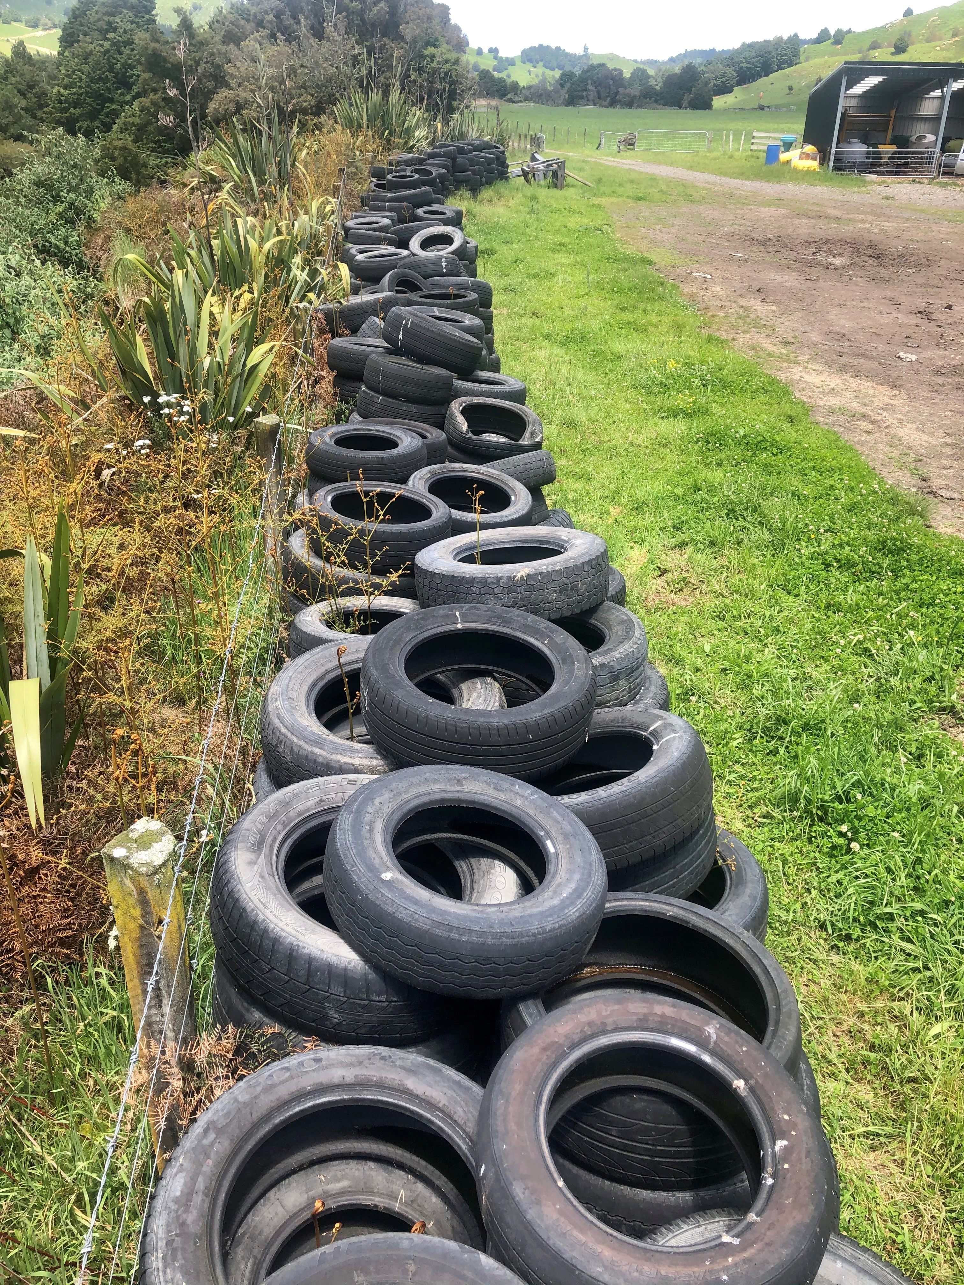
Figure 4: Tyres being stored adjacent to silage pit where silage is stored
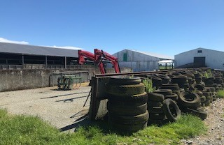
The intent of Regulation 13(1)(b) is to limit the volume of tyres being stored to those needed to cover the silage stack in a single layer. If farmers follow good practice, then tyres on silage stacks should be touching, and a single 17-inch tyre would cover an area of 0.185 square metres. Smaller tyres cover less surface area, so a greater number of tyres would be needed. Regulation 13(2) outlines how to determine whether the volume of tyres being stored is needed to cover a particular silage stack:
For the purposes of subclause (1)(b),—
(a) the volume of tyres needed to cover a silage stack in a single layer of whole tyres is the volume needed to cover the largest silage stack that may reasonably be made in the pit or other area; and
(b) if some tyres are currently being used to weigh down the cover on a silage stack in the pit or other area, the volume of those tyres must be added to the volume of tyres being stored next to the pit or other area.
Regulation 13(1)(b) will require discretion to determine compliance. In some cases, discussions with the farmer may be needed to understand the number of tyres being stored and the largest silage stack that can be made in a pit or other area. Figures 5, 6 and 7 show tyres covering silage stacks in a single layer and volumes of tyres being stored next to large silage pits and stacks prior to covering.
Figure 5: Tyres covering silage stack in a single layer
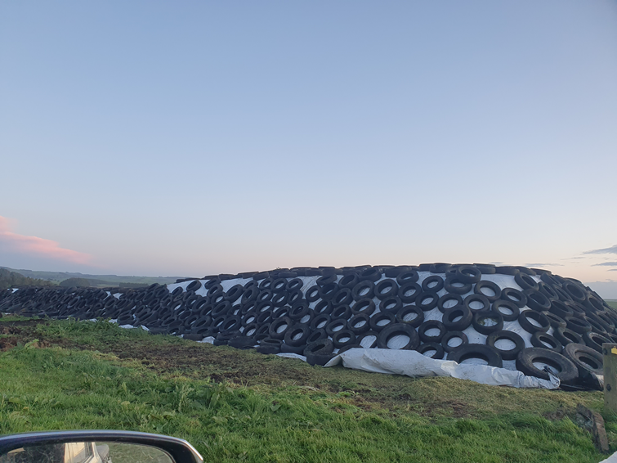
Figure 6: Volume of tyres stored next to silage pit
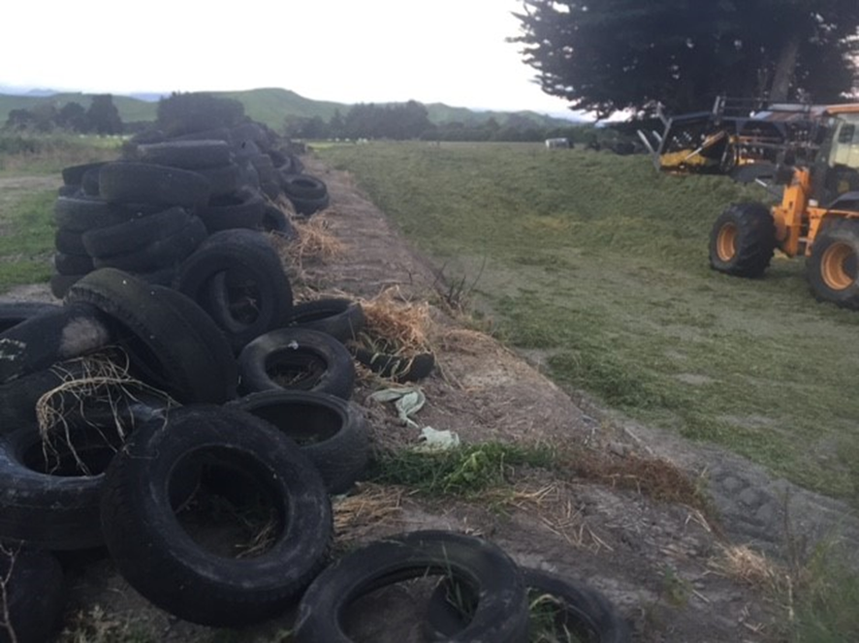
Figure 7: Volume of tyres being stored prior to covering the silage stack
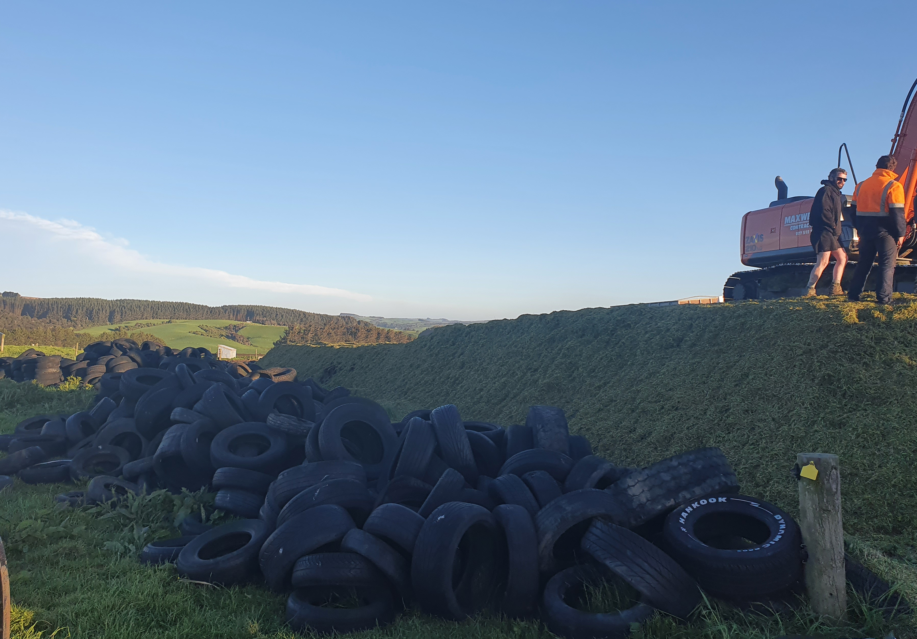

Consent conditions to mitigate environmental risks
Regulation 14 of the NES-STO sets out the matters that discretion is restricted to, as set out in section 3 of this guide. That section covers best-practice approaches for managing the environmental risks of outdoor tyre storage, and can be used by regional councils as a basis for imposing consent conditions.

Fire risk
Tyre stockpiles can pose a major fire risk, and the adverse environmental effects of a tyre fire can be significant. Tyres are made of materials that rapidly combust once ignited and are difficult to extinguish because they can absorb heat for a long period of time. Burning tyres break down into a number of contaminants: up to 32 types of toxic gases and smoke can be discharged into the air, and more than 7.5 litres of oil per tyre can be discharged to land, which can contaminate both ground and surface water.
The critical matters to be considered when mitigating the risk of tyre fires and adverse environment effects are outlined below, based on relevant international and national guidance. Businesses should consider these matters when applying for resource consents required under the NES-STO, and regional councils should consider these matters when assessing resource consent applications and imposing consent conditions (consistent with the matters of discretion set out in Regulation 14).
Some businesses and farmers may have a fire risk management plan in place, developed with the local fire and emergency officer. In these cases, the plan may be submitted with a resource consent application, and if it is current then the council officer may not need to initiate a separate assessment of effects in relation to fire risk.
A tyre fire is likely to be sufficient cause for a council to record a property on their register of sites that have been subject to activities on the Hazardous Activities and Industries List (HAIL). Such properties become subject to the requirements of the Resource Management (National Environmental Standard for Assessing and Managing Contaminants in Soil to Protect Human Health) Regulations 2011 (NESCS).

Site selection
The appropriateness of a site for storing tyres should be determined in consultation with both the regional council and Fire and Emergency New Zealand (FENZ). As well as complying with the setbacks in Regulation 12, a tyre storage location should be:
- large enough to accommodate the volume of tyres and provide adequate space for firefighting access for vehicles and machinery
- in a location with good access points (ideally two access points on opposite sides of the facility), with surrounding roads in a suitable condition to be accessed by emergency vehicles
- able to be secured against unauthorised entry
- on flat or gently undulating land that avoids holes or crevices, such as disused quarries, sandpits etc – as this may make it difficult to extract tyres during a tyre fire to reduce the combustible material
- in an area with adequate access to water for firefighting purposes (see the Effective fire prevention section below for what constitutes ‘adequate’ firefighting water supply)
- set back from dense vegetation, bush, buildings, overhead power lines, or other ignition sources (for example, open fires, flammable or other hazardous material, workshops, smoking areas, electrical equipment)
- set back from sensitive activities such as residential properties, schools, healthcare facilities, major infrastructure or commercial areas (consider the prevailing wind when assessing surrounding sensitive activities).

Size and design of tyre piles

Dimensions of tyre piles
Limiting the size of tyre piles and using an appropriate design can reduce the risk of tyre fires. FENZ recommends a maximum size of 20 metres long x 6 metres wide x 3 metres high; longer, narrow shapes are preferred to large square piles.
A minimum separation distance between stockpiles of at least 20 metres is recommended to both reduce the spread of a tyre fire and provide adequate access for firefighters and excavation equipment in the event of a fire. FENZ also recommends a similar separation distance of 20 metres from all buildings on the property, unless buildings have been constructed specifically from fire-resistant materials to a level reviewed and approved by FENZ.
As a general rule, all businesses and landowners storing tyres outdoors for processing and recovery should minimise the size of tyre piles and storage quantities as far as practical. Australian guidance recommends that all tyres should be processed or transferred within 30 days, unless there are extenuating circumstances preventing this.

Methods of stacking
Where possible, tyres should be stacked to minimise the spread of tyres over the ground and keep them in a contained area. Two common methods of stacking tyres are shown in figure 8.
Figure 8: Two tyre-stacking arrangements A: Banded B: Laced
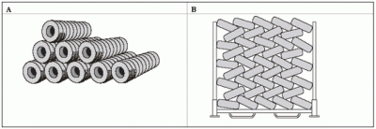
Source: National Fire Protection Association. 2003. Standard No 230: Standard for the Fire Protection of Storage
Laced stacking (method B in figure 8) is the preferred method of tyre storage as it reduces the airspace between tyres, minimises the amount of surface area exposed in a fire, and is relatively stable. However, lacing may not be the best option for tyres that are different sizes, and it does take more time and effort to create a stable stack.
Banded stacking, with tyres stored on their tread (method A) is only appropriate for outdoor storage if the stockpiles can be constrained or contained in some way as storing tyres upright is generally unstable and can cause tyres to roll away in a fire. This may be a solution though for a tyre stockpile with a variety of different-sized tyres. Barrel stacking (whole tyres stacked on their side, on top of each other in a uniform fashion) is another option, as it is more stable than banded stacking. Stockpiles do become increasingly unstable if stacked too high, however. Regulation 12(1)(a) of the NES-STO states that tyres with a volume of 20 cubic metres or more on a property shall not be stacked higher than 3 metres otherwise consent is required under Regulation 14.
Random stacking of tyres, resulting in whole tyres being tossed into a pile, is poor practice and increases the risk of fire and adverse environmental effects. Due to the random placement of tyres, more tyre surface area is exposed and there is more air between tyres, which will further fuel and accelerate a fire if one occurs. It also takes up the most space and increases the area of ground that could be exposed to leachate or firefighting water run-off.

Other forms of tyre storage
As well as being stacked in various formations, end-of-life tyres can also be shredded or bound into tyre bales (see figure 1). Shredded tyres typically take up the least space of any tyre storage method, and fires in piles of shredded tyres are reportedly less intense and produce less smoke, since shredded piles tend to burn at the surface. It is more costly to shred tyres though, and may not be a practical option for many businesses.
Creating tyre bales can be effective from a space-saving perspective, and tyres in a bale are well restrained. Research by Tyre Stewardship Australia found that even after six months’ compression, baled tyres will spring back to their original shape when released. In a fire the steel bale wires are broken under high temperatures and the quick release of pressure draws oxygen and fire into the interior of tyres as they return to their shape, which can further fuel a fire. As such, tyre baling is generally best suited to transporting or exporting tyres, rather than long-term storage.

Effective fire prevention practices
Businesses and landowners storing large volumes of tyres outdoors should implement appropriate fire prevention, management and security measures to reduce the risk of fire and associated adverse environmental effect. The fire prevention measures recommended by FENZ are:
- The site should have a secure perimeter fence (at least 3 metres high, ideally with cyclone wire or similar at the top) or other mechanisms that prevent unauthorised access to the site. Businesses and landowners storing large volumes of tyres outdoors should also consider other security measures such as alarms, early fire warning detection systems and CCTV cameras, particularly if the facility has been a target of arson previously.
- Staff should have access to both first aid and firefighting equipment (for example water and foam fire extinguishers, and hose reels) and be trained on how to use them
- The quantities of firefighting water and foam to manage the identified fire scenarios for the site, and the equipment required to deliver the fire water and foam, should be determined using the Standards New Zealand Publicly Available Specification ‘PAS 4509:2008 – New Zealand Fire Service Firefighting Water Supplies Code of Practice’ (PAS 4509:2008)
- Where reticulated firefighting water is unavailable or insufficient, an adequate static water supply should be available, in accordance with PAS 4509:2008. Fire pumps for large tyre piles in remote locations should be considered.
- Water supply for firefighting should be potable or Grade A recycled water and should be salt free (as salt reacts in a tyre fire, producing highly toxic, carcinogenic dioxins that are a difficult pollutant to remediate).
- An impervious layer should be applied to sites with permeable soil, to prevent run-off of contaminated firewater, oil and liquid by-products of combustion.
- Emergency response procedures developed by the operator should include the use of excavation equipment such as bulldozers and excavators to separate unburnt tyres from the burning pile and the construction of containment bunds, catchment pits or run-off ponds to contain contaminated firewater and access to sufficiently large soil stockpiles to smother fires. Firewater must not be discharged into either stormwater or sewer systems. Emergency response procedures should recognise the significant contamination risks of using water or foam to extinguish a tyre fire and balance these risks with the potential environmental effects from letting the tyre fire burn out.
- A fire risk assessment should be conducted for all tyre stockpiles and an emergency response plan prepared in consultation with FENZ.

Leaching
A variety of heavy metals are found in tyre rubber. Zinc is the main metal of concern. Other heavy metal oxides, such as cadmium, lead and arsenic, are found at low levels. Polycyclic aromatic hydrocarbons (PAHs) are also found in tyre rubber. The risk of tyres leaching contaminants is not immediate, but the longer a tyre pile remains outdoors, the greater the probability that soil underneath and surrounding the pile will become contaminated. Contaminants that leach from the pile will largely be retained in the soil surface, leading to a gradual increase in soil contamination levels, but there is the potential for the leachate to spread to surface or groundwater in some circumstances. Leachates may be toxic to some fish species (eg, rainbow trout).
Factors that may affect the rate of leaching and/or the concentration of tyre leachate compounds in soil, surface water and groundwater include:
- Tyre size: leaching from whole tyres is likely to be slower than leaching from tyre chips or shreds, because of the differences in the surface area to volume ratio
- Amount of exposed steel: if steel is exposed, say in tyre chips, there is likely to be faster leaching of manganese and iron than from whole tyres where the steel is not exposed
- Chemical environment: leaching of metals is likely to be more rapid under acidic conditions while leaching of organic compounds is likely to be more rapid under basic conditions
- Permeability of soil: leaching is likely to be faster when soils are permeable
- Distance to groundwater table: the greater the vertical distance to the groundwater table, the less likely the contamination of groundwater
- Distance from tyre storage site: the further the downstream distance from the tyre storage site, the lower the contaminant concentration in the soil and groundwater
- Contact time with water: the longer the tyres are in contact with water, the greater the risk of groundwater contamination
- Vertical water flow through soil: the greater the water flow through the soil (for example, from rainfall), the greater the dilution of contaminants
- Horizontal groundwater flow: the greater the groundwater flow, the greater the spread of the contaminant plume
- Leached compounds at site: levels of manganese and iron are likely to be elevated in groundwater when steel is exposed. Levels of aluminium, zinc and organic compounds may be elevated in groundwater. Levels of zinc, cadmium and lead may be elevated in soil.

Addressing risk of leachates when assessing resource consent
Most of the research showing leachates from tyres were based on studies of shredded tyres. Intact tyres are less prone to leaching than shredded tyres. A proportionate approach needs to be taken when addressing the risk of leachates from intact or baled tyres, taking into account the particular context. If there is a regular turnover on the site (ie, they are being processed and transferred at least every 30 days), or a relatively moderate amount of tyres stored on land, and the fire risk has been addressed, then in most cases there should be no need to test for or make conditions to prevent leachates.
Situations where measures to reduce water run-off may be needed are:
- shredded tyres
- tyres sitting in water
- uncontrolled stockpiles that do not have a history of turnover. These are at risk of being abandoned and should be proactively monitored
- tyres that have cracked
- storage of very large, concentrated numbers of tyres, in a location where there is a water-quality issue or a sensitive aquatic receiving environment. In this situation, even if the tyres are being turned around, there may be a need to address water run-off.
The following are examples of measures that can be taken:
- Avoiding low-lying areas with permeable soils, flood-prone areas and areas near groundwater recharge points. An example of a suitable area would be one located away from surface water bodies on top of relatively impermeable clayey soils.
- Requiring a greater set back than the minimums allowed for in Regulation 12.
- Ensuring the storage area is on a non-permeable surface, for example a concrete pad or hard-packed clay (not asphalt or grass). Ideally this platform would be slightly raised.
- Designing a suitable stormwater collection system to ensure stormwater run-off and/or overland flow paths are not bringing surface water into contact with the stockpile. This may include soil bunding around the perimeter of the stockpile to prevent clean stormwater from entering the tyre storage area.
- Ensuring the tyres are covered in some way to minimise water contact with tyres, for example, with a roof or tarpaulin. This measure would not be practical for large quantities but could be a short-term measure in the case of tyre shred for instance.

Assessing resource consent applications for ‘active use’ used tyres
Whole tyres and baled tyres are sometimes used in engineering projects, in construction and as retaining walls. A resource consent under the NES-STO may be needed for an ‘active use’ of tyres if it is being applied for after the NES-STO comes into effect. This Users’ Guide does not provide any specific guidance on how local authorities should assess new ‘active use’ applications because there are a number of variables that would need to be assessed in each case. If a restricted discretionary activity consent is required, the matters of discretion in Regulation 14 should be used as a starting point for assessing any new ‘active use’ applications.
Whole tyres proposed to be used in the Coastal Marine Area or in freshwater bodies should be controlled under the RMA or regional or local plans, as active use of tyres in these locations is not covered by the NES-STO.

Risk-based approach to compliance monitoring
A risk-based approach to compliance monitoring is an effective way of targeting activities that have a higher risk of non-compliance, or where non-compliance will have a higher risk of harm to people and the environment. A risk-based approach to compliance monitoring has the following benefits:
- enables the limited resources of local authorities to be prioritised according to the level of risk of adverse effects on the environment
- targets activities and areas where non-compliance is most likely
- enables councils to respond quickly to changing and emerging risks
- provides for robust and transparent decision-making
- ensures a fair and consistent approach to compliance monitoring.
Figure 9: Generic risk matrix
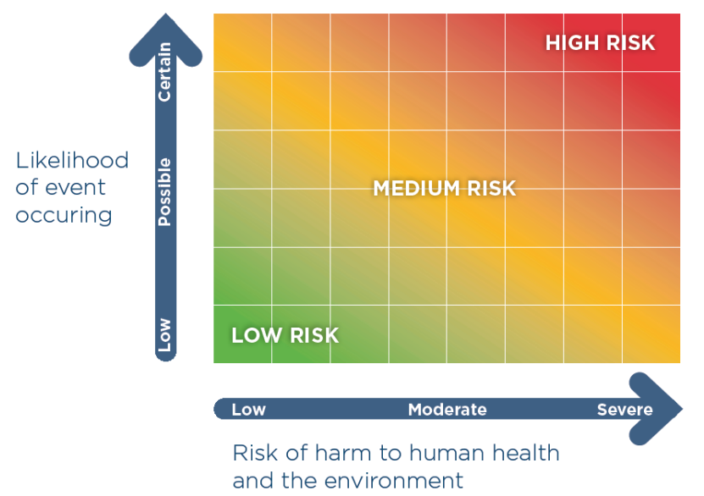
Source: Regional Sector Strategic Compliance Framework 2016–2018
In the context of compliance monitoring, a risk-based assessment considers the likelihood of non-compliance, the risk of harm to people, and any adverse effects on the environment from that non-compliance. These factors form a generic risk matrix shown in figure 9.,
The level of risk should be used to prioritise compliance monitoring activities and determine the most appropriate compliance monitoring approach, including timing, frequency and response. A risk-based approach to compliance monitoring under the NES-STO enables councils to assess:
- The circumstances, behaviour and compliance history of the activity operator.
- The site-specific risks of particular outdoor tyre storage activities – particularly the sensitivity of the receiving environment and the scale of the proposed storage.
- How frequently an outdoor tyre storage activity should be monitored – frequency of monitoring will depend on the risk profile of the activity. Higher risk sites, such as large tyre stockpiles near sensitive environments or tyre collectors with a history of non-compliance may warrant a regular compliance monitoring programme, whereas smaller stockpiles following good storage practices warrant less frequent compliance monitoring.
- The appropriate type or intensity of monitoring – high-risk sites are likely to require more frequent interactions, particularly if compliance is poor. Low-risk sites may not be a priority for regular visits.

Relationship between NES, regional and district plan rules, and resource consents
Sections 43A, 43B and 44A of the RMA outline the legal relationship between NES, regional and district plans, and consents.

Relationship with existing resource consents
There will be limited resource consents authorising outdoor storage of tyres. Where existing regional consents (either regional land use consents and/or coastal, water or discharge permits) expressly allow the storage of tyres outdoors and were granted prior to the gazettal of the NES-STO, these consents will prevail over the NES-STO. This relationship applies until:
- the consent expires; or
- a review of the conditions of the permit or consent under section 128(1)(ba) of the RMA results in some or all of the NES-STO standards prevailing over the permit or consent.

Existing use rights
Existing use rights for activities managed under a regional rule (in a regional plan or NES) are provided for under section 20A of the RMA (certain lawful activities allowed). These rights apply to existing uses and activities that:
- are lawfully established as a permitted activity or could have been lawfully carried out without a resource consent; and
- now require a resource consent as a result of a rule in a plan or proposed plan becoming operative or taking legal effect.
Existing use rights under section 20A(2) of the RMA have limited duration, and a resource consent must be applied for within six months of a rule becoming operative, or in the case of an NES, within six months of the NES coming into force. Section 20A of the RMA also requires that the effects of the activity remain of the ‘same or similar in character, intensity, and scale to the effects that existed before the rule became operative’ for existing use rights to apply.
Section 20A(2) therefore provides a six-month window from the rules in the NES-STO becoming operative for applicants to apply for any regional resource consents required as a result of the NES-STO.

Effects not addressed in NES-STO
The NES-STO addresses effects that fall within regional council functions under section 30 of the RMA. Regulation 14 of the NES-STO sets out the relevant effects being addressed that are associated with outdoor tyre storage.
The NES-STO does not address effects that fall within the functions of territorial authorities under section 31 of the RMA. Regulation 15 of the NES-STO states that district plans may have more stringent rules to manage outdoor tyre storage than the NES-STO (for example, general outdoor rules to address amenity effects in residential zones).
Section 43A(5)(b) of the RMA also allows plan rules to address effects of an activity permitted under an NES that are not addressed in the NES. With tyres, effects that fall in the functions of territorial authorities that are not addressed by the NES-STO could include visual amenity effects (appearance of tyre piles when viewed from public places), noise (truck movements), odour (particularly in the case of shredded tyres) and impacts on sites with heritage values and/or value to Māori. Territorial authorities are able to include provisions to address any of these types of effects without conflicting with or duplicating provisions in the NES-STO.
When consent is required for outdoor tyre storage under the NES-STO and district plan rules, then regional councils and territorial authorities should work together to consider the applications in an integrated manner and streamline the process for consent applicants.

Local authority recognition of NES
Section 44A of the RMA sets out requirements for local authorities to recognise NES through ensuring their plan rules do not conflict or duplicate provision in an NES, and to observe and enforce NES to the extent their powers enables them to do so.

Plan rules that duplicate or conflict with the NES
Research to date, and feedback from regional councils, indicate that most regional plans do not contain existing rules to manage outdoor tyre storage that are more stringent or lenient than the NES-STO. Regardless, regional councils will still need to check their plans to identify how the outdoor storage of tyres is currently being addressed through their plan provisions (if at all) and identify any rules that duplicate or conflict with the NES-STO.
Section 43B(1)-(3) and section 44A(2) set out the circumstances when rules conflict with the NES-STO. Section 44A(2) of the RMA states that a plan rule conflicts with an NES if:
- Section 44A(2)(a) – it is more stringent than an NES provision and the NES does not expressly say it may be more stringent. This includes if it prohibits or restricts an activity the standard permits or authorises. This may be through a more stringent activity status, a more restrictive condition, or both. Regulation 15 of the NES sets out that regional plan rules can be more stringent than the NES-STO, should a regional council choose to implement more stringent rules or if they already have more stringent rules in their plans; or
- Section 44A(2)(b) – it is more lenient than the NES provision and the NES expressly says that it may be more lenient. A rule is more lenient than an NES provision if it permits or authorises an activity the NES prohibits or restricts. The NES does not allow regional plan rules to be more lenient than the regulations. Because of this, any regional plan rule for a tyre storage activity that is more lenient than the NES conflicts with the NES.
The RMA does not specify when a rule duplicates a provision in an NES. There are essentially two tests to consider:
- The rule is not more stringent or lenient than the NES.
- The rule addresses effects dealt with in the NES: section 43A(5)(b) states that plan rules may only deal with effects that are different from those dealt with in the NES. If the terms and conditions in the plan deal with the same effects, then the rule duplicates and the NES prevails (section 43A(5)(c)).

Removing duplication or conflict
Where plan rules duplicate or conflict with a provision in the NES-STO, section 44A of the RMA states that local authorities must amend their plan or proposed plan to remove the duplication or conflict:
- Without using the RMA Schedule 1 process; and
- “As soon as practicable” after the date the NES comes into force.
The NES-STO will prevail over any regional rule that duplicates or conflicts with the NES provisions until these changes are made.

Including a reference to the NES in plans
Section 44A(6) of the RMA enables councils to amend their plans to include a reference to the NES:
- without using the Schedule 1 process
- any time after the date the NES comes into force.
References or advisory notes in RMA plans can be an effective way to highlight the requirements of the NES. For example, regional councils may want to insert an advisory note next to existing generic rules to clarify that these do not apply to the storage of tyres outdoors. The advice note can then direct plan users to the NES-STO.
If a regional plan contains no general or specific rules that could capture the storage of tyres outdoors then a ‘catch-all’ rule may be more appropriate. Catch-all rules are designed to both alert users that an NES is in place and clarify how to interpret plan rules when there is a duplication or conflict with the NES. An example of a ‘catch-all’ rule for the NES is:
Notwithstanding any other rules in this plan, the storage of tyres outdoors is regulated under the Resource Management (National Environmental Standards for Storing Tyres Outdoors) Regulations 2021 and must comply with those regulations. Where there is conflict or duplication between a rule in this plan and those regulations, the regulations prevail.

Relationship with other legislation and regulations and the Treaty of Waitangi

Treaty of Waitangi
Implementing the NES-STO should be consistent with the Tiriti principle of active protection (duty to protect Māori rights and interests). Granting of resource consents under the restricted discretionary activity rule will be subject to an assessment of the impact on statutory acknowledgement areas contained in multiple treaty settlements and to the requirements contained in any other applicable statutory document.
The following Treaty Settlement Acts would have a bearing on the resource consent process and consent decisions near the rivers and lakes covered by these Acts:
- Ngāti Rangi Claims Settlement Act 2019 (Whangaehu River)
- Te Awa Tupua (Whanganui River Claims Settlement) Act 2017
- Waikato–Tainui Raupatu Claims (Waikato River) Settlement Act 2010 and Ngāti Tuwharetoa, Raukawa, and Te Arawa River Iwi Waikato River Act 2010 and Nga Wai o Maniapoto (Waipa River) Act 2012.
Regional councils can make more stringent rules than the NES-STO, which may aid with consistency with Treaty Settlement Acts and meeting Treaty of Waitangi obligations in some regions.

General provisions in the RMA
Outdoor tyre storage is still subject to general restrictions in sections 12, 13(1)(d), 15(1) and 17 of the RMA, which may be used by councils to take enforcement action regarding the disposal of end-of-life tyres in certain circumstances where the NES-STO does not apply. Circumstances where councils may need to use these general sections include where:
- fewer than 20 cubic metres of tyres are being stored outdoors (which is permitted under the NES-STO) and there are particular environmental concerns that the regional council wishes to address
- tyres are proposed to be used in the CMA (which is outside the scope of the NES-STO)
- tyres have been buried on a site as a disposal method (which means they are not covered by the NES-STO).
In terms of which general restriction section is the most appropriate to use, the Ministry has prepared Enforcement Action under the Resource Management Act 1991 to deal with unauthorised storage, dumping and disposal of end-of-life tyres as guidance to assist local authorities. Refer to this guidance in the first instance. Key points are as follows:
- Section 12 – Restrictions on use of the CMA: if a regional council did not have any rules in their coastal plan that prevented deposition of tyres in the CMA, they could use the general restrictions in Section 12 to take enforcement action. (Note also the Litter Act 1979 can be used in cases of littering or dumping in public places including the beach and foreshore).
- Section 13(1)(d) – Restriction on certain uses of beds of lakes and rivers: if a regional council did not have any rules in their regional plan that prevented deposition of tyres in the bed of a lake or river (and the volume of tyres was under 20 cubic metres, so not covered by the NES-STO), they could use the general restrictions in section 13(1)(d) to take enforcement action.
- Section 15(1) – Discharge of contaminants into environment: section 15(1) covers a range of circumstances where contaminants may enter the environment, including any discharge directly into water, any discharge into water via land, and discharges from industrial or trade premises into the air or onto/into land. If a regional council had concerns about these types of discharges from the storage of tyres (that is, the discharge of leachate) not covered by the NES-STO (for example, if the volume of tyres stored was less than 20 cubic metres) and no regional plan rules specific to outdoor tyre storage, they could use the general restrictions in section 15(1) to take enforcement action.
- Section 17 – Duty to avoid, remedy, or mitigate adverse effects: section 17 is generally intended to provide a safeguard to deal with adverse effects that might arise from otherwise unregulated activities. If a tyre storage activity is resulting in adverse effects upon the environment, even if the activity is not contravening any rules, the council might still be able to take a directive enforcement action under section 17(3). If they believe an activity is noxious, dangerous, offensive or objectionable, the council can issue an abatement notice to require the activity to stop or seek an enforcement order from the Environment Court. If they believe the owner or operator of the site or activity needs to take action to deal with adverse effects, they can also apply for an enforcement order to require those actions to be taken. Section 17 cannot be used for adverse effects that have been expressly authorised by the rules of a plan, designation or consent.

Existing legislation
There are several other pieces of legislation that can be relevant to the outdoor storage of tyres in certain situations:
- Litter Act 1979: Under the Litter Act 1979, it is illegal to litter or dump rubbish, including tyres, on public property or on private property without the property owner’s consent. This Act can be used to address the illegal dumping of tyres.
- Fire and Emergency New Zealand Act 2017: Section 65 of the Fire and Emergency Act 2017 enables Fire and Emergency New Zealand to require occupiers to remove or destroy any ‘other thing’ if it “is likely to endanger persons or property by increasing the risk of the outbreak or spread of fire”. While this provision in the Fire and Emergency Act 2017 could be applied to tyres, there would need to be evidence of a likely fire risk, which may be difficult to establish.
- Local Government Act 2002 (LGA): Under section 145 and 146 of the LGA, territorial authorities have power to make bylaws to protect health and safety and regulate waste management. These bylaw-making powers can be used to regulate the disposal and storage of tyres (outdoors and indoors). Any bylaw introduced under the LGA in relation to storing tyres outdoors is enforceable and must be complied with. These bylaws can sit alongside the rules of the NES-STO. Bylaws may be more stringent than the NES-STO.
- Waste Management Act 2008 (WMA): There are waste bylaw-making powers in the WMA that may be used to regulate the disposal of tyres (outdoors and indoors).
- Health Act 1956: Under section 64 of this Act, territorial authorities can make bylaws to prevent the outbreak or spread of disease caused by mosquitoes, rats, or mice. All of these can be harboured in end-of-life tyres stored outside. Disease control is not an effect/issue controlled under the NES-STO. Any bylaw introduced under this Act needs to be complied with in addition to the NES-STO, and may be more stringent than the NES-STO.
- Building Act 2004: This Act may be used to control the use of tyres in building structures. In this context, tyres used as construction materials prior to the gazettal of the NES would meet the definition of ‘active use’ under Regulation 7(2)(c) and would not be considered as ‘storing outdoor tyres’ under the NES. However, tyres used as construction materials after the NES comes into force will need to comply with the general conditions in Regulation 11 if more than 20 cubic metres of tyres are used, in addition to any Building Act requirements. If the tyre material has been processed to remove its constituent parts and/or has been bonded with another material, then it would not be in the scope of the NES-STO.
- Heritage New Zealand Pouhere Taonga Act (HNZPT Act): This Act makes special provision for archaeological sites, defined as places associated with pre-1900 human activity, where there may be evidence relating to the history of New Zealand. Under Part 3 of the HNZPT Act, modification or destruction of any archaeological site needs an archaeological authority. The Act sets out substantial penalties for the unauthorised modification or destruction of archaeological sites. The archaeological authority provisions of the HNZPT Act apply regardless of whether a site is scheduled in a district plan, and regardless of any resource consents obtained under the RMA or permitted activity status conferred by a National Environmental Standard or plan. For further information see the Heritage New Zealand Pouhere Taonga website.

Existing regulations
There are three national environment standards under the RMA that may interact with the NES-STO:
- NES for Air Quality 2004 (NES-AQ): The NES-AQ prohibits the burning of tyres unless the tyres are burnt at an industrial or trade premise that has either a resource consent for the discharge produced and/or emission control equipment that is designed and operated to minimise emissions of dioxins and other toxins from the process. The NES-STO is complementary to the NES-AQ, as it will encourage improved management of outdoor tyre storage, reducing the risk of tyre fire.
- NES for Sources of Human Drinking Water 2007 (NES for Drinking Water): The NES-STO requires outdoor tyre storage to be set back from bores and water bodies used for drinking water supply (Regulations 12(1)(c)-(f)). This is consistent with the overall objective of the NES for Drinking Water to protect sources of drinking water from becoming contaminated. The NES for Drinking Water is currently being reviewed. The aim of the review is to strengthen the ability of regional councils and territorial authorities to manage risks to drinking water posed by activities in drinking water catchments. At the time of drafting this guidance, consultation on amendments to the NES for Drinking Water had not yet taken place and no proposals were available for review.
- NES for Assessing and Managing Contaminants in Soil to Protect Human Health 2011 (NES-CS): The NES-STO is also likely to intersect with the NES-CS. The NES-CS regulates contaminants in soil that present a risk to human health when an activity listed in Regulation 5 of the NES-CS is proposed. The NES-CS applies when a person wants to do one of the five activities regulated under the NES-CS on ‘land covered by the NES-CS, that is, land that has been/is being used for an activity listed on the Ministry for the Environment’s Hazardous Activities and Industries List (HAIL). The storage of tyres may fall under HAIL category G5 (waste disposal to land) especially where the tyres have been stored for long periods of time. Sites where tyres have been burned fall under category I (any other land that has been subject to the intentional or accidental release of a hazardous substance in sufficient quantity that it could be a risk to human health or the environment). Therefore, activities on these sites would be subject to consent under the NES-CS, even if the activity is permitted under the NES-STO.

Appendix 1 – Quick guide to the NES-STO for businesses and types of uses
Type of business | NES-STO rules
End-of-life tyre collector/ transporter  End-of-life tyre recycling or recovery | If the volume of tyres stored outdoors on the property is less than 20 cubic metres (approximately 250 stacked standard passenger tyres), then this is a permitted activity and there are no conditions in the NES-STO to comply with.  If the volume of tyres stored outdoors on the property is 20 cubic metres or more but less than 100 cubic metres (approximately 1,250 stacked standard car tyres) for longer than 72 hours, then the general conditions in Regulation 12 must be met. If these cannot be met, resource consent is required as a restricted discretionary activity.  If the volume of tyres stored outdoors on the property is 100m³ or more for longer than 72 hours, resource consent is required as a restricted discretionary activity.
Tyre suppliers, retailers (new and retread tyres) and other vehicle services | If the volume of tyres stored outdoors on the property is less than 20 cubic metres (approximately 250 stacked standard passenger tyres), then this is a permitted activity and there are no conditions in the NES to comply with.  If the volume of tyres stored outdoors is 20 cubic metres or more for more than 72 hours and the tyres are new or newly retreaded, then the general conditions in Regulation 12 must be met. If these cannot be met, resource consent is required as a restricted discretionary activity.  If used tyres are stored outdoors for more than 72 hours in volumes of 100 cubic metres or more, resource consent is required as a restricted discretionary activity.
Retreading businesses | If the volume of tyres stored outdoors on the property is less than 20 cubic metres (approximately 250 stacked standard passenger tyres), then this is a permitted activity and there are no conditions in the NES to comply with.  If the tyres stored outdoors is 20 cubic metres or more for more than 72 hours and the tyres are new, newly retreaded or awaiting retreading (‘tyre casings’), then the general conditions in Regulation 12 must be met. If these cannot be met, resource consent is required as a restricted discretionary activity.  If other used tyres are stored outdoors for more than 72 hours in volumes of 100 cubic metres or more, resource consent is required as a restricted discretionary activity.
Farmers | If the volume of tyres stored outdoors on the property is less than 20 cubic metres (approximately 250 stacked standard passenger tyres), then this is a permitted activity and there are no conditions in the NES-STO to comply with.  If the tyres are in use on top of a silage stack, the Regulation 8 exception for active use applies.  If the volume of tyres stored outdoors is 20 cubic metres or more on the property for longer than 72 hours and the purpose of the tyres is for use as weights on silage stacks then:  - The general conditions in Regulation 12 must be met; and  - The further conditions in Regulation 13 (tyres for silage stack covers) must be met.  If any of the conditions in Regulations 12 and 13 are not met, resource consent is required as a restricted discretionary activity.  If the volume of tyres stored outdoors is 20 cubic metres or more on the property for longer than 72 hours and they are not for silage and are not in ‘active use’, then:  - The general conditions in Regulation 12 must be met; and  - The total volume of end-of-life tyres on the property must be less than 100 cubic metres; and  If either of the above conditions are not met, then resource consent is required as a restricted discretionary activity.
Regulation 8 exception for ‘active use’ reuse of end-of-life tyres | This is an exception applying to all properties.  Tyres being reused for sporting or recreation purposes, or for engineering, landscaping, drainage, or other construction purposes:  - If the tyres are part of an existing reuse when the NES comes into force, and are part of a structure, then they don’t need to comply with the NES.  - Future such uses must comply (including the 100 cubic metre threshold requirement).  Tyres currently in use as silage stack weights are exempted at any volume.
Tyres fitted to vehicles | Do not need to comply with the NES (Regulation 8)
Burying tyres | NES does not apply. Landfill rules in RMA council plans apply, or RMA Section 15(1)(d).
Tyres in waterways or in the coastal marine area | NES does not apply. The RMA restrictions and council plan rules apply (these are likely to be more stringent than the NES), and Treaty Settlement Acts for rivers. The Litter Act 1979 may also apply.

Property is defined in the NES as “(a) an allotment; or (b) 2 or more allotments taken together, if the allotments are adjacent to each other and owned or managed by the same person”.
There are two exceptions to the 100 cubic metre maximum threshold for a permitted activity: 1) storing tyres for silage stack covers; and 2) storing tyres that are new, newly retreaded, or awaiting retreading by a retreading business. These exempt activities are able to store more than 100 cubic metres of tyres as a permitted activity, provided they comply with the general conditions in Regulation 12. Storing tyres for silage stack covers must also comply with the further conditions in Regulation 12.
Further information on issues raised can be found in the report on submissions and recommendations.
Section 23 of the RMA states that compliance does not remove the need to comply with all other applicable Acts, regulations, bylaws, and rules of law.
For more guidance, see Ministry for the Environment. 2004. Enforcement Action under the Resource Management Act 1991 to Deal with Unauthorised Storage, Dumping and Disposal of End-of-Life Tyres. Wellington: Ministry for the Environment.
For example, buried tyres could be considered a landfill under Chapter E13 of the Auckland Unitary Plan (Operative in Part), making any discharge from the buried tyres a non-complying activity. Buried tyres would also meet the definition of ‘landfill’ in the Waikato Regional Plan and would be controlled under Chapter 5.2 – Discharges onto or into land.
This overview from 2016 is a useful starting point: https://adeptus.co.uk/waste-management/shreded-tyres-health-risk-contamination/.
Cal-Recycle. (2020). Health and Environmental Impacts of Tire-Derived Products. Web page with links to other US state research.
Winter M, Correia A. 2019. The Use and Application of Two Contrasting Non-traditional Embankment and Pavement Foundation Materials. XVII European Conference on Soil Mechanics and Geotechnical Engineering.
Ministry for the Environment. 2004. End-of-Life Tyre Management: Storage Options Final Report for the Ministry for the Environment. Prepared for the Ministry for the Environment by MWH.
Based on the definition of ‘setback’ in the Resource Management (National Environmental Standards for Plantation Forestry) Regulations 2017 (NES-PF).
Water body is defined in the RMA as “fresh water or geothermal water in a river, lake, stream, pond, wetland, or aquifer, or any part thereof, that is not located within the coastal marine area”.
Lake is defined in the RMA as “a body of fresh water which is entirely or nearly surrounded by land”. Wetland is defined in the RMA as “permanently or intermittently wet areas, shallow water, and land water margins that support a natural ecosystem of plants and animals that are adapted to wet conditions”.
Determination of MHWS, Land Information New Zealand, refer: http://www.linz.govt.nz/data/geodetic-system/datumsprojections-and-heights/vertical-datums/tidal-level-information-for-surveyors.
Baker RF, Watkins M. 1991. Guidance Notes for the Determination of Mean High Water Mark for Land Title Surveys. New Zealand Institute of Surveyors Professional Development Committee.
Fire and Emergency New Zealand. Unpublished. Prevention and Containment of Fire in Open Air Tyre Storage – Draft Guidelines.
Tyre Stewardship Australia. 2019. Best Practice Guidelines for Tyre Storage and Fire Emergency Preparedness. Collingwood, Victoria: Tyre Stewardship Australia.
Ibid.
Ministry for the Environment. 2004. End-of-Life Tyre Management: Storage Options Final Report for the Ministry for the Environment. Prepared for the Ministry for the Environment by MWH.
Tyre Stewardship Australia. 2019. Best Practice Guidelines for Tyre Storage and Fire Emergency Preparedness. Collingwood, Victoria: Tyre Stewardship Australia.
Ibid.
Waikato Regional Council. 2017. Guidance for Storage and Stockpiling End of Life Tyres for Local Government. Hamilton: Waikato Regional Council.
Ministry for the Environment. 2004. End-of-Life Tyre Management: Storage Options Final Report for the Ministry for the Environment. Prepared for the Ministry for the Environment by MWH.
Ibid.
There is also research into run-off in the form of tyre rubber dust abraded on roads entering the coastal environment via stormwater drains. The NES is unable to address this problem. One solution may be to improve filtration systems.
Duda A, Kida M, Ziembowicz S, Koszelnik P. 2020. Application of Material from Used Car Tyres in Geotechnics – An Environmental Impact Analysis. PeerJ 8:e9546.
Banasiak L, Chiaro G, Palermo A, Granello G. 2019. Recycling of End-of-life Tyres in Civil Engineering Applications: Environmental Implications. Christchurch: University of Canterbury.
Sections 43B(6)(a) and (6A) of the RMA.
Note that some resource consents (for example, regional land use consents that contravene section 9 of the RMA) may have an unlimited duration (pursuant to section 123 of the RMA).
Section 128(1)(ba) – A consent authority may, in accordance with section 129, serve notice on a consent holder of its intention to review the conditions of a resource consent, in the case of a coastal, water, or discharge permit, or a land use consent granted by a regional council, when relevant national environmental standards or national planning standards have been made.
Section 43B(9) of the RMA states that, where an NES requires a resource consent to be obtained for an activity, section 20A(2) applies to the activity as if the NES was a rule in a plan that had become operative.
Councils that currently have rules for end-of-life tyre businesses or tyre storage are Auckland Council, Hastings District Council and Napier District Council. Note that these rules are all found in district plans (or in district plan sections of combined plans) as opposed to regional plans.
Duplication or conflict is not dealt with in the NES through section 43A(1)(e), which allows rules that the standard applies to continue to have effect. Therefore the provisions in section 44A(3) are not relevant and local authorities need to determine how to best address duplication or conflict with the NES in their plans.
Ministry for the Environment. 2004. Enforcement Action under the Resource Management Act 1991 to Deal with Unauthorised Storage, Dumping and Disposal of End-of-life Tyres. Wellington: Ministry for the Environment.

