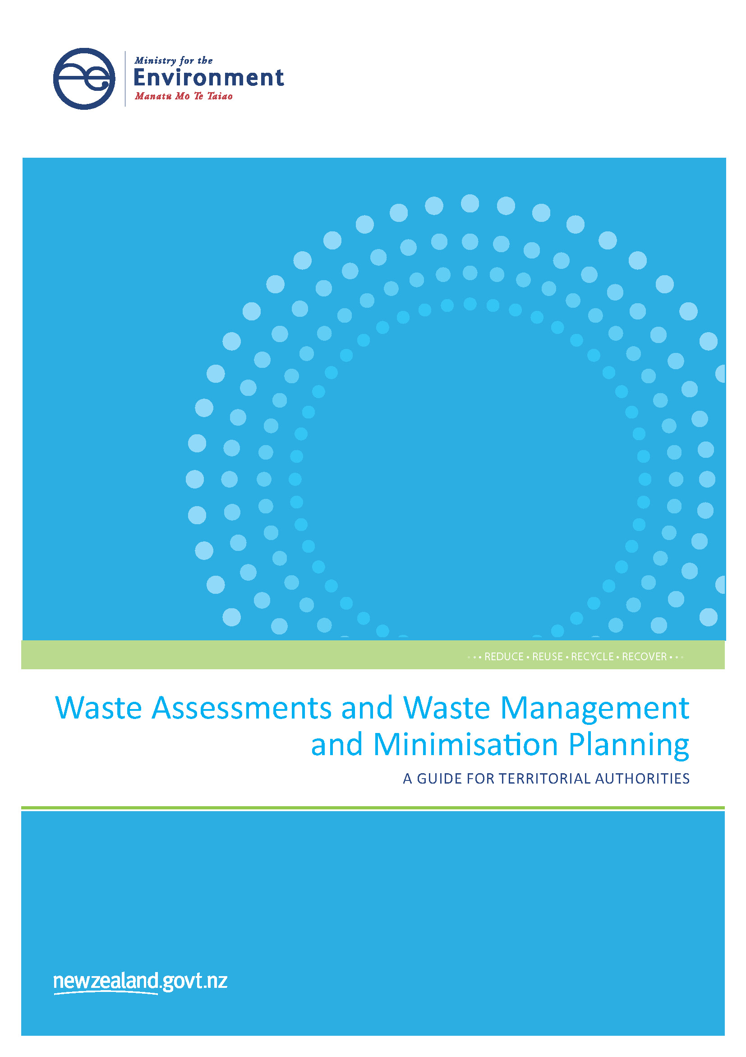

**Disclaimer**

The information in this publication is only intended as a guide for territorial authorities preparing their waste management and minimisation plans as required by Part 4 of the Waste Minimisation Act 2008. It does not alter the law of New Zealand. The Ministry for the Environment has taken all reasonable steps to ensure the information in this publication is accurate at the time of publication.

The content of this publication should not, however, be construed as legal advice. Readers should take specific advice from qualified professional people before relying on information contained in this publication.

The Ministry for the Environment, its employees and agents do not accept any responsibility or liability whatsoever (whether in contract, tort, equity or otherwise) for any action taken by any person who relies on information contained in this publication, nor for any consequences flowing from reliance on that information. Further, the Ministry for the Environment, its employees and agents do not accept any responsibility or liability for any error of fact, omission, interpretation or opinion which may be represented in this publication.

This guide may be cited as: Ministry for the Environment. 2015. *Waste Assessments and Waste Management and Minimisation Planning – A Guide for Territorial Authorities.* Wellington: Ministry for the Environment.

Published in December 2015 by the  
Ministry for the Environment   
Manatū Mō Te Taiao  
PO Box 10362, Wellington 6143, New Zealand

ISBN: 978-0-908339-19-8 (print)  
978-0-908339-20-4 (electronic)

Publication number: ME 1222

© Crown copyright New Zealand 2015

This document is available on the Ministry for the Environment website: [www.mfe.govt.nz](http://www.mfe.govt.nz)

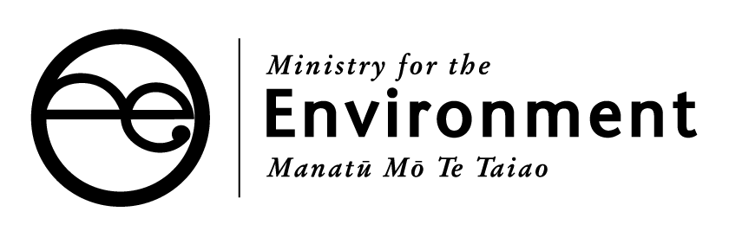

# Acknowledgements

The Ministry for the Environment would like to acknowledge the contribution of the following individuals in producing this guide:

* Anne Lister, Gisborne District Council
* Brent Aitken, Taupo District Council
* Donna Peterson, Invercargill City Council
* Murray Kliskey, Tauranga City Council
* Natasha Hickmott, Palmerston North City Council
* Nicci Wood, Wellington City Council
* Nienke Itjeshorst, Kapiti Coast District Council
* Rebecca Maiden, Tauranga City Council

# Contents

Acknowledgements 3

1 Introduction 7

1.1 Purpose of this guide 7

1.2 Legislative and policy context 7

1.3 About WMMPs 8

2 Getting ready 9

2.1 Process 9

2.2 Review timeframes 11

2.3 Preliminary review of existing WMMP 13

2.4 Scope of the waste assessment and WMMP 14

2.5 Identifying and engaging with stakeholders 14

3 Collaboration and joint WMMPs 17

3.1 Joint WMMPs 18

4 The waste assessment 19

4.1 What is a waste assessment? 19

4.2 The waste situation 20

4.3 Where do we want to be? 26

4.4 How are we going to get there? 29

4.5 Statement of proposals 31

4.6 Consulting with the Medical Officer of Health 33

4.7 Adopting the waste assessment 33

5 Writing, consulting on, and adopting the WMMP 35

5.1 What does the WMMP look like? 35

5.2 Part A – overarching strategy 36

5.3 Part B – action plan 39

5.4 Consultation 40

5.5 Adopting the WMMP 41

6 Implementing the WMMP 43

6.1 Procuring services 43

6.2 Activity and asset management 43

6.3 Health and safety 44

6.4 Bylaws 44

6.5 Performance standards 45

7 Measuring progress and success 46

7.1 Monitoring 46

7.2 Evaluation 48

7.3 Reporting 49

Appendix 1: WMMP template 50

Appendix 2: WMMP review project management stages 57

Appendix 3: Potential options for aligning council planning activities 58

Appendix 4: Legislative and policy context 59

# Tables

Table 1: WMMP review activity timeframes 11

Table 2: Potential options for WMMP collaboration 18

Table 3: The waste situation 20

Table 4: Waste infrastructure and services 23

Table 5: Services and infrastructure providers 24

Table 6: Future demand for infrastructure, services and programmes 25

Table 7: Definitions for vision, goals, objectives and targets 27

Table 8: Example vision, goals, objectives and targets 28

Table 9: Options review questions 30

Table 10: Statement of proposals 32

Table 11: Key components of a WMMP 35

Table 12: Sample action planning table 40

Table 13: Monitoring targets 47

# Figures

Figure 1: Project planning for WMMP components 9

Figure 2: The WMMP process 10

Figure 3: Stakeholder analysis matrix example 16

Figure 4: Vision, goals, objectives and targets 27

# 

# 1 Introduction

## 1.1 Purpose of this guide

This document is a non-statutory guide about reviewing a waste management and minimisation plan (WMMP). Although there is no single way to draft a WMMP, this guide presents an approach to the planning process that is intended to help you produce a constructive document. Specifically, this guide:

* describes the legislative setting for waste management and minimisation planning
* highlights the statutory requirements for undertaking a WMMP review
* provides a blueprint for undertaking a WMMP review, including completing the waste assessment, drafting, consulting on, implementing and monitoring and reporting the plan’s success
* provides a WMMP template (Appendix 1). The template is an example only and using it is not a requirement. The headings in section 4 can be used as a template for producing a waste assessment.

Councils play an important role in managing and minimising waste in New Zealand. The Waste Minimisation Act 2008 (WMA) gives councils (referred to in the WMA as ‘territorial authorities’) the responsibility to promote effective and efficient waste management and minimisation within their district. The WMA requires councils to adopt a waste management and minimisation plan, which must be reviewed every six years.

This guide is the result of a collaborative effort with council staff who are experienced in preparing WMMPs. Their experience and feedback has been important in developing this guide.

The intended audience for this guide are council and unitary authority staff; primarily waste management and minimisation officers, and senior managers involved in developing a WMMP and the decision-making process.

## 1.2 Legislative and policy context

The framework for waste management and minimisation in New Zealand is a result of five pieces of legislation and strategic policy documents. We recommend that you familiarise yourself with the following before starting on your WMMP review process:

* Waste Minimisation Act 2008
* Local Government Act 2002
* the New Zealand Waste Strategy 2010
* Resource Management Act 1991
* New Zealand Emissions Trading Scheme (under the Climate Change Response Act 2002)
* Litter Act 1974
* Health Act 1956
* international agreements and other legislation.

Appendix 4 contains a brief summary of the legislation and policy described above.

## 1.3 About WMMPs

### 1.3.1 What is a WMMP and how is it used?

A waste management and minimisation plan is the term set in the WMA for a council’s waste management and minimisation planning document.

The legislation enables councils to use various tools to influence, promote and implement measures to manage and minimise waste. The WMMP is intended to be the guiding document for councils to promote and achieve effective and efficient waste management and minimisation within their districts.

### 1.3.2 What should a WMMP contain?

A WMMP should contain a summary of the council’s objectives, policies and targets for waste management and minimisation. The plan should clearly communicate how the council will deliver on these objectives.

Section 43 of the WMA states that a WMMP must provide for:

(a) objectives and policies for achieving effective and efficient waste management and minimisation within the territorial authority’s district

(b) methods for achieving effective and efficient waste management and minimisation within the territorial authority’s district, including -

(i) collection, recovery, recycling, treatment, and disposal services for the district to meet its current and future waste management and minimisation needs (whether provided by the territorial authority or otherwise); and

(ii) any waste management and minimisation facilities provided, or to be provided, by the territorial authority; and

(iii) any waste management and minimisation activities, including any educational or public awareness activities, provided, or to be provided, by the territorial authority

(c) how implementing the plan is to be funded

(d) if the territorial authority wishes to make grants or advances of money in accordance with section 47, the framework for doing so.

A WMMP must have regard to the waste hierarchy, the New Zealand Waste Strategy, and a council’s most recent waste assessment. Community targets and the structure of a WMMP can vary from council to council. The approach suggested in this guide is intended to allow significant local flexibility in a WMMP. A common approach across councils can be beneficial though, by allowing for benchmarking and consistency.

# 2 Getting ready

*This section provides information on preparing for a waste management and minimisation plan (WMMP) review and includes the overall process, timeframes, stakeholder engagement and legislation.*

## 2.1 Process

Planning an effective waste management and minimisation plan (WMMP) review process is important and can help ensure that project timeframes are met and roles and responsibilities are clear.

Figure 1 outlines the process for preparing, reviewing and implementing a WMMP. A continual review and improvement process will allow a council to see if desired outcomes are being achieved, or are on track. The stages of the process may not always be sequential.

Figure 1: Project planning for WMMP components

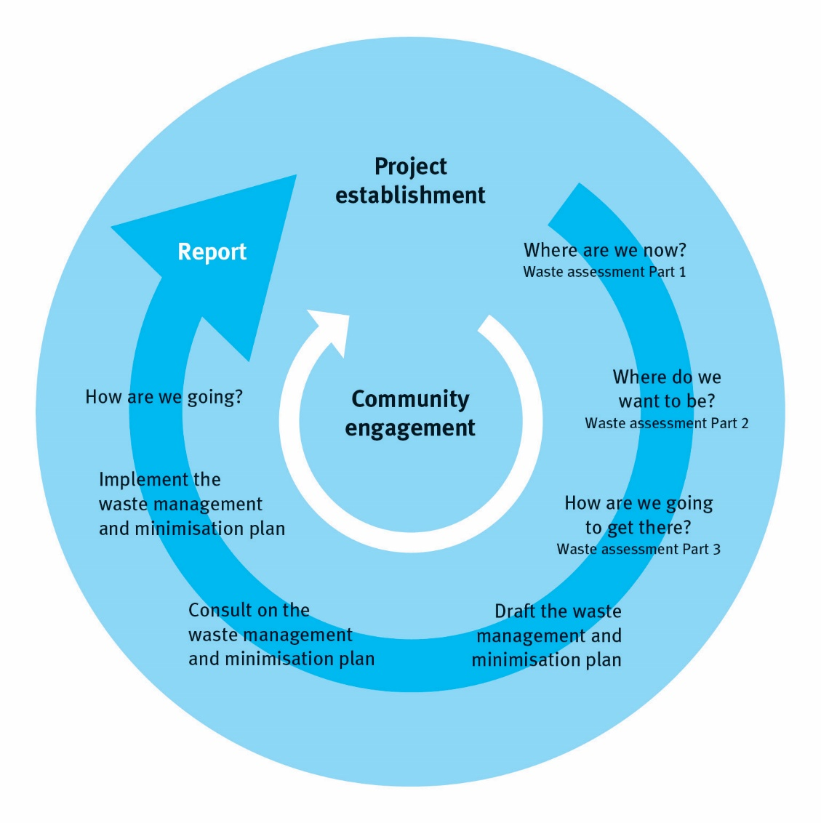

Figure 2 outlines a step-by-step process for reviewing and implementing a WMMP. This guide then provides information about each of the steps described.

Figure 2: The WMMP process

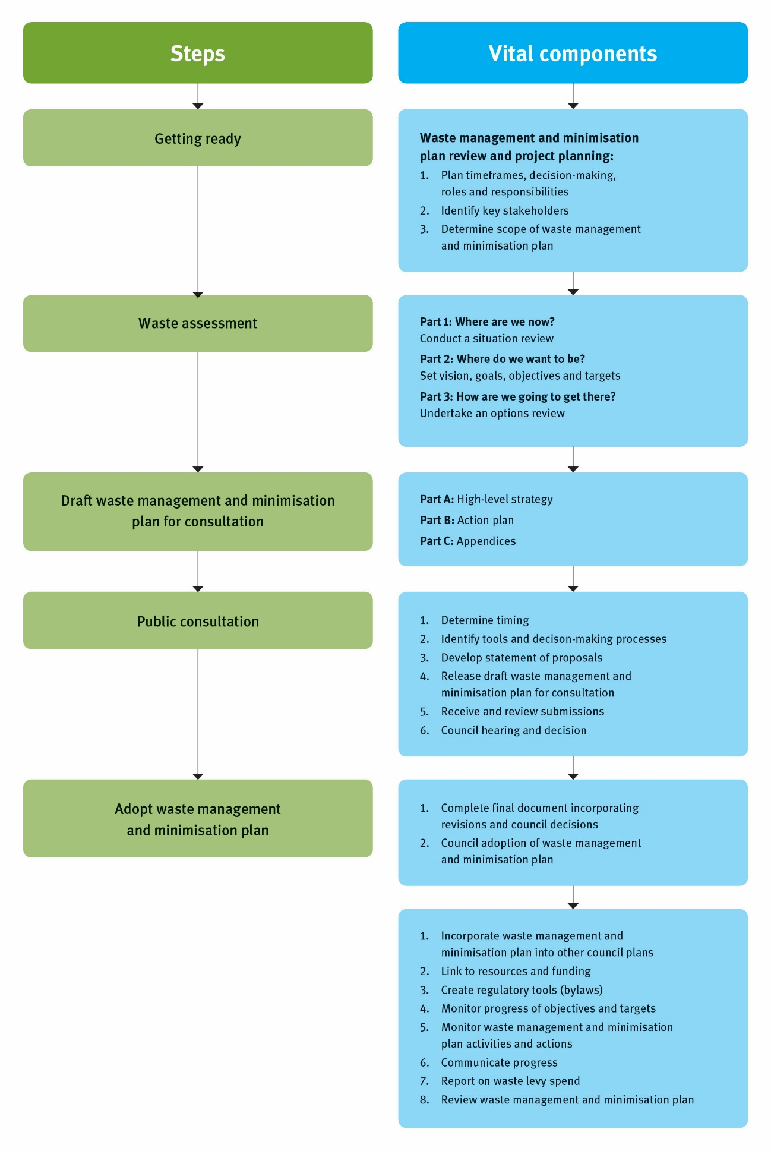

Further detail on using a project management methodology to undertake a WMMP review process is available in Appendix 2.

## 2.2 Review timeframes

WMMPs must be reviewed at least every six years. The Ministry for the Environment keeps track of when all councils’ WMMP reviews are completed. Not keeping to the statutory timeframes for a WMMP review may result in a council’s waste levy funding payments being withheld under section 33 of the Waste Minimisation Act 2008 (WMA).

Timeframes for completing the WMMP review itself are dependent on the circumstances of each council. Table 1 describes the WMMP planning cycle, highlighting estimated timeframes for the main steps. The process may take more or less time to complete, depending on the availability of resources, the level of technical investigation required, and council timeframes.

Table 1: WMMP review activity timeframes

|  |  |  |
| --- | --- | --- |
| WMMP review step | Description | Estimated timeframes |
| Project planning | Project plan development. | One month |
| Waste assessment | Includes the situation review, goals/objectives and target setting, and components of the options review. | Three-plus months, depending on the technical investigation required to support the options review. |
| Drafting your plan | Developing the draft WMMP document for consultation. This step will include decision-makers’ sign-off on the draft before consultation. | Three months |
| Consultation and decision-making | Consultation, as required during the process and adopted through a “special consultative procedure” (section 83 of the Local Government Act 2002). Includes revisions to the draft WMMP arising from consultation, then formal council adoption and finalisation. | Three-plus months |
| Implementation | For implementation to occur, the WMMP needs to be linked to the long-term plan (LTP) by either amending the current LTP or as part of the next LTP round. | Ongoing from adoption of finalised WMMP and incorporation into LTP. |
| Evaluation | Evaluation of progress/performance toward targets and long-term goals and outcomes. A statutory review is required at least every six years, but significant changes made mid-term may trigger review requirements. | Ongoing monitoring and evaluation. Must review formally every six years. Councils should consider aligning with the LTP cycle. |
| Reporting | Your council may have requirements to report on performance indicators and activities of the WMMP. Reporting also includes annual levy spend reporting to the Ministry. | Ongoing, annually through annual plan report. |

Matters that need to be taken into account when planning WMMP review timeframes are discussed in the following sections.

### 2.2.1 Consultation timeframes and other council plans

Within the WMMP review project plan, a council should consider decision-making and consultation timelines, as well as timing with respect to the triennial long-term plan (LTP), annual plan cycles, and service delivery review requirements set out in section 17A of the Local Government Act 2002 (LGA 2002).

Ideally the WMMP review and subsequent consultation process should be conducted as separate exercises, particularly where amendments to the WMMP are anticipated. While there may be cost savings from consulting as part of another special consultative procedure, such as during the annual plan or LTP consultation, this may not give the required level of public attention to the issues in the draft WMMP.

Appendix 2 shows options for sequencing WMMP and LTP events.

When thinking about timeframes for undertaking a WMMP review, consider:

* When will your LTP be prepared?
* When is your service delivery review being prepared?
* Are there are likely to be any significant issues arising from the WMMP review, and as a result the statement of proposal within the WMMP, that will need to be incorporated into the LTP or service delivery review?
* Will the statutory consultation requirements run at the same time as preparing the LTP or will the WMMP consultation be handled separately?
* How does the proposed consultation fit with your council’s significance policy?
* Have you programmed the public consultation and decision-making process?

### 2.2.2 Bylaw reviews

The LGA 2002 and WMA provide councils with the ability to develop bylaws as tools to support delivery of effective and efficient waste management and minimisation for their district.

Section 56(2) of the WMA stipulates that a bylaw must not be inconsistent with a council’s WMMP. Section 58 of the WMA requires that bylaws made under section 56 must be reviewed:

(a) not later than 10 years after the bylaw was made; and

(b) then at intervals of not more than 10 years after the last review.

Councils must review bylaws made under Part 31 of the Local Government Act 1974 (LGA 1974):

(a) not later than 1 July 2012; and

(b) then at intervals of not more than 10 years after the last review.

When reviewing a bylaw, it is sensible to align the review with other council work programmes on the WMMP, LTP and section 17A LGA 2002 activities. Advice on a bylaw review, development and implementation may be necessary from internal and external stakeholders.

Please inform the Ministry when you have carried out a bylaw review and adopted any waste bylaws, by emailing [waste.ta@mfe.govt.nz](mailto:waste.ta@mfe.govt.nz).

### 2.2.3 Other timing factors

Timeframes may need to be adjusted if more or less time is needed to:

* procure contractors to help you carry out a review
* undertake the waste assessment
* align with the frequency of committee meetings
* adjust for existing collection services and infrastructure operation contracts
* develop or review service delivery plans.

When planning a WMMP review, consider:

* the current expiry dates for collection and processing contracts for waste and diverted materials
* whether it is likely that significant changes in the mode of delivery or new services/infrastructure will be made – do the expiry dates for current contracts allow adequate time for technical investigations, development of proposals, consultation, adoption and procurement, and lead-in time
* whether contractors or consultants are being contracted to deliver the WMMP review, and if so, whether procurement processes affect review timeframes
* whether timeframes for drafting the WMMP document have taken into account the dates of committee meetings? Council can approve the draft document before it goes out for consultation.

## 2.3 Preliminary review of existing WMMP

A preliminary review of an existing WMMP is useful before embarking on a waste assessment. Results of the review will give you an understanding of the existing WMMP’s relevance to current conditions, and progress toward meeting goals, objectives and targets.

If carrying out a preliminary WMMP review, consider:

* when the existing WMMP was adopted or reviewed
* the status of the actions set in the current WMMP
* whether any major issues have arisen since the last WMMP was adopted (eg, disposal facility to close soon, transfer station needs upgrading, high public and commercial interest in a new type of waste collection system, market conditions impacting on recycling operations)
* the status of existing waste bylaws and whether they need to be reviewed concurrently with the WMMP.

## 2.4 Scope of the waste assessment and WMMP

You will need to determine the scope of your council’s WMMP and whether to include waste not controlled by the council. Note that the WMA defines a waste as anything that has been discarded or disposed of.

You may wish to include not only all solid waste but also some liquid and gaseous wastes within the scope of your WMMP. Generally, liquid and gaseous wastes (eg, used oil, gas canisters) that are put into containers for collection and then put into landfill are likely to fall within the scope of a WMMP. Other wastes that are directly discharged to the air, land and water are managed under the Resource Management Act 1991 (RMA).

Waste minimisation means reducing waste, and the reuse, recycling and recovery of waste and diverted material. You should consider the methods for reducing the volume of materials discarded and methods for increasing the volume of materials collected for reuse, recycling and recovery.

Some materials with special qualities may need to be dealt with in both the WMMP and other council plans. For example, sewage sent to a wastewater treatment plant is generally dealt with through other means, such as through network consent requirements and trade waste regulations. Sewage sludge from wastewater treatment that is discarded and disposed of to landfill (or incineration), is a waste and therefore included in the scope of the WMMP.

Generally, if the management and minimisation of materials are dealt with in other council strategies or plans (such as water and sanitary assessments, or wastewater asset management plans) this should be indicated in the WMMP document, with reference to where information on this waste (or diverted material component) can be found.

In determining the scope of a WMMP, consider:

* what solid, liquid and gaseous material will be within the scope of the WMMP
* what wastes will not be considered in the WMMP, and how will these be addressed.

## 2.5 Identifying and engaging with stakeholders

Stakeholder engagement is important to successfully develop and implement a WMMP. Council significance policies should be used in considering the level of engagement necessary for WMMP development or review. Where a decision is determined to be significant you must ensure, before any decision is made, that the decision-making requirements of the LGA 2002 have been appropriately observed.

The benefits of engaging with stakeholders include:

* giving decision-makers better confidence in preferred options
* improving the delivery of programmes and services, by reducing the risk of objections from stakeholders
* raising awareness of the WMMP with the community
* helping shape the objectives, goals and targets to make them both politically acceptable and practically deliverable.

Identify internal and external stakeholders early in the WMMP review, and consult with them at key stages to ensure their views are captured. Stakeholders will include:

* elected members
* residents, businesses and community organisations
* iwi
* private waste operators
* public health units of district health boards (Medical Officer of Health for your district)
* regional council and neighbouring councils
* internal colleagues.

### 2.5.1 Stakeholder analysis

A stakeholder analysis matrix may be a useful tool to help understand a stakeholder’s position on a WMMP review. Figure 3 shows an example of a stakeholder analysis matrix. Considering a stakeholder’s placement on the grid may help determine how best to engage with them.

Consider the following questions to help determine stakeholder positions on the grid:

* Will they be providing information for the waste assessment?
* Do they have an interest in the outcome of the WMMP review?
* What are their expectations of the WMMP review?
* At what stage of the WMMP process is it best to engage this stakeholder?
* Will they want to provide input into the WMMP review, or simply be kept informed?
* What is your council’s current and desired relationship with the stakeholder?
* What do we want from the stakeholder?
* What does the stakeholder need from us?
* Are there any non-WMMP council-related interactions with the stakeholder?

Figure 3: Stakeholder analysis matrix example

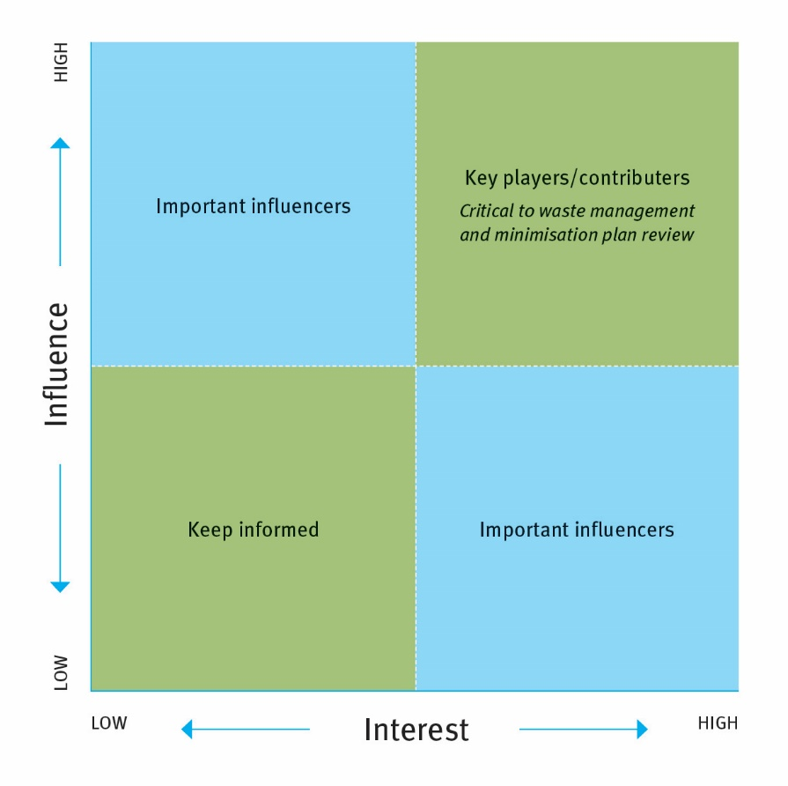

The role each stakeholder will play in the WMMP review will determine how you work or interact with them. A WMMP review project plan should include a strategy for how you will engage with stakeholders. The stakeholder strategy may include things such as developing a community engagement plan, setting up a WMMP review working group of key stakeholders, and organising workshops and site visits. Productive relationships with key players and important influencers are critical to delivering a successful WMMP.

# 3 Collaboration and joint WMMPs

*This section provides information on taking a collaborative approach to waste management and minimisation.*

Many of the waste issues faced by a council are common across other councils. Councils may also have shared interests with other parties such as local industry or research institutions. The waste management and minimisation plan (WMMP) provides an opportunity to cement collaborative approaches to waste management and minimisation in a district, and with adjacent councils.

Where shared interests exist, a collaborative approach can ensure mutually helpful projects are established. Joint projects will avoid duplication of effort and leverage the value of funding available, particularly where available budgets are not large enough to be effective on their own. Neighbouring councils may also help identify opportunities outside your district to use existing facilities, or develop new infrastructure, or find markets for materials. As a result of working together, economies of scale when purchasing waste infrastructure, services or selling products to market, have been used to council advantage.

Options for collaboration include:

* agreeing as a region on waste data definitions and monitoring methodologies to be used consistently across districts
* undertaking a joint waste assessment, including a regional waste flow map
* developing a joint WMMP
* pooling councils’ levy funds tagged to a common outcome (eg, organic waste, hazardous waste) to develop collaborative solutions
* establishing a regional waste forum to share information and ideas
* establishing a waste advisory group with membership from councils, the regional council, and key local industry and research bodies, to identify areas for collaboration
* establishing a joint committee comprising councillors from neighbouring councils to identify and oversee joint waste management and minimisation projects
* implementing a joint WMMP through a shared waste minimisation officer.

|  |
| --- |
| Case study: Canterbury Waste Joint Committee |
| The Canterbury Region has established the ‘Canterbury Waste Joint Committee’ to promote a regional approach to common waste issues. Under this structure, all the Canterbury councils pay into a common fund (based on population) on an annual basis. Regionally applicable projects are then undertaken using the fund, with the aim of providing beneficial outcomes for all councils and the region as a whole. The initiative is making progress in addressing some of the bigger waste issues, such as treated timber disposal and rural waste management. The group has found that economies of scale make a difference at this level and more can be achieved working together. With their regional perspective, Environment Canterbury has found that regional councils can play a useful role in identifying large cross-boundary issues and facilitating solutions. |

## 3.1 Joint WMMPs

Working collaboratively with other councils to develop a joint WMMP may be particularly helpful for groupings of medium and small councils with similar issues and goals, as it allows planning resources and costs to be shared.

Section 45 of the Waste Minimisation Act 2008 (WMA) specifically allows for joint plans to be developed and adopted. Although the WMA does not specify it, councils may also be able to undertake a waste assessment (section 51) jointly, as long as each council clearly demonstrates how they have used the assessment information and options in developing their WMMP.

Table 2: Potential options for WMMP collaboration

|  |  |
| --- | --- |
| Waste assessment and WMMP options | Example |
| Joint waste assessment and WMMP | Wellington local authorities – eight councils developed joint waste assessment and WMMP |
| Joint WMMP only | Tauranga City Council and Western Bay of Plenty District Council |
| Regional collaboration/strategy (but no joint waste assessment or WMMP) | Canterbury local authorities – separate waste assessment and WMMPs, joint regional waste committee with regional council |

For those councils considering developing a joint WMMP, the process may require additional preparation. Councils may wish to develop a joint working group sharing responsibility for the process, as well as an overarching memorandum of understanding to support decision-making.

# 4 The waste assessment

*This section describes the statutory waste assessment required for a WMMP review, information on data requirements, and adopting a waste assessment.* *The headings in this section can be used as a template to structure your waste assessment.*

## 4.1 What is a waste assessment?

The waste assessment establishes the planning foundations for the waste management and minimisation plan (WMMP) by describing the waste situation, setting the vision, goals objectives and targets for the district, and developing options for meeting future demand. Most of the information presented in a waste assessment will be summarised in the final WMMP.

Before starting your assessment:

* bear in mind that a waste assessment is likely to take at least three months
* check when the long-term plan (LTP) and annual plan will be prepared, as you may want to consider aligning WMMP decision-making and consultation timelines
* consider setting up a working group for developing options
* contact your Medical Officer of Health (or equivalent) to advise of the upcoming waste assessment, and their role in this
* review your solid waste asset management plan, as there is likely to be information in that document that can be readily used in your waste assessment.

A waste assessment should contain three parts:

**Part 1 – the waste situation (where are we now?)**

Part 1 covers the current waste situation, including waste flows, waste infrastructure and services, and forecast of future demand. This will be summarised in the final WMMP.

**Part 2 – where do we want to be?**

Part 2 includes the vision, goals, objectives and targets for the waste assessment, which will form part of a draft WMMP. It is necessary to develop the vision, goals, objectives and targets at this stage, before options to meet the forecast demands of the district can be developed.

**Part 3 – how are we going to get there?**

Part 3 identifies options and assesses the suitability of each option (a required step under section 51 of the Waste Management Act 2008 (WMA)) and includes consultation with the Medical Officer of Health. The preferred options will be presented in the WMMP.

## 4.2 The waste situation

### 4.2.1 Introduction

Part 1 of the waste assessment establishes the baseline evidence for making decisions on the waste services and infrastructure that should be available in a district or city to promote and achieve effective and efficient waste management and minimisation. A waste assessment must contain a description of the collection, recycling, recovery, treatment, and disposal services provided within the territorial authority’s district (whether by the territorial authority or otherwise).

The waste situation will be summarised in the final WMMP.

### 4.2.2 Waste quantities, composition and flows

A situation review should take into account the current and projected future quantities and composition of waste and diverted materials (where this information is available) as well as waste flows. Consider what data is available on waste quantities and composition. Table 3 gives examples of the types of information that may be captured in this section of the waste assessment. A waste assessment should not only describe the available information, but also comment on what isn’t known.

Table 3: The waste situation

| The waste situation | Suggestions for information that could be included |
| --- | --- |
| 1.1  Current waste quantities | * landfill tonnages * waste per capita * district population * comparison to national averages (benchmarking) * historic tonnage trends |
| 1.2 Future projected waste quantities | * landfill tonnage projections (at least 6 years/term of WMMP) * waste per capita projections (at least 6 years/term of WMMP) * district population growth projections (at least 6 years/term of WMMP) * medium population projection against waste tonnage projection * high population projection against waste tonnage projection * comparison to national averages |
| 1.3 Composition | * Solid Waste Analysis Protocol (SWAP) data – percentages and tonnages * transfer station waste composition * landfill composition * kerbside collections composition * waste composition sent to managed fill and clean fill * historic composition trends |
| 1.4 Source of waste | * origin of refuse (for example, industrial, residential, kerbside) * public/industry access to landfill and transfer stations * origin of diverted material (for example, industrial, residential, kerbside) * council serviced facilities (for example, litter bins) * source of waste to managed fill and clean fill |
| 1.5 Destination of waste | * refuse and diverted material flows (ie, refuse disposed of at facility X in locality X * recyclables destined for facility X in locality X * hazardous waste destinations * map of waste activity flows |
| 1.6 Diverted materials | * diverted material composition eg, cardboard, plastic, glass (percentages/tonnages) * diverted material destination to processing facility or sales * hazardous waste processing/destination. |

### 4.2.3 Waste data in New Zealand

Planning effective policies and activities to improve waste management and minimisation requires a strong foundation of evidence. Over the years, comprehensive waste data has been difficult to obtain and use for assessing waste policy and implementation, both at a council and a national level.

We encourage councils to:

* find as much relevant data as possible for the waste assessment
* aim to have their data capture methodology consistent with those of other councils.

Consistency helps ensure waste assessment data is meaningful and can be used at local, joint council, regional and national levels.

The National Waste Data Framework is a recent initiative to develop a consistent data framework*.* The framework establishes national definitions for waste terms, and protocols for gathering, managing and reporting waste data. More information can be found at [www.wasteminz.org.nz](http://www.wasteminz.org.nz).

For information on wider environmental reporting requirements, see the Ministry’s website at [www.mfe.govt.nz/more/environmental-reporting](http://www.mfe.govt.nz/more/environmental-reporting).

### 4.2.4 Obtaining waste data

Data for a waste assessment can be obtained from a number of places. Many councils already have good information on waste and diverted materials, particularly where they own and operate waste and waste minimisation infrastructure.

There are a number of options to obtain information for your waste assessment including:

* undertaking Solid Waste Analysis Protocol (SWAP) programmes[1]
* service delivery reports and data collected from council-owned operations such as landfills, transfer stations and resource recovery facilities
* waste and kerbside collection contracts
* carrying out or commissioning surveys for specific wastes, recycling services, or other initiatives in your district
* monthly and annual tonnages of waste disposed to municipal landfills.[2]

When forward planning to obtain waste data, you may also consider that:

* where private operators manage facilities and collection services under contract, data may be obtained through key performance indicators in the contract they have with council
* bylaws may be developed to require waste operators to be licensed and ensure these licensed waste operators report waste data.

### 4.2.5 Data constraints

Ultimately, decisions about what data to gather will be determined by a council’s own circumstances, desired community outcomes, interests and available resources.

When deciding what information to include in the waste assessment, section 51(3) requires a council to have regard to:

a) The significance of the information

b) The costs of, and difficulties in, obtaining the information

c) The extent of the council’s resources

d) The possibility that the councils may be directed under section 23 of the Health Act 1956 to provide the services referred to in that Act.

A waste assessment must also indicate whether and to what extent the matters referred to in (b) and (c) have impacted materially on the completeness of the assessment.

Where data is not available, cannot be obtained through reasonable means, or may have limitations, this should be explained in the assessment, along with how it may affect the assessment outcomes.

### 4.2.6 Waste infrastructure and services

Section 51(1) of the WMA requires that a waste assessment contains a description of waste management and minimisation services and infrastructure facilities provided within the district, whether provided by council or another party. The assessment should describe how waste and resources are collected, recycled, recovered, treated and disposed of in the district.

Section 44 of the WMA requires councils to consider the waste hierarchy in preparing their WMMP. For consistency, councils should refer to the specific definitions of reduction, recycling, recovery, treatment and disposal contained in the WMA.

In undertaking a waste assessment, consider:

* What waste management and minimisation services, resource efficiency programmes, and infrastructure do you currently offer?
* What is offered by other organisations?
* How are education and behaviour change programmes delivered?
* Does your council offer grants or subsidies to encourage waste minimisation?
* What current or planned facilities are available (eg, waste disposal sites)?
* Are any sites due to open or close in the short to medium term?

Table 4 provides examples of the types of information that may be captured in this section of the waste assessment, including a description of information not held by council.

Table 4: Waste infrastructure and services

|  | Information that could be included for each service/infrastructure type in a waste assessment |
| --- | --- |
| 2.1  Reduction | * waste education programmes * resource efficiency programmes for business |
| 2.2 Reuse | * waste education programmes * council-operated reuse collections and services * private or community reuse collections and services |
| 2.3 Recycling | * recycling collections, and which streams are collected * frequency of collections * funding collections – is it paid out of rates or user charges? * whether wheelie bins or bags are used, including size of receptacles * coverage of the collections (eg, urban and/or rural) * nature of any collections carried out by private operators (eg, joint, on-contract and independent) * any licensing arrangements * recycling facilities at transfer stations * waste education programmes |
| 2.4 Recovery | * recovery collections, and which streams are collected * frequency of collections * funding collections – is it paid out of rates or user charges? * type and size of receptacles * coverage of the collections (eg, urban and/or rural) * nature of any collections carried out by private operators (eg, joint, on-contract and independent) * any licensing arrangements * recovery facilities at transfer stations * waste education programmes * material diverted for composting * extraction of materials from waste stream * energy from waste |
| 2.5 Treatment | * whether any of the council’s waste is treated (so it may be disposed of with no or reduced adverse effect on the environment – not including dilution of waste) * alternative waste treatments facilities * hazardous waste collection services and treatment facilities |
| 2.6 Disposal | * frequency of collections * funding collections – is it paid out of rates or user charges? * type and size of receptacles * coverage of the collections (eg, urban and/or rural) * nature of any collections carried out by private operators (eg, joint, on-contract and independent) * disposal facilities (final deposit of waste into or onto land or the incineration of waste – this would include facilities within the councils boundaries, and regional if known) * closed landfills * any other disposal facilities or issues (eg, managed fills and clean fills, mono-fills, recycling storage yards, clean fills, illegal dumping and burning) * relevant resource consent information * refuse transfer stations, including location and materials processed * other related services such as street sweeping * other council (non-recyclable/recoverable) collections (eg, inorganic and hazardous waste). |
| Note: A waste assessment must include a description of the collection services provided in the district. A separate collection heading/column can be included in the waste assessment to ensure that all collection information is included under the other headings. | |

Ensure information on services and infrastructure provided by both a council and other waste providers in the district is included. Table 5 can be used for this.

Table 5: Services and infrastructure providers

|  |  |  |
| --- | --- | --- |
| Services and infrastructure | By territorial authority | By other |
| **Reduce** |  |  |
| **Reuse** |  |  |
| **Recycle** |  |  |
| **Recovery** |  |  |
| **Treatment** |  |  |
| **Disposal** |  |  |

Some of the information for this section of the waste assessment may already have been provided in the situation review. It is worthwhile though either reiterating the information or restructuring this section of the waste assessment to ensure it is covered comprehensively.

### 4.2.7 Forecast of future demand

Section 51(1) of the WMA requires that a waste assessment contain a forecast of future demands for collection, recycling, recovery, treatment and disposal services for the district.

Councils need to identify the main factors and trends that influence demand for waste infrastructure and services, and prepare projections for that demand over time. Forecasting provides a basis for preparing the WMMP and options to deal with future demands.

Forecasting methodologies can be qualitative or quantitative, such as regression analysis or market analysis. It is important to use a reliable forecasting technique. Once different demand factors are understood, mathematical modelling is often used to assess these factors on future demand. A number of IT-based waste modelling tools on the market can be used to support this analysis.

In forecasting future demand, you could consider:

* What have been the trends over time, and what are the expected future quantities and composition of waste?
* Where there are gaps, how could these be filled and what constraints exist?
* How will varying social, cultural, economic, political and environmental changes affect future demand for waste services? Consider population movements, legislative changes and consumption behaviour.
* Based on the expected future quantities and composition of waste, what is the likely future demand for these services and how would they be affected?

Table 6 provides examples on the types of information that may be captured in this section of the waste assessment. The assessment should describe not only information available to a council, but also information not held by council.

Table 6: Future demand for infrastructure, services and programmes

|  |  |
| --- | --- |
| Future demand for infrastructure, services and programmes | Information that could be included |
| 3.1  Predicting changes in future demands and impacts on forecasting | * demographic and population projections * GDP projections (economic growth or recession) * impact of other regions * consumption behaviour * legislative changes (local government regulations, product stewardship schemes) * community expectations * council goals |
| 3.2 Forecast of future demand based on data trends and considering existing services | * per capita waste arising against GDP * projected future refuse volumes/tonnages * projected future diverted material volumes/tonnages * projected future composition of waste stream * projected future demand for waste infrastructure and services (reduce, reuse, recycle, recovery, treatment and disposal) |

## 4.3 Where do we want to be?

### 4.3.1 Policies, plans and regulations

When preparing the WMMP, you should consider national, regional and local strategies, policies and plans. These include the New Zealand Waste Strategy (NZWS), the WMA, performance standards, national environmental standards, regional policy statements, the LTP, and any local bylaws that support the goals of the WMMP. Appendix 4 provides more information on legislation and policy.

Legislation and relevant policies, plans and regulations should be summarised in the WMMP. Concise comments on their relevance to the WMMP should be set out. The summary is only included to provide public reference to these documents.

New Zealand Waste Strategy

In developing a WMMP, councils must have regard to the NZWS. Councils may give regard to the NZWS by adopting it in principle, or making specific reference to its goals in their waste assessments and WMMPs.

The NZWS has two goals. These are to:

* reduce the harmful effects of waste
* improve the efficiency of resource use.

Setting objectives and targets to reduce or better manage waste streams that are likely to cause high environmental harm, or to increase resource recovery rates across the district, may help a council meet the goals of the strategy.

Long-term plan

In drafting a WMMP, councils should consider other local strategies and plans. In particular, it is important to ensure that the long-term plan (LTP) and the WMMP are aligned, so that strategic directions and future costs are reflected consistently. The LTP is the primary mechanism for councils to consider community outcomes and then provide for the activities to achieve these outcomes.

In the LTP, councils are required to identify the waste management and minimisation activities they are undertaking or plan to undertake (Local Government Act (LGA) Schedule 10). The LGA 2002 requires that every LTP contain a summary of the council’s WMMP (unless the actual plan is included in the LTP). We recommend that just a summary of the WMMP be provided in the LTP.

In relation to the LTP, consider whether:

* there are any significant statements or proposal arising from the waste assessment that will need to be supported in the WMMP, and subsequently the LTP
* the WMMP could be incorporated into the LTP preparation cycle, or whether the LTP needs to be amended following adoption of the WMMP
* a full copy of the WMMP will be included in the LTP, or just a summary
* the options review in the waste assessment considered how actions will be funded and linked to the LTP and annual plan.

### 4.3.2 Vision, goals, objectives and targets

A waste assessment includes developing a vision, goals, objectives and targets for the district (see figure 4). Understanding where a council wants to be in the future is a necessary step before undertaking a review of options for the district. The vision, goals, objectives and targets will also be presented in the WMMP.

Figure 4: Vision, goals, objectives and targets

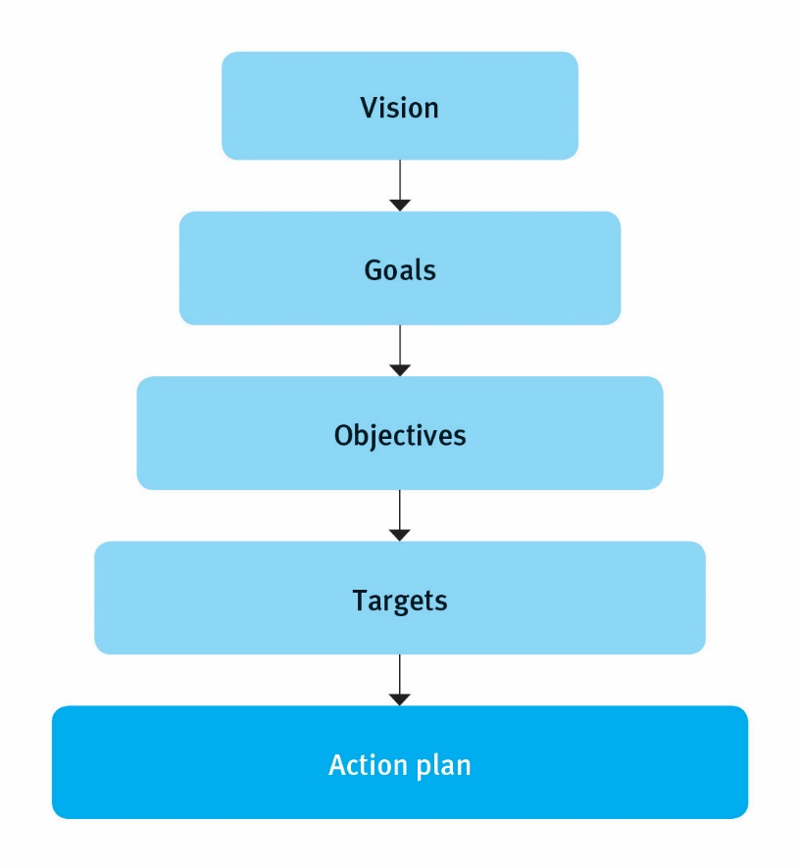

Table 7 provides definitions for vision, goals, objectives and targets.

Table 7: Definitions for vision, goals, objectives and targets

|  |  |
| --- | --- |
| Vision | An aspirational outcome that is desired, or ‘where you want to be’. It should provide an overall direction and focus. |
| Goal | Describes what a council wants to achieve through their WMMP. The goal should not be aspirational; it should be achievable. It is a major step in achieving the council’s vision for the WMMP. |
| Objective | Establishes the specific strategies and policies to support the achievement of the goals. Objectives should be ‘SMART’ (specific, measurable, achievable, relevant and timely). |
| Target | Provide a clear and measurable way to determine how well the council is achieving its goals. Targets should also be SMART. |

In developing where a district wants to be, consider:

* What is our vision?
* Where do we want to be?
* What are our goals?
* What do we want to achieve?
* What are our objectives to help us get there?
* What targets should we set and measure our performance by?
* Is each target SMART? Are they clear? Can they be measured?
* Have we considered the goals of the New Zealand Waste Strategy? How has this been demonstrated?
* What are the risks associated with our high level strategy?

Visions, goals and objectives may be developed with a working group of stakeholders, so there is buy-in to what the district aims to achieve and how it should be achieved. In some cases, councils may have few changes to make to the overarching strategy of their previous WMMP, or they may wish to confirm their commitment to their current vision and goals. Table 8 outlines visions, goals, objectives and targets that councils have developed.

Table 8: Example vision, goals, objectives and targets

|  |  |
| --- | --- |
| Vision statement | Council |
| To maximise resource recovery from the waste stream and reduce reliance on landfill disposal through convenient, effective and efficient waste services. | Hastings District Council and Napier City Council |
| Goals | Council |
| * Work together to improve the efficient use of resources. * Use the waste hierarchy to guide decision-making. * Reduce the harmful effects of waste to our health and environment. | WasteNet Southland |
| Objectives | Council |
| * Reduce the total quantity of waste to landfill. * Increase the quantity of diverted material through reduction, reuse, recycling and recovery. * Support waste minimisation initiatives within the community. * Utilise appropriate pricing methods to incentivise waste minimisation. | Taupo District Council |
| Targets | Council |
| * Have commercial industrial sorting facility operational and achieving a 60% diversion rate by 2017. * Increase the amount of recycling collected from Renwick, Grovetown, Spring Creek, Tua Marina, Rapaura and Rarangi by up to 400 tonnes per year. * Reduce the amount of food waste sent to landfill each year via kerbside collections by 20% (200 tonnes) by 2017. * Increase the amount of green waste processed through the Wither Road site each year by 10% (800 tonnes) by 2018. | Marlborough District Council |

## 4.4 How are we going to get there?

### 4.4.1 Introduction

Section 51 of the WMA requires that waste assessments must contain a statement of options available to meet the forecast demands of the district with an assessment of the suitability of each option.

The preferred options identified in the waste assessment will be presented in the WMMP as methods for achieving effective and efficient waste minimisation and inform the WMMP’s action plan.

### 4.4.2 Identifying options

Once objectives and targets have been defined, options will need to be considered for achieving these. Identifying options should consider (but not be limited to):

* reasonable practicable options to meet forecast demand for waste management and minimisation services, infrastructure and programmes
* advantages and disadvantages (economic, environmental, social and cultural) of these options
* how options will affect the council’s goals or community outcomes
* how these options will affect future demand, such as issues of the capacity of the infrastructure
* how each option will contribute to the goals of the New Zealand Waste Strategy.

When drafting options, consider:

* What are the reasonably practicable options for addressing the issue or need?
* What are the present and future social, economic, environmental and cultural impacts of the option?
* What are the advantages and disadvantages (economic, environmental, social and cultural) associated with the option?
* What criteria are used to prioritise waste streams or options being considered for the WMMP?
* Has the council considered the level to which these materials are addressed by other parties, or how they might impact existing services?
* With the proposed options in mind, do our goals, objectives or targets need to be revised?
* Has the degree to which public health is protected and nuisance is prevented been considered?

### 4.4.3 Assessing options

In assessing options to meet the forecast demands of the district, you need to consider the requirements in the LGA 2002. Section 77 of the LGA requires councils to consider all reasonably practicable options to achieving the objective of the decision and assess these options in terms of their advantages and disadvantages.

Each option should be supported by an appropriate level of technical and/or operational investigation to ensure the council’s decision-makers have a good understanding of the implications for implementing a particular action or service, including what the cost of the option is and how it may be funded.

#### Questions to consider during the options review

Table 9: Options review questions

|  |  |
| --- | --- |
| Technical and operational assessment – ask these questions | |
| Have disposal options been clearly examined, with the preferred option identified? | |
| Where landfilling is an option, has full cost accounting methodology been used in assessing the option?[3] | |
| What regulatory tools or economic incentives/disincentives could support the goals and objectives of the WMMP? How could they be used, and have they been assessed? Have the full range of regulatory tools available under all legislation been considered (eg, LGA, Resource Management Act 1991, WMA)? | |
| Have you explored and costed options for leaving the treatment of particular waste streams open to the private sector to provide a service or contracted service? | |
| Have you worked through charging structures that potentially further incentivise waste minimisation? The WMA (section 46) states that councils are not limited to strict cost-recovery or user-pays principles for any particular service, facility or activity provided by the council in accordance with its WMMP. Fees may be charged for a particular service that are either higher or lower than actual costs if this fee structure is provided for in, and supports the aims of, the WMMP. | |
| Have resource efficiency/waste minimisation programme options been closely examined and preferred options been identified? | |
| Has a detailed operation and technical assessment been carried out with respect to any proposed new programmes or recycling, and/or resource recovery services or operations? | |
| Has the technical assessment for resource efficiency, recycled or recovered materials considered the following factors? | * how a resource efficiency programme can be developed and supported * what goods or materials are to be recycled or recovered * how these materials will be collected (eg, drop-off centres or kerbside methods), sorted, stored, transported and processed * what infrastructure may be needed * if there is economy of scale for collection, transport and processing of these materials, and how this may be achieved * at what level private industry is handling these materials, and if there are any private industry plans to develop additional infrastructure * what quality control systems will be provided to ensure the quality of the product * if there is a sustainable market for the materials or product * what the benefits are (economic, environmental, social and cultural) of providing the service * what the public health benefits are of providing the service * what the cost is of the service, and how it will be funded * how materials will be processed, and how these facilities will be developed, owned and funded (determine capital and operational costs) * if the council will own the materials collected, or products arising from processing * how any resulting proceeds from the operation will be used. |

Options can include powers provided to the council under legislation other than the LGA and WMA. For example, you could address illegal dumping issues using the Litter Act 1979.

You may assess options using a multi-criteria assessment. Use of a multi-criteria assessment demonstrates that a wide range of options have been considered and analysed against environmental, economic, social and cultural costs and benefits. Development of a multi-criteria assessment may be based on the following stages:

1) Develop a list of practicable methods to deliver the strategy, against each level of the waste hierarchy (reduce, reuse, recycle, treat, dispose).

2) Define evaluation criteria (advantages, disadvantages), consulting with key stakeholders where appropriate.

3) Develop a short list of the most favourable options.

4) Evaluate a shortlist of options against criteria, playing out the likely outcomes of each.

5) Present preferred options.

A basic example multi-criteria assessment template is provided below:

|  |  |  |  |  |  |  |
| --- | --- | --- | --- | --- | --- | --- |
| Option number | Option description | *Evaluation criteria 1* | *Evaluation criteria 2* | *Evaluation criteria 3* | *Evaluation criteria 4* | Total score/ Weighting |
|  |  |  |  |  |  |  |

A full multi-criteria assessment could be presented in an appendix to the waste assessment.

### 4.4.4 Preferred options

Ideally, preferred options for managing and minimising waste will have been identified using a multi-criteria assessment. Your preferred options should then be confirmed, along with the proposed funding source, implementation timeframes, and factors such as monitoring and reporting measures.

An example of how you could present the preferred options is provided below:

|  |  |  |  |  |
| --- | --- | --- | --- | --- |
| Preferred option | Description/ details of option | Proposed funding source | Implementation timeframes | Proposed monitoring and reporting of option |
|  |  |  |  |  |

The preferred options identified in the waste assessment will be presented in the WMMP as methods for achieving effective and efficient waste minimisation, and inform the WMMP’s action plan.

## 4.5 Statement of proposals

A waste assessment must contain a statement of:

* options available to meet the forecast demands of the district, with an assessment of the suitability of each option
* the council’s intended role in meeting the forecast demands
* the council’s proposals for meeting the forecast demands, including proposals for new or replacement infrastructure
* the extent to which the proposals will

(i) ensure that public health is adequately protected

(ii) promote effective and efficient waste management and minimisation.

Table 10 outlines the type of information you may wish to consider for each statement.

Table 10: Statement of proposals

|  |  |
| --- | --- |
| Statement of proposals | Information that could be included |
| 6.1 Options available to meet the forecast of future demands, with an assessment of the suitability of each option | * a summary of the information described in the options review * reference to the preferred options table as noted in the options review |
| 6.2 The council’s intended role in meeting future demands | * your preferred options * methods for delivering options * council control/influence * how options align with your overarching objectives/goals/LTP * estimated costs of preferred option and proposed funding sources |
| 6.3 The council’s proposals for meeting future demand | * highlighting proposals where new or replacement infrastructure or services is required, as set out in your preferred options * estimated cost of these proposals and proposed funding sources |
| 6.4 How the council’s proposals ensure that health is adequately protected | * summary from consultation with Medical Officer of Health (see section 4.6) * summary of how the proposal adequately protects public health by addressing health risk, human disease, and nuisance factors * example statement: *The wide range of waste services available in the district as provided by the council or by private industry will ensure that public health is adequately protected in the future. The district has access to [note network of waste management and minimisation facilities]. There is adequate access to the council and private refuse, hazardous waste and illegal dumping/ litter collection services, which will help to protect public health, although further service improvements and waste minimisation is achievable.* |
| 6.5 How the council’s proposal promotes effective and efficient waste management and minimisation | * summary of how proposals will manage waste management and minimisation effectively and efficiently in the district * example statement: *The preferred options, as described in X, are recommended to support the council in meeting future demand (over the next X years) for waste management and minimisation services and infrastructure in the district. The investment in X, Y and Z options, and our X approach to implementation, will put the district in a strong position to effectively and efficiently manage and minimise waste.* |

## 4.6 Consulting with the Medical Officer of Health

Section 51 of the WMA requires that you consult with the Medical Officer of Health when conducting a waste assessment.

The WMA does not prescribe how a council must consult with the Medical Officer of Health. The officer may review your draft waste assessment and provide feedback and recommendations based on the following:

* population health profile and district characteristics
* meeting the requirements of the Health Act 1956
* waste-related health impacts
* waste-related deaths, injuries, and hospitalisations in the district
* hours and locations of waste activities
* sanitary collection and disposal of waste
* handling and storage of hazardous waste
* collection frequency, methods and receptacles (eg, bags versus bins)
* transport of waste
* management of bio-solids (if included in scope of WMMP)
* health and safety of waste operators
* incineration of waste (if applicable).

The list above is not exhaustive, or mandatory. District health boards may have different ways of submitting on council planning documents. You should include a statement about the outcomes from the required consultation with the Medical Officer of Health (ie, how their comments and/or recommendations will be addressed).

You should be explicit that the Medical Officer of Health has been consulted, and attach any submission documents/letters from them to the waste assessment. As with any consultation, it is up to a council as to how they want to address the submission from the Medical Officer of Health.

One tool available to support councils in considering public health protection through the WMMP is the health impact assessment (HIA). A HIA is defined as a practical way to ensure that health and well-being are considered when policy is being developed.[4]

## 4.7 Adopting the waste assessment

Once complete, a waste assessment should at a minimum contain:

* a description of the waste management and minimisation services being undertaken
* results of demand-forecasting for services
* a statement of proposals to meet this demand
* a statement of the extent to which the proposals protect public health
* a statement of the extent to which the proposals provide effective and efficient waste management and minimisation.

The WMA does not specifically require consultation on a waste assessment, but we recommend councils adopt the waste assessment before reviewing and subsequently drafting the WMMP.

The Ministry for the Environment can provide feedback on your draft or adopted waste assessment. If you want feedback on your waste assessment, please send a copy to [waste.ta@mfe.govt.nz](mailto:waste.ta@mfe.govt.nz).

Section 50(3) of the WMA specifies that once a waste assessment has been completed, a council should consider whether a new WMMP needs to be developed or whether the current WMMP should continue without amendment. Either way, consultation on the content of the WMMP must be carried out through the special consultative procedure set out in section 83 of the LGA.

The waste assessment must be notified with the draft WMMP when it goes through the statutory public consultation process. We therefore recommend that you attach the waste assessment to the draft WMMP as an appendix in consultation documents.

# 5 Writing, consulting on, and adopting the WMMP

*This section provides information on producing, consulting on, and adopting a WMMP. Appendix one contains a suggested template for a WMMP.*

## 5.1 What does the WMMP look like?

Section 43 of the Waste Management Act 2008 (WMA) does not set out how a waste management and minimisation plan (WMMP) should be structured. As a result, there is flexibility for a council to develop a WMMP that reflects the needs and desired outcomes of the district. A waste assessment will provide the basis for a WMMP, with most of the detail developed in the waste assessment summarised in the WMMP.

To develop a waste assessment into a strategic, concise, readily understandable and action-orientated council document (ie, your WMMP), you should consider how the objectives and supporting delivery mechanisms identified through the options assessment in the waste assessment will be delivered.

There are a number of ways to structure a WMMP. We recommend the WMMP is made up of three key components, as described in table 11.

Table 11: Key components of a WMMP

|  |  |
| --- | --- |
| Part A | The **overarching strategy**, containing a summary of the waste situation, along with your goals, objectives and targets. |
| Part B | The **action plan**, with detailed information about activities to achieve the objectives and targets, and how they will be carried out and resourced. Actions should be SMART (specific, measurable, achievable, relevant and timely), and drawn from the options review in the waste assessment. |
| Part C | The **appendices**, attached to the document, which are provided to support the proposed objectives and actions of the WMMP (at a minimum appendices should be the waste assessment and any other technical reports or documents that support the WMMP). |

Draft WMMPs prepared for public consultation may be somewhat different from a finalised WMMP once adopted. For example, if significant changes to the level of services or new infrastructure are proposed, more detailed information may be required in the body of the draft WMMP to draw attention to the proposed activity and any statements of proposal. The detail will not be required in the final WMMP.

The Ministry for the Environment is available to provide feedback on the draft, pre-consultation, or consultation version of a WMMP. Please email a copy to [waste.ta@mfe.govt.nz](mailto:waste.ta@mfe.govt.nz).

**A suggested WMMP template is provided in Appendix 1.**

## 5.2 Part A – overarching strategy

The overarching strategy should contain the following sections:

* summary of the waste situation
* legislative context (policies, plans and regulations)
* the vision, goals, objectives and targets for the district
* proposed methods for achieving effective and efficient waste minimisation
* funding the WMMP
* monitoring, evaluation and reporting.

### 5.2.1 Summary of the waste situation

The summary of the waste situation should contain a summary of the more detailed information contained in the waste assessment.

The summary should inform the reader of the tonnage, composition, source and types of waste and diverted materials in the district, based on the data available. The summary should include the situation for current waste and diverted materials, and resource efficiency/waste minimisation activities, along with future predictions based on forecasting. Information can be depicted in text and/or graphically.

Information should be provided about the ability of the services and infrastructure described above to cope with the identified waste streams and diverted materials. Information should be sourced from your activity/asset management plan and from the waste assessment. This section is not expected to replicate these documents, but provide a concise summary of them.

Particular issues and/or challenges facing the district should also be highlighted in this section. The issues will have been identified during the situation assessment phase of the waste assessment. Examples may include:

* limitations on collecting data within the district
* district growth
* providing affordable services to accommodate peak seasonal demand
* current or planned future facilities
* issues associated with the council’s WMMP objectives and targets.

### 5.2.2 Legislative context (policies, plans and regulations)

When preparing the WMMP, you should consider national, regional and local strategies, policies and plans. These can be summarised from the waste assessment.

### 5.2.3 The vision, goals, objectives and targets for the district

The vision, goals, objectives and targets for the district should have been developed in the waste assessment.

### 5.2.4 Proposed methods for achieving effective and efficient waste minimisation

The proposed methods for achieving effective and efficient waste minimisation are likely to be presented in a draft WMMP for consultation. The proposed methods should be drawn from the options review part of the waste assessment.

### 5.2.5 Funding

This section should include a summary of how you intend to generally fund your WMMP (eg, mechanisms such as rates, user fees, local levies, waste levy payments, other contestable funding, or sponsorship).

Funding the implementation of the WMMP is critical to its success. Section 43 of the WMA requires that councils include information in the WMMP about how its implementation will be funded. There are a number of funding options to be considered, such as rates, user pays, landfill gate fees and a council’s waste levy funds. The WMMP should include a summary of proposed funding sources, and each activity within the action plan should have a funding source assigned to it. For most councils, rates and user-pays charges are the primary method of funding activities included in the WMMP.

The following sections describe a number of the other funding methods and tools that councils could consider.

#### 5.2.5.1 The waste disposal levy – funding for councils

The WMA introduced a waste disposal levy to provide funding for waste minimisation and increase the cost of waste disposal to recognise that disposal imposes costs on the environment, society and economy.

Half of the funding secured through the levy is distributed quarterly to councils on a population basis. The WMA requires that all waste levy received by a council must be spent “on matters to promote or achieve waste minimisation”, and in accordance with their WMMP. Each council receives its allocated share of the national waste levy if they have a legally adopted WMMP.

A WMMP should describe how you will spend your waste levy. We have published a guide on levy spending, *Waste levy spending: Guidelines for territorial authorities*. This is available at [www.mfe.govt.nz/publications/waste/waste-levy-spending-guidelines-territorial-authorities](http://www.mfe.govt.nz/publications/waste/waste-levy-spending-guidelines-territorial-authorities).

You may wish to provide a level of flexibility in the WMMP regarding expenditure of the waste levy. New initiatives that will help your council achieve its waste minimisation goals may present themselves after the WMMP has been adopted. To address this, you may wish to identify a general set of waste minimisation activities and allocate waste levy against them. Alternatively, the WMMP can be amended.

A formal council decision-making process is necessary to ensure accountability and transparency on levy spending for significant unanticipated projects. Our preference is that the elected council has full oversight of levy expenditure.

Levy payments can be withheld by the Minister for the Environment if:

* a council has not adopted a WMMP
* council cannot demonstrate that the levy is being used for waste minimisation activities in accordance with its WMMP
* if the plan is not reviewed in accordance with the WMA requirements.

When describing how you will spend your levy funding, consider:

* How does council intend to use the waste levy funds received? Are funds clearly allocated for waste minimisation activity?
* Where the use of waste levy funds is signalled in the WMMP, is this also identified and aligned to the LTP and annual plans?
* Does a decision to use waste levy funds consider the effects on existing services provided in the district?
* How will the use of the waste levy help you achieve your goals or targets for waste minimisation? How will progress be demonstrated?

#### 5.2.5.2 The Waste Minimisation Fund

The remaining half of the waste levy collected (minus levy administration costs) goes to the Waste Minimisation Fund. Councils and others organisations can apply for additional funds for significant projects that promote or achieve waste minimisation.

More information on the Waste Minimisation Fund, the criteria and the application process can be found at [www.mfe.govt.nz/more/funding/waste-minimisation-fund](http://www.mfe.govt.nz/more/funding/waste-minimisation-fund).

#### 5.2.5.3 Other funding or sponsorship

A variety of other external sources of funding may be available for waste minimisation projects through private grant funds or sponsorship. Councils may partner with businesses and local community organisations to develop funding applications or sponsorship programmes.

Consider:

* whether the council will try to find additional contestable funds or sponsorship
* how these funds would be used, and if this is clearly identified in the WMMP, LTP and annual plan.

#### 5.2.5.4 Proceeds from activities for WMMP implementation

Councils need to be aware that the WMA places limitations on the proceeds of sale from certain activities and services. Section 53 of the WMA states:

A territorial authority may sell any marketable product resulting from any activity or service of the territorial authority carried out under this Part, but any proceeds of sale must be used in implementing its waste management and minimisation plan.

‘Marketable product’ is not expressly defined in the WMA, so would carry its ordinary meaning ie, a product for which there is a consumer market. Your legal team will be able to provide formal advice on this issue in specific instances.

An example of how this provision may be applied is where a council contracts the manufacture of compost bins (assuming this is within the scope of its WMMP). The council can on-sell these compost bins to householders. The proceeds from the sale of these compost bins must then be used in implementing the council’s WMMP, and cannot be used for any other purpose.

#### 5.2.5.5 Council waste minimisation grants or funds

Councils have the ability under section 47 of the WMA to make grants or advances of money to any person, organisation or group to promote or achieve waste minimisation, on any terms they see fit. Section 43 of the WMA states that if a council intends to provide any such grants or advances of money, the framework for doing so must be explained in the WMMP. Section 43 requirements are to ensure transparent fund allocation.

The ability to make grants allows you to work with the community to implement the WMMP. Grants can take several forms, for example:

* local contestable funds for community
* business waste minimisation projects
* direct grants to organisations such as community centres that offer waste minimisation education programmes or services.

If you are planning to make grants, the WMMP needs to clearly outline the terms and conditions of these grants.

### 5.2.6 Monitoring, evaluation and reporting

This section of the WMMP describes how the WMMP will be monitored, evaluated and progress reported. Good practice is to link monitoring and evaluation to your LTP. More information on monitoring, evaluation and reporting is provided in section 7 of this guide.

## 5.3 Part B – action plan

### 5.3.1 Developing an action plan

A key part of drafting the WMMP is developing an action plan. An action plan provides a list of specific activities required to meet objectives and targets of the WMMP. These activities should be developed from the options identified in the waste assessment. The action plan will be based on preferred options that were highlighted through the waste assessment.

The plan will also specify how the activities are to be resourced and funded.

### 5.3.2 Action planning tables

You can use an action planning table to set out proposed actions. The tables are preceded by a description of a key waste stream and your objective in relation to it. The action plan should show the approximate timeframe for implementation, and the funding source of each action. The indicative funding sources may include:

* rates
* waste levy
* funds from the contestable Waste Minimisation Fund
* user charges
* a combination of sources.

It is not essential to mention an actual budgeted amount for each project in your action plan, as these figures may be held in a separate internal budget and updated annually through the council’s annual plan process. In the action planning tables you may also want to indicate where a certain activity is positioned on the waste hierarchy, and reference the NZWS targets, where applicable.

Councils have used a variety of methods to create action planning tables. Table 12 shows one example of how action planning tables may be developed.

Table 12: Sample action planning table

|  |  |  |  |  |  |
| --- | --- | --- | --- | --- | --- |
| Objective | Specific actions | New or existing action? | Implementation timeframe | Funding source | Hierarchy position |
| To minimise organic waste to landfill | To compost green waste deposited at refuse transfer station | Existing | Ongoing | User fees/ gate fees | Recovery |
| To collect and process kitchen food waste | New | 2010/11 service starts | Waste levy funds | Recovery |
| To run a home composting promotion and incentive programme | Existing | Ongoing | Rates or targeted rate for waste or waste minimisation | Recovery |
| To establish a pilot programme for smart-shopping behaviour change courses | New | 2009/10 pilot | Waste levy funds | Reduction |

## 5.4 Consultation

All WMMPs are subject to the requirements of the Local Government Act’s (LGA) special consultative procedure, a requirement also set out in the WMA Part 4, sections 44 and 50(3) (which looks at consultation requirements for amending plans, preparing new plans, and continuing a plan without amendment).

### 5.4.1 Consultation for joint WMMPs

When two or more councils are developing a joint WMMP, additional planning may be necessary for the consultation phase. Councils may wish to develop a joint working group, sharing responsibility for the process, and set out in an overarching memorandum of agreement for the WMMP development process.

If undertaking consultation on a joint WMMP, note that:

* the requirements of the WMA (sections 43 and 44) apply to joint plans
* consultative techniques, and the responsibility for their implementation, should be agreed by participants in the joint working group representing all councils
* all councils who are party to the WMMP need to approve the draft WMMP before release for public consultation
* councils may seek endorsement by the regional council (for example, where there is a regional working group made up of councils and the regional council)
* submissions may be received by any of the party councils
* a summary of submissions and the councils’ report should be jointly developed
* joint council hearings of submissions should be held
* each council’s adoption of the decisions may be completed separately or at a joint council meeting.

The councils’ decisions are incorporated into the final WMMP document.

## 5.5 Adopting the WMMP

Following the consultation period needed for the draft WMMP, and completing the process to review and deliberate on submissions, you should make a decision on the final form of the WMMP. The adopted WMMP may be ‘redrafted’ to reflect the outcome of the consultative process. Detailed information and options that have become superfluous to the final document’s content can be removed.

Once you have fulfilled the requirements of the special consultative procedure for the WMMP and amendments have been made accordingly, your council should formally adopt the plan.

Congratulations on completing your WMMP review – your community now has a clear strategic direction and action-orientated plan for promoting effective and efficient waste management and minimisation in your district. We recommend that council, community and other stakeholders involved in the development of a WMMP, continue to be engaged during the implementation of the WMMP. This includes providing a downloadable version of the document on your website.

Please inform the Ministry for the Environment when a WMMP has been adopted by your council, by sending a copy of (or a link to) the document to [waste.ta@mfe.govt.nz.and](mailto:waste.ta@mfe.govt.nz.and) a pdf copy of the council resolution.

### 5.5.1 Statutory reviews

Along with reviews triggered by monitoring and evaluation processes, the WMA (section 50) requires that a council review its WMMP at least every six years. Any review of the WMMP must be preceded by a waste assessment.

If a council’s WMMP does not adequately promote effective and efficient waste management and minimisation within its district, the Governor General may, by Order in Council on the recommendation of the Minister for the Environment, direct that a council make changes to its WMMP (see WMA section 48). Where a council is directed under section 48, section 44 does not apply.

### 5.5.2 Can you modify your WMMP without undertaking a statutory review?

If a significant change (as defined by a council’s significance policy) is proposed to a waste or waste minimisation service or activity between mandatory reviews, a council can amend its WMMP. Depending on your council’s significance policy, you may wish to amend your WMMP in accordance with the requirements set out in section 44 of the WMA.

Where the change in activities will represent a policy change (eg, from user charges to rates paid), or will have a significant impact on your council’s ability to meet its stated targets (such as cancelling a kerbside recycling programme), any amendments need to go through the process set out in section 44 of the WMA.

Where spending is not specifically set out in a WMMP (but is in accordance with the WMMP), it is good practice for territorial authorities to be able to demonstrate:

* the process that has led to decisions on levy spending
* that this process meets all statutory and internal process requirements, including documenting decisions and sign off at the appropriate level of delegated financial authority
* there are clear links between the objectives of the WMMP, levy spending decisions, and what is reported to the Ministry
* there has been appropriate public consultation on key projects
* spending is aligned with activity management plans, long-term plan and annual plan budgets.

A reference to the process set out above should be included in your WMMP.

We recommend that you notify us of any significant changes to your WMMP. Please email [waste.ta@mfe.govt.nz](mailto:waste.ta@mfe.govt.nz).

# 6 Implementing the WMMP

*This section provides information on what to take into account when putting the WMMP into action.*

The action plan developed for your waste management and minimisation plan (WMMP) provides the roadmap for implementing the WMMP. The plan describes resources and funding necessary to carry out activities. In some cases more detailed implementation plans may be needed to deliver the activities. The following sections contain information about tools that can help implementation.

## 6.1 Procuring services

Councils can procure any waste management or minimisation service, facility or activity.

Procurement processes and services contracts can support the aims of your WMMP. Local Government New Zealand has developed a template agreement for kerbside collection contracts that you may find useful, and which can be found at [www.lgnz.co.nz/home/our-work/publications/conditions-of-contract-for-kerbside-collection-services](http://www.lgnz.co.nz/home/our-work/publications/conditions-of-contract-for-kerbside-collection-services).

A best practice guide and helpful tools for procurement can be found on the Ministry of Business, Innovation and Employment’s website at [www.business.govt.nz/procurement](http://www.business.govt.nz/procurement).

### 6.1.1 Key performance indicators

Setting key performance indicators (KPIs) in contracts can ensure that the goals, objectives and targets of the WMMP are being met by service providers.

In setting KPIs, consider:

* what activities, services, programmes or operations you will provide through contracts
* if the procurement process allows for contracts to be structured to support the aims of the WMMP
* what KPIs should be set to measure whether the contract is delivering on the objectives and targets of the WMMP.

## 6.2 Activity and asset management

As part of fulfilling the Local Government Act (LGA) Schedule 10 requirements for the long-term plan (LTP), some councils also prepare activity management plans or asset management plans. These documents are used differently from council to council, as these are not legally prescribed terms, but are methods used by councils to meet LGA requirements. The plans are integral to implementing a WMMP.

Note that there is an overlap of information between the waste assessment, the WMMP, activity management plans, and asset management plans for council waste responsibilities. When planning the work programmes for each activity, it will be helpful to ensure information obtained can be easily used in all other planning documents, and the timing for preparing each of them is linked. New Zealand Asset Management Support (NAMS) provides manuals, a guide, and other helpful tools and information to support councils with their LTP requirements.[5]

## 6.3 Health and safety

Waste management activities are inherently risky, and health and safety risks are very high for people working in the waste sector. Good practice in health and safety is about more than legal compliance, it is about creating a safer workplace through good management and culture change. As the sector operates in a very high-risk environment, we should make every endeavour to help all participants achieve high standards. Good practice in health and safety requires a planned and systematic approach that considers both national and international standards and practices, and should be incorporated into planning documents and subsequent operations or contracts.

### 6.3.1 Minimum standards

You should make every effort to ensure health and safety requirements for staff and contractors are included in planning and implementing activities related to your WMMP.

Codes of practice and guidelines are not mandatory but they are generally considered to be the minimum standard of practice. Regulation and standards should be referred to when councils and other organisations are carrying out their responsibilities.

### 6.3.2 Industry standards

*Health and Safety Guidelines for the Solid Waste and Resource Recovery Sector* have been prepared by representatives from across the waste sector. For a copy of these guidelines, see [www.wasteminz.org.nz/pubs/health-and-safety-guidelines-for-the-solid-waste-and-resource-recovery-sector-parts-one-two-three-and-four/](http://www.wasteminz.org.nz/pubs/health-and-safety-guidelines-for-the-solid-waste-and-resource-recovery-sector-parts-one-two-three-and-four/).

## 6.4 Bylaws

Bylaws are often an important part of implementing WMMPs. Bylaws can be developed to regulate waste collection and disposal, protect health and safety of waste collectors, and to manage litter and nuisance in public places. Specific measures could include, for example:

* a licensing system for waste collectors and operators of waste facilities requiring waste data so you can monitor progress on waste minimisation targets
* ensuring kerbside collection services for domestic waste comply with terms and conditions set as contract requirements or KPIs
* managing waste in multi-unit developments
* managing waste at events
* managing public litter bins and nuisance arising from waste.

Detailed operational controls can be made under a bylaw to specifically give effect to a WMMP.

## 6.5 Performance standards

Under section 49 of the Waste Management Act 2008, the Minister for the Environment may set performance standards for territorial authorities to implement WMMPs. Performance standards would be set by the Minister by notice in the *New Zealand Gazette*. A performance standard may apply generally, or to one or more territorial authorities.

# 7 Measuring progress and success

*This section provides information on reviewing the performance of the WMMP through ongoing monitoring, evaluation and reporting.*

## 7.1 Monitoring

Monitoring is carried out regularly to measure a waste management and minimisation plan’s (WMMP) progress towards its outcomes. Outcomes may be difficult to measure directly, so a set of waste minimisation targets or indicators are used to help understand whether the goals identified in the plan are being achieved. A WMMP contains an action plan that describes the activities that will be undertaken to achieve overall outcomes and goals. Evaluating progress towards these actions, and the quality of delivery, requires ongoing monitoring.

### 7.1.1 Monitoring framework

Developing a monitoring framework is important to ensure you are collecting useful data. The framework will also describe how monitoring data will be used to:

* improve implementation of the WMMP
* measure compliance
* inform decisions on service delivery, asset management and customer service levels
* provide information to support evaluation of the WMMP
* gather evidence for future policy change.

The monitoring framework should describe a WMMP’s outcomes, targets, indicators, and data that will be collected to measure these. Liaising internally with both operational and policy staff involved in annual reporting on long-term plan (LTP) and performance measures is important to ensure a streamlined set of monitoring measures is developed.

Many of the measures assessed during your waste assessment can be reassessed at regular intervals to monitor progress during the life of the WMMP, for example, waste per capita to landfill.

Monitoring can be as simple as noting against the action ‘achieved/actioned’ or ‘not achieved/not actioned’, or may be more complex. Some programmes are measured in terms of both their waste minimisation impact, as well as customer satisfaction. Key performance indicators (KPIs) in contracts should be aligned with measures for the WMMP performance and other waste-related LTP performance measures.

When developing a monitoring framework, consider collaborating with neighbouring councils to come up with a consistent way of using data to monitor, evaluate and report on WMMP progress.

### 7.1.2 Benchmarking

Benchmarking is an improvement process that helps a council understand how they perform in comparison to other relevant organisations. To work well, benchmarking should be a systematic and rigorous process, helping organisations learn together.

Benchmarking uses specific ‘indicators’ to measure how organisations are performing, for example, how much a service costs per user. The indicators provide a simple metric that can then be compared across organisations and year-on-year.

You may wish to benchmark your district’s waste minimisation achievements against other councils. When benchmarking progress and performance, it is important to consider the difference in data collection and circumstances from district to district.

Benchmarking indicators – ensuring valid comparisons

In District A, a targeted rate is used to provide a kerbside refuse bin collection to all households and commercial properties.

In District B, a council user-pays bag system is used to provide a kerbside refuse collection to all households. However, the bag system is in competition with several private waste collection services.

The data on waste arising will be more complete on a per-property basis for District A than District B. District B may indicate fewer tonnes collected per property, but comparison is only accurate if the participation rate in the council-operated service is known.

### 7.1.3 Monitoring techniques for objectives and targets

Monitoring techniques you use should relate to what you want to measure. Table 13 illustrates how some WMMP targets may be monitored.

Table 13: Monitoring targets

|  |  |
| --- | --- |
| WMMP targets | Example of target monitoring |
| * Increase the amount of recycling collected from Renwick, Grovetown, Spring Creek, Tua Marina, Rapaura and Rarangi by up to 400 tonnes per year. * Reduce the amount of food waste sent to landfill each year via kerbside collections by 20% (200 tonnes) by 2017. * 30% reduction from the current regional average of 160kg/person/year to 110kg/person/year by 2018. | * Recycling collection rates (obtained via service contract) in the Renwick, Grovetown, Spring Creek, Tua Marina, Rapaura and Rarangi suburbs increase overall annually. * Annual kerbside Solid Waste Analysis Protocol (SWAP) audit for refuse collections show reduction in amount of food waste sent to landfill, decreasing by 20% overall by 2017. * Waste per capita rates reduce annually, decreasing by 30% overall by 2018. |
| * Reduction of 20kg/capita/annum of waste to landfill by 2015 from the 2010 baseline of 477kg/capita/annum. | * Waste per capita reduces annually, decreasing by 20kg/capita/annum by 2015. |

## 7.2 Evaluation

Evaluation is simply the process of forming judgements about the value, merit or worth of something. These judgements can then be used to make decisions. When we say evaluation, we are referring to both formal and informal evaluations as well as reviews.

Evaluative activities tend to be conducted less frequently than monitoring, because they are more in-depth and can seek to answer additional questions that may be too expensive to ask on a regular basis.

Based on the evaluation, informed judgements can be made about the success of the initiative or service and its level of contribution towards achieving the goals of the WMMP. Evaluation will also identify areas for improvement or changes.

We recommend that you focus on evaluating progress towards the outcomes that the WMMP is aiming to achieve. For example:

* Is waste per capita decreasing at the desired level?
* Is access to infrastructure and services for waste minimisation improving over time?
* Are rates of reuse, recycling and recovery increasing overall?
* Is environmental harm from waste being reduced and is resource recovery increasing (New Zealand Waste Strategy goals)?

Some outcomes may not necessarily be focused on waste or resource recovery. For example, you could evaluate the number of new jobs in the community as a result of an increase in services.

### 7.2.1 Evaluating targets

Evaluating targets can be challenging. Factors such as economic growth may have a major influence on achieving targets and determining progress from baselines set when the WMMP was first prepared.

When evaluating targets, consider:

* What is your progress towards your waste management and minimisation goals, objectives and targets?
* Where some objectives or actions are not achieved by the specified time, will this have any ‘knock-on’ effects on other activities?
* Where targets are not being met or only partially achieved, is there an explanation for this?
* Are targets still realistic?

## 7.3 Reporting

Currently there are no statutory requirements under the Waste Management Act 2008 (WMA) for councils to report externally. Councils are requested to prepare an annual report of their levy spending to the Ministry for the Environment. Reporting how the levy is being spent allows the Ministry to assess whether the levy is having the desired impact. Ideally, reporting to the Ministry on levy expenditure will draw on existing monitoring and reporting processes and information from within councils. An example of the current reporting format can be requested from the Ministry by emailing waste.ta@mfe.govt.nz.

The WMA allows regulations to be developed (section 86) that could require a council to report on the expenditure of their waste levy money or, if set under section 49, on performance standards for the implementation of a WMMP. Reporting regulations would require a Cabinet decision, and consultation would be undertaken before such regulations were made.

Each council has reporting processes in place to ensure accountability for programmes, projects and spending. The guidelines prepared by the Ministry on waste levy spending provide information on best practice financial and project reporting. The guide, *Waste levy spending: Guidelines for territorial authorities*, can be found at [www.mfe.govt.nz/publications/waste/waste-levy-spending-guidelines-territorial-authorities](http://www.mfe.govt.nz/publications/waste/waste-levy-spending-guidelines-territorial-authorities).

Section 3 on good practice decision-making processes, while focused on levy spend, applies to reporting on WMMP implementation. Annual reports for solid waste can be found on many council websites. Reviewing these may help you identify how and what you want to report.

When identifying what to report on, consider:

* Does your council operate a waste disposal facility subject to reporting regulations?
* What other facilities does your council operate, and is data collated on waste and diverted materials collected, stored or processed at these facilities?
* What waste minimisation activities are waste levy funding used for, or might it be used for in future?
* Will the activities as described in the WMMP be reported on in the activity statement section and financials within the annual report?
* What is your council’s progress towards your waste management and minimisation goals, objectives and targets?
* Where are targets not being met or only partly achieved? Is this explained in reports?
* What other opportunities are there to report progress towards the goals of the WMMP communicated to stakeholders?

# Appendix 1: WMMP template

The following template is intended to help you develop the structure and content of a waste management and minimisation plan (WMMP) to meet statutory requirements. The template should be read in conjunction with the main guide. Please note that using this template will not ensure that all statutory requirements are met – this needs to be done through including the appropriate content.

We recommend that a WMMP has three key components:

* Part A − the high-level strategy, containing a summary of the waste situation, along with the council’s goals, objectives and targets for waste management and minimisation.
* Part B – the action plan, with detailed information about activities that will be undertaken to achieve the objectives and targets and how they will be carried out and resourced.
* Part C – an appendix of supporting information, including, for example, the waste assessment and any other technical reports or documents that support the WMMP.

This structure allows ease of use and readability of the main body of the plan, while providing supporting documentation for those readers who require further detail to facilitate decision-making. Separating the action plan also allows for changes to be made to it without triggering a full review of the WMMP.

A draft WMMP prepared for public consultation may be structured differently from a finalised WMMP. For example, a consultation draft may have more detail on proposed options, particularly if significant changes to levels of service or new infrastructure are proposed.

You are not required to adhere to this template and should develop your WMMP in a way that suits your specific circumstances and needs. You are encouraged to submit feedback on how this template could be modified or improved, by emailing [waste.ta@mfe.govt.nz](mailto:waste.ta@mfe.govt.nz).

*[Insert name and logo of council]*

**Waste Management and Minimisation Plan**

*[insert term of the plan]*

*[insert date formally adopted by Council]*

**Part A – Strategy**

#### Foreword [*optional*]

[This section is usually written by either the Mayor or the Chief Executive Officer, or other sponsor of the WMMP. The section often emphasises the key points of the plan and shows the council’s commitment to provide the district with waste management and minimisation that not only meets legislative requirements, but also the community’s demand for services and infrastructure to achieve the plan’s goals, objectives and targets.]

#### Acknowledgements and references [*optional*]

[A list of those who contributed to the research and drafting of the WMMP document appears here. This section may also refer to key printed material and websites that were used in drafting the plan or that may provide amplification of specific parts of the WMMP.]

#### Executive summary [*optional*]

[An executive summary provides a brief synopsis of the content of the WMMP. Depending on what is included in the foreword/introduction this may not be required. The executive summary may be part of the final plan, including a summary of the waste problem, goals, objectives, targets, key waste streams, and current processes for managing waste and generally what the council proposes for future management of waste and waste minimisation. The executive summary could be used to inform the long-term plan (LTP) activity statement for waste in providing for the Local Government Act (LGA) 2002 requirement that the LTP include a summary of the WMMP.]

**1 Introduction**

#### 1.1 Purpose of the plan

[This section explains the purpose of the plan, what it is, and the need/requirement for it, including specific references to the Waste Management Act 2008.]

#### 1.2 Scope of plan

[The types of waste and diverted materials that are considered within the plan are described here. Consideration should be given not only to waste and diverted materials controlled by the council, but also those that are not. Councils should consider all waste in the district, including solid waste, but also potentially some liquid and gaseous wastes.]

#### 1.3 Current status of plan

[This section should clearly state the status (draft or final) of the WMMP, its term, and the date on which it was adopted. A statement should be made as to whether this is a review of a current plan, a new draft, or adopted/final plan.]

#### 1.4 When plan is to be reviewed

[This section should state the intended timeframe for review. It is a requirement of the WMA (section 50) that councils review their WMMP at least every six years. Any review of the plan must be preceded by a waste assessment under section 51.]

#### 1.5 Review of previous plan [*optional*]

[Before undertaking the waste assessment, the council could conduct a preliminary review of the existing WMMP to reach an understanding of its current status and relevance, and to review progress towards its goals, objectives and targets.]

**2 The waste situation**

#### 2.1 Summary of the volume and/or composition of waste or diverted materials

[This section should contain a brief summary of the more detailed information contained in the waste assessment, as obtained from the situation review.]

#### 2.2 Overview of existing waste management and minimisation infrastructure and services

[This section should include an overview of the existing waste management and minimisation facilities and services in the district, including landfills (both open and closed), transfer stations and resource recovery centres, collection services, education and behaviour change programmes, and whether they are council activities or provided by others.]

#### 2.3 Summary of district-specific issues

[Particular issues and/or challenges facing the district should be highlighted in this section. The issues will have been identified during the situation assessment phase of the waste assessment.]

**3 Policies, plans and regulation**

#### 3.1 Summary of guiding policies, plans and legislation that affect the WMMP

[When preparing the WMMP, the council should consider national, regional and local strategies, policies and plans. These may include the New Zealand Waste Management Strategy, the WMA, performance standards, national environmental standards, regional policy statements, the LTP, and any local bylaws that support the goals of the WMMP.]

#### 3.2 Statutory requirements

[When you are preparing, amending or revoking a WMMP, section 44 of the WMA has specific matters that must be either considered or given regard to. The matters that have to be considered are the waste hierarchy and nuisances from waste collection, transport and disposal. The matters that must be given regard to are the NZWS and your most recent waste assessment.]

**4 Vision, goals, objectives and targets**

#### 4.1 Vision

[Taken together, the vision, goals, objectives and targets form the strategy of your WMMP. Completing the situation review phase of the waste assessment provides a good opportunity to consider the council’s vision for the future, as part of developing the high-level strategy component of the WMMP.]

#### 4.2 Goals, objectives and targets

[Most good management plans include goals, objectives and targets (as well as actions aimed at achieving them; see Part B − Action Plan). Councils may wish to identify in this section how these objectives were determined, such as criteria for prioritising waste streams or issues, or other broad policy outcomes and/or desired community outcomes. Councils with agreed regional priorities, objectives or targets may wish to signal these here.

Councils may also wish to state any relevant guiding principles or policies in this section.]

#### 4.3 Council’s intended role

[The council’s role in waste management is driven and enabled by legislative requirements and should be clearly stated in its WMMP. For example, if a council intends to promote ‘towards zero waste’ through active service provision, or if it wants to allow private industry to provide services and take a less active role, this should be indicated. The council’s statement of its role should be relevant to its vision, goals, objectives and targets for how the council will address future demand for waste and waste minimisation services.]

#### 4.4 Protecting public health

[In this section the council should make a summary statement of the level to which public health is protected by the WMMP. This should be summarised from the waste assessment.]

**5 Proposed methods for achieving effective and efficient waste management and minimisation**

[Section 5 is likely to be necessary in a draft WMMP prepared for consultation. The information contained in it would be drawn from the options review part of the waste assessment. Where there are significant changes in services being considered, specific attention to the options review information and any statements of proposal arising from the waste assessment will be provided here. Consultation drafts are likely to have more detailed information than a final WMMP. The section may be removed or shortened to highlight the key aspects/preferences that will be reflected in the Action Plan, Part B.]

#### 5.1 Summary of key waste and diverted material streams and how they are currently managed

[This section identifies the key or priority waste streams. An explanation should be provided as to how these streams have been identified (for example, the criteria used).

Information about the current processes for managing these waste and diverted material streams should also be summarised.]

#### 5.2 Options for the future

[In assessing the options for future waste management and waste minimisation infrastructure and services, the council needs to undertake technical and operational assessments, which will have been detailed within the waste assessment. A summary of the options assessment should be provided.]

**6 Funding the plan**

[Funding support for the implementation of a WMMP is critical to its success. The WMA (section 43) requires that a council include information in the WMMP about how implementation of the plan will be funded, along with information on any grants made and expenditure of levy. Setting out details of funding is important to ensure the council allocates the resources necessary to implement the actions identified in the plan.]

#### 6.1 Plan implementation funding

[This section should include a summary of how the council intends to generally fund its WMMP (eg, mechanisms such as rates, user fees, local levies, waste levy payments, other contestable funding, or sponsorship).]

#### 6.2 Grants and advances of monies [*optional – as relevant*]

[The council has the ability under the WMA (section 47) to make grants to any person, organisation or group for the purposes of promoting waste management and minimisation, as long as this is authorised by the WMMP. If the council intends to provide any such grants, the terms and conditions for this must be explained in the WMMP (section 43). The frame of reference for grants should also be noted in Part B, the Action Plan.]

#### 6.3 Waste minimisation levy expenditure

[The WMA requires that all waste levy payments received by a council be spent on waste minimisation activities in accordance with the council’s WMMP. The WMMP should therefore provide a framework for how these funds will be spent. The levy can be used to provide grants, to support contract costs or as infrastructure capital.]

**7 Monitoring, evaluating and reporting progress**

[This section describes how the WMMP will be monitored, evaluated, and how progress will be reported. Good practice is to link monitoring and evaluation requirements of the WMMP to those in the council’s LTP. The LTP monitoring and evaluation programmes set for waste should be relevant to the goals, objectives and targets in the WMMP.]

#### 7.1 Monitoring and evaluation

[This section should state how council will monitor progress towards their goals and targets.

Examples of monitoring tools include the Solid Waste Analysis Protocol (SWAP), customer surveys, submissions to the annual plan or LTP, measurements of the quantities of waste and diverted materials (such as on a per capita basis), and monitoring trends over time.]

#### 7.2 Reporting

[This section should show how the council proposes to report progress on WMMP implementation, as required in section 86 of the WMA. The council’s annual report can be used to fulfil reporting obligations. This section may also include reporting requirements to the Ministry on expenditure of the council’s waste levy.]

**Part B – Action Plan**

**1 Introduction**

[The action plan sets out the programme of action for achieving the vision, goals, objectives and targets of the WMMP, as described in Part A – Strategy, and should be considered in conjunction with that part of the WMMP. The introduction to the action plan should comment on the term of the action plan and when and how it will be updated and formally reviewed.]

**2 Funding structure [see also Part A, section 6]**

[This section will be drawn from section 6 of Part A, summarising and/or repeating the overall funding structure/policy and mechanisms to be used. The information will also be reflected in the actions in Part B, section 3.]

**3 Targets and measurement**

[Specific actions of the action plan support the objectives of the high-level strategy of your WMMP. The WMMP has quantifiable targets which are important in providing a clear and measurable way to determine how well the council is achieving its goals. A WMMP should set out how these targets will be measured (for example, kerbside recycling participation rates).]

**4 Action plan**

[Action plans should describe the specific actions to be undertaken for each key area/waste stream or for the objectives identified in your WMMP strategy in Part A.]

#### 4.1 Action planning tables

[Tables in this section should contain proposed actions, implementation timeframes, and funding sources for each action.]

**Part C – WMMP appendices**

#### **Waste assessment – overview**

[The waste assessment is required by the WMA (section 51) and we recommend it is appended to the WMMP. The process for undertaking a waste assessment and a template is provided in Appendix 1. The waste assessment should be ‘fit for purpose’ to support the WMMP process and the desired outcomes of the community.]

#### Other appendices to the WMMP

Other appendices to the WMMP may include:

* additional waste data used in the report or forecasting information
* additional references, targets and policy documents
* technical information about options considered in the WMMP (eg, feasibility studies, cost−benefit assessment reports, other technical reports, waste model results).

# Appendix 2: WMMP review project management stages

|  |  |
| --- | --- |
| Project management stage | WMMP review activities |
| Project plan | Project planning builds the foundations for ensuring the waste management and minimisation plan (WMMP) review is successfully scoped and managed to completion. The project plan is usually drawn up as an agreement in the form of a project initiation document (PID). The following steps should be considered in the project planning stage:   * Project team established: who needs to be involved and what will their role be? (Examples to consider include project manager, project executive, governance owner, project board, and other roles such as work stream leads or project administrators) * Agree the objectives of the WMMP review – what must the project deliver? * Define the project scope – what will we be doing? What will we not be doing? * Define roles and responsibilities – who does what and how will decisions be made? * Define processes and governance – how will decisions be made? Who will make them? * Define the products, stages and tasks – break down the project into smaller component parts so you can accurately estimate the time, cost and other resources involved in meeting each deliverable. * Schedule the project – what are the timeframes? * Plan stakeholder management – who will be involved and why? * Plan consultation activities. * Define project controls – managing risks and issues, information management, quality assurance, budget management, monitoring, and reporting. |
| Manage the work | Once the project plan has been approved, it’s time to get on with the work – the project must deliver the review of the WMMP within the specified quality, time, costs and constraints. It is likely the ‘manage the work’ stage will include the following steps:   * Preliminary review of existing WMMP – review progress towards goals, objectives, actions and targets to give the project team an understanding of what changes to current services are likely to arise from the review. * Undertake a waste assessment, as per section 51 of the Waste Management Act 2008. * Draft the WMMP. * Consult on the draft WMMP using Local Government Act special consultative procedure. * Analyse consultation submissions, make final changes to the draft WMMP. * Finalise and adopt the reviewed WMMP. |
| Close the project | Closing a project is undertaken as the project approaches the end of its final stage. The purpose of a managed close is to ensure appropriate handover of WMMP implementation, outstanding activities, and lessons learned, along with archiving project information and documents. It is likely the ‘close the project’ stage will include the following steps:   * Formal handover of WMMP implementation activities, including monitoring, evaluation and reporting activities moving forward. * Evaluation and reporting on the project’s performance. * Identifying any follow-up actions to address open risks and issues. * Decommissioning of the project. * Reporting on lessons learned. * Complete document/information filing and archiving. |

# Appendix 3: Potential options for aligning council planning activities

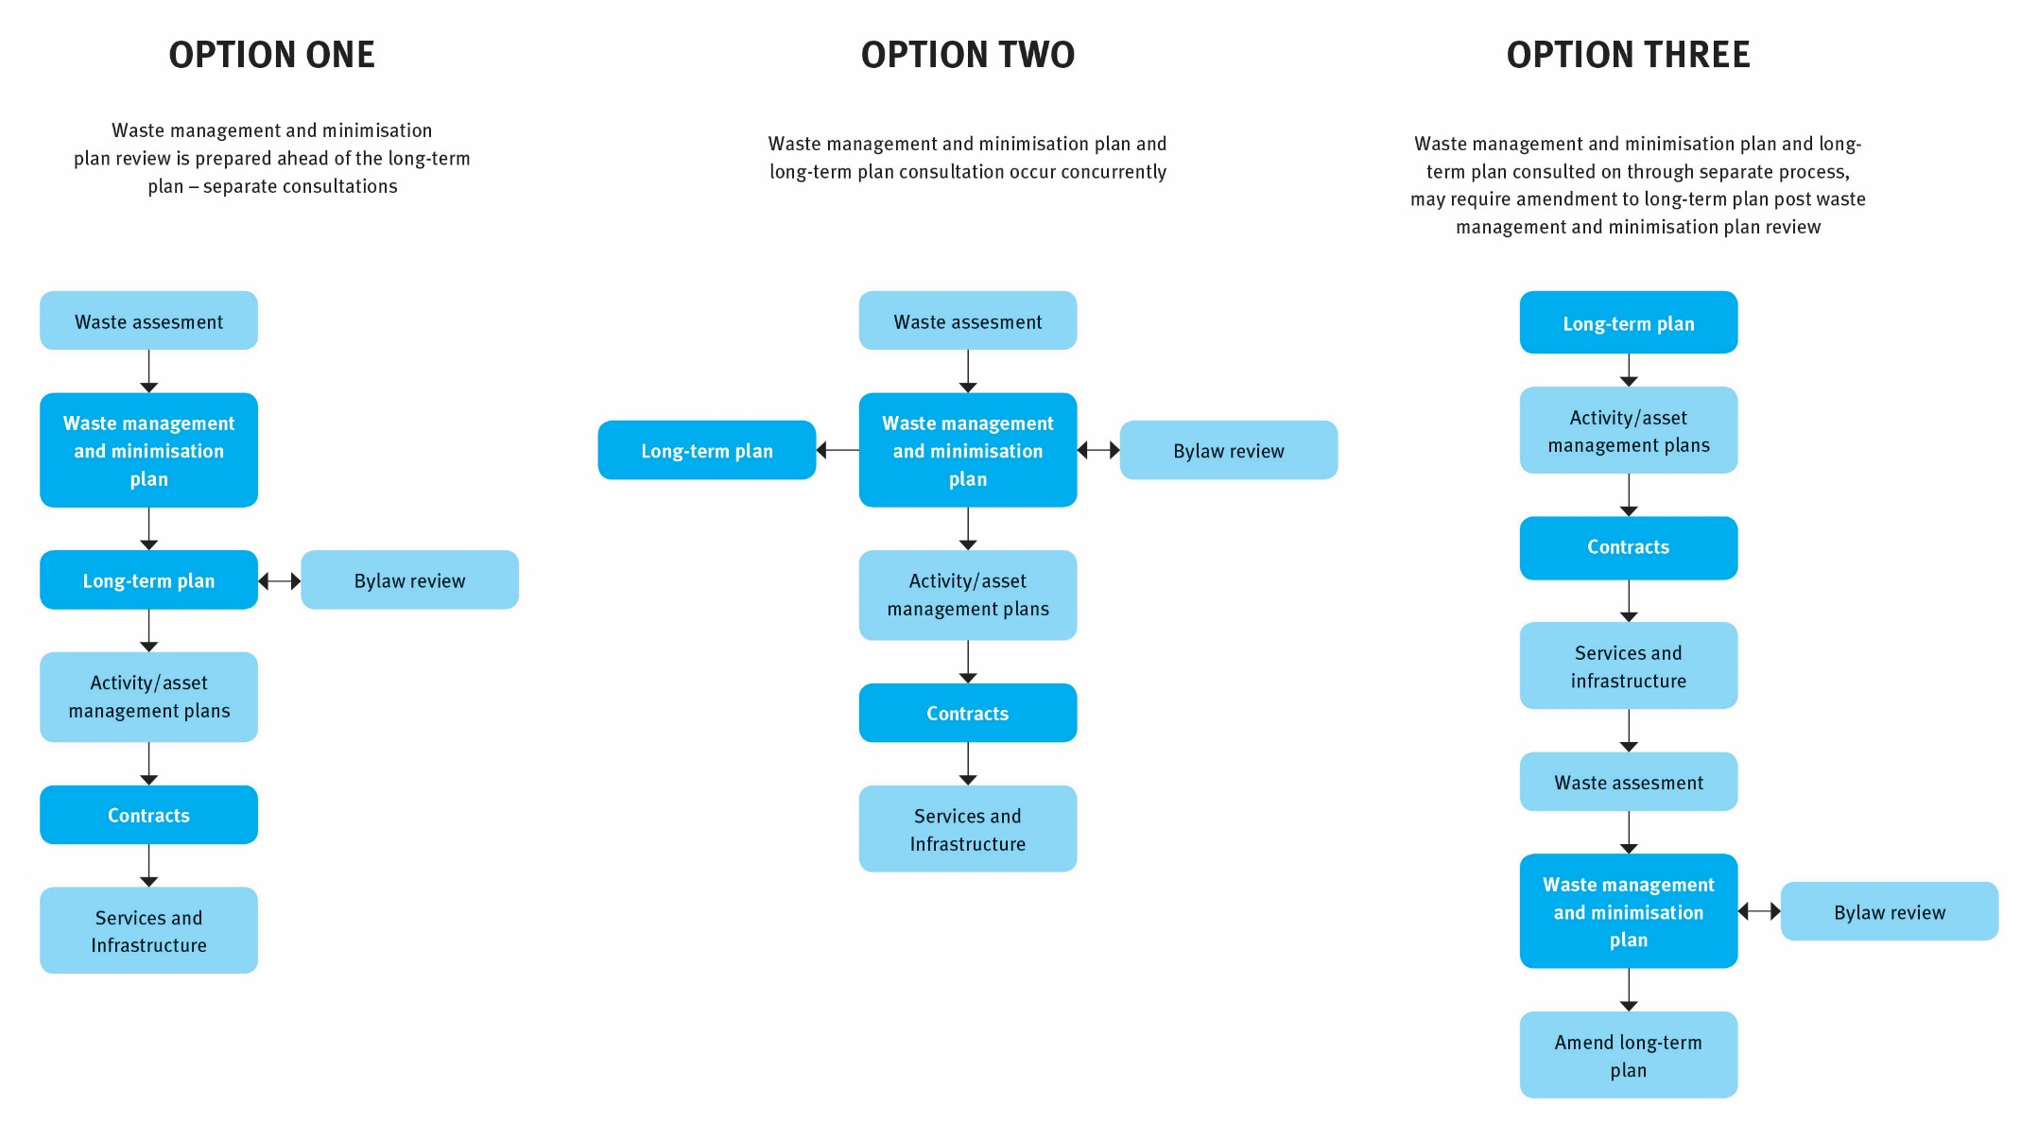

# 

# Appendix 4: Legislative and policy context

### The New Zealand Waste Strategy 2010

The New Zealand Waste Strategy 2010 provides the Government’s strategic direction for waste management and minimisation in New Zealand. This strategy was released in 2010 and replaced the 2002 Waste Strategy.

The New Zealand Waste Strategy has two goals. These are to:

* reduce the harmful effects of waste
* improve the efficiency of resource use.

The strategy’s goals provide direction to central and local government, businesses (including the waste industry), and communities on where to focus their efforts to manage waste. The strategy’s flexible approach ensures waste management and minimisation activities are appropriate for local situations.

Under section 44 of the Waste Management Act 2008, in preparing their waste management and minimisation plan (WMMP) councils must have regard to the New Zealand Waste Strategy, or any government policy on waste management and minimisation that replaces the strategy. Guidance on how councils may achieve this is provided in section 4.4.3.

A copy of the New Zealand Waste Strategy is available on the Ministry’s website at [www.mfe.govt.nz/publications/waste/new-zealand-waste-strategy-reducing-harm-improving-efficiency](http://www.mfe.govt.nz/publications/waste/new-zealand-waste-strategy-reducing-harm-improving-efficiency).

### Waste Minimisation Act 2008

The purpose of the Waste Minimisation Act 2008 (WMA) is to encourage waste minimisation and a decrease in waste disposal to protect the environment from harm and obtain environmental, economic, social and cultural benefits.

The WMA introduced tools, including:

* waste management and minimisation plan obligations for territorial authorities
* a waste disposal levy to fund waste minimisation initiatives at local and central government levels
* product stewardship provisions.

Part 4 of the WMA is dedicated to the responsibilities of a council. Councils “must promote effective and efficient waste management and minimisation within its district” (section 42). Part 4 requires councils to develop and adopt a WMMP. The development of a WMMP in the WMA is a requirement modified from Part 31 of the Local Government Act 1974, but with even greater emphasis on waste minimisation.

To support the implementation of a WMMP, section 56 of the WMA also provides councils the ability to:

* develop bylaws
* regulate the deposit, collection and transportation of wastes
* prescribe charges for waste facilities
* control access to waste facilities
* prohibit the removal of waste intended for recycling.

A number of specific clauses in Part 4 relate to the WMMP process. It is essential that those involved in developing a WMMP read and are familiar with the WMA and Part 4 in particular. You may wish to seek legal advice on the interpretation and application of Part 4 to your particular circumstances.

### Local Government Act 2002

The Local Government Act 2002 (LGA) provides the general framework and powers under which New Zealand’s democratically elected and accountable local authorities operate.

The LGA contains various provisions that may apply to councils when preparing their WMMPs, including consultation and bylaw provisions. For example, Part 6 of the LGA refers to planning and decision-making requirements to promote accountability between local authorities and their communities, and a long-term focus for the decisions and activities of the local authority. This part includes requirements for information to be included in the long-term plan (LTP), including summary information about the WMMP.

More information on the LGA can be found at [www.dia.govt.nz/better-local-government](http://www.dia.govt.nz/better-local-government).

### Resource Management Act 1991

The Resource Management Act 1991 (RMA) promotes sustainable management of natural and physical resources. Although it does not specifically define ‘waste’, the RMA addresses waste management and minimisation activity through controls on the environmental effects of waste management and minimisation activities and facilities through national, regional and local policy, standards, plans and consent procedures. In this role, the RMA exercises considerable influence over facilities for waste disposal and recycling, recovery, treatment and others in terms of the potential impacts of these facilities on the environment.

Under section 30 of the RMA, regional councils are responsible for controlling the discharge of contaminants into or on to land, air or water. These responsibilities are addressed through regional planning and discharge consent requirements. Other regional council responsibilities that may be relevant to waste and recoverable materials facilities include:

* managing the adverse effects of storing, using, disposing of and transporting hazardous wastes
* the dumping of wastes from ships, aircraft and offshore installations into the coastal marine area
* the allocation and use of water.

Under section 31 of the RMA, council responsibility includes controlling the effects of land-use activities that have the potential to create adverse effects on the natural and physical resources of their district. Facilities involved in the disposal, treatment or use of waste or recoverable materials may carry this potential. Permitted, controlled, discretionary, non-complying and prohibited activities, and their controls, are specified in district planning documents, thereby defining further land-use-related resource consent requirements for waste-related facilities.

In addition, the RMA provides for the development of national policy statements and for the setting of national environmental standards (NES). There is currently one enacted NES that directly influences the management of waste in New Zealand – the Resource Management (National Environmental Standards for Air Quality) Regulations 2004. This NES requires certain landfills (eg, those with a capacity of more than 1 million tonnes of waste) to collect landfill gases and either flare them or use them as fuel for generating electricity.

Unless exemption criteria are met, the NES for Air Quality also prohibits the lighting of fires and burning of wastes at landfills, the burning of tyres, bitumen burning for road maintenance, burning coated wire or oil, and operating high-temperature hazardous waste incinerators. These prohibitions aim to protect air quality.

### New Zealand Emissions Trading Scheme

The Climate Change Response Act 2002 and associated regulations is the Government’s principal response to manage climate change. A key mechanism for this is the New Zealand Emissions Trading Scheme (NZ ETS) The NZ ETS puts a price on greenhouse gas emissions, providing an incentive for people to reduce emissions and plant forests to absorb carbon dioxide.

Certain sectors are required to acquire and surrender emission units to account for their direct greenhouse gas emissions or the emissions associated with their products. Landfills that are subject to the waste disposal levy are required to surrender emission units to cover methane emissions generated from landfill. These disposal facilities are required to report the tonnages landfilled annually to calculate emissions.

More information is available at [www.climatechange.govt.nz/emissions-trading-scheme](http://www.climatechange.govt.nz/emissions-trading-scheme).

### Litter Act 1979

Under the Litter Act 1979 it is an offence for any person to deposit litter of any kind in a public place, or onto private land without the approval of the owner.

The Litter Act is enforced by territorial authorities, who have the responsibility to monitor litter dumping, act on complaints, and deal with those responsible for litter dumping. Councils reserve the right to prosecute offenders via fines and infringement notices administered by a litter control warden or officer. The maximum fines for littering are $5,000 for a person and $20,000 for a corporation.

Council powers under the Litter Act could be used to address illegal dumping issues that may be included in the scope of a council’s waste management and minimisation plan.

### Health Act 1956

The Health Act 1956 places obligations on councils (if required by the Minister of Health) to provide sanitary works for the collection and disposal of refuse, for the purpose of public health protection (Part 2 – Powers and duties of local authorities, section 25). The Act specifically identifies certain waste management practices as nuisances (section 29) and offensive trades (Third Schedule). The Health Act enables councils to raise loans for certain sanitary works and/or to receive government grants and subsidies, where available.

Health Act provisions to remove refuse by local authorities have been repealed.

### Other legislation

Other legislation that relates to waste management and/or reduction of harm, or improved resource efficiency from waste products includes:

* Hazardous Substances and New Organisms Act 1996
* Biosecurity Act 1993
* Radiation Protection Act 1965
* Ozone Layer Protection Act 1996
* Health and Safety in Employment Act 1992 (soon to be replaced by the outcome of the Health and Safety Reform Bill)
* Agricultural Chemicals and Veterinary Medicines Act 1997.

For full text copies of the legislation listed above see [www.legislation.govt.nz](http://www.legislation.govt.nz).

### International commitments

New Zealand is party to international agreements that have an influence on the requirements of our domestic legislation for waste minimisation and disposal. Some key agreements are the:

* Montreal Protocol
* Basel Convention
* Stockholm Convention
* Waigani Convention
* Minamata Convention.

More information on these international agreements can be found on the Ministry’s website at www.mfe.govt.nz/more/international-environmental-agreements.

1. A SWAP is a classification and sampling technique to measure the quantity and composition of waste. SWAPs can be carried out for kerbside collections or at transfer stations and landfills. The protocol can be downloaded at [www.mfe.govt.nz/publications/waste/solid-waste-analysis-protocol](http://www.mfe.govt.nz/publications/waste/solid-waste-analysis-protocol).
2. Information is currently only available at an aggregated national level. This information can be found on the Ministry’s website at [www.mfe.govt.nz/waste/waste-disposal-levy/monthly-levy-graph](http://www.mfe.govt.nz/waste/waste-disposal-levy/monthly-levy-graph).
3. For more information, see the *Landfill Full Cost Accounting Guide for New Zealand* at www.mfe.govt.nz/publications/waste/landfill-full-cost-accounting-guide-new-zealand.
4. For more information and resources, see the Ministry of Health website at [www.health.govt.nz/our-work/health-impact-assessment](http://www.health.govt.nz/our-work/health-impact-assessment).
5. See www.nams.org.nz.