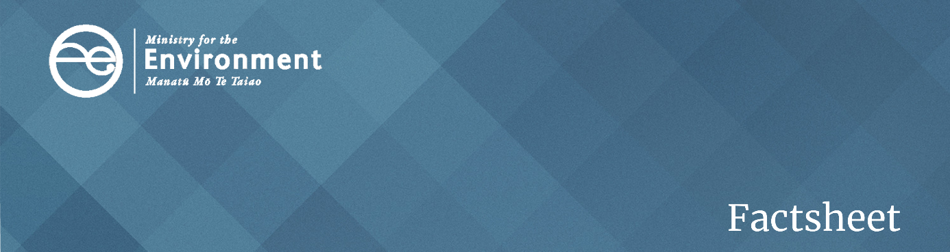

# **A waste to energy guide for New Zealand**

## What is waste to energy technology?

Waste to energy (WtE) technologies have attracted interest around the world because they have the potential to solve several pressing problems at once:

* how to dispose of increasing amounts of waste being generated in modern societies, given limited space in landfills and the greenhouse gas emissions of poor disposal techniques
* shortages in power generation and a desire to move away from fossil fuels.

However, WtE technologies vary greatly, reflecting the wide range of materials that can be processed. It is important to assess individual proposals carefully to understand their particular strengths and weaknesses within the New Zealand context.

#### This factsheet provides:

* a brief introduction to the different types of WtE technologies
* aspects of the New Zealand context that are likely to be relevant when considering WtE proposals
* four basic principles that any WtE proposal should be considered against
* a summary of the basic questions that anyone considering a WtE proposal should be asking.

### There is no ‘one size fits all’ technology or proposal

WtE technology refers to a family of technologies that process some kind of waste material to generate energy. Different technologies use a range of waste materials as ‘feedstock’ for the processing plant, and each plant might produce energy in the form of heat, electricity or a fuel.

Each proposal is likely to have different benefits, risks and complexities and will need to be assessed on its individual merits. However, all proposals will share some common core elements and will raise questions which need to be addressed before introducing a new WtE technology to New Zealand.

The main elements for all proposals are:

* the source material or feedstock (the waste that will be fed into the plant)
* the processing technology that will be used
* the energy product to be produced (what kind of energy and what scale of production)
* the by-products from the production process, such as pollution or ash.

### Renewable or non-renewable feedstock?

Technology that uses renewable feedstock is likely to be preferable, because it aligns better with environmental and circular economy values. It also supports the Government’s target of 90 per cent of electricity from renewable sources by 2025.

Renewable feedstock will comprise organic or biogenic material. WtE technology using this type of feedstock will produce renewable energy. Examples of organic or biogenic material currently used as feedstock for renewable energy include:

* wood waste from pulp and paper mills and wood processors
* black liquor, a by-product derived from wood
* biomass or other organic solid wastes in landfills or from sewage, which can be used to produce biogas through anaerobic digestion
* agricultural waste (eg, tallow), which can be used to produce liquid biofuels.

If the waste feedstock is derived from fossil fuels, like plastic waste, this is not a renewable material and the plant will not produce renewable energy. Mixed solid waste is typically a mixed waste stream, consisting of both waste derived from fossil fuels and waste derived from biogenic and organic material.

### Thermal or non-thermal processing technology?

There are two main types of WtE technology: thermal and non-thermal. These technologies involve different processes, and so create distinct risks and by-products.

Thermal conversion techniques currently lead the WtE market globally. The most common method uses some form of combustion, ranging from incineration (direct combustion or mass burn) and co-processing, to more advanced methods such as pyrolysis and gasification. Non-thermal technologies include anaerobic digestion, landfill gas capture and hydrolysis.

Table 1: Types of waste-to-energy technology

| Types of waste to energy technology | | Definition |
| --- | --- | --- |
| Thermal | Co-processing | Uses feedstock derived from waste to replace natural mineral resources and/or fossil fuels (coal, fuel oil, natural gas) in industrial processes. Most common uses are in the cement industry and in thermal power plants. |
| Gasification | Heats waste at high temperature, in a limited amount of oxygen, to produce combustible gas and an ash residue known as char waste. |
| Incineration | Burns the combustible materials within waste by heating to the necessary ignition temperature with oxygen. The heat generated is captured in a boiler to raise steam for a steam turbine. These plants typically produce exhaust gases (including greenhouse gases) and fly ash, which must be removed in flue gas treatment, as well as bottom ash. |
| Pyrolysis | Heats waste to a moderate-high temperature, without oxygen, to create a partial combustion process. Depending on the temperature reached, it can produce a mixture of gaseous, liquid and solid residues. |
| Non-thermal | Anaerobic digestion | A controlled decomposition process where organic matter decomposes under the influence of microorganisms, in the absence of oxygen. |
| Hydrolysis | Uses water to split the chemical bonds of plant-based materials containing cellulose to create a chemical decomposition process. |
| Landfill gas capture | Gas is collected through vertical and horizontal piping buried in a landfill and then processed and treated for use. |

### By-products and residues

WtE technologies may produce residues from the combustion processes in the form of slag, combustion gases, char waste and different kinds of ash. The residues will vary with the feedstock and technology. If these residues can be safely used in an approved way, they can be regarded as a useful by-product. For example, biochar (a by-product of the biogenic pyrolysis process) can be used as a soil amendment if it is of good quality. Residues that have no further use will need to be disposed of securely and safely.

## The New Zealand context for WtE

### We are producing too much waste

There is no denying New Zealand has a problem with the amount of waste being generated and being sent to landfill. Our disposal of waste to municipal landfills increased by 48 per cent in the last decade. This culminated in some 3.68 million tonnes of waste going to municipal landfills in the 2018/2019 year. This excludes the waste sent to industrial, construction and demolition landfills, and also managed, controlled and cleanfill sites. Waste breaking down in landfills also creates harmful greenhouse gas emissions.

New Zealand’s waste situation prompts WtE to be seen by councils and businesses as an attractive solution, as it might help reduce the amount of waste going to landfill. However, there are a number of other parts of the New Zealand context that are relevant.

### Do we need more renewable sources of energy?

The first question you need to ask is whether our country needs more renewable sources of energy. New Zealand has a high level of renewable electricity generation compared to some other countries. However, non-renewable energy sources still make a significant contribution to total energy consumption. For example, more than 60 per cent of New Zealand’s total energy needs are met by fossil fuels, in particular in the transport sector (20 per cent of emissions) and industrial sector (8 per cent of emissions).

It is not so much about reducing emissions from the generation of electricity but about using low- or zero-emissions energy to fuel the economy. This is where WtE projects can make a difference.

### Geography matters

New Zealand is a long narrow country, with a small population spread out across it. We do not have the very large population centres of some other countries. Our geography for transporting large quantities of feedstock can also be challenging, given our hills, rivers and coastlines. We also experience natural hazards like earthquakes, floods, eruptions, cyclones and droughts.

Due to New Zealand’s remoteness, if access to feedstock were to change and importing waste was required, this would likely be costly and impractical.

Deciding where to locate a WtE plant safely, and ensuring it would have access to sufficient feedstock, might provide quite a different challenge in New Zealand than elsewhere.

### Would it conflict with our broader policy settings and goals?

Another question is whether creating a system that requires waste to be supplied in bulk for feedstock is consistent with our broader environmental goals, particularly in relation to waste and energy.

The Government has a rapidly developing work waste and resource efficiency programme. Its aim is to create a low-waste and low-emissions economy with a world-leading and resilient resource recovery sector and a low-emissions energy system.

#### What is a circular economy?

The programme is based on the circular economy concepts captured in the waste management hierarchy (see figure 1 below).

In essence, a circular economy is one where the same resources are used over and over again through their life cycle, rather than the traditional linear model where a resource is extracted, used, and then disposed of. The waste management hierarchy applies those concepts to waste. It suggests the most effort should go into avoiding waste in the first place (through smart design and purchasing choices), then into reuse, repurposing and recycling.

Recovering energy from waste should be considered only where reuse or recycling is not possible. Permanent disposal of any residual waste (probably to landfill) should be a last resort.

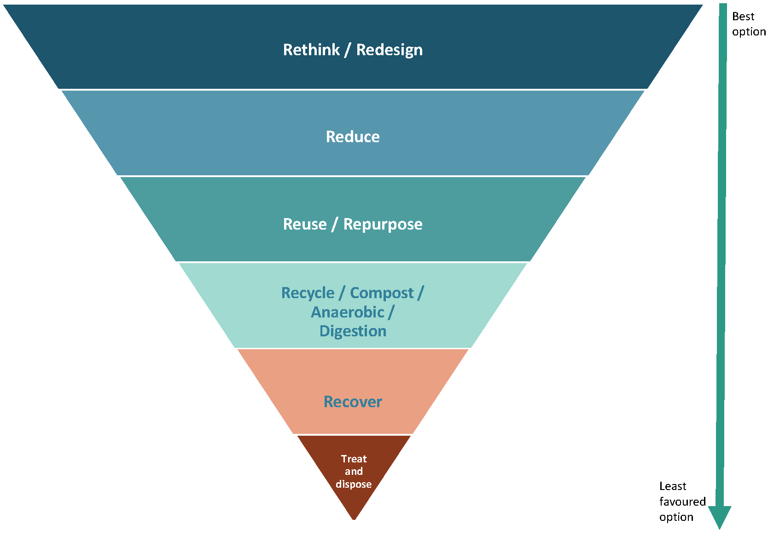Figure 1: waste management hierarchy

1. **Avoid** unnecessary resource use and   
   waste by designing waste out
2. **Reduce** the quantity, toxicity and   
   ecological footprint of consumption
3. **Reuse or repurpose** products and components  
   for the same purpose, or repurpose them for   
   another use that does not reduce their value  
   or require further processing
4. **Recycle/ compost –** recover and process materials   
   to make the same or different materials of similar   
   value when reuse is no longer possible
5. **Recover** value (eg, energy) from materials that   
   cannot be reused or recycled
6. **Treat** the waste with processes to remove or reduce  
   potential harm before **disposing** of the waste safely on   
   land set aside for that purpose

#### What the Government is doing

Applying this thinking, the Government has work underway to:

* support innovation in product design and packaging to prevent waste material being created
* ban the use of some of the most problematic products
* require the importers or sellers of some products to take responsibility for them over the whole of their life, including eventual disposal (known as product stewardship schemes)
* strengthen the resource recovery sector through initiatives to standardise and simplify kerbside collection around the country, and invest in the infrastructure and equipment needed to provide a fit-for-purpose national network of recycling and resource recovery facilities
* reduce the attractiveness of sending waste directly to landfill by increasing and expanding the scope of the levy charged at landfills
* develop a new waste strategy, infrastructure plan and supporting plans for New Zealand to guide efforts and investment across the sector over the next 10 years
* review and update the Waste Minimisation and Litter Acts to ensure they provide appropriate regulatory tools, incentives, enforcement and administrative arrangements to support the revitalisation of the waste and resource recovery sector.

All of this work is designed to move New Zealand’s waste practices steadily up the waste hierarchy, and to minimise the amount of material that ends up needing to be dealt with at the bottom of the hierarchy. There is obvious potential for conflict between this approach to minimising waste and WtE technology, which may rely on large volumes of waste towards the bottom of the pyramid to provide the feedstock for the energy plant.

#### Zero-carbon economy

The Government’s policy direction and priorities for the New Zealand energy system are focused on transitioning to a net-zero-carbon emissions economy by 2050.

Currently the Renewable Energy Strategy Work programme focuses on three main outcomes:

1. an inclusive and consumer focused energy system
2. a system that encourages increased investment in low emissions technologies
3. an innovative and modern energy system that creates new opportunities for business and consumers.

The programme is based on the concept of more affordable, more secure and more sustainable energy, which in turn provides for the wellbeing of all New Zealanders in a low-emissions world. In essence, minimising waste can contribute to a low-emissions energy system, through the potential of waste being used as a source of low-emissions energy. A low-emissions energy system is necessary for a net-zero-carbon emissions economy.

## Four basic principles

Proposals for WtE plants are likely to come to businesses, local government and central government agencies. They can be complex and can look very attractive initially. But closer examination can expose the challenges that might arise in the New Zealand context. This factsheet highlights a number of questions to consider when testing WtE proposals, grouped into four basic principles.

| Principle No | Definition |
| --- | --- |
| **Principle 1** | The proposal should support the goal of moving New Zealand steadily up the waste hierarchy towards a more circular economy approach to managing resources. |
| **Principle 2** | The environmental impacts must be well managed, especially the greenhouse gas emissions. |
| **Principle 3** | The proposal must be commercially viable over the long term. |
| **Principle 4** | There should be a strong level of support from the community and Treaty partners. |

### Principle 1: Proposals should support the goal of moving New Zealand steadily up the waste hierarchy

As noted earlier, New Zealand has a comprehensive and interconnected work programme underway to shift to a low-waste and low-emissions economy.

WtE technology may be able to play a role; it is preferable to use a waste material to create energy (layer 5 of the hierarchy) than to send it to a landfill (layer 6). But it would be even better to avoid, reduce, reuse or recycle the material (layers 1 to 4). A WtE plant may discourage people from some of those preferred options. If there is a better return from sending the material to a WtE plant than recycling or reuse facilities, those parts of the sector may come under financial pressure and become economically unsustainable.

#### Competing with resource recovery and waste reduction

If WtE is used as a complementary technology, taking waste material that cannot otherwise be used or recycled, then it may play a valuable role in our waste management system. However, if it simply competes with other levels of resource recovery activity, then it may destabilise further an already fragile system.

There is also the risk WtE technology makes it too easy to dispose of large quantities of waste, so people lose any incentive to try to reduce the waste we generate. It may provide a solution for disposing waste but it would not solve the problem of excessive and potentially unsustainable use of resources.

Any WtE proposal also needs to be considered in the context of the Government’s ongoing waste work programme and likely future regulatory steps. For example, if a proposal depends on a feedstock material that could soon be banned or subject to a product stewardship system, then the proposal either might not be feasible or undermine the regulatory steps being taken.

A final question is to look at the proposed plant through a circular economy lens. Any proposed construction should include a plan for decommissioning the plant at the end of its useful life so the infrastructure and materials can be reused, repurposed or recycled.

Supporting New Zealand’s move up the waste hierarchy: Suggested questions

* Will this WtE proposal complement or compete with other options for reusing or recycling the waste material further up the waste hierarchy? What effect will it have on local, regional or national resource recovery efforts?
* What are the alternatives for treating this kind of waste?
* Would this WtE proposal motivate people to produce more waste and consume more resources, rather than finding ways to avoid and reduce waste?
* Is the feedstock that would be used likely to be the subject of future regulatory action, for example to ban some or all of it or introduce a product stewardship scheme? How would that affect the proposal and vice versa?
* Does the proposal include plans for how the plant will be decommissioned at the end of its useful life so the infrastructure and materials can be reused, repurposed or recycled?

### Principle 2: Environmental impacts must be well managed, especially greenhouse gas emissions

WtE technology has the potential to cause environmental harm if it is not designed and operated well. In particular, thermal technologies need to manage the risk they could create harmful emissions, both of greenhouse gases and other gases, and substances that may be dangerous to human health or the environment.

Electricity generation represents about 5 per cent of New Zealand’s total greenhouse gas emissions. New Zealand is fortunate to have already such a high proportion of renewable electricity. Most of this renewable electricity is from hydro, geothermal and wind, with a small percentage from solar and biomass.

#### Emissions profile of the plant

Any grid-scale WtE electricity generation project could potentially have a greater emissions profile than the already established renewable electricity generation technologies. Most of New Zealand’s electricity generation is already renewable, unlike many other countries where electricity systems are heavily reliant on fossil fuels like coal and natural gas. In the context of already high levels of renewable electricity, New Zealand has commitments to reduce its greenhouse gas emissions and has a long way to go if it is to contribute to the goals of the Paris Agreement.

Increasing the amount of delivered renewable electricity to high-intensive emissions sectors (industry and transport) of the economy will be integral to meeting these commitments. Many industries are now introducing carbon budgets or similar ways of tracking and reducing their emissions profiles. Any new WtE technology will need careful assessment to ensure it manages the risk of greenhouse gas emissions well. This should include the design of the plant and the inbuilt processes to capture and treat potential emissions, as well as ongoing monitoring, testing and maintenance. Testing might cover the content of exhaust gas such as temperature, oxygen, pressure, water vapour, heavy metals, greenhouse gases, hydrocarbons, chlorinated dioxins and more.

#### Process heat provides an opportunity

The Climate Change Commission believes a significant opportunity for decarbonising our economy lies in tackling emissions from industrial process heat. This is heat energy (often in the form of steam, hot water or hot gas) used by the industrial, commercial and public sectors for industrial processes, manufacturing and space heating. For example, coal is burnt in large industrial boilers to create heat that dries liquid milk into milk powder. Another example is school boilers using fossil fuels for space heating.

Around 60 per cent of process heat in New Zealand is created using fossil fuels: coal, natural gas and diesel. WtE projects have a potential place in decarbonising the industrial sector. In particular, there is a major opportunity in the South Island where coal is used but limited access to sources of lower-emissions fuel like natural gas.

All facilities would have to meet the relevant standards set out in the National Environmental Standards for Air Quality Regulations 2004 (NESAQ) as well as relevant regional council plans. For example, the NESAQ has controls on burning waste at landfills, discharge of gas to air from landfills and high-temperature hazardous waste incinerators.

The by-products and residue from the process would also need to be carefully managed in line with environmental requirements. These matters would generally be managed through the normal processes of the Resource Management Act 1991. This would include considering directions set out in the National Policy Statement for Renewable Electricity Generation and NESAQ.

Managing the environmental impacts: Suggested questions

* Does this technology contribute to electricity generation emissions? How will these be accounted for?
* Are there viable alternative lower-emissions technologies available to support your energy needs?
* What are the by-products, emissions and residues that will be created by the plant? How will they be captured, treated and disposed of?
* What emissions or residues will be allowed to enter the environment?
* Will the plant, or the plant’s products or by-products, create greenhouse gas emissions? How will these be accounted for?
* Will the plant create or release any other harmful or problematic substances, such as heavy metals, dioxins or microplastics?
* Does the technology meet the appropriate standards required by regional council plans and the National Environmental Standard for Air Quality?
* What contingency plans are in place if something goes wrong and harmful emissions or residues escape into the environment? Does the proposal include strong risk management and contingency planning?

### Principle 3: The proposal must be commercially viable over the long term

Many WtE technologies developed overseas are located in bigger markets with larger sources of feedstock or waste material to fuel the plant. Examples of where this type of technology works well are usually where they are set up as part of another larger facility, to use a by-product of the main production process to generate energy (eg, using wood waste at a pulp and paper mill to power some of the plant).

In New Zealand, a key question will be whether the local area, region or the entire country will produce enough feedstock, on an ongoing basis, to keep a WtE plant running. Even if there is enough waste material available now, will that be the case in future or will it be affected by separate efforts to avoid and reduce waste materials being created? For example, will bans on certain products, product stewardship schemes, behaviour change or recycling affect the volume of feedstock in the future? All of these questions need to be considered to assess whether your proposal will be viable.

#### Transportation and mixed waste streams

A related question is whether the feedstock can be transported easily and economically to the plant. If the feedstock is produced nearby that may not be difficult. But if it needs to be collected from further away, transport may be a problem. New Zealand’s road and rail network is not always adequate for transporting large (and potentially hazardous) loads. Transport may also add to the financial and environmental costs and increase the emissions profile of the proposal.

It is also important to consider whether the technology can handle mixed waste streams and contamination, or whether the waste would need to be separated and cleaned before processing. If the technology cannot process a mixed waste stream and the feedstock needs to be separated first, the proposal will need to account for how any unprocessed waste that is rejected as feedstock will be managed.

#### Health and safety costs

Then there are the various costs and challenges of running the plant itself. A facility of this kind may require people to work with hazardous substances and dangerous technologies. This could require a high investment in health and safety to ensure the machinery is safe, staff have the necessary personal protective equipment and training, and any emissions, by-products and residues are dealt with appropriately. All of these requirements carry up-front and ongoing costs.

#### Enough demand and competing technologies

There is also the question of whether there is a demand or market for the energy and by-products that will be produced. Again, the most successful examples so far are those that are linked to another industrial plant which both generates the waste feedstock and uses the energy produced. Without that, the proposal needs to address who it will provide energy to, and how the energy will reach the end customer.

There is also the question of other renewable electricity generation technologies such as onshore wind and solar being potentially cheaper to generate electricity than WtE. WtE projects will have to compete against these other technologies.

#### Testing the technology

A separate question, also related to viability, is how well developed and tested the technology is. Many WtE proposals are still effectively in an experimental or feasibility testing stage. You need to check whether there are examples of the same technology functioning at a similar scale and with similar waste streams elsewhere. If there is not a track record of successful operations in comparable contexts, you will need carry out additional due diligence.

You should carry out a cost-benefit analysis to assess all of the above and show the long-term viability of the proposed WtE plant.

Commercial viability over the long term: Suggested questions

* Is there a sufficient long-term supply of the required feedstock? Is it genuinely renewable? Could it be affected by future changes in the waste management sector, such as regulatory changes to ban products, increased recycling, design and behaviour changes?
* Will you source the feedstock locally or does it need to be collected and transported from elsewhere? What challenges would the need to transport the waste material create (cost, safety, emissions, feasibility)?
* Can the technology use mixed waste streams or does the waste material need sorting before it is used? What would happen to the waste material excluded from the feedstock?
* Have you identified the ongoing operating costs for the plant, including management of health and safety risks, environmental management requirements, inspections, maintenance and so on?
* What market is there for the energy generated? Have you identified a specific customer? How will the energy reach the customer or the market? Is the market likely to endure?
* How established is the technology or is it still experimental? Are there examples of the same technology functioning at a similar scale and with similar waste streams elsewhere?
* Has a cost-benefit analysis been done? Does it show the long-term viability of the proposed WtE plant?

### Principle 4: There should be a strong level of support from community and Treaty partners

A proposal to develop a WtE plant near a community may generate concerns about its effect on the health and wellbeing of the community, as well as the environmental, economic and cultural impacts on the area as a whole. As with any proposed new plant, acceptance by the community and Treaty partners is central to ensuring its successful operation.

A socio-economic impact assessment should be part of any WtE proposal to assess the socio-economic and cultural impacts of the plant. It should:

* outline the impact of the proposed plant on local communities and iwi
* the mitigation measures necessary to address any negative effects identified
* involve consultation with community members and Treaty partners
* incorporate their concerns honestly
* include clear plans for how those concerns will be addressed.

Implementing good neighbour and corporate citizen principles during all stages of the design, development, construction and operation of a WtE plant has also been shown to help greatly in ensuring a supportive and healthy relationship with the community.

Community support: Suggested questions

* Has a full socio-economic impact assessment been carried out to understand the potential effects on those living near the proposed plant, in terms of health and wellbeing, environmental and economic effects?
* Has that work involved consultation with Treaty partners and the community?
* What concerns have been identified and how are they to be addressed?
* What proposals are included to reflect good neighbour and corporate citizen principles? How is the plant intending to become a constructive and contributing part of the community?

## Appendix A: Summary of questions that a waste to energy proposal should address

### Supporting New Zealand’s move up the waste hierarchy

1. Will this WtE proposal complement or compete with other options for reusing or recycling the waste material further up the waste hierarchy? What effect will it have on local, regional or national resource recovery efforts?
2. What are the alternatives for treating this kind of waste?
3. Would this WtE proposal motivate people to produce more waste and consume more resources, rather than finding ways to avoid and reduce waste?
4. Is the feedstock that would be used likely to be the subject of future regulatory action, for example to ban some or all of it, or to introduce a product stewardship scheme? How would that affect the proposal and vice versa?
5. Does the proposal include a plan for how the plant will be decommissioned at the end of its useful life, so the infrastructure and materials can be reused, repurposed or recycled?

### Managing the environmental impacts

1. Does this technology contribute to electricity generation emissions? How will these be accounted for?
2. Are there viable alternative lower-emissions technologies available to support your energy needs?
3. What are the by-products, emissions, and residues that will be created by the plant? How will they be captured, treated, and disposed of?
4. What emissions or residues will be allowed to enter the environment?
5. Will the plant create greenhouse gas emissions? How will these be accounted for?
6. Will the plant create or release any other harmful or problematic substances, such as heavy metals, dioxins or microplastics?
7. Does the technology meet the appropriate standards required by regional council plans and the National Environmental Standard for Air Quality?
8. What contingency plans are in place if something goes wrong and harmful emissions or residues escape into the environment? Does the proposal include strong risk management and contingency planning?

### Commercial viability

1. Is there a sufficient long term supply of the required feedstock? Is it genuinely renewable? Could it be affected by future changes in the waste management sector, such as regulatory changes to ban products, increased recycling, design and behaviour changes?
2. Will you source the feedstock locally or does it need to be collected and transported from elsewhere? What challenges would the need to transport the waste material create (cost, safety, emissions, feasibility)?
3. Can the technology use mixed waste streams or does the waste material need sorting before it is used? What would happen to the waste material excluded from the feedstock?
4. Have you identified the ongoing operating costs for the plant, including management of health and safety risks, environmental management requirements, inspections, maintenance, and so on?
5. What market is there for the energy generated? Have you identified a specific customer? How will the energy reach the customer or the market? Is the market likely to endure?
6. How established is the technology or is it still experimental? Are there examples of the same technology functioning at a similar scale and with similar waste streams elsewhere?
7. Has a cost-benefit analysis been done? Does it show the long-term viability of the proposed plant?

### Community support

1. Has a full socio-economic impact assessment been carried out, to understand the potential effects for those living near the proposed plant, in terms of health and well-being, environmental and economic effects?
2. Has that work involved consultation with treaty partners and the community?
3. What concerns have been identified and how are they to be addressed?
4. What proposals are included to reflect good neighbour and corporate citizen principles? How is the plant intending to become a constructive and contributing part of the community?

## Appendix B: References

Environment Protection Authority Victoria. 2017. *1559.1: Energy from waste guideline.* <https://www.epa.vic.gov.au/about-epa/publications/1559-1>

European Commission Directorate-General Environment. 2008. *Guidelines on the interpretation of the R1 energy efficiency formula for incineration facilities dedicated to the processing of municipal solid waste according to Annex II of Directive 2008/98/EC on waste.* <https://ec.europa.eu/environment/waste/framework/pdf/guidance.pdf>

New South Wales Environmental Protection Authority. 2015. *NSW Energy from Waste Policy Statement*. <https://www.epa.nsw.gov.au/-/media/epa/corporate-site/resources/epa/150011enfromwasteps.pdf>

Scottish Environmental Protection Agency. (nd). *Energy from waste.* <https://www.sepa.org.uk/regulations/waste/energy-from-waste/>

Waste and Resources Action Plan. 2012. *EfW development guide.* <http://www.wrap.org.uk/sites/files/wrap/O_And_EFW_Guidance_FULL.pdf>

UN Environment Programme. 2015. *Global waste management outlook.* <https://unenvironment.org/resources/report/global-waste-management-outlook>

UN Environment Programme. 2019. *Waste to energy: Considerations for informed decision-making.* <https://unenvironment.org/ietc/resources/publication/waste-energy-considerations-informed-decision-making>

US Environmental Protection Agency. 2012. *International best practices guide for landfill gas energy projects.* <https://www.globalmethane.org/documents/toolsres_lfg_IBPGcomplete.pdf>

### Disclaimer

The information in this publication is, according to the Ministry for the Environment’s best efforts, accurate at the time of publication. The information provided does not alter the laws of New Zealand and other official guidelines or requirements. Users should take specific advice from qualified professional people before undertaking any action as a result of information obtained from this publication.

The Ministry for the Environment does not accept any responsibility or liability whether in contract, tort, equity or otherwise for any action taken as a result of reading, or reliance placed on the Ministry for the Environment because of having read any part, or all, of the information in this publication or for any error, or inadequacy, deficiency, flaw in or omission from the information provided in this publication.

Published in August 2020 by the  
Ministry for the Environment   
Publication number: INFO 964

