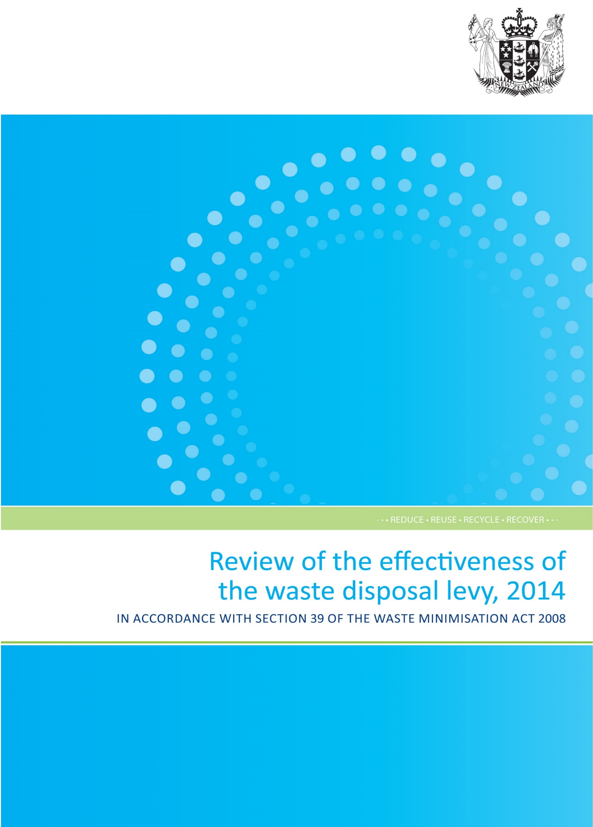

This report may be cited as: Ministry for the Environment. 2014. Review of the effectiveness of the waste disposal levy, 2014 in accordance with section 39 of the Waste Minimisation Act 2008. Wellington: Ministry for the Environment.

Published in July 2014 by the
Ministry for the Environment
Manatū Mō Te Taiao
PO Box 10362, Wellington 6143, New Zealand
ISBN: 978-0-478-41252-9
Publication number: ME 1159
© Crown copyright New Zealand 2014
This document is available on websites of the Ministry for the Environment’s website: www.mfe.govt.nz.


Contents
Acknowledgements 4
Foreword by the Minister for the Environment 4
Executive summary 4
Summary of recommendations 4
Introduction 4
Why is waste disposal a problem? 4
Why a waste disposal levy? 4
The need for review 4
Approach to reviewing the effectiveness of the levy 4
Part 1: Levy administration and application 4
Approach 4
Key findings 4
Part 2: Levy expenditure 4
Approach 4
Key findings 4
Part 3: Cost of waste disposal 4
Approach 4
Key findings 4
Part 4: Achieving waste minimisation 4
Approach 4
Key findings 4
Appendix 1: Performance of the levy collector and Secretary for the Environment 4
Appendix 2: Methodology, assumptions and limitations of the Tonkin & Taylor New Zealand non-municipal landfill database 4
Appendix 3: Examples of international landfill taxes/levies 4
Appendix 4: Data requirements, sources and limitations for Part 4 of the waste levy review 4
Glossary 4
References 4

List of tables
Table 1: 2014 review approach 4
Table 2: Comparison of disposal facility size with proportion of waste disposed 4
Table 3: Applications to waive levy 4
Table 4: Summary of the levy collector’s performance in relation to statutory and regulatory requirements 4
Table 5: Summary of the Secretary for the Environment’s performance in relation to statutory and regulatory requirements 4
Table 6: Composition of non-levied landfills 4
Table 7: Levy revenue raised, 1 July 2009 – 31 January 2014 4
Table 8: Breakdown of levy revenue allocated, July 2009 – January 2014 4
Table 9: Breakdown of spent vs unspent TA levy funding 4
Table 10: TA spending project types and examples 4
Table 11: Definitions and examples of TA spending, by status 4
Table 12: Summary of WMF funding rounds, 2009/10–2012/13 4
Table 13: Summary of WMF spending, by project status 4
Table 14: WMF funding allocated, by waste stream 4
Table 15: Number of WMF projects, by project value, 2010–2013 4
Table 16: Reported TA levy expenditure on infrastructure and services, 2010–2013 4
Table 17: Reported TA expenditure on education and communication, 2010–2013 4
Table 18: Reported participation rates for TA-funded waste minimisation education initiatives 2012/13 4
Table 19: Waste disposal to levied facilities, 2010–2013 4
Table 20: Tonnes of waste diverted through accredited product stewardship schemes, 2013 4
Table A1.1: Assessment of levy collector performance against regulatory functions under the Waste Minimisation (Calculation and Payment of Waste Disposal Levy) Regulations 2009 and Waste Minimisation Act 2008 4
Table A1.2: Assessment of Secretary for the Environment performance against regulatory functions under the Waste Minimisation (Calculation and Payment of Waste Disposal Levy) Regulations 2009 and Waste Minimisation Act 2008 4
Table A3.1: Landfill taxes/levies in Denmark, The Netherlands, UK and Ireland 4
Table A3.2 Summary of landfill taxes/levies in Denmark, the Netherlands, UK and Ireland and their reported effects on waste disposal (and generation) 4
Table A3.3: Waste levies operating in Australia 4

List of figures
Figure 1: The waste hierarchy 4
Figure 2: Expected outcomes of the waste disposal levy and approach to the 2014 review 4
Figure 3: Formula for calculating the levy payable on waste 4
Figure 4: Breakdown of waste measurement systems used at disposal facilities 4
Figure 5: Proportion of total net waste measured by each method (or combination of methods) 4
Figure 6: Timeliness of levy invoice payments 4
Figure 7: Proportion of late levy payments, by disposal facility size 4
Figure 8: Classification of waste material that enters disposal facilities, by disposal facility size 4
Figure 9: Number of non-levied landfills in New Zealand, by class, 2000–2013 4
Figure 10: Estimated breakdown of total waste disposed of to land in 2013 4
Figure 11: Levy revenue allocations (1 July 2009 – 31 Jan 2014) 4
Figure 12: Levy payments to TAs, January 2010 to October 2013 4
Figure 13: TA levy expenditure, by project type, 2010-13 4
Figure 14: Detailed breakdown of reported TA levy expenditure, by project type, 2011–2013 4
Figure 15: TA levy expenditure, by status, 2010–2013 4
Figure 16: WMF funding allocated, by project type, 2010–2013 4
Figure 17: WMF funding allocated, by priority waste streams 4
Figure 18: Comparison of amount of WMF funding approved, by project value, 2011 and 2013 4
Figure 19: Rated achievement of completed WMF projects against project objectives 4
Figure 20: Amount of WMF funding allocated to infrastructure projects, by waste stream 4
Figure 21: Amount of WMF funding allocated to waste minimisation services projects, by waste stream 4
Figure 22: Tonnes of waste minimised (reported) from completed WMF projects 4
Figure 23: A comparison of TA waste minimisation infrastructure and services expenditure, by status over reporting periods 4
Figure 24: Levy expenditure on waste minimisation education and communication by category 4
Figure 25: How the levy is designed to act as a price signal 4
Figure 26: TA household waste collection, by funding method, 2013 4
Figure 27: Waste disposal in New Zealand, 2006–2013 4
Figure 28: Estimated proportion of waste going to each disposal destination in 2013 4
Figure 29: Waste disposal composition at municipal landfills in New Zealand, 2004–2012 4
Figure 30: Proportion of waste diverted from disposal facilities, 2010–2013 4
Figure A3.1: Development of landfilling of total waste and landfill tax in Denmark 4
Figure A3.2: Development in the landfill tax revenue, 1993–2011 4
Figure A3.3: Revenue from the landfill tax in The Netherlands, 2000–2010 4
Figure A3.4: Revenue from landfill tax in The Netherlands, by type of tax rate, 2006–2010 4
Figure A3.5: The landfill tax in the UK in GBP per ton of waste, 1996–2010 4
Figure A3.6: Amount of waste received at landfills in the UK, by type of landfill tax, 1997–2010 4
Figure A3.7: Irish landfill tax per ton of waste, 1996–2012 4
Figure A3.8: Development of landfill tax per ton, generation of waste and landfilling of waste, 1997–2009 4
Figure A3.9: NSW waste disposal and waste levy rate, 2006/07–2010/11 4
Figure A3.10: Waste disposal to landfill and the waste levy in South Australia 1999–2005/06 4
Figure A3.11: Waste disposal and levy rate in Western Australia, 2006/07–2010/11 4
Figure A3.12: Waste disposal and levy rate in Victoria, 2006/07–2010/11 4

Acknowledgements
The Ministry would like to acknowledge the contributions made by the Waste Advisory Board, members of the waste levy stakeholder reference group, participants of the levy review workshop at the 2014 WasteMINZ round-up, and those who completed surveys and information requests. These include representatives from territorial authorities, regional councils, Waste Minimisation Fund recipients, and disposal facility operators. The Ministry also acknowledges support from Statistics New Zealand. Input from these stakeholders has been critical to delivering the 2014 review.


Foreword by the
Minister for the Environment
The waste disposal levy is an important tool in delivering on the purpose of the Waste Minimisation Act. Since its introduction five years ago, the levy has raised more than $115 million which has been distributed for national and local initiatives to reduce waste.
This money is being invested in a wide range of projects and activities such as waste minimisation education, delivery of recycling services, and new infrastructure.
This second review of the effectiveness of the waste disposal levy shows that the levy is generally being applied, collected and spent in accordance with the Waste Minimisation Act. However, more and better data is needed in order to measure the impact the levy is having on waste minimisation in the long-term.
The review makes 11 recommendations based on key findings. These recommendations are aimed at improving the way the levy is being applied, to ensure a level playing field for those paying the levy. They are also aimed at improving the ability to measure and evaluate the impact that levy funding is having on achieving waste minimisation.
The administrative processes for calculating and paying the levy appear to be highly effective. The majority of waste disposed of at defined disposal facilities is being accurately recorded and reported within statutory requirements, and levy payments are largely accurate and on time. Levy funding recipients also appear to be spending in accordance with statutory requirements.
Based on the data that is available however, the review highlights that the levy is only being applied to an estimated 30 per cent of waste disposed of to land, which means many waste generators are receiving no price signal from the levy. It was always intended that the levy could be expanded over time, and it may be timely to now consider this coverage. At the same time, some disposal facility operators are applying inconsistent interpretations as to what materials the levy is payable on. These factors have the potential to create an uneven playing field. The review identifies further work needed to ensure guidance is unambiguous and requirements on operators are fair.
There are significant gaps in the waste data available, both on waste disposal and on the effectiveness of levy-funded projects. Better data is needed to track waste disposal trends and to assess the impact of the levy on waste minimisation. As a result, the review recommends targeted data collection to establish a baseline against which improvements can be measured. It also recommends investigating a wider data collection framework for evaluation of long-term waste minimisation.
Improving waste data will not only allow central government to better direct investment and effort in line with the aims of the Waste Minimisation Act but will also support industry and local government to track and measure their own efforts. It will support everyone as they continue to work together to improve New Zealand’s waste minimisation outcomes.

Hon Amy Adams
Minister for the Environment

Executive summary
The Waste Minimisation Act 2008 (the Act) introduced a waste disposal levy. Since 1 July 2009 the levy has applied to all waste disposed of at disposal facilities. The levy has two purposes, which are set out in the Act:
- to raise revenue for promoting and achieving waste minimisation
- to increase the cost of waste disposal to recognise that disposal imposes costs on the environment, society and the economy.
Section 39 of the Act requires the Minister for the Environment to review the effectiveness of the waste disposal levy at least every three years. The first review was completed in 2011. This report details the findings of the second review of the effectiveness of the levy.
In undertaking a review the Minister must consider whether, since the last review, the amount of waste disposed of has decreased, and whether the amount of waste reused, recycled or recovered has increased. To put this into context and to help define what is meant by ‘effectiveness of the levy’, this review uses the expected outcomes framework that was developed for the 2011 levy review. The framework (see page 21) identifies a series of outcomes (short-, medium- and long-term) that would be expected if the levy is operating effectively.
The first review measured how well the levy had been implemented and progress towards achieving the short-term outcomes in the framework. This second review makes an assessment against the levy’s medium-term outcomes.
The 2011 review found that the levy had been implemented and appeared to be operating as intended. There was no evidence of perverse outcomes, such as an increase in illegal dumping, as a result of the levy. Two unintended ways in which levy payments could be minimised were identified: one relating to the facilities that are subject to levy obligations, the other to the materials that are levied. As a result, the first priority for this review is to determine whether the levy is being applied correctly and equitably, and what needs to be done to ensure a level playing field for those who have obligations to pay the levy.
At the current rate of $10 (plus GST) per tonne the levy generates about $25 million in revenue every year. Half of this money is distributed to territorial authorities (TAs) for waste minimisation initiatives. The rest (minus administration costs) is allocated to waste minimisation projects through the Waste Minimisation Fund. The second priority for this review is to assess the impact this levy funding is having.
The review has been undertaken in four parts, with each part focusing on a core function or purpose of the levy, as per the outcomes framework. Key findings from each part of the review are presented as follows.

Part 1: Levy administration and application
The administrative processes for calculating and paying the levy appear to be highly effective. The majority of waste disposed of at disposal facilities is being accurately recorded and reported within statutory requirements, and levy payments are largely accurate and on time. While administration of the levy is proving to be effective, the review has raised concerns with the way the levy is being applied.
Firstly, data collected as part of this review suggests that currently the levy is only applied to an estimated 30 per cent of all waste disposed of to land. Not only does this relatively narrow application of the levy allow the potential for operators to minimise or avoid levy obligations, it also means the incentive effect of the levy is limited. The decision in 2008 to initially apply the levy only to landfills that accept household waste was a pragmatic one to ensure ease of implementation, and the intent was to make other landfills subject to the levy over time.
Secondly, the levy is not being applied consistently by disposal facility operators across all disposal facilities. The legislation is being interpreted by some in a way that means they are not paying the levy on all waste disposed of at their disposal facilities. For example, some disposal facilities are classifying waste used for operational purposes, such as cover material, as diverted material, and are therefore not including it in levy payments. These practices are inequitable and inconsistent with the original policy intent, which was to levy all material disposed of at a disposal facility. These practices are also reducing the total revenue raised by the levy. This ambiguity over what material is or is not subject to the levy when deposited at a disposal facility could be addressed through a clarification of the legislation.
The levy was never intended to apply exclusively to household waste, but was applied to landfills that accept household waste as a starting point. Information gathered through the review supports consideration being given to extending levy obligations to additional waste disposal sites, to reduce opportunities for levy avoidance and provide greater incentives for waste minimisation.

Part 2: Levy expenditure
The first purpose of the levy is to raise revenue for promoting and achieving waste minimisation. Over $115 million has been raised since the levy was introduced on 1 July 2009. It is being distributed for waste minimisation purposes in accordance with the requirements of section 30 of the Act. Approximately $57 million in levy funds has been allocated to territorial authorities (TAs) to spend on waste minimisation in accordance with their waste management and minimisation plans. There are some good examples of TA waste minimisation initiatives that would not have occurred without levy funding, and overall the review indicated that TAs have increased the amount they spend on waste minimisation per capita since the levy was introduced.
Overall, though, the Government’s ability to evaluate the outcomes of this levy spending is limited due to a lack of outcome-focused reporting by TAs. TAs have only recently been asked to attempt to measure the outcomes of their levy spending, and the quality of information reported has generally been poor. It is recommended that the focus of TA reporting be shifted towards waste minimisation outcomes, including their broader responsibilities under the Act, such as progress against waste management and minimisation plans.
Approximately $52 million has been allocated to projects through the Waste Minimisation Fund (WMF). The focus of these projects has mainly been determined by the applicants, and funding decisions have been based on general assessment criteria without targeted priorities. This has resulted in a broad range of funded projects, with varying benefits.
While it was always intended that WMF funding should be available as a catalyst for new and innovative waste minimisation initiatives, there is scope to operate the fund in a more focused and strategic way, ensuring adequate funding is directed towards projects that support New Zealand’s waste minimisation priorities. This need has previously been identified, and some changes were introduced to the 2014 WMF funding round, but further options to operate the WMF more strategically should be further investigated. Better information is also needed on the outcomes of WMF projects after funding deeds expire.
To evaluate the extent to which funding allocated to TAs and through the WMF is resulting in improved waste minimisation infrastructure and services, the Ministry needs to compile a clearer picture of the current state of the waste infrastructure and services. Data collected from TAs to date has been fragmented and incomplete, and a more targeted and systematic approach is required to establish a baseline against which improvements can be measured.
For both the TA levy funding and the WMF, there is a need for a clear framework against which the outcomes of this spending can be measured by the Ministry for the Environment. This would require the Ministry to set performance expectations and a process for collecting the relevant information from TAs and WMF recipients.

Part 3: Cost of waste disposal
At $10 (plus GST) per tonne the rate of the levy was set to:
- generate an appropriate level of revenue to fund waste minimisation activities within the current capacity and capability to spend such revenue efficiently
- allow for any unintended consequences resulting from the levy to be identified
- minimise the risk of perverse behaviour in response to the levy (such as illegal dumping).
The second purpose of the levy is to increase the cost of waste disposal, in recognition that disposal imposes costs on the environment, society and the economy. The increase in the cost of disposal is expected to provide a small incentive for waste minimisation. The levy has increased the cost of waste disposal to disposal facilities. However, as much as 70 per cent of waste being disposed of to land is estimated to be at facilities that fall outside of the definition of disposal facility, and are not subject to levy obligations. Therefore, the cost of disposal has likely not increased for the majority of waste, and many waste generators are receiving no direct incentive from the levy to minimise waste.
Making additional waste disposal sites subject to levy obligations would allow a greater proportion of waste generators to receive the waste minimisation incentive from the levy.
To ensure waste generators are able to respond to incentives from the levy, pricing systems also need to be considered. The pricing system can affect how responsive people are to any increase in price, whether weight-based, pay-per-bin or pay-per-bag. The majority of kerbside waste collection by TAs is at least partially rates subsidised. This means that what people pay is often not directly connected to the amount of waste they dispose of at the gate. It is recommended that the Ministry considers ways to support user-pays pricing systems for kerbside waste collection that better allow waste generators to respond to price signals.
Cost and convenience are factors that waste generators consider when deciding what to do with their waste. There is a need to better understand how factors such as price and the availability of services influence people’s waste disposal behaviour. Options to make alternatives to disposal (eg, reuse, recycling and recovery) more attractive should be investigated. While this could at some stage include changing the rate of the levy to influence the cost of disposal compared to the alternatives, raising the levy at this time could further exacerbate unintended consequences already being observed in the levy regime, or stimulate others. Applying the levy only to facilities that accept household waste risks providing operators with unintended opportunities to minimise or avoid levy obligations. In addition, inconsistent interpretations by operators of what materials the levy applies to at disposal facilities means the levy is not being applied in a consistent way. The priority is to ensure the levy is being applied in a fair and effective way before any consideration is given to increasing the rate of the levy.

Part 4: Achieving waste minimisation
Waste minimisation means a reduction in waste generation and the reuse, recycling and recovery of waste and diverted material. There is insufficient information available on either waste generation or reuse, recycling and recovery, to conclude whether there has been a change in either since the last review in 2011, or since the levy was introduced in 2009.
Overall waste disposal to levied disposal facilities has not decreased since the last review of the levy in 2011. Between the first full year of levy data (2010) and the time of reporting, disposal at levied facilities increased overall by 6 per cent. This was slightly less than GDP growth over the same period. However, because reliable data is only available on an estimated 30 per cent of total waste disposal to land, it is not possible to conclude whether total waste disposal has changed.
Better data needs to be collected on waste generation, all waste disposed of (not just to levied disposal facilities), and waste that is reused, recycled or recovered. Data collection would need to consider commercial confidentiality and could include the voluntary and/or mandatory provision of data.

Summary of recommendations
Review part | Recommendation | Context
Part 1: Levy administration and application | - Investigate options to clarify the legislation so that the levy is consistently applied at disposal facilities. | The current ambiguity over what material deposited at a disposal facility is reused or recycled could be addressed by setting out more clearly in the Act what material is subject to the levy; for example, section 26 might specify all waste that is not removed from a site within a specified period to be subject to the levy.
Part 1: Levy administration and application | - Investigate making additional waste disposal sites subject to the levy obligations. | The Act allows regulations to be made under section 41 prescribing any facility, or class of facility, as a disposal facility for the purposes of the Act, and therefore subject to the levy. The framework of the WasteMINZ Draft Technical Guidelines for Disposal to Land could be considered for defining the appropriate types of landfill according to the composition of the waste they accept; for example, Class 1 and/or Class 2 landfills, which accept wastes with a greater potential to cause harm than do cleanfills.
Part 2: Levy expenditure | - Investigate options for setting rules on how territorial authorities spend levy funds. | Ministry guidelines for territorial authority expenditure are currently non-binding. To ensure appropriate accountability and spending of levy money, consideration should be given to a more prescriptive approach to directing territorial authority levy spending.
Part 2: Levy expenditure | - Investigate options to require reporting from territorial authorities on levy spending and outcomes in relation to their broader responsibilities to encourage effective and efficient waste minimisation under the Act. | To be able to better measure and evaluate the outcomes of territorial authority levy spending, investigation should be made into options for requiring territorial authorities to provide information on how and when levy money is spent, as well as their performance in achieving waste minimisation.
Part 2: Levy expenditure | - Continue investigating options to operate the Waste Minimisation Fund in a more strategic way, ensuring funding is available for projects that support New Zealand’s waste minimisation priorities. | Waste minimisation priorities are reflected in the goals of the New Zealand Waste Strategy: Reducing the harmful effects of waste and improving the efficiency of resource use. The 2014 funding round for the Waste Minimisation Fund has set priorities to support the reduction of harm to the environment, and further options for operating the WMF more strategically in the future should be investigated.
Part 2: Levy expenditure | - Undertake targeted data collection of key waste minimisation infrastructure and services in New Zealand to establish a baseline against which improvements can be measured. | To evaluate the extent of improvements to waste minimisation infrastructure and services, the Ministry needs to compile a clearer picture of the current state of the infrastructure and services.
Part 2: Levy expenditure | - Develop a framework and agreed metrics to evaluate the medium- and long-term outcomes of levy funding, including considering the wider environmental, social, economic and cultural benefits of waste minimisation funding. | Data collected from levy funding recipients has been predominantly focused on monitoring and compliance needs. To be able to better measure and evaluate the costs and benefits of levy funding, further work should be undertaken to ensure there is an appropriate framework and measures for evaluating medium- and long-term funding outcomes.
Part 2: Levy expenditure | - Investigate options to require Waste Minimisation Fund recipients to report on the ongoing outcomes of projects after funding ceases. | Current funding deeds cannot require recipients to continue to provide information on the outcomes being achieved once funding has ceased. However, this is the stage at which most projects are likely to achieve the majority of their waste minimisation.
Part 3: Cost of waste disposal | - Undertake further work to better understand how factors such as cost and convenience are influencing disposal patterns and consider options to make alternatives to disposal more attractive than landfill. | Research on New Zealand’s market for alternatives to disposal should inform future consideration of ways to make alternatives (eg, reuse, recycling, and recovery) more attractive than landfill disposal. Options could include using levy funding to address gaps in the availability of infrastructure or services, or changing the rate or structure of the levy to bridge the gap between the cost of disposal and alternatives.
Part 3: Cost of waste disposal | - Consider ways to support user-pays pricing systems for waste disposal that would allow waste disposers to better respond to price signals. | Price changes can provide the public with signals to minimise waste. Different pricing systems (eg, rates, fee per container of waste, or fee per kg of waste) can provide stronger or weaker signals.
Part 4: Achieving waste minimisation | - Investigate options to establish the ongoing data collection required to evaluate long-term waste minimisation outcomes. | The information needs set out in appendix 4 of this report focus on the long-term outcomes, so would require data on waste generation, waste disposed of to all landfills, farm dumps or incinerators, and waste that is reused, recycled or recovered. Data collection would need to consider commercial confidentiality and could include voluntary and/or mandatory data provision.

Introduction

Why is waste disposal a problem?
Each year New Zealanders send approximately 2.5 million tonnes of waste to registered disposal facilities. Significant quantities of waste are also disposed of in cleanfills, in commercial and industrial landfills, and in farm dumps. Although modern methods of landfill design and operation have helped reduce the environmental effects of waste disposal, not all impacts have been removed. There is the potential for greater environmental, economic, social and cultural benefits if New Zealand reduces its waste and diverts more waste from landfill to beneficial alternative uses.
New Zealand has a relative abundance of undeveloped land, and so landfilling remains generally cheaper than many other waste management methods. The intense pollution and landfill scarcity that has driven stronger environmental regulations in other Organisation for Economic Cooperation and Development nations has not been experienced to the same extent here. Nonetheless, New Zealand needs to plan for a resilient economy in the longer term. To do this, more waste needs to be diverted away from landfills or other forms of discharge into the environment by employing strategies that sit higher in the waste hierarchy (figure 1).
New Zealand has features that present particular challenges to the viability of recycling materials. Population density is low, which means internal transport costs are high and opportunities to realise economies of scale are limited. Transport costs are further exacerbated by the fact that for many materials there is only one plant within New Zealand capable of processing substantial quantities of recovered material. For example glass, paper and steel recycling plants are all based in Auckland. The alternative to domestic reprocessing is exporting. However, the export market for recovered materials is subject to fluctuating commodity prices and exchange rates.
In recognition of the challenges New Zealand faces in establishing productive alternatives to landfill, a legislative framework for waste minimisation was established with the introduction of the Waste Minimisation Act 2008 (the Act). The Act provides the tools to promote and achieve waste minimisation in New Zealand, one of which is the waste disposal levy.
Figure 1: The waste hierarchy
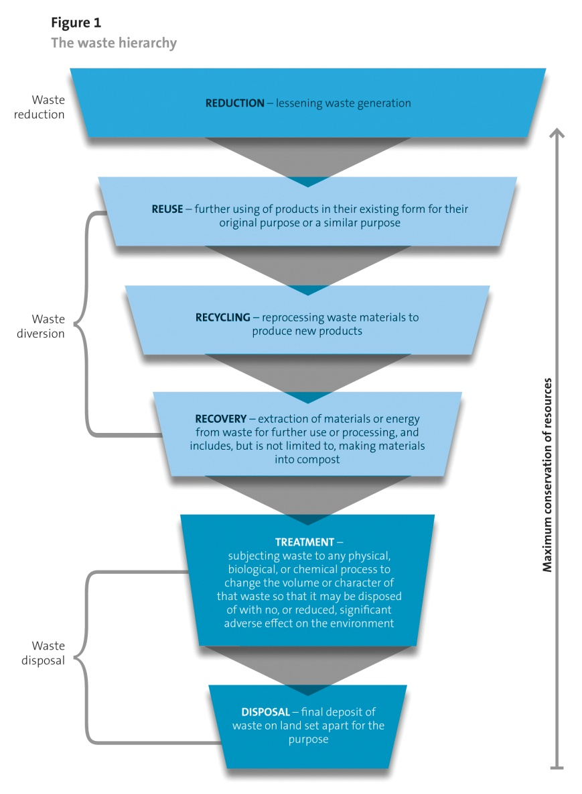

Why a waste disposal levy?
Waste disposal levies are used by governments in many jurisdictions as a user-pays way to influence waste management practices, including the diversion of waste from landfill. A waste disposal (or landfill) levy is imposed over and above the normal gate fees charged by a landfill operator, which increases the price of waste disposal. This price increase is designed to provide an incentive for the waste generator to either reduce the amount of waste they generate, or divert waste away from landfill to other productive uses, such as recycling. As well as influencing waste disposal behaviour, landfill levies raise revenue, which can then be used for specific waste management and minimisation purposes.
In 2006, a review of progress towards the targets in the New Zealand Waste Strategy noted that a lack of funding was a significant barrier to achieving waste diversion and improving councils’ waste minimisation services and infrastructure (Ministry for the Environment, 2007b). An OECD review of New Zealand’s environmental policies in 2007 also recommended increased regulatory support for recovery and recycling, applying the user-pays principle to waste policies, and expanding and upgrading national waste infrastructure (OECD, 2007).
A waste disposal levy in New Zealand is consistent with the user-pays principle and was introduced as a way to provide:
- adequate funding to improve waste minimisation services
- an incentive to minimise the production of waste and divert waste from landfill.
The Waste Minimisation Act introduced a levy on waste disposed of at disposal facilities from
1 July 2009. Currently 48 disposal facilities are subject to levy obligations.
The levy has two purposes set out in the Act: to raise revenue for promoting and achieving waste minimisation, and to increase the cost of waste disposal to recognise that disposal imposes costs on the environment, society and the economy. The levy is currently set at a rate of $10 (plus GST) per tonne.
The revenue raised by the levy is collected by the Ministry for the Environment (the Ministry) and allocated as follows.
- Half is paid to territorial authorities (councils) to spend on promoting or achieving waste minimisation.
- Administration costs to collect and administer the levy and the Waste Minimisation Fund (WMF) are deducted.
- The balance is spent funding projects, through the WMF, that promote or achieve waste minimisation.

The need for review
The Act requires the Minister to regularly review the effectiveness of the levy at least every three years. The review is an opportunity to consider whether the levy is an effective mechanism for:
- raising revenue for waste minimisation
- reducing the amount of waste that is disposed of
- increasing the amount of waste that is reused, recycled or recovered.
The review also provides an opportunity to investigate whether there is a need to vary the application or rate of the levy. The Act states that, in undertaking a review, the Minister:
- must obtain and consider the advice of the Waste Advisory Board
- must consider whether the amount of waste disposed of in New Zealand has decreased since the last review
- must consider whether the amount of waste reused, recycled or recovered in New Zealand has increased since the last review
- may consider any other matters that he or she thinks relevant.
This is the second review. The first review was undertaken in 2011 (Ministry for the Environment, 2011). At that time the levy had only been in place for two years, and so limited conclusions could be drawn about its effectiveness. The first review focused on progress made in implementing the levy and achieving the levy’s short-term outcomes.
The 2011 review found that:
- the levy had been introduced and was operating as intended
- at the time of the review there was insufficient evidence to determine the extent to which levy avoidance or perverse outcomes of the levy (such as illegal dumping) were occurring
- the auditing of disposal facilities indicated the potential for levy avoidance through misclassification of material as ‘diverted’, although at that early point in the levy’s operation it was too soon to determine how widespread or significant this issue might be.
After five years of operation there is a greater body of data available. This review uses an outcomes framework established in 2011 to measure progress against the expected short-, medium- and long-term outcomes of the waste disposal levy.

Approach to reviewing the effectiveness of the levy
As part of the 2011 review an outcomes framework was established to set out a consistent and durable approach to future reviews of the levy. Because these reviews are required to take place at least every three years, it is important they are conducted consistently so an evidence base of the levy’s effectiveness can be built up over time.
The first step in reviewing the effectiveness of the waste disposal levy is to establish a clear understanding of what is meant by ‘effectiveness’. This has been achieved by mapping the anticipated short-, medium- and long-term outcomes of the levy’s operation. Measures can then be used to assess progress against each of these outcomes, building up a picture of the levy’s overall effectiveness.
The anticipated short-, medium- and long-term outcomes of the levy’s operation are set out in the outcomes framework, shown in figure 2. The outcomes framework should be read from the bottom up: from the activity of imposing the levy, to the long-term outcomes to which the levy is designed to contribute.
Figure 2: Expected outcomes of the waste disposal levy and approach to the 2014 review
10. Waste minimisation is achieved.
11. The environment is protected from harm through waste minimisation and a decrease in waste disposal.
12. Environmental, social, economic and cultural benefits are provided through waste minimisation and a decrease in waste disposal.
9. People dispose of less waste and minimise more waste, particularly harmful waste.
6. Waste minimisation infrastructure and services are improved.
7. Waste minimisation is encouraged and promoted.
8. The public appropriately responds to price signals.
3. The cost of waste disposal is increased (to recognise that disposal imposes costs on the environment, society and the economy).
4. Funds are allocated to territorial authorities (to spend on matters to promote or achieve waste minimisation).
5. Funds are allocated to projects (to promote or achieve waste minimisation).
2. Revenue is raised (for promoting and achieving waste minimisation).
1. A levy is imposed on waste disposed of at a disposal facility. (The levy is paid to the levy collector.)
Short-term outcomes
Medium-term outcomes
Long-term outcomes
Activity
Part 1: Levy administration and application
Key evaluation questions:
Is the levy administered effectively?
Is the levy being applied effectively?
Part 2: Levy expenditure
Key evaluation questions:
Has the levy been effective at raising revenue for waste minimisation?
To what extent is levy expenditure resulting in expected waste minimisation outcomes?
Part 3: Cost of waste disposal
Key evaluation questions:
Has the levy increased the cost of waste disposal?
Has the public responded to the levy as a price signal?
Part 4: Achieving waste minimisation
Key evaluation questions:
Has the levy been effective at decreasing the amount of waste disposed of in New Zealand?
Has the levy been effective at increasing the amount of waste reused, recycled or recovered?

The short-term outcomes should be the immediate effects of the levy’s being imposed: revenue is raised, and is then distributed for promoting and achieving waste minimisation, and the cost of waste disposal is increased.
Over the medium term, distributing levy revenue should lead to waste minimisation infrastructure and services being improved, encouraging and promoting waste minimisation. The increase in the cost of waste disposal, through implementing the levy, should lead to the public appropriately responding to price signals (ie, disposing of less waste).
Achieving these short- and medium-term outcomes should lead to minimisation of waste, thereby protecting the environment from harm and achieving environmental, social, economic and cultural benefits. The levy’s implementation has less direct influence on these long-term outcomes because external factors may also come into play. For example, other parts of the Act and other external events will have impacts (both positive and negative) on waste minimisation being achieved.
The effectiveness of the waste disposal levy is reviewed by establishing baseline measures for the short-, medium- and long-term outcomes and making initial measures of progress against these. The data that informs the review was gathered between July 2009 and January 2014.
For the 2014 review the expected outcomes have been grouped into related parts for assessment. Each part focuses on a core function or purpose of the levy, as shown in table 1.
Table 1: 2014 review approach
Review part | Area of focus (as illustrated in figure 2)
Part 1: Levy administration and application | Activity 1
Part 2: Levy expenditure | Outcomes 2, 4, 5, 6, 7
Part 3: Cost of waste disposal | Outcomes 3, 8
Part 4: Achieving waste minimisation | Outcome 9

Key evaluation questions have been identified to focus the analysis of each review part. Figure 2 illustrates the relationship between the outcomes framework, the review parts and the key evaluation questions.

Part 1: Levy administration and application

Approach
Part 1 of the review assesses the extent to which those parties required to calculate, collect, pay or administer the levy are complying with their statutory and regulatory obligations, in order to determine how effectively the levy is being applied and administered. This is the core activity of the levy system, represented at the base of the review framework (figure 2) as activity 1:
1. A levy is imposed on waste disposed of at a disposal facility. (The levy is paid to the levy collector.)
The effectiveness of the levy’s application and administration will influence the extent to which the levy achieves the outcomes shown in the outcomes framework. For example, non-compliance and levy payment minimisation may have an impact on the level of revenue raised by the levy and the effectiveness of the levy as an incentive for waste minimisation.
To determine how effectively the levy is being applied and administered, this part seeks to answer the following evaluation questions:
- Is the levy administered effectively?
- Is the levy being applied effectively?

Is the levy administered effectively?
In assessing the effectiveness of levy administration, the review considered the extent to which disposal facility operators and the Ministry are meeting their statutory and regulatory obligations in paying, reporting on, and collecting the levy. The measures used to analyse this question include the:
- accuracy of levy returns (including the measurement, recording and reporting of waste to the levy collector)
- timeliness of levy returns
- accuracy and timeliness of levy payments
- use of levy waivers
- performance of the levy collector and the Secretary for the Environment in meeting the requirements of the Act and the Waste Minimisation (Calculation and Payment of Waste Disposal Levy) Regulations 2009 (the Regulations).

Is the levy being applied effectively?
This section analyses whether the levy is being applied in accordance with the requirements of the Act and the Regulations, as well as the policy intent. In particular, consideration is given to:
- whether the levy is being applied effectively at prescribed disposal facilities
- whether the current application of the levy only to facilities that accept household waste is effective for generating the expected outcomes of the levy.

Key findings

Levy administration
The Act imposes a levy of $10 per tonne (plus GST) on all waste material disposed of at a disposal facility. A disposal facility is defined in the Act as a facility (including a landfill) where waste, including household waste, is disposed of and which operates, at least in part, as a business to dispose of waste. The operator, or the person who is in control of a disposal facility, must submit levy returns and pay the levy to the levy collector. Since the implementation of the levy, the levy collector has been the Secretary for the Environment.
The Regulations set out the requirements for calculating and paying the levy. Levy obligations have applied to waste disposed of at disposal facilities since 1 July 2009.
This section assesses the:
- accuracy of waste-recording methods used at disposal facilities and the reporting of waste tonnage to the levy collector
- timeliness of disposal facility operators submitting disposal records to the levy collector
- accuracy and timeliness of levy payments by disposal facility operators to the levy collector
- use of waiver provisions in the Act to allow levy payments to be waived
- performance of the Secretary for the Environment and the levy collector in meeting the waste levy requirements of the Act and Regulations.

Accuracy of waste recording and reporting
Disposal facility operators must measure, record and report on the waste that enters their disposal facility. Operators must measure ‘gross tonnage’, or the total tonnage of material that enters a disposal facility. From this, ‘diverted tonnage’ is subtracted. Diverted tonnage is any material that is reused or recycled at the disposal facility, or removed from the disposal facility, within six months. The levy is then payable on the remaining material or ‘net tonnage’ (figure 3).
Figure 3: Formula for calculating the levy payable on waste
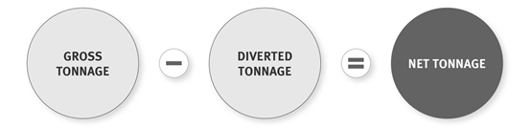
There is a large variation in the amount of waste received and reported across the 48 prescribed disposal facilities (table 2). The largest four of the 48 disposal facilities (8 per cent of the total) account for 59 per cent of the total net waste reported. In contrast, the smallest 15 of the disposal facilities (31 per cent of the total) account for 0.2 per cent of reported net waste.
Based on the large variation in the amount of net waste accepted at disposal facilities, for the purposes of this report the disposal facilities are grouped into five classifications based on the average reported monthly net tonnage:
1. large (> 10,000 tonnes)
2. medium-large (5001–10,000 tonnes)
3. medium (1001–5000 tonnes)
4. medium-small (100–1000 tonnes)
5. small (< 100 tonnes).
Table 2: Comparison of disposal facility size with proportion of waste disposed
The operators of disposal facilities have a regulatory requirement to measure gross tonnage by one of the methods prescribed in the Regulations. The methods include measuring by weight (using a compliant weighbridge), applying volume conversion factors, or using an approved average tonnage system (Ministry for the Environment, 2009a).
The majority of disposal facility operators are measuring their waste accurately using compliant on-site weighbridges. Sixty-two per cent of all current disposal facility operators have a compliant and functioning weighbridge on site and 54 per cent use only their on-site weighbridge to measure waste and diverted tonnage (figure 4).
Figure 4: Breakdown of waste measurement systems used at disposal facilities
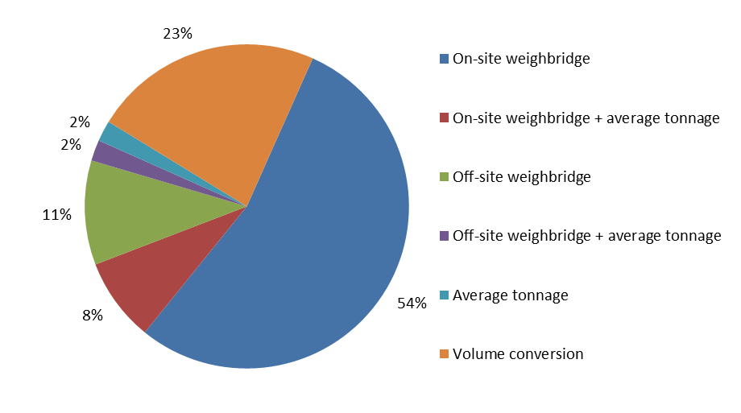
The operators of large, medium-large, and medium-sized facilities are generally most accurate with their waste measurement, with the majority using a compliant weighbridge to measure all of their waste and diverted material.
When evaluated by the amount of net waste measured by each method, over 88 per cent of total net waste is measured using only a compliant on-site weighbridge (figure 5). Only 0.13 per cent of all net waste is measured by either volume conversion or average tonnage system alone.
Figure 5: Proportion of total net waste measured by each method (or combination of methods)
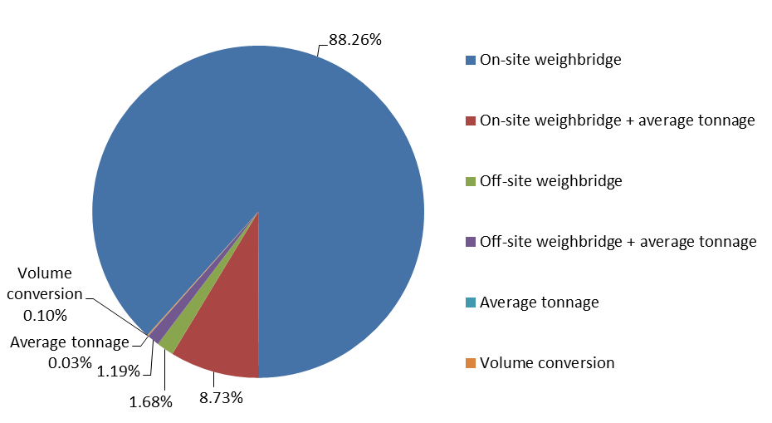

The potential level of inaccuracy is not seen as a significant risk to the effectiveness of levy administration. The operators of disposal facilities that account for the greatest proportion of net waste tonnage have adequate or strong system controls that provide a high level of confidence in the accuracy of tonnage recording and reporting. However, some inconsistencies in the application of average tonnage estimations have been noted, and further guidance on best practice should improve the accuracy of these estimations.

Timeliness of waste reporting
Operators of disposal facilities must adhere to regulatory requirements for submitting returns, as well as for keeping and providing records and other information. A return includes details of the tonnage of waste received, diverted (for reuse, recycling or removal from site), and disposed of within a reporting period.
Disposal facility operators are generally required to submit monthly levy returns on waste tonnage for the calendar month, although operators receiving less than 1000 tonnes annually may apply to submit an annual return. The due date for monthly levy returns is the 20th of the following month. Disposal facility operators submit returns through the Online Waste Levy System (OWLS). They are also required to verify the returns through OWLS before they are finalised.
For the period July 2009 to June 2013, 2034 returns were submitted, of which 97 per cent were submitted by the due date. Only 60 returns (3 per cent) were submitted after the due date. The majority of the late returns (77 per cent) were monthly. However, annual returns have more frequently been late than have monthly returns: 14 per cent of all annual returns were submitted after the due date, whereas this was the case for only 2 per cent of all monthly returns.
Although it is a regulatory requirement that operators of disposal facilities submit returns on or before the due date, no penalties have yet been imposed for late returns. Analysis of returns showed no discernable patterns in which facilities submitted late returns, or how late returns were submitted. Ninety-eight per cent of late returns were submitted within 18 days of the due date, which indicates that any deliberate or systematic late submission of returns does not present any significant risk to the effectiveness of the levy.

Timeliness and accuracy of levy payments
Operators of disposal facilities are required by law to pay the levy on waste disposed of at their disposal facility, based on the information provided in their returns. Invoices are sent to disposal facility operators by the 15th day after the day the return is due and apply to waste deposited two months before the invoice date. For example, an invoice sent on 1 September will relate to a return submitted on 20 August for waste deposited in July. The payment for waste deposited in July is due, at the latest, by 20 October.
During the period 1 July 2009 to 30 June 2013, 2643 invoices were issued. Of the invoices issued, 2246 (85 per cent) were paid on time. Invoices were also issued for interest payable on overdue levy amounts. These invoices for interest owed are more frequently paid late, as illustrated in figure 6.
Figure 6: Timeliness of levy invoice payments
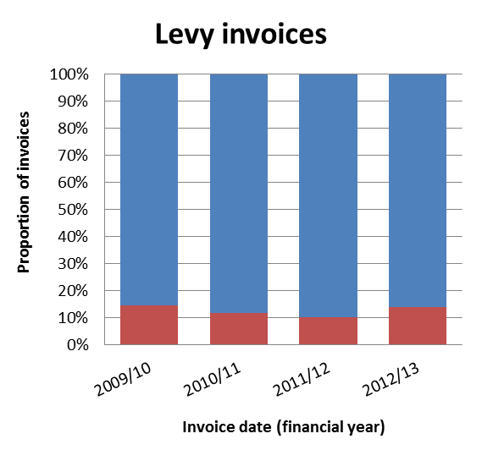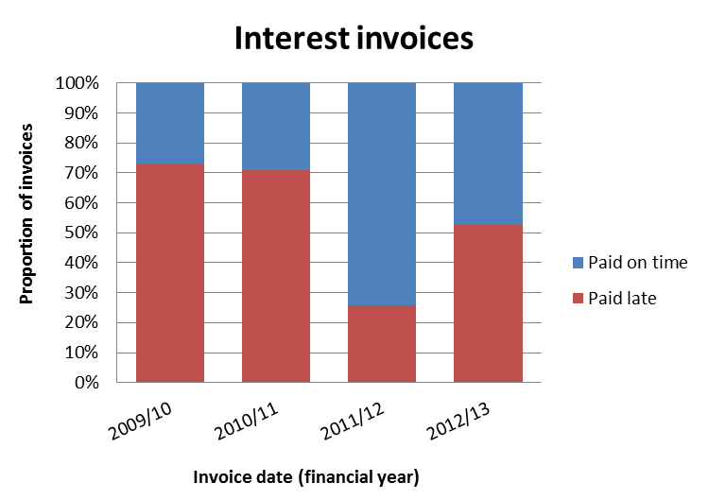
Interest invoices and levy invoices have different payment timeframes. Invoices issued on a levy payable have a due date of nearly three months after the invoice date. Invoices issued on interest payable have a due date of only one month after the invoice issue date. The different due dates for the different invoice types may be a contributing factor to the higher proportion of late interest payments (people may think they have three months to pay an interest invoice).
Late payments of both levy and interest are more frequently made by small to medium-sized disposal facilities (figure 7). The large disposal facilities that account for the majority of the levy payable generally pay their levy on or before the due date. As a result, the total interest that has been charged is very low in comparison to the amount of levy paid: $2444 in interest has been charged during the period 1 July 2009 to 30 June 2013 (equivalent to 0.002 per cent of the total levy payable).
Figure 7: Proportion of late levy payments, by disposal facility size
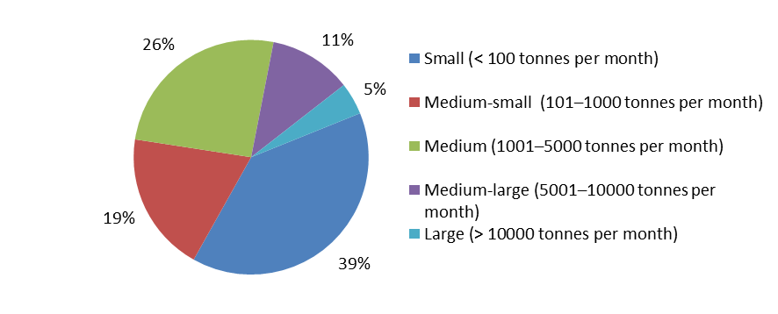
An independent audit of the levy collector in September 2013 identified that interest on unpaid levies had been charged at incorrect rates. Interest had been charged at a rate of 7.5 per cent since July 2009, but in accordance with section 35 of the Act, and section 87(3) of the Judicature Act 1908, the interest rate charged should have been 8.4 per cent until 30 June 2011 and 5.0 per cent from 1 July 2011. The auditors identified a potential net overpayment of $242 by the disposal facility operators. The interest rate has since been corrected and overpayments reconciled with operators.

Waivers
Operators of disposal facilities can apply to the Secretary for the Environment to have the requirement to pay levy money waived. This must be due to exceptional circumstances (eg, something that could not reasonably be predicted or expected and is not a regular event, such as a natural disaster). Approvals to waive the levy on a measure of waste have been granted to only one disposal facility operator for a total of 15 months. Three disposal facility operators have had their waiver applications declined (table 3).
Table 3: Applications to waive levy
Financial year | Approved applications to waive levy |  | Declined applications to waive levy
Financial year | Number of applications approved | Tonnage waived | Number of applications declined | Approximate tonnage applied to be waived
2009/10 | 0 | 0 | 3 | 131,209
2010/11 | 7 | 54,736.95 | 0 | 0
2011/12 | 8 | 21,679.92 | 0 | 0
Total: | 15 | 76,416.87 | 3 | 131,209

The approved levy waivers were granted to the operators of Kate Valley Landfill to deal with waste from the Canterbury earthquakes in 2010 and 2011, in recognition of the fact that the Government wanted to avoid exacerbating the hardship caused to people as a result of the exceptional circumstances arising from the earthquakes. The waivers were granted on a monthly basis for a total of 15 months over two periods: September 2010 to November 2010, and March 2011 to February 2012. The levy waived per month related to amounts ranging from 976 tonnes to 17,720 tonnes, with a monthly average of 5094 tonnes. The levy was waived on a total of 76,416.87 tonnes, which would have equated around 1 per cent of total net tonnes reported from the implementation of the levy to June 2012.
Three applications for levy waivers were declined from disposal facility operators in 2009/10. In all cases the circumstances were deemed not to be exceptional. Declined applications related to:
- contaminated soil removed from a stream under remediation work – the Secretary declined the application on the basis that the circumstances were not exceptional and would be similar in all contaminated land clean ups
- historical treated slag from battery recycling before levy implementation – the Secretary determined that the situation could reasonably have been predicted and should be classified as business as usual
- historical waste excavated from a closed landfill – the situation of the excavated landfill was not considered to be exceptional.
Provisions to waive the requirement to pay the levy in exceptional circumstances appear to have been applied in accordance with the Act and policy intent.

Performance of the Secretary and levy collector
The Act and Regulations specify responsibilities for the Secretary for the Environment and the levy collector for administering the levy. The operator of a disposal facility must pay the levy to the levy collector. The Act and Regulations provide for operators of disposal facilities to apply to the Secretary or the levy collector for approval for a number of functions.
The Secretary for the Environment is the default levy collector under the Act. The decision-making powers and functions of the Secretary as the levy collector are delegated to Ministry officials. Under an Operational Services Agreement, Fishserve Innovations New Zealand Limited (FINNZ) and the Ministry have agreed that FINNZ will perform specific administrative services required of the levy collector.
The performance of the levy collector and Secretary for the Environment in completing their statutory requirements has been evaluated (appendix 1) against the performance rating criteria set out in tables 4 and 5.
The levy collector’s performance was assessed against 25 statutory and regulatory requirements, of which six functions had yet to be used. Table 4 provides a summary of the levy collector’s performance ratings in relation to the 19 functions assessed. The full list of these functions can be found in appendix 1.
Table 4: Summary of the levy collector’s performance in relation to statutory and regulatory requirements
Performance rating | Criteria | Score | Percentage
Excellent | 100% of timeframes/requirements met | 16/19 | 84%
Good | 90+% of timeframes/requirements met | 2/19 | 11%
Adequate | 75+% of timeframes/requirements met | 0/19 | 0%
Poor | < 75% of timeframes/requirements met | 1/19 | 5%
N/A | Function not used to date

The Secretary’s performance was assessed against four statutory and regulatory requirements, of which one is yet to be used. Table 5 provides a summary of the Secretary’s performance ratings in relation to the three functions assessed.
Table 5: Summary of the Secretary for the Environment’s performance in relation to statutory and regulatory requirements
Performance rating | Criteria | Score | Percentage
Excellent | 100% of timeframes/requirements met | 2/3 | 66.6%
Good | 90+% of timeframes/requirements met | 1/3 | 33.3%
Adequate | 75+% of timeframes/requirements met | 0/3 | 0%
Poor | < 75% of timeframes/requirements met | 0/3 | 0%
N/A | Function not used to date

The Secretary for the Environment has met the majority of the statutory requirements of the Secretary and levy collector with 100 per cent compliance. The only requirement that has received an ‘adequate’ or ‘poor’ rating related to the incorrect specification of the interest rate to calculate interest payable on late levy payments (as outlined above).

Application of the levy
The 2011 review highlighted some potential areas where the levy might not be being applied as intended. This section analyses whether the levy is being applied in accordance with the policy intent and the requirements of the Act and Regulations. In particular, consideration is given to:
- whether the levy is being applied effectively at prescribed disposal facilities
- whether the current application of the levy only to facilities that accept household waste is effective for generating the expected outcomes of the levy.

Application of the levy at disposal facilities
The 2011 review noted that the Ministry’s compliance assurance programme had found variation in the way disposal facility operators interpret and treat diverted material and cover material. The audits found “potential for levy avoidance through misclassification of material as diverted”. However, at that early point in the levy’s operation it was thought to be too soon to determine how widespread or significant this issue might be.
Further focus has been given in this review to investigating the nature and extent of the classification of materials and how it reduces payment of the levy. This section provides an analysis of the extent to which waste that was intended to be subject to the levy is currently entering disposal facilities but not having the levy paid on it.
As outlined above, disposal facility operators must measure, record and report on the waste that enters their disposal facility. They must measure ‘gross tonnage’, or the total tonnage of waste that enters a disposal facility. From this, ‘diverted tonnage’ is subtracted. Diverted tonnage is any material that is reused or recycled at the disposal facility, or removed from the disposal facility within six months. The levy is then payable on the remaining material, or ‘net tonnage’.
Auditing data indicates that approximately 24 per cent of waste material entering disposal facilities is being classified as diverted material. Of this, only 3 per cent is being removed from site, while 21 per cent is being classified as diverted tonnage and used on site (figure 8). The levy is therefore being paid on only 76 per cent of waste material entering disposal facilities, or 78 per cent of waste material that enters and remains on site.
Figure 8: Classification of waste material that enters disposal facilities, by disposal facility size
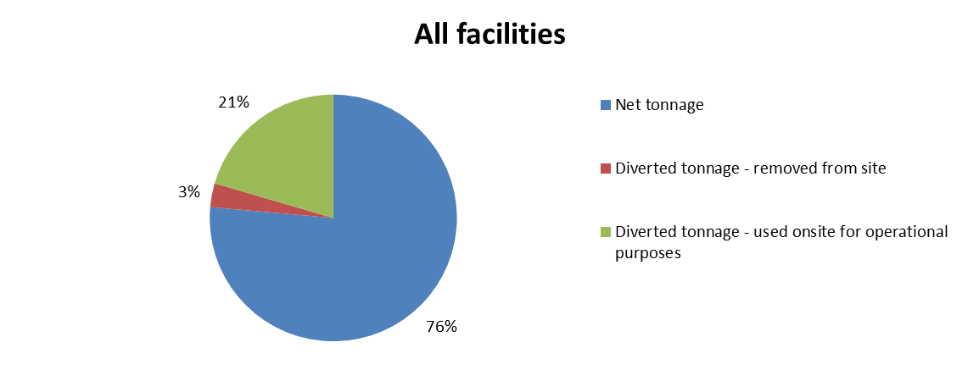
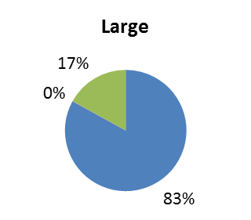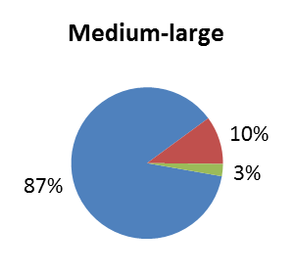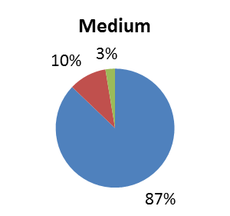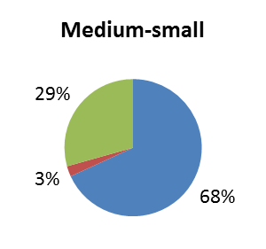
Based on this data, it is likely that a number of disposal facility operators are interpreting their levy obligations to mean that the levy is not payable on waste received at their facility if it is being reused or recycled on site. The issue of which waste materials fall within the definitions of reuse and recycle is not explicitly defined in the Act. Examples of waste classified as reused or recycled by disposal facility operators and used on site include by-products from metal crushing/recycling (shredder floc), pulp waste, shredded tyres, lime glass, and contaminated soils.
This interpretation of the diverted material provisions contradicts the policy intent for the levy, which was that the levy would apply to all waste material disposed of at a disposal facility (“any material that goes to a landfill”), recognising that to allow exemptions “may encourage avoidance of the levy” (Office of the Minister for the Environment, 2007, para 38). Waste materials used for operational purposes at a disposal facility are remaining on site
(ie, ultimately disposed of) and are not being diverted from the waste stream, as the reuse and recycling provisions of the Act intended.
This practice of classifying waste as ‘diverted tonnage’ varies across disposal facility operators. Differing interpretations of the definitions in the legislation are creating inequity with some operators not paying the levy on some materials that other operators are paying a levy on. Disposal facility operators who pay the levy on all deposited waste may face competition from, and risk losing market share to, facilities that do not pay the levy on all deposited waste.
From these proportions, and based on the reported 2012/13 net tonnage of current disposal facilities, it can be inferred that approximately 713,500 tonnes of waste material is diverted annually for operational use on site at disposal facilities. The average amount of waste material that is being diverted for operational purposes, at 20 per cent of total waste disposed of, is around twice the limit that was proposed by the Ministry in 2009 (Ministry for the Environment, 2009b) and is higher than the level of levy exemption for operational materials used in some overseas jurisdictions (eg, 15 per cent in Victoria; EPA Victoria, 2013). This gives further weight to concerns that some operators are exploiting the ambiguity in the definitions of ‘reuse’ and ‘recycling’ of material.
To sum up, at the current levy rate, the amount of waste being classified as diverted material being used on site equates to over $7 million in potential levy revenue that is not being collected. This is not an insignificant issue, and despite the Ministry’s attempts to provide guidance on the matter, ambiguity in the definitions in the Act has meant that a variety of interpretations of the levy obligations are being used. This has resulted in inequity among those responsible for paying the levy.

Application of the levy to facilities that do not accept household waste
Under the Act, the levy is payable on waste disposed of at landfills that accept household waste (a disposal facility). There are a number of other types of landfills that do not accept household waste, variously referred to as cleanfills, managed fills, or construction and demolition fills. At present these landfills that do not accept household waste are not subject to levy obligations.
There is concern that the current application of the levy only to landfills that accept household waste may be too narrow. The Ministry has observed some landfill operations that are structured in ways that reduce or avoid levy obligations. This practice, if it becomes more common, may have the potential to undermine the effectiveness of the levy. Landfills that do not accept household waste are not subject to levy obligations and therefore can offer lower disposal fees than disposal facilities that are required to pay the levy. This situation provides a financial incentive for those who generate or transport non-household waste to dispose of it at non-levied landfills. There is a risk that if these incentives remain, it could ultimately result in the levy applying exclusively to household waste, with other waste being diverted to less expensive, non-levied landfills.
The decision in 2008 to initially apply the levy only to landfills that accept household waste was a pragmatic one to ensure ease of implementation. Data had already been obtained on these landfills through the four National Landfill Censuses conducted between 1995 and 2006. It was recognised at the time that there was very limited data available on other types of landfills.
It is apparent from policy documents informing development of the levy under the Act that the original intent was to make other landfills subject to the levy over time. The Departmental Report on the Waste Minimisation (Solids) Bill notes that “[w]e intend for cleanfills to be subject to the waste disposal levy at a later date. At this stage the Ministry does not have sufficient information on cleanfills to include them.” Also, “[o]nce the Ministry has a more accurate overview of these sites, the Government can make more informed decisions on whether or not they should be subject to the levy” (Ministry for the Environment, unpublished, pp 127–128).
Based on the concerns raised about the current application of the levy, this section aims to assess the extent to which waste that should be subject to the levy is being disposed of at non-levied landfills. The Ministry has gathered further information about waste disposal to non-levied landfills, and this should help inform policy decisions about whether additional landfills should be subject to the levy in order to improve the levy’s effectiveness.
Some information was gathered as part of the 2011 review to investigate anecdotal reports and sector concerns that non-levied landfills were increasingly being used as a form of levy avoidance. To build on this analysis, the Ministry commissioned Tonkin & Taylor to identify the number of non-levied landfills in New Zealand (Tonkin & Taylor, 2013) and to estimate the volume and composition of waste material deposited at these landfills and in farm dumps. Details of the methodology used to establish the database, data limitations, and assumptions are provided in appendix 2.
Raw data on a number of non-levied landfills has been used to inform the review, but detailed data on non-levied landfills was not available where operators were not required to record the volume or composition of waste accepted. There is also very little information on landfills (such as some cleanfills) that operate under permitted activity rules. Consequently, total tonnages have been extrapolated from the raw data based on regional Gross Domestic Product (GDP). The method used was considered appropriate because of the limited data available. However, due to the nature of the method used, detailed trends over short periods of time (ie, 3 to 4 years) cannot be determined from the findings.

(a) Number of non-levied landfills in New Zealand
There have been anecdotal claims from the waste sector that new landfills are being established that deliberately exclude household waste to avoid levy obligations. The Ministry is aware of some new landfills that do not accept household wastes but do accept other wastes that require similar treatment.
Landfills that are not subject to waste disposal levy obligations: Case study: Tauranga
A landfill that does not accept household waste has recently been granted resource consents under the Resource Management Act 1991 in Tauranga.
This Class A landfill specifically excludes household waste and is consented until 2046. The landfill is designed with a geosynthetic clay liner, a leachate collection system, and stormwater controls. The landfill accepts a range of waste, including:
- concrete and brick rubble
- glass
- plastics
- paper and cardboard
- ferrous metals
- fibreglass and polystyrene
- wallboards of plaster, MDF or hardwood
- untreated timber offcuts
- bulky tree wastes
- sawdust (non-treated)
- tyres (quartered)
- grit and sediment from street sweepings, road sump cleaning and truck washes
- boiler ash.

Information was sought on the number of non-levied landfills operating before and after the implementation of the levy to see whether the levy has driven an increase in the number of landfills that do not accept household waste and are therefore not subject to the levy. The Tonkin & Taylor work estimated that there are currently 263 non-levied landfills operating outside of levy obligations in New Zealand, with an additional 460 sites that have closed since 2000. The implementation of the levy in 2009 does not appear to have had an immediate impact on the overall number of non-levied landfills in operation.
However, there is a range of different types of non-levied landfill. To provide greater insight into disposal at these different types of non-levied landfills, data has been classified retrospectively according to the four proposed classes of the draft Land Disposal Technical Guidelines (WasteMINZ, 2013).

(b) Number of non-levied landfills, by type
Each landfill identified in this work has been retrospectively allocated to one of the four classes of the draft Land Disposal Technical Guidelines, based on the composition of waste accepted at that site. Note that levied disposal facilities as defined in the Act would be classified as Class 1 landfills. Table 6 shows how these waste types are allocated to the landfill classes.
Table 6: Composition of non-levied landfills
Landfill class* | Site composition | Count**
Class 4 landfill – cleanfill | - Cleanfill  - < 2% organics | 166
Class 3 landfill – managed/controlled fill | - Managed cleanfill  - Shells: mussel/egg stockpiles  - < 2% organics | 5
Class 2 landfill – construction and demolition landfill or industrial waste landfill | - Ash  - Construction and demolition  - Industrial: where specific type of industrial is unknown  - Industrial mining: mining tailings  - Inert sludge: mud and cuttings from drilling, sludge from waste-holding ponds, and sludge from the power station  - Uncontrolled fill  - < 5% organics | 46
Class 1 landfill – municipal solid waste landfill or industrial waste landfill | - Asbestos  - Biological: sludges from sewer/septic tanks and offal and meat-based waste  - Domestic (but household waste is excluded by the facility operator if the landfill is not to be subject to the levy)  - Farm waste  - Green waste  - Hazardous  - Industrial steel: waste clay slimes from iron sand processing, stormwater pond sludges, minor general non-putrescible waste  - Wood waste  - > 5% organics | 32
Unknown |  | 14
* Landfills have been retrospectively assigned to a class from the draft Land Disposal Technical Guidelines based on the composition of waste accepted at the facility.
** Number of open non-levied landfills in New Zealand per class in 2013.

Figure 9 illustrates the trends in the number of operating non-levied landfills by class between 2000 and 2013. Between 2009 (the year the levy was introduced) and 2013 (the time of research), the number of non-levied landfills designated as Class 1 (accepting wastes similar in composition to levied landfills) increased from 26 to 32. Over the same period, the number of levied landfills decreased from 54 to 48.
Figure 9: Number of non-levied landfills in New Zealand, by class, 2000–2013
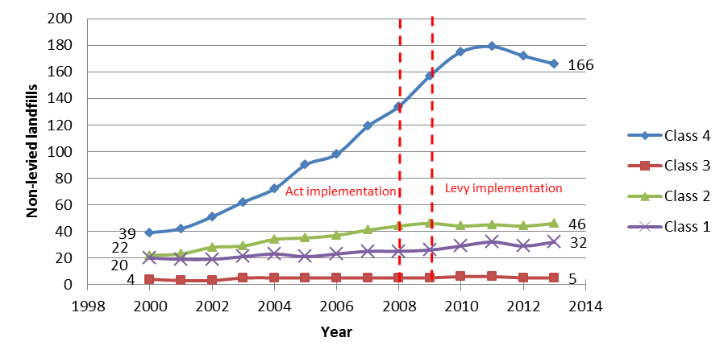
The increase in non-levied Class 1 landfills is relatively minor, but may provide indicative support for anecdotal claims that new landfills are being established that accept wastes with similar composition to levied landfills but that exclude household waste in order to minimise levy obligations.

(c) Estimated total waste disposal to non-levied landfills
Tonkin & Taylor provided estimates of the amount of waste disposed of to non-levied landfills and farm dumps. For 2013, they estimated that 6,454,322 tonnes of waste were disposed of to non-levied landfills and farm dumps in New Zealand (figure 10). This compares to a total of 2,684,056 tonnes of waste deposited in levied landfills.
Figure 10 shows the estimated proportions of total waste disposed of in 2013 to disposal facilities, the four classes of non-levied landfill, and farm dumps. It suggests that less than 30 per cent of total waste disposed of to land in New Zealand went to disposal facilities, while 8 per cent of total waste (or 14 per cent of waste to non-levied facilities) may have gone to non-levied Class 1 landfills.
Figure 10: Estimated breakdown of total waste disposed of to land in 2013
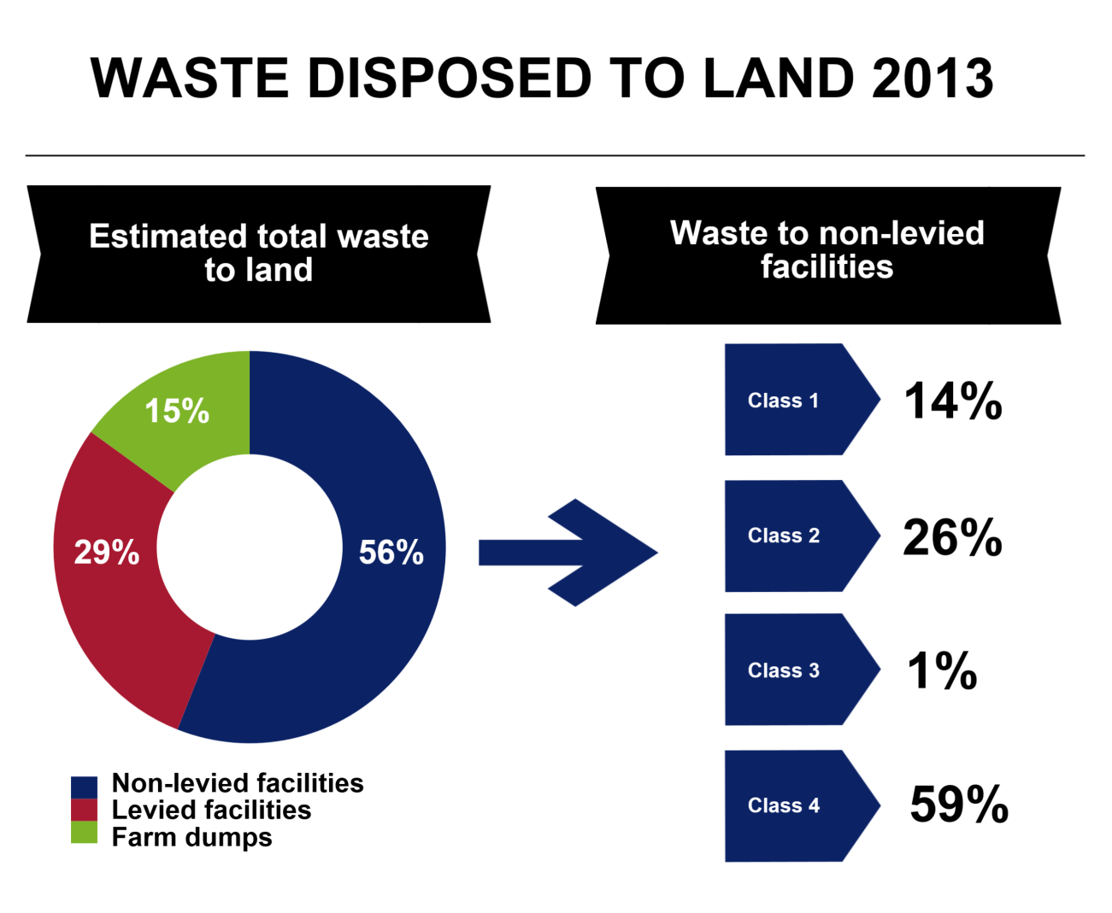
Due to gaps in the data, and the need to extrapolate from raw data based on regional GDP figures, it is not possible to examine changes in overall waste disposal over time. Consequently, it is not possible to conclude whether there has been a change in the quantity of waste disposed of to non-levied landfills since the introduction of the levy.

Activity 1: Conclusions
1. A levy is imposed on waste disposed of at a disposal facility. (The levy is paid to the levy collector.)
The administrative process for calculating and paying the levy appears to be highly effective. The levy collector and the Secretary for the Environment have generally met their obligations in collecting and administering the levy.
The significant majority of waste material deposited at disposal facilities is being appropriately and accurately recorded and reported within statutory requirements, with 97 per cent of levy returns submitted on time.
Operators of disposal facilities are generally meeting their obligations under the Act and the Regulations for levy payments, with 85 per cent of levy invoices paid on time. Late levy payments only represent a small proportion of the total waste levied.
Although operators are largely compliant in their requirement to pay the levy, it does appear that a potential exists for minimising levy payment, both through the potential misclassification of waste at disposal facilities and through disposal of waste at landfills where the levy does not currently apply.
Inconsistent interpretation of the legislation is allowing variation in the way operators are paying the levy on materials used for operational purposes. This practice is inequitable, inconsistent with the policy’s intent (which was to levy all material disposed of at a disposal facility) and has the potential to undermine the levy revenue base.
The 2011 review raised anecdotal concerns that cleanfills and other non-levied fills were increasingly being used as a form of levy avoidance. However, there was insufficient information to establish whether the amount of waste being disposed of at such fills was any higher than before the levy was introduced. This review has attempted to validate these claims by collecting data on the number of, and amount of waste disposed of to, non-levied landfills. It has found a relatively minor increase in the number of non-levied landfills that accept wastes of similar composition to levied landfills since the introduction of the levy, but there is not sufficient information available to determine whether or not the amount of waste disposed of to such landfills has increased.
The finding that the levy is only being applied to landfills taking 30 per cent of waste disposed of to land has implications for the effectiveness of the levy. Not only does this relatively narrow application of the levy allow for unintended levy minimisation, it also means the incentive effect of the levy is limited. The second purpose of the levy is to “increase the cost of waste disposal to recognise that disposal imposes costs on the environment, society and the economy”. By only applying the levy to landfills taking 30 per cent of waste disposed of, a significant proportion of waste generators are not receiving any pricing incentive to minimise waste. The implications of this are discussed further in Part 3 of this report.
The decision to initially apply the levy only to facilities that accept household waste was a pragmatic one, to simplify administration by introducing the levy first on landfills that had already been identified by the Ministry. It was recognised that there was limited information available about non-municipal landfills at the time the levy was introduced, and that subsequent consideration should be given to extending the regime to additional facilities. While there are still significant gaps in the information available about other landfills, information obtained for this review suggests it may be time to consider whether additional landfills should become subject to the levy obligations.

Recommendations
1. Investigate options to clarify the legislation so that the levy is consistently applied at disposal facilities.
2. Investigate making additional waste disposal sites subject to levy obligations.

Part 2: Levy expenditure

Approach
This part looks at the extent to which the first purpose of the levy, “to raise revenue for promoting and achieving waste minimisation”, is being achieved. To do this, we review progress towards outcomes 2 to 7 of the outcomes framework.
To determine how effectively the levy achieves this purpose, this part seeks to answer the following evaluation questions:
- Has the levy been effective at raising revenue for promoting and achieving waste minimisation?
- To what extent is levy expenditure resulting in expected waste minimisation outcomes?
Has the levy been effective at raising revenue for promoting and achieving waste minimisation?
This question evaluates outcomes 2, 4 and 5 of the outcomes framework. It assesses how much revenue the levy is raising, what the funding has been spent on, and whether this spending is compliant with the legislation and aligns with policy intent.
2. Revenue is raised (for promoting and achieving waste minimisation).
4. Funds are allocated to territorial authorities (to spend on matters to promote or achieve waste minimisation).
5. Funds are allocated to projects (to promote or achieve waste minimisation).

To what extent is levy expenditure resulting in expected waste minimisation outcomes?
This question evaluates outcomes 6 and 7 of the outcomes framework and aims to assess the value of the funding in terms of the benefits generated as a result of the investment.
6. Waste minimisation infrastructure and services are improved.
7. Waste minimisation is encouraged and promoted.

Key findings

Outcome 2: Revenue is raised (for promoting and achieving waste minimisation)
Table 7 provides a summary of levy revenue raised, as of 31 January 2014.
Table 7: Levy revenue raised, 1 July 2009 – 31 January 2014
Financial year | Levy revenue raised
2009/10 | $24,990,960
2010/11 | $25,525,980
2011/12 | $24,467,020
2012/13 | $25,958,400
1 July 2013 – 31 Jan 2014 | $13,839,606
Total revenue raised | $114,781,966
Revenue generated by the levy for funding waste minimisation is distributed as follows, as specified in section 30 of the Act.
- Fifty per cent of the gross revenue is allocated to territorial authorities (TAs), on a population basis, to be used for implementing waste minimisation activities specified in their waste management and minimisation plans.
- The remainder (less administrative costs) is used for a contestable fund for waste minimisation projects that further the Government’s policy on waste (the Waste Minimisation Fund, or WMF).
Figure 11 provides a breakdown of levy expenditure at the time of reporting. Further detail is provided in table 8. Note that total funding allocated may exceed revenue collected because WMF allocations are based on a forecast of levy revenue collected and when the funding is expected to be paid to successful applicants.
Figure 11: Levy revenue allocations (1 July 2009 – 31 Jan 2014)
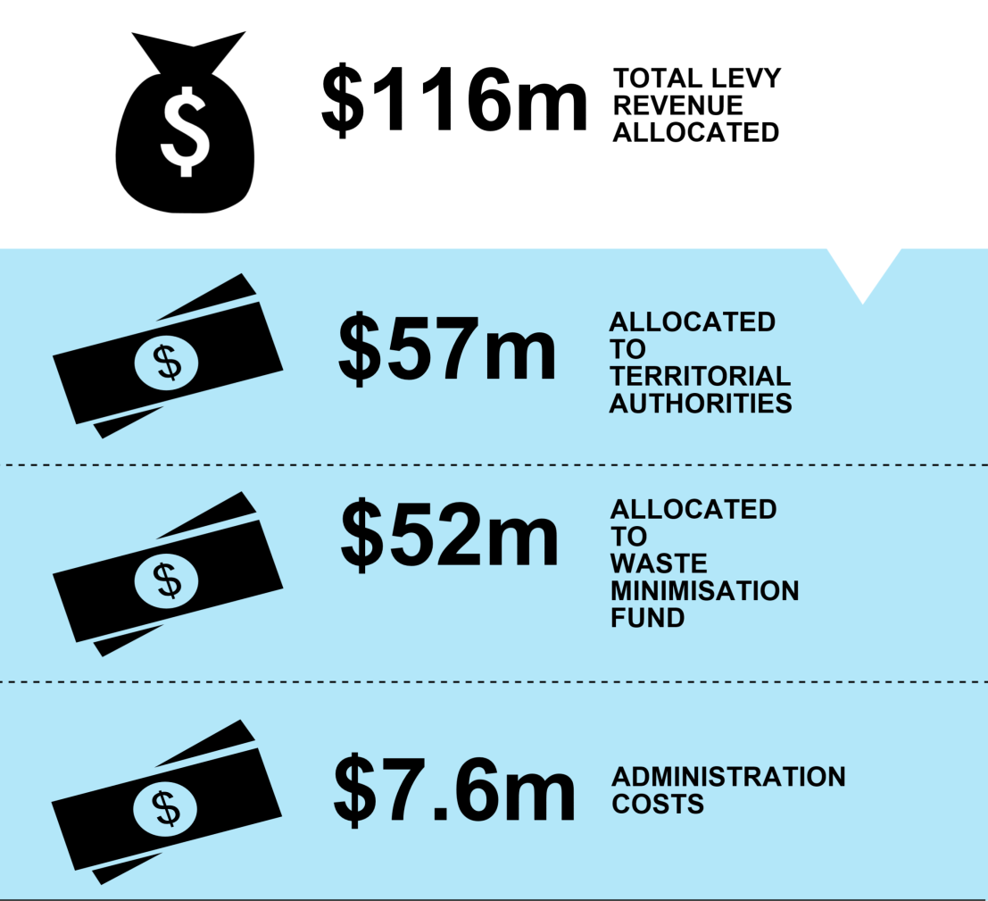
Table 8: Breakdown of levy revenue allocated, July 2009 – January 2014
Year* | Allocation to TAs | WMF funding allocated | Administration | Total
2009/10 | $6,236,138.57 | $7,787,413.00 | $1,700,000.00 | $15,723,551.57
2010/11 | $12,536,954.71 | $12,201,298.00 | $1,524,081.31 | $26,262,334.02
2011/12 | $12,377,925.20 | $14,406,460.00 | $1,698,118.17 | $28,482,503.37
2012/13 | $12,553,523.04 | $10,221,920.00 | $1,700,000.00 | $24,475,443.04
1 July 2013 – 31 Jan 2014 | $13,318,118.74 | $7,720,575.00 | $991,666.67 | $22,030,360.41
Revenue allocated to date | $57,002,660.26 | $52,337,666.00 | $7,613,866.15 | $116,974,192.41
* Financial year 1 July to 30 June.

Outcome 2: Conclusions
2. Revenue is raised (for promoting and achieving waste minimisation).

Revenue is being raised through the levy. At the current rate of $10 per tonne (plus GST), around $115 million has been raised since the levy was introduced on 1 July 2009. It is being distributed for waste minimisation purposes in accordance with the requirements of the Act.

Outcome 4: Funds are allocated to territorial authorities (to spend on matters to promote or achieve waste minimisation)
The 67 territorial authorities (TAs) in New Zealand play a key role in waste management and minimisation. Under the Act, TAs must promote effective and efficient waste management and minimisation within their districts. To achieve this, they must adopt a waste management and minimisation plan.
Half of the revenue raised by the levy is distributed to TAs on a population basis. This money must be spent on matters to promote or achieve waste minimisation, and in accordance with the waste management and minimisation plan. Payments of levy funding are made to TAs on quarterly dates specified in the Act. These quarterly payments are based on levy revenue from waste disposed of at levied disposal facilities during the previous quarter. For example, levy payments to TAs in January of each year are based on levy revenue collected from levied disposal facilities between 20 September and 20 December the previous year.
This section:
- assesses levy funds allocated to TAs
- assesses levy funds spent by TAs
- analyses TA levy spending by category.

Levy funds allocated to TAs
Figure 12 shows levy money paid to all TAs, by quarter, from 2010 onwards. Table 9 provides detail of total funding distributed to TAs by reporting period.
Figure 12: Levy payments to TAs, January 2010 to October 2013
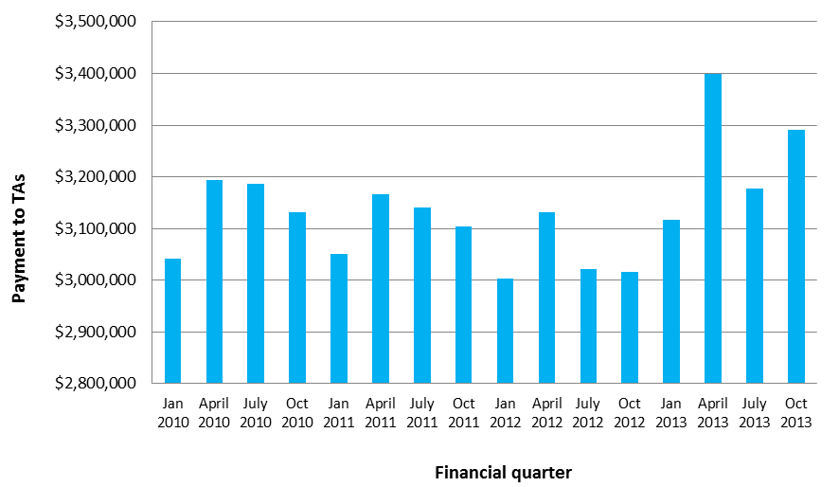

Levy funds spent by TAs
A total of $43,684,547.58 of levy funding had been distributed to TAs up to 30 June 2013. Of this, $13,618,595.28 was reported as unspent. This is equivalent to 31.2 per cent of distributed levy funding to TAs between January 2010 and June 2013. A breakdown of unspent and unreported levy funding for each reporting period is provided in table 9.
Table 9: Breakdown of spent vs unspent TA levy funding
Reporting period | Amount distributed | Amount reported as spent | Amount unspent | % unspent
1 (Jan and April 2010) | $6,236,139.10 | $5,322,502.60 | $622,205.89 | 10
2 (July and Oct 2010) | $6,318,879.33 | $2,650,998.83 | $3,500,012.51 | 55.4
3 (Jan and April 2011) | $6,218,080.40 | $4,549,536.64 | $1,628,715.76 | 26.2
4 (July 2011 – June 2012) | $12,377,925.34 | $8,446,632.36 | $3,931,292.98 | 31.8
5 (July 2012 – June 2013) | $12,533,523.41 | $8,544,340.08 | $3,936,368.14 | 31.4
Total | $43,684,547.58 | $29,514,010.51 | $13,618,595.28 | 31.2
The Ministry requests levy spend reports, commissions independent audits, and undertakes compliance reviews of TAs under the Ministry’s Compliance Assurance Programme to assess whether TAs are spending levy money in accordance with section 32 of the Act. Results indicate that levy spending by TAs is largely compliant with the requirements prescribed in that Act. Audit and review findings have mainly been concerned with accounting procedures for the treatment of unspent levy funding and establishing firm links between projects funded by the levy and waste management and minimisation plans. The Ministry recently developed levy spend guidance material for TAs, to provide clear direction for identifying spending priorities and to accurately report on the spending of levy funding, including good practice financial processes for accruing levy money. The Ministry has been actively working with TAs to ensure all levy money is accounted for.
The Act does not require TAs to spend their levy money within a certain timeframe, but the Ministry wanted to understand why almost a third of money distributed to TAs was unspent. The most common reason cited by relevant authorities was that the amount received through each quarterly payment was simply not enough to put towards worthwhile investments or to get projects off the ground straight away. Funds are therefore generally being accrued for a specific future investment. The current level of funding allocated to TAs at each quarterly payment, or the model for distributing funding on a population basis, may not be sufficient to support advantageous spending by some TAs. This is particularly likely to be the case for smaller TAs with itinerant tourist populations or other issues of economies of scale, which have difficulties providing affordable services or establishing new infrastructure.

Analysis of TA spending by category
Section 32 of the Act states that a TA may spend levy money it receives only “on matters to promote or achieve waste minimisation; and in accordance with its waste management and minimisation plan”. The Ministry asks all TAs to report on how this levy money is being spent, both to ensure that spending is in accordance with the Act and to assess the outcomes of this spending. This reporting is currently not mandatory.

The Ministry has requested information from TAs on their levy expenditure for five reporting periods between January 2010 and June 2013. TA levy spending has been analysed against the following categories:
a) project type: infrastructure, services, education, research and reporting, or other
b) status: new, existing, or expansion of activity.
Results from TA levy spend reports, and staff-led or third-party audits under the Ministry’s Compliance Assurance Programme, indicate that levy spending by TAs is largely compliant with the requirements prescribed in the Act. Audit findings have been mainly concerned with accounting procedures, the treatment of unspent levy money, and establishing firm links between projects funded by levy money and waste management and minimisation plans. Audit findings have been satisfactorily worked through with the TAs concerned.

a) Reported TA levy expenditure, by project type
Figure 13 provides a breakdown of reported levy spending of TAs by project type.
Figure 13: TA levy expenditure, by project type, 2010-13*
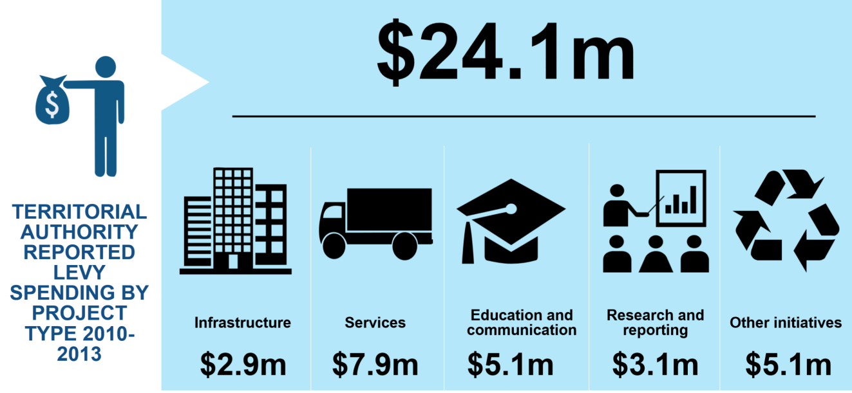
* Excludes reporting period 1, where data on spending by project type was unavailable. See table 10 for reporting periods.
Table 10 provides details of these different project types, along with examples TAs have reported spending waste levy funding on.

Table 10: TA spending project types and examples
Project type | Definition | Examples
Education and communication | All communication- and education-related spending, including communications about the introduction of new services or expansion of existing services, and education aimed at students or the general public, including workshops or any other public-facing messaging the council develops about waste minimisation. | - South Taranaki District Council: funding to the Para Kore Zero Waste Marae education programme  - Tauranga City Council: home-composting education programme  - Funding support to EnviroSchools and Paper4Trees
Infrastructure | Spending on all items that have an asset value and that are managed under the TA’s solid waste asset management plan. Any items (such as bins) recorded as having an asset value by the TA should be recorded as infrastructure. | - Selwyn District Council: shredder for an organic composting operation  - Dunedin City Council: Love NZ public place recycling bins  - Western Bay of Plenty District Council: establishment of a community recycling centre at Te Puke
Services | All costs directly related to the provision of a service, including all contract costs and consumable items (bags, stickers, etc). | - Christchurch City Council: kerbside organic waste collection service  - Horowhenua District Council kerbside recycling service  - Whangarei District Council e-waste recycling service
Research and reporting | Functions that promote and support waste minimisation outcomes, such as research, including survey, studies, trials and pilot schemes; policy initiatives, such as development of bylaws or charging regimes; and monitoring and gathering of information and data and their analysis and reporting. | - Auckland Council’s research for an organic collection and processing project  - Carterton District Council: kerbside waste audit  - Waimakariri District Council: Organics Treatment and Diversion Investigations
Other | All other waste minimisation initiatives that do not fit under the above classifications (eg, support to Waste Minimisation Fund projects or event recycling initiatives). | - Gisborne District Council: contestable waste minimisation fund  - Waimate District Council: funding support to the Canterbury Waste Joint Committee  - South Taranaki District Council: re-using commercial green waste for sand dune stabilisation

TA levy expenditure information for July 2011 to June 2013 can be further broken down into more detailed project types (see figure 14).
Figure 14: Detailed breakdown of reported TA levy expenditure, by project type, 2011–2013
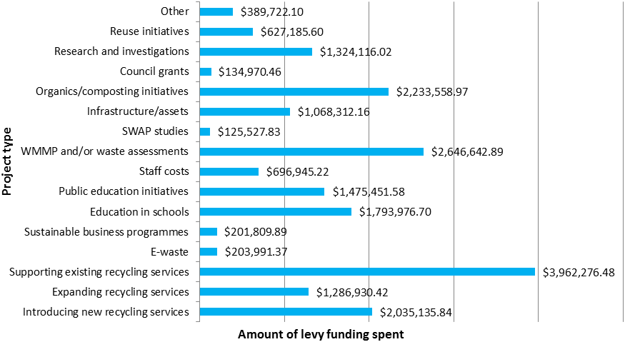
The information reported here shows that the majority of TA levy money is being spent on providing waste minimisation services. As figure 16 shows, most of the funding from 2011 to 2013 supported existing recycling services. Further consideration is given to the proportion of levy money spent on existing services compared to new services in the following section.

b) Reported TA spending on new, existing or expanded initiatives
Information on the ‘status’ of levy expenditure (ie, whether the spending was on new, existing or expanding activities) has been requested from TAs from January 2011 to June 2013. Definitions and examples of each status are provided in table 11.
Table 11: Definitions and examples of TA spending, by status
Status | Definition | Examples
New | Where levy money has enabled a new project/service to start. The levy money does not have to account for the entire project/service budget, but it should make a positive contribution to enabling the project. | - Auckland Council: new resource recovery Social Enterprise workshop  - Hastings District Council support for a new rural recycling depot
Existing | Where levy money has subsidised an existing service that was operational on the same or similar scale before the allocation of levy money to it. | - Invercargill City Council: kerbside recycling collection service  - Westland District Council: funding an information kiosk to Love NZ public place recycling
Expansion | Where levy money has been used to significantly expand a current project/service beyond what it was originally achieving before levy money was allocated. | - Palmerston North City Council: composting site upgrade  - Western Bay of Plenty District Council: upgrade to the Katikati Community Recycling Centre

Figure 15 provides a breakdown of reported TA levy spending, by status, from January 2011 to June 2013.
Figure 15: TA levy expenditure, by status, 2010–2013*
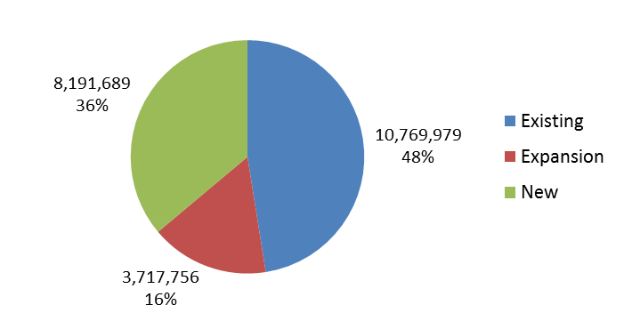
* This does not include spending where status was not specified, which accounts for approximately 23 per cent, or $6,834,586 of the levy funding distributed across all reporting periods.
The Act does not specify that levy spending by TAs must be on new projects, or provide any limitations on how it can be applied to existing initiatives. However, the paper to the Cabinet committee (Office of the Minister for the Environment, 2007) seeking agreement to the policies to be given effect through the Waste Minimisation (Solids) Bill noted a risk that councils might divert existing funds for waste minimisation into other projects once levy money reaches them. This is a particular concern as levy payments present a secure stream of funding for councils, which are often under significant rates pressure from competing priorities. To allay this risk, councils would be required to report on the expenditure of levy money and its effectiveness in improving waste minimisation. This suggests that the levy is intended to fund additional (new or expanded) activities that would improve waste minimisation.
The fact that almost half of the levy money allocated to TAs is being spent on existing activities could therefore be considered inconsistent with policy intent. It indicates that some councils may be using levy money to offset the cost of running existing waste minimisation services (such as kerbside recycling), with no additional net waste minimisation benefit resulting from the additional levy funding.
Although some individual councils may not have spent more on waste minimisation as a result of the levy funding, at the national level it appears there has been an overall increase in waste minimisation spending. It was estimated in 2007 that on average, local government was spending $80 million on waste minimisation each year, before the levy’s introduction. Data from 2012/13 shows the total annual waste minimisation budget of TAs was over $106 million, which indicates that TAs have increased their collective investment in waste minimisation over and above the average $12.5 million in funding provided to them through the levy each year.
The Cabinet paper stipulated that TAs would be required to report on their expenditure and the effectiveness of this expenditure. TAs are not currently required by law – either through reporting regulations or explicitly within the Act – to report on their expenditure or the effectiveness of their expenditure in terms of improved waste management or minimisation. Levy spend reports are a voluntary mechanism to see whether TAs are spending their levy in accordance with the Act, but they are not required to report on the effectiveness of their spending (eg, how their expenditure has improved the amount of waste diverted from landfill). This information is currently requested from TAs on a voluntary basis, and the quality of information received has generally been low.
Efforts by the Ministry to capture and improve the quality of direct reporting on levy expenditure and associated outcomes from TAs have had limited success. This may be due to a number of factors, such as the difficulty separating the levy portion of waste minimisation expenditure from broader waste minimisation budgets, or the effort required to complete reporting requests.
Section 49 of the Act provides for the Minister to set performance standards for the implementation of waste management and minimisation plans by Gazette notice. If performance standards are in place, the Minister has the ability to withhold levy payments if he or she is not satisfied that performance standards have been met. Invoking this provision of the Act could be a way to ensure levy funding is tied to the delivery of waste minimisation outcomes and allay the concern that councils are using their share of levy money to offset the cost of existing recycling, reuse or recovery activities.
However, it is important that any reporting obligations on TAs are commensurate with the level of funding received. Levy funding accounts for only 8-10 per cent of total TA waste management and minimisation costs annually, and some individual councils are receiving as little as $3000 in levy funding per quarterly payment.

Outcome 4: Conclusions
4. Funds are allocated to territorial authorities (to spend on matters to promote or achieve waste minimisation).
Funds have been allocated to councils. Most councils have spent these funds on waste minimisation activities, although almost a third of funding has been carried over for use on future waste minimisation activities. Territorial levy funding is mostly being used to deliver waste minimisation services.
The policy intent in allocating 50 per cent of levy revenue to TAs was to increase the amount that councils spend on waste minimisation. This appears to have happened at the national level: the amount of money spent on waste minimisation by councils has increased from an estimated $20 per capita before the levy’s introduction to a reported $24 per capita in 2013.
However, there remains concern that some individual councils may not be using their levy money to increase the amount spent on waste minimisation, and are instead using levy money to offset existing waste minimisation spending. While this is not expressly prohibited by the Act, it is inconsistent with the policy intent. To mitigate the risk of this happening, it was intended that councils would be required to report on the outcomes of their spending. However, this has only been implemented voluntarily and the quality of data has been low.
With these factors in mind, the focus of TA reporting requirements should be on progress against their broader obligations under Part 4 of the Act and the contribution that levy funding makes to this, in addition to levy spend. The Act’s provisions that allow the Minister to set performance standards for waste management and minimisation plans should be considered to provide a way to tie levy funding to waste minimisation outcomes and ensure accountability by TAs for funding received. These Ministerial performance standards available under section 49 of the Act would also be an appropriate tool to capture more complete, accurate and consistent information from TAs.

Recommendations
3. Investigate options for setting rules on how territorial authorities spend levy funds.
4. Investigate options to require reporting from territorial authorities on levy spending and outcomes in relation to their broader responsibilities to encourage effective and efficient waste minimisation under the Act.

Outcome 5: Funds are allocated to projects (to promote or achieve waste minimisation)
The remaining levy revenue (once half has been distributed to TAs and administration costs have been deducted from the remainder) is allocated through the Waste Minimisation Fund (WMF) to projects that promote or achieve waste minimisation.
All WMF funding decisions are made by the Minister in accordance with section 38 of the Act, which provides for the Minister to “approve funding of any project to promote or achieve waste minimisation”. Funding may be approved on any terms or conditions the Minister thinks fit. In making funding decisions, the Minister must consider the fund criteria and may consider any other matters that he or she thinks relevant. Fund criteria are set by way of Gazette notice.
The current criteria were established when the Waste Minimisation Act was implemented in 2009. Assessment criteria include strategic value, harm reduction and ongoing wider benefits (including economic, environmental, social and cultural). Strategic value is defined as the likely ability of projects to act as catalysts to enhance and extend the uptake of waste minimisation. The criteria also require the applicant to demonstrate their ability to deliver the project and how the project will continue after funding ends.
This section:
- assesses levy funds allocated to the WMF
- assesses levy funds spent through the WMF
- analyses WMF spending by category.

Levy funds allocated through the WMF
Table 12 provides a summary of completed funding rounds from the commencement of the fund until October 2013. Note analysis in this section excludes projects awarded funding after October 2013 and therefore totals differ from those presented on page 41, which include funding awarded at January 2014.
Table 12: Summary of WMF funding rounds, 2009/10–2012/13
Financial year | Number of projects awarded funding | Amount of funding approved | Eligible applications received | Approximate amount requested
2009/10 | 26 | $7,787,413 | 163 | $55,600,000
2010/11 | 29 | $12,201,298 | 63 | $25,900,000
2011/12 | 15 + TV TakeBack | $14,406,460 | 40 | $13,772,436
2012/13 | 16 | $10,221,920 | 77 | $53,508,000
Total | 86 | $44,617,091 | 343 | $150,482,000

Table 12 illustrates that requests for WMF funding generally exceed the amount of revenue available. This indicates that there is significant interest in the fund and that this has been an effective way of generating waste minimisation project ideas and innovation. However, it also means that not all applications are able to be funded. Some applications must therefore be declined due to limitations on the amount of funding available. Other reasons for declining applications include not meeting the eligibility and assessment criteria or quality standards required to secure WMF funding.

Levy funds spent through the WMF
Table 13 shows the status of all WMF funding approved as of October 2013. Of the $44,617,091 approved for WMF projects, around 71 per cent had been spent at the time of reporting. At any given time there is variation in the amount of funding approved by the Minister and the amount of funding paid to recipients. This is due to the fact that funding is paid upon completion of milestones as projects progress, rather than as an upfront payment at the start of the project.
Approximately 26 per cent of funds approved under the WMF are currently unspent and are allocated to projects that are still underway. Where projects do not successfully complete their agreed milestones, or are able to complete their project under budget, any outstanding funding approved is returned to the WMF for reallocation. Approximately 6 per cent of WMF funding falls into this category.
Table 13: Summary of WMF spending, by project status
Project status | No. of projects | Amount approved | Amount paid | Amount unspent
Completed projects | 44 | $11,794,422 | $11,338,289 | $456,133 | Returned to WMF for reallocation
Partially completed projects | 4 | $567,500 | $362,282 | $205,218 | Returned to WMF for reallocation
Discontinued projects | 7 | $1,987,174 | 0 | $1,987,174 | Returned to WMF for reallocation
On-hold projects | 1 | $158,500 | 0 | $158,500 | Still allocated
TV TakeBack | N/A | $11,599,270 | $6,320,455.45 | $5,278,815 | Still allocated
In-progress projects | 30 | $18,510,225 | $13,541,822 | $4,968,403 | Still allocated
Paid total | 86 | $44,617,091 | $31,562,848 | $13,054,243
Completed projects are those that have been delivered in accordance with the requirements of their project plan and funding deed agreed with the Ministry. Approximately 25 per cent of WMF funding approved has been spent on completed projects.
Partially completed projects are those that have failed to deliver all of the milestones agreed with the Ministry in the project plan and funding deed; 0.8 per cent of total WMF funding approved has been spent on partially completed projects.
Discontinued projects are those where the project is withdrawn following approval of funding but before the start of the project. This typically occurs where problems arise during project planning and deed negotiation that deem the project unfeasible. Because discontinued projects are terminated before the project begins, no WMF funding has been spent.
On-hold projects are those where the project has been approved for funding and has been deemed feasible, but cannot start immediately.
TV TakeBack is a Minister-initiated programme, run by the Ministry. As such, it is different to the majority of WMF projects funded through contestable rounds. Approximately 14 per cent of WMF funding approved had been spent on TV TakeBack at the time of reporting.
In-progress projects are those that have been approved for funding and at the time of reporting were still in progress. Approximately 30 per cent of WMF funding approved has been spent on projects still in progress.

Analysis of WMF spending by category
For the purposes of comparison with the 2011 review, funded projects have been broken down into the following three categories:
- type
- waste stream
- value approved.

a) Funded projects, by type
Funded projects are classified into four project types: infrastructure; services; investigative; and education and awareness. Infrastructure and services projects are those where funding is contributing to infrastructure and/or services that directly minimise waste. To encourage investment in large-scale, new and innovative waste minimisation projects, the WMF also provides for the funding of feasibility studies, research and development, proof of concept, and other investigative projects, which are expected to contribute to improving waste minimisation infrastructure and services in the longer term. Education and awareness projects are expected to result in improvements in New Zealanders’ awareness of, and participation in, waste minimisation activities. A breakdown of funds allocated, by project type, is provided in figure 16.
Figure 16: WMF funding allocated, by project type, 2010–2013
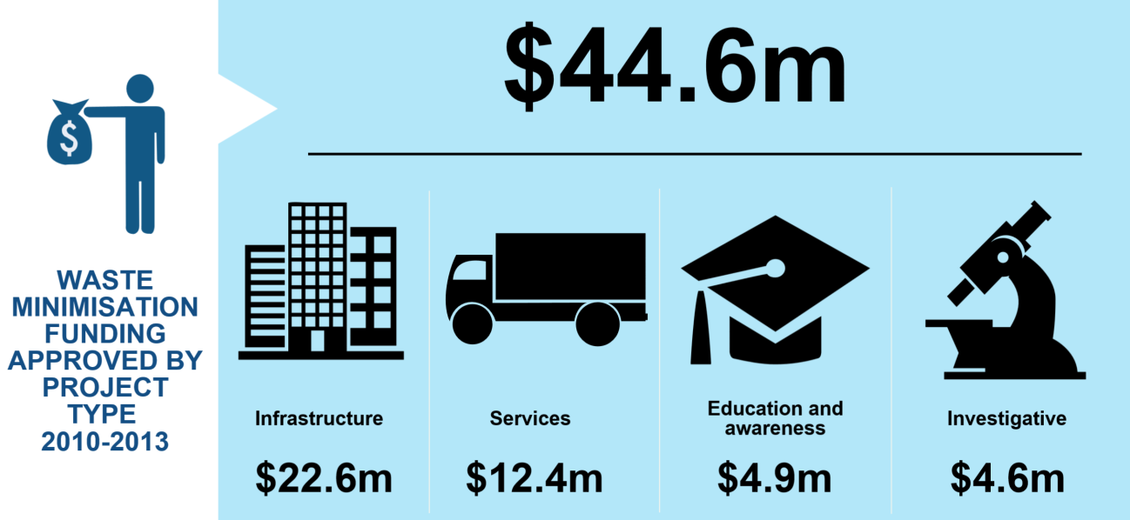

Note: Totals have been rounded for illustrative purposes.
As figure 16 illustrates, WMF funding has weighed heavily in favour of infrastructure projects. A contributing factor is likely to be that the current WMF assessment criteria favour projects that can demonstrate a tangible reduction in waste disposed of or harm to the environment. It can be challenging for investigative and education and awareness projects to quantify the benefits they will generate, particularly as outcomes resulting from behaviour change are long term and likely to be manifested well after funding has ceased. For this reason, an education or behaviour-change-focused application may be rated less favourably than an infrastructure project that can identify tangible benefits (waste reduced, product recycled, jobs created) in the application process.
The preference for investment in waste minimisation infrastructure over other project types is consistent with the Government’s intent in establishing a waste funding mechanism from the levy, which seeks to “ensure appropriate and comprehensive waste minimisation infrastructure is developed across New Zealand”. The Cabinet policy paper that underpinned Government thinking on the development of a national waste levy includes a list of the types of projects likely to be funded as a priority from the contestable levy funds. The first priority listed was to “Establish appropriate domestic reprocessing infrastructure for recovered materials, such as improved plastics washing and sorting facilities”.
There is no guidance in the Cabinet paper on how to determine what ‘appropriate’ domestic reprocessing infrastructure is for WMF investment. Likewise, the current fund criteria do not explicitly guide funding decisions for infrastructure, except to note that funding must be for new (or significantly expanded) waste minimisation activities, thus precluding investment in areas where waste minimisation infrastructure already exists. The lack of guidance in the WMF criteria for targeting investment indicates that funding is likely to have been applicant-driven, as opposed to strategically targeted at national needs.

b) Funded projects by waste stream
Funded projects can also be classified according to the waste stream they address. The Regulatory Impact Statement (Ministry for the Environment, 2007a) for the levy noted a policy

intention to direct funding towards waste streams where infrastructure and services were currently lacking, or where recovery performance has historically been poor:
The types of projects that are likely to be funded as a priority will include proposals to:
- … introduce recycling and recovery services for new materials or in areas that currently lack them. Such services could include kitchen waste and green waste processing facilities …
- … increase the recovery of wastes targeted by the 2002 waste strategy where progress has been poor, such as for construction and demolition waste …
The current WMF criteria require projects to “result in new waste minimisation activity, either by implementing new initiatives or a significant expansion in the scope or coverage of existing activities”. This is consistent with the policy intent to direct funding towards infrastructure and services in areas currently lacking. However, the criteria do not provide for the prioritisation of funding towards particular wastes where progress has historically been poor.
The Regulatory Impact Statement also notes that criteria for allocating the contestable fund would “be consistent with the criteria for prioritising waste minimisation activities set out in the 2002 waste strategy”. These criteria were:
- volume and harm
- achievability
- public concern
- cost-effectiveness.
The WMF criteria do not explicitly provide for any preference for particular waste streams, but do give preference to projects that can demonstrate a greater reduction in harm to the environment and show a greater reduction in the volume of waste disposed of. This is consistent with the criteria of the 2002 waste strategy, and indicates that projects that address high-harm wastes (such as hazardous waste) or high-volume wastes are likely to be given preference for funding. Considerations of achievability and cost-effectiveness are reflected in the current assessment criteria, but public concern is not. Table 14 provides a breakdown of WMF funding allocated by waste stream, as at 31 October 2013.

Table 14: WMF funding allocated, by waste stream
Waste stream | Description | No. of projects awarded funding | Amount approved
Organic | Includes garden and kitchen waste, food process wastes, and sewage sludge. Sewage sludge is a by-product of the sewage collection and treatment processes. | 19 | $9,665,007
Packaging | Includes glass, paper and plastics. | 25 | $7,070,479
Construction and demolition | Waste arising from construction and demolition activities, including concrete, plasterboard, wood, steel, brick, and glass. | 5 | $3,434,131
Hazardous | Materials that are flammable, explosive, oxidising, corrosive, toxic, eco-toxic, radioactive, or infectious (eg, unused agricultural chemicals, solvents and cleaning fluids, medical waste, and many industrial wastes). | 9 | $3,105,495
Tyres | Old and unwanted (end-of-life) tyres. | 3 | $596,818
E-waste | Discarded, surplus, obsolete, or broken electrical or electronic equipment. Also known as electronic waste, e-scrap, or waste electrical and electronic equipment (WEEE). | 7 | $15,559,075*
Other | Includes residual solid waste not otherwise classified, textiles, resins etc. | 18 | $5,186,086
Total |  | 86 | $44,617,091
* Includes $11.5 million allocated to the TV TakeBack programme.
Table 14 shows that the greatest amount of funding by far has been allocated to e-waste projects, followed by projects dealing with organic wastes and packaging. Taking into account the WMF criteria and the policy intent outlined above, it would be expected that these waste streams represent wastes with the highest risk of harm to the environment, or potential for volume to be reduced, or are in an area where infrastructure or services are currently lacking.
In 2013, the Ministry developed a framework for assessing waste streams by priority. The assessment tool assesses different waste types using three criteria – risk of harm, quantity of waste, and benefits from minimisation – and develops a simple rating for each waste type. The criteria are based on the intended outcomes of the Act. Figure 17 illustrates WMF allocation to date against prioritised waste streams. It should be noted that this framework was not in place during the period the funding decisions were made.
When mapping projects funded against potential waste stream priorities, it becomes clear that funding has not necessarily been directed towards the most harmful wastes. Both the Act and the New Zealand Waste Strategy have objectives of reducing harm from waste, yet only 6 per cent of funding awarded has gone on projects that have, or will, address the highest priority wastes.
Figure 17: WMF funding allocated, by priority waste streams
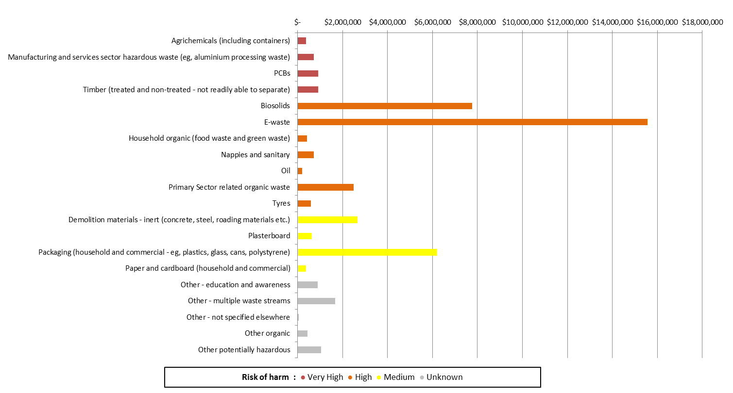

c) Funded projects, by value approved
Table 15 provides a summary of projects funded according to the value of the project, while Figure 18 shows a comparison of the value of WMF funding awarded between 2011 and 2013.
Table 15: Number of WMF projects, by project value, 2010–2013
Project value | Number of projects | Amount approved
> $2 million | 5 | $13,585,020
$750,000 – $2 million | 6 | $5,857,381
$200,000 – $749,999 | 13 | $6,290,515
$0 – $199,999 | 62 | $7,284,905
Total | 86 | $33,017,821
$11,599,270 (TV TakeBack) | 1 | $11,599,270

Figure 18: Comparison of amount of WMF funding approved, by project value, 2011 and 2013
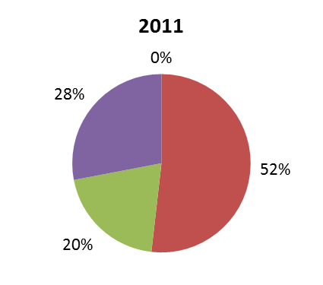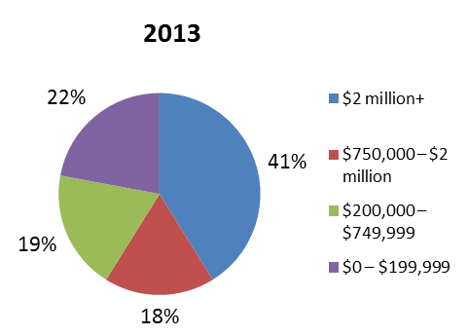

The most noticeable difference in the value of projects funded since the last review in 2011, has been the increased investment in high-value projects. In 2011, no funding had been allocated to projects over $2 million in value, but by 2013 these high-value projects represented over 40 per cent of funding awarded.
The current WMF criteria do not explicitly indicate a preference for any size or value of project, except to limit the minimum grant for feasibility studies to $10,000 and the minimum grant for other projects to $50,000. Results show that a mix of different-sized projects have been funded so far.
The diversity of WMF projects funded is not reflected in the current ‘one size fits all’ operating model of the WMF, where the administrative burden is not responsive to the scale, risk or potential harm associated with a project. This approach is often seen as appropriate during the initiation of a new process, but after five contestable rounds it no longer reflects the operational maturity of the funds management function of the Ministry. Nor does the approach reflect the nature of projects applying for WMF funding, which range from low-value/low-risk feasibility studies to high-value/high-risk heavy machinery installations or new technologies.
Stakeholder feedback in 2011 and again in 2014 has noted that the high administrative burden associated with WMF funding is often disproportionate to the value or risk associated with a project, and that the administrative costs may outweigh the potential benefits of smaller projects. This relates to the fact that projects of low value (< $50,000) have been subject to the same rigorous reporting requirements as a project of a magnitude greater than $1 million, increasing the potential for funding to be spent on administration rather than the desired waste minimisation.
The resulting process has created an unnecessary administrative burden and inefficiency, for both the Ministry and the fund applicants. The Ministry has responded to this feedback by making improvements to the application and reporting processes. Independent reviews of the WMF completed by Deloitte in 2011 and 2013 provided indicators on how to improve the efficiency of the fund. The reviews also identified clear opportunities to secure outcomes more aligned with the fund’s core objective and aim to improve its effectiveness. Steps have been taken by the Ministry to make efficiency improvements identified in these reviews.

Performance of WMF projects
The Act does not prescribe how successful WMF recipients must spend their levy funding. This is defined by the WMF deed of funding. In signing the deed with the Ministry, the recipient agrees to the requirements and expectations of project delivery, as stipulated in the Guide for Grantees.
Results from project reports, and staff-led or third-party audits under the Ministry’s Compliance Assurance Programme, indicate that levy spending through the WMF by fund recipients is largely compliant with the requirements in their deed of funding. At the time of reporting only one audit had shown a major compliance issue associated with funding expenditure where intervention was required. All issues (minor or major) identified through the audits or inspections have been satisfactorily worked through with the fund recipients concerned.
The performance of WMF projects is also assessed by Ministry fund analysts on project completion. Projects are given a rating out of 5 (1 being poor and 5 being excellent) for the success of the project against the objectives agreed in the deed of funding. Figure 19 shows the rated achievement against objectives for all WMF projects completed as at 31 October 2013, and demonstrates that the majority of completed projects are successfully meeting their project objectives. Where projects are not achieving their objectives, this is often the result of overly ambitious targets being set at the beginning of the project. The Ministry has taken steps to address this by providing greater guidance to fund recipients on setting realistic and achievable objectives.
Figure 19: Rated achievement of completed WMF projects against project objectives
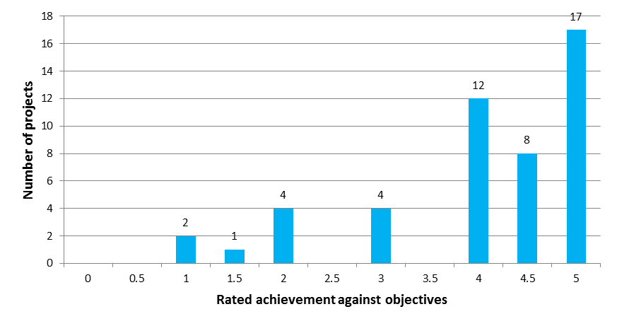

Outcome 5: Conclusions
5. Funds are allocated to projects (to promote or achieve waste minimisation).
Systems and processes are in place to effectively allocate levy revenue to waste minimisation projects through the WMF. Levy spending through the WMF by the fund’s recipients is largely compliant with the requirements prescribed in their deeds of funding.
Changes have been made to improve the efficiency of the WMF since it was first implemented. Further improvements could be made, however, such as better aligning reporting requirements to the value and risk of projects. In particular, application and reporting requirements could be better aligned to the benefits, value and risk of projects.
WMF funding appears to have been predominantly applicant-driven, with funding decisions based on general assessment criteria and without targeted priorities. This has resulted in an ad hoc range of funded projects. While it was always intended that WMF funding should be available as a catalyst for new and innovative waste minimisation initiatives, there is scope to operate the fund in a more strategic way, ensuring funding is also available for projects that support the New Zealand’s waste minimisation priorities.
The Government’s priorities are reflected in the two goals of the Waste Strategy: reducing the harmful effects of waste and improving the efficiency of resource use. The 2014 funding round for the WMF has set priorities to support the reduction of harm to the environment while still encouraging new and innovative initiatives. Further measures to operate the fund more strategically in the future should help to ensure that funding is being allocated where it can have the greatest impact or benefit.

Recommendations
5. Continue investigating options to operate the Waste Minimisation Fund in a more strategic way, ensuring funding is available for projects that support New Zealand’s waste minimisation priorities.

Outcome 6: Waste minimisation infrastructure and services are improved
There is insufficient baseline data from before the introduction of the levy to accurately assess the extent of improvements to waste minimisation infrastructure and services as a result of introducing the levy. Levy funding has, however, been allocated to initiatives that aim to improve waste minimisation infrastructure and services. Therefore, the outcomes of this funding can be used as a measure to assess the extent to which levy funding has contributed to improved waste minimisation infrastructure and services.

WMF contributing to improved infrastructure and services
A total of $22,623,721 had been allocated to infrastructure projects from the WMF at October 2013. Figure 20 shows the waste streams addressed by WMF infrastructure projects.
Figure 20: Amount of WMF funding allocated to infrastructure projects, by waste stream
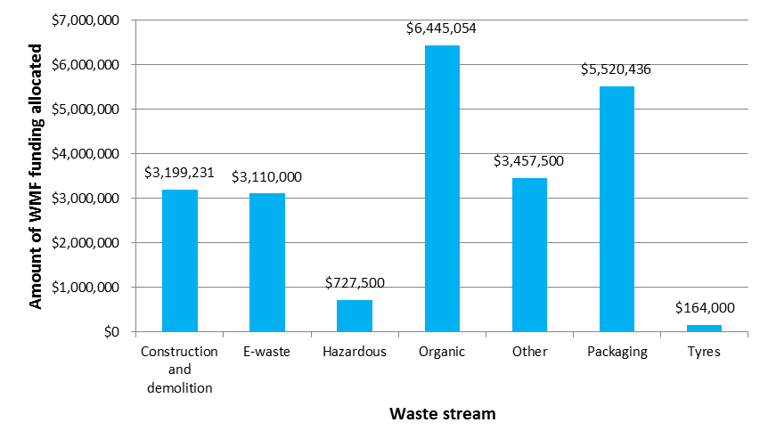WMF funding has been spent on establishing a variety of new waste minimisation infrastructure, ranging from recycling plants for plastics, glass and wood waste, to composting systems, a community reuse centre, and e-waste collection and processing sites. Because the WMF criteria only provide for the funding of new or significantly expanded infrastructure, it can be assumed that the establishment and ongoing operation of funded infrastructure has resulted in some overall net improvement in New Zealand’s waste minimisation infrastructure.
In addition to the infrastructure projects previously outlined, a total of $12,441,106 has been awarded to projects to provide waste minimisation services. Figure 21 shows the waste streams addressed by waste minimisation service projects.
Figure 21: Amount of WMF funding allocated to waste minimisation services projects, by waste stream
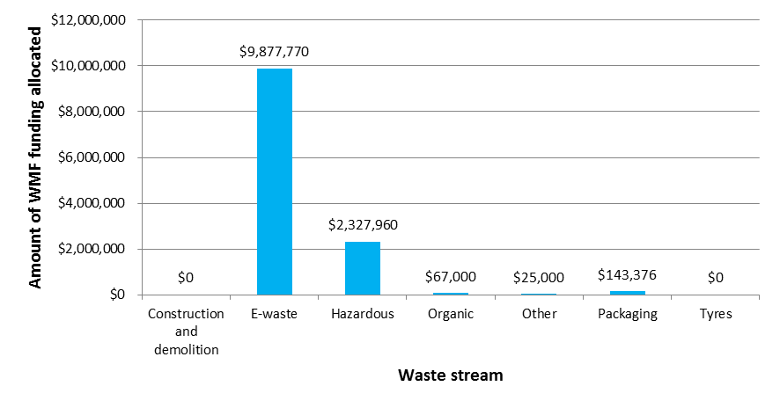
Measuring waste minimised by completed WMF projects
WMF recipients report on their progress to the Ministry during the life of their deed of funding. This means that reported tonnages of waste minimised are often low, because the project may not start diverting waste – or significant amounts of waste – until after the project has been completed.
Across 48 projects that were completed at October 2013, 34,565 tonnes of waste was reported as minimised during the period of WMF funding. This figure covers the period of funding only (normally 1 to 3 years), and for some projects, particularly infrastructure ones, it does not cover their operation at full capacity. WMF recipients whose projects had completed were therefore asked to estimate how much waste the project will minimise in future years. For projects that had been completed for more than a year they were also asked to report on current processing capacity and forecast processing capacity in the year after funding finished.
Figure 22 shows the amount of waste reported to be minimised by WMF projects during and immediately after project completion, as well as ongoing forecasted waste minimisation capacity. Data on long-term processing tonnages from WMF projects is limited due to the fact that there is currently no established system for capturing information about projects after their funding deeds expire.
Figure 22: Tonnes of waste minimised (reported) from completed WMF projects
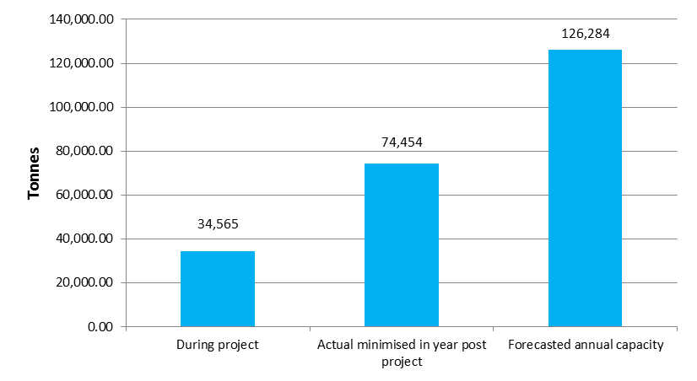

Territorial authority levy spending contributing to improved waste minimisation infrastructure and services
TAs have reported expenditure on waste minimisation infrastructure to a total of $2,874,793.43, or 11.9 per cent of the total expenditure reported. Expenditure on waste minimisation services totals $7,897,385.21, or 32.6 per cent of the total expenditure reported. This can be further broken down into the levy expenditure on infrastructure and services for each reporting period, as shown in table 16.
Table 16: Reported TA levy expenditure on infrastructure and services, 2010–2013
Reporting period | Reported infrastructure spend | % of total reported spending | Reported services spend | % of total reported spending
Jan and April 2010 | N/A | N/A | N/A | N/A
July and October 2010 | $334,271.00 | 12.6 | $1,144,612.00 | 43.2
Jan and April 2011 | $626,487.00 | 13.8 | $1,280,349.17 | 28.1
July 2011 – June 2012 | $1,073,983.15 | 12.7 | $2,204,001.17 | 21.9
July 2012 – June 2013 | $840,042.28 | 9.8 | $3,268,422.87 | 38.3

Figure 23 provides a comparison of reported TA levy expenditure on waste minimisation infrastructure and services according to whether the spending was on new, existing or expanded activity (the expenditure ‘status’).
Figure 23: A comparison of TA waste minimisation infrastructure and services expenditure, by status over reporting periods
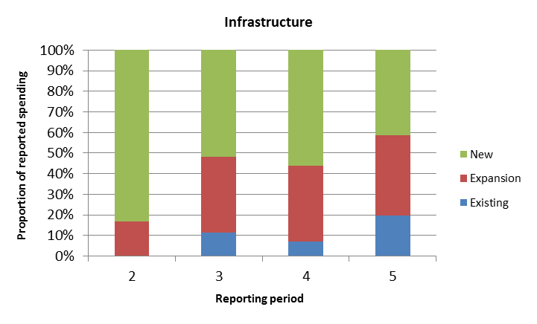
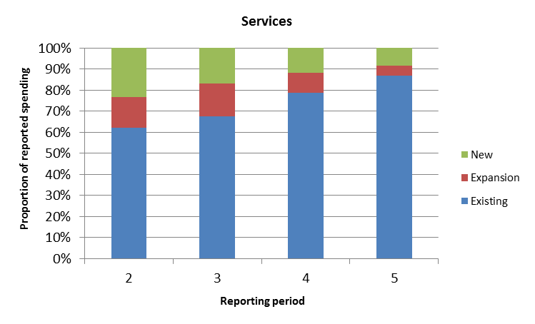
Data provided by TAs on the status of infrastructure spending between July 2010 and June 2013 shows that spending on waste minimisation infrastructure mostly supports new and expanding infrastructure, while spending on waste minimisation services is primarily directed to existing services.
Improving waste minimisation infrastructure: Case study: Central Otago District Council
Central Otago District Council expanded their recycling facilities in 2012/13 to offer additional glass recycling services to the district. Within their Waste Management and Minimisation Plan, Central Otago District Council identified a requirement to facilitate and encourage greater participation in local recycling opportunities. The council decided they would action this strategy by expanding the types of materials collected at recycling drop-off points. Specifically, glass recycling drop-off infrastructure and operational costs of servicing rural communities would be implemented with funding support from the Council’s Long Term Plan budget and the waste disposal levy. The Council funded, using over $28,000 of levy money, Central Otago WasteBusters to provide an additional 20 glass recycling bins for use at rural drop-off facilities to improve the availability of the drop-off services, particularly during peak times. The total glass sent from Central Otago WasteBusters for recycling in 2011/12 was 480 tonnes, and 620 tonnes in 2012/13. This is likely to be due to the increase in access to glass recycling facilities across the district and general growth in recycling participation.
To better target WMF funding on infrastructure and services, an accurate and comprehensive picture of New Zealand’s current waste and resource recovery system is needed, to enable an informed assessment to be made of current gaps and future needs.
The Ministry has begun to collect data on waste management and minimisation infrastructure at the district level via the Territorial Authority Stocktake Survey. This survey was first completed in 2011 for the first levy review, and was updated again in late 2013. The survey sought information from TAs on the waste disposal and resource recovery infrastructure and services in their district. However, due to the voluntary nature of the survey, and differences in data availability and reporting structures between councils, the usefulness of the data gathered is limited. Also, the survey only captures data available to the TAs, so data from private waste minimisation providers is missing.

Outcome 6: Conclusions
6. Waste minimisation infrastructure and services are improved.
Levy funding has been allocated to initiatives that aim to improve waste minimisation infrastructure and services. However, improvements in these areas are difficult to assess, or to attribute directly to the levy, due to data absences and limitations and the lack of a detailed evaluation framework for levy funding.
Current data limitations affect an assessment of the extent to which the WMF allocation and TA levy expenditure have contributed to the medium- and long-term outcomes. Information collected from TAs has varied in reliability and consistency, and there is a lack of information on post-WMF project benefits. Also, the absence of baseline data from before the levy’s introduction makes it difficult to accurately examine the improvements that have been made to waste minimisation infrastructure and services overall.
A comprehensive data collection framework is required to effectively evaluate the contributions that WMF and TA levy funding have made to the outcomes identified in the framework. A review of New Zealand’s key waste minimisation infrastructure and services, including private as well as public operations, should build a better understanding of where improved infrastructure and services are needed most, and therefore whether the current levy funding distribution is effective. This exercise should also inform the development of a strategic direction for levy funding that is linked to broader Government waste and environmental priorities.
The levy review framework is relatively high-level and allows us to track the effectiveness of the levy over the long term. However, to assess our progress towards the outcomes identified in the review framework, more detailed performance expectations for the funding need to be set, alongside a data collection framework and assessment process. This detailed evaluation framework would need to take into account the nature of waste minimisation infrastructure and services, which in many cases only have long-term benefits, and the fact that funding from the levy is only a small portion of the total cost of many waste minimisation projects. This will also help to mitigate some of the current data limitations that have made it difficult to assess the contribution to the medium- and long-term outcomes.

Recommendations
6. Undertake targeted data collection of key waste minimisation infrastructure and services in New Zealand to establish a baseline against which improvements can be measured.
7. Develop a framework and agreed metrics to evaluate the medium- and long-term outcomes of levy funding, including considering the wider environmental, social, economic and cultural benefits of waste minimisation funding.
8. Investigate options to require Waste Minimisation Fund recipients to report on the ongoing outcomes of projects after funding ceases.

Outcome 7: Waste minimisation is encouraged and promoted
Raised awareness is a prerequisite for people to effectively participate in waste minimisation. The WMF provides for the funding of projects that aim to increase awareness and encourage participation in waste minimisation. The WMF’s purpose states that boosting New Zealand’s performance in waste minimisation will require investment in infrastructure and systems for waste minimisation and developing educational and promotional capacity.
A total of $4,941,870 of WMF funding has been allocated to projects focused on waste minimisation education and awareness-raising.
Encouraging and promoting waste minimisation: Case study: Agpac Limited, Plasback Educational Programme
The project aimed to increase New Zealand farmers’ awareness of the opportunity to recycle waste agricultural plastics. In 2010, AgPac were awarded $130,000 from the WMF towards a total project cost of around $192,000 to develop and implement a nationwide educational campaign to promote farmer engagement with the Plasback product stewardship scheme.
The project focused on encouraging behaviour change through developing information packs and websites, attending agricultural shows, and raising awareness through a targeted media campaign.
Plasback is now the only nationwide on-farm collector of agricultural plastics waste, principally silage films. Plasback has collected over 3000 tonnes of plastic waste from farms since its inception in 2006 and is on track to collect 1000 tonnes during the current financial year.
The Plasback programme provides employment opportunities for agricultural plastics collectors (who are generally agricultural contractors) by providing additional work opportunities outside peak season. They expect these employment opportunities to grow as the programme continues to expand.

Thirty-five of the 44 projects that were fully completed at the time of reporting stated that they increased waste minimisation awareness; 23 also elicited media coverage.
Data from completed education and awareness projects indicates that funding has resulted in outputs that have encouraged and promoted waste minimisation. These include websites, media coverage, community events, and educational resources. Due to the typically short periods of funding for education and awareness projects, and the inherently long-term nature of behaviour change outcomes, it is difficult to measure the impact of this funding. If WMF funding is successfully contributing to encouraging and promoting waste minimisation, this will be manifested in behaviour change over the medium to long term, which can be measured through decreased disposal to landfill and increased resource recovery.
TAs also have a key role in encouraging and promoting waste minimisation. This can be done both directly and indirectly. Where a TA offers waste minimisation services and infrastructure in their district, this could be considered encouragement and promotion of waste minimisation because the public has access to alternatives to landfill disposal. However, for the purposes of this section, encouraging and promoting waste minimisation is assessed by the more direct measure of TA levy expenditure on waste minimisation education and communication.
TAs have reported a total expenditure of $5,105,450.28 on education and communication to encourage and promote waste minimisation. This accounts for 21.1 per cent of the total expenditure reported, which can be further broken down into the levy expenditure on education and communication for each reporting period (see table 17).
Table 17: Reported TA expenditure on education and communication, 2010–2013
Reporting period | Reported spend on education and communication | % of total reported spending
Jan and April 2010 | N/A | N/A
July and October 2010 | $460,501.83 | 17.4
Jan and April 2011 | $978,358.47 | 21.5
July 2011 – June 2012 | $1,576,580.46 | 18.7
July 2012 – June 2013 | $2,090,009.52 | 24.5

In the most recent round of levy spend reports (2012/13), TAs were asked to quantify the outcomes of their spending on waste minimisation education and communication by reporting on the number of attendees, pupils, schools or businesses that were addressed by, or participated in, waste education projects, waste behaviour change workshops or similar. Table 18 presents the numbers reported for reporting period five.
Based on this information, approximately $1.18 million of levy spending by TAs between 2012 and 2013 has contributed to the targeted promotion of waste minimisation to at least 0.4 per cent of New Zealand’s population, 6.5 per cent of New Zealand’s households and 32.6 per cent of schools in New Zealand (table 18).

Table 18: Reported participation rates for TA-funded waste minimisation education initiatives 2012/13
Type | Count | Levy fund contribution
Households | 108,999 | $160,343.05
Businesses | 662 | $93,376.87
Pupils | 14,386 | $206,714.70
Schools | 828 | $534,383.72
Attendees at workshops | 4,336 | $185,220.75
 |  | $1,180,039.09
Reported TA levy expenditure on the classification of their education and communication spending (ie, categorising education projects into recovery, reuse, recycling or reduction promotion) for each reporting period is presented in figure 24.
Figure 24: Levy expenditure on waste minimisation education and communication by category
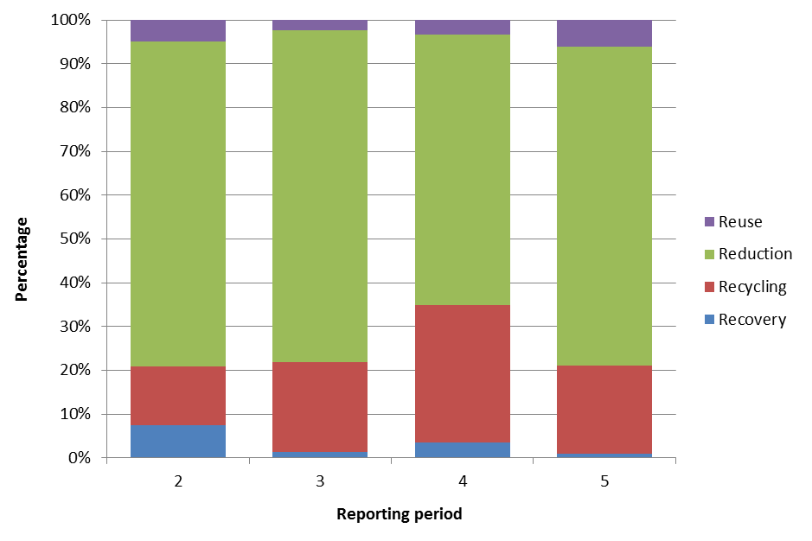
The above data indicates that TAs’ spending of levy money to encourage and promote waste minimisation has predominantly been focused at the top of the waste hierarchy – initiatives aimed at waste reduction.
Encouraging and promoting waste minimisation: Case study: Gisborne District Council
Gisborne District Council introduced a home composting and organic waste reduction promotion project in September 2012, which is fully funded by the waste disposal levy, as specified in their Waste Management and Minimisation Plan. The project involves the promotion of home composting and reduction of green waste and food waste through education programmes, subsidies and economic incentives. Composting workshops offering free compositing bins for attendees provided support to the changes to the fee schedule the Council implemented at the rural transfer stations during October 2012.
Gisborne District Council have reported that an estimated 400 tonnes of waste have been diverted from landfill over a 9-month period as a result of the project, and they estimate that annually the project will result in diversion of 533 tonnes of organic waste from landfill. Between September 2012 and June 2013 the project reached 126,982 households, and 1300 people attended composting workshops. Gisborne District Council also reported that the community response to the project was overwhelmingly positive and that the project would not have had the necessary funding if TA levy money was not available.

Outcome 7: Conclusions
7. Waste minimisation is encouraged and promoted.
Although levy funding has been allocated to encouraging and promoting waste minimisation, there is limited data available to determine the impact this funding has had on disposal behaviour.

Part 3: Cost of waste disposal

Approach
Parts 1 and 2 of this report looked at the effectiveness of the levy in terms of its first purpose. Part 3 looks at the second purpose of the levy: “to increase the cost of waste disposal to recognise that disposal imposes costs on the environment, society and the economy”. In doing so, this part reviews progress on outcomes 3 and 8 in the review framework:
3. The cost of waste disposal is increased (to recognise that disposal imposes costs on the environment, society and the economy).
8. The public appropriately responds to price signals.
Medium term:

Short term:

Key findings

Outcome 3: The cost of waste disposal is increased (to recognise that disposal imposes costs on the environment, society and the economy)
Making the levy payable by disposal facilities was aimed at increasing waste disposal charges. Outcome 3 is a short-term outcome. This means it was expected to be an immediate effect of the levy being imposed.
As of 1 July 2009, the levy was imposed on waste disposed of at disposal facilities, including landfills, which accept household waste. The levy therefore automatically increased the cost of waste disposal for those facilities. Facilities that did not accept household waste did not face an increase in cost.
As noted in Part 1 of this report, as much as 70 per cent of waste being disposed of to land is estimated to be at facilities that fall outside the current definition of disposal facility and so do not attract the levy.

Outcome 3: Conclusions
3. The cost of waste disposal is increased (to recognise that disposal imposes costs on the environment, society and the economy).
Outcome 3 has been achieved to the extent that the cost of waste disposal increased for levied disposal facilities. However, because an estimated 70 per cent of waste is going to facilities that do not pay the levy, the cost of waste disposal has not increased for the majority of waste.
Making additional waste disposal sites subject to the levy would mean the cost of waste disposal would be increased for a greater proportion of waste disposed of in New Zealand. In Part 1 of the report, Recommendation 2 proposes investigating options to make additional waste disposal sites ‘disposal facilities’ that become subject to levy obligations. This recommendation would also address the conclusion reached in this section.

Outcome 8: The public appropriately responds to price signals
Outcome 8 is a medium-term outcome. The final report for the 2011 levy review explains this as follows: “Over the medium-term ... the cost of waste disposal being increased, through the implementation of the levy, should lead to the public appropriately responding to price signals (ie, disposing of less waste) ”.
For the purposes of measuring progress against outcome 8, the term ‘public’ refers to all disposers of waste (organisations, businesses and households) rather than those that supply waste disposal services.
Figure 25 illustrates how the levy was designed to result in a price signal to those who pay for waste disposal services (the public). The levy was intended to act as an incentive to landfill operators to increase their disposal charges (gate fees at landfills and transfer stations). Faced with higher disposal charges, customers (be it organisations, businesses or households) would respond by reducing the amount of waste they send to landfills, thus increasing the amount of waste they reduce, reuse, recover and recycle.
Figure 25: How the levy is designed to act as a price signal
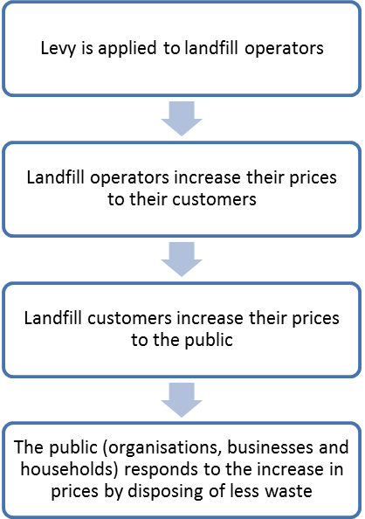

How has the public (all disposers of waste) responded to the levy so far?
As illustrated in figure 25 above, the levy is intended to provide waste disposers with a financial incentive to dispose of less waste. The data available on waste disposal at levied facilities since 2010 (see Part 4 of this report) suggests that waste disposed of to these facilities has remained relatively steady. However, levied facilities are estimated to account for only 30 per cent of total waste disposed of to land. Data on waste disposal to non-levied facilities is therefore required to draw any conclusions on the extent to which waste disposal overall has changed.
The rate of illegal dumping can also be used to measure changes in waste disposal behaviour. The 2011 levy review identified that the majority of TAs had indicated a decline in the number of reported instances of illegal dumping in the year following introduction of the levy (2009/10). In 2013, 62 per cent of TAs that responded to a survey reported an increase in incidents of illegal dumping between 2011/12 and 2012/13. However, there is no evidence to suggest this increase was as a result of the levy or increased disposal charges. More consistent and comprehensive data collection is required to measure rates and trends of illegal dumping (see appendix 4).

Relevant factors for achieving Outcome 8
There are a number of factors that could obscure the use of the levy as a price signal to minimise waste.

a) How attractive are the alternatives (reuse, recovery and recycling)?
As part of this review, international examples of landfill taxes/levies and their reported effects on landfill disposal were studied. A summary of some examples is included in appendix 3. They suggest a link between the rate of landfilling and the relative cost of alternatives (note, though, that in some cases the alternative promoted was incineration). Some countries noted that their levy/tax had to be set at a level where landfilling was more expensive than the alternatives before there was any significant reduction in waste disposed of to landfill.
Price is one factor: another is convenience. If people find it too difficult to access alternative destinations for some of their wastes, they will be more likely to dispose of them to landfill. Research specific to New Zealand conditions would be useful in establishing the impacts that the relative cost and convenience of the alternatives (reuse, recovery and recycling) have on waste disposal behaviour here.

b) How is the levy being passed on to businesses and households?
For the levy to function as a price signal, each party (starting with the disposal facility operator) needs to pass on the increase in costs to their customers in a visible way (ie, clearly linked to the volume of waste disposed of).
Disposal facility operators: To determine whether disposal facility operators responded to the levy by increasing their charges, data was gathered on general refuse disposal charges ($ per tonne) before and after the levy was introduced. While it appears that most TA-owned disposal facilities increased their charges on 1 July 2009 by at least $10 per tonne, there is little data on disposal charges at privately-owned landfills, as charges are often negotiated on a case-by-case basis and are considered commercially sensitive by the disposal facility operators.
Territorial authorities: Although TAs appear to be passing on the cost increase from the levy to their landfill customers, the majority of households are being charged for kerbside refuse collection, at least partially, through rates. Figure 26 shows that in 2013 approximately 80 per cent of households had their kerbside refuse collection funded at least partially through rates. Approximately 15 per cent of households are paying no direct charge for putting out their household waste for collection because the cost is covered entirely by rates. Those households will therefore not receive any message to dispose of less waste when the price of waste disposal at the landfill is increased as a result of the levy (or for any other reason).
Figure 26: TA household waste collection, by funding method, 2013
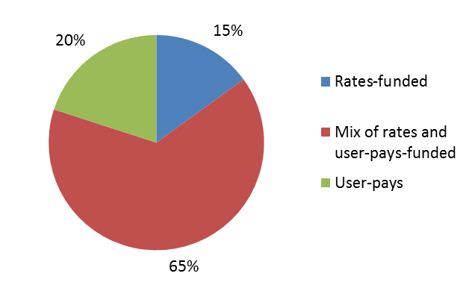
Source: Territorial Authority Survey of Waste Infrastructure and Services carried out by the Ministry and others in 2011 and 2013. The TAs that responded account for approximately 1.4 million households out of a total of approximately 1.6 million households in New Zealand in 2013. Data on household numbers is sourced from Statistics New Zealand: http://www.stats.govt.nz/Census/2013-census/data-tables/population-dwelling-tables.aspx.

c) How are households and businesses being charged for waste disposal services?
Where there is a direct charge for waste collection and disposal, the pricing system can have a bearing on how the customer responds to a change in price. A report prepared by Covec (2012) for the Ministry reviewed a number of US studies on how price affected demand for waste collection and disposal. The report concluded that:
- the largest response to pricing occurs where weight-based systems are used (eg, where households pay more for each additional unit of waste produced)
- the smallest response to pricing occurs with volume-based charging systems (eg, wheelie-bins, where costs are only changing when there is a change in the size of the bin used)
- pay-per-bag systems have intermediate effects.
In New Zealand, waste that is delivered directly to a landfill or a transfer station is usually charged on a weight-based system (a small number of landfills still operate with no weighbridge). However, where there is a direct charge for kerbside refuse collection, the pricing structure is either bag- or volume-based.
The current kerbside waste collection charging systems in New Zealand may therefore have an impact on the ability of the levy to provide a price signal to households (and some businesses) to dispose of less waste. Those who pay for waste disposal via rates have no financial incentive to dispose of less waste, and those who pay per bag have only a partial incentive. This is because their payment system only differentiates between large changes in quantities (one bag to two, or a large versus a small bin).

Outcome 8: Conclusions
8. The public appropriately responds to price signals.
Waste disposal to levied facilities (overall, per capita and in relation to GDP) has remained relatively steady since the introduction of the levy. However, levied facilities are estimated to account for only 30 per cent of the overall waste disposal to land, and there is insufficient data on non-levied landfills and farm dumps to determine any trends. There is also insufficient data to determine any trends in illegal dumping, so it is not possible to draw any conclusion on how the public have responded to price signals.
Even if sufficient data is gathered it may be difficult to observe a response to price signals, for a number of reasons, including:
- a large proportion of waste is disposed of to non-levied landfills, therefore any price increase could potentially be avoided
- alternatives to landfilling may not be sufficiently attractive in terms of cost or convenience for people to respond to a price signal
- the levy/price signal may not be passed through to the public in a way in which they can respond appropriately.
More data is required to determine how the public have responded to price signals (see the recommendations in Part 4), and the potential barriers to a public response to price signals provided by the levy should be investigated.

Recommendations
9. Undertake further work to better understand how factors such as cost and convenience are influencing disposal patterns and consider options to make alternatives to disposal more attractive than landfill.
10. Consider ways to support user-pays pricing systems for waste disposal that would allow waste disposers to better respond to price signals.

Part 4: Achieving waste minimisation

Approach
This part looks at progress towards the long-term outcomes expected if the levy is operating effectively.
9. People dispose of less waste and minimise more waste, particularly harmful waste.
10. Waste minimisation is achieved.
11. The environment is protected from harm through waste minimisation and a decrease in waste disposal.
12. Environmental, social, economic and cultural benefits are provided through waste minimisation and a decrease in waste disposal.
These outcomes are in sequence, so that outcome 9 should lead to outcome 10, which should then lead to outcomes 11 and 12.
To determine whether these outcomes have been achieved, information on waste disposal, reuse, recycling and recovery needs to be analysed to assess whether:
- waste disposal has decreased, and/or
- the amount of waste reused, recycled or recovered has increased.
For outcome 10 there is no guidance for determining whether waste minimisation is ‘achieved’. Where the word ‘achieve’ is used in the Act, it is used in contrast to ‘promote’ and appears to mean an activity that results in a reduction in waste or the reuse, recycling or recovery of waste materials. For the purpose of this report, this has been interpreted to mean that if waste disposal has decreased, and the amount of waste reused, recycled or recovered has increased, then waste minimisation has been achieved. Thus, outcome 10 will be met if and only if outcome 9 is met.
Outcomes 11 and 12 are the final outcomes that form the purpose of the Waste Minimisation Act as a whole. The review has identified examples of environmental protection and environmental, social, economic and cultural benefits, particularly those achieved through levy funding. Some have been included as case studies in other parts of the review. The extent to which these outcomes are achieved will only be apparent in the long term, beyond the time scales of this review. Accordingly, there is no analysis of information about these outcomes.

Key findings

Waste disposal
This section analyses the available data on waste disposal in New Zealand to determine whether there has been any change since the introduction of the levy.

Quantity of waste disposed
To determine the amount of waste disposed of in New Zealand since the introduction of the levy, the Ministry has used information available on waste disposed of to:
- levied disposal facilities (landfills that accept household waste)
- non-levied landfills, including managed fills and cleanfills
- farm dumps.
Figure 27 summarises the information that is available on a calendar year basis. Complete annual data on levied landfills is only available from 2010 on, following the introduction of the levy in July 2009, and is based on returns submitted to the Ministry through the Online Waste Levy System (OWLS).
Non-levied landfill and farm dump quantities are derived from estimates provided in the Tonkin & Taylor report (2013) (see appendix 2 for methodology). These estimates were made by extrapolating from the available data. Because some data is available at very few points in time, assumptions have been made as to variations over time, making any analysis of trends unreliable. Incineration is not displayed in the figure because it is an insignificant amount (around 6000 tonnes per annum).
Figure 27: Waste disposal in New Zealand, 2006–2013
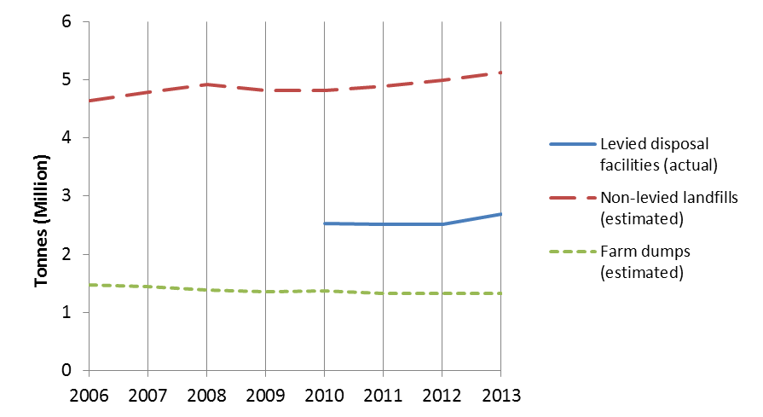
Figure 27 and table 19 show that waste disposal to levied disposal facilities has remained largely static since 2010, although an increase is apparent in 2013. The tonnage disposed of in 2013 was 6 per cent higher than in 2010.
Examining data at a regional level does not show any particular trends. Although there are regional variations, these can generally be accounted for by particular events such as the Waiwhetu Stream clean-up or the Christchurch earthquakes.
On a per capita basis, the average New Zealander disposed of 600 kg of levied waste in 2013. Compared to 2010, this is an increase of approximately 20 kg, or 3.5 per cent. Between 2010 and 2013, waste disposal to levied landfills increased by 6 per cent. This was slightly less than GDP growth over the same period, which increased by 6.5 per cent.
As noted above, the lack of reliable information on waste disposed of outside of levied disposal facilities means it is not possible to make any conclusive assessment of trends in overall disposal. In particular, it is not possible to draw conclusions on trends in total disposal to non-levied facilities, especially compared to GDP, as average amounts of waste per unit of GDP have been used to extrapolate the data from known landfills to estimate the total.
Table 19: Waste disposal to levied facilities, 2010–2013
Waste disposal to levied facilities only (reported)
 | 2010 | 2011 | 2012 | 2013 | Difference 2010–13
Total (tonnes) | 2,532,481 | 2,512,530 | 2,514,878 | 2,684,056 | 5.99%
Tonnes per capita | 0.58 | 0.57 | 0.57 | 0.60 | 3.45%
Tonnes per $million of GDP | 18.26 | 17.79 | 17.39 | 18.15 | –0.60%
Population | 4,367,800 | 4,405,200 | 4,433,000 | 4,471,100 | 2.37%
GDP ($million) | 138,690 | 141,208 | 144,598 | 147,917 | 6.65%
Source: Population and GDP figures sourced from Statistics New Zealand.
Figure 28: Estimated proportion of waste going to each disposal destination in 2013
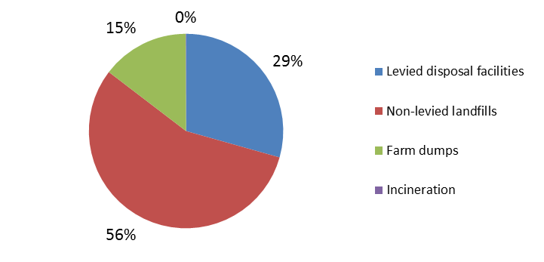
Figure 28 shows an estimate of the proportion of waste going to each destination in 2013. Non-levied landfills received the majority of waste, at approximately 56 per cent, with 29 per cent going to levied facilities, 15 per cent going to farm dumps and less than 1 per cent incinerated.
In summary, although the Ministry has limited data, the information it does have indicates that:
- Waste disposal at levied facilities has been largely static following the introduction of the levy, but with an increase of 6 per cent in 2013 over 2010, which is a slightly greater increase than that of New Zealand’s population, and a slightly smaller increase than GDP over the same period.
- The majority of waste is disposed of in non-levied landfills for which we lack reliable data, so it is not possible to determine changes in total waste disposal since 2010.

Composition of waste disposed of
Outcome 9 relates to the nature of the waste being disposed of, as well as the overall quantities. The composition of waste disposed of to municipal landfills (including levied disposal facilities after 2009) has been estimated for 2004, 2008 and 2012 using data obtained through Solid Waste Analysis Protocol (SWAP) surveys. These surveys were carried out at a sample of municipal landfills to estimate national waste composition. The estimates are presented in figure 29.
Figure 29: Waste disposal composition at municipal landfills in New Zealand, 2004–2012
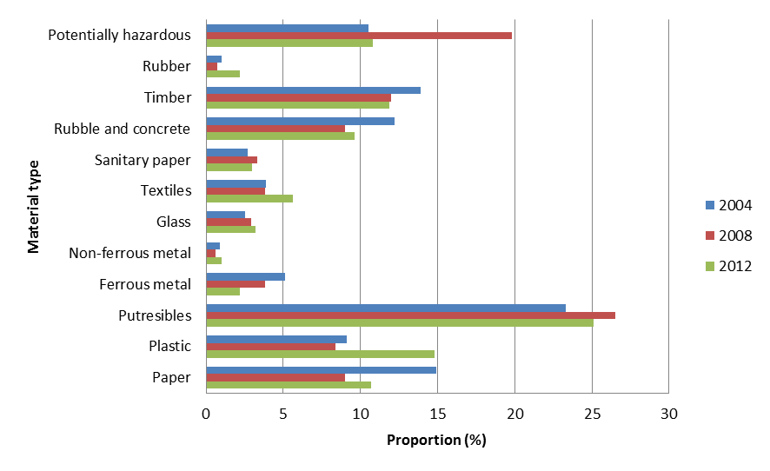
Source: WasteNot 2013
In 2012, the most substantial waste stream was putrescibles (food and garden waste), which equated to approximately 25 per cent (714,273 tonnes) of all waste disposed of to disposal facilities. This was followed by plastic (14.8 per cent; 422,849 tonnes), timber (11.9 per cent; 339,993 tonnes) and ‘potentially hazardous’ waste (10.8 per cent; 308,565 tonnes). In addition to rubble and concrete, these waste types made the most significant contribution to waste taken to disposal facilities in all three years.
The composition of waste disposed of has remained fairly stable over time, (with the exception of potentially hazardous waste in 2008). This could suggest that New Zealand’s pattern of consumption has not changed significantly and that viable alternatives to landfill disposal have not yet been found for any of the waste streams. However, it may be that both the pattern of consumption and alternatives to landfill disposal (which are not measured) have changed in similar ways.

Reuse, recycling and recovery
This section reviews the information available on waste reuse, recycling and recovery through:
- diversion of waste from levied disposal facilities
- reuse, recycling and recovery through accredited product stewardship schemes
- projects funded through the WMF
- activities associated with TA spending of levy payments
- waste diversion reported in TA waste assessments or provided through a Ministry stocktake survey.

Diversion at disposal facilities
In the years since the introduction of the levy, disposal facility operators reported that approximately 14 per cent of waste taken to their facilities was diverted for reuse, recycling or recovery, either on site or off site. Based on OWLS data, the rate of diversion appears to have declined slightly since 2010 (figure 30).
Figure 30: Proportion of waste diverted from disposal facilities, 2010–2013
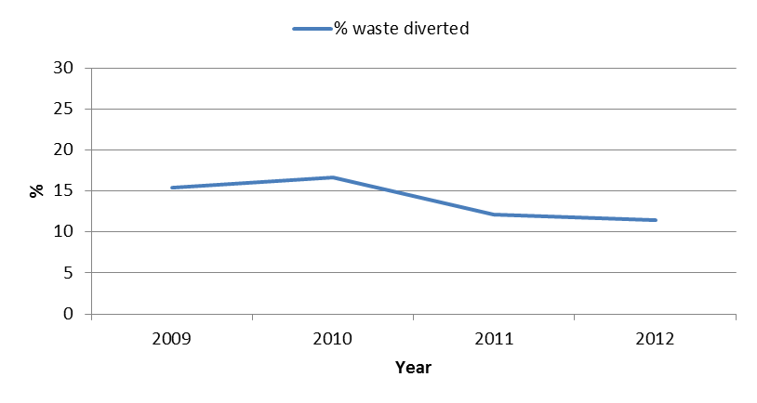
Disposal facility operators are not currently required to specify the type of waste being diverted. As a result, the tendency is to categorise it as ‘General’ and ‘Unspecified’ in OWLS. This makes it difficult to determine the type of waste recovered. Since the introduction of the levy, approximately 97 per cent of diverted material was classified in this way.
However, the Ministry has found through its audit programme that disposal facility operators do not report all tonnes diverted through OWLS, as some material is diverted before measurement, as provided for by regulation. Therefore, the reported data is likely to be an underestimate of the actual proportion of diverted waste. Using audit information in combination with OWLS data, it has been estimated that approximately 24 per cent of waste is diverted each year from levied disposal facilities. It is not possible to determine whether this has changed since 2010.

Diversion through accredited product stewardship schemes
Eleven voluntary product stewardship schemes have been accredited by the Minister for the Environment. These schemes are required to report against their objectives annually. However, objectives vary, along with the quality of reporting and, as a result it is difficult to compare recycled waste versus waste over time.
Approximately 79,378 tonnes of waste has been reused, recycled and recovered through accredited product stewardship schemes. In the year most recently reported for each stream, the total tonnage is approximately 33,795 tonnes per annum (see table 20). This equates to 1.4 per cent of the annual waste disposed of to disposal facilities.
Table 20: Tonnes of waste diverted through accredited product stewardship schemes, 2013
Scheme | Waste | Waste diverted (tonnes/year) | Reduction in targeted waste stream
Holcim/Geocycle Used Oil Recovery Programme and R.O.S.E | Used oil | 12,016 | 36%
Glass Packaging Forum | Glass | 20,549 | 7%
Plasback | Plastic | 850 | 9%
Agrecovery Rural Recycling Programme | Agrichemicals | 15.9 | 26%
Agrecovery Rural Recycling Programme | Plastic | 182.3 | 28.8%
Refrigerant Recovery | Refrigerant gases | 34.4 | 3%
Resene Paintwise | Paint | 147 | 6%
ReEntry | Carpet tiles | RA | –
EnviroComp | Nappies | RA | –
Public Place Recycling – Glass Packaging Forum | Glass | RA | –
Milk in Schools | Tetrapak | RA | –
Total |  | 33,795
Note: Tonnages taken from latest annual report; RA = recently accredited, no reported data (indicated by dash).

Diversion through levy-funded activities
Levy payments are used to fund waste minimisation activities through two mechanisms. Fifty per cent of levy revenue collected is allocated to TAs on a per capita basis, to be used for waste minimisation activities. The remainder, minus administration costs, is allocated to waste minimisation projects through the WMF.
Part 2 of the levy review focused on levy expenditure, and this has helped identify the outcomes of waste minimisation projects funded by the levy. For the 2012 to 2013 period, TAs reported that 168,647 tonnes of waste had been reused, recycled and recovered through activities that were partly or fully funded through the levy.
Data reported by 48 completed WMF projects at October 2013 indicated that 34,565 tonnes of waste had been minimised during the period of funding (ranging from 1 to 3 years). Information is not routinely captured on the amount of waste minimised by WMF projects after funding ceases; however, for the purposes of the review, former recipients of WMF funding were surveyed on the progress of their projects, post-funding. Thirty-seven respondents reported that approximately 74,500 tonnes of waste had been reused, recycled or recovered in the year following completion of their projects. It is not possible to extrapolate this figure across all projects due to their diverse nature.

Total waste reused, recycled and recovered
The total annual amounts of diverted waste that have been reported to the Ministry are as follows:
- diverted at disposal facilities: 101,900 tonnes
- product stewardship: 33,800 tonnes
- Waste Minimisation Fund projects: 74,500 tonnes
- TA activities: 168,600 tonnes
TOTAL: 378,800 tonnes
This is likely to represent only a small proportion of waste minimisation activities in New Zealand, as there is a significant amount of data missing from the analysis. The majority of data on reuse, recycling and recovery is held by TAs, waste and recycling operators and businesses. Some information is available in waste assessments prepared by TAs, but these are of varying quality and are not completed on an annual basis. They therefore do not provide a way for the Ministry to keep an accurate record of waste disposal, reuse, recycling and recovery over time. They may, however, give some indication of the extent of waste minimisation that can be linked to the levy and to other Government waste interventions.

Outcomes 9 and 10: Conclusions
Outcomes 9 and 10 are long-term outcomes and are affected by a number of factors external to the Act. There are significant gaps in knowledge about waste generation, disposal, reuse, recycling and recovery of waste in New Zealand. Nationally aggregated waste data is very limited, and a comprehensive data-gathering exercise has not been carried out to establish a baseline from which to assess progress against policy objectives.
As a result it is not possible to construct a comprehensive picture of the current situation, the situation before the introduction of the levy, or how this has changed. As a consequence, it is impossible to determine whether these outcomes have been achieved, and it will not be possible to do so until these gaps in data are addressed.
Data needs to be collected on waste generation, waste disposed of to all landfills (whether or not they are subject to the levy), farm dumps and incinerators, and waste that is reused, recycled or recovered. Data collection would need to consider commercial confidentiality and could include the voluntary and/or mandatory provision of data. The data requirements are set out in appendix 4.
Based on the available information, the following observations can be made about outcomes 9 and 10.
9. People dispose of less waste and minimise more waste, particularly harmful waste.
Between 2010 and 2013, waste disposal to disposal facilities was largely static, but showed an overall increase of 6 per cent in 2013 over 2010. This was slightly less than GDP over the same period, which grew by 6.6 per cent. It is not possible to determine whether there have been any changes in total waste disposal due to a lack of reliable data on waste disposed of outside of levied landfills.
Waste minimisation means a reduction in waste generation and the reuse, recycling and recovery of waste and diverted material. There is insufficient information available on either waste generation or on reuse, recycling and recovery to determine whether there has been a change in either since 2010.
The composition of waste has not changed significantly over time, but there may have been a slight reduction in the proportion of harmful wastes disposed of.
10. Waste minimisation is achieved.
There is currently insufficient data to indicate if there has been a reduction in waste generation, or if waste reuse, recycling and recovery have increased. As a consequence, it cannot be determined whether waste minimisation has been achieved.

Recommendations
11. Investigate options to establish the ongoing data collection required to evaluate long-term waste minimisation outcomes.

Appendix 1: Performance of the levy collector and Secretary for the Environment
Table A1.1: Assessment of levy collector performance against regulatory functions under the Waste Minimisation (Calculation and Payment of Waste Disposal Levy) Regulations 2009 and Waste Minimisation Act 2008
Function | Regulatory requirement | Performance rating
Annual permission applications | Regulation 9: Provide written notice of the decision to the operator on or before 1 August of the financial year. | Excellent
Extension to return due date | Regulation 30: Written notice of the decision must be provided to the operator a minimum of five days before the return due day. | N/A
Calculate levy due (monthly return) | Regulation 18: For each month of the financial year, where: levy payable = rate of levy x net tonnage. | Excellent
Calculate levy due (annual return) | Regulation 23: For each month of the financial year: levy payable = rate of levy x (expected net tonnage)/12. | Excellent
Estimate levy due (monthly return) | Regulations 19 and 20: Estimate the amount of levy as prescribed under Regulation 20 and make written demand for payment. | N/A
Estimate levy due (annual return) | Regulations 25 and 26: Estimate the amount of levy as prescribed under Regulation 26 and make written demand for payment. | N/A
Levy invoice issued (monthly returns) | Regulation 21: Invoices are to be issued on or before the 15th day after the return due date. | Good
Levy invoice issued (monthly returns) | Regulation 21: Specify the levy payable. | Excellent
Levy invoice issued (monthly returns) | Regulation 28: The due day for payment is on or before the 20th day of the third month after the month for which the levy is payable | Excellent
Levy invoice issued (annual returns) | Regulation 24: Invoices are to be issued on or before the 15th day of the second month after the month for which the levy is payable. | Good
Levy invoice issued (annual returns) | Regulation 24: Specify the levy payable. | Excellent
Levy invoice issued (annual returns) | Regulation 28: The due day for payment is on or before the 20th day of the third month after the month for which the levy is payable. | Excellent
Interest invoice issued | Regulation 31: Provide invoice for interest that becomes payable on any levy that is not paid on or before the due day for payment. | Excellent
Interest invoice issued | Regulation 31: Specify the interest payable. | Poor*
Reconcile levy owed (annual returns) | Regulation 27: Ensure that the operator of an approved facility is ultimately invoiced for the correct amount of levy for the financial year. | Excellent
Reconcile levy owed (annual returns) | Regulation 27: Issue any invoices or credit notes, or increase or reduce the amount of levy payable under any other invoice, to ensure that the correct amount of levy is paid. | Excellent†
Reconcile levy owed (annual returns) | Regulation 27: May specify a due day for payment that is no earlier than 1 month after the day on which the invoice is issued. | Excellent
Reconcile levy owed (annual returns) | Regulation 27: When issuing a credit note, reimburse any money owed to the operator. | Excellent
Correction of levy payable | Regulation 29: Must ensure that the operator is ultimately invoiced for the correct amount. | Excellent
Correction of levy payable | Regulation 29: May specify a due day for payment that is no earlier than 1 month after the day on which the invoice is issued. | Excellent
Correction of levy payable | Regulation 29: When issuing a credit note, reimburse any money owed to the operator. | Excellent
Extension to payment due date | Regulation 30: Provide written notice of the decision to the operator a minimum of 5 days before the payment due day. | N/A
Levy refund | Regulation 33: Arrange for the Secretary to refund any levy money to an operator that was paid on levy waived by a Regulation at the time of payment. | N/A
Recover debt | Section 36: Recover unpaid levy as debt in a court of competent jurisdiction. | N/A
Average tonnage applications | Regulation 15: Provide written notice of the decision to the operator as soon as practicable after making a decision. | Excellent
* The rate of interest has incorrectly been charged at 7.5 per cent since the implementation of the levy in 2009. The interest rate is set by section 87(3) of the Judicature Act 1908, which states the rate of 7.5 per cent per annum, or such other rate as may from time to time be prescribed for the purposes of this section by the Governor-General by Order in Council. The prescribed rate was set at 8.4 per cent on 26 May 2008 and 5.0 per cent on 1 July 2011.
† No validity checks are performed over the credit notes issued due to tonnage amendments by the disposal facility operators. There is no time limit in OWLS to prevent out-of-period tonnage amendments.
Table A1.2: Assessment of Secretary for the Environment performance against regulatory functions under the Waste Minimisation (Calculation and Payment of Waste Disposal Levy) Regulations 2009 and Waste Minimisation Act 2008
Function | Requirement | Performance rating
Levy refund | Regulation 33: Refund any levy money to an operator that was paid on levy waived by a Regulation at the time of payment. | N/A
Levy waiver | Section 29: Waive, in writing, the requirement for an operator to pay any amount of levy, if satisfied that exceptional circumstances justify the waiver. | Excellent
Storage time extension | Section 26 and Regulation 11: Agree in writing to an application to extend the 6-month time period limit for diverted material. | Good
Appoint enforcement officers and auditors | Section 76: Issue enforcement officers with a warrant card. | Excellent

Appendix 2: Methodology, assumptions and limitations of the Tonkin & Taylor New Zealand non-municipal landfill database
In acknowledgment of the continued data gaps in the knowledge of non-levied landfills in New Zealand, in 2013 the Ministry contracted Tonkin & Taylor to undertake research to further develop a database of New Zealand non-levied landfills. The 2013 research built on the existing New Zealand landfills database the Ministry has developed through the 2008 and 2011 research projects.
The objective of the research was to identify the number of non-levied landfills in New Zealand, estimate the total tonnage and composition of waste disposed of to these sites over the period 1950 to 2015 (projected), and identify any trends in changes to waste disposal patterns. Tonkin & Taylor delivered the New Zealand Non-municipal Landfill Database Report to accompany the excel database of non-levied landfills. The report summarises the statistical findings, methodology and data limitations.

Methodology

Raw database
Data provided by the Ministry from similar studies undertaken in 2008 and 2011 provided the basis for the database. Regional and district councils were contacted requesting data on non-levied landfills in their region. Where possible, information on permitted activity sites was provided; however, in most cases permitted activity sites are not known to councils. Landfill operators identified through this process were contacted to obtain more detailed information on their sites and management practices.
Communications with operators also provided more insight into other operations not recorded within council databases as ‘landfills’. This led to contact with other industries, such as forestry and sawmill operators. Regional industry-specific data and data from Statistics New Zealand was reviewed and used to identify other industries that might have been overlooked.

Estimated database
The best annual record for maximum surveyed tonnage for each region was used to estimate annual tonnage per unit regional GDP. For regions where there was no available data, the tonnage per unit GDP for a similar region was adopted. The tonnage per GDP was then used to populate the annual tonnage figures for 1950 to 2015.
Waste tonnages from farm dumps were estimated based on data from Statistics New Zealand and a survey conducted by Environment Canterbury. Farm waste tonnages were then added to the interpolated regional tonnages to obtain total waste tonnage to non-municipal landfills.

Data limitations and assumptions
Limitations associated with the information contained in this report are noted in the report and the reader should refer to these notes.
Information on non-levied landfills contained within this report is based on data and information obtained through the research and analysis undertaken by Tonkin & Taylor.
Tonkin & Taylor were able to add a substantial amount of raw data to information obtained through the previous studies. However, detailed data on many consented non-levied landfills was not available as the operators may not be required to record the volume or composition of waste accepted.
The project relied on information provided by regional councils and the landfills identified were generally related to consented activities. Regional councils tend to hold very little information about landfills (such as cleanfills and farm pits) which operate under permitted activity rules.
Significant efforts were made to obtain further information from councils, waste industry and commercial operators, but only anecdotal and resource consent information was available.
A proportion of sites identified had no information available on the open or close dates. Information on actual composition and volume per year also could not be provided for a number of sites. Many sites do not record tonnages accepted and best estimates were provided if possible. Therefore, it is difficult to provide an indication of how composition of waste going to landfill is changing with time. Information on waste composition and volume accepted is based on the resource consents or regional rules.
Information could not be obtained on the majority of permitted activity non-levied landfills. As permitted activity sites do not require resource consents or monitoring, councils have no means of capturing this information.
Therefore, total tonnages and trends over time are estimated based on GDP. The methodology used was considered appropriate based on the limited data available. However, due to the nature of the methodology used, detailed trends over short periods of time (ie, 3–4 years) cannot be determined from the findings.

Appendix 3: Examples of international landfill taxes/levies

Landfill taxes in Europe
Tables A3.1 and A3.2 summarise the experience of landfill taxes/levies in Denmark, the Netherlands, the UK and Ireland, as identified by the EEA (European Environment Agency) in their 2011/2012 review. Further details on each country and graphs showing the reported effects on waste disposal are included below.
There are some key differences between the waste sector in New Zealand and those operating in the (approximately 22) European Union countries that currently have landfill taxes. For example, landfill taxes often operate alongside a range of regulatory instruments such as landfill bans. Furthermore, some European policies are designed to incentivise waste incineration over landfill disposal, whereas incineration of household waste is not currently permitted in New Zealand.
Table A3.1: Landfill taxes/levies in Denmark, The Netherlands, UK and Ireland
 | Denmark | The Netherlands | UK | Ireland
Year started | 1987 | 1995 | 1996 | 1996
Approach to tax | Initially applied to municipal waste, then extended to cover all waste | Two levels of tax | Two levels of tax | Single rate, some exceptions
Notes | Constant increase of tax in the 1990s created continuous pressure to divert | Tax rate gradually increased until it was abolished in 2012. The tax revenue had gone down so much (along with landfilling) that tax had become an administrative burden | The tax rate has been steeply increasing since 2007 | Like UK, tax rate has been steeply increasing since 2007

Table A3.2 Summary of landfill taxes/levies in Denmark, the Netherlands, UK and Ireland and their reported effects on waste disposal (and generation)
Effects identified | Countries that identified the effect
The tax appears to have achieved significant reductions in waste going to landfills | All four countries
Tax especially good at diverting homogeneous waste types (eg, construction and demolition waste and garden waste) | Denmark, The Netherlands and the UK
Revenue significantly reduced over time as the tax created an incentive to divert waste away from landfills | Denmark and The Netherlands
Now experience very low rates of landfilling for all waste types | Denmark and The Netherlands
Tax effective at landfill diversion when increased to a level where landfilling more expensive than alternatives | The Netherlands
Waste generation continues to rise despite waste to landfill decreasing. The tax appears to solely provide an incentive to recycle | Denmark and Ireland
Source: Overview of the Use of Landfill Taxes in Europe. ETC/SCP Working Paper No.1/2012 prepared for the European Environment Agency. Retrieved from http://scp.eionet.europa.eu/publications/WP2012_1/wp/WP2012_1.

Denmark
- A landfill tax was introduced in 1987.
- Total waste sent to landfill has decreased from 3.5 million tonnes in 1985 to 0.8 million tonnes in 2009 (39 per cent to 6 percent of total waste disposal).
- Waste generation has increased from 9 million to 15.6 million tonnes over the same period.
- The landfill tax is quite high compared with other European countries. However, the extra costs for the generators of the waste are still quite low.
- The increase in waste generated suggests that the tax has not provided an incentive to generate less waste, but to divert waste away from landfills.
- Waste generation has continued to increase while there has been a significant reduction in waste sent to landfill. This suggests the tax solely provides an economic incentive to recycle.
- There has been a significant reduction in waste going to landfill for the types of waste that have a large weight and are reasonably homogeneous (eg, construction and demolition waste and garden waste).
Figure A3.1: Development of landfilling of total waste and landfill tax in Denmark

Figure A3.2: Development in the landfill tax revenue, 1993–2011
Note *Estimate made by the Danish Ministry of Tax in August 2011

The Netherlands
- A landfill tax was introduced in 1995 and abolished in 2012. This is because the revenues from the tax had dramatically reduced, along with waste sent to landfill, and the tax had become an administrative burden. There were a number of developments in between.
- In 2000, two different levels of taxes were introduced. There was a high rate for waste that could be incinerated, and a low rate for waste with a density that was too high for incineration. Essentially, only wastes with no incineration or recycling option were landfilled.
- In 2005, the high tax was increased considerably to EUR 85/t, while the low tax was only increased by 1 EUR.
- From 2008 onwards the amount of waste sent to landfill decreased significantly. This is attributed to the non-inert waste types being charged the higher tax rate.
- Landfill of municipal waste and recyclable waste is banned (municipal waste must be incinerated).
- There has been a moratorium on landfill expansion and new landfills since 1995.
- The combination of the landfill ban with an increasing landfill tax is thought to be significant in developing alternative treatment options. In 2002, an increase in landfill tax to approximately EUR 80/t made landfilling more expensive than alternatives. In 2011, the combination of tax and gate fees meant that it cost approximately EUR 127/t to landfill a tonne of waste, compared to around EUR 90/t for incineration.
Figure A3.3: Revenue from the landfill tax in The Netherlands, 2000–2010

Figure A3.4: Revenue from landfill tax in The Netherlands, by type of tax rate, 2006–2010

United Kingdom (UK)
- A landfill tax was introduced in 1996.
- A 2002 review acknowledged that the 1996 level of tax had been set to reflect the externalities of landfilling, but the rate was found to be too low to change behaviour. The link to externalities was replaced by a primary goal to change behaviour.
- Since the introduction of the tax the proportion of waste sent to landfill has fallen by around half. This change has been accompanied by an increase in recycling as well as other forms of recovery.
- Landfilling of construction and demolition waste has fallen since introduction of the tax.
- The tax has therefore functioned as a policy tool and a driver to divert waste away from landfills to alternative forms of waste management.
- The rate of tax has been steeply increasing since 2007.
Figure A3.5: The landfill tax in the UK in GBP per ton of waste, 1996–2010

Figure A3.6: Amount of waste received at landfills in the UK, by type of landfill tax, 1997–2010

Ireland
- A landfill tax was introduced in 1996.
- The tax is paid on top of the normal landfill fees at a landfill site.
- The aim of the tax is to encourage the disposal of less waste, to recover increased value from waste through recycling and composting, and to stimulate moves to more environmentally friendly waste management methods.
- Like the UK, Ireland’s tax has been steeply increasing in recent years (since 2007).
- Ireland is a very small economy and population and finds it lacks the scale to feed and efficiently run high-quality recycling activities for wastes such as paper and card pulping, plastics, metals, and glass recycling. Facilities in other EU countries have this economy of scale, allowing them to create a price structure that incentivises export (from Ireland) over indigenous recycling. This market pressure has led to local recycling initiatives closing.
- The high fees have created an incentive to divert waste away from landfill. Landfilling of municipal waste was at its lowest in 2003 and 2004, when the total landfill fees were the highest.
- High landfill gate fees incentivised illegal landfill activities, which required a comprehensive and expensive enforcement response.
- Although Ireland has quite a high landfill fee (relative to other European countries), until 2011 it had one of the lowest tax surcharge rates for landfilling.
Figure A3.7: Irish landfill tax per ton of waste, 1996–2012

Figure A3.8: Development of landfill tax per ton, generation of waste and landfilling of waste,
1997–2009

Waste levies in Australia (New South Wales, South Australia, Western Australia and Victoria)
In Australia the states and territories have the primary responsibility for regulating and managing waste. There are waste levies currently operating in four states: New South WalesSouth Australia, Western Australia, and Victoria. Details of the waste levy operating in each state are summarised in table A3.3. Further details on each state and graphs showing the reported effects on waste disposal are included below.
Table A3.3: Waste levies operating in Australia
Basic facts | New South Wales | South Australia | Western Australia | Victoria
Year started | 1971 (in Sydney metro area) | 1999 | 1998 | 1992
Approach to tax |  |  | Two levels of tax (putrescible and inert landfills) | Complex system of levy rates – rate depends on waste type and location of landfill
Notes | The rate has risen sharply since 2006/07 and is planned to reach AUD$120/tonne by 2015/16 | Planned to rise by $5 a year until 2016/17 | Rate increased four times since introduction in 1998 | Levy extended in 1996
*Municipal waste in a metropolitan district.

New South Wales
- The waste levy was introduced in the Sydney metropolitan area at AUD$0.51/t in 1971. The rate has risen sharply since 2006/07 and is planned to reach AUD$120/t by 2015/16.
- The waste levy has been effective at increasing recycling by making the recovery of waste more financially attractive than sending it to landfill.
- Waste generation has continued to increase and outstrip population growth.
- Total waste to landfill has declined: the quantity sent to landfill in 2010/11 was lower than the quantity sent to landfill in 2002/03.
- The waste levy has been effective at diverting construction and demolition waste from landfills but less so for commercial and industrial waste.
- Waste recycled has more than doubled between 2002/03 and 2010/11.
Figure A3.9: NSW waste disposal and waste levy rate, 2006/07–2010/11
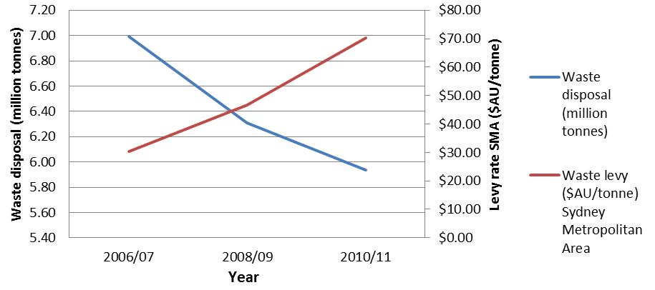
Source: http://www.environment.gov.au/resource/waste-generation-and-resource-recovery-australia-report-and-data-workbooks
Note: SMA = Sydney Metropolitan Area

South Australia
- Current solid waste levy is $AUD47/tonne and is planned to rise by $5 a year until 2016/17 (Waste Levy Regulations, EPA Guidelines).
- The South Australian Government has targets for reducing waste to landfill and reducing waste generation:
- 35 per cent reduction in landfill disposal from the 2002/03 level by 2020
- 5 per cent reduction in waste generation per capita by 2015.
- Since increasing the levy in 2002/03, waste to landfill has decreased by approximately 9 per cent, although not all of the reduction was attributed to the levy as it was implemented in combination with other initiatives.
- When reviewed in 2007, disposal to landfill had been slowly declining. There was a lack of reliable data on recycling, but the recycling quantities were thought to have been increasing over that period. Overall waste generation was on a continuous upward trend, in line with population and economic growth and consumption.
- In 2007, a report prepared by Hyder Consulting concluded that evidence from other jurisdictions (Australia and overseas) suggests there is no significant correlation between the levy and reduction in waste disposal unless the levy is substantial (ie, at least AUD$50 per tonne). A lower increase may achieve small gains in terms of resource recovery but will not lead to significant change.
- The levy has been effective at diverting construction and demolition waste to recycling but less so for commercial and industrial waste (eg, plastics, as these weigh less so there is less incentive to divert, even though they are highly recyclable).
Figure A3.10: Waste disposal to landfill and the waste levy in South Australia 1999–2005/06
Source: Review of Solid Waste Levy, Zero Waste SA. Report prepared by Hyder Consulting, 2 February 2007. Retrieved from http://www.zerowaste.sa.gov.au/upload/resources/publications/reuse-recovery-and-recycling/levy_review_final_report_5_feb_8.pdf.

Western Australia
- A levy on waste sent to landfill was introduced in 1998.
- The levy rate has two levels and is currently set at: AUD$28/t for putrescible landfills and AUD$12/t for inert landfills.
- The levy has two objectives: to act as an economic instrument to reduce waste to landfill by increasing the price of landfill disposal, and to generate funds for a range of environmental purposes.
- The levy has been successful at reducing construction and demolition waste to landfill, but less effective at reducing commercial and industrial waste.
Figure A3.11: Waste disposal and levy rate in Western Australia, 2006/07–2010/11
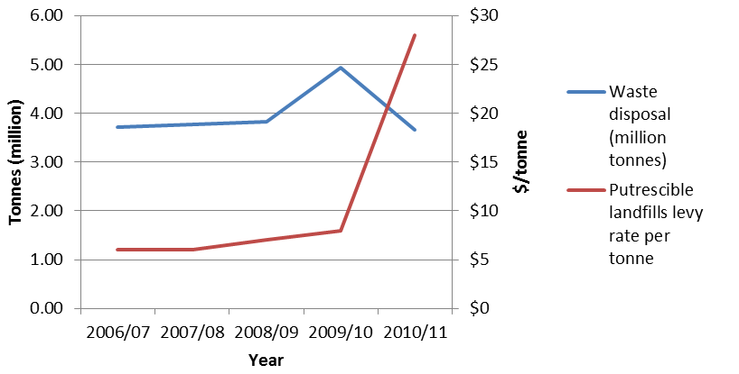

Victoria
- A landfill levy was introduced in 1992 and extended in 1996.
- The aim of the levy was to raise revenue and provide an incentive to minimise waste generation and promote alternatives.
- There is a complex system of levy rates: the rate depends on the type of waste and where the landfill is.
- The current rate (in 2013/14) for municipal waste in a metropolitan district is AUD$53.20/t. This is set to rise to AUD$58.50 in 2014/15. After that, the rate is planned to be frozen for 10 years.
- Since 2003/04, total waste to landfill is trending downwards slightly, but total waste generated is continuing to rise (the amount recovered is increasing).
Figure A3.12: Waste disposal and levy rate in Victoria, 2006/07–2010/11
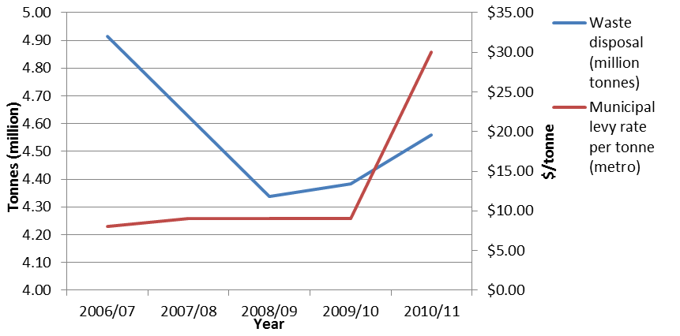

Appendix 4: Data requirements, sources and limitations for Part 4 of the waste levy review
Data required | Measure | Type of disposal facility | Available for 2014 review  Y – Yes, P – Partially, N - No | Data used for 2014 review | Limitations
Waste disposal |  |  |  |  | There is a large gap in knowledge on waste disposal in New Zealand. Data is routinely collected only for disposal facilities, which are subject to the levy.
Total waste disposed of to land | Tonnes per facility per year | Disposal facilities (levied) | Y | Online Waste Levy System (OWLS) | Self-reporting by disposal facility operators subject to audits by the Ministry.
Total waste disposed of to land | Tonnes per facility per year | Non-levied facilities.  (eg, managed fills and cleanfills) | P | Tonkin & Taylor, New Zealand Non-Municipal Landfill Database (Tonkin & Taylor Report.) | Tonnes of waste disposed of to non-levied facilities are often not reported to either territorial authorities or the Ministry.  An estimate has been made using data from a sample of sites and extrapolating waste disposal at non-levied facilities throughout New Zealand based on GDP. There is significant uncertainty associated with this data.  Further detail on the methodology and limitations of this report are provided in the Tonkin & Taylor Report and discussed in appendix 2 of this report.
Total waste disposed of to land | Tonnes per facility per year | Farm dumps | P | Tonkin and Taylor Report | Tonnes disposed of to land on farms are not reported to territorial authorities or the Ministry.  Environment Canterbury has conducted surveys on rural waste within its region on three occasions (See Environment Canterbury Report No. R13/97). Data from these surveys has been extrapolated for the whole of New Zealand based on the estimated number of farms and there is uncertainty in whether this region is representative of the whole country.  Further detail on the methodology and limitations of this report are provided in the Tonkin & Taylor Report.
Waste illegally dumped and location of ultimate disposal | Tonnes per year per region | NA | N | None | An assumption has been made that illegally dumped waste is captured by tonnes to landfill above, as councils measuring illegal dumping usually remove material and dispose of it to local landfill/cleanfill sites. However, this would not account for waste that is illegally dumped and never collected.
Waste exported | Tonnes per year | NA | N | None | Data has not been obtained by the Ministry.
Waste imported | Tonnes per year | NA | N | None | Data has not been obtained by the Ministry.
Waste incinerated | Tonnes per year per incinerator | Consented incinerators | P | Tonkin & Taylor, GHG Estimates from Non-municipal Landfills New Zealand | Estimates of waste incineration by consented incinerators were gathered from territorial authorities and assumed to be constant over time. There is significant uncertainty whether this is accurate.
Disposal patterns |  |  |  |  | There is a large gap in knowledge on where waste is taken for disposal. The only information routinely collected by the Ministry is related to disposal facilities.
Number of disposal facilities | Number of disposal facilities per region per year | Levied disposal facilities | Y | OWLS | From OWLS it is possible to determine the current number of disposal facilities subject to levy obligations.
Number of disposal facilities | Number of disposal facilities per region per year | Non-levied disposal facilities (managed fills and cleanfills) | P | Tonkin & Taylor Report | A survey in 2013 estimated the numbers of facilities. However, this is not considered to be a complete list. Territorial Authorities are not aware of all non-levied disposal facilities (managed fills and cleanfills) because such sites do not always require resource consent under the Resource Management Act 1991. Therefore it is very difficult to determine how many non-levied facilities there are throughout New Zealand.
Number of disposal facilities | Number of disposal facilities per region per year | Farm dumps | P | Tonkin & Taylor Report | The estimate used is based upon surveys carried out in Canterbury over the past 6 years. This data has been extrapolated for the whole of NZ and there is uncertainty whether this is representative of the country as a whole.
Number of incidents of illegal dumping | Number of incidents of illegal dumping per region per year | NA | N | Territorial Authority Survey of Waste Infrastructure and Services carried out by WasteMINZ and the Ministry in 2011 and 2013 | The TA survey identifies the number of councils that have recorded incidents of illegal dumping but does not record the specific number of incidents or volume/weight of waste dumped.
Exports and imports of waste | Number of shipments of waste per year | NA | N | None | Data has not been obtained by the Ministry.
Waste composition |  |  |  |  | Disposal facility operators are not required to report tonnes of waste by type and therefore estimates of waste composition are based on SWAP surveys at municipal landfills. Insufficient information is available on the composition of waste disposal at other facilities.
Waste by weight and type | Tonnes waste by type per facility per year | Disposal facilities | P | WasteNot 2013 | The composition of waste to municipal landfills has been estimated for 3 years between 2004 and 2012 based on Solid Waste Analysis Protocol (SWAP) surveys at selected sites. Composition estimates have not been made for each year and are not based on actual tonnes of waste by type that is disposed of to each facility.
Waste by weight and type | Tonnes waste by type per facility per year | Non-levied facilities (eg, managed fills and cleanfills) | N | None | No information available to the Ministry.
Waste by weight and type | Tonnes waste by type per facility per year | Farm dumps | N | None | No information available to the Ministry.
Waste by weight and type | Tonnes waste by type per facility per year | Consented incinerators | N | None | No information available to the Ministry.
Type of waste and weight exported | Tonnes waste by type per year | NA | N | None | Data has not been obtained by the Ministry.
Type of waste and weight imported | Tonnes waste by type per year |  | N | None | Data has not been obtained by the Ministry.
Reuse, recycling and recovery |  |  |  |  | There is a large gap in knowledge about the level of reuse, recycling and recovery that takes place in New Zealand.
Kerbside collection of domestic and commercial waste | Tonnes per Territorial Authority per year | NA | P | Territorial Authority Waste Assessments | Few territorial authorities have published detailed data on tonnages in their waste assessments, and not on an annual basis.
Collection via public recycling centres (including transfer stations) | Tonnes per centre per year | Public recycling centres (including transfer stations) | P | Territorial Authority Waste Assessments | As above.
Waste reused, recycled or recovered | Tonnes per Territorial Authority per year. | NA | P | Territorial Authority Survey of Waste Infrastructure and Services carried out by WasteMINZ and the Ministry in 2011 and 2013 | Data is not routinely collected on rates of recovery, reuse and recycling of waste through territorial authority activities. The surveys undertaken do not provide specific figures of actual tonnes of waste by type recycled, but only within a range of tonnages.
Diversion of waste from disposal facilities | Tonnes per waste type per disposal facility per year | Disposal facilities | P | OWLS | Data from OWLS does not provide breakdown of waste types and destination of material diverted from landfill, but it does provide an estimate of total waste diverted. Audits by the Ministry have determined that disposal facility operators generally report only waste that is diverted after weighing.
Diversion of waste from disposal facilities | Tonnes per waste type per disposal facility per year | Non-levied facilities (managed fills and cleanfills) | N | None | No information available to the Ministry.
Collections from businesses | Tonnes per waste type per region per year | NA | N | None | No information is reported by either businesses or waste/recycling operators.
Reuse by businesses | Tonnes per waste type per year | NA | N | None | No information is reported by businesses on reuse of waste. In many cases this may not be measured by businesses.
Waste minimisation through product stewardship schemes | Tonnes per waste type per scheme per year | NA | Y | Product stewardship scheme reports from accredited schemes | Information analysed is limited to accredited schemes. The scope of schemes varies, as do objectives; therefore data can be of limited use at an aggregated level. Reported data is not validated by the Ministry.
Waste minimisation via projects funded through the WMF | Tonnes per waste type per project per year | NA | Y | WMF milestone and final project reports | WMF projects do not necessarily minimise waste from the outset. To establish long-term outcomes projects need to be monitored after funding has ceased.
Waste generation |  |  |  |  | Waste generation cannot be measured directly but must be calculated by adding tonnages to each waste destination.
Total waste generated | Tonnes per year | NA | P | As indicated above for each waste destination | Calculation of waste generated will only be as accurate as the estimates of the tonnage to each destination.

Glossary
This glossary provides the relevant legal definitions for key terms used in this report, as set out in sections 5, 6 and 7 of the Waste Minimisation Act 2008, and regulation 11 of the Waste Minimisation (Calculation and Payment of Waste Disposal Levy) Regulations 2009.
Disposal | (1) disposal means—  (a) the final (or more than short-term) deposit of waste into or onto land set apart for that purpose; or  (b) the incineration of waste.
(2) In subsection (1)(a), for all purposes relating to the levy, final (or more than short-term) deposit of waste means any deposit of waste other than a deposit referred to in section 26(3).
(3) In subsection (1) (b), incineration means the deliberate burning of waste to destroy it, but not to recover energy from it.
Disposal facility | (1) disposal facility means—  (a) a facility, including a landfill,—  (i) at which waste is disposed of; and  (ii) at which the waste disposed of includes household waste; and  (iii) that operates, at least in part, as a business to dispose of waste; and  (b) any other facility or class of facility at which waste is disposed of that is prescribed as a disposal facility.  (2) In subsection (1) (a) (ii), household waste means waste from a household that is not entirely from construction, renovation, or demolition of the house.
Diverted material | means anything that is no longer required for its original purpose and, but for commercial or other waste minimisation activities, would be disposed of or discarded.
Diverted tonnage | the tonnage of waste or diverted material that is reused or recycled at the disposal facility, or is removed from the facility, not later than 6 months after entering the facility (or any later time that the Secretary for the Environment has agreed to in writing).
Recovery | (a) means extraction of materials or energy from waste or diverted material for further use or processing; and  (b) includes making waste or diverted material into compost.
Recycling | means the reprocessing of waste or diverted material to produce new materials.
Reduction | means—  (a) lessening waste generation, including by using products more efficiently or by redesigning products; and  (b) in relation to a product, lessening waste generation in relation to the product.
Reuse | means the further use of waste or diverted material in its existing form for the original purpose of the materials or products that constitute the waste or diverted material, or for a similar purpose.
Waste | (a) means any thing disposed of or discarded; and  (b) includes a type of waste that is defined by its composition or source (for example, organic waste, electronic waste, or construction and demolition waste); and  (c) to avoid doubt, includes any component or element of diverted material, if the component or element is disposed of or discarded.
Waste management and minimisation | means waste minimisation and treatment and disposal of waste.
Waste management and minimisation plan | means a waste management and minimisation plan adopted by a territorial authority under section 43 of the Waste Minimisation Act.
Waste minimisation | means—  (a) the reduction of waste; and  (b) the reuse, recycling, and recovery of waste and diverted material.

Further terms used in this report, which are not legal definitions, are:
Cleanfill | any landfill that accepts only material that when discharged into the environment will not pose a risk to people or the environment.
Landfill | a waste disposal site used for the controlled deposit of solid wastes onto or into land.
Price elasticity of demand | A measure used in economics to show the responsiveness, or elasticity, of the quantity demanded of a good or service to a change in its price
Price signal | information conveyed, to consumers and producers, through the price charged for a product or service, thus providing a signal to increase supply and/or decrease demand for the priced item.
Waste generation | the amount of waste produced or created. Waste generation = waste disposal + waste reused, recovered and recycled.

References
Covec. 2012. Economic Factors of Waste Minimisation in New Zealand. Prepared for the Ministry for the Environment by Covec.
EPA Victoria. 2013. Calculating the Landfill Levy and Recycling Rebates. Retrieved from http://www.epa.vic.gov.au/our-work/publications/publication/2013/september/332-5.
Ministry for the Environment. Unpublished. Departmental Report on the Waste Minimisation (Solids) Bill.
Ministry for the Environment. 2007a. Regulatory Impact Statement: Towards a Sustainable New Zealand – Measures to Minimise Solid Waste. https://www.mfe.govt.nz/laws/ris/ris-solid-waste.html.
Ministry for the Environment. 2007b. Targets in the New Zealand Waste Strategy: 2006 Review of Progress. http://www.mfe.govt.nz/publications/waste/waste-strategy-review-progress-mar07/.
Ministry for the Environment. 2009a. Calculation and Payment of the Waste Disposal Levy: Guidance for Waste Disposal Facility Operators. http://www.mfe.govt.nz/publications/waste/calculation-payment-of-waste-disposal-levy/index.html.
Ministry for the Environment. 2009b. Waste Minimisation in New Zealand: A Discussion Document from the Ministry for the Environment. http://www.mfe.govt.nz/publications/waste/waste-minimisation-discussion-document/index.html.
Ministry for the Environment. 2011. Review of the Effectiveness of the Waste Disposal Levy, 2011. https://www.mfe.govt.nz/publications/waste/waste-disposal-levy-review/index.html.
OECD. 2007. Environmental Performance Reviews: New Zealand. Retrieved from http://www.oecd.org/env/country-reviews/environmentalperformancereviewsnewzealand2007.htm.
Office of the Minister for the Environment. 2007. POL (07) 132 - Towards a Sustainable New Zealand: Measures to Minimise Solid Waste. https://www.mfe.govt.nz/issues/sustainability/cabinet-papers/pol-07-132.html.
Tonkin & Taylor. 2013. New Zealand Non-municipal Landfills Database Report. Prepared for the Ministry for the Environment by Tonkin & Taylor.
WasteMINZ. 2013. Draft Technical Guidelines for the Disposal to Land of Residual Waste and Other Material (Land Disposal Technical Guidelines). http://www.wasteminz.org.nz/wp-content/uploads/Consultation-Draft-Land-Disposal-Technical-Guidelines.pdf.

Disposal facilities are defined in section 7 of the Act. They are facilities, including landfills, at which waste, including household waste, is disposed of and which operate at least in part as a business. Under sections 26–28 of the Act, disposal facilities are subject to a waste disposal levy and are required to pay a levy and report data to the levy collector.
Disposal facilities are defined under section 7 of the Act. They are facilities, including landfills, at which waste, including household waste, is disposed of and which operate at least in part as a business. Under sections 26–28 of the Act disposal facilities are subject to a waste disposal levy and are required to pay a levy to the levy collector.
However, waste or diverted material that is separated out immediately on arrival for reuse, recycling or removal from site is not required to be measured and reported.
For the purposes of this report, ‘non-levied landfills’ is used to refer to all landfills that do not accept household waste, termed ‘non-municipal landfills’ by Tonkin & Taylor, whether or not the levy was in effect at the time.
Note that for the purposes of this analysis, it was assumed a landfill would close when the resource consent expired, and the 2013 raw total is not likely to include consents that were renewed or newly approved during late 2013.
Waste Minimisation Act 2008, s43.
The 20th day of January, April, July and October, unless the date falls on a weekend or public holiday, in which case the payment will be made on the next available working day.
For reporting periods two to five only, where project type information was categorised.
Territorial Authority Survey of Waste Infrastructure and Services, carried out in 2011 and 2013.
TAs generally increase their rates and charges at the beginning of the financial year, so any increase to landfill disposal charges at 1 July 2009/10 could have been for a range of reasons and may have obscured the levy.
‘Potentially hazardous’ waste includes sewage sludge, contaminated soils, and industrial by-products.
This may be largely due to the inclusion of data from a large landfill in the 2008 sample that is not representative of the whole of New Zealand
Landfills that do not need resource consent provided they meet conditions as outlined in the regional rules.
The best record on annual total tonnage for a particular region (ie, the maximum annual tonnes disposed of at that region based on the most number of sites for a particular year). Annual tonnage is calculated as the total volume capacity for a landfill divided by the consented years of operation.
Overview of the use of landfill taxes in Europe, ETC/SCP Working Paper No.1/2012 prepared for the European Environment Agency: http://scp.eionet.europa.eu/publications/WP2012_1/wp/WP2012_1.
http://www.epa.nsw.gov.au/waste/levyreview.htm.
NSW EPA. 2013. Draft NSW Waste Avoidance and Resource Recovery Strategy 2013–21. Retrieved from http://www.epa.nsw.gov.au/warr/WARRStrategy2013.htm.
Review of Solid Waste Levy, Zero Waste SA. Report prepared by Hyder Consulting, 2 February 2007. Retrieved from http://www.zerowaste.sa.gov.au/upload/resources/publications/reuse-recovery-and-recycling/levy_review_final_report_5_feb_8.pdf.
http://www.wasteauthority.wa.gov.au/about/levy/.
Sustainability Victoria. 2011. Review of Sustainability Victoria’s Strategic Direction.

