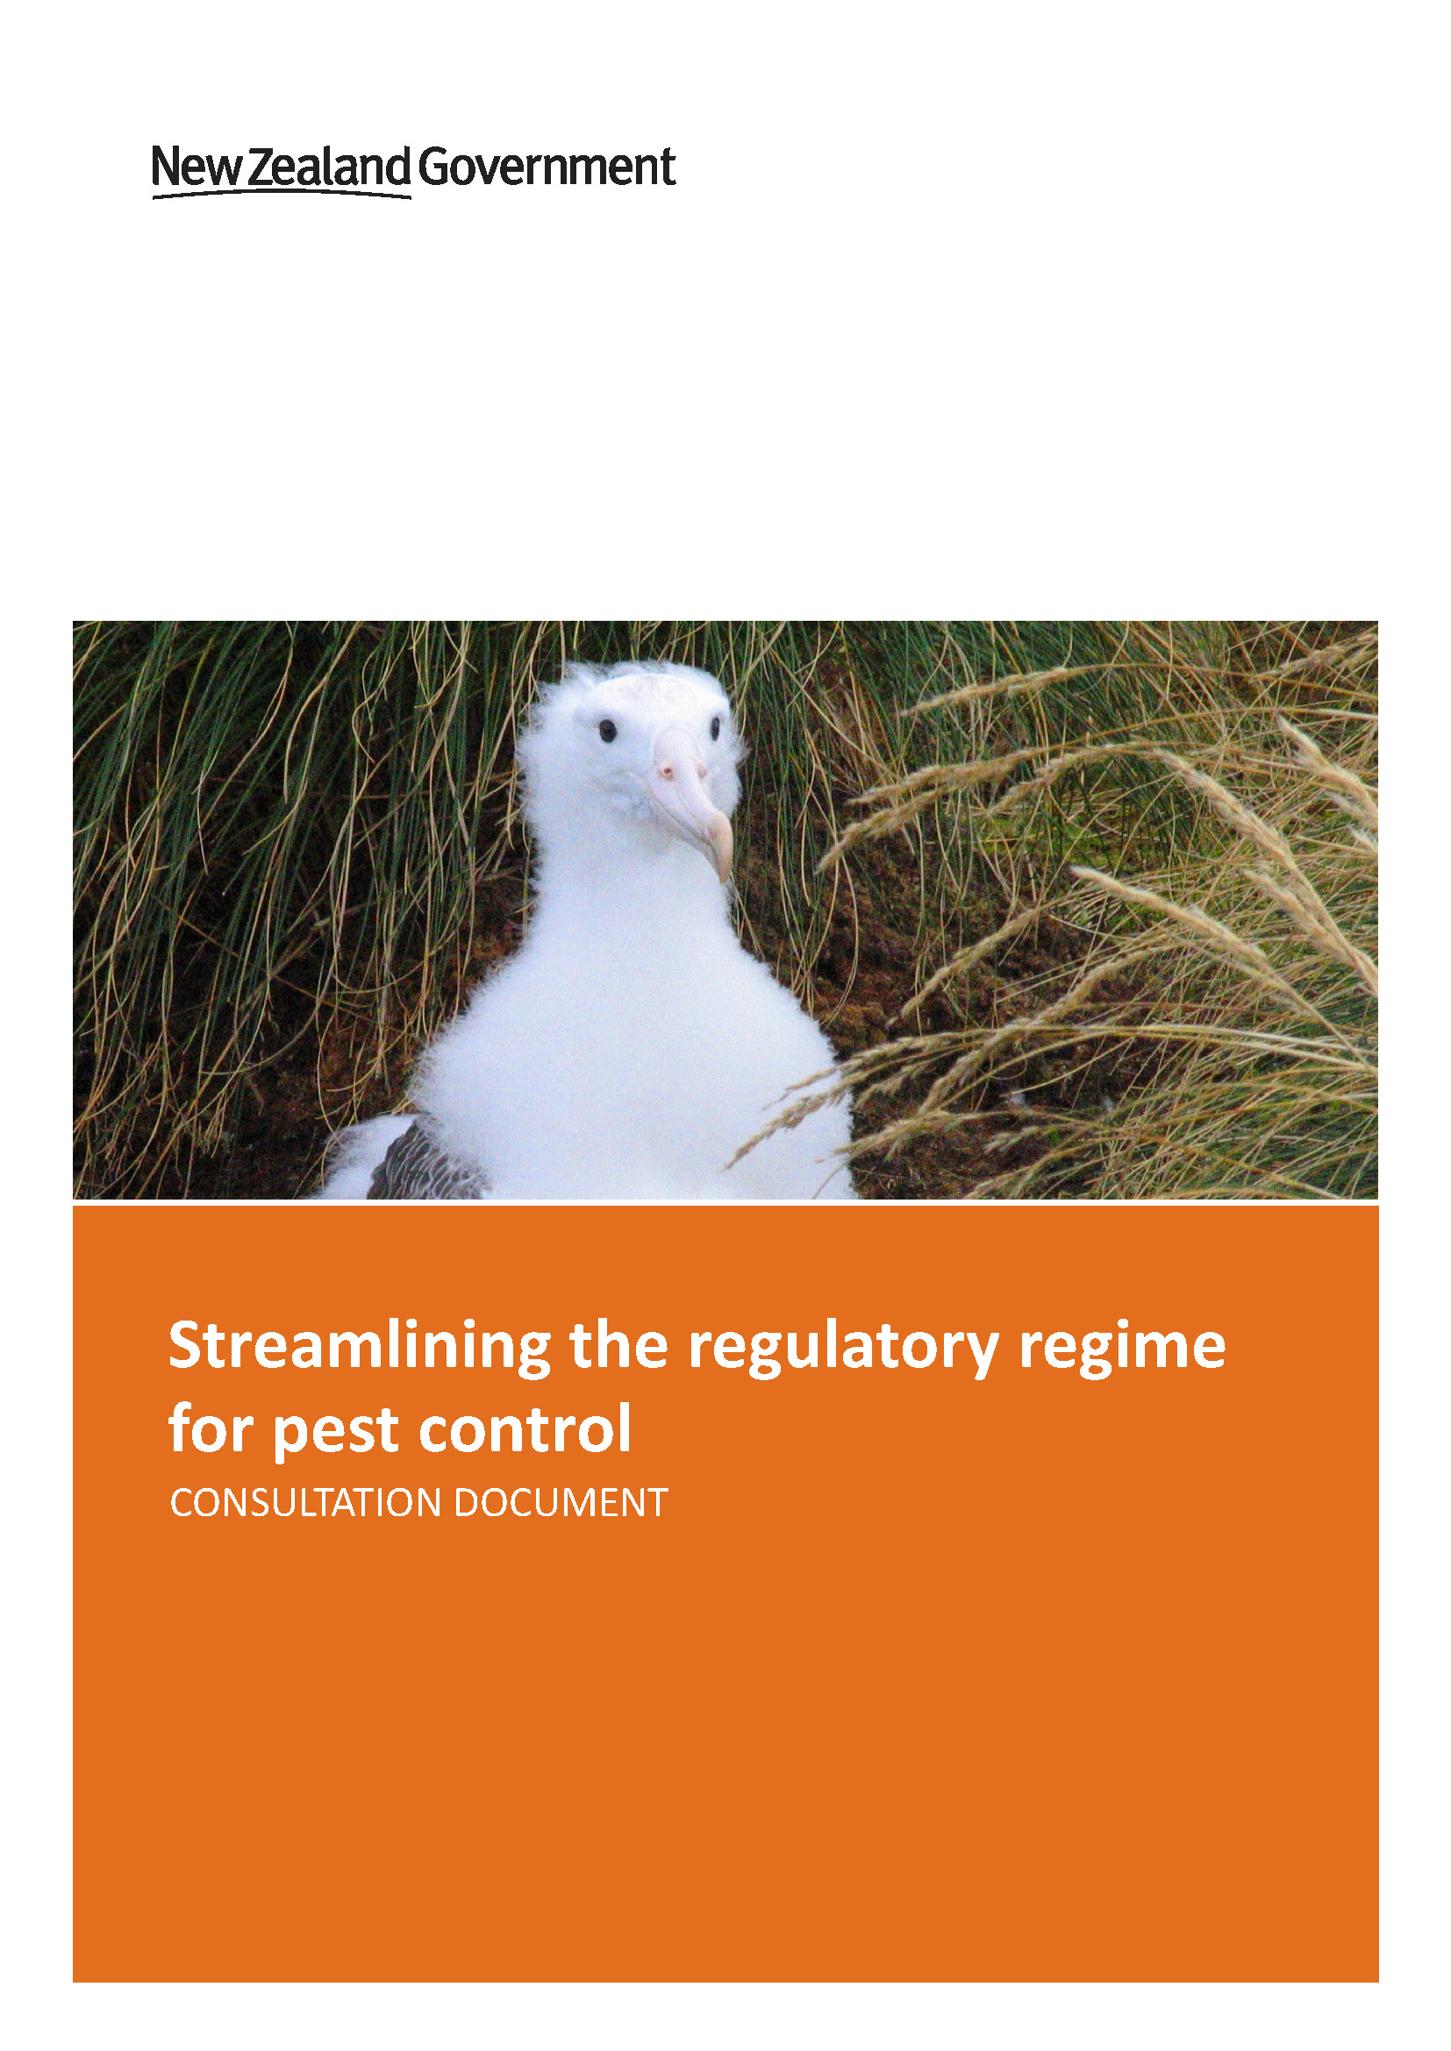
Acknowledgements
Picture acknowledgements:
Banded Kokopu (pg 7) – courtesy of G.A. Eldon
Rock Wren (pg 14) – courtesy of Craig Mckenzie

This report may be cited as:
Ministry for the Environment. 2016. Streamlining the regulatory regime for pest control consultation document. Wellington: Ministry for the Environment

Published in April 2016 by the
Ministry for the Environment
Manatū Mō Te Taiao
PO Box 10362, Wellington 6143, New Zealand
ISBN: 978-0-908339-37-2
Publication number: ME 1236
© Crown copyright New Zealand 2016
This document is available on the Ministry for the Environment’s website:
www.mfe.govt.nz
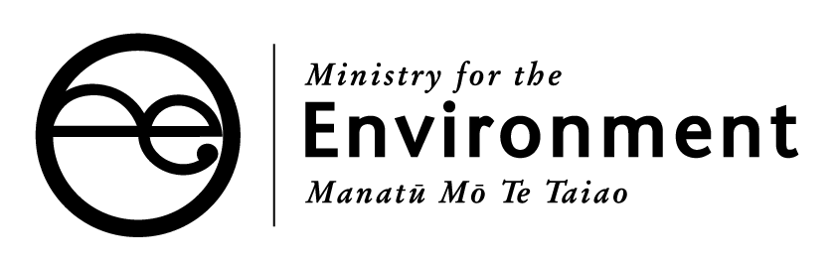

Contents
Ministerial foreword 4
Background 5
Vertebrate Toxic Agents 7
Response to Parliamentary Commissioner for the Environment’s Report 7
The proposal 9
Features of the Proposal 10
Benefits of the Proposal 12
Feedback sought 15
How to make a submission 17
Contact for queries 17
Publishing and releasing submissions 18
What happens next? 18
Appendix One 19
Background information on legislation 19
References 22

Ministerial foreword
An important dimension of the Government's reforms to the Resource Management Act is standardising environmental regulations across New Zealand, because it does not make sense for a country of 4.5 million people to have so many different rules and systems for the same issue. This proposal is about a consistent nationwide approach to pest control.
Pests are one of our greatest environmental problems because introduced predators like rats, stoats and possums are devastating our native ecosystems and spreading TB, putting at risk our important food export industries. We need robust rules to ensure poisons are used safely but we also want to minimise compliance costs so we can stretch the funding further. The direct cost savings from these proposals is over $10 million, enabling agencies like DOC to reinvest in conservation work rather than being wasted on unnecessary bureaucracy.
These proposals are based on the recommendations of the Parliamentary Commissioner for the Environment who highlighted the problems of the duplication of existing controls under the Hazardous Substances and New Organisms and the Resource Management Acts.
I welcome feedback on these proposals. I encourage submitters to focus on the science and the need for New Zealand to protect our native biodiversity and ensuring we have robust systems for managing the risks of the use of those pest controls.

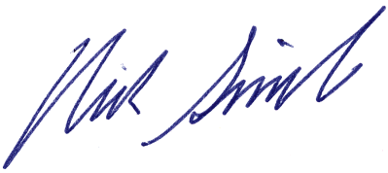

Hon Dr Nick Smith
Minister for the Environment

Background
New Zealanders are rightfully concerned about how well we match up to our clean, green brand. It matters to our view of ourselves, our lifestyle and our economy. The millions of tourists who come here marvel at our majestic mountains, rich green bush, weird and wonderful birds and crisp clean lakes, rivers and beaches. Our good environmental credentials assist in providing a premium for our dairy products, fish, fruit, meat, wine and wood exports. The point few New Zealanders appreciate is that our most significant environmental challenge is the decline and extinction of our native species.
If we compare ourselves with the other 193 countries in the United Nations and look at what proportion of our land area is protected in reserves, we rank seventh best. On the proportion of our energy that is renewable, we rank eighth. On air quality, we rank fourteenth. On water quality we have work to do – we are 43rd but still in the top quarter. But we rank 193rd – rock bottom – for the proportion of our animals at risk of extinction. All the scientific literature points to New Zealand’s biggest environmental problem being species decline and loss, and particularly for our birds.
For 60 million years after New Zealand split off from Gondwanaland, we had no mammal predators. This meant a whole range of flightless birds and unusual creatures like tuatara and giant weta evolved, making New Zealand different to any other land mass. Last century we lost a number of significant birds. The huia in 1907, the laughing owl in 1914, the piopio in 1963, and the South Island kokako, with its orange rather than blue wattle, has not been seen in more than 30 years. Nor has the South Island pateke, or brown teal, since the 1990s. An iconic example is our kiwi. Our most prolific species is the brown kiwi that once numbered in the millions. It is down to numbers of about 25,000 and declining by three per cent per year. We are only two generations away from when kiwi are estimated to completely disappear from the wild without intervention.
There was a time when hunting and deforestation was the primary reason for the decline of these native birds. These birds are now all protected and the impact of hunting is negligible. The cause of on-going decline and the risk of extinction comes primarily from predator pests. Pest enemy number one is the rat, number two is the stoat and number three is the possum.
Landcare ecologists estimate that rats, stoats and possums kill 25 million native birds a year. That puts into perspective the true scale of the threat these pests pose to our environment. Take the Rena ship grounding and sinking in 2011, labelled as New Zealand’s worst environment disaster. About 2000 birds were found dead. So the damage caused by rats, stoats and possums is like having a Rena disaster every single hour.
Possums, stoats, and rats are present in at least 94 percent of New Zealand. Possums, wallabies and other animals also threaten plant species and ecosystems. Extensive conservation efforts by the Government, industry and community groups are underway to increase biodiversity and bring back species from the threat of extinction. Extensive pest control operations are completed each year to reduce the impact of these pests.
Predator-free offshore islands are the last refuges for some animals and rare plants.
These include: seabirds, forest birds, tuatara, numerous species of lizards, and large invertebrates. There are now 100 predator free offshore islands around New Zealand.

Tuatara are only found on offshore islands or in pest free sanctuaries.

Possum control is a cornerstone activity for New Zealand’s National Pest Management Plan for Bovine TB (the TB Plan) which is operated by OSPRI New Zealand through its subsidiary TBFree NZ (previously the Animal Health Board). The programme has been investing around $50 million per year in possum control. Possums and a number of other introduced vertebrates are carriers of bovine TB and can transmit infection to cattle and deer herds. Infected possums are likely to occur across about 90,000 km² of New Zealand, about one third of our total land area. Infected stock must be culled, which along with restrictions on stock movement can cause significant financial losses to farmers. An effective TB control programme reduces costs to farmers and helps maintain the value of New Zealand’s dairy, beef and deer industry exports.

In freshwater systems, a major threat to trout fisheries, native fish and freshwater ecosystems is pest fish, including gambusia and koi carp. Species such as carp feed by stirring through the sediment at the bottom of lakes and rivers. That damages water quality, and can also affect the habitats and spawning sites of native species and trout. Most freshwater pest species are restricted to a small number of waterbodies or part of the country. Preventing spread by eradicating new pest fish populations is a key focus for pest fish programmes.

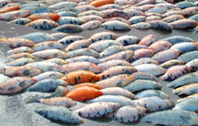
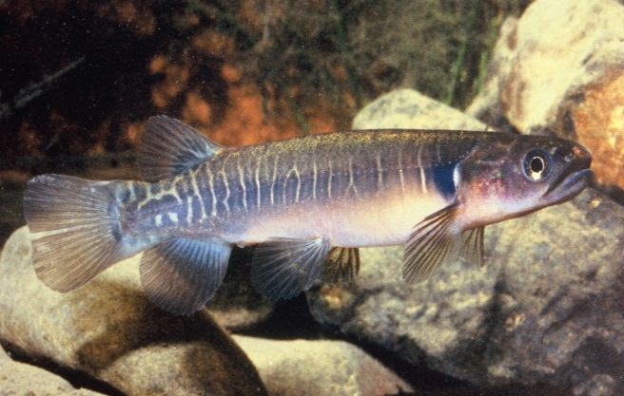
Native habitats of this Banded Kokopu are damaged where fish like koi carp (photo on the right) have become established.

As well as direct effects, vertebrate pests affect the ecosystem services arising from biodiversity, such as protection of soils, mitigation of flood risks and delivery of clean freshwater, which are critical for New Zealand’s primary industries, cities and economy.

Vertebrate toxic agents
Vertebrate toxic agents (VTAs) are poisons used to kill vertebrate pest species, and include a range of toxins (eg, cyanide, brodifacoum, rotenone, 1080) delivered using a range of methods. There are currently two levels of controls on the use of VTAs. The first level of control are national controls that apply to all VTA uses, particularly the controls imposed under Hazardous Substances and New Organisms Act 1996 (HSNO) and the Agricultural Compounds and Veterinary Medicines Act 1997 (ACVM). A VTA cannot be imported, manufactured, sold or used until it has gained authorisation under both these Acts.
The second level of controls are local controls placed on an individual operation that uses a specific VTA in a specific circumstance. Depending on the VTA and the way it is to be used, other legislation may also apply. In particular, the Conservation Act 1987 and the Fisheries Act 1996 control the use of poisons to kill fish, and the Resource Management Act 1991 (RMA) controls the release of chemicals into the environment. There are also RMA controls on manufacture, storage and transport of hazardous substances.
Local controls are appropriate elements in a regulatory regime where they address site or operation specific matters that are not addressed through the national controls. For example, in the case of the Conservation and Fisheries Act controls on rotenone use to kill fish, the controls ensure that its use will deliver a net fisheries management benefit – something the HSNO regime does not address.

Response to Parliamentary Commissioner for the Environment’s Report
In 2011, the Parliamentary Commissioner for the Environment (the PCE) investigated the use of one of the main VTAs we use in New Zealand - sodium fluoroacetate (1080).
In that report the PCE recommended:
The Minister for the Environment investigate ways to simplify and standardise the way 1080 and other poisons for pest mammal control are managed under the Resource Management Act and other relevant legislation.
The PCE concluded that the labyrinth of laws, rules and regulations that govern 1080 and the other poisons used to control introduced pests creates unnecessary complexity and confusion. The report found that under the RMA, the use of poisons for controlling pest mammals is treated differently by different councils, where some councils treat the use of poisons as a permitted activity with only a few conditions, while other councils treat exactly the same use as a discretionary activity requiring a resource consent. The report also concluded that many of the rules also replicated controls already in place under other legislation.
In response to the PCEs report on 1080, the Department of Conservation (DOC), Ministry of Primary Industries (MPI) and TBFree (a subsidiary of OSPRI) completed a detailed analysis of all consents for aerial use of 1080 issued by councils between 2003 and 2013. Their findings were presented in the report Business Case: Simplifying the regulation of aerial 1080 under the Resource Management Act (2015). This report found a compelling case to change the existing arrangements and seek to simplify the management of aerial 1080 under the RMA, for reasons including but not limited to:
- the risks and effects of 1080 are robustly and effectively managed under the HSNO, ACVM and by the Ministry of Health. The regulation of 1080 under the RMA is not affording any extra protection to the environment or public health, nor is it managing risks outside those already managed under HSNO
- there are high levels of unnecessary duplication between the RMA and HSNO. Significant levels of duplication occur between RMA consent conditions and HSNO controls. There is also duplication between plan rules and HSNO requirements. This duplication is costly and does not improve the management of effects and risks
- the analysis presented in this business case has found the sustainable management purpose and principles of the RMA are being sufficiently achieved under HSNO. The further management of 1080 under the RMA is not affording additional environmental protection, due to 100% duplication with HSNO permissions and standard operating procedures
- the management of 1080 through regional plans is inconsistent, and this can adversely impact the effectiveness of operations. There are 13 Regions with varying Regional Plan rules/standards that trigger the need for resource consent for aerial 1080 operations. Over 200 such resource consents have been issued in the last ten years in 10 Regions. There is significant regional variability in consent conditions and in the way consents are managed
- inconsistency and duplication increases the risk of compliance failure. Having variable consent conditions reduces the ability of the operators to ensure that best practice is always achieved. Regional inconsistency and duplication also increases the risk of breaching consent conditions. Even if the effects of such breaches are minor, they are treated as adverse incidents in EPA reports. The recurrence of such incident reports could lead to imposition of further controls under the HSNO Act, potentially resulting in the loss or reduced availability of 1080 as a pest management tool for biosecurity and biodiversity programmes.

The proposal
This consultation document proposes to simplify the regulatory controls on vertebrate toxic agents (VTAs) by putting in place a regulation under section 360(1)(h) of the Resource Management Act 1991 (RMA) that will exempt the requirement for a resource consent or rules in regional plans (under section 15 of the RMA) for discharges of:
- any vertebrate toxic agent that has been through a full assessment under section 63 or 29 of the Hazardous Substances and New Organisms Act 1996 (HSNO)
- any vertebrate toxic agent that has been through a rapid assessment under section 28A assessment, provided a full assessment under section 63 or 29 of HSNO has been completed for the active ingredient in the formulation
- brodifacoum use compliant with the conditions of registration placed on the relevant brodifacoum based products (Pestoff Rodent Bait 20R; AVCM registration no V009014) registered under the Agricultural Compounds and Veterinary Medicines Act 1997(ACVM).
Parts 1 and 2 are intended to ensure that the regulation only applies to VTAs that have been through a full assessment, with public submissions, under HSNO. Many VTAs have been through assessments under earlier law that did not include a full public process, and these are not included in this proposal.
Part 3 is specifically for brodifacoum when used in certain locations. The only brodifacoum operations covered by the regulation will be those on offshore islands (where public access can be restricted), or within fenced sanctuaries (where the ACVM Code of Practice must be followed). The limitations provide an effective way to minimise risks to public health and the environment.

Consultation questions
- Do you agree with the proposal to use a section 360(1)(h) regulation to simplify the regulatory framework for the VTAs in New Zealand?
- Do you agree with the scope for the proposal?
- Part 1: any vertebrate toxic agent that has been through a full assessment under section 63 or 29 of the Hazardous Substances and New Organisms Act 1996 (HSNO).
b) Part 2: any vertebrate toxic agent that has been through a rapid assessment under a section 28A assessment, provided a full assessment under section 63 or 29 of HSNO has been completed for the active ingredient in the formulation.
c) Part 3: brodifacoum use compliant with the conditions of registration placed on the relevant brodifacoum based products (Pestoff Rodent Bait 20R; AVCM registration no V009014) registered under the Agricultural Compounds and Veterinary Medicines Act 1997(ACVM).

Features of the Proposal

Conditions in the regulation
It is proposed that the regulation include the conditions outlined in Table 1.
Table 1: Conditions in the section 360(1)(h) regulation
Condition | Rationale
Occupier permission for the land where the aerial discharge is occurring | This ensures aerial operations do not occur without people’s knowledge or consent on land they occupy.
Information to be provided to councils on:  - location of the planned operation (GPS data),  - timing of the operation  - chemical being used. | This provides information to councils that they have requested in the past in resource consents. This also provides councils with the ability to see where operations are occurring within their regions, and if necessary undertake monitoring and compliance actions.
Compliance with HSNO controls. | Whether this condition is included or not, all operations must comply with HSNO, ACVM and any other regulatory requirements. The purpose of this condition in the regulation is to ensure councils have a legal mechanism to enter private property to monitor compliance, and potentially use RMA enforcement mechanisms if the regulation is breached.

Consultation Questions
- Should any of the conditions be changed? If so, how should they be changed?
- Are there conditions that should be added? Please provide information to support new conditions.
We also seek specific feedback, particularly from regional councils and unitary authorities, on:
- Are there likely to be any unintended consequences as a result of the proposal that we have not identified?
- Will the conditions ensure that you have the necessary information to allow you to undertake your general environmental protection functions?
- How far in advance of an operation do you need the information to be provided?
- How will the change affect the way you monitor and enforce general regulatory controls on pest control, or implement biosecurity functions?

VTAs will continue to be assessed under HSNO
The HSNO Act provides an assessment process that includes a full public submission process and consideration of those submissions by an independent expert body. That is the case for those approved under HSNO section 29 or 63.
An assessment for the approval to import or manufacture a hazardous substance is determined under section 29 of HSNO. Section 29 is used to seek HSNO approval for any new VTAs that are developed for use in pest control in New Zealand.
Section 63 of the HSNO Act provides the mechanism for a hazardous substance reassessment. Many hazardous substances had been approved under previous legislation, and those approvals were carried over into HSNO. The section 63 assessment can be applied to substances that were carried over if there is new information about the substance that would warrant a reassessment.
An applicant can request a reassessment when there is new information, or the Environmental Protection Authority (EPA) can require it. The outcomes of a reassessment might change the way in which the substance is used (eg, to allow it to be used for a wider range of pests) or the HSNO controls that are put on the substance. It can also be used to confirm the safety of the controls in place for a toxin, or it can result in the chemical being banned.
Section 28A is a rapid assessment of a hazardous substance. In some cases a rapid assessment is appropriate because the substance is considered low risk, but the power is also used for a formulation change for a substance that has already gone through the comprehensive section 29 or 63 assessment. Only the latter case (ie, where the toxin has been through a section 29 or 63 public process) is treated as a “full assessment with public process” in this proposal.

What is covered
This proposal only covers VTAs. Similar issues (eg, duplication of controls between HSNO and the Resource Management Act 1991 (RMA)) may exist for other pest control substances (eg, herbicides), but no detailed work has been done on those. There are also more likely to be site specific issues (such as, risks of spray drift) that are being usefully managed under the RMA.
A review of the effect of RMA controls on wilding pine operations indicated that most operations are now permitted activities, suggesting that there is no urgent need to carry out a review of the impact of regulatory complexity for that nationally important programme.
The proposal covers those VTAs that have been subject to relatively recent assessments, under HSNO. This allows confidence that detailed assessments have been completed for a VTA that has been through the process and are included in scope. It also means that the public will have had a say on the approvals of any VTA that in future falls within the scope of the regulation.
Currently the VTAs that are able to be used in a way that would be considered a discharge under section 15, and that have been through a full HSNO approval process are 1080 (under section 63) and rotenone (under section 28).
In the case of brodifacoum, the ACVM process and the fact that the proposal only applies to use in fenced sanctuaries and on offshore islands are considered sufficient to ensure that the national regulatory system fully addresses the public interest.
Appendix 1 provides links to the HSNO and ACVM controls for rotenone, 1080 and brodifacoum.

Compliance
Under this proposal, and in accordance with recent changes in the Health and Safety Reform Act 2015, Worksafe New Zealand will be responsible for monitoring compliance with all of the national controls and conditions of aerial 1080 use. In addition, the Ministry of Health is also able to audit and check compliance with controls of operations where they have issued consent. Medical Officers of Health regularly check operations in the field. The Environmental Protection Authority and the Department of Conservation (DOC) also undertake compliance checks of operations and TBFree complete audits of their operations.
Regional councils have a function to check compliance with controls for operations. This proposal includes an explicit condition that operations follow HSNO conditions, together with conditions that ensure that basic information about operations is provided to councils, to ensure council staff can use RMA powers to prosecute any VTA user who acts in a way that is contrary to HSNO requirements. Under the new proposal councils will not be able to recover costs of any monitoring they choose to undertake. Currently, if the council has made aerial 1080 use a permitted activity (with conditions) councils are not able recover costs. If they are issuing a resource consent, however, they are able to recover costs.

Benefits of the Proposal
The expected benefits of the proposal are to:
- reduce duplication within the regulatory regime
- ensure that the regulatory regime does not bias the choice of VTA for an individual operation, so the best toxin is used in each case
- enable consistency across the country and to ensure that best practice in the use of each VTA can be developed and implemented throughout New Zealand
- remove unnecessary costs of the regulatory regime, and unnecessary delays to pest control work, so New Zealand can more effectively control vertebrate pests.

Consistency established
The proposal will enable operations to be run consistently across the country. Operations that cross regional boundaries would be more effective and less complex. National consistency would also allow more standardisation of good practice by pest management agencies and operators. Currently, variations in conditions between regions means that standard operating systems cannot be applied, and instead systems have to be designed for each operation.
Currently regional plans regulate the aerial application of 1080 in different ways, and there is significant variance in the way resource consents are considered, processed and conditions applied. The business case analysis showed there is significant variation in the length of time it takes for resource consents to be processed, and the number of conditions that are imposed on different operations is highly variable around the country. For example, consents granted by the West Coast Regional Council contain an average of 22 conditions, whilst consents from the Marlborough District Council contain an average of eight conditions.
Where a pest control operational area overlaps different local authorities, different rules are applied to contiguous terrain by the different councils. This scenario was particularly apparent in an operation carried out in Kahurangi National Park. A 20m wide buffer (bait exclusion) zone was required either side of the Heaphy track by the West Coast consent authorities, up to the regional boundary. When the track entered the Tasman District Council area, a different rule applied and buffers were not required.
The requirement for the buffer along the Heaphy track also required an additional operational buffer zone to ensure that the consented boundary was not breached thereby effectively creating at least a 100m wide untreated area both sides of the track. Due to the meandering complexity of the track direction, the effect of this was to create a wide ( >200-300m) strip of un-treated predator habitat leaving a residual pest population to compromise the effectiveness of the operation and significantly increasing the complexity and cost.

More effective use of resources
This proposal will provide users of VTAs with significant savings, both in staff time and the cost of operations. Currently the resource consent process takes time, can be complicated and unpredictable in duration, and councils recover their costs from applicants.
The business case estimated the cost of obtaining resource consents for aerial 1080 operations over 2003-13 at $10.7 million. Third party costs are not included in this estimate. The cost of all brodifacoum operations has not been calculated, however available data indicates that the resource consent cost of brodifacoum operations can be up to 28 per cent of the overall cost of the operation, and up to around $60,000. That is a significant cost for a community sanctuary programme.
The reviews of 1080, rotenone and brodifacoum consents, found a number of sources of costs arising from the section 15 controls. These were:
- the direct financial costs of gaining consents or providing input to plan changes
- the direct financial costs of complying with conditions on consents
- delays and timing uncertainties as a result of the consent processes.
The Battle for Our Birds pest control programme was DOC’s biggest yet. One year after the last aerial drops, it is being declared a success. Between August 2014 and February 2015, DOC staff planned and carried out an unprecedented 27 aerial pest control operations over more than 600,000 hectares in priority areas across the South Island to protect native species from the forecast predator plagues. In addition, six North Island operations covered more than 94,000 hectares.
Some fragile populations of threatened species have been saved by the Battle for our Birds programme. Early results from intensive bird and bat monitoring also showed the nesting success of rock wren, mohua, robin and rifleman were significantly higher within pest control areas than outside. Ongoing monitoring is continuing to show benefits that will become more apparent at the end of summer 2016.
Mohua  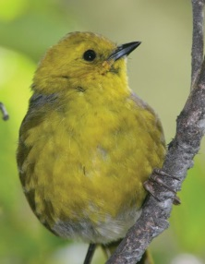  In the Dart Valley in Mt Aspiring National Park, the population of mohua has been observed over a number of years. During this time, there has been a series of localised beech mast events. The last time there was a rat and stoat plague in the Dart in 2011 we did not undertake a 1080 drop and nesting success was 57%.  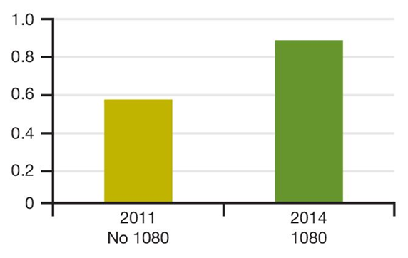  This time, with the 1080 operation covering 15,000 hectares, nesting success for mohua was 89%. | Rifleman  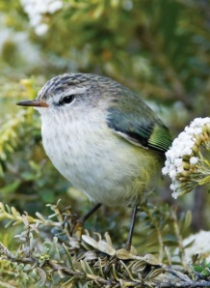  Again at the Mt Stanley operation in the Marlborough Sounds, 30 riflemen were monitored and none died. Nesting success went from 29% to 100% – three times as many chicks produced after the operation.  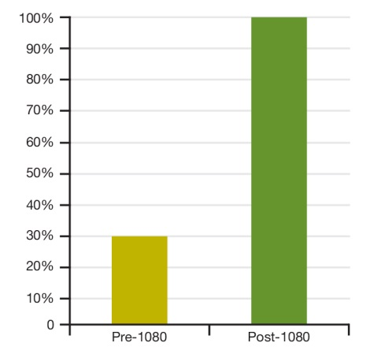

Robin  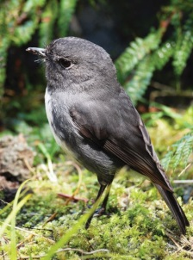  During the 4,000 hectare Mt Stanley 1080 operation in the Marlborough Sounds, 24 robins were monitored. None died. Nesting success where 1080 was used rose to 50% compared to 7% before the operation and outside the operational area.  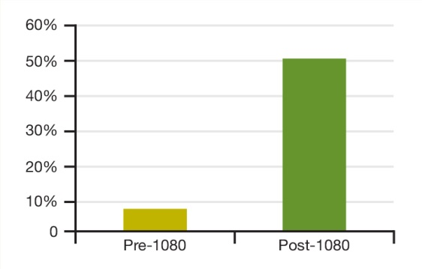 | Rock Wren  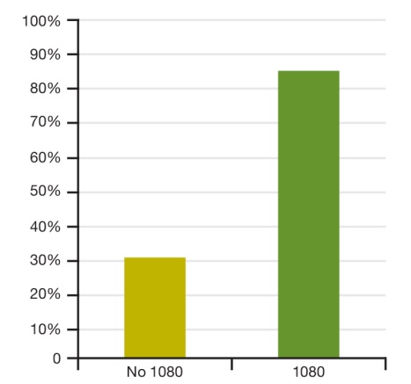  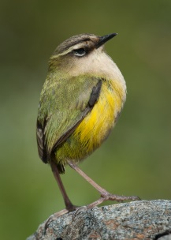  During the Kahurangi 1080 operations, 49 rock wren were monitored. A bad-weather event compounded an already-difficult tracking of these elusive alpine dwellers and 22 birds were unaccounted for. However, 24 nests were monitored – 14 in the 1080 area and 10 in the untreated area. In the treated area, nesting success was more than 80%. In the untreated area, nesting success was just over 20%.

Better outcomes and better timing
The timing of operations is often critical because of seasonal or biological factors. Currently the consenting regime can create unpredictable delays that impact on the timing of an operation. Removal of the section 15 controls will remove the key delay risk, as it is the uncertainty about how long consent processes will take (eg, because of the risk of Environment Court appeals) that creates the greatest uncertainty about when operations will be able to be undertaken.
Predictable timeframes for approvals have a number of benefits:
- they enable operations that are in response to pest incursions to be undertaken before the pest becomes fully established or spreads
- they allow operations to be planned to make optimal use of scarce expertise within the sector (eg, helicopters, pest control operation planners). That will make the overall pest control system more efficient, but also ensure that the best expertise is always used
- they allow operations to be undertaken at the best time to achieve good pest kill rates
- they allow time-sensitive research associated with operations to be successfully completed.
One example of an effect of timetable uncertainty was the DOC aerial 1080 operation over the Tennyson Scenic Reserve in 2013. Gaining RMA consents involved a notified resource consent process, followed by an appeal to the Environment Court, mediation and negotiated settlement. The planned operation was delayed by one year as a result of delays caused by the appeal process. This in turn set back an associated $500,000 multi-year research programme in the same location.

Feedback sought
We seek your feedback on the proposal to simplify the regulatory regime. In particular:
- Do you agree with the proposal to use a section 360(1)(h) regulation to simplify the regulatory framework for the VTAs in New Zealand?
- Do you agree with the scope for the proposal?
- Part 1: any vertebrate toxic agent that has been through a full assessment under section 63 or 29 of the Hazardous Substances and New Organisms Act 1996 (HSNO).
b) Part 2: any vertebrate toxic agent that has been through a rapid assessment under a section 28A assessment, provided a full assessment under section 63 or 29 of HSNO has been completed for the active ingredient in the formulation.
c) Part 3: brodifacoum use compliant with the conditions of registration placed on the relevant brodifacoum based products (Pestoff Rodent Bait 20R; AVCM registration no V009014) registered under the Agricultural Compounds and Veterinary Medicines Act 1997(ACVM).
- Should any of the conditions be changed? If so, how should they be changed?
- Are there conditions that should be added? Please provide information to support new conditions.
We also seek specific feedback, particularly from regional councils and unitary authorities, on:
- Are there likely to be any unintended consequences as a result of the proposal that we have not identified?
- Will the conditions ensure that you have the necessary information to allow you to undertake your general environmental protection functions?
- How far in advance of an operation do you need the information to be provided?
- How will the change affect the way you monitor and enforce general regulatory controls on pest control, or implement biosecurity functions?
This consultation document is not about whether VTAs should be used or which VTA should be used for particular purposes. The proposal will not be changing which VTAs can be used in New Zealand, or the level of protection provided to people and the environment. This proposal is to remove a duplicate layer of permissions to achieve greater regulatory efficiency and effectiveness, while retaining regulatory safeguards for the public and the environment.

How to make a submission
The Government welcomes your feedback on this consultation document. The questions are listed on page 15 and 16. They are a guide only and all comments are welcome. You do not have to answer all the questions.
To ensure your point of view is clearly understood, you should explain your rationale and provide supporting evidence where appropriate.
There are three ways you can make a submission:
- Use our online submission tool, available at www.mfe.govt.nz/more/biodiversity/streamlining-regulatory-regime-pest-control.
- Download a copy of the submission form to complete and return to us. This is available at www.mfe.govt.nz/more/biodiversity/streamlining-regulatory-regime-pest-control. If you do not have access to a computer we can post a copy of the submission form to you.
- Type up or write out your own submission.
If you are posting your submission, send it to National Direction Pest Control, Ministry for the Environment, PO Box 10362, Wellington 6143 and include:
- the title of the consultation – (Streamlining the regulatory regime for pest control)
- your name or organisation name
- postal address
- telephone number
- email address.
If you are emailing your submission, send it to pestcontrol@mfe.govt.nz as a:
- PDF
- Microsoft Word document (2003 or later version).
Submissions close at 5pm on Thursday 26 May 2016.

Contact for queries
Please direct any queries to:
Phone: Ministry for the Environment 04 439 7400
Email: pestcontrol@mfe.govt.nz
Postal: National Direction Pest Control, Ministry for the Environment, PO Box 10362,
Wellington 6143

Publishing and releasing submissions
All or part of any written submission (including names of submitters), may be published on the Ministry for the Environment’s website, www.mfe.govt.nz. Unless you clearly specify otherwise in your submission, the Ministry will consider that you have consented to website posting of both your submission and your name.
Contents of submissions may be released to the public under the Official Information Act 1982 following requests to the Ministry for the Environment (including via email). Please advise if you have any objection to the release of any information contained in a submission and, in particular, which part(s) you consider should be withheld, together with the reason(s) for withholding the information. We will take into account all such objections when responding to requests for copies of, and information on, submissions to this document under the Official Information Act.
The Privacy Act 1993 applies certain principles about the collection, use and disclosure of information about individuals by various agencies, including the Ministry for the Environment. It governs access by individuals to information about themselves held by agencies. Any personal information you supply to the Ministry in the course of making a submission will be used by the Ministry only in relation to the matters covered by this document. Please clearly indicate in your submission if you do not wish your name to be included in any summary of submissions that the Ministry may publish.

What happens next?
Once submissions have been considered, a recommendation will be provided to the Minister for the Environment. Once the Minister has considered the recommendations, any progression of this proposal requires Cabinet approval.

Appendix One

Background information on legislation

Hazardous Substances and New Organisms Act 1996
The Environmental Protection Authority (EPA) administers HSNO. The Act sets out the overarching framework for the management of hazardous substances, including approving the importation, manufacture and use of all VTAs (and other hazardous substances) in New Zealand. Decisions are made by the EPA, which is an independent, expert, semi-judicial body. Most decisions involve a public process with submissions and hearings.
VTAs are hazardous substances because they have either or both of the following intrinsic properties under section 2 of HSNO:
- ecotoxicity, with or without bioaccumulation (ie, can kill living things either directly or by building up in the environment)
- acute or chronic toxicity (toxic to humans).
When hazardous substances are assessed under HSNO, this includes consideration of the costs and benefits of using the substance, taking into account potential effects on environmental, social, economic, and Maori cultural values. The EPA can only approve a hazardous substance if it is satisfied that the positive effects of the use of that substance (in accordance with any conditions) outweigh the negative effects. The focus is on making sure that the use of the substance in New Zealand is managed to minimise risks and ensure that those risks are justified by the benefits to society. For example, petrol is a hazardous substance, but controls on its storage and use are designed to minimise the potential risks it poses (eg, the risk of explosions and fires, or of spills affecting waterways).
The Environmental Protection Authority (EPA) website outlines the controls for all hazardous substances that are approved for use.

1080
- 1080 reassessment decision document with amendments: http://www.epa.govt.nz/Publications/1080-Decision-document-with-amendments.pdf . This document has a summary of the controls in non-technical language.
- Approved hazardous substances with controls. The following are 1080 substances that are aerially applied:
- cereal-based pellets containing 0.4 - 0.8 g sodium fluoroacetate/kg (HSR002422): http://www.epa.govt.nz/search-databases/Pages/controls-details.aspx?SubstanceID=11364&AppID=1807
- cereal-based pellets containing 1.5 – 2.0 g sodium fluoroacetate/kg (HSR002424): http://www.epa.govt.nz/search-databases/Pages/controls-details.aspx?SubstanceID=39609&AppID=1807
- soluble concentrate containing 200 g sodium fluoroacetate/litre (HSR002427): http://www.epa.govt.nz/search-databases/Pages/controls-details.aspx?SubstanceID=11370&AppID=1807

Rotenone
There are two decision documents for rotenone that contain the conditions:
- Cube Root Powder: http://www.epa.govt.nz/search-databases/Pages/applications-details.aspx?appID=HSR02059
- Cube Root Slurry: http://www.epa.govt.nz/search-databases/Pages/applications-details.aspx?appID=HSR08078#
Note: you will need to open the ‘documents’ page.

Brodifacoum
http://www.epa.govt.nz/search-databases/Pages/controls-details.aspx?SubstanceID=9824&AppID=3281

Agricultural Compounds and Veterinary Medicines Act 1997
The Ministry for Primary Industries (MPI) administers ACVM. The Act manages four risk areas (trade, animal welfare, public health, agricultural security) in relation to agricultural compounds. The main regulatory tool under the Act is registration of trade name products including VTAs. When registering VTAs, conditions of registration are used to manage the four risk areas. They include conditions on labelling, signage and restrictions on use for VTAs.

Agricultural Compounds and Veterinary Medicines Act 1997 (ACVM) Conditions
To get to the ACVM conditions on use for brodifacoum:
- Go to: https://eatsafe.nzfsa.govt.nz/web/public/acvm-register.
- Type in the relevant name (eg, Pestoff rodent bait 20R) in the trade name section
(you need to ensure the name is correct).
- Click search.
- When the registration details come up, click on [show details] under the conditions
The ACVM Code of Practice for brodifacoum referred to in the consultation document can be found at http://www.pestoff.co.nz/pdf/Code%20of%20Practice%2020R.pdf

The Health Act 1956
The Health Act 1956 sets up a system for managing public health issues. It does not directly control use of VTAs, but procedures under the Act implement a number of the controls imposed under HSNO for specific substances (including 1080).
For 1080 specifically, restrictions are set by local health authorities, and generally include measures to protect public drinking water supplies and measures to mitigate human health risks, such as establishing buffer zones around poisoning operations. The Ministry of Health operates under this Act when setting conditions on HSNO permissions for 1080 use. In practice, the issue and conditioning of permissions is delegated to the public health units of District Health Boards, who also monitor compliance.

The Resource Management Act 1991
In addition to these controls, VTA use is classed as a discharge of contaminants under section 15 of the Resource Management Act 1991 (RMA), unless the VTA is kept contained (eg, in a bait station). All regional plans made under the RMA require resource consent for some types of VTA operations. Each region differs, however, in terms of what types of VTA operation need consent, and what conditions need to be satisfied by applicants and consent holders. For example, some regions allow 1080 to be used without resource consent or any information being provided to the council, and others require resource consent for each individual operation.
Risks posed by the manufacture, storage and transport of VTAs are managed by district councils, and those controls are not affected by the proposal in this consultation document.

The Fisheries Act 1996
The Fisheries Act is relevant when rotenone operations are being completed. Under section 97 of the Fisheries Act (special permits) the Director General of MPI may issue any person with a special permit to manage or eradicate unwanted aquatic life.

Protected areas legislation
Protected areas legislation, including the National Parks, Reserves, Conservation and Wildlife Acts, impose controls on pest control operations undertaken by someone other than the land manager. For example, OSPRI needs regional council permission if they are doing a tuberculosis (TB) possum control operation in a regional park. That legislation will also ensure that the land administrator only does pest control where that is necessary for the purposes for which the land is held.
Under the Conservation Act 1987, section 26ZR makes it an offence to use a hazardous substance (eg, rotenone) to catch or destroy fish unless it is a being used by a warranted officer, fish and game ranger or any person authorised in writing by the Department of Conservation or a Fish and Game Council.

References
Department of Conservation, Ministry for Primary Industries & TBFree New Zealand. 2015. Business case: simplifying the regulation of aerial 1080 under the Resource Management Act.
Ministry of Agriculture and Forestry. 2009. Economic Costs of Pests to New Zealand. MAF Biosecurity New Zealand Technical Paper No: 2009/31. Wellington: MAF Biosecurity New Zealand.
Ministry for the Environment & Statistics New Zealand. 2015. New Zealand’s Environmental Reporting Series: Environment Aotearoa 2015. Wellington: Ministry for the Environment & Statistics New Zealand. Retrieved from www.mfe.govt.nz/publications/environmental-reporting/environment-aotearoa-2015.
Parliamentary Commissioner for the Environment. 2011. Evaluating the use of 1080: Predators, poisons and silent forests. Wellington. Parliamentary Commissioner for the Environment.

New Zealand’s Environmental Reporting Series: Environment Aotearoa 2015 (page 106)
Government service responsible for inspection, information, and training activities in the area of occupational safety and health.

