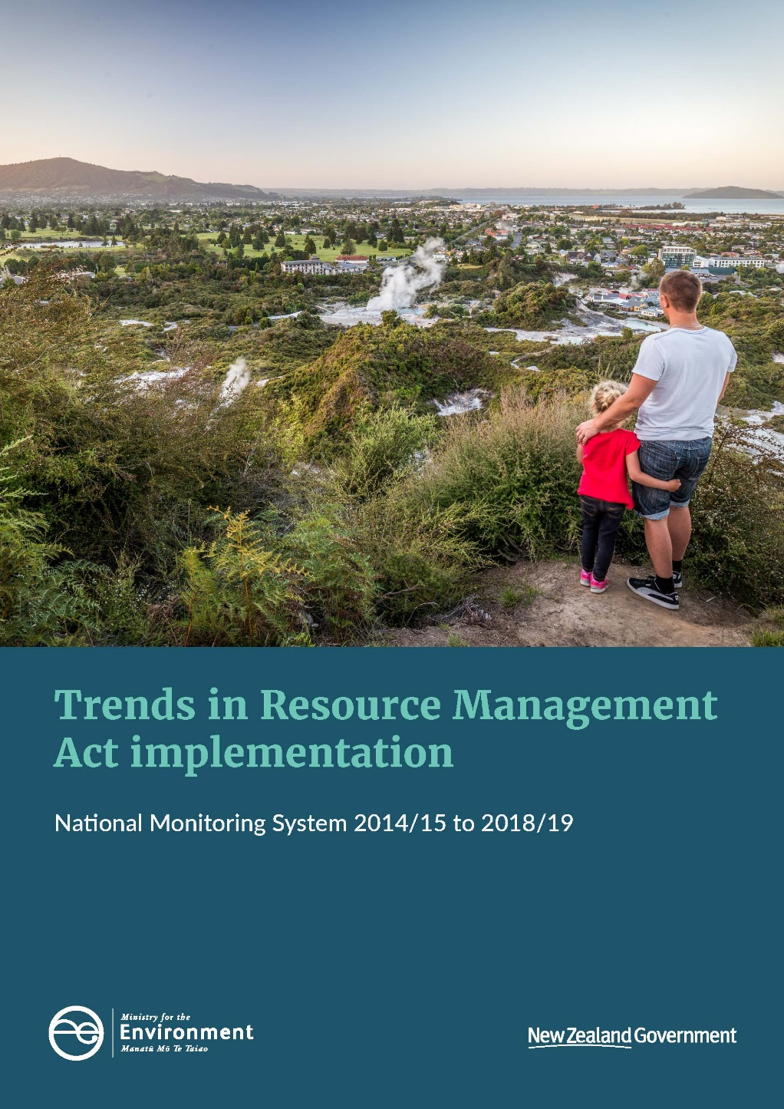

**Disclaimer**

The National Monitoring System data is provided by local authorities and compiled by the Ministry for the Environment. Whilst every effort has been made to ensure the accuracy of this data, the Ministry makes no representations or warranties about its accuracy, reliability, completeness or suitability for any particular purpose and disclaims all responsibility and all liability (including without limitation, liability in negligence) for all expenses, losses, damages (including indirect or consequential damage) and costs which you might incur as a result of the product being inaccurate or incomplete in any way or for any reason. The dataset is updated periodically as new information is received. The findings in this report are based on the data at the time of publication.

**Copyright**

© Crown copyright New Zealand 2020. Unless otherwise stated, this copyright work is licensed for re-use under a Creative Commons Attribution 4.0 International licence. In essence, you are free to copy, distribute and adapt the work, as long as you attribute the work to the New Zealand Government and abide by the other licence terms. To view a copy of this licence, visit Creative Commons Attribution 4.0 International licence.

If you publish, distribute, or otherwise disseminate this work (or any part of it) to the public without adapting it the following attribution statement should be used: Source: Ministry for the Environment and data providers and licensed by the Ministry for the Environment for re-use under the Creative Commons Attribution 4.0 International licence. If you adapt this work in any way, or include it in a collection and publish, distribute, or otherwise disseminate that adaptation or collection to the public, the following attribution statement should be used: This work uses material sourced from the Ministry for the Environment and data providers, which is licensed by the Ministry for the Environment for re-use under the Creative Commons Attribution 4.0 International licence.

Where practicable, please hyperlink the name of the Ministry for the Environment to the Ministry for the Environment web page that contains, or links to, the source data.

**Acknowledgements**

We would like to acknowledge the efforts of local authorities to collect and provide the data for the National Monitoring System that informs this report.

This document may be cited as: Ministry for the Environment. 2020. *Trends in Resource Management Act implementation: National Monitoring System 2014/15 to 2018/19*. Wellington: Ministry for the Environment.

Published in April 2020 and revised in July 2020  
by the Ministry for the Environment   
Manatū Mō Te Taiao  
PO Box 10362, Wellington 6143, New Zealand

ISBN: 978-1-98-857978-8

Publication number: ME 1492

This document is available on the Ministry for the Environment website: [www.mfe.govt.nz](http://www.mfe.govt.nz).



# Contents

Key trends in RMA implementation 6

How to read this report 7

Trends in RMA implementation 8

Timeliness of resource consent processing 8

Application fees for resource consents 16

Approval rates for resource consent applications 20

Timeliness of plan changes 23

Submission volumes for plan changes 26

Iwi/hapū participation in resource management 28

Other trends and observations 32

Appendix 38

Summary tables 38

Supplementary analysis 41

# Tables

Table 1: Percentage of resource consent applications granted or declined that had at least one information request (section 92(1)), a report commissioned (section 92(2)), or processing time extension (section 37) 15

Table S1: An overview of planning processes 38

Table S2: Number of planning documents worked on by type 38

Table S3: An overview of resource consent application processing 39

Table S4: Number of applications for new resource consents that were granted or declined by notification pathway 39

Table S5: Number of applications for new resource consents that were granted or declined by consent type 39

Table S6: Percentage of resource consent applications processed within statutory time limits 40

Table S7: Number of certificates issued and deemed permitted activities 40

Table S8: Number of enforcement actions by local authorities 40

# Figures

Figure 1: Distribution of the number of working days for a resource consent application to be granted or declined in 2018/19 8

Figure 2: Median number of working days for a resource consent application to be granted or declined by council in 2018/19, if non-notified and no hearing was held 10

Figure 3: Percentage of resource consent applications that were granted or declined within statutory time limits in 2018/19 by council 12

Figure 4: Percentage of resource consent applications that were granted or declined within statutory time limits 13

Figure 5: Median number of working days to grant or decline a resource consent application for notified applications with a hearing and non-notified applications without a hearing 14

Figure 6: Distribution of fees for resource consent applications granted or declined in 2018/19 16

Figure 7: Median application fee for a resource consent application granted or declined in 2018/19 by council, if non-notified and no hearing was held 17

Figure 8: Median fee for a resource consent application if notified with a hearing or non-notified without a hearing 19

Figure 9: Percentage of resource consent applications granted 20

Figure 10: Percentage of resource consent applications granted in 2018/19 by council 22

Figure 11: Distribution of the number of years from notification to being operative for plan changes completed in 2018/19 23

Figure 12: The five plan changes with the longest amount of time from notification to being operative, for plan changes completed in each of the past four years, by subject area 24

Figure 13: Percentage of decisions made within two years of notification for plan changes decided in the financial year 25

Figure 14: Median number of years from notification to being operative for plan changes completed in the financial year 25

Figure 15: Number of submissions received on plan changes completed in 2018/19 26

Figure 16: The five plan changes with the most submissions, for plan changes completed over the past three years, by subject 27

Figure 17: The median number of submissions received on plan changes completed in the financial year 27

Figure 18: Percentage of local authorities providing budget for iwi/hapū participation in planning and consenting 28

Figure 19: Local authorities’ support for iwi/hapū participation in planning or consenting in 2018/19 by type of support (budgetary or in-kind) 29

Figure 20: The number of iwi management plans endorsed by iwi authorities and lodged each year with councils 31

Figure 21: The number of resource consent applications granted by year and consent type 32

Figure 22: Percentage of resource consent applications granted or declined in 2018/19 by notification and hearing status 33

Figure 23: Number of plan changes started, underway or completed in 2018/19 by the reasons for the plan change 34

Figure 24: Number of plan changes started, underway or completed in 2018/19 by national driver 35

Figure 25: Total number of enforcement actions (infringement notices, abatement notices and enforcement order applications) taken by councils by council type 36

Figure 26: Total full-time equivalents (FTE) working on resource management at local authorities by subject area 37

Figure S1: How many times longer (in working days) than a non-notified land-use consent (without a hearing or information request) it took to grant or decline an application, by factor, in 2017/18 and 2018/19 41

Figure S2: How much more expensive than a non-notified land-use consent (without a hearing) it cost to apply for a resource consent, by factor, in 2017/18 and 2018/19 42

Figure S3: Resource consent application decline rate, by factor, in 2017/18 and 2018/19 43

Figure S4: Number of decisions on resource consent applications appealed by consent type and decision (granted or declined) in 2017/18 and 2018/19 44

Figure S5: Number of years to progress a plan change from notification to operative, by phase, for plan changes completed in 2018/19 45

Figure S6: The number of working days from close of submissions to decision notification for plan changes completed in 2017/18 and 2018/19 by the number of submissions 46

# Key trends in RMA implementation

The Resource Management Act 1991 (RMA or the Act) is the main legislation guiding the management of New Zealand’s environment. Most of the everyday decision-making under the Act is delegated to territorial authorities and regional councils (ie, local authorities). Each year, the Ministry for the Environment collects information from local authorities on their implementation of the Act via the National Monitoring System (NMS).[1]

This report highlights patterns and trends in implementation of the RMA by local authorities over the past five years, as recorded by the NMS. The purpose of the report is to identify areas for improvement in policy or practice.

Key trends

* Resource consent applications are processed within time limits prescribed in the RMA 82 per cent of the time. This is the fourth consecutive year that this rate has fallen.
* Both resource consent processing times and application fees are increasing over time.
* A section 37 time extension is applied to almost a third (31 per cent) of resource consent applications. This rate is increasing over time.
* Local authorities are required to decide plan changes within two years of notification. All 81 plan changes decided in the past two years met this requirement.
* About four in five councils (78 per cent) provide either budgetary or in-kind support for iwi/hapū participation in resource management.
* Monitoring and enforcement staffing levels have increased by 50 per cent over the past two years. This increase has occurred across all council types.

# How to read this report

This report is written for central and local government to inform them of trends in implementation of the RMA. It has been publicly released to make it accessible to the wider resource management community.

The report is organised by topic area. Each topic contains a number of findings that are supported by a figure or table and accompanying text. The topic areas were chosen from the information collected by the NMS based on central and local government interest and where the data was most robust. It is neither a comprehensive record of trends in the NMS nor a comprehensive record of trends in RMA implementation.

This report highlights trends in RMA implementation and, where supporting data is available in the NMS, provides insight into why the trends are occurring. It does not look beyond the NMS to provide a full explanation for why patterns or trends are occurring. It is intended to spur further work in areas of interest or concern.

Unless otherwise noted, all consenting facts and figures relate to applications for new resource consents only. These comprise the bulk of applications that councils receive, and other application types (reviews or applications to change conditions on existing consents) may follow somewhat different processes.

Unless otherwise noted, all consenting facts and figures relate to applications that are either granted or declined in a given financial year. This excludes applications that are incomplete, withdrawn or returned. The term ‘processed’ refers to consents that are granted or declined.

All councils have provided data for all years of the NMS except for Otorohanga District Council in 2018/19. Otherwise, the report notes if data was not provided from individual councils on particular topics.

# Trends in RMA implementation

## Timeliness of resource consent processing

Local authorities have a responsibility under the RMA to process resource consent applications within a set amount of time, to avoid undue inconvenience to the applicant. In most cases, the statutory time limit is 20 working days.[2] Additional time is allowed under certain circumstances, such as if the consent application is notified or a hearing is held.

Regulations were introduced in 2010 that provide a financial disincentive for local authorities to exceed statutory timeframes when processing resource consents (the [Discount Regulations)](http://www.legislation.govt.nz/regulation/public/2010/0171/latest/DLM3040343.html).

Processing time is only one element of the quality of council performance in making a decision on resource consent applications. Councils may take more time to make a more informed decision and/or they may commit to greater community input at the expense of a quick decision.

### Finding 1: The most common processing time for a resource consent application is about one month

Figure 1: Distribution of the number of working days for a resource consent application to be granted or declined in 2018/19

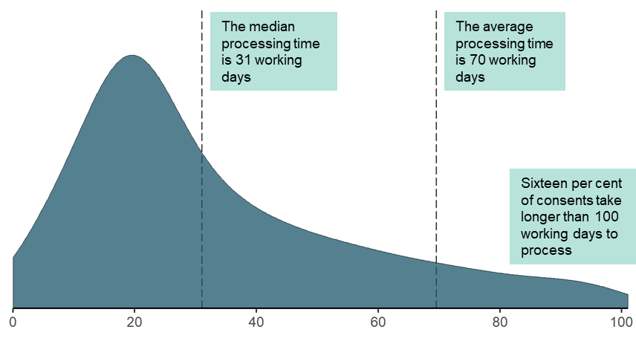

Across New Zealand, resource consent applications are usually processed in one to three calendar months. The most common decision time is 20 working days (the statutory time limit for most consents), or about one calendar month.

Applications to change or cancel the conditions of an existing resource consent tend to be processed more quickly (in a median of 21 working days vs 31 working days for new consents).

Processing times are longer if consent applications are notified, a hearing is held, an information request is made, or the consent is of a type other than land-use.[3] Of these, notification and information requests lead to the longest delays.

### Finding 2: Processing time for resource consent applications varies by council

Figure 2: Median number of working days for a resource consent application to be granted or declined by council in 2018/19, if non-notified and no hearing was held

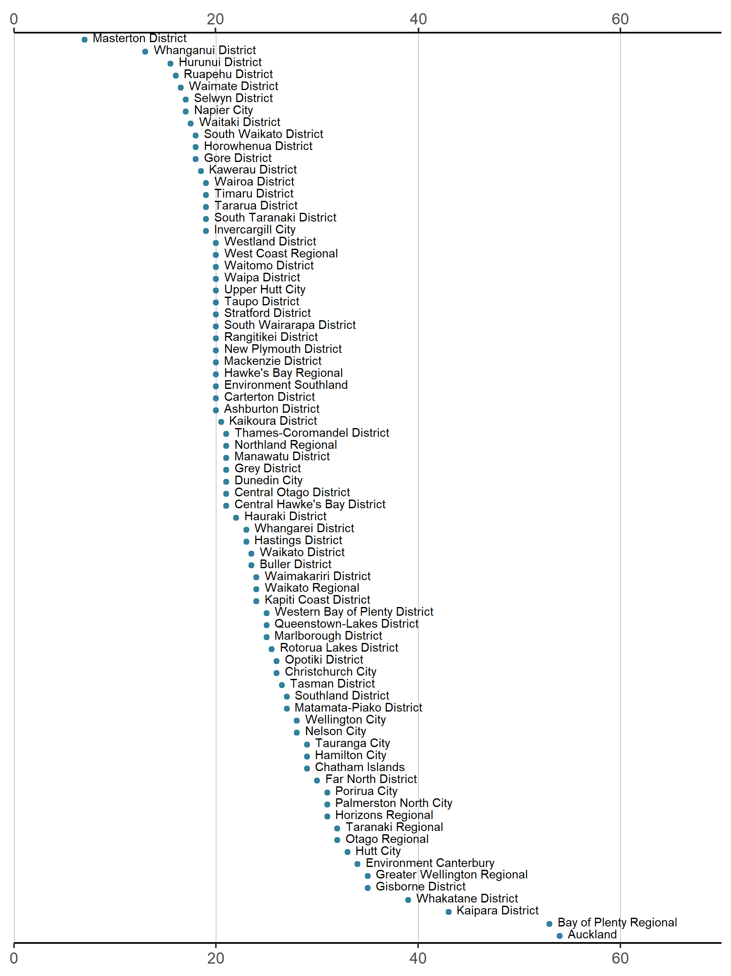

* The notification status was not reported for consent applications to Clutha District Council. Their applications were processed in a median of 20 working days.

There is considerable variation in resource consent processing times across councils. Eight of the 11 councils with the longest processing times are regional councils or unitary authorities. To an extent, this may reflect the fact they assess a different profile of consent types than territorial authorities, including all coastal, discharge, and water permits, and land-use consents with non-localised effects.[4]

Increased complexity of resource consent applications and insufficient staffing contribute to consenting delays

There are myriad ways in which consenting can be delayed. A common difficulty is insufficient staffing levels for the volume of resource consent applications received. In some cases, this is because councils have difficulty recruiting and retaining staff with the required skill set.

Local authorities also note an increase in complexity in assessing some consent applications due to expectations of consultation, a need to consider new planning rules and a higher risk profile for some residential and commercial developments. In such cases, councils may surpass timeframes or apply time extensions to ensure sufficient time is available to make good decisions.

### Finding 3: Most councils process the majority of their resource consent applications within statutory time limits

Figure 3: Percentage of resource consent applications that were granted or declined within statutory time limits in 2018/19 by council

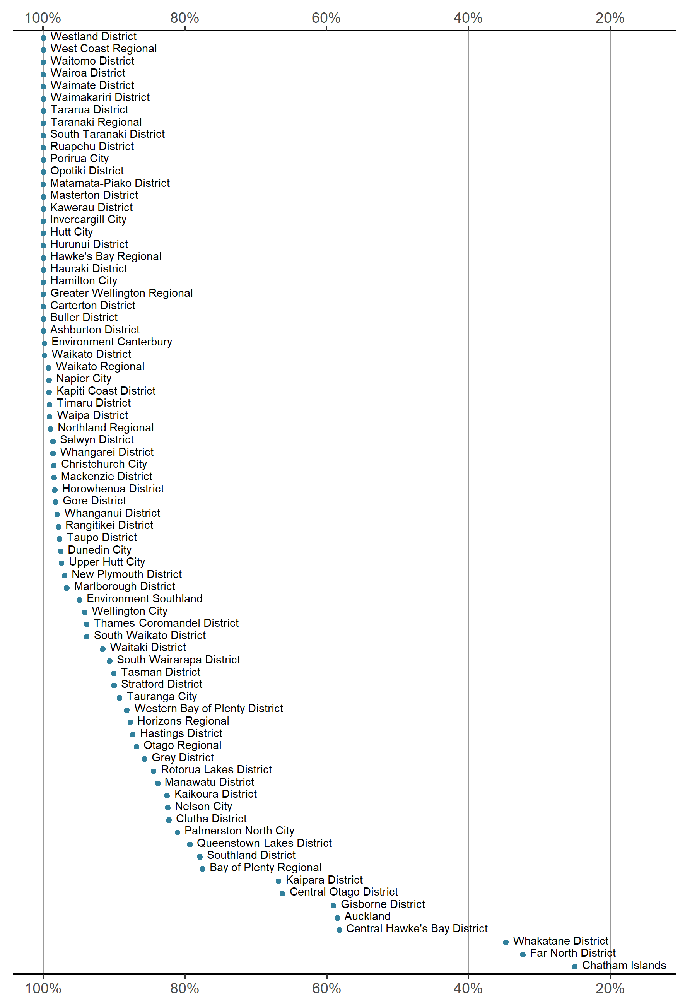

Twenty-five councils reported perfect adherence to statutory time limits, and a further 29 councils reported completing at least 90 per cent of their consent applications within the time limits prescribed by the RMA.

Eleven of the 78 councils (14 per cent) processed less than 80 per cent of their resource consent applications within statutory limits.[5] This is an increase from the previous year (2017/18), when only five councils processed less than 80 per cent of their consent applications on time.

### Finding 4: The timeliness of consenting is declining

Figure 4: Percentage of resource consent applications that were granted or declined within statutory time limits

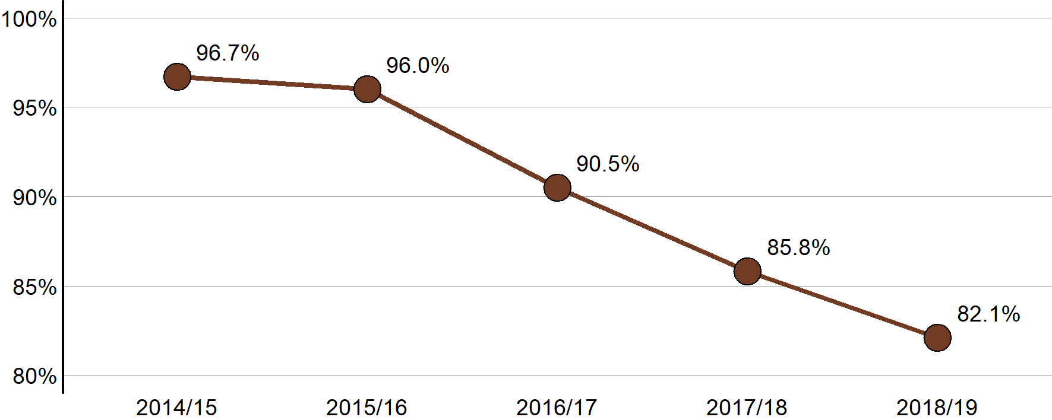

Figure 5: Median number of working days to grant or decline a resource consent application for notified applications with a hearing and non-notified applications without a hearing

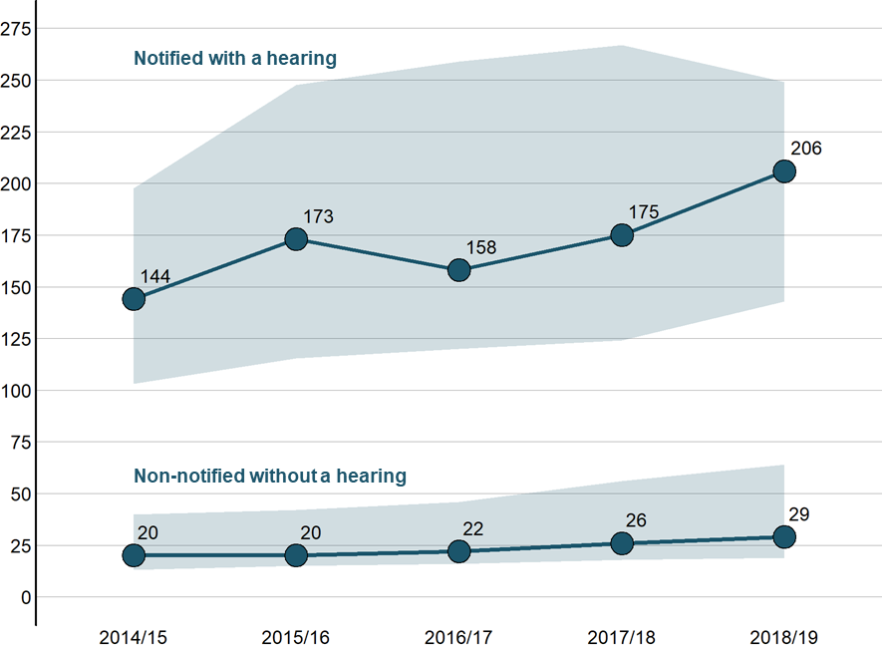

* The shaded area shows the consenting times for the middle 50 per cent of consents (ie, excluding the one-quarter slowest and fastest). Notified applications with a hearing and non-notified applications without a hearing are shown because they tend to be the slowest and fastest application types to process.

It is taking longer for councils to process resource consent applications. This is true for both notified consents with a hearing (which tend to have the longest processing times) and non-notified consents without a hearing (which tend to have the shortest processing times).

The slower processing times are reflected in the decreasing rate at which consent applications are processed within statutory timeframes. In 2014/15, 1227 applicants waited longer than the statutory time limit to receive a decision on their application; in 2018/19, this number was 6370.

Slower consenting times at Auckland Council drive the national trends

The national trends are highly sensitive to the performance of Auckland Council, which processed between 26 per cent and 30 per cent of all consent applications each year from 2014/15 to 2018/19.

Auckland has experienced a sharper decline in on-time processing than the rest of the country, falling from 93.2 per cent of consents processed within statutory time limits in 2014/15 to 58.5 per cent in 2018/19.

Some of the challenges facing Auckland include implementation of new systems and processes for consenting, reduction in staff numbers, a drop in the quality of applications and delays in obtaining specialist input.

With an increased focus on timeliness, additional training and an increase in staff numbers, Auckland Council expects its on-time rates to substantially improve in 2019/20.

For all councils except Auckland, the on-time processing rate has decreased by 7 per cent (from 98.3 per cent in 2014/15 to 91.4 per cent in 2018/19).

### Finding 5: Use of section 37 time extensions and section 92(1) requests for information are increasing

Table 1: Percentage of resource consent applications granted or declined that had at least one information request (section 92(1)), a report commissioned (section 92(2)), or processing time extension (section 37)

| Percentage of applications | 2014/15 | 2015/16 | 2016/17 | 2017/18 | 2018/19 |
| --- | --- | --- | --- | --- | --- |
| With an information request | 32.6% | 37.7% | 38.5% | 40.0% | 45.3% |
| With a report commissioned | 0.6% | 0.5% | 0.5% | 0.9% | 1.3% |
| With a processing time extension | 19.4% | 19.9% | 24.7% | 27.8% | 30.9% |

Under section 37 of the Act, local authorities can grant extensions to statutory timeframes under special circumstances or where the applicant agrees to an extension. The frequency with which these extensions have been applied has increased over time, from 19 per cent of applications in 2014/15 to 31 per cent in 2018/19.

Under section 92(1) of the Act, local authorities can request additional information from the applicant to help them reach a decision on the application. Such a request stops the statutory clock[6] until the information is provided or the applicant declines to respond. The percentage of consent applications for which councils request additional information has steadily increased, from 33 per cent of applications in 2014/15 to 45 per cent in 2018/19.

## Application fees for resource consents

Local authorities are empowered to charge application fees to help offset their costs related to processing resource consents. Application fees are distinct from other charges that might be applied as conditions of consent, such as financial and development contributions or monitoring charges.[7]

Local authorities set their own application fees but are required to provide a discount if consent processing times exceed statutory time limits.

This section only considers applications where an application fee was paid.[8]

### Finding 6: The most common fee for a resource consent application is about $1300

Figure 6: Distribution of fees for resource consent applications granted or declined in 2018/19

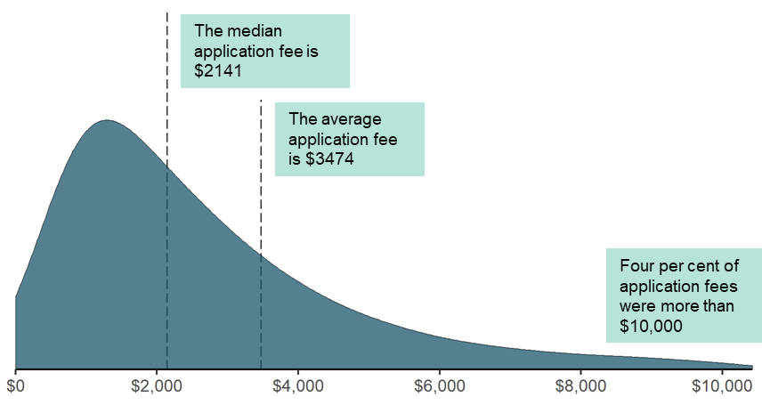

Across New Zealand, resource consent applications usually cost between $1200 and $3800, with the most common fee being around $1300. Unlike resource consent processing times, there are relatively few fees that are far above the normal range.

Applications to change or cancel the conditions of an existing resource consent tend to be less expensive than new consents (a median application fee of $1222 vs $2141 for new consents).

A publicly notified resource consent application with a hearing is 10 times more expensive than a non-notified application without one.[9]

### Finding 7: Application fees for resource consent applications vary by council

Figure 7: Median application fee for a resource consent application granted or declined in 2018/19 by council, if non-notified and no hearing was held

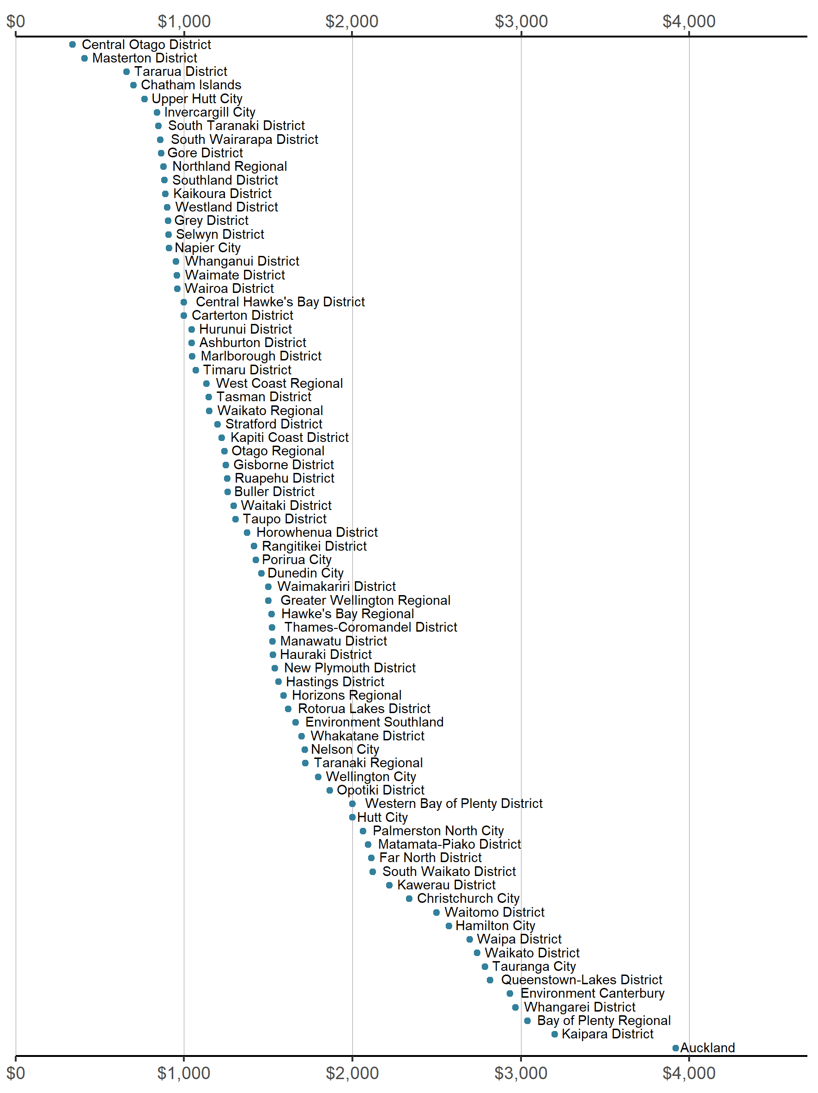

* The notification status was not reported for consent applications to Clutha District Council. Its median application fee was $820. Application fees were not reported for Mackenzie District Council.

There is wide variation in the fees charged by councils, from a median application fee of $337 at Central Otago District Council to $3918 at Auckland Council (if the applications were not notified and no hearing was held). The fees charged for different types of resource consent are fairly similar,[10] which may explain why there is no clear assortment in fees by council type.

Discounts appear underpaid by some councils

From information supplied by local authorities to the Ministry on processing times and fees, it is possible to determine if applicants were eligible for a discount under the Discount Regulations and, if so, how much they were owed.[11] We compared the discount owed to the amount councils reported paying for each application. A discrepancy could indicate data was not reported accurately or that the council did not provide the required discount.

A total of 4558 consent applications were eligible for a discount, with a combined amount owing of $6,242,111. This is about $1 for every $16 collected by councils in application fees.[12]   
The majority of this (85 per cent) was owed by Auckland Council, which paid out a total of $3,231,143 on 2497 consents.

Excluding Auckland, local authorities reported paying $638,330 in discounts on 1245 consent applications. This is 68 per cent of our estimate for the total amount owed. Two councils other than Auckland returned more than $100,000 in 2018/19 (Far North District Council and Queenstown-Lakes District Council).

### Finding 8: Resource consent applications are becoming more expensive

Figure 8: Median fee for a resource consent application if notified with a hearing or non-notified without a hearing

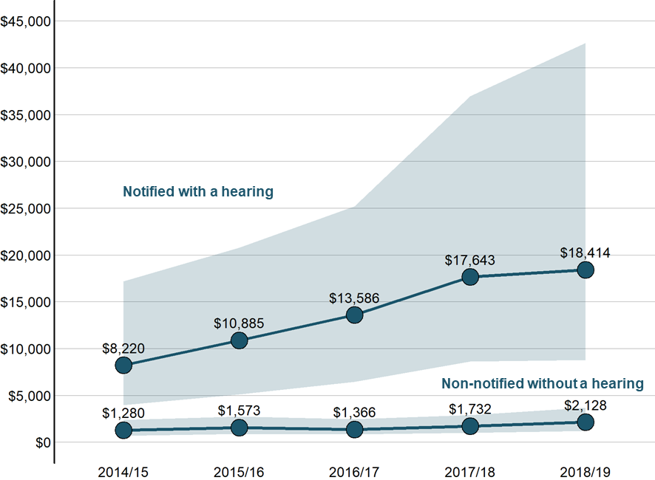

* The shaded area shows the consenting times for the middle 50 per cent of consents (ie, excluding the one-quarter slowest and fastest). Notified applications with a hearing and non-notified applications without a hearing are shown because they tend to be the most and least expensive application types.

Nationwide, it is costing more to apply for a resource consent. This is true for both notified consents with a hearing (which tend to have the highest fees and the greatest complexity) and non-notified consents without a hearing (which tend to have the lowest fees and are the most straightforward to assess). Costs for notified consents with a hearing are rising more sharply, more than doubling in the past five years.

The median application fee has gone up from 2014/15 to 2018/19 for all but two councils (Environment Southland and Buller District). Over the same time, the median application fee has more than doubled for 18 councils, and more than tripled for four councils.[13]

## Approval rates for resource consent applications

A resource consent is required for activities that are inconsistent with a district or regional plan. In most cases, local authorities decide whether to approve consent applications and, if so, under what conditions.

The rate at which consent applications are granted does not provide the full picture. Councils generally impose conditions on consents that are granted. These conditions of consent help to avoid, remedy or mitigate potential effects of the relevant activity to an acceptable level.

### Finding 9: Almost all resource consent applications are granted

Figure 9: Percentage of resource consent applications granted

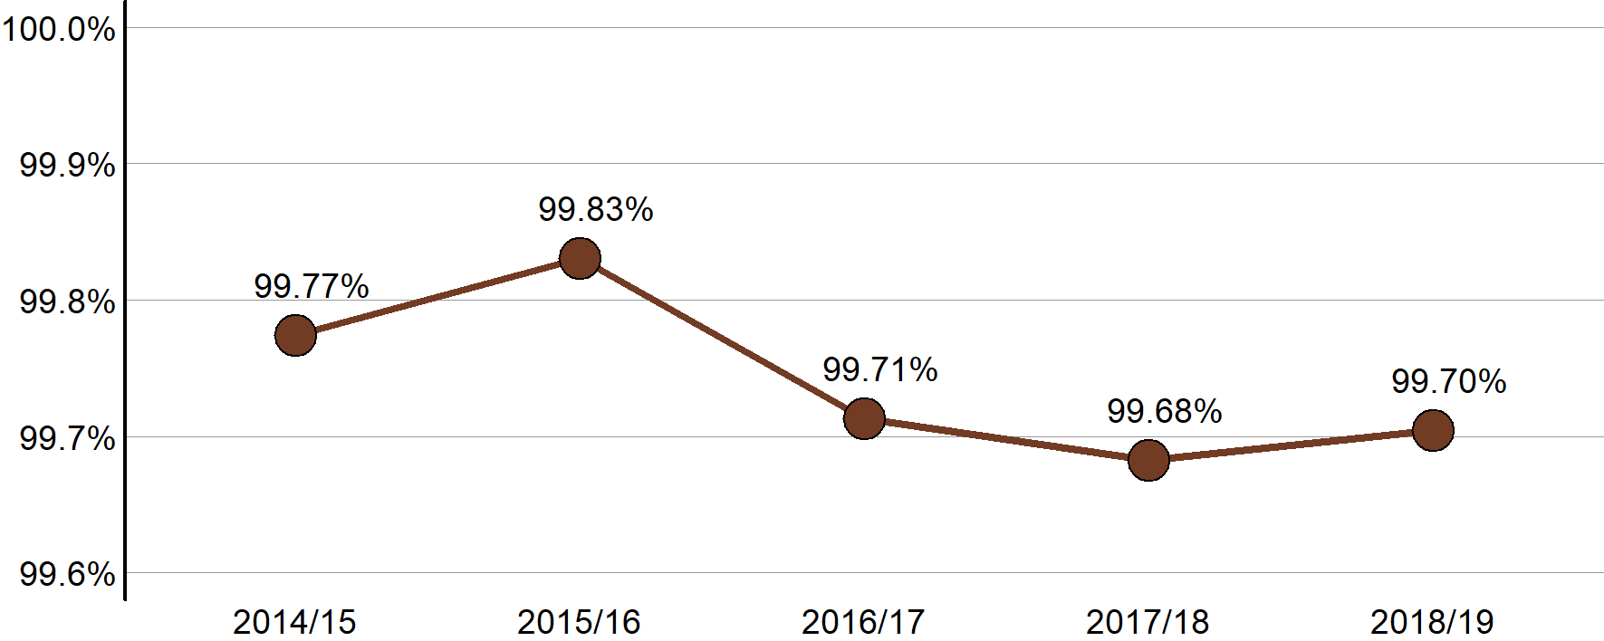

Across New Zealand, it is highly uncommon for consent applications to be declined. In 2018/19, only 105 consents applications were declined against 35,434 applications approved. The decline rate has been about two to three consents out of every 1000 applications for the past five years.

Resource consent applications are declined more often when notified or processed by someone other than a local authority officer.[14] Applications that are notified or that are processed by alternate decision-making entities are often more contentious to begin with, and may have been declined at a higher rate regardless of the process followed.

Declined resource consent applications are appealed less often but at a higher rate than granted applications.[15]

Many declined applications involve residential building and subdivision

The most frequently declined consents, by volume, are land-use consents (138 applications were declined in 2017/18 and 2018/19).

Most declined applications (about 70 per cent) involved residential activity, either solely or in combination with other activities. Many of these related to applications to modify building rules or subdivide and build in rural zones. The NES for Assessing and Managing Contaminants in Soil to Protect Human Health was cited in relation to nine applications that were declined.

Other declined applications involved commercial (18 per cent) or other non-residential activities.

### Finding 10: The majority of councils approve every resource consent application

Figure 10: Percentage of resource consent applications granted in 2018/19 by council

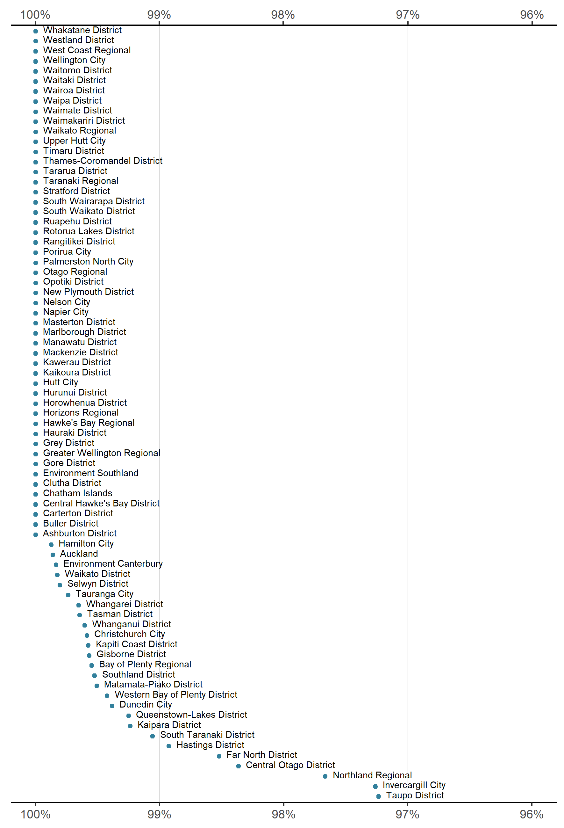

Fifty-one local authorities approved every resource consent application in 2018/19. Of these 51 councils, 42 also approved every resource consent application the year before (in 2017/18).

Northland Regional Council and Auckland Council declined the most resource consent applications in 2018/19 (16 and 14, respectively); no other council refused more than 9.

## Timeliness of plan changes

Local authorities can update a plan or policy statement (hereafter, plan) in one go or incrementally. Plan changes can be requested by private entities or council-initiated, and can be in relation to either operative or proposed plans (ie, variations). The process followed is essentially the same for each, though private plan changes require less preparation work by councils before notification.

The Resource Management Amendment Act 2013 introduced a two-year time limit from notification to decisions for all planning processes ([Schedule 1 Clause 10](http://www.legislation.govt.nz/act/public/1991/0069/latest/DLM241242.html)). This is the part of the process over which local authorities generally have the most control of the timing.

This section focuses on the length of time from notification of a plan change to it being fully operative (under clause 20 of Schedule 1).[16]

### Finding 11: Most plan changes take less than two years to complete once notified

Figure 11: Distribution of the number of years from notification to being operative for plan changes completed in 2018/19

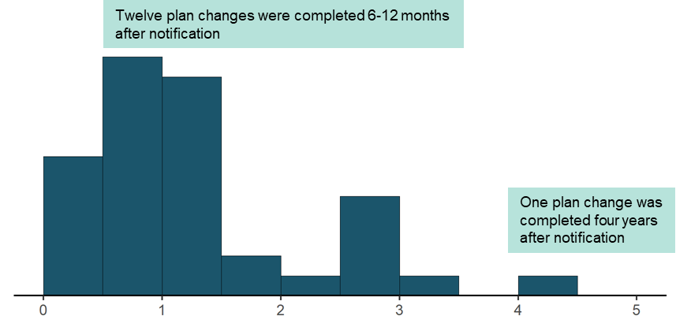

Fifty-two councils worked on 183 plan changes in 2018/19, of which 37 were completed (ie, were made fully operative[17]). Most plan changes took between 11 to 20 months to progress from notification to completion, with a median completion time of 13 months.

The quickest plan change was an amendment to rules regarding the sale of alcohol in Palmerston North, which took a little less than four months from notification to completion. The slowest plan change was about genetically modified organisms, which took a little over four years to become operative.

Unsurprisingly, there was a strong relationship between appeals and completion times.[18]   
Plan changes that were not appealed were usually completed between 8 and 13 months after notification (11-month median), whereas plan changes that were appealed usually took between 28 to 35 months after notification (33-month median). Of the 37 plan changes completed in 2018/19, 10 (27 per cent) were appealed. The time period from notification of decisions to being fully operative, tends to be the most variable phase of the planning process.[19]

### Finding 12: Changes to zoning are sometimes time-consuming to complete

Figure 12: The five plan changes with the longest amount of time from notification to being operative, for plan changes completed in each of the past four years, by subject area

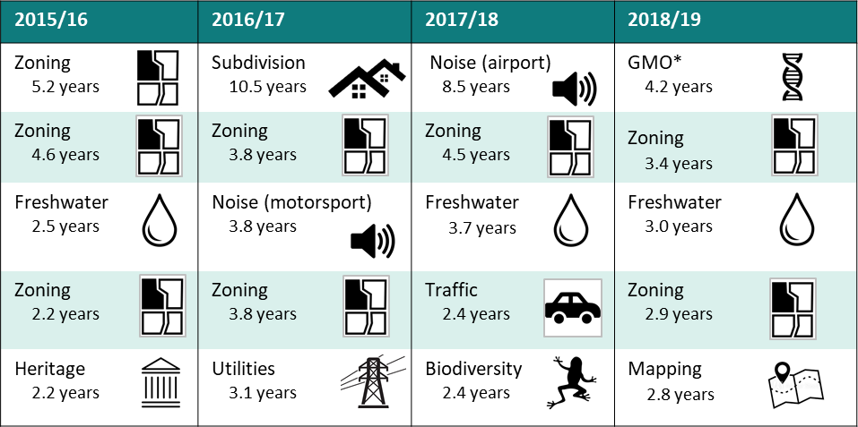

* Genetically modified organisms.

At least one plan change involving zoning has been one of the two slowest plan changes to complete (after notification) in each of the past four years. Plan changes related to noise and freshwater management have also taken a long time to complete on multiple occasions.

Fifteen different councils worked on the 20 plan changes in Figure 13. This suggests that complexity associated with particular topics and circumstances is contributing to longer completion times for plan changes more so than issues at particular councils.

### Finding 13: Plan change timeliness has improved

Figure 13: Percentage of decisions made within two years of notification for plan changes decided in the financial year

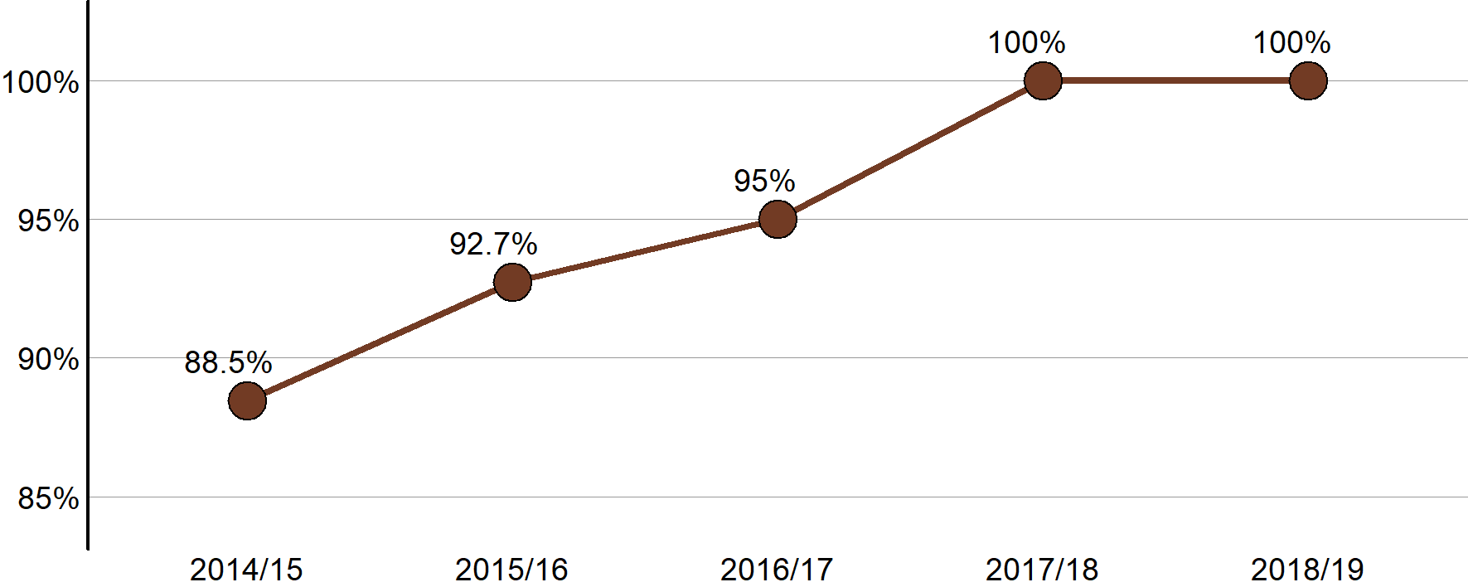

Figure 14: Median number of years from notification to being operative for plan changes completed in the financial year

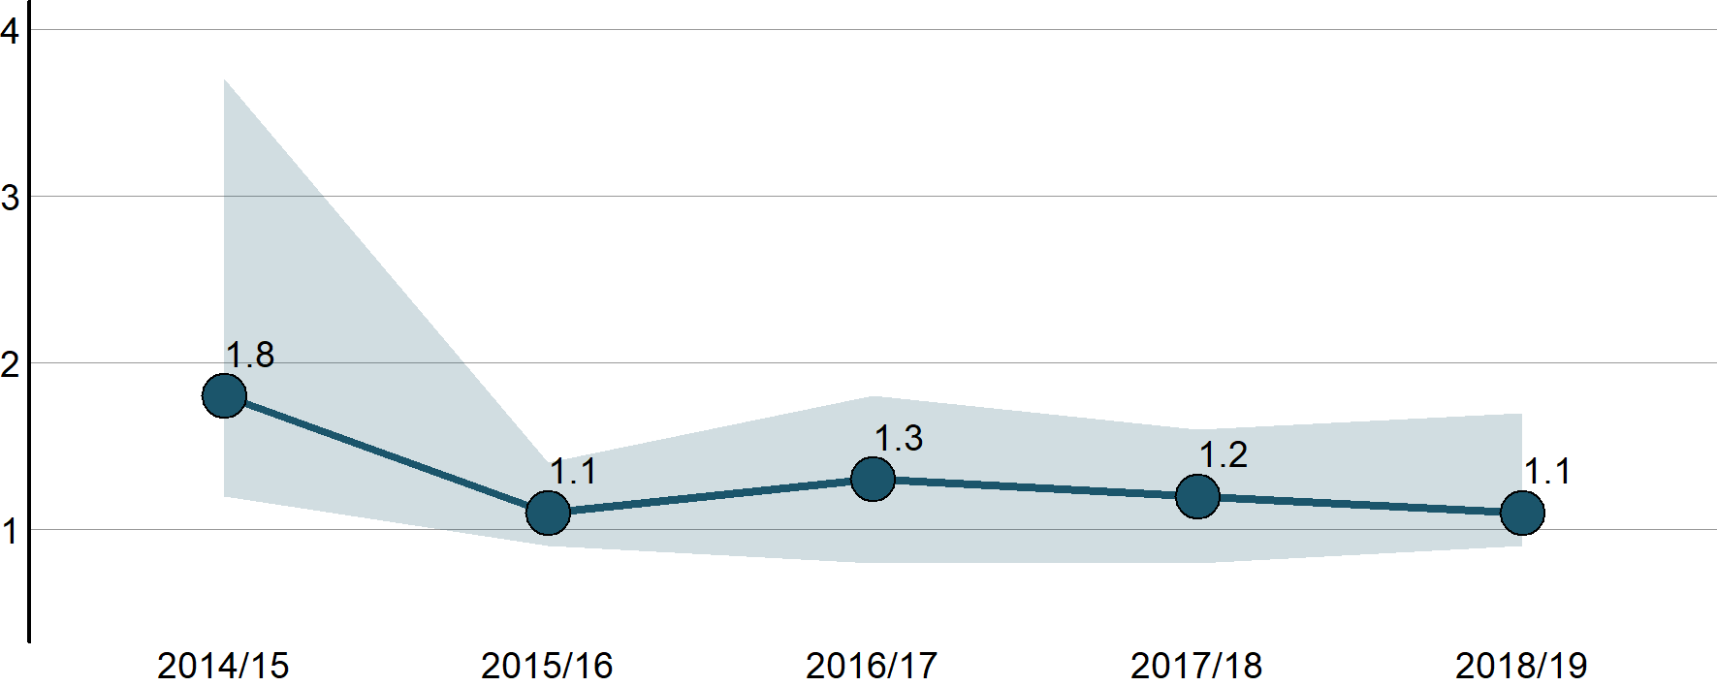

* The shaded area shows the planning times for the middle 50 per cent of plan changes (ie, excluding the one-quarter slowest and fastest).

Since 2015/16, it has been uncommon for plan changes to take longer than two years to complete after notification, with about three-quarters of plan changes completed within a year and a half.

All plan changes decided in the past two financial years have met the statutory requirement for timeliness (ie, reaching a decision within two years of notification). The development of full plans is also subject to this time limit and, perhaps unsurprisingly, councils find it more difficult to meet this timeframe for full plans.[20]

## Submission volumes for plan changes

The RMA provides an opportunity for the public to formally express their views on proposed plan changes through submissions to council when a proposed plan change is notified. The RMA requires local authorities to make a decision on the provisions and matters raised in submissions, and provide a reason why they accept or reject the submissions. They are not required to provide a decision that addresses each submission individually, and instead can group provisions or matters to which they relate.

### Finding 14: Plan changes usually receive few or a very large number of submissions

Figure 15: Number of submissions received on plan changes completed in 2018/19

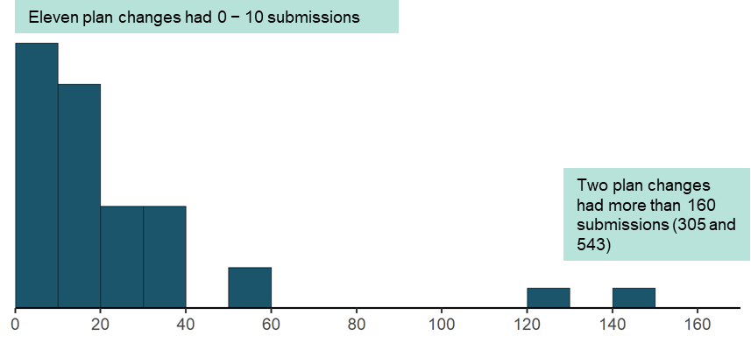

Of the 37 plan changes completed in 2018/19, most received less than 40 submissions, and half received less than 20 submissions.[21]

In a few cases, the number of submissions was many times higher than the norm. The two plan changes that received the most submissions[22] had about as many submissions (848 in total) as the other 35 plan changes combined (866 in total).

Plan changes with more submissions do not take substantially longer to decide.[23]

### Finding 15: Plan changes on diverse topics have attracted a large number of submissions over the past three years

Figure 16: The five plan changes with the most submissions, for plan changes completed over the past three years, by subject

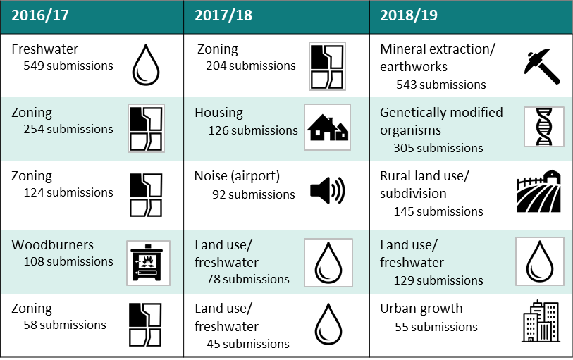

Plan changes on diverse topics have attracted a large number of submissions over the past few years, including plan changes related to mineral extraction, wood burners, airport noise and genetically modified organisms. All of the zoning plan changes in figure 17 were private plan change requests and all of the freshwater plan changes were by Environment Canterbury.

### Finding 16: Submission volumes are similar across recent years

Figure 17: The median number of submissions received on plan changes completed in the   
financial year

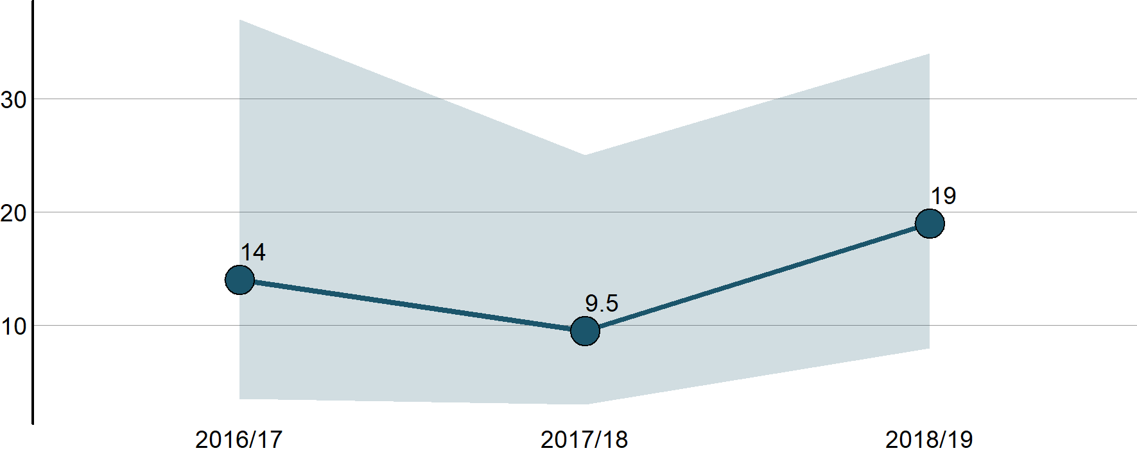

* The shaded area shows the submission count for the middle 50 per cent of plan changes (ie, excluding the one-quarter with the most and fewest submissions).

There does not appear to be a significant trend in recent years in the volume of submissions received on plan changes.[24] Plan changes usually receive 30 or fewer submissions, with a median each year of between 10 and 20.

Over the past three years, Environmental Canterbury has received the highest volume of submissions for all completed plan changes (848), followed by Whangarei District Council (749), Queenstown-Lakes District Council (468) and Far North District Council (375).

## Iwi/hapū participation in resource management

In support of purposes and principles embedded in Part 2 of the RMA, local authorities have processes in place to support tangata whenua participation in resource management.

This support often comes in the form of a budgetary commitment to help iwi/hapū participate in planning and/or consenting. There may also be in-kind forms of support such as access to databases or memoranda of understanding.

Iwi management plans are developed by iwi/hapū as a way for tangata whenua to express their kaitiakitanga of the natural and physical resources in their takiwā. They are planning documents recognised by an iwi authority and therefore must be taken into account by councils when preparing plans or policy statements.

### Finding 17: Budgetary commitment for iwi/hapū participation in consenting is improving

Figure 18: Percentage of local authorities providing budget for iwi/hapū participation in planning and consenting

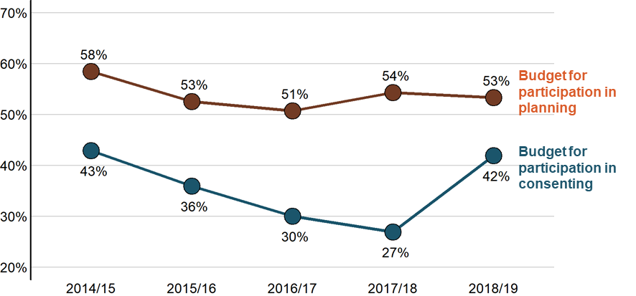

* Excluding councils by year if the NMS does not have a record of whether a budgetary commitment was made.[25]

A little over half (53 per cent) of councils provide budget to support iwi/hapū participation in planning processes. This percentage has remained relatively constant since 2014/15; however, the composition of councils providing budget for participation in planning has varied from year to year. Only 20 of 78 councils (26 per cent) have made a budgetary commitment every year since 2014/15.[26]

Budgetary support from councils for iwi/hapū participation in consenting is less common than support for planning. This support declined from 43 per cent of councils in 2014/15 to 27 per cent in 2017/18 before increasing sharply to 42 per cent in 2018/19. This increase was due to seven councils providing budget in 2018/19 that did not in 2017/18, and five councils providing budget in 2018/19 that did not report their budgetary status to the NMS in 2017/18.

### Finding 18: Most councils have processes in place to support iwi/hapū participation in resource management

Figure 19: Local authorities’ support for iwi/hapū participation in planning or consenting in 2018/19 by type of support (budgetary or in-kind)

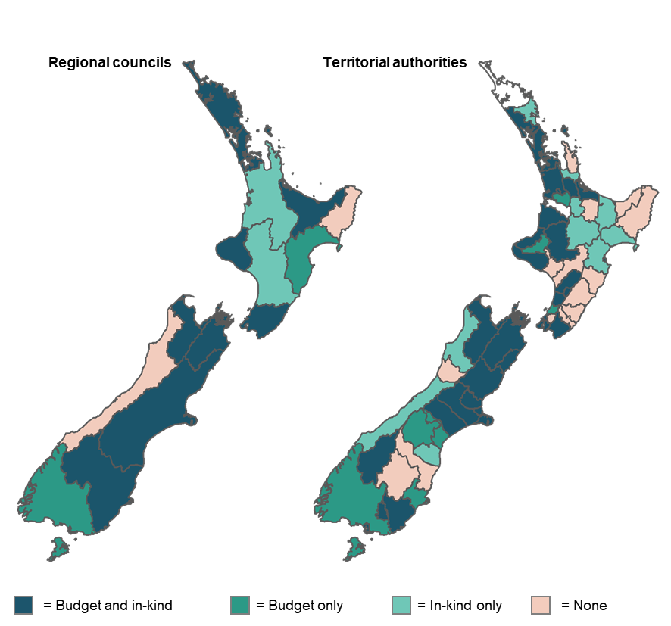

* Blank spaces indicate councils where support for iwi/hapū participation was not reported to the NMS. Chatham Islands Council (not shown) had no budget on in-kind support for iwi/hapū participation in 2018/19.

Forty-seven of 76 councils[27] (62 per cent) provided budget for iwi/hapū participation in consenting, planning or both in 2018/19. This includes 8 of 11 regional councils (73 per cent), 4 of 6 unitary authorities (67 per cent) and 35 of 59 territorial authorities (59 per cent).

Many local authorities provide non-budgetary support for iwi/hapū participation in resource management in addition to, or instead of, monetary support. Twelve of the 29 councils without a budgetary commitment offered some other kind of support, meaning most councils (59 of 76, 78 per cent) have processes in place to support iwi/hapū participation.

Councils support iwi/hapū participation in consenting and planning in a variety of ways

The 39 councils that provide non-budgetary support for iwi/hapū participation in consenting do so in many forms. Eleven councils regularly notify iwi/hapū of all consent applications, applications that are deemed to be relevant, or all publicly notified applications. Eight councils have dedicated meetings with iwi/hapū to engage in the consenting process, inform on matters of interest or engage on sensitive applications.

A number of councils have dedicated staff, either a consents officer or separate iwi advisory team within council, to assist iwi consents advisors where necessary. Other councils have agreements in place with iwi, or dedicated iwi groups set up either separately or as part of council, to get advice and consult on consents and other council processes.

Forty-two councils have non-budgetary processes in place to support iwi/hapū participation in planning. Most commonly, councils have iwi policy working groups, council partnership forums, dedicated groups set up to support specific plans, or dedicated staff to assist iwi or hapū in planning processes.

Waikato Regional Council has designed specific communications materials and established engagement guidelines to support iwi/hapū participation in review of the regional plan and regional coastal plan. A governance committee of six councillors and six iwi representatives has been established to provide oversight of the reviews.

### Finding 19: The number of iwi management plans is growing

Figure 20: The number of iwi management plans endorsed by iwi authorities and lodged each year with councils

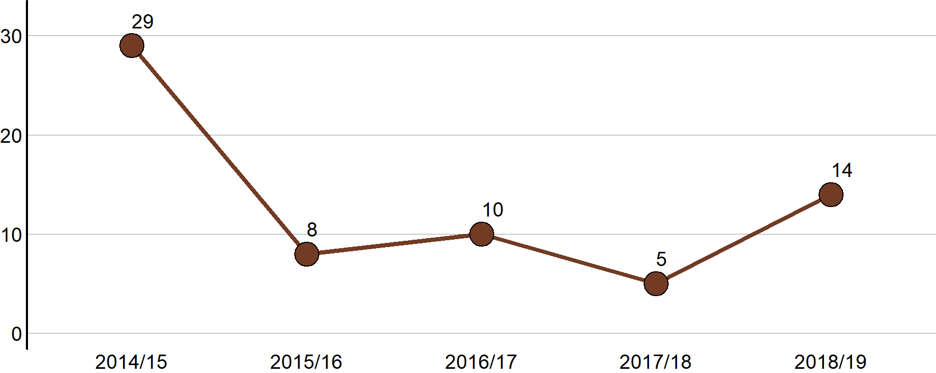

Over the past five years, there has been a steady stream of new iwi management plans endorsed by iwi authorities and lodged with councils. The 19 plans created in the past two years intersected the boundaries of 17 different local authorities.

There are about 260 iwi management plans endorsed by iwi authorities and lodged with councils nationwide and 155 formal agreements on iwi/hapū participation in resource management.

In 2014/15, the NMS asked for a record of all iwi management plans lodged with councils, not just the ones lodged that financial year as in subsequent years. Details were provided for 190 iwi management plans.

From 2015/16, we asked only for iwi management plans that were lodged in a given financial year, but we were sometimes sent records of plans that were lodged earlier or later. We compiled all of the records received from all years to identify there are 262 unique iwi management plans lodged with 58 different councils (ie, about 74 per cent of councils have received at least one iwi management plan). Every regional council and unitary authority has received at least one iwi management plan.

In 2018/19, councils reported having 155 written agreements (eg, memoranda of understanding or heads of agreement) with iwi/hapū for participation in resource management. Fifty of these agreements are with Auckland Council and 17 with Tauranga City Council (all of the other councils have five or less). Forty-nine of 75 councils (65 per cent) reported having at least one written agreement.[28]

## Other trends and observations

The following findings capture other patterns and trends in resource consents, planning, national direction, enforcement and council staffing.

### Finding 20: The number of land-use consents being granted is decreasing

Figure 21: The number of resource consent applications granted by year and consent type

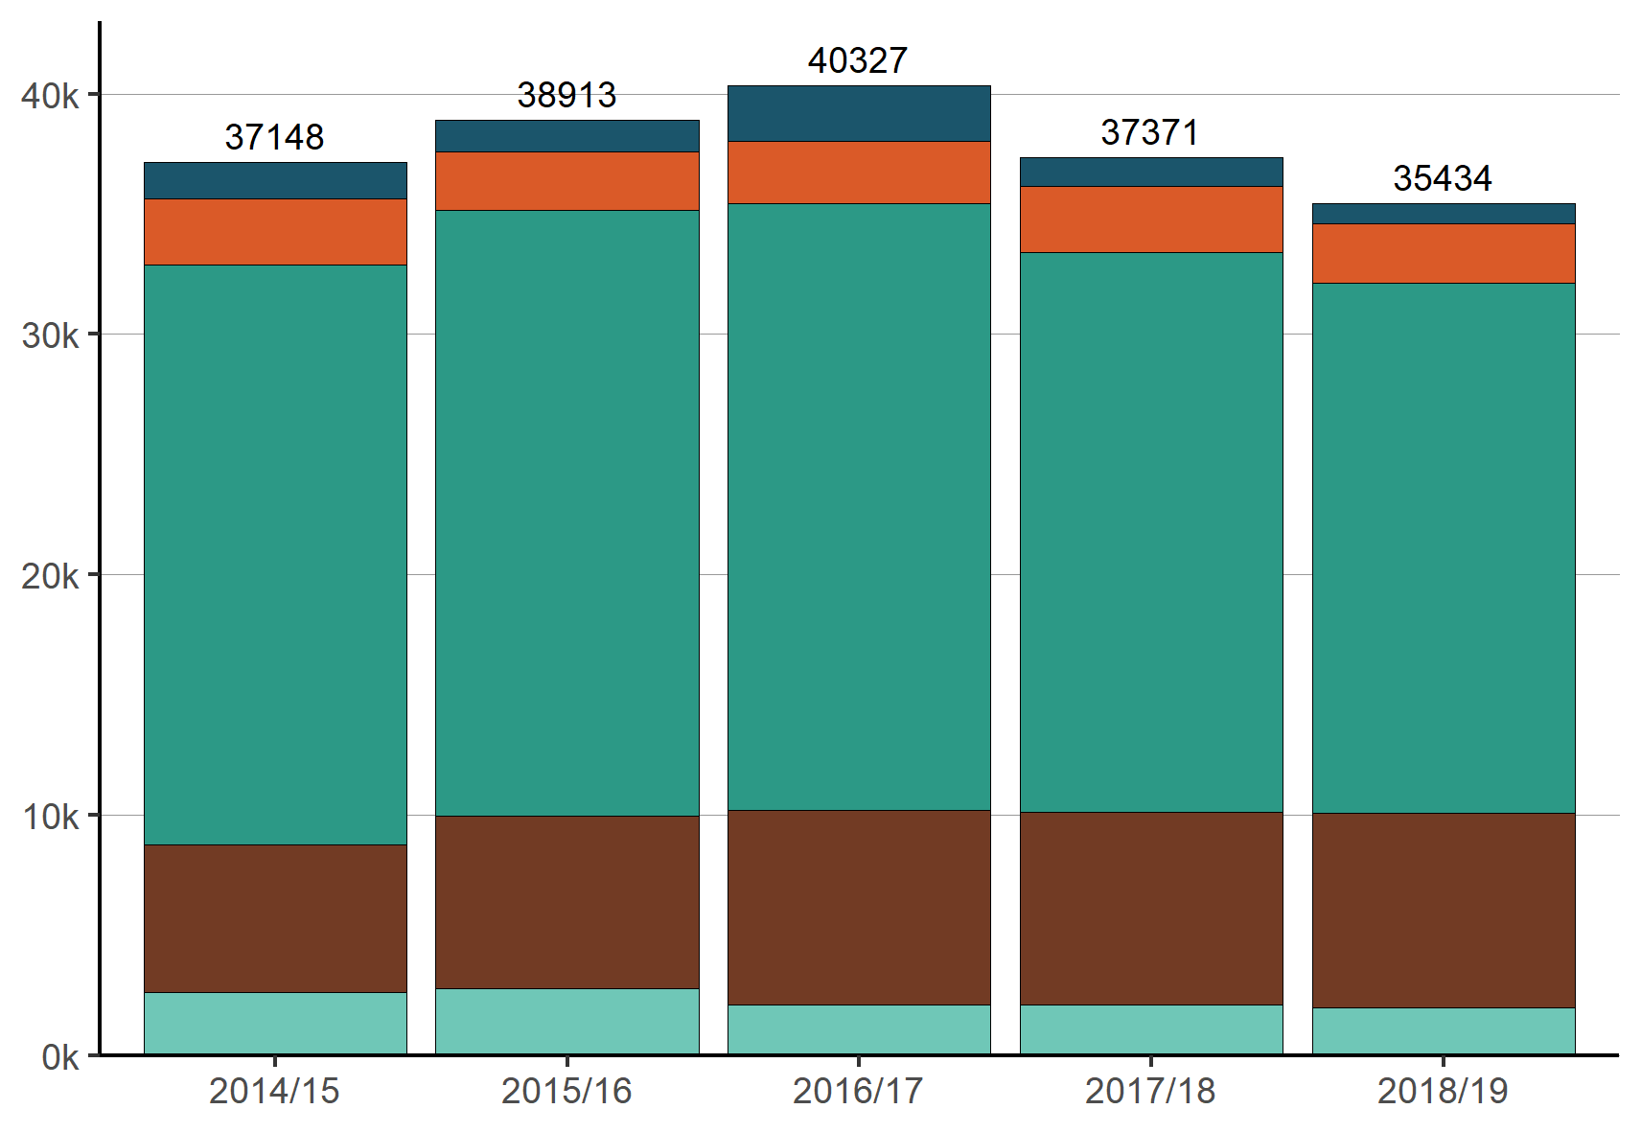

The overall volume of consents granted by all councils rose from 2014/15 to a maximum of 40,327 in 2016/17, and has decreased since to below 2014/15 levels (35,434 granted in 2018/19).

The increase in consenting volume from 2014/15 to 2016/17 was mainly due to an increase in the number of subdivision consents granted, from 6139 to 8102 (an increase of 32 per cent). The decrease in consenting volume from 2016/17 to 2018/19 is mainly due to a decrease in the number of land-use consents granted from 25,204 to 22,070.

Part of the decline in the number of land-use consents granted may be due to the creation of a separate process to assess boundary activities, and temporary and marginal activities in October 2017.[29] In 2018/19 (the first year the NMS recorded these activities), councils approved 1462 boundary activities and 171 temporary or marginal activities.

### Finding 21: About four per cent of resource consent applications are notified and about one and a half per cent have a hearing

Figure 22: Percentage of resource consent applications granted or declined in 2018/19 by notification and hearing status

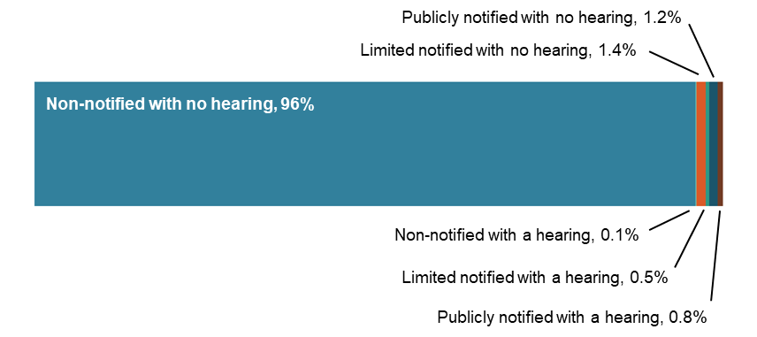

It is relatively uncommon for resource consent applications to be notified or have a hearing, with one of these applying to only 1 in every 25 applications (4 per cent). Excluding Marlborough District Council (which notified 34 per cent of its consents in 2018/19), the rate drops to 1 in every 41 applications (2.4 per cent).

Subdivision consents are the least likely to be notified (1.5 per cent) and coastal permits are the most likely to be notified (32.4 per cent).[30]

The percentage of resource consent applications that are notified and/or have a hearing has remained constant since 2014/15, varying from 3.6 per cent to 4.1 per cent between years.

### Finding 22: Plan changes are most often initiated to meet the statutory requirement for plan reviews (section 97) and to respond to emerging issues

Figure 23: Number of plan changes started, underway or completed in 2018/19 by the reasons for the plan change

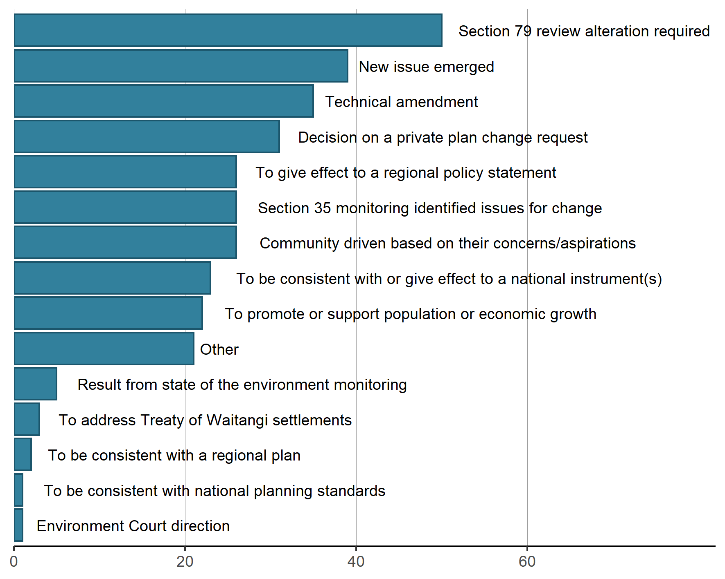

* Councils listed up to six reasons for each plan change in the NMS. Reasons were coded into a number of pre-set categories and ‘other’.

Plan changes are initiated for many reasons, as shown in figure 27. The most common reason for a plan change is that a change was required as the result of a section 79 review of a planning document. The next most common reason is that a new issue had emerged.

These two reasons (section 79 review and a new issue emerging) have been the top two reasons for a plan change every year since 2014/15.

### Finding 23: The NPS for Urban Development Capacity is the most common national driver of plan changes

Figure 24: Number of plan changes started, underway or completed in 2018/19 by national driver

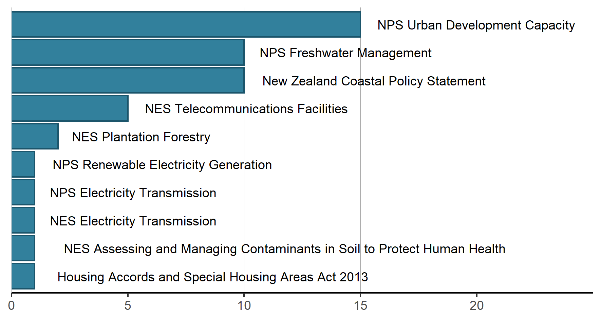

* Councils listed up to seven national instruments motivating each plan change.

Fifteen plan changes in 2018/19 were initiated, at least in part, because of direction given in the National Policy Statement for Urban Development Capacity (the NPS-UDC). The 15 plan changes were progressed by nine different councils.[31]

The NPS-UDC, the National Policy Statement for Freshwater Management (NPS-FM) and the New Zealand Coastal Policy Statement (NZCPS) have been the top three national drivers of plan changes since 2016/17. The NPS-FM and NZCPS were also the top two in 2014/15 and 2015/16.

### Finding 24: The number of enforcement actions taken by councils other than Auckland has remained steady the past few years

Figure 25: Total number of enforcement actions (infringement notices, abatement notices and enforcement order applications) taken by councils by council type

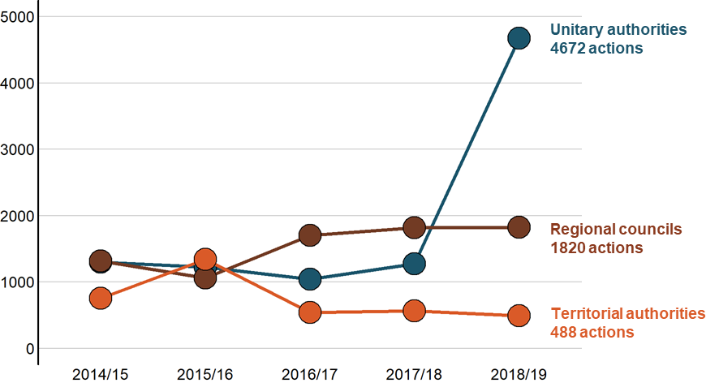

The number of enforcement actions taken by councils has been relatively constant since 2016/17, other than the number of enforcement actions taken by Auckland Council.

Auckland Council increased the number of infringement notices served from 456 to 1210 from 2017/18 to 2018/19 (a 165 per cent increase) and increased the number of abatement notices served from 648 to 3186 (a 392 per cent increase). This increase was due in part to increased staffing levels[32] and in part to a particular focus on erosion and sediment control issues, which led to a large number of Section 15 (discharge) enforcement actions.

### Finding 25: Monitoring and enforcement staffing is increasing

Figure 26: Total full-time equivalents (FTE) working on resource management at local authorities by subject area

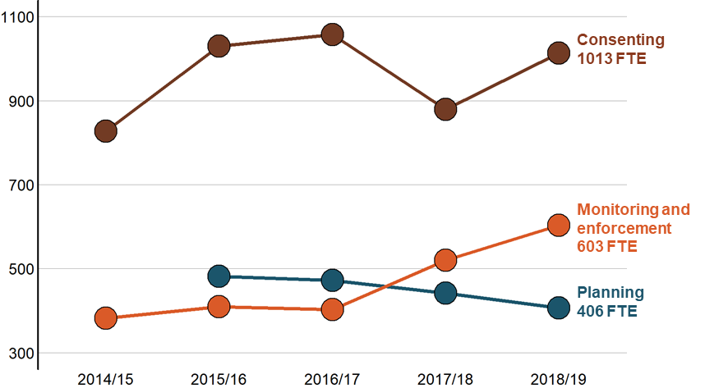

Staffing levels related to monitoring and enforcement have markedly increased over the past two years, from 403 FTE in 2016/17 to 603 FTE in 2018/19 (a 50 per cent increase). This increase occurred across territorial authorities, regional councils and unitary authorities.[33] More than half of councils (42) increased their staffing levels from 2016/17. Four councils had FTE dedicated to monitoring and enforcement in 2018/19 that had no FTE in 2016/17 and 17 councils doubled their FTE or more from 2016/17 to 2018/19.

# Appendix

## Summary tables

### Planning

The NMS records every process to prepare or change policy statements and plans that are started, underway or completed in a financial year. The same planning process is often represented in multiple NMS years.

Table S1: An overview of planning processes

| Number | 2014/15 | 2015/16 | 2016/17 | 2017/18 | 2018/19 |
| --- | --- | --- | --- | --- | --- |
| Councils working on new plans | 28 | 27 | 23 | 22 | 18 |
| New plans worked on | 34 | 37 | 30 | 29 | 24 |
| New plans completed | 5 | 2 | 2 | 4 | 0 |
| Plan changes worked on | 324 | 267 | 215 | 207 | 183 |
| Plan changes completed | 106 | 69 | 53 | 33 | 37 |
| Plan changes worked on that were privately requested | 50 | 28 | 25 | 37 | 32 |
| Plan changes completed that were privately requested | 20 | 8 | 6 | 9 | 10 |

* For brevity, policy statements and plans are collectively referred to as ‘plans’.

Table S2: Number of planning documents worked on by type

| Type of planning document | 2014/15 | 2015/16 | 2016/17 | 2017/18 | 2018/19 |
| --- | --- | --- | --- | --- | --- |
| District plan | 292 | 250 | 187 | 172 | 134 |
| Regional plan | 32 | 29 | 33 | 28 | 22 |
| Regional policy statement | 7 | 9 | 7 | 5 | 3 |
| Combined regional policy statement and regional plan | 4 | - | - | 1 | 1 |
| Combined regional plan(s) and district plan(s) | 9 | 14 | 18 | 15 | 14 |
| Combined district plan with another local authority | – | – | – | 1 | 1 |
| Combined regional policy statement, regional plan(s) and district plan(s) | 14 | 2 | – | 14 | 32 |

### Resource consents

The NMS records every application for a new consent or to change or review consent conditions that is granted, declined, found incomplete, withdrawn or returned in a financial year.

Table S3: An overview of resource consent application processing

| Number of applications | 2014/15 | 2015/16 | 2016/17 | 2017/18 | 2018/19 |
| --- | --- | --- | --- | --- | --- |
| New consents – granted | 37,148 | 38,913 | 40,327 | 37,371 | 35,434 |
| New consents – declined | 84 | 66 | 116 | 119 | 105 |
| New consents – found incomplete (section 88(3)) | 1,123 | 1,966 | 1,719 | 1,983 | 1,163 |
| New consents – withdrawn by applicant | 530 | 588 | 1266 | 565 | 633 |
| New consents – returned (section 91(C)) | 20 | 18 | 29 | 16 | 1 |
| Change consent conditions (section 127 or section 221(3)(a)) – granted or declined | 4,181 | 4,117 | 4,218 | 4,211 | 4,205 |
| Review conditions (section 128 or section 221(3)(b)) – granted or declined | 42 | 88 | 6 | 102 | 4 |
| Extend time conditions (section 125) – granted or declined | – | – | 95 | 180 | 224 |

* The NMS started recording section 125 applications in 2016/17. The type of application was unknown for 15 granted consents in 2018/19.

Table S4: Number of applications for new resource consents that were granted or declined by notification pathway

| Notification decision | 2014/15 | 2015/16 | 2016/17 | 2017/18 | 2018/19 |
| --- | --- | --- | --- | --- | --- |
| Not notified | 35,743 | 37,152 | 38,975 | 35,867 | 34,097 |
| Limited notification | 732 | 753 | 804 | 950 | 649 |
| Public notification | 751 | 586 | 641 | 608 | 710 |
| Notification decision not recorded | 6 | 488 | 23 | 65 | 83 |

Table S5: Number of applications for new resource consents that were granted or declined by consent type

| Consent type | 2014/15 | 2015/16 | 2016/17 | 2017/18 | 2018/19 |
| --- | --- | --- | --- | --- | --- |
| Land-use | 24,186 | 25,243 | 25,277 | 23,381 | 22,125 |
| Subdivision | 6,161 | 7,164 | 8,123 | 8,030 | 8,098 |
| Coastal | 1,496 | 1,325 | 2,287 | 1,229 | 863 |
| Discharge | 2,762 | 2,433 | 2,629 | 2,720 | 2,453 |
| Water | 2,627 | 2,814 | 2,127 | 2,130 | 2,000 |

Table S6: Percentage of resource consent applications processed within statutory time limits

| Percentage of applications  on-time | 2014/15 | 2015/16 | 2016/17 | 2017/18 | 2018/19 |
| --- | --- | --- | --- | --- | --- |
| New consents – granted or declined | 96.7% | 96.0% | 90.5% | 85.8% | 82.1% |
| New consents – granted or declined and publicly notified | 92.5% | 98.8% | 89.8% | 84.2% | 88.7% |
| New consents – granted or declined and limited notified | 91.7% | 91.5% | 91.6% | 91.4% | 87.0% |
| New consents – granted or declined and not notified | 96.9% | 96.1% | 90.5% | 85.7% | 81.8% |
| Change consent conditions (section 127 or section 221(3)(a)) – granted or declined | 97.5% | 97.8% | 92.1% | 89.4% | 86.6% |

### Certificates and deemed permitted activities

The NMS records every application for a certificate of compliance, existing use certificate, or deemed permitted activity status (boundary or temporary and marginal) issued, withdrawn or declined in a financial year.

Table S7: Number of certificates issued and deemed permitted activities

| Number | 2014/15 | 2015/16 | 2016/17 | 2017/18 | 2018/19 |
| --- | --- | --- | --- | --- | --- |
| Certificates of compliance (section 139) issued | – | – | 415 | 286 | 594 |
| Existing use certificates (section 139A) issued | – | – | 53 | 29 | 116 |
| Deemed permitted boundary activities (section 87BA) | – | – | – | – | 1,462 |
| Deemed temporary or marginal activities (section 87BB) | – | – | – | – | 171 |

* The NMS started recording certificates in 2016/17 and deemed permitted activities in 2018/19.

### Enforcement

The NMS records every infringement notice, abatement notice, enforcement order application and prosecution initiated in a financial year.

Table S8: Number of enforcement actions by local authorities

| Number | 2014/15 | 2015/16 | 2016/17 | 2017/18 | 2018/19 |
| --- | --- | --- | --- | --- | --- |
| Infringement notices | 1,413 | 1,231 | 1,372 | 1,566 | 2,373 |
| Abatement notices | 1,925 | 2,365 | 1,876 | 2,058 | 4,591 |
| Enforcement order applications | 20 | 16 | 25 | 19 | 16 |
| Prosecutions initiated | 81 | 58 | 71 | 91 | 94 |

## Supplementary analysis

### Finding S1: Information requests and notification more than double the resource consent application processing time

Figure S1: How many times longer (in working days) than a non-notified land-use consent (without a hearing or information request) it took to grant or decline an application, by factor, in 2017/18 and 2018/19

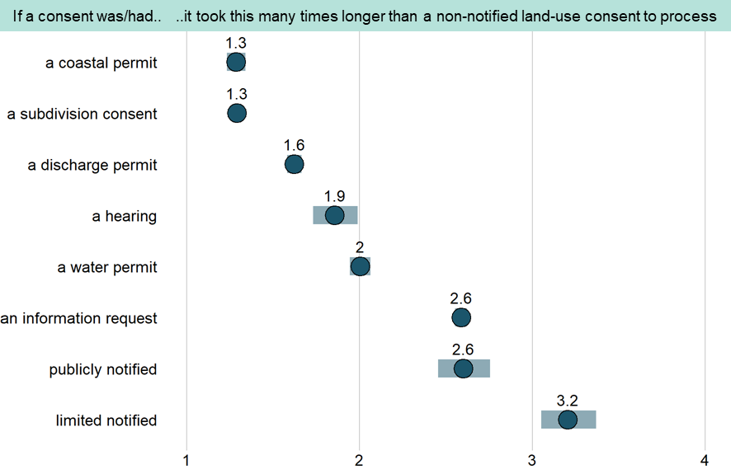

* Error bars show the 95 per cent confidence interval for each factor. Each factor was considered independently of the others in a linear regression model. Two years of data were included to produce a more robust model.

Processing times were longer if consents were notified, a hearing was held, an information request was made, or the consent was of a type other than land-use. Of these, notification and information requests led to the longest delays.

The multiples listed in figure S1 indicate how many times longer (than a non-notified land-use consent) it takes to decide an application if each factor is considered independently. In practice, applications often have more than one of these circumstances apply. In this case, the multiples themselves multiply. For example, a subdivision consent (x 1.3) with an information request (x 2.6) that is publicly notified (x 2.6) with a hearing (x 1.9) would be expected to take about 17 times longer than a non-notified land-use consent to process.[34]

### Finding S2: A publicly notified resource consent application with a hearing is 10 times more expensive than a non-notified application without one

Figure S2: How much more expensive than a non-notified land-use consent (without a hearing) it cost to apply for a resource consent, by factor, in 2017/18 and 2018/19

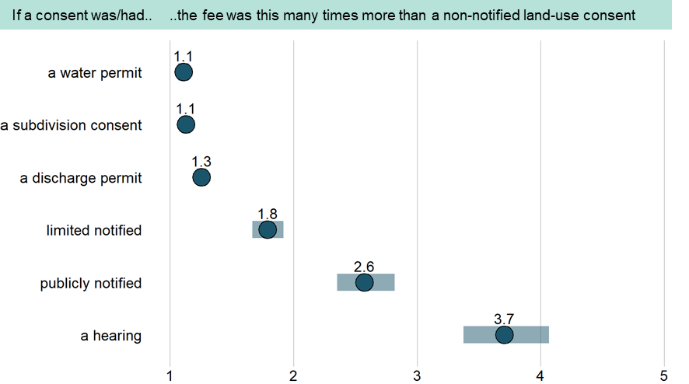

* Error bars show the 95 per cent confidence interval for each factor. Each factor was considered independently of the others in a linear regression model. Coastal permits were no more expensive than land-use consents so were excluded.

As was the case with processing times, notification has the largest impact on application fees, increasing them two-fold in the case of limited notification, and three-fold in the case of public notification. A discharge permit application that is publicly notified with a hearing would be expected to generate the highest fees.[35]

### Finding S3: Resource consent applications are declined more often when notified or decided by someone other than a local authority officer

Figure S3: Resource consent application decline rate, by factor, in 2017/18 and 2018/19

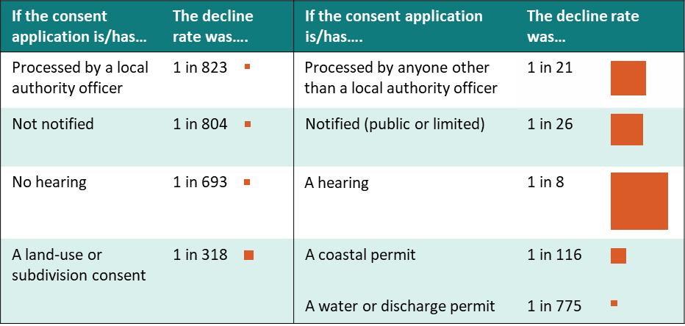

* The squares are scaled to the relative probability of a consent application being declined. Two years are included for more robust rates.

Applications that are notified have a decline rate 31 times higher than non-notified applications. Applications with a hearing have a decline rate 87 times higher than applications without one. Applications that are processed by someone other than a local authority officer have a decline rate 39 times higher than applications processed by a local authority officer.

Applications that are notified, for which hearings are held, or that are processed by alternate decision-making entities are often more contentious to begin with and may have been declined at a higher rate regardless of the process followed. About one in every 1153 applications is declined when not notified and processed by a local authority officer.

In each of the past five years, water permits were declined at the lowest rates. From 2014/15 to 2018/19, 17 water permit applications were declined and 11,681 were approved.

### Finding S4: Declined resource consent applications are appealed less often but at a higher rate than granted applications

Figure S4: Number of decisions on resource consent applications appealed by consent type and decision (granted or declined) in 2017/18 and 2018/19

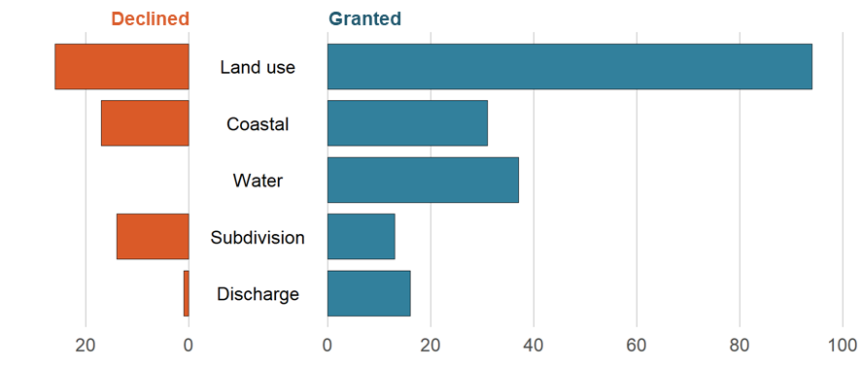

* Two years of applications were considered to produce more robust appeal rates.

Of the 224 consent applications declined in 2017/18 and 2018/19, about one quarter (58 applications, 26 per cent) were appealed.[36] A little more than three times as many granted consents were appealed (191) over the same time period; however, the rate of appeal for granted consents was far lower (0.3 per cent) given so many are granted each year.

### Finding S5: The time period from notification of decisions to being fully operative tends to be the most variable phase of the planning process

Figure S5: Number of years to progress a plan change from notification to operative, by phase, for plan changes completed in 2018/19

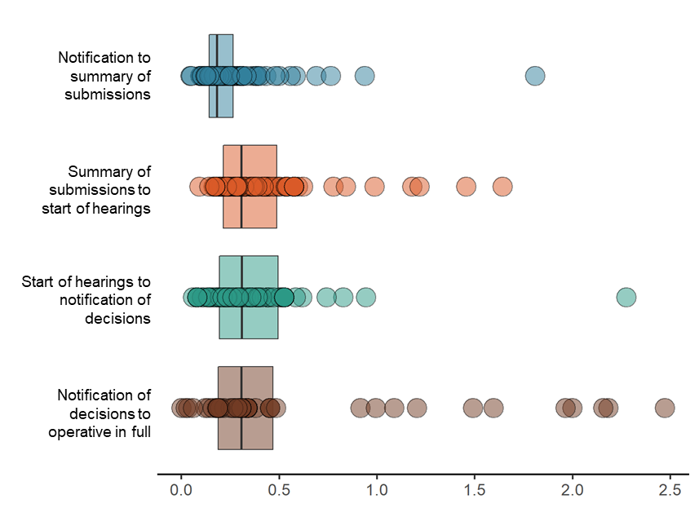

* Circles represent individual plan changes and boxes indicate the middle 50 per cent of plan changes in terms of timeliness. The line in the middle of the boxes is the median.

Plan changes usually progress relatively quickly from notification to public notice of the summary of submissions. The remaining process can be divided into three roughly equal time periods:

* summary of submissions to the start of hearings
* start of hearings to decisions
* decisions to being fully operative.

Each of these phases is usually completed in less than half a year; however, all can potentially take much longer. In particular, a plan change that is appealed takes much longer to complete once the decisions are notified.[37] Plan changes that are ultimately appealed tend to take longer to progress through submissions and hearings as well, although the difference is less pronounced.[38]

### Finding S6: Plan changes with more submissions do not take substantially longer to decide

Figure S6: The number of working days from close of submissions to decision notification for plan changes completed in 2017/18 and 2018/19 by the number of submissions

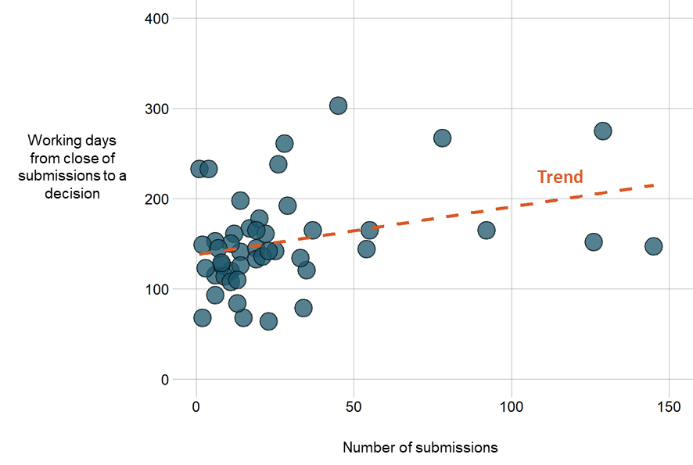

* Two years are included to establish a more robust relationship. Five plan changes were considered outliers and excluded.[39]

It could be expected that having to process more submissions (and associated further submissions, and having more submitters at hearings) would delay decisions on plan changes, but there is little evidence this is the case, at least over the past two years.

Based on a weak association between the volume of submissions and the length of time from the close of submissions to notification of decisions, it can be expected for decisions to take about a month longer for every 30 submissions received.[40]

Caution should be taken in attributing slower decision times to submission volumes alone; it is possible more complex plan changes both attract more submissions and take longer to resolve due to their complexity.

The number of submissions received hints at the future path of the plan change

Unsurprisingly, plan changes with more initial submissions went on to have more additional submissions. On average, councils received about one extra submission for every five initial submissions received.[41]

The number of submissions is a strong predictor of whether the plan change decision will ultimately be appealed. No plan changes with fewer than 10 initial submissions were appealed; about half of those with 10 or more submissions were appealed (19 of 36, 53 per cent). Almost all plan changes with 40 or more submissions were appealed (10 of 11, 91 per cent).

1. The NMS is a spreadsheet that councils fill in annually and submit to the Ministry. This includes detailed information on every plan or policy statement worked on and every resource consent issued, in addition to other functions, tools and processes they are responsible for under the RMA. The Ministry compiles and publishes this information as a national dataset each year. NMS data for 2014/15 to 2018/19 is [publicly available](https://www.mfe.govt.nz/rma/monitoring-rma-implementation/complete-datasets) along with further detail about [what is collected](https://www.mfe.govt.nz/rma/monitoring-rma-implementation/data-required).
2. A working day is defined in the RMA as any day excluding weekends, national holidays and the summer shutdown period from the 20 December to the 10 January.
3. See finding S1 in the appendix for details.
4. The median processing time for a coastal permit was 42 working days, 44 working days for a discharge permit and 60 working days for a water permit in 2018/19. The median processing times for land-use and subdivision consents were 27 working days and 35 working days, respectively.
5. The 11 councils collectively processed 40 per cent of all resource consent applications in 2018/19.
6. Prevents subsequent days from counting as working days (as defined under the RMA) in the calculation of processing times.
7. The NMS only collects information on application fees, which in some cases will be a minor portion of what the applicant has to pay to obtain and remain compliant with a resource consent.
8. Fees were waived or not required for 6 per cent of applications granted or declined in 2018/19. In some cases, councils charge one application fee for more than one related resource consent (ie, the fees are bundled). Seventeen per cent of applications had their fees bundled with other related consents.
9. See finding S2 in the appendix for details.
10. The median application fee was $950 for a coastal permit, $2021 for a subdivision consent, $2181 for a land-use consent, $2286 for a water permit and $2580 for a discharge permit in 2018/19.
11. The statutory time limit for a given application was determined by its notification and hearing status. The number of working days in exceedance of the limit was calculated by subtracting time limits from processing times reported by councils. The discount owed was calculated as 1 per cent of the application fee per working day in excess of the time limit to a maximum of 50 per cent.
12. For applications for new consents (Section 88) or applications to change conditions of existing consents (Section 127). The Discount Regulations apply to these two types of applications.
13. Gore District, Waikato Regional, Bay of Plenty Regional and Kawerau District.
14. See finding S3 in the Appendix for details.
15. See finding S4 in the Appendix for details.
16. The NMS collects information on the length of time from the start of a plan change to notification, but it is not fully reliable. This is because councils interpret what constitutes the start of a plan change in different ways (ie, from years before notification up to and including the same date as notification).
17. Beyond appeal. Also see Clause 20, Schedule 1 of the RMA.
18. See finding S5 in the Appendix for more detail.
19. See finding S5 in the Appendix for details.
20. Three of seven plans decided in 2017/18 and 2018/19 were decided within two years of notification.
21. The median submission volume for plan changes completed in 2018/19 was 19.
22. A review of mineral extraction areas and earthworks provisions (Whangarei District Council) received 543 submissions. A chapter on genetically modified organisms (Far North District Council) received 305 submissions.
23. See finding S6 for details.
24. The NMS did not record the number of submissions received in 2014/15 and 2015/16.
25. The number of excluded councils for participation in planning was 1 for 2014/15, 7 for 2016/17, 8 for 2017/18 and 2 for 2018/19. The number of excluded councils for participation in consenting was 1 for 2014/15, 8 for 2016/17, 11 for 2017/18 and 3 for 2018/19.
26. Eighteen councils have never provided a planning budget for iwi/hapū participation and 40 councils have provided budget in some years but not others.
27. The NMS does not have a record of budgetary commitment from Far North District Council or Otorohanga   
    District Council.
28. Far North District Council, Kaikoura District Council and Mackenzie District Council did not report their number of agreements with iwi in 2018/19.
29. Introduced in the Resource Legislation Amendment Act 2017.
30. 14.7 per cent of water permits were notified in 2018/19, as were 5.4 per cent of discharge permits and 2.4 per cent of land-use consents.
31. Three each for Whangarei District Council and Waipa District Council, two each for Hastings District Council and Waikato District Council, and one each for Auckland Council, Hutt City, Manawatu District Council, Palmerston North Council and South Waikato District Council.
32. Auckland Council reported 111 full-time equivalents (FTE) working on monitoring and enforcement in 2017/18 and 165 FTE in 2018/19, a nearly 50 per cent increase in staffing levels.
33. Monitoring and enforcement FTE at territorial authorities rose from 112 to 171 from 2016/17 to 2018/19, a 53 per cent increase. Monitoring and enforcement FTE at regional councils rose from 169 to 228 from 2016/17 to 2018/19, a 35 per cent increase. Monitoring and enforcement FTE at unitary authorities rose from 122 to 205 from 2016/17 to 2018/19, a 68 per cent increase.
34. Note these are modelled estimates and the actual time taken could be much shorter or longer.
35. Based on modelled estimates; actual costs may be higher or lower for applications with different properties.
36. The NMS does not follow up on whether the appeals were successful.
37. The median completion time for plan changes once notified is 65 working days (a bit over three months) if not appealed, and 424 working days (about 21 months) if appealed.
38. The median decision time for plan changes once notified is 158 working days (eight months) if not appealed, and 228 working days (11 months) if appealed.
39. Plan change 102 (Whangarei District Plan) had 543 submissions and took 296 working days to decide. Plan change 18 (Far North District Plan) had 305 submissions and took 489 working days to decide. Plan change 51 (Queenstown-Lakes District Plan) had 204 submissions and took 226 working days to decide. Plan change 44 (Queenstown-Lakes District Plan) had 25 submissions and took 686 working days to decide. Plan change 17 (Far North District Plan) had 16 submissions and took 485 working days to decide.
40. In a linear regression model, the number of working days from close of submissions to notification of decisions = 160 + the number of initial submissions x 0.65 (R2=0.11, p=0.013).
41. In a linear regression model, the number of further submissions = 0.6 + the number of initial submissions x 0.2 (R2=0.65, p<0.001).