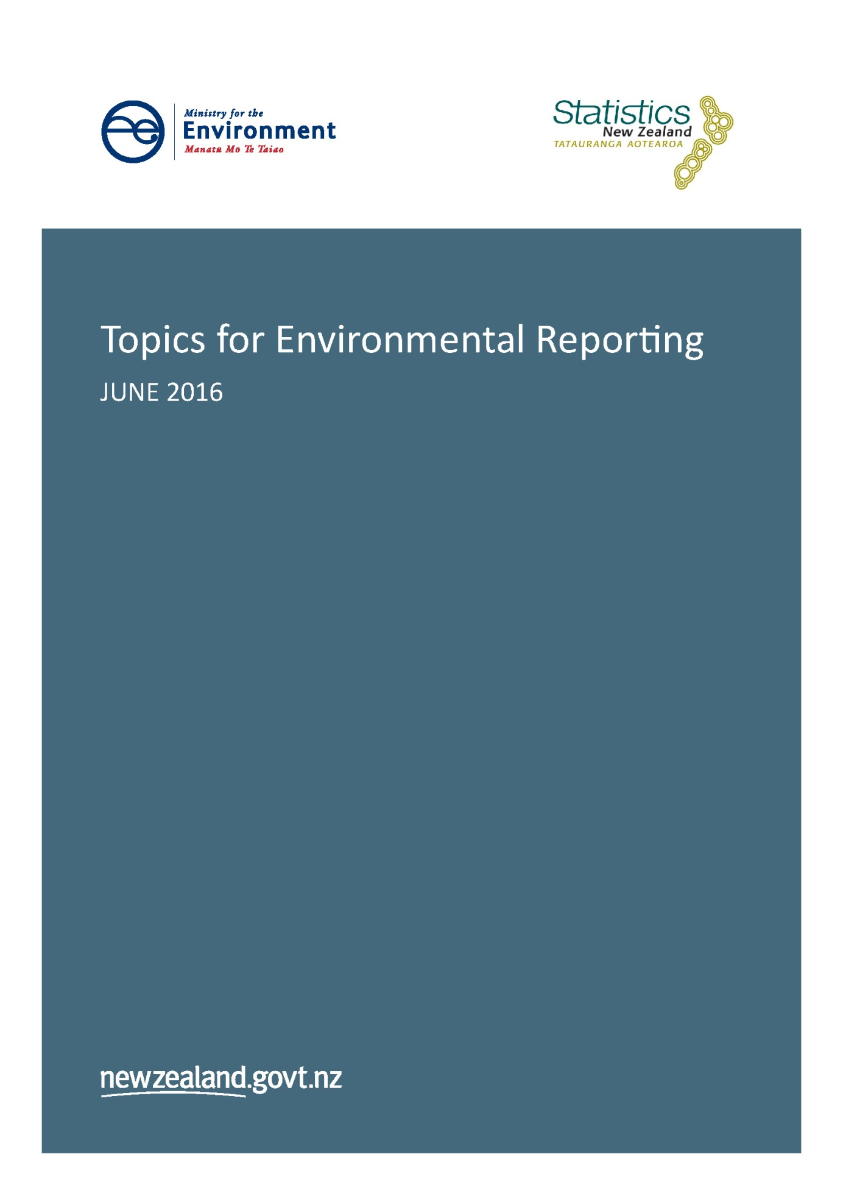

Citation
Ministry for the Environment & Statistics New Zealand. 2016. Topics for Environmental Reporting. Available from www.mfe.govt.nz and www.stats.govt.nz.

Published in June 2016 by the
Ministry for the Environment and Statistics New Zealand
ISBN: 978-0-908339-43-3
Publication number: ME 1246
© Crown copyright New Zealand 2016

Contents
Introduction 4
About topics 4
Topics and descriptions 5
Air pressure and state topics 5
Atmosphere and climate pressure and state topics 6
Freshwater pressure and state topics 7
Land pressure and state topics 8
Marine pressure and state topics 9
Impact topics (all domains) 10

Introduction
The Environmental Reporting Act 2015 (the Act) provides for regular, independent national reporting on the state of New Zealand’s environment. The Act organises the environment into five domains: air, atmosphere and climate, fresh water, land and marine.
Under the Act, the Secretary for the Environment and the Government Statistician jointly develop and publish a report on one domain every six months and a ‘whole-of-the –environment report’ report every three years. The Environmental Reporting (Topics for Environmental Reports) Regulations 2016 (the Regulations) set the topics to be reported on in environmental reports. Topics identify key issues within each domain.
This document lists the topics for each domain, as set in the Regulations, and provides a description of each.

About topics
Topics describe the scope of environmental reporting and let people know what to expect in reports. They:
- identify the key areas of interest for each domain
- help create consistency across domains
- help ensure continuity of information over time.
Topics also bridge the gap between an environmental domain (set in the Act) and a statistic (set by the Government Statistician).
State topics describe the broad aspects of the condition of the domain.
Pressure topics describe the main sources of pressure on each domain.
Impact topics cover the impacts in the areas of ecological integrity, public health, the economy, te ao Māori (the Māori world view), and culture and recreation.
Under section 19 of the Act, topics are required to relate to:
- the state of New Zealand’s environment
- pressures on the state of the environment that may be causing, or have the potential to cause, changes to the state of the environment
- impacts that the state of the environment and changes to the state of the environment may be having on:
- ecological integrity
- public health
- the economy
- te ao Māori
- culture and recreation.

Topics and descriptions
This section lists the state and pressure topics and their description for each domain and the impact topics across all domains.

Air pressure and state topics
Pressure topics
Topic |  | Description
Pressures from: | Human activities | Emissions of air pollutants from human activities, including residential emissions (eg burning wood or coal for home heating), transport, forestry, agriculture, and industry.
 | Climate and natural processes | Contribution of natural substances (eg sea salt, volcanic ash) and meteorological conditions to New Zealand’s air quality.
 | Physical form of the land environment | How the physical form of the land affects the concentrations and distribution of air pollutants. Note that under the Environmental Reporting Act 2015, ‘pressure’ refers to ‘a natural or human-induced circumstance, factor, element, activity, or process’. This topic provides important context, but is unlikely to change significantly over time.
State topics
Topic |  | Description
State of: | Air quality and concentrations of air pollutants | Concentrations of air pollutants in New Zealand that affect air quality, many of which can affect human health. This includes gases such as carbon monoxide, sulphur dioxide, nitrogen dioxide and ground-level ozone; metals such as arsenic and lead; and organic compounds such as benzo(a)pyrene and benzene.

Atmosphere and climate pressure and state topics
Pressure topics
Topic |  | Description
Pressures from: | Human activities generating greenhouse gases | Activities such as energy use, transport, agriculture, waste, and industry that generate emissions of gases that absorb infrared radiation and contribute to the warming of the planet. Greenhouse gases include carbon dioxide, methane, and nitrous oxide.
 | Human activities generating particulate matter | Activities such as ploughing, construction, quarrying and the burning of fossil fuels which produce emissions of particulate matter (can include both solid and liquid particulates) that can absorb or scatter radiation from the sun and Earth, and therefore affect the climate. Examples are black carbon, trace elements such as heavy metals, salts (eg nitrates, sulphates, etc) and organic carbon compounds.
 | Human activities generating ozone-depleting substances | Activities such as refrigeration, food processing, air conditioning, and other human activities that result in emissions of substances such as chlorofluorocarbons. These substances can damage the ozone layer, which protects the Earth from ultra violet rays.
 | Land cover and use | Land-use change, such as deforestation and reforestation, which can affect the extent to which the land surface absorbs or reflects radiation, and the exchange of greenhouse gases such as carbon dioxide between the land and the atmosphere.
 | Natural pressures | The effect that natural pressures have on the state of New Zealand’s atmosphere and climate. These may include:  - land form  - natural climatic variations such as the El Niño Southern Oscillation  - atmospheric circulations and cloud cover that affect the intensity of ultra violet radiation reaching the ground  - natural sources of aerosols such as wind erosion, forest fires, volcanic eruptions, and the ocean. Natural aerosols absorb or scatter radiation and can affect cloud formation and properties, and therefore the climate  - the intensity of radiation from the sun reaching the top of the atmosphere, which can naturally vary  - sea temperature, which can influence how much moisture is taken up by the air, as well as land temperature and atmospheric circulations.
State topics
Topic |  | Description
State of: | Atmospheric properties | Concentrations of greenhouse gases in the atmosphere, such as carbon dioxide, methane, nitrous oxide, and carbon monoxide; concentration of atmospheric ozone over New Zealand; concentrations of particulate matter that absorb or scatter light and heat, or affect cloud formation.
 | Climate | Climate variables such as national average temperature, annual number of frosts days and ‘warm days’; precipitation (eg rainfall, snowfall, sleet, and hail); sunshine hours; wind gusts; occurrence of extreme weather (eg extreme wind, rainfall, and thunderstorms).
 | Ultra violet (UV) intensity | Intensity of the ultra violet radiation at ground-level.

Freshwater pressure and state topics
Pressure topics
Topic |  | Description
Pressures from: | Pests, diseases and exotic species | The occurrence and distribution of diseases and introduced and exotic species in the freshwater environment, including wetlands. This topic may include measures of introduced species, such as trout, which are not considered pests but can affect indigenous ecosystems and species, and indigenous species that have the potential to become pests.
 | Resource use and management and other human activities | The pressures that resource use and management and other human activities have on the state of the freshwater environment. For example:  - how catchment land use and management influences the condition of freshwater bodies in that catchment. For example, land use, irrigation, and the extent of riparian protection influences pressures such as soil loss and run-off from land, including nutrients and contaminants  - abstractions and diversions of fresh water, which can reduce flows and change hydrology, affecting freshwater ecoystems  - taking of freshwater species for recreational, commercial, and customary uses  - physical modifications such as river straightening, diversions, hydro dams, underground piping/culverts, weirs, and other barriers to fish passage.
 | Discharges and waste | Discharges from industry, sewage treatment plants, stormwater, and other sources and run-off from agricultural land. Waste and litter from land that makes its way into the freshwater environment.
 | Physical form of the land and freshwater environments | The landscape and form of freshwater catchments. This includes the shape of the land (topography), geology, and river morphology. This topic provides important context, but is unlikely to change significantly over time.
 | Climate and natural processes | Pressures on the freshwater environment from climatic and natural events such as rainfall, temperature, volcanic and seismic activity, natural erosion, and natural nutrient discharges from the substrate (underlying rock).
State topics
Topic |  | Description
State of: | Freshwater ecosystems and habitats | Freshwater ecosystems and habitats (eg condition of river beds and extent of wetlands).
 | Freshwater species, taonga species, and genetic diversity | Occurrence, abundance, and genetic diversity of freshwater species (includes threatened species). Taonga species includes those valued for mahinga kai (food- gathering), for example tuna (eels).
 | Freshwater quality, quantity, and flows | Measures of freshwater quality, quantity (the volume of water), and flows (how quickly the water is flowing). Freshwater quality measures include the chemical condition of the water, for example, concentrations of nutrients, such as nitrogen and phosphorus; salinity; the physical condition of the water, such as the amount and quality of sediment it carries and how clear it is; and the concentration of harmful organisms that contaminate water and can affect human and ecosystem health (eg Escherichia coli). This topic covers extent of glacial ice, snow cover, and geothermal water quality and quantity.

Land pressure and state topics
Pressure topics
Topic |  | Description
Pressures from: | Pests, diseases and exotic species | The occurrence and distribution of exotic species, pests, and diseases in the land environment. This topic may include exotic species that are not considered pests, but affect indigenous ecosystems and species, for example, deer, chamois, and tahr.
 | Resource use and management and other human activities | The pressure placed on land by rural and urban land use and management and the extraction and use of minerals and other resources.
 | Waste, effluent, and contaminants | The pressure placed on land by solid and liquid wastes (both point source and diffuse), including hazardous waste and litter. This topic also covers the presence of heavy metals such as cadmium in soils, which in high concentrations can be toxic to humans.
 | Physical form of the land environment | The landform that underlies and shapes the land domain. Landform is a major factor in the extent and severity of erosion, ecosystem distribution and type, and vegetation cover. This topic provides important context, but is unlikely to change significantly over time.
 | Climate and natural processes | Climatic conditions and natural events such as volcanic and seismic activity, which affect the condition, habitats, and physical terrain of the land.
State topics
Topic |  | Description
State of: | Land cover, ecosystems, and habitats | The extent and distribution of vegetation and other land cover in New Zealand, including indigenous forests, wetlands, peatlands, production forest, pasture, urban, and infrastructure, and how this has changed over time. This topic will cover protection/conservation status, rare ecosystems (naturally uncommon ecosystems), and threatened ecosystems.
 | Land species, taonga species, and genetic diversity | Occurrence, abundance, and genetic diversity of terrestrial species (includes threatened species). Taonga species (species valued from a traditional Māori perspective) includes those valued for mahinga kai (traditional food gathering).
 | Land and soil condition | Measures of soil erosion (both the extent of actual erosion and the susceptibility to erosion), soil health (the physical, biological, and chemical condition of soils), and the applications different land types are suitable for.

Marine pressure and state topics
Pressure topics
Topic |  | Description
Pressure from: | Pests, diseases and exotic species | The occurrence and distribution of diseases and introduced and exotic species in the marine environment, including estuaries.
 | Resource use and management, and other human activities | The pressure exerted on the marine environment through commercial, recreational and customary fishing; the extraction of resources such as oil, gas and minerals; non-extractive use such as shipping and recreation; modification of oceanic and coastal benthic (sea-floor) habitats, for example, as a result of bottom trawling or coastal structures, such as a marina or seawalls.
 | Discharges, soil loss and waste | Includes discharges into waterways and the sea (both point-source and diffuse), including nutrients and contaminants such as heavy metals; soil loss from land; and waste, litter and marine debris.
 | Physical form of the marine environment | The physical form of the ocean floor, such as seamounts or trenches, and the type of benthic substrate (what the seafloor is made of). This topic provides important context, but is unlikely to change significantly over time.
 | Climate and natural processes | How climate and natural processes affect the marine environment, for example, temperature and climate oscillations such as the El Niño Southern Oscillation, and extreme wave and storm events.
State topics
Topic |  | Description
State of: | Marine ecosystems and habitats | The condition, distribution and range of marine ecosystems and habitats. Includes protection/conservation status of coastal and marine areas.
 | Marine species, taonga species, and genetic diversity | The numbers, distribution, range and conservation status and genetic diversity of marine species such as seabirds, fish, marine mammals (including threatened species), invertebrates, plankton and algae. Taonga species includes those valued for mahinga kai (traditional food gathering).
 | Marine water and sediment quality and ocean acidity | The physical and chemical quality of water in oceanic, coastal and estuarine areas, including concentrations of contaminants such as heavy metals, water clarity, and ocean acidity.
 | Sea level, temperature, and circulation | The physical and chemical properties of oceanic waters related to sea temperature, sea level (including frequency of sea level extremes), currents and waves.

Impact topics (all domains)
Impact topics
Topic | Description
Impacts on biodiversity and ecosystem processes | The impact the state of the environment has on New Zealand’s biodiversity and ecosystem processes. For example:  - air pollutants can settle and accumulate in habitats, such as heavy metals in waterways and alter ecosystem processes (air domain)  - rainfall influences how ecosystems are able to function because it affects the ability of plants to grow and support the wider ecosystem (atmosphere and climate domain)  - change in the conservation status of plant and animal species  - ecosystem functioning, such as food chains.
Impacts on public health | The occurrence of health effects that are related to the state of the environment. For example:  - the health effects of New Zealand’s air quality (from respiratory irritation through to some forms of cancers) (air domain)  - the occurrence of skin cancers (which is related to ultra violet exposure) and the occurrence of Salmonella, Cryptosporidium and Influenza (related to temperature) (atmosphere and climate domain)  - toxic algae and water-borne diseases such as Campylobacter and Giardia can have significant human health effects (freshwater domain)  - how the condition and management of land affects food safety, for example, through the presence of heavy metals and other contaminants in food (land domain)  - illness from faecal contamination of coastal areas or consuming shellfish affected by contamination or toxic algae (marine domain).
Economic impacts | The impact the state of the environment has on natural resource value, availability and use, and industry and households in economic terms. For example:  - measurement of the economic production of New Zealand, focusing on the aspects of New Zealand’s primary industry that are strongly dependent on the atmosphere and climate, including agricultural production (atmosphere and climate domain)  - impacts on tourism and recreation, for example, ski-field open days (atmosphere and climate domain)  - the effect of the freshwater environment on hydroelectricity generation, tourism, and urban water use, including drinking water and industrial use (freshwater domain)  - the extent of highly productive soils available for food production (land domain)  - extent and availability of minerals, energy, and other resources in all domains  - impacts on economic value of Māori-owned land (land domain)  - lost work days due to the health impacts of air quality (air domain)  - impacts on agricultural production and forestry in the primary industry sector, which are dependent on fresh water (freshwater domain)  - the monetary value of food produced on the land and the added value to the economy (land domain)  - the economic impacts caused by coastal erosion and storms that affect housing and infrastructure around the coastline (marine domain)  - impacts of pests and diseases on the economy.
Matauranga Māori, tikanga Māori, and kaitiakitanga | How the state of the environment affects the ability to maintain, develop, and transmit traditional Māori knowledge about the environment and maintain tikanga practice. The ability to pass on knowledge about the environment to the next generation through hands-on experiential learning and interactions with the environment is especially important.  Tikanga practice involves traditional protocols and practices relating to the environment, such as the size of customary take of mahinga kai (traditional food) or the use of rahui (closures). The retention and development of tikanga practice is important to Māori identity and well-being.  Kaitiakitanga governs use (customary and otherwise) of resources and access to sites ensuring, among other things, the sustainability and integrity of the resources and sites.
Customary use and mahinga kai | How the state of the environment (and especially biodiversity and ecosystems) affects the ability of Māori to exercise customary use and access mahinga kai (traditional food sources) in land, coastal, marine, and freshwater environments. This topic will measure access to these sites and their condition, and abundance of mahinga kai resources.
Sites of significance, including wāhi taonga and wāhi tapū | Extent, distribution, and condition of sites which are significant from a cultural, historical, archaeological, recreational, or ecological perspective, including wāhi tapū (sacred sites). Covers how the state of the environment affects the condition, integrity, and access to these sites.
Impacts on culture and recreation | The impact the state of the environment has on the cultural and recreational use of our environment, for example:  - through air clarity and visibility (air domain)  - damage caused to heritage sites from extreme weather events (atmosphere and climate domain)  - health risks for recreation, for example, swimming, freshwater swimming closures or alerts, and popularity of freshwater activities such as freshwater fishing (freshwater domain)  - fishing and boating (marine domain).  - aesthetic and amenity value.

