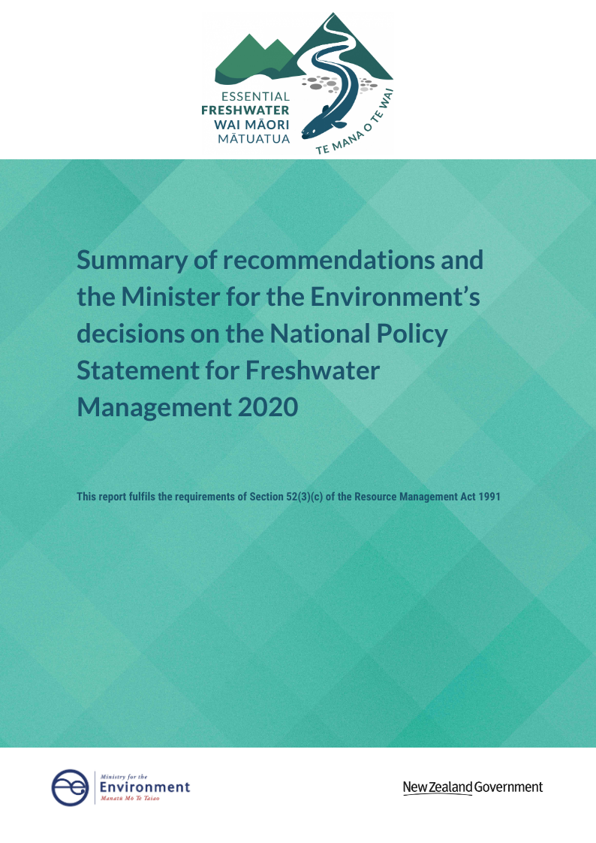
Disclaimer
This document should be read in conjunction with the Action for Healthy waterways discussion document, Submissions Report, Independent Advisory Panel report and the National Policy Statement for Freshwater Management 2020.

Acknowledgement
The Ministry for the Environment would like to acknowledge the work undertaken by the Independent Advisory Panel, and thank the members for their invaluable contribution to the Action for Healthy waterways package.

This document may be cited as: Ministry for the Environment. 2020. Summary of recommendations and the Minister for the Environment’s decisions on amendments to the National Policy Statement for Freshwater Management 2020. Wellington: Ministry for the Environment.

Published in October 2020 by the
Ministry for the Environment
Manatū Mō Te Taiao
PO Box 10362, Wellington 6143, New Zealand
ISBN: 978-1-99-003331-5 (online)
Publication number: ME 1543
© Crown copyright New Zealand 2020
This document is available on the Ministry for the Environment website: www.mfe.govt.nz.
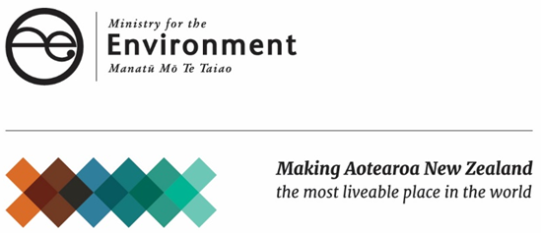

Contents
Introduction 5
Summary of recommendations and Minister’s decision 6
Consultation on other matters 6
Independent Advisory Panel recommendations and Ministers decision 7

Tables
Table 1: General NPS-FM 2020 provisions 7
Table 2: Large hydro-electric generation schemes 8
Table 3: National Objectives Framework 8
Table 4: Compulsory and other values 9
Table 5: Attributes 10
Table 6: Wetlands 11
Table 7 Stream loss 12
Table 8: Fish passage 12

Introduction
The Government announced its intention to amend the National Policy Statement for Freshwater Management 2014 (as amended in 2017), in October 2018 (see Essential Freshwater: Healthy water, fairly allocated).
Specific amendments were then publicly consulted on through the discussion document Action for healthy waterways. Consultation took place from 5 September to 31 October 2019. This included 17 general public meetings, with another eight for the primary sector and rural community, and 16 hui for iwi and Māori around New Zealand. To view all the information on the proposals see the Ministry’s website at: www.mfe.govt.nz/consultation/action-for-healthy-waterways.
The Government received 17,500 submissions on the proposals outlined in Action for healthy waterways. Of these, 3300 were unique with the remainder based on organisation templates. A summary of the submissions made on the proposals outlined in Action for healthy waterways was provided to the Minister (the Submissions Report).
Under section 46A of the Resource Management Act 1991 (RMA) the Minister for the Environment must establish a process for preparing national policy statements, either by appointing a board of inquiry, or other process that meets the requirements set out in the Act. The Minister decided to appoint a Freshwater Independent Advisory Panel (IAP), chaired by retired Principal Environment Court Judge David Sheppard QSO. Under section 52(1)(a) of the RMA, the Minister is required to consider a report and any recommendations from the IAP.
In its report to the Minister dated 27 February 2020, the IAP provide recommendations on the proposals, which took into account the public submissions received. The IAP report fulfils the requirements of section 46A(4)(c) of the RMA.
After considering the IAP recommendations, the Minister made some changes to the amendments proposed through Action for healthy waterways.
The Order in Council approving the National Policy Statement for Freshwater Management 2020 (NPS-FM 2020) was published in the Gazette in August 2020. The new NPS-FM came into force on 3 September 2020.
Section 52(3)(c) of the RMA requires the Minister, as soon as practicable after a national policy statement has been approved, to provide every person who made a submission with a summary of the recommendations made by the IAP, and a summary of the Minister’s decisions on those recommendations (including the reasons for not adopting any recommendations). This document, prepared by the Ministry for the Environment on behalf of the Minister, provides that summary.

Summary of recommendations and Minister’s decision
The Independent Advisory Panel (IAP) recommended a number of changes. A full discussion on the reasons for the IAP recommendations can be found in its report.
The format of this document follows, where possible, the sequence of the recommendations contained in the IAP Report, as they relate to the NPS-FM 2020. Apparent gaps in numbering of recommendations in the following tables are due to those recommendations being addressed through the National Environmental Standards for Freshwater (NES-F). Those recommendations which relate to the NES-F are not required to be addressed in this report under section 52.

Consultation on other matters
Throughout the consultation on Action for healthy waterways, the Government also sought feedback on amendments to, and regulations under the Resource Management Act, including:
- National Environmental Standards for Freshwater 2020 (NES-F)
- Stock exclusion, and Measurement and Reporting of Water Takes and
- A new Freshwater Planning Process under Schedule 1, Part 4 of the RMA.
Concurrently, consultation was conducted on the following matters, to which separate processes, requirements and timeframes apply:
- product stewardship
- hazardous substances
- highly productive land
- urban development
- Three Waters.

Independent Advisory Panel recommendations and Ministers decision
Table 1: General NPS-FM 2020 provisions
Recommendation | Summary of, and key reasons for, Minister’s decision
1. Add descriptions for the terms mātauranga Māori and ki uta ki tai to provide clarity to councils. | The Minister decided not to define ki uta ki tai, instead, clause 3.5 clarifies that councils must adopt an integrated approach, ki uta ki tai, as required by Te Mana o te Wai, and sets out a series of matters to guide councils. The Minister considered the concerns of te Kāhui Wai Māori on defining ki uta ki tai nationally, and decided that demonstrating how ki uta ki tai is to be implemented was preferable.  On defining mātauranga Māori, the Minister considers these are concepts that have long been included in resource management planning documents and are well understood.
2. Remove the long-term vision requirement in 3.2 of the NPS-FM 2020 to speed the process and reduce administrative burden. | The Minister decided to retain the requirement for councils to develop a long-term vision following engagement with communities and tangata whenua. The Minister considers the long term vision will clearly set out aspirations for freshwater and their ecosystems in the region, which can then guide the setting of target attribute states, and limits.
3. Revise the sections on Te Mana o te Wai priorities and obligations to reduce the risk of challenge and remove imperative language, and integrate directions with other requirements on regional councils. | In accordance with feedback received through consultation and the work with Te Kāhui Wai Māori, the Minister decided to retain the requirement to ‘give effect’ to Te Mana o te Wai’.  In order to address some of the concerns raised by the IAP, the Minister decided to:  - integrate the directions of ‘giving effect to’ Te Mana o te Wai into specific requirements of the NPS-FM 2020 and better link the requirements of Te Mana o te Wai with the rest of the NPS-FM 2020  - require councils to ‘apply’ the hierarchy of obligations during the process of implementing the NPS-FM (such as developing a long-term vision for freshwater or implementing the National Objectives Framework). The intent of the hierarchy of obligations is to shift the way that we think about managing freshwater and guide the implementation of the National Objectives Framework (NOF), rather than imposing new thresholds, hard limits or bottom lines to the NPS-FM 2020.
4. Add a clause to the NPS-FM 2020 on council process requirements in making decisions under the NPS [to require councils to exercise their functions in a way that records the reasoning for the decision and ensures the public is informed]. | The Minister accepted this recommendation - see Subpart 1, clause 3.6 – Transparent decision making.
5. Add a clause to the NPS-FM 2020 requiring councils to have regard to the effects of climate change. | The Minister agreed to include a policy (Policy 4) stating that freshwater is managed as part of New Zealand’s integrated response to climate change.  There are additional requirements for councils to have regard to the effects of climate change in the following clauses:  - 3.14 – Setting limits on resource use  - 3.16 – Setting environmental flows and levels, and  - 3.30 – Assessing and reporting, which requires councils to report predictions of change, including the foreseeable effects of climate change, which are likely to affect water bodies and freshwater ecosystems in the region.
6. Amend the timing provision to refer to the date of public notification, rather than date of final decisions. | The Minister accepted this recommendation. An amendment to the RMA requires public notification of plans implementing the NPS-FM 2020 no later than 31 December 2024.

Table 2: Large hydro-electric generation schemes
Recommendation | Summary of, and key reasons for, Minister’s decision
7. Accept the provision allowing councils to make exception for specified hydroelectricity schemes. | The Minister accepted this recommendation in order to balance the Government’s priorities for action on climate change and freshwater health (see clause 3.31 of the NPS-FM 2020).
8. Restrict the possibility of an exception to the most significant hydro-electricity schemes. | The Minister accepted this recommendation. The Minister decided to restrict the policy to the 5 following schemes; Waikato Scheme, Tongariro Scheme, Waitaki Scheme, Manapouri Scheme, and Clutha Scheme, as these are the 5 largest electricity generation schemes.
9. Remove the Waikaremoana scheme from the list of schemes that are to be exempted. | The Minister accepted this recommendation – see above.
10. Clarify within the NPS-FM 2020 that the requirement on councils to maintain or improve water quality applies even where an exception is granted. | The Minister agreed to require that improvement must be achieved to the extent practicable without having a significant adverse effect, where a council chooses to set a target attribute state below a national bottom line.
11. Add a policy to 2.2 of the NPS-FM to the effect that freshwater resources are managed as part of New Zealand’s integrated response to climate change. | The Minister agreed to include Policy 4: Freshwater is managed as part of New Zealand’s integrated response to climate change, to signal the importance of balancing the priorities of freshwater health and action on climate change.

Table 3: National Objectives Framework
Recommendation | Summary of, and key reasons for, Minister’s decision
12. Remove the requirement at 3.5 in the NPS-FM 2020 to consult at every stage of the process. | The Minister decided to retain a requirement to engage with communities and tangata whenua at each stage of the NOF process (see clause 3.7(1)) to ensure that the content of regional plans is derived with input from the whole community and to reflect various requirements of the RMA including Part 8.
13. Add a subclause to 3.6 in the NPS-FM 2020 to the effect that councils ought to monitor vulnerable sites and sensitive receiving environments, alongside representative sites. | The Minister decided not to specifically require councils to monitor vulnerable sites as this is captured by monitoring receiving environments. The NPS-FM 2020 directs councils to take into account receiving environments when establishing target attribute states. Further, when developing target attribute states for nutrients, the NPS-FM 2020 explicitly directs regional councils to take into account the environmental outcomes sought for downstream nutrient-sensitive receiving environments.
14. Incorporate ‘load to come’ (or nutrient lag) into current state identification where it is justified. | The Minister agreed that lags (or the ‘load to come’) need to be accounted for in freshwater planning. However, lags are best accounted for through the timeframes councils and communities set for achieving target attribute states (including those to maintain current state, where some degradation is likely as a result of lags), and when reporting on progress over time (which is now an explicit requirement). It is accepted that lags may result in freshwater health getting worse before it gets better, and that maintaining freshwater health may be more challenging in some places (ie, those with longer lag times). However, it would not be consistent with policy intent – to halt further declines in water quality, and begin reversing it – to account for lags when identifying the baseline state that is to be maintained. Doing so would permit those declines to occur without steps being taken to halt or reverse them.
15. Do not require that action plans be included in regional plans, instead including the clause on council process requirements above. | The Minister agreed to include requirements on council processes (see recommendation 4) and agreed that action plans could either, be included as part of a regional plan, or by publishing them separately and reviewed every 5 years (see clause 3.15).
16. Otherwise, to accept the National Objectives Framework largely as it is, with several amendments recommended to the attributes framework (key recommendations for that framework below). | The Minister accepted this recommendation – see also Table 5 below.

Table 4: Compulsory and other values
Recommendation | Summary of, and key reasons for, Minister’s decision
17. Accept the components of the Ecosystem Health value. | The Minister accepted this recommendation - see Appendix 1A.
18. Accept the definition of Ecosystem Health, with some drafting changes for clarity and robustness, and to ensure that all components are considered holistically. | The Minister accepted this recommendation - see Appendix 1A.
19. Elevate Mahinga Kai to the status of a compulsory value. | The Minister accepted this recommendation – see Appendix 1A.
20. Accept the Threatened Species value as compulsory, with some wording amendments to clarify council responsibilities. | The Minister accepted this recommendation - see Appendix 1A.
21. Accept the other values as proposed. | The Minister accepted this recommendation, with the exception of the description for water supply which was made more specific so that it better aligns with the National Environmental Standard for Sources of Human Drinking Water.

Table 5: Attributes
Recommendation | Summary of, and key reasons for, Minister’s decision
22. Amend the attributes framework to include two new classes of attributes: compulsory monitoring only, and ‘must consider for use where relevant’. | The Minister decided not to implement these recommendations.  A ‘compulsory monitoring only’ class of attributes was not progressed as the Minister considers that desired outcomes for all attributes should still be established (whether or not a national bottom line is imposed), and if monitoring detects a declining trend then a method (limits or action plans) needs to be in place to address this.  The Minister decided not to progress the recommendation for a class of attributes that councils ‘must consider for use where relevant’. Currently under the NPS-FM 2020, all attributes must be included in a regional plan as they are all linked to the compulsory values. A class such as this could be relevant in future if attributes are developed exclusively for Appendix 1B values eg, other values that must be considered.
23. Move the suspended sediment attribute to the action plan class of attributes. | The Minister chose not to implement this recommendation but did alter the assessment requirements of the suspended fine sediment attribute to address the concerns the IAP raised that led to this recommendation. For example, to take into account the concerns around the effect of extreme events, the minimum record length for grading a site was extended from two to five years.
24. Allow visual clarity measure for the suspended sediment attribute, alongside turbidity and direct measurement of suspended sediment. | The Minister accepted this recommendation.
25. Move the Dissolved Inorganic Nitrogen (DIN) and Dissolved Reactive Phosphorus (rivers) (DRP) attributes to the action plan class of attributes to allow more flexible management. | The Minister agreed to shift the DRP attribute into the action plan class of attributes, but without a bottom line. The reason for this is that a single national bottom line risks being ineffective and inequitable because DRP shows significant natural variation in different river types. With a single national bottom line, many rivers would fall under the existing exemption for naturally occurring processes. The Minister decided further research was needed to potentially derive attribute values that vary with different river classes.  The Minister decided not to progress a DIN attribute at this time but committed to review whether a DIN attribute is appropriate.  Regional councils are still required to manage DIN and DRP by setting catchment loads and instream criteria to achieve the desired outcomes for other ecosystem health attributes, such as periphyton (slime), and for nutrient-sensitive receiving environments.
26. Move total N and P (lakes) attributes to the action plan class of attributes for consistency with the DIN and DRP (rivers) attributes and allow for situations where lakes may be N or P limited. | The Minister considered that the total nitrogen and total phosphorus (lakes) attributes should remain as attributes that require limits on resource use to be set. Regional councils are able to set limits on resource use to achieve the target attribute state for both these attributes.
27. Move the QMCI and ASPM macroinvertebrate measures to the new ‘must consider for use where relevant’ class of attributes, leaving MCI as an action-plan attribute. | As discussed above in relation to recommendation 22, the Minister chose not to implement a ‘must consider for use where relevant’ attribute class. The three macroinvertebrate measures – QMCI, ASPM, MCI – remain as attributes that require action plans.
28. Raise the MCI threshold to 90 in line with STAG’s recommendation. | The Minister accepted this recommendation.
29. Move lake SPI, lake-bottom dissolved oxygen, and mid-hypolimnetic dissolved oxygen into the new ‘must consider for use where relevant’ class of attributes. | As discussed above in relation to recommendation 22, the Minister chose not to implement a ‘must consider for use where relevant’ attribute class. The lake SPI, lake-bottom dissolved oxygen and mid-hypolimnetic dissolved oxygen attributes remain attributes that require action plans.
30. Move Fish IBI and ecosystem metabolism measures to the new ‘compulsory monitoring only’ class of attributes. | As discussed above in relation to recommendation 22, the Minister chose not to implement a ‘compulsory monitoring only’ attribute class. The Fish IBI and ecosystem metabolism attributes remain attributes that require an action plan. To address some of the concerns raised by the IAP about its robustness, the Fish IBI attribute no longer has a national bottom line.
31. Add to the Fish IBI a column for the measurement of salmonids, applying only to specific salmonid fisheries. | The Minister did not consider it appropriate to include salmonids in a compulsory attribute table. Policy 10 of the NPS-FM 2020 provides protection to the habitat of trout and salmon, as long as it is consistent with the protection of the habitat of indigenous freshwater species. Councils can include a salmonid attribute if they consider it appropriate.
32. Raise the ammonia and nitrogen toxicity attributes to the 90th percentile and change ‘toxicity’ to ‘species sensitivity’. | The Minister strengthened the ammonia and nitrogen toxicity attributes to protect 95% of species from toxic effects, up from 80%. The change was made to recognise that without the addition of a DIN attribute, the nitrogen policies do not sufficiently provide for ecosystem health, especially in soft-bottomed rivers that do not support the growth of periphyton. Strengthening these attributes improves control on nitrogen levels without the same level of stringency which a DIN attribute would require.  The term ‘toxicity’ is widely used in scientific literature and well understood. As such the Minister chose not to change it to ‘species sensitivity’.
33. Amend the bathing season’s primary contact sites attribute to require weekly monitoring during the bathing season retaining flexibility for regional councils to determine the appropriate bathing season. | The Minister accepted this recommendation.

Table 6: Wetlands
Recommendation | Minister’s decision
34. Tighten the definition of ‘net loss’ to remove loopholes. | The Minister accepted this recommendation.
35. Ensure restored wetlands are not counted as constructed wetlands. | The Minister accepted this recommendation.
* Note that apparent gaps in numbering of recommendations occurs due to those recommendations being incorporated into the National Environmental Standards for Freshwater. As such are they not addressed in this report under section 52, which relates only to decisions made on the NPS-FM 2020.
Table 7 Stream loss
Recommendation | Minister’s decision
40. Amend references to ‘streams’ to read ‘rivers’, and clearly define ‘rivers’ as having the same meaning as in the RMA. | The Minister accepted this recommendation.
41. Amend Policy 9 of the NPS-FM 2020 to read: ‘there is no net loss of the extent and habitat quality [or ecosystem health] of rivers’. | The Minister amended Policy 9 (now Policy 7) to state that “the loss of river extent and values is avoided to the extent practicable”.

Table 8: Fish passage
Recommendation | Minister’s decision
45. Clarify the relation between fish passage provisions in the NPS-FM 2020, and those in the Freshwater Fisheries Regulations 1983, and the Conservation Act 1987. | The Minister accepted this recommendation in principle but considered it could be best achieved through guidance.
46. Review the drafting of the NPS-FM 2020 to relate ‘aquatic life objectives’ to ‘environmental outcomes’, and ‘work programmes’ to ‘action plans’. | The Minister accepted this recommendation in part. Changes were made to clarify that the requirement for a ‘work programme’ sits within an action plan (see 3.26 (6) and (7)), and for the fish passage objective required in clause 3.26 (1).

