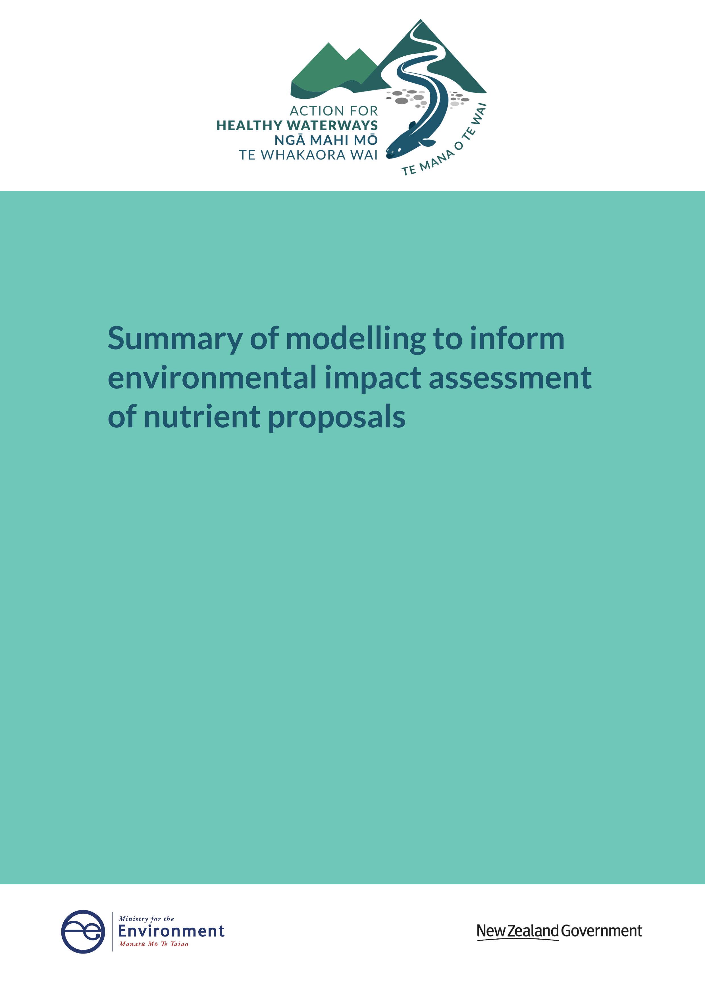

**Acknowledgements**

The Ministry acknowledges Sandy Elliott and Sharleen Yalden of NIWA who provided the modelling methodology and results, and Ton Snelder of Land and Water People who reviewed the document.

This document may be cited as: Ministry for the Environment. 2020. *Action for healthy waterways: Summary of modelling to inform environmental impact assessment of nutrient proposals*. Wellington: Ministry for the Environment.

Published in May 2020 by the  
Ministry for the Environment   
Manatū Mō Te Taiao  
PO Box 10362, Wellington 6143, New Zealand

ISBN: 978-1-98-857988-7 (online)

Publication number: ME 1501

© Crown copyright New Zealand 2020

This document is available on the Ministry for the Environment website: [www.mfe.govt.nz](http://www.mfe.govt.nz).



# Contents

Executive summary 5

1. Introduction 7

Nitrogen and phosphorus 7

Requirements under the 2017 NPS-FM 7

Action for healthy waterways 8

Purpose of this document 8

2. Methods 9

Overview of modelling approach 9

Input datasets 10

Nutrient targets for managing periphyton 11

Scenarios modelled 11

Model results analysis 12

Assumptions and limitations 12

3. Results 14

Nutrient load reductions 14

Comparison to previous work 21

Sensitivity testing of spatial exceedances for periphyton 21

References 23

Appendix 1: Spatial exceedance criteria for periphyton 24

Appendix 2: Differences in total nitrogen (TN) concentration targets for periphyton 37

Appendix 3: Model results by scenario and region 41

# Tables

[Table 1: Phosphorus load reduction target for different regions and its proportion to the current load. The figure includes different scenarios with 20 per cent periphyton spatial exceedance criteria. Results for 10 per cent and 30 per cent periphyton spatial exceedance criteria can be found in Appendix 3 14](#_Toc40950230)

[Table 2: Nitrogen load reduction targets for different regions and its proportion to the current load. The figure includes different scenarios with 20 per cent periphyton spatial exceedance criteria. Results for 10 per cent and 30 per cent periphyton spatial exceedance criteria can be found in Appendix 3 15](#_Toc40950231)

[Table 3: Nitrogen load and target reduction summary for MfE (2019) and this study. 21](#_Toc40950232)

[Table 4: Sensitivity to choice of spatial exceedance criterion (the policy scenario is for new national bottom-lines set for DIN at 1 mg/L and DRP at 0.018 mg/L) 22](#_Toc40950233)

# Figures

[Figure 1: Nitrogen load reductions required to achieve periphyton TN target, nitrate toxicity bottom-line and lake TN bottom-line described in the existing 2017 NPS-FM (baseline scenario). The reduction is expressed as a percentage of the estimated current load. 16](#_Toc40951010)

[Figure 2: Additional nitrogen load reductions (above the baseline) required to achieve a new bottom-line for DIN of 1 mg/L (DIN1 scenario only). The reduction is expressed as a percentage of the estimated current load. 17](#_Toc40951011)

[Figure 3: Total nitrogen load reductions required to achieve the baseline and a new bottom-line for DIN of 1 mg/L (baseline + DIN1 scenarios). The reduction is expressed as a percentage of the estimated current load. 17](#_Toc40951012)

[Figure 4: Additional nitrogen load reductions (above the baseline) required to achieve an amended nitrate toxicity bottom-line of 2.4 mg/L (NTox24 scenario only). The reduction is expressed as a percentage of the estimated current load. 18](#_Toc40951013)

[Figure 5: Total nitrogen load reductions required to achieve the baseline and an amended nitrate toxicity bottom-line of 2.4 mg/L (baseline + NTox24 scenarios). The reduction as a percentage of the estimated current load. 18](#_Toc40951014)

[Figure 6: Phosphorus load reductions needed to achieve periphyton DRP target and lake TP bottom-line defined in the 2017 NPS-FM (baseline scenario). The reduction is expressed as a percentage of the estimated current load. 19](#_Toc40951015)

[Figure 7: Additional phosphorus load reductions (above the baseline) required to achieve a new bottom-line for DRP of 0.018 mg/L (DRP18 scenario only). The reduction is expressed as a percentage of the estimated current load. 20](#_Toc40951016)

[Figure 8: Total phosphorus load reductions required to achieve the baseline and a new bottom-line for DRP of 0.018 mg/L (baseline + DRP18 scenarios). The reduction is expressed as a percentage of the estimated current load. 20](#_Toc40951017)

# Executive summary

In September 2019, the Government consulted on *Action for healthy waterways*, a group of proposals to address systemic freshwater management issues and reduce undesirable levels of sediment and pollution in waterways. As part of *Action for healthy waterways*, the Government considered different options for improving management of nutrients (nitrogen, N and phosphorus, P) in New Zealand’s freshwaters. This policy development process is described further in *Regulatory Impact Analysis: Action for healthy waterways. Part II: Detailed Analysis* (Ministry for the Environment, 2020).

This document outlines environmental impact assessment analysis that informed the *Action for healthy waterways* proposals. It describes modelling of the nutrient reductions that would be required to meet the existing National Policy Statement for Freshwater Management (NPS‑FM), and compares these to the reductions that would be required under different scenarios. The scenarios modelled were:

* **Baseline (2017 NPS-FM):** N and P concentrations to provide for periphyton, lake, and nitrate toxicity bottom-lines (the requirements under the 2017 NPS-FM).
* **DIN1:** Baseline with addition of the proposed river dissolved inorganic nitrogen (DIN) concentration bottom line (1 mg/L).
* **NTox24:** Baseline with alternative nitrate toxicity bottom-line (2.4 mg/L). Note this scenario does not have DIN concentration bottom line.
* **DRP18:** Baseline with addition of the proposed river dissolved reactive phosphorus (DRP) concentration bottom-line (0.018 mg/L).

Within all of these scenarios different periphyton spatial exceedance criteria of 10 per cent, 20 per cent and 30 per cent were tested. Periphyton spatial exceedance is an indicator of the level of risk accepted by regional councils to waterways having excessive levels of periphyton.[[1]](#footnote-2) Periphyton spatial exceedance is important because it influences the size of the nutrient load reduction required to meet the periphyton biomass bottom-line contained in the existing 2017 NPS-FM.

The following results were generated using a periphyton spatial exceedance of 20 per cent. The target nutrient reduction loads are expressed as a percentage reduction required in relation to the current level of nutrient loads. Baseline (2017 NPS-FM) nutrient reduction targets are also expressed, to show the source of the required reduction.

##### To achieve the requirements of the 2017 NPS-FM with a national bottom-line for DIN of 1 mg/L

Nitrogen loads would have to reduce by 10.2 per cent across New Zealand. Of that 10.2 per cent, the new bottom-line contributes 3.0 per cent relative to the current level of the nitrogen load. Regionally, the DIN bottom-line has the most noticeable impact in Canterbury (contributing 9.2 per cent to an overall 32.0 per cent reduction in nitrogen) and Waikato (contributing 6.7 per cent to an overall reduction of 9.9 per cent).

##### To achieve the requirements of the 2017 NPS-FM with a strengthened national bottom‑line for nitrate toxicity of 2.4 mg/L

Nitrogen loads would have to reduce by 7.7 per cent across New Zealand. Of that 7.7 per cent, the change to the bottom-line contributes 0.5 per cent relative to the baseload. The change is most noticeable in Canterbury and Waikato.

##### To achieve the requirements of the 2017 NPS-FM with a national bottom-line for DRP of 0.018 mg/L

Phosphorus loads would have to reduce by 2.5 per cent across New Zealand. Of that 2.5 per cent, the new bottom-line contributes 1.7 per cent relative to the baseload. The new bottom-line makes a noticeable difference in Waikato, Manawatū-Whanganui and Northland, but not elsewhere.

There is only a small difference between a 10 per cent or 20 per cent spatial exceedance on the additional nutrient load reduction needed to meet the proposed new bottom-lines. Assuming that other requirements, such as impacts on lakes and sensitive receiving environments don’t become more binding, a 30 per cent spatial exceedance would mean that nutrient load reductions to meet the 2017 NPS-FM periphyton bottom-line are less than the reductions required for the proposed DIN and DRP bottom-lines in many River Environment Classification (REC) classes (ie, DIN and DRP become the more stringent bottom line).

# **1. Introduction**

## Nitrogen and phosphorus

Nitrogen and phosphorus are nutrients that are necessary for all plant growth and are present naturally at low levels in freshwater ecosystems. However, excessive nutrients can:

* contribute to problematic growth of phytoplankton (algae), periphyton (slime) or macrophytes (rooted plants), affecting ecosystem health and people’s use and enjoyment of the waterbody
* change the ways that microbes and invertebrates break down and recycle organic matter (such as leaf litter) in rivers, which alters the way ecosystems function.

Some forms of nitrogen can also have direct toxic impacts on human and animal health[[2]](#footnote-3).

## **Requirements under the existing National Policy Statement for Freshwater Management**

Under the Resource Management Act (1991) , local governments are responsible for implementing national requirements through their planning processes. Relevant content in regional plans is directed through the National Policy Statement for Freshwater Management (NPS-FM).

The existing NPS-FM (2014, revised in 2017) directs councils to manage nutrients in rivers by setting objectives for ammonia and nitrate (in terms of their toxic effects, not their nutrient effects on plant growth) and for periphyton biomass. Councils are required to determine the levels of in-stream dissolved inorganic nitrogen (DIN) and dissolved reactive phosphorus (DRP) that will deliver their periphyton objective. The NPS-FM makes it clear that nitrate and ammonia toxicity bottom-lines are insufficient to provide for ecosystem health. However, it does not directly specify the nutrient levels that will provide for ecosystem health.

The periphyton attribute was intended to give councils flexibility in managing the negative effects of nutrients, because the impact of the same nutrient concentration on periphyton will vary due to other factors present (eg, flow, stream shading, temperature bed type) at different locations.

Councils also need to work out target attribute states for each part of the catchment and manage the catchment to protect the most sensitive areas. That will mean the levels of nitrogen and phosphorus in rivers need to provide for the desired outcomes in nutrient-sensitive downstream environments (such as rivers, lakes or estuaries). In rivers that neither grow periphyton nor have a sensitive receiving environment downstream, the nitrate and ammonia toxicity attributes provide the minimum requirement for setting a target attribute state under the NPS-FM.

## Action for healthy waterways

In October 2018, the Government launched the *Essential Freshwater: Healthy Water, Fairly Allocated* work programme. The programme is the latest in a series of Government initiatives to address the effects of water use and land use on water quality and ecosystem health.

In September 2019, the Government consulted on *Action for healthy waterways*, a group of proposals to achieve a major part of the Essential Freshwater work programme. It addresses systemic issues with freshwater management and aims to reduce undesirable levels of sediment and pollution in waterways.

## Purpose of this document

The purpose of this document is to evaluate load reductions required to meet the new NPS-FM nutrient-related bottom-lines proposed in *Action for healthy waterways*, and compare these to the nutrient load reductions required under the baseline defined by the 2017 NPS-FM. Load reductions are changes required to the estimated/measured current loads to comply with the new NPS-FM bottom-lines and these reductions are compared with reductions needed to comply with the 2017 version of the NPS-FM, which is taken to be the baseline. These nutrient load reductions will inform broader economic and policy evaluation.

The results of this work are also reported in *Regulatory Impact Analysis: Action for healthy waterways. Part II: Detailed Analysis* (Ministry for the Environment, 2020).

# **2. Methods**

## Overview of modelling approach

Modelling was conducted by the National Institute for Water and Atmospheric Research (NIWA), and data analysis and display was undertaken by the Ministry for the Environment. The modelling approach taken by this study follows previous modelling conducted for the Ministry for the Environment (Elliott et al 2016b; Elliott et al 2020), but is simplified in that only load reductions are considered (not potential load increases[[3]](#footnote-4)), model inputs are updated, and scenarios are tested for proposed bottom-lines for dissolved inorganic nitrogen (DIN) and dissolved reactive phosphorus (DRP) and nitrate toxicity.

Current catchment load estimates are based on the Catchment Land Use for Environmental Sustainability (CLUES) catchment model (Elliott et al 2016a; Semadeni-Davies et al 2019; Semadeni-Davies et al 2020), which models contaminant load generation and transport through a representation of the national drainage network provided by the River Environment Classification (REC). Lakes were also represented within the network. This study used the total nitrogen (TN) and total phosphorus (TP) components of CLUES.

The assessment of load reductions examines each stream network segment and lake of interest (evaluation locations) and compares the estimated current concentration with the target bottom-lines. The concentration reduction to meet the bottom-lines is calculated as a proportion of the current (estimated) concentration, and that proportion is applied to the current load (in a stream or out of a lake) to determine a maximum allowable load. If multiple bottom-lines apply (for example, nitrate toxicity and general river ecosystem health), then the bottom-line with the largest associated proportion reduction was chosen (the most strict bottom-line). For each catchment (as defined by terminal segment, that is, locations where the river reaches the coast):

* the ‘critical location’ (stream segment or lake) requiring the greatest proportion reduction in loading is determined, where the proportion reduction is how much the load needs to be reduced divided by the maximum it could be reduced if all land-use reverted to pre-development conditions and point sources were removed
* all source loads upstream of the critical location are reduced by the same proportion
* the new cumulative reduced loads are then calculated throughout the catchment, and the next critical location is found (if load reduction is still required)

* only reductions in concentrations and loading were considered (no increases), according to the maintain or improve provisions in the National Policy Statement for Freshwater Management (NPS-FM).[[4]](#footnote-5)

## **Input datasets**

Source loadings for each REC sub-catchment were taken from the latest version of CLUES. They include pastoral sources calculated from a simplified version of Overseer nutrient budgets. The version of Overseer uses the Overseer 6.2 calculation engine, but applies representative farm systems for each of dairy, intensive pasture and hill pasture, but can be modified for soil order, rainfall, slope, and stocking rate. The source loads for other land uses are determined as described in the CLUES documentation (Elliott et al 2016a; Semadeni-Davies et al 2019; Semadeni-Davies et al 2020) and includes point sources.

The evaluation locations comprised:

* 2567 lakes.
* All locations where relevant water quality is measured (Larned et al 2018a).
* All river terminal segments.

The estimated concentration was determined by measurements, where available, or otherwise concentrations were estimated using the CLUES model (non-monitored lakes, and most of the terminal reaches). The following datasets were used:

* Measured lake quality for 2013-17 (Larned et al 2018b). The relevant summary statistics for the ecological and periphyton-related nutrient concentrations were calculated from the datasets.
* Predicted lake water quality data (Fraser and Snelder 2019).
* Land use was based on FarmsOnline data for 2016, but also took LCDB land cover into account.
* Land use proportion summaries for each REC sub-catchment, in classes compatible with the CLUES model.

The concentration bottom-lines used in this study were:

* Baseline requirements in the 2017 NPS-FM:
* For nitrate toxicity, the existing bottom line concentration for the median NPS-FM attribute (6.9 mg/L).
* For river periphyton, TN and DRP targets to achieve periphyton objectives were derived based on Snelder et al (2019) but recalibrated using new information for nitrogen as described in Ministry for the Environment (2019). The nutrient targets were calculated for each stream segment. These nutrient targets vary by REC class to account for differences in sensitivity of rivers to nutrients. Nutrient concentrations associated with the periphyton biomass bottom-line of 200 mg chl-a/m2 were used. Three variants of nutrient targets are available, based on spatial exceedance criteria 10 per cent, 20 per cent and 30 per cent as described in Snelder (2019) and later in this document.
* Lake bottom-lines for median TN and TP. Bottom-lines defined by the NPS-FM differ for two types of lakes where type is based on the mixing regime. For monitored sites, where an estimate of lake mixing type was available, the estimated mixing type was used to determine the TN threshold (0.8 mg/L for polymictic lakes, 0.75 mg/L for seasonally-stratified or brackish lakes lake); for other lakes, where the mixing status is not known, the more conservative value of 0.75 mg/L was used. For TP the bottom-line limit of 0.05 mg/L was used.
* Proposals in *Action for healthy waterways*:
* For the new ecosystem health criteria, consulted bottom-line median concentrations of 1.0 mg/L for DIN, and 0.018 mg/L for DRP.
* For nitrate toxicity, alternative bottom-lines of 3.8 mg/L and 2.4 mg/L.

## Nutrient targets for managing periphyton

Deriving nutrient targets to achieve a periphyton biomass/abundance objective or to restrict periphyton biomass/abundance to levels less than the biomass bottom line cannot be 100 per cent certain because of natural variability, complex interactions in the environment, and the complexity of the relationship between nutrients and periphyton abundance. This is because periphyton responds to a wide range of environmental drivers, such as: nutrients, flows, temperature, light, and grazing by invertebrates. For a given amount of nutrients in a river, there will always be a risk that the predicted amount of periphyton will be exceeded. Therefore, the risks of not achieving the periphyton biomass bottom-line were built into the nutrient targets for managing periphyton. The spatial exceedance criteria quantify the probability of a randomly chosen site having periphyton abundance greater than the biomass bottom-line when the concentration is within the target concentration.

NIWA tested three periphyton spatial exceedance criteria of 10 per cent, 20 per cent and 30 per cent.

Spatial exceedance is important because it affects the size of the nutrient load reduction required to meet the periphyton biomass bottom-line contained in the existing 2017 NPS-FM.

The level of risk (spatial exceedance) is something that would be chosen by regional councils based on their level of comfort with the risk of waterways having excessive levels of periphyton.

See Appendices 1 and 2 for further information on spatial exceedance.

## Scenarios modelled

The following scenarios were modelled, for each of N and P, and for each of 10 per cent, 20 per cent and 30 per cent spatial exceedance:

* **Baseline (2017 NPS-FM):** N and P concentrations to provide for periphyton, lake, and nitrate toxicity bottom-lines (the requirements under the 2017 NPS-FM).
* **DIN1:** Baseline with addition of the proposed river DIN concentration bottom line (1 mg/L).
* **NTox24:** Baseline with alternative nitrate toxicity bottom-lines (2.4 mg/L). Note this scenario does not have DIN concentration bottom line.
* **DRP18:** Baseline with addition of the proposed river DRP concentration bottom-line (0.018 mg/L).

The purpose of these scenarios was to identify the additional load reductions imposed by DIN, DRP and nitrate toxicity bottom-lines, and the sensitivity of those reductions to the choice of periphyton spatial exceedance criteria.

## Model results analysis

The model evaluated the minimum load reduction (tonnes/year) required to be compliant with the scenario-defined bottom-lines at all downstream evaluation points (reduction target). This reduction target evaluation was assessed at all REC network segments (see modelling approach and referenced docs for more information).

The proportional reduction target in relation to the current load (t/yr) for each scenario was projected on the map to illustrate the scale of reduction relative to the location. The additional load reduction required for each proposed bottom-line were calculated by subtracting the reduction target already required by the 2017 NPS-FM bottom-lines. The additional reductions at each REC segment were also projected in the map to indicate the impact of the proposed bottom-lines.

The numerical results were then analysed at regional and national scales. The total reduction targets (t/yr), as well as total reduction target relative to the total current load (per cent reduction) were calculated (added) for each region and entire country. The additional reductions to meet the target were also calculated for each region.

## Assumptions and limitations

This analysis was based on the modelled predictions of nutrient concentrations that is nation-wide but spatially explicit. Focusing on smaller scales using these model results will introduce greater uncertainty, and analysis of such scales would benefit from using more localised and potentially detailed models.

This study did not take into account the stricter limits that may be required to manage estuaries because we do not yet have national bottom-lines for estuaries in the NPS-FM.

This analysis also assumes the effects of periphyton are managed solely by nutrient management and not by shading, flow manipulation, or other methods. This is a conservative assumption (ie, it maximises the impact of the current NPS-FM requirements) because measures other than nutrient concentration management could contribute to achieving periphyton objectives. The implications of this assumption will vary depending on the catchment in question.

If we expect councils to be less precautionary and set relatively permissive nutrient limits to manage periphyton, the relative reduction in nutrients required to meet the proposed bottom-lines is smaller. On the other hand, if we assume councils are more precautionary and set relatively tight nutrient limits to manage periphyton then the relative nutrient load reduction required to meet the proposed bottom-lines is higher. The consequences of adopting different levels of precaution regarding achieving the periphyton bottom-lines have been represented by three spatial exceedance criteria of 10 per cent, 20 per cent and 30 per cent.

# **3 Results**

## Nutrient load reductions

The following results were generated using a periphyton spatial exceedance criterion of 20 per cent. The target nutrient reduction loads are expressed as the percentage reduction required in relation to the current level of nutrient load. Baseline (2017 National Policy Statement for Freshwater Management, NPS-FM) nutrient reduction targets are also expressed to discuss the source of the required reduction (Tables 1 and 2, Figure 1).

##### To achieve the requirements of the 2017 NPS-FM with a national bottom-line for DIN of 1 mg/L

Nitrogen loads would have to reduce by 10.2 per cent across New Zealand (Figures 2-3). Of that 10.2 per cent, the new bottom-line contributes 3.0 per cent relative to the current level of the nitrogen load. Regionally, the DIN bottom-line has the most noticeable impact in Canterbury (contributing 9.2 per cent to an overall 32.0 per cent reduction in nitrogen) and Waikato (contributing 6.7 per cent to an overall reduction of 9.9 per cent).

##### To achieve the requirements of the 2017 NPS-FM with a strengthened national bottom-line for nitrate toxicity of 2.4 mg/L

Nitrogen loads would have to reduce by 7.7 per cent across New Zealand (Figures 4-5). Of that 7.7 per cent, the change to the bottom-line contributes 0.5 per cent relative to the baseload. The change is most noticeable in Canterbury and Waikato.

##### To achieve the requirements of the 2017 NPS-FM with a national bottom-line for dissolved reactive phosphorus (DRP) of 0.018 mg/L

Phosphorus loads would have to reduce by 2.5 per cent across New Zealand (Figures 6-7). Of that 2.5 per cent, the new bottom-line contributes 1.7 per cent relative to the baseload. The new bottom-line makes a noticeable difference in Waikato, Manawatū-Whanganui and Northland, but not elsewhere.

Table 1: Phosphorus load reduction target for different regions and its proportion to the current load. The figure includes different scenarios with 20 per cent periphyton spatial exceedance criteria. Results for 10 per cent and 30 per cent periphyton spatial exceedance criteria can be found in Appendix 3.

| Scenario | Current load | 2017 NPS-FM | DRP18 |
| --- | --- | --- | --- |
| t/yr | t/yr (%) | t/yr (%) |
| Auckland | 565 | 26 (5) | 36 (6) |
| Bay of Plenty | 2,990 | 38 (1) | 124 (4) |
| Canterbury | 3,262 | 15 (0) | 22 (1) |
| Gisborne | 10,233 | 19 (0) | 21 (0) |
| Hawke’s Bay | 2,956 | 79 (3) | 104 (4) |
| Manawatū-Wanganui | 3,640 | 92 (3) | 372 (10) |
| Marlborough | 616 | 1 (0) | 21 (3) |
| Nelson | e | - (1) | 1 (2) |
| Northland | 1,865 | 36 (2) | 156 (8) |
| Otago | 3,744 | 31 (1) | 39 (1) |
| Southland | 4,106 | 50 (1) | 60 (1) |
| Taranaki | 1,155 | 18 (2) | 51 (4) |
| Tasman | 603 | - (0) | 5 (1) |
| Waikato | 2,569 | 70 (3) | 367 (14) |
| Wellington | 1,060 | 14 (1) | 36 (3) |
| West Coast | 15,579 | - (0) | - (0) |
| New Zealand | 54,964 | 488 (1) | 1,414 (3) |

Table 2: Nitrogen load reduction targets for different regions and its proportion to the current load. The figure includes different scenarios with 20 per cent periphyton spatial exceedance criteria. Results for 10 per cent and 30 per cent periphyton spatial exceedance criteria can be found in Appendix 3.

|  |  |  |  |  |
| --- | --- | --- | --- | --- |
| Scenario | Current load | 2017 NPS-FM | DIN1 | NTox24 |
| **t/yr** | **t/yr (%)** | **t/yr (%)** | **t/yr (%)** |
| Auckland | 4,460 | 111 (2) | 169 (4) | 112 (3) |
| Bay of Plenty | 13,057 | 155 (1) | 300 (2) | 155 (1) |
| Canterbury | 33,355 | 7,610 (23) | 10,690 (32) | 8,671 (26) |
| Gisborne | 4,482 | 9 (0) | 9 (0) | 9 (0) |
| Hawke's Bay | 12,672 | 891 (7) | 1,008 (8) | 891 (7) |
| Manawatū-Wanganui | 21,261 | 918 (4) | 1,147 (5) | 918 (4) |
| Marlborough | 2,638 | 4 (0) | 15 (1) | 4 (0) |
| Nelson | 139 | - (0) | - (0) | - (0) |
| Northland | 14,365 | 66 (0) | 124 (1) | 67 (0) |
| Otago | 17,572 | 544 (3) | 680 (4) | 577 (3) |
| Southland | 26,690 | 3,677 (14) | 4,282 (16) | 3,704 (14) |
| Taranaki | 14,484 | 1,556 (11) | 1,696 (12) | 1,556 (11) |
| Tasman | 3,352 | 3 (0) | 9 (0) | 3 (0) |
| Waikato | 38,377 | 1,231 (3) | 3,808 (10) | 1,294 (3) |
| Wellington | 6,918 | 158 (2) | 172 (2) | 158 (2) |
| West Coast | 21,875 | 19 (0) | 22 (0) | 19 (0) |
| New Zealand | 235,698 | 16,951 (7) | 24,131 (10) | 18,138 (8) |

|  |  |  |
| --- | --- | --- |
| Figure 1: Nitrogen load reductions required to achieve periphyton total nitrogen (TN) target, nitrate toxicity bottom-line and lake TN bottom-line described in the existing 2017 NPS-FM (baseline scenario). The reduction is expressed as a percentage of the estimated current load.  \\mfeprodfps01\ogilvieb$\downloads\NPS2017.jpg | | |
| Figure 2: Additional nitrogen load reductions (above the baseline) required to achieve a new bottom-line for DIN of 1 mg/L (DIN1 scenario only). The reduction is expressed as a percentage of the estimated current load.  \\mfeprodfps01\ogilvieb$\downloads\diff_DINTo2017.jpg | | Figure 3: Total nitrogen load reductions required to achieve the baseline and a new bottom-line for DIN of 1 mg/L (baseline + DIN1 scenarios). The reduction is expressed as a percentage of the estimated current load.  \\mfeprodfps01\ogilvieb$\downloads\DIN1.jpg |
| Figure 4: Additional nitrogen load reductions (above the baseline) required to achieve an amended nitrate toxicity bottom-line of 2.4 mg/L (NTox24 scenario only). The reduction is expressed as a percentage of the estimated current load.  \\mfeprodfps01\ogilvieb$\downloads\diff_T24To2017.jpg | | Figure 5: Total nitrogen load reductions required to achieve the baseline and an amended nitrate toxicity bottom-line of 2.4 mg/L (baseline + NTox24 scenarios). The reduction as a percentage of the estimated current load.  \\mfeprodfps01\ogilvieb$\downloads\T24.jpg |
| Figure 6: Phosphorus load reductions needed to achieve periphyton DRP target and lake total phosphorus (TP) bottom-line defined in the 2017 NPS-FM (baseline scenario). The reduction is expressed as a percentage of the estimated current load.  \\mfeprodfps01\ogilvieb$\Desktop\NPS2017.jpg | | |
| Figure 7: Additional phosphorus load reductions (above the baseline) required to achieve a new bottom-line for DRP of 0.018 mg/L (DRP18 scenario only). The reduction is expressed as a percentage of the estimated current load.  \\mfeprodfps01\ogilvieb$\Desktop\diff_DRPTo2017.jpg | Figure 8: Total phosphorus load reductions required to achieve the baseline and a new bottom-line for DRP of 0.018 mg/L (baseline + DRP18 scenarios). The reduction is expressed as a percentage of the estimated current load.  \\mfeprodfps01\ogilvieb$\Desktop\EFWDRP.jpg | |

## Comparison to previous work

MfE (2019) conducted an initial study to assess the nutrient reduction required to meet the periphyton bottom-line in the 2017 NPS-FM, compared to the proposed DIN and DRP bottom-lines. A noticeable difference was found in the nutrient loads, namely the current nutrient load and subsequent load reduction required to meet the target concentrations (Table 3). The differences most likely originated from the different approaches taken by the two studies, including the fundamental model mechanisms, input data and other assumptions.

Differences were also found in the total reduction required to comply with 2017 NPS-FM and additional reduction required to comply with the DIN1 scenario. The differences in these studies originated from the different assumptions taken to assess the list of rivers bound by the periphyton bottom-lines. MfE (2019) assessed that the reduction in 2017 NPS-FM is relatively higher (11 per cent vs 7 per cent), while MfE (2020; this study) found that the DIN1 scenario requires more reduction (1 per cent vs 3 per cent). The largest differences of additional load reduction targets were found in Waikato and Canterbury regions, with 7 per cent and 5 per cent greater additional reduction predicted by MfE (2020). This is because these two regions contain many soft-bottomed rivers that wouldn’t usually have periphyton.

MfE (2019) assessed the finer spatial scale nutrient targets in river systems to understand the extent that reducing nutrients concentrations controlled periphyton growth. That study assumed if a river included any hard-bottom river segments, it had to comply with the periphyton bottom-lines (that assumption is discussed in detail in MfE (2019)). Whereas MfE (2020) assumes that periphyton bottom-line compliance is assessed only at the evaluation sites, disregarding small areas of hard bottom sediment in the river system. The approach applied in MfE (2020) is based on how councils monitor and manage their catchments.

Table 3: Nitrogen load and target reduction summary for MfE (2019) and this study.

|  |  |  |  |  |  |
| --- | --- | --- | --- | --- | --- |
|  | Current load | 2017 NPS-FM | Additional reduction by DIN1 | 2017 NPS-FM | Additional reduction by DIN1 |
| **t/yr** | **t/yr** | **t/yr** | **%** | **%** |
| MfE (2019) | 185,700 | 20,110 | 1,800 | 11% | 1% |
| This study | 235,698 | 16,951 | 7,180 | 7% | 3% |

## Sensitivity testing of spatial exceedances for periphyton

This section describes the outcomes of sensitivity testing of the periphyton spatial exceedance.

The spatial exceedance assumption affects the size of the nutrient load reduction required to meet the periphyton bottom-line in the existing 2017 NPS-FM. The spatial exceedance criteria essentially describe the probability of a randomly chosen river reach in the River Environment Classification (REC) failing to meet the bottom-line. In this way, the spatial exceedance criterion reflects the level of precaution regional councils might take. It represents the risk that a reach in the REC (with more than 500,000 reaches nationally) fails the bottom-line even where periphyton monitoring sites (around 200 nationally) pass the bottom-line.

NIWA tested three periphyton spatial exceedance criteria: 10 per cent, 20 per cent and 30 per cent for each scenario described above. The load reductions are reported in 3.

The difference between the 10 per cent and 20 per cent spatial exceedance criteria has only a small impact on the additional nutrient load reduction needed to meet the proposed new bottom-lines (numbers bolded in Table 4 below). It does affect the size of the nutrient load reduction required to meet the periphyton bottom-line in the existing 2017 NPS-FM (those results marked \*).

A 30 per cent spatial exceedance criterion makes a larger difference to the additional nitrogen load reductions required (assuming that other requirements, such as impacts on lakes and sensitive receiving environments do not become more binding in this case). Under this choice of spatial exceedance criteria, nutrient concentrations consistent with meeting the 2017 NPS-FM periphyton bottom-line are higher than the proposed DIN and DRP bottom-lines in many REC classes, ie, the DIN and DRP bottom-lines are more stringent.

Table 4: Sensitivity to choice of spatial exceedance criterion (the policy scenario is for new national bottom-lines set for DIN at 1 mg/L and DRP at 0.018 mg/L).

| Periphyton spatial exceedance | Description | N (tonnes per annum) | P (tonnes per annum) |
| --- | --- | --- | --- |
| *N/A* | *Current nutrient discharge rate* | *235,698* | *54,964* |
| 10 per cent | Reduction under existing 2017 NPS-FM | \*44,106 | \*5,779 |
|  | Reduction under 2017 NPS-FM with new bottom-lines (DIN 1 mg/L; DRP 0.018 mg/L) | \*50,488 | \*6,228 |
|  | **Additional reduction required by the proposed bottom-lines (DIN 1 mg/L; DRP 0.018 mg/L)** | **6,382** | **448** |
|  | Reduction under 2017 NPS-FM with new bottom-lines (DIN 2.4 mg/L) | **\*45,272** |  |
|  | **Additional reduction required by the proposed bottom-lines (DIN 2.4 mg/L)** | **1,166** |  |
| 20 per cent | Reduction under existing 2017 NPS-FM | \*16,951 | \*488 |
|  | Reduction under 2017 NPS-FM with new bottom-lines (DIN 1 mg/L; DRP 0.018 mg/L) | \*24,131 | \*1,414 |
|  | **Additional reduction required by the proposed bottom-lines (DIN 1 mg/L; DRP 0.018 mg/L)** | **7,180** | **926** |
|  | Reduction under 2017 NPS-FM with new bottom-lines (DIN 2.4 mg/L) | **\*18,138** |  |
|  | **Additional reduction required by the proposed bottom-lines (DIN 2.4 mg/L)** | **1,187** |  |
| 30 per cent | Reduction under existing 2017 NPS-FM | \* 8,171 | \*101 |
|  | Reduction under 2017 NPS-FM with new bottom-lines (DIN 1 mg/L; DRP 0.018 mg/L) | \*18,961 | \*1,254 |
|  | **Additional reduction required by the proposed bottom-lines (DIN 1 mg/L; DRP 0.018 mg/L)** | **10,790** | **1,153** |
|  | Reduction under 2017 NPS-FM with new bottom-lines (DIN 2.4 mg/L) | **\*9,500** |  |
|  | **Additional reduction required by the proposed bottom-lines (DIN 2.4 mg/L)** | **1,328** |  |

# References

Elliott, A.H., Semadeni-Davies, A.F., Shankar, U., Zeldis, J.R., Wheeler, D.M., Plew, D.R., Rys, G.J., Harris, S.R. 2016a. A national-scale GIS-based system for modelling impacts of land use on water quality. *Environmental Modelling & Software* 86: 131–144. http://dx.doi.org/10.1016/j.envsoft.2016.09.011

Elliott, S., Wadhwa, S., Whitehead, A., Snelder, T., Muirhead, R., Monaghan, R. 2016b. *Modelling national land-use capacity: Exploring bottom-lines and headroom under the NPS-FM 2014*. Update Report. October 2016. NIWA Client Report No: 2016103HN, National Institute of Water and Atmospheric Research.

Elliott, A.H., Snelder, T.H., Muirhead, R.W., Monaghan, R.M., Whitehead, A.L., Bermeo-Alvear, S.A., Howarth, C.J. 2020. A heuristic method for determining changes of source loads to comply with water quality limits in catchments. *Environmental Management* 65: 272–285.

Fraser, C., Snelder, T. 2019. *Spatial modelling of lake water quality state Incorporating monitoring data for the period 2013 to 2017*. LWP Client Report 2018-16, Land Water People.

Larned, S., Whitehead, A., Fraser, C., Snelder, T., Yang, J. 2018a. *Water quality state and trends in New Zealand rivers: Analyses of national data ending in 2017*. Ministry for the Environment.

Larned, S., Snelder, T., Whitehead, A., Fraser, C. 2018b. *Water quality state and trends in New Zealand lakes: Analyses of national data ending in 2017*. Ministry for the Environment.

Ministry for the Environment. 2019. *Essential Freshwater: Impact of existing periphyton and proposed dissolved inorganic nitrogen bottom-lines*. Ministry for the Environment.

Ministry for the Environment. 2020. *Action for healthy waterways: Regulatory Impact Analysis: Part II Detailed Analysis*. Ministry for the Environment.

Semadeni-Davies, A., Jones-Todd, C., Srinivasan, M., Muirhead, R., Elliott, A., Shankar, U., Tanner, C. 2020. CLUES model calibration and its implications for estimating contaminant attenuation. *Agricultural Water Management* 228: 105853.

Semadeni-Davies, A.F., Jones-Todd, C.M., Srinivasan, M.S., Muirhead, R.W., Elliott, A.H., Shankar, U., Tanner, C.C. 2019. CLUES model calibration: residual analysis to investigate potential sources of model error. *New Zealand Journal of Agricultural Research* 10.1080/00288233.2019.1697708.

Snelder, T.H., Moore, C., Kilroy, C. 2019. Nutrient Concentration Targets to Achieve Periphyton Biomass Objectives Incorporating Uncertainties. *Journal of the American Water Resources Association*. 10.1111/1752-1688.12794.

# Appendix 1: Spatial exceedance criteria for periphyton

Memorandum

**To: Ministry for the Environment**

**From: Ton Snelder, LWP Ltd**

**Date: 2nd March 2020**

**Subject: Definition of nutrient concentration targets for periphyton objectives including 30 per cent spatial exceedance criteria**

**Introduction**

Snelder *et al* (2019) published nutrient concentration targets to achieve river periphyton biomass objectives defined by three thresholds 50 mg chlorophyll m-2, 120 mg chlorophyll m-2 and 200 mg chlorophyll m-2. These nutrient concentration targets included the concept of a spatial exceedance criteria. Snelder *et al* (2019) included concentration targets for total nitrogen (TN) and dissolved reactive phosphorus (DRP) for three spatial exceedance criteria: 10 per cent, 20 per cent and 50 per cent. The Ministry for the Environment approached LWP Ltd and requested that the TN and DRP concentration targets for a 30 per cent spatial exceedance criteria be added to the targets of Snelder *et al* (2019). This memo details the definition of the additional spatial exceedance criteria.

The following memo is in four parts. First, there is an explanation of the meaning of the spatial exceedance criteria. Second, the TN and DRP concentration targets for a 30 per cent spatial exceedance criterion are presented. Third, a test nutrient concentration targets for the 30 per cent spatial exceedance criterion using an independent dataset are presented. Fourth, the re‑calibrated versions of the 30 per cent spatial exceedance concentration targets are presented.

**The meaning of the spatial exceedance criteria**

Most targets for water quality are based on a relationship between a stressor and a response. In the case of periphyton, the stressor is nitrogen or phosphorus (N and P) and the response is biomass. Concentration targets for N and P are generally defined by deciding on a response threshold that is acceptable – for example a periphyton biomass of 200mg m-2 of chlorophyll a.

The acceptable level of response is a subjective (socio-political) decision. The level of the stressor that will allow this threshold (or objective) to be achieved is the “target” and is derived from a relationship biomass – response. The derivation of the concentration target is essentially a scientific/technical process – but it is not entirely objective, and it has uncertainties.

A stressor-response relationship is generally derived by observing sites (or lab test cases) with differing levels of stressor and response. The relationship is usually defined by fitting a line to the observations (a regression). There is always uncertainty involved due to sampling error and uncontrolled sources of variation, so the regression model approximates the relationship. A purely made up stressor-response relationship and associated regression model is shown in Figure 1. The grey ribbon in this plot represents the uncertainty of the regression model of the stressor-response relationship.

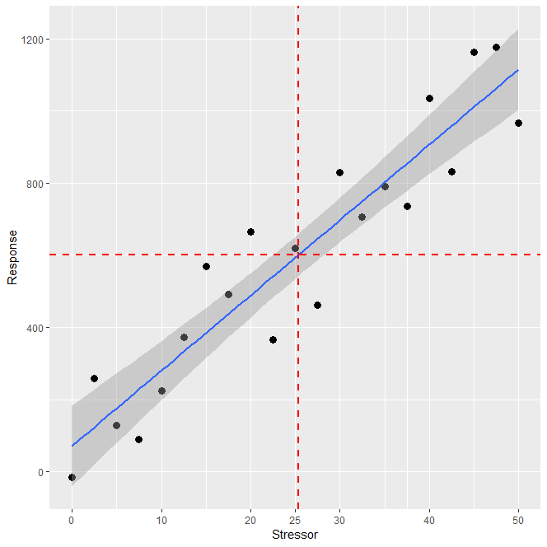

**Figure 1. Made up example of** **stressor-response relationship and associated regression model. The blue line is a regression fitted to the observations (black points). The red dashed lines indicates the stressor target value to achieve a nominated response threshold.**

The uncertainty associated with the stressor-response relationship means that when reading off the target to fit a nominated response threshold there will be uncertainty. For example, in Figure 2 the (purely nominal) response threshold is 600 and the stressor target is estimated to be 25. However, because the stressor-response relationship is based on a line of best fit, the stressor target indicates the mean response to that level of the stressor. Therefore, our expectation should be that if many locations have a stressor level of 25, only 50 per cent will have a response below 600. In addition, at a stressor level of 28, 50 per cent of locations can be expected to exceed the response threshold.

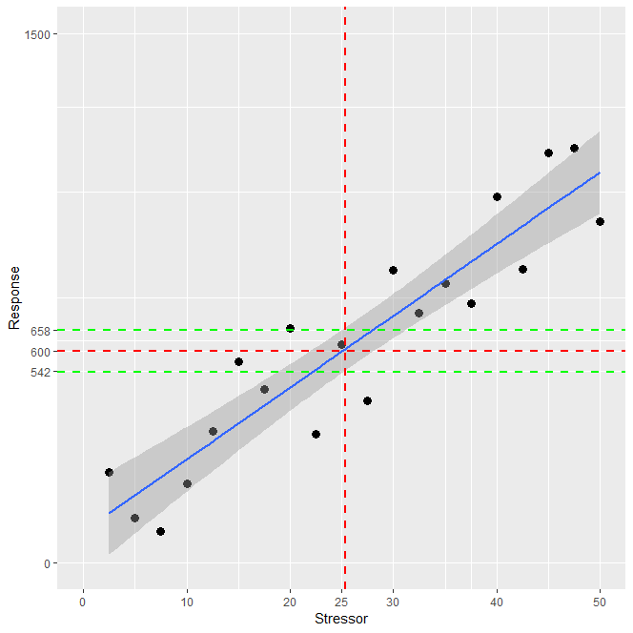

**Figure 2. Estimate of the level of the stressor associated with a response threshold of 600 (in this case a stressor value of 25). The green lines indicate the 95 per cent confidence interval for the mean value of the response associated with a stressor of 25.**

When concentration targets are defined, the details of these uncertainties are often not made clear. A subjective decision is made by the developer of the target that the uncertainty is acceptable because the amount by which the 50 per cent of locations that exceed the acceptable response is “small”. However, some stressor – response relationships are less certain than others due to unexplained variation. To illustrate this, another made up example of a more uncertain stressor - response relationship is shown in Figure 3. In this case, the response threshold is the same as before (600) and the estimated target is the same as before (25). Half of the cases with a stressor level equal to 25 will have a response greater than the response threshold (as before) but those responses can be expected to deviate to a greater extent from the threshold of 600 (as shown by the green lines in Figure 3).

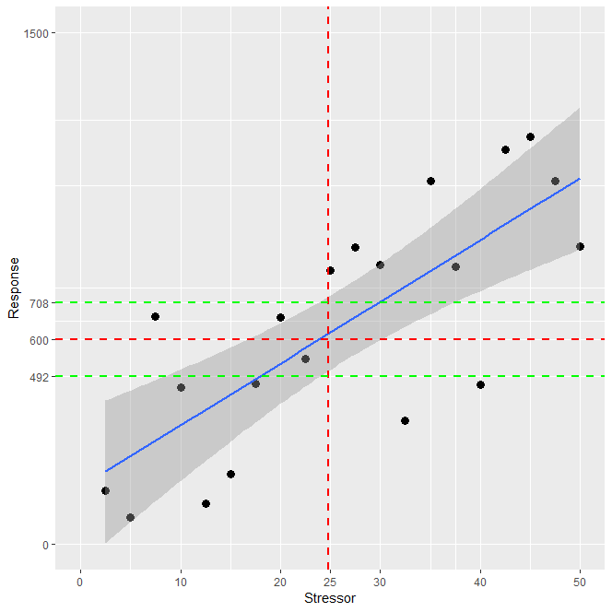

**Figure 3. Estimate of the level of the stressor associated with a response threshold of 600 from a stressor-response relationship that is more uncertain than the example shown in Figure 2. The green lines indicate the 95% confidence interval for the mean value of the response associated with a stressor of 25.**

Stressor response relationships are generally very uncertain for periphyton (and other biological responses) because the responses are complex and important controlling variables are often unknown and unmeasured. When Snelder *et al* (2019) derived TN and DRP targets for periphyton, they developed the idea of spatial exceedance criteria as a way of being transparent about, and allowing the user to make choices about, the uncertainty of the concentration targets.

Although the mechanics were slightly more complicated in the Snelder *et al* (2019) study, the different spatial exceedance criteria can be thought of as translations of the regression line upwards so that the proportion of sites that exceed the biomass threshold is decreased (Figure 4). In the made up example shown in Figure 4 the solid red line is the translation of the original regression line upwards so that a smaller proportion of the sites are above the line (eg, 10 per cent or 20 per cent instead of 50 per cent). The new criterion corresponding to a response threshold of 600 and a smaller spatial exceedance criterion is read off from the translated line. This stressor target (15) is obviously more conservative than when the spatial exceedance criteria are not applied. Note that using the original regression line to define the target is effectively employing a 50 per cent spatial exceedance criterion.

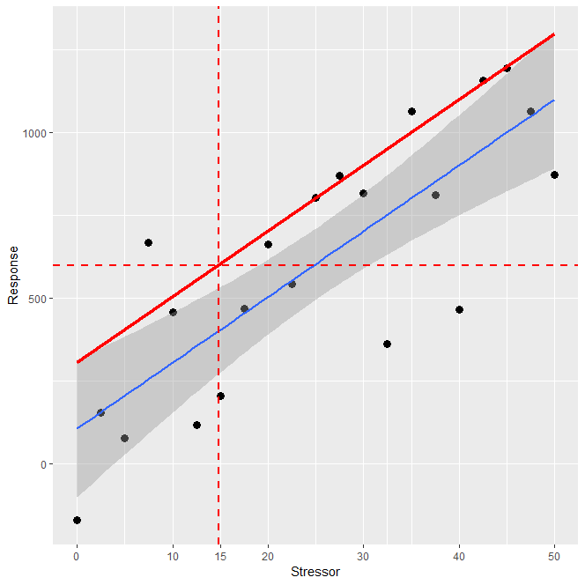

**Figure 4. Estimate of the level of the stressor associated with a response threshold of 600 when a spatial exceedance criterion is applied to the stressor-response relationship.**

Snelder *et al* (2019) proposed spatial exceedance criteria as a way of transparently managing the risk of not keeping the response to at or below the threshold when the underlying stressor-response relationship was uncertain. It is noted that even with a spatial exceedance of 10 per cent there is some risk (ie, 10 per cent) that the response at some sites will exceed the threshold. Reducing this risk further would mean increasing the stringency of the target – which obviously has costs that ideally would be weighed against the consequences of some localised exceedances.

A key point is that acceptance of the risk that a target will not always achieve the acceptable level of response (the threshold) is common to most environmental targets but it is often unstated. For example, the toxicity based attribute states in the NPS-FM are based on similar types of statistical analysis. For toxicity, the attribute state is set to protect a proportion of the test species (ie, the threshold), but there is (unstated) uncertainty in the target and the actual proportion of species being protected may be less than the nominated threshold. Another example of risks of non-achievement of attribute states is the TN and TP for lakes. TN and TP are stressors and targets for these are intended to achieve associated in-lake chlorophyll biomass (the response). However, the TN and TP concentration targets are uncertain and, for at least some lakes, the in-lake chlorophyll biomass threshold will exceed the designated attribute states when either TN and TP do not exceed the associated target.

In conclusion, the Snelder *et al* (2019) nutrient targets are intended to be guidance/starting points for defining nutrient concentrations for managing to the periphyton attribute states. They are not inconsistent with other water quality targets because all targets should be regarded as uncertain. However, the Snelder *et al* (2019) targets were not intended to be used as attributes for setting objectives; they are targets for biological stressors intended for use in setting risk-based limits to resource use, and are uncertain. If an individual site exceeds the Snelder *et al* (2019) targets, the correct interpretation is that it has an “unacceptably high risk” of failing to achieve the nominated biological threshold (or objective). Exceeding the target, however, does not mean that the site is exceeding the biological threshold, because the nutrient targets are uncertain and only monitoring of periphyton can confirm the actual biomass. However, in the absence of biological information, the manager would interpret failing the target as evidence that there is an issue and may decide to act accordingly.

**TN and DRP concentration targets for a 30% spatial exceedance criteria**

The TN and DRP concentration targets to achieve a periphyton biomass thresholds of 50 mg chlorophyll m-2, 120 mg chlorophyll m-2 and 200 mg chlorophyll m-2 for 21 River Environment Classification (REC) classes and corresponding to a 30 per cent spatial exceedance criteria were derived using the methodology described by Snelder (2018) and Snelder *et al* (2019). The results obtained for the 10 per cent, 20 per cent and 50 per cent spatial exceedance criteria are consistent with those of Snelder, (2018) and Snelder *et al* (2019). Note that there are small (insignificant) differences between the results presented here are the earlier studies due to stochastic variation produced by the Monte Carlo analysis. As expected, for a given REC class, the nutrient concentration targets for a 30 per cent spatial exceedance criterion was always between that for the 20 per cent and 50 per cent spatial exceedance criteria.

The targets to achieve periphyton biomass threshold of 50 mg chlorophyll m-2, 120 mg chlorophyll m-2 and 200 mg chlorophyll m-2 for 10 per cent, 20 per cent and 30 per cent spatial exceedance criteria are provided for TN in Table 1 and for DRP in Table 2.

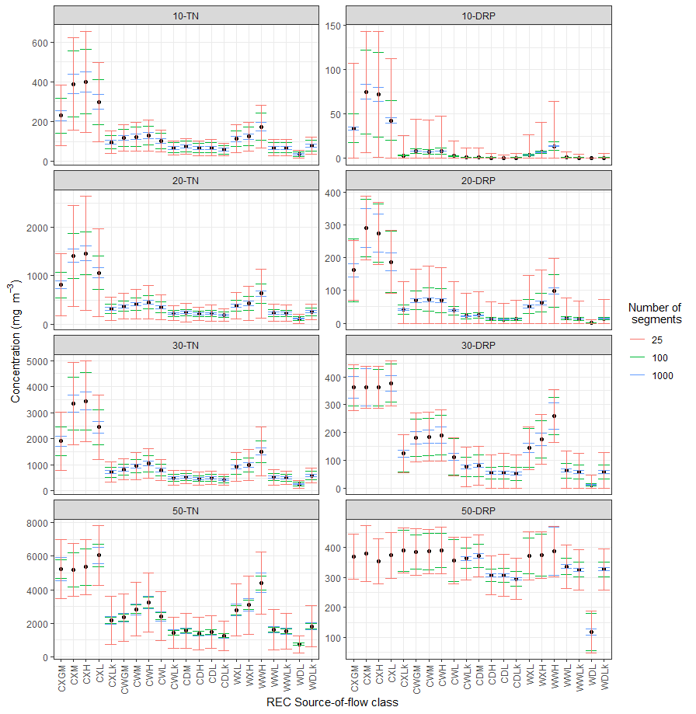

**Figure 5. The derived TN and DRP targets to achieve the periphyton biomass threshold of 200 mg chlorophyll m-2 and their uncertainties (error bars) for domains of 25, 100 and 1000 sites for four spatial exceedance criteria (10%, 20%, 30% and 50%). Note change in Y-axis scales.**

**Table 1. TN concentration targets (mg m-3) to achieve the thresholds of 50, 120 and 200 mg chlorophyll m-2 for spatial exceedance criteria of 10%, 20% and 30%.**

|  |  |  |  |  |  |  |  |  |  |
| --- | --- | --- | --- | --- | --- | --- | --- | --- | --- |
| **REC class** | **10% Spatial exceedance** | | | **20% Spatial exceedance** | | | **30% Spatial exceedance** | | |
| **T50** | **T120** | **T200** | **T50** | **T120** | **T200** | **T50** | **T120** | **T200** |
| **CXGM** | 17 | 95 | 230 | 66 | 331 | 811 | 165 | 804 | 1905 |
| **CXM** | 27 | 161 | 390 | 116 | 584 | 1409 | 295 | 1424 | 3349 |
| **CXH** | 29 | 166 | 401 | 119 | 612 | 1465 | 302 | 1478 | 3444 |
| **CXL** | 21 | 123 | 299 | 87 | 434 | 1063 | 210 | 1037 | 2441 |
| **CXLk** | 7 | 39 | 96 | 27 | 132 | 318 | 62 | 301 | 725 |
| **CWGM** | 9 | 48 | 118 | 31 | 154 | 371 | 70 | 344 | 822 |
| **CWM** | 9 | 50 | 124 | 34 | 175 | 411 | 82 | 398 | 952 |
| **CWH** | 9 | 53 | 129 | 37 | 187 | 450 | 91 | 442 | 1053 |
| **CWL** | 8 | 42 | 102 | 29 | 144 | 349 | 69 | 338 | 799 |
| **CWLk** | 5 | 28 | 68 | 18 | 91 | 220 | 43 | 208 | 501 |
| **CDM** | 6 | 31 | 75 | 19 | 99 | 240 | 45 | 221 | 531 |
| **CDH** | 5 | 27 | 66 | 18 | 88 | 213 | 40 | 199 | 473 |
| **CDL** | 5 | 28 | 68 | 18 | 92 | 222 | 43 | 209 | 497 |
| **CDLk** | 5 | 24 | 59 | 16 | 80 | 190 | 36 | 176 | 424 |
| **WXL** | 8 | 47 | 113 | 32 | 161 | 384 | 78 | 375 | 922 |
| **WXH** | 9 | 50 | 124 | 35 | 178 | 429 | 86 | 418 | 999 |
| **WWH** | 12 | 71 | 173 | 51 | 258 | 630 | 129 | 624 | 1512 |
| **WWL** | 5 | 28 | 69 | 19 | 94 | 228 | 45 | 217 | 525 |
| **WWLk** | 5 | 28 | 69 | 19 | 93 | 225 | 43 | 210 | 504 |
| **WDL** | 3 | 14 | 35 | 10 | 48 | 114 | 22 | 108 | 257 |
| **WDLk** | 6 | 32 | 78 | 21 | 108 | 256 | 50 | 248 | 591 |

**Table 2. DRP concentration targets (mg m-3) to achieve the thresholds of 50, 120 and 200 mg chlorophyll m-2 for spatial exceedance criteria of 10%, 20% and 30%.**

|  |  |  |  |  |  |  |  |  |  |
| --- | --- | --- | --- | --- | --- | --- | --- | --- | --- |
| **REC class** | **10% Spatial exceedance** | | | **20% Spatial exceedance** | | | **30% Spatial exceedance** | | |
| **T50** | **T120** | **T200** | **T50** | **T120** | **T200** | **T50** | **T120** | **T200** |
| **CXGM** | 0.2 | 5.3 | 33.8 | 1.5 | 56.3 | 161.4 | 14.9 | 158.8 | 362 |
| **CXM** | 0.4 | 19.3 | 75.1 | 8.1 | 115 | 289.9 | 42 | 298.6 | 362 |
| **CXH** | 0.4 | 16.5 | 71.9 | 6.9 | 105.7 | 274 | 39.5 | 282.4 | 361.3 |
| **CXL** | 0.2 | 7.1 | 42.7 | 2.5 | 68.6 | 186.4 | 18.7 | 182.4 | 377 |
| **CXLk** | 0.1 | 0.4 | 3.4 | 0.2 | 5.5 | 41.4 | 0.9 | 35.3 | 123.6 |
| **CWGM** | 0.1 | 0.7 | 8.1 | 0.3 | 14.5 | 69.2 | 1.8 | 57.2 | 181.2 |
| **CWM** | 0.2 | 0.8 | 7.5 | 0.3 | 15.1 | 71.5 | 2.3 | 61.8 | 184.8 |
| **CWH** | 0.2 | 0.8 | 8.4 | 0.3 | 15.3 | 69.1 | 2.6 | 62.5 | 190.2 |
| **CWL** | 0.1 | 0.4 | 2.8 | 0.2 | 5.6 | 38.4 | 0.9 | 32.7 | 112.2 |
| **CWLk** | 0.1 | 0.2 | 1.1 | 0.2 | 1.9 | 21.5 | 0.5 | 16.3 | 76.3 |
| **CDM** | 0.2 | 0.2 | 1.4 | 0.2 | 2.3 | 23.8 | 0.5 | 18.1 | 81.1 |
| **CDH** | 0.1 | 0.2 | 0.7 | 0.2 | 1.2 | 12.8 | 0.3 | 9.7 | 54.1 |
| **CDL** | 0.2 | 0.2 | 0.6 | 0.2 | 1.1 | 11.8 | 0.3 | 9.7 | 55 |
| **CDLk** | 0.2 | 0.2 | 0.7 | 0.2 | 1 | 12.5 | 0.3 | 8.6 | 51.8 |
| **WXL** | 0.2 | 0.4 | 4.1 | 0.2 | 8.1 | 50.6 | 1.5 | 43.5 | 143.5 |
| **WXH** | 0.2 | 0.7 | 7 | 0.3 | 14 | 62.6 | 2.3 | 57.2 | 174.9 |
| **WWH** | 0.2 | 1.6 | 13.9 | 0.6 | 26.7 | 97.6 | 5.5 | 91.9 | 259 |
| **WWL** | 0.2 | 0.2 | 0.9 | 0.2 | 1.9 | 15.3 | 0.4 | 12.3 | 62.1 |
| **WWLk** | 0.1 | 0.2 | 0.7 | 0.2 | 1.4 | 13.3 | 0.3 | 11.1 | 57.7 |
| **WDL** | 0.1 | 0.1 | 0.2 | 0.1 | 0.2 | 1.4 | 0.2 | 1.3 | 11.2 |
| **WDLk** | 0.2 | 0.2 | 0.8 | 0.2 | 1.3 | 14 | 0.3 | 11 | 57.7 |

### Tests using independent data

Tests of the derived TN and DRP concentration targets were performed using observations of periphyton biomass and nutrient concentrations at 173 independent sites in six regions; Northland, Bay of Plenty, Manawatu-Wanganui, Wellington, Canterbury and Southland. The testing methodology is as described by Snelder *et al* (2019). The tests presented here were consistent with those of Snelder *et al* (2019) (Figure 6, Table 3).

The tests on independent data indicate that for DRP and the 10 per cent, 20 per cent and 30 per cent spatial exceedance criterion, the nutrient concentration targets are consistent with observations (considering the uncertainties associated with both the observations and concentration targets). The tests indicate that the concentration targets are too permissive for DRP for 50 per cent spatial exceedance (ie, the concentration targets are too low) and are consistently too conservative for TN (ie, the concentration targets are too high).

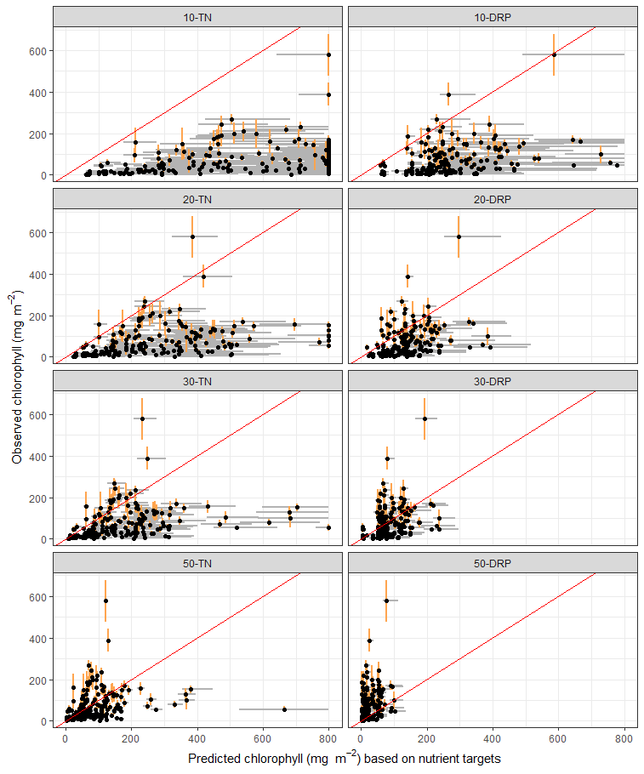

**Figure 6. The observed and predicted values of the periphyton biomass at the 173 test data sites where predicted values are derived from the nutrient concentration targets for spatial exceedance criteria of 10, 20, 30 and 50%. Panel labels indicate the spatial exceedance criteria and the target concentration targets (TN or DRP). The red diagonal (one to one) line represents perfect agreement between the predictions and observations. The points lying below the red line indicate sites for which the observed biomass was less than that predicted by the targets and vice versa. The grey bars indicate the standard errors for the 92nd percentile biomass predicted from the nutrient targets. The tan bars indicate the standard errors for the estimate of 92nd percentile biomass made from the observations. Biomass estimates and their uncertainties that exceeded 800 mg m-2 could not be estimated and have been plotted as 800 mg m-2.**

**Table 3. Performance of the concentration targets based on independent test data.**

|  |  |  |  |  |
| --- | --- | --- | --- | --- |
| **Variable** | **Spatial exceedance** | **Mean proportion exceeding (%)** | **Standard error mean proportion exceeding (%)** | **95% confidence intervals (%)** |
| **TN** | 10 | 2.3 | 1 | 0.3 - 4.3 |
| 20 | 9.2 | 1.9 | 5.5 - 12.9 |
| 30 | 19.1 | 2.5 | 14.2 - 24 |
| 50 | 38.6 | 3.4 | 31.9 - 45.3 |
| **DRP** | 10 | 8.1 | 1.8 | 4.6 - 11.6 |
| 20 | 20.1 | 2.5 | 15.2 - 25 |
| 30 | 32.8 | 3.1 | 26.7 - 38.9 |
| 50 | 59.2 | 3.5 | 52.3 - 66.1 |

### Recalibrated concentration targets

Snelder *et al* (2019) suggested that testing data could be used to re-calibrate the TN and DRP concentration targets given the test indicated that they were too conservative and too permissive across all REC classes, respectively. Re-calibration involves adjusting the concentration targets so that the proportion of test sites exceeding the biomass threshold matched the spatial exceedance criteria. It was proposed re-calibration is justifiable because the test dataset (of 173 regional council sites) are generally on smaller rivers than the NRWQN sites.

To recalibrate the concentration targets, each row of the original concentration targets (ie, each REC Source of Flow class shown in Table 1) is interpolated from the observed (ie, test results in Table 3) to obtain the TN and DRP concentrations at which the proportion of sites exceeding the biomass threshold is consistent with the designated spatial exceedance (ie, 10, 20, 30 and 50). The results of the re-calibrations are show in Tables 4 and 5. Note that re‑calibrated TN concentration targets were used in the analysis of the impact of existing NPS-FM periphyton attribute bottom-lines and dissolved inorganic nitrogen bottom-lines proposed as part of the Essential Freshwater policy package (Ministry for the Environment, 2019).

**Table 4. Recalibrated TN concentration targets (mg m-3) to achieve the chlorophyll thresholds of 50, 120 and 200 mg m-2 for spatial exceedance criteria of 10 per cent, 20 per cent and 30 per cent.**

|  |  |  |  |  |  |  |  |  |  |
| --- | --- | --- | --- | --- | --- | --- | --- | --- | --- |
| **REC class** | **10% Spatial exceedance** | | | **20% Spatial exceedance** | | | **30% Spatial exceedance** | | |
| **T50** | **T120** | **T200** | **T50** | **T120** | **T200** | **T50** | **T120** | **T200** |
| **CXGM** | 74 | 369 | 899 | 183 | 883 | 2059 | 555 | 2519 | 5233 |
| **CXM** | 130 | 651 | 1566 | 328 | 1554 | 3434 | 1019 | 4252 | 5188 |
| **CXH** | 134 | 682 | 1625 | 336 | 1609 | 3532 | 1044 | 4324 | 5346 |
| **CXL** | 96 | 482 | 1174 | 233 | 1134 | 2607 | 710 | 3144 | 6040 |
| **CXLk** | 30 | 146 | 351 | 68 | 330 | 792 | 195 | 918 | 2171 |
| **CWGM** | 34 | 169 | 407 | 77 | 374 | 892 | 214 | 992 | 2337 |
| **CWM** | 38 | 193 | 455 | 90 | 437 | 1039 | 262 | 1242 | 2833 |
| **CWH** | 41 | 208 | 499 | 101 | 488 | 1154 | 311 | 1428 | 3243 |
| **CWL** | 32 | 159 | 385 | 76 | 370 | 874 | 223 | 1045 | 2426 |
| **CWLk** | 20 | 100 | 243 | 47 | 227 | 544 | 131 | 617 | 1450 |
| **CDM** | 22 | 109 | 263 | 50 | 241 | 578 | 139 | 648 | 1551 |
| **CDH** | 19 | 97 | 234 | 44 | 217 | 516 | 124 | 589 | 1394 |
| **CDL** | 20 | 101 | 244 | 47 | 229 | 542 | 132 | 633 | 1474 |
| **CDLk** | 17 | 88 | 209 | 40 | 192 | 463 | 111 | 521 | 1257 |
| **WXL** | 36 | 179 | 427 | 87 | 414 | 1008 | 259 | 1211 | 2792 |
| **WXH** | 39 | 198 | 475 | 95 | 462 | 1096 | 287 | 1371 | 3082 |
| **WWH** | 57 | 288 | 701 | 144 | 690 | 1645 | 444 | 2064 | 4401 |
| **WWL** | 21 | 104 | 252 | 50 | 238 | 576 | 143 | 689 | 1636 |
| **WWLk** | 20 | 102 | 247 | 47 | 230 | 551 | 135 | 644 | 1525 |
| **WDL** | 11 | 53 | 125 | 24 | 117 | 279 | 68 | 317 | 751 |
| **WDLk** | 24 | 119 | 283 | 55 | 272 | 648 | 161 | 761 | 1822 |

**Table 5. Recalibrated DRP concentration targets (mg m-3) to achieve the chlorophyll thresholds of 50, 120 and 200 mg m-2 for spatial exceedance criteria of 10 per cent, 20 per cent and 30 per cent.**

|  |  |  |  |  |  |  |  |  |  |
| --- | --- | --- | --- | --- | --- | --- | --- | --- | --- |
| **REC class** | **10% Spatial exceedance** | | | **20% Spatial exceedance** | | | **30% Spatial exceedance** | | |
| **T50** | **T120** | **T200** | **T50** | **T120** | **T200** | **T50** | **T120** | **T200** |
| **CXGM** | 0.4 | 13.4 | 54.0 | 1.5 | 55.9 | 160.3 | 104.5 | 300.7 | 366.7 |
| **CXM** | 1.6 | 34.5 | 109.1 | 8.0 | 114.2 | 288.1 | 206.5 | 336.4 | 373.0 |
| **CXH** | 1.4 | 30.6 | 103.9 | 6.8 | 105.0 | 272.3 | 194.8 | 359.3 | 356.1 |
| **CXL** | 0.6 | 16.8 | 65.5 | 2.5 | 68.1 | 185.2 | 117.7 | 311.8 | 374.6 |
| **CXLk** | 0.1 | 1.2 | 9.4 | 0.2 | 5.5 | 41.1 | 21.1 | 169.9 | 298.6 |
| **CWGM** | 0.1 | 2.9 | 17.8 | 0.3 | 14.4 | 68.7 | 30.2 | 227.4 | 315.1 |
| **CWM** | 0.2 | 3.1 | 17.6 | 0.3 | 15.0 | 71.0 | 36.6 | 245.3 | 317.5 |
| **CWH** | 0.2 | 3.1 | 18.0 | 0.3 | 15.2 | 68.6 | 41.0 | 252.0 | 321.8 |
| **CWL** | 0.1 | 1.2 | 8.4 | 0.2 | 5.6 | 38.1 | 20.1 | 159.5 | 272.9 |
| **CWLk** | 0.1 | 0.5 | 4.3 | 0.2 | 1.9 | 21.3 | 9.3 | 104.5 | 265.6 |
| **CDM** | 0.2 | 0.5 | 4.9 | 0.2 | 2.3 | 23.6 | 10.1 | 108.2 | 272.5 |
| **CDH** | 0.1 | 0.4 | 2.6 | 0.2 | 1.2 | 12.7 | 5.5 | 76.0 | 221.3 |
| **CDL** | 0.2 | 0.3 | 2.4 | 0.2 | 1.1 | 11.7 | 6.0 | 76.7 | 220.9 |
| **CDLk** | 0.2 | 0.3 | 2.6 | 0.2 | 1.0 | 12.4 | 5.6 | 72.4 | 212.2 |
| **WXL** | 0.2 | 1.6 | 11.5 | 0.2 | 8.0 | 50.2 | 26.9 | 201.3 | 293.9 |
| **WXH** | 0.2 | 2.8 | 15.8 | 0.3 | 13.9 | 62.1 | 36.6 | 241.9 | 305.8 |
| **WWH** | 0.3 | 5.6 | 27.2 | 0.6 | 26.5 | 96.9 | 60.3 | 287.5 | 343.3 |
| **WWL** | 0.2 | 0.5 | 3.2 | 0.2 | 1.9 | 15.2 | 7.9 | 88.6 | 243.0 |
| **WWLk** | 0.1 | 0.4 | 2.7 | 0.2 | 1.4 | 13.2 | 6.9 | 83.0 | 234.3 |
| **WDL** | 0.1 | 0.1 | 0.4 | 0.1 | 0.2 | 1.4 | 1.1 | 22.9 | 81.5 |
| **WDLk** | 0.2 | 0.4 | 2.9 | 0.2 | 1.3 | 13.9 | 7.0 | 84.3 | 235.1 |

**References**

Ministry for the Environment, 2019. *Essential Freshwater: Impact of Existing Periphyton and Proposed Dissolved Inorganic Nitrogen Bottom-lines*. Ministry for the Environment & Statistics NZ, Wellington, New Zealand.

Snelder, T., 2018. *Nutrient Concentration Targets to Achieve Periphyton Biomass Objectives Incorporating Uncertainties*. GNS Science Report, Geological and Nuclear Sciences, Wellington, New Zealand.

Snelder, T.H., C. Moore, and C. Kilroy, 2019. Nutrient Concentration Targets to Achieve Periphyton Biomass Objectives Incorporating Uncertainties. *JAWRA Journal of the American Water Resources Association* 55:1443–1463.

# **Appendix 2: Differences in total nitrogen concentration targets for periphyton**

Memorandum

**To: Ministry for the Environment**

**From: Ton Snelder, LWP Ltd**

**Date: 8th May 2020**

**Subject: Differences in TN concentration targets for periphyton objectives defined by the 2018 and 2020 analyses**

In an email dated 17th April 2020, MfE officials asked why the recalibrated TN criteria derived by LWP (2020) differed to those used in work carried out to describe the impact of the existing periphyton and proposed DIN regulations (MFE, 2019). The targets used by MFE (2019) were a “recalibrated” version of the “original targets” provided by Snelder (2018), which were also published in Snelder *et al* (2019). This memo explains the reasons for the differences between the LWP (2020) values and those appearing in MFE (2019).

The reason for the differences between the two sets of nutrient targets is that the derivation of both sets of nutrient targets were based on a Monte Carlo statistical procedure. Monte Carlo analysis is a type of numerical analysis that relies on repeated random sampling of the data. Monte Carlo analysis is used when there is uncertainty associated with the input data that are used in the analysis, which then combine to cause uncertainty in the output. For example, when the 92nd percentile of periphyton biomass is calculated from monthly samples at an individual site from (say) 3 years of data, the value is an estimate and is uncertain. There were several other sources of uncertainty in the analyses and all were taken into account in the derivation of the nutrient targets (described by Snelder 2018 and Snelder *et al*, 2019). The Monte Carlo procedure provided a way of assessing the impact of the combined uncertainties on the uncertainty of the final output; the TN criteria.

The outcome of all analyses was a set of nutrient target concentrations plus their uncertainties expressed as standard errors (SE). A standard error can be understood to be the characteristic uncertainty of the derived nutrient concentration targets. More precisely, +/- the SE indicates the range over which we are 68 per cent certain that the “true” target concentration lies.

Each time a Monte Carlo analysis is repeated, slightly different results are obtained each time due to the random components of the analysis. There are two sources of variation in the derived nutrient concentration targets because there are Monte Carlo analyses involved in the derivation procedure and the recalibration procedure (ie, two sets of Monte Carlo analyses). Therefore, the target values produced in LWP (2020) are not exactly the targets used by MFE (2019) despite the same input data. However, the two sets of results are close and well within the uncertainties of the respective analyses.

To illustrate the closeness of the two sets of results, thresholds for the 10 per cent spatial exceedance are shown in the plots below. Figure 1 compares the 2018 and 2020 original (not recalibrated) TN targets. Figure 2 compares the recalibrated targets. The grey error bars shown in both figures indicate the standard errors for the targets. The red line indicates one to one (ie, perfect agreement).

Figure 1 indicates close agreement – note that it is difficult to see but there is not perfect agreement between the original 2018 and 2020 values. The second plot shows close agreement of the recalibrated values – but the disagreement is visible. However, note that for both sets of targets, the level of disagreement is small relative to the uncertainty of the targets (ie, the error bars showing the standard errors). Thus, although the target values differ in absolute terms, these differences are well within the characteristic uncertainties and therefore the two sets of targets are not significantly different.

A contribution to the divergence of the 2020 values from recalibrated 2018 values (reported in MFE 2019) is slight differences in the results of the testing. These differences arose due the use of Monte Carlo analysis as part of the testing procedure and can be seen by comparing the 2018 test results (see Table 1) with the 2020 test results (Table 2). The columns headed “Mean proportion exceeding (per cent)” are the key data that are used in the recalibration. Note two things here. First, the test results do not perfectly agree for reasons explained above. Second, the 2020 targets introduced a new exceedance criterion (30) which provided a new data point in the recalibration. This influences the outcome to a degree due to differences in the “distance” over which interpolation occurs in the recalibration process.

The conclusion is that the two sets of targets, ie, the LWP (2020) targets and those used in MFE (2019) are not significantly different. The deviations between the two sets of targets are well within the uncertainties of the analyses. It is noted the targets were reported in LWP (2020) to the nearest one mg m-3 (eg, 3349 mg m-3). This level of precision is not justified by the uncertainty of the targets. In contrast, MFE (2019) reported targets to the equivalent of the nearest hundred mg m-3 (eg, 3300 mg m-3). Much of the confusion could have been avoided if the targets had been reported in LWP (2020) with a more appropriate level of precision.

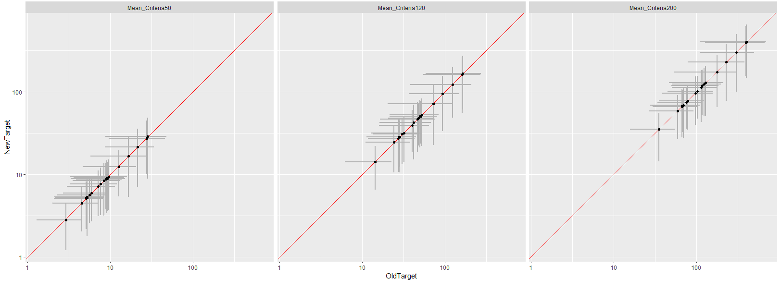

**FIGURE 1. COMPARISON OF 2018 AND 2020 ORIGINAL (NOT RECALIBRATED) TN CONCENTRATION TARGETS FOR THE 10 per cent SPATIAL EXCEEDANCE CRITERIA.**

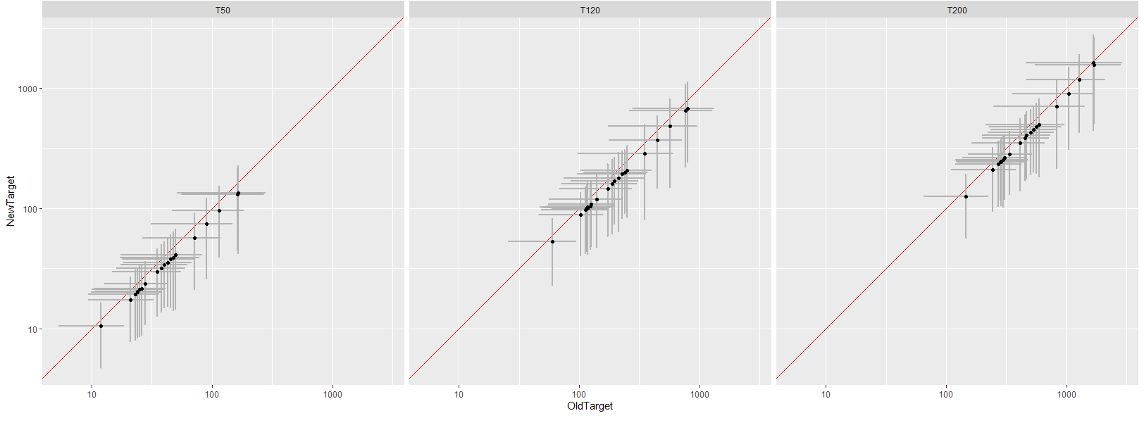

**FIGURE 2. COMPARISON OF 2018 AND 2020 RECALIBRATED TN CONCENTRATION TARGETS FOR THE 10 per cent SPATIAL EXCEEDANCE CRITERIA. NOTE THE RECALIBRATED 2018 TARGETS WERE REPORTED IN MFE (2019).**

**Table 5. Test results for the 2018 analysis**

|  |  |  |  |  |
| --- | --- | --- | --- | --- |
| **Variable** | **Spatial exceedance** | **Mean proportion exceeding (%)** | **Standard error mean proportion exceeding (%)** | **95% confidence intervals (%)** |
| **TN** | 10 | 2.3 | 1.0 | 0.3 - 4.3 |
| 20 | 8.8 | 1.8 | 5.3 - 12.3 |
| 50 | 42.2 | 3.2 | 35.0 – 48.5 |
| **DRP** | 10 | 7.8 | 1.8 | 4.3 - 11.3 |
| 20 | 19.9 | 2.5 | 15.0 - 24.8 |
| 50 | 58.7 | 3.5 | 51.8 - 65.6 |

**Table 6. Test results for the 2020 analysis.**

|  |  |  |  |  |
| --- | --- | --- | --- | --- |
| **Variable** | **Spatial exceedance** | **Mean proportion exceeding (%)** | **Standard error mean proportion exceeding (%)** | **95% confidence intervals (%)** |
| **TN** | 10 | 2.3 | 1 | 0.3 - 4.3 |
| 20 | 9.2 | 1.9 | 5.5 - 12.9 |
| 30 | 19.1 | 2.5 | 14.2 - 24 |
| 50 | 38.6 | 3.4 | 31.9 - 45.3 |
| **DRP** | 10 | 8.1 | 1.8 | 4.6 - 11.6 |
| 20 | 20.1 | 2.5 | 15.2 - 25 |
| 30 | 32.8 | 3.1 | 26.7 - 38.9 |
| 50 | 59.2 | 3.5 | 52.3 - 66.1 |

**References**

LWP, 2020. Definition of nutrient concentration targets for periphyton objectives including 30 per cent spatial exceedance criteria. Memo to MFE. 4th March 2020.

MFE, 2019. *Essential Freshwater: Impact of Existing Periphyton and Proposed Dissolved Inorganic Nitrogen Bottom-lines*. Ministry for the Environment & Statistics NZ, Wellington, New Zealand.

Snelder, T., 2018. *Nutrient Concentration Targets to Achieve Periphyton Biomass Objectives Incorporating Uncertainties*. GNS Science Report, Geological and Nuclear Sciences, Wellington, New Zealand.

Snelder, T.H., C. Moore, and C. Kilroy, 2019. Nutrient Concentration Targets to Achieve Periphyton Biomass Objectives Incorporating Uncertainties. *JAWRA Journal of the American Water Resources Association* 55:1443–1463.

# Appendix 3: Model results by scenario and region

Table A3-1: Phosphorus load reduction target for different regions and proportion to the current load, including different scenarios with three periphyton spatial exceedance criteria (10 per cent, 20 per cent and 30 per cent).

|  |  |  |  |  |  |  |  |
| --- | --- | --- | --- | --- | --- | --- | --- |
| Scenario | Current load | 2017 NPS-FM | 2017 NPS-FM | 2017 NPS-FM | DRP18 | DRP18 | DRP18 |
| Periphyton criteria | **–** | **10%** | **20%** | **30%** | **10%** | **20%** | **30%** |
|  | **t/yr** | **t/yr (%)** | **t/yr (%)** | **t/yr (%)** | **t/yr (%)** | **t/yr (%)** | **t/yr (%)** |
| **Auckland** | 565 | 73 (13) | 26 (5) | 6 (1) | 83 (15) | 36 (6) | 22 (4) |
| **Bay of Plenty** | 2,990 | 406 (14) | 38 (1) | 0 (0) | 438 (15) | 124 (4) | 122 (4) |
| **Canterbury** | 3,262 | 108 (3) | 15 (0) | 3 (0) | 112 (3) | 22 (1) | 14 (0) |
| **Gisborne** | 10,233 | 459 (4) | 19 (0) | 9 (0) | 461 (5) | 21 (0) | 11 (0) |
| **Hawke's Bay** | 2,956 | 655 (22) | 79 (3) | 2 (0) | 656 (22) | 104 (4) | 81 (3) |
| **Manawatu-Wanganui** | 3,640 | 1,400 (38) | 92 (3) | 17 (0) | 1,403 (39) | 372 (10) | 364 (10) |
| **Marlborough** | 616 | 146 (24) | 1 (0) | 0 (0) | 146 (24) | 21 (3) | 21 (3) |
| **Nelson** | 22 | 5 (23) | - (1) | 0 (0) | 5 (23) | 1 (2) | - (2) |
| **Northland** | 1,865 | 287 (15) | 36 (2) | 3 (0) | 407 (22) | 156 (8) | 138 (7) |
| **Otago** | 3,744 | 586 (16) | 31 (1) | 2 (0) | 592 (16) | 39 (1) | 19 (1) |
| **Southland** | 4,106 | 370 (9) | 50 (1) | 2 (0) | 372 (9) | 60 (1) | 27 (1) |
| **Taranaki** | 1,155 | 387 (34) | 18 (2) | 1 (0) | 394 (34) | 51 (4) | 45 (4) |
| **Tasman** | 603 | 30 (5) | - (0) | - (0) | 35 (6) | 5 (1) | 5 (1) |
| **Waikato** | 2,569 | 510 (20) | 70 (3) | 52 (2) | 767 (30) | 367 (14) | 358 (14) |
| **Wellington** | 1,060 | 344 (32) | 14 (1) | 3 (0) | 344 (32) | 36 (3) | 27 (3) |
| **West Coast** | 15,579 | 13 (0) | - (0) | - (0) | 13 (0) | - (0) | - (0) |
| **New Zealand** | 54,964 | 5,779 (11) | 488 (1) | 101 (0) | 6,228 (11) | 1,414 (3) | 1,254 (2) |

Table A3-2: Nitrogen load reduction targets for different regions and proportion to the current load, including different scenarios with three periphyton spatial exceedance criteria (10 per cent, 20 per cent and 30 per cent).

|  |  |  |  |  |  |  |  |  |  |  |
| --- | --- | --- | --- | --- | --- | --- | --- | --- | --- | --- |
| **Scenario** | **Current load** | **2017 NPS-FM** | **2017 NPS-FM** | **2017 NPS-FM** | **DIN1** | **DIN1** | **DIN1** | **NTox24** | **NTox24** | **NTox24** |
| **Periphyton criteria** | - | 10% | 20% | 30% | 10% | 20% | 30% | 10% | 20% | 30% |
|  | t/yr | t/yr (%) | t/yr (%) | t/yr (%) | t/yr (%) | t/yr (%) | t/yr (%) | t/yr (%) | t/yr (%) | t/yr (%) |
| Auckland | 4,460 | 389 (9) | 111 (2) | 21 (0) | 447 (10) | 169 (4) | 86 (2) | 390 (9) | 112 (3) | 22 (0) |
| Bay of Plenty | 13,057 | 1,021 (8) | 155 (1) | 20 (0) | 1,038 (8) | 300 (2) | 272 (2) | 1,021 (8) | 155 (1) | 20 (0) |
| Canterbury | 33,355 | 10,170 (30) | 7,610 (23) | 5,397 (16) | 13,140 (39) | 10,690 (32) | 9,358 (28) | 11,231 (34) | 8,671 (26) | 6,458 (19) |
| Gisborne | 4,482 | 596 (13) | 9 (0) | 2 (0) | 596 (13) | 9 (0) | 2 (0) | 596 (13) | 9 (0) | 2 (0) |
| Hawke’s Bay | 12,672 | 2,599 (21) | 891 (7) | 320 (3) | 2,609 (21) | 1,008 (8) | 928 (7) | 2,599 (21) | 891 (7) | 344 (3) |
| Manawatu-Wanganui | 21,261 | 5,980 (28) | 918 (4) | 379 (2) | 5,984 (28) | 1,147 (5) | 1,061 (5) | 5,980 (28) | 918 (4) | 379 (2) |
| Marlborough | 2,638 | 88 (3) | 4 (0) | 1 (0) | 92 (3) | 15 (1) | 12 (0) | 88 (3) | 4 (0) | 1 (0) |
| Nelson | 139 | 9 (7) | - (0) | - (0) | 9 (7) | - (0) | - (0) | 9 (7) | - (0) | - (0) |
| Northland | 14,365 | 1,186 (8) | 66 (0) | 24 (0) | 1,244 (9) | 124 (1) | 82 (1) | 1,187 (8) | 67 (0) | 25 (0) |
| Otago | 17,572 | 2,861 (16) | 544 (3) | 122 (1) | 2,958 (17) | 680 (4) | 317 (2) | 2,895 (16) | 577 (3) | 156 (1) |
| Southland | 26,690 | 7,816 (29) | 3,677 (14) | 862 (3) | 8,376 (31) | 4,282 (16) | 2,321 (9) | 7,843 (29) | 3,704 (14) | 1,006 (4) |
| Taranaki | 14,484 | 4,854 (34) | 1,556 (11) | 127 (1) | 4,934 (34) | 1,696 (12) | 995 (7) | 4,854 (34) | 1,556 (11) | 127 (1) |
| Tasman | 3,352 | 46 (1) | 3 (0) | - (0) | 52 (2) | 9 (0) | 7 (0) | 46 (1) | 3 (0) | - (0) |
| Waikato | 38,377 | 5,229 (14) | 1,231 (3) | 782 (2) | 7,743 (20) | 3,808 (10) | 3,373 (9) | 5,271 (14) | 1,294 (3) | 845 (2) |
| Wellington | 6,918 | 1,184 (17) | 158 (2) | 97 (1) | 1,184 (17) | 172 (2) | 127 (2) | 1,184 (17) | 158 (2) | 97 (1) |
| West Coast | 21,875 | 80 (0) | 19 (0) | 18 (0) | 83 (0) | 22 (0) | 21 (0) | 80 (0) | 19 (0) | 18 (0) |
| New Zealand | 235,698 | 44,106 (19) | 16,951 (7) | 8,171 (3) | 50,488 (21) | 24,131 (10) | 18,961 (8) | 45,272 (19) | 18,138 (8) | 9,500 (4) |

1. For example, a 10 per cent spatial exceedance means there is a 10 per cent chance that, at a given site and at the target nutrient concentration, the periphyton bottom-line will not be met. A risk-based approach is necessary due to variation between locations in flow regimes, temperature and stream shading (amongst other factors). Periphyton is more likely to grow in stony or gravelly rivers and is less likely to grow in muddy or sandy rivers. [↑](#footnote-ref-2)
2. Human health effects from nitrates in drinking water are addressed in the Guidelines for Drinking-water Quality Management for New Zealand: [www.health.govt.nz/publication/guidelines-drinking-water-quality-management-new-zealand](http://www.health.govt.nz/publication/guidelines-drinking-water-quality-management-new-zealand) [↑](#footnote-ref-3)
3. Previous studies considered the idea that in locations where current loads were less than the proposed threshold, there was potential to increase loads up to the threshold (headroom). This would not be consistent with the maintain provision in the *Action for healthy waterways* proposals. [↑](#footnote-ref-4)
4. For nitrogen (N), this is relevant to all segments even under the existing NPS-FM, because nitrate toxicity requirements apply to all segments. For phosphorus (P), we assumed that no increases were permitted for all segments, even if they do not support periphyton, because P generally varies with N. This provides a conservative (larger) estimate of the required reductions. Also, we required strict maintenance of concentration values, rather than maintaining concentrations in a band, based on proposed updates to the NPS-FM. [↑](#footnote-ref-5)