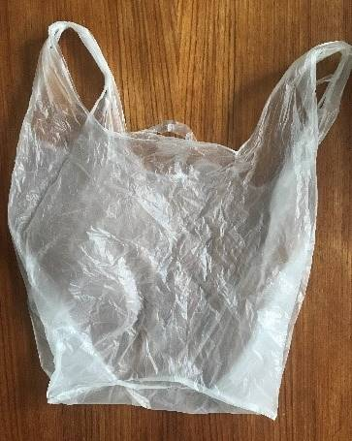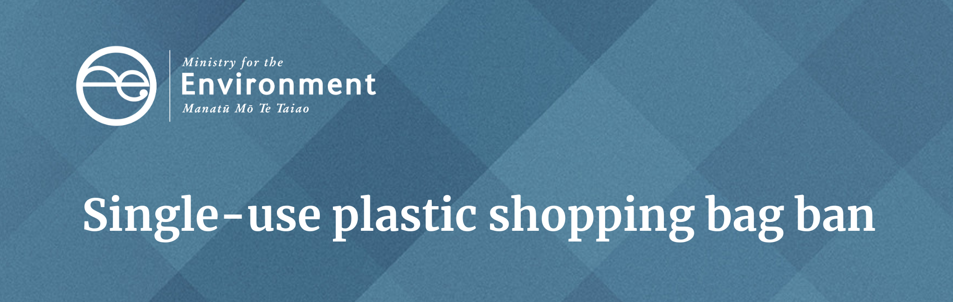Facts for businesses
This factsheet has information for businesses on the single-use plastic shopping bags ban which takes effect in New Zealand on 1 July 2019.

What is happening?
The Waste Minimisation (Plastic Shopping Bags) Regulations 2018 come into force on 1 July 2019. From this date retailers can no longer sell or distribute single-use plastic shopping bags.

What about the six-month, phase-out period?
The regulations were approved and announced in December 2018. This has given businesses a six-month period, until 1 July, to move away from plastic bags.
From 1 July, businesses cannot sell or provide single-use plastic shopping bags to customers for carrying or distributing their sold goods.

Who is affected?
All retailers: The regulations apply to all businesses in New Zealand who sell goods. This includes sales directly to consumers, business-to-business transactions and online sales.
The regulations apply to small produce markets and retail stores through to large department stores and supermarkets. They apply to both profit and not-for-profit organisations.

Which bags are banned?
The regulations apply to plastic shopping bags which meet all of the following criteria:
- made of any type of plastic less than 70 microns in thickness. This includes plastics made from bio-based materials such as starch and plastics designed to be degradable, biodegradable or oxo-degradable.
- with carry handles
- new or unused.

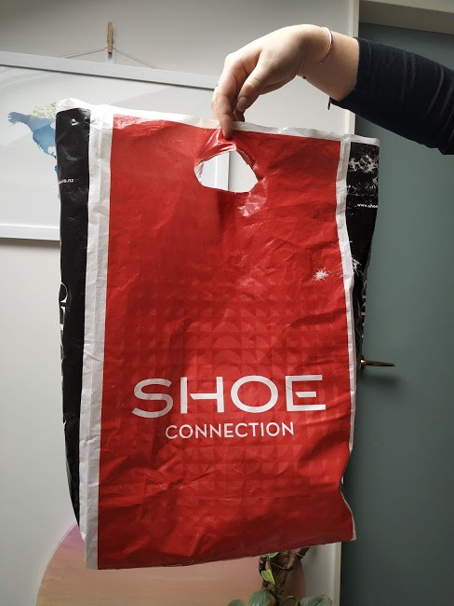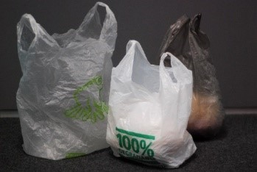
BANNED: Bags with handles made of any type of plastic (including bio-sourced plastic) under 70 microns in thickness. This includes degradable, oxo-degradable, and compostable bags.

Which bags are not covered by the ban?
- Bags without handles including lightweight barrier bags (eg, bags without handles used for containing meat and/or produce)
- Bin liners/rubbish bags
- Bags for pet waste or nappies
- Bags that are an essential part of a product’s packaging (eg, bread bags and pouches for cooked chicken)
- Bags that don’t contain plastic including bio-sourced plastics (eg, cotton, jute, hemp, paper and flax)
- Long-life, multi-use bags made from synthetic fabric (eg, nylon and polyester) between 45 and 70 microns in thickness.

How will the ban be enforced?
Ahead of the 1 July ban, we are letting businesses know how to source alternative carry bag options. From 1 July 2019, when the regulations come into force, we will:
- provide an online form on our website which consumers, retailers and suppliers can use to let us know about retailers who don’t comply
- respond to complaints we receive through the online process about the supply of banned plastic bags, and follow these up directly with the retailer involved.
- We will encourage voluntary compliance. Our preference is to start with an educational approach and offer advice to help businesses understand their responsibilities.
The Waste Minimisation Act allows for fines to be issued when parties deliberately breach regulations under the Act. These fines are not specific to the plastic bag regulations. Any fines will be in proportion to the offence.

What can I do with my existing stock after 1 July?
We recognise the phase out may result in some businesses having a large amount of single-use plastic bags left over on 1 July 2019.
The decision for a short phase-out period was supported by most submitters during the regulations’ public consultation phase. New Zealanders want less plastic waste. The phase-out of single-use shopping bags will benefit the environment by preventing these bags from continuing to be made and circulated.
Local recycling and plastic manufacturers may be able to help get rid of unused stock. You will need to contact businesses in your area to find out. We strongly recommend against sending surplus bags to landfill.
The transition away from single-use plastic shopping bags has been moving quickly. In a survey in September 2018, 50 per cent of New Zealanders reported they brought their own bags, up from 35 per cent in April 2018.

Why are biodegradable, oxo-degradable and compostable bags included in the phase out?
New Zealand does not t have the nationwide infrastructure to deliver biodegradable, oxo-degradable and compostable plastics to a composting facility where they will break down into substances that are safe for nature. In addition, not everyone has a home compost bin and these are rarely set up with the right conditions and capacity to break down these bags properly.

Why are bags made of plant materials considered plastic?
Bio-based bags (including bags marketed as 100 per cent plant-based eg, cassava or cornstarch), are made through turning the original plant source into a new resilient material (a bio-plastic). These bio-bags don’t degrade as quickly or easily as their source material, and don’t help in the shift from disposal to reusable options.
How can I help?
We encourage you to make your neighbours and other businesses aware of the regulations and where to find information. Find out more in the other guidance on our website:
- Alternatives to single-use plastic shopping bags by retailer type
- Single-use plastic shopping bag ban: Answering customers’ questions
- Questions to ask your bag supplier
- Environmental pros and cons of alternatives to single-use plastic shopping bags.
Disclaimer
The information in this publication is, according to the Ministry for the Environment’s best efforts, accurate at the time of publication. The information provided does not alter the laws of New Zealand and other official guidelines or requirements. Users should take specific advice from qualified professional people before undertaking any action as a result of information obtained from this publication.
The Ministry for the Environment does not accept any responsibility or liability whether in contract, tort, equity or otherwise for any action taken as a result of reading, or reliance placed on the Ministry for the Environment because of having read any part, or all, of the information in this publication or for any error, or inadequacy, deficiency, flaw in or omission from the information provided in this publication.

Published in May 2019 by the
Ministry for the Environment
Publication number: INFO 885

