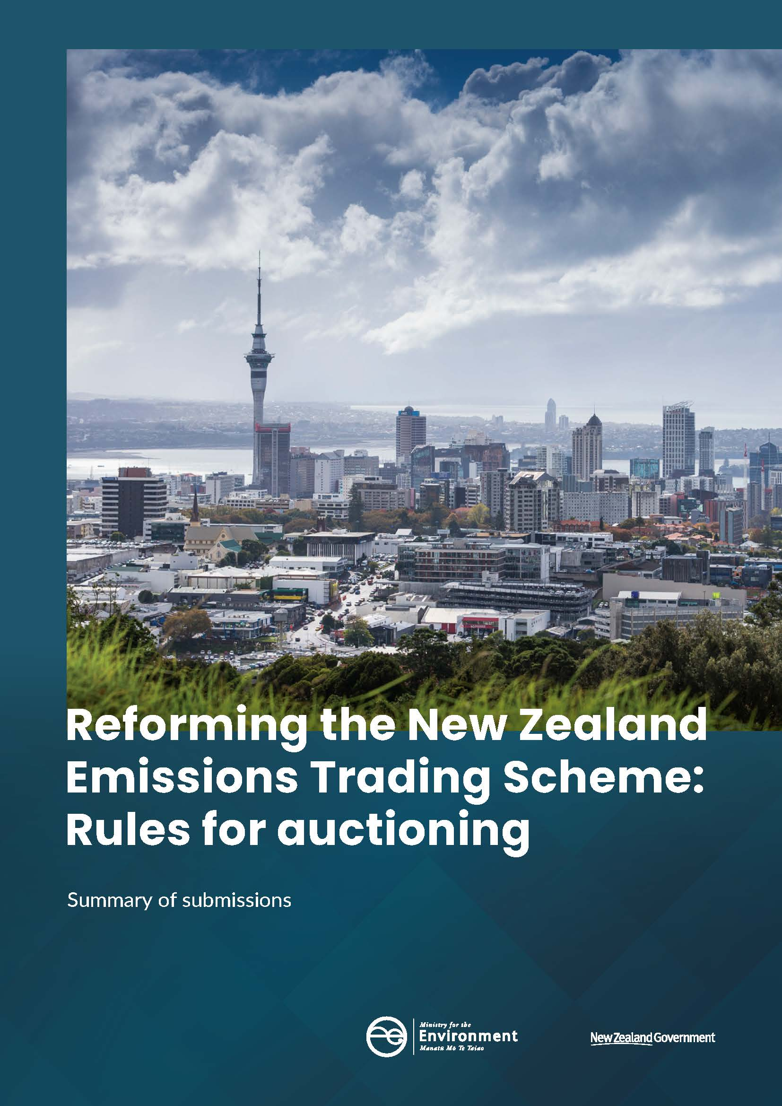
This report may be cited as: Ministry for the Environment. 2020. Reforming the New Zealand Emissions Trading Scheme – Rules for auctioning: Summary of submissions. Wellington: Ministry for the Environment.

Published in June 2020 by the
Ministry for the Environment
Manatū Mō Te Taiao
PO Box 10362, Wellington 6143, New Zealand
ISBN: 978-1-98-857986-3 (online)
Publication number: ME 1499
© Crown copyright New Zealand 2020
This document is available on the Ministry for the Environment website: www.mfe.govt.nz.


Contents
Abbreviations 6
1 Introduction 7
What is the purpose of this consultation? 7
How did we get here? 7
What happens next? 8
Who responded to the consultation? 9
Just under 50 submissions were received 9
What did submitters say about the proposed rules for auctioning? 10
Auctioning is important to an effective emissions trading scheme 10
Auction schedules and rules for distributing volume must be well signalled in advance 10
Price controls must be transparent and simple to understand 14
Registration for auctions should be easy, without compromising the integrity of the auction system 17
There is some support for most of the proposed bidding rules 22
Settlement approach and immediate reporting of results widely supported 28
Auction monitor role necessary for transparency 30
Comments received on topics not covered by the consultation 32
Concerns expressed about unit supply 32
Market governance is still important 32
Price controls play a critical role 32
Agriculture sector supports maximum participation 32
Appendix 1: Consultation process 34
Appendix 2: Consultation meetings held 35
Appendix 3: Submissions analysis 36
Appendix 4: Notes on conventions used in this document 37
Appendix 5: List of submitters 38

Tables
Table 1: Number of submissions, by submitter type 9
Table 2: Reforming the NZ ETS: Rules for Auctioning – Consultation meetings 35

Figures
Figure 1: Q1 Do you agree that auction volumes should be evenly distributed over the calendar year? 11
Figure 2: Q3 Do you think that unsold units should be added to next auction, added to subsequent auctions within a limit (preferred) or other (please specify) 12
Figure 3: Q7 Do you agree that the bidding window should be three hours, from 9am to 12 noon on the scheduled auction date? 14
Figure 4: Q8 When a price trigger is reached in the cost containment reserve, how should the volume of units from the reserve be sold? 15
Figure 5: Q9 If you support option 2, should the units sold in the reserve auction be limited for use to meet surrender obligations? 16
Figure 6: Q10 Do you agree that the cost containment reserve should have a single price trigger for all the reserve volume? 17
Figure 7: Q11 How far in advance should the auction notice be published? 18
Figure 8: Q13 Do you agree that an intention to bid form must be submitted a minimum of 28 calendar days in advance of an auction? 19
Figure 9: Q14 Do you agree that bidders should have to provide collateral to participate in an auction? 19
Figure 10: Q15 If collateral is required, how much should it be? 20
Figure 11: What forms of collateral should be accepted? 21
Figure 12: Q18 – Do you agree that collateral (depending on its form) should be used against payments for successful bids, if the bidder requests? 21
Figure 13: Q19 Do you agree that bidders should be able to choose to have their collateral automatically returned, released at their request, or retained for future auctions? 22
Figure 14: Q20 What should be the minimum number of NZUs that can be sold at auctions? 23
Figure 15: Q21Bids are only accepted in multiples of the minimum lot size. What should the minimum lot size be for auctions? 23
Figure 16: Q22 What should the minimum price increment be? 24
Figure 17: Q23 Do you think a maximum bid limit should be set? 25
Figure 18: Q24 If set, should the maximum bid limit apply to all bids made by a single participant or all bids made by related participants? 25
Figure 19: Q26 How do you think tied bids should be resolved? 26
Figure 20: Q27 Do you agree that a technical reserve price should be set for auctions? 27
Figure 21: Q28 If a technical reserve price is set, do you agree that the methodology for calculating the price be kept confidential? 28
Figure 22: Q29 What results should the auction operator publish as soon as practicable following an auction? Please select all that apply 29
Figure 23: Q30 What is the best approach for settlement of successful bids? 29
Figure 24: Q32 What information should the auction monitor report include? Please select all that apply 30
Figure 25: Q35 How often do you think the auction monitor should review the auctioning system? 31

Abbreviations
EITE Emissions Intensive and Trade Exposed
EPA Environmental Protection Authority
FPO Fixed Price Option
MfE Ministry for the Environment
MPI Ministry for Primary Industries
NGO Non-Governmental Organisation
NZ ETS New Zealand Emissions Trading Scheme
NZU New Zealand Units

Introduction

What is the purpose of this consultation?
The New Zealand Emissions Trading Scheme (NZ ETS) is the government’s main tool to help New Zealand meet its emissions reduction targets and support our transition to a low-carbon economy. It does this by putting a price on greenhouse gas emissions and removals.
Auctioning of New Zealand Units (NZUs) is being implemented in the NZ ETS as part of a package of amendments to improve the scheme and enable it to align with New Zealand’s emissions targets.
During November and December 2019, the Government asked for feedback on a range of proposals to set rules for auctioning within the NZ ETS. These proposals aim to give the market certainty about how auctions will be run, and ensure clear and transparent processes. The proposals support an efficient auctioning system that balances the need to minimise cost and complexity with preserving the integrity of the NZ ETS.

How did we get here?
Since it was established in 2008, the NZ ETS has undergone a series of reviews to ensure it is a strong, credible and well-functioning scheme that helps us meet international climate change targets and reduce greenhouse gas emissions below business-as-usual levels.
The outcomes of the 2015/2016 review led to the Government agreeing to a number of in-principle decisions that are intended to strengthen the scheme’s framework. As a package, these decisions would enable a cap (a limit) to be placed on emissions covered by the NZ ETS and allow the scheme to be aligned with New Zealand’s emission reduction targets. Auctioning of NZUS is the most efficient means to distribute units to the market within the cap.
In October 2019 following a series of government decisions, the Climate Change Response (Emissions Trading Reform) Amendment Bill (the Bill) was introduced to Parliament. The Bill is intended to reform the NZ ETS to drive emissions reductions. It includes a number of reforms to achieve this including:
- setting a cap on emissions
- preparing for robust and transparent auctions
- phasing down industrial allocation from 2021
- encouraging afforestation
- putting a price on agricultural emissions from 2025.
To enact the reforms proposed in the Bill for auctioning, further decisions are required to establish the rules for how auctions will be run and set these rules in regulations. Regulatory rules give the market certainty about how auctions will be run, and ensure auction processes are clear and transparent.
The Government opened consultation on the rules in November 2019 alongside the Parliamentary process for the Bill. This meant stakeholders could review and provide feedback on the legislative and regulatory proposals at similar times.
This summary of submissions only provides an overview of responses to the consultation, ‘Reforming the New Zealand Emissions Trading Scheme: Rules for auctioning’. It does not include analysis of submissions on proposed settings for the NZ ETS as they were part of a separate consultation, ‘Reforming the New Zealand Emissions Trading Scheme: Proposed settings’.

What happens next?
The Government will consider submissions received during the consultation period when deciding on regulatory policy to set the rules for auctioning within the NZ ETS. These submissions also inform the Ministry’s ongoing policy work.
The Climate Change Response Act 2002 is the establishing legislation for the NZ ETS. The Climate Change Response (Emissions Trading Reform) Amendment Bill (the Bill) was introduced to the House of Representatives in October 2019 to implement the amendments needed to improve the operation of the NZ ETS. At the time of writing, the Bill is progressing through the House and is expected to be enacted by mid-2020.
Subject to the enactment of the Bill, the Government expects to make final decisions to set the rules for auctioning later in 2020. This will be at the same time as decisions to set the unit supply volumes to set a cap on the NZ ETS. Consultation on proposed NZ ETS settings was also held in early 2020.

Who responded to the consultation?

Just under 50 submissions were received
We received submissions from 47 individuals and organisations from across New Zealand, representing a wide range of sectors. Just over half of submitters (24) identified themselves as participants in the NZ ETS. For a full list of submitters refer to appendix 5.
Table 1: Number of submissions, by submitter type
Submitter type | Number
Agriculture | 3
Business/Industry group | 27
Electricity | 5
Forestry | 7
Individual | 6
Industrial processors | 4
Iwi/Māori | 1
Liquid fossil fuels | 8
Local government | 2
Market intermediaries | 1
Non-government organisation (NGO)/community group | 0
Research and tertiary organisations | 2
Stationary energy (excluding electricity) | 3
Waste | 2
Submitters could identify as more than one type, so the total above adds to more than 47.

What did submitters say about the proposed rules for auctioning?

Auctioning is important to an effective emissions trading scheme

Submitters generally support auctioning
Most submitters expressed support for auctioning in general, or for the Government’s approach to setting the rules for auctioning, provided the rules are simple, and support transparency and accessibility. In particular, they acknowledged the need to develop a cost-effective auction design which encourages participation (whilst maintaining efficiency, reliability and effectiveness) and promotes certainty and transparency. Several submitters reiterated the need for clear and predictable signals as to the policy and pricing trajectory. This would enable people to make informed investment decisions to support New Zealand achieving emissions targets.
“Well-designed auction rules are an important step towards improving the NZ ETS and transitioning New Zealand to a low-emissions economy. Mercury strongly supports the steps taken by the Government to strengthen the NZ ETS.” (Mercury, submission 25)

Although some foresters expressed concerns
There were seven submitters who expressed discomfort with the introduction of auctioning. They believe it may undermine the scheme or the interests of foresters and that it conflicts with the Government’s afforestation plans.
“The auction process is potentially in conflict with the Government’s interest in afforestation, and its efforts to encourage forest growers to have a strong interest in generating and trading sequestration units under the Emissions Trading Scheme. Despite the Consultation document promising otherwise, we believe the proposed auctions will undermine that encouragement by adding uncertainty to investment in land and forests.” (New Zealand Farm Forestry Ltd, submission 60)

Auction schedules and rules for distributing volume must be well signalled in advance
The Government will announce annually, on a five-year rolling basis, the volume of units available to auction each year. The volume will be determined based on the volume of emissions remaining in the emissions budget after taking into account emissions that sit outside the ETS and emissions covered by units that are freely allocated.
The Government has already decided auctions will be held using a single-round, sealed-bid, uniform pricing format and that they will take place monthly or quarterly.
Feedback was sought on how auction volumes should be distributed across auctions within a year, how unsold units should be treated and how auctions should be scheduled.

Even distribution of auction volume is preferred but some want it weighted towards compliance deadline
Figure 1: Q1 Do you agree that auction volumes should be evenly distributed over the calendar year?
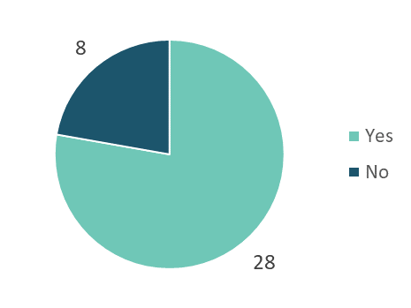
Over three-quarters of submitters favoured even distribution. These submitters noted the simplicity and predictability of this approach and recognised not all bidders will have surrender obligations that drive demand. Some also noted a simple approach is more appropriate when new systems are being developed and is less likely to encourage strategic bidding behaviour.
“Overall, weighted distribution introduces an additional criterion for determining the bidding strategy over the year, adding unnecessary complexity. Furthermore, it could create incentives for strategic behaviour in the secondary market leading to increased price volatility.” (BusinessNZ, submission 45)
Those supporting a weighted distribution included emitters who generally preferred weighting auction volumes to better align supply with demand, as the latter is not evenly spread across the year.
“Traditionally, the secondary market is more active during the start of the calendar year as emitters calculate and source their unit requirements for surrender in May. Therefore, a weighted distribution option is preferred by increasing the unit volumes at times when participants are seeking units to meet their surrender obligations...” (First Gas Limited, submission 38)

Unsold units should be added to the next auction(s) with no agreement on limits
Figure 2: Q3 Do you think that unsold units should be added to next auction, added to subsequent auctions within a limit (preferred) or other (please specify)
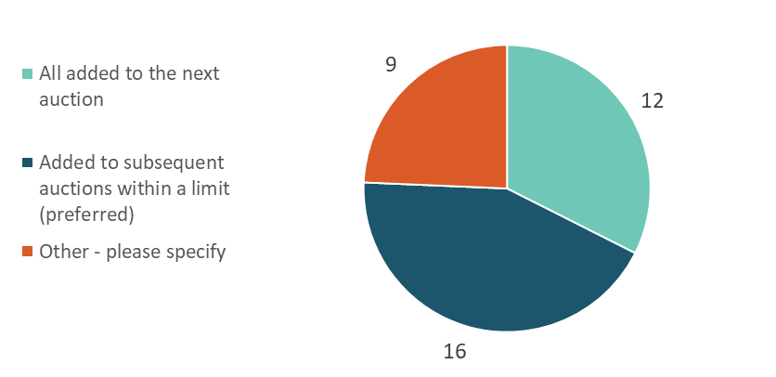

Submitters in favour of imposing a limit on the number of unsold NZUs that could be added to subsequent auctions felt this might help avoid a glut of units in the later auction which could disrupt prices and affect the secondary market. Views on market behaviour influenced some responses to the preference for a limit.
“Auctions will only be successful if buyers participate in them. If buyers stand back in the expectation that future auction volumes will grow, this will have subsequent negative price impacts due to oversupply in later auctions. Unsold units should be rolled forward but limits should be applied to encourage buyers to take part actively and often”. (Carbon Farming Limited, submission 28)
When asked to suggest what limit should be set if one were to be imposed, there was no consistency in responses. Submitters’ suggestions included:
- up to half of the volume
- not more than 33 per cent
- an even spread of volume across the remaining auctions for the calendar year
- up to 10 per cent of the scheduled auction volume (if monthly auctions)
- up to 30 per cent (if quarterly).
Those not in favour of imposing a limit expressed a preference for certainty as to the total number of NZUs available in the calendar year. They thought it an unnecessary complexity or that it might cause price volatility if market trading was inconsistent due to heightened activity in the first half of the year.
“Adding to more than one subsequent auction would create unnecessary complexity. It also weakens price signals as to the relative supply and demand of the market. Settings should be determined by a mandated formula to avoid too much discretion sitting with the decision maker. If a large volume of units is unsold this suggests the market is in oversupply which justifies the potential for ‘dampened’ prices. The rolling cap setting is designed to establish forward confidence and provide avenues to adjust supply and demand over the forward term.” (BP New Zealand, submission 44)
A few submitters suggested unsold NZUs could be allocated to the cost containment reserve, or simply cancelled.
“Unsold units should be held (banked within the budget period) and used to back any units that are made available through the cost containment reserve. Any remaining surplus beyond this should be cancelled at the end of the budget period. Unsold units should not be added to subsequent general auctions. Unsold units are a signal that the system cap has been set too loosely – the price floor gives a mechanism to correct this as long as units are actually removed from the system.” (Compass Climate, submission 35)
A few submitters noted it would be unlikely for volume to be unsold given market demand. They suggested that instances of unsold volume should be investigated to ensure settings were appropriate.

Rules are required to ensure transparency for when auctions will be scheduled, although perspectives vary on what rules are important
Submitters reiterated the need for auctions to be scheduled well in advance and the market notified of the dates as early as possible to support certainty and enable people to plan ahead.
When asked what dates should be avoided when scheduling auctions, submitters suggested the following (in addition to public holidays and days when important economic or emissions data are released):
- budget day
- regional anniversary holidays
- between the 20th and 30th of each month
- during the first five working days at the start of the month
- Australian or Singaporean public holidays
- days when announcements are due from the Climate Change Commission.
A few submitters suggested the auction schedule should therefore be set in conjunction with other relevant agencies such as the Reserve Bank.
One submitter suggested auctions should be scheduled mid-week to avoid interruption to settlement processes due to weekends and public holidays, and to avoid impacts on international bidders.
Thirty-one submitters responded to the question of how far in advance the closest auction should be scheduled to the main NZ ETS surrender date (currently 31 May). This scheduling would need to take into account both monthly and quarterly auction frequencies. Most submitters said between two weeks to a month as the minimum lead time. Some suggested longer lead times of six weeks to two months, particularly for quarterly auctions.
“For monthly auction, not within two weeks of 31 May, providing sufficient lead time to complete NZU surrender prior to compliance date of 31 May. For quarterly auction, not within six weeks of 31 May, again to provide sufficient lead time.” (Queenstown Lakes District Council, submission 18)
Rationales for lead times included giving time for all parties to process the auction results in sufficient time to purchase further units on the secondary market, if required. Submitters also suggested longer lead times might be required to allow time for a separate cost containment reserve auction to be held, if trigger prices were hit and that was the chosen option to release reserve units to the market.

A three-hour bidding window gained majority support
Figure 3: Q7 Do you agree that the bidding window should be three hours, from 9am to 12 noon on the scheduled auction date?
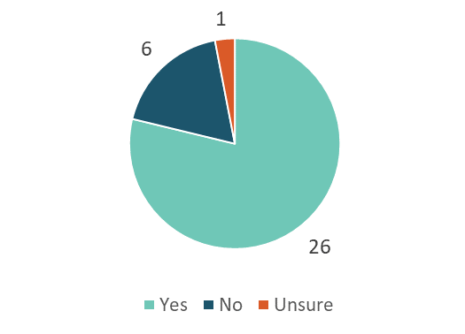
Amongst the six submitters who did not agree with the three-hour bidding window, there was a preference for a later start time to make it easier for international bidders to participate.

Price controls must be transparent and simple to understand
Price controls allow the Government to manage unacceptably low or high prices in the NZ ETS. The Government has decided to enable a price floor and ceiling through the auctioning system. A price floor sets a minimum price at which units may be sold by auction. The current NZ ETS price ceiling is the fixed price option but this will be replaced by a cost containment reserve that operates within auctions.
The cost containment reserve will allow the Government to release additional NZUs for sale at auction if the auction clearing price reaches a specified price trigger. By releasing more NZUs into the market, the cost containment reserve increases the supply of units, therefore lowering prices. The mechanism to enact a price floor is already defined in the Bill and specifies that the auction operator will not accept bids below the price floor, so no further consultation is required.
Feedback was sought on how to operate the cost containment reserve. In general, submitters wanted to clearly understand how the cost containment reserve would operate, emphasising principles of transparency and simplicity. Some submissions stated it was difficult to comment in detail on the proposals for the cost containment reserve when the value of the price trigger(s) and price floor were unknown.

No clear preference for how to release reserve volume to the market
Figure 4: Q8 When a price trigger is reached in the cost containment reserve, how should the volume of units from the reserve be sold?
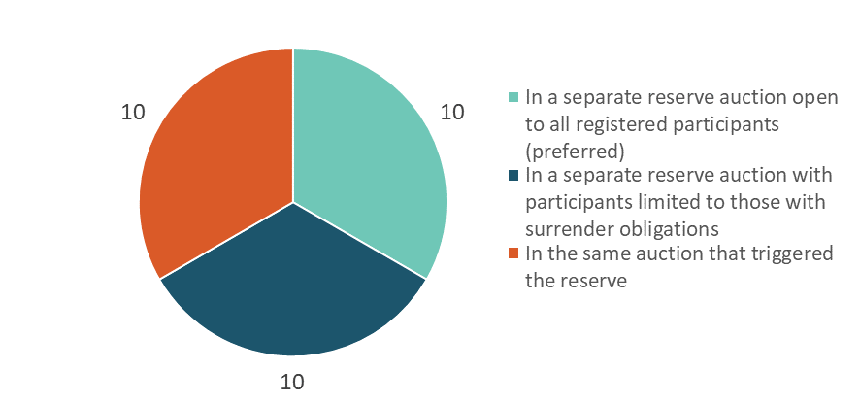
Three options were proposed for releasing reserve volume to the market if a cost containment reserve price trigger was hit during an auction. Thirty submitters responded to this question with 10 supporting each option.
Two of the options involved holding a separate auction shortly after the auction at which the price trigger was hit to sell the reserve volume to the market. The difference between the two options was whether participation should be restricted to participants with compliance obligations or not. Submitters were evenly split on this point. Both those in favour of, and those opposed to, restricted participation suggested it would be better for avoiding market distortions. However, their views differed on how this distortion would play out. Some of those in favour of restricting participation were concerned that allowing everyone to participate might limit the ability of those with compliance obligations to access the units they needed and encourage speculation.
Submitters who supported the option to release reserve units in the same auction where the trigger price was hit often did so because this option was perceived to be simpler. However, there were also concerns that holding a separate auction might lead to distortions in clearing prices.
“The units from the cost containment reserve should be added to the auction volume when a trigger price is reached, with the floor set at the level of the trigger price. We would have concerns if a further auction is held for the sale of the cost containment reserve where a different set of rules will apply, e.g. limitations on which parties could participate. This could create distortions in the clearing price across the original auction and the auction for the cost containment reserve.” (Vector Limited, submission 51)
Figure 5: Q9 If you support option 2, should the units sold in the reserve auction be limited for use to meet surrender obligations?
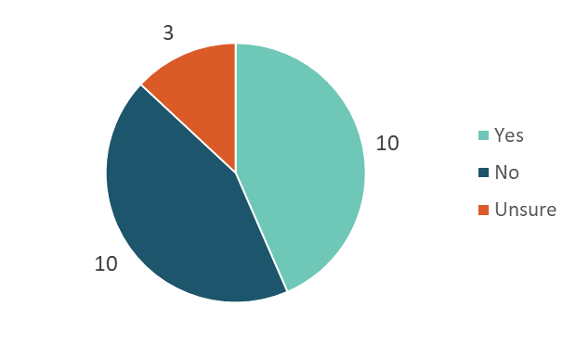
If submitters were in favour of restricting participation, then further feedback was sought on whether units sold in the reserve auction should be limited for use to meet surrender obligations. Once again there was no clear majority. Of the 23 who chose to answer, 10 agreed that use should be limited, 10 disagreed and 3 were unsure.
Those favouring limited use of reserve units generally did so to address concerns about supply being available to meet compliance obligations. Sometimes these same submitters also suggested reserve units should only be available for surrender during the compliance year in which they were sold.
An alternative view was that any limitations on use would effectively create a two-tier system and add unnecessary uncertainty and complexity to the market.

A single price trigger is preferred for the cost containment reserve
The cost containment reserve could have either one or multiple price triggers. The latter would mean only some of the reserve volume was released when each price trigger was hit. When the first trigger price was reached, then a specified volume of units would be sold. If prices continued to rise and a second, higher trigger price was hit then further volume would be sold.
Alternatively, a second, higher price trigger might be hit first, in which case the volume from both the first and second reserve volumes would be sold. The consultation asked submitters their preference.
Figure 6: Q10 Do you agree that the cost containment reserve should have a single price trigger for all the reserve volume?
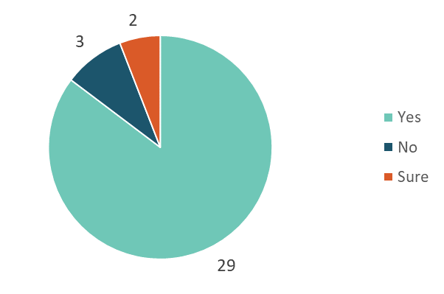
Most submissions (85 per cent) supported the Government’s preferred option to have only a single price trigger in the cost containment reserve. Submitters agreed a single trigger would be the simplest way to activate the reserve and send a clear signal to the market of the maximum emissions price. Multiple triggers were seen as being too complex and creating uncertainty.

Registration for auctions should be easy, without compromising the integrity of the auction system
Regulations are needed to specify rules for what happens before bidding opens in an NZ ETS auction, in particular rules about when the market is notified of upcoming auctions, what potential bidders need to do to register to bid, and whether or not any collateral is required. Submitters were invited to comment on these questions and to express their views on the registration process more generally.

Auction notices should be published 30 days ahead of auctions
Before a scheduled auction, an auction notice is published. It is typically posted on the auction website, sufficiently far in advance to enable potential bidders to prepare. NZ ETS auction notices confirm the date and time of the auction (that has been pre-announced on the auction schedule the year before), the number of NZUs available, the values of any price controls that apply and any other relevant information that is required by legislation.
Figure 7: Q11 How far in advance should the auction notice be published?
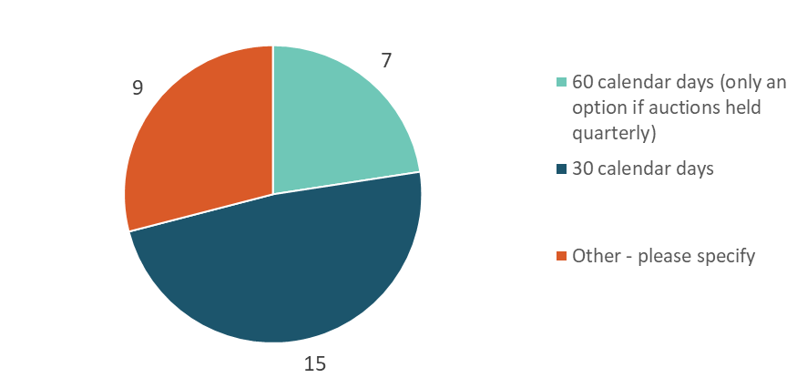
When asked what the lead time should be for publishing the auction notice, most submitters chose 30 days. Submitters gave little consideration to a different lead time based on the frequency of auctions. Responses tended to note 30 days was enough time to allow bidders and the auction operator to prepare.
Some of those seeking a longer period of notice were advocating for the auction schedule to be published before the start of the year (which the Government intends to do). One submitter noted the potential complexity of the pre-registration process for some bidders would require a longer time to complete.

Registration process is seen as necessary but could be simplified
The preferred registration process, as consulted on, can be described as follows:
To pre-register, participants should submit information to the auction operator to establish their identity and ensure they are not a risk to the integrity of NZ ETS auctions. The process may take some time, but once completed, if participants confirm their circumstances have not materially changed, they can bid at any future auction simply by submitting an intention to bid form. Participants should confirm their identity and business capacity and will be required to provide certain information.
Twenty-seven comments were received on the pre-registration process. Most of the comments supported the need for a registration process of some form. However, many suggested the process could be simpler.
Several submitters expressed reservations about the need for an intention to bid form, which they described as an administrative burden and generally unnecessary. Others suggested the information held by the registry could be used as a starting point for registration. A few submitters also said they did not see the need for any more information to be provided than was required when registering as an NZ ETS account holder.
A few submitters felt a rigorous vetting and due diligence process through pre-registration was warranted to ensure the integrity of auctions.
Figure 8: Q13 Do you agree that an intention to bid form must be submitted a minimum of 28 calendar days in advance of an auction?
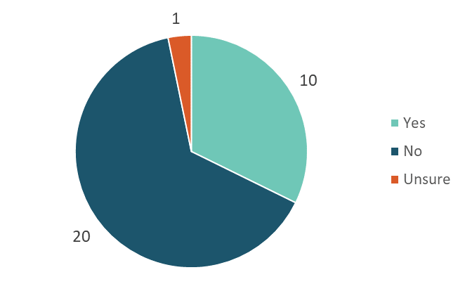
When asked to comment on the appropriate lead time for providing an intention-to-bid form, a minority supported the Government’s preferred option of 28 days. Others reiterated their view the form was unnecessary. Those who disagreed with the recommended lead time often felt it was excessive and the form should be required no more than 1–5 days before the auction.

Submitters hold a range of views on provision of collateral
The Government needs to manage the risk of a winning bidder defaulting on payment to ensure the credibility of the financial management systems for NZ ETS auctions and preserve the auctions’ integrity. To minimise risks, collateral may be required for bids at auction and we sought the submitter views on this.
Figure 9: Q14 Do you agree that bidders should have to provide collateral to participate in an auction?
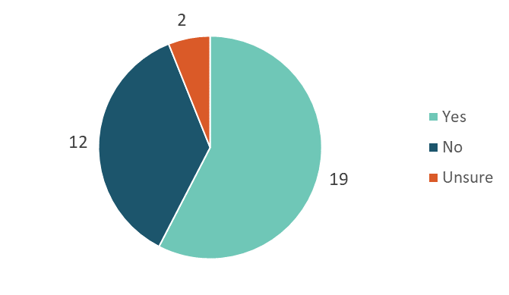
Several of the larger companies with ETS surrender obligations were among the submitters who did not agree that collateral should be provided. They felt the penalty for default was not receiving NZUs and this was enough to deter defaults. A few submitters distinguished between auction participants, noting that no collateral should be required from those with surrender obligations or emissions-intensive, trade-exposed (EITE) participants, but for other bidders some form of collateral should be required.
Some submitters who supported providing collateral mentioned that, although the risk of default might be low, safeguards were necessary to ensure the integrity of the NZ ETS in general, and more specifically the integrity of the new auctioning system. A further reason given was to deter frivolous bidders from participating. However, collateral requirements should not be too onerous.
“Contact is supportive of collateral requirements provided they are not onerous. Note this may create complications for smaller participants.” (Contact Energy, submission 47)

If collateral is required, then it should represent a proportion of total bid value and could be provided in a range of forms
Figure 10: Q15 If collateral is required, how much should it be?
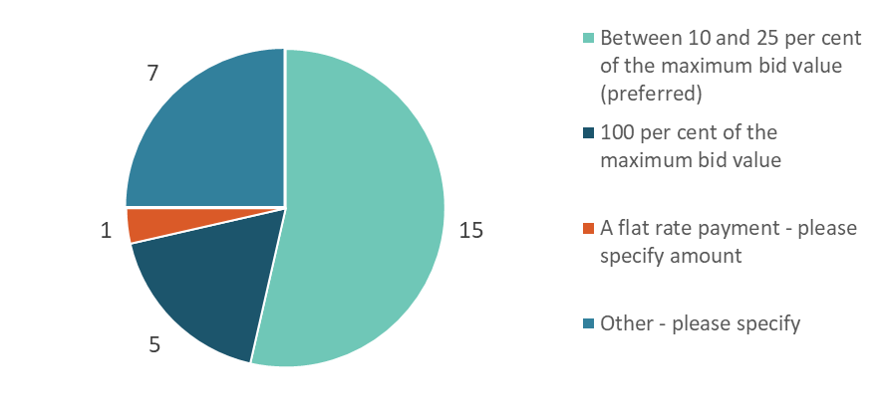
There was broad support for the Government’s preferred option of collateral being between 10 and 25 per cent of the maximum bid. For some submitters, this was a compromise option as they did not agree collateral should be required, so they supported the idea of a low proportion. For others, the lower amount represented a lower opportunity cost to businesses, or appropriately represented the level of risk.
“There is merit in considering a reduction in collateral requirements for bidders who, through their behaviour at prior auctions, are deemed to be low risk.” (Anonymous, submission 59)
However, five submitters thought 100 per cent collateral should be required to streamline settlement processes.
“We believe collateral should be set at 100 per cent of the maximum bid value, and should be able to be used to settle purchases. Although this is more costly than if a lesser percentage was required, this will effectively eliminate credit risk and will result in a quicker payment and settlement process.” (Genesis Energy, submission 53)
The sole submitter supporting a flat rate payment did so on the basis this might better support smaller participants.
Figure 11: What forms of collateral should be accepted?
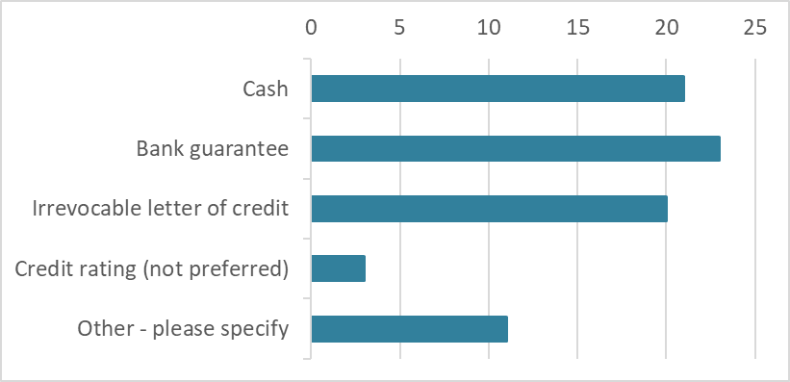
Most submitters agreed that cash, bank guarantee and an irrevocable letter of credit should be acceptable forms of collateral (refer figure 11). There were a few other suggestions for developing these options (either now or in the future as the auction system develops). These included NZUs, credit rating or removing the obligation for bidders with a proven payment record in previous auctions. Some submitters reiterated earlier suggestions there should be different requirements (ie, no collateral) for participants with surrender obligations.
Figure 12: Q18 – Do you agree that collateral (depending on its form) should be used against payments for successful bids, if the bidder requests?
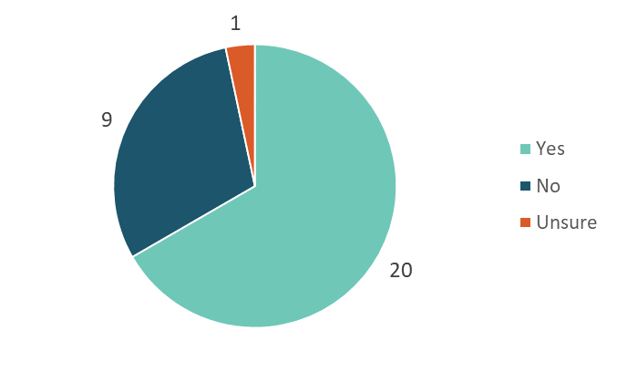
There was general support for the use of collateral as payment for successful bids, if the form was appropriate and the bidder requested it. Those who disagreed tended to do so because they did not agree collateral was required.
Figure 13: Q19 Do you agree that bidders should be able to choose to have their collateral automatically returned, released at their request, or retained for future auctions?
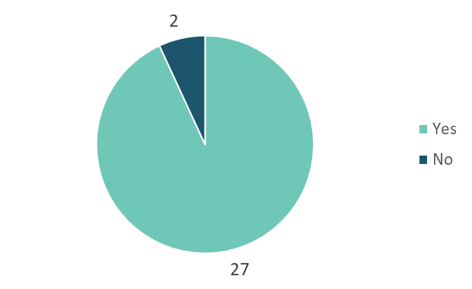
Submitters were similarly supportive of a flexible approach to whether collateral should be returned to bidders after auction. One submitter disagreed as it would increase transaction costs.
When asked what the lead time should be for providing collateral, there was wide support (more than 20 submitters) for the Government’s preferred option of five business days. However, a few felt a shorter period would suffice; for example, two or three business days. Only two submitters suggested a longer period (between five and 10 days).

There is some support for most of the proposed bidding rules
Bidding rules set the framework for how auctions should be run and, in particular, what the rules are for accepting bids. The consultation sought feedback on:
- preferred minimum lot size
- price increments
- resolving tied bids
- whether there should be a maximum bid limit
- rules for setting a technical reserve price.
Minimum bid size was linked to accessibility
Figure 14: Q20 What should be the minimum number of NZUs that can be sold at auctions?
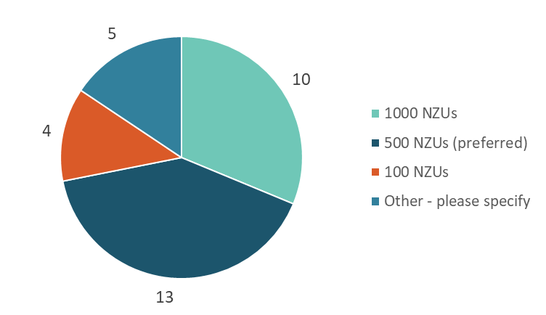
Of the submitters agreeing with the Government’s recommended minimum bid size of 500 NZUs, several commented this seemed to strike a balance between administrative cost and accessibility.
Most submitters who selected ‘Other’ (four of five) supported a larger minimum bid size of 5000 NZUs as this was more in line with the existing secondary market. Their comments, and those of several submitters who supported a minimum of 1000 NZUs, reflected the secondary market was available to provide access for smaller bidders.
DairyNZ was the only submitter who felt there should be a much smaller minimum bid size.
“We favour a minimum of as low as possible. Potentially a 10 NZU limit. We are concerned that the proposed minimum transaction of 500 NZUs will particularly reduce participation from farmers and foresters.” (Dairy NZ, submitter 49)

Preference for smaller lot size than minimum bid but few gave a rationale
Figure 15: Q21Bids are only accepted in multiples of the minimum lot size. What should the minimum lot size be for auctions?
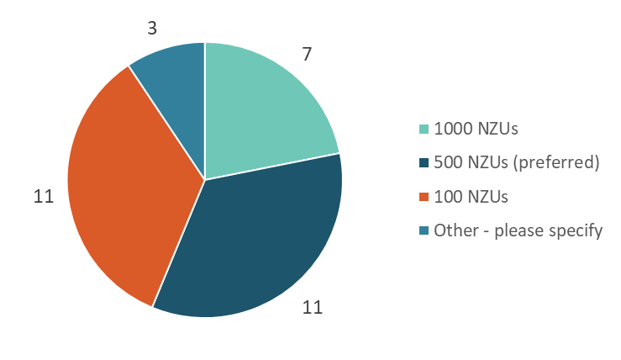
On average, submitters were more likely to support a smaller lot size than their preferred minimum bid size, as evidenced by higher levels of support for lot sizes of 100 and 500 NZUs. However, fewer than five commented on their rationale.
A few submitters who supported the lower option of 100 NZUs said their preference was to give incentive to wide participation in auctions. Of submitters supporting the 1000 NZU option, the only comment was that the minimum lot size should align with established standards in the secondary market.

Price increment of five cents widely supported
Price increments are the amount by which bids must be increased during the bidding process per NZU. They can be in dollars and cents without rounding, or in steps such as $0.05.
Figure 16: Q22 What should the minimum price increment be?
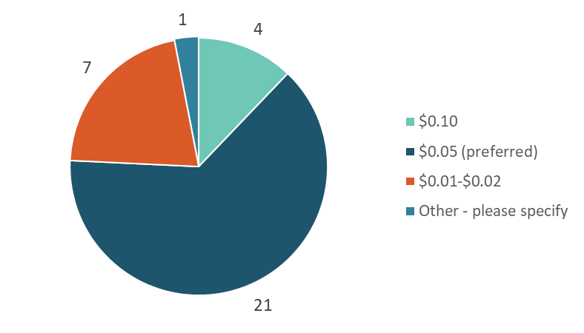
The Government’s preferred minimum price increment of $0.05 was widely supported. Seven submitters supported a lower option of $0.01–$0.02 to match the secondary market for reasons that included avoiding tied bids and unnecessary price ratcheting.

There was no consensus on whether a maximum bid limit is required
The Government consulted on whether a maximum bid limit should be set. Such a limit would prevent any one entity from dominating the market by purchasing a large number of units and using this to their advantage. There has been no evidence of this type of market manipulation in the New Zealand secondary market to date, but participants have suggested that the potential exists.
Figure 17: Q23 Do you think a maximum bid limit should be set?
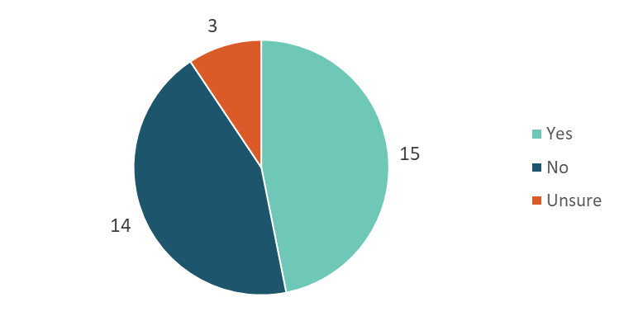
Supporters of a maximum bid commented this might help ensure participants with surrender obligations were not unfairly disadvantaged as there would be less risk of them being unable to access the units they needed. Others suggested this could avoid the risk of one entity dominating the auction.
Rationales for opposing a limit included there was no evidence of this type of manipulation, a limit would be arbitrary and complications could arise where intermediaries or brokers were acting on behalf of multiple clients. Some submitters commented a limit could be gamed regardless and therefore it provided less protection than might be thought.
Figure 18: Q24 If set, should the maximum bid limit apply to all bids made by a single participant or all bids made by related participants?
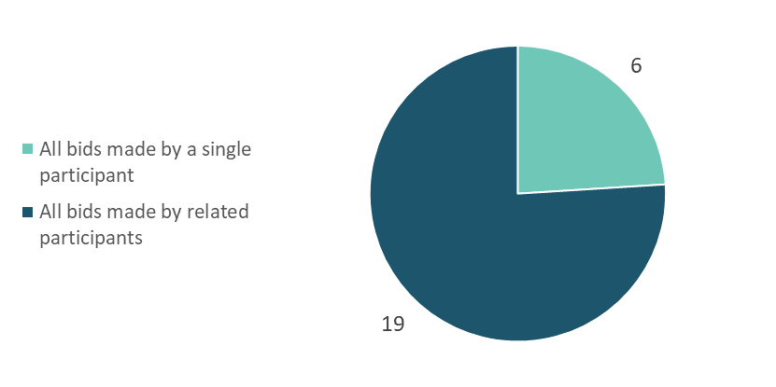
When asked to consider how a maximum bid limit could operate, if the Government decides to set one, three-quarters of responses said the limit should apply to all bids made by related participants. Comments were clear this was to make sure the limit was effective. Supporters of the alternative option noted it would reduce administration and complexity.

When asked for their views on what value to set as a maximum bid limit, 23 suggestions were made covering a wide range of options. Several submitters suggested setting the limit based on a percentage of available auction volume, with figures ranging from 10 to 60 per cent. Others suggested the limit could be a flat amount per annum or be set using a formula based on obligations and timing of auctions. A few suggested any limit should only apply to entities who did not face surrender obligations. Other submitters reiterated they did not see the need for a maximum bid limit at all, or suggested other ways to set such a limit.
“A maximum bid limit should be set at a sufficiently high level to not impact auction participants who are seeking to purchase units to meet genuine surrender obligations but low enough to prevent market manipulation. This is difficult to assess without indicative auction volumes so our suggestion is that maximum bid limit is a criterion which can be managed by the auction monitor and part of the future consultation around NZ ETS settings” (Air New Zealand, submission 55)

A pro-rata approach was more popular than other methods of resolving tied bids
The Government has previously decided all successful bidders will pay a uniform price, rather than the price they bid, and that auctions will run using a single-round, sealed bid format. This means bidders submit bids for their preferred volume of units at a given price. Then, when the auction ends, the operator ranks all bids from highest to lowest price. NZUs will be awarded to bidders from highest to lowest price until the supply of NZUs is used, or until all bids have been filled. The lowest price at which units are sold is the clearing price.
In single-round, sealed bid auctions, ties occur when more than one bid is proposed at the clearing price, and the total amount bid at prices higher than, or equal to, the clearing price exceeds the volume up for sale.
The Government proposed three different methods for resolving tied bids (refer figure 19).
Figure 19: Q26 How do you think tied bids should be resolved?
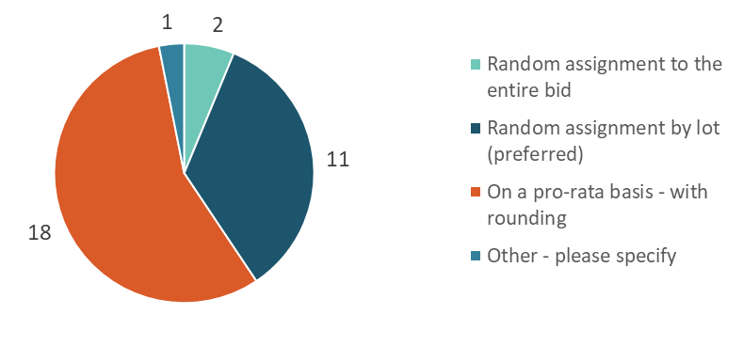
There was wider support for resolving tied bids using a pro-rata approach than the Government’s preferred option to resolve them using random assignment by lot. It is difficult to gauge reasons for this preference, as only four comments were provided. Those who did comment said that pro-rata resolution was seen to be fairer and was used in other financial markets.
“Creating trust in the market will be critical in its early stages. Both mature trading companies and those with simple NZU needs will be looking for certainty of outcome and fair process. Sophisticated trading companies could possibly converge around price points as the market matures. The prospect of a random allocation could devalue the market as a source of units, as the arbitrary nature of allocation may disincentivise participation over time.” (Transpower New Zealand, submission 34)
Supporters of either of the random assignment approaches also commented on the perceived fairness of random assignment, sometimes noting it was less likely to lead to collusion. One submitter said random assignment by entire bid was a simple and well-understood approach used in other ETS markets.

There is support for setting a technical reserve price for auctions
A reserve price is the lowest price the Government would be willing to accept for NZUs during any particular auction. Setting a reserve price protects against the risk of NZUs being sold at a price significantly below the prevailing secondary market price.
The Government proposes to set a technical reserve price before each auction using a prescribed methodology indexed to the market price of NZUs. If the clearing price fails to meet the technical reserve price, no units would be sold at the auction. A technical reserve price is different from an auction price floor because the price floor is a price control the Government has agreed to use if necessary.
Figure 20: Q27 Do you agree that a technical reserve price should be set for auctions?
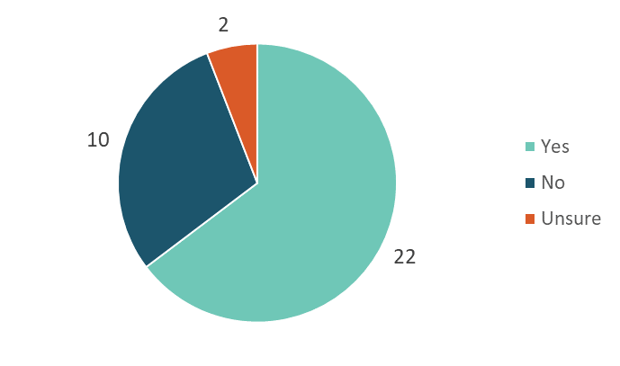
Most submitters supported setting a technical reserve price at auction as they saw it as an effective way to support price discovery and ensure units were not sold below their market value.
Submitters opposed to a technical reserve said it was unnecessary given an auction price floor had already been enabled, and could result in auctions failing if prices on the secondary market spiked.
Figure 21: Q28 If a technical reserve price is set, do you agree that the methodology for calculating the price be kept confidential?
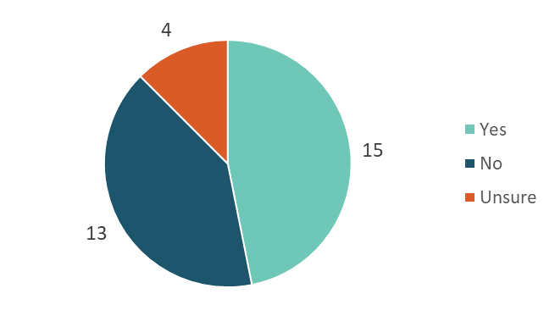
Setting a technical reserve price requires a methodology; however, based on experience in overseas markets, it may be advisable to keep the details of the methodology confidential. Only half of submitters agreed confidentiality should be retained. Those wanting the methodology published argued it would increase transparency and aid participation in the bidding process. The most common rationale for confidentiality was it would help avoid undesirable bidding behaviour as bidders would be unable to develop strategies targeting the reserve price.

Settlement approach and immediate reporting of results widely supported

Proposed immediate publication of auction results attracts support
The Government proposed to require the auction operator to publish some auction results as soon as practicable after every auction. When asked what information should be included in these results, most submitters favoured publishing all suggested options. Rationales given were to provide transparency for auction activity and promote confidence in the process.
A few submitters noted there might be limited value in publishing average bid sizes and numbers of bids, as these would vary and depended on individual bidding strategies.
Figure 22: Q29 What results should the auction operator publish as soon as practicable following an auction? Please select all that apply
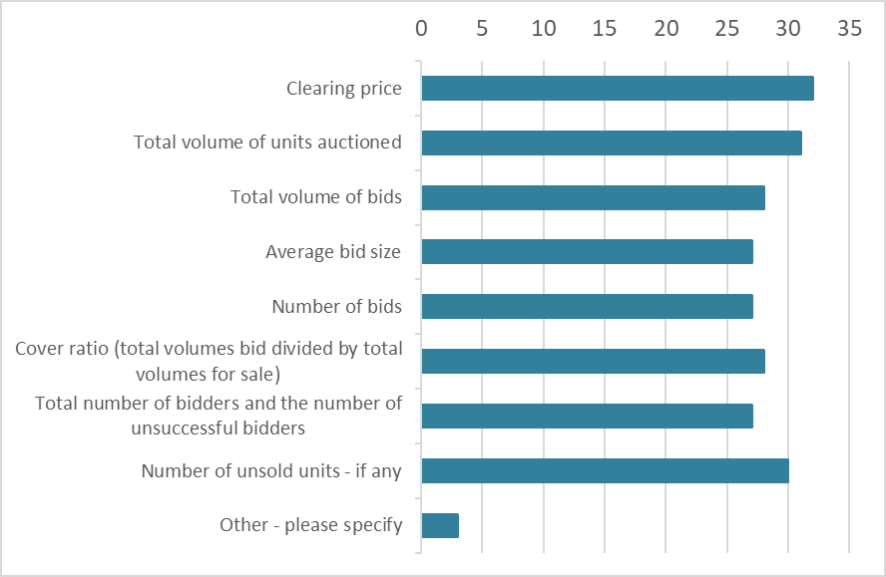

Payment before delivery almost unanimously preferred
Payment is the financial settlement of successful bids, ie, successful bidders providing monies for the value of the bids won. Delivery is the transfer of NZUs won by the bidder to their registry account.
Figure 23: Q30 What is the best approach for settlement of successful bids?
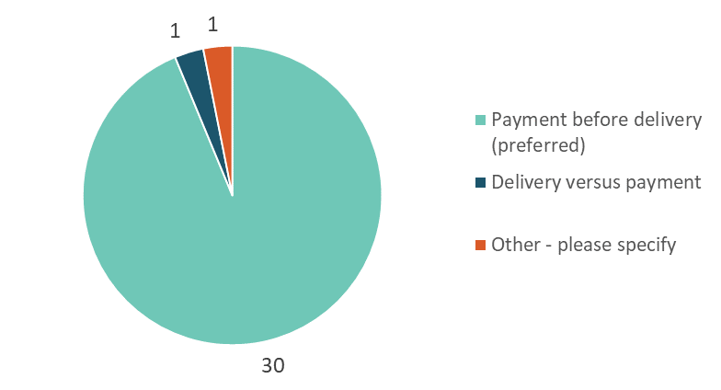
Overwhelmingly, submitters agreed settlement should be done via payment before delivery as opposed to the alternative that would likely require the services of a clearing house.
When asked about a preferred maximum settlement time, there was broad agreement with the Government’s suggested settlement period of four days. A minority were in favour of a shorter settlement period of between two and four days. Only one submitter felt the settlement period was too short and sought a maximum of 10 days.

Auction monitor role necessary for transparency
The Government has decided to enable the appointment of an independent auction monitor to oversee auctions in the NZ ETS, including monitoring auction results and publishing a report on auction outcomes.

Auction monitor report should include as much information as possible while taking care to ensure confidentiality is maintained
When asked to comment on the information that should be included in the auction monitor report, most submitters agreed all the information suggested in the consultation document should be included. A few submitters noted it was important this information was aggregated so that individual bidders could not be identified. Others suggested information on any settlement defaults should also be included.
Figure 24: Q32 What information should the auction monitor report include? Please select all that apply
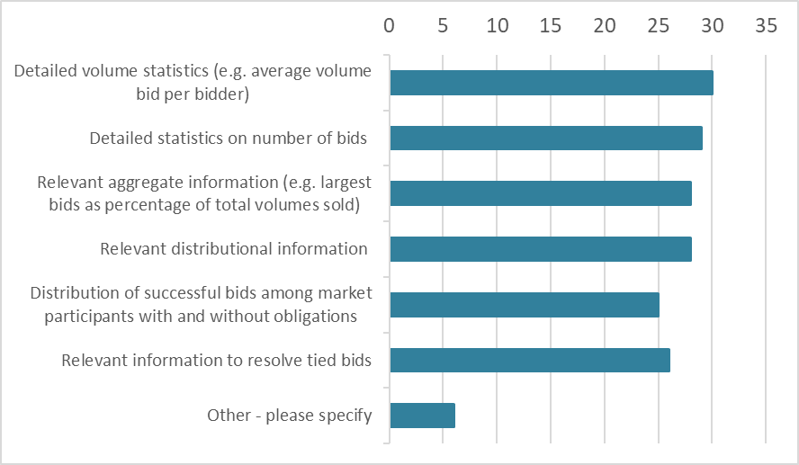
The consultation asked further questions about data confidentiality and whether the proposals for the role of the auction monitor raised any concerns about commercially sensitive information.
Nearly two-thirds of submitters said they had no confidentiality issues so long as the data released did not identify bidders by name. However, nine submitters responded they did have confidentiality concerns, some noting that given the size of the market, it might be possible for identities to be derived from the reporting, with a potential impact on the secondary market.
Only three submitters noted some concerns about commercially sensitive information, especially any information that might potentially disclose information regarding bidder’s market position.

There is support for regular reviews by the monitor, either biennially or annually
The Government proposes that the auction monitor will regularly review the auctioning system.

Figure 25: Q35 How often do you think the auction monitor should review the auctioning system?
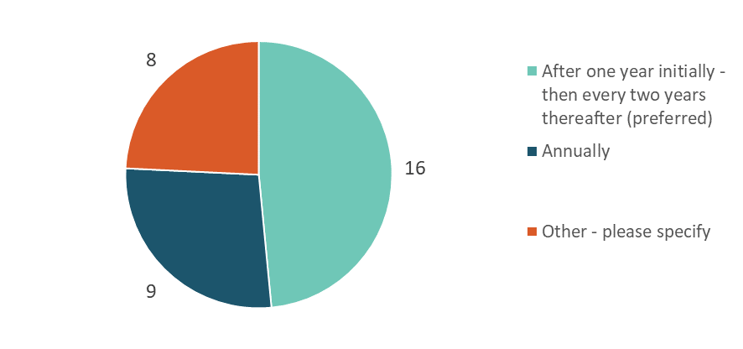

Most submitters supported the idea of a first annual review followed by biennial reviews thereafter. There was also significant support for annual reviews, particularly in the first few years of the new auctioning system.

“New markets are always tricky to establish and full of unforeseen circumstances. We suggest Annual reviews for the first three years of operation, biennial reviews for the next four years and once every five years after that.” (New Zealand Automobile Association, submission 48)

Comments received on topics not covered by the consultation

Concerns expressed about unit supply
Some concerns were raised about liquidity in the market – particularly in light of the strengthened compliance and penalties regime under the Bill – which will impact on those participants unable to secure units. This led at least one submitter to suggest the auctioning mechanism should be abolished in favour of restoring the fixed price option that currently exists in the Act.

Market governance is still important
Several submitters commented on the need for good market governance to maintain the integrity of the NZ ETS. In particular, some noted auctions should be structured and regulated to minimise opportunities for market manipulation.
The provision of market information was seen as being strongly linked to good governance. The role of the auction monitor in publishing analysis after each auction was noted as important in this regard. Similarly, a few submitters expressed their support for the level of transparency being proposed both pre- and post-auction.

Price controls play a critical role

There were a number of comments on the perceived adequacy and effectiveness of price controls to moderate price volatility in the NZ ETS market in general. Some cautioned the price trigger of the cost containment reserve and corresponding reserve pricing should be reviewed regularly to ensure they drive emissions reductions at a sufficient speed.
The cost containment reserve is seen as having a critical role in stabilising the market. This led to some submitters stressing the importance of achieving a well-informed market through clear processes and information about the cost containment reserve being made available. One submission suggested the levels of price triggers in the cost containment reserve should be set based on expert advice from (for example) the Productivity Commission. Another said there was no need for either a price floor or price ceiling.

Agriculture sector supports maximum participation
A common theme from the major agriculture industry organisations to submit in this consultation was that participation should be encouraged for all ETS account holders, regardless of size. Federated Farmers sought to ensure there would be quantities of units available at the smaller scale farmers may require. DairyNZ also sought to ensure maximum participation is promoted through choices for auction design, so as to maximise price discovery and reduce the risk of arbitrage.
Others took the opportunity to further express their support for the sector agreement with the Government known as ‘He Waka eke noa’. They noted that emissions pricing alone would not achieve the level of change needed and that further research and development was required to support the sector.

Appendix 1: Consultation process
We conducted a five-week public consultation on Reforming the New Zealand Emissions Trading Scheme: Rules for Auctioning between 12 November and 19 December 2019. A discussion document set out the background for the consultation and called for written submissions.
The following methods were used to promote and facilitate an open and equitable consultation and encourage submissions to be completed:
- publishing the discussion document on the Ministry website
- emailing all NZ ETS registered account holders via the New Zealand Emissions Trading Register (sent by the Environmental Protection Authority (EPA))
- emailing stakeholders who had previously registered their interest in being told about any NZ ETS changes.
We ran two public consultation workshops, one in Auckland and one in Wellington, in early December 2019. Between 30 and 40 people attended each workshop. Slide-packs that formed the basis of the workshop presentations were published on our website and emailed to meeting attendees. We also held an online webinar which had approximately 15 attendees (refer appendix 2 for meeting details).
We are publishing the submissions on our website alongside the release of this document [https://www.mfe.govt.nz/consultations/nzets-rules-for-auctioning], and we will email submitters and New Zealand Emissions Trading Register users to let them know their submissions have been published.
Submitters received privacy notifications when they sent in their submissions, advising that all submissions would be published unless we were instructed to withhold the submitter’s individual or company name, contact details, or any commercially sensitive material. Nine submitters requested their submissions either be published anonymously, or be withheld in full. The content of these submissions is included in the overall analysis.

Appendix 2: Consultation meetings held
We invited stakeholders to consultation meetings to discuss the proposals contained in the Reforming the New Zealand Emissions Trading Scheme: Rules for auctioning consultation document. We held meetings in Wellington and Auckland during December 2019.
One online webinar was held for people unable to attend a meeting in person. We published the presentation slides on our website after all meetings had been held.
Meetings provided information on the proposals and allowed time for questions. This was to help attendees write their submissions and allowed us to gather initial feedback on the questions being asked.
Table 2: Reforming the NZ ETS: Rules for Auctioning – Consultation meetings
Date | Location | Approximate number of attendees
6 December 2019 | Wellington | 35
9 December 2019 | Auckland | 35
11 December 2019 | Online webinar | 12

Appendix 3: Submissions analysis
We used an online submissions tool to process submissions. Submitters either used online forms for their submissions, or emailed submissions directly to us. We did not receive any handwritten submissions.
We assigned all submissions with a unique identification number and classified them according to the submitter type (such as individual, business, local government). If no submitter type was selected, we made a selection based on the content of the submission. Multiple submitter types were allowed.
A small number of parties provided more than one submission document. In these cases, all documents were logged as a single combined submission to avoid duplication.
We have made every effort to ensure the report accurately summarises the overall feedback on issues and proposals outlined in the discussion document. However, we cannot guarantee that all views are reflected in this report.

Appendix 4: Notes on conventions used in this document
Where numbers and percentages are used when referring to the number of submitters who supported or opposed specific proposals, these are based on our interpretation of the submissions. We were careful to ensure as much consistency in interpretation as possible.
Submitters did not always identify whether they agreed, disagreed or were ambivalent to proposals, even where they made comments on the proposals. We used a category of ‘not specified’ to reflect these views. If the comments appeared to strongly support or oppose a proposal, our analysts entered a selection on behalf of the submitter.
We have included selected quotations from submissions in this document. We selected the quotations for their value in illustrating issues raised by submitters or because they articulate issues in a way that is difficult to paraphrase without losing the original meaning. Their inclusion in this document does not imply they have been given more weight over and above submissions that have not been cited specifically.
Some submitters addressed issues that are outside the scope of the current discussion document. Comments on some of these issues were included in this summary document, for example, comments about overall unit supply, market governance or the inclusion of agriculture in the NZ ETS.

Appendix 5: List of submitters
Name/Organisation | Unique number
Chris Jonassen | 1
Anonymous | 2
Tunakino Forestry Ltd | 5
CarbonClick Limited | 6
Kerry Worsnop | 7
Temperzone | 11
NCDEX e Markets Limited | 13
Gull New Zealand Limited | 14
Anonymous | 15
Anonymous | 16
Tailored Energy Solutions Ltd | 17
Queenstown Lakes District Council | 18
Forest360 Limited | 21
Jeremy William Manks | 23
Mercury | 25
Chemiplas NZ Ltd | 26
Anonymous | 27
Carbon Farm Limited | 28
Commonwealth Bank of Australia | 29
Anonymous | 33
Transpower New Zealand Limited and emsTradepoint Limited | 34
Compass Climate | 35
Jansen Forest Consulting Limited | 37
First Gas Limited | 38
Forest Owners Association | 39
Bathurst Resources | 41
Mike Currie | 42
Minerals West Coast | 43
BP New Zealand | 44
BusinessNZ | 45
Federated Farmers of New Zealand | 46
Contact Energy Ltd | 47
New Zealand Automobile Association | 48
DairyNZ | 49
Anonymous | 50
Vector Limited | 51
Forestry Reference Group | 52
Genesis Energy Limited | 53
Euan Mason | 54
Air New Zealand | 55
NZX Limited (NZX) and European Energy Exchange AG (EEX) | 56
OceanaGold Corporation | 57
Horticulture New Zealand, Tomatoes New Zealand, Vegetables NZ Incorporated | 58
Anonymous | 59
New Zealand Farm Forestry Association | 60
O-I New Zealand | 62

See https://www.mfe.govt.nz/sites/default/files/media/Climate%20Change/Final-Market-Governance-Report-2017%20-%20Market-Governance-of-the-ETS%20-%20options-and-analysis.pdf.
For details of each method, please refer to pages 42 to 45 of the consultation document https://www.mfe.govt.nz/publications/climate-change/reforming-new-zealand-emissions-trading-scheme-rules-auctioning

