

Recommendations for

standardisation of kerbside collections in Aotearoa

Prepared for Ministry for the Environment

May 2020

# DOCUMENT QUALITY CONTROL

|  |  |  |  |
| --- | --- | --- | --- |
| **Version** | **Date** | **Written by** | **Distributed to** |
| Draft 0.1 | 29 May 2020 | Sarah Pritchett (WasteMINZ) and Sunshine Yates (Sunshine Yates Consulting) on behalf of WasteMINZ | Stephen Goodman |
| Draft 0.2 | 10 June 2020 | Sarah Pritchett and Sunshine Yates | Stephen Goodman |
| Final 1.0 | 26 June 2020 | Sarah Pritchett and Sunshine Yates | Stephen Goodman |

CONTACT DETAILS

##### Ministry for the Environment

Stephen Goodman Policy Manager

23 Kate Sheppard Place Thorndon

Wellington 6143

##### WasteMINZ

Sarah Pritchett Sustainability Advisor

PO Box 305426

Triton Plaza Auckland 0757

# ACKNOWLEDGEMENT

The Project Managers acknowledges the time, expertise and guidance provided by the members of the Steering Group and Oversight Group in preparing this report.

|  |  |
| --- | --- |
| **Steering Group** | **Oversight Group** |
| Duncan Wilson (Chair) - Eunomia Research and Consulting | Stephen Goodman (Chair) - MfE |
| Mike Jones - Earthcare Environmental | Shaun Lewis - MfE |
| Rick Thorpe - Xtreme Zero Waste/Zero Waste Network | Parul Sood - Auckland Council |
| Rob Wilson - Eco Central | Jason Krupp - Local Government New Zealand |
| Angela Atkins - Hastings District Council | Pamela Ritchie - MfE |
| Janine Brinsdon - WasteMINZ |  |
| Rodrick Boys - MfE |  |
| Stephen Goodman - MfE |  |

The Project Managers also thank each and every local authority representative and waste and resource recovery industry representative that generously gave of their time and expertise as part of the engagement process for this project.

# TABLE OF CONTENTS

EXECUTIVE SUMMARY 6

1. INTRODUCTION 8
2. CONTEXT 9
   1. THE WASTE MINIMISATION ACT 2008 9
   2. HE TIROHANGA MAORI I TE PARA ME HANGARUA 9
   3. CIRCULAR ECONOMY AND ZERO WASTE 10
   4. WASTE HIERARCHY 10
   5. WASTE LEVY AND A CONTAINER RETURN SCHEME 11
   6. EXPORT RESTRICTIONS 11
   7. PRIVATISATION OF WASTE SECTOR 12
   8. OUR RECORD ON WASTE MINIMISATION 12
   9. CURRENT KERBSIDE COLLECTIONS 13
   10. GEOGRAPHIC CONSTRAINTS 14

2.11. COVID-19 15

1. LITERATURE REVIEW 16
   1. LITERATURE REVIEW ON CONSISTENCY OF MATERIALS ACCEPTED IN KERBSIDE RECYCLING 16
   2. KERBSIDE ORGANIC COLLECTION SYSTEMS 17
   3. KERBSIDE RECYCLING COLLECTION SYSTEMS 18
   4. KERBSIDE RESIDUAL RUBBISH COLLECTION SYSTEMS 19
2. ENGAGEMENT PROCESS 20
3. WHAT PEOPLE THINK 21
   1. STANDARDISATION OF COLOURS USED FOR BINS, LIDS AND SIGNAGE 21
   2. STANDARDISING MATERIALS COLLECTED IN KERBSIDE RECYCLING 21
      1. PLASTIC - KIRIHOU 22
      2. METAL - KONGANUKU 22
      3. GLASS - KARAEHE 22
      4. FIBRE - PEPA ME KARI MARO 23
   3. PRESENTATION OF MATERIALS AT KERBSIDE RECYCLING 23
   4. STANDARDISING KERBSIDE COLLECTION SYSTEMS 24
      1. ORGANICS COLLECTIONS 24
      2. RECYCLING COLLECTIONS 25
         1. SOURCE SEPARATED/ KERBSIDE SORT 26
         2. COMINGLED SYSTEMS (WITH GLASS IN) 27
      3. RESIDUAL RUBBISH COLLECTIONS 27
   5. FINDINGS FROM INDUSTRY CONVERSATIONS 28
   6. FURTHER DISCUSSION ON GLASS 29
4. DISCUSSION 31
5. RECOMMENDATIONS 33
   1. STANDARDISATION OF MATERIALS COLLECTED FOR RECYCLING 33
   2. BEST PRACTICE COLLECTION SYSTEMS 34
      1. ORGANICS COLLECTIONS 35
      2. RECYCLING COLLECTIONS 36
      3. RESIDUAL RUBBISH COLLECTIONS 37

7.3. FURTHER RECOMMENDATIONS 38

1. HIGH LEVEL COSTS 40

BIBLIOGRAPHY 41

APPENDIX A – GLASS PACKAGING FORUM MAP 44

APPENDIX B – LITERATURE REVIEW - RECYCLING SYSTEMS 45

APPENDIX C – CONSULTATION WITH INDUSTRY 51

APPENDIX D – LOCAL AUTHORITY ATTENDENCE AT HUI 52

APPENDIX E – SUMMARY OF SURVEY RESPONSES 53

APPENDIX F – MATERIALS TO BE ACCEPTED IN KERBSIDE AS PRESENTED AT HUI 59

APPENDIX G – WRAP CYMRU 62

# EXECUTIVE SUMMARY

Domestic kerbside collections in Aotearoa New Zealand vary significantly across the country. Adjacent local authorities often collect different materials in kerbside recycling collections, use different types of collection bins, and provide different types of residual rubbish collections, using different funding mechanisms (rates funded, user pays). Some local authorities provide organic waste collections, others don’t.

These many inconsistencies lead to confusion among the public, incentivise waste to landfill, and can increase contamination in recycling.

The tolerance for contamination in recycled materials has dropped significantly with the enactment of the China National Sword Policy in 2018, and the upcoming Basel Convention Amendments in 2021.

There are limited onshore markets to recycle some materials, such as fibre and glass, and much of Aotearoa New Zealand’s reprocessing infrastructure is aging. While there are onshore markets for plastic recycling, most of these are limited to “downcycling”.

In addition, geographic distances make it uneconomical for some local authorities to ship (by land or sea) materials to local markets, whereas some local authorities are fortunate to have reprocessors in their region, leading to an unfair “postcode lottery” where some local authorities have to heavily subsidise recycling services to their householders.

This report was commission by the Ministry for the Environment (MfE) to provide recommendations to the Minister on opportunities to standardise domestic kerbside collections to increase consistency, reduce confusion for householders, improve material quality and reduce residual rubbish to landfill.

The recommendations provided in this report can be broadly divided into two: recommendations for the standardisation of materials collected through domestic kerbside recycling, and recommendations for best practice collection systems to reduce residual waste to landfill and improve recyclable material quality.

The recommendations for the standardisation of materials to be collected through domestic kerbside recycling are based on a significant piece of work undertaken by WasteMINZ and the resource recovery sector in 2019, and these recommendations have been finalised as part of this project.

The recommendations on standardising collection systems and improving material quality have been informed by the engagement programme undertaken as part of this project with local authorities and the waste and resource recovery sector, as well as an international literature review.

While the standardisation of materials collected through domestic kerbside recycling collections has received broad approval from across the country, there are many different factors to be considered when attempting to standardise collection systems, including geography, distance to markets, and local infrastructure.

The recommendations provided in this report recognise these differences, and do not attempt to provide a one size fits all solution. Rather, recommendations for standardising kerbside collections provide best practice recommendations, based on improving the quality of recyclate and reducing residual rubbish to landfill.

The four key recommendations provided by this report are:

1. Standardise materials to be collected in domestic kerbside recycling collections across the country, and how they should be presented, to increase consistency, reduce confusion for householders and reduce contamination
2. Incentivise local authorities to collect food waste for composting or AD to reduce kerbside residual rubbish to landfill
3. Incentivise local authorities to collect glass separately to other recyclable materials to improve the quality of all materials accepted in kerbside recycling
4. Provide best practice recommendations for food waste, recycling, and residual rubbish collections to increase consistency across the country

The report also provides a series of further recommendations that, while outside of the immediate scope of this project, would assist in achieving more effective domestic kerbside collections.

# INTRODUCTION

In February 2020, the Ministry for the Environment (MfE) commissioned WasteMINZ to undertake a national research and engagement programme and make recommendations for the standardisation of kerbside collections in Aotearoa New Zealand.

The final recommendations include the materials to be collected in kerbside recycling, the presentation of these materials, and a way forward for the standardisation of kerbside collections for rubbish, recycling and organic waste, and aim to:

* + Increase consistency in household rubbish and recycling collections across the nation
  + Reduce confusion for householders and provide the basis for national messaging
  + Improve recyclable material quality through the reduction of contamination
  + Decrease residual rubbish to landfill

The views and opinions of local government, industry, and resource recovery service providers were sought during the engagement phase of this project and the circumstances and context of different local authorities, including their size, location, geography and population base, inform the final recommendations.

This report also highlights other areas that need to be addressed for Aotearoa New Zealand to transition to a more circular economy, where residual rubbish, recycling and the composting of organics are managed effectively, and all waste streams are being reduced.

# CONTEXT

In June 2018, the Associate Minister for the Environment directed the establishment of an internal Ministry National Resource Recovery Taskforce to examine Aotearoa New Zealand’s resource recovery sector and potential responses to the impact of the China National Sword Policy. Work was commissioned to undertake a situational analysis and make recommendations. Eighteen recommendations were then tested with two working groups consisting of territorial authorities and experts from the resource recovery sector. The recommendations were narrowed down to nine that align with a circular economy model.

1. Completing an infrastructure and services stocktake and identifying the gaps in materials recovery and waste infrastructure where investment is needed
2. Reviewing kerbside collection and processing systems
3. Undertaking feasibility studies and/or investigations around how to increase Aotearoa New Zealand ’s

processing and reprocessing capacity for:

* 1. fibre (paper and cardboard),
  2. plastics, and
  3. construction and demolition waste

1. Investigate and design a container deposit scheme for New Zealand
2. Examining product stewardship options for other packaging
3. Assessing the options for shifting away from low-value and difficult-to-recycle plastics
4. Running an education campaign to help New Zealanders 'recycle right'
5. Developing model Material Recovery Facilities (MRF)/ local authority contracts for the sector
6. Developing a sustainable procurement plan and guidelines.

This project, to make recommendations for the standardising of kerbside collections, is part of the second recommendation.

The role of a standardised approach to kerbside collections in reducing contamination and increasing the quality of the material recovered via kerbside collections was also emphasised in the 2019 *Rethinking Plastics in Aotearoa New Zealand* by the Prime Minister's Chief Science Advisor. This report recommended: “Standardising national recycling practice and ensuring equitable access.”

The following sections provide the context for standardising kerbside collections.

## The Waste Minimisation Act 2008

The Waste Minimisation Act (WMA), enacted in 2008, requires local authorities to promote effective and efficient waste management and minimisation through six yearly Waste Management and Minimisation Plans (WMMP). Section 43 of the WMA outlines the requirements for a WMMP including the objectives, policies and methods for achieving “effective and efficient waste management and minimisation”.

To provide for effective and efficient waste management and minimisation, 85% of local authorities provide for kerbside collections of domestic rubbish and recycling through collection contractors, 12% have private sector collections only, and the remaining 3% have free recycling drop-offs only.

## He tirohanga Māori i te para me hangarua

He tirohanga Māori i te para me te mahi hangarua (Māori views on waste and recycling) emphasise whakapapa (genealogical) connections between humans and the natural world.

The respect for natural resources and the materials made from them is demonstrated by maintaining their value for as long as possible before they reach the end of their life, at which point they are disposed of in a way that

causes the least harm to Papatūānuku. In this way, he tirohanga Māori i te para precedes the concept of a circular economy (ōhanga āmiomio) but similarly acknowledges the mauri (life force) of natural resources.

## Circular economy and zero waste

In 2020, few disagree with the need for us to move towards a more Circular Economy and better outcomes for material use. The Ellen MacArthur Foundation describes a circular economy as “based on the principles of designing out waste and pollution, keeping products and materials in use, and regenerating natural systems”. In Aotearoa New Zealand, the Ministry for the Environment has adopted the circular economy as a key principal in its approach to waste.

In Europe, the European Commission adopted a Circular Economic Action Plan in 2015, that has driven economic development, the creation of new jobs, and an increase in recycling.

Before the circular economy was widely known as a concept in Aotearoa New Zealand, many local authorities had adopted a goal of zero waste to landfill. Popularised by the Zero Waste New Zealand Trust in the early 2000’s, by 2002 over half of the country’s local authorities had adopted a zero waste goal and the 2002 New Zealand Waste Strategy set targets to move Aotearoa New Zealand towards ‘zero waste’. Many local authorities still retain a zero waste goal in their WMMPs.

The Zero Waste Network, an organisation representing community enterprises across Aotearoa New Zealand working towards zero waste, defines a zero waste world as: “one where resources are valued and nothing is wasted. The goal of zero waste is to minimise and ultimately eliminate waste.”

It is important that the standardisation of kerbside collections assist in moving us towards a circular economy and a zero waste world.

At the same time, we must remember that while kerbside organics and recycling collections provide an opportunity to recover materials that may otherwise be landfilled, composting and recycling are low on the waste hierarchy, and both a circular economy and zero waste require us to identify ways to reduce the generation of organic waste and the packaging waste that are currently recycled. While we want the best possible organics collections, recycling collections and residual rubbish collections, a reduction in waste materials must be our greater goal.

## Waste hierarchy

Within the scope of this project, waste management includes three waste streams from households: organics, recycling and residual rubbish.

The waste hierarchy is central to the management of these waste streams. Significantly, composting, recycling and landfilling are the three least desirable methods for managing materials based on the waste hierarchy.

Reducing (or refusing) the use of materials, reusing, repairing, and repurposing are better outcomes, resulting in a lower resource use and a lower environmental impact.

However, for the forseeable future, local authorities will be required to manage significant quanities of materials that are being processed through composting or recycling or disposed of to landfill.

Therefore, we must ensure that composting, recycling and landfilling are undertaken in the most effective and environmentally sound manner, and that composting (or anaerobic digestion) and recycling are providing a quality resource that can be reused and ‘close the loop’ of materials use.

|  |  |
| --- | --- |
|  |  |

## Waste levy and a Container Return Scheme

Two important pieces of work are currently underway that could impact on kerbside recycling.

The first is the expansion and increase of the waste levy. The waste levy is a key incentive for diverting waste away from landfill to recycling and composting and provides valuable revenue for local authorities to implement their WMMPs. A cabinet decision on the consultation carried out on this piece of work is expected in 2020. If the recommendations for increasing and expanding the levy are implemented, local authorities may have access to increased funding from the waste levy in order to achieve waste minimisation. This could include upgrading or improving kerbside recycling systems.

The co-design of a Container Return Scheme (CRS) is also well underway and the final report on recommendations for the design of this scheme is due in September 2020. If implemented, a CRS is expected to have some impact on the amount and composition of beverage container recyclate collected at kerbside but also to improve the overall quality of recyclate. Any changes to kerbside collection systems need to consider some flexibility in order to incorporate changes in quantities of recyclate set out at kerbside that could result from the implementation of a CRS.

## Export restrictions

It has become increasingly difficult to find export markets for recyclate, due to restrictions from importing countries and changes to international agreements.

In 2018, the China National Sword dramatically decreased the tolerance for contamination in materials imported into China for recycling. As the low quality materials were redirected towards other markets, other importing countries have since implemented their own importation restrictions, making it increasingly difficult for local authorities and contractors to find markets for some materials, particularly low quality, low value plastic packaging such as packaging made from plastics 3, 4, 6 and 7.

On 1 January 2021, new international requirements under the Basel Convention for the trade in plastic waste will come into effect. The Basel Convention is a United Nations Environment Programme (UNEP) initiated agreement that came into force in 1992. It aims to “protect human health and the environment against the adverse effects resulting from the generation, transboundary movements and management of hazardous wastes and other wastes” (Basel Convention. 2020).

Under the Basel Convention any waste defined as hazardous requires a permit for export and any exports to and from nations not signed up to the convention are illegal unless there is a special agreement.

The Ministry for the Environment is proposing amendments to the Imports and Exports (Restrictions) Prohibitions Order (No 2) 2004 (Imports and Exports Order) to meet the proposed Basel Convention amendments. Under these amendments, imports and exports of most mixed plastic waste will require a permit but imports and exports of separated plastic waste suitable for recycling, and mixtures of PET, PE and PP, will not require a permit as long as all materials are destined for separate recycling. This will increase the difficulty of exporting mixed plastic bales.

## Privatisation of waste sector

In 1984, the then New Zealand Government began adopting policies that favoured a free market economy. This led to the privatisation of many sectors including the waste and resource recovery sector, which would come to include the collection of kerbside recycling. The private sector has invested significantly in the waste and resource recovery sector and most local authorities contract these services from the private sector, which has benefited both local government and the private sector.

Some local authorities do not provide recycling or waste services and leave it entirely up to private contractors to have individual contracts with households for these services. A majority of greenwaste collections are also provided by the private sector. Other local authorities fully or partially own their own recycling facilities. For example, Palmerston North City Council fully owns their collection and sorting facilities. Christchurch City Councils owns Eco Central who operate the Materials Recovery Facility (MRF) used by many local authorities in the Canterbury region but contract out collection services. A few local authorities only offer drop-off services for recycling (e.g. Whanganui, Rangitikei and Chatham Islands).

The funding models used for domestic kerbside collections differs across the country. While some local authorities have a fully rates-based collection system, many have a rates-funded recycling service combined with user-pays residual rubbish collections.

## Our record on waste minimisation

According to World Bank data, Aotearoa New Zealand is one of the highest waste per capita countries in the OECD and the 10th most wasteful country in the world (Kaza, 2018). Waste to levied landfills has increased by 48% between 2009 and 2019 (MfE, 2019). According to research by Eunomia Research and Consulting, the rate of resource recovery in Aotearoa New Zealand is only 28% (Wilson et al, 2017). This lack of progress in reducing waste to landfill has been attributed to a lack of reliable data and a preference for voluntary agreements over the use of economic instruments (PCE, 2006).

The 2006 report from the Parliamentary Commissioner for the Environment (PCE, 2006) noted that without reliable data economic instruments have not been used to their full potential in Aotearoa New Zealand, despite the recognition that they are an effective way of incentivising the reduction of waste. The continued lack of meaningful data regarding the composition of waste to landfill, as well as diversion from it, has been highlighted many times since (MfE, 1997; Middleton and Wilson, 2015; Blumhardt, 2018; OPMCSA, 2019) and this has hindered the MfE's ability to make evidence based, informed policy decisions (WasteMINZ, 2015). The Associate Minister for the Environment, the Honourable Eugenie Sage, stated at a Green Party AGM in 2018 that “we lack a full national picture of what is going to landfill, and what is being recovered or recycled, knowing this is critical if we are to make informed decisions” (as cited in OPMCSA, 2019, p 201). A National Waste Data Strategy developed by WasteMINZ and funded by MfE has not been mandated and in the four years since its voluntary implementation only about one third of local authorities are working on fully implementing it (OPMCSA, 2019).

The Waste Minimisation Act 2008 provides many opportunities for economic instruments that would incentivise meaningful resource recovery and diversion from landfill (Blumhardt, 2018), yet few have been utilised to date. The three countries with the best municipal waste recycling rates are listed in a 2017 Eunomia report as Germany, Taiwan and Wales. The report notes that Wales uses binding resource recovery targets for local

authorities and its performance in reducing and diverting municipal waste is increasing and could overtake

Germany’s performance ([Papineschi,](https://www.eunomia.co.uk/person/joe-papineschi/) 2017).

## Current kerbside collections

Currently in Aotearoa New Zealand there are a range of collection methodologies used by local authorities and their contractors to collect residual rubbish, recycling and organics.

The main types of kerbside collection services offered for the collection of organic materials are:

* Food only collected in 23-litre bins, sometimes with a food caddy provided (and sometimes free or council approved corn starch bags)
* Food and greenwaste collected together in 80-litre bins with options for larger (up to 240-litre bins)
* Greenwaste only collected in 240-litre bins

The main types of kerbside collection services offered for the collection of recyclable materials are:

* Comingled (using wheelie bins or crates) to collect paper, cardboard, glass, plastic, and aluminium and steel cans.
* Source separated (using crates) to collect paper/cardboard in one crate, plastic and metal in another crate, and glass in another crate.
* Two stream (using wheelie bins or crates or a combination of both) to collect paper/cardboard, plastic, metal in one bin or crate and glass collected in a separate bin or crate.

There are also a range of variations on these systems.

The following figures provides an overview of the recycling systems used by the 67 local authorities. Some local authorities use more than one recycling collection system, however only the predominant system per local authority is listed.

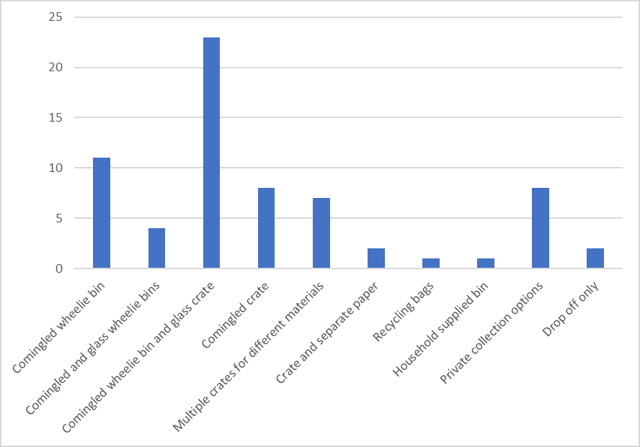

##### Figure 2.1 – Number of local authorities using each recycling collection system

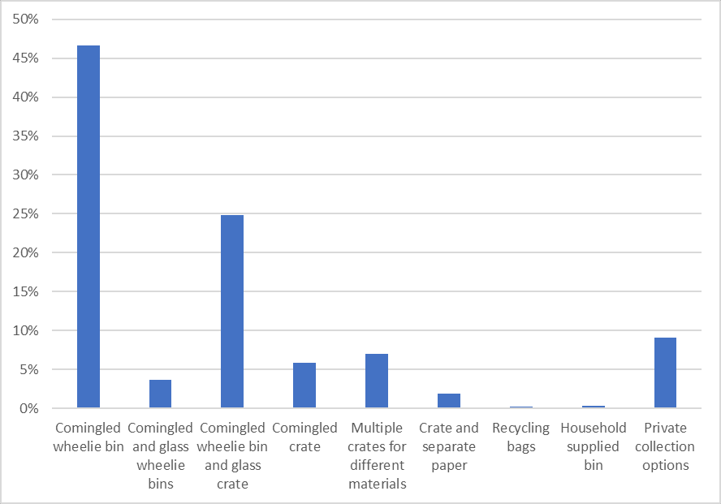

**Figure 2.2 – Percentage of population with access to each recycling collection system**

Eleven local authorities (16%) have comingled recycling wheelie bin collections that include glass, though these local authorities represent 47% of the population. In contrast, 44 local authorities (66%) have a separate glass collection or a kerbside glass sort and represent 43% of the population.

Materials set out in wheelie bins are predominantly collected by side loader trucks and transported to MRF to be sorted into their individual material components, and to remove any materials that are not recyclable (contamination).

Crates are sorted at the kerbside or on the back of the truck into their different material components. When sorted at the kerbside, non-recyclable or heavily contaminated (i.e. with food) items are generally removed and left in the bin for the householder to dispose of. Glass collected in a crate is usually colour sorted at the kerbside.

While two of Aotearoa New Zealand’s large local authorities (Auckland and Christchurch) still collect glass comingled in wheelie bins, many local authorities have moved away from collecting glass comingled with other materials in recent years. Appendix A provides a map produced by the Glass Packaging Forum showing the local authorities that have separate glass collections as of May 2020.

The main types of kerbside collection services offered for the collection of residual household rubbish are:

* Wheelie bins - these can range in size from 45-240 litres in size and can be collected weekly or fortnightly. They are provided as a rates funded service or user-pays service by local authorities or as a subscription based service from private contractors.
* Bags - these are either local authority or private contractor branded prepay bags that range in size from 30-65 litres, or householder provided bags that require a prepay sticker.

## Geographic constraints

Aotearoa New Zealand is a long slender island nation with what is often called ‘the most expensive stretch of water in the world’ between the two main islands. This unique geography, coupled with its relatively small population, leads to challenges in freighting recyclate across the country. While plastic can generally be affordably freighted to the North Island from the South Island (and vice versa), shipping glass from some parts

of the South Island to Auckland is currently cost prohibitive and a lack of competition for glass recyclate compounds the issue.

Some regions are fortunate to have local reprocessors for fibre (such as the Hawke’s Bay), whereas many regions must find overseas markets, such as India. Disparity between regions is exacerbated for areas with large geographic areas but smaller and more rural populations.

Many local authorities only provide kerbside collections to urban and semi-urban residents, with more rural residents relying on drop-off points and transfer stations, due to the economic unviability of collecting from individual households in large but sparsely populated areas.

These differences in distances to market and in geography, coupled with differences in population base and the urban and rural split of these populations can significantly change the economics and logistics of collection systems and markets. Geography and the location of markets can lead to an unfair “postcode lottery” where some local authorities have to heavily subsidise recycling services to their householders.

## Covid-19

The impact of COVID-19 on kerbside collections is yet to be fully determined. However, there were immediate impacts including:

* An inability for some local authorities to continue kerbside recycling due to concerns about exposure to the virus. This was exacerbated by a shortage of PPE for frontline workers, and the Ministry of Health guidelines for Alert Level 4 and 3 not supporting the use of additional PPE, contrary to workers requests.
* Increased contamination in comingled wheelie bins in some local authority areas leading to the discontinuation of sorting during the lockdown period.
* Initially a lack of overseas markets for fibre due to overseas mills closing. This was followed by an increase in overseas markets due to mills that continued operating becoming short of material.
* A shortage of glass at Visy’s beneficiation plant and provided to the glass reprocessor OI.
* Increased volume in both kerbside recycling, organics and rubbish collected during the lockdown period.

A report prepared for WasteMINZ in April 2020 by First 4 Safety notes a number of health and safety implications to the collection of recycling and residual rubbish during COVID-19 and suggested measures to address these. This report is included in the literature review.

During COVID-19 some councils made decisions to discontinue the collection of plastics 3, 4, 6 and 7. However, this was due to existing difficulties in finding markets for these plastics and the impact the Basel Convention amendments will have on these markets, and not related to COVID-19.

# LITERATURE REVIEW

A literature review was conducted to determine if a standardised list of materials to be accepted in kerbside recycling and consistent presentation rules for these materials would assist in decreasing contamination in recycling by reducing confusion for householders and allowing for national messaging.

The literature review also aimed to determine the best kerbside collection systems for organics, recycling and residual rubbish, to improve recyclable material quality, reduce contamination, and decrease residual rubbish to landfill.

The literature reviewed below starts with an examination of the benefits of having a consistent set of materials accepted in kerbside recycling. This is followed by a review of literature on residual rubbish collections, organic collections and concludes with kerbside recycling collections.

## Literature review on consistency of materials accepted in kerbside recycling

A key finding of the Office of the Prime Minister’s Chief Science Advisor’s Report *Rethinking Plastics* (2019) was that Aotearoa New Zealand’s recycling rates are hindered by inconsistent approaches to kerbside recycling across the country which raises multiple problems including:

* Contamination of the recycling stream with items that cannot be recycled in kerbside systems (such as soft plastics, polystyrene, composite packaging, food)
* Items that could be recycled through kerbside systems being put in household rubbish bins instead
* Territorial authorities and the resource recovery sector missing out on clean streams of resources that do have market value.

The literature reviewed supports the hypothesis that a consistent national approach to recycling reduces contamination. In the UK, WRAP’s *A framework for greater consistency in household recycling* (2017) states that “enabling all households to recycle a core set of materials will help address confusion, meaning that householders recycle more of the right materials on every occasion; and contamination is reduced”. The framework states that calculated over an eight-year period (2018 to 2025) the benefits are cumulative and include:

* The potential for an additional 11.6 million tonnes of materials and food waste to be collected for recycling
* The potential to yield up to £478 million more from the sale of recovered materials
* The potential to yield up to 8 million tonnes of organic fertiliser to the agri-food sector, with a nutrient value of £30 million.

The *Consultation on consistency in household and business recycling collections in England* (DEFRA, 2019) recommends that it be legislated that all local authorities in England “be required to collect a minimum or core set of ‘dry’ recyclable materials from kerbside households and flats. This will ensure that every householder is able to recycle a consistent set of materials”.

The importance of having a consistent set of materials across a nation is backed up by WRAP’s *Recycling Tracker Survey* (2018) which includes an analysis of the reasons for householder contamination of recycling. It found that almost half (46%) of UK households surveyed presume that on-pack labels/guidance applies to their local collection. The survey also determined that contamination was caused by other factors that would be reduced if there was consistency in materials accepted, such as:

* Householders putting something in the recycling in the hope that it can be recycled (22% of respondents) (i.e. wishcycling)
* Number of items collected by the council: contamination is highest in areas collecting fewer items (83% vs. 68%) (i.e. wishcycling)
* Confidence: Levels of contamination are as high among those who are very confident as those who are less confident (indicating over-confidence among some householders*).*

Recent research from a WasteMINZ commissioned report demonstrates there is a high level of confusion among New Zealand householders. An online survey was undertaken of 1741 adults over the age of 18, who were representative of the national population by age, gender, ethnicity, and region and who have access to kerbside recycling. The research states that:

*Respondents were tested on their knowledge of the recyclability of 30 different items. The average number correct was 20.8 (out of 30). This lack of knowledge could result in higher chances of contamination. Mostly when respondents get items incorrect they are ‘wish-cycling’.*

The report notes that a key motivational barrier to correctly recycling is a sense of confusion around what can and cannot be recycled and that half of the respondents (51%) feel confused about what they can and cannot recycle at home (Langley, 2020).

*Rebooting Recycling* (WasteMINZ, 2018) noted that in Aotearoa New Zealand local authorities choosing kerbside recycling systems are presented with many choices and may not have the technical knowledge to understand the longer-term impacts of their choices. This can result in lowest cost and more convenient services being chosen over ones that deliver the best long-term value. The report advocates for best practice guidance and specifications for local authority procurement of kerbside systems to increase standardisation and to enable clearer education messages, cheaper service delivery, higher quality of service and materials collected, reduced procurement and contract management costs, and reduced risks in the industry.

## Kerbside organic collection systems

Composting organic waste can generate fewer carbon emissions than disposing of it to landfill (depending on the type and standard of landfill facility) and can also provide other environmental and economic benefits. These can include higher productivity (Hogg, 2010), reduced requirement for manufactured fertiliser (Hogg, 2010, Hogg and Ballinger, 2015), and an increase in soil carbon resulting from the application of compost to soil (Hogg and Ballinger, 2015). WRAP’s *A framework for greater consistency in household recycling* (2017) notes that in the UK, if a food waste collection system was implemented for every local authority there would be potential to yield up to 8 million tonnes of organic fertiliser to the agri-food sector, with a nutrient value of £30 million. In addition, the benefits of removing organic waste from landfill may include an increase to the effective life of a facility because of a reduction in total materials disposed to it and improved air quality (landfill produces ammonia, composting and AD does not) emissions (Hogg and Ballinger, 2015).

It is estimated that in Aotearoa New Zealand in areas where an organic waste collection service is not offered, approximately 40%, by weight, of household residual rubbish is food waste, and a further 10% is green waste (Yates, 2013).

The Welsh Blueprint Collections notes that collecting food waste only (compared with collecting a combination of food and green waste) increases householder awareness of food waste thus helping to reduce the amount of edible food wasted. A reduction in food waste significantly reduces carbon emissions (Hogg and Ballinger, 2015). In addition, the Welsh Blueprint Collections (Welsh Assembly Government, 2011) notes that collecting food waste weekly enables residual waste to be collected fortnightly (or even monthly), which incentivises households to reduce the overall amount of waste put out for collection, along with an increase in the amount separated out for recycling. A report by WRAP (2016a) notes that separate weekly collections of food waste result in higher levels of participation and capture of food than for mixed garden and food collections.

A New Zealand cost benefit analysis of household organic waste collections by Eunomia (Hogg et al, 2010) monetised the environmental costs of food waste only and food waste and greenwaste collections and combined this with the financial costs of collections and processing. The report determined that collecting food

waste only provided more overall benefits. It noted that collecting green waste along with food waste adds a financial burden to local authorities to collect a material that would have previously been collected by private contractors or delivered directly to transfer stations by householders. The report also notes that collecting food separately opens up more processing options and allows processors to control inputs into their process and to cater to seasonal fluctuations in green waste yields.

Guidelines from WRAP on best practice receptacles for food waste also suggest that providing a food caddy to householders encourages participation in a food collection system (WRAP, 2016b).

## Kerbside recycling collection systems

There are three main domestic kerbside collection systems described in the literature, though there are a number of configurations within those three systems. These three systems and their different configurations are described below.

**Source separated/kerbside sort** refers to systems where materials are collected in crates from the kerbside. This system includes:

* Pre-sorted materials in different crates that are emptied as they are into different bins on a collection truck (e.g. glass, fibre, plastics and metals combined)
* Pre-sorted materials in different crates that are emptied as they are into different bins on a collection truck, with some sorting (e.g. glass colour sorted into three bins)
* Pre-sorted materials in different crates and fibre stacked beside the crates, either emptied as they into bins on a truck or glass colour sorted
* Comingled materials collected in one or two crates and hand sorted into different bins on a truck, either at kerbside or on the back of the truck

**Two stream with glass separate** refers to a system where materials are collected comingled in a wheelie bin and glass is collected separately, either in a crate (which is then colour sorted into a collection truck) or in a second wheelie bin.

**Comingled** refers to the use of a single wheelie bin used to collect all materials and is emptied directly into a collection truck.

The full literature review of the performance of different kerbside recycling systems is provided in Appendix B. The literature review drew on 26 reports. Nine of these were from Aotearoa New Zealand, twelve from the United Kingdom, three from Australia, one from Europe and one from Canada.

A summary of the literature reviewed for kerbside recycling collection systems is presented below, addressing contamination, yield and missed capture, employment, health and safety, cost and environment.

**Contamination**: Eight reports addressed this and all found that source separated and/or kerbside sort recycling systems result in the lowest rates of contamination and comingled systems in the highest rates of contamination.

**Yield and missed capture**: Twelve reports addressed this and five determined that comingled systems yield more material. However, three of the reports qualified this with one stating “marginally more” and two noted that comingled systems had higher contamination. One report found that if householders using a source separated

/ kerbside sort system were give the same capacity as a comingled system (through additional crates or increased collections) yield was the same or even higher than for a comingled system. Four reports found that source separated and or kerbside sort systems produced higher yield than comingled systems (with one qualifying that this was when contamination in a comingled system was taken into account). Two reports found that the collection system had little impact on missed capture.

**Employment**: Only one report addressed employment and it determined that when capture rates are over 70% (which is not achieved by any nations as of yet) a two stream with glass out created higher employment rates,

whereas when capture rates are below 70% (as is the case in Aotearoa New Zealand) source separated/kerbside sort created the most employment. For both scenarios a comingled system was found to create the 2nd highest employment rate.

**Health and safety**: Three reports included this aspect. One of these thoroughly reviewed 12 other reports, including one of the other reports reviewed here, and concluded there was no clear higher health and safety risk for any one system in respect of both employees and the public when looking at fatal and major accident rates, musculoskeletal disorders, noise exposure and sprain injuries, trips and “struck-by” accidents. One report addressed the health risks of COVID-19 and determined that manual handling exposes workers to increased risks of contracting a virus such as COVID-19.

**Cost**: Ten reports addressed the issue of collection and sorting costs. Six of the reports found that when sorting costs are combined with collection costs a source separated and/or kerbside sort system is cheaper overall, though one of these found that when adjusted for household density comingled systems cost less. One report noted that if a local authority does not have access to a modern MRF, a source separated and/or kerbside sort system is often cheaper. Two found that the costs of a source separated versus a comingled system were similar, and one report included evidence from a waste management association that separation at source costs more than a comingled system.

**Environment**: Two reports addressed environmental impacts. One looked at carbon emissions and air quality and concluded that with capture rates above or below 70% source separated and/or kerbside sort systems had the lowest environmental impacts. The other report determined that because source separated and or kerbside sort systems produce higher quality recyclate this has a higher environmental benefit as it is more likely to be recycled into like-for-like products and be recycled many times instead of being “down cycled” and only being recycled once.

## Kerbside residual rubbish collection systems

The literature on residual rubbish systems is limited. A summary of the literature reviewed as part of this project is provided here. The WRAP 2012/13 *Analysis of recycling performance and waste arisings* took into account geographical and socio-economic factors and determined that the size of residual rubbish receptacles has a highly significant effect on yield. More capacity for rubbish leads to lower recycling rates (i.e. each additional litre in residual capacity leads to a reduction of mean recycling rates of 0.05±0.02%). WRAP’s 2009 report *Choosing the right recycling collection system* suggests that the amount of space provided for recycling and the frequency of collection of both recycling and residual rubbish is what determines the amount of material collected in each. Another WRAP document *A framework for greater consistency in household recycling* (WRAP, 2017) states that dry recycling capacity should be equivalent to a minimum of 120-litres per week and that recycling services perform better and are more cost effective when residual rubbish capacity is restricted to a maximum equivalent of 120-litres per week. It does not make a differentiation between household density or household type. It also notes that fortnightly residual rubbish collections are more cost effective than weekly collections.

Another issue regarding residual rubbish collections is raised in a 2017 article by Eunomia Research and Consulting. A study by Waste Not Consulting cited in the article demonstrates that when local authorities offer a user-pays rubbish bag service, the market share for private services grows and, in some instances, can be as high as 90%. This can lead to a local authority service becoming unviable (Wilson, 2017). Other issues identified in the article include: the private sector offering 240-litre residual rubbish bins, which acts as a disincentive to separate organics and recycling; an increased number of rubbish and recycling trucks on the road in areas where a large number of private services operate; and reduced opportunities for local authorities to educate householders (Wilson, 2017).

# ENGAGEMENT PROCESS

The project brief requested that engagement be undertaken with key stakeholders (local government, industry and resource recovery service providers) to:

* Generate support for the project
* Share information with stakeholders
* Improve proposals put forward
* Make decisions for project recommendations
* Identify problems and opportunities

The project brief was developed before the Covid-19 epidemic began to impact on Aotearoa New Zealand, and the engagement programme had to be adapted after the project had been launched to be completed during level 4 and level 3 lockdown. The new engagement plan was undertaken in three key ways:

* Phone interviews were held with key resource recovery service providers (material reprocessors, material industry bodies, collection contractors).
* Eleven regional online hui were undertaken with local authority representatives and their collection contractors.
* An online resource “Have Your Say” was developed and made available to all hui attendees to contribute to the project over the duration of the hui and for three weeks afterwards. A survey was created on the Have Your say page after the hui were completed.

Twenty-seven one-on-one telephone interviews were conducted with resource recovery service providers and experts from the plastic, fibre, glass and metal recycling industries, the organics processing industry, collection contractors, MRF operators and other industry experts. A full list of these organisations is provided in Appendix C.

All 67 local authorities were invited to attend one of eleven regional hui. An invitation to elected members was issued from LGNZ. Each local authority was asked to invite their waste and recycling contractors, mana whenua, and other interested partners.

A total of 139 people attended the hui, some people (mainly contractors and MfE staff) attending more than one hui.

Fifty-four local authorities (80% of local authorities) and two regional authorities sent representatives to the hui, including a total of 16 councillors and one mayor. Many local authorities sent more than one representative. A list of the local authorities that attended is provided in Appendix D.

During the hui attendees were also introduced to the online Have Your Say resource. This tool allowed the Project Team to share key information with participants, such as a document library, a newsfeed that was updated regularly throughout the hui, and a forum that allowed attendees to discuss different topics relevant to standardisation amongst themselves. Key information from this forum is provided in Section 5.

The Have Your Say tool was used by a total of 120 participants with 110 (92%) of these engaging in articles and discussions on the page and 58% actively participating in discussions or contributing ideas.

On completion of the hui a survey was sent to all local authorities to gain further information. The survey was completed by 37 local authorities (55% of local authorities), representing 76% of the population. Results of the survey are provided in Appendix E.

# WHAT PEOPLE THINK

This section outlines the information presented to stakeholders, mainly via the hui, as well as the feedback received from stakeholders at the hui, through the Have Your Say tool, and from the survey posted on completion of the hui. It includes information on the positives and negatives raised about the two main kerbside collection systems used for recycling, as well as a summary of the main points raised during the one-on-one conversations with industry.

## Standardisation of colours used for bins, lids and signage

Prior to October 2014, local authorities and businesses used a variety of colours for recycling and rubbish bins and signage. Following WasteMINZ-led consultation, an agreement was made between WasteMINZ, territorial authorities and the Glass Packaging Forum in 2015 on the colours to be used for collecting different materials. The New Zealand Recycling Symbols (formerly known as the RONZ symbols) were updated to reflect this agreement.

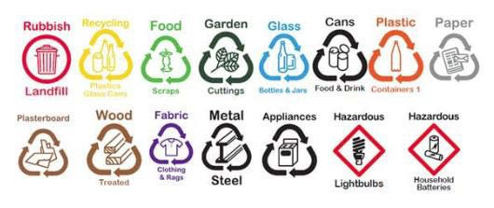

##### New Zealand Recycling Symbols

No feedback was sought on this issue during the current project as a decision had previously been reached.

## Standardising materials collected in kerbside recycling

At the WasteMINZ conference in 2018, it was suggested that work should begin on the standardisation of materials collected in kerbside recycling. In February 2019, a working group was formed with representatives from:

* Visy (MRF operator and glass beneficiation plant)
* EnviroWaste (Recycling collector and reprocessor)
* Waste Management (Recycling collector and MRF operator)
* Smart Environmental (Recycling collector and MRF operator)
* Eco Central (MRF operator)

This group met on a three-weekly basis until July 2019, working through a list of materials to be accepted in kerbside recycling and the presentation of these materials (that had been adapted from WRAP guidelines). The recommendations of this group were then worked through at a hui of other contractors, MRF operators and community recyclers.

A face to face hui was held in Auckland with the original working group (along with a new working group member, Earthcare Environmental) and one or two local authority representatives and the contractors they work with.

The recommendations from this hui were then presented at the TAO Forum at the WasteMINZ Conference 2019. It was hoped that agreement on recommendations could be reached, but the TAO forum requested the opportunity to undertake further discussions with their contractors first.

The project was due to be picked up again in 2020 and was eventually absorbed into this Standardising Kerbside Collections project. Prior to this current project being launched, the original working group reconvened once to ensure the earlier recommendations had not changed since August 2019, and also to make recommendations on the types of plastic that should be accepted in kerbside recycling collections.

During the engagement process of this project, feedback was sought, based on this earlier work, from local authorities and their contractors on a list of materials to be accepted in kerbside recycling, as well as the presentation of these items.

The full list of recommendations presented at the hui are in Appendix F. A summary is presented here along with key feedback from the hui attendees.

Where additional information was required to clarify a concern raised at a hui, this information is also included below.

#### Plastic - kirihou

It was recommended that only plastic containers 1 (PET), 2 (HDPE), and 5 (PP) are accepted in kerbside recycling collections.

It was recommended that plastics 3 (PVC), 4 (LDPE), 6 (PS) and 7 (Other) are not accepted in kerbside recycling collections, as well as any items listed in Appendix F made from plastics 1 (PET), 2 (HDPE) and 5 (PP).

##### Feedback

At the hui there was overall agreement that plastics 1 (PET), 2 (HDPE), and 5 (PP) should be collected in kerbside recycling. There was some discussion about householders requiring assistance to identify plastics 5 (PP) and a need to identify the markets for plastic 5 (PP).

There was also discussion about the need to remove the other plastics (3 (PVC), 4 (LDPE), 6 (PS) and 7 (Other)) from the consumer packaging market.

#### Metal - konganuku

It was recommended that only drink cans, food cans and aerosol cans are accepted.

##### Feedback

There was some concern raised at early hui about aerosols being included in kerbside recycling and a forum was created on Have Your Say to enable discussion about this. The views of the New Zealand Association of Metal Recyclers were also sought. They stated that aluminium aerosol cans included in bales of used beverage containers (aluminium cans) are considered to be contamination, and reduce the price paid for the material.

Concerns were also raised at hui about pressurised aerosols being included in kerbside collections, when pressurised gas canisters are not. It was suggested that aerosols should instead be collected at transfer stations.

#### Glass - karaehe

It was recommended that only glass food and beverage packaging (i.e container glass) from around the home, such as bottles and jars are accepted.

It was recommended that non-container glass not be accepted (i.e. drinking glasses and cosmetics packaging).

##### Feedback

There was general agreement that glass bottles and jars should be collected at kerbside. There was also general agreement that best practice is for glass to be collected separately from other materials.

#### Fibre - pepa me kāri mārō

It was recommended that only clean paper and cardboard be accepted at kerbside.

It was recommended that composite fibre packaging such as disposable coffee cups and liquid paperboard (Tetrapak® or gable top) containers not be accepted.

A full list can be found at Appendix F.

##### Feedback

At one hui it was noted that till receipts were not included in the not accepted list. At several hui the issue of whether circulars should be collected at kerbside was raised. Advice was sought from two fibre reprocessors who noted that the circulars themselves are not an issue and can be dealt with in paper recycling.

It was suggested that fibre quantities could be reduced by providing an option for householders to opt-in rather than opt-out of circular deliveries. Opportunities to work with retailers to reduce circulars was also discussed.

It was also suggested that a separate fibre collection would improve fibre quality.

## Presentation of materials at kerbside recycling

At the hui the following recommendations were presented:

* All items to be free of food and rinsed clean
* No items smaller than 55mm in diameter (i.e. a small yoghurt container)
* No lids accepted
* No triggers and pumps accepted
* Items are not to be squashed by householders.

##### Feedback

There was general agreement on the exclusion of items of less than 55mm diameter. The way this message could be conveyed was raised (for example, nothing smaller than the size of a small yoghurt container). There was some discussion about whether there needs to be a clear message about minimum sizes for all materials, including fibre (i.e. small pieces of paper).

It was generally accepted that a no lids message was acceptable, however, it was noted that some lids can be recycled so alternative ways of capturing them should be investigated.

There was no disagreement with triggers and pumps being excluded from kerbside recycling.

At hui attended by representatives of local authorities using crate-based systems the message of not squashing was raised as a concern because allowing the householder to lightly squash items increase capacity in crates, in trucks, and at drop-off centres. It also takes some of the air out of containers meaning they are less likely to become windblown. Because crate-based systems are generally hand sorted and do not use automated MRFs, the issues raised above are not seen as relevant to a crate-based, hand sort methodology.

##### Feedback from local authority survey

Thirty-one respondents (84%) agree with the recommendations for materials to be accepted in kerbside recycling. Three respondents (8%) did not agree. Of these three respondents two preferred an approach where all plastics continue to be collected but solutions are found for those hard to recycle plastics (i.e. either markets

found, or manufacturers persuaded to use other plastics). Another three respondents (8%) were unsure about the recommendations. Of these respondents, one is currently only collecting glass at kerbside, and one noted that there needs to be certainty around markets for plastic 5 (PP).

## Standardising kerbside collection systems

During the engagement process, the project team sought feedback from local authorities and their contractors on a selection of kerbside collection systems. The systems presented were ‘strawmen’ options, aimed at generating discussion, and providing the project team with feedback on local authorities and their contractors preferences, and possible concerns regarding different systems. The ‘strawmen’ options, while not aimed to represent the project managers’ recommendations, were based on ‘best practice’ from the literature review and discussions with reprocessors.

The feedback from the hui, the industry conversations, the Have Your Say page and the local authority survey are provided below for organics collections, recycling collections and residual rubbish collections.

It is recognised that some local authorities who do not currently provide kerbside collections, or only provide them to their more urban populations. Some provide rural drop-off centres or transfer stations, and other rely on the private sector to provide services. These recommendations are aimed at local authority and private collections, but are not aimed at replacing drop-off centres and transfer stations in rural areas.

#### Organics collections

One option was presented for organics collections based on the findings of the literature review. This was a 23- litre food waste bin with a small bench top caddy and corn starch bags.

It was also recognised that some local authorities may choose to also collect food waste with greenwaste (e.g. FOGO – Food Organics and Garden Organics) if they need the greenwaste for their composting facility.

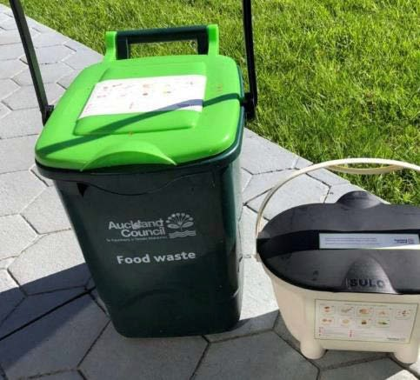

##### Food waste bin and caddy

**Feedback**

During the hui was little opposition to the idea of collecting food waste in a 23-litre bin.

Local authorities with FOGO collections preferred their current systems. Some rural local authorities were concerned at the potential cost of collecting food waste, and their current lack of infrastructure to process it. One local authority representative stated that their residents already compost all of their food waste so they do not have a need for a separate collection.

There was much debate around the need for corn starch bags. Some people argued that there is higher set out of food waste if bags are used, and others argued that local authorities should not be providing single use bags. Some organic processing plants can not accept corn starch bags.

One local authority described their experience implementing a food waste collection with 23-litre bins and no caddy or bags, saying that while there was initial push back from residents, it was now working well. Another observation was that if a local authority supplies cornstarch bags and a householder runs out of them there can be the mistaken belief that they can use a traditional plastic bag instead.

##### Feedback from local authority survey

Of the 37 local authorities that completed the survey, 17 agreed with the organic collection methodology (46%). Forteen respondents (38%) were unsure and expressed concerns about the cost to local authorities of implementing such a system, especially in those areas without a composting or AD (anaerobic digestion) facility in their region. One was unsure because they already have an opt-in system that includes greenwaste. Of the 6 respondents (16%) who disagreed, comments included that it is too complex an issue, or they felt that diversion could be achieved by other means.

#### Recycling collections

Three ‘strawman’ options were presented for recycling. These were:

1. A three crate option, with glass collected in one bin, fibre in another, and cans and plastic in the third
2. A commingled wheelie bin for cans and plastic, with glass collected separately in a crate, and fibre in a second crate
3. A three bin stakable crate option (Trollibocs), with a lid and wheels, as used in some local authorities in Wales. The collection truck used by these local authorities collects food waste at the same time.

|  |  |  |
| --- | --- | --- |
|  |  |  |
| **Three crates** | **Wheelie bin and crates** | **Trollibocs** |

In some of the later hui another collection option was presented, in the form of a woven polyprop bag, used by some local local authorities in the UK to collect fibre or plastic and metal containers.

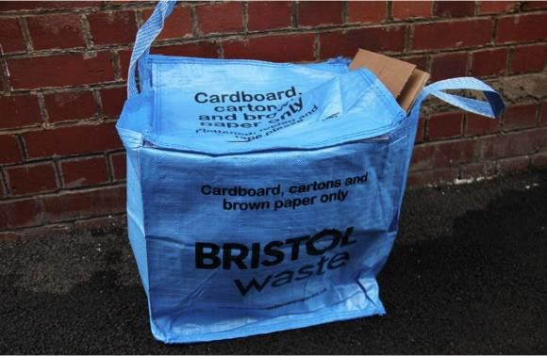

##### Polyprop bag

**Feedback**

The feedback appeared to be influenced mostly by the current collection system used by each local authority and their contractors. Local authorities currently using a crate system had a preference for crate systems. Local authorities with comingled wheelie bins had a preference for wheelie bin systems. It should also be noted that at some hui the main consideration for local authorities when choosing a collection system was whichever system their contractor prefered.

There was very little support for a comingled wheelie bin with fibre collected in a separate crate and much discussion about the need to keep fibre dry and avoid it being windblown. Apart from those local authorities currently using crates, it was generally believed that fibre should be collected in a closed bin.

While there were questions around the use of the Trollibocs, there was not wide support for the idea.

The woven polyprop bag led to questions, and concerns, about how difficult they would be to empty and whether they would slow down collection times.

The following sections 5.4.2.1 and 5.4.2.2 outline the positive and negative aspects of source separated / kerbside sort systems and comingled systems raised by stakeholders during industry interviews, hui and on the Have Your Say forum. These comments are the opinions of individual stakeholders and are provided without commentary or analysis.

#### Source separated/ kerbside sort

##### Positives of a source separated / kerbside sort system

* Produces clean easily sale-able material
* Produces higher financial return for more remote / small local authorities
* Easy to educate householder about what is recyclable and what is not (by leaving items behind and stickering them)
* Able to respond quickly to changes in market and what is acceptable by leaving items behind and stickering items
* Good for rural areas where people have long driveways and tend to pop them in the boot to drop off point or end of drive
* More buy in from householder (i.e. they are an important part of the goal of producing high quality recyclate)
* No need for an expensive MRF or truck technology
* Can provide more employment in areas where unemployment is high
* Kerbside sort workers tend to stay in jobs longer than those employed in MRF sorting
* Active jobs versus risks of sedentary desk jobs
* A bonus of source separated is it puts the burden onto householders and reduces need for further sorting

##### Negatives of a source separated / kerbside sort system

* Crates can be too small and lead to overflowing bins
* Wind can blow items around the streets
* Crates can be blown away by the wind when empty
* Fibre can get wet
* Glass crates can be difficult for elderly or people with disabilities to carry
* Can be difficult to find workers to do kerbside sort jobs
* Health and safety concerns with manual handling and injuries (repetitive strain), high speed rural roads and belief that Worksafe will make it more difficult to use LEV trucks

#### Comingled systems (with glass in)

##### Positives of a comingled system (with glass in)

* Less manual handling (safer)
* Lids keep water out
* Can have more capacity than crate system which can lead to reduced collection (i.e. fortnightly rather than weekly)
* Easier for householders to handle
* No windblown litter
* Fewer customer complaints and dissatisfaction with service
* Faster to service

##### Negatives of a comingled system (with glass in)

* High contamination rates
* While system can be put in place to manage contamination (i.e. auditors, warning stickers, letters etc) however still difficult to manage
* Lid means people hide items inside
* Larger capacity leads to people using it as an overflow for rubbish
* Higher investment needed in technology for trucks and MRFs
* Take up more room
* Not great for rural areas with long driveways
* Some mobility impaired or unwell people cannot move them, and an assisted service costs more per house and in staff time to administer
* Bins can tip over on windy days and result in windblown litter
* Costs more to get high quality recyclate because you need to have more resources to pick out contamination and slow sort lines down, need extra sorters and equipment
* Collection system designed to suit the collector rather than the reprocessor
* Doesn’t incentivise householders to reduce the recycling and rubbish they create.

##### Feedback from local authority survey

Eighty-four per cent of respondents (31 respondents) agreed with the recommendations for the recycling collections methodology. Of the three respondents that disagreed (8%), one was concerned about expanding recycling services due to having a small and rural population. Of the three respondents (8%) who were unsure, one was not convinced glass needed to be collected separately.

#### Residual rubbish collections

Two options were presented during the hui for discussion:

1. A 120-litre wheelie bin, collected weekly until a food waste collection is available, and then collected fortnightly, or
2. 60-litre refuse bags.

##### Feedback

There was general agreement that these two systems are appropriate options, and that the two options allow for regional differences.

There was some feedback that 140-litre wheelie bins are less likely to blow over in areas of high winds. There were also some queries around the Health and Safety of collecting refuse bags.

It was also recommended that 30-litre refuse bags be provided as an option as these are useful for households occupied by one person.

There was discussion about the effect of user-pays rubbish collections combined with rates-funded comingled recycling wheelie bin collections and the increase in contamination of recycling bins this can lead to. It was noted that this combination can result in householders avoiding residual rubbish costs by placing rubbish in their recycling wheelie bin. This was not an issue when a user-pays rubbish collection was combined with a rates funded crate recycling system, as contamination was usually left in the crate by the collection crew.

##### Feedback from local authority survey

Thirty-one respondents (84%) agreed with the recommendations for the residual rubbish collections methodology. Of the five (14%) who were unsure, one was unconvinced of the benefits of using wheelie bins for rubbish collections.

## Findings from industry conversations

Prior to the hui, semi-structured phone conversations were conducted with:

* Reprocessors and associated experts
* Collection and MRF contractors
* Organic reprocessors

The purpose of these conversations were to gather qualitative information to identify any common key themes that could help inform the recommendations. The conversations followed this general format as follows:

* The project was introduced
* Participants were asked to describe what their organisation does
* Participants were asked to describe what they thought best practice kerbside collections would include The key themes that arose are summarised here for each group spoken with in Table 6.1 and 6.2.

##### Table 5.1 - Key themes from conversations with reprocessors and industry bodies

|  |  |  |  |  |  |
| --- | --- | --- | --- | --- | --- |
| **Interviews with industry** | **Prefer glass collected separately** | **Prefer fibre collected separately** | **Prefer source separated/kerb side sort** | **Prefer lids on or off** | **Recommend collecting PP at kerbside** |
| **Plastic reprocessor 1** | Yes | - | Yes | Either | Yes |
| **Plastic reprocessor 2** | Yes | - | Yes | Off | Yes |
| **Plastic reprocessor 3** | Yes | - | Yes | Off | - |
| **Plastic reprocessor 4** | Yes | Yes | Yes | Either | - |
| **Plastic reprocessor 5 / collection contractor** | Yes | Yes | H&S concerns | Off | Yes |
| **Metal industry body/metal collector** | Yes | - | Yes | Off | - |
| **Glass reprocessor** | Yes | No preference | Yes | Off | - |
| **MRF/Glass sorter** | Yes | Yes | Yes | Off | Yes |
| **Glass industry body** | Yes | Yes | Yes | Off | - |
| **Fibre reprocessor 1** | Yes | No preference | Yes | - | - |
| **Fibre reprocessor 2** | Yes | Yes | Yes | - | - |
| **Fibre reprocessor 3** | Yes | Yes | Yes | - | - |

(Key – blank cell mean it was not mentioned/discussed)

##### Table 5.2 - Key themes from conversations with collectors and MRF operators

|  |  |  |  |  |
| --- | --- | --- | --- | --- |
|  | **Support glass out** | **Kerbside sort produces higher quality recyclate** | **H&S concerns with manual sort (i.e. high-speed roads, repetitive strain injuries)** | **User pay system for rubbish increases recycling contamination** |
| **Collector 1** | Yes | Yes | No – they can be managed | - |
| **Collector 2** | Yes | NA | Yes | Yes |
| **Collector 3** | NA | Yes | Yes | Yes |
| **Collector 4** | Yes | - | No – they can be managed | Yes |
| **Collector 5** | Yes | - | Yes | - |
| **Consultant 1** | NA | - | - | Yes |
| **Consultant 2** | Yes | Yes | - | - |
| **Consultant 3** | Yes | Yes | - | Yes |

(Key – blank cells mean it was not mentioned/discussed)

## Further discussion on glass

The issue of glass being collected comingled with other recyclable materials was a common theme raised in the industry discussions, with the main themes as follows:

* Glass collected in wheelie bins results in lower quality glass as glass broken during the collection and transport process can no longer be easily colour sorted.
* Removing glass from comingled collections ensures a better quality fibre, and to a lesser degree, also improves the quality of plastic and metal.
* Glass collected in crates and colour sorted at kerbside enables a maximum quantity of glass to be recovered.
* While there is currently limited capacity for the beneficiation of non-colour sorted glass, it is recommended that glass be collected in a crate and colour sorted at kerbside. However, if infrastructure is expanded in the future to include further opportunities for colour sorting at a beneficiation plant, non-colour sorted collections of glass may become a possibility for local authorities.
* Overseas experience shows that when glass is collected separately, compaction rates for trucks collecting other materials can be increased, increasing capacity in the trucks.

It was also noted by stakeholders that having only one reprocessor in Aotearoa New Zealand leads to stagnant prices paid for glass, and transport from the South Island to OI in Auckland can be uneconomical. Therefore, there is no incentive to pay for a kerbside sort. Hui participants suggested a new beneficiation plant could be established in the South Island or alternatively an investigation should be undertaken into regional wash plants and standardisation of bottle shapes to enable and promote refilling, which better aligns with a circular economy model.

Another issue raised with regards to the separate collection of glass is the unknown effect that CRS could have on glass collections. CRS is currently being investigated and a final report on recommendations for the design of a CRS scheme is due to MfE in September 2020. This design may or may not include glass bottles. Once the design has been released, Cabinet will decide whether to proceed with the scheme. If the scheme does get established, it is likely several years from launch.

If glass is included in CRS, it will significantly reduce the quantity of glass set out in kerbside recycling. There will, however, still be a percentage of glass beverage bottles set out, as well as all glass non-beverage bottles and jars.

During the hui some stakeholders suggested that if glass is included in a CRS scheme, then glass collections would continue, but become monthly. One local authority suggested that it would be better to collect fibre in a separate bin, so that the lower quantities of glass can be collected with plastic and metals.

# DISCUSSION

Standardising the materials to be collected in kerbside recycling, the presentation of these materials, and providing best practice recommendations for the standardisation of kerbside collections for rubbish, recycling and organic waste has the potential to significantly reduce confusion for householders, reduce contamination in kerbside recycling, improve the quality of recyclable materials, and reduce residual rubbish to landfill.

However, it became apparent during the engagement and research undertaken for this project, that the collection of materials at kerbside is one part of a much larger puzzle and cannot be considered alone. The following diagram attempts to outline where kerbside collections fits into a wider system, and some of the current barriers to the effective operation of this system.

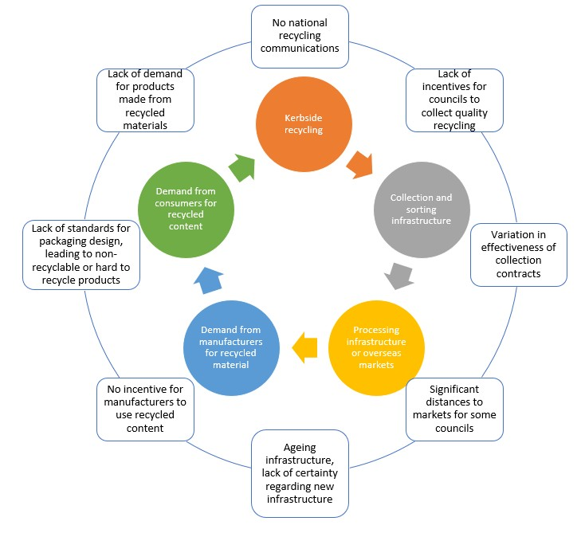

##### Figure 6.1 – Wider resource recovery system and key barriers

Only minimal improvements will be available without taking a more holistic approach to the system and providing incentives for change. The current system is fragmented, with each player operating within the boundaries of their own specific interests. For example:

* Local authorities are incentivised to select the cheapest collection contract available
* There are few incentives for local authorities to increase their diversion of waste from landfill, especially if there is a cost to achieving this
* There is little incentive for collection contractors to reduce contamination (unless a contract is specifically designed to avoid this). Collection contractors are also unlikely to have access to effective

levers to achieve this, even if they desired to (e.g. ability to influence local authority education, or penalise or reward householders for their recycling)

* MRF operators are by default incentivised to include the maximum allowable quantity of contamination in a bale of material, as this reduces their sorting costs and waste disposal costs
* There are monopolies within the reprocessor sector, which results in stagnant prices being paid for materials
* Product manufacturers have little incentive to use recycled materials, especially when virgin material is available for a similar or lower price
* There are few incentives for organisations or householders to purchase products containing recycled material
* There is much uncertainty in materials commodity markets, resulting in hesitancy to invest in the sector

These issues need to be addressed to maximise the benefits of the implementation of standardisation of kerbside collections.



# RECOMMENDATIONS

Based on the objectives of this project and the research and engagement undertaken, the following are the four key recommendations:

1. Standardise materials to be collected in domestic kerbside recycling collections across the country, and how they should be presented, to increase consistency, reduce confusion for householders and reduce contamination
2. Incentivise local authorities to collect food waste for composting or AD to reduce kerbside residual rubbish to landfill
3. Incentivise local authorities to collect glass separately to other recyclable materials to improve the quality of all materials accepted in kerbside recycling
4. Provide best practice recommendations for food waste, recycling, and residual rubbish collections to increase consistency across the country

Further detail on these recommendations, and other recommended initiatives, are provided in the following sections.

## Standardisation of materials collected for recycling

The following recommendations for standardisation of materials collected through kerbside recycling collections and their presentation are based on previous research undertaken by WasteMINZ and the sector and validated through the consultation undertaken as part of this project. Some of the recommendations presented below are different to those presented during the hui, based on the feedback and research undertaken as part of this project.

|  |  |
| --- | --- |
|  | * Plastics 1 (PET), 2 (HDPE) and 5 (PP) grocery packaging only, must be clean and presented without lids |
|  | * Clean aluminium beverage cans and steel food cans. * Aerosol cans will not be accepted in kerbside recycling. |
|  | * Clean glass food and beverage bottles and jars only. Must be presented without lids. |
|  | * Clean paper, paperboard and cardboard. * No shredded paper, till receipts or composite materials such as coffee cups or liquid paperboard (Tetrapak® and gable top) containers. See full list in Appendix F. |

|  |  |
| --- | --- |
|  | * No items smaller than 50mm in diameter (e.g. bottles caps, bread bag tags, small pill bottles…) * No containers larger than 3-litres |
|  | * No lids, triggers or pumps (including large lids e.g. ice cream container lids) |
|  | * It is recommended that there is system specific messaging about the squashing of containers. If a local authority has a crate system, they may want to ask their resident to lightly squash bottles and cans. If a local authority has a wheelie bin system and an automated MRF, they may want to ask their residents to not squash items. |

## Best practice collection systems

As the quality of material collected from kerbside recycling collections is key to finding markets for these materials, and can affect their financial value, quality must be central to the adoption of any kerbside recycling collection system.

With residual rubbish, the size of the receptacle is important in encouraging waste minimisation. With food waste collections, collecting food separately from green waste and providing particular receptacles has an impact on participation in a scheme.

This section provides recommendations for best practice collection systems for food waste, recycling, and residual rubbish. Instead of recommending that a particular collection system be mandated, this report provides recommendations for best practice based on the systems that best meet the objectives of this project:

* + - Increase consistency in household rubbish and recycling collections across the nation
    - Reduce confusion for householders and provide the basis for national messaging
    - Improve recyclable material quality through the reduction of contamination
    - Decrease residual rubbish to landfill

The following recommendations are for best practice kerbside collection systems, based on the research and consultation undertaken as part of this project.

#### Organics collections

It is recommended that a weekly food waste collection is adopted by local authorities, and that the **food is collected in 23-litre bins** from the kerbside.

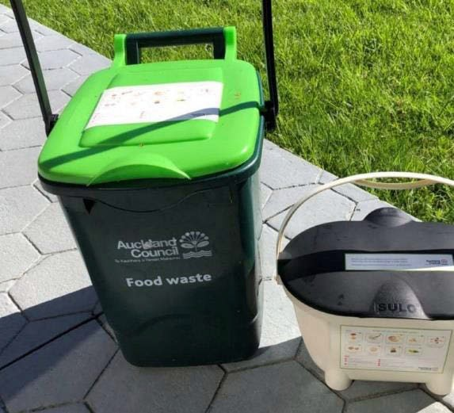

##### 23-litre food waste bin and food waste caddy, as trialled by Auckland Council

This system has the potential to significantly reduce the approximately 40%, by weight, of residual rubbish that is food waste.

Some local authorities may choose to collect food waste along with greenwaste. Collecting greenwaste, a material that is generally not currently being collected by local authorities, and that in many areas is already being diverted through private collections or directly to drop-off areas at transfer stations, can place an additional burden on a local authority. Therefore, it is not recommended that greenwaste be collected, unless the local authority has a need for this material in their organics processing facility and cannot access it from elsewhere. Other tools are seen as more effective at removing greenwaste from residual rubbish, such as bans on greenwaste to landfill through local authority bylaws.

Rural local authorities with low populations and large geographic areas may investigate alternative options to divert food waste, such as community composting or home composting, but should aim to achieve similar diversion rates to local authorities with food waste collections.

It is recommended that food waste collections be limited to food, and that ‘compostable’ and ‘biodegradable’ packaging not be accepted, due to these items not being able to be accepted by all organic processing plants, and the confusion this causes householders when trying to determine what is compostable and what is not.

There are also certain types of greenwaste that are not accepted in an organics collection (such as cabbage tree and flax tree leaves which can cause problems for machinery), and if collecting greenwaste, it is recommended that local authorities consult their organics processors to ascertain their requirements.

#### Recycling collections

It is recognised that there are two main systems used for collecting recyclable materials at the kerbside in Aotearoa New Zealand, crates and wheelie bins, and that both of these systems have their strengths and weaknesses. However, international literature and the resource recovery industry agree that a source separated crate collection produces better quality recyclate.

Therefore, this report recommends that best practice for the collection of recyclable materials at kerbside is to **collect materials weekly in three 45-litre crates**. This system provides the highest quality material, lowest levels of contamination, and provides direct feedback to householders by leaving contamination in bins. The bins can be used to collect glass, fibre, and metal and plastic separately. However, households could use more than one bin for one material as required each week.

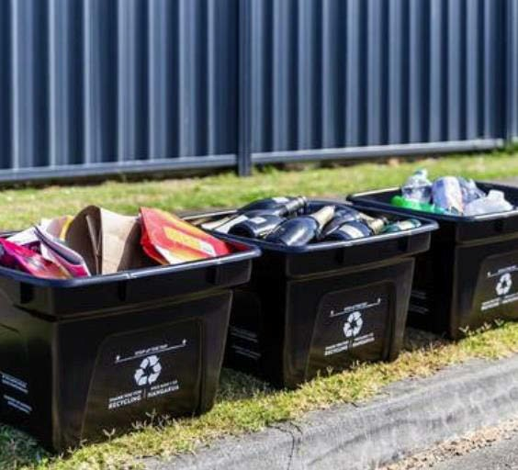

##### Example of three crate system

This system provides households with a weekly capacity of 135-litres for recyclable materials.

It is also recommended that all local authorities, regardless of their current collection system, **collect glass separately** to other materials, preferably in a kerbside sorted crate.

If CRS is implemented, collection frequencies could be reduced to fortnightly, or certain materials (particularly glass) could be collected less frequently, possibly even monthly depending on the effectiveness of the scheme.

There will be local authorities that do not see a kerbside crate system as practical for their particular situation, and that already have, or are prepared to invest in additional sorting equipment at a Materials Recovery Facility (MRF) instead. However, at a minimum, glass needs to be collected separately from other materials.

Those that do adopt, or continue to use, a crate system will need to consider the effects of wind and rain, particularly on fibre, and may choose to use nets, or other solutions, to protect the contents of crates.

It is also recommended that robust health and safety research be commissioned to understand the risks each system presents and how these can be minimised and managed. Based on the research undertaken for this report, it is suggested the following issues be included in future research:

* Injury risks of different systems, including to households, pedestrians, collection crew, and MRF operators
* Fire risks of different systems from e-waste being incorrectly included in recycling bins
* Risks to each system in the event of a pandemic
* Mental wellbeing of workers in different systems (including job satisfaction).

#### Residual rubbish collections

It is recommended that residual rubbish is collected weekly, in either **120-litre wheelie bins or 60-litre bags**. After the implementation of a food waste collection, it is recommended that residual rubbish collections are undertaken fortnightly. This will reduce cost and carbon emissions from collection vehicles.

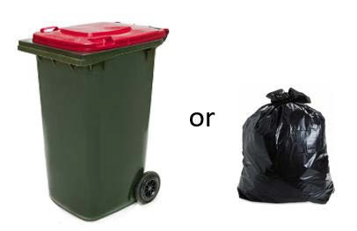

##### 120-litre wheelie bin and 60-litre bag

It is recognised that due to the current design of 120-litre wheelie bins, a 140-litre wheelie bin may be less likely to fall over in some terrain and weather conditions.

If using bags, local authorities may want to also make 30-litre bags available on demand.

Rates funded refuse collections, or the use of bylaws to limit the provision of 240-litre wheelie bins by the private sector, is shown to reduce residual rubbish and reduce contamination in recycling.

## Further recommendations

The engagement process and literature review highlighted a number of initiatives that would assist in achieving more effective domestic kerbside collections and a move towards a more circular economy.

While these initiatives are outside the immediate scope of this project and may require further research, several

are already being addressed through MfE’s work programme, as was outlined in Section 2.

A comprehensive list of further recommended initiatives is provided below. They have been loosely grouped into initiatives that would provide centralised assistance to local authorities and their contractors; national strategy; national campaigns; and central government leadership.

1. Centralised assistance for local authorities and their contractors:
   1. to identify and model the most appropriate collection systems
   2. to standardise collection and processing contracts
   3. to develop waste strategies
   4. to prioritise climate in waste and recycling contracts (e.g. EV collection vehicles, prioritising local markets etc)
   5. to consolidate materials and markets across Aotearoa New Zealand
   6. to identify best markets for recyclate, prioritising onshore markets and high value add
   7. to level out the playing field with regards to geographic distances to markets for local authorities
   8. to promote transparency of recyclate markets, so consumers know where their materials are ending up
2. National strategy:
   1. to incentivise onshore recycling. Where it is not viable to recycle onshore, to raise the value of product being exported
   2. to reduce and divert food waste from landfill, including regional need gap analysis for organic processing facilities
   3. to ensure local infrastructure investment decisions by government and the private sector are aligned with a circular economy model
   4. to ensure investment in like-for-like reprocessing options that raise the value of materials and keep them in circulation
   5. to acknowledge mātauranga Māori perspective on waste as being a forerunner to circular economy thinking, which can shape the kaupapa of waste strategies in Aotearoa New Zealand
3. National campaigns:
   1. to promote recycling and the standardised materials collected for recycling (ensuring these are targeted at different ethnicities)
   2. to brand recycled packaging to enhance consumer demand
   3. to bring the public on a journey – ensure they are informed about the importance of quality recyclate and of avoiding and diverting food waste so they start to request these services and are prepared to ‘do their bit’ to ensure quality materials are collected
   4. to focus on designing out single use packaging items, and promoting reduction and reuse of materials
4. Central government leadership:
   1. to implement a waste data framework and collect standardised national waste data
   2. to implement waste minimisation targets for local authorities
   3. to phase out use of plastics 3, 4, 6, 7 in consumer packaging
   4. to implement a national labelling scheme for recyclable materials
   5. to develop national procurement standards for local and central government agencies, promoting recycled content
   6. to implement opt-in rather than opt out framework for circular deliveries

It is the authors’ opinion that some of these recommended initiatives could provide a framework for substantial

and continued improvement in domestic kerbside collections.

Particularly, the introduction of a mandatory waste data framework, waste minimisation targets, and a national education campaign would support the standardisation of domestic kerbside collections, produce higher quality recyclate, and ongoing reduction of residual rubbish to landfill.

Collecting standardised waste data across local authorities would allow for the measuring and monitoring of kerbside collection systems. The setting of waste reduction targets, based on the waste data, would drive waste minimisation in a manner that has not been possible in New Zealand to date.

Providing a national education campaign alongside these two initiatives would ensure that public support is gained and maintained, and that issues that arise in the waste and recycling sector, and successes achieved, can be shared nationally.

Cohesive delivery of the initiatives recommended in this report may require appropriate delivery structures or agencies.

Further investigation could be undertaken into the value of creating an entity to oversee the management and minimisation of waste in Aotearoa New Zealand. Similar to EECA, whose purpose is “Mobilising New Zealanders to be world leaders in clean and clever energy use”, the role of this new entity could be to mobilise New Zealanders to be world leaders in waste minimisation and a Circular Economy. This entity could work at the interface between local government, central government, industry and communities, as is undertaken by WRAP in the United Kingdom.

This entity could provide much of the centralised assistance to local authorities and their contractors as outlined on the previous page, as well as leading national campaigns and assisting with strategy. They may even be able to lead some of the central government leadership projects.

An overview of the assistance provided to the sector by WRAP Cymru in Wales is provided in Appendix G.

# HIGH LEVEL COSTS

Determining the cost to local authorities and industry of implementing the recommendations outlined in this report is beyond the scope of this research. This section provides some high level cost assumptions, based on discussions with local authorities and industry experts.

The main costs associated with a change to materials collected in kerbside recycling will be related to educating householders. However, if all local authorities are aligned, then this could be undertaken on a national level, thereby removing some of the burden from local authorities. Experience from local authorities who have recently moved from collecting plastics 1 through to 7 to just collecting plastics 1, 2 and 5 is that plastics 3, 4, 6 and 7 have been reducing in volume anyway, due to manufacturers reducing their use. As these plastics reduce further (either because of voluntary or legislative measures) local authorities will likely be able to reduce costs associated with sorting mixed plastics and landfilling plastics 3, 4, 6 and 7.

There are unique geographical and market challenges in Aotearoa New Zealand that result in large cost differentials in collecting materials from region to region. Existing infrastructure, distance to markets, and local geography will need to be taken into consideration when selecting a collection system.

Based on discussions with industry, and modelling data undertaken for local authorities, operating a separate food waste collection is likely to cost local authorities in the order of $45 per household per annum (though this can range between $30 and $80 per household). This includes the cost of containers, collections, and processing infrastructure. This would be partially offset by reduced residual rubbish disposal costs, with less residual rubbish being collected, and local authorities also potentially being able to reduce residual rubbish collections to fortnightly to further offset costs.

The cost of separate fortnightly glass collections is likely to be between $31 and $36 per household per annum based on discussions with South Island and North Island local authorities providing separate colour sorted glass collections in crates. If CRS is adopted, then the cost of providing this collection is likely to be reduced by reducing collections to monthly.

The literature review suggests that when factors beyond the collection of materials are factored in, such as MRF operational costs and the lower value of material collected in comingled collections, a kerbside sort system is no more expensive than a comingled system and is often cheaper.

# BIBLIOGRAPHY

Auckland Council. 2017. *The Launch of Auckland Council’s three bin system in Papakura*. Presentation at WasteMINZ Conference 2017.

Basel Convention. 2020. *The Basel Convention at a glance...* retrieved from [http://www.basel.int/TheConvention/Overview/tabid/1271/Default.aspx#](http://www.basel.int/TheConvention/Overview/tabid/1271/Default.aspx) (22 May 2020)

Blumhardt H. 2018. *Trashing waste: unlocking the waste potential of New Zealand’s Waste Minimisation Act,*

Policy Quarterly, 14:4.

Commonwealth of Australia. 2018. *Report on Waste and Recycling Industry in Australia.* Australia: Commonwealth of Australia

Dearsly, G. 2020. Residential Refuse and Recycling Collections: COVID-19 Worker Risk Factors by Collection Methodology. Commissioned by WasteMINZ. Auckland: First 4 Safety.

DEFRA. 2019. *Consultation on consistency in household and business recycling collections in England****.*** UK: Department for Environment Food & Rural Affairs

Denne T, et al. 2007. *Recycling: Cost Benefit Analysis*. Prepared for the Ministry for the Environment by Covec. Auckland: Covec

Department of Environment and Conservation. 2004. *Assessment of domestic waste and recycling systems.*

Parramatta: Department of Environment and Conservation

Hogg D, et al. 2010. *Household Organic Waste Cost Benefit Analysis*. Auckland: Eunomia Research and Consulting Hogg D, Ballinger A. 2015. *The Potential Contribution of Waste Management to a Low Carbon Economy.*

Commissioned by Zero Waste Europe in partnership with Zero Waste France and ACR+. Bristol: Eunomia

Johnson M, Raggett N. 2008. *Solid Waste and Recoverable Resources Industry Injury Causation.* Wellington: Research New Zealand

Kaza S, et al 2018. 2018. *What a Waste 2.0: A Global Snapshot of Solid Waste Management to 2050, urban development series knowledge paper*. Washington: World Bank

Lakhan C. 2015. *A Comparison of Single and Multi-Stream Recycling Systems in Ontario, Canada.* Resources, 4, 384-397; doi:10.3390/resources4020384

Langley E. 2020. Rethinking Rubbish and Recycling Research Report. Commissioned by WasteMINZ TAO Forum. Auckland: Colmar Brunton.

Middleton B, Wilson D. 2015. *New Zealand Waste Data Framework: Review of International Waste Data Practice*; Prepared for the Ministry for the Environment by WasteMINZ. Auckland: WasteMINZ.

Ministry for the Environment. 1997. *National Waste Data Report*. Wellington, Ministry for the Environment

Ministry for the Environment. 2017a. *Review of the Effectiveness of the Waste Disposal Levy 2017*. Wellington: Ministry for the Environment.

Ministry for the Environment. 2018. *National Resource Recovery Taskforce: New Zealand’s options in response*

*to effects created by the implementation of the National Sword Policy*, Wellington: Ministry for the Environment

Ministry for the Environment. 2019. *Reducing waste: a more effective landfill levy – consultation document*. Wellington: Ministry for the Environment.

Morrison Lowe. 2010. *An assessment of the health and safety costs and benefits of manual vs automated waste collections.* Auckland: WasteMINZ

Nolan J, Philpott L, 2013. *Independent assessment of kerbside recycling in Australia*. Australia: Nolan-ITU Pty Ltd

Office of the Prime Minister’s Chief Science Advisor (OPMCSA). 2019. *Rethinking Plastics in Aotearoa NZ*, Auckland: The University of Auckland

Papineschi J, Tilbrook E, Emery L. 2016. *Review of the Welsh Government Collections Blueprint*. UK: Eunomia Research and Consulting

Papineschi J, Jones P, Gillies R. 2017. *Recycling: Who really leads the world?* Bristol: Eunomia Research and Consulting

Parliamentary Commissioner for the Environment. 2006. *Changing behaviour: Economic instrutments in the management of waste*. Wellington, Parliamentary Commissioner for the Environment.

Seyring N, et al. 2015. *Assessment of separate collection schemes in the 28 capitals of the EU.* Prepared for European Commission by BiPRO and the Copenhagen Resource Institute (CRI) in cooperation with ENVIRON, ENVIROPLAN, Geotest and ACR+. Brussels: European Commission

WasteMINZ. 2015 *Waste Data Needs – Survey Results & Analysis . In fulfilment of Milestone 1 of the National waste data framework Project.* Auckland: WasteMINZ.

WasteMINZ. 2018. *National waste data framework - Standard reporting indicators for territorial authorities*. Auckland: WasteMINZ

WasteMINZ. 2019. *Rebooting Recycling*, Auckland: WasteMINZ

Welsh Assembly Government. 2011. *Municipal Sector Plan Part 1, Towards Zero Waste One Wales: One Planet, Collections Blueprint For affordable and sustainable local authority collection services for recyclable, compostable and residual waste (Version 01 – 10 March 2011),* Wales: Welsh Assembly Government

Wilson D, Chowdhury T, Elliott T, Elliott L and Hogg D. 2017. *The New Zealand Waste Disposal Levy: potential impacts of adjustments to the current levy rate and structure*, Auckland: Eunomia Research & Consulting

Wilson D. 2010. *An assessment of the health and safety costs and benefits of manual vs automated waste collections*. Auckland: Eunomia Research and Consulting

Wilson D. 2018. *National Resource Recovery – situational analysis report.* Auckland: Eunomia Research and Consulting

WRAP. 2006. *MRFs Comparison of efficiency and quality.* UK: WRAP WRAP. 2009. *Choosing the right recycling collection system*. UK: WRAP

WRAP. 2011. *Kerbside Collections Options: Wales*. Prepared for WRAP by Eunomia Research & Consulting, Resource Futures and HCW Consultants. UK: WRAP

WRAP. 2012/13. *Analysis of recycling performance and waste arisings in the UK 2012/13.* UK: WRAP WRAP. 2016a. *Household food waste collections guide section 1: Context and background*. UK: WRAP WRAP. 2016b. *Food Waste Caddies and Caddy Liners.* UK: WRAP

WRAP. 2017. *A framework for greater consistency in household recycling****.*** UK: WRAP

WRAP. 2018. *Recycling Tracker Survey 2018: Behaviours, attitudes and awareness around recycling*. UK: WRAP

WYG Group. 2013. *Review of Kerbside Recycling Collection Schemes in the UK in 2011/12.* Hampshire: WYG Group

Yallop D. 2017. *The Launch of Auckland Councils Three bin system in Papakura*. Powerpoint Presentation at WasteMINZ Conference. Rotorua

Yates S. 2013. *Report on Food Waste in New Zealand*. Auckland: Waste Not Consulting

Yates S. 2020. *Rethinking Rubbish and Recycling*. Prepared for WasteMINZ TOA Forum. Auckland: Sunshine Yates Consulting

# APPENDIX A – GLASS PACKAGING FORUM MAP

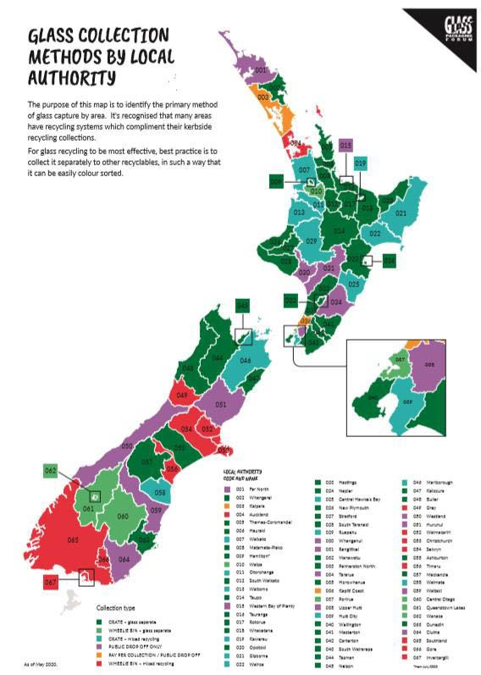

Download map from [http://ovbshwospg3y3lle2ft6zyha-wpengine.netdna-ssl.com/wp-](http://ovbshwospg3y3lle2ft6zyha-wpengine.netdna-ssl.com/wp-content/uploads/2020/05/GPF_GlassCollectionAreas_05-20-smaller.jpg) [content/uploads/2020/05/GPF_GlassCollectionAreas_05-20-smaller.jpg](http://ovbshwospg3y3lle2ft6zyha-wpengine.netdna-ssl.com/wp-content/uploads/2020/05/GPF_GlassCollectionAreas_05-20-smaller.jpg)

# APPENDIX B – LITERATURE REVIEW - RECYCLING SYSTEMS

The literature review on kerbside recycling systems examined contamination, yield and missed capture, employment, health and safety, cost and environment.

##### Contamination

The literature reviewed unequivocally demonstrates that comingled recycling systems produce the highest levels of contamination, compared to two / multi-stream systems, source separated or kerbside sorting.

The Welsh Collections Blueprint (2011, p 3) notes that:

*If [recyclate] is kept separate at source its quality is assured; if it is mixed with other recyclate at source then expensive and energy using mechanical processing usually need to be employed to separate it out again. The more materials are mixed together at source, the more mechanical effort is required to separate them out again. This can never be 100% efficient.*

The Commonwealth of Australia’s *Report on Waste and Recycling Industry in Australia* (2018), based on submissions made by the resource recovery sector to a select committee hearing, presents eight submissions (from Re.Group, Maitland City Council, the Waste Management Association of Australia (WMAA), the Total Environment Centre/Boomerang Alliance, Visy, and the Governments of Western Australia, South Australia and the Australian Capital Territory) that link comingled recycling systems with contamination and low value recyclate material and advocated for source separation of materials. Re.Group noted that “Contamination management is a key factor in the cost of operating a recycling facility.” Two other submitters OI (glass recycler) and Equilibrium noted that comingled kerbside systems result in a significant level of small glass fragments and contaminants that cannot be used in recycled glass manufacturing and that high compaction rates break glass into small fragments that cannot be extracted, and contaminates other recyclable materials.

The *DEFRA report* (2019) states that:

*Comingled collections typically contain more contamination, which cannot always be dealt with efficiently by sorting facilities. Higher levels of contamination from non-target materials can increase costs of collection and sorting, and reduce the overall value of secondary materials… Available data for sampling of inputs to MRFs shows that 15.2% of material sent to be sorted was either non-target material or non-recyclable material.*

The report goes on to say that research (by WRAP UK, Zero Waste Scotland, the Welsh Government and WRAP Cymru) demonstrates that multi-stream / two stream collections contain significantly less contamination than comingled collections because the recycling is pre-sorted into separate streams by the householder and then further sorting is carried out at the kerbside meaning “non-target and non-recyclable” items are left in the recycling receptacle.

This is backed up by a European Commission report on *The Assessment of separate collection schemes in the 28 capitals of the EU* (2016) that compares the recycling systems (both kerbside and bring to) of 28 capital European Union cities and determines that strict separate collections of one stream per bin leads to higher quality and lower rejection rates whereas collecting several materials together results in higher contamination and lower quality of recyclables leading to higher rejection rates. It notes that when paper is comingled with other waste streams, and particularly with glass, contamination of the paper/cardboard is between 5-20% compared with 1% when collected separately. The report indicates that plastic and metal collected together does not have the same issues so is a reasonable way of reducing costs and maintaining good quality material for these streams.

The MfE commissioned the *National Resource Recovery – situational analysis report* (2018) notes that “Wheeled bin-based systems typically suffer more in terms of contamination. There are two types of contamination that

occur: the contamination from the mixing of recyclable materials (plastic in with paper, paper in with plastic, glass in with paper etc.); and gross contamination from householder placing non-recyclable items in the recycling containers.” It goes on to point out that in a comingled system “gross contamination is impractical to identify or remove before it is collected, and material become mixed as it is emptied into collection vehicles, compacted, discharged, and loaded onto sort lines”. While the report notes that there are various reasons for contamination in comingled system (such as confusion about what can be recycled, or because of a cost associated with disposing of rubbish or lack of space in rubbish receptacles), it also points out that lids on wheelie bins enable householders to ‘hide’ rubbish in their recycling bins. The report further states that kerbside sort systems allow gross contamination to be removed at kerbside, although this is dependent on the level of sorting at kerbside. Additionally, kerbside sorting means materials have less opportunity to become mixed and cross-contaminate each other. The report also states that because kerbside sorting enables contamination to be identified and rejected at the point of collection it reduces the need for subsequent sorting and lowers the overall level of contamination in the end product. This in turn means recyclers and local authorities receive higher prices for the material and reduced capital investment needs for sorting equipment.

*Rebooting Recycling (WasteMINZ, 2018)* also recommends that glass should be collected separately from other recyclables due to the contamination that occurs when glass breaks. It goes on to recommend other actions that could be taken to improve the quality of recycling (within the current kerbside collection model), including undertaking more sorting at kerbside to ensure “contamination is removed before the material is bulked”, as well as providing education to the public when non-recyclable material is left behind in their receptacles.

WRAP’s *Choosing the right recycling collection system* (2009) notes that reject rates for kerbside sort schemes are typically less than 1% whereas reports of MRF reject rates vary from 10.8% (from the Environment Agency) to 7% (from the Waste Data Flow 2007/08), to 12-15% for MRFS involved in a 2006 WRAP study and between 2- 5% for the most efficient MRFs. The report notes, however, that these rates only reflect the residual rubbish sent to landfill from MRFs because UK reprocessors report that they send further residual rubbish to landfill that reflects the contaminants included in the material they receive.

Another report from WRAP entitled *MRFs Comparison of efficiency and quality (2006)* notes that:

*Local authorities and waste contractors often prefer the convenience and potential lower collection costs of the single- and two-stream co-mingled collection systems. On the other hand, most reprocessors purchasing the recovered materials prefer that materials be sorted at kerbside as this minimises the potential for cross contamination and generally produces higher quality materials. The challenge of two-stream, and more so single-stream MRFs, is to meet the specifications required by the materials markets/ reprocessors.*

##### Yield and missed capture

A 2020 report on materials disposed of to domestic kerbside rubbish and recycling in Aotearoa New Zealand (Yates, 2020) estimated that the average household disposes of the following recyclable materials through domestic kerbside rubbish collections annually:

* + 5.8 kg of plastic 1 (PET)
  + 2.7 kg of plastic 2 (HDPE)
  + 2.6 kg of plastic 5 (PP)
  + 2.1 kg of corrugated cardboard
  + 24.5 kg of recyclable paper and paperboard
  + 3.7 kg of steel cans
  + 0.9 kg of aluminium cans
  + 10.3 kg of glass bottles and jars

The literature reviewed varies in its conclusions about the impact of collection systems and yield, depending on whether the report merely measures gross yield or whether it is concerned with capturing high quality yield.

The DEFRA report (2019) purports that comingled systems “yield marginally more recyclate” whereas the WRAP report *Kerbside Collections Options: Wales* (2011) notes that applying waste flow models shows that comingled sort systems achieve higher yields than kerbside sort systems, but are more contaminated. Another UK report from WYG *Review of Kerbside recycling collection schemes in the UK in 2011/12* (2013) that includes factors such as the impact of deprivation on yields to make a comparison between different collection types notes that areas with lower deprivation tend to have higher recycling yields. In addition it claims that yield is higher for fully co- mingled, including glass, systems compared to: two-stream with separate glass; two-stream with separate paper; separate collections for all materials or co-mingled with no glass; and lowest for separate collections for all materials that exclude glass.

The Eunomia NZ report (Wilson, 2018) notes that because comingled wheelie bin systems offer more capacity than crate systems, they enable more material to be collected and that good performing systems can collect approximately 250kg per household per year or 25% more than crate-based systems.

The WRAP report *Choosing the right recycling collection system* (2009) notes that it is widely perceived that co- mingled collections are more effective at capturing material than kerbside sort schemes and on average co- mingled collections do attract around 36kg per household more material – most of which is paper and card. However, the report goes on to note that these figures make no allowance for rejects from either the MRF or the reprocessor of wrongly sorted material. The report states that there is evidence that providing additional containers or more frequent collections, kerbside sort schemes can have the same effective volume for recyclate as co-mingled collections and achieve similar results. An *Assessment of domestic waste and recycling systems* by the New South Wales Department of Environment and Conservation (2004) found that of the six domestic waste management collection scenarios considered in the study, yields are highest for fortnightly commingled wheelie bins with a fortnightly collection of paper and cardboard in a separate bin, followed by fully commingled recycling collections. Crate systems were found to yield the lowest quantity but had the lowest contamination rates.

However, in contrast, the European Commission report (Seyring et al. 2015) determines that strict separate collections of one material per bin usually leads to higher recycling rates. This is supported by the Commonwealth of Australia report (2018) where seven submitters stated that separation of materials at source results in higher yield and quality recycling materials. The Welsh Assembly Government’s *Collections Blueprint for affordable and sustainable local authority collection services for recyclable, compostable and residual waste* (2011) also argues that the best kerbside sort systems yield the same level of capture as comingled systems, and when contamination is taken into account outperform comingled systems in terms of yield.

Lakhan (2015) also found that single stream recycling systems yield 4.11% more recycling than multi-stream systems.

Two other reports did not determine that the type of collection system has an impact on yield. WRAP’s *Analysis of recycling performance and waste arisings in the UK 2012/13* (2015) takes into account geographical and socio- economic factors and determines that the only predictor that had a highly significant effect on yield was the size of residual rubbish receptacles – more capacity for rubbish lead to lower recycling rates (i.e. each additional litre in residual capacity lead to a reduction of mean recycling rates of 0.05±0.02%). It also found that collection systems made very little difference to yield.

WRAP’s 2018 *Recycling Tracker Survey* found that confusion about what can and can’t be recycled is a prominent reason for missed capture, as identified by around one in three households who took part in the survey (34%). A lack of recycling bin capacity was also identified as an enabler of missed capture with around one in five of household respondents identifying with this as an issue for their recycling bin (leading to missed capture). In addition, the more items collected by the local authority the more missed capture there was. In areas that collect 0-8 items missed capture was estimated at 43%, which rose to in 59% in areas collecting 14-15 items.

##### Employment

While employment is not an issue this project specifically addressed, it was raised by stakeholders as something that needs to be kept in mind when assessing best practice kerbside collection systems. Therefore, where the literature addressed employment, it has been included here.

Only one report by Eunomia for WRAP Wales (2011) analyses employment intensity. It used a capture rate of over 70% and a capture rate of below 70% and concludes that with a capture rate of below 70% more full time equivalent jobs would be created if all Welsh authorities adopted a kerbside sort methodology. However, when capture rates move to above 70% a two-stream collection would create more jobs. For both scenarios co- mingled collections created the second highest number of jobs.

##### Health & Safety

Again, while health and safety issues are not a specific part of the scope of this report it was another issue that stakeholders identified as needing to be considered during the project.

A report commissioned by WasteMINZ Health and Safety Sector group and compiled by Morrison Low *An assessment of the health & safety costs and benefits of manual vs automated waste collections* (2010) analyses a report from Research NZ, which was based on data from the four major waste companies and is concerned with health and safety relating to collectors only. It focuses on the key health and safety risks associated with both automated and manual collection methodologies and determined that while automated bin collection systems accounted for 46% of all collections, they only accounted for 5% of the injuries. Bag collection was the second most common collection method with 32% of the collections but resulted in 36% of the total injuries sustained. ‘Loose collection’ injuries accounted for 41% and non-automated bin collection accounted for the remaining 17% of injuries.

A review of this report (Wilson, 2010) found that the original Research NZ report overstated the hours worked for manual collections by not taking into account the extra workers this method often entails. This means the injury rates estimated per 100,000 hours and costs per 100,000 households for manual sort methods may not have been accurate.

The report by Eunomia for WRAP Wales (2011) reviewed the WasteMINZ/Morrison Low report, alongside ten other reports that address health and safety issues and concludes:

*There has been much debate in the industry about the relative merits of kerbside sort, two-stream and co-mingled collections in terms of whether one system is inherently ‘safer’ or ‘healthier’ than another. Statements that one system is safer than another are often missing the point, as a holistic approach is required when managing risks. The question that needs to be asked is ‘can the risks in any given system be managed?’.*

The report goes onto note that their analysis of collection systems and health and safety was inconclusive.

A recent report commissioned by WasteMINZ examines the COVID-19 pandemic risk factors for different collection methods. It highlights that where there is more than one employee in a rubbish or recycling truck social distancing is difficult to maintain, thus increasing the risk of exposure. In additional manual handling of wheelie bins and crates is a risk factor as the virus can be passed on from surfaces touched by a householder with the virus. With manual sorting or handling the risk increases as more time is spent touching potentially contaminated surfaces. The report includes recommendations for managing these risks during a pandemic such as a crew of workers working on the same route travelling in different vehicles and increased use of PPE (Dearsly, 2020).

It is important to note that none of the literature address emerging health and safety issues such as the fire risk of ewaste incorrectly disposed of in recycling bins. Kerbside sort systems allow e-waste and other hazardous items to be left behind, limiting fire risk in recycling trucks and at recycling facilities.

##### Financial Cost

The Commonwealth of Australia Report Waste and Recycling Industry (2018) includes a submission from the Victorian Waste Management Association (VWMA) which states that “separation at source (i.e. by the householder) requires significantly more resources and space and reduces the economics of the activity”.

However, the report by Eunomia for WRAP Wales (2011)1 found that where the cost of waste collection and disposal, revenue from the sale of recyclable material and the cost of processing material at a MRF are taken into account, a roll out of kerbside sort collection across the whole of Wales would result in lower financial cost than either co-mingled or two-stream collection in both the 2011 performance and under the enhanced performance scenario. The cost differential increases under the enhanced performance scenario, again in favour of kerbside sort systems. In the enhanced performance scenario, co-mingled and two-stream collection would cost 22% (or £25.2 million) and 21.4% (or £24.6 million) more respectively than kerbside sort systems. The Eunomia *Review of the Welsh Assemblies Collection Blueprint* (Papineschi et al, 2016) also found that materials collected in separate containers and sorted at the kerb provide a lower cost solution than other comparative collection systems, even when the efficiency of all services is optimised.

This finding is backed up by the European Commission report (Seyring N, et al. 2015), which found that the total cost of collection and processing together tends to be lower in source separated systems than in commingled systems.

The WYG Group report (2013) concluded that where a local authority has access to a locally-based modern MRF (modern is not defined), co-mingling or two-stream is usually cheaper, but, if not, kerbside-sort is often cheaper.

The Eunomia NZ report (Wilson, 2018) notes that systems that produce more contamination had increased costs due to the need to employ more sorters, upgrade equipment, slow down sort lines, as well as the additional landfill costs of disposing of the contamination. *An independent assessment of kerbside recycling in Australia* (Nolan, Philpott 2013) concludes that crate-based kerbside sort systems are not significantly different in cost terms to crate-based MRF systems, i.e. the additional labour costs of the kerbside sort component are similar to the MRF sorting costs.

A report by Covec *Recycling: Cost-benefit Analysis* (Denne et al, 2007) prepared for MfE found that both collection and sorting costs were lower for source-segregated/crate systems, but when adjusted for household density cost per tonne was lower for a comingled collection system, as outlined in the tables below1:

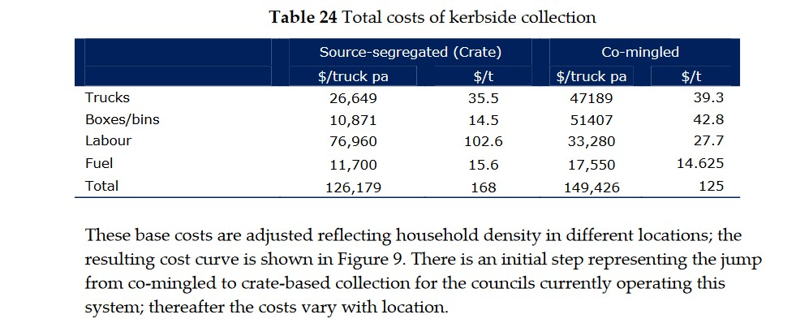

1 It is important to note that since 2007 the value of recyclate has dropped significantly in Aotearoa New Zealand, this would impact on any new cost benefit analysis.

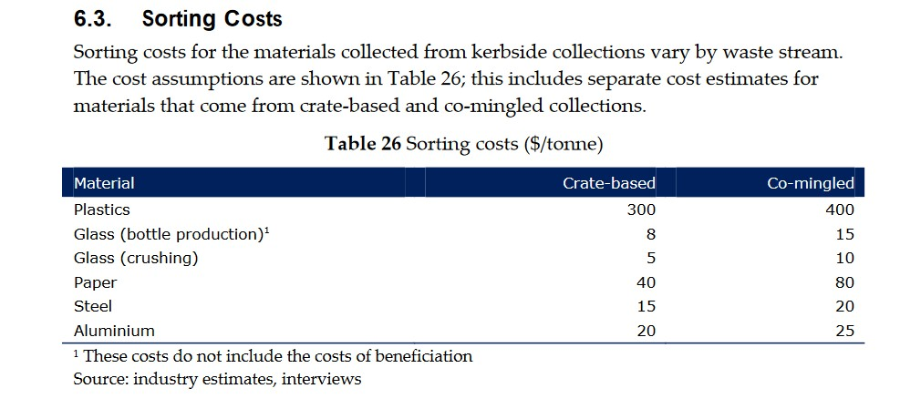

The NSW Department of Environment and Conservation (2004) report found that as the cost of residual rubbish

disposal increases the net cost of kerbside recycling reduces. The authors noted that for comingled systems the savings in collection costs needed to be measured against the increased costs of disposing of contamination. Because of increased costs of processing the overall cost of comingled systems was found to be similar to the other systems modelled and the quality of materials (especially paper, for example) recovered through these systems may reduce its ability to find a market.

Finally, a study in Resources *A comparison of single and multi-stream recycling systems in Ontario, Canada* (Lakhan, 2015) used data from 223 municipalities over a ten year period and concludes that municipalities who implement single-stream (comingled) kerbside collections have higher material management costs than those with multi-stream recycling systems. The author found that while collection costs for single stream collection is lower compared to multi-stream collections these savings are offset by processing costs that can be 48.7% higher and a 9.6% lower revenue from the sale of recyclable material.

##### Environmental costs

While environmental costs are not part of the scope of this project one of the reports reviewed did address this issue. The Eunomia report for WRAP Wales (2011) used environmental modelling to consider carbon emissions and air quality impacts and found that in the current and enhanced performance scenario, kerbside sort produced the least overall carbon emissions, with two stream producing the second least amount of carbon emissions.

The WRAP report on choosing the right recycling system (2009) asserts that recycling has to be viewed as more than just an alternative to disposal to landfill and argues that higher value recyclates have a lower impact on the environment. It notes that:

*Recycling reduces the use of virgin materials and much of the energy required to extract and process raw materials. Generally, the greatest benefit is achieved by closed loop recycling where materials are put back into the same or equivalent application substituting for virgin materials. These benefits can only be achieved if the collection system delivers recyclates of sufficient quality. Lower quality recyclates can generally only be used for lower value open loop applications. One example is container glass that has to be used as aggregate with little environmental, resource or financial benefit because it is not of a quality suitable for re-melt applications.*

The NSW Department of Environment and Conservation (2004) asserts that recycling of paper to make paper significantly higher environmental benefits than using paper for energy recovery, or to be converted into mixed- waste derived compost.

# APPENDIX C – CONSULTATION WITH INDUSTRY

The following organisations were consulted during the engagement process:

|  |  |
| --- | --- |
| **Plastic industry** | **Organics processing** |
| Plastics NZ | Envirofert |
| Flight Plastics | EcoStock |
| Replas | Living Earth |
| Comspec | **Collection contractors/MRF operators** |
| Pact Group | Waste Management |
| **Fibre industry** | EnviroWaste |
| Oji | Metallic Sweepings |
| Hawk Packaging | Smart Environmental |
| Reclaim | Earthcare Environmental |
| **Metals industry** | EcoCentral |
| NZ Metal Recyclers Association/ | Xtreme Zero Waste |
| Pheonix Metal | Northland Waste |
| **Glass industry** | **Other stakeholders and industry experts** |
| Glass Packaging Forum | Para Kore |
| Visy | Waste Not Consulting |
| OI | Eunomia Research and Consulting Container Return Scheme Working Group |

# APPENDIX D – LOCAL AUTHORITY ATTENDENCE AT HUI

Representatives from the following local authorities attended the hui:

|  |  |
| --- | --- |
| Ashburton District Council | New Plymouth District Council |
| Auckland Council | Northland Regional Council |
| Buller District Council | Palmerston North City Council |
| Central Hawke's Bay District Council | Porirua City Council |
| Central Otago District Council | Queenstown District Council |
| Christchurch City Council | Rangitikei District Council |
| Clutha District Council | Rotorua District Council |
| Dunedin City Council | Selwyn District Council |
| Far North District Council | South Taranaki District Council |
| Gisborne District Council | South Wairarapa District Council |
| Gore District Council | Southland District Council |
| Grey District Council | Tararua District Council |
| Hamilton City Council | Tasman District Council |
| Hastings District Council | Taupo District Council |
| Hauraki District Council | Tauranga City Council |
| Horowhenua District Council | Timaru District Council |
| Hutt City Council | Upper Hutt City Council |
| Invercargill City Council | Waikato Regional Council |
| Kaipara District Council | Waimakariri District Council |
| Kapiti Coast District Council | Waipa District Council |
| Kawerau District Council | Wairoa District Council |
| Mackenzie District Council | Waitaki District Council |
| Manawatu District Council | Wellington City Council |
| Marlborough District Council | Western Bay of Plenty District Council |
| Masterton District Council | Westland District Council |
| Matamata Piako District Council | Whakatane District Council |
| Napier City Council | Whanganui District Council |
| Nelson City Council | Whangarei District Council |

# APPENDIX E – SUMMARY OF SURVEY RESPONSES

Of the 67 local authorities invited to respond to the survey, 37 (55%) responded. Four respondents (11%) had not attended a regional hui. A summary of the responses to key questions relevant to the standardisation of kerbside collections is provided here.

##### When does your current kerbside recycling contract expire, or do you have an opportunity to negotiate a change to the methodology?

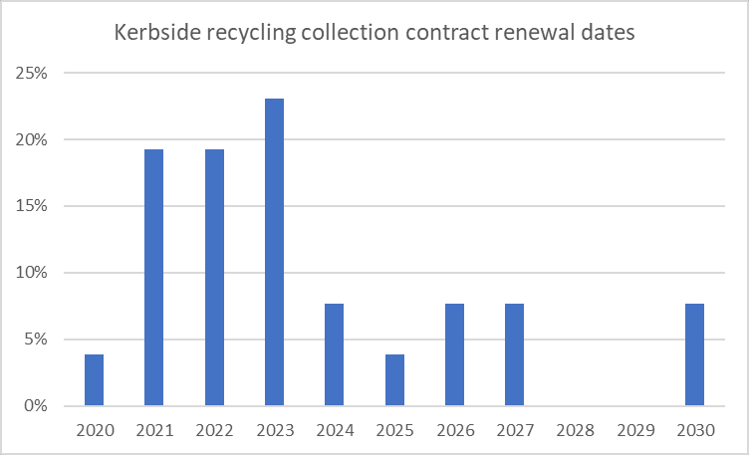

A number of local authorities indicated they can change contracts at any time but sometimes this involves a financial cost.

##### What was the current average contamination rate in your kerbside recycling collection before Covid-19?

Contamination rates ranged from under 1% to up to an estimated 40% but interestingly 16 out of the 37 local authorities who participated in the survey did not know their contamination rates.

##### If you use a MRF, is it located in your district? If not, is it located in your region?

20 of the 37 local authorities who responded to the survey have a MRF in their district (54%) and a further 13 (35%) had a MRF in their region.

##### Recyclable materials: Do you agree that kerbside recycling collections should collect plastics 1, 2 and 5, glass bottles and jars, aluminium and steel cans, and fibre (excluding liquid paperboard)?

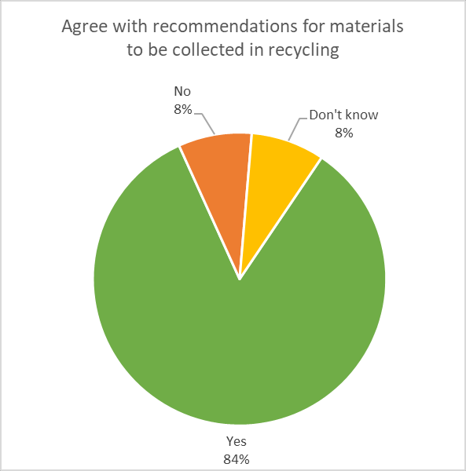

**Comments:**

* 1. **In support**
* Do materials first. This is an easy win.
* Recycling - agree 1, 2, 5 plastics only. Glass must be separate and ideally colour sorted

##### Plastics 5

* There is some difficulty in identifying No.5 plastics and there is a risk of introducing contamination
* I have agreed with the materials but only on the basis that there is an economic market available to our contractors for the sale of this product.
* If 5 could be collected under the same market conditions as 1 and 2 great.

##### Plastics 3, 4, 6 and 7

* Instead of removing plastics 3,4,6 and 7 from the collections, it should have standardization of applications/use for those "low-value" plastics. There is no point to try to become "zero waste" if we send plastics that could be recycled to landfills. It's important to promote alternatives or look for facilities that will be able to process.
* Why are WasteMINZ not lobbying MfE more on the sectors behalf to legislate low grade plastics out of the market place and also bring in an accelerated container deposit scheme for glass and other drinks containers. The two issues were glossed over at our Hui and I recall a comment from the MfE that these are still some years away yet. This is not good enough and relies on TLAs being the ambulance at the bottom of the cliff (as usual). It seems to be easier to put the reliance on the end user (and thus end up with multiple different services which serves to confuse and make up look stupid) rather than tackle head on where it needs - at the highest level. Do it once and do it right!
* I think kerbside should collect all plastics and sort at stations and work with manufacturers to not

package with “non-recyclable" recycling.

##### General

* In order to determine what recycle products we can take, and if needs to be separated, we need to see if we can establish recycle MRF's regional. What can we develop and build on a regional basis so recycle processing can be done locally
* The community will need to be notified and educated of any change in the acceptance of recyclables. An alternative could be to avoid changing the public understanding of what is acceptable. This allows

the product to resume being sold as soon as a market is available. However, this would require space for stockpiling the product with no guarantees that the markets will recover. As such, there is a significant risk with this consideration

##### Organics: Do you agree with food waste collection in 23-litre bin, weekly (option for food and greenwaste collection if compost facility requires greenwaste – though preference is for this to be sourced from transfer stations or private collection contractors)

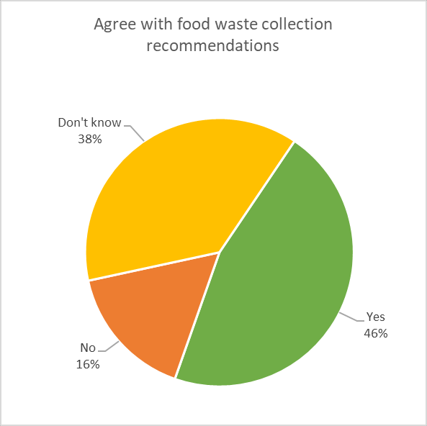

**Comments**

* 1. **Against**
* Do not accept that separate food waste collection needs to be part of kerbside.
* food waste will be a very tricky one to sort out. I disagree with moving this material for miles & miles green waste & food waste should not be mixed as both require different systems degradable bags & organic certification needs to be addressed in composting systems

##### Supportive but with reservations

* Not sure comment added for greenwaste as Timaru DC system not in alignment 240 litre organics bin for greenwaste and food collected weekly

##### Rural areas / areas without a facility

* A food waste collection shouldn't be mandatory for rural areas where diversion can be achieved through other methods.
* Food waste in Hurunui likely to be a low uptake as a rural community
* Not sure about organics as there is no composting facility in our region
* Very keen for a food waste collection service, however in our region we do not currently have a facility to deal with food waste. So for a region like ours - standardising an organics collection would be a wonderful opportunity however infrastructure/processing is a key consideration

##### Recycling: Do you agree with a collection system to be selected by council and their contractors, but that must have glass collected separately and achieve a high set standard for contamination and material quality?

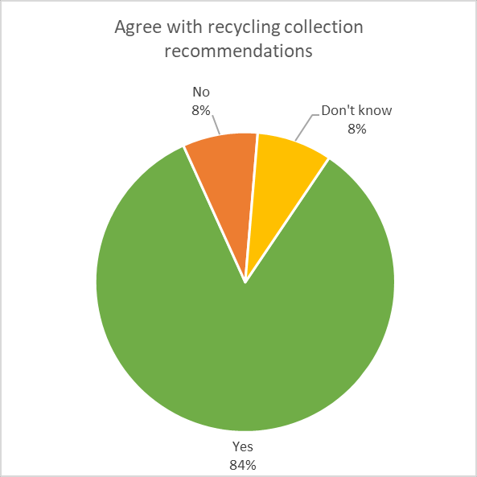

**Comments:**

* 1. **Glass separate**
* Getting glass out is a no brainer.
* I would be in support if the glass packaging industry was going to fund the glass collection system, and the paper packaging industry funded to meet the cost of contamination standard.
* We have found in Hurunui that keeping glass out of the kerbside recycling improves the contamination levels and we use clear bags to see contamination at the kerbside and sticker and leave for education
* I am not convinced that glass should be separate. Impact of CRS on glass should not be ignored. As I understand from the paper and cardboard recycler - fibre should be collected separately to minimise contamination. The remaining glass (after CRS) can go in with the remaining products

##### Central government assistance needed

* Due to small size of residential population (6,000 est.) it is too expensive to expand our recycling services without central govt. assistance. We want to do more but can not fund through rates.
* Standardising the collection methodology is very complex and need the time and consideration it deserves. It will require significant financial support from central government for smaller local authorities due to required scale up of operations and roll out of facilities.

##### General

* We have not discussed the crate vs bin discussions regarding contamination, in Taupo there is no limit on the recycling volume placed for collection, and as it is Kerbside sort we don't really suffer contamination. So the only benefit a wheelie bin has is no manual handling and no wind blown litter. Our pre-paid refuse bag incentivises recycling as you have to pay for another bag. You don't really get this incentive when using wheelie bins as the cost is either in rates or paid 6 monthly or yearly. This then gets people to fill their wheelie bins as they want to get their monies worth...

##### Rubbish – do you agree with 120 or 140-litre wheelie bins (collected fortnightly once food waste collection is available), or 60-litre rubbish bags?

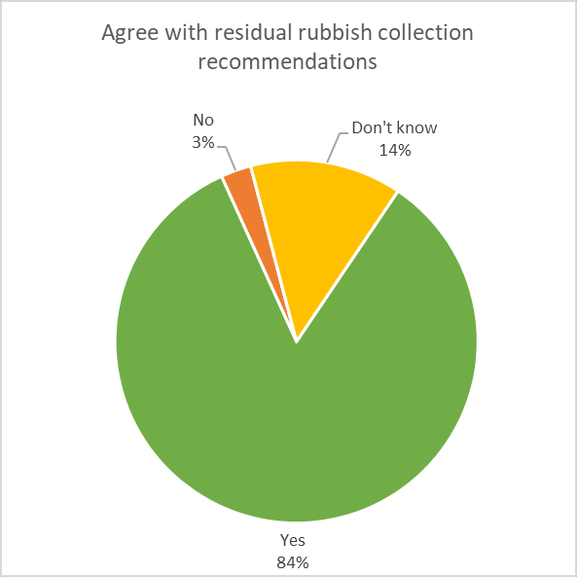

**Comments**

* 1. **Bags**
* Please add 60 litre or less rubbish bags
* Avoid rubbish bags where possible

##### Bins

* Not sure about benefits of wheelie bin for waste - if provided they should be commercial or pay as you go to reduce incentive to fill the bin. Also not sure of the need for food waste collections.

##### Size options

* Rubbish - either 140l wheelie bin (or smaller 80l? option) and 60l rubbish bags depending on topography/wind.
* Weekly collections of rubbish in a 80l MGB should also be an option as this is pretty standard

##### Do you think there is need for a national organisation (similar to EECA) that provides assistance with collections modelling, waste strategy development, operational support, identifying best markets for recyclate, and education?

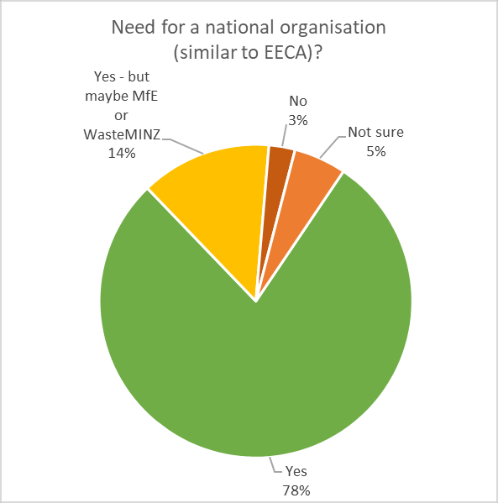

**General comments**

* Fully endorse standardization and happy to work towards achieving it.
* The timing of this research will affect the quality of the outcome. Also many of the real opportunities to divert or prevent are outside the scope of this project but interconnected with it, thus limiting the effectiveness. The focus should be on changing the quality of what is collected to preserve what little value the commodities have. Education is best served at the kerb by rejecting material. This also means what is collected is clean. Every region has specific issues. Our landfill receives a lot greenwaste from commercial wheelie bins for example, which is where we decided to make changes. In a dense city that would be different. One size does not fit all nor can everyone afford the same solution. There are places where carting glass to OI does not make sense for example. The length of contracts is not in synch with the markets, which the National Sword policy in China has painfully proven. So lets focus on these and new markets nationally and internationally before changing what we feed into them. At the moment the markets move quicker than the time it takes to educate the community. Oil is almost given away making virgin plastic very cheap. It always has the quality edge as well. Lastly I hope this project is portrayed by the media in the right way, as it can put many Councils that are really trying into a bad light i.e. they don't have the recommended "standard" solution and are locked in for years. The general public is quick to judge and not hindered by the integral knowledge needed to understand the topic at hand.

# APPENDIX F – MATERIALS TO BE ACCEPTED IN KERBSIDE AS PRESENTED AT HUI

### Plastic – kirihou

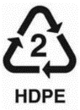Plastics 1 (PET), 2 (HDPE), and 5 (PP) are accepted.

|  |  |
| --- | --- |
| **ACCEPTED** | **CONDITIONS** |
| Plastic pots, tubs and trays:   * Jars (e.g. mayo, peanut butter) * Punnets (e.g. fruit, veg, cake packaging) * Meat and biscuit trays * Tubs (e.g. ice cream, yoghurt) * Takeaway containers   Plastic bottles, clear and coloured, from around home:   * Drinks bottles (e.g. juice, fizzy drink, milk) * Cleaning product bottles * Personal care bottles (e.g. shampoo, shower gel) * Ready to use plant food * Medicine and shampoo bottles | Rinsed clean  Removed and placed in rubbish:   * Lids * Film lids and wrap * Absorbent pads in trays * Pumps and triggers   No chemicals containers e.g. anti-freeze, pesticides |

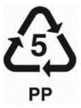Plastics 3 (PVC), 4 (LDPE), 6 (PS) and 7 (Other) are not accepted. This includes all of the following items, and any items listed below made from plastics 1 (PET), 2 (HDPE) and 5 (PP).

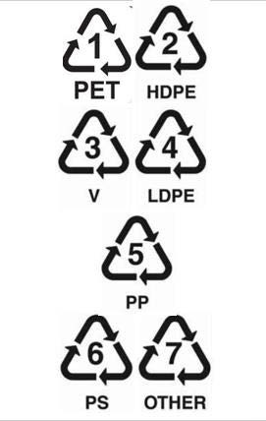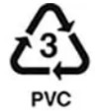

|  |
| --- |
| **NOT ACCEPTED** |
| * Non-PET and coloured chocolate, biscuit, cracker trays * Film lids from the pots or trays * Laminated pouches (e.g. cat food/coffee pouches) * Plastic bottles containing chemicals (e.g. anti- freeze, pesticides) * Plastic toys * Plant pots * Medicine packs (e.g. headache pills, etc.) * Toothpaste tubes and toothbrushes * Expanded polystyrene e.g. packaging inserts * Hose, tubing, PVC pipe * Buckets and washing baskets * Strapping * Carrier bags/plastic wrapping film e.g. bread bags and bubble wrap |



### Metal - konganuku



|  |  |
| --- | --- |
| **ACCEPTED** | **CONDITIONS/NOT ACCEPTED** |
| * Drink cans * Food cans * Aerosols from kitchen, bathroom, laundry only | Must be:   * emptied * rinsed clean   Not accepted   * loose tabs * laminated foil * metal lids – including from glass bottles and jars * biscuit/chocolate tins and their lids * aluminium foil and trays * aluminium tubes (e.g. tomato paste) |

**Glass - karaehe**



|  |  |
| --- | --- |
| **ACCEPTED** | **CONDITIONS/NOT ACCEPTED** |
| Glass food and beverage packaging from  around the home, including:   * Bottles (e.g. wine, beer, spirits, olive oil) * Jars (e.g. sauces, jam, baby food) | Must be:   * emptied * rinsed clean * lids removed and placed in rubbish   Not accepted   * Non-food or beverage bottles (e.g. perfume, aftershave, face creams) * Other glass (e.g. Pyrex, drinking glasses, ceramics, nail varnish bottles, microwave plates, mirrors, windscreen glass etc) |

**Fibre - pepa me kāri mārō**

|  |  |
| --- | --- |
| **ACCEPTED** | **CONDITIONS/NOT ACCEPTED** |
| * Newspapers and supplements * Magazines, brochures and catalogues * White paper (e.g. computer paper, letters) * Telephone directories * Leaflets and flyers * Envelopes (including with windows) * Brown paper * All card from around the home (e.g. card boxes, corrugated cardboard boxes, egg boxes, pizza boxes…) | Must be:   * Clean and empty   Not accepted   * Liquid paperboard beverage containers * Disposable coffee cups * Hygiene/sanitary products (i.e. nappies, wet wipes, sanitary towels) * Paper towels, tissues, cotton wool * Till receipts * Shredded paper * Post-it notes, sticky labels, paper tape * Non-paper gift wrap (e.g. foil-based gift wrapping) or bags * Glitter covered greeting cards or wrapping paper * Lolly packets/wrappers * Wallpaper and decoration paper * Fish & chip paper, or butcher paper that has wrapped takeaways |

### Small items

Recommended that items less than 55mm diameter (i.e., a small yoghurt pottle) are not included in kerbside collections

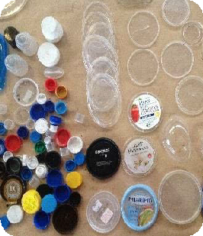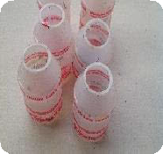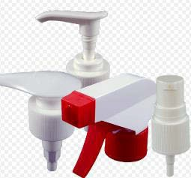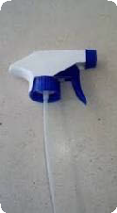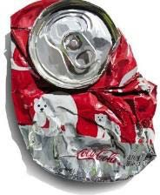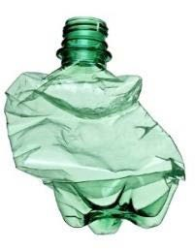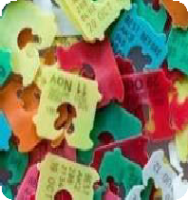

* Issues with small items include:
* Fall out during collection
* Too difficult to pick out of a manual sort line
* End up with glass in mechanical sort due to 55mm holes in trammel
* Have limited commercial value and are difficult to bale

### Lids

Recommended that lids are not collected through kerbside collections. Issues with lids include:

* They get stuck in equipment
* Blow away in wind
* Slip through trammel and contaminate glass
* Can be made of multiple materials
* Larger lids, such as ice cream containers, can be sorted as paper
* Lids off means more chance the container will be empty
* OI specifies no lids for glass bottles and jars

### Triggers and pumps

Recommended that triggers and pumps are not accepted in kerbside recycling.

Issues with triggers and pumps:

* Can be made from different plastic to bottle
* Can contain metal spring

### Squashing of containers

Recommended that bottles and cans are not squashed by householders. Issues with squashing:

* Automated MRFs need 3D shapes or they are perceived as 2D objects (i.e. paper) by optical sorters
* Squashed items that end up in paper line are not salvaged
* Local authorities may prefer squashed items to maximise recycling collected, but this could be a false saving if these items end up in landfill

# APPENDIX G – WRAP CYMRU

WRAP Cymru provides support to local authorities in Wales on behalf of the Welsh Government. It leads the government’s [Collaborative Change Programme](http://www.wrapcymru.org.uk/content/local-authority-support-wales) for local authorities, and supports Wales' [resource](http://www.wrapcymru.org.uk/waste-and-recycling-sector) [management](http://www.wrapcymru.org.uk/waste-and-recycling-sector) and [re-use](http://www.wrapcymru.org.uk/reuse-sector) sectors.

In 2010, the Welsh government released a waste strategy entitled: *Toward Zero Waste, One Wales, One Planet,* that includes targets for municipal waste diversion to recycling and composting, with a target of 70% recycling/composting by 2024/25 as outlined in the following table.

|  |  |  |  |  |  |
| --- | --- | --- | --- | --- | --- |
| **Municipal waste collected by local authorities** | **09/10** | **12/13** | **15/16** | **19/20** | **24/25** |
| **Minimum levels of preparing for reuse and recycling/composting (or AD) for municipal waste.** | 40% | 52% | 58% | 64% | 70% |

The Collaborative Change Programme for Wales was set up by the government and is administered by WRAP Cymru. The programme provides strategic and technical support to help local authorities to develop and deliver detailed plans to achieve the outcomes of the Waste Strategy.

Within the Collaborative Change Programme, local authorities can apply for a range of support, including:

* Service/operations reviews
* Participation monitoring
* Route planning
* Business planning
* Procurement advice and support
* Service and change management
* Enabling partnership working
* Assistance with marketing recyclate to increase revenue
* Skills/capacity building
* Communications and raising awareness

An outcome of the Wales Waste Strategy and the Collaborative Change Programme is that Wales has the highest recycling rate in the UK, and the third highest recycling rates in the world (Papineschi et al, 2017).