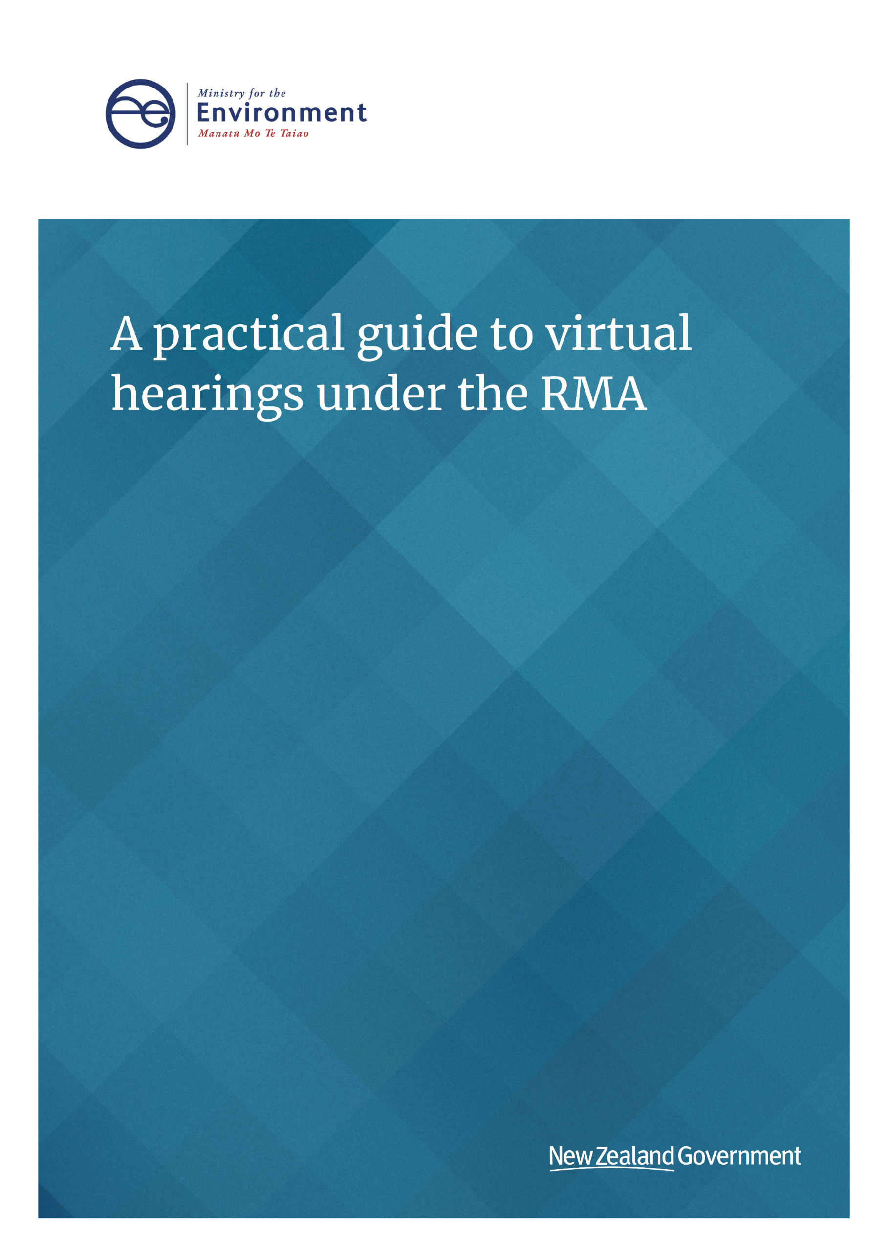

This document may be cited as: Ministry for the Environment. 2020. *A practical guide to virtual hearings under the RMA*. Wellington: Ministry for the Environment.

**Acknowledgements**

Prepared for the Ministry for the Environment by

Phil Mitchell Partner, Mitchell Daysh Ltd

Martin Williams Barrister

Linda Te Aho Associate Professor, Te Piringa Faculty of Law, Te Whare Wānanga o Waikato

Lisa Thorne Associate, Mitchell Daysh Ltd

As the use of AVL technology for public hearings under the RMA is relatively new, this is interim guidance and will be updated as practice evolves. If you have any feedback on the guidance, or useful practical experience with the technology for hearings, email [RMQueries@mfe.govt.nz](mailto:RMQueries@mfe.govt.nz).

Published in August 2020 by the  
Ministry for the Environment   
Manatū Mō Te Taiao  
PO Box 10362, Wellington 6143, New Zealand

ISBN: 978-1-99-003300-1 (online)

Publication number: ME 1510

© Crown copyright New Zealand 2020

This document is available on the Ministry for the Environment website: [www.mfe.govt.nz](http://www.mfe.govt.nz).



# Contents

Overview 4

What is a virtual hearing? 5

Public participation in decision-making 7

Expressly enabling virtual public participation 7

Principles of natural justice 8

Principle of open justice – public ‘confidence’ 8

Applying the principles of natural justice and open justice to a virtual hearing 9

When should virtual hearings be considered? 9

The benefits of a virtual hearing 9

Limitations and constraints 10

When a council should consider a virtual hearing 11

Providing for tikanga considerations in virtual hearings 13

Providing for tikanga virtually 13

Disclosure of sensitive information 14

The mechanics of a virtual hearing 15

Choosing the right technology 15

Providing support and flexibility to hearing participants 15

The virtual hearing process 17

Before the hearing 18

During the hearing 18

After the hearing 19

Appendix 1: template letter or memorandum canvassing party preferences 20

Appendix 2: checklist of virtual hearing requirements 22

# Overview

How we participate in meetings and hearings is changing. Online meetings have become a more common and familiar practice over recent years. While audio-visual technology has been popular for many years, it has had limited use in most of the formal processes under the Resource Management Act 1991 (the RMA), at least until the COVID-19 pandemic.

For many RMA practitioners, virtual hearings, virtual meetings and virtual mediation became the new normal during the COVID-19 pandemic. Not only has this worked well as a substitute for undertaking hearings ‘in person’ or ‘face to face’, but the significant benefits of well-run virtual hearings make them a realistic ongoing alternative to the traditional ‘in-person’ approach.

This document provides the following guidance on how to run an effective virtual hearing:

* what a virtual hearing is and when it can be used in processes under the RMA
* meeting the principles and requirements of open and natural justice in a virtual hearing
* when to consider a virtual hearing – understanding the benefits, limitations and constraints, and canvassing the virtual hearing option with parties
* how to provide for tikanga considerations in a virtual hearing
* the mechanics of a virtual hearing – choosing the right technology and providing support and flexibility to parties
* the virtual hearing process – what to do before, during and after.

Virtual hearings must be fair, run transparently, ensure information is readily available, be participatory, and ensure natural justice for participants. By applying these principles, virtual hearings can provide for good RMA outcomes in terms of both process and decision-making.

# What is a virtual hearing?

A virtual hearing is conducted using a ‘remote access facility’. This is defined under the RMA as meaning an audio or audio-visual link, or ‘any other similar facility’. Typically, the entire hearing is conducted by an audio-visual link. For participants who are uncomfortable or unable to connect to an audio-visual link, an audio link can be made available. A hybrid approach may also be an option for some hearings where both in-person and virtual options are available for participants.

This document uses the following terms to explain the different roles in a virtual hearing:

* **The council** – means the relevant local authority with responsibility under the RMA for the matter in question, which may be a regional or district council.
* **The hearing panel** – means the decision-makers appointed by the council to hear submissions and make decisions or recommendations on its behalf.
* **The democracy advisor** – means the person appointed by the council to support the hearing panel, and other participants in the hearing.
* **The applicant or proponent** – (in relation to resource consents or private plan changes, respectively) means the person and/or entity who is seeking the resource consent or plan change.
* **The submitters** – means people who have made a submission on the resource consent application or plan change involved.
* **The parties** – means all or any of the applicant, proponent or submitters for a plan change or resource consent application, who have a right to be heard.

As is common practice in face-to-face hearings, reports and evidence are pre-circulated electronically and made available online. The virtual hearing is organised in much the same way as a hearing in person, with a timetable and agenda setting out the order and timing of speakers. All participants have remote access to the hearing either online or via phone. Rather than presenting to the hearing panel in person, submitters speak to their submissions over the audio or audio-visual link and can ‘share’ documents on screen if they wish to supplement their presentation with photographs or maps.

Preparation is critical to ensure the hearing runs smoothly on the day, and that all parties can participate fully without any issues. Conducting the hearing audio-visually allows participants to see and hear those speaking, and to view evidence presented on screen. At the end of the hearing, the recording is made available to all participants and published online so there is a complete and accurate record of it. Before starting the hearing, the chair of the hearing panel should make it clear to all participants the proceedings will be recorded and made available on the council website.

Provided the process is managed sensibly, there is good use of audio-visual technology, and there are options for those unwilling or unable to participate virtually, the principles of natural justice and public participation can readily be met. When conducted well, the process is fair, transparent and can be highly participative.

Audio-visual technology is already being used in a number of participative and decision-making processes under the RMA, including:

* plan changes and plan review hearings
* limited and publicly notified resource consent hearings
* other participation under the RMA including pre-application and pre-hearing meetings, expert conferencing, and section 375 objections and section 127 applications to change consent conditions.
* expert conferencing and mediation in the Environment Court.

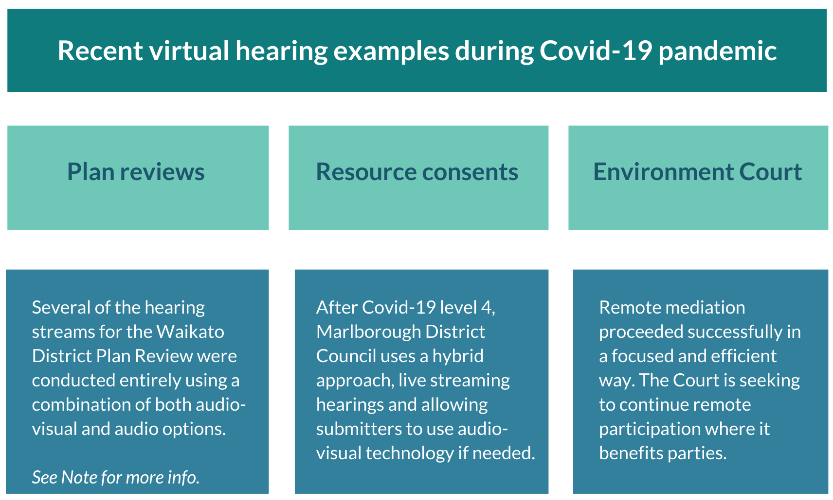

Source: Waikato District Council Proposed District Plan Review Stage 1: <https://www.waikatodistrict.govt.nz/your-council/plans-policies-and-bylaws/plans/waikato-district-plan/district-plan-review/stage-1/hearings>

# Public participation in decision-making

Section 39(1) of the RMA requires local authorities to hold hearings ‘in public’ and establish procedures that are ‘appropriate and fair’ in the circumstances. The term ‘public’ is not defined in the Act but reflects the public participatory scheme in the Act as emphasised by the Supreme Court in *Westfield (New Zealand) Limited v North Shore City Counci*l ([2005] NZRMA 337). This decision highlighted that a general principle of the Act is that ‘better substantive decision-making results from public participation’.

Additionally, the Local Government Official Information and Meetings Act 1987 (LGOIMA), requires, in section 47, that every meeting of a local authority shall be open to the public. As with the RMA, the term ‘public’ is not defined.

## Expressly enabling virtual public participation

In response to the COVID-19 pandemic, the COVID-19 Response (Urgent Management Measures) Legislation Act 2020 and the COVID-19 Response (Further Management Measures) Legislation Act 2020 introduced interim changes to both LGOIMA, the Local Government Act 2002 and the RMA to expressly provide for the use of remote access facilities in meetings and hearings. On 15 May 2020, section 39AA *Hearing using remote access facilities during COVID-19 Response* was introduced to  
the RMA.

This new provision states:

Direction to use remote access facilities

(2) For the purposes of section 39, an authority may direct that a hearing or part of a hearing may be conducted using 1 or more remote access facilities.

(3) A direction may be made under subsection (2)—

(a) on the initiative of the authority itself; or

(b) at the request of any person with a right to be heard at the hearing under section 40.

(4) An authority may make a direction under subsection (2) provided that the authority—

(a) considers it appropriate and fair to do so; and

(b) is satisfied that the necessary remote access facilities are available.

This section expressly confirms clearly that a hearing conducted using one or more ‘remote access facilities’ is a hearing ‘in public’ for the purpose of section 39. An authority may direct that a hearing be conducted using one or more ‘remote access facilities’ if ‘appropriate and fair to do so’. Importantly, while originally set to apply only until 31 October 2021, the Resource Management Amendment Act 2020 has since extended application of the section indefinitely.

There are, however, important requirements to make the hearing ‘public’ in a virtual sense, both during and after the hearing. Specifically, where reasonably practicable to do so, the hearing must be made available, live and free of charge to the public on an internet site, and the authority must similarly make available a recording or transcript of the hearing online as soon as possible after the hearing closes.[1]

## Principles of natural justice

Section 27(1) of the New Zealand Bill of Rights Act 1990 sets out that:

“Every person has the right to the observance of the principles of natural justice by any Tribunal or other public authority which have the power to make a determination in respect of that person’s rights, obligations, or interests protected or recognised by law”.

Section 27 confers to all people the right to be heard – to put one’s case forward and to respond to the case against you.[2] There is no hard and fast rule that natural justice requires an appearance in person before the decision-maker. Instead, the essential test is “what is required to be fair, in the particular circumstances”. This test reflects section 39(1) of the RMA, being a “procedure that is appropriate and fair in the circumstances”.

Under common law, if a matter does not lend itself well to written submissions,[3] or if some parties are not heard orally, it could amount to a breach of natural justice not to offer an oral hearing to all parties. That said, an oral hearing can be provided by an audio-visual link and does not need to be in person in the traditional sense to meet this requirement.

## Principle of open justice – public ‘confidence’

In *Erceg v Erceg,[4]* the Supreme Court found the principle of open justice is fundamental to the common law system of civil and criminal justice, stating:

“The principle’s underlying rationale is that transparency of Court proceedings maintains public confidence in the administration of justice by guarding against arbitrariness or partiality, and suspicion of arbitrariness or partiality, on the part of the Courts...The principle means not only that judicial proceedings should be held in open court, accessible by the public, but also that media representatives should be free to provide fair and accurate reports of what occurs in court.”

This decision by the Supreme Court underscores that what is really at stake is public confidence in the process, with hearings in public better upholding that confidence than if they were considered behind closed doors or decided ‘on the papers’. Again, this policy concern can be met through virtual hearing technologies, which are sufficiently ‘open’ to provide such confidence.

## Applying the principles of natural justice and open justice to a virtual hearing

Overall, there is no reason why the principles and requirements of open and natural justice cannot be met by a virtual hearing. As noted above, section 39AA of the RMA now expressly confirms that an authority may direct a hearing be conducted using one or more remote access facilities.

Section 39AA provides for a direction to be made on the initiative of the authority or at the request of any person with a right to be heard. An authority may make such a direction, provided the authority considers it is “appropriate and fair to do so” and is satisfied the necessary remote access facilities are available. This reflects section 39(1) of the RMA and the common law requirements addressed above.

The authority will need to assess situations in which appearing by remote access facility would, for some reason, not be fair and reasonable in the circumstances, or adequately enable a party to put their case, or respond to the case of another party to the hearing. There may be personal circumstances involved for a given submitter, or the nature of the case or evidence in question may raise this issue. Options to address such concerns can be explored with the party concerned, as discussed further below.

## When should virtual hearings be considered?

There are significant benefits to running a virtual hearing. When run well, virtual hearings can be efficient, effective, transparent and participatory. However, there are some limitations and constraints to virtual hearings that need to be understood and addressed if a virtual hearing is to proceed.

## The benefits of a virtual hearing

Virtual hearings can be just as fair and transparent as a hearing conducted in person. They can be more efficient in both time and cost and highly participatory. They can even be more transparent as the entire hearing is ‘live’ and recorded, and made publicly available. Benefits include adaptability, cost and time efficiencies, transparency, environmental benefit, participant behaviour, fairness, and adaptability for both small and large hearings. More details of these benefits are provided below.

### Adaptability

Virtual hearings are adaptive to changing circumstances and situations. Where there are issues or risks associated with travel and meeting in person, a virtual hearing ensures people can participate in the hearing from their homes or workplaces. This ensures participants remain safe and ensures the hearing remains on-track to avoid delays.

### Cost efficiencies

There is a significant cost saving for all parties involved in the hearing, as there is no need to hire a venue or provide catering or security. Product licences for audio-visual technology are affordable, and there are significant cost savings for those attending who would have previously been required to travel. Parties also need not pay for travel costs including for expert witnesses to attend in person as well as their accommodation at the hearing location.

### Time efficiencies

Virtual hearings save participants significant travel time and save council staff time in not having to set up or pack down venues.

### Transparency

A virtual hearing can be more transparent than a hearing in person, particularly for longer hearings where those who have an interest cannot be present for the whole hearing, but want to stay informed of its progress. By recording the hearing, all content can be made available to all parties, who can then view the hearing at any time.

### Environmental benefit

Virtual hearings significantly reduce carbon emissions that would otherwise be associated with running a hearing in person. Where hearing participants previously had to travel to a hearing to present their submissions, a virtual hearing results in fewer flights and less car travel.

### Participant behaviour

As the virtual hearing is streamed live and recorded, with participants’ faces and responses on screen, this can change participant behaviour in positive ways. As discussed further below, managing participant behaviour can be more readily achieved than for some situations where hearings are attended in person.

### Fairness

Virtual hearings are equitable to all participants as they can increase the ability for those who may not typically be able to participate to do so. Costs in both time and money can deter people from participating in a hearing. The formal setting of an in-person hearing can also deter lay submitters. Hearings in person can be intimidating, particularly for those who do not submit often. A virtual hearing can make it simpler for all parties to participate.

### Adaptable for both small and large hearings

While virtual hearings are easy to organise for small hearings with a small number of submitters, they are also suitable for large hearings. Product licences can host up to 1000 participants depending on the licence obtained. Virtual hearings are particularly suited to topic-based plan review hearings, where a large number of submitters can participate and observe the hearing as it happens. It also allows submitters to present their submissions on multiple topic streams more efficiently and effectively without having to travel to the hearing venue each time.

## Limitations and constraints

There are several limitations and constraints to virtual hearings that must be carefully considered before deciding whether to proceed. These limitations include technology and access, security and data, participant reluctance, and physical presence and body language. Further details of these limitations are set out below.

### Technology and access

A virtual hearing requires an audio-visual product suited to the hearing and, in addition, the council must have the technology to run the hearing effectively and the IT support to address any issues as they arise, particularly for submitters who need help. In more remote locations, the council will need to assess if access to the internet or to technology is a limitation for participants.

### Security and data

Not all audio-visual products are the same, and all platforms carry some level of risk for privacy and data security. When choosing a platform, the council will need to be satisfied the level of security the platform provides will protect the privacy and data of both the council and participants. That said, given the aim is to enable online-accessible public hearings, for most situations security concerns and risk should not arise.

### Participant reluctance

Some participants may be either unwilling or unable to participate in a virtual hearing. They may be challenged, or even intimidated, by the technology involved. This can often be resolved by making technology support available, testing the technology with participants beforehand, providing an audio-only option, and making rooms or spaces with an audio-visual link available to them, for example at a convenient council venue. Where participants are reluctant, understanding why they are will help identify a solution.

### Physical presence and body language

While some submitters may express concerns that virtual hearings will prevent them from being able to read the room effectively, or express themselves fully or with emphasis, this has not been an issue for recent virtual hearings. Where this is a significant concern for submitters, understanding their concerns will help identify whether the issue can be resolved, or whether that portion of the hearing should be heard in person.

## When a council should consider a virtual hearing

If considering a virtual hearing, hearing panels need to consider whether they can run the hearing efficiently and effectively so it provides the same level of transparency and fairness as an in-person hearing.

The type of hearing is a main consideration. A virtual hearing can be simple and efficient for a resource consent application, particularly where there is a limited number of submitters wanting to be heard. For a plan change or plan review process, considerably more pre-planning is required, particularly where submissions are to be heard by topic. For this type of hearing, a licence from the technology provider will likely be required to allow a greater number of participants.

The following is a useful checklist:

* Is a virtual hearing appropriate in the specific circumstances of the hearing involved?
* Can it be run fairly?
* Is the technology and support in place to run this well?
* Where needed, will there be support for those who are not confident using the technology?
* Will the virtual hearing be able to increase (or at least adequately cater for) the participation of submitters?

If these criteria can be met, then a virtual hearing can be canvassed with the parties, including the applicant for a resource consent or private plan change proponent, as the case may be. One way of doing this is for a hearing panel to seek participants’ views in a letter or memorandum sent as soon as possible once the hearing date is set. See appendix 1 for a template letter or memorandum councils can use.

# Providing for tikanga considerations in virtual hearings

In working out appropriate procedures for hearings, section 39(2) of the RMA requires authorities to recognise tikanga Māori where appropriate. In a virtual hearing, providing for tikanga principles and procedures needs extra planning.

Tikanga can be defined as following correct procedure, custom, habit, lore, method, manner, rule, way, code, meaning, reason, plan, practice or convention. Tikanga in an RMA hearing context means to follow procedures and protocols that are appropriate in the circumstances. Tikanga is dynamic, so protocols and ceremonial practices can be adapted to suit a change in circumstances and use of technology where this is appropriate.

This guidance has been prepared with input from an independent expert and informed by feedback from others who apply tikanga in RMA planning and decision-making. Canvassing the option of a virtual hearing with tangata whenua and submitters for a given case will require careful consideration of tikanga principles. Tangata whenua views on the appropriateness of tikanga in a virtual hearing, and how to provide for tikanga virtually, will differ depending on the circumstances and the iwi or hapū involved. Canvassing a virtual hearing with tangata whenua should be done early, possibly before other submitters, and should include kōrero on how to support them to ensure tikanga can be appropriately incorporated into hearing procedures.

## Providing for tikanga virtually

### Tikanga is dynamic

Sometimes protecting the health and wellbeing of people outweighs other considerations, so protocols and ceremonial practices can be adapted to suit a change in circumstances. For example, during the COVID-19 pandemic, tikanga protocols for tangihanga changed significantly – a limit was imposed on the number of people able to attend, tangihanga could not take place on marae, the time period was condensed, and physical contact, including hongi and handshaking, had to be avoided. More and more tangihanga are now also taking place online to allow whānau who live overseas to participate.

### Protocols

Where tikanga is provided for in hearings, space is created for ceremonial protocols involving karakia and mihimihi. This is still achievable in virtual hearings. The act of providing a group waiata in support does not translate particularly well to virtual hearings, but the space to enable a waiata can still be provided.

### Face to face

A key principle for hui is kanohi ki te kanohi or meeting face to face. This allows participants to not only see who they are communicating with, but to use all their senses. This may be achievable to some degree in a virtual hearing on the basis that all faces can be seen. With physical hearings, observers are often seated behind submitters, preventing them from seeing the face of submitters as they speak and engage with the hearing panel.

### Kaupapa

Tangata whenua submitters will often wish to bring a group of support people to enhance their submission, demonstrate mana and highlight the importance of kaupapa. This gives the submitter a level of support beyond the individual presenter. The support group will often comprise kaumātua, or elders who have mana within the community. This is still achievable in virtual hearings as a group can gather and present as one, and hongi and harirū can be practiced within the group.

### Kaitakitanga

The reduction in carbon emissions from avoiding the need to travel to a virtual hearing aligns with tikanga principles of kaitiakitanga, the responsibility to care for the environment.

## Disclosure of sensitive information

The same requirements under the RMA regarding the disclosure of sensitive information apply in a virtual hearing. Where tangata whenua present sensitive information, including disclosing the locations of wāhi tapu, the hearing panel may move to protect the information under section 42(2) of the RMA. Ordinarily, this would be on application by the person or party presenting the sensitive information.

Where this applies, that part of the virtual hearing where the sensitive information is presented can exclude the public. The hearing panel would make a direction before the sensitive information was presented as evidence in the same way as for an in-person hearing – that is, as a resolution to exclude the public under section 48 of LGOIMA.

After such a direction is made, the audio-visual host for the virtual hearing would need to ensure the platform is set up to ensure the submission can only be heard by the hearing panel, and no other parties have access to the audio-visual link until the order has expired under section 42(3), which may be indefinite – giving permanent protection to the information.

# The mechanics of a virtual hearing

The mechanics of running a virtual hearing are different to a hearing in person. Understanding these differences and being prepared for them will ensure the hearing runs efficiently and all parties can participate effectively.

## Choosing the right technology

There are a number of audio-visual platforms currently available, and these are improving over time. Several providers are being used effectively by central and local government and private companies. When choosing technology, important things to consider include the number of participants, the cost and features of the platform.

### Number of participants

When running a virtual hearing, the platform must be able to cater for the anticipated number of participants, as well as any observers and journalists. As a hearing under the RMA is public, councils should choose a product that can accommodate at least 100 people at any one time. If the hearing is of significant public interest and/or has a large number of submitters (such as a plan review), then a larger licence may be needed.

### Cost

The costs of various platforms differ depending on the features they provide. The more features, the higher the price. However, the platform cost is typically significantly more affordable when factored against the comparative costs to council and participants associated with holding a hearing in person.[5]

### Platform features

When choosing a platform, it is critical to ensure the platform provides all the features needed to run the hearing successfully. At a minimum, this must include the ability to record the hearing and share a screen, so documents such as plans and maps can be made available easily and instantly to all online.

Other important features that may be needed include virtual participant waiting rooms, and the ability to mute and remove participants as needed. The platform must also enable audio-only connection both online, and by telephone.

## Providing support and flexibility to hearing participants

The kind of support parties will require in a virtual hearing depends on their level of comfort with the technology being used. Ensuring options are available for parties to be heard in alternative ways and that technical support is available to them is crucial. Important things to consider include testing the technology, troubleshooting protocols, audio option, providing a public space, an in-person option and a hybrid option.

### Testing technology

The democracy advisor supporting the hearing process should test the audio-visual platform before the hearing starts with those parties who want to trial the technology before the day of the hearing.

### Troubleshooting protocols

Establish protocols for the democracy advisor, hearing panel and IT support to address any technological issues that arise, such as audio-visual disruptions from poor internet connectivity.

### Audio option

Audio (either through an internet connection or telephone) should be made available as an option for those with limited internet connectivity.

### Provide a public space

It is good practice to also have a public space available (such as a room in a library) and a computer for those parties that don’t have a mobile phone or computer, are not confident using the technology, or have limited connectivity at home. A support person should be available to help these parties use the space and technology to ensure they can participate fully.

### In-person option

Where the hearing panel is satisfied that a person has a legitimate reason for needing to be heard in person, the hearing panel can hear all other parties virtually, then reconvene the hearing in person to enable that individual to be heard.

### A hybrid approach

A hybrid approach can be used where there are a number of parties who wish to present in person, but others are comfortable participating virtually. Audio-visual technology can also be used to livestream and record hearings in person so the full hearing can be made available online.

Additional planning is required for a hybrid approach to work successfully. The hearing venue will need to be set up well and tested before the hearing to ensure all participants can be easily heard through the venue speakers, and seen by the hearing panel, other participants and observers, and, in turn, the hearing panel can be clearly seen by the participants.

# The virtual hearing process

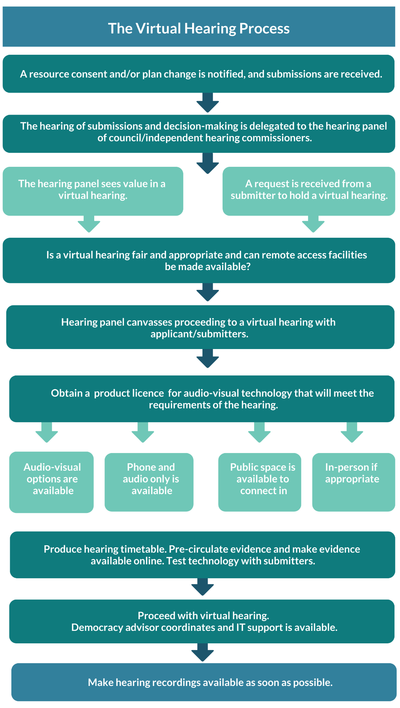

See appendix 2 for a checklist of virtual hearing requirements for before, during and after the hearing.

## Before the hearing

### Structure of the hearing

The hearing panel will need to consider how to structure the hearing early on, particularly for major resource consent and plan changes or plan reviews. By way of example, the audio-visual requirements for a plan review hearing by submission or ‘submitter’ will be different to a hearing by submission topic. This will also affect the sequencing and timing for the hearing and so the requirements need to be well understood before deciding on the best approach.

Audio-visual technology is effective in topic-based plan review hearings, where a large number of participants can attend, observe other parties and present their evidence or submissions on multiple topic streams over weeks or months without having to travel to the hearing venue each time. Topic-based hearings, whether conducted in person or virtually, require considerably more advance planning to ensure:

* the sequence of topics is logical and well publicised
* the hearing enables effective participation for all involved and good decision-making by the hearing panel.

### Understanding and addressing any limitations to participation

The council and hearing panel will need to ensure good planning goes into providing for parties who don’t want to, or are unable to, participate in a virtual hearing. Understanding and accommodating a participant’s personal circumstances and ensuring their participation is appropriate and fair, is critical. The democracy advisor should test the technology with parties and provide continuing support, as needed.

### Communicating the procedural requirements

Much like a hearing in person, getting the logistics and process running smoothly will ensure that on the day, the hearing is efficient and focuses on the key issues.

The hearing panel will need to communicate clearly with parties about the procedural requirements, and all material should be pre-circulated and made available online – not just expert evidence, as is often the practice for in-person hearings under section 41B of the RMA. Sequential pre-circulation of material and requiring summary statements of evidence will narrow down the issues to those key matters needing to be addressed through the hearing.

Clearly communicating the limits on speaking times before the hearing, and actively managing this on the day will keep the hearing to time. The hearing panel should encourage parties to identify matters of agreement in their summary statements clearly so the panel can focus on the main matters in contention, and identify potential solutions to address parties’ concerns.

## During the hearing

### Keeping the hearing to time

Having a democracy advisor run the logistical matters is advisable to keep the hearing to time. This will allow the hearing panel to focus on the matters being raised by parties, rather than on managing the technology. Also, it is advisable to ensure there is time built into the hearing day for breaks, overruns and any technical glitches that may arise.

### Managing participation

The mute and speaker functions of the technology platform should be used so only those who are speaking can be heard at one time. In most platforms, either the participant or the hearing chair can enable the mute function. This is effective in ensuring observers cannot actively participate. Most participants moderate their behaviour well, however the same ‘host’ function can be used to disconnect participants when required, to the extent that such a step would be authorised under the RMA and LGOIMA for hearings in person.[6] Questions from parties are sometimes allowed through the chair during in-person council hearings, to clarify points made by a witness giving evidence. If such questions are to be allowed in a virtual hearing, the chair’s opening remarks should explain how the technology can be used to register that a participant would like to ask a question for that purpose.

### Managing technical issues

Technical issues are uncommon but having IT on standby will ensure these are addressed as they arise. Trouble-shooting protocols will ensure there is a plan in place to address any technological issues such as audio-visual disruptions from poor internet connectivity.

## After the hearing

To keep the process as transparent as possible, hearing recordings should be made available online at the end of each day. Transcripts may also be produced and made available online.

Process improvements can be identified by seeking feedback from participants at the end of the hearing process.

# Appendix 1: template letter or memorandum canvassing party preferences

## From hearing panel or consent authority

1. We have been appointed as the [INSERT HEARING PANEL] to consider and make decisions on [INSERT PLAN CHANGE OR RESOURCE CONSENT REFERENCE] which you are a party to or have submitted on. The hearing is scheduled to start on [DATE IF KNOWN].
2. Section 39 of the Resource Management Act 1991 requires that a “public hearing” be held for the [INSERT PLAN CHANGE OR RESOURCE CONSENT REFERENCE]. Ordinarily, this type of hearing would be held in person, at the [INSERT RELEVANT COUNCIL VENUE].
3. However, section 39AA of the Resource Management Act 1991 now provides that an authority may direct that a public hearing be conducted using one or more ‘remote access facilities’ if ‘appropriate and fair to do so’.
4. This means the hearing for [INSERT PLAN CHANGE OR RESOURCE CONSENT REFERENCE], which you are a party to or have submitted on, could be conducted over the internet using audio-visual technology, rather than in person at the council hearing venue. This option is what we refer to here as a ‘virtual’ or ‘remote’ hearing.
5. We consider a virtual hearing can be just as effective and transparent or ‘open’ as a normal public hearing, enabling all parties to be fairly heard about the issues involved. We also think a virtual hearing can be more efficient, saving travel time and costs for everyone involved, who can then choose where they participate from using their computer or other device. Accordingly, the hearing panel is proposing the hearing proceed virtually.
6. Before we make a final decision about that however, we want to ensure all parties understand and are happy with the process involved. We are writing to seek your views about the option and the process involved.
7. The procedure we propose is set out below:
8. The hearing panel, key council staff and parties will participate in the hearing via video conference using [INSERT PLATFORM NAME’]. This platform can run on a desktop computer, laptop, tablet or smartphone. We would therefore be able to interact with each other in much the same way as would occur if we were all in the same room.
9. We will email all parties including submitters and/or further submitters a “meeting link” a few days before they are scheduled to appear at the hearing. You will just have to click your mouse or keypad on this link to join the hearing at the scheduled time. We will send you further instructions about how to connect and participate soon after. This follow-up email will also advise how long you have been allocated to speak. Our staff will be available to help submitters navigate and test “INSERT PLATFORM NAME” on your device before the hearing begins.
10. To help those parties without access to a suitable computer, tablet, smartphone or other device, or for those parties who are nervous about the technology, we will provide a computer in the [INSERT NAME] library for those submitters who need it. Our staff will be available to help submitters use this computer during the hearing.
11. In the event that you cannot or do not want to participate in the virtual hearing via computer, tablet or smartphone, or at the [INSERT NAME] library, you can still join the virtual hearing by telephone or mobile phone.
12. Members of the public, observers and other council staff can observe or listen to a livestream or audio file of the hearing, which will be published on our website a short while after the hearing.
13. We invite you to respond if you have any issues or concerns about this proposal by return email or phone call. Send your email to [INSERT EMAIL ADDRESS] or phone us on [INSERT PHONE NUMBER] no later than [INSERT DATE]. If you do have concerns, we ask you explain why you feel a virtual hearing might mean you are disadvantaged, in terms of how your submission is presented or understood at the hearing.
14. When considering your response to this proposal we also encourage you to investigate your ability to video conference proactively. Please consider things such as computer/webcam/microphone capability, internet speed and internet data cap, for example.
15. [Option only if the hybrid option is to be considered]
    1. We wish to emphasise that if we proceed with this option, there would be no obligation for anyone to participate in the virtual hearing if they did not want to or could not – for any reason whatsoever, even with the help that would be provided as outlined above. Anyone in this position would only need to advise our [democracy advisor] of their position no later than 10 days before the scheduled start of this hearing. In such cases, we can make alternative arrangements to hear submissions in person in the traditional way.
16. Once we have considered any responses received and decided whether to proceed with a virtual hearing as currently proposed we will let you know.
17. Finally, and whichever option is adopted, we note our [democracy advisor] will contact you separately to find out how much time you need to present your evidence, and whether you have any time constraints over the hearing days proposed [SET OUT IF KNOWN].
18. If you have any questions about this memorandum send them to [INSERT CONTACT INFORMATION].

# Appendix 2: checklist of virtual hearing requirements

|  |  |  |  |
| --- | --- | --- | --- |
| Is a virtual hearing appropriate? | | | Checkmark |
| 1. Can the requirements of *Section 39AA Hearing using remote access facilities during COVID-19 response* be met? In other words, will a virtual hearing be appropriate and fair? | | |  |
| 1. Consider the type of hearing – will a virtual hearing be more simple or straightforward, or more complex? | | |  |
| 1. The hearing panel to canvass tikanga considerations with iwi to determine if tikanga can be appropriately provided for. | | |  |
| 1. The hearing panel to canvass the virtual hearing option with applicant/submitters to find out if they are comfortable with that approach. | | |  |
| 1. Understand submitter issues and risks and address these with individual submitters who have raised any concern. | | |  |
| Before the hearing |  | | Checkmark |
| 1. Find out if there is an existing licence in place for the audio-visual technology or whether a new licence needed. | | |  |
| 1. If obtaining a new licence, answer these questions:  * Will it cater to the required number of participants and observers? * Can it record the hearing? * Can the hearing be made available ‘live’? * Is it cost effective? * Can documents be ‘shared’ on screens easily? * Does it provide a virtual waiting room facility? * Does it enable audio only, and phone connection? * Have privacy and data security risks been considered? * Is it easy to use? | | |  |
| 1. The hearing panel to provide clear instructions about the sequential pre-circulation of material and the requirement for summary statements of evidence. | | |  |
| 1. The hearing panel to communicate clearly the limits on speaking times before the hearing. | | |  |
| 1. Make all pre-circulated material available online on the hearing web page. | | |  |
| 1. The council’s democracy advisor to set up hearing and arrange speaking times. | | |  |
| 1. Test the technology with submitters who require support. | | |  |
| 1. Arrange a public space to be available (eg, a room at a library) and a computer(s) for those submitters without a mobile phone or computer to participate on. | | |  |
| During the hearing | | | Checkmark |
| 1. The democracy advisor to run logistics on the day, ensuring there is enough time built into the hearing day for breaks, overruns and any technical glitches that may arise. | | |  |
| 1. The hearing panel to use the mute and speaker functions so that only those who are speaking can be heard at one time. | | |  |
| 1. Set up trouble-shooting protocols to address technological issues that may arise, such as audio-visual disruptions from poor internet connectivity. | | |  |
| 1. Have IT on standby to address any technical issues. | | |  |
| 1. Have a support person on standby for participants presenting submissions from a public library or another location arranged by the council. | | |  |
| After the hearing | | Checkmark | |
| 1. The democracy advisor to make the recording of the hearing available at the end of each hearing day. | | |  |
| 1. The democracy advisor to seek feedback from participants at the end of the hearing. | | |  |

## 

1. Section 39AA (5).
2. Refer Making Good Decisions: A Resource for RMA Decision Makers (2nd Edition), Module 1, page 17. In an RMA case, this might be the case of an applicant or opposing submitters, for example.
3. In *Faloon v Palmerston North Airport Limited [2013] NZHC 2124*, the High Court found the Environment Court would have benefitted from an oral exchange with an applicant for a declaration, before deciding whether to strike out that person’s case.
4. At [33], *Erceg v Erceg [2016] NZSC 135, [2017] 1 NZLR 310* at [2].
5. At the time of writing (June 2020), a Zoom pro account can be purchased for US $14.99/month per host, which includes up to 100 participants, admin and scheduling controls and recording.
6. Section 50 of LGOIMA authorises the chair of a hearing panel to exclude any person where their conduct would prejudice the orderly conduct of the hearing. Further guidance on managing participant behaviour can be found in Making Good Decisions: A Resource for RMA Decision Makers (2nd Edition), Module 8 – Managing Hearings, as remains relevant to virtual hearings.