##### Memo

To Robin Brasell, the Ministry for the Environment

From Mark Dean, NZIER

Date 26 May 2015

Subject Estimating an electricity allocation factor (EAF)

The Ministry for the Environment (MfE) has engaged NZIER to interpret and comment on a report by Concept Consulting “High level review of approaches for estimating a standard electricity allocation factor (EAF), 1 May 2015”. The report refers a process undertaken back in 2011 (and also 2008) when MfE formed a Contact group to estimate an EAF for energy intensive trade exposed (EITE) firms.

The short run marginal cost (SRMC) analysis in 2011 highlighted how difficult it is to interpret SRMC modelling results once the build schedules start to diverge. Also, in terms of the modelling techniques employed, the long run marginal cost method (LRMC) is relatively simpler and more accessible to ‘non-experts’. So an LRMC modelling technique makes sense in terms of transparency and simplicity, and it is also a theoretically sound approach.

However, I would not support using a purely LRMC approach as the sole analytical tool for determining an EAF. Other factors to consider are:

* a counterfactual scenario, which is subjective yet a critical determinant of the EAF regardless of which modelling technique is employed (for example, using an LRMC method in the 2011 analysis resulted in an EAF post 2020 of either 0.568 or 0.282 t/MWh depending on the counterfactual scenario used)
* EAF volatility due to carbon price uncertainty (with an LRMC approach this effect is magnified if the price forecast is driven by renewables)
* the lack of demand growth in recent years, which if continues will mean less new plant built and therefore LRMC plays a lesser role in price setting behaviour
* the potential uptake of solar PV, which may require new modelling approaches to be considered
* the inability to measure if the market is in a long run equilibrium due to hydrology and other noise, which may result in scepticism of an LRMC approach from stakeholders who pay actual contract or spot market prices.

In reality, the short run spot market will never be in a long run equilibrium for any sustained period of time. Decisions made now under uncertainty result in markets over or under shooting in the future, as inevitably demand or costs evolve in an unexpected way. Figure 1 shows an extract from a high level, simplified dispatch and build model, where hydro volatility is ignored (i.e. assumes ‘mean’ hydrology each year). This is illustrative only and is intended to show how a market in short run equilibrium moves towards a long run equilibrium. Once short run prices rise high enough they are a signal to build new plant (see point 4 for the $0/tonne scenario). If renewable ($0 SRMC) plant is built, expensive thermals are marginalised which supresses SRMC prices. However, as demand continues to grow so do SRMC prices, and so the process cycles on over time.

When a carbon price is introduced (blue line) the SRMC price rises as the thermal stations setting the price will face an increase in their own SRMC. This means that the signal to build new plant is accelerated (point 2). Note the LRMC line doesn’t change since the new plant is renewable (nil emissions in this example). Prices fall as they did in the counterfactual, however at this point in time the counterfactual SRMC price is rising, so is higher than the carbon price scenario. This is what causes a negative EAF.

The key point is that once the two scenarios start to diverge on different build profiles, it becomes very difficult to make comparisons between SRMC outcomes in any given year. Some years will be positive and some will be negative, but over time the average EAF for the carbon scenario should be positive.

This is a dynamic which wasn’t obvious to the contact group at the time of commissioning the modelling work. If it had been known perhaps a slightly different approach to scenario design, modelling and/or output interpretation would have been considered. I don’t believe this dynamic calls into question the entire modelling approach as Concept suggests.

Figure 1 SRMC dynamics when LRMC driven by new renewables

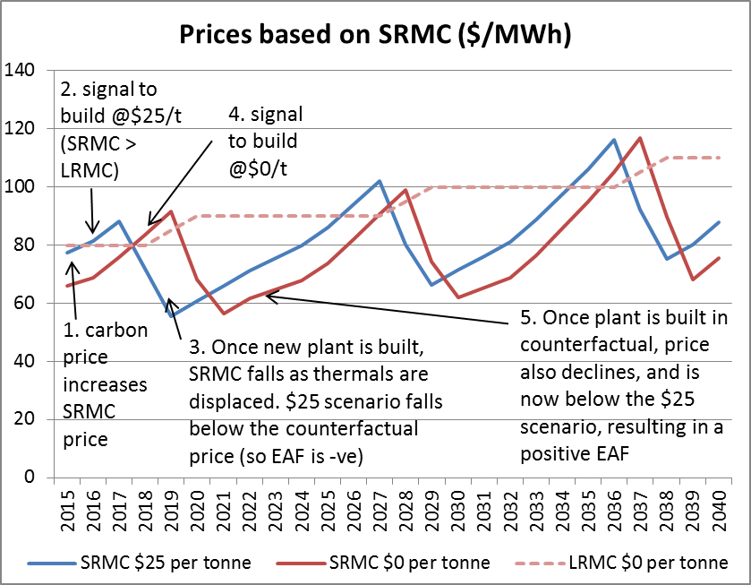

Source: NZIER simplified dispatch and build model

Figure 2 EAF when LRMC driven by new renewables

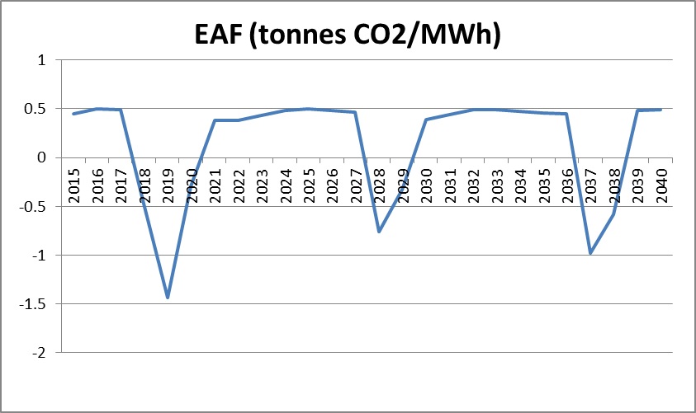

Source: NZIER simplified dispatch and build model

Over time there should be consistency between spot and hedge prices, otherwise there are arbitrage opportunities. Furthermore, if demand increases and new plant is required to be built, the LRMC of new generation is also a sensible indicator of where hedge prices should sit, since a potential investor in a power station would only invest in that plant if they were convinced that generation could be hedged at a price equivalent to LRMC. Therefore, the theory suggests that over time either an SRMC or LRMC approach to forecasting an EAF should yield consistent results.

However, there will be sustained periods when the market is in a long run disequilibrium (Figure 1) and it is possible that hedge contracts will be written for values higher or lower than LRMC. An SRMC approach would be able to model these short run imbalances more explicitly. However, it does require layers of assumptions, more complex modelling techniques, and as we have seen, the design of the scenarios is also a critical component in the analysis.

The optimisation techniques used in the OCCAM[1] and GEM[2] models assume perfect information, and risk neutral behaviour by firms. GEM is like a central planner with knowledge of the costs of all plant, and who can forecast demand with 100% accuracy. If either of these highly stochastic variables turn out to be different than forecast, it is unlikely that the results will be ‘optimal’.

So it is clear that both SRMC and LRMC techniques have their deficiencies. LRMC is a theoretically sound approach however because of short run imbalances, consumers may not be convinced that the EAF calculated from this method will ever reflect a ‘real world’ (as opposed to a theoretical) outcome.

It would seem wise to maintain an open mind when considering modelling approaches for any subsequent EAF revisions, especially given the uncertainty over demand growth and potential ‘disruptive technologies’. A complementary SRMC and LRMC approach should be considered[3], and econometric analysis may be viable now with more historical data available. The modelling of disruptive technologies such as solar PV also needs some consideration.

We would recommend that more rigour be applied to the scenario design and especially in the interpretation of results. Start off by mapping out what the key assumptions were in 2008 and 2011, and then see where we are now. Understand at each step of the process how a particular assumption or scenario could affect the interpretation of the results. The scenario design could be done interactively by interpreting the implications on SRMC, LRMC and potential new build using a high level top down modelling approach (which could provide a ‘null hypothesis’ for testing using more rigorous modelling techniques).

A new smoothed price measure could also be introduced which avoids the negative EAFs in some years. This measure would capture both the expected short run costs on dispatched generation and the accelerated capital build costs (if new build of renewables is brought forward to offset thermal plant). The smoothed price could be labelled the ‘hedge price profile that is NPV (or share price) neutral’[4].

Some crucial assumptions made in 2011 around Huntly decommissioning and carbon prices and demand growth have all turned out differently than was expected at the time. These divergences are probably material enough to warrant revisiting the EAF estimates made in 2011.

1. OCCAM is a stochastic hydro-thermal scheduling model which was used to determine the SRMC price forecasts in the 2011 study. It was also used to determine imperfect market outcomes using a separate Cournot equilibrium process (the Cournot results were not used in the final EAF recommendation).
2. The Electricity Authority’s Generation Expansion Model (GEM) was used to determine the new build schedules, which were then passed as an input into the OCCAM model.
3. Feedback from the 2011 approach indicated most stakeholders were comfortable with the modelling approach taken.
4. This would require a basic financial model of the generators projected revenues and costs over time (estimated using the results from SRMC and LRMC modelling).