Ministry for the Environment

New Zealand Non-Municipal Landfill Database

REPORT


REPORT

Report prepared for:
Ministry for the Environment

New Zealand Non-Municipal Landfill Database

Ministry for the Environment
Report prepared by:
Tonkin & Taylor Ltd
Distribution:
Ministry for the Environment 1 copy
Tonkin & Taylor Ltd (FILE) 1 copy
January 2014
T&T Ref: 29310/ ver5

Table of contents
1 Introduction 1
1.1 Background 1
1.2 Scope of work 1
2 Project methodology 3
3 New Zealand’s main industries 5
4 Sources of information 7
4.1 Communication with Councils 7
4.2 Communications with operators 7
4.3 Cleanfills 7
4.4 Permitted activity sites 8
4.5 Farm dumps 10
4.5.1 National and regional farm holdings 10
4.5.2 Wastes from farms 12
4.5.3 Agricultural soil 14
4.6 Sawmilling operations 14
4.7 New Zealand Defence Force sites 16
4.8 Sludge disposed to land 16
5 Data estimation 18
5.1 Overview 18
5.2 Annual tonnages 18
5.3 Linear regression analysis 19
5.3.1 National gross domestic product (GDP) 19
5.3.2 Regional gross domestic product 20
5.3.3 Results of linear regression analysis 23
5.4 Tonnage per unit regional GDP 25
6 Results 27
6.1 Open and closed sites 27
6.2 Number of consented and permitted sites 31
6.3 Waste composition 32
6.4 Landfill classes 33
6.5 Waste tonnages 37
7 Uncertainties and limitations 40
7.1 Data format 40
7.2 Data entry QA/QC 40
7.3 Data quality rating 40
7.4 Data limitations 41
8 References 43
9 Applicability 44

Appendix A: Summary tables

Acknowledgements
The non-municipals landfills database has been developed with the assistance of Regional and District Council staff and landfill operators. We thank those who have been generous with their time and their willingness to share information. The information shared has provided valuable information and insights for this project.

Introduction

Background
Tonkin & Taylor Ltd (T&T) has been engaged by the Ministry for the Environment (MfE) to develop a database of non-municipal landfills throughout New Zealand. The initial aim of the database is to gather available information on non-municipal fills for greenhouse gas emission estimation. The database is also intended to inform the review of the waste disposal levy.
Estimates of greenhouse gas emissions from solid waste disposal to landfills form part of New Zealand’s Greenhouse Gas Inventory submission to the UNFCCC. Currently these estimates are based on waste disposed to municipal landfills (landfills that accept some household waste). A number of different types of landfills beyond municipal landfills exist. These landfills include cleanfills, industrial fills, construction and demolition fills and others.
The MfE now wishes to incorporate the emissions from non-municipal landfills into its estimates of emissions from solid waste disposal to landfills. This work would involve determining the quantities of waste, the composition of the waste and the management of the waste at these fills for the period 1950-2015.
In 2008, a survey of waste disposal facilities in New Zealand was conducted (SKM, 2008). The survey identified 212 sites around the country that accepted cleanfill, obtained costs of disposal in most regions and estimated the total amount of material being disposed to fills. A follow up report was prepared by the MfE in 2011 which provided more information on consented cleanfill locations and compliance with conditions on their resource consents (MfE, 2011). That report was used to inform the statutory review of the waste disposal levy in July 2011.
The database developed for this project provides the following information:
- Names and locations of consented and where known, permitted fill sites by region
- Years of operation
- Annual quantities placed (actual and permitted limits)
- Types of waste accepted
- Management practices that could influence greenhouse gas emissions
The 2008 and 2011 studies were used as a starting point for this project. Further information was collected for New Zealand wide covering the period from 1950 to present (October 2012). Projections and back-casting was conducted using real GDP.

Scope of work
T&T has been engaged by the MfE to conduct the following:
1A. Develop a database of the raw data. The database will include as far as practical, but is not limited to:
- the location of each facility;
- the age of facility, where possible (when it was first consented, how long it has been in operation);
- the type(s) of waste accepted at the facility;
- the approval type (i.e. consented or permitted activity); and
- the quantities of waste, the composition of the waste and the management of the waste at these fills for the period 1950-2012. The tonnages of waste and the composition of this waste after July 2009 will be highlighted.
1B. A database combining the raw data and estimates.
This database builds upon the database in 1A. It will include estimates to fill the information gaps for years 1950 to 2012 and forecasting tonnages of waste up to 2015. The estimates will be provided at the regional and national scale, and at a finer scale where possible.
Accompanying this document will be a brief document providing a high level summary of the methodology and the limitations of the estimates.
In response to a request from the MfE the level of reporting has been changed to a more detailed report, with the inclusion of some statistical analysis on the data collected.
Statistics
The MfE requested for the database to be developed such that it could be used as part of the review of the waste levy and in particular to assist with the understanding of where different types of wastes are going to nationally, in addition to GHG estimation. Some specific statistical analysis was also requested by the MfE as follows:
At the national level:
- The number of operating non-municipal sites (differentiating between closed and open) in New Zealand over time (from, at the latest, 2000 to 2013)
- The total tonnes going to non-municipal landfills in New Zealand (from, at the latest, 2000 to 2013)
- The composition of waste (it is acknowledged this will be based on accepted materials rather waste received) going to non-municipal landfills in New Zealand (from, at the latest, 2000 to 2013)
- The number of non-municipal sites in the different classes of landfill (1-4) (from, at the latest, 2000 to 2013).
- The total tonnes going to each of these landfill classes (from, at the latest, 2000 to 2013).
At the regional level:
- The number of operating sites over time (from, at the latest, 2000 to 2013)
- The total tonnes going to non-municipal landfills in each region (from, at the latest, 2000 to 2013)
- The composition of going to non-municipal landfills (from, at the latest, 2000 to 2013)
- The number of non-municipal sites in the different classes of landfill (1-4) in each region (from, at the latest, 2000 to 2013)
- The total tonnes going to each of these landfill classes in each region (from, at the latest, 2000 to 2013).

We note that permitted activity sites do not require resource consent or monitoring. Therefore Councils have no means of capturing this information and is therefore only limited information is available. We have therefore extrapolated information as best as we can.

Project methodology
A broad overview of the data collection and data gap filling process is outlined below and represented diagrammatically in Figure 1:
Data collection – Raw Database
- The basis of the database stems from data provided by the MfE at the project initiation stage.
- Regional and District councils were contacted by phone and email explaining the project and requesting data on non-MSW sites in their region. Where possible information on permitted activity sites were provided, however in most cases permitted activity sites are not known to Councils unless an incident arises in relation to the site.
- Follow up phone calls and emails were made to Councils where further clarification on the information provided was required.
- Landfill operators were identified through Council records and discussions with Council Officers.
- Landfill operators were contacted to obtain more detailed information on their sites and management practices.
- Communications with operators also provided more insight into other operations that were not recorded within council databases as “landfills”. This led to contact with other industries such as forestry and sawmill operators.
- Regional industry specific data and data from Statistics New Zealand was reviewed and used to identify other industries that might have been overlooked.
- The data collected was reviewed and entered into the database (refer spreadsheet 1. Non-municipal Landfills LIST.xlsx and 2. Non-municipal Landfills ANNUALDATA.xlsx).
- The raw data was then quality assured (QA) by randomly checking 10% of the database by a third party.
Database combining raw data and estimates
- Regression analyses with independent variable were conducted to determine the strongest correlation with available waste tonnages. However, this did not result in good correlations due to gaps in the survey data.
- An alternative approach was therefore taken, using the maximum surveyed tonnage to estimate annual tonnage per unit regional GDP. For regions where there was no available data, the tonnage per unit GDP for a similar region was adopted.
- Waste tonnages from farm dumps were estimated based on the number of farm holdings and estimated waste tonnages from a survey conducted by Environment Canterbury. Waste from farm dumps were then added to the interpolated tonnages using regional GDP to obtain total waste tonnage to non-municipal landfills (refer spreadsheet 3. Non-municpal Landfills DATAFILLv2.xlsx).

Throughout the process, we have been in discussions with the peer reviewer, Mr Joe Pickin, to discuss the approach and any key findings. This input provides reassurance that the approach is being supported by an international third party expert.
DATA COLLECTION

Regional data comprise:
- Consented & permitted activity sites
- Years of operation
- Annual tonnages from 1950 to 2015
- Composition
- Landfill Class

DATA INTERPOLATION

Figure 1. Schematic methodology for developing the non-municipal landfills database

New Zealand’s main industries
Statistics NZ has identified the main industries in each region, Figure 1. The main industries in New Zealand as categorised by Statistics NZ are listed in Table 3-1. The likely end point for the wastes generated by each industry has been considered based on our knowledge of waste disposal practices in New Zealand and is summarised in an effort to ensure that the major waste generators that potentially contribute to waste disposal at non-municipal landfills have largely been captured in this project.
Non-municipal landfills include cleanfills, industrial fills, construction and demolition fills and farm dumps.
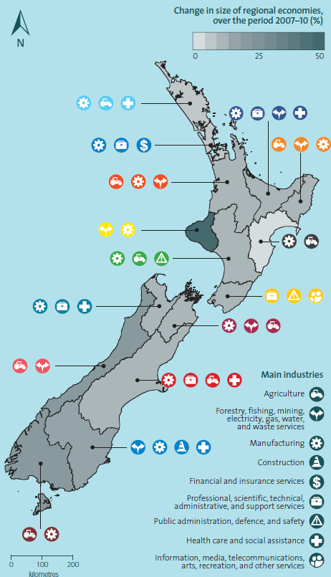
Figure 1. Major industries in each region (source: New Zealand’s Regional Economies, Statistics NZ)
Table 3-1. Main industries and waste disposal
Industry | Most likely waste end point
Agriculture | Farm dumps and MSW landfills. Farming statistics and ECan survey results described in Section 4.5.2.  Emissions from agricultural soil (T&T, 2011) described in Section 4.5.3.
Forestry, fishing, mining, electricity, gas, water and waste services | Consented fills, as provide by Councils and previous database, in relation to forestry, power generation, wastewater treatment (sludge dumps), and discussions with operators.  Other source likely to go to MSW landfills.
Manufacturing | Consented fills for large operations as provided by Council and T&T records.  Smaller operations likely to go to MSW landfills.
Construction | Construction and demolition fills require consents. Depending on contamination threshold some material goes to cleanfills. Information on consented fills were provided by Councils.  Cleanfill material associated with small construction and roading projects eg minor land clearing, cut & fill earthworks, is likely to end up in permitted activity fills.
Financial and insurance services | MSW landfills
Professional, scientific, technical, administrative and support services | MSW landfills
Public administration, defence and safety | Sites provided by NZDF.  Other industry waste to MSW landfills.
Health care and social assistance | MSW landfills
Information, media, telecommunications, arts, recreation and other services | MSW landfills
Further details on wastes from these main industries are provided in the following sections.

Sources of information

Communication with Councils
There are 17 regions in New Zealand with nine of those located in the North Island (DIA, 2011). There are 11 Regional Councils which are responsible for managing the impacts to air, land and water, amongst other responsibilities. As of 1 November 2010, the 1 Regional Council and 7 Territorial Authorities that make up the Auckland area were amalgamated to the form the Auckland Council unitary authority. Therefore, there are now 78 local authorities and 67 territorial authorities (which include city/ district councils and unitary authorities).
Information provided by Regional Councils were largely around consented sites. Resource consents were provided by some Councils. Some Councils were able to provide their records electronically, whilst others preferred our staff member to go into Council offices to go through hardcopy files. T&T visited Council offices for Auckland, Wellington, Manawatu and Nelson.

Communications with operators
Individual disposal site operators were contacted in an effort to obtain more detailed information on their sites. Only one operator considered their waste tonnages as commercially sensitive and declined to share this information.
Information on a large of number of sites were provided by one operator. That operator provided a list of almost 300 sites and indicated that there are likely to be in the order of 1000 sites they are operating, with some sites operating on a need basis only. All sites provided by that operator have been entered in to the database.
No actual tonnages were recorded by majority of the site operators and information was provided as best estimates only. For a number of sites, the operating starts and end dates were unknown. Of the sites provided by that operator, 11 site were closed, 23 sites were open and the status of 247 sites were unknown. A number of sites are likely to have operated as permitted activity sites accepting cleanfill material with low organic content (Mr M LeRoy-Dyson 2013, pers. comm., 30 Sept). A number of sites accept material from roadside slips, which include a mix of topsoil, clays and silts with mainly grass and small roadside vegetation. A cleanfill management plan has been developed documenting the management of their sites.

Cleanfills
The New Zealand Waste Strategy defines cleanfills as waste disposal sites that accept only inert wastes including clay, soil, rock, concrete and bricks. The 2002 Guide to the Management of Cleanfills (MfE cleanfill guidelines) defines cleanfill material as (MfE, 2002):
“Material that when buried will have no adverse effect on people or the environment. Cleanfill material includes virgin natural materials such as clay, soil and rock, and other inert materials such as concrete or brick that are free of:
  - Combustible, putrescible, degradable or leachable component
  - Hazardous substances
  - Products or materials derived from hazardous waste treatment, hazardous waste stabilisation or hazardous waste disposal practices
  - Materials that may present a risk to human or animal health such as medical and veterinary waste, asbestos or radioactive substance
  - Liquid waste”
Cover is not used at all cleanfills during the operational life of the facility, but may be used as final cover for the site, depending on the rehabilitation plans for the site.
The MfE commissioned a study of waste composition and construction waste data in 2006 (Waste Not Consulting, 2006). The study reviewed data on cleanfill tonnages mainly in Christchurch, Auckland, Tauranga and Western Bay of Plenty Region and converted the results into a figure for tonnes per capita per annum. Based on the weighted average of the data, the quantity of waste disposed to cleanfill is in the range of 0.65 to 0.91 tonnes/capita/annum.
WasteMINZ conducted a survey of cleanfills, managed fills and C&D fills in 2010. Based on the responses from Regional Councils, Territorial Authorities and other stakeholders nationally there is an estimated total number of 777 to 1,420 fills in New Zealand (WasteMINZ, 2010). Almost half of the respondents were aware of cleanfills in their area accepting waste that was not consistent with the MfE cleanfill guidelines. The survey also estimated there to be between 100 and 200 C&D fills nationwide.
In that survey, the respondents were provided a numerical range for respondents to select, therefore the results are a rough estimate only. The majority of respondent selected 0 to 5 cleanfills in their area, 0 to 5 managed fills in the area and 0 to 5 C&D fills in their area.

Permitted activity sites
As permitted activity sites do not require resource consent or monitoring, Councils have no means of capturing this information. To get an understanding on permitted activity sites, a conversation with Council was typically required. Council staff who are familiar with the region provided useful anecdotal information regarding permitted activity sites. Where Council held records of permitted activity sites these were typically due to an environmental incident.
Review of Regional Plan rules is not within the scope of this project. Permitted activity limits vary between Regions. A summary of the disposal volumes in relation to permitted activity cleanfills (having to meet cleanfill guidelines) and other land disposal sites (not meeting cleanfill guidelines) is provided is Table 4-1. Other land disposal sites include the disposal of contaminated material which has been excavated from another part of the same property.
We acknowledge that a number of changes have been made to Regional Plans since 2008, in particular completely new plans have been developed for Southland and Manawatu-Whanganui and more recently the Proposed Auckland Unitary Plan was recently notified for submissions on 30 September 2013. The proposed unitary plan replaces the existing Regional Policy Statement and 13 existing district and regional plans. Wellington is in the process of developing new plans and changes have also been made to the Canterbury Regional Plan with the new air, land & water plan soon to become operative.
We recommend that a separate scope of work be conducted to update Table 4-1 to reflect the plan changes since 2008 to provide a more up to date understanding of permitted activity rules. However, this has little bearing on the outcome of this project at this stage as there is limited knowledge within Councils with respect to the number of permitted activity sites in their area.

Table 4-1. Regional rules in relation to site volume and composition (extracted from SKM (2008))
Region | Cleanfills permitted activity limit^ | Refuse discharge to land permitted limit | Cleanfill organic content limit
- Northland | <1,000 m³ per annum | <12 m³ per annum per property | As per MfE definition
- Auckland | No limit. Permitted so long as meet siting, design and management requirements. | - | As per MfE definition
- Bay of Plenty | No limit. Permitted as long as does not discharge leachate or contaminants. Slope of site is considered. | - | Largely consistent with MfE definition.  Allows up to 10% by vol untreated timber in each load
- Gisborne District | No limit. Permitted as long as meets operation stds. | - | As per MfE definition
- Waikato Region | <2,500 m³ per annum no resource consent  <1,000 m3 per annum requires written notification | - | As per MfE definition
- Taranaki Region | No permitted cleanfills | - | As per MfE definition
- Hawkes Bay | <50 m³ per day | <100 m³ no notification to council required | Largely consistent with MfE definition.  Allows up to 10% by vol untreated timber in each load
- Manawatu-Wanganui Region (Horizons) | <2,500 m³ per annum | - | Largely consistent with MfE definition.  Allows up to 5% by weight putrescible matter, degradable or leachable components
- Wellington Region | No limit as long as no contaminated of water bodies. | Landfills, rubbish dumps and tips are discretionary activities | As per MfE definition
- Tasman District | Discretionary | Discretionary | Largely consistent with MfE definition.  Allows up to 10% by volume organic material
- Nelson City | None | - | As per MfE definition. No organic material allowed.
- Marlborough District | Total <1,000 m³ | - | As per MfE definition.  Resource consents allow 5% or10% organic material.
- West Coast Region | Total <5,000 m³ | Total <5,000 m³ | As per MfE definition.
- Southland | <500 m³ and <2m deep | Waste produced on site, no offal or hazardous waste | As per MfE definition.
- Otago Region | None | None | As per MfE definition
- Canterbury Region | Established before 2002  City Council Bylaw 2003 allows <50 m³ per annum. |  | As per MfE definition.  Resource consents allow 2.5% and 5% by volume vegetative material in each load.
Note: Permitted subject to conditions
Cleanfills in Christchurch City Council (CCC) operate under the Christchurch City Council Cleanfill Licensing Bylaw. The 2003 bylaw was revoked and replaced in 2008. Cleanfills are inspected under the Bylaw and the licensee is required to report on the volumes of material being disposed. CCC prepare state of the environment monitoring indicator sheets for cleanfilled waste, (CCC, 2009). The CCC reported tonnes of waste to cleanfills from 2005 to 2009. In 2009, there were 12 cleanfill sites owned by private companies within the Christchurch City Area accepting a total of 653,448 tonnes (CCC, 2009). Cleanfill sites in CCC are governed by their resource consent conditions from Environment Canterbury (ECan) and CCC Cleanfill Licensing Bylaw.
The information provided by Environment Canterbury (ECan) for this study included annual tonnage for 14 sites. However the total tonnage is some 34% less than the data reported by CCC in the environmental monitoring indicator sheets. We were unable to resolve this apparent discrepancy with CCC as the staff familiar with this work was on long leave. However, we have used the total tonnages reported by CCC for the interpolation work (described in later sections of this report) as it appears that reporting under the CCC bylaw has been actively occurring and is likely to provide more accurate data than from ECan.
Other non-consented sites in the database include closed landfills, as determined from projects previously conducted by T&T or council records (CCC, 2009), farm dumps, sawmilling operations, defence force fills, and other cleanfill sites as informed directly from operators such as Winstone Aggregate and Fulton Hogan, amongst others. These however are likely to be incomplete as there is no regulatory requirement to monitor permitted activity sites. An operator noted that they are likely to operate more than double what has been recorded with some sites operating only on an as-required basis.

Farm dumps

National and regional farm holdings
Statistics NZ provides the number of farm holdings in 18 regions from 1990 to 2012, and New Zealand’s total farm holdings dating back beyond 1950 (Figure 2).
The overall number of farms has decreased over the recorded period. This is particularly evident in the regional data for the North Island with the number of farms in Northland and Auckland decreasing by 45 to 60% since 1990. Only the Marlborough Region has shown an increase in the number of farms with almost 300 more farms in 2012 than in 1990.
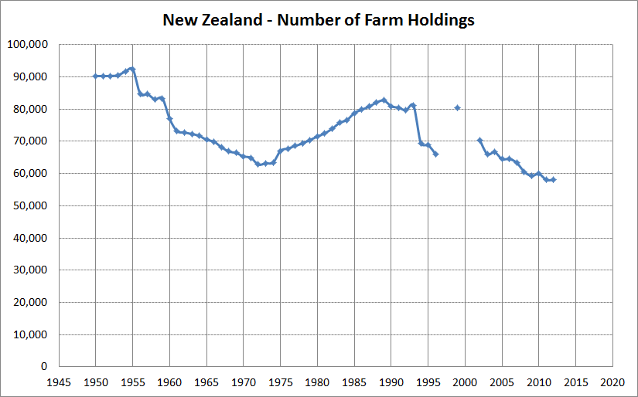
Figure 2. New Zealand Farm Holdings (source: Statistics NZ)
However, in general terms the percentage contribution by each region to total farm holdings in New Zealand is fairly consistent over this 22 year period, Figure 3. As the percentage contribution by each region is so stable, we have used the average percentage contributions to backcast and forecast regional data for farm holdings by region.
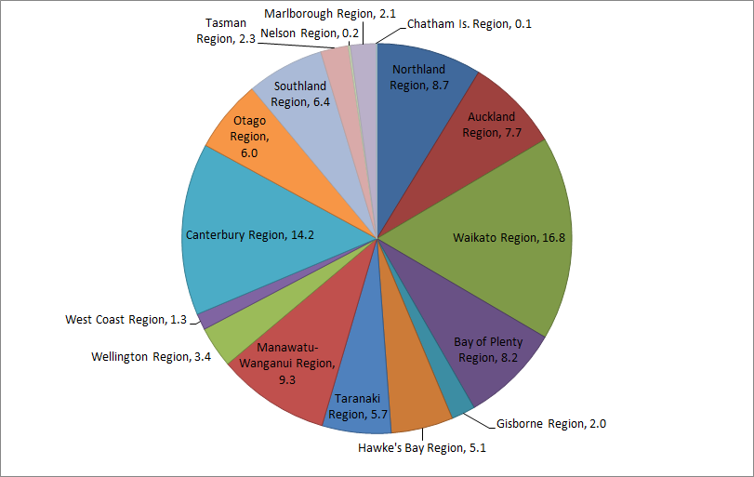
Figure 3. Percentage of New Zealand’s total farm holdings in each region.
Statistic NZ has conducted Agricultural Censuses which provide data on farm counts by farm type operating within each region. The census were conducted in 2002, 2007 and 2012. The percentage of dairy, livestock, arable and viticulture farm types from the results of the census have been used to estimate the number of each farm type together with the results of the Environment Canterbury farm waste survey. This process is described in more detail in the following section.

Wastes from farms
ECan conducted surveys of the disposal of non-natural farm wastes in 2012 and 2013 (SKM, 2012), (GHD, 2012), (GHD, 2013). The aim of the surveys was to better understand rural waste streams in particular core types of Non Natural Rural Waste (NNRW) that are likely to be generated by each type of farm in Canterbury. NNRW is produced by numerous rural production activities including dairy, livestock, bee keeping, land based aquaculture, horticulture and cropping. The range of NNRW include scrap metal, treated timber and fence posts, plastic wraps and ties, crap netting, glass, batteries, some construction and demolition wastes and domestic refuse.
The farms surveys were broadly categorised as (GHD, 2013):
- Dairy
- Livestock (beef, sheep, deer, piggery, poultry and alpaca)
- Arable (crops, vegetables and orchards)
- Viticulture (grape growing)
The type of farming activity is likely to have a bearing on the volumes and mixtures of NNRW wastes produced. However, there are still common activities across all farms that produce wastes, i.e. containment, wrapping, binding, pest control, etc. These common practices tend to produce the largest volume of waste.
The farm pits encountered during the surveys ranged from a few metres in length to pits 60 metres by 10 metres wide and deep. The bigger holes had been excavated for gravel for construction of farm roads. The majority of these pits were infilled with waste and it was often the case that fires were started within these pits to burn off as much waste as possible, extending the life span and available void space within the pit.
The most common waste management practices on farms are to burn, bury or bulk store for an indefinite time (3B’s). Of the farms surveyed, 92% of the sites used the 3B method of waste management (GHD, 2013). The study used 92% as a multiplier across all farm sites in Canterbury. As farming practices are fairly similar across the country this multiplier is likely to provide a fair representation of waste management in farms nationally. However, we note that the report warns that caution should be used when applying the multiplier as it is based on only 53 farm sites within Canterbury.
A summary of the findings of the survey has been extracted as follows (GHD, 2013):
Table 4-2. Annual waste volumes produced by farm types
Farm Type | Average size | NNRW Waste | Domestic Waste | Organic Materials | Total
Dairy | 224 ha  882 cows | 6.1 tonnes | 0.6 tonnes | 21.2 tonnes | 27.9 tonnes
Livestock (beef, sheep, deer, piggery, poultry and alpaca) | 1,950 ha | 8.9 tonnes | 0.08 tonnes | 21.2 tonnes | 30.18 tonnes
Arable (crops, vegetables and orchards) | 393.6 ha | 7.4 tonnes | 1.1 tonnes | 3.2 tonnes | 11.7 tonnes
Viticulture (grape growing) |  | 22.1 tonnes | NA – owners not living on site | 40 tonnes | 62.1 tonnes
Lifestyle blocks and small fruit farms | 7.8 ha | 354.2 kg | 300 kg | NA | 654.2 kg
Typical waste composition
Dairy – large volumes of plastic waste in NNRW plus organic and animal carcass waste fractions.
Livestock – large volumes of plastic produced silage use or from bale wraps.
Viticulture – large volumes of vine netting as replaced every 5 to 7 years.
The proportion of wastes that are burnt, buried or bulk stored, could not be determined from the survey as practices were different between farmers (Mr C Keeling 2013, pers. comm., 14 Oct). However, as it was noted that the majority of wastes were buried, we have assumed that all the 92% of NNRW waste is buried, thereby providing an overestimate of waste disposal to land.
The surveys found that all farms are likely to have one farm pit, with the exception of dairy farms which may have more than one farm pit if it is accommodating more than one residence producing domestic wastes. There is approximately 58,000 to 94,200 (range from 1950 to 2012) number of farms in New Zealand, and we have assumed that each farm is likely to have one farm dump each (refer spreadsheet 3. Non-municipal Landfills.DATAFILLv2.xlsx, Farms tab).
Total tonnes of waste generated from farms are shown below:
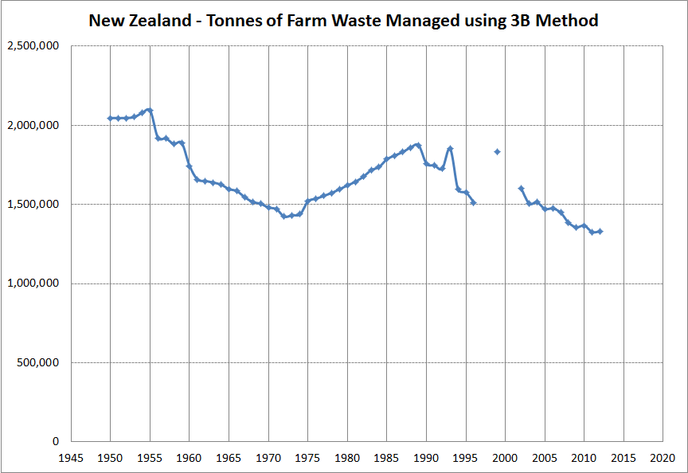
Figure 4. Tonnes of waste generated from farms nationally.
Tonnes of waste managed by the 3B method have been added to the annual tonnage estimates, further discussed in Section 6.5.

Agricultural soil
T&T conducted a project for the Ministry of Agriculture and Forestry (MAF) to quantify GHG emissions from agricultural soils resulting from waste additions (T&T, 2011). The project considered wastes produced from process of the primary ingredient in an industrial/ factory environment that are subsequently applied to land. The industry categories identified by MAF included in that study were:
- Slaughterhouse wastes
- Dairy industry waste
- Brewery waste
- Winery waste
- Major horticultural industry waste
- Compost
Overall, the project concluded that after considering material sent to landfill, recycled and reused, majority of these industries produce very small quantities of waste going to land and in some cases no waste to land. Therefore, waste to agricultural soils has not been added to the database.

Sawmilling operations
The overall picture of timber waste stream from sawmills in New Zealand was provided by the New Zealand Timber Forestry Industry Federation Inc (Hing, 2013).

Table 4-3. Estimated number of permanent sawmills in operation
Region | Number of Sawmills
North Island – Northland, Auckland, Waikato, Bay of Plenty | 34
North Island – Taranaki and Gisborne south | 23
South Island – Nelson-Marlborough-West Coast | 18
South Island – Canterbury-Sth Canterbury | 19
South Island – Otago-Southland | 18
Total | 112
Note: Data provided by NZTIF based on Statistics New Zealand and Ministry of Primary Industry figures.
In addition there are numerous (likely more than 100) portable sawmills throughout New Zealand. The operating period of these sites could not be obtained.
A search request made to Environment Waikato (EW) returned 17 operating sawmill operations (2 with saw dumps sites) and 2 sites that only operate as saw dump sites. These 4 active saw dumps sites have been included in the database. In total, the project identified 9 sites (open and closed) that accepted woodwaste in Waikato. A list of HAIL sites were also provided by EW however included a number of other contaminated sites not relevant to this project. In addition, no tonnages were available from the Hazardous Activities and Industries List (HAIL) database.
Sawn timber production in New Zealand is around 4 million cubic metres annually of which an estimated 2.25 million cubic metres is treated. Treated timber is used in construction, normally boric treatment, and for outdoor uses, normally CCA and LOSP Azole for outdoor joinery. An estimated 60% of treated timber is CCA, 25% is Boric and 15% is LOSP. There are other forms of treatment but at this stage they are quite minor. Around 50% of sawn timber production is exported as both treated and untreated product (K. Hing, 2013, pers. comm. 9 Oct).
With current technology sawmills convert around 55% (and up to 60% depending on log size) of each log into sawn timber. Of the remaining 45%, 30% becomes chip which is used to make pulp and MDF and 15% is sawdust. In some cases the sawdust is dried and used as energy to heat boilers and kilns. Otherwise the sawdust is sold to produce compost.
Sawmills are driven to minimise waste therefore we expect that sawdust is sold for uses such compost rather than dumped. Although, some evidence suggest that some municipal landfills use sawdust to assist with disposal operations at their sites (as daily cover, for mixing with wetter waste, etc). Shavings produced from machining sawn timber is generally used as heating fuel or is used for stock and animal bedding.
Discussions with some sawmill and forestry operators indicate that there is a history of sawmill/bark dumps, however these dumps have gradually been phased out over time the waste wood is used as fuel or other productive uses. More details on these historical bark and sawdust dumps are difficult to obtain with no monitoring records maintained during that time. The manner in which the dumps were managed appears to differ depending on the operator as well, with a mix of spreading, stockpiling and burying materials. It is likely that where the material is buried this is more likely to be within shallow pits, therefore resulting is lower GHG generation. With the lack of historical data and negligible potential for GHG generation, sawdust and bark dumps have not been included in the database.
These historical sites do not tend to keep information on such dumps unless they are required to. Therefore prior to the RMA or consenting of these sites, there is no available information.

New Zealand Defence Force sites
The New Zealand Defence Force (NZDF) is spread across camps and bases throughout New Zealand. Its national strategic headquarters is in Wellington and the operational joint headquarters are at Trentham in Upper Hutt.
In response to a request for the project, NZDF collated a list of 18 current and historic cleanfills and landfills based on knowledge of individual staff members. NZDF is in the process of conducting a HAIL identification project expected to be completed in the next two years. Therefore, the information provided for this project should be treated as indicative only due to the limited time available.
Information provided by NZDF has been included in to the raw database. Of the 18 sites, 11 landfills accepted general waste including domestic refuse from NZDF facility, associated housing areas and frequently civilian townships. The remaining sites accepted decommissioned or expended munitions and cleanfill. A couple of sites operated in the 1930’s and 1940’s therefore have not been included in the database. At the time of reporting, three of the sites were still operating.

Sludge disposed to land
In 2011, T&T conducted a project for the MfE on estimating greenhouse gas emissions from wastewater sludges (T&T, 2011). The review of sludge disposal practices throughout New Zealand showed the following disposal methods:
- Municipal solid waste landfills
- Dedicated sludge landfill
- Land
- Composting with other green waste
- Incineration (one plant only)
The study concluded that the majority of treatment plants dispose of sludge to landfill either to a MSW landfill or a dedicated sludge landfill, with the second most popular method being disposal to land. Data collected in relation to disposal to land did not differentiate, in all cases, whether disposal was to forestry or agricultural land. Both practices are adopted in New Zealand. The report presented annual sludge disposal from 1990 – 2008 for disposal to landfill, land, compost, incineration, etc.
There is no distinction in the data to determine the proportion of sludge to MSW landfill or a dedicated sludge landfill. A brief review of wastewater treatment practices in the major cities showed that majority of sites either dispose of sludge to MSW landfills, incinerate, compost, or convert to fertiliser. The review involved discussions with our Principal Wastewater Engineer who has worked on a number of sites in New Zealand. We also utilised information published on websites of major councils including Hamilton, Tauranga, New Plymouth, Wellington, Palmerston North, Christchurch and Dunedin, which provides information on their local wastewater treatment plants and how sludges from these facilities are managed. The only major wastewater treatment plant with dedicated sludge landfills is operated by Watercare Services in Auckland, which has been captured in the database.
Sludge disposal to land (forestry or agriculture) is typical by spreading treated dry biosolids therefore, greenhouse gas emissions are likely to be negligible.
Therefore, the annual sludge figures in the 2011 study have not been included.

Data estimation

Overview
Real data has been collected as far as practicable in the time given. Approximately one third of the database included sites that although we knew were in existence at some point, there was no available information on when the site started, closed or its annual filling rate. In these cases, only information on the site name, location and operator was available.
Annual tonnages from sites where data was available was added to provide a regional total for years 1950 to 2015. In general, a number of sites had tonnages from 2000 onwards. It was not possible to estimate tonnages for individual sites with the very limited available information. Therefore, data was interpolated on a regional scale to backcast and forecast annual tonnages.
The process of producing a more complete regional dataset is outlined in the following sections.

Annual tonnages
Annual tonnages were populated in the database in the following manner:
- Where actual tonnages for all operating years were provided, they were used.
- Where actual tonnages were provided for one year, this was assumed to be consistent throughout the life of the landfill.
- Where consented limits were provided, this was assumed to apply throughout the consented life of the landfill and the maximum consented limits were applied.
- Where site volumes (based on estimated areas and depths) and operating years were provided, the total volume was divided by the operating years and a consistent annual filling rate was assumed.
- Volumes (in cubic metres) were converted to tonnes using density (in tonnes per cubic metre) values. For cleanfills sites a density of 1.4 tonnes/m³ was used (adopted from the previous SKM database). Other density factors applied include woodwaste 0.3 tonnes/m³, biosolids 0.72 tonnes/m³, bark 0.6 tonnes/m³, ash 0.72 tonnes/m³, egg shells 2.38 tonnes/m³.
- Where a range of filling rates was provided, the average filling rate was applied to each operating year.
- Where no information was provided, the annual tonnages were left blank.
Six sites were able to provide actual annual tonnage rates. The actual filling rates were compared with their consented limits. This provided a broad understanding how closely sites filled to their consented limits.
A comparison with their consented limits shows that these sites fill at a rate of approximately 30% of their consented limit. This seems low and unlikely to apply to all other sites. Three of the six sites however, had no limits on their consents. Site operations vary significantly depending on the site use however there was insufficient information from the survey to justify applying a percentage to the consented tonnages.
As an alternative, a review of filling rates at municipal landfills was conducted to determine the proportion of filling compared to their consented limits. The MfE provided data on the 2006 Landfill Census. From that census, 10 sites provided sufficient information on the consented period (start and end years) and maximum volume capacity of the site. Most municipal landfills do not have consented annual filling rates, but rather a total volume capacity for the site. Using this information, a calculated annual “consented limit” was determined by dividing the consented total volume capacity for the site by the consented years of operation. Some sites were found to be filling well over 100% of the calculated limit whilst other sites were well below that calculated limit. On average, the sites were found to be filling approximately 100% of the calculated “consented” limit. Due to the limited information available, the 100% filling rate has been applied to consented, permitted and unknown sites where specific annual filling rates could not be provided.

Linear regression analysis
Linear regression modelling is the simplest method for completing time series and is an easily interpreted method for estimating intermediate data points.
Real GDP is the preferred independent variable as time series data dating back to 1950 is available. Due to the patchiness of the tonnage data, using real GDP was considered most likely to provide the best correlations above other potential variables (such as population, building consents, etc) and is in-line with common industry practice for estimating non-municipal landfill waste (IPCC, 2006), (Andersen, Skovgaard, Moll, Isoard, & Larsen, 2007), (Chung, 2010).

National gross domestic product (GDP)
Gross domestic product (GDP) represents the country’s income earned from production in New Zealand. It measures the goods and services produced by an economy during a given period. Real GDP is GDP adjusted to take into account inflation.
Following the 1998 "Asian crisis" New Zealand’s GDP recovered strongly. Annual GDP growth from 2001 through to 2004 (on average) exceeded that of its major trading partners, partly as a result of strong net inward migration and associated population growth.
The recent global recession, and the associated financial crisis in many countries, had a significant adverse effect on global economic activity. Most of New Zealand’s trading partners experienced contractions in GDP between 2008 and 2009. In that period, Australia was the only economy not to experience negative GDP growth on an annual basis, Figure 5. The contractions experienced by the US, UK and Japan over this period were more severe than that experienced by New Zealand (Reserve Bank, 2013).
Statistics NZ reports that overall, New Zealand’s economy expanded between 2000 and 2010, although the drivers behind the growth varied over that period. From 2000 to 2007, contribution to national GDP increased from the construction, rental, hiring, and real estate services; health care and social assistance; retail trade; and dairy product manufacturing industries.
From 2007 to 2010, the contribution to GDP decreased for the manufacturing industries, including dairy product; metal product; and petroleum and coal product manufacturing. Decreased contributions to GDP also came from construction, retail trade and rental, hiring and real estate services. Increased contributions to GDP came from the dairy farming, mining, finance and insurance, and health care industries.
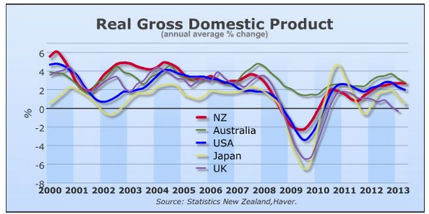
Figure 5. Real gross domestic product since 2000 – NZ, Australia, USA, Japan & UK (Source: Reserve Bank of New Zealand, Sept 2013)
It is common industry practice to use GDP for estimating waste generation (as referenced in Section 5.3). Typically, increasing waste generation is observed with improved economy. Data on New Zealand’s total real GDP was obtained from Statistics NZ with data available from 1950 to 2013. Assuming a continued growth in the economy at a similar rate, future GDP was extrapolated to 2015, Figure 6.

Figure 6. Trend of New Zealand real GDP with values extrapolated to 2015.

Regional gross domestic product
Regional GDP measures the contribution and make-up of economic activity for the regions of New Zealand. The data available from Statistics NZ covers March 2007 to 2010. This is the first release of regional GDP by Statistics NZ. In 2006, a feasibility study and some experimental statistics for 2000 to 2003 were published.
New Zealand’s regions can be grouped based on their industry compositions, urban and rural characteristics, and the relative importance of agricultural production to GDP, Table 5-1. Exposure to agriculture and food product manufacturing, specifically dairy, has caused some volatility and growth differences between regions.
The diversity of the regions is also noticeable, with more diversified regions expanding into the supporting service industries, such as professional, scientific, and technical services. The urban regions provide services to the rest of the country, while rural regions largely produce goods.
Although the agriculture industry has been the main driver of increased GDP between 2007 and 2010, regional contributions to national GDP levels do not reflect that. Regional contributions to national GDP mostly reflect the population distribution.
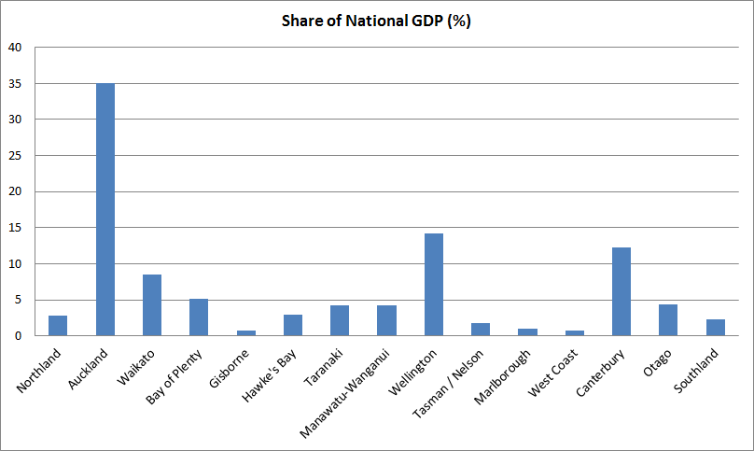Figure 7. Share of national GDP (Source: Statistics NZ)
The share of the national GDP remained fairly consistent between 2007 and 2010, with this available information, we have applied the average share of the national GDP for each region to years 1950 – 2015 (refer spreadsheet 3. Non-municipal Landfills.DATAFILLv2.xlsx, GDP tab). This is likely to apply to the majority of the 65 year period, as Auckland remained the region with the largest population for majority of this period except pre-1956 where the population in Wellington was highest in the country. There was a period between 1986 and 1991 where the census area boundaries changed. This is indicated by a sudden decrease in population figures in Wellington and the Bay of Plenty, and an increase in population in Waikato and Horizons. However, population growth and contribution by each regional remained fairly consistent before and after this period.
The percentage contribution was calculated by dividing the GDP for each region with the total (national) GDP and is summarised in Table 5-1 along with the top three industries contributing to the GPD within each region.

Table 5-1. Share of national GPD from each region (2007 to2010 average)
Region | Share of national GDP (%) | Top 3 Industries in the Region (2010)/ Proportion of Region’s GDP
Northland | 3 | Manufacturing (19.3%), Agriculture (8.2%), Healthcare and social services (7.3%)
Auckland | 36 | Manufacturing (12.5%), Professional, scientific, technical, administrative, and support services (11.6%), Financial and insurance services (8.2%)
Waikato | 9 | Agriculture (11.3%), Manufacturing (11.2%), Forestry, fishing, mining, electricity, gas, water, and waste services (9.3%)
Bay of Plenty | 5 | Manufacturing (10.4%), Professional, scientific, technical, administrative, and support services (9.5%), Forestry, fishing, mining, electricity, gas, water, and waste services (8.6%)
Gisborne | 1 | Agriculture (9.8%), Forestry, fishing, mining, electricity, gas, water and waste services (8.9%), manufacturing (8.7%)
Hawke's Bay | 3 | Manufacturing (15.1%), Agriculture (8.9%), Health care and social assistance (8.0%)
Taranaki | 4 | Forestry, fishing, mining, electricity, gas, water and waste services (40.6%), Manufacturing (10%), agriculture (9.1%)
Manawatu-Wanganui | 4 | Manufacturing (9.9%), Agriculture (8.9%), Public administration, defence and safety (8.3%)
Wellington | 14 | Professional, scientific, technical, administrative, and support services (12.1%), Public administration, defence and safety (11.0%), Other services (10.9%)
Tasman / Nelson | 2 | Manufacturing (13.5%), Professional, scientific, technical, administrative and support services (8.7%), Health care and social assistance (7.9%)
Marlborough | 1 | Manufacturing (15.1%), Forestry, fishing, mining, electricity, gas, water and waste services (10.3%), Agriculture (10.1%)
West Coast | 1 | Agriculture (14.3%), Forestry, fishing, mining, electricity, gas, water and waste services (13.8%), Manufacturing (10.5%)
Canterbury | 12 | Manufacturing (13.4%), Professional, scientific, technical, administrative and support services (8.2%), Agriculture (7.1%)
Otago | 4 | Forestry, fishing, mining, electricity, gas, water and waste services (8.8%), Manufacturing (8.6%), Construction (7.6%)
Southland | 2 | Agriculture (22.2%), Manufacturing (14.0%), Forestry, fishing, mining, electricity, gas, water and waste services (6.9%)
Source: Statistics NZ Regional Gross Domestic Product: Year ended March 2007–10
Urban services
The Auckland and Wellington regions are predominantly urban. Both regions provide services to the rest of New Zealand as opposed to supporting their internal industries only. Their economies tend to include less agricultural activities and related food product processing. A large proportion of Auckland’s GDP comes from a varied manufacturing base, and a large proportion of Wellington’s GDP comes from public administration and safety. Both regions make a large contribution to the professional, scientific, technical, administrative, and support services. Auckland’s GDP declined in 2009 as manufacturing retreated with the economic slowdown. Wellington’s GDP also slowed in 2009, however was more stable than Auckland as it has a larger proportion of public administration and safety - a stable industry group.
Agriculture-based regions
Waikato, Southland, and West Coast contributed about 25%, 12%, and 3%, respectively, to the country’s dairy farming GDP. These regions are reliant on dairy farming as it makes up a large proportion of their economy.
A high proportion of Marlborough’s GDP comes from beverage and tobacco product manufacturing. Marlborough’s economy is centred around horticulture and fruit-growing activities.
Gisborne and Hawke’s Bay have close to 80% of their agriculture GDP coming from a combination of horticulture and fruit growing; and sheep, beef, cattle, and grain farming.
Agriculture and food product manufacturing supported by other industries
Many of the rural economies have a broad network of industries in addition to agriculture and food product manufacturing, such as professional, scientific, technical, administration, and support services. Canterbury, Otago, and Bay of Plenty are well-diversified regions.
The economy of the combined regions of Tasman and Nelson is based on manufacturing and a broad range of services. The region is diversified without a large agriculture industry.
Manawatu-Wanganui has also expanded into the support services. The region makes a large contribution to agriculture but also has also diversified into central government services.
Taranaki and Northland are relatively specialised regions. They have more than one significant industry, but they provide a smaller contribution to the service industries than the more diversified regions. A large proportion of Taranaki’s GDP comes from oil and gas production, with the mining industry making up around 35% of Taranaki’s GDP in 2010.
Northland’s economy is largely based on petroleum refining, followed by health care and social assistance, and agriculture.

Results of linear regression analysis
Real GDP for each region was compared with the annual tonnes of waste landfilled. The R² value provides information about the goodness of fit of a model. An R² of 1 indicates that the regression line perfectly fits the data.
For this initial review of linear regression, the period over which the correlation was subjectively determined for each region based on the extent to which the data set for a given year appeared to be comprehensive. Trial and error was used in some cases to find the set of years that gave the highest R² value.
Based on experience, a minimum R² value of 0.7 was an appropriate threshold below which the relationship between the two data sets was considered unreasonably weak. The seven regions in which this threshold R² value was not achieved were typically those for which data was poor (i.e. small data set, few sites with tonnage information). These regions were Northland, Gisborne, Hawkes Bay, Manawatu-Wanganui, Wellington, Tasman and Otago. A summary of R² values for each region is provided below highlighting the regions that had poor datasets and required adaptation from other regions.
Table 5-2. Regional R² values for annual tonnages vs real GDP
Region | Correlation period# | R² value for annual tonnes vs real GDP | Adopted region’s projection equation^
Northland | NA | NA | Canterbury
Auckland | 1976 – 2012 | 0.7129 | -
Waikato | 1972 – 2013 | 0.9487 | -
Bay of Plenty | 1991 – 2005 | 0.8319 | -
Gisborne | 2002 – 2010 | 0.5855 | West Coast
Hawke's Bay | 1999 – 2005 | 0.2058 | Marlborough
Taranaki | 1997 – 2013 | 0.8757 | -
Manawatu-Wanganui | NA | NA | Waikato
Wellington | 1993 – 2008 | 0.4631 | Waikato
Nelson | 1965 – 2012 | 0.7459 | -
Tasman | NA | NA | Nelson
Marlborough | 2001 – 2013 | 0.7664 | -
West Coast | 2004 – 2013 | 0.7691 | -
Canterbury | 1996 – 2013 | 0.8435 | -
Otago | 1999 – 2013 | 0.3138 | Taranaki
Southland | 1995 – 2013 | 0.9406 | -
NA – no annual tonnages available
# Period resulting in highest R² value
^ Adopted region based on similar dominant industries and contribution to national GDP, Table 6-1.
Poor linear regression fit with regional GDP.

Further analysis of the linear regression revealed that the correlations resulted in negative tonnages in most regions. The assessment was then broadened to a national scale, however this still resulted in negative tonnages when back-casting. This may have been due to the small quantities of non-municipal solid waste generated during the earlier years, or a larger proportion of those waste types going to municipal landfills. However, there would still be some other non-municipal wastes generated from various industries and the negative tonnages were considered erroneous.
Additional analysis on the quality of data was conducted to get a better understand the period of time when data quality improved, if at all, with the aim of objectively identifying periods of time when data could be used for the regression analysis.
Reviewing, the Auckland region as an example, knowledge of site status (open or closed versus not known) varies through time randomly. Knowledge of site status is an indicator of knowledge of the key variable – tonnes. As shown in Figure 8, the number sites with known site status increases with time. However, there is no consistent period shared with all regions indicating when knowledge of site status improves.
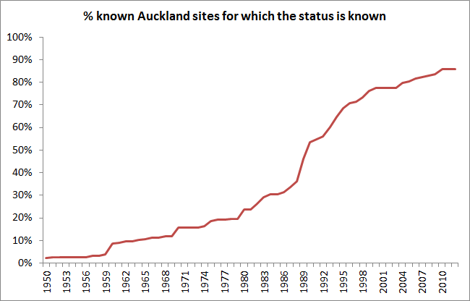
Figure 8. Number of known sites in Auckland
Therefore the linear regression analysis was considered unsuccessful and an alternative method was developed by determining the tonnes of waste per unit regional GDP, further described in the next section.

Tonnage per unit regional GDP
The number of non-municipal sites for most regions, particularly the regions with more complete datasets has been well captured as this stems from an exhaustive search of Council records and capturing key industry waste generators.
The best record on annual total tonnage for a particular region (i.e. the maximum annual tonnes disposed at that region based on the most number of sites for a particular year) has been divided by the regional GDP for that particular year to determine the waste tonnage per unit GPD (regionally). The tonnage per unit GDP is then used to populate the annual tonnage figures for 1950 to 2015. For regions where there is no actual tonnage data, the per unit GDP figure for a comparable region is adopted. A summary of the calculated tonnes per unit GDP is provided in Table 5-3.

Table 5-3. Regional tonnes per unit GDP
Region | Tonne per unit regional GDP
Auckland | 10.8
Bay of Plenty | 47.1
Canterbury | 50.9
Gisborne | 16.9
Hawkes Bay | 9.2
Horizons | 110.1 (adopted Waikato)
Marlborough | 51.8
Nelson | 12.9
Northland | 50.9 (adopted Canterbury)
Otago | 70.1
Southland | 23.2
Taranaki | 17.4
Tasman | 12.9 (adopted Nelson)
Waikato | 110.1
Wellington | 4.3
West Coast | 88.9
The variability between regions reflects the main industries operating in those regions and where waste from those industries is likely to be disposed at. For example, Wellington is a region dominant in service industries, and wastes from service industries are likely to be disposed at municipal landfills. By contrast a region that has strong agricultural, farming and rural industries such as Canterbury is likely to generate more wastes going to non-municipal landfills.
Once the interpolated annual tonnages were determined, waste generated from farm dumps was added. A plot of the project tonnages plus waste tonnages from farm dumps is prepared as a reality check to identify any data anomalies.
This alternative method was discussed with the peer reviewer who was in support of this approach.

Results

Open and closed sites
The following summary information can be drawn from the raw database. Note that this is based on the information that was able to be collected. Data limitations are discussed in Section 7.
Summary information is provided from 2000 onwards as requested by the MfE. We note that these years generally had the best available information.
This project identified 1,047 non-municipal landfill sites in New Zealand. Auckland had the most number of sites with 267 landfills and Tasman with the least number of sites with 7 landfills. In total, there were 263 open sites, 460 closed sites and 324 sites of which the status was unknown.
The Figure 9 shows the number of closed and operating sites since 2000. The number of non-municipal fills appears to be increasing gradually with operating sites hitting a plateau around 2011 with 283 sites open and 184 sites that were closed. From around 2011, the number of operating sites is decreasing and correspondingly, the number of closed sites is increasing.
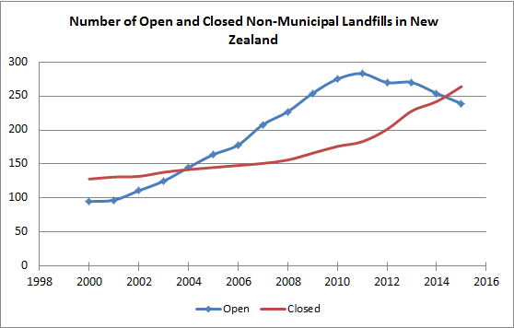
Figure 9. Rising number of non-municipal landfills in New Zealand
The number of open and closed sites in each region is provided in Table 6-1. The data presented here is based on information that could be collected. A third of the sites could not provide details on when the sites were opened or closed, or currently operating.

Table 6-1. Number of sites in each region
Region | Open Sites | Closed Sites | Unknown
Auckland | 22 | 121 | 124
Bay of Plenty | 27 | 37 | 2
Canterbury | 38 | 19 | 44
Gisborne | 2 | 5 | 2
Hawke's Bay | 3 | 1 | 18
Horizons | 2 | 10 | 28
Marlborough | 11 | 15 | 11
Nelson | 6 | 33 | 6
Northland | 6 | 5 | 0
Otago | 6 | 2 | 16
Southland | 25 | 22 | 7
Taranaki | 35 | 119 | 1
Tasman | 6 | 0 | 1
Waikato | 48 | 38 | 26
Wellington | 16 | 31 | 28
West Coast | 11 | 2 | 10
Total | 263 | 460 | 324
The number of open and closed sites in each region for years 2000 to 2013 is provided in Table 6-2.
Table 6-2. Number of closed and operating non-municipal landfills in each region
 | Auckland |  | Bay of Plenty |  | Canterbury |  | Gisborne |  | Hawke's Bay |  | Horizons |  | Marlborough |  | Nelson |  | Northland |  | Otago |  | Southland
Year | Open | Closed | Open | Closed | Open | Closed | Open | Closed | Open | Closed | Open | Closed | Open | Closed | Open | Closed | Open | Closed | Open | Closed | Open | Closed
2000 | 15 | 95 | 13 | 0 | 18 | 11 | 0 | 2 | 1 | 0 | 2 | 4 | 3 | 0 | 3 | 1 | 1 | 0 | 3 | 3 | 5 | 0
2001 | 16 | 94 | 13 | 0 | 18 | 12 | 0 | 2 | 1 | 0 | 1 | 5 | 4 | 0 | 3 | 1 | 1 | 0 | 3 | 3 | 6 | 0
2002 | 16 | 94 | 13 | 0 | 24 | 12 | 1 | 2 | 1 | 0 | 1 | 5 | 4 | 0 | 3 | 1 | 1 | 0 | 3 | 3 | 8 | 0
2003 | 16 | 94 | 16 | 0 | 24 | 13 | 3 | 2 | 1 | 0 | 1 | 5 | 5 | 0 | 4 | 1 | 1 | 0 | 3 | 3 | 10 | 0
2004 | 19 | 94 | 16 | 1 | 26 | 14 | 3 | 2 | 3 | 0 | 1 | 5 | 6 | 0 | 5 | 1 | 1 | 0 | 3 | 3 | 9 | 1
2005 | 19 | 95 | 16 | 1 | 28 | 14 | 3 | 2 | 3 | 0 | 2 | 5 | 7 | 0 | 6 | 1 | 1 | 0 | 3 | 3 | 15 | 1
2006 | 20 | 95 | 17 | 2 | 28 | 14 | 3 | 2 | 3 | 0 | 4 | 5 | 7 | 0 | 8 | 1 | 2 | 0 | 4 | 4 | 15 | 1
2007 | 20 | 96 | 19 | 2 | 34 | 14 | 3 | 2 | 4 | 0 | 4 | 5 | 9 | 0 | 7 | 2 | 3 | 0 | 5 | 5 | 20 | 1
2008 | 20 | 97 | 20 | 2 | 38 | 14 | 3 | 2 | 4 | 0 | 4 | 5 | 10 | 0 | 6 | 3 | 2 | 0 | 5 | 5 | 23 | 3
2009 | 21 | 97 | 19 | 5 | 43 | 14 | 4 | 2 | 4 | 0 | 4 | 5 | 12 | 0 | 6 | 3 | 2 | 0 | 7 | 7 | 25 | 4
2010 | 24 | 97 | 18 | 6 | 42 | 15 | 4 | 2 | 4 | 0 | 3 | 6 | 14 | 1 | 7 | 4 | 2 | 0 | 8 | 8 | 28 | 7
2011 | 22 | 99 | 27 | 7 | 42 | 15 | 3 | 3 | 4 | 0 | 3 | 6 | 15 | 2 | 7 | 4 | 2 | 0 | 8 | 8 | 28 | 7
2012 | 19 | 102 | 20 | 15 | 41 | 16 | 3 | 3 | 4 | 0 | 3 | 6 | 13 | 5 | 7 | 4 | 2 | 0 | 7 | 7 | 26 | 9
2013 | 17 | 106 | 24 | 16 | 41 | 17 | 4 | 3 | 3 | 1 | 2 | 7 | 11 | 8 | 7 | 5 | 6 | 0 | 7 | 7 | 24 | 12
2014 | 14 | 109 | 23 | 17 | 39 | 19 | 2 | 5 | 3 | 1 | 2 | 7 | 11 | 8 | 7 | 5 | 6 | 0 | 6 | 6 | 22 | 14
2015 | 13 | 109 | 21 | 19 | 39 | 19 | 2 | 5 | 3 | 1 | 2 | 7 | 11 | 8 | 6 | 6 | 6 | 0 | 6 | 6 | 21 | 15
Note: Waste disposal levy applied 1 July 2009.

Table 6-2. Number of closed and operating non-municipal landfills in each region (cont’d)
 | Taranaki |  | Tasman |  | Waikato |  | Wellington |  | West Coast
Year | Open | Closed | Open | Closed | Open | Closed | Open | Closed | Open | Closed
2000 | 7 | 0 | 0 | 0 | 11 | 8 | 12 | 3 | 1 | 2
2001 | 8 | 0 | 0 | 0 | 10 | 9 | 12 | 4 | 1 | 2
2002 | 11 | 0 | 0 | 0 | 13 | 9 | 11 | 5 | 1 | 2
2003 | 13 | 2 | 0 | 0 | 17 | 9 | 9 | 8 | 2 | 2
2004 | 16 | 2 | 1 | 0 | 20 | 9 | 14 | 9 | 2 | 2
2005 | 20 | 2 | 1 | 0 | 23 | 10 | 15 | 10 | 2 | 2
2006 | 22 | 2 | 2 | 0 | 23 | 11 | 17 | 10 | 3 | 2
2007 | 26 | 2 | 2 | 0 | 30 | 11 | 18 | 10 | 4 | 2
2008 | 31 | 2 | 3 | 0 | 33 | 11 | 18 | 11 | 7 | 2
2009 | 33 | 4 | 3 | 0 | 45 | 11 | 17 | 13 | 9 | 2
2010 | 37 | 4 | 3 | 0 | 52 | 11 | 18 | 14 | 11 | 2
2011 | 36 | 5 | 3 | 0 | 54 | 12 | 18 | 14 | 11 | 2
2012 | 39 | 5 | 3 | 0 | 54 | 14 | 18 | 14 | 11 | 2
2013 | 36 | 8 | 6 | 0 | 49 | 22 | 23 | 14 | 10 | 3
2014 | 36 | 9 | 6 | 0 | 48 | 23 | 19 | 18 | 10 | 3
2015 | 38 | 15 | 5 | 1 | 39 | 32 | 18 | 19 | 9 | 4

Number of consented and permitted sites
The number of permitted and consented sites in the database is summarised below (Table 6-3). Limited information was able to be provided by Councils for permitted activity as there is no requirement for reporting on such sites.
We have identified consented sites where consent numbers have been provided for the site, or where T&T have knowledge of the site as being consented although no consent number was provided by Council.
The sites operated by the operator with a multitude of sites, provided estimated site capacities. Where the capacity is less than 1,000 m³/yr, they are assumed to be permitted activity sites.
Where there is no known information regarding the consent status of the site, we have identified this as “unknown”.
Table 6-3. Number of consented and permitted non-municipal landfills (raw database)
Region | Consented | Permitted | Unknown
Auckland | 245 | 6 | 16
Bay of Plenty | 31 | 21 | 14
Canterbury | 58 | 1 | 42
Gisborne | 7 | 2 | 0
Hawke's Bay | 22 | 0 | 0
Horizons | 33 | 0 | 7
Marlborough | 25 | 11 | 1
Nelson | 13 | 26 | 6
Northland | 7 | 0 | 4
Otago | 14 | 5 | 5
Southland | 42 | 6 | 6
Taranaki | 54 | 94 | 7
Tasman | 7 | 0 | 0
Waikato | 91 | 15 | 6
Wellington | 56 | 7 | 12
West Coast | 18 | 0 | 5
Note: This table does not include farm dumps
There are likely to be other permitted activity sites that may not have been captured in this project as Councils have no means of tracking such sites. The sites are likely to be small and accepting largely cleanfill material in order to comply with permitted activity rules.
Farm dumps are permitted activity sites in some regions, e.g. Northland allows for refuse discharged to land <12 m³/yr. However, in other regions there are no such allowances, therefore the presence of farms dumps could be considered a discretionary or prohibited activity in some regions. ECan’s Regional Plan addresses farm waste using effects based rules. Therefore, depending on the placement of waste in relation to receiving water bodies and meeting regulations around burning of waste, the potential for non-natural farm waste to be disposed of on farms is possible. Besides ECan’s Regional rules, the generation and management of non-natural farm waste is largely unregulated.
The passive approach to managing farm dumps has been attributed to resource constraints, councils trusting farms “to do the right thing”, little assistance requested from the rural sector and the long term historical practice of having farm dumps (SKM, 2012).

Waste composition
Information on waste composition was generally provided as a description (e.g. as described in the consent or by the operator, or reference to the MfE Cleanfill Guidelines) rather than percentage content. In order to provide useful statistics on composition of waste in each region, the descriptions provided by the information source was allocated with a code, as follows:
Table 6-4. Waste composition coding
Code | Description
AS | Asbestos
AH | Ash
B | Biological: Sludges from sewer /septic tanks and offal and meat based waste
CF | Cleanfill
CD | Construction & Demolition
DD | Domestic
FF | Farm waste
GW | Green Waste
HZ | Hazardous
IN | Industrial: Where specific type of industrial is unknown
IM | Industrial Mining: Mining tailings
IS | Industrial Steel: waste clay slimes from iron sand processing stormwater pond sludges minor general non-putrescible waste
MC | Managed Cleanfill
NA | No information /not defined
SH | Shells: Mussel /egg stockpiles
SL | Inert Sludge: mud and cuttings from drilling, sludge from waste holding ponds, and sludge from the power station
U | Uncontrolled fill
WW | Woodwaste
The composition of waste in each region (based on the raw data collected) is provided in the excel spreadsheet “5. Non-MSW Landfills.Stats.xls” > Regional Composition tab, Appendix B. The majority of sites captured are cleanfill sites therefore, the dominant waste composition is cleanfill material with some greenwaste and woodwaste.

Table 6-5. Composition of waste going to open non-municipal landfills in New Zealand
 | COMPOSITION
YEAR | AS | AH | B | CF | CD | DD | FF | GW | HZ | IN | IM | IS | MC | NA | SH | SL | U | WW
2000 | 2 | 4 | 5 | 60 | 18 | 1 | 0 | 16 | 2 | 4 | 0 | 1 | 0 | 9 | 2 | 0 | 0 | 17
2001 | 2 | 4 | 5 | 63 | 19 | 0 | 0 | 16 | 1 | 4 | 0 | 1 | 0 | 9 | 2 | 0 | 0 | 16
2002 | 2 | 4 | 5 | 77 | 25 | 0 | 0 | 23 | 1 | 4 | 0 | 1 | 0 | 8 | 2 | 0 | 0 | 15
2003 | 3 | 4 | 5 | 90 | 26 | 0 | 0 | 25 | 1 | 4 | 0 | 1 | 0 | 6 | 3 | 0 | 0 | 17
2004 | 3 | 4 | 6 | 104 | 31 | 0 | 0 | 28 | 1 | 4 | 0 | 1 | 0 | 9 | 3 | 0 | 0 | 18
2005 | 3 | 4 | 5 | 123 | 32 | 0 | 0 | 29 | 1 | 3 | 0 | 1 | 0 | 11 | 3 | 0 | 0 | 17
2006 | 3 | 5 | 6 | 133 | 34 | 0 | 0 | 32 | 1 | 3 | 0 | 1 | 0 | 13 | 3 | 0 | 1 | 15
2007 | 3 | 6 | 5 | 158 | 37 | 0 | 1 | 34 | 1 | 3 | 0 | 1 | 0 | 16 | 3 | 0 | 1 | 16
2008 | 2 | 6 | 4 | 174 | 37 | 0 | 2 | 34 | 1 | 3 | 0 | 1 | 0 | 17 | 3 | 0 | 2 | 14
2009 | 2 | 7 | 4 | 199 | 39 | 0 | 2 | 37 | 0 | 3 | 0 | 1 | 0 | 18 | 3 | 0 | 2 | 15
2010 | 2 | 7 | 5 | 217 | 37 | 0 | 2 | 37 | 1 | 3 | 0 | 2 | 1 | 19 | 3 | 0 | 2 | 15
2011 | 2 | 7 | 5 | 225 | 36 | 0 | 2 | 42 | 1 | 3 | 0 | 2 | 1 | 19 | 3 | 0 | 2 | 15
2012 | 2 | 7 | 5 | 212 | 36 | 0 | 2 | 36 | 0 | 3 | 0 | 2 | 1 | 18 | 2 | 0 | 1 | 15
2013 | 2 | 6 | 7 | 207 | 38 | 0 | 1 | 37 | 0 | 3 | 0 | 2 | 1 | 19 | 2 | 1 | 1 | 16

Landfill classes
Non-municipal landfill sites identified in this project have been classified into the four types of landfills in accordance with the 2013 Draft Land Disposal Technical Guidelines (WasteMINZ, 2013):
Table 6-6. Landfill class definitions
Landfill Class | Definition | Site composition that would trigger landfill class
Class 4 Landfill - Cleanfill | Accepts only cleanfill material including virgin excavated natural materials, including soils, clays, gravels and rocks.  Maximum incidental inert manufactured materials (concrete, brick, tiles) no more than 5% per load.  Maximum incidental or attached biodegradable materials (vegetation) no more than 2% by volume per load. | A, C  <2% organics
Class 3 Landfill – Managed/ Controlled Fill | Accepts predominantly cleanfill materials but also other inert materials and soils with chemical contaminants greater than regional background concentrations.  Maximum incidental or attached biodegradable materials (vegetation) no more than 2% by volume per load.  Maximum chemical contaminant limits | MC, S  <2% organics
Class 2 Landfill – C&D Landfill or Industrial Waste Landfill | Accepts non-putrescible wastes including C&D wastes, inert industrial wastes, controlled/managed fill and cleanfill.  Maximum incidental or attached biodegradable materials (vegetation) no more than 5% by volume per load.  Maximum chemical contaminant leachability limits. | AH, CD, I, IM, SL, UF  <5% organics
Class 1 Landfill - Municipal Solid Waste Landfill or Industrial Waste Landfill | Accepts municipal solid waste and generally all Class 2-4 waste.  Maximum chemical contaminant leachability limits from module 2 Hazardous Waste Guidelines – Class A. | AS, B, D, F, GW, HZ, IS, W  >5% organics
It is our understanding that the classes of landfill listed in the draft guidelines have been developed to manage the risk to the environment from the types of wastes deposited. A higher risk to the environment would require a higher standard of design and management. The dominant governing factor applied is the organic content and leachability criteria of waste disposed to the site.
Each site in the database has been retrospectively allocated to one of the Classes 1 to 4 based on the composition of waste accepted at that site. It is noted however that the guidelines are only in draft and therefore the Classes are not widely adopted together with the engineering requirements for liners, leachate management systems and landfill gas collection systems, as appropriate to the specific Class (this predominantly relates to Class 1 and 2 Landfills). Besides some of the large industrial fills which are lined, other sites captured in the database may well not be engineered to the levels required by the draft guidelines. In addition, there is no available monitoring data to aid in the classification.
For classing the sites, where the percentage organic content for a cleanfill site is unknown (i.e. described as cleanfill with some greenwaste accepted), we have assumed that the organic content is <2% per load (as per the draft guidelines) and a Class 4 landfill. Based on discussions with operators, the organic content of majority of cleanfill sites accept small (incidental) quantities of greenwaste, therefore applying <2% per load is considered appropriate. Where there is specific information on greenwaste content (e.g. approximately <5% greenwaste or 10% greenwaste) as provided by the operators, consent or council documents, we have classed these sites accordingly.
Information on composition by year for each site could not be provided, therefore there is no information to provide an indication of how composition of wastes going to each Class of landfill is changing with time. It is recommended that to better understand the changes of waste composition going to a particular landfill class, a sample size of the those landfill classes be surveyed in more detail over a period of time. This would provide more comprehensive data on waste changes going to those landfills. This would be akin to conducting a Solid Waste Analysis Protocol (SWAP) analysis.
The number of non-municipal landfills categorised into the four landfill classes is provided in the excel spreadsheet “5. Non-MSW Landfills.Stats.xls” > Landfill Class tab, Appendix B.
The number of active Class 4 – Cleanfill Landfills have been gradually increasing (Figure 10), whilst the other landfill classes have remain steady or increased marginally. The data collected provides a good indication on the general trend of the likely changes in waste management in New Zealand. The number of sites however should be used with caution due to the patchiness of the raw dataset particularly in regard to permitted activity sites.

Figure 10. Number of active Class 1-4 landfills and active landfills with unknown composition (and therefore unknown landfill class) in New Zealand
There is likely to be more Class 4 landfills than collected in the raw database. These permitted cleanfills, however, are likely to be small sites accepting <1,000m³ per year, or operating intermittently only on a required basis.
Sites of unknown composition (Table 6-7) have not been included in the landfill classification exercise.
Table 6-7. Number of sites with unknown landfill class (due to unknown composition)
Region | Number of sites
Auckland | 60
Bay of Plenty | 4
Canterbury | 36
Gisborne | 0
Hawke's Bay | 9
Horizons | 11
Marlborough | 15
Nelson | 0
Northland | 1
Otago | 0
Southland | 4
Taranaki | 3
Tasman | 0
Waikato | 17
Wellington | 27
West Coast | 3
TOTAL | 190
There are a number of sites where the composition is unknown, as summarised in the spreadsheet “Non-MSW Landfills.Stats.xlsx” > Regional Composition tab, Appendix B. There are also sites where the composition is known but the tonnages are not known, however these sites are included in the landfill classification statistics. The quality of data for each region is further described in Section 7.3.
Tonnes of waste going to each class of landfill have been determined by reviewing the raw data for years 2000 to 2013. Review of the available data showed that majority of non-municipal wastes go to Class 4 landfills with approximately 60% of total waste (in the more recent years), followed by Class 2 landfills (approximately 30%). The annual distribution of wastes to each landfill class was then applied to the estimated annual tonnages for 2000 to 2013.
Table 6-8. Percentage of waste going to each landfill class nationally
 | Class 4 | Class 3 | Class 2 | Class 1
2000 | 22 | 8 | 34 | 36
2001 | 23 | 2 | 37 | 38
2002 | 24 | 1 | 37 | 38
2003 | 40 | 1 | 28 | 31
2004 | 37 | 1 | 33 | 29
2005 | 41 | 1 | 34 | 25
2006 | 45 | 1 | 32 | 22
2007 | 56 | 1 | 28 | 15
2008 | 61 | 1 | 27 | 11
2009 | 62 | 1 | 26 | 10
2010 | 56 | 1 | 35 | 8
2011 | 58 | 1 | 34 | 7
2012 | 60 | 1 | 32 | 8
2013 | 59 | 1 | 26 | 14
Note that there are likely to be tonnages associated with sites that have unknown classes due to their composition being unknown, therefore have been excluded from the table above. The distribution of waste for each region could not be determined as a number of regions (such as Northland, Tasman, Manawatu-Wanaganui) had no data or insufficient data on waste composition and class. Therefore, using the national average was considered more appropriate.
The tonnes of waste going to each of the landfill classes are shown below (Figure 11).
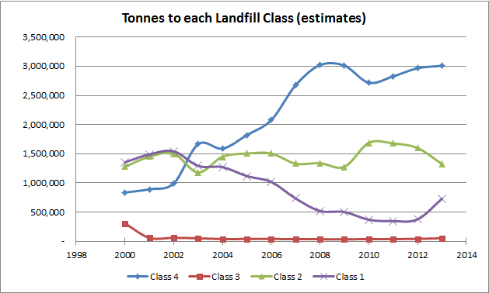
Figure 11. Tonnes of waste to open Class 1 – 4 landfills nationally (excluding farm dumps)
The tonnage figures are based on the annual estimates and excludes farm dumps.

Waste tonnages
Annual waste tonnages have been interpolated for each region using per unit GPD figure as described in Section 5.4.
A time series graph showing total tonnes of waste going to non-municipal landfills (raw data and interpolated data plus farm sites) in New Zealand is shown in Figure 12 and regional tonnages in Figure 13.

Figure 12. Annual tonnes of waste to non-municipal landfills (including farm dumps)

Figure 13. Tonnes of waste disposed at non-municipal landfills by region (including farm dumps)

Uncertainties and limitations

Data format
Information from various sources and forms has been entered to the database. The forms of data include:
- Previously developed database provided by MfE in excel format
- Hardcopy consents and property files viewed at Council offices
- Electronic copy consents or literature provided in pdf or word
- Tabulated information from various stakeholders
- Email communications
- Telephone communications
Where possible, these records have been saved in our project filing system.

Data entry QA/QC
1,047 sites have been entered into the database. Care has been taken during the data entry process to make sure that information as accurately as possible. This includes providing references to information, cross checking data and establishing a systematic method of entering and filing information.
There is no standardised method for checking data entries. Following discussion with the peer reviewer, we considered that conducting random checks on a reasonable sample size was appropriate in addition to review of formulas and “realty checks”.
A staff member outside of the immediate project team was selected to QA the database by randomly selecting 10% of the sites entered to check the accuracy of information. Any discrepancies were noted in a spreadsheet. This QA on the database resulted in 4 errors which have been corrected. The errors were around reading data off a specific table and document. Other site records derived from those sources have been checked as well and corrected where needed.

Data quality rating
As a mean of data quality check, a data quality rating has been provided to each site based on the parameters and rating system tabulated below. Data quality ratings are based on knowledge of key parameters as follows:
Table 7-1. Data quality ratings based on parameters
Parameter: Knowledge of … | Scenarios
Opening year | Unknown | n/a | Known
Closing year | Unknown | n/a | Known
Annual tonnes | Unknown | Assumed from consented limit | Data or reasonable estimate available
Rating | Low (0) | Medium (0.5) | High (1)
The overall data quality rating for a site is based on the sum of the parameter ratings. Therefore, the highest rating a site can have is 3 – with known start date, known end date and actual annual tonnages. Note that only 6 sites (located in Otago, Canterbury, Hawke’s Bay and Gisborne) had actual annual tonnages.
The quality rating provides an indication on the overall quality of data for each region, Table 5-2. The regional data quality is represented by the average data quality rating of all sites in the region expressed as a percentage. It can be seen that the regional data quality ratings are generally low. The highest score of 56% is achieved in the Gisborne region and the lowest (12.5%) in Manawatu-Wanganui. The average score is only 37%. This can be interpreted to mean that typically only a third of the data on site opening year, closing year and tonnage figures are available.
Table 7-2. Quality of data in each region
Region | Number of sites in database | Regional data quality  (%)
Northland | 11 | 33
Auckland | 267 | 23
Waikato | 112 | 47
Bay of Plenty | 66 | 42
Gisborne | 9 | 56
Hawke's Bay | 22 | 40
Taranaki | 155 | 32
Manawatu-Wanganui | 40 | 12.5
Wellington | 75 | 34
West Coast Region | 23 | 36
Canterbury Region | 101 | 39
Otago Region | 24 | 35
Southland Region | 54 | 52
Tasman Region | 7 | 48
Nelson Region | 45 | 32
Marlborough Region | 37 | 36

Data limitations
The following limitations on the non-municipal landfills database should be considered:
- During the course of this project we have identified and contacted the industries we believe are the primary waste generators that are likely to deposit their waste in non-municipal landfills. There are a number of other industries operating in New Zealand which have not been contacted such as manufacturing (meat, dairy, textiles, machinery) and service industries that are unlikely to contribute to non-municipal waste. Therefore, we consider that the key businesses that have contributed data to this project provides the overall picture of non-municipal waste management by industry.
- Due to the permitted activity rules, there are likely to be permitted activities in each region that have not been captured. However, based on a review of primary industries in New Zealand, we believed that the majority of the industries contributing to waste going to non-municipal solid waste landfills has been captured as best as possible, refer Section 3.
- There are likely to be a number of small cleanfill permitted activity sites throughout New Zealand. As indicated by an operator, there could be in an order of 2 to 3 times more unrecorded permitted cleanfill sites. It should be noted that these permitted sites would be small ranging from 12 m³/yr to 2,500 m³/yr. However, it should be noted that the total volume of the site would be unknown as the permitted activity limits are volumes per annum and not total.
- For known sites, actual annual tonnages are typically not recorded and in most cases have been assumed based on consented limits and applying a multiplier. Further explanation is provided in earlier sections. An extensive search for information has been conducted, and there is unlikely to be additional information available as data has either not been collected or lost as staff or operators have changed.
- This project does not capture illegal dump sites.
- We note that there are discrepancies in reporting tonnages in the CCC indicator reporting sheet and data provided by ECan with total tonnages 34% less than that reported by CCC. Further clarification is required with CCC staff.
- This project has been conducted from a partial “bottom-up” and “top down” approach where individual sites have been identified working upwards to gather regional and national data, then using regional GDP to correlate data. Given the paucity and uncertainties of data, we believe it would be beneficial to validate the results using an alternative approach, such as comparing the per capita waste estimates with other similar countries or using a complete top down approach. This approach is consistent with IPCC requirements and was used in the development of the Australian inventory. Australia applied surrogate data on paper consumption, for which data were available back to 1936, to develop its waste quantity estimates and used 1990 composition estimates (see p.10 of http://www.climatechange.gov.au/sites/climatechange/files/documents/05_2013/AUS_NIR_2011_Vol3.pdf).

References
Andersen, F., Skovgaard, M., Moll, S., Isoard, S., & Larsen, H. (2007, February). A European model for waste and material flows. Resources, Conservation and Recycling, 49(4), 421-435.
CCC. (2009). Indicator Reporting Sheet: Cleanfilled Waste, State of the Environment Reporting, September. Retrieved from resources.ccc.govt.nz/files/Waste_2128_QuantityOfMaterialDispoedOfInCleanfills-docs.pdf
Chung, S. (2010, September). Projecting municipal solid waste: The case of Hong Kong SAR. Resources, Conservation and Recycling, 54(11), 759-768.
DIA. (2011). Council Profiles by Region, Department of Internal Affairs. Retrieved from localcouncils.govt.nz.
GHD. (2012). Canterbury Non-natueral Rural Waste Regional Assessment and Guidance Note Development, prepared for Environment Canterbury Regional Council, September.
GHD. (2013). Non-natural Wastes Site Survey Data Analysis, prepared for Environment Canterbury Regional Council.
Hing, K. (2013, October 9). New Zealand Timber Industry Federation - Statistics on Sawmill Wastes. (S. Peng, Interviewer)
IPCC. (2006). Guidelines for National Greenhouse Gas Inventories Volume 4 Waste. Intergovernmental Panel on Climate Change.
MfE. (2002). A Guide to the Management of Cleanfills, Ministry for the Environment, January . Beca Carter Hollings and Ferner Ltd.
MfE. (2011). Consented Non-levied Cleanfills and Landfills in New Zealand, Ministry for the Environment, July 2011.
Reserve Bank. (2013, September 20). Key graphs. Retrieved from Reserve Bank of New Zealand: www.rbnz.govt.nz/statistics
SKM. (2008). Waste Facilities Survey - Methodology and Summary of Results, Ver 3, 16 July.
SKM. (2012). Non-natural Farm Waste Scoping Study, Rev3 for Environment Canterbury, 7 June.
T&T. (2011). National Greenhouse Gas Emissions from Wastewater Sludge, Tonkin & Taylor Ref: 27577, January.
T&T. (2011). Waste Additions for Ministry of Agriculture and Foresry, Tonkin & Taylor Ref: 27715, August.
Waste Not Consulting. (2006). Waste Composition and Consturction Waste Data, prepared for Ministry for the Environment, Feb.
WasteMINZ. (2010). Cleanfills, Managed Fills and C&D Fills - Survey Summary Report, June.
WasteMINZ. (2013). Tehnical Guidelines for the Disposal of Land of Residual Waste and Other Material (Land Disposal Technical Guidelines), Draft for Consultation, June.

Applicability
This report has been prepared for the benefit of The Ministry for the Environment with respect to the particular brief given to us and it may not be relied upon in other contexts or for any other purpose without our prior review and agreement.

Tonkin & Taylor Ltd
Environmental and Engineering Consultants
Report prepared by: Authorised for Tonkin & Taylor Ltd by:

.......................................................... ...........................….......…...............
Sze-Fei Peng Simonne Eldridge
SNR ENVIRONMENTAL ENGINEER PROJECT DIRECTOR

SFP
p:\3835\issueddocuments\29310.sfp.nonmsw.rpt5.final.docx

Appendix A: Summary tables

Table A-1. Number of closed and operating non-municipal landfills in New Zealand
Year | Number of operating sites | Number of closed sites
2000 | 95 | 129
2001 | 97 | 132
2002 | 111 | 133
2003 | 125 | 139
2004 | 145 | 143
2005 | 164 | 146
2006 | 178 | 149
2007 | 208 | 152
2008 | 227 | 157
2009 | 254 | 167
2010 | 275 | 177
2011 | 283 | 184
2012 | 270 | 202
2013 | 270 | 229



Mr. Joe Pickin, Director of Blue Environment Pty Ltd.
The remaining 8% was not discussed in the GHD report; however could be assumed that these sites did not burn, burry or bulk store but managed their waste by a combination of perhaps, reuse, recycle, recover and residual management or disposal to MSW landfills.
Mr Tony Bryce has over 30 years experience in the design of water and wastewater treatment plants and residual handling.
Pond 2, Sludge Drying Bed Landfill and future Puketutu sludge landfill
Density values from “Waste Wise Events Waste Volume to Weight Conversion Table”, http://www.aqua-calc.com/page/density-table/substance/sewage-coma-and-blank-sludge, www.engineeringtoolbox.com/density-materials-d_1652.html,
Note that the number of open and closed sites for each year may not correspond with the total number of sites that are open or closed as some sites have no information on when the sites were operating. Therefore would not have been counted in the annual statistics.

