
New Zealand Emissions Trading Scheme Review 2015/16

Summary of stage two: other issues consultation responses

Annex two: Operational matters technical note

October 2016

This report may be cited as:
Ministry for the Environment. 2016. New Zealand Emissions Trading Scheme Review 2015/16 – Summary of Stage Two: Other Issues Consultation Responses. Annex Two: Operational Matters Technical Note Responses. Wellington: Ministry for the Environment.

Published in October 2016 by the
Ministry for the Environment
Manatū Mō Te Taiao
PO Box 10362, Wellington 6143, New Zealand

ISBN: 978-0-908339-61-7
Publication number: ME 1264

© Crown copyright New Zealand 2016

This document is available on the Ministry for the Environment’s website:
www.mfe.govt.nz.



Contents
1. Introduction 6
2. Encouraging compliance with New Zealand Emissions Trading Scheme (NZ ETS) requirements 8
3. Disclosure of NZ ETS information 12
4. Transfer of participation for post‐1989 forestry 15
5. Tree weed exemption provisions under the Climate Change Response Act 2002 19
6. The public’s limited access to information about the NZ ETS status of land 22
References 25

Tables
Table 1: Submitter positions – Do you encounter challenges when completing NZ ETS requirements, such as meeting your emissions reporting or surrender requirements? 9
Table 2: Submitter positions – Are there options, not already included here, for improving compliance with emissions reporting and surrenders? 11
Table 3: Submitter positions – Does the current level of information available allow you to make informed decisions about your participation in the NZ ETS? 13
Table 4: Submitter positions – Have you undertaken, or expect to undertake in the future, an NZ ETS transfer process? 15
Table 5: Submitter positions – Do you think the NZ ETS transfer requirements should be changed or simplified? 18
Table 6: Submitter positions – Have you encountered any problems with the tree weed exemption process? 19
Table 7: Submitter positions – Do you think the tree weed exemption provisions could be improved? 21
Table 8: Submitter positions – Have you faced any problems in classifying forest land under the NZ ETS or in accessing information on forest land’s NZ ETS status? 23
Table 9: Submitter positions – Do you think the Government should provide information on the NZ ETS status of land that is not already subject to the NZ ETS? 24

Figures
Figure 1: Submitter positions – Do you encounter challenges when completing NZ ETS requirements, such as meeting your emissions reporting or surrender requirements? 9
Figure 2: Submitter positions – Are there options, not already included here, for improving compliance with emissions reporting and surrenders? 11
Figure 3: Submitter positions – Does the current level of information available allow you to make informed decisions about your participation in the NZ ETS? 13
Figure 4: Submitter positions – Have you undertaken, or expect to undertake in the future, an NZ ETS transfer process? 16
Figure 5: Submitter positions – Do you think the NZ ETS transfer requirements should be changed or simplified? 18
Figure 6: Submitter positions – Have you encountered any problems with the tree weed exemption process? 20
Figure 7: Submitter positions – Do you think the tree weed exemption provisions could be improved? 21
Figure 8: Submitter positions – Have you faced any problems in classifying forest land under the NZ ETS or in accessing information on forest land’s NZ ETS status? 23
Figure 9: Submitter positions – Do you think the Government should provide information on the NZ ETS status of land that is not already subject to the NZ ETS? 24

1. Introduction

1.1 New Zealand Emissions Trading Scheme Review 2015/16
The New Zealand Emissions Trading Scheme (NZ ETS) review began on 24 November 2015, with the release of a discussion document and a call for written submissions. The discussion document set out the terms of reference for the review, and issues for consultation.
The issues for consultation covered the following three key areas:
- transition measures, with the exception of surrender obligations for biological emissions from agriculture
- evolution of the NZ ETS design, taking into account the changing conditions in which
it operates
- operational and technical improvements.
Consultation on stage two ‘other issues’ of the NZ ETS ran from the beginning of the review to 30 April 2016. During this period, two technical notes were released to support consultation and seek additional feedback on some specific issues.

1.2 Technical notes
The following technical notes were released on 3 March 2016 and published on the Ministry for the Environment website:
- New Zealand Emissions Trading Scheme Review 2015/16: Forestry Technical Note (www.mfe.govt.nz/publications/climate-change/forestry-technical-note)
- New Zealand Emissions Trading Scheme Review 2015/16: Operational Matters Technical Note (www.mfe.govt.nz/publications/climate-change/operational-matters-technical-note)
These documents provided further detail on some forestry and operational issues not included in the NZ ETS review discussion document and sought stakeholder feedback on those issues.

1.3 This summary of responses
In October 2016, a summary of consultation responses on stage two of the review was published on the Ministry for the Environment website (www.mfe.govt.nz/publications/climate-change/new-zealand-emissions-trading-scheme-review-201516-summary-stage-two). This document accompanies the main summary of consultation stage two responses, and includes information on submissions provided in response to the Operational Matters Technical Note (www.mfe.govt.nz/publications/climate-change/nz-ets-review-201516-summary-stage-two-annex-one).
This document provides a summary of consultation responses on the operational matters technical note only.

1.4 Conventions used in this document
Where numbers and percentages are used when referring to the number of submitters who responded to questions, these are based on interpretation of the submissions. Protocols were established to ensure as great a degree of consistency in interpretation as possible.
Selected quotes from submissions have been included in this summary document. These have been included for their value in illustrating issues raised by submitters, or because they articulate issues in a way that is difficult to paraphrase without losing the original meaning. Their inclusion in this document does not imply that they have been given more weight over and above submissions that have not been cited specifically.
Where quotes from submissions are used, any unexplained acronyms or minor typographical errors have been amended to allow for improved readability. Every effort has been made to ensure citations of submissions are accurate. Where these have been manually typed, however, there may be minor errors.
Percentages referred to in this document have been rounded. As such, in some cases total values may not equal 100 per cent.
Please see the main summary of submissions document for stage two ((www.mfe.govt.nz/publications/climate-change/new-zealand-emissions-trading-scheme-review-201516-summary-stage-two) for further information on the submission analysis process for the review and information on stakeholders who provided submissions on the NZ ETS review.

2. Encouraging compliance with New Zealand Emissions Trading Scheme (NZ ETS) requirements

2.1 Do you encounter challenges when completing NZ ETS requirements, such as meeting your emissions reporting or surrender requirements? What are these? What would help overcome these challenges? (Question OM1)
In total 28 submitters addressed to this question. Just over half of these submitters (approximately 55 per cent) commented on challenges they encounter when fulfilling NZ ETS requirements, with most of these submitters also providing suggestions for improving the NZ ETS in response to these issues. Approximately 20 per cent of submitters that addressed this question noted they had faced no challenges in meeting their NZ ETS obligations, while the remaining submitters did not specify any challenges.
A key theme noted across a number of submissions was that participants (or potential participants) lacked an understanding of NZ ETS obligations. Submitters linked this lack of understanding to the high degree of complexity in NZ ETS rules and emissions reporting requirements. In particular, submitters from the forestry sector raised complex carbon accounting rules and a lack of awareness of NZ ETS liabilities as challenges for their sector.
“Pre-1990 forestry deadlines and obligations remain poorly understood and are often punished heavily relative to the scale of the offence committed, in our view. For many forest owners ETS compliance remains in the ‘too hard’ basket. We anticipate more difficulties with compliance related to surrenders and reporting as harvest of the post-1989 forest estate gets underway. …More information is required to inform those Participants about their obligations and the potential penalties for not keeping compliance up to date.” (Carbon Farm Limited, 00121)
Other common issues raised by submitters included the high cost of meeting NZ ETS requirements, especially for forestry participants and participants who use a unique emissions factor (UEF), as well as technical issues with the New Zealand Emission Unit Register (NZEUR) and online carbon accounting systems.
“Overall compliance cost in just registering is quite high. The field measurement approach (FMA) is quite high also for a frequency of every 5 yrs. Could this be pushed out to every 6 or 7 yr intervals interspersed with Lookup table data in the intervening years. The wash up of over rounder will happen at the next FMA.” (The Proprietors of Hauhungaroa 1c Incorporation, 02011)
“A specific issue noted was that the NZEUR website can be very slow on the final filing and surrender dates (e.g. on these dates it is common for the site to freeze and lock users of registry accounts for substantial periods).” (Petroleum Exploration and Production Association, 00114)

Table 1: Submitter positions – Do you encounter challenges when completing NZ ETS requirements, such as meeting your emissions reporting or surrender requirements?
 | Yes | No | Unsure / Unclear | Total
Forestry | 9 | 3 | 2 | 12
All other sectors | 6 | 2 | 6 | 9
TOTAL | 15 | 5 | 8 | 28

Figure 1: Submitter positions – Do you encounter challenges when completing NZ ETS requirements, such as meeting your emissions reporting or surrender requirements?
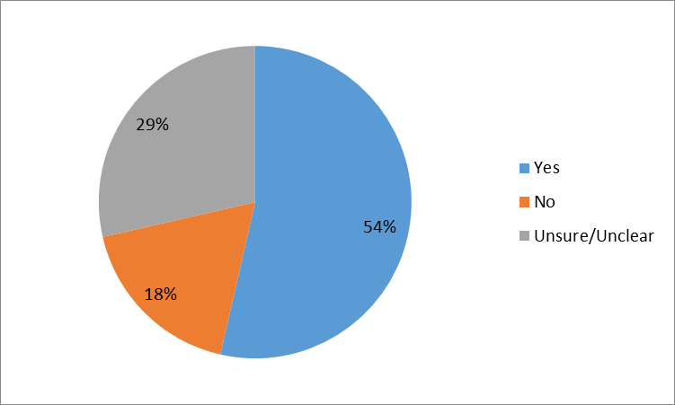

2.2 What is your opinion of the tools available to regulators to correct errors and address non‐compliance? What would help improve these tools? (Question OM2)
Twenty-one submitters provided information relating to this question. These submitters held a range of views about the tools currently available to regulators to address errors and non-compliance, and no clear trend could be identified. Around one third of submitters commented that the current tools were adequate, another third that they were not sufficient, and the last third commented that they were unsure or did not provide a firm view.
A key theme among submitters who discussed improving compliance tools was that regulators should have more flexibility in dealing with instances of accidental or minor non-compliance. Submitters included a number of suggestions, including giving regulators discretion to review or edit emissions returns where there are obvious errors and providing more flexibility with regard to penalties for small errors.
“[Penalties for breaching NZ ETS obligations] are necessary but need to have more flexibility. At the present fines can be handed out for minor and innocent mistakes. It needs to be remembered that many MPI [Ministry for Primary Industries] staff live with this all day while the average forest owner has no idea. More flexibility needs to be given to staff to make decisions here.” (Forest Management Limited, 00024)
Other submitters commented that the Government and NZ ETS agencies should provide additional guidance to participants to encourage compliance, or that more regular communication with participants would encourage compliance.
“Education is the most effective compliance tool – most people do not deliberately avoid compliance and most of the rest want to comply when they understand the penalties involved. So, making information available and taking a pro-active engagement approach for compliance will be most effective. MPI provides a good example of this to date and should be congratulated for trying to resolve issues pro-actively and using compliance action only as a last resort.” (Carbon Farm Limited, 00121)

2.3 Are there options, not already included here, for improving compliance with emissions reporting and surrenders? What are they? (Question OM3)
In total, 21 submitters provided information addressing this question, and over half of these thought there were additional options for improving compliance. Approximately 30 per cent noted they were unsure or did not provide a firm view in their answer, while around 10 per cent thought there were no additional options available.
A common suggestion for improving compliance was increasing education or communication to help participants understand their obligations, and a number of submitters provided recommendations to help achieve this. These included increasing MPI resourcing to provide greater levels of assistance for forestry participants; providing reminders ahead of compliance and other deadlines; and publishing more online guidance and information.
“Improved communication with ETS-registered participants would assist with compliance requirements. Such communication could also cover aspects of best practice such as ways to minimise the risks of NZU [New Zealand Unit] price fluctuations under different circumstances.” (New Zealand Forest Owners Association, 00039)
“Federated Farmers of New Zealand recommends government better resource the processing of ETS documents in a more timely manner, as well as better resource administrator support to assist scheme participants to correct minor technical issues with ETS documents.” (Federated Farmers of New Zealand, 00115)
Other submitters suggested ways to simplify carbon accounting and reduce costs, as they considered these changes would reduce the level of non-compliance.

Table 2: Submitter positions – Are there options, not already included here, for improving compliance with emissions reporting and surrenders?
 | Yes | No | Unsure / Unclear | Total
Forestry | 9 | 1 | 1 | 11
All other sectors | 4 | 1 | 5 | 10
TOTAL | 13 | 2 | 6 | 21

Figure 2: Submitter positions – Are there options, not already included here, for improving compliance with emissions reporting and surrenders?
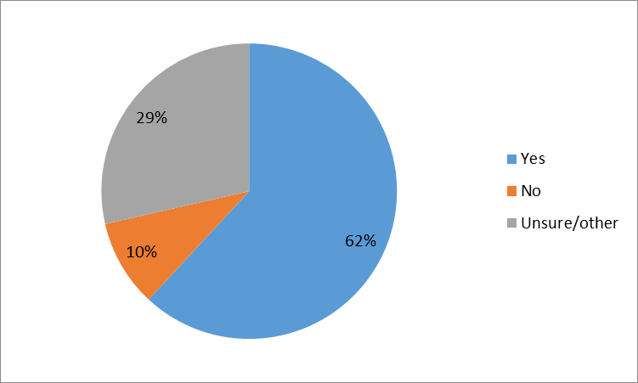

3. Disclosure of NZ ETS information

3.1 Does the current level of information available allow you to make informed decisions about your participation in the NZ ETS? If not, please give examples of information you think would be useful, and how it would help you. (Question OM4)
In total, 30 submitters addressed this question, and many of these submitters provided suggestions for additional information they would find useful.
Approximately one third of submitters who addressed this question thought that the information currently available allows them to make informed decisions about participating in the New Zealand Emissions Trading Scheme (NZ ETS). Some of these submitters, however, still provided suggestions for additional information that would be helpful.
A further one third did not think the information currently available was sufficient for making informed decisions, and the remaining third noted they were unsure or provided suggestions for additional information without providing a view on information currently available.
Most submitters who addressed this question provided examples of additional information they would find useful or made suggestions for how current information could be improved. Common suggestions included more regular and timely reporting of NZ ETS emissions data and forecasts, as well as providing a centralised website or location for all NZ ETS data and information.
“There is scope for the management and dissemination of information to be more centrally located or better integrated. Currently information is scattered on multiple disconnected websites and the timetable for publication of new data regarding supply/demand fundamentals is not well publicised. This increases the complexity of participating in the NZETS and as NZU-only [New Zealand Unit] trading activity picks up and this data has increasing implications for the value of units, it is important to simplify and create low entry barrier information to help create a level playing field for both local and international market participants.” (Shell New Zealand, 00085)
“In addition, greater transparency about the data being relied upon by Government, for example, for modelling purposes, would be useful for emitters and other ETS participants to access. This would include data on the effects of different carbon prices, carbon trading scenarios or different industries' use and emissions.” (Genesis Energy, 00053)
Other suggestions also called for additional information, with submitters recommending the Government present information and data in more accessible ways. A number of submitters thought the Government should provide market data, for example information on trades that have occurred or forward carbon prices.
“A key input to the business planning process is the future price of emissions (i.e. the value of valid emissions units). There are however currently no sufficiently active forward markets with respect to carbon prices to provide clarity as to the likely future price of units, or any ability to readily hedge price risks. This makes forecasting future carbon obligations or managing price risks very difficult.” (Petroleum Exploration and Production Association, 00114)
Table 3: Submitter positions – Does the current level of information available allow you to make informed decisions about your participation in the NZ ETS?
 | Yes | No | Unsure / Unclear | Total
Forestry | 8 | 2 | 3 | 13
All other sectors | 2 | 8 | 7 | 17
TOTAL | 10 | 10 | 10 | 30

Figure 3: Submitter positions – Does the current level of information available allow you to make informed decisions about your participation in the NZ ETS?
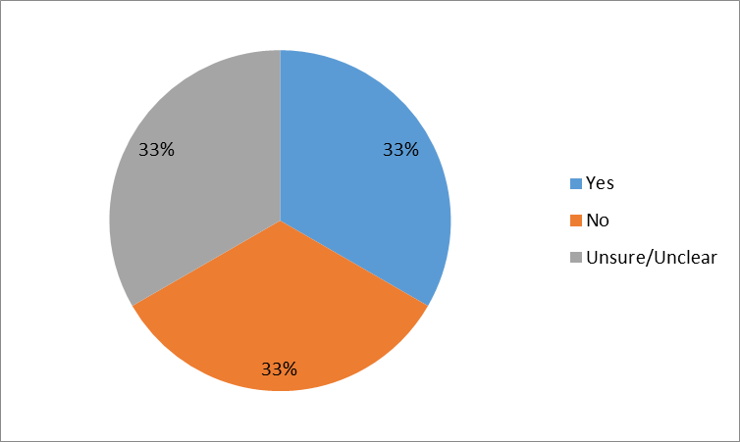

3.2 Are there any additional forms of information that would assist with your understanding of, or participation in, the market? (Question OM5)
In total, 20 submitters addressed this question in their submission and provided examples of additional forms of information to assist with understanding the carbon market. Many of the suggestions provided were similar to those provided above.
There were a number of common themes across suggestions for new information that would assist with participants’ understanding of the market. These included providing more regular and detailed data sets; providing information on how the NZ ETS aligns to New Zealand’s international targets and progress towards these targets; and providing additional information on carbon market activities, such as detail of volume traded and NZU price.
“BP believes that the Government should consider the role of information transparency and regular data reporting. … Compared to other Emissions Trading Schemes globally, the NZ ETS is relatively opaque. While the NZ ETS Facts and Figures‘’ and ‘Section 89’ reports are useful, they are lagging indicators and do not align to enable participants to develop an up-to-date view on market fundamentals. … Providing regular access to information such as parties’ annual reported emissions figures and ‘grown’ NZUs would assist to remove asymmetric information and promote wider participation in the market. This would enable participants to more easily identify potential sources of supply and demand, improve liquidity and reduce volatility.” (BP Oil New Zealand, 00135)
“As the market for NZUs expands and matures, core market data such as volumes traded, prices, forward market, even futures and hedges should also be available on one website.” (Oji Fibre Solutions, 00071)

4. Transfer of participation for post‐1989 forestry

4.1 Have you undertaken, or expect to undertake in the future, an NZ ETS transfer process? If so, how well do you understand the transfer provisions? (Question OM6)
Seventeen submitters addressed this question. Almost half of these submitters (approximately 45 per cent) stated that they had completed a New Zealand Emissions Trading Scheme (NZ ETS) land transfer process. The remaining submitters who addressed this question were mixed between those who had never completed a transfer process (and did not anticipate ever doing so) and submitters who noted they were ‘unsure’ in their submissions.
Many submitters who had experience with the NZ ETS land transfer provisions commented on how well they understand the provisions. Although many of these submitters noted that they had a good personal understanding of the transfer provision, a common theme among these submitters was noting the complexity of the provisions. Many of these submitters also noted that there is a low level of understanding among a range people, including professionals, such as lawyers and accountants, as well as land owners themselves.
“PF Olsen has completed several transfers of participation on behalf of participation clients. The requirement to transfer NZ ETS participation is often poorly understood by the lawyers involved in conveyancing and PF Olsen has often become involved once the sale and purchase has concluded and the paperwork is already overdue.” (PF Olsen, 00006)
Table 4: Submitter positions – Have you undertaken, or expect to undertake in the future, an NZ ETS transfer process?
 | Yes | No | Unsure / Unclear | Total
Forestry | 8 | 2 | 1 | 11
All other sectors | 0 | 2 | 4 | 6
TOTAL | 8 | 4 | 5 | 17

Figure 4: Submitter positions – Have you undertaken, or expect to undertake in the future, an NZ ETS transfer process?
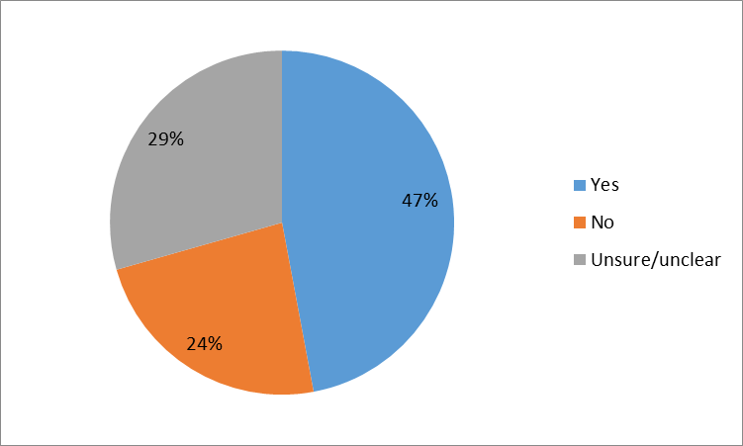

4.2 Have you encountered issues with NZ ETS land transfer requirements? If so, what issues did you have? (Question OM7)
Thirteen submitters addressed this question, and just under half of these submitters (approximately 45 per cent) noted they had encountered issues with NZ ETS land transfer requirements.
Common issues noted across submitters included the tight legislative timeframes; accessing information required to complete requirements; and complex land transfers taking a long time to be finalised.
“Yes, we have had problems with Transfers. One common problem is getting both Transferor & Transferee to sign the documents within 20 working days of the Date of Transmission, which leads to late filing issues. A second problem is getting the information required to complete the Transfer of Participation forms and/or the Mandatory Emissions return (Transmission), including ETS shapefiles, CAR, FMA tables and other data. Usually, the Transferee is most motivated to complete these forms and have the transfer take effect but MPI [Ministry for Primary Industries] cannot supply the ETS records to them until the Transfer has taken effect – catch 22.” (Carbon Farm Limited, 00121)
Some submitters also commented that many of the issues faced by NZ ETS participants surrounding land transfer requirements are often a result of a lack of understanding due to the complex nature of the rules.
“Absolutely [we have encountered issues] but generally by people (including legal) attempting to do it themselves in an uninformed way.” (Woodnet 2005 Limited, 00109)

4.3 Do you think the NZ ETS transfer requirements should be changed or simplified? If so, how? (Question OM8)
In total, 16 submitters addressed this question in their submissions. Approximately 30 per cent of these submitters thought the transfer requirements should be changed, while three submitters noted did not think the current requirements needed to be changed. The remaining submitters were either unsure or did not provide a clear view in their answer.
Submitters provided a number of suggestions for how to improve the NZ ETS transfer requirements. These included requiring lawyers to complete transfer obligations; automating transfer processes using Land Information New Zealand (LINZ) data; and sharing NZ ETS data between transferors and transferees.
“I have dealt with many transfers for clients. Often ETS participants and purchasers are unaware of their obligations. I suggest that LINZ notifies MPI each time an ETS affected land transfer occurs so that MPI can then send a notice to the transferee. Transfers and FMA participation. If a forest is measured during and emissions period and then transferred during the same emissions period the new ETS Participant should where possible be able to use the FMA participant specific table. This would reduce costs for all involved and avoid duplicating measurement.” (Carbon Forest Services Limited, 00081)
“The onus should be on the lawyers involved in conveyancing to provide/complete the transfer of participation paperwork as part of the property settlement process. Ministry for Primary Industries could then generate the required Mandatory Emission Return (surrender) based on the supply of the transfer of participation document. It’s the MER (surrender) that generates the most confusion.” (PF Olsen, 00006)
Table 5: Submitter positions – Do you think the NZ ETS transfer requirements should be changed or simplified?
 | Yes | No | Unsure / Unclear | Total
Forestry | 5 | 2 | 3 | 10
All other sectors | 0 | 1 | 5 | 6
TOTAL | 5 | 3 | 8 | 16

Figure 5: Submitter positions – Do you think the NZ ETS transfer requirements should be changed or simplified?
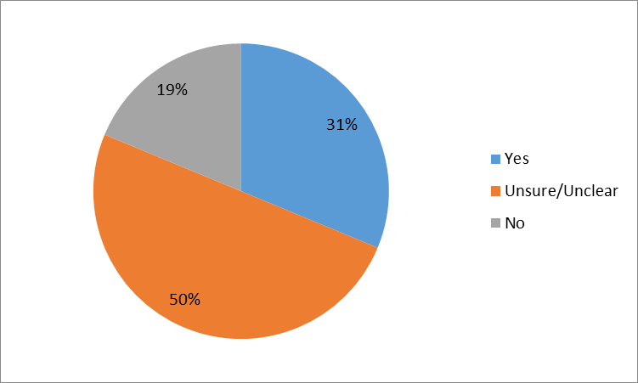

5. Tree weed exemption provisions under the Climate Change Response Act 2002

5.1 Have you encountered any problems with the tree weed exemption process? (Question OM9)
In total, 13 submitters addressed this question; many of these submitters noted they had no experience with the tree weed exemption process and only one submitter provided information on problems with the exemption process.
Submitters who discussed the tree weed exemption process noted that it was complex for applicants to understand.
“Complexity in the treatment of tree weeds has left many of our members confused as to whether or not they are compliant in their efforts to control tree weed species on their farms. That a landowner is required to apply for the exemption has not been made clear to farmers, giving rise to situations where some of our farmer members have been sent deforestation notices by MPI [Ministry for Primary Industries] for having cleared tree weed species on their farms. This is of concern where the success of community efforts to control tree weed species rests in part on the goodwill and active participation of private landowners.” (Federated Farmers of New Zealand, 00115)
A few submitters who had no experience with the tree weed exemption process noted they thought it was important the New Zealand Emissions Trading Scheme (NZ ETS) supported the eradication of trees weeds.
“Not sure about this question. However it is essential people with weed trees are not penalised for eradicating them. Given that there is not likely to be huge areas, there should be financial assistance to re-plant with exotics and allow land owners to participate in the post-1989 ETS.” (Federation of Māori Authorities, 00140)
Table 6: Submitter positions – Have you encountered any problems with the tree weed exemption process?
 | Yes | No | Unsure / Unclear | Total
Forestry | 0 | 5 | 2 | 7
All other sectors | 1 | 1 | 4 | 6
TOTAL | 1 | 6 | 6 | 13

Figure 6: Submitter positions – Have you encountered any problems with the tree weed exemption process?
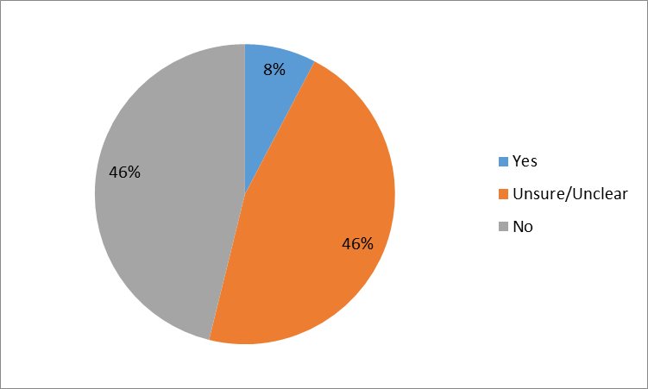

5.2 Have you encountered issues in complying with the conditions of a tree weed exemption? (Question OM10)
Eight submitters addressed this question. None of these submitters noted any issues in complying with the conditions on a tree weed exemption, and some noted they no experience with tree weed exemptions.

5.3 Do you think the tree weed exemption provisions could be improved? If so, how? (Question OM11)
Twelve submitters addressed this question in their submissions; most of these submitters did not provide a clear or firm view on if the tree weed exemption provisions could be improved. A small number of submitters, however, did provide information on possible ways to improve the tree weed exemption provisions. These included possibly removing deforestation liabilities for tree weeds; managing exemptions at a group level; and managing tree weeds as forests with suitable management plans.
“Tree weed species tend to be controlled at a regional and community level. It would make sense for the tree weed exemption to apply where there are registered efforts to control tree weed species that might give rise to deforestation liabilities. In this manner, one reduces the complexity of applying for exemptions on an individual instance while also ensuring that the exemption only applies to those tree weed species controlled under registered efforts.” (Federated Farmers of New Zealand, 00140)

Table 7: Submitter positions – Do you think the tree weed exemption provisions could be improved?
 | Yes | No | Unsure / Unclear | Total
Forestry | 0 | 1 | 6 | 7
All other sectors | 1 | 1 | 3 | 5
TOTAL | 1 | 2 | 9 | 12

Figure 7: Submitter positions – Do you think the tree weed exemption provisions could be improved?
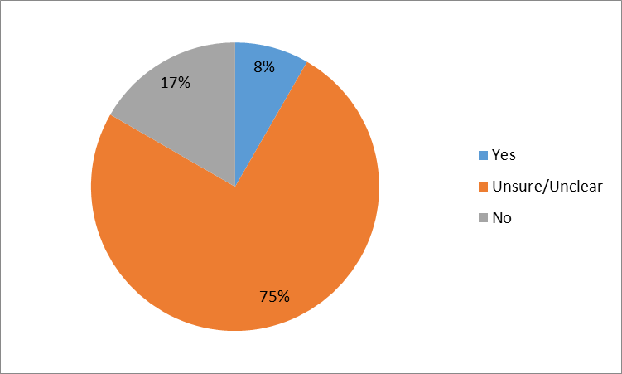

6. The public’s limited access to information about the NZ ETS status of land

6.1 What information on land status under the NZ ETS would be useful for your decision making? (Question OM12)
Sixteen submitters addressed this question; most of these submitters provided examples of the type of information on New Zealand Emissions Trading Scheme (NZ ETS) land status they find useful. There were a number of similarities across these responses.
Common types of useful information identified included detail beyond the NZ ETS land status, such as shape file data and the unit balance of carbon accounting areas.
“It is imperative to know what carbon credits have been claimed on a forest and whether said forest is pre 1990 or post 1989 so that you know your potential liability as a purchaser.” (Individual, 00118)
“If the satellite imagery that MPI use to assess land eligibility could also be shared, the applicant and assessor (MPI) share all the information on eligibility of the land. This can only serve to make the application process more efficient, expediting the preliminary determination phase. … [In addition,] it would be useful if the notice on the title could provide the status of post-1989 registration or pre-1990 allocation, to remove the requirement to also purchase the instrument (which includes long lists of unrelated titles). This makes the NZ ETS land status information (where registered or allocation received) available instantly to anyone who views a title” (PF Olsen, 00006)
“Ready access to registered land GIS shape file information would be useful for land purchase appraisals.” (City Forests, 00032)

6.2 Have you faced any problems in classifying forest land under the NZ ETS or in accessing information on forest land’s NZ ETS status? (Question OM13)
In total, 14 submitters addressed this question and half of these submitters commented on problems they had experienced. Many of these comments were focused on difficulties submitters faced trying to classify land that had not already been classified by the Ministry for Primary Industries (MPI). Common problems described included a lack of understanding among landowners and difficulties in acquiring information from previous landowners or other sources.
“No problems finding out about ETS status (registered or unregistered), although classifying land that has not been formally assessed via MPI’s eligibility review is always difficult (e.g., pre-1990 versus post-1989 determinations).” (Carbon Farm Limited, 00121)
“Property Information needs to be released without having to hunt back historical owners for their records. This is regularly an issue for us when looking at new acquisitions whether they are Post, Pre, Exempt. The new prospective owner is taking on these assets with no idea or means of getting this info without a wild goose chase. The previous owners are quite often out of business, dead or uncontactable.” (IFS Growth Limited, 04004)
Table 8: Submitter positions – Have you faced any problems in classifying forest land under the NZ ETS or in accessing information on forest land’s NZ ETS status?
 | Yes | No | Unsure / Unclear | Total
Forestry | 6 | 3 | 1 | 10
All other sectors | 1 | 1 | 2 | 4
TOTAL | 7 | 4 | 3 | 14

Figure 8: Submitter positions – Have you faced any problems in classifying forest land under the NZ ETS or in accessing information on forest land’s NZ ETS status?
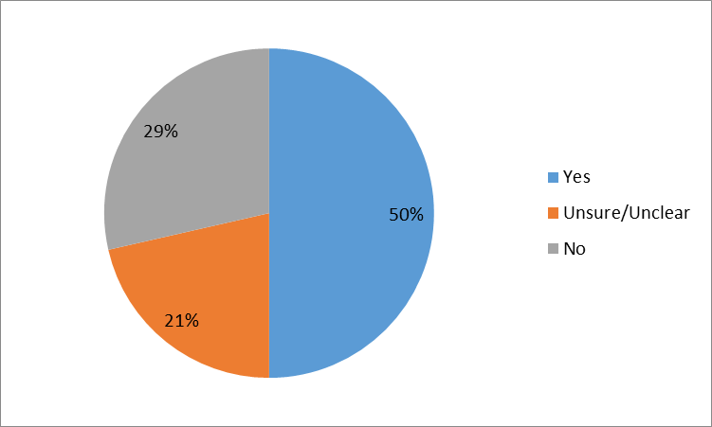

6.3 Do you think the Government should provide information on the NZ ETS status of land that is not already subject to the NZ ETS? If so, how would this help you? (Question OM14)
In total, 18 submitters addressed this question in their submission; just over half of these submitters (approximately 55 per cent) thought the Government should provide information on the NZ ETS status of land not already subject to the NZ ETS. Most of the remaining submitters were unsure, and there were a few submitters who did not consider this information to be useful.
Many submitters who recommended the Government provide information on the status of land not already subject to the NZ ETS commented that doing so would help landowners make decisions about land and forestry investments in a timely manner. These submitters also often commented that the Government is an authoritative source of information, which already holds a lot of relevant data for identifying land status.
“MPI holds a lot of information on what is post and pre 1990 land and should make this freely available so decisions and approvals can be done quickly. This helps investment decisions and stops a lot of duplication in 2 sides collecting data. This has to become a collaborative process with the goal being to get more forest planted. Not a cat and mouse game. The overriding goal should be to get forest going.” (Forest Management Limited, 00024)
“It would help for the government to have available information on the ETS status of land that is not currently registered in the ETS so that landowners are empowered to make more informed decisions. Federated Farmers of New Zealand recommends that the government have available information on the ETS status of unregistered lands.” (Federated Farmers of New Zealand, 00115)
A few submitters did not think the Government should provide this type of information; these submitters gave various reasons, including that the information currently available is sufficient.
“No. The essentials of this are available already via LUCAS, land titles and existing databases.” (Carbon Farm Limited, 00121)
Table 9: Submitter positions – Do you think the Government should provide information on the NZ ETS status of land that is not already subject to the NZ ETS?
 | Yes | No | Unsure / Unclear | Total
Forestry | 6 | 3 | 2 | 11
All other sectors | 4 | 0 | 3 | 7
TOTAL | 10 | 3 | 5 | 18

Figure 9: Submitter positions – Do you think the Government should provide information on the NZ ETS status of land that is not already subject to the NZ ETS?
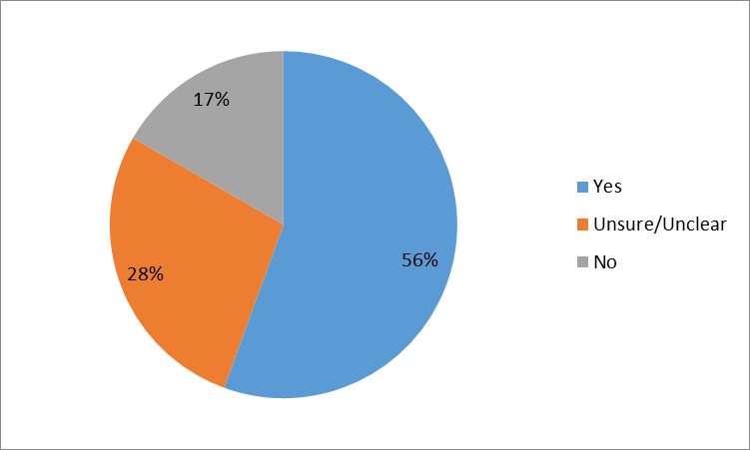

References
Ministry for the Environment. 2015. New Zealand Emissions Trading Scheme Review 2015/16: Discussion document and call for written submissions. Wellington: Ministry for the Environment.
Ministry for the Environment, 2016a. New Zealand Emissions Trading Scheme Review 2015/16: Forestry Technical Note. Wellington: Ministry for the Environment.
Ministry for the Environment, 2016b. New Zealand Emissions Trading Scheme Review 2015/16: Operational Matters Technical Note. Wellington: Ministry for the Environment.
Ministry for the Environment. 2016c. New Zealand Emissions Trading Scheme Review 2015/16 –Summary of Stage Two: Other Issues Consultation Responses. Wellington: Ministry for the Environment.
Ministry for the Environment. 2016d. New Zealand Emissions Trading Scheme Review 2015/16 – Summary of Stage Two: Other Issues Consultation Responses. Annex One: Forestry Technical Note Responses. Wellington: Ministry for the Environment.

Ministry for the Environment. 2016c

