
New Zealand Emissions Trading Scheme Review 2015/16

Summary of stage two: other issues consultation responses

Annex one - Forestry technical note Responses

October 2016

This report may be cited as:
Ministry for the Environment. 2016. New Zealand Emissions Trading Scheme Review 2015/16 – Summary of Stage Two: Other Issues Consultation Responses. Annex One: Forestry Technical Note Responses. Wellington: Ministry for the Environment.

Published in October 2016 by the
Ministry for the Environment
Manatū Mō Te Taiao
PO Box 10362, Wellington 6143, New Zealand

ISBN: 978-0-908339-62-4
Publication number: ME 1266

© Crown copyright New Zealand 2016

This document is available on the Ministry for the Environment’s website:
www.mfe.govt.nz.



Contents
Figures 4
1. Introduction 5
2. Existing structural design settings 7
3. Future forestry accounting in the NZ ETS 16
4. Averaging 19
5. Harvested wood products 25
6. Other 29
References 30

Tables
Table 1: Submitter positions – Do you think the NZ ETS forestry settings discourage deforestation? 9
Table 2: Submitter positions – Do you think the NZ ETS forestry settings incentivise afforestation and replanting? 10
Table 3: Submitter positions – Does the NZ ETS provide effective incentives for smaller foresters to participate in the scheme? 12
Table 4: Submitter positions – Does the NZ ETS work well alongside other forestry programmes? 13
Table 5: Submitter positions – Do you think a different forestry accounting approach in the NZ ETS would change the scheme’s incentives for afforestation? 17
Table 6: Stakeholder positions – Do you think averaging should be introduced for post‐1989 forests? 20
Table 7: Stakeholder positions – Do you think it should averaging be optional or mandatory? 21
Table 8: Stakeholder positions – Should there be limits on the types of forests that can use an averaging accounting method? 22
Table 9: Stakeholder positions – Do you think deferred liability for emissions from harvested wood products (HWPs) should be recognised domestically? 27
Figures
Figure1: Submitter positions – Do you think the NZ ETS forestry settings discourage deforestation? 9
Figure 2: Submitter positions – Do you think the NZ ETS forestry settings incentivise afforestation and replanting? 11
Figure 3: Submitter positions – Does the NZ ETS provide effective incentives for smaller foresters to participate in the scheme? 12
Figure 4: Submitter positions – Does the NZ ETS work well alongside other forestry programmes? 14
Figure 5: Submitter positions – Do you think a different forestry accounting approach in the NZ ETS would change the scheme’s incentives for afforestation? 18
Figure 6: Stakeholder positions – Do you think averaging should be introduced for post‐1989 forests? 21
Figure 7: Stakeholder positions – Do you think it should averaging be optional or mandatory? 21
Figure 8: Stakeholder positions – Should there be limits on the types of forests that can use an averaging accounting method? 23
Figure 9: Stakeholder positions – Do you think deferred liability for emissions from harvested wood products (HWPs) should be recognised domestically? 27

1. Introduction

1.1 New Zealand Emissions Trading Scheme Review 2015/16
The New Zealand Emissions Trading Scheme (NZ ETS) review began on 24 November 2015, with the release of a discussion document and a call for written submissions. The discussion document set out the terms of reference for the review, and issues for consultation.
The issues for consultation covered the following three key areas:
- transition measures, with the exception of surrender obligations for biological emissions from agriculture
- the evolution of the NZ ETS design, taking into account the changing conditions in which
it operates
- operational and technical improvements.
Consultation on stage two ‘other issues’ of the NZ ETS ran from the beginning of the review to 30 April 2016. During this period, two technical notes were released to support consultation and seek additional feedback on some specific issues.

1.2 Technical notes
The following technical notes were released on 3 March 2016 and published on the Ministry for the Environment website:
- New Zealand Emissions Trading Scheme Review 2015/16: Forestry Technical Note (www.mfe.govt.nz/publications/climate-change/forestry-technical-note)
- New Zealand Emissions Trading Scheme Review 2015/16: Operational Matters Technical Note (www.mfe.govt.nz/publications/climate-change/operational-matters-technical-note)
These documents provided further detail on some forestry and operational issues not included in the NZ ETS review discussion document, and sought stakeholder feedback on those issues.

1.2 This summary of responses
In October 2016, a summary of consultation responses on stage two of the review was published on the Ministry for the Environment website (www.mfe.govt.nz/publications/climate-change/new-zealand-emissions-trading-scheme-review-201516-summary-stage-two). This document accompanies the main summary of consultation stage two responses, and includes information on submissions provided in response to the Forestry technical note ((www.mfe.govt.nz/publications/climate-change/nz-ets-review-201516-summary-stage-two-annex-two).
This document provides a summary of consultation responses on the forestry technical note only.

1.4 Conventions used in this document
Where numbers and percentages are used when referring to the number of submitters who responded to questions, these are based on interpretation of the submissions. Protocols were established to ensure as great a degree of consistency in interpretation as possible.
Selected quotes from submissions have been included in this summary document. These have been included for their value in illustrating issues raised by submitters, or because they articulate issues in a way that is difficult to paraphrase without losing the original meaning. Their inclusion in this document does not imply that they have been given more weight over and above submissions that have not been cited specifically.
Where quotes from submissions are used, any unexplained acronyms or minor typographical errors have been amended to allow for improved readability. Every effort has been made to ensure citations of submissions are accurate. Where these have been manually typed, however, there may be minor errors.
Percentages referred to in this document have been rounded. As such, in some cases total values may not equal 100 per cent.
Please see the main summary of submissions document for stage two (www.mfe.govt.nz/publications/climate-change/new-zealand-emissions-trading-scheme-review-201516-summary-stage-two) for further information on the submission analysis process for the review and information on stakeholders who provided submissions on the NZ ETS review.

2. Existing structural design settings

2.1 What do you consider the strengths and weaknesses of the NZ ETS forestry settings? (Question F1)
Forty-one submitters responded to this question, and provided information on a range of strengths and weaknesses of forestry settings in the New Zealand Emissions Trading Scheme (NZ ETS). Nineteen of these submitters provided comments on strengths, and 38 provided comments on weaknesses of these settings.

Strengths
A number of submitters commented that, although some improvements could be made to the scheme, the NZ ETS forestry settings are generally good. Some submitters considered including forestry in the NZ ETS to be a key strength, especially because it allows post-1989 forestry participants to receive New Zealand Units (NZUs) to enhance the value of their forests and support forestry investment.
Other strengths noted included the voluntary nature of post-1989 forestry participation and having more simple rules for small forests (eg, restricting the Forest Management Approach (FMA) to large forests only).
“The strength was that the ETS potentially provided income for eco services and therefore cashflow prior to clearfell. This made marginal forest investment attractive and supported in many cases good land use.” (Woodnet Limited, 00109)
“Strengths include allowing the growers of post 1989 forests to choose to participate or not as it suits their circumstances and abilities.” (New Zealand Farm Forestry Association, 00022)

Weaknesses
Weaknesses of the NZ ETS identified by submitters included the complexity and costs of current settings, especially the FMA, and a lack of alignment between the NZ ETS and other forestry policies or desired outcomes.
“The registration and accounting methods for post 1989 forest are far too complex and expensive.” (Graeme Edwards, 00011)
“The policy is restricted to the role of forests for climate change. It does not include the other public benefits forests provide and therefore produces a sub-optimal overall result. One example is the lack of consideration of biodiversity in a policy that encourages planting of a single introduced species.” (Andrew McEwen, 00184)
Some submitters identified particular forestry settings as weaknesses, including the requirement for post-1989 forestry to surrender units at harvest, and the split between pre-1990 and post-1989 forests. Concerns about the division between pre-1990 and post-1989 forest land were raised by several Māori/iwi stakeholders, some of whom highlighted that the majority of land owned by Māori is pre-1990 forest land. Lack of recognition for pre-1990 natural forests was also raised by some submitters as a weakness.
“Te Rūnanga [o Ngāi Tahu] understands that the purpose of the distinction between pre 1990 and post 1989 forest is an arbitrary consequence of the Kyoto Protocol that has limited relevance in reducing emissions or promoting carbon sequestration. Emissions continue to increase. This shows the current policy settings are not sufficient and brings into question the effectiveness of the arbitrary distinction between pre 1990 and post 1989 forests.” (Te Rūnanga o Ngāi Tahu, 00154)
Many submitters also discussed their concerns relating to particular settings in further questions, including question F6 “What changes could be made to NZ ETS forestry sector provisions to improve the scheme?”, and when submitting on possible future accounting approaches for post-1989 forestry.

2.2 Do you think the NZ ETS forestry settings discourage deforestation? If not, what settings do you think would? (Question F2)
In total, 30 submitters answered this question, and there was no clear trend in these answers. Thirteen submitters (approximately 40 per cent) thought the current forestry settings discourage deforestation and a further 11 (approximately 35 per cent) thought they did not. The remaining six submitters were unsure, or did not give a firm view in their submissions.
Some submitters who considered the current settings sufficient to discourage deforestation pointed to the size of deforestation liabilities as a deterrent. Other submitters, however, noted that for post-1989 foresters the NZ ETS only discourages deforestation if the land is voluntarily registered in the NZ ETS.
Many submitters who considered the current NZ ETS settings to be appropriate to discourage deforestation also acknowledged that low NZU prices as well as factors outside the NZ ETS can drive deforestation.
“The settings are appropriate to discourage deforestation […] It has been low prices that have driven deforestation since 2011, not the settings themselves. If the price is higher the settings will suppress continued deforestation.” (Carbon Farm Limited, 00121)
“Recent deforestation has been driven by other factors, relative performance of dairy sector, perceived under performance by forestry sector.” (Southern Forests NZ Ltd, Carbon Solutions NZ Ltd, 05003)
Submitters who stated they did not think current NZ ETS settings discourage deforestation also often pointed to the previous low NZU price or wider NZ ETS settings as factors. Some of these submitters commented the NZ ETS had not discouraged deforestation because the NZU price had been driven down by the transitional measures, including the one-for-two surrender obligation, or use of international units.
Some submitters who thought the NZ ETS does not discourage deforestation also considered that this should not be an aim of the NZ ETS, and that instead the NZ ETS should be focused on increasing emissions reductions, or replanting.
“The ETS settings not only fail to discourage deforestation, they actually promote it. Providing sufficient incentive to re-forest should be the focus rather than considering that more might be done to prevent deforestation.” (New Zealand Forest Owners Association, 00039)
Table 1: Submitter positions – Do you think the NZ ETS forestry settings discourage deforestation?
 | Yes | No | Unsure / Unclear | Total
Forestry | 8 | 9 | 3 | 20
All other sectors | 5 | 2 | 3 | 10
TOTAL | 13 | 11 | 6 | 30

Figure 1: Submitter positions – Do you think the NZ ETS forestry settings discourage deforestation?
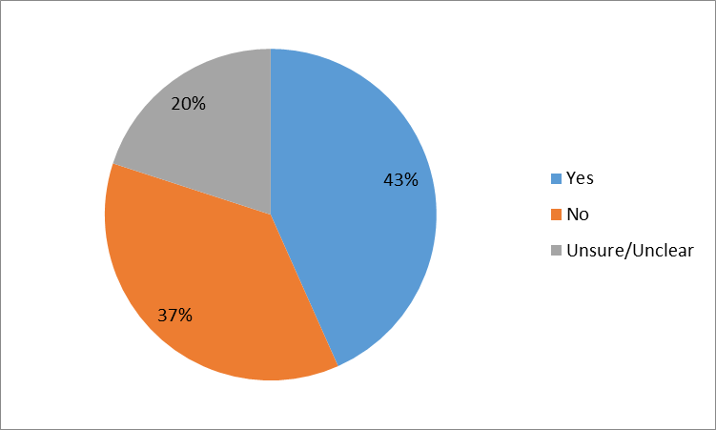

2.3 Do you think the NZ ETS forestry settings incentivise afforestation and replanting? If not, what settings do you think would? (Question F3)
In total, 34 submitters addressed this question. Fifteen stakeholders (approximately 45 per cent) commented that they did not think the current forestry settings incentivise afforestation and replanting, while eight (approximately 25 per cent) thought the current settings were sufficient. A number of submitters across both positions held similar views regarding the importance of NZU price as well as NZ ETS forestry settings. The remaining submitters either commented that they were unsure or did not provide a clear position in their answer.
Many of the submitters who thought the forestry settings were sufficient to incentivise increased afforestation and replanting also commented on the NZU price, noting that a consistently high price is important for the NZ ETS to be able to influence behaviour.
“Current ETS settings are sufficient to encourage afforestation, but the price is not sufficient. If by settings we mean the rules of the ETS, barriers to entry and so on, these are appropriate as-is and have proven effective so far. Low carbon prices are the main barrier to afforestation.” (Carbon Farm Limited, 00121)
Submitters who thought current settings do not encourage increased afforestation or replanting expressed some similar views with regards to the importance of the NZU price on the scheme’s incentives. A number of these submitters also provided information on potential changes to NZ ETS settings that could help increase these incentives, including removing broader NZ ETS transitional measures or introducing a post-1989 forestry accounting approach to reduce harvest liabilities, such as averaging or deferred liabilities for harvested wood products (HWPs).
“The ETS settings probably have little impact on afforestation and replanting compared to land prices, carbon prices and log prices.” (New Zealand Farm Forestry Association, 00022)
“No - Until forest owners can sell some of their carbon credits without a significant element of risk then it is not really an incentive for afforestation. If the likes of averaging or recognition of harvested wood products is brought into the scheme then people can see the financial benefit of registering their forest in the scheme.” (Laurie Forestry Ltd, 02020)
Table 2: Submitter positions – Do you think the NZ ETS forestry settings incentivise afforestation and replanting?
 | Yes | No | Unsure / Unclear | Total
Forestry | 6 | 10 | 4 | 20
All other sectors | 2 | 5 | 7 | 14
TOTAL | 8 | 15 | 11 | 34

Figure 2: Submitter positions – Do you think the NZ ETS forestry settings incentivise afforestation and replanting?
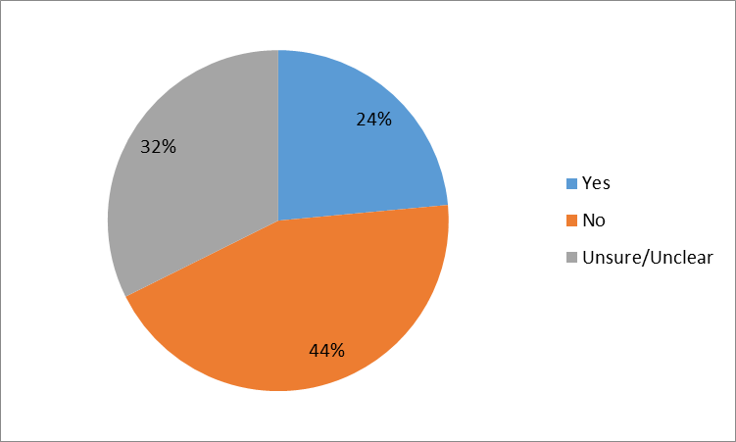

2.4 Does the NZ ETS provide effective incentives for smaller foresters to participate in the scheme? If not, what settings do you think would? (Question F4)
In total, 30 submitters provided information that addressed this question. Most submitters (approximately 60 per cent) did not think the NZ ETS provides effective incentives for smaller foresters to participate in the scheme, and approximately 30 per cent of submitters were unsure or did not provide a clear position. Only three submitters thought that the current settings provide effective incentives for small foresters.
Submitters who did consider current NZ ETS settings sufficient to incentivise owners of small forests to participate identified that parts of existing settings, such as the use of default lookup tables, help keep costs down for these foresters.
The majority of submitters who did not think NZ ETS settings are sufficient to incentivise small forestry participation, however, pointed towards compliance costs and uncertain carbon prices at harvest as the main barriers to participation.
“The ETS is shunned by many owners of smaller, limited age class forestry blocks. The single biggest reason why more post-1989 forest owners are not registered in the ETS is because of the uncertainty over carbon price at harvest.” (New Zealand Forest Owners Association, 00039)
“The liabilities on smaller forests is harder to manage – as they are generally logging one stand at a time and cannot spread liabilities over time. If the forestry sector was recognised correctly for its actual carbon liabilities – like Harvest wood products, then this would assist smaller forest owners in managing their harvest liabilities over time” (Gibbons Holdings Limited, 00130)
Many submitters suggested ways to help further incentivise owners of small forests to participate in the NZ ETS. Common suggestions included reducing ongoing administrative costs and introducing different accounting approaches to minimise harvest liabilities for post-1989 forestry, such as deferring emissions for harvested wood products or introducing an averaging approach.
Other suggestions included offering financial instruments to help manage price risk associated with harvest cycles; expanding the definition of an eligible forest (eg, to include riparian planting); and allowing small forest owners to aggregate their forests for NZ ETS participation.
Table 3: Submitter positions – Does the NZ ETS provide effective incentives for smaller foresters to participate in the scheme?
 | Yes | No | Unsure / Unclear | Total
Forestry | 2 | 13 | 1 | 16
All other sectors | 1 | 4 | 9 | 14
TOTAL | 3 | 17 | 10 | 30

Figure 3: Submitter positions – Does the NZ ETS provide effective incentives for smaller foresters to participate in the scheme?
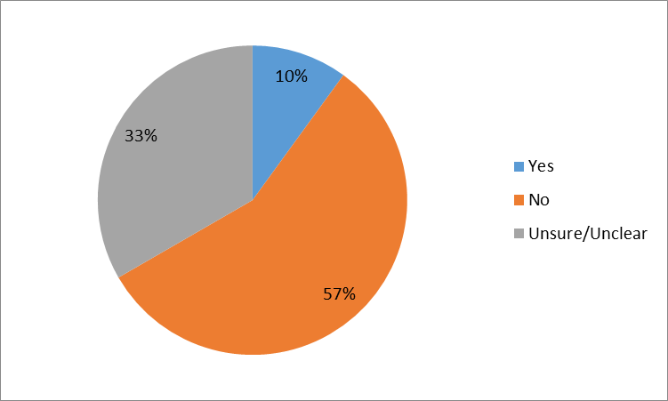

2.5 Does the NZ ETS work well alongside other forestry programmes? If not, how do you think these programmes could be better aligned? (Question F5)
In total, 34 submitters addressed this question; many of these submitters (approximately 60 per cent) provided comments on other forestry programmes but did not specifically discuss how well these programmes align with the NZ ETS. Just over half of submitters who provided an explicit view in their submission thought that the NZ ETS works well alongside other forestry programmes, while the remaining submitters thought it does not.
Outside the NZ ETS, the most commonly discussed forestry programme was the Permanent Forest Sink Initiative (PFSI). Other commonly raised programmes included the Afforestation Grant Scheme (AGS) and the Erosion Control Funding Programme (ECFP).
A few submitters who did not provide an explicit position still expressed support for such programmes, and encouraged their alignment with the NZ ETS. A few other submitters also noted that overall other forestry programmes had minimal impact on afforestation rates.
“As a matter of principle we consider it important that the NZ ETS be designed to align well with other forestry programmes in order to provide consistency and certainty to forest owners and those considering investing in forestry.” (Mighty River Power, 00152)
“The other forestry programmes offered by the government are relatively minor in scale and impact. Whether or not the ETS works well alongside them is practically irrelevant and has no bearing on reducing gross emissions.” (New Zealand Farm Forestry Association, 00022)
A number of submitters commented that there should be more support and recognition for the PFSI. Many of these submissions included suggestions for improving the PFSI, such as encouraging new PFSI forests in areas where other co-benefits (eg, erosion control) could be realised; introducing additional subsidies for PFSI forests; or promoting units generated from PFSI forests through measures like PFSI price floors or minimum surrender quotas.
“There has been insufficient support for the Permanent Forest Sink Initiative. This should be incentivised via an adequate price, but also through promotion for use in areas that are not suitable for commercial forestry (which includes urban areas, riparian planting, steep hillsides and erosion-prone land). The Review should consider creating a Permanent Forest Unit as recommended in the Pure Advantage report, ‘Our Forest Future’.” (Sustainable Initiatives Aotearoa, 02023)
“Recognise that carbon offsets are not created equal. PFSI offsets for example have surety of being long-term, and PFSI forests located on environmentally problematic land types can deliver considerable additional environmental benefits for NZ Inc. NZ Emitters should be required to buy a percentage of their offset requirements from PFSI forests.” (Permanent Forests New Zealand Limited, 00054)
Table 4: Submitter positions – Does the NZ ETS work well alongside other forestry programmes?
 | Yes | No | Unsure / Unclear | Total
Forestry | 4 | 4 | 7 | 15
All other sectors | 4 | 2 | 13 | 19
TOTAL | 8 | 6 | 20 | 34

Figure 4: Submitter positions – Does the NZ ETS work well alongside other forestry programmes?
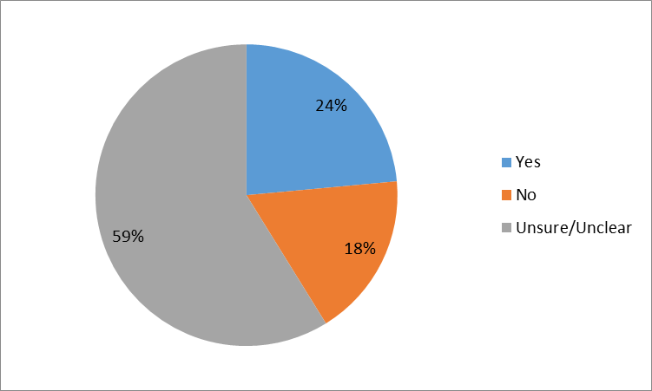

2.6 What changes could be made to NZ ETS forestry sector provisions to improve the scheme? (Question F6)
In total, 41 submitters included information on changes that could be made to forestry sector provisions to improve the NZ ETS. Submitters provided a range of recommended changes, with many referring to the possible accounting approaches for post-1989 forestry that were discussed in part two of the Forestry Technical Note.
Many submitters raised the different treatment of pre-1990 and post-1989 forestry under the NZ ETS as an issue and suggested changes to the NZ ETS to address their concerns. These suggestions included removing the distinction between forests planted pre-1990 and post-1989 from the NZ ETS completely.
“The NZ forest industry and forest landowners need a rational discussion with the Government on the merits of removing the distinction between pre-1990 and post-1989 forest land and thereafter consideration of the alternatives.” (Taumano, 00172)
“Remove the differentiation between post-1989 and pre-1990 forest […]This is a major issue for all Iwi. The differentiation lacked substantive support at the time of implementation and has, along with creating perverse incentives from the perspective of the purpose of the ETS, arbitrarily generated substantial inequality of treatment between the owners of forested lands.” (Climate Change Iwi Leaders Group, 00180)
Another suggestion included providing NZUs for carbon removals from pre-1990 forests, such as for additional carbon removals following pest control programmes.
“Pre-1990 forests should be able to participate voluntarily in earning carbon from improved forest management of the forest. This would promote better forest management practices to increase carbon storage of the pre-1990 forest estate (including native forest). It would also enable some benefits to flow to pre-1990 forests as opposed to only deforestation liabilities.” (Carbon Forest Services, 00081)
Other key themes for improving the NZ ETS forestry provisions included administrative improvements to the NZ ETS to improve efficiency or reduce compliance and transaction costs. These included improvements to the Field Measurement Approach; updating default look up tables; increasing MPI resourcing; and simplifying and increasing the flexibility of the compliance approach.
“The settings are manageable, it is the compliance costs that need addressing, especially for small foresters.” (The Omapere Taraire E & Rangihamama X3A Ahu Whenua Trust, 05021)
A number of these administrative and technical issues are also addressed in questions 24 and 25 of the discussion document, and in the Operational matters technical note.
Some submitters also suggested that the NZ ETS could be improved if different accounting approaches for post-1989 forestry were adopted, specifically averaging accounting or deferred liabilities for harvested wood products. These submitters often thought that these approaches would improve NZ ETS participation and incentives for forestry.
These accounting approaches were explored further in the Forestry technical note, and submitters’ responses are summarised later in this document.
Some submitters also suggested changes to the wider NZ ETS, outside the forestry provisions, that would improve the scheme for forestry participants, for example removing wider transitional measures such as the $25 fixed price option, or introducing a price floor.

3. Future forestry accounting in the NZ ETS

3.1 What are important factors when considering changes to forestry accounting settings in the NZ ETS? (Question F7)
In total, 33 submitters provided information on important factors when considering changes to NZ ETS forestry accounting settings. Submitters considered a range of factors to be important, and key themes included the importance of stability and simplicity when considering changes to NZ ETS forestry accounting settings.
There was broad consistency across submitters’ responses that stability of NZ ETS forestry settings is a key factor for the sector, because of the long-term investment horizon of forestry. These submitters noted that the long-term stability and predictability of any changes to forestry accounting settings must be considered.
“The most important factor when considering changing forestry accounting settings is to understand the impact the changes will have on the supply and price dynamics in the market. This includes the signals and perceptions any action delivers impacting certainty for forestry investors. In addition, the core principles that must be considered with any forestry accounting system is accuracy, completeness, consistency, transparency and variability.” (New Zealand Carbon Farming Group, 00069)
Another common theme raised was the need for simplicity in NZ ETS forestry accounting settings. Several submitters considered that reduced complexity in forestry accounting rules should be a primary consideration for any changes considered.
“A key goal should be to simplify many parts of it so it is easier to understand and explain to people. At present there are very few people who understand how it technically works and the rules. These need to be simplified and clearly set out.” (Forest Management Limited, 00024)
Some submitters discussed the extent to which NZ ETS forestry settings should align with accounting rules for forestry under international climate change agreements. There were mixed views among respondents. Some thought the NZ ETS should align with international rules, while other submitters considered that domestic policy goals could, in some cases, take precedence when considering NZ ETS forestry accounting settings.
“By default the government assumes all credit and associated liability for gains and losses in the carbon pool. The industry recognises therefore that it is important to manage the Crown liability with any proposed revisions within the ETS.” (New Zealand Forest Owners Association, 00039)
Some submitters also provided suggestions for other factors that should be considered, such as how changes to forestry accounting would impact the wider NZ ETS.

3.2 Do you think a different forestry accounting approach in the NZ ETS would change the scheme’s incentives for afforestation? (Question F8)
In total, 32 submitters addressed this question and a large majority of these submitters (approximately 75 per cent) thought a different forestry accounting approach would change NZ ETS incentives for afforestation. Most of these submitters also indicated support for a changed forestry accounting approach.
Out of the remaining eight submitters that addressed this question, six were unsure of the impacts of a different accounting approach, and two did not think a changed accounting approach would increase the incentives for afforestation.
Many of the submitters that thought a different accounting approach would improve NZ ETS incentives for afforestation commented that approaches with lower harvest liabilities would reduce the perceived risk of entering the NZ ETS, and that this could increase participation.
“Reducing liability for removals at harvest would have an immediate and huge impact on profitability and investment.” (Southern Forests NZ Ltd, Carbon Solutions NZ Ltd, 05003)
“Changes to the rules that reduce our Forest liabilities at harvest will make the ETS more attractive to us and other forestry companies… By introducing Harvested wood products this would incentivise afforestation. Introducing averaging as an option may increase afforestation by attracting the smaller forest holdings.” (Gibbons Holdings Limited, 00130)
A few submitters also noted that other broad changes to the NZ ETS, rather than a different forestry accounting approach, would be more effective in increasing new planting.
“No, CCILG do not believe another accounting approach will increase the incentives for afforestation. The only effective incentives are ongoing policy certainty and the removal of weakening signals.” (Climate Change Iwi Leaders Group, 00180)
Table 5: Submitter positions – Do you think a different forestry accounting approach in the NZ ETS would change the scheme’s incentives for afforestation?
 | Yes | No | Unsure / Unclear | Total
Forestry | 19 | 1 | 1 | 21
All other sectors | 5 | 1 | 5 | 11
TOTAL | 24 | 2 | 6 | 32
Figure 5: Submitter positions – Do you think a different forestry accounting approach in the NZ ETS would change the scheme’s incentives for afforestation?
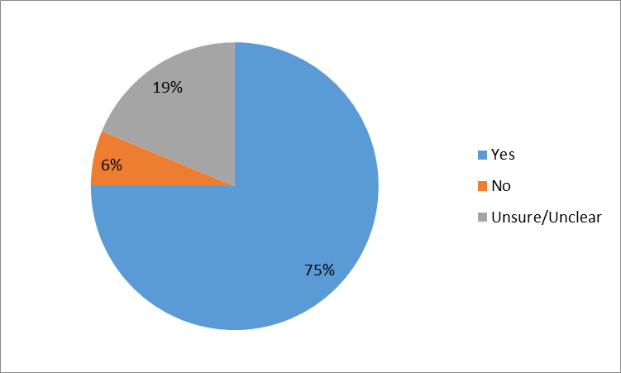

4. Averaging

4.1 Do you think averaging should be introduced for post‐1989 forests? If so, why, and do you think it should it be optional or mandatory? (Question F9)
In total, 37 submitters included views on averaging accounting. Twenty-one submitters (approximately 55 per cent) thought that averaging should be introduced for post-1989 forestry. A very large majority of these submitters (approximately 90 per cent), however, specified that averaging should only be introduced if it were optional. Approximately 30 per cent of submitters that addressed this question were not sure if averaging should be introduced or did not provide a clear position, while around 10 per cent thought averaging should not be introduced.
Submitters who supported introducing averaging accounting for post-1989 forestry often commented that its advantages include reduced carbon price risk; increased simplicity; and reduced compliance costs. Many of these submitters also commented that averaging accounting would be particularly attractive to small foresters.
“Removal of the threat of an unknown cost at harvest is likely to encourage a higher level of owners of small forest blocks including farm-foresters and farmers to enter the ETS. […] In addition measurement, reporting and compliance costs are likely to be less than the current option because it is a simpler system.” (New Zealand Forest Owners Association, 00039)
Most submitters also commented that if averaging accounting for post-1989 forestry was implemented it should be optional. Many of these submitters noted that larger forestry participants may prefer the current accounting approach as they are more able to manage the carbon credits and debits associated with the status quo. These larger participants often commented on the flexibility of the current settings as being a key advantage.
“I think it [averaging accounting] could be an option. Obviously a system like averaging is not going to be the preference of every forestry Participant in the ETS. The small scale foresters are likely to be the ones who would utilise this option. It allows them to benefit financially and is an incentive for more small forest owners to become Participants in the scheme. Less risk around carbon price and a tangible financial gain for their efforts.” (Laurie Forestry Limited, 02020)
“One of the main attractions of the existing scheme under which companies such as Tunakino Forestry have committed investment is that it allows a degree of optionality. We can make harvest vs. sale of carbon credit decisions and time those decisions based on prevailing market prices for logs vs. carbon. […]Under the averaging proposal it seems that this optionality could potentially be taken away – however it was exactly this optionality that was a key reason for us investing in the first place.” (Tunakino Forestry Limited, 03002)
Other submitters were unsure if averaging should be introduced or did not think it should be introduced. Many of the submitters who were unsure if averaging should be introduced thought there was not sufficient information available or detail on implementation options to make a decision.
Submitters who thought averaging should not be implemented raised issues including concern about increased fiscal risk from the approach and the lack of incentives for permanent forestry under an averaging approach. Some submitters who thought averaging should be introduced raised similar concerns and noted these issues need further consideration.
“The negative side of averaging is that it provides no incentives for permanent forestry or other forest options (continuous canopy management) that minimises carbon losses for example. Changing a forest to a non-harvest management regime has no advantages under averaging, all the benefits are in the first rotation and are limited or nothing for the second rotation.” (Gibbons Holdings Limited, 00130)
“I do not wish to use the averaging method on my forest I am intending to retire some of the land from forestry and leave it in trees for the long term. Obviously averaging does not support this approach.” (Individual, 00003)
A couple of other submitters noted that incentives for introducing averaging accounting should be re-assessed if deferred liabilities for emissions from Harvested Wood Products (HWPs) were incorporated into the NZ ETS.
“Deferral of harvested liability achieves a similar outcome in that it removes the concern associated with a large one-off liability in the year of harvest. If deferred liability was introduced we consider that it would then be worth consulting further with the industry to determine if there was still any appetite for introducing averaging. We anticipate the demand would be minimal, and not justify the time and effort to implement it.” (New Zealand Forest Owners Association, 00039)
Table 6: Stakeholder positions – Do you think averaging should be introduced for post‐1989 forests?
 | Yes | Yes with conditions | No | Unsure / Unclear | Total
Forestry | 2 | 15 | 3 | 4 | 24
All other sectors | 0 | 4 | 1 | 8 | 13
TOTAL | 2 | 19 | 4 | 12 | 37

Figure 6: Stakeholder positions – Do you think averaging should be introduced for post‐1989 forests?
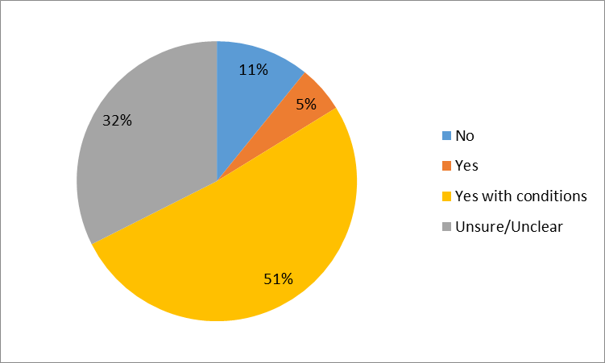

Table 7: Stakeholder positions – Do you think it should averaging be optional or mandatory?
 | Optional | Mandatory | No stated preference | Total
Forestry | 20 | 0 | 4 | 24
All other sectors | 8 | 1 | 4 | 13
TOTAL | 28 | 1 | 8 | 37

Figure 7: Stakeholder positions – Do you think it should averaging be optional or mandatory?
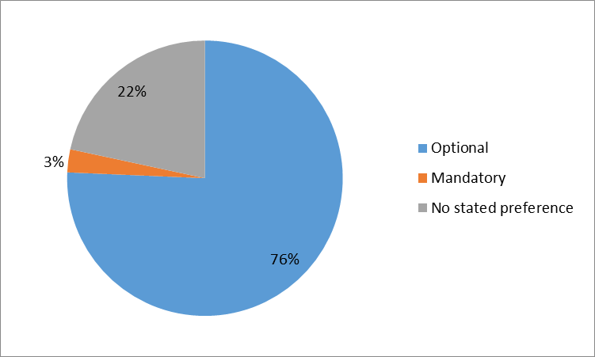

4.2 Should there be limits on the types of forests that can use an averaging accounting method? For example, new forests only or forests under a size threshold (Question F10)
In total, 30 submitters addressed this question. Many of these submitters (approximately 40 per cent) thought there should be no restrictions on the types of post-1989 forests that could use an averaging accounting approach if it were introduced.
These submitters sometimes pointed to increased complexity and reduced flexibility as a result of implementing such limits. Many submitters assumed an optional averaging accounting approach, and also commented there should not be limits on the types of forests as it should be up to the forest owner themselves to decide which approach to use.
“Most large participants are not likely to be as interested in implementing averaging, as the surrender requirement for carbon stock change due to harvesting, is likely offset by the carbon stock change for forest growth in a large multi age forest, therefore a limit on forest size is not likely to be required.” (PF Olsen, 00006)
“I believe it should be left to the individual forester to recognise the most appropriate mechanism for their forest circumstance.” (The Carbon Shop, 05017)
A similar number of submitters (approximately 40 per cent) commented that they were unsure if there should be limits on the forest types able to use averaging, with some observing that the lack of detail available on how averaging accounting would work makes it difficult to comment.
There were a few submitters that thought size limits should be applied to forests eligible for averaging accounting if it were introduced. These submitters pointed to factors including simplicity and limiting fiscal risk to the Crown.
“Only forests up to the FMA [Forest Management Approacj] threshold (100 ha) or smaller should be able to opt for averaging, to minimise fiscal risks to the Crown.” (Carbon Farm Limited, 00121)
Table 8: Stakeholder positions – Should there be limits on the types of forests that can use an averaging accounting method?
 | Yes | No | Unsure / Unclear | Total
Forestry | 3 | 10 | 6 | 19
All other sectors | 2 | 3 | 6 | 11
TOTAL | 5 | 13 | 12 | 30

Figure 8: Stakeholder positions – Should there be limits on the types of forests that can use an averaging accounting method?
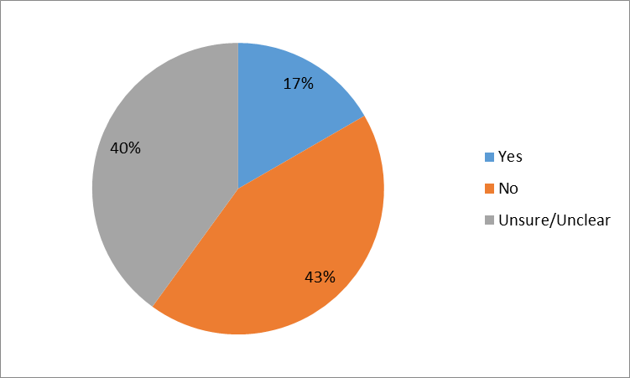

4.3 How might averaging impact on your business decisions? (Question F11)
In total, 28 submitters addressed this question. Many submitters considered averaging accounting would positively impact their business or otherwise pointed towards the benefits averaging would provide other foresters, such as owners of small forests.
“It could be a good incentive for afforestation. If people are establishing new areas of forestry and they know that after a certain number of years they are going to be given some credits that they can sell and not have to worry about paying back, the cost of establishing said forest becomes less of a deal breaker as the cost doesn’t have to be carried for so many years. Likewise they might put the credits towards establishing another virgin planting” (Laurie Forestry Ltd, 02020)
“Application of the concept of averaging would result in an increase in the level of the unencumbered NZUs [New Zealand Units] available to the forest owner to be sold, would increase market supply and liquidity, improve the financial returns from forestry and thus incentivise further forest investment.” (Matariki Forests ,04019)
Some other submitters noted that they were unable to comment on how averaging might impact their business decisions at this stage. Many of these submitters noted that the impact on their business would depend on how averaging was implemented, including if it was mandatory or optional and if there were any limits of forest types able to use averaging.
A small number of submitters considered averaging would impact their business decisions negatively. Those who considered averaging to have negative impacts often pointed to the fact it would reduce long-term carbon gains.
“We would not use averaging in our forest management. Some of our smaller clients may choose it if it was an option. We would recommend that forest buyers avoid any forest that was managed under an averaging regime, because long-term carbon gains and management options are reduced under this option.” (Carbon Farm Limited, 00121)

5. Harvested wood products

5.1 Do you think deferred liability for emissions from harvested wood products (HWPs) should be recognised domestically? If so, how? (Question F12)
In total, 57 submitters addressed the possibility of recognising deferred liabilities for emissions from harvested wood products (HWPs) domestically. More submitters addressed this question than any other question in the Forestry Technical Note. A large majority of submitters (around 75 per cent) supported the introduction of an accounting approach that includes HWPs. Only around 2 per cent of submitters thought that deferred liabilities for emissions from HWPs should not be devolved domestically.
Common themes among submitters who thought deferred emissions liabilities from HWPs should be recognised domestically included support for a New Zealand Emissions Trading Scheme (NZ ETS) accounting approach that would reduce harvest liabilities; support for devolving the benefit of international accounting domestically; and a view that accounting for HWP emissions in the NZ ETS would improve market liquidity and stability.
Some submitters also commented that they considered devolving deferred liabilities for HWPs to post-1989 forestry participants in the NZ ETS to be one of the key ways to improve the scheme’s incentives for increased afforestation and replanting.
“Forest owners who participate in the ETS currently still face an instant requirement to account for all of the carbon emissions associated with the log at harvest. The FOA considers that this needs to change and that benefit of HWP deferred liability should be devolved to the sector. … As well as addressing the single biggest obstacle to participation in the ETS by forest growers it would also free up ‘banked credits’ that forest owners are holding for surrender upon harvest thus providing additional liquidity and stability to the carbon market.” (New Zealand Forest Owners Association, 00039)
“We would like to emphasise that there is a single issue within these consultations that we believe is the most important one to address, and that it should be reprioritised to as to be the top issue that the Ministry and MPI focuses on and resolves. That is the issue of deferred liability for emissions from HWPs.” (Tunakino Forestry Limited, 03002)
A number of submitters (approximately 15 per cent) indicated they were not sure if deferred liabilities for emissions from HWPs should be recognised domestically, either through changes to NZ ETS rules or outside of the NZ ETS, or did not provide a firm view firm. Some of these submitters noted there were still many questions to be answered with regard to implementation options and impacts. These submitters often emphasised the need for a full, wide-ranging analysis of possible impacts.
“We encourage further work on accounting options, both averaging and harvested wood products accounting. Until this work has been undertaken it is not possible to determine which accounting approach is preferable though as a matter of principle simplicity is important so that as many forestry owners as possible are able to participate in the NZ ETS. …Both options need to be carefully considered against the status quo in terms of striking the right balance between simplicity and meaningfulness.” (Mighty River Power, 00152)
Most submitters who provided detail on how deferred emissions from HWPs should be devolved domestically thought a HWP accounting approach should be applied to post-1989 forestry participants in the NZ ETS using a national average to assume the HWP product mix.
Common reasons provided for this approach included a focus on simplicity; reduced transaction costs for participants; keeping the benefit and liability with the forest owner; and that using a national average would ensure HWP accounting in the NZ ETS does not change incentives for end product use.
“Harvested wood products should be initially recognised using a national-level average-use methodology applied to all post-1989 forests regardless of end use. This would meet the principles of accuracy, completeness, consistency, transparency and verifiability, and remain consistent with national-level accounting methodologies for HWP.” (New Zealand Carbon Farming Group, 00069)
“To avoid any distortion to the value chain and in particular to ensure that the use of wood for heating purposes is not disadvantaged in any way, we suggest that the deferred liability should be devolved on an overall product mix averaging basis to the owners of post-1989 forests that are registered in the ETS﻿” (Bioenergy Association, 00070)
One submitter, the New Zealand Wood Council (WoodCo), included an approach for devolving HWP emissions liabilities domestically in their submission that was supported or referred to by a number of other submitters. It proposed the differed liability for emissions from HWPs be applied to post-1989 foresters using an average national-level product mix and also recommended a complementary fund be set up to encourage wood processing and manufacturing.
“The forest and wood processing sectors are co-dependent. While the deferral of liability at harvest will provide benefits for the entire forest industry value chain the benefit for processing is indirect, and difficult to quantify. The Wood Council considers it is appropriate for government to provide some direct encouragement to processing and manufacturing that will complement the deferred liability at harvest for growers and equally stimulate forest investment and an expansion of the harvested wood products pool.” (Wood Council of New Zealand, 00116)
A small number of submitters commented that any benefit of deferring liabilities from HWPs should be devolved only outside the NZ ETS. Suggestions included setting up a fund or developing initiatives that would support industry good, make forestry more commercially attractive, or emphasise the benefits of wood as a product.
“In my view, the complexity of appropriately accounting for HWP on anything other than a national scale will far outweigh any advantages of devolving those credits to ETS participants. If the quantity of green-house gases stored in HWP can be estimated at a national level, I would rather see the country (through the government) collect and account for the value ascribed to those units, but to then apply a similar quantum of funds to making forestry more attractive as a commercial venture.” (Andrew McEwen, 00184)
“WPMA supports the idea that the financial benefits derived from implementation of the new Harvested Wood Regulation be managed by government to establish a funding pool to provide for industry good. Providing an industry good fund from the government proceeds arising from environmental benefits provided by the forest industry would go some way towards redressing the international imbalance in trading relations described above.” (Wood Processors and Manufacturers of New Zealand, 00119)
Table 9: Stakeholder positions – Do you think deferred liability for emissions from harvested wood products (HWPs) should be recognised domestically?
 | Yes | No | Unsure / Unclear | Total
Forestry | 27 | 1 | 5 | 33
All other sectors | 15 | 0 | 9 | 24
TOTAL | 42 | 1 | 14 | 57

Figure 9: Stakeholder positions – Do you think deferred liability for emissions from harvested wood products (HWPs) should be recognised domestically?
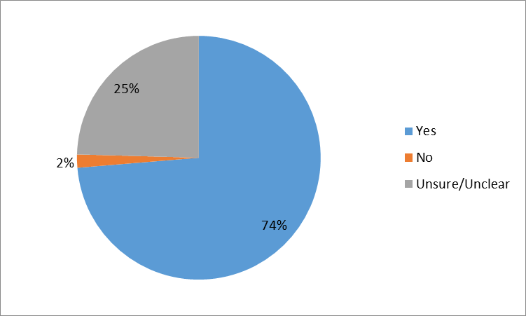

5.2 How might the options for deferred liability for emissions from HWPs impact on your business decisions? (Question F13)
In total, 32 submitters addressed this question in their submissions; around half of these submitters thought recognising deferred liabilities for emissions from HWPs would have a positive impact on their business decisions. Most of the remaining submitters were not sure of the impacts or expected no impact on their business decisions.
Submitters who discussed positive impacts of deferred liabilities for emissions from HWPs often focussed on the impact of devolving HWP accounting to post-1989 forestry participants in the NZ ETS. Common positive impacts on business decisions noted include increased profitability of forestry; increased incentives to participate in the NZ ETS; and increased incentives to plant more forests.
“Harvested wood product rules would in our opinion increase the value of carbon in forestry sector. We believe it would increase afforestation rates, companies would commit to re-planting of second rotation forests and it would encourage forest owners to engage in the ETS. It would incentivise Gibbons Forestry to plant more forests as we feel our industry is being recognised for its true value of carbon sequestration.” (Gibbons Holdings Limited, 00130)
“Amending the liability for Harvested Wood Products would result in an increase in the level of the unencumbered NZUs available to the forest owner to be sold, would increase market supply and liquidity, improve the financial returns from forestry and thus incentivise further forest investment.” (Matariki Forests, 4019)
“This would make an enormous difference. It would change our entire investment calculus, and make us much more likely to invest in planting new post-1989 forests. It is the single most important decision the Ministry should make, from our perspective, and it has the benefit of being the right thing to do, from an economic efficiency, environmental and fairness perspective.” (Tunakino Forestry Limited, 03002)
There was also a number of submitters who noted that they were unsure of the impacts or that the impact of recognising deferred liabilities for emissions from HWPs would depend on how any change was implemented.
“Any devolvement option which favours product mix will undoubtedly result in distortion to the value chain. The wood supply chain in New Zealand is complex, highly integrated and yields a wide range of products. The long run economic viability of the supply chain depends upon the interdependence of products and residues. Options which upset the balance risk undermining the sustainability of the overall supply chain.” (Bioenergy Association, 00070)

6. Other

6.1 Do you have any other comments or things you think are important? (Question F14)
In total, 42 submitters addressed this question and provided a range of comments on other New Zealand Emissions Trading Scheme (NZ ETS) forestry matters they considered important. Key themes across these submissions included highlighting additional co-benefits of forestry, such as erosion control or improving water quality; the importance of aligning forestry in the NZ ETS with the rest of the scheme as well as with other forestry and non-forestry policies; and a focus on the role the forestry sector could play in moving to a low-emissions economy, in terms of both carbon removals from trees growing and the use of wood products.
“The forest sector contributes positively to a lowered C emissions goal both in terms of the growing forests and the wood products that are delivered. The entire industry is based on a sustainable and infinitely renewable resource. As well as other environmental benefits, one of the strong unique characteristics of the industry is the absorption and storage of carbon as well as large scale use of energy from wood to replace fossil fuels.” (Wood Council of New Zealand, 00116)
“Carbon sequestration is just one example of eco-system benefits. Research is underway to quantify other benefits arising from afforestation, such as improved water quality and erosion control.” (New Zealand Farm Forestry Association, 00022)
“If we had a strong and secure carbon price for permanent forested headwaters this would incentivise the retirement and/or planting of our steep erodible headwaters into permanent forest sinks. This will provide investors with an ongoing carbon credit income (but not timber unless Continuous Cover Forestry is developed in NZ) while also providing economic benefits to downstream users. The ETS could incentivise the transition from undesirable land uses in these headwater (such as clear fell forestry and farming) to more appropriate long term land use.” (Flightworks, 00108)
“Any analysis should take into account the views of the forestry sector and the impact on long term carbon off-take contracts. We also think it is important that any forestry treatment integrates with forestry policies outside the NZ ETS in the interests of consistency and certainty. As with other aspects of NZ ETS design the more information that can be made available the easier it will be for market participants, particularly those in the forestry sector to plan and make investment decisions.” (Mighty River Power, 00152)

References
Ministry for the Environment. 2015. New Zealand Emissions Trading Scheme Review 2015/16: Discussion document and call for written submissions. Wellington: Ministry for the Environment.
Ministry for the Environment, 2016a. New Zealand Emissions Trading Scheme Review 2015/16: Forestry Technical Note. Wellington: Ministry for the Environment.
Ministry for the Environment, 2016b. New Zealand Emissions Trading Scheme Review 2015/16: Operational Matters Technical Note. Wellington: Ministry for the Environment.
Ministry for the Environment. 2016c. New Zealand Emissions Trading Scheme Review 2015/16 –Summary of Stage Two: Other Issues Consultation Responses. Wellington: Ministry for the Environment.
Ministry for the Environment. 2016d. New Zealand Emissions Trading Scheme Review 2015/16 – Summary of Stage Two: Other Issues Consultation Responses. Annex Two: Operational Matters Technical Note Responses. Wellington: Ministry for the Environment.

Ministry for the Environment, 2016a
Ministry for the Environment, 2016b
Ministry for the Environment, 2016a
Ministry for the Environment, 2016a

