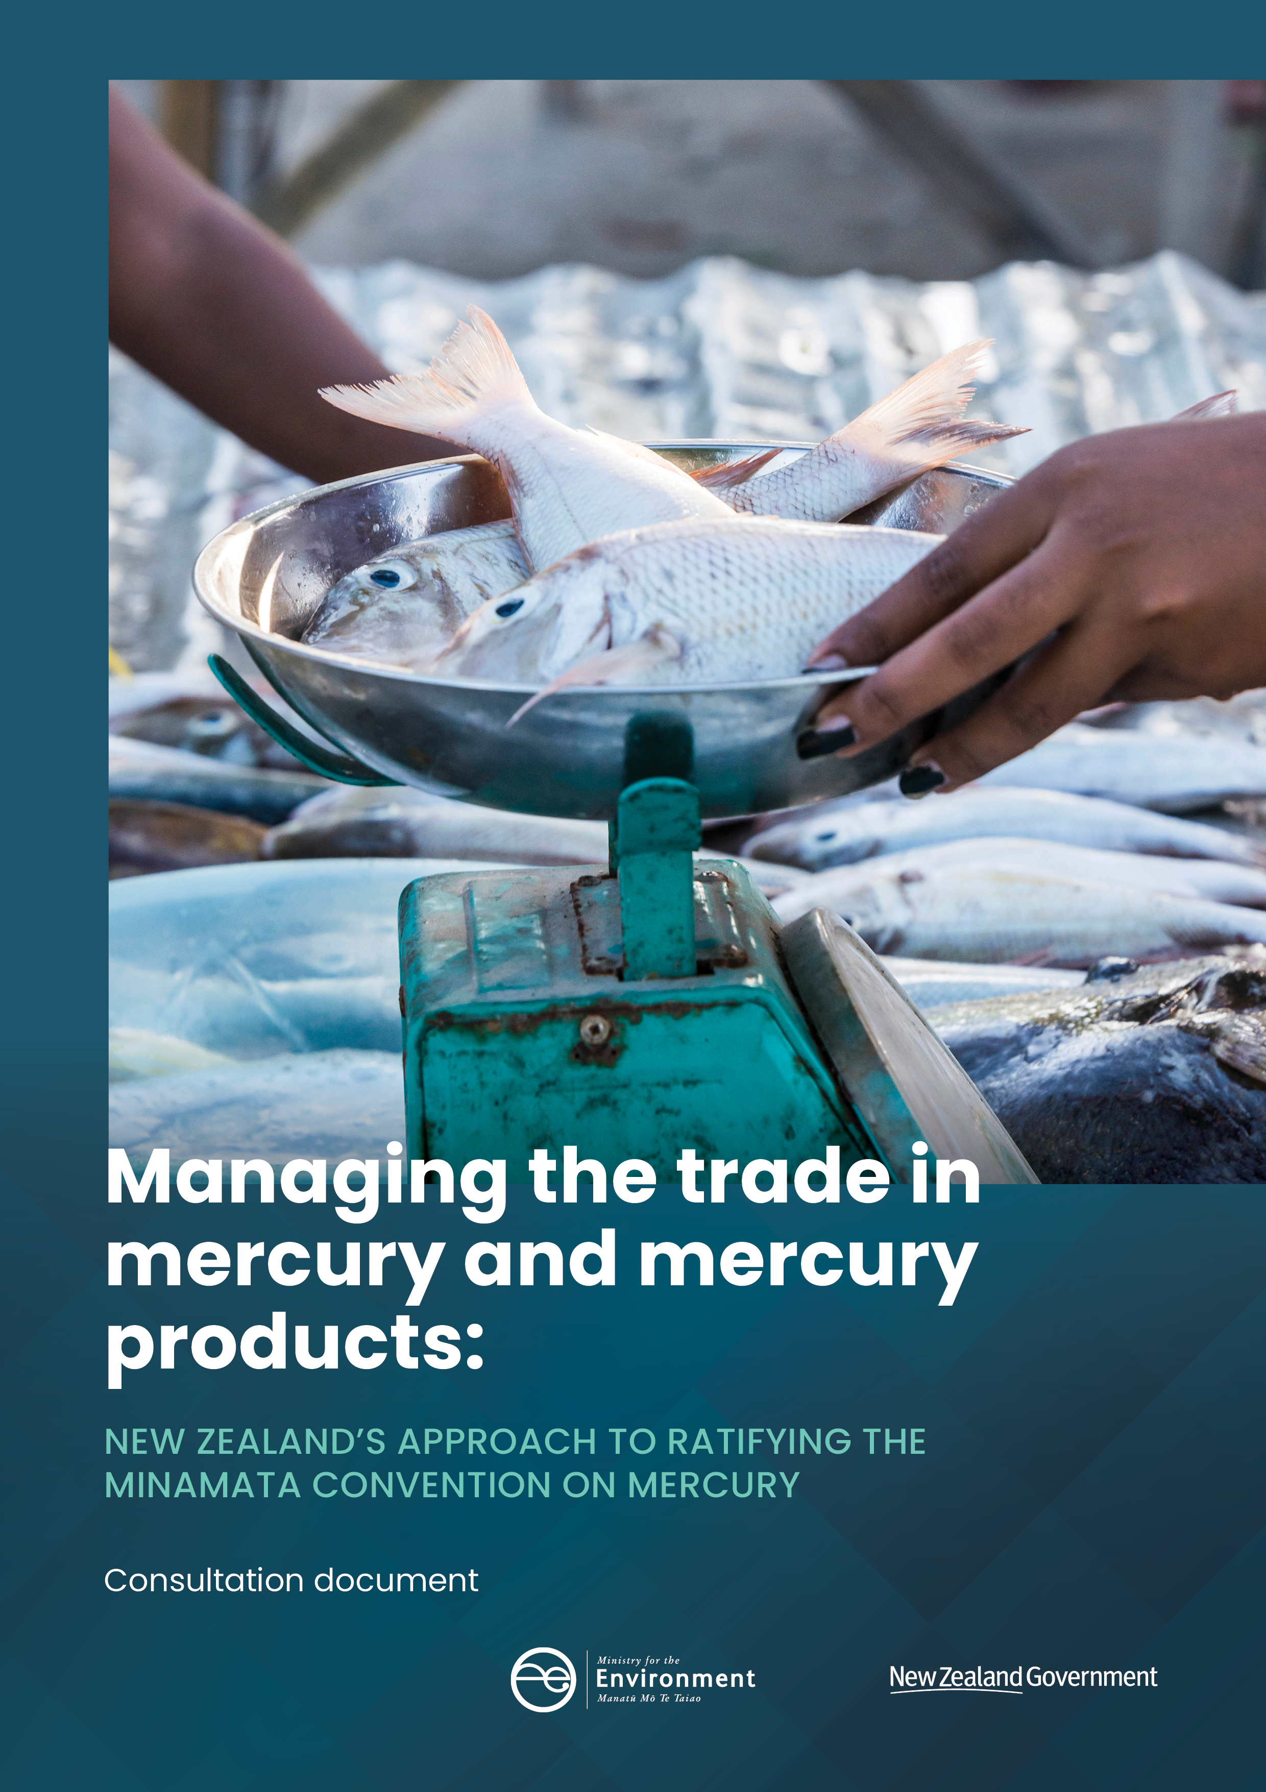

This document may be cited as: Ministry for the Environment. 2020. Managing the trade in mercury and mercury products: New Zealand’s approach to ratifying the Minamata Convention: Consultation document. Wellington: Ministry for the Environment.
Cover image courtesy of Dave Allen, NIWA.

Published in July 2020 by the
Ministry for the Environment
Manatū Mō Te Taiao
PO Box 10362, Wellington 6143, New Zealand
ISBN: 978-1-98-857980-1
Publication number: ME 1493
© Crown copyright New Zealand 2020
This document is available on the Ministry for the Environment website: www.mfe.govt.nz.
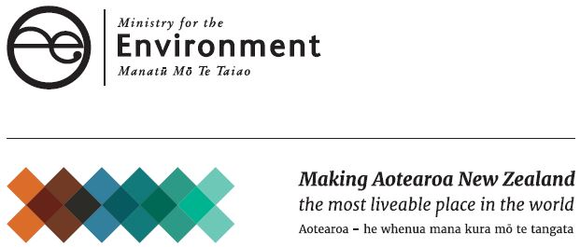

Contents
Message from the Minister 4
Section 1: About this consultation 5
Section 2: The problem with mercury 6
Background to the Minamata Convention 6
Why New Zealand signed the Convention 6
Impacts of man-made mercury pollution in New Zealand 7
What New Zealand needs to do 7
Section 3: Seeking views on the proposed regulations 8
Proposal 1: Regulating the trade in mercury 8
Proposal 2: Regulating products containing mercury 12
Section 4: Consultation process 21
How to make a submission 21
Contact for queries 21
Publishing and releasing submissions 21
Questions to guide your feedback 22
Appendix 1: How New Zealand will meet its obligations under the Minamata Convention 24
Appendix 2: The impact of regulating mercury containing products 26
Appendix 3: Rules for the import of mercury under the Convention 29
Appendix 4: Rules for the export of mercury under the Convention 30
References 31

Message from the Minister
The Government intends to ratify the Minamata Convention on Mercury and is proposing to introduce a new set of regulations to do so.
In 2013, New Zealand alongside 91 other states signed the Minamata Convention on Mercury, an international environmental treaty aimed at addressing the global threat posed by anthropogenic (human-made) mercury pollution to human health and the environment. New Zealand has a proud record of supporting the work of international environmental treaties that collectively contribute to safeguarding the environment from the impacts of hazardous substances for both present and future generations.
Mercury is a highly toxic heavy metal that can be released into the atmosphere and water naturally and due to human activity. Human exposure to mercury causes severe health issues. Once in the environment, mercury is able to travel long distances. So, the problem of mercury pollution cannot be addressed by any one country alone. A global framework is necessary to address the increased levels of mercury from human sources in the environment.
Mercury pollution is not a significant issue in New Zealand. We do not have many mercury-intensive industries and there are strong environmental controls in place that broadly manage its harmful environmental effects. Therefore the implementation of the Convention will not be too onerous for the Government or the public.
This consultation covers two key steps New Zealand needs to take to ratify the Convention – introducing a permitting system for trade in mercury, and prohibiting the manufacture, import and export of certain products containing mercury. A third step, to reduce the release of mercury into the environment from certain industrial processes, is being undertaken separately as part of a review of the Resource Management (National Environmental Standards for Air Quality) Regulations 2004.
To establish the best approach for ratifying the Convention, I want to understand the impact these proposals will have on retailers, users, importers and exporters. I believe this proposed approach to ratification will lead to the lowest costs and impacts on stakeholders, and will be the most administratively efficient.
It is important for New Zealand to support the Convention and encourage international action to protect human health and the environment from mercury pollution.
I welcome feedback on the Government’s proposals through this consultation.

Hon David Parker
Minister for the Environment

Section 1: About this consultation
The Government intends to ratify the Minamata Convention on Mercury and is proposing to introduce a new set of regulations to do so.
This consultation document presents our proposals for regulatory changes under the:
- Waste Minimisation Act 2008 – to ban the manufacture and sale of specific mercury products
- Imports and Exports (Restrictions) Act 1988 – to control the trade of mercury and regulate the import and export of specific mercury products.
We are seeking your views on the Government’s proposals and the impacts of the proposed controls on New Zealand.
Submissions close at 5.00pm on 5 August 2020.

Section 2: The problem with mercury

Background to the Minamata Convention
The Minamata Convention is a global environmental treaty that was agreed in 2013 and that aims to address the adverse impacts of human-made sources of mercury on human health and the environment.
The Convention was named after the Japanese town called Minamata which experienced high levels of mercury pollution over a number of decades. The local people became extremely sick from mercury poisoning due to industrial wastewater being discharged into the harbour which polluted fish food sources.
Human exposure occurs mainly through inhalation of elemental mercury vapours during industrial processes and through consumption of contaminated fish and shellfish (World Health Organisation, 2010).
Mercury is a highly toxic naturally occurring heavy metal. Exposure to mercury, even in small amounts, is considered unsafe for humans (World Health Organisation, 2017). Mercury exposure causes health impacts to the nervous, digestive and immune systems; lungs, kidneys, skin and eyes. The World Health Organisation considers mercury to be one of the top 10 chemicals of global concern (World Health Organisation, 2010).
Mercury can cross borders once it is released into the atmosphere and the ocean, and often causes pollution far from its initial point of release. Once mercury is in the environment it bioaccumulates in the food chain, mostly in ocean fish. Mercury is persistent and can last in the environment for decades.
The Convention addresses mercury at all stages of its lifecycle by controlling products, processes and certain industries and requires rules for mining; export and import; and safe storage and disposal.

Why New Zealand signed the Convention
New Zealand is a Party to the other chemical and waste treaties, including the Basel, Rotterdam, and Stockholm Conventions and the Montreal Protocol. New Zealand has a strong record of supporting the ongoing work of global agreements that address chemical pollution. The Minamata Convention is the newest treaty to join these other successful global environmental agreements and the Government believes it is important to support the global effort to curb the adverse impacts of mercury.
By ratifying the Convention, New Zealand will directly benefit from:
- phasing out the importation of non-essential mercury products to prevent more products from entering into the waste stream in the long term
- maintaining our international reputation
- being able to participate as an active Party at meetings of the Convention, including in decisions on adding new mercury sources or products to the Convention’s controls
- avoiding and mitigating potential future risk of mercury accumulation in Pacific marine fisheries.

Impacts of man-made mercury pollution in New Zealand
It is estimated that about 4400 tonnes of mercury are emitted into the atmosphere each year with about half (about 2200 tonnes) coming from human activity (United Nations Environment Programme, 2019).
In 2016, New Zealand emitted 1.82 tonnes of human-made mercury into the atmosphere (Bingham and Graham, 2017). New Zealand’s largest sources of human-made mercury in 2016 were from waste disposal, and primary metal production (Bingham and Graham, 2017). For more information on the use of mercury in New Zealand refer to the New Zealand mercury inventory.
Due to New Zealand’s geographic isolation, anthropogenic emissions from neighbouring countries are not a significant concern.
Human-made mercury is not a significant pollutant in New Zealand. The use of mercury is already strictly controlled under a number of environmental regulatory regimes including the Resource Management Act 1991, Hazardous Substances and New Organisms Act 1996, Health and Safety at Work Act 2015, and regulations under the Imports and Exports (Restrictions) Act 1988. Most mercury intensive industries do not now exist in New Zealand. For example, there has been no primary mercury mining activity for many decades.

What New Zealand needs to do
As New Zealand is a signatory to the Convention, the next step is for New Zealand to ratify. New Zealand must align its domestic laws and processes with the legal requirements of the Convention to ratify and become a Party to the Convention. See appendix 1 for a full list of the Convention’s obligations and how New Zealand intends to meet each obligation.
New Zealand is required to ban primary mercury mining to ratify. There has been no primary mercury mining in New Zealand since the 1940s. The Government has already put in place this ban. Section 87B of the Resource Management Act 1991 was amended on 23 October 2019 to make primary mining a prohibited activity (as per section 129 of the Statutes Amendment Act 2019).
New Zealand will also be required to control industrial emissions from mercury to air and prohibit the use of mercury in certain industrial processes to ratify the Convention. These requirements are being considered as part of another work stream to amend the Resource Management (National Environmental Standards for Air Quality) Regulations 2004.

Section 3: Seeking views on the proposed regulations
We are proposing to introduce a package of regulations to meet the legal requirements of the Minamata Convention. We will be ready to ratify once New Zealand’s law and processes are aligned with the requirements of the Convention.
This section outlines each of the regulatory proposals:
- regulating trade in mercury
- regulating specific mercury containing products.
Each proposal is broadly broken into the following sections:
- our proposal
- why we are proposing the control
- information on implementation
- impacts of implementation.

Proposal 1: Regulating the trade in mercury

What are we proposing?
We propose creating a permitting system to control the import and export of mercury by amending the Imports and Exports (Restrictions) Prohibition Order (No 2) 2004 (Imports and Exports Order).
The Convention specifies rules for the import and export of mercury in Article 3. Mercury includes mixtures of mercury with other substances including alloys of mercury, with a mercury concentration of at least 95 per cent by weight.
We propose to amend the Imports and Exports Order to restrict imports and exports of mercury in limited circumstances; namely where the source activity or intended use of the mercury is banned by the Convention. The restrictions are as follows for trade of mercury between Parties to the Convention:
- Mercury must not be imported if it has been sourced from primary mercury mining or the decommissioning of a chlor-alkali facility.
- Mercury must not be exported to a country which has not provided its written consent.
- Mercury can only be exported for a use allowed under the Convention or for environmentally sound storage as set out in Article 10 of the Convention.
There are additional requirements for trade of mercury to a non-Party, including a certification that the non-Party has measures in place to protect human health and the environment, and will comply with relevant provisions to the Convention.
Note that mercury for research, or mercury present in trace quantities, as per section 33 ‘Exemptions from Act for small-scale research on hazardous substances’ of the Hazardous Substances and New Organisms Act 1996 is exempt from the requirements, and can be imported and exported.
Mercury compounds are not subject to the rules for import and export of mercury.
Under the Imports and Exports Order, a permit is required for the export of mercury compounds under the Rotterdam Convention.
See appendix 3 and appendix 4 for diagrams of the rules for importing and exporting mercury under the Convention.
Table 1: Requirements for importing and exporting mercury
Import and export permits | What will be required
Control the import of mercury. | We propose to ban the import of mercury except if imported with a permit.  The Environmental Protection Authority (EPA) will administer the permitting system and allocate permits for import. The EPA will be able to revoke an import permit if the holder fails to comply with a permit condition, provides the EPA with false information, or is convicted of certain offences.  If the mercury is being imported from a non-Party to the Convention, the non-Party will need to provide certification that the mercury was not sourced from primary mercury mining or the decommissioning of a chlor-alkali facility.
Control the export of mercury | We propose to ban the export of mercury from New Zealand, except if exported with a permit.  Before mercury can be exported from New Zealand, the EPA will need to obtain written consent from the importing country. Further, mercury can only be exported to an importing Party:
- for the purpose of an activity or process allowed under the Convention, or
- for environmentally sound interim storage (Article 10 of the Convention).
The EPA will grant a permit if it meets the above criteria. If mercury is exported for uses not allowed under the Convention then the EPA will not grant a permit.
If the mercury is being exported to a non-Party to the Convention, the EPA will need to obtain written consent, and certification that demonstrates the non-party:
- is importing the mercury for a use allowed under the Convention
- has measures in place to ensure the protection of human health and the environment, and to ensure compliance with the environmentally sound storage provisions of the Convention.
The EPA will be able to revoke an export permit if the holder fails to comply with a permit condition, provides the EPA with false information, or is convicted of certain offences.

Why are we proposing this?
Articles 3(6) and 3(8) of the Convention are intended to reduce the global supply of mercury, and prevent surplus mercury from being used in activities that are harmful to human health and the environment.
The main aims of these proposals are to ensure:
- mercury use is limited to uses allowed under the Convention
- mercury use is from a source allowed by the Convention
- exports have the prior informed consent of the importing Party or non-Party.
The existing Imports and Exports Order has been used to implement similar permitting systems for the import and export of hazardous substances and wastes to meet international obligations under three separate agreements: the Basel, Rotterdam and Stockholm Conventions. This proposal aligns permit requirements for mercury exports with the wider permitting systems implemented under the Imports and Exports Order to meet similar international obligations.
Regulations can be made under the Imports and Exports (Restrictions) Act 1988 regulating imports that are in the public interest, and exports needed to give effect to international obligations. We view it is in the public interest to regulate imports of mercury to support global action on controlling a harmful pollutant. The export regulations are necessary to satisfy our international obligations under the Convention.

Impacts of implementation
We believe these proposals will provide industry with greater certainty for business planning, and have a low overall impact because:
- of low administrative costs due to alignment with existing hazardous chemicals permitting systems that have been implemented using the Imports and Exports Order
- the process of applying for a mercury export permit under the Minamata Convention will be the same as the existing process for mercury compounds under the Rotterdam Convention. There will be minor changes to update the Imports and Exports Order to reflect the Minamata Convention’s requirements
- administrative costs will apply whether New Zealand ratifies or not (ie, is a Party or non-Party) because the Convention’s prior informed consent rules also apply to non-Parties.

Offences and enforcement
Under section 4 of the Imports and Exports (Restrictions) Act 1988 it is an offence to import any goods whose importation is prohibited in New Zealand, to export any goods which are prohibited or to fail to comply with the requirements of a permit granted under an Order under the Act. Offences are liable to a fine not exceeding $5000 for individuals, $25,000 for corporates, or an amount equal to three times the value of the goods to which the offence relates, whichever is the greater.
The New Zealand Customs Service (Customs) enforces the Imports and Exports Order at the border.
Questions
1. Do you agree with the proposed approach to implement a permitting system to control the import and export of mercury? Please explain why/why not.
2. How do you anticipate the proposed permitting system will impact your business?
3. Do you, or are you likely to, export mercury to a country that is not a Party to the Minamata Convention? For a list of Parties go to: www.mercuryconvention.org/ Countries/Parties/tabid/3428/language/en-US/Default.aspx.

Proposal 2: Regulating products containing mercury
The Minamata Convention requires that the manufacture, import and export of specific products containing mercury are not allowed after 2020. We propose the following regulatory changes:
- ban the manufacture and sale of specific mercury products by making new regulations under the Waste Minimisation Act 2008
- ban the import and export of specific mercury products by amending regulations under the Imports and Exports (Restrictions) Act 1988.

What does the Minamata Convention require?
The products that are in scope of both these regulatory changes are shown in table A on the following page.
The Convention specifically excludes the following categories of products from prohibition:
- Products essential for civil protection and military uses.
- Products for research, calibration of instrumentation, for use as reference standard.
- Where no feasible mercury-free alternative for replacement is available, switches and relays, cold cathode fluorescent lamps, and external electrode fluorescent lamps (CCFL and EEFL) for electronic displays, and measuring devices.
- Products used in traditional or religious practices.
- Vaccines containing thiomersal as preservatives.
Mercury products such as paints and cosmetics, which are the reason for the traditional or religious practices exclusion, are not known to be used in New Zealand and cannot be manufactured and imported in New Zealand under the Cosmetic Products Group Standard 2017 (and its predecessors).
Most vaccines used for humans in New Zealand do not contain thiomersal as a preservative. Animal vaccines (including those that contain thiomersal as a preservative) are regulated under the Agricultural Compounds and Veterinary Medicines Act 1997.
Note that dental amalgam is not within scope of these proposals. Under the Convention dental amalgam is subject to a phasedown which is different to the rules for the products in table A. Each Party must take at least two of nine possible measures to phase down the use of dental amalgam. New Zealand already meets more than two of these measures so no change is required.
Table A: Mercury-containing products which cannot be manufactured, imported or exported after 2020 as required by the Minamata Convention
Products in scope of prohibition
Batteries, except:
- button zinc silver oxide batteries with a mercury content less than 2%
- button zinc air batteries with a mercury content less than 2%.
Switches and relays, except:
- very high accuracy capacitance and loss measurement bridges
- high frequency radio frequency switches and relays in monitoring and control instruments with a maximum mercury content of 20 mg per bridge, switch or relay.
Lamps containing specified quantities of mercury
- compact fluorescent lamps (CFLs) for general lighting purposes that are less than or equal to 30 watts with a mercury content exceeding 5 mg per lamp burner
- linear fluorescent lamps (LFLs) for general lighting purposes:
- triband phosphor less than 60 watts with a mercury content exceeding 5 mg per lamp
- halophosphate phosphor less than or equal to 40 watts with a mercury content exceeding 10 mg per lamp
- high pressure mercury vapour lamps for general lighting purposes
- cold cathode fluorescent lamps (CCFL) and external electrode fluorescent lamps (EEFL) for electronic displays:
- short length (less than or equal to 500 mm) with mercury content exceeding 3.5 mg per lamp
- medium length (greater than 500 mm and less than or equal to 1 500 mm) with mercury content exceeding 5 mg per lamp
- long length (greater than 1 500 mm) with mercury content exceeding 13 mg per lamp.
Cosmetics (with mercury content above 1ppm), including skin lightening soaps and creams, and not including eye area cosmetics where mercury is used as a preservative and no effective and safe substitute preservatives are available.
Pesticides, biocides, topical antiseptics
Non-electronic measuring devices except non-electronic measuring devices installed in large-scale equipment or those used for high precision measurement, where no suitable mercury-free alternative is available:
- barometers
- hygrometers
- manometers
- thermometers
- sphygmomanometers.

A lower mercury content for compact fluorescent lamps?
We propose to have a lower mercury content for compact fluorescent lamps (CFLs) for general lighting purposes that are less than or equal to 30 watts of 2.5 mg per lamp burner instead of 5 mg. This is the threshold applied in Australia and the European Union, and is closer to that of China (3 mg). The average mercury content in CFLs used in New Zealand has been declining from 3.26 mg in 2013 to 2.24 mg in 2019. The prohibition would apply to compact fluorescent lamps (CFLs) for general lighting purposes that are:
- less than or equal to 30 watts with a mercury content exceeding 2.5 mg per lamp burner
- greater than 30 watts with a mercury content exceeding 5 mg per lamp burner.

Banning the sale and manufacture of specific products containing mercury

What are we proposing?
We propose prohibiting the manufacture and sale of the products containing mercury in
table A (with the proposed new mercury thresholds for CFLs) by making new regulations under section 23(1)(b) of the Waste Minimisation Act 2008 (WMA).
The proposed ban will apply from 1 January 2021 in compliance with the Convention requirements.
The proposed regulations will not impact the use of products sold in New Zealand before 1 January 2021; these products will need to be replaced with mercury-free alternatives at the end of their life. We do not propose to ban the sale of second-hand products.
Table A permits some mercury-containing products where the level of mercury is below a set threshold. These products are out of scope of the prohibition on manufacture and sale.
Table A also permits the manufacture of non-electronic measuring devices where no suitable mercury-free alternative is available. These products are also out of scope of the prohibition on manufacture and sale.
The Convention specifically excludes some mercury-containing products from being subject to the prohibition on manufacture (Annex A); also called essential products. These products are also out of scope of the prohibition on manufacture and sale.

Why are we proposing these regulations?
Article 4(1) requires Parties to stop the manufacture of mercury-containing products after 2020 unless explicitly excluded or exempted under the Convention. A ban on sale is not expressly required by the Convention; however, we think a ban on sale will create a workable enforcement mechanism to support the related ban on import and exports. A ban on sale contributes to a holistic approach by ensuring that there is no commerce in goods subject to an import, export, and manufacture prohibition.
The purpose of ratifying the Convention is to ensure our environmental regulations protect human health and the environment from emissions and releases of mercury from human-made sources. In New Zealand waste minimisation is an important component of reducing releases of human-made mercury. In addition, reducing the amount of hazardous substances that are sent to landfill is positive for the environment.
We consider the proposal to ban the manufacture and sale of the mercury containing products specified in the Convention will align with the overarching purpose of the WMA to minimise waste and reduce waste disposal. This will protect the environment from harm and provide environmental, social, economic and cultural benefits.
The WMA allows for regulations to be made for “controlling or prohibiting the manufacture or sale of products that contain specified materials” on the Minister for the Environment’s recommendation.
Before making this recommendation, the Minister must be satisfied that:
- a reasonably practicable alternative to the specified materials is available
- the benefits expected from the regulations exceed the costs
- the regulations are consistent with New Zealand’s international obligations.
We believe there are safe and economically feasible alternatives for all of the mercury-containing products listed in table A. See appendix 2 for details. It is expected the benefits flowing from the regulations will exceed the costs. See the impact section below for details.

Impacts of the proposals
New Zealand does not have a manufacturing industry that makes the mercury-containing products specified in the Convention, so there will be no impact on business or industry caused by a ban on the manufacture of the listed products. International demand will continue to decline as Minamata Parties phase out the import of these products.
New Zealand sells batteries, lighting products, switches and relays, and non-electronic measuring devices containing mercury (Bingham and Graham, 2017). There are no import controls for some of these products in New Zealand, though some existing regulations apply to certain table A products, for example:
- All CFLs and LFLs sold in New Zealand must comply with the Energy Efficiency (Energy Using Products) Regulations 2002. To demonstrate this, they must register in Australia or New Zealand on the trans-Tasman Equipment Energy Efficiency (E3) system. Importers/manufacturers must declare the level of mercury in their lamps and, upon request, supply a test report to prove their products do not exceed the legal thresholds.
- Cosmetics are regulated under the Cosmetics Products Group Standard under the Hazardous Substances and New Organisms Act 1996 which are already consistent with the Convention restrictions.
In most cases there has been movement towards mercury-free products; for example, CCFLs and EEFLs have almost entirely been replaced in the market by LEDs. Furthermore, the New Zealand Transport Agency and regional councils have been working to replace existing streetlamps (some of which are high pressure mercury vapour lamps) with LED lighting (New Zealand Transport Agency, 2018). Many of the alternative products are more energy efficient, and will bring cost benefits for consumers. See appendix 1 for more detail on the current status and use of the listed products, and the perceived impact of regulation.
If there are no feasible mercury-free alternatives for any table A products, then there are avenues to consider whether the product fits within one of the exclusions in the Convention. The Government can also consider registering an exemption with the Convention’s Secretariat, which would exclude a category of product from the proposed prohibition for five years after the phase-out date. Any exemption can only be extended for a maximum of an additional five years.
A range of regulatory measures were considered before proposing to make regulations under the WMA. These are outlined in the regulatory impact analysis document produced by the Ministry for the Environment.

Information on implementation
In developing the proposed regulations under the WMA, it will be necessary to develop mechanisms for their administration and enforcement. Under Section 76(1) of the WMA, the Secretary for the Environment can appoint a person as an enforcement officer to ensure compliance with regulations under the WMA.

Offences and enforcement
Section 65(1)(d) of the WMA states that it is an offence to “knowingly contravene” regulations made under Section 23(1)(b) of the WMA to prohibit manufacture or sale of products. Any person committing an offence is liable for a fine not exceeding $100,000, as well as an additional penalty for commercial gain flowing from the contravention. It is also an offence, which can result in a fine of up to $5,000, to do various acts which obstruct an enforcement officer’s activities, or to incite another person to do those acts. Details of these offences are contained in part 5 of the WMA.
Questions
4. Do you agree that the Government should implement a ban on the sale of specific mercury-containing products as an additional step for the reasons outlined? Please explain why/why not.
5. Do you support the Government setting a lower mercury threshold for the manufacture and sale of CFLs less than or equal to 30 watts, to be consistent with the level set in Australia and the European Union?
6. In your view, is it achievable to introduce a ban on the sale and manufacture of mercury-containing products by 1 January 2021? Please explain your answer.
7. How do you anticipate the proposed ban on the sale and manufacture of listed mercury-containing products will impact your business?
8. Are you aware of any products listed in Table A that are manufactured in New Zealand? And if so, which ones?
9. Are there any product categories listed in table A for which you think the Government should register an exemption for manufacture from the phase out date? If so, which one(s), why and for how long (initial exemption is for a maximum of five years after the phase out date)?
10. Are there any other considerations for administration and enforcement of the proposed regulations that have not been outlined in the administration and enforcement section of this consultation document?

Trade controls on the import and export of certain mercury-containing products

What are we proposing?
We propose prohibiting the import and export of the products containing mercury listed in table A (with the proposed new mercury thresholds for CFLs) on page 13, by amending the Imports and Exports Order under the Imports and Exports (Restrictions) Act 1988. The proposed ban will apply from 1 January 2021 in compliance with the Convention requirements.
Table A permits the import and export of some mercury-containing products where the level of mercury is below a set threshold. These products are out of scope of the prohibition on import and export.
We propose to require a permit for products containing mercury where certain conditions are fulfilled but that do not fully meet the criteria for banning the import and export of a mercury containing product listed in Table A.
The Convention excludes specific products from being subject to the prohibition on import and export (Annex A of the Convention); also called essential products. These products are not subject to the Convention’s phase out obligations. We seek your feedback on whether these products are sufficiently defined or should be subject to an import and export permit to avoid certain non-essential uses being captured in a blanket exemption.
The ban on import and export relates to the proposed ban on sale and manufacture outlined above. The entire package is a holistic approach to regulate non-essential mercury containing products and decrease the volume of mercury-containing products that eventually enters the waste stream.

Products out of scope of the prohibition on import and export
The Convention prohibits the import and export of products falling within the definitions contained in table A. Some of these products have thresholds for mercury content (ie, some products with less than the specified levels of mercury content are not prohibited). There will be no restrictions on the import and export of:
- button zinc silver oxide batteries with mercury content less than 2 per cent and button zinc air batteries with a mercury content less than 2 per cent
- very high accuracy capacitance and loss measurement bridges and high frequency radio frequency switches and relays in monitoring and control instruments with a maximum mercury content of 20 mg per bridge, switch or relay
- CFLs – lamps greater than 30 watts with less than 5 mg of mercury per lamp
- CFLs – lamps 30 watts and under with less than 2.5 mg of mercury per lamp
- LFLs – triband phosphor lamps of 60 watts or more
- LFLs – triband phosphor lamps less than 60 watts with a mercury content less than 5 mg per lampLFLs – halophosphate phosphor lamps greater than 40 watts
- LFLs – halophosphate phosphor lamps of 40 watts or less with a mercury content less than 10 mg per lamp
- CCFL and EEFL for electronic displays that are short length (less than 500 mm with mercury content less than 3.5 mg per lamp), medium length (over 500 mm and less than 1500 mm with mercury content less than 5 mg), and long length (over 1500 mm with mercury content less than 13 mg per lamp)
- cosmetics with mercury content less than 1 part per million.

Products subject to an import and export permit
Where the Convention only allows the import and export of a product containing mercury in certain circumstances, this will be subject to a permit. The permitting system will be administered by the EPA who will allocate import/export permits if it is satisfied the product meets one of the following conditions:
- The product is listed in table A but may be allowed if there are no feasible alternatives to the product and the product is either a:
- non-electronic measuring device that is used for high precision measurement, and where there are no suitable mercury free alternatives (barometers, hygrometers, manometers, thermometers, and sphygmomanometers), or
- a non-electronic measuring device installed in large-scale equipment, and where there are no suitable mercury-free alternatives available (barometers, hygrometers, manometers, thermometers, and sphygmomanometers).
- If New Zealand were to register for a specific exemption for a mercury-containing product under Article 6 of the Convention on becoming a Party to the Convention. The Convention allows Parties to register an exemption from the phase out date for products containing mercury for five years. This exemption may only be extended for one further five-year period if other Parties to the Convention agree (ie, an exemption would expire on 1 January 2031 at the latest). This means the New Zealand Government can consider applying for an exemption to the phase out date to provide further time to phase out the relevant product containing mercury. We think it is unlikely an exemption for any of the table A products will be needed, but we seek your views on this.
An import and export permit could be applied to those products that fall under a general exclusion in Annex A of the Convention, if more certainty is required including:
- products essential for civil protection and military uses
- products for research, calibration of instrumentation, for use as reference standard
- where no feasible mercury-free alternative for replacement is available, switches and relays, cold cathode fluorescent lamps and external electrode fluorescent lamps (CCFL and EEFL) for electronic displays, and measuring devices
- products used in traditional or religious practices
- vaccines containing thiomersal as preservatives.
The EPA may deny a permit if the applicant has been convicted of an offence against the Imports and Exports (Restrictions) Act 1988 or an offence involving mercury, or if the applicant provided it with incorrect information.
The EPA will be able to revoke an import permit if the holder fails to comply with a permit condition, provides the EPA with false information, or is convicted of certain offences.

Why are we proposing these controls?
Article 4(1) requires the phase out of the import and export of products listed in table A by 1 January 2021. These proposals are intended to ensure New Zealand meets the legal requirements of the Convention.
The overall use of the table A products has been decreasing over time and mercury-free alternatives are available and safer for use. Despite these trends there are no regulations in place for every product category listed in table A.
Regulations can be made under the Imports and Exports (Restrictions) Act 1988 regulating imports that are in the public interest, and exports needed to give effect to international obligations. We consider it is in the interest of public to ban non-essential mercury containing products to reduce the amount of mercury that eventually ends up in the waste stream at the end of products’ life.

Impacts of implementation
Overall we believe that prohibiting the import and export of specific products containing mercury will have a minimal negative impact for New Zealand. The Convention has created a global phase out which means the products listed in table A are decreasing in use and availability anyway. For many of the products listed in table A, mercury-free alternatives are available and are replacing the mercury-containing products. There are also some regulations that already restrict the import, manufacture and use of some of the product categories in table A, such as the Cosmetics Group Standard and the Energy Efficiency (Energy Using Products) Regulations 2002.
See appendix 1 for more detail on the perceived impacts of regulating each product.

Offences and enforcement
Under section 4 of the Imports and Exports (Restrictions) Act 1988 it is an offence to import any goods whose importation is prohibited in New Zealand, and export any goods that are prohibited or to fail to comply with the requirements of a permit granted under an Order under the Act. Offences are liable to a fine not exceeding $5000 for individuals, $25,000 for corporates, or an amount equal to three times the value of the goods to which the offence relates, whichever is the greater.
Questions
11. Do you consider any of the products listed in table A are essential and should not be subject to an import/export ban? If so, which products and why?
12. Do you consider that it will be economically feasible to transition to the alternative mercury-free products? If not, why not?
13. Are you aware of any mercury-containing products used in traditional or religious practices that would not be considered a cosmetic? If so, which products?
14. Do you think it is feasible for the import and export ban to apply from 1 January 2021?
15. Are there any mercury-containing products for which New Zealand should seek an import or export exemption from the phase out date? If so, how long for (initial exemption is for a maximum of five years after phase out date)?
16. Do you support the Government setting a lower mercury threshold for the import and export of CFLs less than or equal to 30 watts, to be consistent with the level set in Australia and the European Union?
17. Do you think any of the essential use products that fall under the exclusions in Annex A of the Convention should require an import and export permit? Please explain why/why not?

Section 4: Consultation process

How to make a submission
The Government welcomes your feedback on this consultation document. The questions posed throughout this document are summarised below. They are a guide only and all comments are welcome. You do not have to answer all the questions.
To ensure your point of view is clearly understood you should explain your rationale and provide supporting evidence where appropriate.
There are two ways you can make a submission:
- Use our online submission tool, available at: https://www.mfe.govt.nz/consultations/mercury-managing-trade.
- Write your own submission.
If you are posting your submission, send it to Minamata Consultation, Ministry for the Environment, PO Box 10362, Wellington 6143 and include:
- The title of the consultation (Minamata Consultation)
- Your name or organisation name
- Postal address
- Telephone number
- Email address
If you are emailing your submission, send it to minamataconsultation@mfe.govt.nz as a:
- PDF; or
- Microsoft Word document
Submissions close at 5.00pm on 5 August 2020.

Contact for queries
Please direct any queries to:
Phone: (04) 439 7400
Email: minamataconsultation@mfe.govt.nz
Postal: Minamata Consultation, Ministry for the Environment, PO Box 10362, Wellington 6143.

Publishing and releasing submissions
All or part of any written submission the Ministry for the Environment receives electronically or in printed form, including your name, may be published on our website, www.mfe.govt.nz. Unless you clearly specify otherwise in your submission, the Ministry will consider that you have consented to website posting of both your submission and your name.
Submissions may also be released to the public under the Official Information Act 1982 following requests to the Ministry for the Environment (including by email). Please advise if you object to the release of any information contained in your submission and, in particular, which part(s) you consider should be withheld, together with the reason(s) for withholding the information.
Any personal information you supply to the Ministry when making a submission will only be used by the Ministry in relation to the consultation covered in this document. You have the right to request access to or to correct any personal information you supply to the Ministry.
If you have any questions about the publishing and releasing of submissions, or if you would like to access or correct any personal information you have supplied, please email info@mfe.govt.nz.

Questions to guide your feedback

Regulating the trade in mercury
- Do you agree with the proposed approach to implement a permitting system to control the import and export of mercury? Please explain why/why not.
- How do you anticipate the proposed permitting system will impact your business?
- Do you, or are you likely to, export mercury to a country that is not a Party to the Minamata Convention? For a list of Parties go to: http://www.mercuryconvention.org/Countries/Parties/tabid/3428/language/en-US/Default.aspx.

Proposed ban on the sale and manufacture of certain mercury-containing products
- Do you agree the Government should implement a ban on the sale of specific mercury-containing products as an additional step for the reasons outlined? Please explain why/why not.
- Do you support the Government setting a lower mercury threshold for the manufacture and sale of CFLs less than or equal to 30 watts, to be consistent with the level set in Australia and the European Union?
- In your view, is it achievable to introduce a ban on the sale and manufacture of mercury-containing products by 1 January 2021? Please explain your answer.
- How do you anticipate the proposed ban on the sale and manufacture of listed mercury-added products will impact your business?
- Are you aware of any products listed in Table A that are manufactured in New Zealand? And if so, which ones?
- Are there any product categories listed in table A for which you think the Government should register an exemption for manufacture from the phase out date? If so, which one(s), why and for how long (initial exemption is for a maximum of five years after the phase out date)?
- Are there any other considerations for administration and enforcement of the proposed regulations that have not been outlined in the administration and enforcement section of this consultation document?

Proposed ban on the import and export of certain mercury-containing products
- Do you consider any of the products listed in Table A are essential and should not be subject to an import/export ban? If so, which products and why?
- Do you consider that it will be economically feasible to transition to the alternative mercury-free products? If not, why not?
- Are you aware of any mercury-containing products used in traditional or religious practices that would not be considered a cosmetic? If so, which products?
- Do you think it is feasible for the import and export ban to apply from 1 January 2021?
- Are there any mercury-containing products for which New Zealand should seek an import or export exemption from the phase out date? If so, how long for (initial exemption is for a maximum of five years after the phase out date)?
- Do you support the Government setting a lower mercury threshold for the import and export of CFLs less than or equal to 30 watts, to be consistent with the level set in Australia and the European Union?
- Do you think any of the essential use products that fall under the exclusions in Annex A of the Convention should require an import and export permit? Please explain why/why not.

Appendix 1: How New Zealand will meet its obligations under the Minamata Convention
Article 1 sets out the objective of the Convention.
Article 2 sets out some of the defined terms under the Convention.
Article 3 requires Parties to ban new primary mercury mining, phase out existing primary mercury mining within 15 years, phase out mercury cell chlor-alkali facilities, identify stocks of mercury and mercury compounds above certain thresholds, and it requires trade controls. New Zealand has implemented the ban on primary mercury mining through the Resource Management Act 1991.
Article 4 requires Parties to enact measures on mercury added products to phase out the manufacture, import or export of such products. This also requires Parties to phase down the use of dental amalgam via a number of measures which New Zealand already undertakes.
Article 5 requires Parties phase out certain manufacturing processes that use mercury or prohibit future occurrences of these activities. None of the listed processes currently take place in New Zealand and prohibition of future use will be progressed through the separate workstream to amend the Resource Management (National Environmental Standards for Air Quality) Regulations 2004.
Article 6 outlines the process for Parties to register for exemptions from the phase out dates. The consultation process would confirm whether any exemption is required for New Zealand.
Article 7 requires Parties to reduce and where feasible eliminate artisanal and small-scale gold mining. In New Zealand this is met by existing requirements under the Health and Safety in Employment Act 1992. Article 7 also provides an ability to self-nominate your country as exceeding “more than insignificant” levels of artisanal gold mining, and prepare a National Action Plan to help access capacity-building and financial resources to reduce reliance on that mining. New Zealand has very low amounts of artisanal gold mining, which we consider is not more than “insignificant”.
Article 8 requires Parties to control and where feasible reduce emissions of mercury and mercury compounds to the air. This will be progressed through the separate workstream to amend the Resource Management (National Environmental Standards for Air Quality) Regulations 2004.
Article 9 requires Parties to identify and take measures to control certain significant sources of mercury discharge to land and water and create and maintain inventories. Mercury inventories are already undertaken periodically by the Ministry for the Environment.
Article 10 requires Parties to ensure environmentally sound interim storage of mercury. This is already a requirement under the Hazardous Substances and New Organisms Act 1996 (HSNO Act).
Article 11 requires Parties to manage mercury waste and waste containing mercury in an environmentally sound manner. This is already a requirement under the HSNO Act.
Article 12 requires Parties to develop strategies to identify mercury contaminated sites, and manage any identified sites. This is already undertaken by the Ministry for the Environment.
Articles 13 – 14 outline each Parties obligation to provide financial support to the Convention, and financial and capacity building support for developing countries. New Zealand will incur a small financial cost from membership of the Convention, which will be met by an existing Ministry for the Environment departmental appropriation. New Zealand’s existing contribution to the Global Environment Facility (which is the financial mechanism for the Convention) will meet the obligation to provide support to developing countries.
Article 15 establishes an implementation plan and compliance committee for the Convention.
Articles 16–18 set out obligations on Parties to promote public awareness and educational programmes to prevent human exposure to mercury, and to provide public information on the health effects of mercury. This is already undertaken by a combination of Government agencies.
Article 19 requires Parties to cooperate with other countries for research and capacity building. This is already undertaken by a combination of Government agencies, Crown Research Institutes and universities in New Zealand.
Article 20 relates to Parties’ implementation plans, should they choose to do so.
Article 21 requires Parties to report regularly on implementation of the Convention. The Ministry for the Environment will undertake these functions within its existing work programme.
Articles 22–35 outline administrative matters associated with the operation of the Convention.

Appendix 2: The impact of regulating mercury containing products
Product | Use in New Zealand and availability of alternative | Impact
Batteries, except for button zinc silver oxide batteries with a mercury content less than 2% and button zinc air batteries with a mercury content less than 2%. | 75% of batteries in New Zealand are mercury free, in part due to EU regulation increasing the availability of alternatives or batteries with less than 2% mercury content. | Minimal – as these products are being phased out internationally and the products consisting of the majority of the market share are not affected.
Switches and relays, except very high accuracy capacitance and loss measurement bridges and high frequency radio frequency switches and relays in monitoring and control instruments with a maximum mercury content of 20 mg per bridge, switch or relay. | Mercury switches are used in small quantities for specialised uses, for example, in some older cars for light switches in the boot or bilge switches for boats.  Quantities imported and sold in New Zealand are estimated to be very small.  Mercury free alternatives are available for these uses. | Minimal – as these products are being phased out internationally, the numbers used in New Zealand are very small, and mercury free alternatives are available.
The Convention requires prohibition after 2020 on manufacture, import and export of compact fluorescent lamps (CFLs) for general lighting purposes that are less than or equal to 30 watts with a mercury content exceeding 5 mg per lamp burner.  We propose a lower threshold for New Zealand:  - compact fluorescent lamps (CFLs) for general lighting purposes that are less than or equal to 30 watts with a mercury content exceeding 2.5 mg per lamp  - compact fluorescent lamps (CFLs) for general lighting purposes that are greater than 30 watts with a mercury content exceeding 5 mg per lamp. | The number of CFLs sold in New Zealand is decreasing every year (1 million units in 2019) but they are likely to remain part of the market in the shorter term. People are increasingly switching to LEDs as a cost effective alternative. LEDs do not contain mercury. | Minimal – consumers are increasingly switching to LEDs which re mercury free and represent a cost effective alternative to CFLs.  Australia and New Zealand share a common lighting product market. Australia adopted the lower mercury thresholds proposed here in 2017. Product at the lower mercury level is readily available.
Linear fluorescent lamps (LFLs) for general lighting purposes:  - triband phosphor less than 60 watts with a mercury content exceeding 5 mg per lamp  - halophosphate phosphor less than or equal to 40 watts with a mercury content exceeding 10 mg per lamp. | There is widespread use of LFLs in New Zealand (1 million LFLs imported in 2019) although they are increasingly being replaced by mercury free alternatives (LED lights) which are more energy efficient, last much longer and have a lower lifetime cost.  Under the current energy efficiency regulations, the allowable mercury content per LFL lamp is 15 mg, higher than the Convention’s threshold. However, the actual mercury content is estimated to be well below this at around 4 mg per lamp.  Halophosphate phosphor lamps are not typically sold in New Zealand. | Anticipated to be minimal (consultation to confirm).  Although Minamata would set a lower threshold than the current energy efficiency regulations, product manufacturers would be able to meet the lower threshold.  Australia and New Zealand share a common lighting product market. Australia adopted the lower mercury thresholds proposed here in 2017. Product at the lower mercury level is readily available.  In addition, recently Australian regulation has been updated to reflect the Convention limits, and many New Zealand suppliers will be compliant with this.
High pressure mercury vapour lamps (HPMV) for general lighting purposes. | These are used in commercial lighting in New Zealand (street lights, sports field lights), but this is declining over time and they are not the predominant product used.  NZ Transport Authority has been successful in encouraging switch to LED street lighting (which is mercury free).  EECA does not recommend their use as more efficient, mercury free alternatives are available. | Small impact expected (consultation to confirm).  Their use is not significant and has been declining. More efficient, mercury free alternatives are available (LEDs).  However, there will be some transition costs from upgrading equipment at end of life to transition to LEDs.
Mercury in cold cathode fluorescent lamps and external electrode fluorescent lamps (CCFL and EEFL) for electronic displays. | CCFLs and EEFLs are only present in existing stock (not in scope of proposed regulations) as LEDs are now predominant source of lighting in electronic displays. | Minimal/none as no imports of these products have been identified.
Cosmetics (with mercury content above 1ppm), including skin lightening soaps and creams, and:  - not including eye area cosmetics where mercury  - is used as a preservative and no effective and safe substitute preservatives are available. | Already prohibited under the Cosmetic Products Group Standard 2017 under the Hazardous Substances and New Organisms Act 1996 (except for minimal amounts in eye area cosmetics) | None as this category is already prohibited except minimal amounts in eye area cosmetics
Pesticides, biocides and topical antiseptics | There are no registrations of biocides and pesticides containing mercury in New Zealand.  Pesticides, biocides and topical antiseptics used as vet medicines require approval under HSNO. There are none currently registered.  Several topical antiseptics for people are currently approved in New Zealand; none of these products contain mercury compounds. | Minimal – as there is no record of any such products being in use in New Zealand.
The following non-electronic measuring devices except non-electronic measuring devices installed in large-scale equipment or those used for high precision measurement, where no suitable mercury-free alternative is available:  - barometers  - hygrometers  - manometers  - thermometers  - sphygmomanometers | There is a general move towards phasing out mercury containing medical equipment.  - Glass thermometers: used mainly for personal and GP use. Pharmac is responsible for managing the assessment, standardisation and procurement of medical devices for DHBs and is phasing out the use of mercury containing thermometers. 3810 units sold in 2016.  - Sphygmamonometer: 23 units sold in 2016 (only 3 units in 2012). Similar minimal use for barometers. | Small impact expected.

Appendix 3: Rules for the import of mercury under the Convention
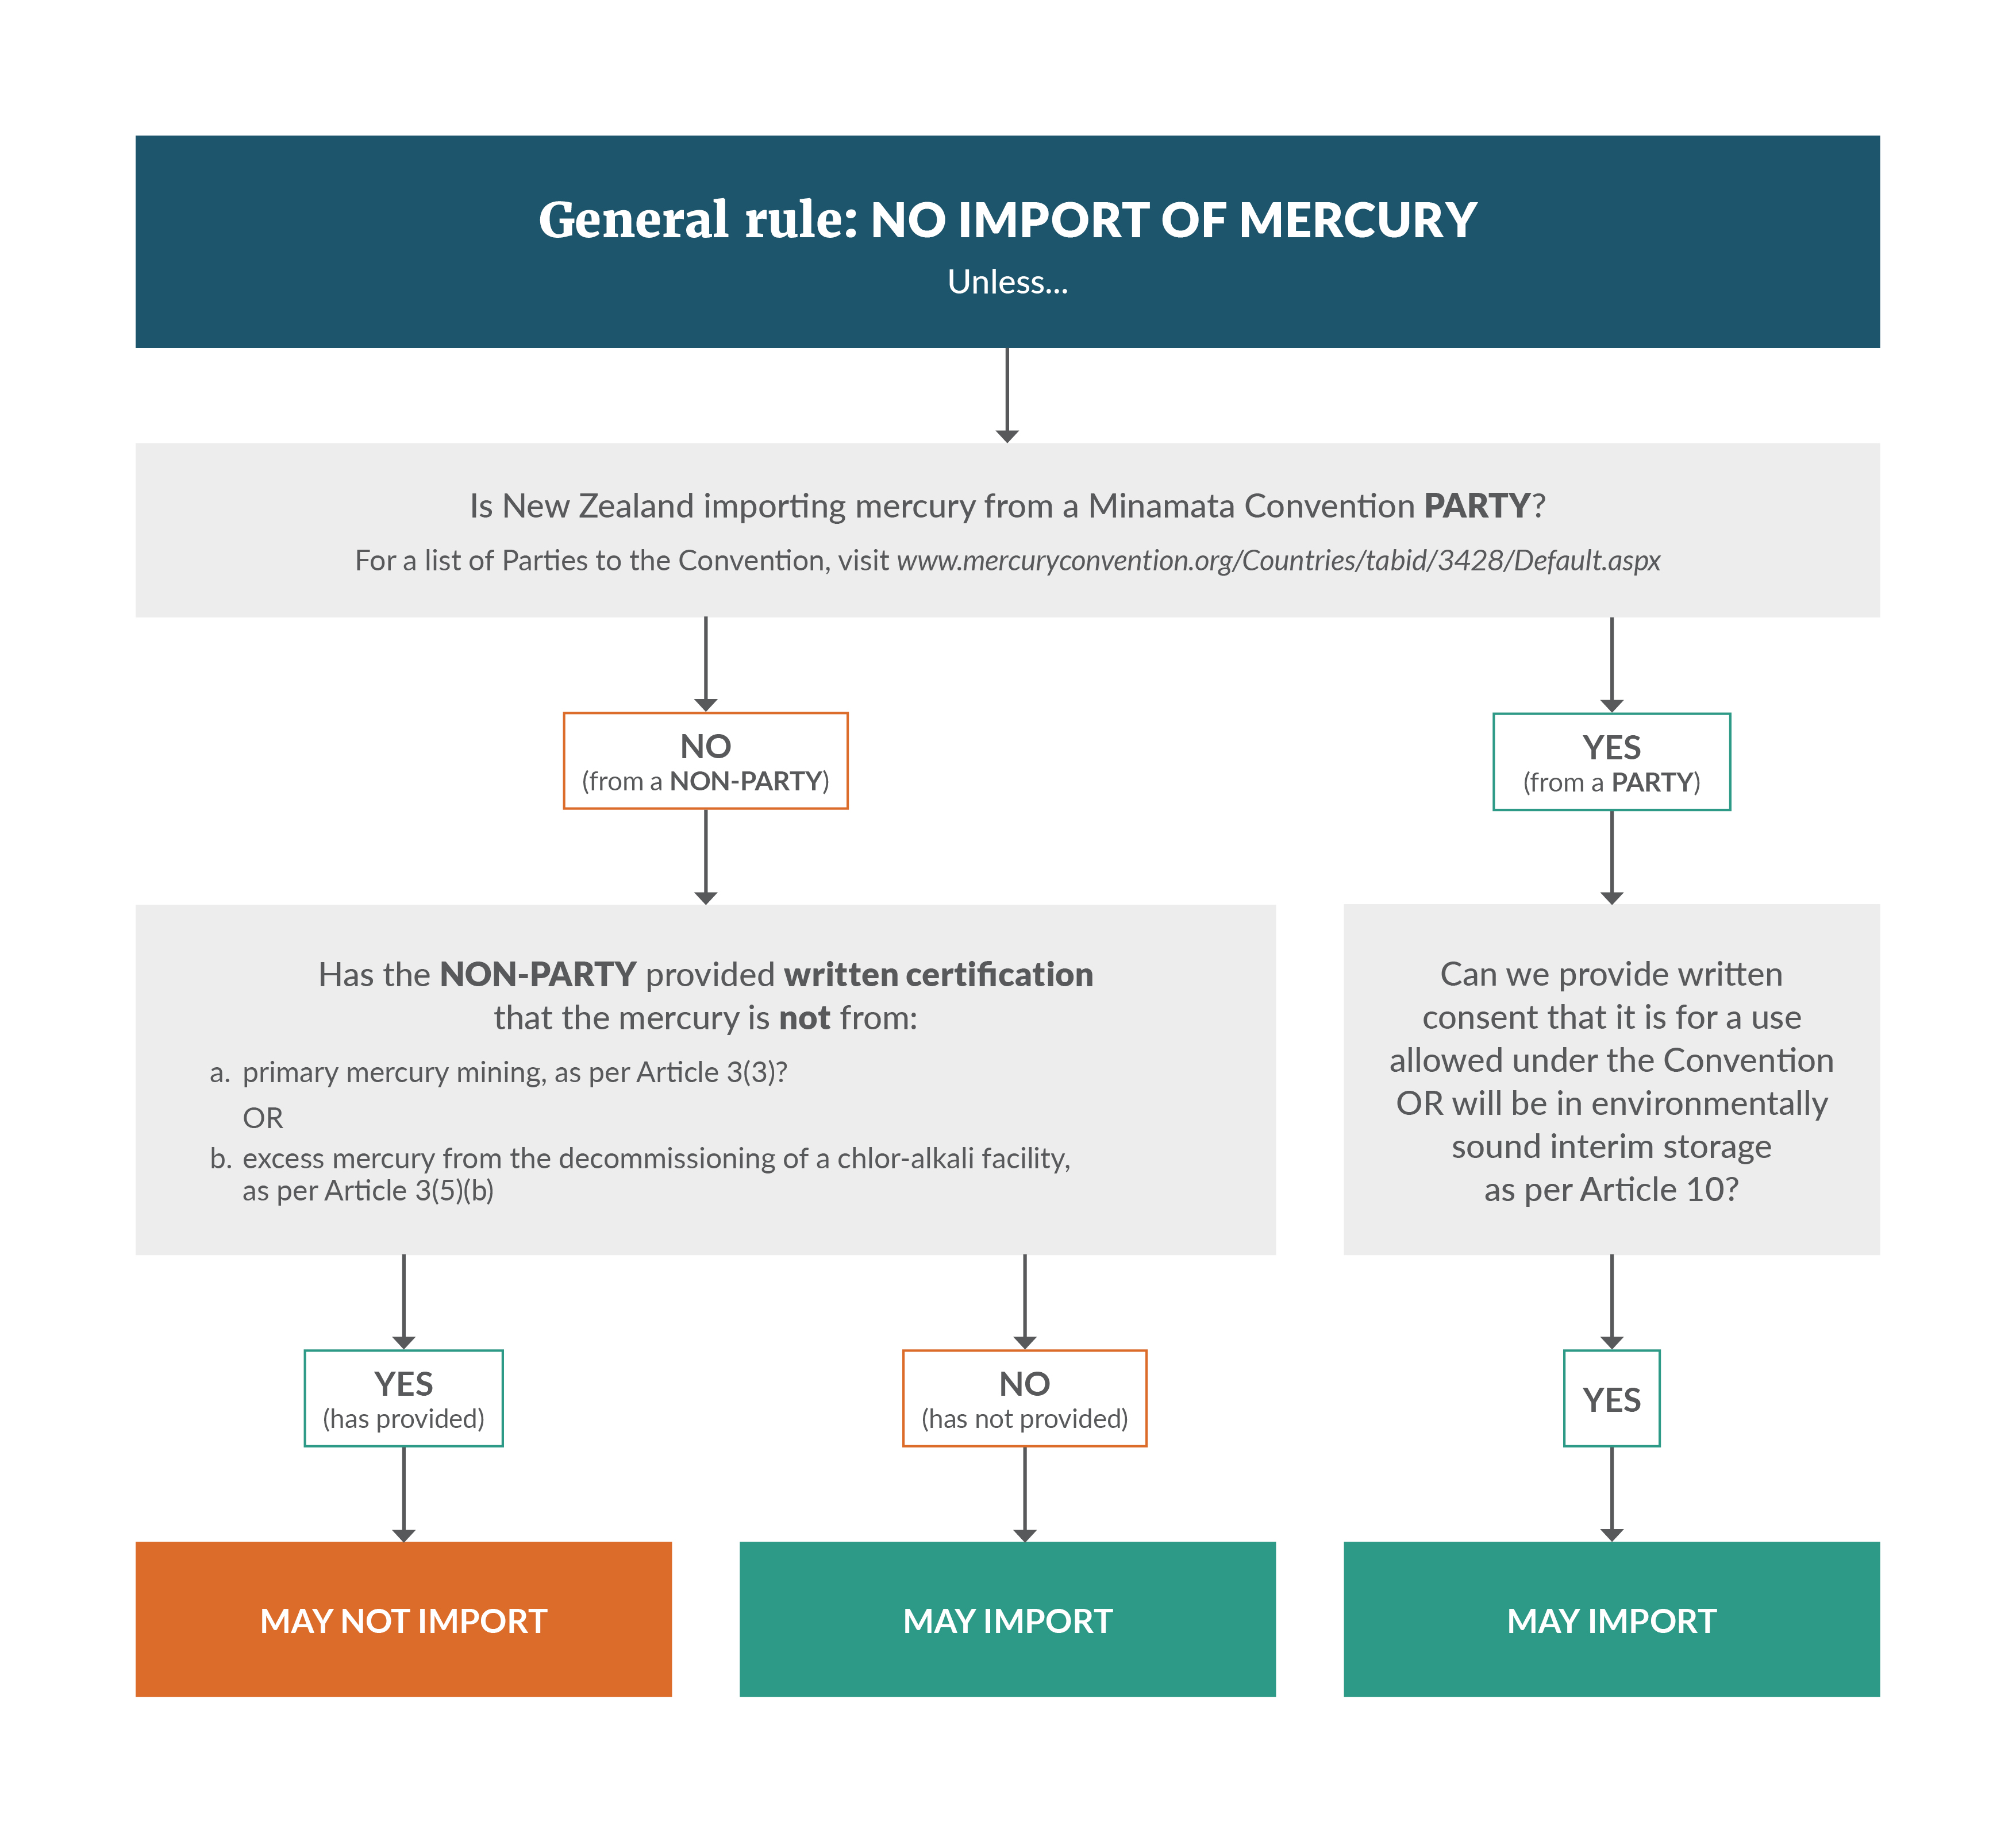

Appendix 4: Rules for the export of mercury under the Convention
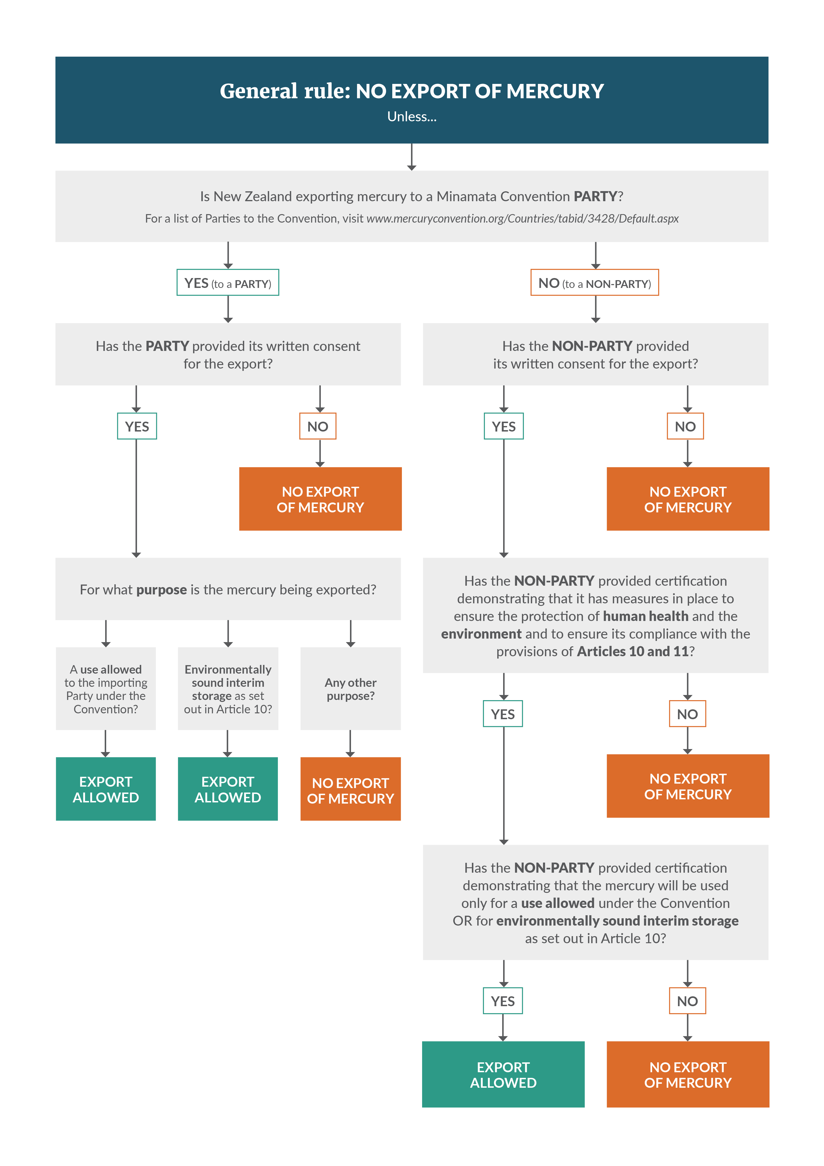

References
Bingham A, Graham B. 2017. Mercury Inventory for New Zealand: 2016. Prepared for the Ministry for the Environment by JCL Air & Environment Limited and Graham Environmental Consulting Limited. Wellington: Ministry for the Environment.
Ministry for the Environment. 2013. National Interest Analysis: Minamata Convention on Mercury. Wellington: Ministry for the Environment.
New Zealand Transport Agency. 2018. Converting street lights to LED. Wellington: NZ Transport Agency.
United Nations Environment. 2019. Global Mercury Assessment 2018. Geneva: United Nations Environment Programme.
World Health Organisation. 2010. Chemicals of Public Health Concern. Geneva: World Health Organisation.
World Health Organisation. 2017. Mercury and Health. Geneva: World Health Organisation.

In this context ‘states’ includes both countries and regional economic integration organisations (the European Union).
In October 2013 New Zealand was among 91 states to sign the Minamata Convention. A National Interest Analysis was submitted to Parliament in November 2013 and was considered by the Foreign Affairs, Defence and Trade Select Committee which reported back positively in March 2014.
For more information see the multilateral environmental agreements section on the Ministry for the Environment’s website.
Mercury is often produced as a result of gold and silver mining.
Articles 3(6) and 3(8) of the Convention require regulation of the import and export of mercury. Mercury means elemental mercury (Hg(O), CAS No. 7439-97-6) as per Article 2.
This is a regulation under the Imports and Exports (Restrictions) Act 1988.
As defined in Article 3(1)(a) of the Convention.
Articles 3(6)9a) and 3(8) only apply to mercury as defined under Article 3(1)(a) of the Convention. This may change in the future if mercury compounds are considered for trade controls by Parties under Article 3(13). ‘Mercury compounds’ means mercury (I) chloride (known also as calomel), mercury (II) oxice, mercury (II) sulphate, mercury (II) nitrate, cinnabar and mercury sulphide.
The full name is the Rotterdam Convention on the Prior Informed Consent Procedure for Certain Hazardous Chemicals and Pesticides in International Trade 1998. The Imports and Exports Order (Schedule 2) requires permits for the export (not import) of “mercury compounds, including inorganic mercury compounds, alkyl mercury compounds, and alkyloxyalkyl and aryl mercury compounds” under the Rotterdam Convention.
Section 3BA of the Imports and Exports (Restrictions) Act 1988. Offences causing possible revocation are offences against that Act or offences involving mercury.
This means it cannot be used in the manufacturing of certain mercury containing products and certain manufacturing processes prohibited by Article 4 or Article 5 of the Convention.
However, note that the EPA may still decline to grant a permit if the applicant has been convicted of an offence against the Imports and Exports (Restrictions) Act 1988 or an offence involving mercury, or if the applicant provided incorrect information (section 3BC of the Imports and Exports (Restrictions) Act 1988).
This means it cannot be used in the manufacturing of certain mercury containing products and certain manufacturing processes prohibited by Article 4 or Article 5 of the Convention.
Section 3BA of the Imports and Exports (Restrictions) Act 1988. Offences causing possible revocation are offences against that Act or offences involving mercury.
Section 3 of the Imports and Exports (Restrictions) Act 1988.
Sections 3A and 3B of the Imports and Exports (Restrictions) Act 1988.
These products are referred to in the Minamata Convention as “mercury-added products.” The term “mercury-added” is used to show that mercury has been intentionally added by humans, rather than occurring naturally in the product. We use the term “products containing mercury” as a synonym for “mercury-added products” throughout this discussion document.
Article 4(1) and Annex A to the Minamata Convention specifies exclusions.
See Article 4(3) of the Convention.
These measures are listed in Part II of Annex A of the Convention.
Part I, Annex A of the Minamata Convention on Mercury.
This Article also requires the ban on import and export which will be dealt with in the next section.
Section 3(a), Waste Minimisation Act 2008.
Section 3(b), Waste Minimisation Act 2008.
Section 23(2)(b), (3)(b)(ii) and 3(b)(iii) of the Waste Minimisation Act 2008. Note that, before making the regulations, the Minister must also obtain and consider advice of the Waste Advisory Board and be satisfied that adequate consultation has occurred (section 23(3)(a) and (b)(i)).
Note that the HSNO Cosmetics Group Standard prohibits cosmetics with higher levels than this.
Article 6 of the Minamata Convention on Mercury.
See section 3BC of the Imports and Exports (Restrictions) Act 1988.
Section 3BA of the Imports and Exports (Restrictions) Act 1988. Offences causing possible revocation are offences against that Act or offences involving mercury.
Article 4(1) contains the requirements for the phase out of the import and export of mercury containing products listed in table A.
Section 3 of the Imports and Exports (Restrictions) Act 1988.
Sections 3A and 3B of the Imports and Exports (Restrictions) Act 1988.
Estimate from Mercury Inventory for New Zealand: 2016.
EU Directive 2006/66/EC.
Estimate from Mercury Inventory for New Zealand: 2016.
New Zealand Mercury Inventory for 2016 found no imports because technology has upgraded to LEDs.

