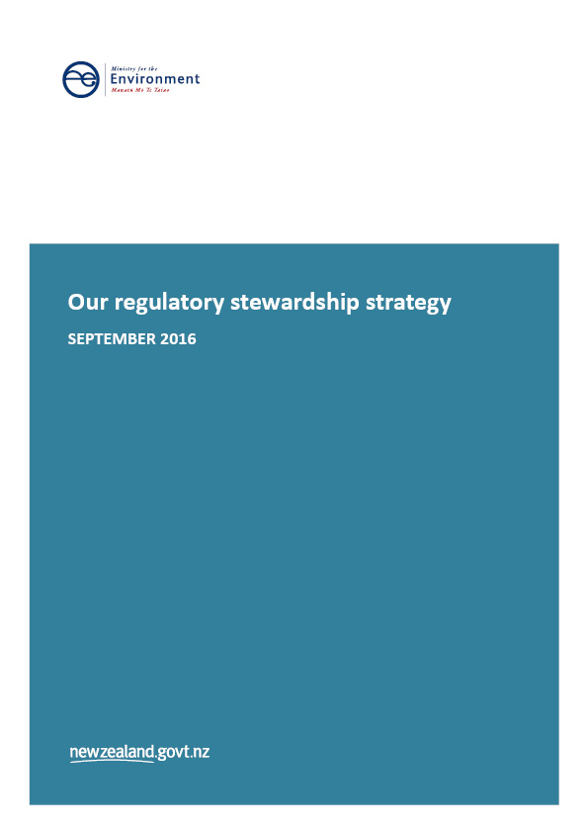

This document may be cited as: Ministry for the Environment. 2016. *Our Regulatory Stewardship Strategy*. Wellington: Ministry for the Environment.

Published in September 2016 by the  
Ministry for the Environment   
Manatū Mō Te Taiao  
PO Box 10362, Wellington 6143, New Zealand

ISBN: 978-0-908339-63-1 (online)

Publication number: ME 1269

© Crown copyright New Zealand 2016

This document is available on the Ministry for the Environment website: [www.mfe.govt.nz](http://www.mfe.govt.nz).



# Contents

Executive summary 6

Introduction 8

Why environmental regulation matters 8

Environmental management system 8

How the environmental management system is regulated 11

Role of the Ministry for the Environment 11

Role of others in the environmental management system 11

Regulatory instruments that govern the environmental management system 12

Main issues facing our regulatory regimes 13

Ministry for the Environment’s regulatory approach 14

Our strategic direction 14

How do we determine our regulatory priorities? 14

How do we ensure quality regulation? 15

Our regulatory regimes and Acts 17

Priorities and reviews for 2016–17 21

Monitoring, accountability, implementation and compliance 24

Condition and fitness for purpose of regulatory regimes 27

# Figures

Figure 1: Environmental management system 9

Figure 2: What success looks like in the Environmental Management System domains in 2045 10

Figure 3: Our strategic direction: Ministry for the Environment’s long-term outcomes and strategic priorities 14

Figure 4: Ministry for the Environment’s regulatory impact analysis process 16

# Table

Table 1: Ministry for the Environment’s national direction priorities for 2016/17 22

# **Executive summary**

The Ministry for the Environment’s mission is “Environmental stewardship for a prosperous New Zealand”. This means ensuring New Zealanders can use and benefit from the natural and built environment today, while maintaining its capacity to produce benefits tomorrow. This meshes well with the Ministry’s purpose that “We make Aotearoa New Zealand the most liveable country in the world”.

Maintaining high environmental standards is essential for market access and New Zealand’s economic growth and continued prosperity, as well as for creating high quality environments (built and natural) for New Zealanders to live in.

The Ministry often operates in a high-level policy role, with detailed policy design or implementation being handled by other entities at national or local levels. This requires a long-term partnership approach, supported by clear outcomes and effective monitoring and reporting, as is now being seen with the Environmental Reporting regime that is jointly managed with Statistics New Zealand.

This partnership model is reflected in the various non-regulatory mechanisms that support our regulatory strategy: science, information, funding and sharing best practice. In future versions of this strategy document, we intend to more fully integrate discussion of these non-regulatory elements with the formal regulatory ones.

The Ministry’s role in the complex environmental management system is one of leadership and coordination. This role has increased over the past five years. It now extends to Environmental Reporting, Exclusive Economic Zone and Marine Protected Area legislation, and development and implementation of National Policy Statements for various issues. Historically, the Ministry’s role has been highly decentralised but the Ministry has acknowledged the need for stronger leadership, so has moved to strengthen its own strategic capability.

The foundation for that strategic capability is a combination of collaboration within and outside government, bringing together and interpreting an integrated database of management practices and environmental outcomes and trends, within a ‘domain-based’ long-term outcomes framework.

Within that framework, we will emphasise continuous improvement, information, working with iwi and Māori, building our own and the system’s capability to support better decision making, and partnerships. This will include a focus on innovative, collaborative models; using non-regulatory mechanisms wherever these can add value; and holding both new and existing regulations to a high standard, reflecting the burdens they impose.

The regimes we administer face challenges from rising public expectations, managing competing goals between national and local levels, competing demands for the same resources, tensions between certainty and flexibility for both regulators and users, and long (legal and ecological) timeframes for change.

Several significant reviews are under way within the Ministry’s current regimes, including the Resource Management Act 1991 and the New Zealand Emissions Trading Scheme. Major reforms are also being implemented in other regimes and will be for some years to come, such as fresh water and the marine environment.

This is requiring an increased focus on building and maintaining relationships, and supporting effective local implementation linked to ongoing monitoring and reporting. We are also investigating models for measuring, and driving improvements in, the effectiveness of our regimes – an area where we acknowledge current weakness and are committed to demonstrating progress in future years.

The Ministry for the Environment faces major challenges but is positioned, with its many partners, to address these in an increasingly effective fashion over the coming years.

# Introduction

Under the State Sector Act 1988,[1] the Ministry for the Environment (MfE) has regulatory stewardship responsibilities for the legislation it administers. A good regulatory steward ensures regulation is, and will remain, ‘fit for purpose’ over time. In 2015, the Government asked seven of the main regulatory departments[2] to publish annual assessments of the current state of their regulatory regimes, plans for amendments to regulation and new regulation, and their views of important emerging issues for regulation.

This Regulatory Stewardship Strategy is MfE’s response to the Government’s request.It covers how MfE develops and maintains the regulatory regimes for which it is responsible, including both longer-term perspectives and day-to-day support of its regulatory partners – the Environmental Protection Authority and local authorities.

## Why environmental regulation matters

The natural and built environment is important to New Zealanders for many reasons. Most fundamentally, it supplies our basic needs: clean air, water, food and a place to live. Much of New Zealand’s international competitive advantage lies in the quality and quantity of its environment and natural resources. Maintaining high environmental standards is essential for market access and New Zealand’s economic growth and continued prosperity, as well as for creating high-quality environments (built and natural) for New Zealanders to live in.

Ecological systems are constantly changing, as are the demands placed on them. The extent to which we can use the environment before we start to put it and its resources at risk is limited. Often, the full implications of the environmental policies and interventions made in the past only become clear generations later. This means environmental regulation must support New Zealand’s prosperity by allowing ongoing access and use of the natural environment, while at the same time protecting it for future generations.

The environment confers mana and provides sustenance to Māori. It has shaped the living culture of Māori, and the Māori culture has in turn shaped the New Zealand environment over many generations. It is the resting place for those who have died, with many features of the natural landscape representing important ancestors. The environment is important to tāngata whenua as a form of personal and tribal identity, a symbol of social stability and an important source of emotional and spiritual strength.

## Environmental management system

The term ‘environmental management system’ describes the numerous and complex interactions and interdependencies between New Zealand’s environmental and social processes (see figure 1). This system is determined, in part, by the biophysical reality of resources, but also by how these resources are used, managed and valued. It is a dynamic system made up of political, economic, cultural and social drivers.

Figure 1: Environmental management system

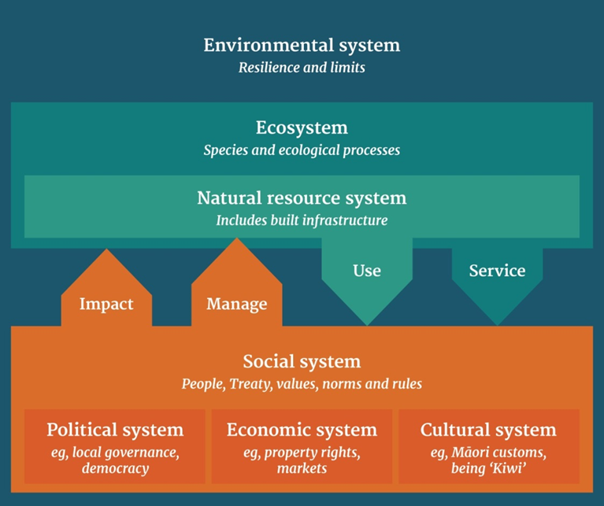

Water, land management and climate change are not simply environmental issues – any action on these issues has economic, social and cultural implications. Social and economic systems drive how people value, use and manage natural resources. Therefore, much of what government seeks to achieve across its wider policy programme and ministerial portfolios depends on the performance of the environmental management system.

As such, a long-term, cross-sector view in decision-making is essential. This approach resonates with the holistic way Māori consider their relationship with the environment. The phrase “ki uta ki tai” – “from the mountains to the sea” is often used to describe how the environment should be viewed and managed.

The Ministry uses a ‘domain’ approach to understand the different components of the Environmental Management System. This approach focuses on each domain, allowing us to build coherent understanding within each one, before viewing the system as a whole. The domains are Air, Atmosphere and Climate, Fresh water, Land, Marine and Urban (see figure 2).

Figure 2: What success looks like in the Environmental Management System domains in 2045

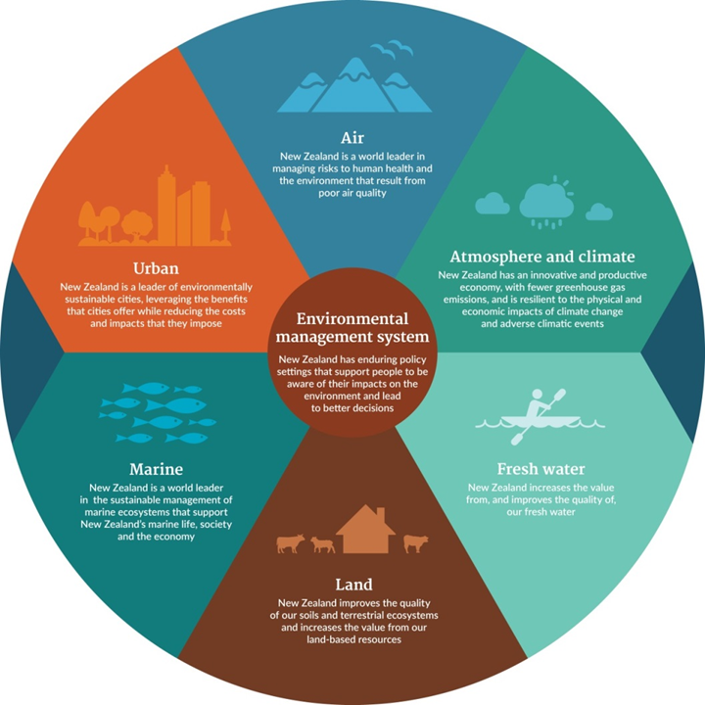

Though the Ministry uses a domain approach to understand and manage the environmental management system, it is important to recognise that domains do not operate in isolation from one another. Both ecosystems and the influence of activities and management interventions connect domains in many ways.

# How the environmental management system is regulated

## Role of the Ministry for the Environment

The Ministry’s purpose is:

*Aotearoa New Zealand is the most liveable place in the world*

*Aotearoa – he whenua mana kura mō te tangata*

We are stewards for the environment, so that we continue to have a prosperous Aotearoa New Zealand, now and in the future – Tiakina te taiao kia tōnui a Aotearoa – Environmental stewardship for a prosperous New Zealand. This means ensuring New Zealanders can use and benefit from the environment today, while maintaining its capacity to produce benefits tomorrow.

We are the Government’s primary adviser on how human interactions and uses impact on the environment, both nationally and internationally. We set policy on how the New Zealand environment is managed. We advise the Government on the system of institutions, laws, regulations, policies and economic incentives that form the framework for environmental management, as well as monitoring the performance of the system.

We lead cross-government activity on climate change, and are supported by many other government agencies. We also coordinate national and international reporting on greenhouse gas emissions, removals and projections.

The Ministry works within international forums to promote action on important international environmental issues. This ensures New Zealand’s interests are protected and advanced in the work of international organisations, and that New Zealand meets its obligations under multilateral environment agreements it has ratified.

## Role of others in the environmental management system

The Ministry often operates in a high-level policy role, with detailed policy design or implementation being handled by other entities at national or local levels. It involves a broad range of participants, and each has a different view about how natural resources should be managed to support the economy, conservation, recreation and customary purposes.

The Ministry works with the Environmental Protection Authority (EPA) to develop policy and regulations. The EPA has regulatory functions that include making decisions on environmental matters, ensuring compliance with rules, and monitoring environmental management on behalf of the Minister for the Environment.

We are currently working with the EPA and Ministry of Business, Innovation and Employment on actions to reduce workplace harm. In addition, to ensure the successful implementation of the regulatory framework that underpins the Exclusive Economic Zone (EEZ), the Ministry will work closely with the EPA to ensure it has robust capability and systems in place to fulfil the obligations under the Exclusive Economic Zone and Continental Shelf (Environmental Effects) Act 2012 (the EEZ&CS Act). Extensive work is also being done with other central government agencies (especially those within the Natural Resources Sector).

The Ministry invests significantly in maintaining relationships with local authorities and providing guidance and tools to support Resource Management Act 1991 (RMA) plan making and implementation. The role of local government is crucial because it makes most resource management decisions, due to the devolved nature of the RMA, and is responsible for most monitoring and enforcement activity. The RMA is the main legislation for making decisions on the use of resources. As well as managing air, soil, fresh water and coastal marine areas, the RMA regulates land use (including subdivision) and the provision of infrastructure, which are integral components of New Zealand’s planning system.

Relationships with iwi and Māori under Te Tiriti o Waitangi (the Treaty of Waitangi) are significant across most of MfE’s work programmes. Other partnerships span:

* Crown entities
* business
* non-governmental organisations
* the wider community.

Working in partnership with the Land and Water Forum on freshwater reform has been a valuable exercise. It has also been a useful model for collaborative engagement and planning that is expected to become more frequent at all levels of the environmental management system. The Ministry has also worked with local authorities to develop guidance for collaboration planning processes. The partnership model is reflected in the range of non-regulatory mechanisms that support our regulatory strategy: science, information, funding and sharing best practice.

All of our advice should ultimately be framed within our overall mission as an agency and our strategic priorities of:

* leadership
* information
* system capability and capacity
* kaitiakitanga.

## Regulatory instruments that govern the environmental management system

The environmental management system is regulated by 12 main Acts and underpinned by nearly 200 regulations, codes of practice and notices, National Policy Statements, and National Environmental Standards. The Ministry’s legislative responsibilities span the whole environmental system, relating primarily to managing how people interact with the natural and built environment across the six domains.

# Main issues facing our regulatory regimes

Because of the diffuse but interrelated nature of the environmental management system, one of the main challenges for our regulatory regimes is to support (or at least not hinder) outcomes in other domains. To do this, MfE needs to:

* better anticipate the implications of change in one part of an interconnected system
* gain further insight into causes, consequences and cumulative effects
* better develop regulatory solutions that benefit multiple domains.

Other issues facing MfE’s regimes are:

* rising expectations regarding the quality and effectiveness of local planning, and the consequent monitoring and enforcement activity
* tensions over how resources are allocated, used and conserved
* political and public appetite for changing the status quo (ie, genetically modified organisms, waste management)
* how to value natural capital and resources
* timeframes that can span decades, due to lagged environmental and cumulative effects
* demand for collaborative approaches at national and local levels, with end goals being the achievement of effective integration of how we manage:

1. awareness of impacts across domains (eg, land, water, marine)
2. conflicts between different resource uses, particularly recreational, cultural and activities that extract resources or discharge into the environment
3. tensions between central and national direction on environmental issues and localised decision-making
4. multi-agency responses that benefit multiple domains

* how to address iwi rights and interests in a post-settlement era
* how to ensure New Zealanders feel the system encourages their participation and input – including having effective institutional practices, such as efficiency, responsiveness, inclusiveness, fairness and trustworthiness
* how to ensure New Zealand actions decisions from international forums it is signatories to (ie, Montreal Protocol on Substances that Deplete the Ozone Layer) and appropriately responds to global environmental trends and pressures (ie, climate change).

Although MfE faces major challenges, it is positioned, with its many partners, to address these effectively in the coming years. Several significant reviews are under way within our current regimes, including the RMA and the New Zealand Emissions Trading Scheme (NZ ETS). Major reforms are also being implemented on other regimes and will be for some years to come, such as fresh water and the marine environment.

# Ministry for the Environment’s regulatory approach

## Our strategic direction

The Ministry is increasingly taking a longer-term approach to its work programme, within its mission of “Environmental stewardship for a prosperous New Zealand”. To support this, we have developed the following four long-term outcomes and strategic priorities (see figure 3), which are underpinned by a domain-based  [outcomes framework](http://www.mfe.govt.nz/sites/default/files/media/About/generation-from-now-outcomes.pdf) (with supporting targets and measures from 2020–40).

Figure 3: Our strategic direction: Ministry for the Environment’s long-term outcomes and strategic priorities

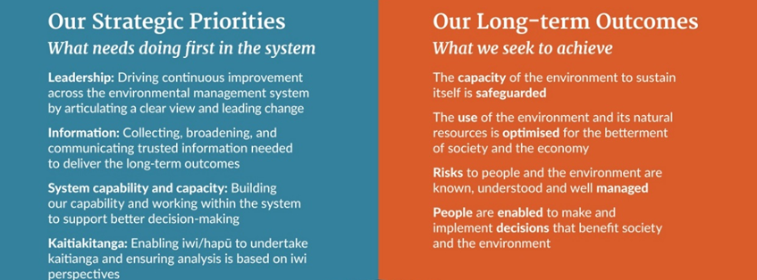

These long-term outcomes and strategic priorities provide MfE with a clear direction of travel. They also provide the context in which we undertake regulatory stewardship; the way that we set and deliver environmental regulation must support and continue to support our long-term outcomes and strategic priorities.

## How do we determine our regulatory priorities?

In addition to alignment with our strategic direction, MfE uses several other factors to determine its regulatory approach and help frame its regulatory priorities. These include:

* non-discretionary obligations (ie, statutory obligations) and alignment with international agreements and obligations
* long- and medium-term environmental stewardship considerations as identified by Environmental Reporting and National Monitoring System findings
* feedback from our stakeholders and from within our business, and what this tells us about where and how regulatory adjustments may be necessary
* supporting ministerial priorities, Cabinet-mandated work and the Government’s Business Growth Agenda – MfE has a significant role in delivering the Business Growth Agenda Natural Resources Sector priorities.[3]

## How do we ensure quality regulation?

Quality is a high priority for the Ministry, and regulatory impact analysis (RIA) is a part of the many tools and processes MfE has to measure and improve its advice. All of our regulatory proposals must meet RIA requirements. We have embedded the RIA approach into our policy advice (see figure 4). This means we are clear about the nature and significance of the problems we are addressing and the intended objectives.

Consistent with this approach, we consider both regulatory and non-regulatory options (eg, product stewardship, education and marketing campaigns, and funding schemes) to determine how best to address the problem and achieve the objectives. We expect non‑regulatory options, especially in partnership with different levels of government, iwi and stakeholders, to become more common in achieving lasting change in environmental outcomes.

Our independent Regulatory Impact Analysis Panel assesses our regulatory impact statements to determine whether they meet the requirements for a regulatory impact statement to be complete, convincing, clear and concise, and consulted.

Figure 4: Ministry for the Environment’s regulatory impact analysis process

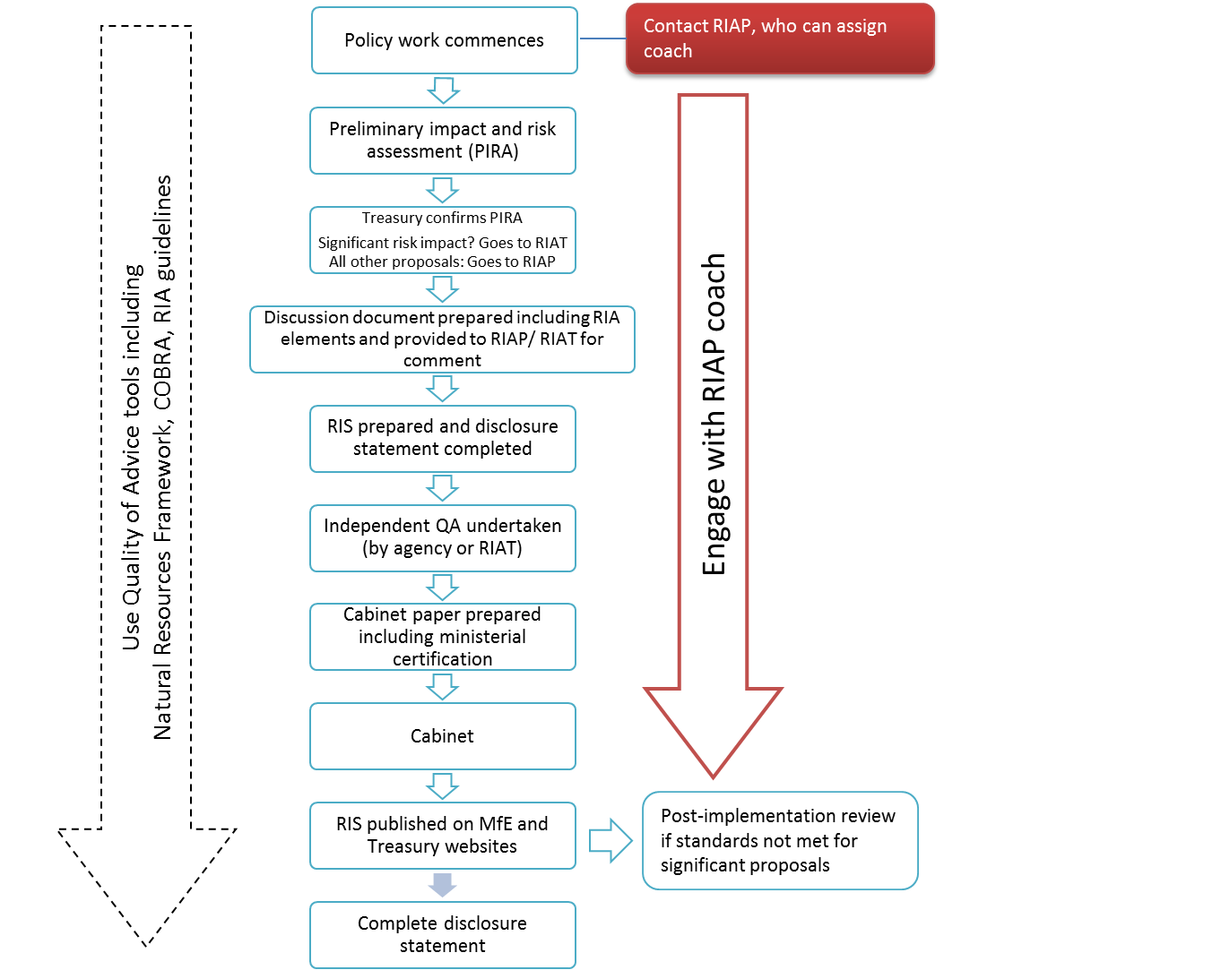

Note: COBRA = costs opportunites benefits risks analysis; MfE = Ministry for the Environment; QA = quality assessment; RIA = regulatory impact analysis; RIAP = MfE’s Regulatory Impact Analysis Panel; RIAT = Treasury’s Regulatory Impact Analysis Team; RIS = regulatory impact statement.

In general, MfE’s approach to quality advice supports clear problem definition, impact analysis and guidance to ensure the case for regulations (and their design and delivery) is robust. It includes:

* training, tools and internal processes to support good commissioning of work, backed by similar arrangements for effective peer review
* regular assessments of nearly 20 per cent of advice that has been sent, followed by feedback to staff involved and adjustment of overall guidance, tools and processes.

Externally, MfE has extensive partnerships with local authorities and others engaged in planning to promote sharing of knowledge and best practice. In fresh water, guidance on implementing the National Policy Statement for Freshwater Management is developed through such partnerships.

Our regulatory approach is increasingly supported by investment in science, support for and integration of data on environmental outcomes, model development, and collating the results through mechanisms such as the Environmental Reporting work programme. Improved understanding of evidence and drivers supports improved policy and implementation at national and local levels.

# Our regulatory regimes and Acts

### Regime – Atmosphere and climate

* Climate Change Response Act 2002

The Climate Change Response Act 2002 establishes the NZ ETS, New Zealand’s main domestic policy instrument for addressing climate change. Seven regulations and four orders sit under this Act covering a broad scope of technical regulations including general exemptions, fishing allocation plans, eligible industrial activities, removal activities, stationary energy and industrial processes, synthetic greenhouse gas levies, the New Zealand Refining Company Limited, unique emissions factors, New Zealand Emission Unit Register, waste, forestry and fossil fuels.

The Act also puts in place a legal framework to enable New Zealand to ratify the Kyoto Protocol and to meet its obligations under the United Nations Framework Convention on Climate Change.

* Ozone Layer Protection Act 1996

The purpose of the Ozone Layer Protection Act 1996 is to protect human health and the environment from adverse effects resulting from human activities that may deplete the ozone layer and to phase out ozone-depleting substances as soon as possible. New Zealand’s obligations under the [Montreal Protocol and the Vienna Convention](http://www.mfe.govt.nz/more/international-environmental-agreements/multilateral-environmental-agreements/key-multilateral-7) on substances are implemented through the Ozone Layer Protection Act 1996 and the Ozone Layer Protection Regulations 1996. The EPA is responsible for enforcing the legislation and managing the permit system for imports and exports, while MfE has overall responsibility for policy.

### Regime – Environmental management system

* Environment Act 1986

The Environment Act 1986 established both the Parliamentary Commissioner for the Environment and the Ministry for the Environment. The Act aims to ensure that, in the management of natural and physical resources, full and balanced account is taken of:

* the intrinsic values of ecosystems
* all values that are placed by individuals and groups on the quality of the environment
* the principles of the Treaty of Waitangi
* the sustainability of natural and physical resources
* the needs of future generations.
* Environment Canterbury (Temporary Commissioners and Improved Water Management) Act 2010

The Minister for the Environment and the Minister of Local Government are jointly responsible for the Environment Canterbury (Temporary Commissioners and Improved Water Management) Act 2010. The Act:

* provides for the replacement of the elected members of the Canterbury Regional Council with commissioners who will act as the Council’s governing body until new elected members come into office
* provides the Canterbury Regional Council with certain powers that it does not otherwise have to address issues relevant to the efficient, effective and sustainable management of fresh water in the Canterbury region.

The new Environment Canterbury (Transitional Governance Arrangements) Act received the royal assent on 9 May 2016. This Act provides governance arrangements for the Canterbury Regional Council during the 2016 to 2019 local authority election-cycle period and replaces the governance arrangements that have been in place since 2010. It provides for:

* a majority of members of the Council to be elected by the people of the Canterbury region
* the continuation of some of the modified resource management processes that have operated under the Environment Canterbury (Temporary Commissioners and Improved Water Management) Act 2010 to remain available to the Council in order to further progress issues relating to the management of fresh water within the Canterbury region
* Environmental Protection Authority Act 2011

The purpose of the Environmental Protection Authority Act 2011 is to protect the environment, and the health and safety of people and communities, by preventing or managing the adverse effects of hazardous substances and new organisms. This Act establishes the EPA and provides for its functions and operations. Twenty-two regulations sit under this Act covering a broad scope of controls including fireworks and other explosive controls, and the management, disposal, classification, packaging and transport of hazardous substances and new organisms.

* Environmental Reporting Act 2015

The purpose of the Environmental Reporting Act 2015 is to require regular reports on New Zealand’s environment. The Act makes responsibilities for independent, fair and accurate environmental reporting explicit, and sets the broad framework for the scope of reporting and timing for reporting products. Regulations will be developed under set topics that will be reported on when environmental reports are produced under the Act.

* Resource Management Act 1991

The Resource Management Act 1991 (RMA) is the principal legislation through which New Zealand’s land and coastal environment is managed. It sets out the general framework for the management of air, water, soil, biodiversity, the coastal environment, noise, subdivision and land use. The Ministry administers the RMA, with most decision-making under the RMA devolved to local authorities or Boards of Inquiry appointed by the Minister for the Environment for nationally significant proposals (supported through the EPA).

Thirteen regulations sit under the RMA covering a broad range of activities, including:

* requiring authority approvals
* heritage protection authority approvals
* forms, fees and procedure
* marine pollution
* metering of water takes
* national environmental standards for contaminants in soil, drinking water, electricity transmission, air quality, air pollutants
* dissolution of the Waitaki Water Allocation Board.

There are four National Policy Statements:

* National Policy Statement for Freshwater Management
* National Policy Statement for Renewable Electricity Generation
* National Policy Statement on Electricity Transmission
* New Zealand Coastal Policy Statement.

There are five National Environmental Standards:

* Air Quality
* Sources of Drinking Water
* Telecommunication Facilities
* Electricity Transmission Activities
* Assessing and Managing Contaminants in Soil to Protect Human Health

### Regime – Marine

* Exclusive Economic Zone and Continental Shelf (Environmental Effects) Act 2012

The EEZ&CS Act aims to protect New Zealand’s oceans from the potential environmental risks of activities like petroleum exploration activities, seabed mining, marine energy generation and carbon capture developments. The EPA is responsible for marine consent decisions under the EEZ Act. Five regulations sit under this Act covering:

* environmental effects of permitted and non-permitted activities
* fees and charges
* discharges and dumping
* burial at sea.
* Fiordland (Te Moana o Atawhenua) Marine Management Act 2005

The Fiordland (Te Moana o Atawhenua) Marine Management Act 2005 establishes the Fiordland (Te Moana o Atawhenua) Marine Area, including eight marine reserves. It also establishes the Fiordland Marine Guardians and implements measures to help in the preservation, protection and sustainable management of the marine environment and biological diversity. The Act recognises the local, national and international importance of the Fiordland marine environment, including the distinct biological diversity, outstanding landscape and cultural heritage.

### Regime – Land

* Hazardous Substances and New Organisms Act 1996

The Hazardous Substances and New Organisms Act 1996 (HSNO) aims to prevent or manage the adverse effects of hazardous substances and new organisms, including genetically modified organisms within New Zealand. This is a complex regime to administer, with MfE responsible for the Act and regulations, while the EPA is responsible for enforcement and engagement, and the Ministry for Primary Industries, WorkSafe New Zealand and Institutional Biological Safety Committees all play roles in implementation.

* Waste Minimisation Act 2008

The Waste Minimisation Act 2008 encourages a reduction in the amount of waste generated and disposed of in New Zealand and aims to lessen the environmental harm of waste. This Act also aims to benefit the New Zealand economy by encouraging better use of materials throughout the product life cycle, promoting domestic reprocessing of recovered materials and providing more employment. One set of regulations sits under the Act covering the calculation and payment of the waste disposal levy.

* Soil Conservation and Rivers Control Act 1941

The overriding purpose of the Soil Conservation and Rivers Control Act 1941 is to make provision for the conservation of soil resources, the prevention of damage by erosion and to make better provision for the protection of property from damage by floods.

To achieve the Act’s purpose and objects, catchment boards are able to be established under the Act. Catchment boards are responsible for the activities in their catchment district. These boards are given wide-ranging powers to achieve the purpose and objects of the Act.

# Priorities and reviews for 2016–17

The Ministry’s regulatory activity for 2016–17 includes:

* progressing reforms to the RMA and supporting instruments (particularly fresh water and urban) primarily through the:

1. Resource Legislation Amendment Bill (RLAB)
2. proposed National Policy Statement on Urban Development (NPS-UD)
3. amendments to the National Policy Statement for Freshwater Management (NPS‑FM).

* implementing regulatory framework underpinning EEZ regulation,
* delivery of a Bill to enable implementation of the Minamata Convention on Mercury
* marine instruments, including Kermadec Ocean Sanctuary and Marine Protected Areas,
* reviewing the functioning of the NZ ETS.

The top priorities are the NZ ETS review, RLAB, NPS-UD and the NPS-FM amendments.

### Resource management reforms

The major priority for 2016/17 is to deliver the second phase of RMA reforms. This large Bill was introduced to Parliament on 26 November 2015 and contains over 40 individual proposals. It is an important part of the Government’s broader programme of maintaining economic growth, addressing housing supply and affordability, and better managing the environment. The main elements of the RMA reforms include:

* clearer national direction and tools
* single, local resource management plans that address future environmental and development priorities and cover all local, regional and national issues; replacing the existing range of planning documents
* simpler, faster and fewer resource consents
* Māori interests and values to be considered earlier in resource management planning processes with solutions developed upfront
* comprehensive management of natural hazards in planning and consenting
* housing affordability through explicit attention to this issue in plans and changes to consenting arrangements to drive down their cost and improve their timeliness.
* Resource Legislation Amendment Bill (EEZ aspects)

The Bill includes amendments to the Exclusive Economic Zone and Continental Shelf (Environmental Effects) Act 2012. This includes provisions to align decision-making processes more closely with the process for considering nationally significant proposals (under the RMA), and making better provision for decommissioning offshore oil and gas fields.

* National direction priorities

Running in parallel to the legislative change is important work on National Policy Statements, National Environmental Standards and new planning templates. These are focused on improving how the RMA works in areas like urban development, transport and infrastructure planning, air quality, contaminated land, pest control and forestry. Table 1 shows our national direction priorities for 2016/17.

Table 1: Ministry for the Environment’s national direction priorities for 2016/17

|  |  |  |  |
| --- | --- | --- | --- |
| Topic | Indicative date of completion | Description | For more information see the following web pages |
| Telecommunication facilities (amendments) | 2016 | Changes to bring the existing national environmental standards (NESs) up to date with current technology. | [Proposed amendments to the NES for Telecommunication Facilities](http://www.mfe.govt.nz/node/20637/) |
| Plantation forestry | 2016 | Nationally-consistent rules to reduce compliance costs for plantation forestry. | [About the proposed NES for Plantation Forestry](http://www.mfe.govt.nz/node/20845/) |
| Urban development | 2016 | Requirements for councils to provide sufficient capacity for urban development including housing and business land. | [Proposed NPS on Urban Development](http://www.mfe.govt.nz/more/towns-and-cities/managing-urban-development-nz/developing-proposed-national-policy-statement) |
| Freshwater management (amendments) | Consultation in 2016 | The proposed reforms aim to improve the management of fresh water to deliver better environmental and economic outcomes and better outcomes for iwi. | [Freshwater reforms 2016](http://www.mfe.govt.nz/fresh-water/reform-programme/freshwater-reforms-2016) |
| Biodiversity (subject to agreement on terms of reference between farmers and conservation groups) | 2016/17 | Clear national guidance on implementation of section 6(c) of the Resource Management Act 1991. | [About an NPS for biodiversity](http://www.mfe.govt.nz/more/biodiversity/national-policy-statement-biodiversity/about-national-policy-statement) |
| Pest control and eradication | 2016 | Improving the regulatory approach to pest control and avoiding duplication with the Hazardous Substances and New Organisms Act 1996. | [Pest control and biodiversity](http://www.mfe.govt.nz/more/biodiversity/protecting-nzs-biodiversity/pest-weeds-and-diseases) |
| Air (amendments) | 2016 | Changes to the existing NESs to incorporate current findings on the health impacts of air pollution. | [About the NES for Air Quality](http://www.mfe.govt.nz/node/17892/) |
| Aquaculture | 2016 | Nationally consistent framework for the management of aquaculture space to provide greater certainty for investment in aquaculture. | [National direction for aquaculture](http://www.mfe.govt.nz/marine/national-direction-aquaculture) |
| Contaminants in soil (amendments) | 2017 | Changes to make the existing NES more targeted toward risks from contaminants. | [Interim review of the NES for Assessing and Managing Contaminants in Soil to Protect Human Health](http://www.mfe.govt.nz/land/nes-assessing-and-managing-contaminants-soil-protect-human-health/interim-review-nes) |
| Natural hazards | 2018 | Guidance on managing significant risks from natural hazards. | [Managing natural hazards in New Zealand](http://www.mfe.govt.nz/more/natural-hazard-management/managing-natural-hazards) |

### Review of New Zealand Emissions Trading Scheme

The NZ ETS is the Government’s main domestic policy instrument for addressing climate change and providing an incentive to reduce greenhouse gas emissions. The Ministry is currently reviewing and assessing the operation and effectiveness of the NZ ETS to 2020 and beyond, to ensure the New Zealand economy is well prepared in the context of a strengthening international response to climate change and potentially higher carbon prices in the 2020s.

This review will also allow the NZ ETS to evolve, particularly with respect to the framework provided by the new climate agreement (Paris Agreement) that will apply after 2020, this may involve the amendment or creation of necessary legislation or regulations to ensure compliance with the obligations imposed by the Paris Agreement. Amendments to the NZ ETS components of the Climate Change Response Act 2002 may also be required.

### Marine reforms

Another priority for MfE is work to support New Zealand to be a leader in the sustainable use and management of its marine environment. This includes implementing legislation for the Kermadec Ocean Sanctuary, which will be a fully protected area extending from the Kermadec Islands marine reserve out to the boundary of the EEZ. It also includes developing the Marine Protected Areas Act that will provide a new approach to Marine Protection in New Zealand. The legislation will provide for four categories of marine protected areas with different levels of marine protection.

The Ministry will continue to focus on the successful implementation of the regulatory framework that underpins the EEZ while ensuring the framework remains fit for purpose over time.

### Waste

The Waste Minimisation Act 2008 requires the Minister for the Environment to conduct a review of the effectiveness of the waste disposal levy every three years. The first review was completed in 2011, the second review in 2014, and the next review is scheduled to be completed by 1 July 2017. The priority for the next review will be reporting on the progress made against the 11 recommendations identified in the 2014 levy review.

### Implementing the Minamata Convention on Mercury

In September 2013, Cabinet agreed that New Zealand sign the Minamata Convention on Mercury. Mercury is a toxic heavy metal released from human processes (such as coal-fired power stations) and naturally (such as from volcanoes). A Bill is proposed for late 2016 to enable ratification of the Convention before the first Conference of the Parties (COP1).

# Monitoring, accountability, implementation and compliance

### Monitoring

The Ministry has a mixture of monitoring arrangements, which reflects the range of different regimes and instruments it administers. Internal monitoring systems include the National Monitoring System for the RMA and the Environmental Reporting regime with Statistics New Zealand. These allow us to understand how and how well regimes work. The Ministry also draws heavily on councils and stakeholders, public consultation and data collected under individual regimes and by other agencies.

* National monitoring system

The National Monitoring System is a national framework that identifies and captures consistent and comparable information on how the RMA is implemented.

It provides robust information on the implementation of the RMA and the performance of tools (national policy statements, national environmental standards and water conservation orders). This information is used to produce a picture of the impact of the functions, tools and processes of the RMA.

We continue to improve the availability, consistency and comparability of RMA information, and to streamline data collection.

The data collected under the National Monitoring System will contribute significantly to our information base and ability to measure performance. It will also enhance the ability of councils and local communities to compare performance and identify best practice. This will provide information to support better local decision-making and planning.

* Environmental reporting

With regard to environmental outcomes, the Ministry’s major monitoring mechanism is the Environmental Reporting Act 2015, where it jointly operates a statutorily independent and statistically robust public reporting cycle with Statistics New Zealand. The environmental reporting regime provides regular, independent and robust reports that detail the current state of New Zealand’s biophysical environment. Information on biodiversity and ecosystems will feature in the freshwater, land and marine domains. Every three years, a comprehensive report (the Environment Aotearoa synthesis report) will bring together information on the air, atmosphere and climate, freshwater, land and marine domains.

The Ministry is undertaking work to improve quality and consistency of environmental monitoring, and the data that underpins reporting. Several collaborative initiatives with regional councils will address issues of consistency, representativeness and accessibility.

Specific mechanisms are in place with regard to measuring climate change emissions, air quality exceedances, waste minimisation and water monitoring (Land, Air, Water Aotearoa   
– [www.lawa.org.nz](http://www.lawa.org.nz/)).

* International monitoring

Periodically, New Zealand’s environmental performance is assessed by international agencies. This information is useful for assessing how the international community views New Zealand, and it is an effective mechanism for prompting discussion and debate about whether New Zealand’s environmental regulatory settings are right.

For example, the Organisation for Economic Co-operation and Development (OECD) reviews New Zealand’s environmental performance. These reviews are designed to help OECD member countries improve their individual and collective performances in environmental management with the goal of achieving sustainable development. The review evaluates progress on actions taken to date and results achieved. These results are assessed against the country’s own stated intentions, international commitments and the aims of the OECD’s environmental programme.

New Zealand’s next OECD environmental performance review is scheduled for release in 2017.

* Freshwater monitoring

An area for further development is the implementation of an effective monitoring and evaluation framework for fresh water. The Ministry will assess progress toward medium- and long-term objectives and overarching goals of the freshwater reforms. Specifically, this will enable evaluation of the environmental outcomes and the environmental, economic and social impacts of freshwater management. This will include evaluation of interventions (eg, the National Policy Statement for Freshwater Management, water funds and collaborative planning) as well as evaluation of the application of the water reform policy in council plans.

* Waste monitoring

The Ministry will continue to work with the EPA to improve the monitoring of the HSNO regime, particularly the environmental effects from hazardous substances, and to bed in improved monitoring of new organisms identified through the updated outcomes framework in 2015.

### Implementation and compliance

The Ministry often operates in a high-level policy role, with detailed policy design, implementation and compliance with regimes carried out by other entities at national or local levels; primarily, these are the EPA and local government.

* Atmosphere and climate

The EPA is responsible under the Climate Change Response Act 2002 for ensuring compliance with the NZ ETS. The EPA encourages people involved in the NZ ETS to follow the rules, and responds when it seems that people are falling short of their obligations.

The EPA is also the enforcement agency for matters relating to ozone-depleting substances (under the Ozone Layer Protection Act 1996). Non-compliance can result in penalties, including the person’s permit being revoked and a fine being imposed.

* Marine

The EPA is responsible for considering applications for marine consents, monitoring compliance with the EEZ Act and any conditions on marine consents, carrying out enforcement, and promoting public awareness of the requirements of the EEZ Act and associated regulations.

* Resource Management Act 1991

The Ministry’s role in administering the RMA is to set a framework within which other parties set outcomes, design policies or apply policies to specific cases. Although the number of national direction statements coming under it is growing, fundamentally the RMA devolves decision-making to communities (through their elected councils) for what they want and how to achieve it.

The Ministry’s compliance and enforcement activity in practice consists mainly of engagement with local authorities regarding plan development, consenting, monitoring and enforcement. This activity has focused primarily on guidance and support for councils, combined with public reporting of processes and, increasingly, of outcomes.

* Hazardous substances and new organisms

The EPA is also the enforcement agency for matters relating to hazardous waste (under the Import and Export (Restrictions) Amendment Act 2011). Enforcement matters relating to hazardous substances and new organisms under the HSNO Act are assigned to enforcement agencies with responsibility for specific areas. For example:

* new organisms – [Ministry for Primary Industries](http://www.mpi.govt.nz/)
* hazardous substances in places of work – [WorkSafe New Zealand](http://www.business.govt.nz/worksafe/)
* hazardous substances in relation to travel and transport – [New Zealand Transport Agency](http://www.nzta.govt.nz/), [New Zealand Police,](http://www.police.govt.nz/) [Civil Aviation Authority of New Zealand](http://www.caa.govt.nz/), [Maritime New Zealand](http://www.maritimenz.govt.nz/)
* hazardous substances at the border – [New Zealand Customs Service](http://www.customs.govt.nz/)
* hazardous substances in relation to public health – [Ministry of Health](http://www.moh.govt.nz/).
* Waste

The Ministry is working with the EPA to implement a new outcomes framework for new organisms, to improve MfE’s ability to monitor the impacts of new organisms on New Zealand’s economy, society and culture. We also intend to improve the system for monitoring hazardous substances, so as to better identify more long-term effects on the environment.

# Condition and fitness for purpose of regulatory regimes

In identifying whether regimes are fit for purpose, the approach taken here has been to assess regimes solely against their legislated purpose. Over time, we would also seek to assess the effectiveness of these regimes in achieving the Ministry’s long-term outcomes.

The following is a summary assessment based on:

* monitoring and reviews of individual regimes
* external assessment – see past [Best Practice Regulation Assessment](http://www.treasury.govt.nz/regulation/bpr)s on the Treasury website
* internal monitoring systems.

We are investigating models for measuring, and driving improvements in, the effectiveness of our regimes – an area where we acknowledge current weakness and are committed to demonstrating progress in future years. This work will need to cover the following areas.

* What do we want to achieve and is it likely the regime will achieve it?
* How well does the regime work in terms of:
* delivery methods
* delivering required outputs
* achieving desired outcomes?
* Is the regime worth it: are there more efficient or effective options?

This work will:

* help MfE meet statutory obligations and reporting requirements against respective outcomes frameworks and strategic plans
* address Performance Improvement Framework reviews and Treasury and Productivity Commission recommendations on best practice regulation
* provide better alignment across agencies in terms of understanding the regulatory system and its performance
* support decisions on work programmes and allocation of resources.

|  |  |  |
| --- | --- | --- |
| Regimes: Coastal, urban and land | RESOURCE MANAGEMENT ACT 1991 | Regime condition and fitness for purpose  In 2008, the Government initiated a programme of reform of the resource management system. This resulted in the Resource Management (Simplifying and Streamlining) Amendment Act 2009, which improved operational efficiency of Resource Management Act 1991 (RMA) processes, and now the Resource Legislation Amendment Bill. To support this, MfE is beginning work to prepare for implementation of the reforms, including scoping and developing materials to provide support for councils and other participants in resource management processes should the Bill pass into law.  As part of their stewardship obligations, MfE and the Natural Resources Sector (NRS) continue to think about the future of the resource management and planning system. This thinking will inform the Government’s response to the current Productivity Commission Inquiry, in addition to forming the basis of future advice.  Rationale and evidence base  The Best Practice Regulation Assessment identified concerns about implementation and the balance between economic and non-economic objectives. Amendments since then and the current Resource Legislation Amendment Bill address issues related to the functioning of the current regime. |
| Regime: Air | Regime condition and fitness for purpose  In 2009, the regulations relating to PM10 were reviewed to address concerns about the perceived stringency of the ambient standard, the lack of equity for industrial air pollution sources, and the difficulty in achieving the original target timeline of 2013. In response, the standards were revised and the amended regulations came into force on 1 June 2011.  Priorities for national direction include changes to the standards to incorporate current findings on the health impacts of air pollution.  Rationale and evidence base  The Best Practice Regulation Assessment noted that changes in 2011 to the National Environmental Standard (NES) were aimed at reducing the imbalance where business bore a disproportionate share of the cost of improving air quality. There has been no further reform to the regime since the last assessment. |
| Regime: Fresh Water | Regime condition and fitness for purpose  The National Policy Statement for Freshwater Management (NPS-FM) came into effect in July 2011, with the recognition that further amendments would be required to fully achieve the regime’s purpose.  Initial amendments were completed in 2014 (these amendments, amongst other things, introduced a National Objectives Framework and freshwater accounting to the document). Additional amendments are required to enhance the effectiveness and implementation of the policies and objectives of the document.  The regime has yet to have a full review of its implementation and effectiveness to date. A review of the NPS-FM is planned for the second half of 2016. Changes to the RMA have been proposed to make the necessary consequential amendments to fully enable the above package of reforms. Changes to the Water Conservation Order section of the RMA have been proposed.  A review of the NES for drinking water is proposed. The proposed NES for ecological flows and water level is on hold.  Rationale and evidence base  The suite of proposals for consultation will strengthen the foundations of our freshwater management system. Ongoing work over the next few years will continue to improve the freshwater management system to ensure the reform’s objectives are achieved, including addressing iwi and hapū rights and interests.  We have had the benefit of advice from the Land and Water Forum, representing over 70 stakeholder organisations. This demonstrates a strong consensus and momentum on the need for change from water users and environmental organisations. We have also worked closely with the Iwi Leaders Group to develop proposals for addressing iwi and hapū rights and interests. The Groups has undertaken nationwide hui to draw together iwi and hapū views on their rights and interests.  The metering regime on water takes is now fully in place and delivering data on usage, while the Environmental Reporting process is delivering robust information on outcomes. |
| Regime: Hazardous substances | HAZARDOUS SUBSTANCES AND NEW ORGANISMS ACT 1999 | Regime condition and fitness for purpose  Through the Health and Safety Reform Bill, which was passed in September 2015, changes are being made to the management of hazardous substances. The intention of the changes is to reduce the complexity of the legislative framework and increase compliance, in order to reduce the harm that hazardous substances cause. Controls relating to workplace use will be transferred from the hazardous substances and new organisms (HSNO) regime to regulations made under the new Health and Safety at Work (HSW) Act 2015, while many other controls will move into Environmental Protection Authority (EPA) notices, a new tertiary legislative instrument. The transfer to HSW legislation should see a greater focus being placed on hazardous substance use in workplaces and improved compliance and enforcement. EPA notices will allow for remaining HSNO controls to be more easily amended and updated to reflect best practice.  The Ministry is interested in discussing wider change proposals regarding hazardous substances and new organisms for opportunities to help reduce duplication between the RMA and HSNO Act. RMA reform proposals include plans to remove the explicit function for councils to control hazardous substances, and a new regulation making power to prohibit inclusion of certain rules (such as where those rules would duplicate the same subject matter as other legislation).  Rationale and evidence base  Best Practice Regulation Assessment noted poor compliance due to implementation and enforcement capability issues. Transition of workplace issues to WorkSafe New Zealand is under way. The EPA is developing EPA notices – a new tertiary legislative tool, and preparing its own implementation plan. These changes will be implemented no later than 1 January 2018. The success of those reforms is yet to be assessed. |
| Regime: New organisms | Regime condition and fitness for purpose  For new organisms, we continue to monitor the performance of the regime, particularly developments in biotechnology techniques and regulatory responses to these internationally.  The Ministry has recently reviewed the Hazardous Substances and New Organisms (Organisms Not Genetically Modified) Regulations 1998, to address an issue identified by a High Court decision in 2014. Genetic modification is a fast-evolving and technically complex area of science. The reforms will not affect the current decision-making process for genetically modified organisms (GMOs). The amendments are regarded as being minor, and technical and further amendments may need to be considered as international trends in regulation of GMOs become more transparent.  Internationally, there is little consensus on the acceptability of new techniques. The Ministry will need to monitor the international situation. At the same time, we will need to build our own knowledge of the likely opportunities and risks of enabling greater access to new genetically modified technologies so that we are able to offer an informed policy response over the next four years. We will also need to build our awareness of public opinions in this space and be prepared to make any necessary amendments to the regulatory framework.  Rationale and evidence base  The Best Practice Regulation Assessment expressed concern that the new organisms regime was prescriptive and high cost, with significant opportunity costs and risk-averse decision-making. The Ministry noted that market and economic factors also drove business decisions, and the EPA noted court views that it should be more cautious. |
| Regime: Marine | EXCLUSIVE ECONOMIC ZONE AND CONTINENTAL SHELF ACT 2012 | Regime condition and fitness for purpose  Regime is too new to make an assessment as the Act made in 2012 required regulations in order to have effect. These were made in 2015.  **Rationale and evidence base**  No Best Practice Regulation Assessment has occurred yet for this regime. |
| Regime: Atmosphere and Climate | CLIMATE CHANGE RESPONSE ACT 2002 | Regime condition and fitness for purpose  Regime is supporting New Zealand to meet its international commitments. A review of the NZ ETS is being carried out to assess its operation and effectiveness to 2020 and beyond to:   * Ensure that New Zealand can meet its international obligations cost effectively * Ensure the New Zealand economy is well prepared for a strengthening response to climate change, and potentially higher carbon prices * Allow the NZ ETS to evolve with these changing circumstances and particularly with respect to the framework provided by the Paris Agreement.   Rationale and evidence base  International negotiations continue and a reviewing of the functioning of the ETS is underway. |
| OZONE LAYER PROTECTION ACT 1996 | Regime condition and fitness for purpose  The regime has been and remains effective with almost complete phase out of imports.  Rationale and evidence base  The import of non-essential halons was phased out by 1994 and chlorofuorocarbons (CFCs), other fully halogenated CFCs, carbon tetrachloride, methyl chloroform and hydrobromoflurocarbons (HBFCs) by 1996. The import of methyl bromide for non-quarantine and pre-shipment purposes ended in 2007. The phase-out of baseline production and consumption of hydrochlorofuorocarbons(HCFCs) was completed in 2014. A small amount of imports is still possible under wholesaler permits. The Government is proposing to phase out wholesaler permits for imports of HCFCs. |
| Regime: Waste | WASTE MINIMISATION ACT 2008 | Regime condition and fitness for purpose  The 2014 statutory review of the waste minimisation levy identified an inconsistency in the application of the levy. Currently, there are 48 landfills that are Hazardous Activities and Industrial List (HAIL) sites and subject to the levy. We are aware of a large number of facility operators that are not subject to the levy, but accept waste that can be as harmful as the waste that enters 48 landfills. We anticipate addressing this by analysing options to extend the levy to cover these facilities. We have identified that up to 70 per cent of New Zealand’s waste may be disposed of in facilities that are not covered by the Waste Minimisation Act (WMA), in some cases, adding to the national HAIL site inventory. The review also revealed that landfill operators interpret differently which materials are subject to the levy. The WMA needs to be amended if we are to resolve these inconsistencies.  Better implementation of national objectives and priorities is critical to improving long-term outcomes for land. The Ministry will be working closely with local government on implementing national direction. We intend to support local government to improve their waste management planning, service delivery and reporting as they undertake the six-yearly process to review and update their Waste Management and Minimisation Plans.  Rationale and evidence base  The 2014 statutory review of the waste minimisation levy identified In the area of waste policy, most of the Ministry’s activity involves administering the WMA framework. While this is adequate, there are areas arising from a 2014 statutory review of the waste disposal levy effectiveness that could lead to improvement in the framework. |

1. Section 32, as amended in 2013.
2. Ministry for the Environment, along with the Ministry of Business, Innovation and Employment; Ministry of Primary Industries; Ministry of Transport, Ministry of Justice and the Department of Internal Affairs and Department of Inland Revenue.
3. These priorities are:

   * encouraging regional economic development with certain and timely processes for allocating access to resources
   * freeing up urban land supply and accelerating access and the use of it
   * improving the efficiency of freshwater allocation and usage within limits, and encouraging investment in water storage and irrigation
   * developing New Zealand’s aquaculture, fisheries and other marine resources, while maintaining marine biodiversity and sustainability
   * improving energy efficiency and use of renewable energy to raise productivity, reduce carbon emissions and promote consumer choice.

  