Project Twin Streams case study:
Large-scale property purchase without recourse to compulsory purchase

Prepared for the Ministry for the Environment
By Atlas Communications & Media Ltd on behalf of Waitakere City Council

This report may be cited as:
Atlas Communications & Media Ltd. 2011. Project Twin Streams case study: Large-scale property purchase without recourse to compulsory purchase. Prepared for the Ministry for the Environment on behalf of Waitakere City Council. Wellington: Ministry for the Environment.

Published in July 2011 by the
Ministry for the Environment
Manatū Mō Te Taiao
PO Box 10362, Wellington 6143, New Zealand
Publication number: CR 108
© Crown copyright New Zealand 2011
This document is available on the Ministry for the Environment’s website:
www.mfe.govt.nz



Table of Contents
Executive summary 1
Introduction 2
Methodology 2
Context 3
Background 3
Part 1 – Policy story 4
The flooding problem facing WCC 4
The options 4
Part 2 – Implementing the project 6
The approach to purchasing properties located within the flood plain 6
Planning the property purchase process 7
Completing the purchases 7
Contributory success factors 8
Overcoming challenges 11
Covenants – how the process differed 12
Property process in a snapshot 14
Property purchase example A – “Can’t fault the process” 16
Property purchase example B – “I thought I’d be there forever” 17
Property purchase example C – “Giving people time makes a difference” 18
Part 3 – Project summary and lessons learnt 19
APPENDIX A 20
APPENDIX B 21
APPENDIX C 22
APPENDIX D 23
APPENDIX E 25
APPENDIX F 26
APPENDIX G 27
APPENDIX H 31

Executive summary
Project Twin Streams is a 10-year urban sustainability project that aims to restore 56 kilometres of Waitakere stream banks through an integrated community development initiative.
Seventy-eight full purchases and 78 part-purchases have been successfully negotiated without having to invoke the compulsory acquisition component of the Public Works Act (1981) (PWA).
The approach adopted by Project Twin Streams reinforces the value of the international Agenda 21 approach, which implies that if people understand the problems, and are involved in the solutions, the uptake is likely to be much more successful.
The process fulfilled the intent of the Local Government Act (2002) to: “provide for local authorities to play a broad role in promoting the social, economic, environmental, and cultural well-being of communities, taking a sustainable development approach.”
The conciliatory approach instigated by Project Twin Streams is arguably more cost effective than protracted and expensive legal battles that can carry on for years.
This approach used to bring the property purchases to a successful conclusion also improves the relationship between council and community, and builds the foundation for further cooperative relationships.

Introduction
This case study outlines the process that Project Twin Streams, a stormwater management project based in Waitakere City (see Appendix A), used to purchase 156 full and part properties located within the 100-year flood plain of the project catchment (see Appendix B), without recourse to compulsory purchase under the PWA.
The success of the property purchase project is due to the meticulous and detailed planning subsequently well executed by a handpicked project team, who were also well resourced in terms of training, time and budget.

Methodology
In compiling this case study the authors undertook the following research.
- A series of face-to-face, in-depth interviews with key Waitakere City Council (WCC) staff and external contractors (see List of interviewees: Appendix C).
- A review of key planning documents and communication materials used during the property purchase project.
- An analysis of project data to extract key facts and figures.
- A series of phone interviews with property owners.

Context

The catchment
Waitakere City has grown extensively over the past 50 years and this growth is continuing – the population grew approximately 8.5 per cent from 1996–2001 and it is projected that by 2021 the number of dwellings within the city will increase by 40–60 per cent. Increased population has meant more houses and impermeable surfaces have been built over the years, which has led to increased runoff flooding of Waitakere’s streams, and adverse effects on the receiving environment.
Waitakere is New Zealand’s fifth-largest city (Appendix A), with a population of approximately 204,000 and an annual growth rate of around 2 per cent. Over 100,000 people live in the Project Twin Streams catchment (Appendix B).
The Project Twin Streams catchment spans 10,000 hectares, including the streams draining from the Waitakere Ranges in the west of Auckland to the Henderson and Huruhuru Creeks, and the Waitemata Harbour – the Opanuku, Oratia, Waikumete, Paremuka, Pixie and Swanson Streams. While predominantly urban, the catchment includes some rural land along the foothills of the Waitakere Ranges.

Background

The project
Stormwater challenges in the Project Twin Streams catchment had been gradually increasing over a number of years. Waitakere City Council (WCC) was aware of these challenges and had instigated a number of measures to diminish their impact. However, in the early nineties, the Auckland Regional Council (ARC) informed WCC that further development within the Oratia catchment would not be permitted until the stormwater issue was addressed more comprehensively. A moratorium on growth would have severely restricted the city’s economic development and growth.
Stormwater studies commissioned in 1997 explored the effects of stormwater on the Oratia and Opanuku Streams. These studies clearly captured the adverse effects of increasing stormwater volumes. In response to the proposed moratorium on development described above, and following significant internal debate within WCC, an intensive flood modelling exercise was undertaken and the concept of a large-scale stormwater management project – Project Twin Streams – was developed in 2002.
This project, to be executed over 10 years, was a comprehensive scheme that involved the purchase and removal of houses in the flood plains as a significant part of the multifaceted approach, which would also restore 56 kilometres of riparian margins.

Part 1 – Policy story

The flooding problem facing WCC
An increase in housing density and impermeable ground surfaces (fuelled by significant population growth) had resulted in an escalation in the frequency and intensity of stormwater problems in Waitakere.
Due to a range of factors, including the availability of affordable and accessible land and the lack of accurate flood modelling, development had historically been permitted within the 100-year flood plain. This development had the effect of narrowing the stream channel and impeding the natural flow of stormwater during periods of heavy rain, which often led to flooding.
As well as posing a health and safety threat to residents, this flooding increased erosion and sediment deposition in the streams, which was detrimental to overall stream ecology.
Added to this, the growing body of evidence warning of the effects of climate change with more frequent and extreme weather events in the future, made dealing with the issue of flooding even more pressing.

The options
Creating natural flow paths for stormwater and improving sedimentation and water quality issues were the motivating factors driving the Project Twin Streams property purchase project.
Very early on it was decided that these aims would be delivered in partnership with local communities using environmentally sensitive methods, such as the removal of properties from flood plains and the planting of riparian margins. This was considered more effective than relying solely on hard-engineering solutions.
While a number of interventions to manage stormwater (such as the building of flood walls and raising houses onto poles) had previously been considered, these were discarded in favour of a more natural approach which included purchasing an extensive number of properties identified as being ‘at-risk’ by flood modelling.
Removing these houses from the flood plains would create an overflow area, or stormwater management reserve, which would be able to absorb higher-than-normal stream levels. Planting the riparian margins would help to slow the flow of water and improve the stream flow patterns.
The adoption of this approach was largely driven by the fact that Waitakere City had declared itself an Eco City in 1993 – with Agenda 21 as its basis – following the Rio Summit in 1992. The city’s sustainable development agenda and Eco City mantle provided the context for the sustainable, multifaceted approach of Project Twin Streams. Working with nature (ie, removing houses from the flood plains and allowing the flood plains to ‘do their job’) as opposed to undertaking hard-engineering solutions such as building flood walls, was seen to be more in line with Agenda 21 and Waitakere’s Eco City principles.

Funding the preferred option
A successful funding application was made to Infrastructure Auckland (now Auckland Regional Holdings or ARH) and a grant of $39 million was allocated over a 10-year period (2003–2012). Of this money, $19 million was allocated for property purchases.
Initially, 98 full property purchases and 83 part-purchases were identified. The 83 part-purchases involved 92 negotiations, as some of the land was cross-leased. In addition, 67 covenants to allow riparian planting of the stream margins were also sought.
Properties were identified to be purchased for the following reasons:
- they were located within the revised 100-year flood plain and were acting as an impediment to the natural flow of stormwater, resulting in the flooding of households
- their removal would enable the natural treatment of flooding streams through the creation of riparian margins in stormwater reserves.
Areas of purchased land will be either made into esplanade reserves or drainage reserves. Some of the reclaimed land was opened up for public gardens, such as the community edible garden on Millbrook Road Esplanade in Oratia, and Duck Park in Glen Eden.
The land was also used to create 8.5 kilometres of walkways and cycle ways, which were constructed between 2005 and 2010.

Part 2 – Implementing the project

The approach to purchasing properties located within the
flood plain
The objective for Project Twin Streams was to purchase the required properties with the minimum amount of opposition by using a process that would achieve community buy-in.
Traditionally, councils had used the PWA to compulsorily acquire land but this was not the approach taken by Project Twin Streams. Although the process of the PWA was used as a baseline guide, from the outset a conscious decision was made not to use the compulsory acquisition component of the Act.
Instead, WCC senior management agreed that a conciliatory and educative approach would be taken and that nobody would be forced to sell.
It was also recognised that negotiations using the compulsory acquisition component of the Act could end up being lengthy and costly, especially in relation to legal costs.
The principles of the PWA would allow WCC to compulsorily acquire property for stormwater management purposes from property owners unwilling to sell. Even though there was no compulsory acquisition, it was important that WCC could demonstrate the need for public work as provided for in the PWA prior to entering into any property agreement.
Accordingly, from the beginning the goal that the council articulated was:
“To buy properties in areas required for stormwater management projects in a way which respects property owners’ rights, avoids coercion and is fair.”
WCC also took on board the principles of social, cultural, spiritual and environmental well-being in the process – not necessarily opting for the solution with the lowest financial cost.
As a member of WCC senior management explains:
“We recognised that people have special needs; that they’ve bought a property based on a lifestyle choice or because they have family close by. A straight legal process doesn’t take that into account. The reality is bureaucracy often doesn’t deal with the person; we tried to deal with the person.”
Underlying this approach also was a number of assumptions – that if people:
- understood the ‘big picture’ issues of stormwater management
- had a collective ‘ownership’ of the problem and solutions through a community/council partnerships approach
- comprehended the options that had been considered and/or taken to address the issue
- saw the potential risks and benefits for their own properties
then they would not feel coerced or rushed into making a decision and were more likely to eventually agree to take part in the collaborative processes.
Therefore, the overall process was designed to ensure that all affected property owners and people in the immediate surrounding area, understood the stormwater issues affecting their locality and the wider catchment and the range of options which had been considered to address them, such as piping and channelling, stream walls, barriers, lifting houses and so on.
Project Twin Streams wanted property owners to reach their own understanding of how the decision to purchase was really the only practical option after considering health and safety issues and the environmental and technical aspects of the stormwater problem in the locality.

Planning the property purchase process
A decision was made to plan and develop both the entire community engagement process and all required support materials before any contact was made with affected property owners.
In 2003, an external consultant with a background as a mediator, facilitator, city councillor and advisor on community engagement, was brought in to design the consultative process for engaging with the property owners around the council’s purchase of their properties.
A team of council employees, Project Twin Streams staff and several external contractors worked for nine months to design the process and develop the extensive range of communication materials required.
Materials included:
- letters to affected property owners
- information on the flood modelling and how it would affect certain properties
- detailed information of the process council would follow in offering to purchase the properties
- scripts for call centre staff
- key messages for project team members
- factsheets and FAQs about both Project Twin Streams and the property purchase segment.
A property company was also engaged and worked as part of the project team in preparation for, and during, the implementation phase.

Completing the purchases
A detailed and thorough action plan was developed with strong lines of communication and clear responsibilities for all stakeholders, from politicians and media to council staff. The effective implementation of this action plan – attention to detail, weekly progress and review meetings, trouble shooting and a great flexibility in dealing with the needs of the property owners – resulted in WCC facing only nine refusals to sell in the past seven years.
Across the project to date, 78 full and 78 part-properties have been purchased, 25 are still in negotiation, and 20 have been withdrawn from the project because of financial or practical considerations (eg, the size of the section identified in the flood modelling was considered too small to warrant negotiations being pursued).
The compulsory purchase component of the PWA has not been invoked once during negotiations.

Contributory success factors
As property purchase projects on this scale and of this kind are rare in New Zealand, it is worthwhile looking at some of the project’s characteristics that aided its success.

1. Clarity around purpose and process
Starting with a clear idea of the approach that would be taken and the philosophy that would be adopted during negotiations (ie, conciliatory not compulsory purchase) and the communication of that approach to all stakeholders, ensured there was clarity around both purpose and process.
Based on scientific evidence, a clear prioritisation process was undertaken that identified which houses were at risk, to what extent they were affected and whether a full or part-purchase was sought. It was important to set these criteria early on to enable a clear answer to homeowners who asked ‘why my property?’ It was also vital to prioritise which areas were most at risk and approach these homeowners first, and to have a plan for the order in which flood-prone areas would be dealt with.

2. Sharing information
A detailed action plan, with regular weekly debriefing, problem solving and planning meetings, was vital to keep all project team members (Project Twin Streams staff, WCC staff, external consultants) working together in a cohesive manner.
Property owners were given comprehensive and up-to-date information on how their properties would be affected and what WCC was planning to do as part of its package of measures. This built a real understanding of Project Twin Streams and how the community development-led stream restoration work linked in with the bigger picture. This was fundamental to getting a greater buy-in.
As highlighted previously, underpinning the whole property purchases project was a philosophy that if you bring people with you and give them information and an understanding, you’ll achieve a greater buy-in.
As the external consultant who oversaw the process explains:
“I knew from my mediation experience, that people would often be willing to overcome their immediate resistance to something if they had enough information to understand. So to that end, it seemed important to explain the vision of Project Twin Streams and the purpose of what the funding had come through for, which was to allow nature to treat the flooding in its own way rather than the forced way that man has tended to impose on stormwater.”
Explaining the problem fully to owners helped in this respect. Articulating and showing what caused flooding, what could be done by WCC, what couldn’t be done and what else contributed to the problem (eg, historic flooding), along with the growing body of evidence that warned of extreme weather events in the future, all served to help owners in their understanding.
Effective and thorough preparation of the process and the required information and materials before starting any discussion with property owners was critical.
Outlined in the detailed plan of action was the importance of visiting all properties in selected localities within the same week “to minimise the risk of gossip, rumours and adverse publicity in the local media”. Working with residents in small blocks meant people were less likely to get misinformation via ‘across the fence’ chats.
Having accurate, well-researched information was vital. For example, detailed flood modelling and council property records gave WCC hard evidence to show property owners what damage flooding had caused in the past and what damage future flooding was expected to bring.

3. The right people
Employing people with the right skills was vitally important in three main respects.
Firstly, the skill set of the team members was crucial. The external consultant who oversaw the development of the process had a background as a mediator, facilitator and city councillor. One of the other key members was previously a minister. He and other team members brought the sensitivity and practical skills necessary to drive this kind of ‘softly, softly’ approach. Another team member had particular skills in presenting complex material in an easy-to-understand manner.
Secondly, using the right combination of people, covering both technical and social skills, was vital. As these people would be going out to explain the property purchase project directly with property owners they were key to the success of the project. Initial visits were made by a team of two – one, an engineer who understood both the problems facing the properties and the philosophy of Project Twin Streams, and the other someone who could not only explain the problem in simple terms, but had highly developed ‘people skills’. This pair would outline to the owners the process and their (the owners’) rights and expectations under the process that was specific to the particular property. They were also able to identify and acknowledge the personal feelings of owners, and their attachment to their particular property.
Thirdly, having a small core team of people who worked well together was essential.

4. Flexibility
Flexibility in dealing with property owners was paramount. Each case required individual attention – there was no ‘one solution fits all’ approach. In some instances, owners had ideas as to how the flooding could be addressed – these ranged from barriers to redirecting water flow, vegetation clearance or re-diverting stream flow upstream, along with lifting houses. Each idea was treated with respect; in some instances they had potential and were investigated further. Each owner was given feedback on their suggested options, and reasons for accommodating or not pursuing them.
Other examples of this flexibility included splitting a property into three titles, enabling WCC to purchase the part in the middle which they required for stormwater purposes, and allowing the owner to develop the remaining two sections; shifting a house from one part of the site to another; and ‘turning a blind eye’ to illegal past doings (eg, infilling, redirecting of stream and rubbish dumping) in order to secure a deal and achieve a successful outcome.
Allowing owners time to come to their own decision so they didn’t feel forced off their properties was vitally important. Staff articulated their understanding that this was a stressful and challenging process and that council wanted to allow them as much time as they required.

5. Key messages
The importance of consistency of messages – having a number of key messages that everyone, from receptionists to negotiating staff, used in dealing with property owners was valuable. These included that the council:
- wants to help
- has some ideas but wants to hear yours
- will not hurry you
- will help as much as it can
- wants to be fair.
Nothing was left to chance. An agreed and consistent script was developed and distributed to front-line staff who received some in-house training so that a clear chain of responses to enquiries was established.

6. Health and safety
Health and safety was a strong motivating factor for many of the residents involved in the project. The fact that they were living on a flood plain and were in a risky situation made negotiating easier. In many instances, people realised the WCC was helping them out of a potentially dangerous and financially fraught situation. A large flood in the Henderson Valley area, just before the property purchase project launched, was timely and the team engaged in that area first. The project received considerable support and good initial uptake from residents in Henderson Valley, which helped set the scene for other areas. Of the 13 full-purchases earmarked for this area, three sold almost instantly with another three selling very quickly, without much negotiation needed.

7. Support systems for residents
Ensuring systems were in place to support residents was another key factor in the project’s success. While the processes of the PWA were never invoked, local lawyers were briefed on the project and the documentation was carefully designed, in close liaison with the legal services team at WCC, to make it clear that the PWA was underlying negotiations. Local Citizens Advice Bureau (CAB) managers also participated in the planning and training in order to give accurate, independent advice and support to residents with the aim of providing as much support as possible to help people through what was often a very stressful time. In some instances CAB managers accompanied elderly people with limited support to visit real estate agents and lawyers.
Other supportive measures, such as making vacant houses available to relocated families as temporary accommodation, also helped make the transition easier for some homeowners.

8. Internal council processes
Maintaining good relationships with other departments within WCC was important. There was, for example, good support for the conciliatory approach from the person in charge of WCC’s Legal Services Department. This person was happy to discuss alternatives and displayed great flexibility – a trait that was extremely helpful in being able to find win-win solutions. The approval of the legal department was sought at specific stages of the process such as reviewing the letters and information sheets sent to property owners.
Legal advice was also sought in dealing with more difficult or high profile cases such as the purchase of property which belonged to a prominent parliamentarian. Council’s call centre staff, water engineers and receptionists in the council’s water section, as well as public affairs staff, were closely involved in the process.
Having agreement within WCC to this ‘working with’ approach was extremely beneficial. Officers realised that going down the compulsory purchase path could be hazardous and was, by no means, an ‘easier’ option.
It was very important that elected representatives in the affected areas were regularly and fully briefed about the plans and processes and their role in it. Politicians accepted the recommendation that it would be preferable if they did not attend the drop-in days in order to allow the technical people to deal with residents directly and to ensure that a consistent approach to the entire process was followed.
The project team worked with elected representatives to make sure they were kept updated on progress through agenda items, briefings, memos and informal contact as required, and to seek feedback from them. This ensured they knew what they needed to know at the appropriate stages in order to prevent risks of information leaking out earlier than planned and to manage the process of dealing with concerns and queries from their local residents and ratepayers.
Politicians were briefed on the importance of enabling the property purchases project to proceed without press involvement, which could threaten the success of the whole process, and were advised to refer any enquiries or concerns through to a designated senior officer to ensure consistent and accurate information was disseminated. Non-affected politicians, other community boards, Taumata Rununga (the Maori standing committee) and Pacific Island Advisory Board were also regularly updated with general information.
Because there were no seriously adverse reactions, and they were kept fully informed, the project largely had the support of politicians.

9. Dealing with the media
The process was carefully designed to minimise the risk of media coverage before staff could engage with and explain the problem and proposed solution to affected property owners. Meetings were held with local media representatives at appropriate stages to ensure accurate information was provided as the council teams moved into specific areas. Regular press releases were issued after initial letters were delivered to property owners in each area.

Overcoming challenges
A number of challenges arose during the process, which required careful handling.
Many of the residents had no personal experience of flooding or flood damage and found it difficult to imagine the risks to themselves and their properties. Visiting people in their homes to discuss the issues and being able to give ‘real-life’ examples of potential flood damage helped immensely. For example, saying: “In a 100-year flood, the water will be over the sofa here in your living room” made the health and safety risks real for people.
Preventing panic selling by property owners was very important. The team was aware that people might try to sell their properties privately as soon as they knew of the council’s interest, which would have made it very difficult to work with an uninformed new owner. This issue was handled carefully and all owners were informed that after contact had been made by the council team, an indicator would go on their Land Information Memorandum (LIM) showing it was in a flood zone and that council was discussing purchase with the owner for stormwater management purposes. Care was also taken to ensure residents were not aware which properties were going to be targeted prior to the project being launched in their area. A close eye was kept on properties for sale in the affected areas so that vendors could be reminded that intending purchasers must be informed of council’s interest in the property.
Once properties were tagged on LIMs as being susceptible to flooding, there was a potential reduction in their value. WCC decided valuations at the time of the announcement of interest in purchasing the property would be used as a starting point for negotiation, as opposed to when property values started to drop in response to the project.
Extra-sensitive negotiation was necessary at times to overcome people’s suspicions that WCC was looking to purchase their property for the lower price and perhaps looking to take advantage of the declining value of their property. At times, people were fearful and angry that the local council was removing their right to live where they chose.
Great care was taken to ensure information was not leaked to the press prior to the owners being approached. However, there was one instance when a media leak resulted in a reporter door-knocking on properties (before owners had been approached by the council) and telling residents that WCC was going to force them to sell their properties. This situation required Project Twin Streams’ staff to take particular care and they had to spend extra time overcoming people’s alarm and agitation caused by the misinformation printed in the newspaper article. These properties were visited and the purchase process and wider Project Twin Streams context were fully explained. Residents were informed that no one would be forced to sell and they would have as much time as they needed to come to a decision.
Many residents had emotional ties to their properties. There were instances where placentas were buried on properties, special trees had been planted to celebrate weddings, and some properties had been in families for many generations. These instances were dealt with on a case-by-case basis and WCC worked with the owners to find a satisfactory resolution. This sometimes involved relocating placentas and special trees and, in one instance, marking the site where a family farm had once existed with a plaque.
Another challenge arose when people living in very low-value properties, some retired people and some on benefits, realised that the money they would receive from the house sale would not buy them a property in the same area. Again, a sensitive approach was taken and an attempt was made to re-house these people where possible. In one case, a woman who sold her property to Project Twin Streams was able to rent for a number of years another Project Twin Streams house which was vacant (see Property Purchase example, page 17).
In some cases, WCC only wished to purchase a strip of land for stormwater management purposes but because owners were reluctant to sell just part of their section, a full buy-out was agreed upon. In these instances, the smaller section on a revised title would be on-sold. However, in the intervening period the homes were available for rent.
In a few cases, a family living on adjoining properties were faced with the possibility of being split up if council wanted to purchase one of the sections and not the others. Sometimes the decision was made to buy out the property next door as well to avoid dividing families.
The team was very flexible in giving residents as much time as required. However, the guarantee of funding a purchase a long time into the future could not be given. The team worked with people as long as they could but as in one case, where a resident wished to remain where she was for three or more years until her terminally-ill husband died, the team, while being very sympathetic, had to say that there was no guarantee the funding would be available then.

Covenants – how the process differed
As well as full and part property purchases, 67 covenants were sought for riparian planting along the stream. A legal covenant allows the council to access the streambank margin on private property for planting and maintenance.
Due to changes in key staff, the original, very thorough process developed for the full and part-property purchases was not followed for this component. It was felt that the wider community appeared to have a full appreciation and understanding of Project Twin Streams and that drop-in days or public meetings outlining the covenant process weren’t seen to be as necessary as they had been for property purchases.
In this instance, householders received a letter asking them to contact WCC to arrange an on-site meeting where covenants and the ‘working together’ nature of Project Twin Streams could be discussed, with negotiations proceeding from there.
There is a feeling that this covenanting process has been less successful than the property purchase process due to the lower levels of engagement residents feel with the Project Twin Streams.
Also, the relationship between council and residents with regard to covenants is ongoing and there are more opportunities for dissatisfaction.
A number of property owners feel they aren’t being kept informed about the planting and maintenance work that is being undertaken on their land. One Project Twin Streams community coordinator, who works closely with locals, observes that while the full and part-purchases have been well received generally by the community, the covenants haven’t been as well received. She points out that those homeowners who sold up and moved away are no longer guardians of the streams; it is those who have signed covenants who are the real caretakers of Waitakere’s streams. “They’re the ones we need to have most onside and they’re the ones council has most upset.” Community coordinators say they’ll try and rebuild these relationships but add, “It’s a tough road after the damage has already been done”.

Property process in a snapshot
- Assemble project team – meet regularly throughout entire process.
- Gather detailed evidence together and check that all options have been considered.
- Plan process and priority areas.
- Prepare confidential report to council on properties in specific area.
- Prepare general reports to local community board, Taumata Rununga and Pacific Island Advisory Board.
- Prepare letters (see Appendices D–E), information sheets, property flooding history and maps for property owners.
- Check process and key written information for residents ie, history, problems, causes of the problems, range of solutions considered by council, process from here, and council contact person. Also include map of floodplain and engineering options considered.
- Meet with council’s lawyers.
- Develop script of key phrases for call centre staff and key council staff contacts.
- Prepare information folders for affected owners – Project Twin Streams information sheet and legal rights sheet (see Appendix G), CAB leaflet with contact person, council contact person, Project Twin Streams leaflet.
- Plan drop-in days – this includes checking for clashes with other key events, planning displays, equipment, arranging personnel including childcare, and take-home materials.
- Brief all WCC and Project Twin Streams staff who may be interacting with property owners on the problem, the proposed solutions, process being developed and the implementation of this process.
- Brief CAB managers.
- Brief local lawyers.
- Brief local politicians (councillors and community board chairs) and members of parliament.
- Hand-deliver letters to affected homeowners (landlords sometimes received mailed letters and were requested to advise their own tenants).
- Post letters to all affected properties in locality explaining Project Twin Streams and the property purchase process and inviting owners to attend a local drop-in day.
- Brief media.
- Make appointments for property team to visit property owners who responded to requests for house visits, to discuss science/flooding issues, to explain the property purchase process and to manage the ‘people process’. Appointments available 7 days a week – night or day (at owners’ convenience).
- Make follow-up phone calls every 10–14 days for owners who didn’t request appointments.
- Make ongoing checks of property market in case of ‘panic selling’.
- Hold public consultation ‘drop-in’ days for affected property owners and others in the locality within two weeks of letters to property owners being delivered.
- Provide ample time and support to assist decision-making.
- Once property owners indicate a willingness to negotiate the purchase process, a member of the project team to visit owner to discuss the next stage of the process including valuations, negotiations and timeframes.
- Carry out valuations – firstly the council’s and later the owners’.
- Negotiate sale and purchase agreement. A fair price was then negotiated, with all reasonable expenses being paid by council – including legal, valuation and relocation costs.
- Relocation of owners by agreement.
- Houses removed or tenanted until removed.
- On-sale of any surplus land.

Property purchase example A – “Can’t fault the process”
Family A are a young couple that were living with their baby girl in Henderson Valley when they were approached about selling their home. They found the process smooth and stress free, unlike the flood that raged through their house one night in 2004.
“We got woken at about 1am by our cats jumping around knocking stuff off, I stepped out of bed and the floor was covered in water,” one of the owners recalls. “The first thing I thought was to turn off the power and get [the baby] out. When we stepped outside the water came up to our waist and it was quite powerful but I couldn’t really think about it – we just had to get out.”
The family’s property had previously been flooded but never to that extent. “It was so devastating. We could not believe it. When we went back everything was such a mess.” She says they were aware they were buying in a 100-year flood zone, but interpreted that as meaning there would be a flood once every 100 years and they were willing to take that risk.
It came as a great relief to the family when Project Twin Streams offered to buy their property. “The whole process was so great. They took away so much stress. They paid for everything; lawyers, moving truck, everything – all we had to do was look for another place.”
The couple was impressed with the fact that someone at the council was always available to answer questions. “It was the little things that meant a lot too, like when we asked if we could buy the oven from our old house because the one in our new house was useless. They let us have it.”
They admit they did have reservations at first that they wouldn’t get enough money to buy another house in the area, but say they “walked away with more than we expected”.
The family have settled not far from the location of the original house, and drive past the site of their old house every morning on the way to school. “It was pretty sad when they took the house away but the area looks great now – it has all been replanted.”
The family now enjoys the other benefits of Project Twin Streams and its property purchases – frequently using the Oratia walk and cycle way. “It’s a great place to take our daughter to ride her bike. It’s safe and it’s good not having to go too far.”
They readily admit they might not have been so ready to sell if it hadn’t been for that big flood. But having experienced a major flood first-hand, they had no reservations about selling.
“I can’t think of anything that could have been done better. From something so negative, it all turned out so positively.”

Property purchase example B – “I thought I’d be there forever”
Property owner B is a 70-year-old retired woman who lived with her (now recently-deceased) husband for 30 years in their four-bedroom family home on Millbrook Rd.
The couple raised their children there and during that time experienced only one minor flood, which affected their land but not the house.
Shortly before WCC approached her about buying the property, she and her husband had re-wired and re-carpeted their home and installed a new hot water cylinder with a view to seeing out the rest of their lives there – she thought she would “be there forever”.
As the house was brick, relocation wasn’t an option and it was eventually demolished.
Since very reluctantly selling her house to the council three years ago, she has been renting a Project Twin Streams house. This was one of the properties council bought and subdivided and the house has just sold. She is soon to move into a small unit she has found to rent for $330 per week.
She felt the original price council offered her was “disgusting” – “where can you buy a house for $159,000?” She changed lawyers and managed to negotiate a better deal but “it still wasn’t enough to buy a house. Houses were selling for $300,000 and there’s no way at my age I was going to take out another mortgage.”
She was one of the last in the neighbourhood to sell and when asked why she finally decided to, she replied: “I didn’t decide; I felt I had no other option.”
After the sale, her lawyer got in touch with the council’s property division and requested they find her a place to rent. A lot of the rentable Project Twin Streams houses had been left vacant and prone to burglaries and vandalism, and many had been stripped of hot water cylinders, kitchens, fireplaces and so on – including one she had signed up for. In the end there was only one house available – “a pigsty”. After some work had been done on the house, she moved in reluctantly three years ago. While she admits she got a good deal on rent from the council, she dislikes the house (“It’s freezing, like a fridge”) and feels she has acted as caretaker of the property for the three years it has taken council to subdivide the land and sell the house. “I saved this house for them.”
She is angry with WCC for asking her to move out of her home and for not paying her enough money to buy another house in the area. “It’s all right when you’re young, but what can you afford at my age?”
She’s also angry that council removed fences from her old neighbourhood and opened up the empty sections around her while she was still living in her home. “There was no security. People could just drive their vans in and start loading up.” The garden shed at her old home was burgled while she was in negotiations with council and she has witnessed an attempted burglary at the Project Twin Streams house she is renting, which likewise isn’t fenced. “They were under the house trying to take away the hot water cylinder; they thought the house was empty”. She feels WCC should have offered more security to the residents that remained in the neighbourhoods during negotiations and also looked after the vacated houses better so there would have been more choice of rental properties.
“I am so angry with it all. I should have gone to Fair Go.”

Property purchase example C – “Giving people time makes a difference”
Family C lived outside Auckland with two children with autism. They regarded their rental property in Glen Eden as an investment that would pay for their children’s care when they couldn’t provide for them anymore.
The Project Twin Streams facilitator recalls meeting them at a local reserve to discuss the purchase of their property.
“The kids were all over the place, and it was very difficult for them to manage the kids and talk to us at the same time. We had to condense what we were saying as much as we could, and yet we were very conscious of the need to give them full information. We explained why we wanted to do it – I think the property hadn’t experienced significant flooding but we were able to explain what the risks were in the future.
“Their reaction was, ‘but this house is our children’s security for when we’re not around’. I remember the human factor of what we were doing hit me most fully with that couple. Ultimately, the woman just had to draw away to look after the kids and we continued talking to the husband.
“At a later time when the couple were ready, we met with the husband on the site of the house itself. By then he and his wife had talked and he was able to see what it was that we were doing. I think what really helped is that we both had the skills, and I hope the compassion, that I think they felt really heard and understood.
“I don’t remember there being any problems over the sale of the property, so it was actually just acknowledging their stressful situation and grief and moving on with them from that very emotional situation.
“We certainly gave people the time that they needed and I think in terms of our methods that was a really significant thing.”

Part 3 – Project summary and lessons learnt
Seventy-eight full purchases and 78 part-purchases have been negotiated (see Appendix H) without the compulsory acquisition component of the PWA being invoked.
Large-scale property purchases without recourse to compulsory purchase under the PWA are possible if a well-designed and thorough process is well executed.
The members of the project team need to be carefully selected and well resourced in terms of training, time and budget.
The process adopted by Project Twin Streams fulfilled the intent of the Local Government Act (2002) to “provide for local authorities to play a broad role in promoting the social, economic, environmental, and cultural well-being of communities, taking a sustainable development approach.”
The approach also reinforces the value of the international Agenda 21 approach, that if people understand the problems, and are involved in the solutions, the uptake is likely to be much more successful.
The conciliatory approach used by Project Twin Streams is arguably a more cost-effective approach than protracted expensive legal battles, which can easily prolong progress for years.
The approach used to bring the property purchases to a successful conclusion improves the relationship between council and community and builds the foundation for further cooperative relationships.

APPENDIX A

Map of New Zealand highlighting Waitakere City

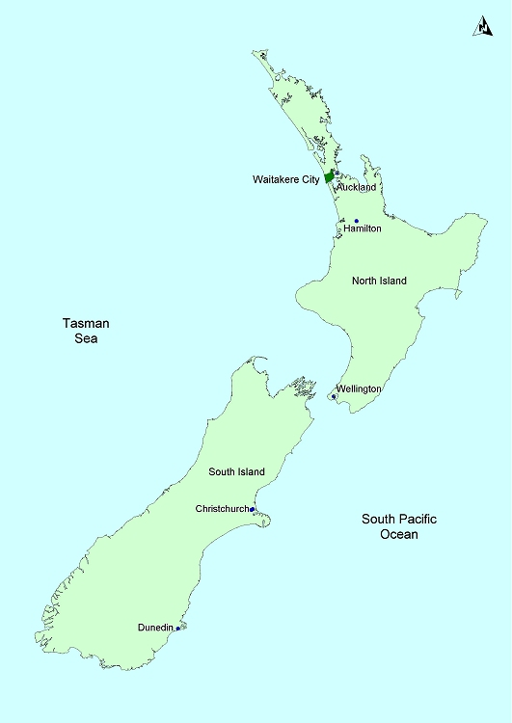

APPENDIX B

Map of Waitakere City highlighting Project Twin Streams catchment

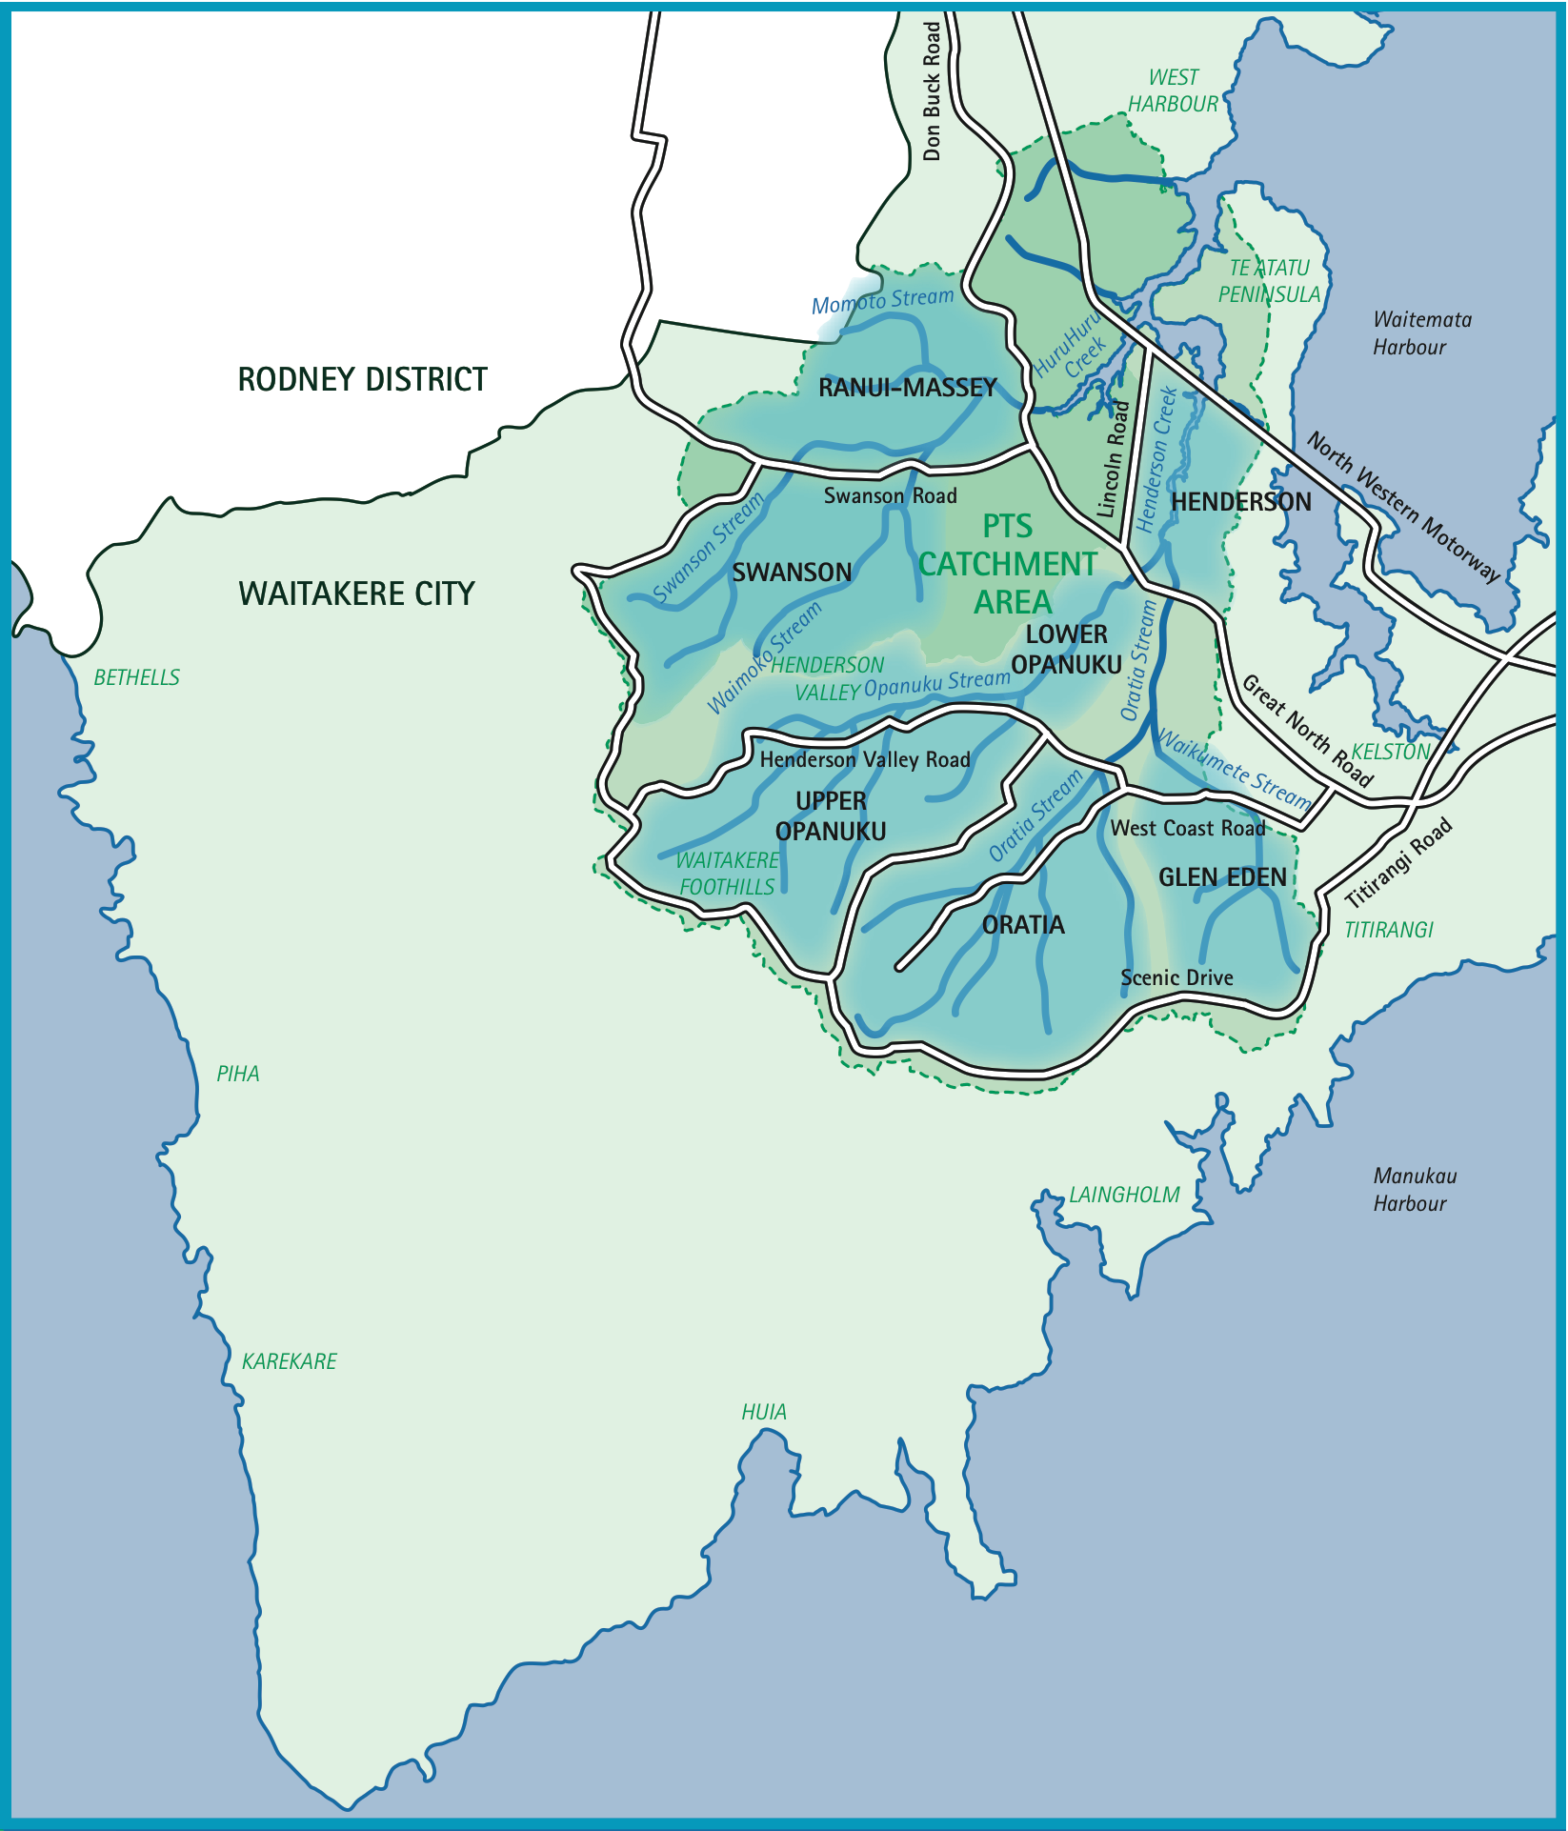

APPENDIX C

List of interviewees
Anil Karan – Project Co-ordinator Environment, Ecowater – Waitakere City Council
Bruce Fraser – Property owner
Donna Skipps – Intranet Content Administrator – Waitakere City Council
Elizabeth Morrison – Environmental Advisor – Project Twin Streams
Helen Haslam – Independent consultant
James Puketapu – The Property Group
Kevin Fan – Drainage Network Modeller Ecowater – Waitakere City Council
Kylie Barrie – Property owner
Marion Gibbons – Property owner
Mike Belcher – Landscape Architect, Project Twin Streams – Waitakere City Council
Mike Bristow – Valuer – Darroch Valuations
Mike Simpson – Contractor, Park Assets – Waitakere City Council
Peter Reid – Independent consultant
Richard Thomas – Managing Director – TCC Ltd
Teremona Jones – Co-ordinator – Project Twin Streams, Glen Eden
Tony Miguel – Acting Director – City Services

APPENDIX D

Invitation to drop-in day
<<Date>>

Project Twin Streams
Invitation to an important drop-in workshop

Dear <<Name>>

Over recent years there has been flooding in Serwayne Place, Seymour and Millbrook Roads. Your house and property at <<address>> is in the flooding area.

The flooding is inconvenient, frustrating and worrying for many residents. Council has agreed to start solving the problem.

We invite you to a drop-in workshop to start working with you on resolving flood issues on your property and restoring the stream.

The drop-in workshop will be held on:

<<Date>> – <<Time>>
At <<Venue>>
<<Address>>

Please drop in at any time during the day.
Childcare will be available at the hall.
Transport can be arranged.

At the drop-in day, the reasons for flooding will be explained. We will explain some ways of dealing with it and answer your questions. This meeting will be followed up by a visit to your property on the day, or at a convenient time to you, to speak to each property owner/family/resident on a one-to-one basis.
Flooding over such a big area is not an easy issue to deal with. Council wants to take time to get it right and work with you to find a workable solution. There will be further chances to discuss the best way to deal with the problem on your own property and for the community as a whole.

Please come to the drop-in workshop.

If you want more information please phone Christine Henley at (09) 835 0290.

Yours sincerely

<<Name>>
<<Position>>

Please RSVP by posting this slip in the reply paid envelope enclosed:

To: <<Name>>
<<Position>>
<<Organisation>>
<<Address 1>>
<<Address 2>>
<<CITY>>

Name: …………………………………………………………………………………………………
Address: …………………………………………………………………………………………………
…………………………………………………………………………………………………
Telephone: ………………………………………………
Email: ………………………………………………

Are you the landowner? Yes No

Please let us know if you need transport, childcare or any other special needs

Transport needs (please state): ……………………………………………………………….………………
Childcare needs (please state): ……………………………………………………………….………………
Do you need a language interpreter? If so, which language? ………………………………………………………………………………
Special needs (please state): …………………………………………………………………………………

APPENDIX E

Homeowners letter 1
Dear <<Name>>
You may be aware that Council has been exploring an extensive stormwater management programme – to be known as Project Twin Streams. This is a city-wide programme which includes extensive restoration of waterways and riparian margins.
During this exploration, you may have seen – or even spoken to – Council engineers working in the street (and possibly your property). As a result, you may have become aware that as part of this programme, the Council was considering certain properties that lie within the riparian margins.
It has taken longer than we had predicted to complete this evaluation because we have wanted to be thorough, but I can now confirm that your property does lie within the riparian margin and accordingly we wish to discuss the purchase of your property, with you.
We would like to make an appointment to come to your house to discuss this proposition with you, on one of the following days: <<Date Range>>. One of my team will soon ring you to make a time for us to visit. If you wish to contact us to make a time, please feel free to ring <<phone number>>.
I apologise for this somewhat impersonal method of contacting you but we have to speak to a number of people on this issue, and they are all entitled to hear about the proposal at the same time. The last thing we want is for an affected family to hear from a neighbour or the press. The only way to reach you all at once is by letter – however, as you see, our intention is to meet to discuss detail with you, in the privacy of your own home.
We will send two people who, between them, will be able to cover all aspects of the proposed purchase. They will also bring explanatory documentation to leave with you. We understand that you may want to seek your own legal advice and if you wish to have your own lawyer present at the meeting, that is of course your privilege. However, my team will visit only for the purposes of discussing the situation with you. The aim is not to commit you to anything at that time.
Yours faithfully

<<Name>>
<<Position>>

APPENDIX F

Homeowners letter 2

Dear <<Name>>
You may be aware that Council has been exploring an extensive stormwater management programme – to be known at Project Twin Streams. This is a city-wide programme which includes extensive restoration of waterways and riparian margins.
During this exploration, you may have seen – or even spoken to – Council engineers working in the street (and possibly your property). As a result, you may have become aware that as part of this programme, the Council was considering certain properties that lie within the riparian margins.
Obviously this will have raised uncertainty in some minds and we feel it is important to advise that your property does not lie within the riparian margin and accordingly the Council does not want to purchase it.
Nevertheless some properties may be purchased and this, together with the riparian margin restoration work, may change your neighbourhood. This will certainly be true for those families living close to the restoration works – and it may be of interest to people living a little further away.
Therefore you are invited to a “Drop in Day” at the <<Venue>>, <<Address>> on <<Date>>, to explain what Project Twin Streams is about – and what effect it will have on your neighbourhood.
Besides displays to explain the project, we will have staff on hand to answer your queries.
Yours faithfully

<<Name>>
<<Position>>

APPENDIX G

Legal rights information sheets

PROJECT TWIN STREAMS
Your property is in an area where work may be required to improve flows and quality of stormwater. This could mean that Council may want to discuss the purchase of your property with you. If so, it is important that you are aware that you have rights which the Council will respect.
The following questions about your rights as a property owner may help:
What if my property is required for stormwater work?
Council staff will explain why the property is needed for the project, they will answer your questions and give you time the think about it and discuss it with others. You may want to talk things over with friends or Citizens Advice (their leaflet is attached): You may also want to seek the advice of a lawyer. Citizens Advice workers can suggest some independent lawyers if you need one.
Can I refuse to sell?
An Act of Parliament called the Public Works Act 1981 provides councils with the power to buy private properties for public works such as improving stormwater quality and flow. The Act also requires councils to pay a fair price and reasonable costs.
Who decides what a fair price is?
Council staff will talk to you about this. You and Council may have differing ideas about the value of your property. If so, you may engage a registered valuer and explain that you need an independent valuation under the Public Works Act. Council may also engage its own valuer. The valuation reports will recommend a reasonable price.
What are the ‘reasonable costs’ related to this?
Council will pay reasonable valuation, legal and other professional costs related to the negotiations for your property. Other costs include reasonable moving and possibly transfer of mortgage costs. Before engaging any professional advice, make sure you talk to Council first about the criteria for approval of costs to be paid by Council.
How about lawyers?
The Citizens Advice workers can suggest names of independent lawyers. Or you may wish to talk with your own lawyer. But remember, before speaking to a lawyer it is important to talk first with council about what costs they will cover.
How long do I have to make up my mind?
You have several months to think about this. When you are ready, you can contact Council to discuss next steps. If we have not heard from you, we will contact you. In the meantime, please contact Council if you have any further questions.

PROJECT TWIN STREAMS
Public works often cannot be carried out without affecting private landowners and their interests in land. A basic principle of our system of government is that no person shall be deprived of land without receiving fair compensation.
The Public Works Act 1981 (“the Act”) provides the power to acquire land for public works and pay compensation. The Act provides an acquiring authority, such as the Waitakere City Council (“the Council”), the power to acquire your land for public work.
Landowners may negotiate with the Council as they would any other prospective purchaser or land. An agreement may contain any terms that you and the Council agree and the amount of compensation to be paid under the Public Works Act.
The Act provides primarily for a process of negotiation that leads to an agreement that is acceptable to the landowner and to the Council. You should seek independent legal and professional advice as part of your negotiation.
The acquiring authority is obliged to meet you reasonable costs associated in reaching an agreement. If the amount of compensation to be paid cannot be agreed with the Council, but otherwise you agree to your land being acquired, the agreement can be subject to the compensation to be paid, being determined by the Land Valuation Tribunal. The costs associated with this determination will be awarded separately.
Quite simply, as an affected property owner under the Act, you are entitled to:
- Fair compensation for your land

Reimbursement of reasonable valuation, legal and other professional costs you have incurred related to the negotiation of your compensation for your land being acquired.

- The valuer you engage must be registered and must have been instructed that the valuation is required for compensation purposes under the Public Works Act 1981. The valuation report must be made available to the Council, if requested. The Council will comply with the same protocol.

- If you intend to commission professional advice before incurring costs, you should discuss this and the criteria for approval with the Council so that there is no misunderstanding about what you are entitled to and whether the Council will pay.

- Reimbursement of reasonable removal costs to another property within 80km radius of your affected property. You should also discuss this and the criteria for approval with Council so that there is no misunderstanding about what you are entitled to and what the Council will pay.

- Compensation for loss on the mortgage repayment. Where a loss occurs in having to transfer a mortgage as a direct result of land being acquired, you as the borrower are entitled to compensation for the loss where you have to take a mortgage at a higher rate, which will be more expensive than the existing mortgage on your land. Similarly, you are entitled to compensation for early repayment of a fixed rate mortgage.

- Be paid a solatium (or home-loss payment) of $2000 provided that the land to be acquired contains the home in which you live.

Should you have any queries regarding your entitlement, you should consult with your legal adviser or contact <<Name>>

APPENDIX H

Aerial images of property purchases
HENDERSON VALLEY ROAD
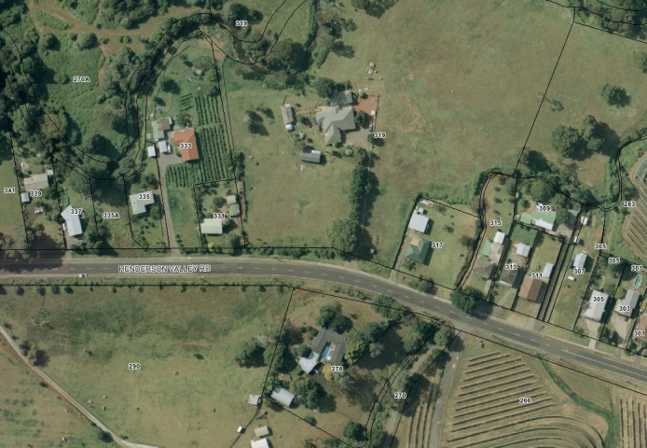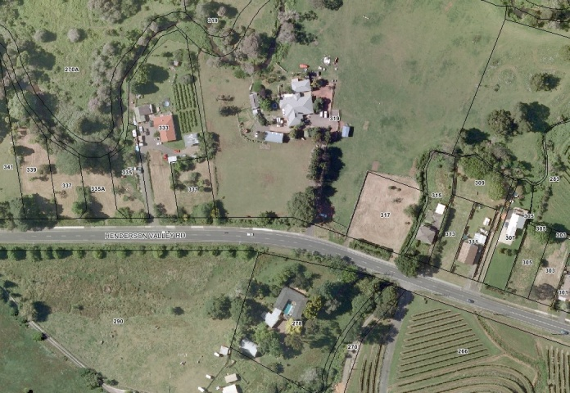
2000 2008
SAVOY ROAD
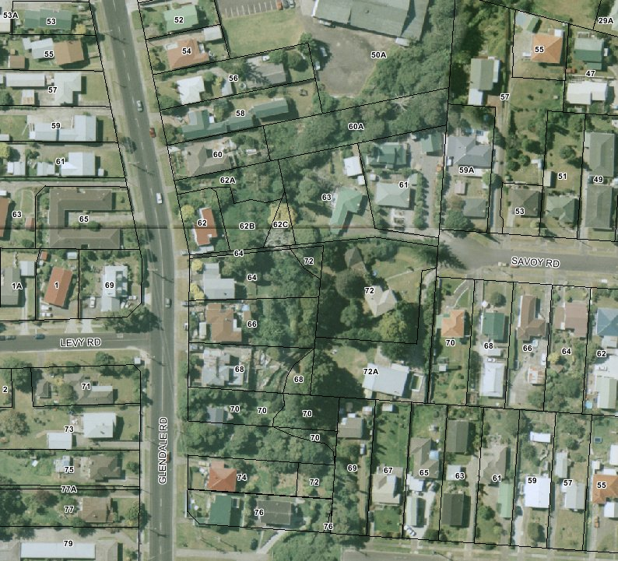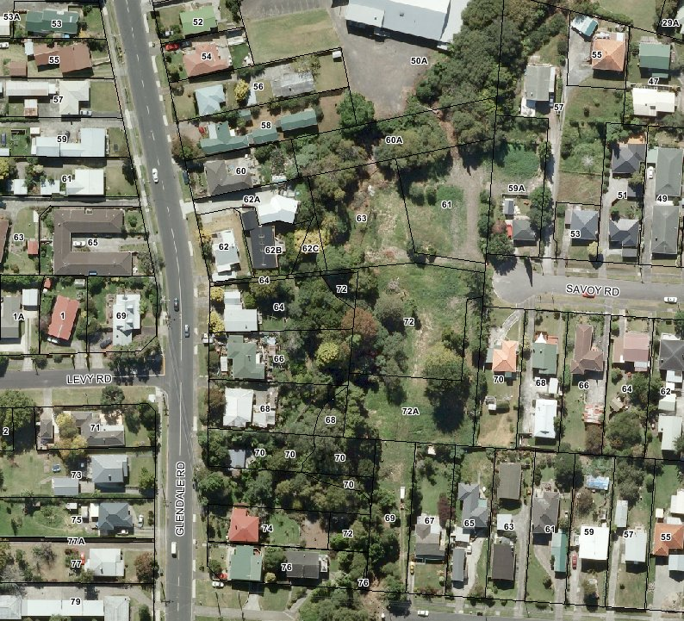
2000 2008
SERWAYNE PLACE
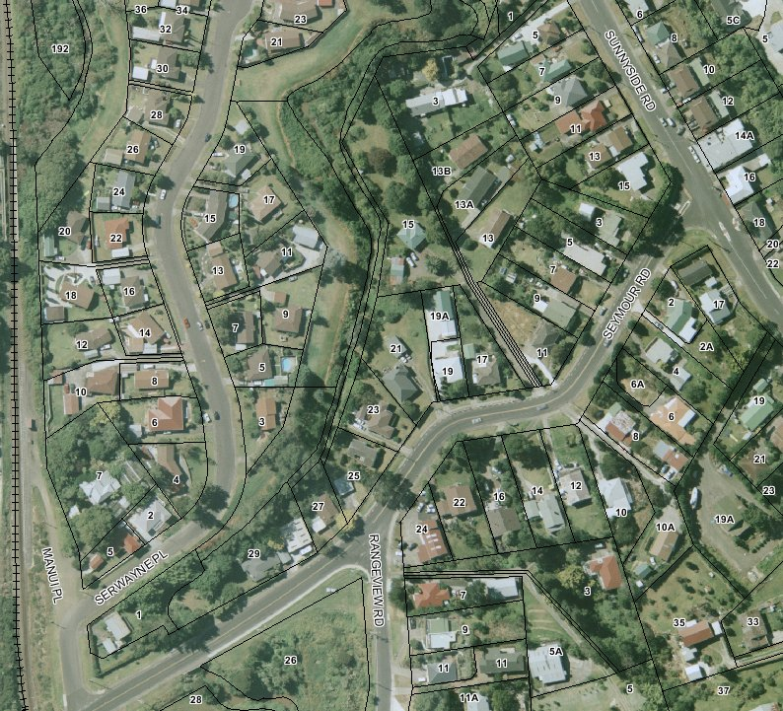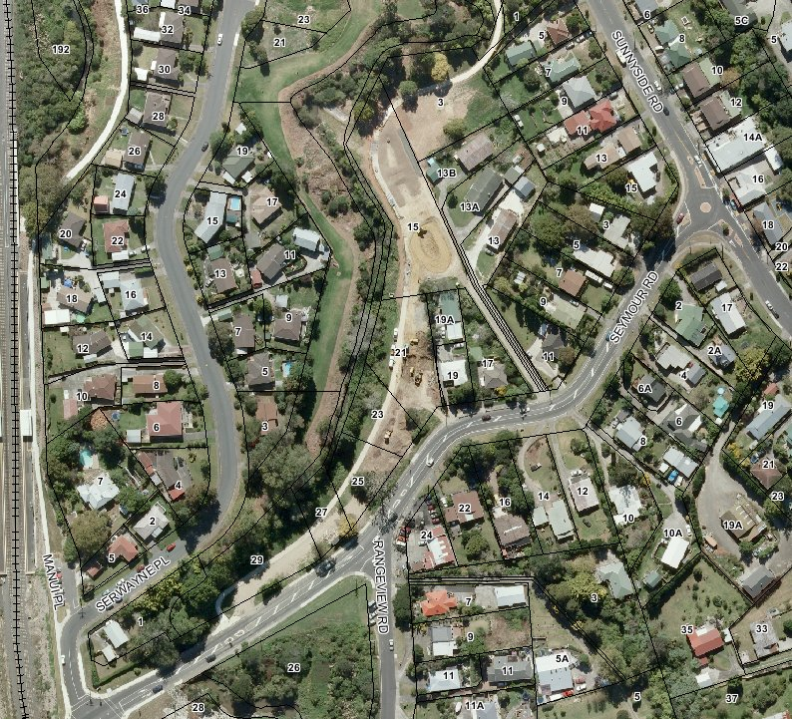
2000 2008

