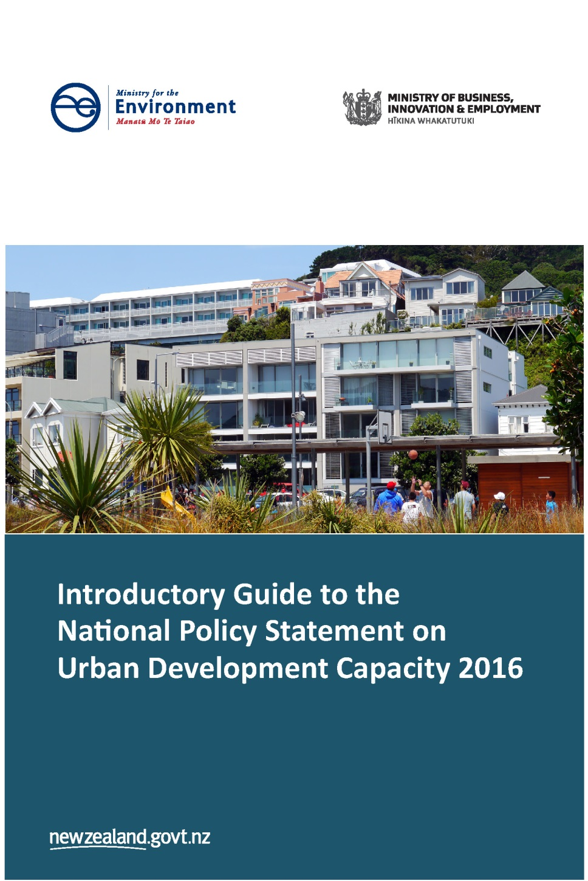

This document may be cited as: Ministry for the Environment and Ministry of Business, Innovation and Employment. 2016. Introductory Guide to the National Policy Statement on Urban Development Capacity 2016. Wellington: Ministry for the Environment and Ministry of Business, Innovation and Employment.

Published in November 2016 by the
Ministry for the Environment and the Ministry of Business, Innovation and Employment
Manatū Mō Te Taiao and Hikina Whakatutuki
PO Box 10362, Wellington 6143, New Zealand
ISBN: 978-0-908339-71-6
Publication number: ME 1274
© Crown copyright New Zealand 2016
This document is available on the Ministry for the Environment website: www.mfe.govt.nz.


Contents
1 Introduction 5
Purpose and focus of this guide 5
Role of a national policy statement 5
National Policy Statement on Urban Development Capacity 5
Overview of the requirements 6
Which policies apply to my local authority and when? 6
2 Requirements of all local authorities 10
Objectives 10
Definitions 10
Outcomes for planning decisions 14
3 Requirements of medium- and high-growth urban areas 18
Policies PB1–PB7: Evidence and monitoring to support planning decisions 18
Policies PC1–PC4: Responsive planning 21
Policies PD1–PD2: Coordinated evidence and decision-making 24
Policies that medium-growth local authorities are encouraged to also give effect to 25
4 Requirements of high-growth urban areas 26
Policies PC5–PC14: Responsive planning 26
Policies PD3–PD4: Coordinated evidence and decision-making 28
5 NPS-UDC implementation programme 30
References 32

Tables
Table 1: Which objectives and policies apply to which councils and when 9

Figures
Figure 1: Feasible development capacity as a proportion of plan-enabled capacity 15
Figure 2: Take-up of development capacity 22
Figure 3: Timeframes for implementation of the NPS-UDC 31

1 Introduction

Purpose and focus of this guide
This is the first in a series of guides to support local authorities in implementing the National Policy Statement on Urban Development Capacity (NPS-UDC). It provides a general overview of what the NPS-UDC requires and of selected terms and concepts. More detailed guidance will be developed with local authorities and other stakeholders throughout 2017 on how to best implement specific policies in the NPS-UDC.
The main purpose of this introductory guide is to help decision-makers under the Resource Management Act 1991 (RMA) to understand the objectives and policies in the NPS-UDC so they can respond to these as intended. The guide provides a point of reference for council officers, elected members, planners, lawyers and the development community. It draws on the intended outcomes behind the NPS-UDC; however, it is not part of the NPS-UDC and does not have statutory weight.
The guide is organised into sections that correspond to where the NPS-UDC policies apply:
- all councils
- medium-growth urban areas
- high-growth urban areas.
The final section outlines the Government’s intentions to work with local authorities on implementation of the NPS-UDC.
This guide should be read with the NPS-UDC and other documents available on the Ministry for the Environment website.
The intention is to update this guide following feedback on its clarity and usefulness.

Role of a national policy statement
A national policy statement provides direction to local authorities and other decision-makers under the RMA on matters of national significance relevant to achieving the purpose of the RMA. A national policy statement sets objectives from a national perspective and identifies policies to achieve those objectives. These objectives and policies must then be recognised and responded to by decision-makers, such as local authorities, in their policy statements and plans prepared under the RMA. A national policy statement cannot direct decisions made under other legislation.

National Policy Statement on Urban Development Capacity
In many of New Zealand’s growing urban areas, the supply of housing has not kept up with demand. This has contributed to high and rapidly increasing home prices as well as housing affordability challenges and overcrowding. Rapidly increasing house prices have national as well as local consequences. They drive inequality, put pressure on Government expenditure on housing assistance and inflate interest rates and exchange rates. Local authority planning should provide enough opportunities for development to meet the housing and business needs of people and communities – both current and future. To address this, the NPS-UDC directs decision-makers under the RMA to:
- put greater emphasis on enabling change and development when making decisions about urban development
- provide sufficient urban development capacity to support housing and business growth
- ensure that planning processes facilitate urban development.
The NPS-UDC is part of a comprehensive, longer term programme of national direction under the RMA. The Government’s Forward Agenda provides an updated list of priorities for national direction and is available on the Ministry for the Environment’s website. Government understands that local authorities will be required to implement a range of national direction tools simultaneously, and, in recognising this, it intends to support local authorities to implement them.
The NPS-UDC is one of a number of initiatives designed to improve housing supply and affordability, including extending and amending the Housing Accords and Special Housing Areas Act 2013; amendments to the Building Act 2004 and the Construction Contracts Act 2002; as well as development of the future housing infrastructure fund and urban development legislation.

Overview of the requirements
The NPS-UDC is made up of objectives and policies which are grouped as follows:
- outcomes for planning decisions
- evidence and monitoring to support planning decisions
- responsive planning
- coordinated planning evidence and decisions.
Policies in these four groups apply to different urban areas according to their size and population growth. The more challenging policies are targeted at local authorities experiencing higher levels of growth, and avoid imposing unnecessary costs on others. The following section explains how this targeted system works.

Which policies apply to my local authority and when?
The NPS-UDC targets different policies to particular local authorities based on whether or not they have all or part of a high- or medium-growth urban area within their district or region. These area are defined below.
A ‘high-growth urban area’ is any urban area (as defined by Statistics New Zealand in 2016) that:
has either:
- a resident population of over 30,000 people according to the most recent Statistics New Zealand urban area resident population estimates
or
- at any point in the year a combined resident population and visitor population of over 30,000 people, using Statistics New Zealand urban area resident population estimates
and
- in which the resident population of that urban area is projected to grow by more than 10% between 2013 to 2023, according to the most recent Statistics New Zealand medium urban area population projections.
A ‘medium-growth urban area’ is any urban area (as defined by Statistics New Zealand in 2016) that:
- has a resident population of over 30,000 people according to Statistics New Zealand urban area resident population estimates
and
- in which the resident population of that urban area is projected to grow by between 5% and 10% between 2013 to 2023, according to the most recent Statistics New Zealand medium urban area population projections.
These definitions are transitional definitions and will be reviewed no later than 31 December 2018.
As well as targeting particular policies to particular local authorities, these definitions also indicate when neighbouring local authorities should work together. This is because the definitions use Statistics New Zealand’s urban area classification, which are areas of contiguous settlement that approximate urban labour and housing markets, and often cross local authority boundaries.
To be clear, however, the NPS-UDC policies should not just be applied to the area within the geographic boundaries of Statistics New Zealand’s urban areas. Local authorities can build on joint analysis and strategic planning (which many local authorities are already undertaking) that may cross local authority boundaries. Existing examples include the Greater Christchurch Urban Development Strategy, Heretaunga Plains Urban Development Strategy, SmartGrowth, Future Proof, and Upper North Island Strategic Alliance.

Statistics New Zealand review and revisions
The high- and medium-growth urban area definitions are based on urban areas as defined by Statistics New Zealand in 2016. Statistics New Zealand is currently reviewing its urban–rural classification and boundaries, and decisions on new urban areas are expected by the end of 2017, with maps published early in 2018. This urban–rural classification review will not affect the NPS-UDC until the end of 2018, when government will also review the NPS-UDC high- and medium-growth urban area definitions.
The high- and medium-growth urban area definitions in the NPS-UDC also use the most recent Statistics New Zealand population projections for the 2013 (base) to 2023 period. Statistics New Zealand will be revising its urban area population projections by September 2017. It is likely that some urban areas will be newly defined as high- or medium-growth with these revisions. Government will notify the local authorities likely to be affected by this revision about this possibility in early 2017, and will invite them to participate in preparatory work to meet the relevant NPS-UDC policy requirements. Local authorities newly defined as high or medium growth will also have later timeframes to meet these requirements.
Table 1 sets out the current high- and medium-growth urban areas and corresponding local authorities, the policies that apply to them and the timeframes for completing policy requirements.

Table 1: Which objectives and policies apply to which councils and when
Area | Councils | Objectives and policies | Timeframes
All councils
All | All councils | All objectives  PA1: Sufficient development capacity in the short, medium and long term  PA2: Other infrastructure required to support urban development  PA3: Provide choice; promote efficient use of land and infrastructure; limit adverse effects on competition  PA4: Take into account the benefits and costs of urban development at a national, interregional, regional, district and local scale | Immediate and ongoing  Immediate and ongoing  Immediate and ongoing  Immediate and ongoing  Immediate and ongoing
Medium-growth urban areas (subject to change as population projections are revised)
New Plymouth | New Plymouth District, Taranaki Region | As above plus:  PC1–2: Provide an additional margin of feasible development capacity  PC3: Respond when development capacity is insufficient  PC4: Use all practicable options to provide development capacity  PD1–2: Work with other local authorities and infrastructure providers on housing and business assessment and to agree development capacity  PB6: Monitor market indicators  PB7: Use price efficiency indicators  PB1–5: Produce a housing and business development capacity assessment | Immediate and ongoing  Immediate and ongoing  Immediate and ongoing  Immediate and ongoing  1 June 2017  31 December 2017  31 December 2018
Nelson | Nelson City, Tasman District
Kapiti | Kapiti Coast District, Greater Wellington Region
Palmerston North | Palmerston North City, Horizons Region
Wellington | Wellington City, Porirua City, Lower Hutt City, Upper Hutt City, Greater Wellington Region
High-growth urban areas (subject to change as population projections are revised)
Auckland | Auckland Council | As above, plus:  PD3–4: Work with neighbouring local authorities and infrastructure providers to agree minimum targets and future development strategy  PB1–5: Produce a housing and business development capacity assessment  PC5–11: Set minimum targets in plans  PC12 – PC14: Future development strategy | Immediate and ongoing  31 December 2017  31 December 2018  31 December 2018
Tauranga | Tauranga City, Western Bay of Plenty District, Bay of Plenty Region
Hamilton | Hamilton City, Waipa District, Waikato District, Waikato Region
Queenstown | Queenstown Lakes District, Otago Region
Christchurch | Christchurch City, Waimakariri District, Selwyn District, Environment Canterbury Region

2 Requirements of all local authorities

Objectives
The objectives outline the high-level outcomes that the NPS-UDC policies aim to achieve. The objectives also relate directly to the national significance statement and to achieving the purpose of the Resource Management Act 1991 (RMA), particularly through enabling people and communities to provide for their social, economic, cultural and environmental wellbeing. For example, objective:
- OA1 explicitly recognises the need for urban environments that provide for social, economic, cultural and environmental wellbeing
- OA2 recognises that sufficient opportunities for development for both housing and business are needed to provide for all aspects of people’s and communities’ wellbeing
- OA3 recognises that people’s and communities’ needs will change over time, and that urban environments need to change with them.

Definitions
The following explains key definitions of words used in objectives and policies throughout the NPS-UDC. The definitions apply to words used in the policies that apply to all local authorities and that only apply to medium- and high-growth urban areas.

Decision-maker
means any person exercising functions and powers under the Act [RMA].
The objectives in the NPS-UDC and policies PA3 and PA4 apply to decision-makers when they are making planning decisions that affect an urban environment. In this context, decision-makers would include elected officials and consenting officers, as well as other decision-makers such as independent hearings panels and the Environment Court.

Demand
means:
In relation to housing, the demand for dwellings in an urban environment in the short, medium and long-term, including:
- the total number of dwellings required to meet projected household growth and projected visitor accommodation growth;
- demand for different types of dwellings;
- the demand for different locations within the urban environment; and
- the demand for different price points
recognising that people will trade off (b), (c) and (d) to meet their own needs and preferences.
In relation to business land, the demand for floor area and lot size in an urban environment in the short, medium and long-term, including:
- the quantum of floor area to meet forecast growth of different business activities;
- the demands of both land extensive and intensive activities; and
- the demands of different types of business activities for different locations within the urban environment.
The definition of ‘demand’ is core to the definition of sufficient development capacity, and in the policies requiring demand to be assessed as part of the evidence and monitoring to support planning decisions (PB1 and PB2).
An important feature of the definition of ‘demand’ is that it emphasises both the total quantity of demand in a local area and the subsets of that demand (by location, type and price point). It refers to the demands of different groups in a local community and to different business activities in a local economy. For example, there may be demand for townhouses and apartments as well as stand-alone houses of different sizes.
The definition of demand includes the demands of future generations and economic activities. This definition should be read along with the definitions of ‘short term’, ‘medium term’ and ‘long term’.
The demand for visitor accommodation may be included in the demand for housing and/or business land, recognising that this includes demand for holiday homes and hotels.
There is a dynamic relationship between demand, supply and price. Changes in one will result in changes in the others.

Development capacity
means in relation to housing and business land, the capacity of land intended for urban development based on:
- the zoning, objectives, policies, rules and overlays that apply to the land, in the relevant proposed and operative regional policy statements, regional plans and district plans; and
- the provision of adequate development infrastructure to support the development of the land.
The definition of development capacity includes opportunities to intensify development in existing urban environments as well as greenfield development.
The definition refers to the capacity for development allowed in plans where this is, or will be, also supported by local authority-controlled infrastructure. The intended effect of this is to direct land use planning under the RMA to be coordinated with infrastructure planning under other legislation.
This definition should be read with the definitions of ‘development infrastructure’, ‘other infrastructure’, ‘feasible’, ‘sufficient’, and policies that require local authorities to provide sufficient development capacity (PA1, PC1, PC3), which are at the core of the NPS-UDC.
These definitions and policies are ‘additive’. Sufficient development capacity is that which is enabled in resource management plans, supported with development infrastructure, and meets projected demand. Local authorities must also provide sufficient development capacity that is ‘commercially feasible’ to develop, and to satisfy themselves about the availability of other infrastructure that they do not control. Finally, ‘high growth’ local authorities must also provide a margin of feasible development capacity over and above projected demand.

Development infrastructure
means network infrastructure for water supply, wastewater, stormwater and land transport as defined in the Land Transport Management Act 2003 to the extent that it is controlled by local authorities.
The definition of ‘development infrastructure’ is included in the definition of ‘development capacity’ and in policies that require local authorities to provide sufficient development capacity.
The definition of ‘development infrastructure’ is used in policies requiring local authorities to:
- have regard to promoting the efficient use of urban land and infrastructure (PA3b)
- produce a housing and business development capacity assessment that assesses the actual and likely availability of infrastructure (PB3b)
- seek and use the input of infrastructure providers in this assessment (PB5)
- work with providers of other infrastructure to prepare a future development strategy (PD3b).
Development infrastructure means infrastructure that is usually, but not necessarily, funded and/or provided by the local authority or a council-controlled organisation. It includes locally controlled transport infrastructure that is part funded by the New Zealand Transport Agency. Development infrastructure can also include network infrastructure for water, wastewater and stormwater installed by a developer by agreement with the relevant local authority.
The definition of ‘development infrastructure’ is intentionally different from the definitions of ‘infrastructure’ in the RMA and the Local Government Act 2002 (LGA). The narrow definition of infrastructure to that which local authorities control is used to ensure that local authorities can comply.

Other infrastructure
means:
- open space;
- community infrastructure as defined in the Local Government Act 2002;
- land transport as defined in the Land Transport Management Act 2003, that is not controlled by local authorities;
- social infrastructure such as schools and healthcare;
- telecommunications as defined in the Telecommunications Act 2001;
- energy; and
- other infrastructure not controlled by local authorities.
Infrastructure other than ‘development infrastructure’ also supports development capacity. Recognising this, the NPS-UDC includes a definition of ‘other infrastructure’, which is a non-exclusive list that includes parks, reserves and community facilities that local authorities might control. It also includes other infrastructure that they do not control (for example, transport infrastructure that might be installed by a developer by agreement with the relevant local authority, and infrastructure controlled by the New Zealand Transport Agency, Ministry of Education and other infrastructure providers). The definition is used in policies that require local authorities to:
- satisfy themselves that other infrastructure required to support urban development is likely to be available (PA2)
- have regard to promoting the efficient use of urban land and infrastructure (PA3b)
- produce a housing and business development capacity assessment that assesses the actual and likely availability of infrastructure (PB3b)
- seek and use the input of infrastructure providers in this assessment (PB5)
- work with providers of other infrastructure to prepare a future development strategy (PD3b).

Policies
This section provides guidance on particular policies that apply to all local authorities.

Outcomes for planning decisions

Policies PA1 and PA2 (Development capacity, infrastructure and feasibility)
PA1: Local authorities shall ensure that at any one time there is sufficient housing and business land development capacity according to the table below:
Short term | Development capacity must be feasible, zoned and serviced with development infrastructure.
Medium term | Development capacity must be feasible, zoned and either:  Serviced with development infrastructure, or  The funding for the development infrastructure required to service that development capacity must be identified in a Long Term Plan required under the Local Government Act 2002.
Long term | Development capacity must be feasible, identified in relevant plans and strategies, and the development infrastructure required to service it must be identified in the relevant Infrastructure Strategy required under the Local Government Act 2002.
PA2: Local authorities shall satisfy themselves that other infrastructure required to support urban development are likely to be available.
PA1 is the central policy of the NPS-UDC, stating that local authorities must ensure there is sufficient, feasible development capacity at any one time.
This policy does not direct local authorities as to how or where this development capacity should be provided. It does, however, set out the expectations for the provision of development capacity in the short, medium and long term (periods of three years, 10 years and 30 years). The expectations for these periods vary to accommodate decreasing certainty over time and the long lead times required to provide network infrastructure.

Provision of ‘development infrastructure’
Local authorities must ensure that development capacity specified in resource management plans as available in the short term is supported with development infrastructure that is actually in place. Over the medium term, development capacity must have development infrastructure either in place or identified in a 10-year long-term plan under the LGA. In the long term, development capacity can be ‘future zoned’ and supported by infrastructure that is identified in a 30-year infrastructure plan under the LGA.
Some of this development infrastructure might be installed or financed privately by agreement with the local authority. The possibility of some private provision of development infrastructure can also be incorporated in the 30-year infrastructure strategy, which is included in local authority long-term plans under the LGA.

Provision of ‘other infrastructure’
Policy PA2 recognises that urban environments need to be serviced by more than just development infrastructure. The policy requires local authorities to “satisfy themselves” that other infrastructure is likely to be available. This does not make local authorities accountable for the provision of infrastructure outside their control; rather it requires local authorities to be informed about the likely availability of such infrastructure when they make resource management decisions about where to provide development capacity. To do this, local authorities should consult with providers of other infrastructure and make sure that there are no significant barriers that would mean necessary other infrastructure will almost certainly not be available.

Feasible development capacity
Policy PA1 directs local authorities to provide development capacity that is feasible in the short, medium and long term. Development capacity is feasible if it is commercially viable to be developed. This can be calculated by considering the current likely costs, revenue and yield from any development. Figure 1 shows the relationship between development capacity enabled in a plan, development infrastructure that is in place, and development that might be considered commercially feasible to develop.
Figure 1: Feasible development capacity as a proportion of plan-enabled capacity
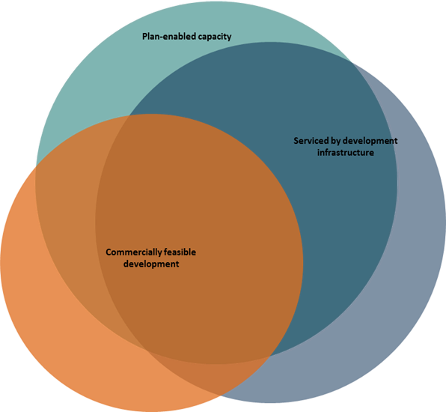

These three things overlap but they are not the same. Plans and demand are never perfectly aligned:
- Some plan-enabled development capacity may not yet be supported by infrastructure that is in place. However, this infrastructure should be identified in a council’s long-term plan and be in place within a 10-year period.
- On the other hand, in some parts of an urban area the infrastructure that is in place may have spare capacity that could support more development (ie, greater densities or heights) than the plan allows.
- It is unlikely that all the development capacity provided by a plan would be considered commercially feasible at a particular point in time. For example, some capacity might be in locations where demand is lower, or for apartments at a height for which there is not currently a market.
- Conversely, some commercially viable development will fall outside of what the plan allows, where it is judged as not being in the public interest.
How feasibility is calculated for housing or business land will be different, and how feasibility is calculated in different areas may be different depending on the local situation.
Information about how to assess the feasibility of development will come as part of further guidance on the housing and business assessment, during the first half of 2017.

Policy PA3c (Competitive operation of land and development markets)
PA3: When making planning decisions that affect the way and the rate at which development capacity is provided, decision-makers shall provide for the social, economic, cultural and environmental wellbeing of people and communities and future generations, whilst having particular regard to:
c) Limiting as much as possible adverse impacts on the competitive operation of land and development markets.
Enabling land and development markets to be more competitive is important because this should put downward pressure on prices and costs. A more competitive environment should also produce higher quality and greater choices in products and services, and encourage innovation and change. Competition is part of a well-functioning market that can help ensure the full range of needs in a community can be met.
Various factors affect the competitiveness of land and development markets, including for example how many landowners there are. However, planning and public infrastructure provision can have a significant impact. For example, regulations may overly constrain development opportunities and therefore the number of developers that can take them up.
Local authorities could give effect to policy PA3c by:
- using non-regulatory approaches to achieving some outcomes, so that the cumulative effect of regulations leaves plenty of scope for development in a range of locations
- minimising uncertainty about the impact of regulations on development opportunities, by keeping regulations simple and unambiguous and undertaking plan changes quickly
- ensuring consenting processes are clear, coordinated and speedy, to keep the additional costs of doing development to a minimum.
Policy PB7 requires high- and medium-growth local authorities to monitor indicators of price efficiency (see page 21). These indicators will provide information about how competitive the local land and development markets are, and how planning might be affecting this.
Further guidance will be provided in 2017about how to give effect to policy PA3C as part of work on more enabling and responsive plans that provide sufficient development capacity.

Policy PA4b (National costs and benefits of urban development)
PA1: When considering the effects of urban development, decision-makers shall take into account:
b) The benefits and costs of urban development at a national, inter-regional, regional and district scale, as well as the local effects.
PA4b directs decision-makers to take into account national and interregional benefits and costs (as well as those at the regional, district and local level) when considering the effects of urban development. This policy reflects the impacts of local urban planning decisions on neighbouring areas, and on New Zealand as a whole.
Decision-makers could give effect to this policy via section 32 evaluation reports accompanying significant planning decisions. These reports should consider the national impacts of these decisions such as:
- the fiscal cost of increasing welfare expenditure for those who cannot afford increasingly high rents and house prices
- loss of productivity, as workers and business people migrate away from areas with high house prices and rents
- housing investment crowding out investment in other economic activities and pushing up interest rates and the exchange rate
- increased house price volatility and reduced macro-economic stability.
Decision-makers assessing the effects of smaller urban planning decisions should consider the cumulative national impact of such decisions.

3 Requirements of medium- and high-growth urban areas
Local authorities that have all or part of a medium- or high-growth urban area in their district or region must give effect to policies PB1–PB7, PC1–PC4 and PD1–PD2, in addition to the objectives and policies that apply to all local authorities.

Policies PB1–PB7: Evidence and monitoring to support planning decisions
The NPS-UDC requires high- and medium-growth local authorities to prepare comprehensive housing and business development capacity assessments every three years, and to monitor market indicators on a frequent basis.
This is to ensure that local authorities have a quality base of information on which to make decisions that affect development capacity and, ultimately, the supply and price of housing and business space.
The NPS-UDC specifies what should be included in the housing and business assessments, as well as some of the market indicators that must be monitored. However, it does not spell out how to do the assessments or monitoring.

Policies PB1–PB5 (Housing and business development capacity assessment)
Policies PB1 to PB7 apply to all local authorities that have part, or all, of either a medium-growth urban area or high-growth urban area within their district or region.
The application of these policies is not restricted to the boundaries of the urban area.
PB1: Local authorities shall, on at least a three-yearly basis, carry out a housing and business development capacity assessment that:
a) Estimates the demand for dwellings, including the demand for different types of dwellings, locations and price points, and the supply of development capacity to meet that demand, in the short, medium and long-terms; and
b) Estimates the demand for the different types and locations of business land and floor area for businesses, and the supply of development capacity to meet that demand, in the short, medium and long-terms; and
c) Assesses interactions between housing and business activities, and their impacts on each other.
Local authorities are encouraged to publish the assessment under policy PB1.
PB2: The assessment under policy PB1 shall use information about demand including:
a) Demographic change using, as a starting point, the most recent Statistics New Zealand population projections;
b) Future changes in the business activities of the local economy and the impacts that this might have on demand for housing and business land; and
c) Market indicators monitored under PB6 and PB7.
PB3: The assessment under policy PB1 shall estimate the sufficiency of development capacity provided by the relevant local authority plans and proposed and operative regional policy statements, and Long Term Plans and Infrastructure Strategies prepared under the Local Government Act 2002, including:
a) The cumulative effect of all zoning, objectives, policies, rules and overlays and existing designations in plans, and the effect this will have on opportunities for development being taken up;
b) The actual and likely availability of development infrastructure and other infrastructure in the short, medium and long term as set out under PA1;
c) The current feasibility of development capacity;
d) The rate of take up of development capacity, observed over the past 10 years and estimated for the future; and
e) The market’s response to planning decisions, obtained through monitoring under policies PB6 and PB7.
PB4: The assessment under policy PB1 shall estimate the additional development capacity needed if any of the factors in PB3 indicate that the supply of development capacity is not likely to meet demand in the short, medium or long term.
PB5: In carrying out the assessment under policy PB1, local authorities shall seek and use the input of iwi authorities, the property development sector, significant land owners, social housing providers, requiring authorities, and the providers of development infrastructure and other infrastructure.
Policies PB1–PB5 spell out what the housing and business development capacity assessments should cover and what data they should draw on.
These assessments will build on information that local authorities already gather both independently and in joint processes. This is summarised in a report prepared for the NPS-UDC, How Councils Estimate Demand and Supply of Development Capacity for Housing and Business (Ministry for the Environment and Ministry for Business, Innovation and Employment, 2016). This report identifies considerable variability in the work currently undertaken by local authorities. There are opportunities to share best practice, and also some consistent gaps across the board about aspects of the housing market and about business land.
PB1c requires that the housing and business development capacity assessment includes information about the interactions between housing and business activities, and their impacts on each other. This should inform planning decisions about:
- appropriate shares of land zoned for business relative to housing
- location of different types of business land relative to housing
- managing the negative effects that different activities might have on each other
- managing reverse sensitivity
- how to respond to and facilitate spatial change associated with economic development.
Government will establish a technical advisory group at the end of 2016 to oversee the development of guidance on components of the housing and business development assessment. This group will include local authority officers, Statistics New Zealand, and individuals with development expertise. The guidance will outline best practice approaches to assessing demand, commercial feasibility, and take-up of development capacity, and business land. This guidance will be released in modules during 2017.
High-growth urban areas are required to complete their housing and business development capacity assessment by the end of 2017, and medium-growth urban areas by the end of 2018.
Policy PD1 strongly encourages local authorities that share jurisdiction over an urban area to prepare a joint housing and business development capacity assessment. The geographic focus of the assessment need not be restricted to the boundaries of Statistics New Zealand’s urban area.

Policies PB6–PB7 (Monitoring market indicators)
PB6: To ensure that local authorities are well-informed about demand for housing and business development capacity, urban development activity and outcomes, local authorities shall monitor a range of indicators on a quarterly basis including:
a) Prices and rents for housing, residential land and business land by location and type; and changes in these prices and rents over time;
b) The number of resource consents and building consents granted for urban development relative to the growth in population; and
c) Indicators of housing affordability.
PB7: Local authorities shall use information provided by indicators of price efficiency in their land and development market, such as price differentials between zones, to understand how well the market is functioning and how planning may affect this, and when additional development capacity might be needed.
The Productivity Commission report Using Land for Housing notes that “the planning system is not responsive to price signals that provide information about the location and type of housing that people demand, and about the available supply” (Productivity Commission, 2015, p 324).
To address this, PB6 directs high- and medium-growth local authorities to monitor prices and rents, consents relative to population growth, and indicators of housing affordability. These indicators should provide information about:
- relative demand for different types of homes and business spaces in different locations, and the commercial feasibility of development
- supply–demand imbalances
- the social and economic consequences of increasing prices and rents.
Local authorities are required to monitor these indicators quarterly, starting within six months of the NPS-UDC being made operative. This should ensure that local authorities can respond quickly to up-to-date information, even when the market is changing rapidly.
PB7 directs the same local authorities to use information provided by indicators of ‘price efficiency’ to understand:
- how well the market is functioning
- how planning may affect this
- when additional development capacity might be needed.
Local authorities are required to begin using this information by the end of 2017.
Price efficiency and competitiveness indicators will be specified in guidance and are likely to include:
- discontinuities in values between rural and urban land, and between residential and business zones
- the ratio of marginal building costs to market price (eg, for one more floor on an apartment building)
- the Herfindahl-Hirschman Index (an index of competitiveness as measured by land owner market shares).
Government will establish a technical advisory group to oversee the development of price efficiency indicators and the preparation of guidance on implementing policies PB6 and PB7. Government will provide some of the data that local authorities will need to undertake the monitoring, including data on land, housing and business land prices and rents, and indicators of housing affordability.
In the meantime, further information about market indicators, data and methodologies can be found in Covec and MRCagney, Signals of Under-capacity: The Practicalities of Monitoring Prices Signals Under the National Policy Statement on Urban Development Capacity (Ministry for the Environment and Ministry of Business, Innovation and Employment, 2016).

Policies PC1–PC4: Responsive planning
The responsive planning policies require medium- and high-growth local authorities, when making and implementing planning decisions, to respond:
- to information (be evidence based)
- to what is happening in urban land and development markets
- as quickly as possible.
Responsive planning is necessary in order to provide sufficient development capacity and enable development at all times in high- and medium-growth urban areas.

Policies PC1 and PC2 (Additional margins of development capacity)
PC1: To factor in the proportion of feasible development capacity that may not be developed, in addition to the requirement to ensure sufficient, feasible development capacity as outlined in policy PA1, local authorities shall also provide an additional margin of feasible development capacity over and above projected demand of at least:
- 20% in the short and medium term; and
- 15% in the long term.
PC2: If evidence from the assessment under policy PB1, including information about the rate of take-up of development capacity, indicates a higher margin is more appropriate, this higher margin should be used.
Policies PA1 and PA2 require all councils to provide feasible development capacity in their plans in the short, medium and long term. Policies PC1 and PC2 build on this by requiring local authorities in high- and medium-growth urban areas to provide additional margins of feasible development capacity “over and above projected demand”.
This ‘over-supply’ of feasible development capacity is to allow for the likelihood that not all plan-enabled development capacity that is commercially feasible to develop will result in actual development. This is because, at any one time, a proportion of the owners of land that is commercially viable to develop will hold onto their land for various reasons. For example:
- land may be appreciating in value at a faster level than the expected return from development
- land may be subject to legal covenants that prevent certain types of development occurring
- land identified as feasible development capacity may be an owner–occupied family farm or suburban backyard, which owners have no intention of developing
- the practicalities and transaction costs of development may be too much to bother with.
Providing an additional margin of feasible development capacity over and above projected demand is necessary in order to recognise and account for this. Without these margins, plans will not allow enough scope for development to respond to growth in demand.
Figure 2 on page 23 illustrates the relationship between the feasible development capacity and the development that actually occurs (or take-up rate).
Figure 2: Take-up of development capacity
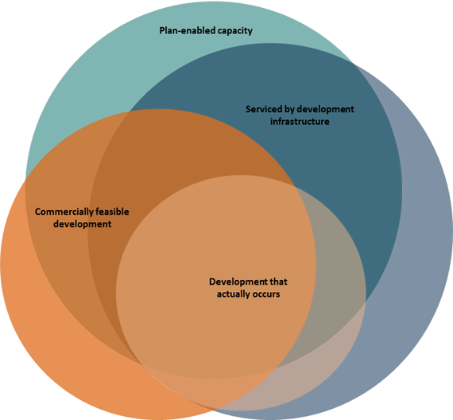
Policy PC1 directs local authorities to provide an additional margin of feasible development capacity of at least 20 per cent in the short and medium term, and 15 per cent in the long term. Policy PC2 recognises, however, that in many situations it is likely that this margin will not be large enough for the local circumstances. It directs local authorities to use a higher margin if their evidence (as part of the housing and business assessment, especially information about trends in take-up rates) indicates that this is needed.
Local authorities may find that different margins of additional feasible development capacity are needed in already established urban areas than are needed in greenfield areas. Policies PC1 and PC2 do not preclude this, as long as minimum additional margins are met.
Guidance on assessing take-up rates will be developed in early 2017 as part of the housing and business development capacity assessment guidance modules.

Policy PC4 (Consider all practicable options to provide sufficient development capacity)
PC4: A local authority shall consider all practicable options available to it to provide sufficient development capacity and enable development to meet demand in the short, medium and long term, including:
a) Changes to plans and regional policy statements, including to the zoning, objectives, policies, rules and overlays that apply in both existing urban environments and greenfield areas;
b) Integrated and coordinated consenting processes that facilitate development; and
c) Statutory tools and other methods available under other legislation.
Policy PC4 directs councils to consider all practicable options available to provide sufficient development capacity and enable development, and suggests examples of what must be considered. These cover regulations and plan making, consenting processes, and statutory tools and other methods available under other legislation (such as long-term strategic planning).
These examples may be more or less appropriate, depending on whether the local authority is responding to provide development capacity in the short, medium or long term. For example, in the short term, the most appropriate response may be to enable more development through more integrated and coordinated consenting processes that streamline local authority processes and provide one point of contact in a local authority. An example of this was the Housing Project Office at Auckland Council, which was used to implement the special housing area legislation. In the medium and long term, initiating a plan change process to change zoning, objectives, policies, rules and overlays to provide more development capacity may be the most appropriate way to respond.
The list of options in policy PC4 is not intended to preclude local authorities from pursuing other options to provide sufficient development capacity, including non-RMA tools and methods. For example, this could include:
- bringing forward infrastructure provision or entering into development agreements for the private provision of infrastructure
- incentivising development through the contributions regime or rebates schemes
- other methods a council might have available to it.
Government will establish practice groups to oversee the development of separate technical guidance during 2017 on plans that provide sufficient development capacity and consenting practices that enable development.

Policies PD1–PD2: Coordinated evidence and decision-making
PD1: Local authorities that share jurisdiction over an urban area are strongly encouraged to work together to implement this national policy statement, having particular regard to cooperating and agreeing upon:
a) The preparation and content of a joint housing and business development capacity assessment for the purposes of policy PB1; and
b) The provision and location of sufficient, feasible development capacity required under policies PA1, PC1 and PC2.
PD2: To achieve integrated land use and infrastructure planning, local authorities shall work with providers of development infrastructure, and other infrastructure, to implement policies PA1 to PA3, PC1, and PC2.
While a national policy statement cannot direct joint decision-making between councils, the NPS-UDC goes as far as possible to encourage coordination between local authorities when they share jurisdiction over a medium- or high-growth urban area. Regional councils and territorial authorities both have functions that impact how growth is planned for and accommodated, and on the ability to achieve the objectives of the NPS-UDC. Neighbouring local authorities will also each affect development in urban markets that cross their boundaries. It is highly desirable that they align their planning decisions and processes.
The NPS-UDC also requires local authorities to work with providers of development infrastructure and other infrastructure to fulfil specific requirements of the NPS-UDC.
There are clear benefits to coordination and aligned planning decisions across an urban area for local communities, local councils, infrastructure providers and the development sector. This coordination need not exclude the possibility of local authorities and infrastructure providers responding to demands that they cannot predict.

Policy PD1 (Local authorities planning together)
Policy PD1 strongly encourages local authorities that share jurisdiction over an urban area to prepare a joint housing and business development capacity assessment. This would provide a shared understanding of the relevant urban development market and a basis for local authorities to align their planning decisions affecting the provision and location of development capacity. It would also minimise the costs of preparing the housing and business assessment for individual local authorities.
Many of the local authorities covered by the medium- and high-growth urban area policies have already established relationships and agreements with other local authorities and infrastructure providers and already work together on shared evidence and growth strategies. These include for example, SmartGrowth, Future Proof, the Heretaunga Plains Urban Development Strategy, and the Greater Christchurch Urban Development Strategy.
The NPS-UDC is intended to build on and strengthen these existing relationships. For example, throughout the NPS-UDC it states that “the applications of policies should not be restricted to the boundaries of the urban area”. This allows for local authorities that share jurisdiction over an urban area to decide which area makes the most sense for them to apply the policies. This means, for example, that local authorities that have all or part of the Christchurch urban area in their district or region can apply the policies in NPS-UDC to the area used for the Greater Christchurch Urban Development Strategy.
While the ideal outcome from the NPS-UDC is that all local authorities sharing jurisdiction over an urban area prepare a joint assessment and future development strategy, this is not mandatory. A lack of consensus should not prevent any local authority or groups of local authorities from meeting the requirements of the NPS-UDC.
Government will monitor the effectiveness of coordinated local planning.

Policies that medium-growth local authorities are encouraged to also give effect to

Policies PC5–PC14 and PD3–PD4 (Minimum targets and future development strategies)
Local authorities with all or part of a medium-growth urban area in their region or district are ‘encouraged’ to also give effect to policies PC5–PC11 (minimum targets), PC12–PC14 (future development strategies) and PD3–PD4 (coordination over minimum targets and future development strategies). These policies apply to high-growth urban areas, as discussed in the next chapter.

4 Requirements of high-growth urban areas
Local authorities that have all or part of a high-growth urban area in their district or region must give effect to policies PC5–PC14 and PD3–PD4, in addition to the policies that apply to all local authorities and medium-growth urban areas.

Policies PC5–PC14: Responsive planning

Policies PC5–PC11 (Setting minimum development capacity targets)
PC5: Regional councils shall set minimum targets for sufficient, feasible development capacity for housing, in accordance with the relevant assessment under policy PB1 and with policies PA1 and PC1 or PC2, and incorporate these minimum targets into the relevant regional policy statement.
PC6: A regional council’s minimum targets set under policy PC5 shall be set for the medium and long term, and shall be reviewed every three years.
PC7: When the relevant assessment required under policy PB1 shows that the minimum targets set in the regional policy statement are not sufficient, regional councils shall revise those minimum targets in accordance with policies PC5, and shall incorporate these revised targets into its regional policy statement.
PC8: Regional councils shall amend their proposed and operative regional policy statements to give effect to policies PC5 to PC7 in accordance with section 55(2A) of the Act without using the process in Schedule 1 of the Act.
PC9: Territorial authorities shall set minimum targets for sufficient, feasible development capacity for housing, as a portion of the regional minimum target, in accordance with the relevant assessment under policy PB1, and with policies PA1, PC1 or PC2, and PD3 and incorporate the minimum targets as an objective into the relevant plan.
PC10: If a minimum target set in a regional policy statement is revised, the relevant territorial authorities shall also revise the minimum targets in their plans in accordance with policy PC9.
PC11: Territorial authorities shall amend their relevant plans to give effect to policies PC9 and PC10 in accordance with section 55(2A) of the Act without using the process in Schedule 1 of the Act.
Policies PC5–PC11 require regional and district councils to include minimum targets for feasible development capacity for housing in their plans. Minimum targets should reflect the overall quantity of demand for housing identified in the relevant housing and business development capacity assessment required under policy PB1, and should include the additional margins of feasible development capacity required under policy PC1 or PC2. Note that these are ‘minimum’ targets, and local authorities could provide more development capacity in their plans if they choose.
Regional councils should set the minimum targets for housing in their regional policy statement (RPS). This target should reflect the geographic area of focus used for the relevant housing and business development capacity assessment. The policies also direct territorial authorities to set minimum targets as an objective in their plans. These targets should represent a proportion of the minimum target set in the RPS.
Ideally, the assessment and targets should be agreed between the local authorities that share jurisdiction over the urban area, as per policies PD1 and PD3. This would mean that when the territorial authorities’ minimum targets are aggregated they would not be less than the target set at the regional level (for the area agreed).
Minimum targets must be set in the RPS and district plans for the medium and long term, and they must be reviewed every three years. Minimum targets must be in place by the end of 2018, one year after local authorities that have all or part of a high-growth urban area in their district or region should have completed their housing and business development capacity assessment.
Where the relevant assessment shows that current minimum targets are insufficient, the target set in the RPS should be revised. Minimum targets in the district plans should also then be updated to reflect the new targets in the RPS.

Use of section 55(2A) of the RMA
Policies PC8 and PC11 allow local authorities to set these minimum targets in the RPS and plans using the process set out in section 55(2A) of the RMA. This means that they can insert these targets directly into the relevant RPS or plan without using the consultation process set out in Schedule 1 of the RMA.
Local authorities can only use this process to set the minimum targets and not to give effect to the targets through policies and rules. Local authorities should work with their communities through the usual plan change consultation process to decide zones and other regulations that allocate the targeted capacity to different locations and types of housing.

Policies PC12–PC14 (Future development strategy)
PC12: Local authorities shall produce a future development strategy which demonstrates that there will be sufficient, feasible development capacity in the medium and long term. This strategy will also set out how the minimum targets set in accordance with policies PC5 and PC9 will be met.
PC13: The future development strategy shall:
a) identify the broad location, timing and sequencing of future development capacity over the long term in future urban environments and intensification opportunities within existing urban environments;
b) balance the certainty regarding the provision of future urban development with the need to be responsive to demand for such development; and
c) be informed by the relevant Long Term Plans and Infrastructure Strategies required under the Local Government Act 2002, and any other relevant strategies, plans and documents.
PC14: The future development strategy can be incorporated into a non-statutory document that is not prepared under the Act, including documents and strategies prepared under other legislation. In developing this strategy, local authorities shall:
a) Undertake a consultation process that complies with:
• Part 6 of the Local Government Act; or
• Schedule 1 of the Act;
b) be informed by the assessment under policy PB1; and
c) have particular regard to policy PA1.
Policies PC12–PC14 direct local authorities to produce future development strategies that demonstrate there will be sufficient development capacity in the medium and long term, and demonstrate that the minimum targets for sufficient development capacity will be met.
The preparation of this strategy should provide a vehicle for discussing the path of future development and change with communities, including the extent of intensification and land release.
Once completed, the strategy should signal to the market that there will be plenty of development opportunities in the medium and long term, while also providing some certainty (for communities, infrastructure providers and developers) about where and when this is likely to be provided.
The future development strategy should also be flexible enough to respond to change, for example, in demand or landowner intentions. For this reason, the strategy can be incorporated into a non-statutory document (for example, a spatial plan or growth strategy like the Greater Christchurch Urban Development Strategy ). This means that it can be developed and amended as needed through either a consultation process that complies with Part 6 of the LGA or Schedule 1 of the RMA.
The future development strategy could provide a clear framework for the private provision or funding of development infrastructure, and for other infrastructure within a 30-year timeframe. It would not need to decide which projects should be privately provided, where and when. However, it could provide certainty about the skeleton of infrastructure that would be provided in a future development area by the end of the 30-year period, and allow for some of this to be provided privately. This might allow for ‘out of sequence’ development in a planned way.
Government will establish a practice group to oversee the development of separate technical guidance during 2017 on preparing a future development strategy that is responsive to demand.
How high-growth local authorities should work together to produce a future development strategy and set minimum development capacity targets for housing is discussed in the next section.

Policies PD3–PD4: Coordinated evidence and decision-making

Policies PD3–PD4 (Integrated land use and infrastructure planning)
PD3: Local authorities that share jurisdiction over an urban area are strongly encouraged to collaborate and cooperate to agree upon:
a) The specification of the minimum targets required under PC5 and PC9 and their review under policies PC6, PC7 and PC10; and
b) The development of a joint future development strategy for the purposes of policies PC12 to PC14.
PD4: Local authorities shall work with providers of development infrastructure, and other infrastructure, in preparing a future development strategy under policy PC12.
Policies PD3–PD4 build on the coordination around housing and business development capacity assessments required under policies PD1-PD2. PD3 encourages cooperation and agreement on setting minimum targets of development capacity and the preparation of a joint future development strategy. PD4 stipulates that local authorities will work with providers of development and other infrastructure to prepare this strategy.
Many of the local authorities covered by the medium- and high-growth policies have already established relationships and agreements with other local authorities and already work together on shared evidence and growth strategies. These include for example SmartGrowth, Future Proof, the Heretaunga Plains Urban Development Strategy, and the Greater Christchurch Urban Development Strategy.
The NPS-UDC is intended to build on and strengthen these existing relationships. For example, throughout the NPS-UDC, it states that “the applications of policies should not be restricted to the boundaries of the urban area”. This allows for local authorities that share jurisdiction over an urban area to decide which area makes the most sense for them to apply the policies. This means, for example, that local authorities that have all or part of the Christchurch urban area in their district or region can apply the policies in NPS-UDC to the area used for the Greater Christchurch Urban Development Strategy.
While the ideal outcome from the NPS-UDC is that local authorities that share jurisdiction over an urban area agree on data and evidence to prepare a joint assessment and future development strategy, and agree minimum targets and the allocation of development capacity, a lack of consensus should not prevent any local authority from meeting the requirements of the NPS-UDC.
Government will monitor the effectiveness of coordinated local planning.

5 NPS-UDC implementation programme
The Ministry for the Environment and Ministry of Business, Innovation and Employment will work with local authorities over the next five years to help them implement the NPS-UDC as intended, and to maximise the benefits of this national direction.
Technical advisory groups and practice groups will be established incorporating local authority representatives, developers and other experts. These groups will oversee the development of guidance during 2017 on:
- monitoring market indicators, including price efficiency
- components of the housing and business development capacity assessment
- more enabling and responsive plans that provide sufficient development capacity
- best practice consenting processes for urban developments
- preparing a future development strategy that is responsive to demand.
Government will also ensure that local authorities have access to the data that is required to monitor market indicators and to undertake the housing and business development capacity assessments. Further information is available on the Ministry for the Environment’s website.
The Ministry for the Environment and Ministry of Business, Innovation and Employment will monitor implementation and the effectiveness of the NPS-UDC against a set of key performance indicators. A formal review of the NPS-UDC will be undertaken by the end of 2021.
Figure 3 outlines the timeframes for implementation of the NPS-UDC.

Figure 3: Timeframes for implementation of the NPS-UDC
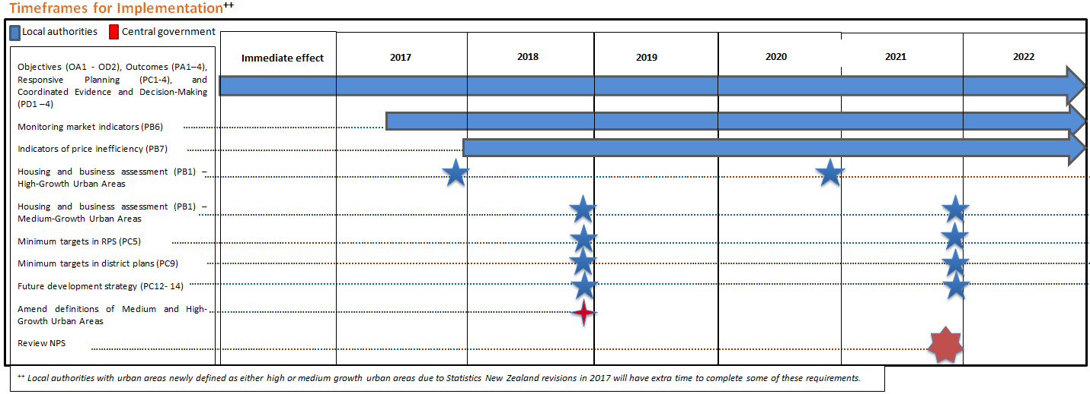

References
Covec and MRCagney. 2016. Signals of Under-capacity: The Practicalities of Monitoring Price Signals Under the National Policy Statement on Urban Development Capacity. Wellington: Ministry for the Environment and Ministry of Business, Innovation and Employment. Retrieved from www.mfe.govt.nz/publications/towns-and-cities/signals-under-capacity-practicalities-monitoring-price-signals-under (31 October 2016).
Ministry for the Environment and Ministry for Business, Innovation and Employment. 2016. How Councils Estimate Demand and Supply of Development Capacity for Housing and Business. Wellington: Ministry for the Environment and Ministry for Business Innovation and Employment. Retrieved from www.mfe.govt.nz/publications/towns-and-cities/how-councils-estimate-demand-and-supply-development-capacity-housing (31 October 2016).
Productivity Commission. 2015. Using Land for Housing. Wellington: Productivity Commission. Retrieved from www.productivity.govt.nz/inquiry-content/2060?stage=4 (31 October 2016).

For example, the New Plymouth urban area may be redefined as high growth, while the Napier–Hastings, Blenheim and Whangarei urban areas may be newly defined as medium growth.
Section 101B(6) of the LGA states that the infrastructure strategy can include “any other assets that the local authority, in its discretion, sees fit to include”.
This diagram is conceptual and not to scale.
Not all of these indicators will be suitable for all areas.
This diagram is conceptual and not to scale.

