# \\Anchor\BhadraZ$\Desktop\Planning standards and S32s\header.pngImplementing the National Planning Standards: Options for district, regional and combined plans

## Introduction

The Minister for the Environment and the Minister of Conservation released the first set of National Planning Standards (planning standards) on 5 April 2019 and they came into effect on 3 May 2019.

The planning standards represent a new form of national direction introduced through the 2017 amendments to the Resource Management Act 1991 (RMA). Their purpose is to reduce the variety and complexity of policy statements, regional plans and district plans by providing nationally consistent:

* structure and format (eg, chapter headings, arrangement of chapters and existing provisions, zone names, spatial layers, planning map colour palette and use of symbols)
* definitions (for commonly referenced terms)
* noise and vibration metrics
* electronic policy and plan functionality and accessibility.

To achieve consistency, the planning standards outline various implementation timeframes that policy statements and plans are required to comply with:[1]

* compliance with the full set of relevant planning standards (apart from the Definitions Standard and Electronic Functionality and Accessibility Standard): three years for regional policy statements, five years for district plans, seven years for district plans recently subject to a full review[2] and 10 years for regional and combined plans
* compliance with the Definitions Standard: three years for regional policy statements, seven years for district plans, nine years for district plans recently subject to a full review,[3] and 10 years for regional and combined plans
* compliance with the Electronic Functionality and Accessibility Standard:
* basic electronic functionality and accessibility (eg, hosted on a council webpage, keyword search functionality): one year
* online interactive format (ie, e-Plan): five years for most councils, although some have seven years,[4] and 10 years for regional and unitary councils, and city and district councils with under 15,000 ratepayers.[5]

## Purpose and scope

In light of these requirements, this guidance aims to help councils identify a suitable pathway to comply with the district, regional and combined plan-related timeframes in the Implementation Standard. Because several councils are likely to achieve compliance as part of an impending full review of their plans (including Hutt City Council, Nelson City Council, New Plymouth District Council, Porirua City Council, Selwyn District Council, Waimakariri District Council and Wellington City Council), this guidance is directed mainly towards those councils not undertaking a full review of their plan or policy statement within the implementation timeframes.

To inform consideration of an appropriate way forward, this guidance identifies possible implementation options and their relative advantages, disadvantages and risks. Due to the technical and administrative nature of the directions in Standard 16 (Electronic Accessibility and Functionality), that standard has been excluded from the scope of this guidance.

# Options for implementing the National Planning Standards

## Implementation options

Two main pathways are available to councils to ensure their plans comply with the directions in the Implementation Standard:

* **early compliance** – involves making district, regional and combined plans fully compliant with the structure, format and definitional requirements by the first implementation date directed by the standard (eg, broadly May 2024 for district plans)
* **staged compliance** – involves making district, regional and combined plans progressively compliant with the structure, format and definition requirements by the associated implementation date directed by the standard.

Although not exhaustive, the following three possible options could be used by councils to meet the compliance timeframes specified in the Implementation Standard:

• Option 1: Early compliance by 2024/2026/2029

• Option 2: Staged compliance to 2026/2028

• Option 3: Early staged compliance via a ‘rolling review’ process.

These options are described further below and shown in figure 1.

### Option 1: All-inclusive changes

This option requires amending plan structure, format and definitions to be fully compliant with the planning standards by May 2024 for district plans generally, May 2026 for district plans recently subject to a full review,[6] and May 2029 for regional plans and combined plans. Changes to structure and format would be progressed without recourse to Schedule 1 of the RMA and definitions incorporated through consequential amendments and/or a targeted plan change.

### Option 2: Structure and format changes followed by definitions

Without recourse to Schedule 1 of the RMA, this option requires amending plan structure and format to be fully compliant with the relevant planning standards by May 2024 for district plans generally, and May 2026 for district plans recently subject to a full review. Changes to definitions would be incorporated through consequential amendments and/or a targeted plan change by May 2026 and May 2028, respectively.

### Option 3a: Rolling review with topic-based and/or national direction plan change

This option requires full compliance aligned with a ‘rolling’ plan review.[7] It would involve amending plan structure, form and definitions by May 2024 for district plans generally, May 2026 for district plans recently subject to a full review,[8] and May 2029 for regional plans and combined plans. This would be in parallel with the introduction of a topic-based or omnibus plan change and/or change to implement national direction (eg, freshwater for regional and unitary councils; urban development and highly productive land for city, district and unitary councils).

### Option 3b: Rolling review with topic-based and/or omnibus plan change

This option requires full compliance aligned with a ‘rolling’ plan review. It would occur without recourse to Schedule 1 of the RMA and involve amending plan structure and format to be fully compliant with the relevant planning standards by May 2024 for district plans generally, May 2026 for district plans recently subject to a full review, and May 2029 for regional plans and combined plans. Changes to definitions would be incorporated through consequential amendments and/or introduction of a topic-based or omnibus plan change by May 2026, May 2028 and May 2029, respectively.

Figure 1: Visual depiction of the options to implement the National Planning Standards from May 2019 to May 2029 for district plans, regional plans and combined plans.

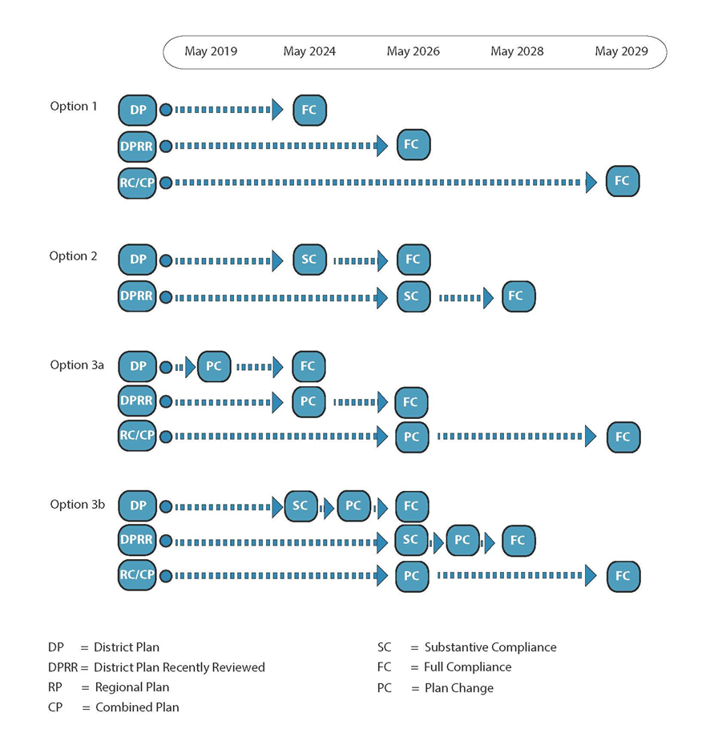

This diagram displays the chronological steps in the four options set out in this document for implementing the planning standards for district plans, regional plans and combined plans from May 2019 (when the planning standards came into force) to 2029 (when all plans and councils must be fully compliant with the planning standards).

*Option 1* shows that full compliance can be achieved for district plans by May 2024. For district plans recently reviewed, it shows full compliance by May 2026, and for regional plans and combined plans, it shows full compliance by May 2029.

*Option 2* shows that for district plans, if substantive compliance is achieved by May 2024, full compliance can be achieved by May 2026. For district plans recently reviewed, it shows substantial compliance by May 2026 and full compliance by May 2028.

*Option 3a* shows that for district plans, if a plan change is undertaken in 2020, full compliance can be achieved by May 2024. For district plans recently reviewed, it shows that if a plan change is undertaken by May 2024, full compliance can be achieved by May 2026. For regional plans and combined plans, if a plan change is undertaken by May 2026, full compliance can be achieved by May 2029.

*Option 3b* shows that for district plans, if substantive compliance is achieved by May 2024, and a subsequent plan change is undertaken by 2025, full compliance can be achieved by May 2026. For district plans recently reviewed, if substantive compliance is achieved by May 2024 and a subsequent plan change is undertaken by May 2027, full compliance can be achieved by May 2028. For regional plans and combined plans, if a plan change is undertaken in May 2026, full compliance can be achieved by May 2029.

## Option assessment

To assess the merits of these options, we have developed the criteria below.

* Efficiency and effectiveness – will the option enable compliance with the planning standards to be achieved in an efficient and effective manner?
* Capacity and capability – can the option be delivered effectively within existing capacity and capability levels?
* Certainty – does the option provide plan users with sufficient certainty?
* Utility – will the option improve the overall usability of the plan to users?
* Integration – does the option encourage a timely, coherent approach for aligning with the planning standards?
* Coordinated – does the option provide an opportunity to implement and align the plan with further national direction proposals signalled? [9]

The advantages, disadvantages and risks of the three options are summarised below, based on the criteria above.

### Option 1: All-inclusive changes

#### Advantages

* Highly efficient because it allows full, timely compliance with the planning standards, so avoids unnecessary duplication of effort and workload (ie, structure and format, and definitional changes implemented independently) and ongoing administrative and compliance costs.
* Highly effective because it allows all aspects of the planning standards (ie, structure and format, and definitions) to be considered and implemented in an integrated and coordinated manner.
* Early alignment with the planning standards offers improved utility, compared with options 2 and 3b, because it provides plan users with an integrated, fully ‘standards-compliant’ version of the plan within a shorter timeframe than required by the standards.
* Provides greater certainty to plan users than options 2 and 3b because all changes required to comply with the planning standards, including any consequential changes resulting from implementing the Definitions Standard, would be incorporated into a plan through a single, integrated process.
* Allows any necessary changes to give effect to proposed National Direction on Urban Development and Highly Productive Land to be addressed in parallel with any consequential changes arising from implementation of the Definitions Standard.[10]

#### Disadvantages

* Likely to be more resource intensive to implement and could incur higher ‘front-end’ compliance costs than options 2 and 3b, particularly if consequential changes involving a Schedule 1 RMA process are required.
* May be less practicable than options 2 and 3b unless councils have, or contract in, the necessary capacity and capability to identify and process any necessary consequential changes.
* Largely dependent on the nature and extent of consequential, definitional changes required and the potential need to resort to a Schedule 1 RMA process to give effect to proposed changes (eg, amendments to rules to address previously excluded activities).
* Creates potential public uncertainty in differentiating between mandated changes and consequential changes, particularly if the latter (and not the former) are subject to a Schedule 1 RMA process and open to submissions.

#### Risks

* Ability of a council to implement the option easily within the available timeframe. Also, the potential to impose unrealistic workload demands on staff resources, particularly if controversial and/or complex consequential changes are required.
* Introducing consequential changes without recourse to the Schedule 1 RMA process may lead to an application for judicial review. This would be most likely if the consequential changes had the potential to exceed the anticipated scope of change mandated by the planning standards.
* Ability to achieve full compliance if substantive and/or wide-ranging submissions and appeals were lodged on proposed consequential changes subject to a Schedule 1 RMA process extended timeframe.

### Option 2: Structure and format changes followed by definitions

#### Advantages

* Meets the implementation requirements set out in the planning standards.
* Allows the implementation requirements to be delivered in a staged, cost-effective manner, with the distribution of associated administrative and compliance costs spread over a longer timeframe.
* Highly achievable because it allows councils to manage their internal capacity and capability realistically to achieve compliance within the compulsory implementation timeframes.
* Extended timeframe allows more time and rigour to be applied to identifying consequential amendments that arise from compliance with the Definitions Standard. It also gives councils more time to prepare and process any changes that exceed the anticipated scope using a Schedule 1 RMA process.
* Provides clear differentiation between directions progressed without recourse to the Schedule 1 RMA process (ie, structure and format) and directions that may require a plan change to deal with consequential changes (ie, definitions). This would reduce potential confusion for plan users and submitters.

#### Disadvantages

* Although time compliant, this option involves a more prolonged implementation timeframe than Option 1 and potentially Option 3a.
* Less efficient compared with Options 1 and 3a because it would mean duplicating effort and workload (ie, structure and format, and definitional changes implemented independently), with the potential to increase the overall cost of compliance.
* Staged alignment with the planning standards may result in reduced ease of navigation within a plan for plan users compared with Option 1 and potentially Option 3a (ie, a longer implementation timeframe to achieve full compliance).
* Provides less certainty to plan users compared with Option 1 and potentially Option 3a because implementing definitional changes, along with any consequential changes resulting from their inclusion in a plan, would be staged through to 2026 or 2028.
* Potentially offers less scope, compared with Options 1 and 3a, to introduce timely amendments to give effect to the National Policy Statement for Urban Development and for example, the proposed National Policy Statement for Highly Productive Land in parallel with any consequential changes arising from implementation of the Definitions Standard.

#### Risks

* Introducing consequential changes without recourse to a Schedule 1 RMA process could result in an application for judicial review, particularly where those changes potentially exceed the anticipated scope mandated by the planning standards.
* Ability for councils to achieve full compliance if substantive and/or wide-ranging submissions and appeals lodged on proposed consequential changes are subject to Schedule 1 RMA process extended timeframe.

### Option 3a: Rolling review with topic-based and national direction plan change

#### Advantages

* We consider the advantages of Option 3a to be the same as for Option 1 but with an extra advantage. This option enables councils to address any gaps identified in associated plan content, which were caused by implementing the planning standards (eg, relevant objectives and policies for general matters such as subdivision and earthworks currently included in zone-based plan chapters), as part of a confirmed ‘rolling review’ programme.

#### Disadvantages and risks

• We consider the disadvantages and risks to be the same as for Option 1.

### Option 3b: Rolling review with topic-based and omnibus plan change

#### Advantages

* We consider the advantages to be the same as for Option 2, but with the extra advantage as in 3a above.

#### Disadvantages and risks

* We consider the disadvantages and risks to be the same as in Option 2.

Disclaimer

The information in this publication is, according to the Ministry for the Environment’s best efforts, accurate at the time of publication. The Ministry will make every reasonable effort to keep it current and accurate. However, users of this publication are advised that:

* The information provided has no official status and does not alter the laws of New Zealand, other official guidelines or requirements.
* It does not constitute legal advice, and users should take specific advice from qualified professionals before taking any action as a result of information obtained from this publication.
* The Ministry for the Environment does not accept any responsibility or liability whatsoever whether in contract, tort, equity or otherwise for any action taken as a result of reading, or reliance placed on this publication because of having read any part, or all, of the information in this publication or for any error, or inadequacy, deficiency, flaw in or omission from the information provided in this publication.
* All references to websites, organisations or people not within the Ministry for the Environment are provided for convenience only and should not be taken as endorsement of those websites or information contained in those websites nor of organisations or people referred to.

Published in September 2020  
by the Ministry for the Environment   
Publication number: INFO 983



1. Refer Planning Standard 17: Implementation Standard.
2. Refer direction 17.5.
3. Refer direction 17.6.
4. Refer direction 17.14.
5. Refer direction 17.15.
6. Refer direction 17.5.
7. A staged approach to amending plan structure, form and relevant definitions on a ‘rolling’ chapter-by-chapter basis presents further alternative options, particularly for regional and unitary councils given their 10-year compliance timeframe. Although hypothetically possible, it would be an impractical option for most city and district councils because it would generally necessitate all chapter content to be notified and determined by May 2024. Furthermore, the implementation directions do not require piecemeal changes and variations to meet the planning standards format and structure until either the implementation deadline expires or a ‘full’ proposed plan is notified for submissions.
8. See note above.
9. Of particular relevance are the intended national policy statements on urban development and highly productive land, both of which have been signalled to come into force in the first half of 2020, pending approval by ministers and Cabinet.
10. This could be particularly relevant for the six major urban centres (ie, Auckland, Hamilton, Tauranga, Wellington, Christchurch and Queenstown) depending on a suggested 18-month timeframe to implement various intensification policies in the proposed National Policy Statement on Urban Development. However, most of the other provisions would have immediate effect. Also, this option could be used as a vehicle for implementing the proposed National Policy Statement on Highly Productive Land within the suggested five-year timeframe.