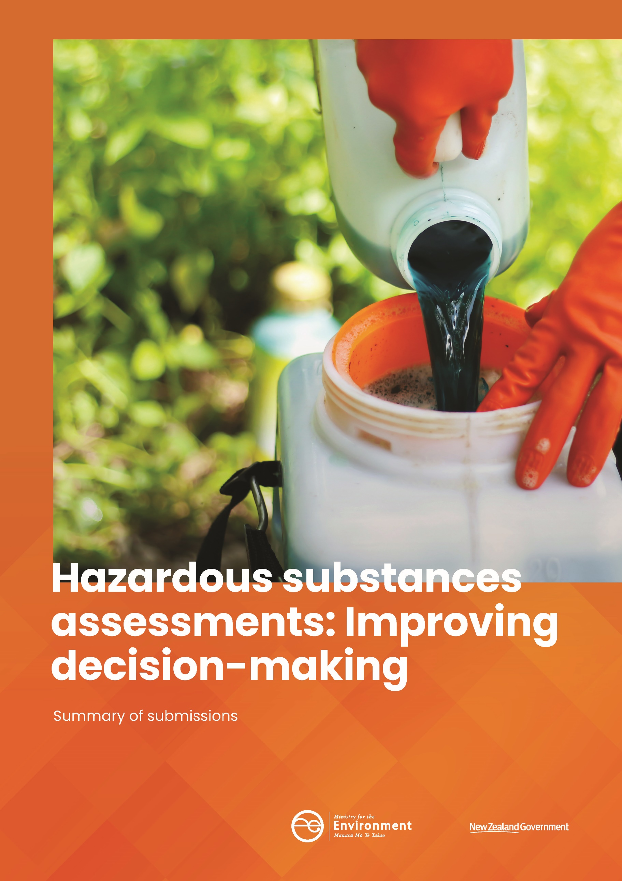mp

This document may be cited as: Ministry for the Environment. 2020. *Hazardous substances assessments:* *Improving decision‑making – Summary of submissions*. Wellington: Ministry for the Environment.

Published in July 2020 by the  
Ministry for the Environment   
Manatū Mō Te Taiao  
PO Box 10362, Wellington 6143, New Zealand

ISBN: 978-1-98-857973-3  
Publication number: ME 1488

© Crown copyright New Zealand 2020

This document is available on the Ministry for the Environment website: [www.mfe.govt.nz](http://www.mfe.govt.nz).



# Contents

Message from the Secretary from the Environment 5

Introduction 7

The consultation process 8

Public feedback 9

Number of submissions 9

Submitter groups 9

Overall position 9

[Proposal 1: Making better use of international information during assessments  
and reassessments of hazardous substances 10](#_Toc34749246)

[Proposal 2: Applying trusted information to suspend or temporarily   
restrict an approval 18](#_Toc34749247)

[Proposal 3: Applying a trusted regulator’s decision to change a hazard   
classification 21](#_Toc34749248)

Proposal 4: Collecting quality information for reassessment 22

Proposal 5: Streamlining targeted consultation for modified reassessments 24

Proposal 6: Streamlining the early stage of reassessments of priority chemicals 25

[Proposal 7: Avoiding replication during assessments of related substances   
containing the same active ingredient 26](#_Toc34749252)

[Proposal 8: Updating controls on existing substances based on a recent   
EPA assessment 28](#_Toc34749253)

Other issues raised by submitters 28

# Figures

Figure 1: Submitter groups 9

Figure 2: Overall position 10

Figure 3: Do you agree that the EPA should make better use of international information during assessments and reassessments of hazardous substances? 11

Figure 4: Do you agree with the criteria for defining who is a trusted regulator? 13

Figure 5: Do you agree with the proposed principles and considerations of using international information? 14

Figure 6: Which options do you support for using information from trusted regulators for assessments of new hazardous substance? 16

Figure 7: Which options do you support for using information from trusted regulators for reassessments of existing hazardous substances? 17

Figure 8: When applying information from a trusted regulator, should the New Zealand context always be considered? 17

Figure 9: Options for suspension or restriction 20

Figure 10: Options for adopting a trusted regulator’s decision to change a hazard classification 22

Figure 11: Options for collecting quality information for reassessments 24

Figure 12: Would you support an option that allows the EPA more flexibility in consultation? 25

Figure 13: Options for reassessments of priority chemicals 26

Figure 14: Options for assessment and reassessments of substances containing the same active ingredient 27

Figure 15: Options for updating controls on existing substances based on a recent EPA assessment 28

# Tables

Table 1: Policy proposals 8

Table 2: Submitter groups 9

# Introduction

The Government is seeking improvements to New Zealand’s hazardous substances management system, to better protect human health, safety, and the environment.

The Ministry for the Environment is proposing making better use of international information to assess new and existing hazardous substances, especially from international regulators who we recognise as following a comparable process.

We are also considering other improvements to the reassessment process to enable a more efficient process to review hazardous substances of the most concern. To this end, we have been consulting on possible improvements to the assessments and reassessments of hazardous substances.

## Submissions analysis and next steps

This document summarises the feedback received during the Ministry’s consultation, which was carried out in August and September 2019.

We will use these submissions as part of evidence to inform advice to the Government on the policy proposals. Other evidence, such as from engagement with other government agencies and regulators, and cost benefit analysis, will also inform our work on the proposals.

# The consultation process

The Ministry for the Environment consulted on the proposed improvements to the assessments and reassessments of hazardous substances in August and September 2019. A consultation document, [*Hazardous substances assessments: Improving decision-making*](http://www.mfe.govt.nz/sites/default/files/media/Hazards/hazardous-substances-discussion-document.pdf), presented the policy issues and proposed options on a set of proposals (summarised in table 1).

**Table 1: Policy proposals**

|  | Proposals |
| --- | --- |
| Make better use of information | * Making better use of international information during assessments and reassessments. * Applying trusted information to suspend or temporarily restrict an approval. * Applying a trusted regulator’s decision to change a hazard classification. |
| Streamline consultation | * Collecting quality information for reassessment. * Streamlining targeted consultation for modified reassessments. |
| Avoid duplication | * Streamlining the early stage of reassessments of priority chemicals. * Avoiding replication during assessments of related substances containing the same active ingredient. * Updating controls on existing substances based on a recent EPA assessment. |

The consultation document invited people to respond to 50 different questions.

The Ministry organised a combined consultation process in September 2019 to seek feedback from the public on five policy issues: freshwater, urban development, highly productive land, product stewardship, and hazardous substances assessments. The joined-up consultation included more than 20 public meetings and 20 hui with iwi in all regions across New Zealand.

The Ministry and the Environmental Protection Authority (EPA) held two hui in Wellington and Whangārei to seek advice from iwi through the Te Herenga – the EPA’s Māori network. Fourteen iwi, hapū, and whānau representatives attended the two hui to discuss the proposals. The Ministry sent letters to iwi who have relationship agreements with the Ministry, and to other iwi, to invite advice on the proposals.

We organised two stakeholder meetings in Auckland and Wellington to engage with the chemical industry, primary industry sectors, and non-government organisations (NGOs). These meetings attracted 52 attendees.

At those hui and meetings, the Ministry and the EPA explained the purpose of the project and presented the policy proposals, which was followed by open discussion with attendees on each proposal.

# Public feedback

### Number of submissions

The Ministry for the Environment received 44 submissions (see table 2 and figure 1), four of them partial form submissions. All submissions received have been analysed and given equal weight in the analysis.

We received one submission after the submissions had been formally processed and analysed. We did, however, welcome the submitter’s views and comments, which we considered in our overall analysis and advice.

### Submitter groups

**Table 2: Submitter groups**

| Submitter groups | Number of submissions | Percentage of total submissions (%) |
| --- | --- | --- |
| Chemical industry | 8 | 18.2 |
| Horticultural sector | 5 | 11.4 |
| Agricultural sector | 11 | 25.0 |
| Forestry | 1 | 2.3 |
| Iwi/Māori | 6 | 13.6 |
| Individuals | 5 | 11.4 |
| Central government | 0 | 0.0 |
| Local government and health agencies | 4 | 9.1 |
| Non-government organisations (NGOs) | 1 | 2.3 |
| Other chemical users | 1 | 2.3 |
| Others | 2 | 4.5 |

Figure 1: Submitter groups

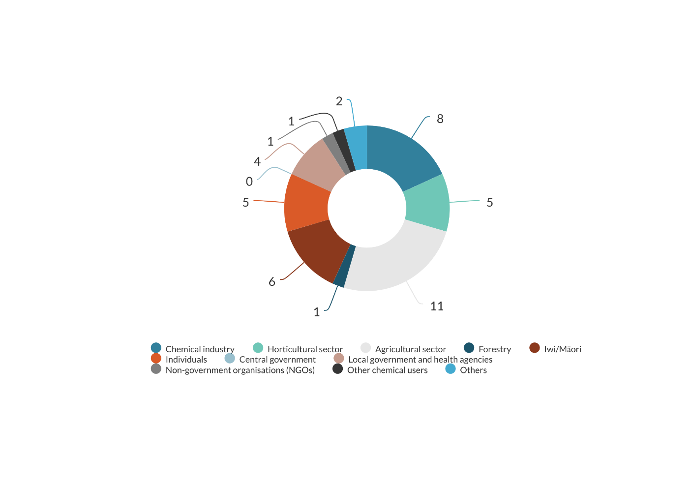

### Overall position

This summary of submissions is largely qualitative in nature, focusing on submitters’ comments and explanation rather than on the overall position. This is because there were a small number of submissions (44), disproportionally represented by the chemical and primary industry sectors. More importantly, half the submissions were received in PDF files via email, and many submission processing and analysis. In general, however, most submitters supported or supported the proposals in part, with some requests for particular changes (figure 2).

Submitters also had different positions on each proposal.

Figure 2: Overall position

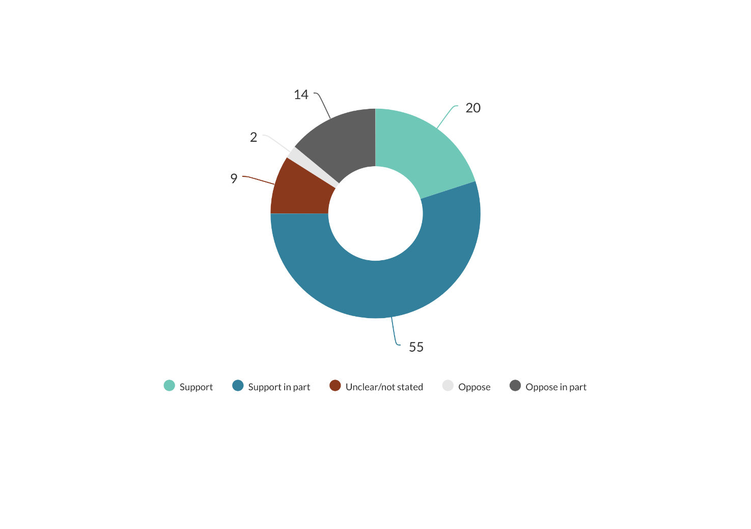

### Proposal 1: Making better use of international information during assessments and reassessments of hazardous substances

#### Should the Environmental Protection Authority (EPA) make better use of international information?

The majority of submitters (82 per cent) (see figure 3) agreed that the EPA should make better use of international information during assessments and reassessments of hazardous substances. This would avoid duplication of work, achieve more efficiency and harmonisation, and enable easier global trade. All submitters who supported the proposal required the EPA to undertake additional assessments to consider the New Zealand context. This is to:

* fill gaps in studies to protect New Zealand’s unique environment, indigenous flora and fauna, and ecosystems
* manage differences in technical aspects of assessments, including changes in formulation and use scenarios
* consider the unique benefits of substances to the New Zealand economy
* eliminate political, commercial, or local factors that could have impacted conclusions of overseas regulators.

Iwi representatives particularly emphasised the importance of Māori knowledge (a mātauranga Māori framework) and matters relating to the Treaty of Waitangi (Te Tiriti o Waitangi) during the EPA’s assessments of hazardous substances: “This will provide for mauri of a place and that mauri is given the same weighting as biochemistry, which, is imperative to drive positive outcomes for the Taiao.”

Some submitters suggested that international information is only a part of the information that the EPA needs to consider before making a decision. The use of international information should not compromise sound science and best practices in risk management. That use should maintain the EPA’s reputation and public confidence in the regulator.

Other submitters suggested enabling the industry and the public to submit on concerns about the information, or to challenge the data or assessments. Supportive submissions requested having a say in setting out criteria for choosing trusted regulators. Submitters also wanted the EPA to publish its preferred risk assessment methodology, and to be consistent in applying that methodology rather than selecting the methodology with the most conservative outcome.

Figure 3: Do you agree that the EPA should make better use of international information during assessments and reassessments of hazardous substances?

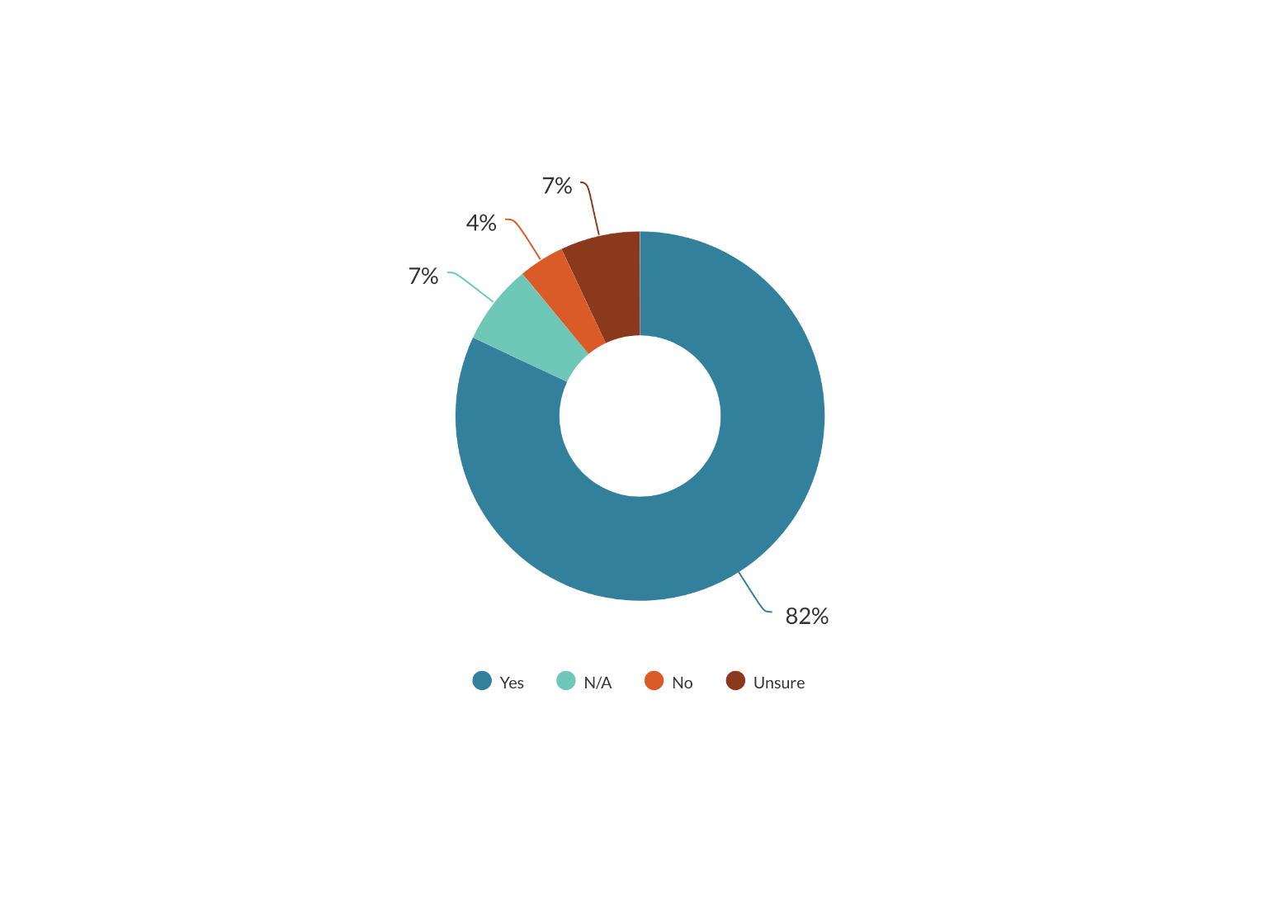

Eleven per cent of submissions did not support or were unsure if the EPA could make better use of international information. These submitters were concerned about:

* different assessment approaches taken by the EPA and other regulators (hazard-based vs risk-based approaches)
* risks and benefits of substances in the New Zealand context not being considered by other regulators
* different approaches in technical aspects of assessment such as choosing sources of data, interpreting data, and using thresholds for hazard classification
* different use scenarios that lead to non-applicable information
* overseas regulators making mistakes
* doubt about regulators’ integrity in assessing hazardous substances.

One submitter had no trust in any regulator and requested using tests undertaken by independent scientists in New Zealand only. Some other submitters only trusted the European Union (EU) regulators. These submitters supported this and other proposals on the condition that New Zealand followed the EU’s approach to hazardous substances management.

Other submitters were unsure or opposed the proposal, but recognised the benefits of using international information in some cases, such as:

* applying overseas approvals that are no longer subject to data protection, and for the same chemical, with the same use patterns with the applications to the New Zealand EPA
* using of overseas regulators’ reviews to inform and validate decisions around hazard assessments (toxicological endpoints).

These submitters also suggested that the EPA carry out “its own evaluation of all the data” and provide a science-based risk assessment. This would ensure that “New Zealand[’s] unique environment, economy, protection objectives and culture”were considered.

These submitters were concerned about the negative effects on the New Zealand EPA’s reputation as one of the world’s leading regulators. Their concern was that using overseas regulators’ information may make the EPA become a follower rather than a leader. They also questioned the practical benefit of the proposal in cases where applicants choose New Zealand as the first entry country.

These concerns mainly came from the uncertainty of:

* who would be chosen as trusted regulators
* what information would be trusted
* the extent that the EPA would rely on this information
* whether the EPA would continue to engage with the industry and the public during assessments using the trusted regulator approach.

Representatives from the chemical industry, therefore, asked to be involved in a Technical Working Group to discuss the technical details of the proposal. They particularly requested that the EPA continue its planned operational improvements as an immediate solution to improve hazardous substances assessments, before considering the proposals. Another submitter requested that the EPA improve its capability and communication with the industry. Some submitters believed that the EPA could make better use of international information   
(as proposed in option 2A, 2B, or 2C) without legislative change.

Some submitters mentioned protecting confidential information to foster innovation in New Zealand. Submitters suggested applicants who want the EPA to apply information from other regulators must own the data or have the right to use it.

One iwi submitter wanted Māori insight to have a higher weight than other information, including overseas opinion or even data, particularly in the risk area. Another submitter suggested that there should be a formal distinction in how the EPA treats information from experts compared to lay people. In contrast, some submitters were concerned that information presented to the EPA is predominantly supplied by the chemical industry, and so reflects those interests, whereas scientists and the general public are under-resourced to put their views forward.

#### Criteria for choosing a trusted regulator

Twenty-three per cent of submitters (see figure 4) disagreed with the proposed criteria for defining trusted regulators. The majority of submitters either agreed with the criteria, did not indicate their position, or were unsure about the criteria. Submitters suggested considering other criteria, including regulators:

* reputation and/or history
* having a commitment to share information with the EPA
* following established standard criteria for selecting studies
* following ‘best practice’ in regulatory toxicology and risk assessment
* providing implementable, evidence-based recommendations on risk management
* being independent and transparent
* having relevant expertise
* engaging in effective consultation on decision-making
* having good governance in the protection of intellectual property rights
* following the Organisation for Economic Co-operation and Development’s (OECD’s) Good Laboratory Practices
* updating the EPA on changes in their assessment process so that the EPA could review their status.

One submitter commented on the criteria for ensuring a ‘transparent and robust’ chemical assessment process. In their opinion, regulators such as Australia, Canada and the United States Environmental Protection Agency (US EPA) do not follow a ‘transparent and robust chemical assessment process’ because they sometimes withhold confidential information, do not publish some of the literature, or do not declare chemical formulation.

Figure 4: Do you agree with the criteria for defining who is a trusted regulator?

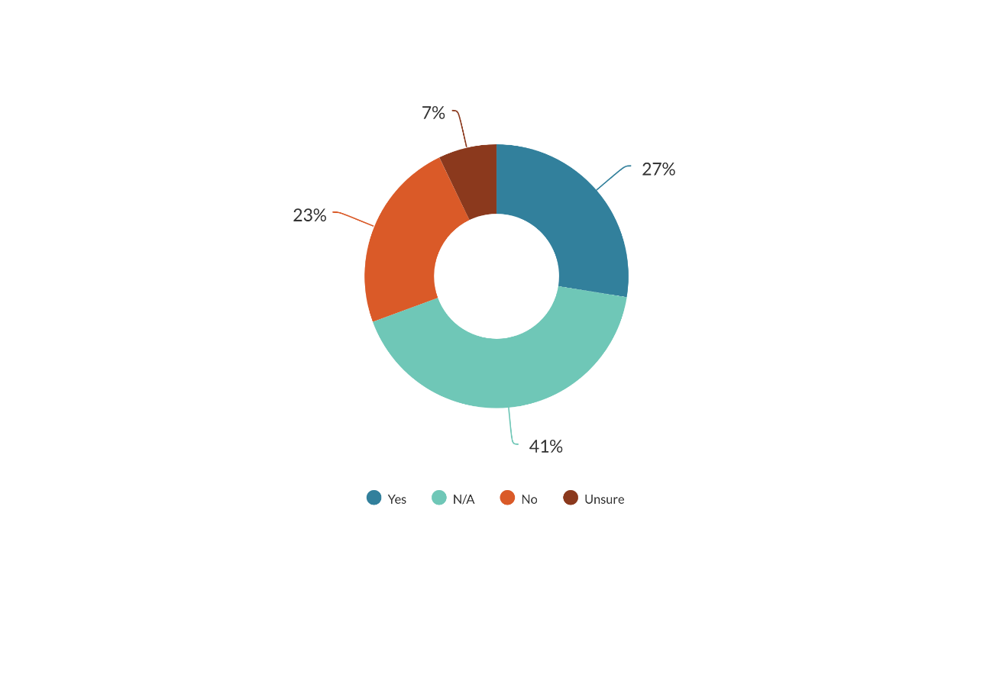

Submitters identified some regulators as suitable candidates for a trusted regulator, including:

* Australia (National Industrial Chemicals Notification and Assessment Scheme (NICNAS), Therapeutic Goods Administration (TGA), Australian Pesticides and Veterinary Medicines Authority (APVMA), Food Standards Australia New Zealand (FSANZ), Office of Gene Technology Regulatory (OGTR))
* Canada
* the European Union (EU) (European Food Safety Authority (EFSA), European Chemical Agency (ECHA))
* the US EPA
* regulators in English-speaking countries
* OECD, the World Health Organization (WHO), the Food and Agriculture Organization of the United Nations (FAO) (including the Joint FAO/WHO Meeting on Pesticide Residues (JMPR) and Joint FAO/WHO Expert Committee on Food Additives (JECFA))
* NGOs with experts who have data.

There was a concern that some regulators could disengage with the industry and the public at times, or would not make their assessments available to the public. Caution would be needed in using information from these sources.

There also needs to be clarification on:

* who would be chosen as trusted regulators
* how other trusted regulators assess and make decisions, and how those processes are relevant to the New Zealand situation
* how the EPA deals with conflicting assessment conclusions or decisions from different trusted regulators
* how the EPA deals with trusted regulators’ assessments referring to non-trusted regulators’ information.

Submitters also raised the relationship risk of nominating some regulators over others as trusted, and whether the EPA should trust reliable data rather than reliable regulators. The chemical industry wanted to have a say on the final list of trusted regulators.

Some submitters only trusted one regulator or international body, such as EFSA, EU, WHO, or the OECD, and disregarded other regulators. Some submitters were opposed because they were concerned that the EPA could ‘blindly’ adopt a trusted regulator’s decisions.

#### Principles for applying information from trusted regulators

The majority of submitters (63 per cent) did not indicate their view on the proposed principles for using international information, and 32 per cent agreed with the proposed principles (see figure 5). One submitter emphasised the need to manage differences in formulation, use scenarios, and local context when using international information. Another submitter indicated that the EPA must understand the regulator’s grounds for withholding information to be able to make a good judgement on how to use the information from trusted regulators.

Some submitters did not agree with the principles because they did not know who the trusted regulators would be and would like to have more opportunities to discuss the trusted regulator approach.

Figure 5: Do you agree with the proposed principles and considerations of using international information?

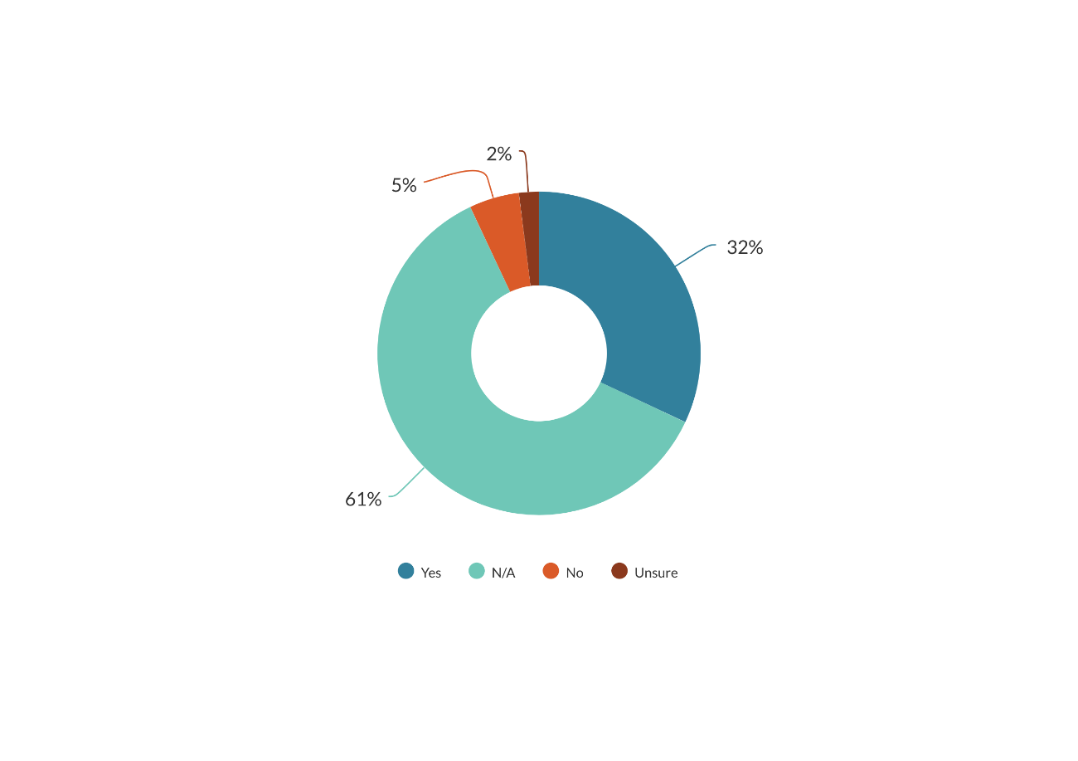

#### Trusted information

Submitters regarded trusted information as:

* evidence-based, scientific data
* industry data when it is available to the public or has already been used in final regulatory assessments
* peer-reviewed scientific journals
* peer-reviewed assessments, hazard assessment, risk assessment reports
* information free of conflict of interest or in accordance with the OECD’s Good Laboratory Practices.

One submitter only trusted studies undertaken by universities or independent scientific laboratories in New Zealand.

One submitter was concerned about using information where the supporting data is confidential and not available to be analysed. The risk is commercial and proprietary confidence can be used to mask a deficit in scientific rigour. Withheld information also makes it difficult for submitters to respond. Therefore, these submitters only supported using information available to the public.

Submitters also:

* requested caution with decisions made by political bodies, because they can be influenced by local risk appetite or biased advice
* raised concerns that risk assessments may be influenced by local risks that are not relevant to New Zealand.

Some submitters only supported the use of assessments of data and end point, but not risk assessments and decisions. Submitters required an opportunity for stakeholders and the public to submit additional information, including information available after the trusted regulators produce their assessments or decisions.

Submitters believed that the EPA should give more weight to trusted regulators’ information compared to other international information. However, they thought that information specific to New Zealand should not be given less weight than trusted regulators’ information.

#### Options for changes

##### Assessments of new hazardous substances

For these assessments, 18 per cent of submitters supported option 2A (applying a part of international information, such as data, peer-reviewed assessments, assessments supported by a full package of data) together with the EPA’s own assessment. Seven per cent supported option 2B (applying full risk assessments), 30 per cent of submitters supported option 2C (applying data, assessments, or decisions), 16 per cent did not agree with any of the proposed options, and 29 per cent did not indicate their position (see figure 6).

Supporters of option 2A only agreed with the use of data with permission from the data’s owner. One submitter supported this option, with the exception for high-risk substances. One submitter requested that the EPA only use data that applicants have access to and not use the risk assessment because of differences in “rate, timing, crops, and application methods”.

Supporters of option 2B wanted the data and risk assessments to be reviewed by the EPA, to ensure the relevance to New Zealand, and the EPA to consult with industry and other stakeholders to achieve cooperation and transparency.

Supporters of option 2C thought this was the best balance of cost and time for both the EPA and industry, as this would allow the maximum flexibility, reduce costs, and make efficient use of international information. Some submitters only supported this option if the trusted regulator was the EU or EFSA, and with New Zealand lens.

One submitter noted that as New Zealand is a small market for chemicals, it may be more practical to consider unilateral adoption or recognition other regulators’ assessments and decisions with New Zealand lens, rather than entering complex mutual recognition agreements.

Most submitters thought that in situations where there were concerns or disagreements with the international information from a trusted regulator, the EPA should undertake additional assessments. This would ensure the New Zealand context would be considered, and changes in use scenarios would be assessed.

Some submitters chose “none of proposed options” because:

* users may lose access to some substances if the EPA solely uses international information without a consideration of the benefits of the substances in the New Zealand context
* they wanted more information on the cost and benefits of this trusted regulator approach and how the New Zealand context would be weighted
* they wanted the applicants applying for an EPA approval to provide authorisation for another regulator to provide information to the EPA
* they wanted a ban on all hazardous substances.

Figure 6: Which options do you support for using information from trusted regulators for assessments of new hazardous substance?

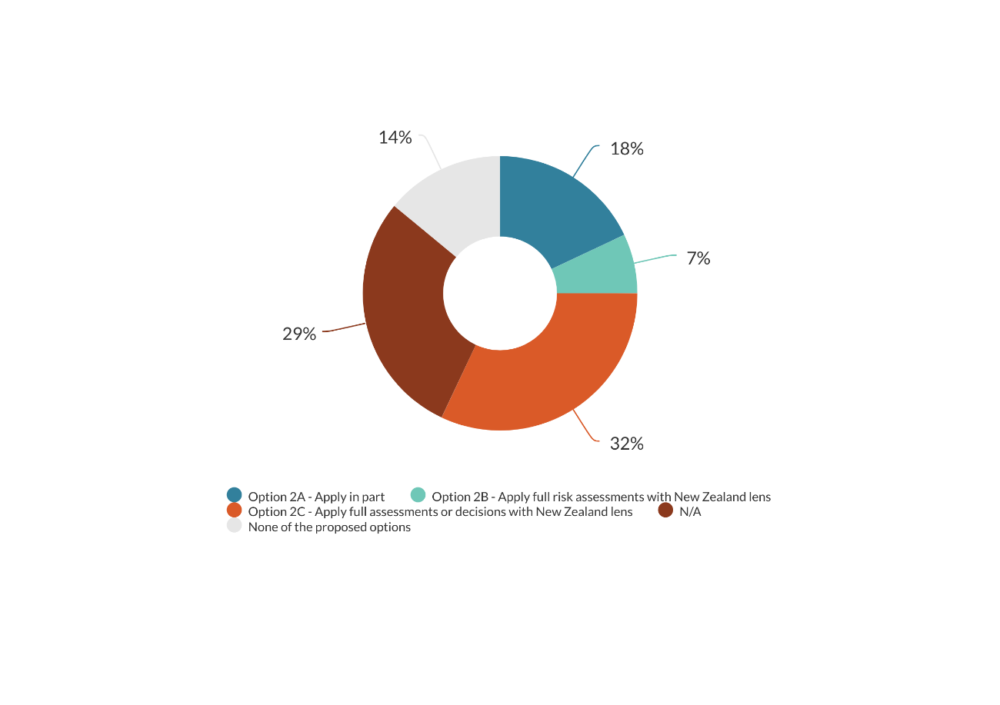

##### Reassessments of existing hazardous substances

For these reassessments, 2 per cent of submitters supported the status quo, 11 per cent supported option 2A (applying a part of international information, such as data, peer-reviewed assessments, assessments supported by a full packaged of data) in companion with the EPA’s own assessment, 14 per cent supported option 2B (applying full risk assessments), 20 per cent of submitters supported option 2C (applying data, assessments, or decisions), 7 per cent of them did not agree with any of the proposed options, and 46 per cent did not indicate their position (see figure 7).

The supporters of the status quo were again worried about the release of information to the EPA without permission of the owners of the data. One supporter of option 2B emphasised the risk of applying decisions from other regulators mentioned in the discussion document.

Some industry representatives and growers were concerned about the risk of losing access to a chemical because the EPA simply applied international information without considering its impacts on the New Zealand economy. For this reason, they requested that in each case the EPA evaluate the quality and reliability of data. Others were keen to see that the risk of the substance was not diluted because of “economic considerations and an underlying threat of a trade dispute if not approved”. Some submitters believed that the EPA must evaluate all types of information, including its reliability and relevance and so did not support any option.

Figure 7: Which options do you support for using information from trusted regulators for reassessments of existing hazardous substances?

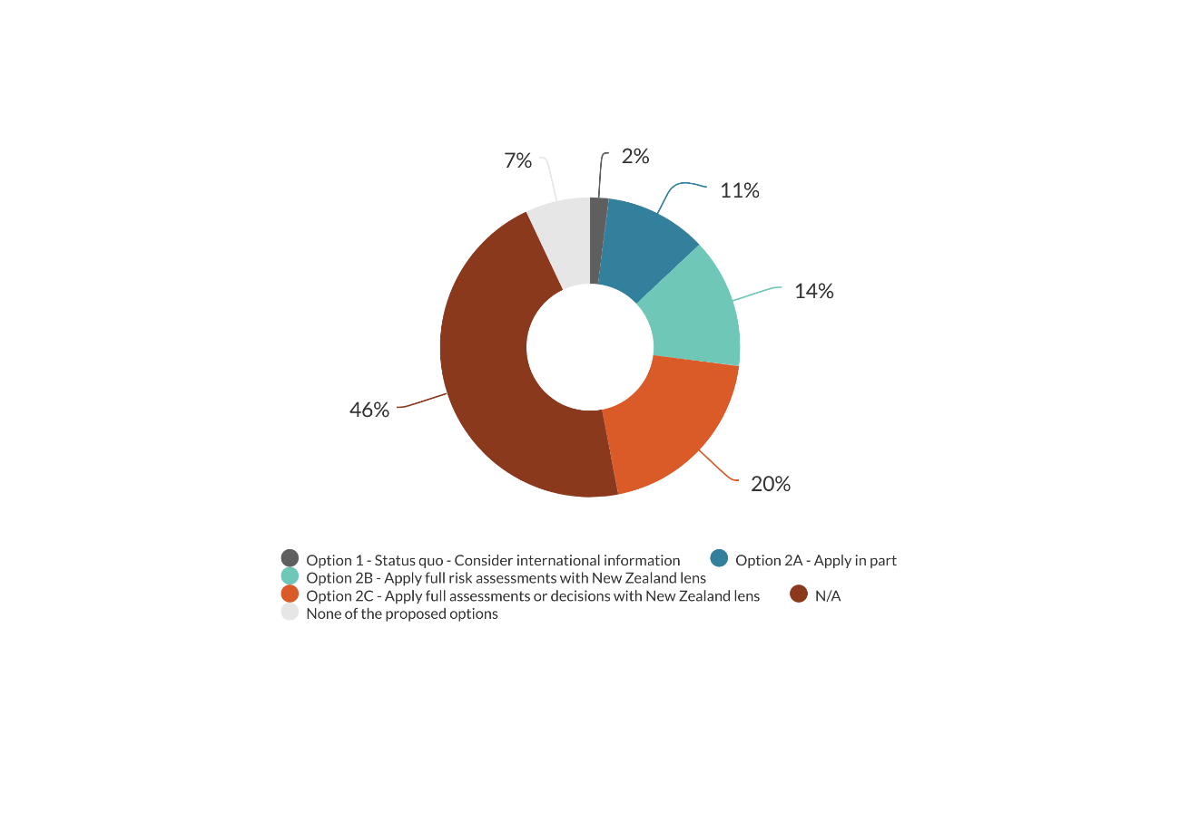

Nine submitters chose different options for assessments and reassessments. Some of these submitters cited the urgency of reassessments for some substances as a reason for a greater application of international information. Others considered that initial assessments need more caution than reassessments because there is more available information for substances with existing approvals. As a result, these submitters supported the greatest use of international information for reassessments (option 2C) but a more conservative option for initial assessments (option 2A or 2B).

Other submitters noted that reassessments have post-market implications and should consist of a more independent process, with consideration of the New Zealand context. To these submitters, option 2C would suit reassessments involving minor changes with minimal impact, and 2B reassessments involving more substantial changes, while option 2C would be appropriate for initial assessments.

Six submitters believed that requirements should be the same for both assessments and reassessments, and the rest did not answer this question.

Most submitters stated it’s important to consider the New Zealand context (see figure 8). Only four submitters opposed this, either because the submitter did not trust any regulators, or they thought in some cases (such as single component chemicals) the New Zealand context is not always applicable, or the submitter wanted this to be considered on a case-by-case basis.

Figure 8: When applying information from a trusted regulator, should the New Zealand context always be considered?

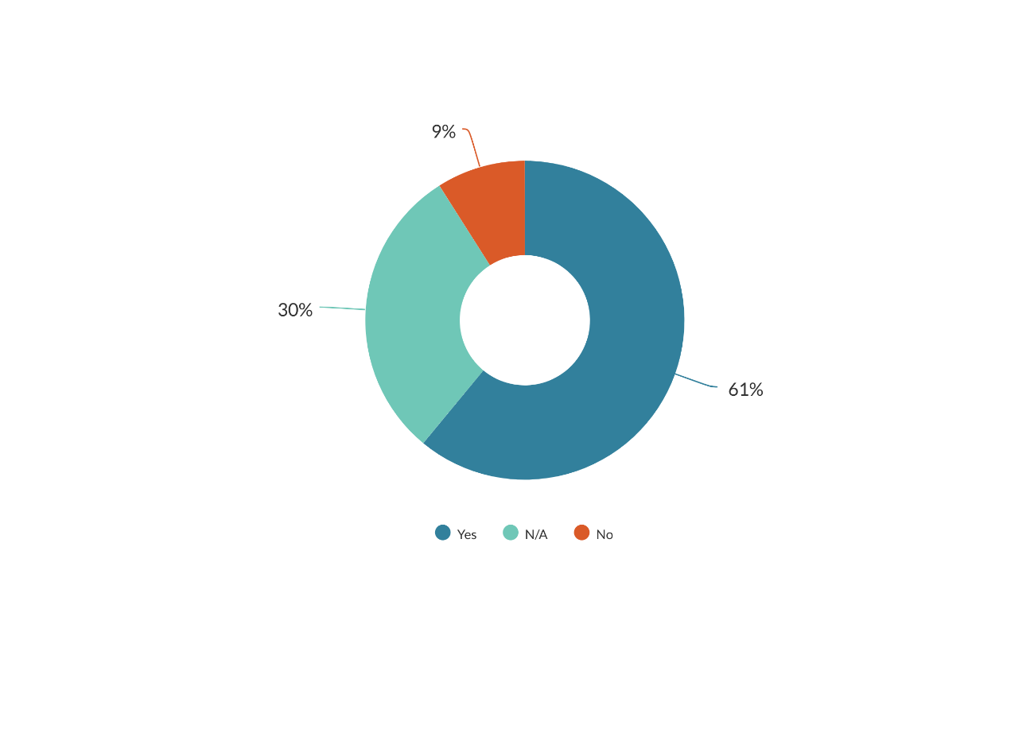

In general, submitters supported the idea of making better use of international information, provided there would be more clarification on the trusted regulator approach, and the EPA would retain responsibility for considering the applicability of the information to the New Zealand context, including environmental, economic, and cultural impacts. Submitters suggested the EPA to manage all technical differences between the trusted information and the applications to the EPA. Submitters were also keen for continuing public engagement, so the industry and the public could challenge any concerns raised from the trusted information. The chemical industry would like to further discuss the trusted regulator approach before the Government advances to the policy decisions.

Submitters were broadly supportive of the proposed criteria for choosing a trusted regulator, but also suggested some further consideration of the trusted regulators’ reputation or assessment methodology. The use of scientific information, data and assessments supported by a full package of data was widely accepted, whereas applying full risk assessments and decisions with withheld information was perceived as risky.

### Proposal 2: Applying trusted information to suspend or temporarily restrict an approval

#### An appropriate threshold for a suspension

Twenty-three per cent of submitters agreed with the current threshold for suspending an approval. They believed that lowering the threshold may have negative impacts on both chemical industry and users, especially where there are no suitable alternatives or the hazardous substance is important for their business. Submitters suspected that overseas regulators may ban a substance based on hazard assessments without considering risk management methods, or for other reasons not relevant to New Zealand. The chemical industry wanted to have a say before the EPA suspends a substance, to avoid serious impacts from a suspension, especially where a reassessment later proved that the suspension was unnecessary. Submitters asked for compensation if the latter were the case.

Another submitter considered that relying on only overseas information to suspend an approval was problematic because the EPA has no monitoring and measuring of hazardous substances effects on the environment to fully understand the costs and benefits of a substance without undertaking a reassessment.

Some submitters also wanted to have specific details of cases where the EPA felt suspension was necessary but was unable to meet the current threshold under section 64. Some submitters cited the case study in the discussion document as an example that not all concerned substances were banned after a reassessment, and that sometimes the EPA needs to set a phase-out time.

Submitters were also concerned about potential inconsistency in how different regulators interpret risk, and suggested reviewing the Hazardous Substances and New Organisms Act 1996 (HSNO) and the Hazardous Substances and New Organisms (Methodology) Order to enable the use of the precautionary approach and developing criteria for using the suspension power in a consistent way.

On the other hand, 27 per cent of submitters considered the current threshold for suspending an approval is too high, because it was aimed at acute issues instead of the possibility of longer term impacts, which led to the EPA never having been able to suspend an approval. As a consequence, substances of concern are still being used.

These submitters stated that transferred substances with inappropriate controls are still being used, and requested the EPA take a precautionary approach to protect the environment. Submitters wanted the EPA to react more quickly to international information. These submitters also used the case study in the discussion document to claim that the chemical industry and end-users were better resourced to submit to the EPA’s reassessment. They believed that as a result, some substances of concern continue to be used for a period of time.

#### Timing of a suspension

Twenty per cent of submitters supported the current timing of a suspension (after a decision to reassess is notified), because a suspension decision should be based on sound risk-benefit analysis in the New Zealand context. They suggested the EPA notifies the industry and the public about the planned suspension, or fast track the reassessment process, rather than suspending an approval without consulting the industry. Some submitters wanted the EPA to consider alternatives before suspending an approval, to mitigate impacts on the industry and end-users.

Some other submitters wanted earlier suspension, to manage risks to people and the environment. One submitter wanted the EPA to suspend all approvals until there is evidence of their safe use.

#### Temporary restriction

Some submitters agreed that a temporary restriction is sometimes more appropriate than a suspension, because this would allow for some special uses, such as biosecurity responses, critical phases of fruit or crop production, or redesigned formulation to be less toxic. One submitter supported suspension and temporary restriction for non-horticulture uses only. Some supporters requested that the EPA engage with industry to address any concerns before making a suspension or temporary restriction decision.

Submitters raised an issue about implementing the restriction, as this requires management and enforcement such as approval to purchase, contacting purchasers regarding new conditions, and so on.

Submitters opposed to this proposal were concerned that overseas decisions could be influenced by political biases or matters not relevant to New Zealand. They thought that the benefits of substances to the New Zealand economy also need to be considered. These submitters did not support any suspension or restriction without a reassessment where industry has an opportunity to be consulted on.

#### Options for changes

Twenty per cent of submitters chose option 1 (maintaining the status quo of a high threshold for suspension), and required consultation with the industry before a suspension or restriction (see figure 9). One of the reasons cited was that overseas decisions could be biased or politically influenced, and a suspension or restriction could be very disruptive to the market. Another reason was that an approval may cover different products and the ban may be needed for only one or some of them, while the rest would be unfairly affected. Some submitters were also concerned that the decision would be made subjectively and inconsistently by the regulator. Another submitter believed that there are rarely any occasions where a suspension is needed and the risk we are concerned about is non-existent.

The chemical industry did not agree with our assumption that a suspension may motivate industry to provide information to maintain an approval. These submitters considered that industry has always been prompt to response to the EPA’s requests for information (see more in Proposal 4).

The industry was of the opinion that this proposed change may “lead to greater uncertainty for the industry, place the wider New Zealand economy and environment at risk, and is seen as providing no benefits”. Implementation of suspensions or restrictions was also a concern.

They suggested looking at other legal options such as the “Red Alerts” the EPA has been issuing on certain substances, or restrictions under the Agricultural Compound and Veterinary Medicines Act 1997 or WorkSafe regulations.

Twenty-three per cent of submitters supported changes to section 64 to lower the threshold, allowing timely suspension to protect human health and the environment. Some submitters suggested new criteria including: “reasonable danger to human health or safety or the environment”, “evidence-based potential danger”, “serious chronic effects”, or “clear and certain evidence of potential harm within New Zealand or from a trusted regulator”.

Submitters also put forward the idea of following the Canadian approach to seek a Ministerial decision.

Figure 9: Options for suspension or restriction

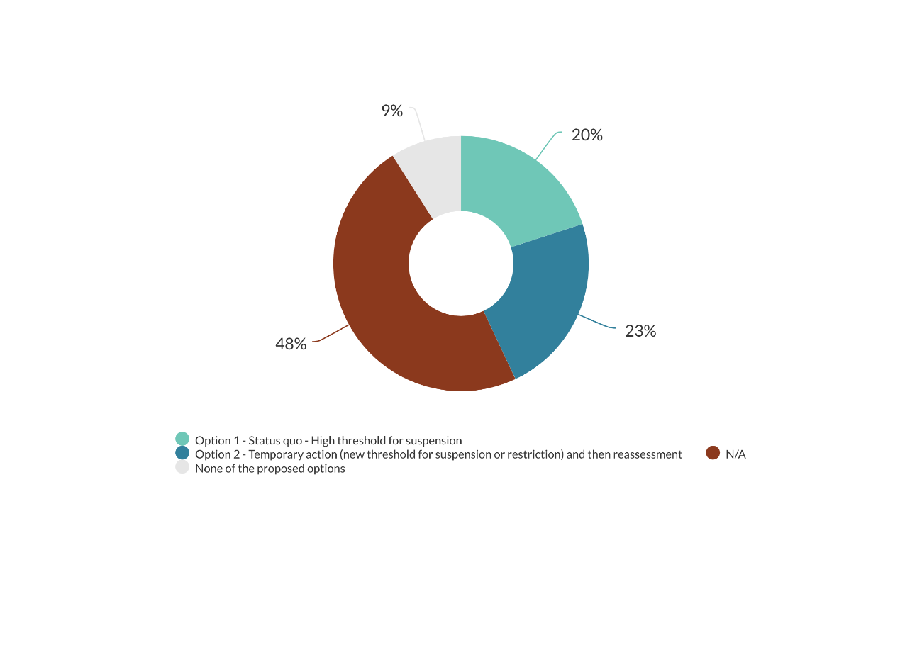

Submitters noted impacts of a suspension or restriction including profit or economic loss especially where there are no alternatives, potentially job losses, or an industry even leaving the New Zealand market. Submitters also questioned how the EPA monitors and ensures compliance of a suspension or restriction. One submitter mentioned the need to retain special use for biosecurity purposes. Other submitters also noted proposed changes to section 64 may bring benefits to human health and the environment, and encouragement for less harmful hazardous substances.

To manage the impacts of a suspension or restriction, submitters suggested:

* engaging with the industry and growers to consider the impacts of a decision, including economic loss; this would also shift the burden of proof from the EPA to the industry to maintain an approval
* applying a suspension or restriction where there is high risk only
* enabling ongoing vital use with appropriate controls
* triggering a priority reassessment of that substance to limit adverse consequences for industry or the environmental outcomes.

One submitter noted “Safety should always trump ‘negative impacts ... on the industry and end-users’”. Another submitter was concerned that industry would support maintaining an approval rather than providing information on the risk of the hazardous substance. This submitter also noted that the public and NGOs often submit published peer-reviewed information, whereas industry’s data is unpublished.

Another submitter suggested a tax break for people who grow organic produce. There was also a comment about generic pesticides formulations that could be more toxic than the active ingredient but have not been assessed.

In general, feedback on this proposal was mixed. While some submitters supported lowering the threshold for suspending an approval to better protect human health and the environment, others wanted to retain the high threshold. Opponents of the proposal were concerned that it could have impacts on the chemical industry and end-users, especially where there are no alternatives or international information could be biased and not relevant to the New Zealand context.

Responses to proposed changes to the timing of suspension were also mixed, mainly because industry wanted to have input towards the decisions. Most submitters supported a temporary restriction to allow vital uses, such as biosecurity or critical phases of fruit or crop production. More work is needed on monitoring and enforcing a suspension or restriction decision.

### Proposal 3: Applying a trusted regulator’s decision to change a hazard classification

Submitters supported a more internationally harmonised classification system to facilitate trade and reduce cost and burden on industry. In general, submitters also supported a shorter process to allow changes of hazard classification in a more efficient way. However, one submitter noted that the EPA has already processed these changes in batches through a chemical review, which is very efficient. Some submitters commented that engagement with industry and the public is still necessary, because:

* new information or data may be available after a trusted regulator’s decision
* different regulators may have different practices and approaches in determining hazard classifications
* different regulators may assign different classifications on a chemical based on the same data
* differences in substance formulation need to be considered.

Figure 10: Options for adopting a trusted regulator’s decision to change a hazard classification

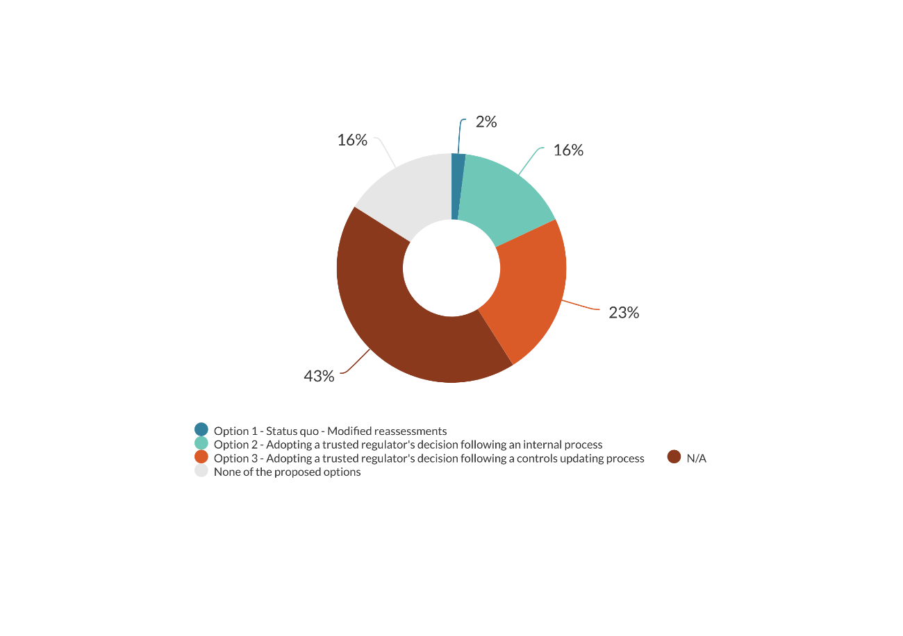

Only one submitter clearly chose option 1, maintaining the status quo, while a significant number of submitters supported a shorter process that includes stakeholder engagement (option 2 or 3 with engagement with stakeholders) (see figure 10). Some submitters chose option 2 only if the EPA were to adopt the EU’s decisions. Submitters also raised the issue of how the EPA would target the right stakeholders in a targeted consultation (see more in Proposal 5).

One submitter suggested allowing the EPA to update or correct classifications where there is an obvious error, rather than following a reassessment process. Some submitters supported a shorter process for stricter controls, and a more complicated process for relaxing controls.

Some submitters supported the EPA adopting a trusted regulator’s classification change before the Globally Harmonized System of Classification and Labelling of Chemicals (GHS) update is complete, if the trusted regulator also applies GHS classification. Two submitters opposed the adoption before the completion of the GHS update, because currently the EPA only partially adopts GHS. These submitters requested that the HSNO classification system fully align with GHS first.

In summary, submitters supported a shorter process to enable faster changes of hazard classifications based on a trusted regulators’ decision. However, due to technical matters, this process should include engagement with industry and the public to ensure appropriate controls are in place for managing hazardous substances in the New Zealand context. Submitters also suggested using the Chemical Review process to make changes to hazard classifications.

### Proposal 4: Collecting quality information for reassessment

One submitter recognised the difficulties faced by the EPA in collecting information for reassessments:

The EPA does not know who is importing chemicals and how much is coming into the country. The EPA does not know all of the products the chemical is in and what all of those products are used for. Aside from information sharing from Customs (limited by tariff codes). The EPA will find it difficult to get totally accurate usage information for New Zealand. Additionally the EPA will find it hard to compel businesses to spend a lot of time responding to a request for information if they don’t feel they are affected, or stand to benefit from their investment.

Industry and growers commented that they have always been prompt to respond to the EPA’s requests for information. Industry submitters stated that in some instances industry may have not provided information because:

* they did not hold the information
* the cost of collecting the information was too high, and the return would not be sufficient
* there is a lack of data protection under the HSNO Act.

Growers were concerned that as New Zealand is an insignificant market for agrichemicals, the chemical industry may at times have less incentive to maintain some approvals, while the growers are more impacted by the reassessment process.

Therefore, most submissions from the chemical industry and growers supported the status quo, keeping the call for information voluntary, and requested the EPA make changes to the call for information. This included:

* being more specific about the information requested[1]
* not asking for information on a long list of substances[2]
* allowing sufficient time for the industry to respond
* avoiding requests during holidays or growing and harvesting seasons
* providing greater data protection.

One of the reasons for maintaining the status quo was:

revoking an approval could inadvertently remove critical products from the marketplace. There may be instances where a business may not be across these requests or may not be marketing the concerned substance at the present moment. Revoking approvals minimises market capability and in turn could create more work in re-establishing the same approval again down the track – creating a reduced efficiency burden to government and industry.

One local council also supported the status quo because the proposals “seem more about providing more flexibility to remove/amend approvals on the basis of insufficient information than improving consultation.” The council questioned the merit of a statutory call for information, and noted this would also impose another step in the process. Many other submitters did not clearly express their position on a preferred option (see figure 11).

Figure 11: Options for collecting quality information for reassessments

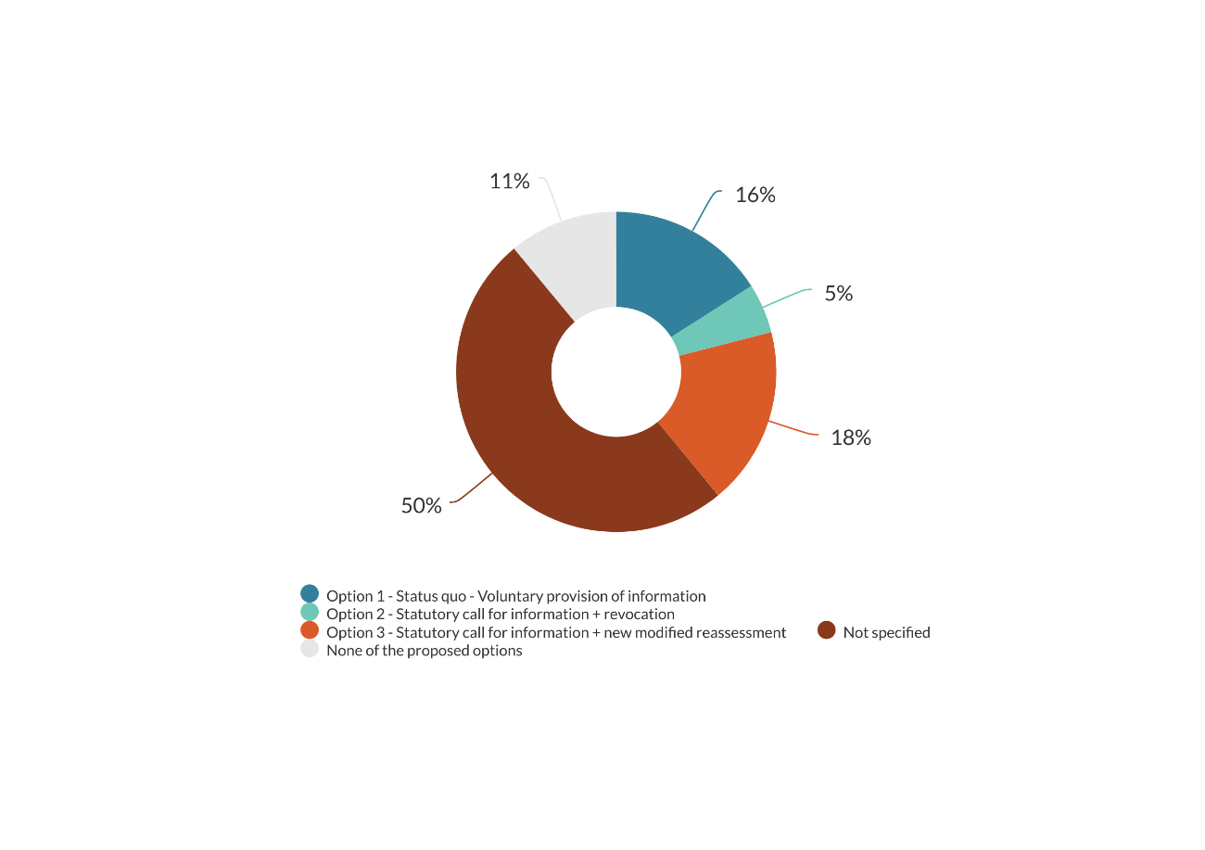

Twenty-three per cent of submissions supported option 2 or 3 (statutory call for information, and revocation of approvals because of lack of information). One submitter raised an issue that civil and scientific societies are under-resourced to respond to the call for information to balance with information from the industry. Some submitters suggested that the EPA uses the Cultural Health Indicators and international information as part of information for reassessment.

Some submitters questioned the reasons why the EPA takes the burden of proof for external reassessments and suggested the EPA simply declines external applications if there is a lack of information. Some submitters suggested making wide notification to the public, and update HSNO classifications to the GHS to improve engagement from a global perspective.

Most submitters requested that “lack of information” must be prescribed by the HSNO Act or regulations, to ensure consistency in interpretation and implementation.

In general, feedback on this proposal was mixed. Industry and end-users stated that they have always been active in responding to the EPA’s calls for information, and a revocation of an approval would have great impacts on their business, so the proposal should be cautiously progressed. They also suggested the EPA make operational changes to the way they undertake the call for information, to increase responses. Other submitters were supportive that the burden of proof should be on the industry rather than the EPA.

### Proposal 5: Streamlining targeted consultation for modified reassessments

Most submitters agreed that the EPA can be more targeted in consulting during modified reassessments, because this process only looks at one or some aspects of an approval (previously publicly consulted on). However, submitters raised an issue of how the EPA determines the appropriate stakeholders for targeted consultation. One submitter noted that the targeted consultation for modified reassessment is not as time consuming as a public notification of a full reassessment, because the scope of the information that needs to be gathered and assessed is limited. Another submitter suggested that “public consultation should not be seen as a negative burden to efficiency. Public consultation is seen as best practice and should be maintained to support a fair system and avoid potential biases in decision making”.

Figure 12: Would you support an option that allows the EPA more flexibility in consultation?

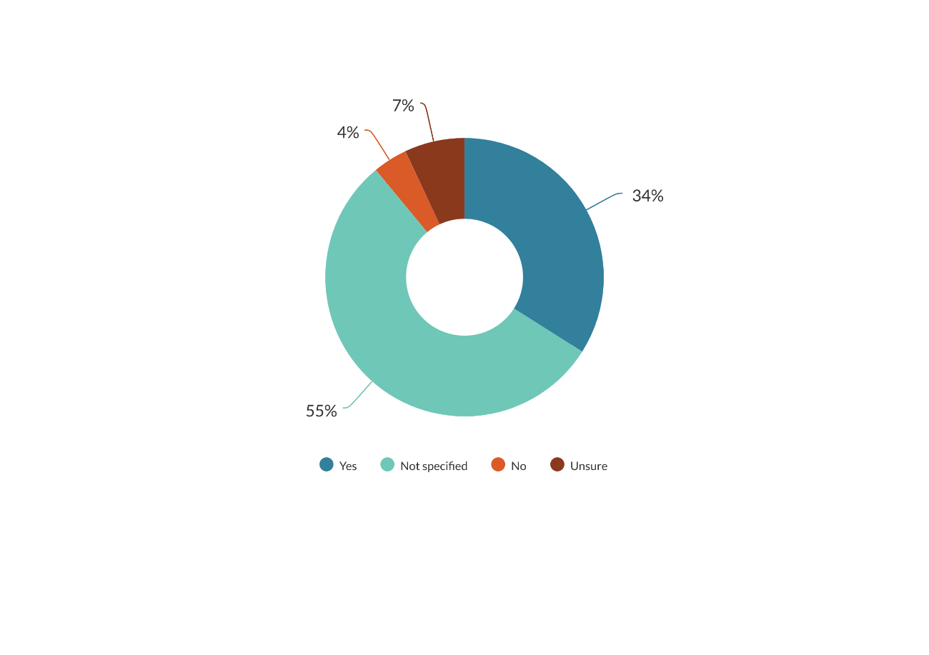

Although the majority of submitters did not indicate whether they supported option 2 (allowing more flexibility on targeted consultation for modified reassessments) (see figure 12), a significant number of submitters supported a more targeted consultation. These submitters felt there must be clarification on who would be the targeted stakeholders (for example, manufacturers, importers, downstream users, and industry association), and the EPA must be able to identify those stakeholders.

Some submitters supported public notification because they believed that targeted consultation would allow the industry to have their say while the public and scientists may have no voice and the EPA may target wrong stakeholders.

One submitter recommended the EPA publicly notify modified reassessments in the *New Zealand Gazette*, allowing for written submissions from the general public but not hold a public hearing. This would be in addition to targeted consultation.

Most submitters agreed that the EPA could be more targeted in consulting during modified reassessments, because this process only looks at one or some aspects of an approval (which has been previously publicly consulted on). However, submitters questioned how the EPA would identify the appropriate stakeholders for targeted consultation.

### Proposal 6: Streamlining the early stage of reassessments of priority chemicals

Some submitters agreed that there may be duplication of work between the prioritisation process, and the formal justification (ground step)[3] for reassessing chemicals on the Priority Chemical List (PCL). One submitter pointed out that the duplication can be insignificant, because the EPA would not need great effort to prepare for the grounds for priority chemicals.

The majority of submitters did not indicate their position for a preferred option for Proposal 6 (see figure 13). One submitter supported option 1 (the status quo). This submitter had little trust in the EPA’s Flexible Reassessment Categorisation Screening Tool (FRCaST). One example was cited that a chemical was put on the list just after it had been approved. This meant the prioritisation process focused more on hazard and less on risk. More importantly, this meant there was no new information to meet the ground criteria. This submitter was also critical of the EPA’s perceived lack of engagement with the industry about concerns relating to the PCL.

Some submitters (who did not indicate their position) also criticised the screening process, stating that it did not engage with the industry, or take into account published scientific literature to protect human health and the environment (for example, literature on neonicotinoid or glyphosate).

Supporters of option 2 (giving the PCL a statutory status, and skipping grounds for reassessment of priority chemicals) required industry consultation on the PCL, and a public notification or a calendar of upcoming reassessments of chemicals on PCL (via the EPA’s website, newsletter, or even newspapers). Supporters of option 3 (adding the PCL to the list of grounds) also requested industry consultation on the PCL. To these submitters, adding the PCL to the list of grounds meant that the chemicals on the list should be considered for reassessment, but this would not be the sole criteria.

Some submitters (who did not indicate their position) also emphasised the need to know what chemicals will be the next for reassessment.

Figure 13: Options for reassessments of priority chemicals

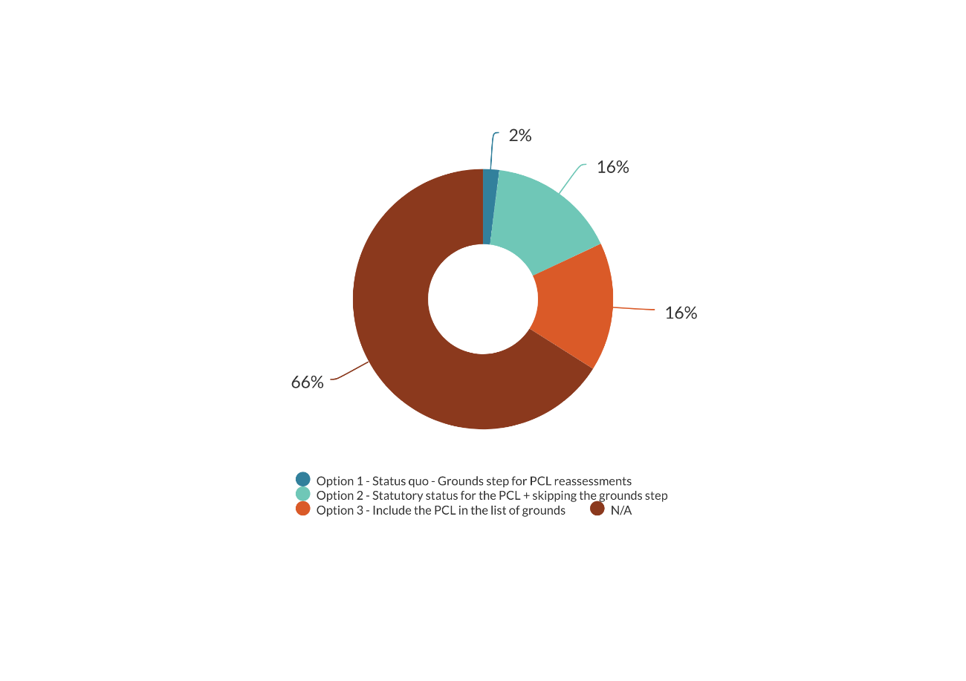

Overall, submitters agreed that there may be duplication of work between the prioritisation process and the grounds step for reassessing chemicals on the Priority Chemical List (PCL). However the duplication could be insignificant because information used for prioritisation could be reused and expedite the grounds step. Submitters generally supported the proposal to reduce the duplication, but were also interested in being engaged in the prioritisation process to identify the PCL.

### Proposal 7: Avoiding replication during assessments of related substances containing the same active ingredient

Some submitters agreed that there may be duplication of work between reassessment and assessment of substances containing the same active ingredient. There was also a question about the frequency of this situation, and the need of legislative intervention.

The chemical industry was against the proposal, because they were concerned that the EPA may impose “some controls which result in making some products with the same active ingredient unusable” without considering the different uses of different substances. They were also concerned that a reassessment is triggered because there is an application. One example was cited:

The EPA receives an application for a new glyphosate formulation. Unlike for existing glyphosate formulations, they now want to impose buffer zones on this new substance. All existing approvals will be reassessed at the same time to apply buffer zones across the board (not necessarily the same buffer zones but a consistent spray drift policy. On the second point in such cases the EPA would be viewed as interfering with the free market. The new substance would cause no harm beyond the products that are already available in the market. Also, there is an expectation that the substance will be approved under the current principles and risk assessment framework adopted by the EPA. As such, it is unlikely the risks (if any) that will rise from the use of the substance will be unacceptable.

From these comments, there may have been misunderstanding of the situation where the proposal applies. The proposal is for a situation where an application for a new substance is made while a reassessment is under way. The application cannot trigger a reassessment (as interpreted by some submitters).

There was also a misunderstanding that the EPA would not consider the differences between substances (combining decisions (as interpreted by some submitters) vs combining the timing of the processes (as proposed)).

Some other submitters supported the status quo (two separate assessment and reassessment processes and the new approval can be granted before a reassessment is made), or did not indicate their position (see figure 14) but suggested that the EPA add a condition in the approval of the new substance to allow the approval to be automatically updated following a reassessment decision. This is because the reassessment can take time and the proposal could delay the access to market of the new substance.

Some submitters agreed that option 2 (combining the timing of the two processes) would ensure consistent decision-making and improve efficiency. This option also allows data of the new application to be used for the reassessment.

Supporters of option 3 (declining or postponing the new application) believed that it is not right to add a new formulation to the market while the active ingredient is being reassessed, because of risks to the human health and the environment.

One submitter suggested asking the applicant if they would like to withdraw the application until a reassessment decision is made.

Figure 14: Options for assessment and reassessments of substances containing the same active ingredient

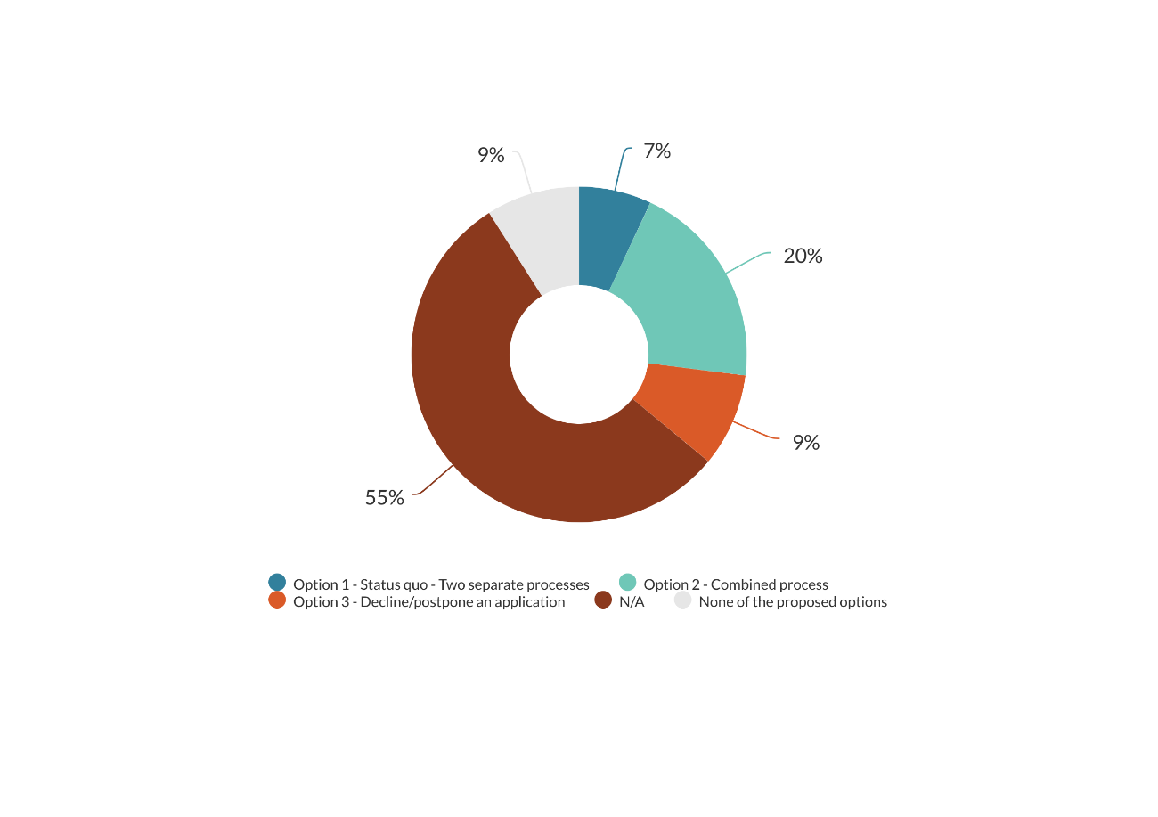

To summarise, submitters agreed that there may be duplication of work where there is an application for a substance with an active ingredient that is currently being reassessed. However, the benefit of the proposal could be small because of the low frequency of this situation.

### Proposal 8: Updating controls on existing substances based on a recent EPA assessment

Again, many submitters did not indicate their position (57 per cent) but a significant number of submitters (43 per cent) agreed that controls on existing substances should be updated quickly to align with a more recent EPA assessment. Thirty-two per cent of submitters supported option 3 (following a controls updating process to allow the update to happen in a timely manner) (see figure 15), and only two per cent supported the status quo.

Supporters of option 3 also raised concerns about the transition period for implementing new controls on existing substances (updating safety data sheet, labelling, etc). They suggested the EPA holding a targeted consultation during the controls-updating process, rather than having discretion in consultation. This would also address concerns of other submitters who did not indicate their preferred option.

This suggestion means the EPA would not automatically apply the changes of controls on existing substances. Instead the authority would engage with related stakeholders to consider appropriate controls on specific uses vs controls on the intrinsic hazard of different substances containing the same active ingredient.

One submitter requested a cost-benefit analysis to understand the impact of the options. Despite recognising the importance of consistency in hazardous substances management, and the potential for a level playing field, the industry was concerned that this proposal may enable the EPA’s ‘new practices’ of managing substances to be constantly applied to existing substances. This would create instability to the market. Industry suggested this should be undertaken every 10 years, for example.

Figure 15: Options for updating controls on existing substances based on a recent EPA assessment

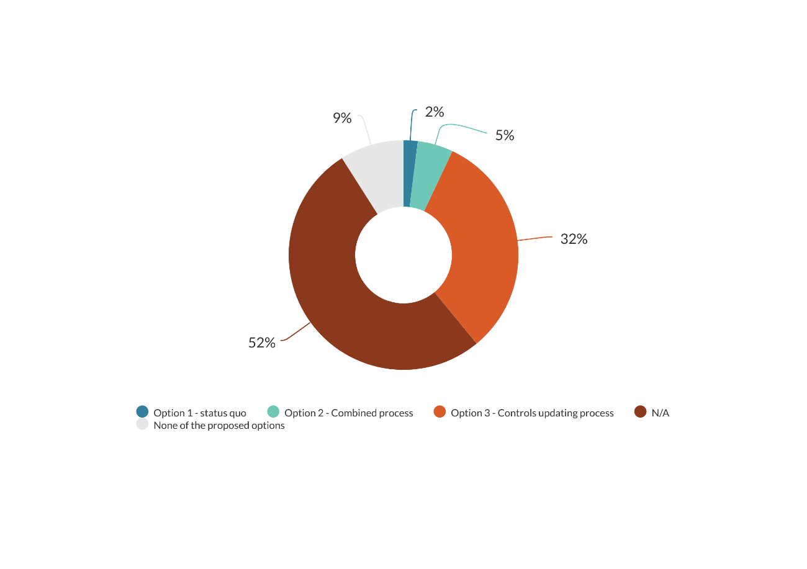

In general, submitters supported a simplified process for updating controls on existing substances based on a recent EPA assessment. Similar to feedback on the proposal for changes to hazard classification based on a trusted regulator’s decision, submitters requested a targeted consultation during this process. The industry raised concern that this proposal could create market instability.

### Other issues raised by submitters

Submitters mentioned some other matters that may not fit well into the proposals, such as:

* changing the scope of the HSNO Act from substances to Trade Name Products, to enable the EPA hold information of all companies commercially using hazardous substances in New Zealand
* setting statutory timeframes for reassessments of all hazardous substances
* providing fee incentives for applications of safer alternatives
* focusing on controls on substances that have no substitutes
* introducing a fast-track process or lighter touch for low-risk substances
* greater data protection
* taking a pragmatic approach to permitting trials in containment
* letting industry classify substances
* introducing a metal risk-assessment framework to consider metal specificities.

1. focusing on new risks and data gaps
2. manageable workload for industry
3. Under Section 62 of the HSNO Act, the EPA may decide that grounds exist to reassess a hazardous substance after taking into account new information triggering a reassessment, for example, significant new information relating to the effects of a hazardous substance. The process of establishing grounds for reassessment is, hereafter, referred to as a formal justification for reassessment or grounds step, which is the first step of a formal reassessment process.