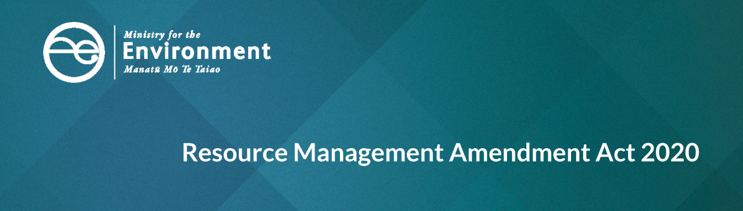

# **Changes to compliance and enforcement**

This is part of a series of factsheets that give an overview of amendments made to the Resource Management Act 1991 (RMA) by the Resource Management Amendment Act 2020 (the Act).

This factsheet outlines changes to compliance and enforcement functions of the RMA. All of these changes take effect on 1 July 2020.

## Timeframe for laying prosecution charges

**Previously,** the limitation period for an offence against the RMA ended six months after the date on which the contravention giving rise to the charge first became known, or should have become known, to the local authority or the consent authority.

**Section 338(4) of the RMA has been amended** to extend the limitation period to 12 months.

**The overall intent of this change** is to:

* give more time for investigations to be completed
* enable better decisions about which potentially liable parties should face charges
* ensure consistency with comparable regulatory compliance limitation periods.

## Maximum infringement fees

**Previously**, the maximum fee for an infringement offence that can be set through regulations under the RMA was $1,000.

**Section 360(1) of the RMA has been amended** to provide for maximum fees for infringement offences to be up to $2,000 in the case of a natural person, and up to $4,000 in the case of a person other than natural persons (ie, entities with legal personhood, including the Crown, a corporation sole, and also a body of persons, whether corporate or unincorporate).

**The overall intent of this change** is to ensure infringement fees are an adequate deterrent. The change also provides a consistent approach for sentencing offences under the RMA, where the maximum fine for non-natural persons is double the maximum fine for natural persons.

The actual fees that can be issued for infringement offences are specified in regulations (see Schedule 1 of the Resource Management (Infringement Offences) Regulations 1999). Now that the RMA has been amended, new regulations setting new infringement fees in line with the new maximums may be prepared.

## A new role for the Environmental Protection Authority

**Previously,** the compliance and enforcement functions of the RMA have been delegated only to councils (and in relation to specified offshore islands, the Minister of Local Government or the Department of Conservation).

**The RMA has been amended** to allow the Environmental Protection Authority (EPA) to also have a role in RMA compliance and enforcement.

The EPA has discretion to become involved in an RMA compliance investigation in three different ways. The EPA may:

* start an investigation into any incident or allegation of RMA non-compliance that no local authority is already dealing with
* help a local authority with an investigation into any incident or allegation of RMA non-compliance at the invitation of (or by agreement with) the local authority
* intervene in, and become the lead agency on, an investigation started by a local authority.

To support the EPA with this new role, various powers and functions also become available to the EPA. These include the ability:

* to appoint enforcement officers through a warrant of appointment
* for EPA enforcement officers to enter private property (excluding a dwelling house) under section 332 of the RMA to undertake an inspection and obtain samples, for the purpose of determining compliance with the RMA
* for EPA enforcement officers to issue compliance notices under the RMA, including abatement notices under section 322 and infringement notices under section 343C
* for EPA enforcement officers to apply to the Environment Court for a determination, enforcement order or interim enforcement order
* to prosecute (file a charging document) for an offence against the RMA in the district court

• to require information from a local authority to support an RMA investigation

* to obtain and execute a search warrant in relation to a suspected offence against the RMA.

The EPA enforcement unit is centrally funded. However, nothing in the Act prevents the EPA and a local authority from making an agreement about cost-sharing in relation to a specific case. The RMA now includes provisions that allow the EPA to apply to the district court for a costs order for successful prosecutions.

The RMA also now includes a requirement for the EPA to include information about its use of RMA enforcement powers in its annual report.

**The overall intent** of this change is to provide a supplementary investigative resource to support our local government partners in carrying out their compliance and enforcement functions under the RMA.

#### Disclaimer

The information in this publication is, according to the Ministry for the Environment’s best efforts, accurate at the time of publication. The information provided does not alter the laws of New Zealand and other official guidelines or requirements. Users should take specific advice from qualified professional people before undertaking any action as a result of information obtained from this publication.

The Ministry for the Environment does not accept any responsibility or liability whether in contract, tort, equity or otherwise for any action taken as a result of reading, or reliance placed on the Ministry for the Environment because of having read any part, or all, of the information in this publication or for any error, or inadequacy, deficiency, flaw in or omission from the information provided in this publication.

Published in June 2020 by the  
Ministry for the Environment   
Publication number: INFO 953

