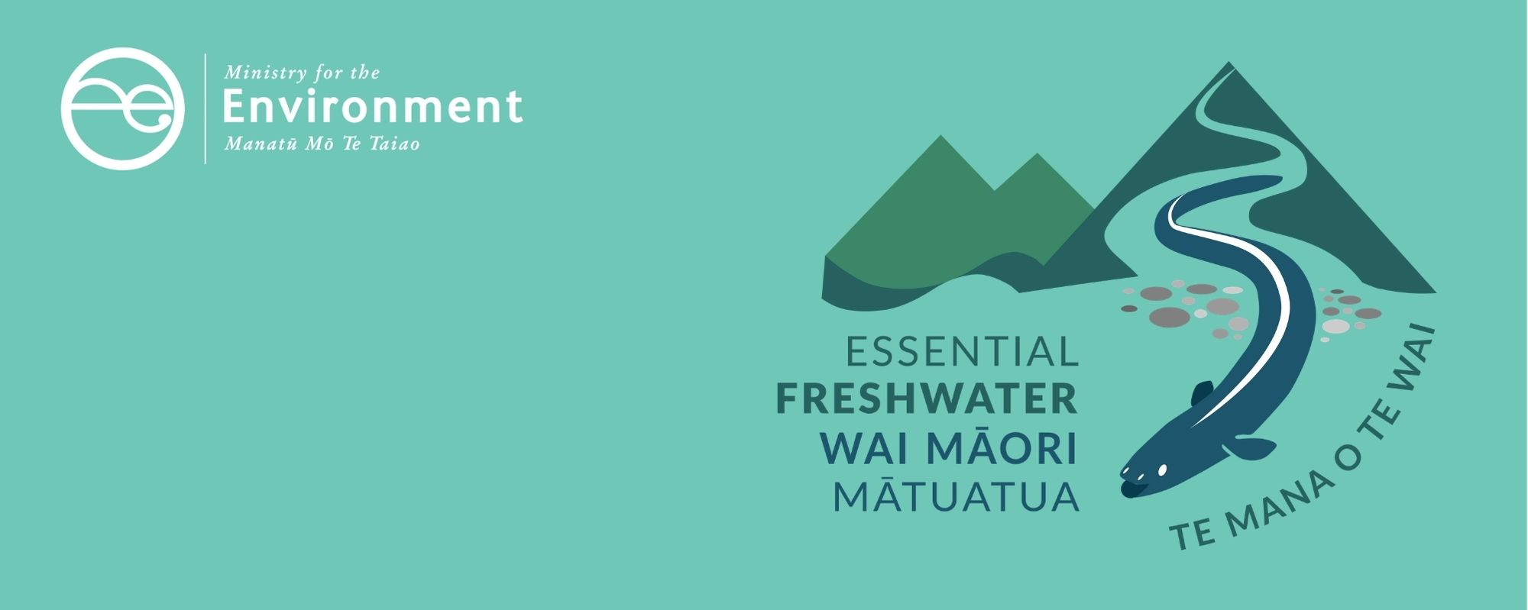

Wetlands factsheet
Essential Freshwater is part of a new national direction to protect and improve our rivers, streams, lakes and wetlands. The Essential Freshwater package aims to:
- stop further degradation of our freshwater
- start making immediate improvements so water quality improves within five years
- reverse past damage to bring our waterways and ecosystems to a healthy state within a generation.
Te Mana o te Wai is fundamental to all freshwater management
Te Mana o te Wai recognises the vital importance of water. It expresses the special connection that New Zealanders have with freshwater. By protecting the health of freshwater we protect the health and well-being of people and our ecosystems. When managing freshwater, Te Mana o te Wai ensures the health and well-being of the water is protected and human needs are provided for before enabling other uses of water. Through discussions with regional councils, tangata whenua and communities people will have a say on how Te Mana o te Wai is applied locally in freshwater management. More information can be found in the Te Mana o te Wai factsheet.

Who should read this factsheet
This factsheet is part of a series and provides information on new provisions for wetlands. It is primarily intended for council staff and land users, but may also be of interest to iwi, the wider agricultural industry, farm advisors and consultants, and anyone else with an interest in freshwater policy.

New provisions for wetlands
The National Policy Statement for Freshwater Management 2020 (NPS-FM 2020) includes new policies to avoid the loss of extent of natural inland wetlands, protect their values and promote their restoration. The new regulations in the National Environmental Standards for Freshwater (NES) place restrictions on damaging activities in and near natural wetlands. The Resource Management (Stock Exclusion) Regulations 2020 mandate that certain stock must be excluded from natural wetlands in some circumstances. The NES, NPS-FM 2020 and stock exclusion regulations come into force on 3 September 2020. Regional councils will need to amend their regional plans as soon as practicable to include a policy to avoid the loss of extent of natural inland wetlands, protect their values and promote their restoration, without using the Schedule 1 process. Any other changes to give effect to the NPS-FM 2020 through their regional policy statement and changes to regional plans will need to be notified by 31 December 2024.
NPS-FM 2020 applies to: | NES applies to:
- Natural inland wetlands1  - This includes constructed wetlands outside the coastal marine area that were constructed to offset impacts on, or restore an existing or former natural wetland. | - Natural inland wetlands AND  - Natural coastal wetlands  (Together referred to as natural wetlands1)  - This includes constructed wetlands that were constructed to offset impacts on, or restore an existing or former natural wetland
NPS-FM 2020 does not apply to: | NES do not apply to:
- Natural coastal wetlands (as these are covered by the New Zealand Coastal Policy Statement 2010 (NZCPS)).  - Geothermal wetlands  - Constructed wetlands inside the coastal marine area  - Constructed wetlands created for other purposes | - Geothermal wetlands  - Constructed wetlands created for other purposes

What are the new NPS-FM 2020 policies and when do they apply?

Overarching policy
From 3 September 2020, regional plans need to be amended to include an overarching policy to avoid the loss of extent of natural inland wetlands, protect their values and promote their restoration.
This amendment must be made as soon as practicable, without the use of the Schedule 1 process in the Resource Management Act 1991 (RMA). Under s104 of the RMA consent authorities need to have regard to a national policy statement. Councils are encouraged to seek legal advice as to how the NPS-FM 2020 applies to specific applications for resource consent that are being processed at the time of amendment.

Exceptions to the overarching policy
The overarching policy allows councils to permit or grant resource consents for some specified activities in or near wetlands. For detail on which activities may be permitted or granted resource consents, see figure 1 below.
One notable exception is that councils may grant resource consents for the construction or upgrade of specified infrastructure that will provide significant national or regional benefits, if the regional council is satisfied that there is a functional need1 for that infrastructure in that location.
Since “specified infrastructure” includes regionally significant infrastructure identified as such in a regional policy statement or plan, regional councils are encouraged to begin the process of identifying appropriate infrastructure in their policy statements and plans as soon as possible.

Managing adverse effects on wetlands
Resource consents must be assessed by applying the effects management hierarchy1 to manage any adverse effects on the wetland extent or values, including cumulative effects and loss of potential value, as a result of the proposed activity. Councils must impose conditions on resource consents to apply the effects management hierarchy and require monitoring of the wetland for the consent duration, at a scale appropriate to the potential adverse effects of the activity.
Under the effects management hierarchy, adverse effects on the wetland extent or values caused by the activity are avoided, minimised then remedied (in that order) wherever practicable, then offset or compensated (in that order) where possible. If these cannot be achieved, the activity must be avoided, and consent declined.
The Ministry is planning to work with partners and stakeholders to develop technical guidance on the effects management hierarchy. In the meantime, aquatic offsetting1 and compensation1 under the effects management hierarchy should be measured and monitored in accordance with the principles that underpin biodiversity offsetting in currently available guidance, noting that the NPS-FM 2020 and NES also require consideration of values other than indigenous biodiversity, such as ecosystem health, hydrological functioning, mahinga kai and other Māori freshwater values, and amenity values.
Aquatic offsets should achieve at least no net loss,1 and preferably result in a net gain1 in wetland extent or values. However, many values (especially biodiversity) cannot be offset or compensated due to irreplaceability or vulnerability, and if they are adversely affected, they may be permanently lost. This means for some projects, offsetting and compensation is not achievable and the activity should be avoided. This will be decided by regional councils.

Mapping and monitoring
Regional councils also need to identify, map, and monitor those natural inland wetlands that are larger than 500 square metres or that contain threatened species (if less than 500 square metres), excluding those located on public conservation lands or waters. Councils may also include coastal wetlands and conservation lands and waters in their mapping at their own discretion. Mapping must be completed by 3 September 2030. If there is uncertainty about the existence or extent of a wetland, this should be decided using the wetland delineation protocols, available online.
Monitoring should provide enough information for the council to assess whether its plan provisions are successfully ensuring no net loss of wetland extent and values. The mapping and monitoring information collected should be used to create and maintain an inventory of wetlands in the region. This data collection will support councils to track the health of wetlands in their region and provide a baseline for restoration efforts.
Additionally, regional councils must include provisions for the restoration of natural inland wetlands in their regional plans, including restoring the values of ecosystem health, indigenous biodiversity, hydrological functioning, Māori freshwater values, and amenity value.

What are the NES regulations and when do they apply?
The NES regulations come into force on 3 September 2020.
The regulations require strict measures, including but not limited to resource consents, for activities that can result in the loss of extent and values of natural wetlands. The NES prescribes activity statuses and detailed conditions for various potentially damaging activities in and around wetlands. Some activities that cause complete or partial drainage of all or part of a natural wetland are now prohibited - see figure 1 for details. A regional rule or resource consent may be more stringent than the regulations, but more lenient rules in regional plans will be superseded by the NES.
The new standards do not apply to the customary harvest of food or resources undertaken in accordance with tikanga Māori.
Figure 1 explains what activity status may apply to a proposed activity in or near a natural inland wetland. This is determined by the purpose of the activity, the type of activity, and its expected adverse effects on the natural wetland. See the NES text for detailed conditions that apply to each activity. The NES also details matters to which the discretion of a consent authority is restricted.
The relationship between these new regulations and existing consents or existing lawful activities is set out in section 43B of the RMA. In general:
- consents granted prior to gazettal of the regulations prevail until reviewed
- consents also prevail if there was a decision made about whether or not to notify the relevant consent application prior to gazettal of the regulations
- activities that require a consent under the regulations may be able continue temporarily under section 20A(2) of the RMA if:
- they were permitted, or allowed without a consent, and lawfully established, prior to the relevant regulations commencing; and
- the effects of the activities are of the same or similar character, scale, and intensity as they were before commencement; and
- the person carrying out the activities applies for consent no later than 6 months after commencement. The activities may continue until the consent application, and any appeals, are finally determined.
For activities to which section 20A applies, this means that people must apply for their consent no later than 2 March 2021.

Figure 1: The status of wetlands activities under the National Environmental Standards for Freshwater
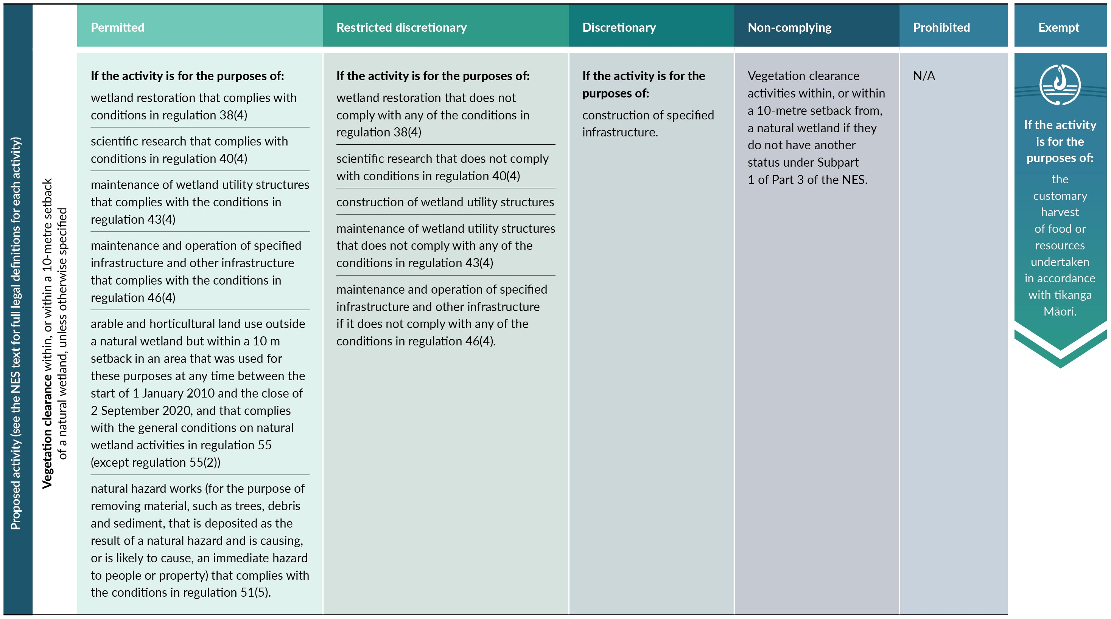
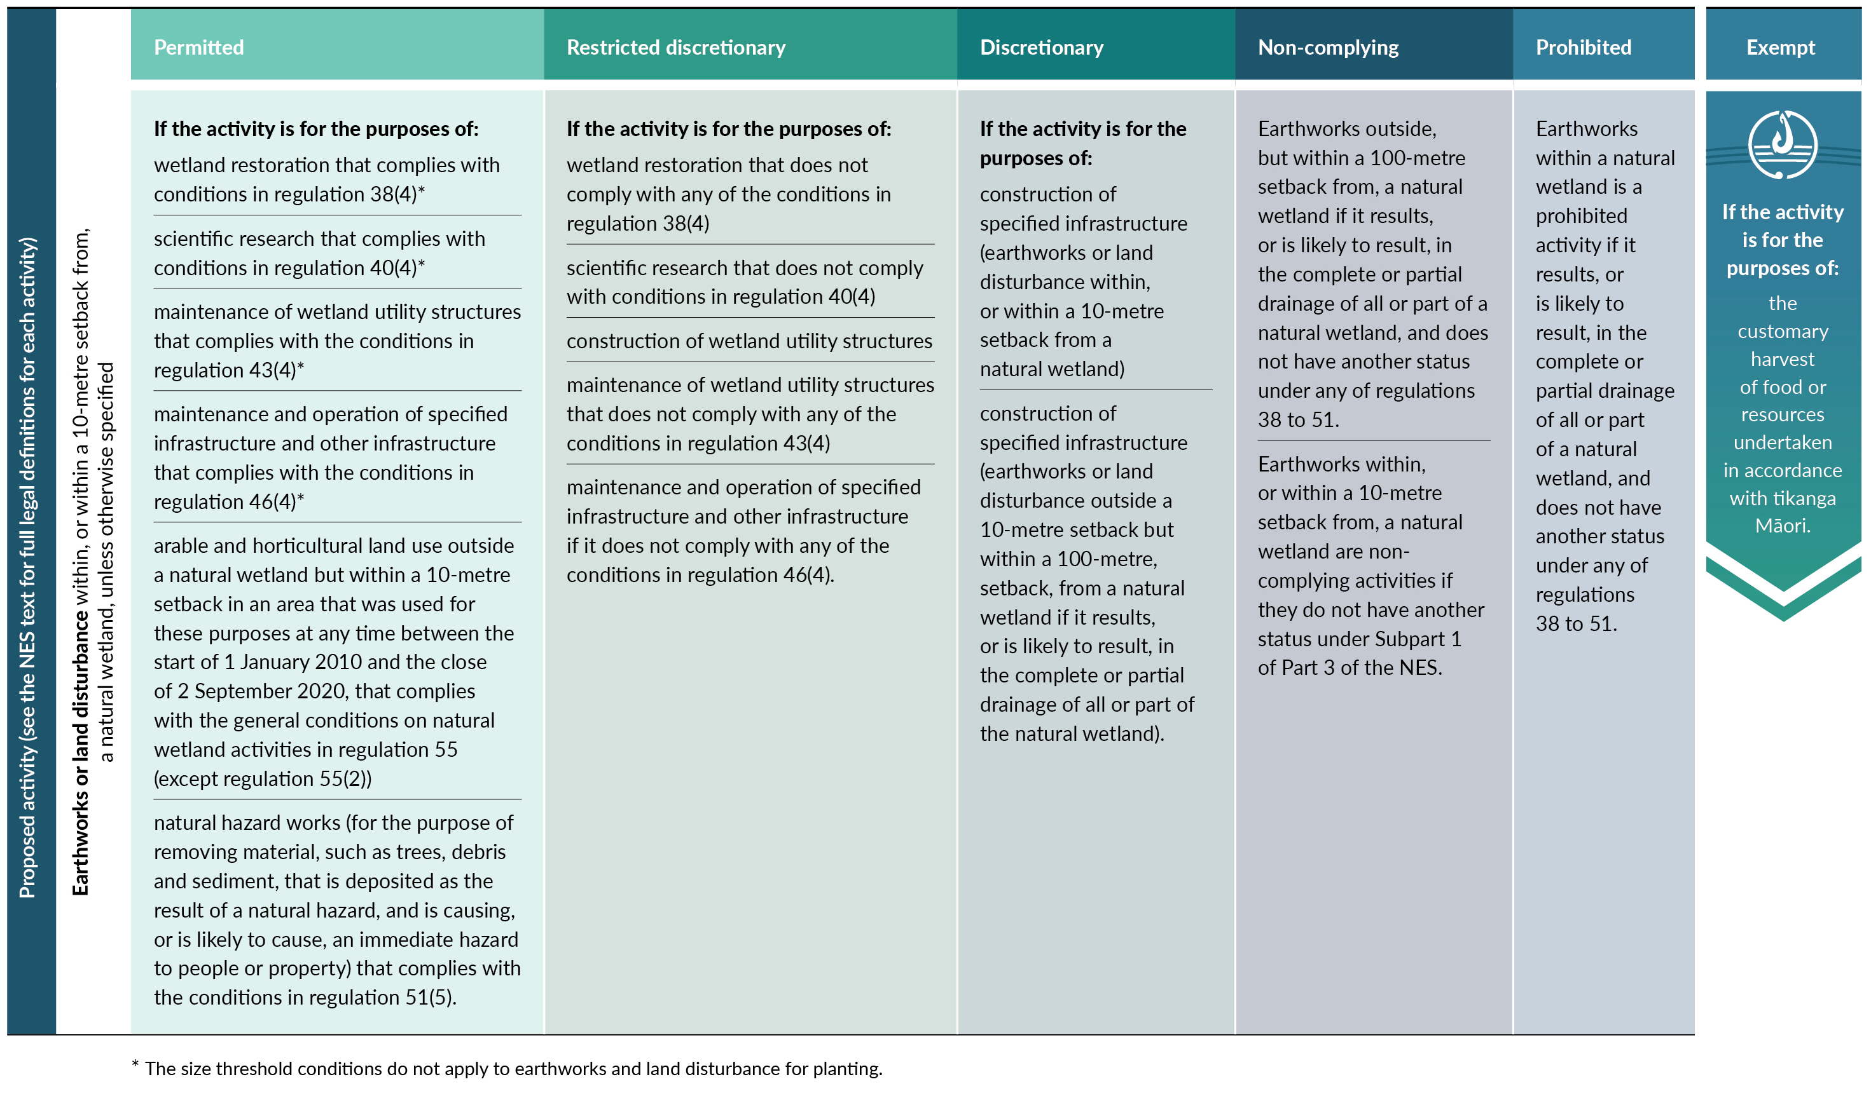
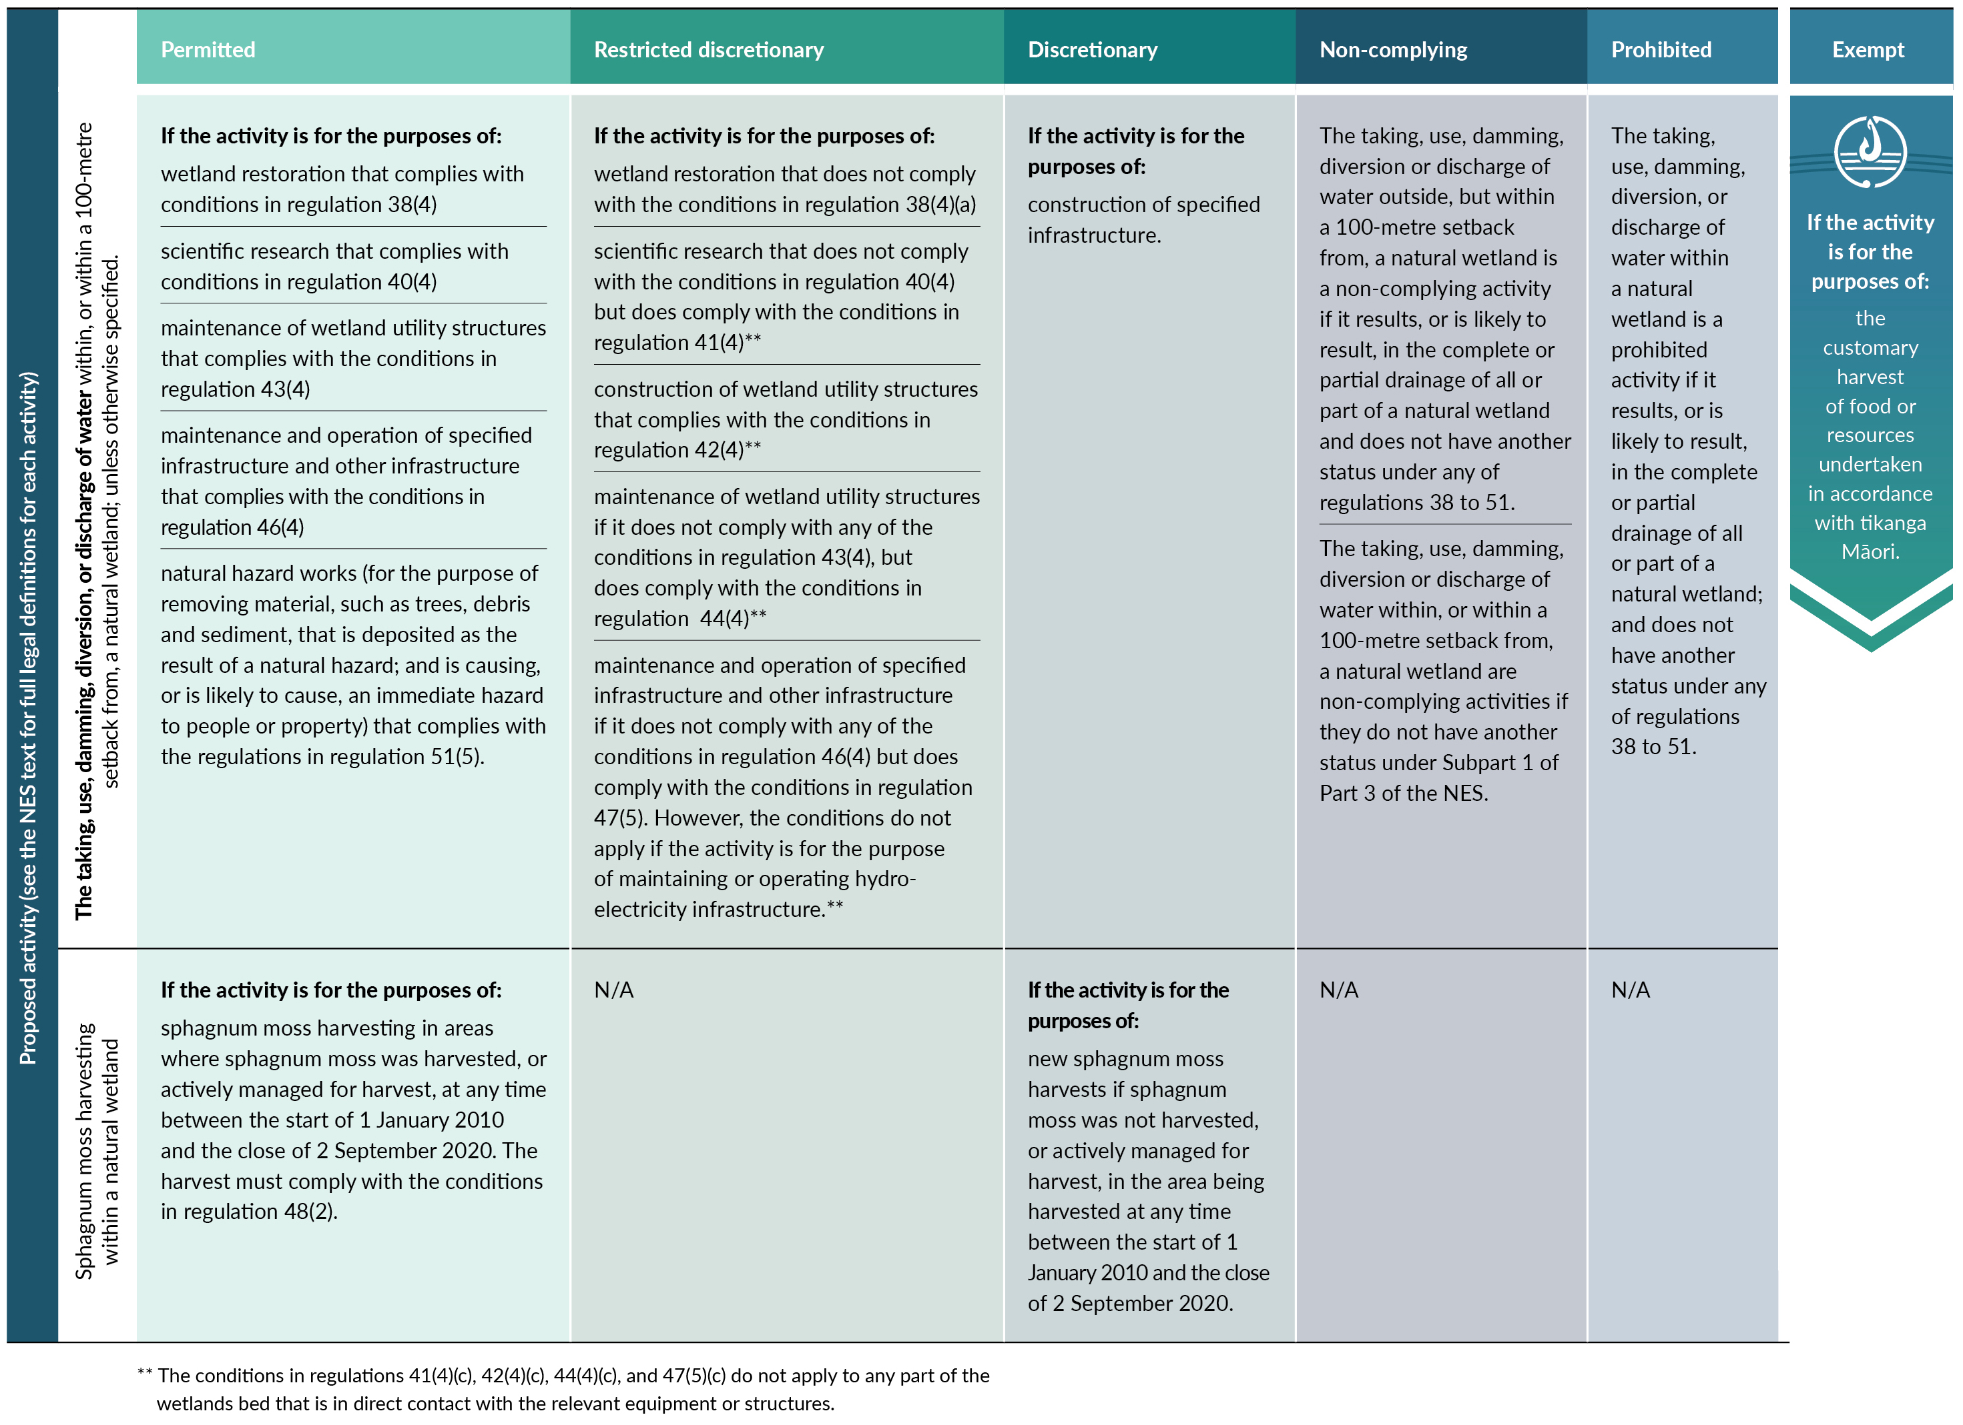

What are the stock exclusion regulations and when do they apply?

New farms
Under the stock exclusion regulations, for any new pastoral system, stock, being beef cattle, dairy cattle, dairy support cattle, deer or pigs, must be excluded from natural wetlands that are identified in any regional or district plan or regional policy statement that is operative on or after 3 September 2020.
Farmers managing a new pastoral system must also ensure stock are excluded from wetlands supporting a population of threatened species (identified in the NPS-FM 2020), and from any wetland 0.05 ha (500 square metres) or greater on low slope land as mapped. The maps form part of the stock exclusion regulations and are published on the Ministry for the Environment website.

Existing farms
For all other farms, stock (excluding sheep) must be excluded by 1 July 2023 from natural wetlands identified in an operative regional or district plan or regional policy statement as at 3 September 2020.
These farms also must exclude stock from wetlands supporting a population of threatened species (identified in the NPS-FM 2020) by 1 July 2025.
Finally, stock must be excluded from wetlands 0.05 ha or greater on low slope land by 1 July 2025.

All farms
The responsibility for complying with the stock exclusion regulations sits with the person who owns or controls the stock.
More stringent stock exclusion provisions in a regional plan prevail over provisions in these stock exclusion regulations.

Why these provisions?
The NES, NPS-FM 2020 and stock exclusion regulations are designed to prevent further loss of New Zealand’s valuable natural wetlands and associated ecosystems.
New Zealand wetlands provide essential habitat for a diverse range of endemic flora and fauna, including critically endangered birds like matuku and kōtuku, as well as 67 per cent of freshwater and estuarine fish species, and 13 per cent of nationally threatened plant species. Wetlands provide essential ecosystem services, acting as buffers for flooding, nutrient cyclers, water purifiers and carbon sinks. Replacing these ecosystem services with infrastructure like constructed wetlands, flood barriers and dams generally costs more than avoiding their loss in the first place.
The value of wetlands has not been historically recognised, and many were drained to create additional ‘usable’ land. This has resulted in the loss of over 90 per cent of New Zealand’s historical inland wetland extent.

More about the Essential Freshwater package
The package includes a number of new provisions including:
- new National Environmental Standards for Freshwater
- new stock exclusion regulations under section 360 of the RMA
- amendments to the Resource Management (Measurement and Reporting of Water Takes) Regulations 2010
- the National Policy Statement for Freshwater Management 2020 which replaces the NPS-FM 2017
- amendments to the RMA to provide for a faster freshwater planning process
- amendments to the RMA to enable mandatory and enforceable freshwater farm plans, and the creation of regulations for reporting nitrogen fertiliser sales.
Factsheets in this series
The full set of Essential Freshwater factsheets are available on our website.
Find out more and give us feedback
Contact us by emailing freshwater@mfe.govt.nz, or visit the Essential Freshwater page on our website.

Disclaimer
The information in this publication is, according to the Ministry for the Environment’s best efforts, accurate at the time of publication. The information provided does not alter the laws of New Zealand and other official guidelines or requirements. Users should take specific advice from qualified professional people before undertaking any action as a result of information obtained from this publication.
The Ministry for the Environment does not accept any responsibility or liability whether in contract, tort, equity or otherwise for any action taken as a result of reading, or reliance placed on the Ministry for the Environment because of having read any part, or all, of the information in this publication or for any error, or inadequacy, deficiency, flaw in or omission from the information provided in this publication.
Published in September 2020 by the
Ministry for the Environment and Ministry for Primary Industries
Publication number: INFO 972
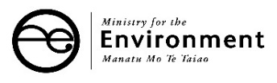

See the NPS-FM 2020 text for legal definitions of terms.
Currently available biodiversity offsetting guidance: https://www.eianz.org/document/item/4447 https://www.doc.govt.nz/Documents/our-work/biodiversity-offsets/the-guidance.pdf https://www.lgnz.co.nz/assets/Uploads/7215efb76d/Biodiversity-offsetting-under-the-resource-management-act-full-document-....pdf Please note that the LGNZ guidance references the hierarchy of obligations in the RMA, and therefore will not be directly applicable to the NPS-FM 2020 as the order and steps of the effects management hierarchy differs.
https://www.mfe.govt.nz/publications/fresh-water/wetland-delineation-protocols
5 August 2020
Any land converted to pastoral land use on or after 3 September 2020

