

# Stockholding and feedlots factsheet

Essential Freshwater is part of a new national direction to protect and improve our rivers, streams, lakes and wetlands. The Essential Freshwater package aims to:

* stop further degradation of our freshwater
* start making immediate improvements so water quality improves within five years
* reverse past damage to bring our waterways and ecosystems to a healthy state within a generation.

Te Mana o te Wai is fundamental to all freshwater management

Te Mana o te Wai recognises the vital importance of water. It expresses the special connection that New Zealanders have with freshwater. By protecting the health of freshwater we protect the health and well-being of people and our ecosystems. When managing freshwater, Te Mana o te Wai ensures the health and well-being of the water is protected and human needs are provided for before enabling other uses of water. Through discussions with regional councils, tangata whenua and communities people will have a say on how Te Mana o te Wai is applied locally in freshwater management. More information can be found in the [Te Mana o te Wai factsheet](https://www.mfe.govt.nz/publications/fresh-water/essential-freshwater-te-mana-o-te-wai-factsheet).

## Who should read this factsheet

This factsheet is part of a [series](https://www.mfe.govt.nz/fresh-water/freshwater-guidance/factsheets-policies-and-regulations-essential-freshwater) and provides information on the new temporary regulations for stockholding and feedlots. It will be most useful for council staff, but may also be of interest to iwi, land users, the agricultural industry, farm advisors and consultants, and anyone else with an interest in freshwater policy.

## What do the regulations affect and when do they apply?

The new [National Environmental Standards for Freshwater](http://www.legislation.govt.nz/regulation/public/2020/0174/latest/LMS364099.html) (NES) set stronger controls for both feedlots and other stockholding areas.

The new rules for feedlots comes into force on **3 September 2020**.

The rules for other stockholding areas comes into force on **1 July 2021**.

These regulations apply only to farms comprising 5 hectares or more of horticulture, 20 hectares or more of pasture or arable crops, or 20 hectares or more of a combination of any of these. See figure 1 for flow diagram about how systems for holding cattle are regulated under these regulations, and what activity classifications apply to each.

The relationship between these new regulations and existing consents or existing lawful activities is set out in section 43B of the RMA. In general:

* consents granted prior to gazettal[1] of the regulations prevail until reviewed
* consents also prevail if there was a decision made about whether or not to notify the relevant consent application prior to gazettal of the regulations
* activities that require a consent under the regulations may be able to continue temporarily under **section 20A(2)** of the RMA if:
* they were permitted, or allowed without a consent, and lawfully established, prior to the relevant regulations commencing; and
* the effects of the activities are of the same or similar character, scale, and intensity as they were before commencement; and
* the person carrying out the activities applies for consent no later than 6 months after commencement. The activities may continue until the consent application, and any appeals, are finally determined.

For 2020 and 2021 this means:

* Holding cattle in feedlots and other stockholding areas can continue without a consent indefinitely if carried out in accordance with the relevant permitted activity rules in the new regulations.
* Holding cattle in feedlots and other stockholding areas can also continue without a consent temporarily if all the conditions in section 20A(2) apply.
* For feedlots, consent applications must be made no later than **2 March 2021**.
* For other stockholding areas, consent applications must be made no later than **31 December 2021**.

A regional rule or resource consent can be more stringent than the feedlots and other stockholding areas rules in the regulations. If this is the case, the more stringent regional rule or consent prevails over the regulations.

## What are the regulations?

#### Feedlots

See figure 1 for what is considered a feedlot under the NES. The regulations for feedlots apply to the use of land on a farm for holding cattle in a feedlot, and to associated discharges of contaminants into or onto land, including in circumstances that may result in a contaminant entering water.

Holding small and young cattle in a feedlot is a permitted activity if 90 per cent or more of the cattle held are no more than four months old, or weigh no more than 120 kilograms. In any other case, the farmer must apply for resource consent.

Holding cattle in a feedlot must comply with the following conditions to be considered a **discretionary activity**:

* the base area of the feedlot must be sealed to a minimum permeability standard of 10-9 m/s, and
* effluent expelled in the feedlot must be collected, stored and disposed of in accordance with a rule in a regional or district plan, or a resource consent, and
* the feedlot must be at least 50 metres away from any waterbody, and water abstraction bore, and drain, and the coastal marine area.

Otherwise holding cattle in a feedlot is a **non-complying activity**.

**Feedlots regulations will come into force on 3 September 2020.**

#### Stockholding areas

See figure 2 for what is considered a stockholding area (other than a feedlot) under the NES.

The regulations apply to the use of land for holding cattle in a stockholding area other than a feedlot, and to associated discharges of contaminants into or onto land, including in circumstances that may result in a contaminant entering water. These are **permitted activities** provided they comply with the following conditions:

* 90 per cent or more of the cattle held are no more than four months old, or weigh no more than 120 kilograms

or

* fewer than 90 per cent of the cattle are no more than four months old or weigh no more than 120 kilograms, but
* the base area of the stockholding area must be sealed to a minimum permeability standard of 10-9 m/s, and
* effluent expelled in the stockholding area must be collected, stored, and disposed of in accordance with a rule in a regional or district plan, or a resource consent, and
* the stockholding area must be at least 50 metres away from any waterbody, any water abstraction bore, any drain, and the coastal marine area.[2]

**Stockholding regulations come into force 1 July 2021.**

How these regulations affect existing consents or existing lawful activities is set out in section 43B of the RMA.

Figure 1: Permitted, discretionary and non-complying activities

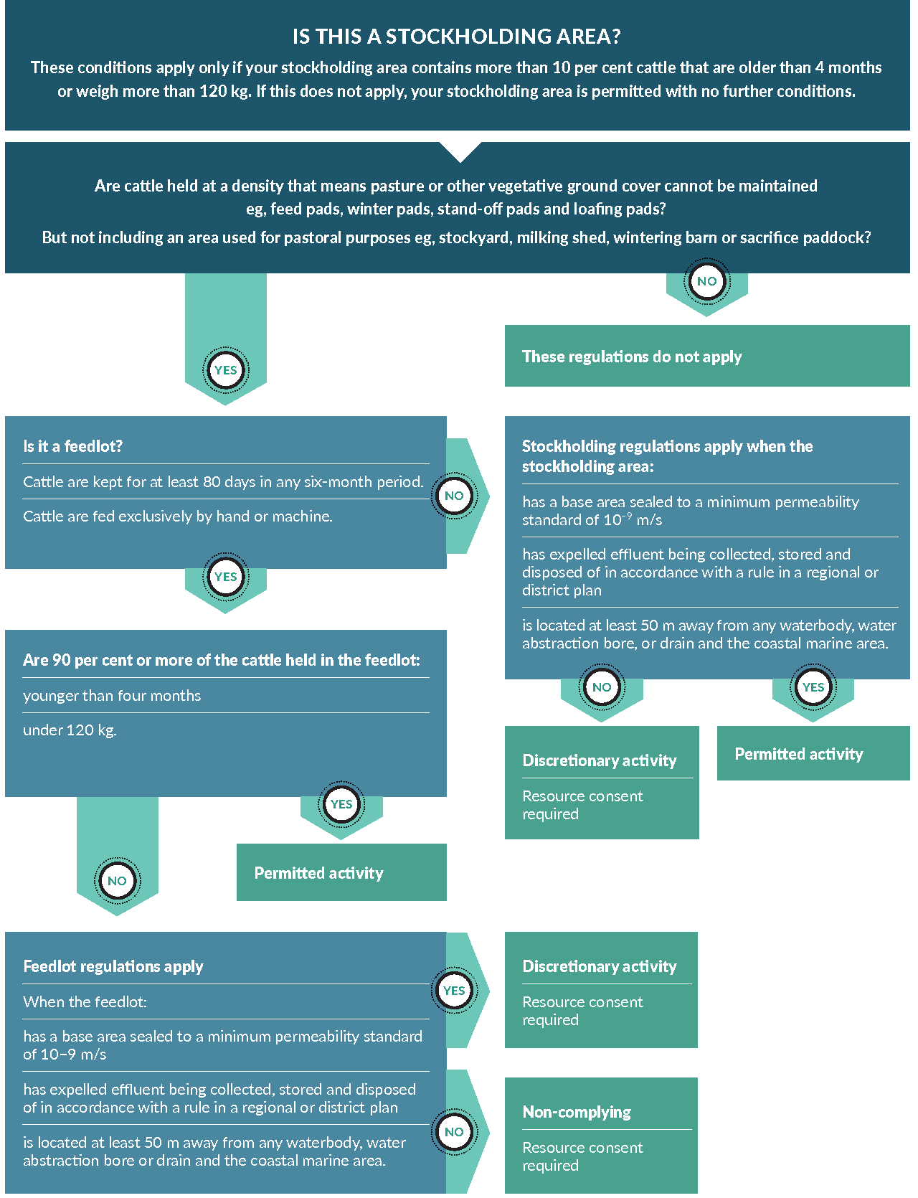

Figure 2: Definition of stockholding area

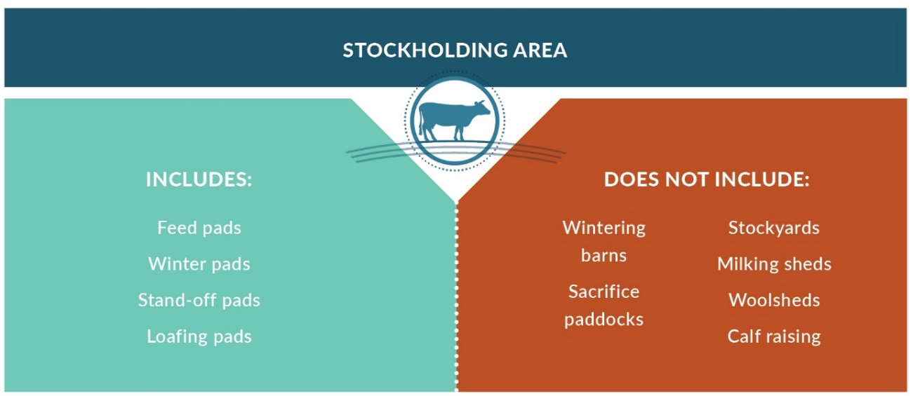

## Why these regulations?

Feedlots and intensive stockholding areas pose high environmental risks to freshwater if not managed well.

Water quality degradation caused by these areas results from the volume and concentration of animal dung and urine (effluent) accumulating from holding cattle in a confined space. When feedlots and stockholding areas are not adequately designed, managed, and/or sited, this effluent can leach to and pollute waterbodies as well as increase erosion.

## More about the Essential Freshwater package

The package includes a number of new provisions including:

* new [National Environmental Standards for Freshwater](http://www.legislation.govt.nz/regulation/public/2020/0174/latest/LMS364099.html)
* new [stock exclusion regulations](http://www.legislation.govt.nz/regulation/public/2020/0175/latest/LMS379869.html) under section 360 of the RMA
* amendments to the [Resource Management (Measurement and Reporting of Water Takes) Regulations 2010](http://www.legislation.govt.nz/regulation/public/2020/0176/latest/LMS351161.html)
* the [National Policy Statement for Freshwater Management](https://www.mfe.govt.nz/publications/fresh-water/national-policy-statement-freshwater-management-2020) 2020 which replaces the NPS‑FM 2017
* [amendments to the RMA](https://www.mfe.govt.nz/rma/improving-our-resource-management-system) to provide for a faster freshwater planning process
* [amendments to the RMA](https://www.mfe.govt.nz/fresh-water/freshwater-acts-and-regulations/regulations-freshwater-farm-plans-and-reporting-of-sales) to enable mandatory and enforceable freshwater farm plans, and the creation of regulations for reporting nitrogen fertiliser sales.

Factsheets in this series

The full set of Essential Freshwater factsheets is available [on our website](https://www.mfe.govt.nz/fresh-water/freshwater-guidance/factsheets-policies-and-regulations-essential-freshwater).

Find out more and give us feedback

Contact us by emailing **fresh**water@mfe.govt.nz, or visit the [Essential Freshwater page](https://www.mfe.govt.nz/fresh-water/freshwater-guidance/factsheets-policies-and-regulations-essential-freshwater) on our website.

### Disclaimer

The information in this publication is, according to the Ministry for the Environment’s best efforts, accurate at the time of publication. The information provided does not alter the laws of New Zealand and other official guidelines or requirements. Users should take specific advice from qualified professional people before undertaking any action as a result of information obtained from this publication.

The Ministry for the Environment does not accept any responsibility or liability whether in contract, tort, equity or otherwise for any action taken as a result of reading, or reliance placed on the Ministry for the Environment because of having read any part, or all, of the information in this publication or for any error, or inadequacy, deficiency, flaw in or omission from the information provided in this publication.

Published in September 2020 by the  
Ministry for the Environment and Ministry for Primary Industries  
Publication number: INFO 970



1. 5 August 2020
2. The provisions in regulation 13(3) will not take effect until such time as certified freshwater farm plans are enabled through new regulations. For more information refer to <https://www.mfe.govt.nz/fresh-water/freshwater-acts-and-regulations/regulations-freshwater-farm-plans-and-reporting-of-sales>