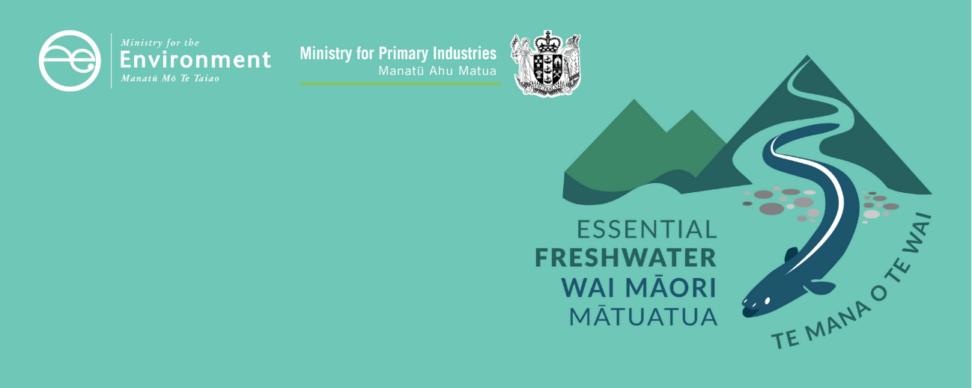

# Agricultural intensification factsheet

Essential Freshwater is part of a new national direction to protect and improve our rivers, streams, lakes and wetlands. The Essential Freshwater package aims to:

* stop further degradation of our freshwater
* start making immediate improvements so water quality improves within five years
* reverse past damage to bring our waterways and ecosystems to a healthy state within a generation.

Te Mana o te Wai is fundamental to all freshwater management

Te Mana o te Wai recognises the vital importance of water. It expresses the special connection that New Zealanders have with freshwater. By protecting the health of freshwater we protect the health and well-being of people and our ecosystems. When managing freshwater, Te Mana o te Wai ensures the health and well-being of the water is protected and human needs are provided for before enabling other uses of water. Through discussions with regional councils, tangata whenua and communities people will have a say on how Te Mana o te Wai is applied locally in freshwater management. More information can be found in the [Te Mana o te Wai factsheet](https://www.mfe.govt.nz/publications/fresh-water/essential-freshwater-te-mana-o-te-wai-factsheet).

## Who should read this factsheet

This factsheet is part of a [series](https://www.mfe.govt.nz/fresh-water/freshwater-guidance/factsheets-policies-and-regulations-essential-freshwater) and provides information on the new temporary regulations for agricultural intensification. It is primarily intended for council staff and land users, but may also be of interest to iwi, the wider agricultural industry, farm advisors and consultants, and anyone else with an interest in freshwater policy.

## What do the regulations affect, and when do they apply?

New regulations for agricultural intensification under the new [National Environmental Standards for Freshwater](http://www.legislation.govt.nz/regulation/public/2020/0174/latest/LMS364099.html) 2020 (NES) comes into force on 3 September 2020.

The regulations are temporary. They will apply until a change to a regional plan is publicly notified to give effect to the [National Policy Statement for Freshwater Management](https://www.mfe.govt.nz/publications/fresh-water/national-policy-statement-freshwater-management-2020) 2020 (NPS-FM 2020), which must be done by 31 December 2024 at the latest. The regulations include a provision so that they will automatically be revoked on 1 January 2025.

The relationship between these new regulations and existing consents or existing lawful activities is set out in section 43B of the RMA. In general:

* consents granted prior to gazettal[1] of the regulations prevail until reviewed
* consents also prevail if there was a decision made about whether or not to notify the relevant consent application prior to gazettal of the regulations
* activities that require a consent under the regulations may be able to continue temporarily under **section 20A(2)** of the RMA if:
* they were permitted, or allowed without a consent, and lawfully established, prior to the relevant regulations commencing; and
* the effects of the activities are of the same or similar character, scale, and intensity as they were before commencement; and
* the person carrying out the activities applies for consent no later than 6 months after commencement. The activities may continue until the consent application, and any appeals, are finally determined.

A regional rule or resource consent can be more stringent than any of the agricultural intensification rules in the regulations. If this is the case, the more stringent regional rule or consent prevails over the regulations.

## What are the regulations?

#### Intensification activities covered by the regulations

The regulations apply to specified intensification of agricultural land, and associated discharges of contaminants into or onto land including in circumstances that may result in the contaminant (or any other contaminant emanating as a result of natural processes from the contaminant) entering water.

#### Permitted activities

The following small-scale intensification is **permitted**:

* the conversion of land from plantation forestry to pastoral land use, provided the amount of land in pastoral use never increases by more than 10 hectares compared to the end of 2 September 2020
* the conversion of land on a farm to dairy farm land, provided the amount of land in dairy farm use never increases by more than 10 hectares compared to the end of 2 September 2020
* expanding the area of dairy farm land that is irrigated, provided the amount of irrigated dairy farm land never increases by more than 10 hectares compared to the end of 2 September 2020. This only applies to farms of a certain size[2]
* expanding the area of land on a farm used as dairy support land below the maximum area used for dairy support land between 1 July 2014 and 30 June 2019. This only applies to farms of a certain size.2

#### Activities requiring a resource consent

If the specified intensification activities are not permitted they will require a resource consent as a **discretionary activity**.

Resource consents can be granted only if the regional council is satisfied the activity will not increase contaminant loads in the catchment, or concentrations of contaminants in freshwater or other receiving environments (compared with the loads or concentrations as at 2 September 2020).

The consents can only be granted for a term which ends before 1 January 2031. After a consent expires, activities will need to get another consent or, if the regulations have been revoked (on 1 January 2025) comply with applicable regional rules.

Information on the temporary provisions relating to intensification of winter grazing is provided in the [intensive winter grazing factsheet](https://www.mfe.govt.nz/publications/fresh-water/essential-freshwater-intensive-winter-grazing).

## Why these regulations?

Agricultural intensification can result in higher levels of nutrients, sediment and microbial contamination of our rivers, lakes, wetlands and groundwater.

As well as these regulations, the [National Policy Statement for Freshwater Management](https://www.mfe.govt.nz/publications/fresh-water/national-policy-statement-freshwater-management-2020) 2020 (NPS-FM 2020) has been introduced. The NPS-FM 2020 requires regional and district councils to work with their communities to prepare changes to their regional policy statements and regional and district plans that give effect to the NPS-FM 2020. These changes will need to be notified by 31 December 2024. These plans will include setting limits on resource use such as nutrient and sediment levels, but in the meantime these temporary regulations will help stop contaminant discharges from increasing.

## More about the Essential Freshwater package

The package includes a number of new provisions including:

* new [National Environmental Standards for Freshwater](http://www.legislation.govt.nz/regulation/public/2020/0174/latest/LMS364099.html)
* new [stock exclusion regulations](http://www.legislation.govt.nz/regulation/public/2020/0175/latest/LMS379869.html) under section 360 of the RMA
* amendments to the [Resource Management (Measurement and Reporting of Water Takes) Regulations 2010](http://www.legislation.govt.nz/regulation/public/2020/0176/latest/LMS351161.html)
* the [National Policy Statement for Freshwater Management](https://www.mfe.govt.nz/publications/fresh-water/national-policy-statement-freshwater-management-2020) 2020 which replaces the NPS‑FM 2017
* [amendments to the RMA](https://www.mfe.govt.nz/rma/improving-our-resource-management-system) to provide for a faster freshwater planning process
* [amendments to the RMA](https://www.mfe.govt.nz/fresh-water/freshwater-acts-and-regulations/regulations-freshwater-farm-plans-and-reporting-of-sales) to enable mandatory and enforceable freshwater farm plans, and the creation of regulations for reporting nitrogen fertiliser sales.

Factsheets in this series

The full set of Essential Freshwater factsheets are available [on our website](https://www.mfe.govt.nz/fresh-water/freshwater-guidance/factsheets-policies-and-regulations-essential-freshwater).

Find out more and give us feedback

Contact us by emailing freshwater@mfe.govt.nz, or visit the [Essential Freshwater page](https://www.mfe.govt.nz/fresh-water/freshwater-guidance/factsheets-policies-and-regulations-essential-freshwater) on our website.

### Disclaimer

The information in this publication is, according to the Ministry for the Environment’s best efforts, accurate at the time of publication. The information provided does not alter the laws of New Zealand and other official guidelines or requirements. Users should take specific advice from qualified professional people before undertaking any action as a result of information obtained from this publication.

The Ministry for the Environment does not accept any responsibility or liability whether in contract, tort, equity or otherwise for any action taken as a result of reading, or reliance placed on the Ministry for the Environment because of having read any part, or all, of the information in this publication or for any error, or inadequacy, deficiency, flaw in or omission from the information provided in this publication.

Published in September 2020 by the   
Ministry for the Environment and Ministry for Primary Industries   
Publication number: INFO 971



1. 5 August 2020
2. Farms with agricultural systems (pastoral or arable) of 20 ha or more, horticultural systems of 5 hectares or more, or any combination of 20 ha or more.