Economic impact of meeting 2050 emissions targets
Stage 2 modelling
NZIER final report to Ministry for the Environment
9 November 2018

About NZIER
NZIER is a specialist consulting firm that uses applied economic research and analysis to provide a wide range of strategic advice to clients in the public and private sectors, throughout New Zealand and Australia, and further afield.
NZIER is also known for its long-established Quarterly Survey of Business Opinion and Quarterly Predictions.
Our aim is to be the premier centre of applied economic research in New Zealand. We pride ourselves on our reputation for independence and delivering quality analysis in the right form, and at the right time, for our clients. We ensure quality through teamwork on individual projects, critical review at internal seminars, and by peer review at various stages through a project by a senior staff member otherwise not involved in the project.
Each year NZIER devotes resources to undertake and make freely available economic research and thinking aimed at promoting a better understanding of New Zealand’s important economic challenges.
NZIER was established in 1958.
Authorship
This report was prepared at NZIER by John Ballingall and Dr Daniel Pambudi.
Technical quality assurance was provided by Dr Erwin Corong.
It was quality approved by Peter Clough.
The assistance of countless officials in helping us design the scenarios and update our database is gratefully acknowledged, without implicating them for the results in any way.

Key points
Purpose, approach and caveats

This report refines our earlier estimates of the economic impacts of meeting different 2050 emissions targets
This study is the second stage of our Computable General Equilibrium (CGE) modelling of the economic impacts of meeting different 2050 emissions targets.
Macroeconomic impacts have not been quantified by any other research into the transition to a low-emissions economy.
Understanding macroeconomic impacts is vital when seeking to explore the trade-offs inherent in using regulatory measures to influence the future direction of the New Zealand economy.
The key changes from the Stage 1 report are:
- We consider a slightly different set of targets, including:
  - Status quo representing existing commitments to reduce emissions by 50% of 1990 levels [SQ]
  - Net zero CO₂ emissions [A-Mod]
  - Net zero all gases with 30Mt CO₂e of sequestration in 2050
[C-Wide (30Mt)]
  - Split gas targets equivalent to net zero long-lived gases plus stabilisation of short-lived gases at close to 50% or 75% of 2016 levels; in which we explore:
Fungibility – the ability to substitute emissions of one type of gas with abatement or sequestration of another. This means emissions of all greenhouse gases can be offset using sequestration or abatement [B-F-50 and B-F-75]; and
Non-fungibility – where only long-lived gases can be offset through sequestration, or abatement of long-lived gases (and for short-lived gases this places an absolute cap on biogenic methane)
[B-NF-50 and B-NF-75].
- The scenarios above represent our core scenarios. We also explored the sensitivity of some results to access to international units and higher levels of forestry sequestration:
  - Net zero all gases with 20% of the emissions reduction accounted for by the purchase of international units at $150 per unit
[C-Wide-80-Int-$150].
  - A sensitivity analysis for the net zero all gases target with sequestration of 40Mt CO₂e in 2050 [C-Wide (40Mt)]
- We have modified the sequestration and innovation assumptions.
- We now account for the opportunity costs for dairy, sheep and beef and horticulture production of an expanding forestry industry. However, it was not possible to directly link sequestration to the carbon price within the modelling framework in the time available.

CGE modelling is an appropriate framework for analysing the economy-wide effects of meeting emissions targets, despite its limitations
- All economic models have different strengths and weaknesses. A key advantage of CGE modelling for exploring the economic impacts of policy or regulatory changes is that it estimates both macroeconomic impacts (such as Gross Domestic Product [GDP] and Gross National Disposable Income [GNDI]), and microeconomic/industry impacts, both of which are important for informing policy advice.
- However, CGE modelling is also subject to several limitations (see Table 1).
Table 1 Summary of CGE modelling approach caveats
Caveat | Comment/implications
We are exploring impacts over a 30+ year period. | It is impossible to forecast with accuracy over such a long time period, especially given the rapid technological change that will occur.
CGE models rely on many data sources, parameters, equations and assumptions. | The behavioural responses of the various actors in the economy are determined primarily by elasticities that have to be imposed on the model. Changing these elasticities will change the way that the economy adjusts to the imposition of an emissions target.
The economic theory underpinning our CGE model is neoclassical in nature. | Neoclassical economic theory may or may not be an appropriate representation of the way firms, households and other actors behave in the New Zealand economy.
Our CGE model cannot predict changes in technology, innovation or consumer preferences. | We have to design scenarios that incorporate assumptions about technological change and innovation; and tell the model when they will occur.
Sequestration is not determined within our CGE model. | As with innovation, we make assumptions about the potential sequestration associated with different emissions targets and impose them on the model. Our results are highly sensitive to these sequestration assumptions.
Our CGE model cannot estimate the potential co-benefits of efforts to reduce the physical impacts of climate change. | We do not consider the physical impacts of climate change, such as rising sea levels, changes to crop yields, increased incidence of severe drought and damage to infrastructure from more frequent severe weather events. Neither do we explore potential benefits from improved water quality that may be associated with changes in New Zealand’s economic structure.
We do not split emissions by type of gas | Our database is based on CO2-e. When exploring different emissions targets for long-lived and short-lived gases, we have to design scenarios that proxy the movements of different types of gas (by identifying carbon dioxide- and methane-dominant industries, and adjusting accordingly).
We cannot explore other countries’ climate change actions | We assume all countries take equivalent climate change action to New Zealand. If they are less ambitious, New Zealand will likely experience declines in export competitiveness and hence higher economic costs.
Source: NZIER
- As such, the results we report here should be seen as indicative of the likely direction and magnitude of changes to the economy when different types of emissions targets are introduced, given the numerous assumptions required to model an entire economy over a 30+ year period.
Overview of results
When considering these results, it is important to remember that there any multiple moving parts that contribute to the differences between scenarios (Figure 1). These are all acting at the same time within the model.
Figure 1 Influences on economic impacts
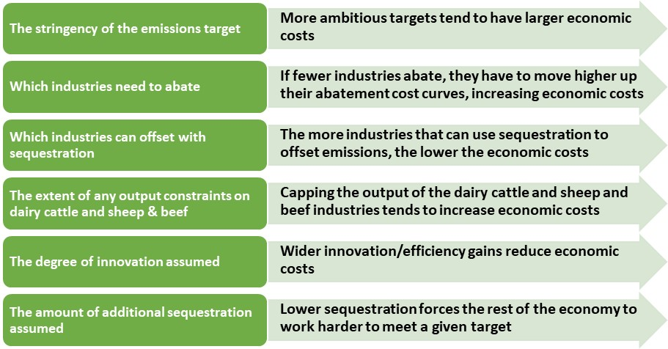
Source: NZIER

The GDP costs of meeting the more ambitious targets are large…
Figure 2 Reduction in 2050 real GDP, $ billions
Change in 2050 real GDP from the status quo of $536 billion
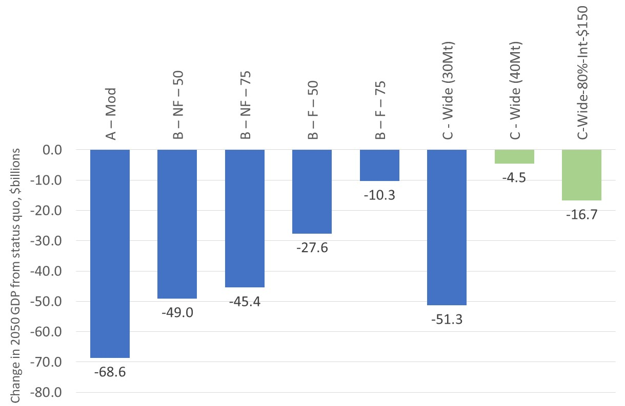
Source: NZIER
- By 2050, real GDP in New Zealand will be between $10.3 billion and $68.6 billion lower in our core scenarios than under the status quo scenario.
- The net zero carbon target (A-Mod) is particularly costly because:
  - We assume only moderate innovation and sequestration, which may be conservative given the carbon prices this scenario generates.
  - This target is met only by CO₂-emitting industries, which excludes dairy cattle and sheep and beef farming (directly). Forcing the emissions reduction on a smaller subset of the economy pushes up the costs of each marginal unit of abatement.
  - Dairy cattle and beef farming are not fully insulated from a target that only focuses on CO₂ reductions.
    - They are heavily indirectly affected since they also use fossil fuels as intermediate inputs which are now much more expensive as higher carbon prices (see Table 2) push up fuel costs.
    - They also consume other intermediate inputs, such as fertilisers, which are now more expensive due to the carbon tax paid by industries producing intermediate inputs into farming.
    - On top of this, transport costs to deliver these intermediate inputs to dairy cattle and sheep and beef farming have increased.
    - Higher transport costs also affect farming margins when their outputs are delivered to processors and to the port of exit for exports.
- Of the targets that limit both short-lived and long-lived gases, the net zero all gases scenario has the highest economic cost – 2050 real GDP will be $51.3 billion lower than the status quo.
- The non-fungible target that considers net zero carbon and stabilises methane at 50% of 2016 levels would result in real GDP being $49.0 billion below the status quo by 2050.
- Allowing fungibility has a material moderating impact on economic costs. A fungible stabilisation target equivalent to net zero carbon and stabilisation of methane at 50% of 2016 levels would lead to real GDP being $11.7 billion below the status quo by 2050.
- Our sequestration assumptions are hugely important. When we consider a sensitivity analysis for the net zero all gases scenario and assume an additional 10Mt CO₂e of sequestration, the GDP cost in 2050 reduces to $4.5 billion below the status quo.
- This finding would apply to the other scenarios too – higher sequestration than assumed would reduce the economic costs of a given target.
- Access to international units also reduces the economic costs of meeting a given target. When we allow 20% of a net zero all gases target to be met through international units at $150 per unit, the reduction in GDP by 2050 is around 1/3 of the impact when no access is considered.

… but the economy continues to grow in all scenarios
- We estimate average real GDP growth between 2020 and 2050 to be 2.06% in the status quo scenario that reflects existing emissions reduction commitment. Real GDP will grow by $238 billion over this period.
- For the all gases core scenarios, average GDP growth softens to between 1.71% to 1.99%.
Figure 3 Average real GDP growth, 2020-2050
Compound Average Growth Rate, %
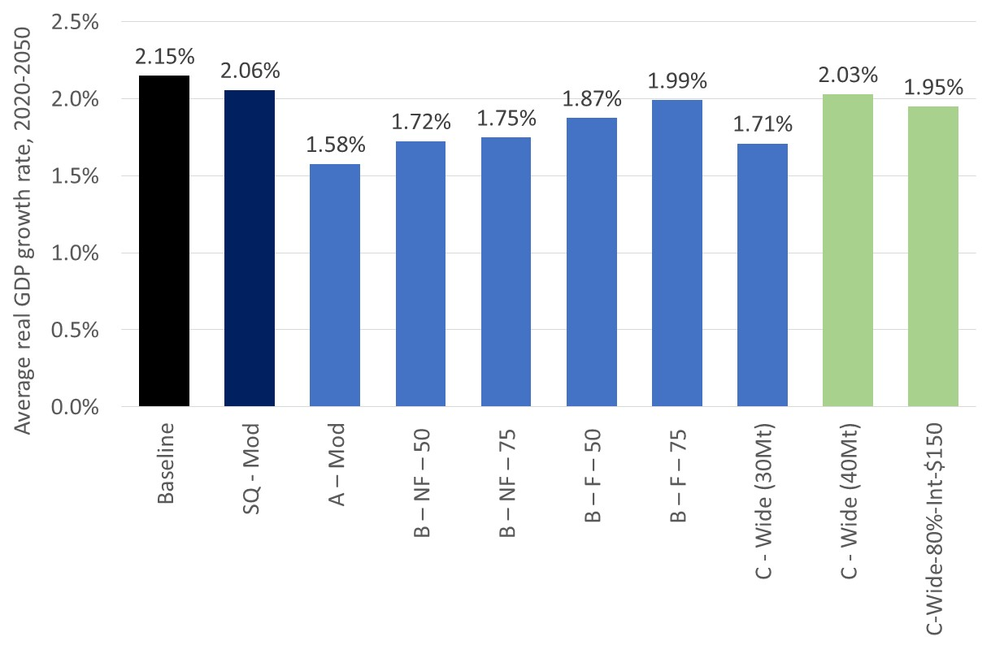
Source: NZIER

Carbon prices would rise sharply to meet ambitious emissions targets
- Our CGE model solves for the implied carbon price that would be required to meet each emissions target. The implied carbon price in our model reflects the additional cost (per ton of carbon emissions) associated with meeting a desired carbon emissions target.
- Our carbon price estimates are substantially higher than those estimated by Concept Consulting, Motu Economics and Public Policy Research and Vivid Economics [CMV] (2018a, 2018b).
Table 2 Average implied carbon prices
$ per tonne CO₂e; average price 2020-2050
Status quo | A-Mod | B-NF-50 | B-NF-75 | B-F-50 | B-F-75 | C-Wide (30Mt) | C-Wide (40Mt) | C-Wide-80-Int-$150
115 | 1125 | 978 | 1039 | 518 | 271 | 1056 | 406 | 567
Source: NZIER
- NZIER (2018a) and Productivity Commission (2018) have both outlined potential reasons for these differences, including:
  - Different types of models were used, with CMV’s being more detailed on land use, energy and transport; and ours being designed to explore macroeconomic and inter-sectoral (direct and indirect flow-on) impacts
  - The modelled scenarios and assumptions were not identical; our assumed sequestration was lower than CMV’s model delivers
  - CMV exogenously imposed prices to 2030 whereas we do not
  - CMV’s model does not explicitly take into account the feedback effects of higher carbon prices on the costs of intermediate inputs across the entire economy.
- As noted by Wilkerson et al (2015), who compared and contrasted the results of climate change policy analysis across different types of models, including a partial equilibrium energy and land use model (GCAM) and a dynamic CGE model (EPPA):
“Models which include many low-carbon technology options and weak constraints on adoption (e.g., GCAM) will react ﬂexibly in response to a carbon price, substituting technologies quickly and dramatically to reduce [carbon intensity] and emissions.
Other models with fewer low-carbon alternatives and stronger constraints on adoption (e.g., EPPA) are comparatively rigid, and the energy structure will transform less signiﬁcantly and more gradually. Neither is likely ‘correct’ but together they bound the possible solutions”.
- These insights are also likely to apply to a comparison between CMV’s modelling and our own. CMV’s model is likely to adjust more rapidly to an emissions target through rapid energy-switching technologies; our CGE model will tend to adjust more slowly through decreases in energy use instead, leading to larger GDP impacts and higher prices.
- Whilst significant differences remain, both models do at least suggest that transitioning to a low-emissions economy will require significantly higher carbon prices to induce the required behavioural changes by firms and households.

A slower economy and higher carbon prices will dent households’ purchasing power
- Economic wellbeing is not particularly well proxied by GDP. An alternative measure of the economic impacts on households of meeting emissions targets is to examine changes in RGNDI per household.
- Measured in this way, New Zealand households’ purchasing power will fall $2,900 to $11,400 per household per year over the 2020-2050 period for the all gases core scenarios, relative to the status quo.
- Greater sequestration (40Mt instead of 30Mt) or access to international units reduces these adverse impacts significantly.
- We do not look here at the impacts on households with different incomes, but our Stage 1 report suggested that those on lower incomes will experience far greater costs as a proportion of their incomes. That is, higher carbon prices are regressive.
Figure 4 Change in average real Gross National Disposable Income (RGNDI) per household
Change in average annual RNGDI per household between 2020 and 2050, relative to the status quo, $000s; labels show % change from status quo
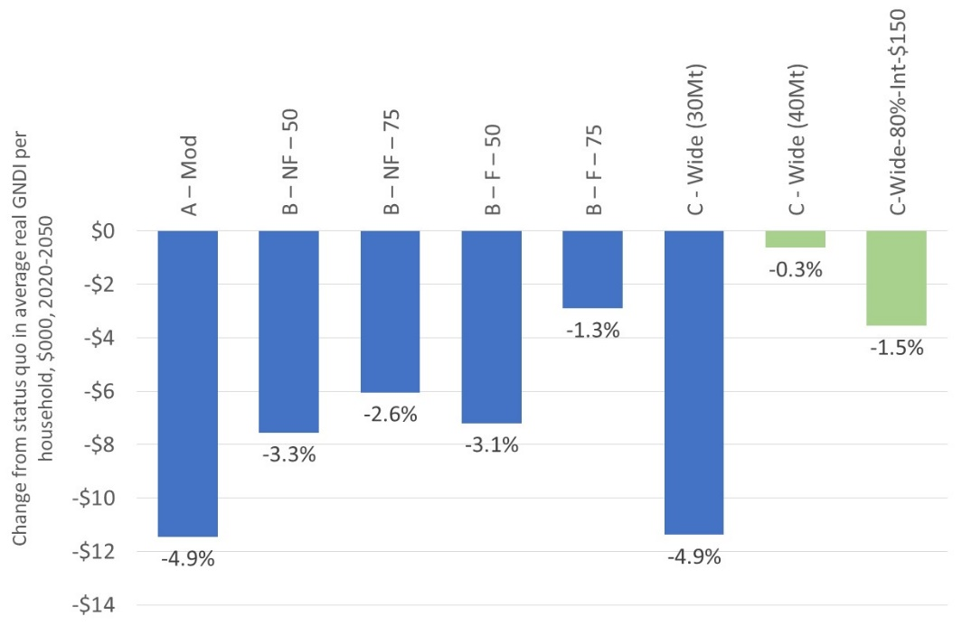
Source: NZIER
Contents
Purpose, approach and caveats i
Overview of results iii
1. Scope and objectives 1
1.1. This is Stage 2 of our research into the economic impacts of different options for 2050 emissions targets 1
1.2. Scenarios modelled in Stage 2: overview 1
1.3. What’s changed? 2
1.4. We use a CGE model to estimate economic impacts 2
1.5. Caveats with our approach 4
1.6. How does our CGE model differ from the model used to inform the Productivity Commission’s recent report? 5
2. Changes to model structure and database 7
2.1. Improving the treatment of forestry 7
2.2. We updated the baseline emissions to reflect the latest official projections 9
3. Changes to scenarios and targets 10
3.1. We explored a different set of targets to Stage 1 10
3.2. How we approach fungibility 10
3.3. Treatment of international units 12
3.4. We use different sequestration assumptions to Stage 1 12
3.5. We also incorporated different innovation assumptions 13
3.6. We recalculated the emissions required to achieve net zero emissions at 2050 14
3.7. Assumption on rest of the world action 15
3.8. We advise caution when comparing these results with those from Stage 1 15
4. Results 18
4.1. Overview of macroeconomic results 18
4.2. Discussion of macroeconomic results 20
4.3. Aggregated industry results 22
4.4. Impacts on forestry 28
4.5. Carbon price results 30
4.6. Impacts on households 31
5. Conclusions 33

Appendices
Appendix A References 34

Figures
Figure 1 Influences on economic impacts iii
Figure 2 Reduction in 2050 real GDP, $ billions iii
Figure 3 Average real GDP growth, 2020-2050 v
Figure 4 Change in average real Gross National Disposable Income (RGNDI) per household vii
Figure 5 Components of a CGE model 3
Figure 6 Influences on economic impacts 20
Figure 7 Aggregated industry impacts across core scenarios 23
Figure 8 Aggregated industry impacts – effects of fungibility 24
Figure 9 Proportionate change in value added 25
Figure 10 Land use impacts on primary sector 29
Figure 11 Forestry and wood processing sector value added 30
Figure 12 Change in per household purchasing power 32

Tables
Table 1 Summary of CGE modelling approach caveats ii
Table 2 Average implied carbon prices v
Table 3 Summary of CGE modelling approach caveats 4
Table 4 Innovation assumptions 14
Table 5 Effects of change in definition of net zero all gases target 15
Table 6 Description of Stage 2 scenarios 17
Table 7 Headline results 18
Table 8 Headline results – differences from baseline 19
Table 9 Headline results – differences from status quo 19
Table 10 Farming’s use of CO₂-intensive inputs 27
Table 11 Average implied carbon prices 30

Scope and objectives

This is Stage 2 of our research into the economic impacts of different options for 2050 emissions targets
Our earlier report (henceforth ‘Stage 1 report’) was used as one input into the consultation stage of the Zero Carbon Bill.
The aim of the Stage 1 report was to provide some initial economic impact estimates to help inform officials’ advice to Ministers and – through the consultation document – help businesses, industry organisations, not-for-profit organisations and the wider public understand some of the potential trade-offs involved with meeting different 2050 emissions targets.
Based on feedback on the Stage 1 report, the acknowledged caveats around our results, and in line with developments in policy discussions, we then refined our modelling approach, scenarios and assumptions to provide revised economic impact estimates in this Stage 2 report.

Scenarios modelled in Stage 2: overview
For Stage 2, we were asked to estimate the economic impacts of the following targets:
- Status quo representing existing commitments to reduce emissions by 50% of 1990 levels [SQ]
- Net zero CO₂ emissions [A-Mod]
- Net zero all gases with 30Mt CO₂e of sequestration in 2050
[C-Wide (30Mt)]
- Split gas targets equivalent to net zero long-lived gases plus stabilisation of short-lived gases at close to 50% or 75% of 2016 levels; in which we explore:
  - Fungibility – the ability to substitute emissions of one type of gas with abatement or sequestration of another. This means emissions of all greenhouse gases can be offset using sequestration or abatement
[B-F-50 and B-F-75]; and
  - Non-fungibility – where only long-lived gases can be offset through sequestration, or abatement of long-lived gases (and for short-lived gases this places an absolute cap on biogenic methane) [B-NF-50 and B-NF-75].
- The scenarios above represent our core scenarios. We also explored the sensitivity of some results to access to international units and higher levels of forestry sequestration:
  - Net zero all gases with 20% of the emissions reduction accounted for by the purchase of international units at $150 per tonne CO₂-e
[C-Wide-80-Int-$150].
  - A sensitivity analysis for the net zero all gases target with sequestration of 40Mt CO₂e in 2050 [C-Wide (40Mt)]

What’s changed?
We explain the differences between our Stage 1 approach and the Stage 2 approach in more detail in sections 2 and 3 below. In short, the main changes were:
- We augmented our model to incorporate the opportunity costs for the rest of the primary sector associated with an expansion of the forestry industry in response to the imposition of an emissions target. Forestry output now grows within the model.
- We adjusted our baseline emissions projections to reflect the latest available official estimates out to 2050.
- We aligned the modelling of emissions targets more closely to the options being considered by officials and Ministers related to the treatment of long-lived and short-lived gases.
- We only considered scenarios that incorporated economy-wide innovation, rather than scenarios that looked at energy or agriculture innovation alone.
- We moderated the strength of some innovation assumptions, notably the effectiveness and uptake of a methane vaccine.
- We adjusted the sequestration assumptions for each scenario.
As a consequence of these numerous changes, direct comparisons between the Stage 1 and Stage 2 results should be approached with considerable caution. In our view, the Stage 2 approach – and hence results – is an improvement on the Stage 1 approach, although as discussed further below, it remains subject to several important caveats (see section 0 for a summary).

We use a CGE model to estimate economic impacts
As in Stage 1, we used a Computable General Equilibrium (CGE) model to estimate the economic impacts of meeting different emissions targets. CGE models have been widely used in New Zealand and overseas to explore the economic impacts of policy changes, including climate change policy changes.
A CGE model is a representation of an economy and the various inter-linkages between industries, as well as their links to households (via the labour market), the government sector, capital markets and the global economy (via imports and exports).
A visual representation is shown in Figure 5, highlighting the complex and multidirectional relationships between the various parts of an economy. Any time that one part of the economy responds to a change in policy settings, there will be accompanying flow-on effects for supplying and downstream industries as resources such as labour, capital and land move between industries towards their most productive use.
Figure 5 Components of a CGE model
Source: NZIER
Because they consider the inter-linkages between all actors in the economy, CGE models are useful when we want to consider the immediate and flow-on effects of policy changes in order to assess potential economy wide impacts on Gross Domestic Product (GDP), Gross National Disposable Income (GNDI); and on industry output and employment, etc.
More detail on our CGE model can be found in NZIER (2018a, section 2 and Appendices A-D).

Caveats with our approach
Table 3 summarises the key limitations of using CGE analysis to explore the economic impacts of meeting emissions targets, drawing on section 1.2 of our Stage 1 report.
Table 3 Summary of CGE modelling approach caveats
Caveat | Comment/implications
We are exploring economic impacts over a 30+ year period. | It is impossible to forecast with accuracy over such a long time period, especially given the rapid pace of technological change that will inevitably occur.  Our results should be seen as projections of economic impacts, given a specific set of assumptions about the way the economy works now and into the future.
CGE models rely on many data sources, parameters, equations and assumptions, not all of which can be adjusted for each scenario. | Our model considers 111 industries producing 210 products, and their multi-directional links to households, the government sector and the global economy. The behavioural responses of these various actors in the economy are determined primarily by elasticities that have to be imposed on the model.  Changing these elasticities will change the way that the economy adjusts to the imposition of an emissions target. Given time constraints, it was not possible to perform sensitivity analysis on these parameters.
The economic theory underpinning our CGE model is neoclassical in nature. | Neoclassical economic theory may or may not be an appropriate representation of the way firms, households and other actors behave in the New Zealand economy.  Given sufficient time and resources, alternative theoretical specifications can be built into a CGE modelling framework if they are judged to be superior.
Our CGE model cannot predict technological change, innovation or changes in consumer preferences. | We cannot ask our model to predict when, for example, a methane vaccine would be developed, or how rapidly widespread energy efficiency gains might occur as the carbon price increases.  We have to design scenarios that incorporate assumptions about technological change and innovation; and tell the model when they will occur. Similarly, unless we tell the model that global consumers will start to prefer low-emissions goods (e.g. foodstuffs), it won’t be able to predict when this might occur or how significant it may be. Alternative assumptions can be explored in future work.
Sequestration is not determined within our CGE model. | As with innovation, we make assumptions about the potential sequestration associated with different emissions targets and impose them on the model.  Our results are highly sensitive to these sequestration assumptions.
Our CGE model cannot estimate the potential co-benefits of efforts to reduce the physical impacts of climate change. | We do not consider the physical impacts of climate change, such as rising sea levels, changes to crop yields, increased incidence of severe drought and damage to infrastructure from more frequent severe weather events. Neither do we explore potential benefits from improved water quality that may be associated with changes in New Zealand’s economic structure. To the extent that New Zealand’s climate change policy directly or indirectly reduces these physical impacts, our modelled economic costs will be an over-estimate.
We do not split emissions by type of gas | Our database is based on CO2-e. When exploring different emissions targets for long-lived and short-lived gases, we have to design scenarios that proxy the movements of different types of gas (by identifying carbon dioxide- and methane-dominant industries, and adjusting accordingly).
We cannot explicitly explore actions of other countries to reduce emissions | Our model is a single-country model. In essence, we assume all countries take equivalent action to New Zealand. If the rest of the world is less ambitious than New Zealand, the economic costs reported here will be larger due to declines in New Zealand’s export competitiveness.
Source: NZIER

How does our CGE model differ from the model used to inform the Productivity Commission’s recent report?
The Productivity Commission’s inquiry into transitioning to a lower-emissions economy draws heavily on the modelling results from Concept Consulting, Motu Economics and Public Policy Research and Vivid Economics (CMV). CMV link two models to explore the impacts of meeting different emissions targets on carbon prices and other metrics:
- Motu’s LURNZ model, which “is a dynamic and spatially explicit, partial-equilibrium model of rural land use. It can simulate changes in dairy, sheep-beef, forestry and scrub in response to changes in economic incentives” (CMV, 2018a, p.37).
- Concept Consulting’s ENZ model, which is “a series of inter-dependent modules or sub-models. The sub-models seek to identify the least-cost means of meeting demand for a service (for instance transport, process heat or electricity) given the underlying market drivers (such as population growth, emissions prices, fossil fuel prices and technology costs) and accounting for exogenously imposed policy actions (such as support for transport mode-shifting to public transport/cycling, or the forced closure of a fossil power station)” (CMV, 2018b, p.37).
The Productivity Commission (2018, pp.71-77) explores in some detail the differences between the two model structures, as did our Stage 1 report (NZIER, 2018a, pp.26-27). We repeat here our perspective from our Stage 1 report (p.27):
All models have strengths and weaknesses, and for policy issues such as climate change, there is considerable value in having a range of models to provide different insights into the main issues in play. The main strength of our approach, for this research objective, is that it generates whole-of-economy costs.
So a key advantage of a CGE model for analysing the effects of meeting emissions targets is that it is explicitly designed to capture the impacts on macroeconomic measures such as GDP and Gross National Disposable Income, as well as microeconomic/industry-level output changes.
Partial equilibrium models such as LURNZ and ENZ are not designed to estimate these macroeconomic impacts, but they offer considerably more detail than a CGE model on certain parts of the economy, such as rural land use, transport and energy switching.
Wilkerson et al (2015) provide further insights into the differences between the types of partial equilibrium land use models used by CMV and the CGE models we employ. They compare the results of a carbon tax scenario from a partial equilibrium model with land use change (GCAM) with those from a recursive dynamic CGE model (EPPA).
They note (p.30, emphasis added) that:
Models which include many low-carbon technology options and weak constraints on adoption (e.g., GCAM) will react ﬂexibly in response to a carbon price, substituting technologies quickly and dramatically to reduce [carbon intensity] and emissions.
Other models with fewer low-carbon alternatives and stronger constraints on adoption (e.g., EPPA) are comparatively rigid, and the energy structure will transform less signiﬁcantly and more gradually.
Neither is likely ‘correct’ but together they bound the possible solutions”.

Changes to model structure and database

Improving the treatment of forestry
A key limitation of our Stage 1 modelling, as with most previous CGE modelling of climate change policy in New Zealand, was that sequestration was assumed exogenously and imposed on the model. It did not respond directly to the carbon price endogenously (within the model).
Neither did an expansion in sequestration result in growth in forestry output and a reduction in productive land area available for other uses, such as dairy, sheep and beef and horticulture.
In agreement with officials, a key priority for Stage 2 was improvements to the estimation of forestry in the modelling.

We now account for the opportunity costs and benefits of a larger forestry industry…
In Stage 1, we did not explore the opportunity costs for the non-forestry primary sector of significant growth in the forestry sector in response to higher carbon prices associated with the emissions targets. The growth in forestry occurred outside the model, and thus did not lead to a reduction in land available for dairy, sheep and beef and horticulture.
Similarly, the model did not estimate potential output gains in the forestry industry and related processing industries.
To address this, in Stage 2 we introduce an additional nest into the production structure of these land-based activities. We followed the approach of Adams, Parmenter and Verikios (2014, see p.14).
Total productive land is fixed but is reallocated between industries after an emissions target was imposed.
The reallocation occurs through changes in the relative land returns (i.e. price of land) in each industry. The land price in industry reflects the opportunity cost of land. Alternatively, it can be seen as the economic surplus (revenue net of costs) generated from the productive use of land.
When an emissions target is imposed, and a carbon price levied, each of the four land-using industries above experiences a different impact on revenue and profitability. More emissions-intensive industries (dairy, sheep and beef) see their profitability fall relative to less emissions-intensive industries (forestry, horticulture).
This leads to a decrease in land prices in the more emissions-intensive primary industries, which sees land reallocated towards the less emissions-intensive industries.
The key point here is that we explicitly account for the opportunity cost, in terms of lost productive capacity for emissions-intensive industries, associated with an expansion of the forestry industry.

…but full endogenisation of forestry was not possible
We had hoped that introducing the additional land use nest into the model structure would allow us to more closely link sequestration to the carbon price, albeit indirectly through changes in relative land prices.
However, upon testing, we found that the model as structured could not generate sufficient forestry expansion in response to an emissions target and carbon price rise. There was insufficient time available for this project to attempt alternative approaches to fully endogenising forestry.
This is a common challenge when using CGE modelling to explore the impacts of land use change. A recent attempt to endogenise land use in a dynamic CGE model is described in Tian et al (2013). They note that:
Despite the importance of introducing the forestry sector into a general equilibrium framework, modelling the forestry sector in a general equilibrium context remains an extremely difficult task due to the complex dynamics inherent in forestry management.
It takes several decades to grow new forests. Perhaps more so than other land use sectors, investments in forest are based on expectations about future markets and climate change policies. The harvest and management decisions are also dynamic. With user costs, any changes in harvesting have implications for the future, so decisions are made in an intertemporal context.
While it might be enough to use a static or a recursively dynamic model for agriculture, the dynamic nature of forestry sector requires an intertemporal framework which allows forward-looking behaviour. In addition, prices should be endogenous.
Many simple dynamic models hold prices as fixed and thus cannot adequately reflect market fluctuations. Finally, growth rates of forests are nonlinear and vary substantially across vintages. This requires substantial computational effort from CGE modellers.
Tian et al (2013) resorted to assuming autarky (i.e. zero trade with the rest of the world) when introducing endogenous forestry into their dynamic, which severely reduced its policy relevance.
As a result of these challenges, we reverted to the approach used in our Stage 1 modelling – exogenously imposing a chosen level of sequestration on the model so that the rest of the economy has less work to do in terms of meeting a given emissions target.
We also adjusted the sequestration assumptions for each target, based on discussions with officials, so that they were more nuanced than in Stage 1. We proportionally aligned sequestration with the abatement required from the rest of the economy. Tougher emissions reductions targets were therefore associated with a proportionally greater amount of assumed sequestration.

We updated the baseline emissions to reflect the latest official projections
In Stage 1, no official emissions projections to 2050 were available when we were developing our baseline scenario. Therefore, we created our own set of projections that were consistent with our economic growth projections and expected emissions-intensity trends by industry.
New Zealand's Seventh National Communication and Third Biennial Report were published in December 2017. The projected greenhouse gas emissions in these reports only contained data going out to 2030.
For purposes of our research and for use in updating New Zealand's 2018 Net Position and related information on projected greenhouse gas emissions, Ministry for the Environment officials asked Government agencies to provide updated projections out to 2050. These projections relied on the same assumptions used in both New Zealand's Seventh National Communication and Third Biennial Report.
We used these projections to inform our own database’s baseline emissions trends. Gross emissions projections by broad sector were distributed across the 111 industries in our database based on industry shares of the broad sectors.
Our emissions projections show a trend in greenhouse gas emissions that is consistent with agency projections.
In consultation with Ministry for the Environment officials, we have assumed 9 MtCO₂e for our 2050 baseline level of sequestration. This is roughly the same as 2016 levels (using an approach consistent with that used in New Zealand’s Paris Agreement Nationally Determined Contribution) and within the Ministry for Primary Industries’ projected range for sequestration in 2050 of between of 4 MtCO₂e to 17 MtCO₂e.

Changes to scenarios and targets

We explored a different set of targets to Stage 1
In Stage 1, we considered three potential emissions targets:
- 100% reduction in all gases, or Zero Net Emissions targets
- 75% reduction in all gases to broadly proxy a split gas target
- 50% reduction in all gases to broadly proxy a Zero Net Carbon target.
In Stage 2, we sought to bring a greater level of granularity into our targets.
As well as modelling a Net Zero all gases target, we also designed scenarios that sought to reflect:
- A Net Zero Carbon target
- Non-fungible stabilisation targets that achieve Net Zero emissions of long-lived gases and also cap short-lived gases at close to 50% or 75% of 2016 levels.
- Fungible stabilisation targets which remove an equivalent amount of emissions to the non-fungible targets, but under which all gases can be offset using sequestration.
- Net Zero all gases with limited access to international units at $150 per unit.
The scenarios are summarised in Table 6 on page 17 and key aspects are discussed below.

How we approach fungibility
Fungibility is the ability to substitute emissions of one type of gas with abatement or sequestration of another. It means that emissions of all greenhouse gases can be offset using sequestration or abatement (or access to international units, where considered).
Non-fungibility means that only long-lived gases can be offset through sequestration, or abatement of long-lived gases. Practically, this means that biogenic methane emissions cannot be offset through the abatement of long-lived gases, sequestration or international units. This places an absolute cap on biogenic methane.
The intention of these non-fungible split gas scenarios was to model the impact of a target that reduces net emissions of long-lived gases to zero and stabilises emissions of short-lived gases at a certain percentage (50% or 75%) of 2016 levels by 2050.
However, as noted in section 0 above, we do not have different types of gases in our model. All gases are measured in CO₂-e. As a result, we have to proxy stabilisation by limiting emissions from certain industries.
In the non-fungible scenarios, we proxy short-lived gases as emissions from the dairy cattle and sheep and beef industries. Therefore, to proxy stabilisation of short-lived gases in the non-fungible scenarios, we restrict the output (and associated methane emissions) of the dairy cattle and sheep and beef industries; trending output down to 50% or 75% of 2016 levels between 2020 and 2050.
Note that in these scenarios, a methane vaccine is introduced in 2030 in addition to constraining output. This has the effect of reducing methane emissions slightly below 2016 by 2050 – by around 6% for dairy and 4% for sheep and beef.
When we constrain the output of these methane-producing sectors, this also results in reductions of nitrous oxide, a long-lived gas. Most (94%) nitrous oxide emissions in New Zealand are from cattle farming.
It was therefore decided that for the non-fungible split-gas scenarios, solely carbon dioxide emissions would be reduced to net zero. This avoids double-counting reductions of nitrous oxide emissions, which would overstate the economic impact of these targets.
In the fungible scenarios, we allow methane to be offset by sequestration or abatement of carbon dioxide. Therefore, we do not need to impose caps on dairy cattle and sheep and beef output – farmers can continue to emit as much methane as they like, provided there is sufficient CO₂ sequestration or abatement to offset these emissions.
We thus model the fungible scenarios in a similar way to the Net Zero all gases scenario, but with a lower level of ambition that is equivalent to Net Zero carbon plus methane held at 50% or 75% of 2016 levels.
We proxy long-lived gases as those gases emitted by all other industries. We recognise this is an over-simplification in our scenario design.

Treatment of international units
When we explore the impacts of access to international units to offset emissions, we are unable to shock both an emissions reduction (including sequestration) and an emission price (it is not generally possible to exogenise volume and price in a CGE modelling framework).
Therefore, we model a scenario which reduces emissions of all gases by 80% by 2050 (i.e. 80% of Net Zero all gases). We also use 80% of the Net Zero all gases sequestration assumption.
This leaves 20% of the Net Zero all gases target to be met through purchases of international units, at an assumed price of $150 per tonne CO₂-e. It was not possible to model this within the CGE modelling framework at the same time as modelling an emissions reduction, so we calculated the value of these purchases outside of the model. We discuss this additional cost to businesses as a downside to the GDP impacts of meeting the 80% of Net Zero all gases emissions target.

We use different sequestration assumptions to Stage 1
As it was not feasible to fully endogenise sequestration (i.e. make it respond directly to the carbon price within the model), we reverted to imposing sequestration exogenously, as per Stage 1.
Selecting the appropriate level of sequestration for any given scenario and target is challenging. It requires consideration of the ambition of the target and hence potential level of carbon prices.
If we impose much more sequestration, the rest of the economy does not have to work as hard to abate, leading to smaller GDP impacts. If we impose less sequestration, the economy moves further up its Marginal Abatement Cost Curve (MACC), which makes meeting a given target costlier.
Through an iterative process, we first determined that for a Net Zero all gases target, a sequestration level of 30 MtCO₂e was appropriate, given our innovation assumptions. We then pro-rated this 30 MtCO₂e sequestration down across the other scenarios, broadly based on the size of the required gross emissions reduction to hit the specific target.
Our assumed sequestration levels are lower than CMV’s, and so we carry out a sensitivity analysis for the Net Zero all gases target scenario with a higher sequestration level of 40 MtCO₂e (CMV’s sequestration levels in 2050 for a net zero emissions target range from 46-52 MtCO₂e).
We appreciate that in an ideal world our sequestration assumptions would align perfectly with those produced by CMV, but given different model structures, assumptions and purposes, this was not feasible. However, a key message from CMV’s analysis also holds true for our analysis: meeting ambitious targets at a reasonable cost will require a lot more trees.

We also incorporated different innovation assumptions
In Stage 1, we considered scenarios shaped around three core sets of assumptions regarding innovation:
- Energy innovation
- Agriculture innovation
- Wide innovation (combining the two above).
The first two sets of scenarios were designed to explore whether emissions targets could be met at a reasonable cost solely through innovation improvements in specific parts of the economy (energy and transport, and agriculture, respectively). They were not meant to project what we thought would happen if ambitious emissions targets were to be introduced.
When we used only 1 or 2’s sector-specific assumptions (so only innovation in energy, or only in agriculture), the economic impacts of meeting emissions targets were very large, both in GDP and implied carbon price terms.
In Stage 2, we discarded the sector-specific innovation assumptions. We considered only two sets of innovation assumptions (Wide and Moderate), both of which were ‘economy-wide’ – spanning both energy and agriculture, as outlined in Table 4 overleaf.
The Wide innovation assumptions were applied to the more ambitious emissions targets; the Moderate innovation assumptions to the relatively less ambitious targets.
The idea here is that we would expect more innovation to occur when ambitious emissions targets are announced and implemented than we would do if less ambitious targets were announced.
For example, in the Zero Net Carbon scenario (A-Mod) where we do not seek to limit methane emissions, there is little logic in assuming a methane vaccine would be incentivised into existence.
Similarly, for the fungible split gases scenarios (B-F-50 and B-F-75), methane is not capped in the scenario design. As such, there is not so much of an incentive for a methane vaccine to be developed and implemented at pace as long as sufficient sequestration occurs.
Table 4 Innovation assumptions
Innovation type | Wide innovation assumptions | Comparison to Stage 1 Wide innovation assumptions | Moderate innovation assumptions
Scenario | B-NF, C-Wide, C-Wide-Intl |  | SQ-Mod; A-Mod; All B-F
Biological emissions | Priced | Same as Stage 1 | Priced
Methane vaccine | Reduces dairy emissions by 15%; S&B by 10%; 70% adoption; spread over 20 years (2030-2050) | Reduces dairy emissions by 30%; S&B emissions by 20%; 100% adoption; spread over 5 years (2030-2035) | No methane vaccine
Electric vehicles (EVs) | 95% light vehicle fleet; 50% heavy vehicle fleet by 2050 | Same as Stage 1 | 80% light vehicle fleet; 25% heavy vehicle fleet by 2050
Renewable electricity generation | 98% renewables from 2035-2050; remainder gas | Same as Stage 1 | 92% renewables from 2035-2050; remainder gas
Energy efficiency improvements | Double the baseline energy efficiency trends | Same as Stage 1 | 1.5 times the baseline energy efficiency trends
Source: NZIER, based on discussions with officials
We remove entirely the Stage 1 Wide innovation assumptions related to changes in consumer preferences towards lower-emissions primary produce and the expansion of horticulture. The change in model structure to incorporate shifts in primary sector land use, as explained above in section 2.1.1, effectively plays this role in our Stage 2 modelling.
Lower-emissions primary products such as horticultural produce will be relatively more profitable when an emissions target is imposed and an implied carbon price generated. This sees primary sector land (and other resources) shift towards horticulture, leading to a relative expansion in its output.

We recalculated the emissions required to achieve net zero emissions at 2050
In our Stage 1 scenario design, we calculated the net zero all gases emissions target based on reducing 100% of 1990 emissions by 2050, or 64.6Mt.
This was our understanding of what a net zero all gases target entailed, and our assumptions were clearly spelt out in our Stage 1 report (see descriptions on p.ii and p.3; and calculations in Table 10 on p.12).
Subsequent discussions with officials following Stage 1 clarified that a net zero target should be calculated as 100% of 2050 baseline emissions, not 1990 emissions.
This is because subtracting 100% of 1990 gross reductions from the 2050 emissions baseline (69.3Mt) does not quite take us to net zero emissions by 2050. The difference based on our Stage 2 emissions baseline is 4.8Mt of CO2-e; or around 6.8% of the 2050 baseline emissions.
To understand the impacts on our Stage 1 net zero all gases results of changing from 100% of 1990 emissions to 100% of 2050 emissions, we re-ran the Stage 1 Wide Innovation 50Mt sequestration, ZNE scenario. But as a ‘control’, instead of reducing gross emissions by 100% of 1990 levels (64.6Mt), we reduced gross emissions by 100% of our Stage 2 emissions baseline for 2050 (69.7Mt). This means we make the economy work slightly harder to get to net zero all gases, as shown in Table 5.
Table 5 Effects of change in definition of net zero all gases target
Scenario | 2017-2050 average GDP growth, CAGR | 2017-2050 average GDP, $m | Change in 2017-2050 average GDP from status quo, $m
Status quo | 2.15% | $377,051
Original Stage 1 net zero all gases (100% of 1990 emissions) | 1.90% | $369,510 | -$7,541
‘Control’ Stage 1 net zero all gases (100% of 2050 emissions) | 1.83% | $365,772 | -$11,279
Source: NZIER

Assumption on rest of the world action
As in Stage 1, our scenarios assume all other countries take comparable action to New Zealand in reducing their emissions – we assume they commit to and stick with their proposed Intended Nationally Determined Contributions under the Paris Agreement. If this occurs, then we would not expect any material impacts on New Zealand’s export competitiveness, as our competitors would also be facing the costs of their emissions. We hold New Zealand’s terms of trade fixed in our model to proxy this assumption.
Whether this will occur in practice is perhaps debatable, although it is difficult to predict what international action will occur over the next 30+ years.
To the extent that New Zealand’s competitors do not take equivalent actions to reduce emissions, and global consumers do not exhibit any marked change in preferences for lower-emissions goods and services, then the results presented here will likely be over-optimistic – we might expect the negative impacts on New Zealand’s GDP and other metrics to be larger.

We advise caution when comparing these results with those from Stage 1
As explained above, our Stage 2 modelling uses a different CGE model specification with a different baseline, to explore different targets under different sequestration and innovation assumptions. As such, direct comparisons with the Stage 1 results are to be treated with care.

Table 6 Description of Stage 2 scenarios
Scenario name | Description | Innovation assumptions | Fungibility | Access to international units | Required emissions reduction, MtCO₂e | Sequestration in 2050, MtCO₂e | Comment
SQ-Mod | Status Quo | Moderate | Yes | No | 37.0 | 16.0 | Reflects existing commitments to reduce all emissions by 50% from 1990 levels.
A-Mod | Net Zero Carbon | Moderate | N/A | No | 29.2 | 16.0 | 2050 CO₂ fully offset by abatement or sequestration.
B-NF-50 | Net Zero Carbon + Methane Stabilisation at 50% of 2016 levels; non-fungible | Wide | No | No | 36.9 | 16.0 | 2050 CO₂ fully offset by abatement or sequestration; proxy methane stabilisation at 50% of 2016 levels by 2050 by constraining output of dairy and sheep and beef industries; methane cannot be offset by sequestration.
B-NF-75 | Net Zero Carbon + Methane Stabilisation at 75% of 2016 levels; non-fungible | Wide | No | No | 36.9 | 16.0 | 2050 CO₂ fully offset by abatement or sequestration; proxy methane stabilisation at 75% 2016 levels by 2050 by constraining output of dairy and sheep and beef industries; methane cannot be offset by sequestration.
B-F-50 | Equivalent to Net Zero Carbon + Methane Stabilisation at 50% of 2016 levels; fungible | Moderate | Yes | No | 52.2 | 22.6 | 2050 CO₂ fully offset by abatement or sequestration; methane stabilised at 50% of 2016 levels by 2050 (modelled as an all gases target); methane can be offset by sequestration.
B-F-75 | Equivalent to Net Zero Carbon + Methane Stabilisation at 75% of 2016 levels; fungible | Moderate | Yes | No | 43.7 | 18.9 | 2050 CO₂ fully offset by abatement or sequestration; methane stabilised at 75% of 2016 levels by 2050 (modelled as an all gases target); methane can be offset by sequestration.
C-Wide (30Mt) | Net Zero all gases | Wide | Yes | No | 69.3 | 30.0 | 2050 emissions of all gases fully offset by abatement or sequestration (assumed to be 30 MtCO₂e by 2050)
C-Wide (40Mt) | Net Zero all gases; high sequestration | Wide | Yes | No | 69.3 | 40.0 | 2050 emissions of all gases fully offset by abatement or sequestration (assumed to be 40 MtCO₂e by 2050)
C-Wide-80%-Int-$150 | Emissions reductions to 80% of Net Zero all gases; remainder abated through international units at $150 per unit | Wide | Yes | Yes | 55.5 | 24.0 | Emissions reduction of 80% Net Zero all gases. Assume remaining 20% of target met by international units at $150. These unit costs are calculated outside the model and discussed qualitatively rather than being assessed within the modelling framework.
Source: NZIER, informed by discussions with officials

Results

Overview of macroeconomic results
The key macroeconomic results are presented below, in absolute terms (Table 7) and compared against the baseline (Table 8) or status quo (Table 9).
Given that New Zealand has already announced a commitment to reduce all gases by 50% of 1990 levels (our status quo scenario), Table 9 is the most appropriate summary of the additional costs associated with introducing legislation to place New Zealand on a pathway to a lower-emissions future, assuming that New Zealand is on track to meet its pre-existing commitments.
Table 7 Headline results
Scenario | Average real GDP growth 2020-2050 (CAGR) | Average real GDP level 2020-2050, $m | Real GDP, 2050, $m | Average carbon price 2020-2050 | Average real GNDI per household 2020-2050, $000s
Baseline | 2.15% | $397,893 | $536,108 |  | $238
SQ - Mod | 2.06% | $387,606 | $521,619 | $115 | $232
A – Mod | 1.58% | $368,852 | $452,989 | $1,125 | $220
B – NF – 50 | 1.72% | $375,368 | $472,590 | $978 | $224
B – NF – 75 | 1.75% | $377,739 | $476,204 | $1,039 | $226
B – F – 50 | 1.87% | $375,938 | $494,009 | $518 | $225
B – F – 75 | 1.99% | $382,908 | $511,338 | $271 | $229
C - Wide (30Mt) | 1.71% | $369,231 | $470,341 | $1,056 | $220
C - Wide (40Mt) | 2.03% | $386,693 | $517,119 | $406 | $231
C-Wide-80%-Int-$150 * | 1.95% | $381,949 | $504,916 | $567 | $228
* Recall that in this scenario, we get to 80% of net zero all gases. The remaining 20% of emissions is offset through international purchases, at an additional cost to businesses of $2.08 billion between 2020 and 2050. Therefore the GDP and GNDI costs will be larger than reported in the table, as this additional cost is effectively an increase in imports. The average carbon price would reduce as the cost of international units is lower than the modelled carbon price.
Source: NZIER

Table 8 Headline results – differences from baseline
 | Difference from the baseline in:
Scenario | Average real GDP growth 2020-2050 (CAGR) | Average real GDP level 2020-2050, $m | Real GDP, 2050, $m | Average carbon price 2020-2050 | Average real GNDI per household 2020-2050, $000s
SQ - Mod | -0.09% | -$10,286 | -$14,489 | $115 | -$6.5
A – Mod | -0.57% | -$29,041 | -$83,119 | $1,125 | -$17.9
B – NF – 50 | -0.42% | -$22,525 | -$63,518 | $978 | -$14.0
B – NF – 75 | -0.40% | -$20,154 | -$59,904 | $1,039 | -$12.5
B – F – 50 | -0.27% | -$21,955 | -$42,099 | $518 | -$13.7
B – F – 75 | -0.16% | -$14,985 | -$24,769 | $271 | -$9.4
C - Wide (30Mt) | -0.44% | -$28,662 | -$65,767 | $1,056 | -$17.8
C - Wide (40Mt) | -0.12% | -$11,199 | -$18,989 | $406 | -$7.1
C-Wide-80%-Int-$150 * | -0.20% | -$15,944 | -$31,192 | $567 | -$10.0
*Recall that in this scenario, we get to 80% of net zero all gases. The remaining 20% of emissions is offset through international purchases, at an additional cost to businesses of $2.08 billion between 2020 and 2050. Therefore the GDP and GNDI costs will be larger than reported in the table, as this additional cost is effectively an increase in imports. The average carbon price would reduce as the cost of international units is lower than the modelled carbon price.
Source: NZIER
Table 9 Headline results – differences from status quo
 | Difference from the status quo in:
Scenario | Average real GDP growth 2020-2050 | Average real GDP level 2020-2050, $m | Real GDP, 2050, $m | Average carbon price 2020-2050 | Average real GNDI per household 2020-2050, $000s
A – Mod | -0.48% | -$18,755 | -$68,630 | $1,010 | -$11.5
B – NF – 50 | -0.33% | -$12,238 | -$49,029 | $863 | -$7.5
B – NF – 75 | -0.31% | -$9,868 | -$45,415 | $924 | -$6.0
B – F – 50 | -0.18% | -$11,668 | -$27,610 | $403 | -$7.2
B – F – 75 | -0.07% | -$4,699 | -$10,281 | $156 | -$2.9
C - Wide (30Mt) | -0.35% | -$18,375 | -$51,278 | $940 | -$11.4
C - Wide (40Mt) | -0.03% | -$913 | -$4,500 | $290 | -$0.6
C-Wide-80%-Int-$150 * | -0.11% | -$5,657 | -$16,703 | $452 | -$3.6
* Recall that in this scenario, we get to 80% of net zero all gases. The remaining 20% of emissions is offset through international purchases, at an additional cost to businesses of $2.08 billion between 2020 and 2050. Therefore the GDP and GNDI costs will be larger than reported in the table, as this additional cost is effectively an increase in imports. The average carbon price would reduce as the cost of international units is lower than the modelled carbon price.
Source: NZIER

Discussion of macroeconomic results

What drives the differences in results between scenarios?
When considering these results, it is important to remember that there any multiple moving parts that contribute to the differences between scenarios (Figure 6). These are all acting at the same time within the model.
Figure 6 Influences on economic impacts
Source: NZIER

Discussion
Of the all gases targets, reaching net zero all gases with 30 MtCO₂e of sequestration (C-Wide (30Mt)) has the largest impact on average GDP growth rates.
On average, GDP growth between 2020 and 2050 will be 0.35% lower than the status quo. This equates to average GDP being $18.4 billion per year lower than the status quo between 2020 and 2050.
The sequestration assumptions, unsurprisingly, have a large impact on the results. For example, if we assume 40 MtCO₂e of sequestration instead of 30 MtCO₂e for the net zero all gases target (C-Wide-(40Mt)), the GDP growth costs decrease sharply to 0.03% below the status quo for the 2020-2050 period.
The net zero all gases target is closely followed in terms of economic costs by the non-fungible 50% stabilisation target (B-NF-50).
While less ambitious than the net zero all gases target, this scenario imposes a hard output constraint on two key sources of GDP and export earnings (dairy cattle, and sheep and beef). The economy therefore has less flexibility to adjust than in the net zero all gases scenario. Under this scenario, average GDP growth between 2020 and 2050 is 0.33% lower than the status quo, or $12.2 billion per year.
Under the less ambitious non-fungible stabilisation scenario B-NF-75, where methane is capped at 75% of 2016 levels instead of 50%, the average GDP growth costs are lower, at 0.31% below status quo per year between 2020 and 2050, or $9.9 billion lower average GDP over this period.
In the non-fungible scenarios, the average carbon price, which applies only to carbon dioxide, is higher in B-NF-75 than B-NF-50. This counter-intuitive results occurs because the economy grows faster in the less stringent scenario as there is a softer cap on dairy cattle and sheep and beef output.
As a consequence, more emissions are generated by the economy than in the 50% stabilisation scenario. Yet the sequestration amount is the same between scenarios. This leads to more competition for sequestration offsets in the 75% stabilisation scenario, which pushes up the implied carbon price.
The fungible scenarios can be achieved at lower cost than their non-fungible comparators. This is because in the fungible scenarios, emitters of all gases can offset using sequestration, which may be cheaper than abatement. In these scenarios, methane-emitting industries are also unconstrained in terms of the output and exports that can be generated, and there is greater flexibility across the economy to abate at least cost.
The more moderate innovation assumptions (relative to the non-fungible scenarios) employed narrows the GDP growth differentials between the fungible and non-fungible scenarios, however.
Under a fungible 50% stabilisation target (B-F-50, or the equivalent of net zero carbon with methane capped at 50% of 2016 levels), average GDP growth is 0.18% lower than the status quo. This equates to lower average real GDP of $11.7 billion over the 2020-2050 period.
The net zero carbon target (A-Mod) results suggest that getting to net zero carbon would be relatively more costly than the net zero all gases target or split gas stabilisation targets. On the face of it, this feels counter-intuitive. However, it can be explained by several factors:
- In the net zero carbon scenario, emissions reductions are primarily carried out by industries other than dairy cattle and sheep and beef. This gives the economy less flexibility to adjust to the emissions target and forces carbon-emitting industries further up their MACCs. Dairy cattle and sheep and beef farming are still impacted indirectly by the CO₂ reduction, however, as the cost of their intermediate inputs rises substantially.
- We assume moderate innovation (compared to wide innovation in the non-fungible stabilisation and net zero all gases scenarios).
- We assume a low level of sequestration relative to the fungible and net zero all gases scenarios. It may be that we have been overly conservative here, given the high carbon prices this scenario delivers. Assuming a higher rate of sequestration would moderate the GDP growth impacts. However, time constraints prevented further sensitivity analysis.
Access to international units would significantly reduce the costs of meeting a given emissions target. In C-Wide-80%-Int-$150, we model emissions reductions equivalent to 80% of a net zero all gases target, with 80% of the sequestration assumed for the net zero all gases scenario.
Under this scenario, getting to an 80% all gases target results in average GDP growth between 2020 and 2050 being 0.11% below the status quo, compared to 0.35% for the net zero all gases target. This equates to average GDP between 2020-2050 being $5.7 billion lower than the status quo, compared to the $18.4 billion per year for the net zero all gases target without access to international units.
We then assume the remaining 20% of the net zero all gases target can be met through purchases of international units at $150. As discussed above in section 3.3, this could not be modelled within the CGE framework.
In an out-of-model calculation, we estimate these international units impose an additional cost on businesses of $67.1 million per year, or $2.08 billion over the 2020-2050 period.
We cannot simply subtract these additional costs from the GDP results of the 80% reduction and then re-calculate the average GDP growth rates/levels. This is because, while the purchase costs could be seen as higher imports that would reduce GDP, in reality these imports would have second-round general equilibrium effects on the exchange rate, input costs, production, value-added, etc.
It is more appropriate to see these international units as imposing an additional cost to the economy of an indeterminate, but not trivial, size on top of the $5.7 billion annual average GDP costs noted above.

Aggregated industry results
While our CGE model database contains 111 industries, we aggregate the industry results here to simplify presentation. We then discuss forestry separately.
- Figure 7 shows the change, in levels, between the status quo and core scenarios for our aggregated industries for 2050:
- Figure 8 shows these results just for the fungible and non-fungible scenarios, to demonstrate the effects of fungibility.
- Figure 9 shows the results in terms of percentage change from the status quo in 2050.
We first explore the high-level trends across scenarios, then look in greater detail at differences between scenarios.
Figure 7 Aggregated industry impacts across core scenarios
$ millions change in aggregated industry value added from status quo, 2050
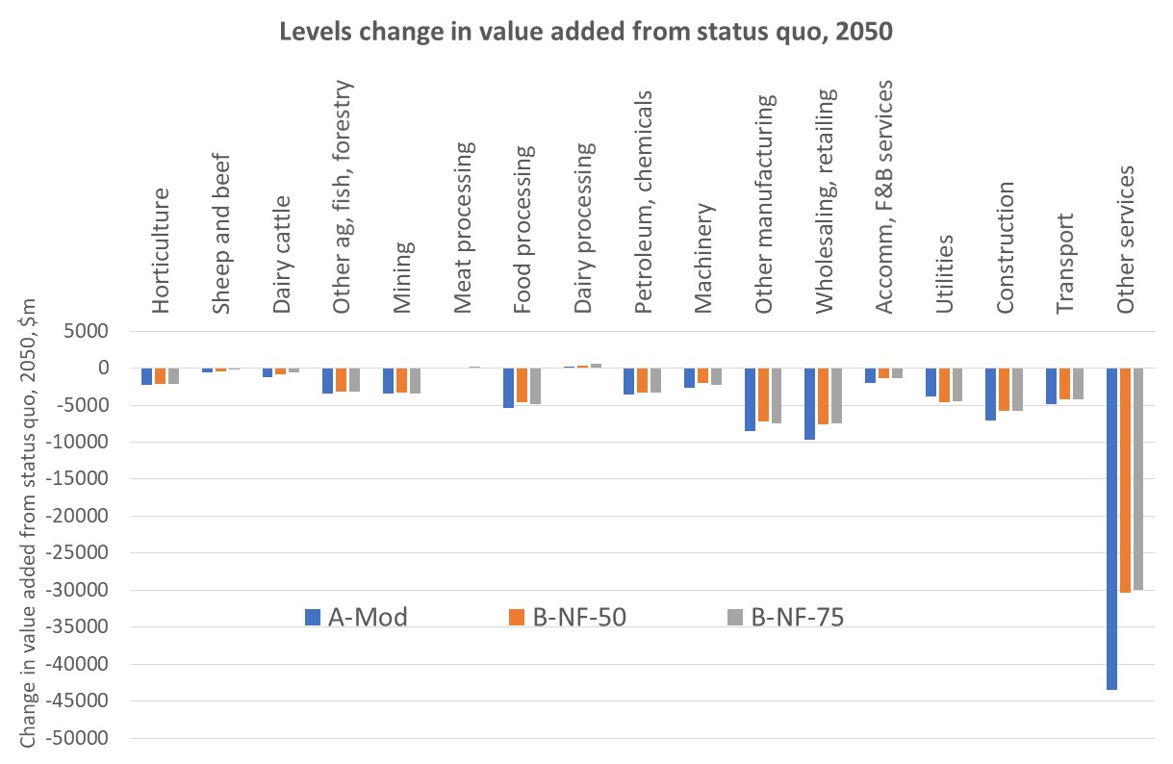

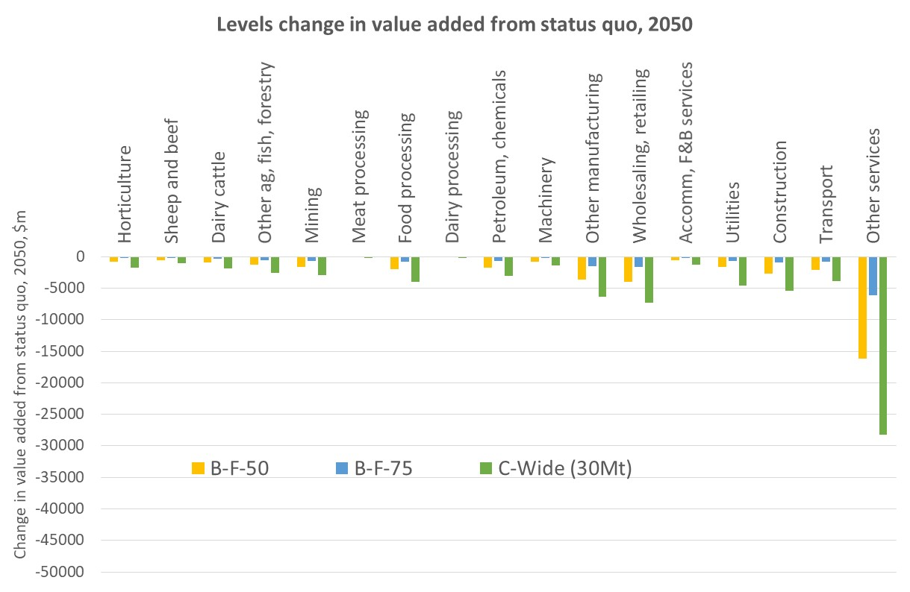
Source: NZIER
Figure 8 Aggregated industry impacts – effects of fungibility
$ millions change in aggregated industry value added from status quo, 2050
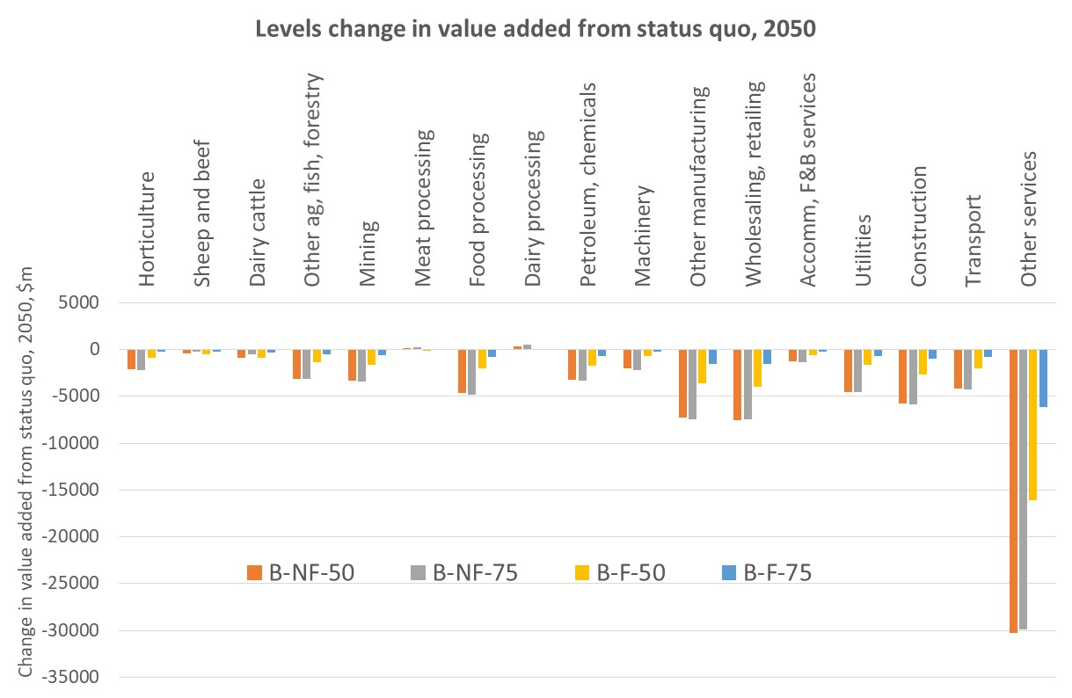
Source: NZIER

The overall picture
The largest impacts, in levels terms, are felt in the ‘Other services’ sector. This largely reflects the scale of this sector, which accounts for over 60% of the economy. Relative to its GDP, the impacts are much smaller (see Figure 9).
This is consistent with services sectors being relatively less emissions-intensive than many primary sector or manufacturing sectors – as a result they attract resources away from the more emissions-intensive sectors.
The wholesale and retail sector is another large sector, at almost 9% of the economy. It too sees large drops in activity, due to its scale and also due to its reliance on the transport sector and the impacts of lower household purchasing power.
A similar story can be told for the construction and ‘Other manufacturing’ sectors – they are large, relatively emissions-intensive and the demand for their goods and services is heavily influenced by households’ disposable income and business profitability.
In the primary sector, dairy cattle and sheep and beef value added fall in all core scenarios, relative to the status quo. The levels impacts are not as large as those for larger sectors, but as a proportion of their value added, the impacts are significant (Figure 9).
The downstream dairy and meat processing industries suffer less in levels terms, and indeed benefit very slightly in some scenarios relative to the status quo, primarily due to their scale and the energy efficiency improvements that we model to proxy innovation.
Horticulture is relatively lower-emissions intensive than dairy cattle and sheep and beef farming, and so might be expected to gain resources at the expense of dairy and sheep and beef farming. However, it also competes for land with forestry, so when we assume additional sequestration, it has relatively less land available for productive use.
Emissions-intensive sectors such as mining and petroleum and chemicals unsurprisingly experience declines in value added after emissions targets are introduced and an implied carbon price generated. These effects are offset in part by the assumed energy efficiency gains through our innovation assumptions.

Comparing across scenarios
As discussed above in section 4.2.1, there are multiple, simultaneous drivers of results when we compare across scenarios. Identifying precisely what is driving each industry result is challenging in the face of different assumptions and targets. However, we delve deeper into some of the industry results below.
Figure 9 Proportionate change in value added
% change in value added, relative to status quo, 2050
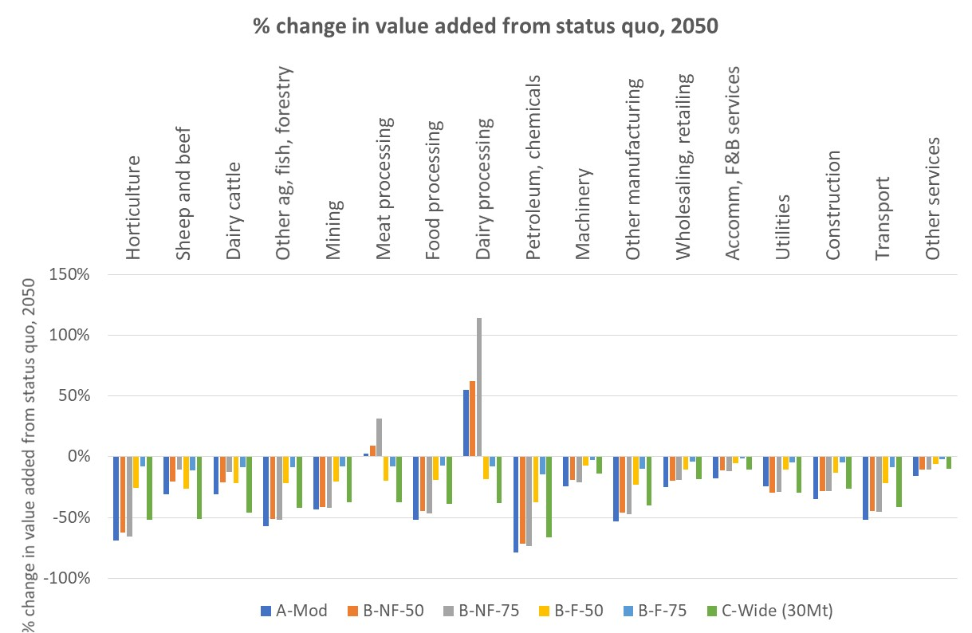
Source: NZIER

Horticulture
In all scenarios, horticulture value added falls relative to the 2050 status quo. This is largely a result of the assumed increases in sequestration, which flow through to an expansion in the forestry industry. As the forestry industry expands, less land is available for other productive uses, including horticulture.
The decreases in value added are smaller under the fungible scenarios partly because the implied carbon prices are considerably lower in these scenarios than in the non-fungible or net zero all gases targets. This means the horticulture sector’s intermediate costs, particularly fertilizer and transport, are relatively less expensive than in those scenarios.
In addition, the competing land uses of dairy and sheep and beef benefit from the methane vaccine’s impact on productivity, whereas the horticulture industry does not enjoy such a boost.
It may be that these impacts on the horticulture industry are overstated somewhat. As our CGE model is not a land use model, we do not have different qualities of pastoral land in our model. In reality some pastoral land is relatively low-yielding, while other pastoral land is higher-yielding. We might expect lower-yielding pastoral land to be displaced by an expansion in forestry first before it displaces higher value horticultural land uses.

Dairy cattle and sheep and beef farming and processing
Recall that we impose hard constraints on the dairy cattle and sheep and beef industries in the non-fungible scenarios. We tell the model what these industries can produce, rather than letting the model tell us.
In all other scenarios, the outputs of these industries are not restricted. They will adjust based on the pace of economic growth, the innovation assumptions employed (especially the methane vaccine) the overall shift to less emissions-intensive activities such as many services, the relative prices of land, labour and capital, land available for primary sector use after assumed changes to sequestration, etc.
Dairy cattle and sheep and beef farming are most affected in the net zero all gases scenario, C-Wide (30Mt) This is the most ambitious target and there are no constraints on how low production can go in these industries.
The next largest impacts come under the 50% stabilisation target scenarios. The value added impacts are very similar between the fungible and non-fungible scenarios. This is perhaps surprising – intuition suggests that the costs would be larger under the non-fungible scenario. This is the result of several counteracting drivers:
- We have stronger innovation assumptions in the non-fungible scenario, particularly the methane vaccine, which acts as a productivity boost for the dairy and sheep and beef industries. The vaccine is not present in the fungible scenario, and so these sectors do not get the same productivity boost.
- We determine by assumption dairy and sheep and beef output in the non-fungible scenario, which gives the economy fewer options to adjust output across the economy. The model does not let dairy and sheep and beef output settle to its ‘natural’ level. There is no such cap in the fungible scenario.
- Sequestration is higher in the non-fungible scenario, which reduces the overall burden on the rest of the economy, relative to the fungible scenario.
In the net zero carbon scenario, we also see sharp drops in dairy cattle and sheep and beef farming value added. This is surprising at first glance, since we do not ask these sectors to directly reduce or abate methane emissions. The results are due to several factors relating to their input use, which includes:
- Fossil fuels
- Intermediate inputs which have carbon-intensive production processes, like fertilisers
- Intermediate inputs which do not have carbon-intensive production processes but are also now more expensive since they use fossil fuels in their production and delivery (such as forage material); and
- Transport margins for intermediate input use.
Table 10 shows the reliance of farming on intermediate inputs that will be heavily impacted by higher carbon prices generated through a CO₂-only emissions reduction target. Note that the carbon prices in the net zero carbon scenario are much higher than those in the fungible and net zero all gases scenarios, and similar to those in the non-fungible scenarios.
Table 10 Farming’s use of CO₂-intensive inputs
Shares of intermediate input costs
Intermediate input | Sheep & beef farming | Dairy cattle farming
Petrol | 32% | 39%
Electricity | 3% | 10%
Fertilisers and pharmaceutical products | 31% | 40%
Total – CO2-intensive inputs | 66% | 89%
Source: NZIER CGE database
In addition, on the demand side, the outputs of the farming sector need to be delivered to processors, consumers and ports (for export), so demand would also fall due to higher transport costs.
The key message across all scenarios remains consistent though: meeting ambitious emissions targets will require significant changes to the status quo for the pastoral farming sector.
For dairy and meat processing, value added increases relative to the status quo in the net zero carbon and non-fungible scenarios. This doesn’t happen in the other scenarios.
This counter-intuitive result can be explained in part by the fact that in these scenarios, sequestration offsets are only available to CO₂-emitting industries, so there is more sequestration to go around, relative to the fungible and all gases scenarios. Dairy and meat processing are both highly energy-intensive, and they will use lower-cost sequestration to meet their emissions reduction requirements rather than higher-cost abatement through reducing output.

Heavy manufacturing and extractive sectors
The results are similar across scenarios for mining, machinery and ‘Other manufacturing’. These industries experience the largest value added declines, relative to the status quo, in the net zero carbon, net zero all gases and non-fungible scenarios.
In the net zero carbon and non-fungible scenarios, they are being asked to do much of the heavy lifting in terms of reducing carbon dioxide emissions. This emission reduction burden is spread more widely across the economy under the all gases and fungible scenarios.

Services
In proportionate terms, the services sectors in the economy experience relatively lower reductions in value added than the primary and manufacturing sectors.
This is largely because they are less emissions-intensive, so the introduction of an emissions target and implied carbon price has a relatively lower impact on their activities. They also benefit from the availability of relatively cheaper labour and capital as other, more emissions-intensive parts of the economy contract; and to a lesser extent, from the energy efficiency improvements in our innovation assumptions.
However, they suffer from decreases in household purchasing power and a broader slowing of economic growth.

Impacts on forestry
As Figure 10 shows, introducing emissions targets will have significant impacts on land use in New Zealand’s primary sector. The forestry expansion is largely in line with our sequestration assumptions and leads to forestry accounting for a larger proportion of available productive land.
This eats into land available for alternative uses in our model – dairy cattle and sheep and beef farming, poultry farming, and horticulture – there are no land use free lunches with sequestration as there were in the Stage 1 modelling. In all scenarios, the share of land in pastoral farming decreases substantially.
Recall that in the non-fungible scenarios, we fix dairy and sheep and beef output, so it is not free to adjust to its ‘natural’ level. This in part explains why the land use impacts on these sectors is larger under the fungible and all gases scenarios. The lack of methane vaccine in the fungible scenarios is another driver of these results.
Figure 10 Land use impacts on primary sector
Accumulative % change from baseline primary sector land use
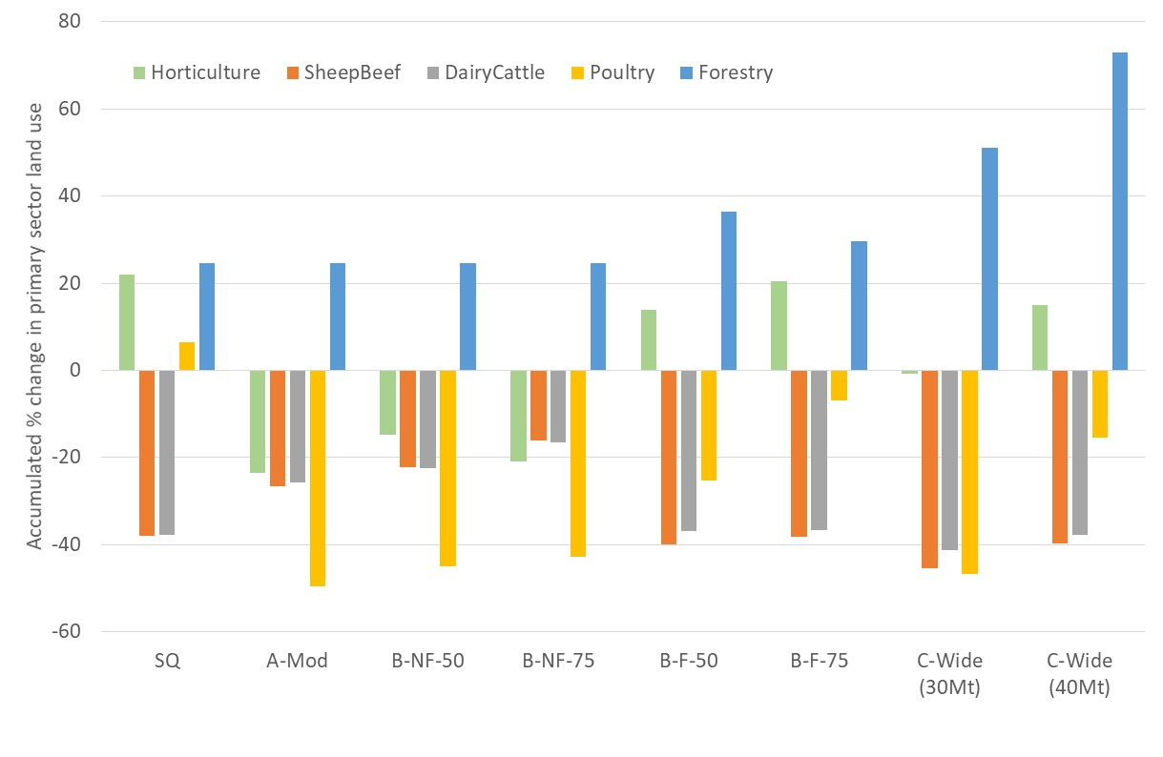
Source: NZIER
The impact on the forestry industry and its related downstream wood processing industries of these changes in land use, along with the various other changes to the economy incorporated into our scenarios, is shown below in Figure 11.
It is not as simple as saying that more sequestration leads to a proportionate increase in forestry value added, because value added in our model is generated when trees are harvested and then processed, not when they sit in the ground sequestering emissions.
Figure 11 Forestry and wood processing sector value added
Level of value added in $ millions, 2020 and 2050
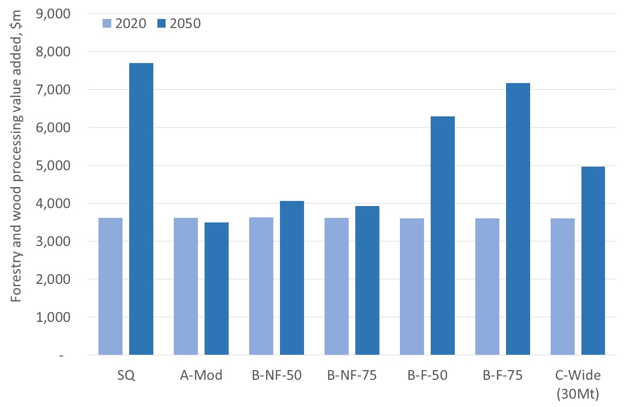
Source: NZIER

Carbon price results
Our CGE model solves for the implied carbon price that would be required to meet each emissions target. The implied carbon price in our model reflects the additional cost (per ton of emissions) associated with meeting a desired emissions target.
Changes in the implied carbon price affect the allocation of resources across the economy, as CGE models adjust resource use across industries based on changes in relative prices.
Our CGE modelling estimates of the average implied carbon price between 2020 and 2050 are shown in Table 11.
Table 11 Average implied carbon prices
$ per tonne CO₂e; average price 2020-2050
Status quo | A-Mod | B-NF-50 | B-NF-75 | B-F-50 | B-F-75 | C-Wide (30Mt) | C-Wide (40Mt) | C-Wide-80-Int-$150
115 | 1125 | 978 | 1039 | 518 | 271 | 1056 | 406 | 567
Source: NZIER
Our carbon price estimates are substantially higher than those estimated by CMV (2018a, 2018b). NZIER (2018a) and Productivity Commission (2018) have both outlined potential reasons for these differences, including:
- Different types of models were used, with CMV’s being more detailed on land use, energy and transport; and ours being designed to explore macroeconomic and inter-sectoral (direct and indirect flow-on) impacts. If CMV’s model more explicitly captured economy-wide income constraints, employment, trade impacts, etc, then it would likely deliver higher carbon prices.
- The modelled scenarios and assumptions were not identical. Our assumed sequestration was lower than CMV’s model delivers. If we increased our sequestration assumptions, then our CGE modelling framework would generate lower implied carbon prices that are closer to those from CMV’s model.
- CMV exogenously imposed (i.e. assumed) prices to 2030 whereas we let the CGE model solve for the carbon prices in all years from 2017 to 2050.
Determining which estimates are ‘best’ is challenging – we simply don’t know what will happen over the next 30 years and there is little evidence from history that we can draw on to sense-check our respective estimates. Perhaps all we can say is that CMV’s estimates are appropriate in their modelling framework; and ours are appropriate in our quite different modelling framework.
Both models do at least suggest that transitioning to a low-emissions economy will require significantly higher emissions price signals to induce changes in household and firm behaviour.

Impacts on households
A slower economy and higher carbon prices will dent households’ purchasing power and economic wellbeing. Wellbeing is not particularly well proxied by GDP. An alternative measure of the economic impacts of meeting emissions targets is to examine changes in RGNDI per household.
While RGNDI is not an ideal metric for wellbeing either, it does at least measure of New Zealanders’ purchasing power. As Statistics New Zealand notes: “GDP is a measure of economic activity, while RGNDI is a measure of the volumes of goods and services New Zealand residents have command over. RGNDI takes into account changes in the terms of trade effect (the price of imports relative to the price of exports), as well as net investment income and net transfer income flows with the rest of the world” (Statistics New Zealand, 2018a).
Measured in this way, in the status quo scenario, the average household’s purchasing power rises from $192,500 in 2020 to $283,400 in 2050; an increase over 55% over the period. Average purchasing power per year per household between 2020 and 2050 is $230,000.
This purchasing power will fall by $2,900 to $11,400 per household per year over the 2020-2050 period for the all gases core scenarios, relative to the status quo. So while households will still be better off in all scenarios than they are now, the introduction of emissions targets will have a non-trivial impact on the amount of goods and services they can buy, relative to the status quo.
Much higher sequestration (40Mt instead of 30Mt) reduces these impacts to around $600 per household per year, relative to the status quo. Access to international units also materially reduces the impacts on households’ purchasing power.
We do not look here at the impacts on households with different incomes, but our Stage 1 report suggested that those on lower incomes will experience far greater costs as a proportion of their incomes. That is, higher carbon prices are regressive.
This indicates that an important part of the transition to a lower emissions economy will be adjusting the tax and welfare systems to ensure those on low incomes are appropriately supported. Or as the Productivity Commission (2018, p.293) notes, “one key way to counter the regressive impacts of emissions pricing and other climate change policies is to provide financial assistance to affected individuals and households (eg, through transfer payments or the tax system)”.
Figure 12 Change in per household purchasing power
Change in average annual RNGDI per household between 2020 and 2050, relative to the status quo, $000s; labels show % change from status quo
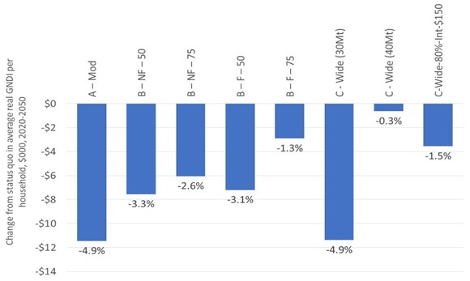
Source: NZIER

Conclusions
Our modelling shows that transitioning to a low-emissions economy by 2050 will dampen economic growth and household purchasing power in New Zealand.
Average real GDP growth between 2020 and 2050 will fall from 2.15% in the baseline or 2.06% in the status quo that reflects existing emissions reductions commitments to between 1.71% and 1.99% when reductions in all gases are considered.
Aside from choosing a less ambitious emissions target, the extent of the adjustment to economic growth can be moderated by:
- Actions to encourage additional sequestration over and above what is assumed in our core scenarios.
- Efforts to support innovation in emissions-reducing technologies over and above those we have modelled.
- Allowing fungibility so that sequestration can be used by all industries to offset emissions of all types of gases.
- Using international units to offset some of the emissions target, rather than seeking to reduce emissions domestically only.
As with all economic modelling, these results are dependent on the assumptions employed, the scenario design and the limitations of the data and framework used. However, we hope that these results service to highlight the trade-offs and challenges involved with the transition to a low-emissions economy over the coming decades.

- References
Adams, P., Parmenter, B., and G. Verikios. 2014. ‘An Emissions Trading Scheme for Australia: National and Regional Impacts’. Centre of Policy Studies Working Paper, Victoria University, Melbourne.
Concept, Motu and Vivid Economics. 2018a. ‘Modelling the transition to a lower net emissions New Zealand: Interim results’. Report to New Zealand Productivity Commission, April 2018. https://www.productivity.govt.nz/sites/default/files/Modelling%20the%20transition%20to%20a%20lower%20net%20emissions%20New%20Zealand_Interim%20Results_Concept%2C%20Motu%2C%20Vivid.pdf
Concept, Motu and Vivid Economics. 2018b. ‘Modelling the transition to a lower net emissions New Zealand: Uncertainty analysis’. Report to New Zealand Productivity Commission, July 2018. https://www.productivity.govt.nz/sites/default/files/Modelling%20the%20transition%20to%20a%20lower%20net%20emissions%20New%20Zealand%20-%20Uncertainty%20analysis%20-%20Concept%2C%20Motu%2C%20Vivid.pdf
Infometrics. 2015. ‘A General Equilibrium Analysis of Options for New Zealand’s post-2020 Climate Change Contribution’. Report to Ministry for the Environment, April 2015. http://www.mfe.govt.nz/sites/default/files/media/Climate%20Change/general-equilibrium-analysis_0.pdf
Landcare Research. 2015. ‘Modelling the economic impact of New Zealand’s post-2020 climate change contribution’. Report to Ministry for Primary Industries and Ministry for the Environment, May 2015. http://www.mfe.govt.nz/sites/default/files/media/Climate%20Change/economic%20impact%20of%20NZ%20post-2020%20climate%20change%20contribution.pdf
Ministry for the Environment. 2017a. ‘New Zealand’s Seventh National Communication: Fulfilling reporting requirements under the United Nations Framework Convention on Climate Change and the Kyoto Protocol’. http://www.mfe.govt.nz/sites/default/files/media/Climate%20Change/21-12-17%20Web%20FINAL%20-%20Seventh%20National%20Communication%202017.pdf
Ministry for the Environment. 2017b. ‘New Zealand’s Third Biennial Report under the United Nations Framework Convention on Climate Change.’ Wellington: Ministry for the Environment. http://unfccc.int/files/national_reports/biennial_reports_and_iar/submitted_biennial_reports/application/pdf/148395_new_zealand-br3-1-new_zealand_third_biennial_report.pdf
New Zealand Climate Change Research Institute and NIWA. 2018. ‘Estimating financial costs of climate change in New Zealand’. Report to New Zealand Treasury, September 2018.
https://treasury.govt.nz/sites/default/files/2018-08/LSF-estimating-financial-cost-of-climate-change-in-nz.pdf
NZIER. 2018a. ‘Economic impact analysis of 2050 emissions targets: A dynamic Computable General Equilibrium analysis’. NZIER report to Ministry for the Environment, June 2018. http://www.mfe.govt.nz/sites/default/files/media/Climate%20Change/NZIER%20report%20-%20Economic%20impact%20analysis%20of%202050%20emissions%20targets%20-%20FINAL.pdf
NZIER and Infometrics. 2009. ‘Economic modelling of New Zealand climate change policy’. Report to Ministry for the Environment, May 2009. https://www.mfe.govt.nz/sites/default/files/media/Climate%20Change/economic-modelling-of-new-zealand-climate-change-policy_0.pdf
New Zealand Productivity Commission. 2018. ‘Low-emissions economy: Final report’. www.productivity.govt.nz/low-emissions
Tian, X., Sohngen, B. and R. Sands. 2013. ‘Modelling a Dynamic Forest Sector in a General Equilibrium Framework’. Selected Paper prepared for presentation at the Agricultural & Applied Economics Association’s 2013 AAEA & CAES Joint Annual Meeting, Washington, DC, August 4-6, 2013.
Wilkerson, J.T, Leibowicz, B.D., Turner, D. D. and Weyant J.P. 2015. ‘Comparison of integrated assessment models: Carbon price impacts on U.S. energy’. Energy Policy 76 (2015),pp.18-31
https://www.researchgate.net/publication/267393055_Comparison_of_Integrated_Assessment_Models_Carbon_Price_Impacts_on_US_Energy#pfd

We interpret this commitment as occurring without access to international units.
Long-lived gases include carbon dioxide and nitrous oxide. Note that in the non-fungible scenarios we modelled net zero carbon dioxide (i.e. we did not include nitrous oxide) — this is because most nitrous oxide emissions in New Zealand are from dairy farming, and the constraint placed on short-lived gases from the dairy and sheep and beef sectors in these scenarios would result in reductions of nitrous oxide.
Short-lived gases refer to biogenic methane.
Note that in this scenario, the cost of purchasing international units to abate 20% of the emissions target is calculated outside of the modelling framework. The results reported here do not take into account this additional cost.
New Zealand Climate Change Research Institute and NIWA (2018, p.17) estimate that “climate change attributable extreme rainfall-related floods have cost New Zealand around $120M in climate change attributable privately insured damages over that [2007-2017] ten year period….[and] that climate change-attributable economic losses associated with droughts have cost New Zealand around $720M over that ten year period”.
Note that within the model, we moved to 80% of a net zero all gases target, with the remaining 20% of the target being met by purchases of international units at $150. The additional cost of these units ($2.08 billion spread over the 2020-2050 period), which represents an outflow of resources from New Zealand, could not be captured within the modelling framework in the time available. This additional cost presents a downside risk to the GDP impacts reported for this scenario.
If we increased our sequestration assumptions and incorporated a wider range of energy technologies, then our CGE modelling framework would generate lower implied carbon prices that are closer to those from CMV’s model. If CMV’s model more explicitly captured economy-wide income constraints, employment, trade impacts, etc, then it would likely deliver higher carbon prices.
This does not mean that we will have lower purchasing power than we do currently. In the status quo scenario, real GNDI per household grows by around 47% between 2020 and 2050; and this growth will be slightly lower in the remaining modelled core scenarios.
NZIER (2018a).
We interpret this commitment as occurring without access to international units.
Long-lived gases include carbon dioxide and nitrous oxide. Note that in the non-fungible scenarios we modelled net zero carbon dioxide (i.e. we did not include nitrous oxide) — this is because most nitrous oxide emissions in New Zealand are from dairy farming, and the constraint placed on short-lived gases from the dairy and sheep and beef sectors in these scenarios would result in reductions of nitrous oxide.
Short-lived gases refer to biogenic methane.
Note that in this scenario, the cost of purchasing international units to abate 20% of the emissions target is calculated outside of the modelling framework. The results reported here do not take into account this additional cost.
See, for example NZIER and Infometrics (2009), Infometrics (2015) and Landcare Research (2015).
A recent report by the New Zealand Climate Change Research Institute and NIWA (2018, p.17) estimates that “climate change attributable extreme rainfall-related floods have cost New Zealand around $120M in climate change attributable privately insured damages over that [2007-2017] ten year period….[and] that climate change-attributable economic losses associated with droughts have cost New Zealand around $720M over that ten year period”.
Concept, Motu and Vivid Economics (2018a); Concept, Motu and Vivid Economics (2018b).
New Zealand Productivity Commission (2018).
As CMV (2018a, p.14) note, their bottom-up linked model focuses on “accurately depicting the incentives and outcomes within their specific sectors of focus. This means that while they provide a richness of detail that can be lacking in other models, they are unable to provide estimates of aggregate whole-of-New Zealand economic cost of different pathways”.
In this report, we use “carbon price” and “emissions price” interchangeably.
Adams, P., Parmenter, B., and G. Verikios (2014).
Tian, X., Sohngen, B. and R. Sands (2013).
Ministry for the Environment (2017a).
Ministry for the Environment (2017b).
Including carbon dioxide, nitrous oxide and fossil methane.
Including biogenic methane, and other greenhouse gases (mostly HFCs). Fossil methane (e.g. natural gas leakage) should be considered a long-lived gas as, unlike biogenic methane, it adds new CO₂ to the atmosphere upon decay. New Zealand’s methane emissions in 2016 were 97% biogenic methane (from agriculture and waste), and 3% fossil methane (from the energy sector).
Note that the B-F-50 target is similar to a 75% reduction in all gases target.
This explains why the headline emissions reductions we ‘shock’ in the non-fungible scenarios are lower than their fungible comparators. Essentially, we use the constraint on dairy cattle and sheep and beef output as a second shock to reduce methane emissions.
This can be seen as our non-fungible stabilisation scenarios asking the dairy and sheep and beef industries to work slightly harder than a 50% or 75% emissions stabilisation target would imply, but the impacts are unlikely to be material and would not change the high-level picture.
The rest of the economy also grows more slowly when emissions targets are imposed. Reduced economic activity in the non-agricultural industries will also lead to reduced nitrous oxide emissions from these industries, albeit a small amount relative to the 94% that is accounted for by the dairy cattle and sheep and beef industries.
The choice of international unit price does not influence the modelled results presented here. It is used for our out-of-model calculation of the cost of these units for businesses.
In specifying the scenario parameters there was an omission of residual emissions from household transport (i.e. emissions from fuel use in household-owned motor vehicles) which is computed outside the model. Offsetting these residual emissions would require an additional 2–3 MtCO₂e of forestry sequestration. For example, the scenario C-wide-(30Mt) would require 32 MtCO₂e sequestration (rather than 30 MtCO₂e) to meet the net zero emissions target with the stated economic impact.
See Table 9, page 10, of NZIER (2018a).
Note that this excludes emissions from household transport, which is computed outside the model (footnote 31 refers).
The actual sequestration required would be 2–3 MtCO2e higher than these figures (footnote 31 refers).
This also applies to the non-fungible scenarios.
For the sake of comparability with our Stage 1 results, and to avoid re-running the modelling, we have used the same industry aggregation as in Stage 1, where forestry was included in the composite ‘Other ag, fish and forestry’.
Although there will be some value-added generated by labour in the years of planting and thinning trees.
A recent paper (Wilkerson et al, 2015) compares the results of a single carbon tax scenario across three types of climate change models, including a partial equilibrium energy and land use optimisation model (GCAM) that solves for the least-cost solution for a given climate change policy objective; and a recursive dynamic global CGE model (EPPA). These models are analogous, albeit not identical, to those used by CMV and NZIER. They find that “Both models generate a very large drop in carbon emissions in the ﬁrst period of the policy. GCAM is particularly ﬂexible in adapting quickly to the new policy land-scape, with emissions declining 82% in the ﬁrst time step following the 2050 tax shock. The GCAM response includes many stranded assets and investment in new capacity, while the EPPA response features primarily a large reduction in energy use” (p.23). These insights are also likely to apply to a comparison between CMV’s modelling and our own – CMV’s model is likely to adjust more rapidly to an emissions target through rapid energy-switching technologies; our CGE model will tend to adjust more slowly through decreases in energy use instead, leading to larger GDP impacts and higher prices.

