

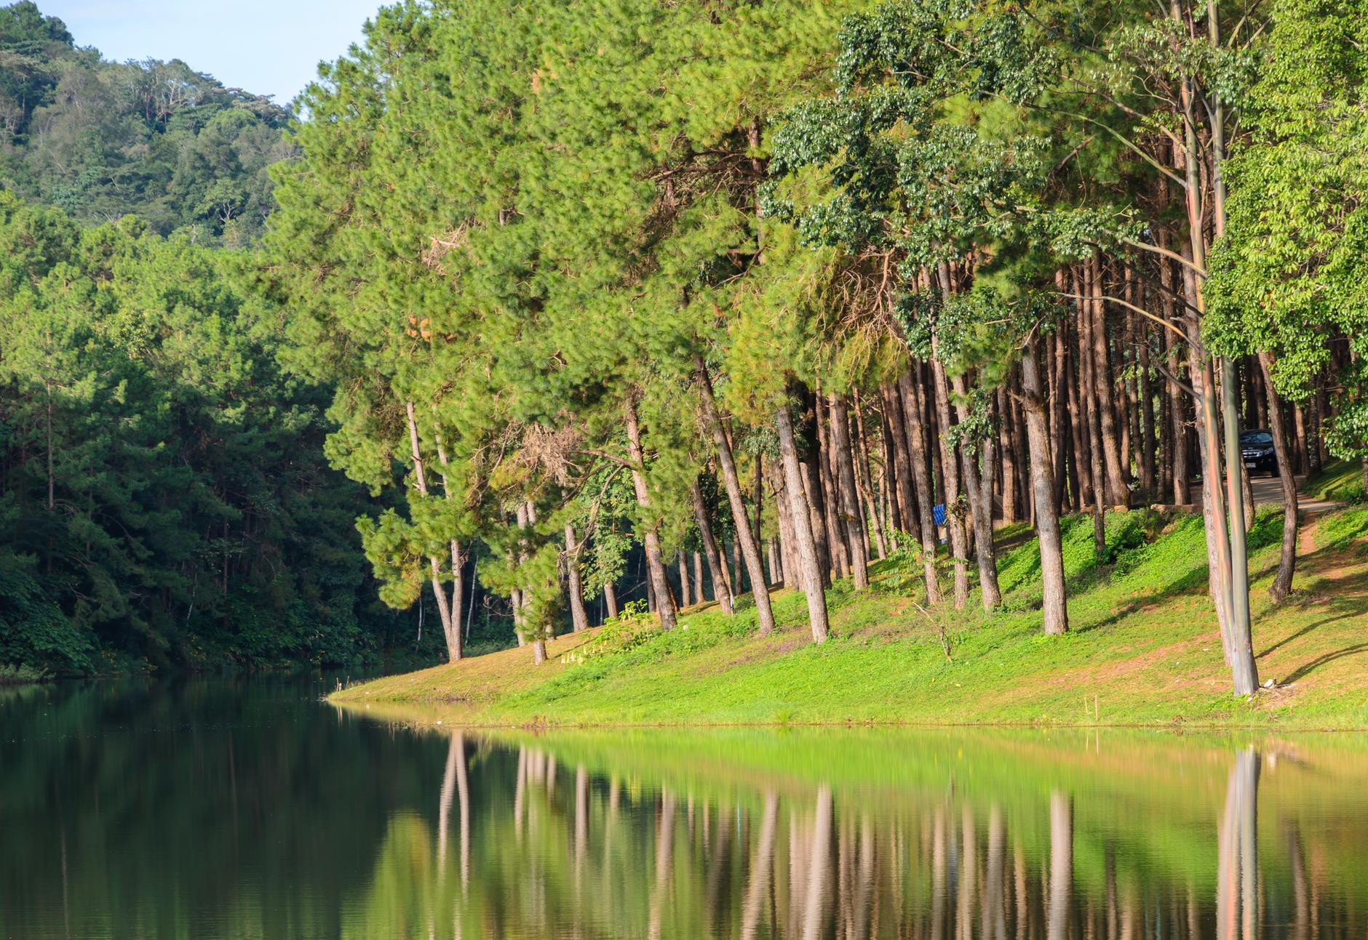
The economic effects of water quality proposals
Modelling scenarios

NZIER report to Resource Economics Ltd
May 2020

About NZIER

NZIER is a specialist consulting firm that uses applied economic research and analysis to provide a wide range of strategic advice.
We undertake and make freely available economic research aimed at promoting a better
understanding of New Zealand’s important economic challenges.
Our long-established Quarterly Survey of Business Opinion (QSBO) and Quarterly Predictions are available to members of NZIER.
We pride ourselves on our reputation for independence and delivering quality analysis in the right form and at the right time. We ensure quality through teamwork on individual projects, critical review at internal seminars, and by peer review.
NZIER was established in 1958.

Authorship

This paper was prepared at NZIER by Peter Wilson and Milad Maralani. It was quality approved by Todd Krieble.
The assistance of Tim Denne, Bill Kaye-Blake and Sarah Spring and participants at a seminar organised by the Ministry for the Environment is gratefully acknowledged.
John Ballingall of Sense Partners and Adolf Stroombergen of Infometrics peer-reviewed this report for the Ministry for the Environment. Their very helpful comments on an earlier draft have been incorporated into the final version.

Registered office: Level 13, Willeston House, 22–28 Willeston St | PO Box 3479, Wellington 6140 Auckland office: Ground Floor, 70 Shortland St, Auckland
Tel 0800 220 090 or +64 4 472 1880 | econ@nzier.org.nz | www.nzier.org.nz

© NZ Institute of Economic Research (Inc). Cover image © Dreamstime.com
NZIER’s standard terms of engagement for contract research can be found at www.nzier.org.nz.

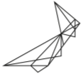
While NZIER will use all reasonable endeavours in undertaking contract research and producing reports to ensure the information is as accurate as practicable, the Institute, its contributors, employees, and Board shall not be liable (whether in contract, tort (including negligence), equity or on any other basis) for any loss or damage sustained by any person relying on such work whatever the cause of such loss or damage.

Executive Summary

This report presents the results of some economic modelling of possible changes in the regulation of freshwater in New Zealand.

Three policy packages over two timeframes
We have used our detailed model of the New Zealand economy to measure the nationwide and regional economic effects of possible reactions to three policy packages:
- The changes due to the National Policy Statement on Freshwater
- Two variants of the Essential Freshwater Package.
The first scenario, entitled NPS (2017), is based on an estimate of council requirements for meeting the objectives of the National Policy Statement for Freshwater Management.
The second scenario – Essential Freshwater Package (EFWI) – includes costs of nitrogen (N) and phosphorus (P) limits, stock exclusion policy and whole farm plans.
The third scenario (EFWII) – replaces N and P limits with requirements of strengthening the nitrogen toxicity in EFWI
We model progressive implementation of the scenarios, looking at results in 2030 and 2050. We do not report the marginal contribution from, for example, moving from NPS (2017) to EFWII, or from EFW I to EFW II, but the cumulative impact of each scenario. Those interested in the marginal impacts of a change such as that from NPS (2017) to EFWII, or from EFW I to EFW II, need to contrast the two cumulative results to infer the marginal impact.
We have undertaken a production-based assessment of the economic costs of the proposals, not a cost benefit analysis. Our analysis can be used to compare the costs with the wider benefits, but that is a separate exercise beyond the scope of this paper.
Our task here is test scenarios. We present a series of ‘what if’ proposals that detail possible responses to policy changes, informed by economic principles.

Farmers look for least-cost ways to respond
The scenarios assume that farmers look for least-cost ways to adjust their production techniques to the new rules, which includes changing land use, i.e. converting a dairy farm to a less intensive operation.
A major response that we model is that land is converted from dairy farming to forestry.

One policy package at a time
The government is seeking to transform the economy to a more sustainable footing across a range of policy areas, including moving to a low carbon future.
This report, however, seeks to isolate the economic effects of just one policy package: water quality. So, we have assumed that all other policy settings – including climate change

policies – remain steady at current settings. While not a perfect reflection of the future, it does allow us to identify the likely effects of the Government’s water policies in isolation.

Modest 2030 impacts
In 2030, the NPS package has a total negative economic impact, measured in terms of real gross domestic product (GDP), of $200 million.
The Essential Freshwater Package I has a larger negative effect – $568 million.

Larger 2050 effects
In the long term, out to 2050, the NPS policy changes have a negative impact of $508 million, while the EFW Package I will result in a reduction in real GDP of about $955 million, while the EFW Package II will see the economy being about $700 million smaller, compared to the status quo.

Table 1 Economic effects of the scenarios
Real GDP, in millions of dollars

 | 2030 | 2050
National Policy Statement | -$208 | -$508
Essential Freshwater Package One | -$568 | -$955
Essential freshwater Package Two | -$259 | -$701
Source: NZIER

To put these figures into context, in 2019 New Zealand’s GDP was roughly $300 billion. Table 2 presents the results from the three scenarios as a proportion of GDP.

Table 2 The proportional effects of the scenarios
Percentage points of real GDP

 | 2030 | 2050
National Policy Statement | -0.06% | -0.17%
Essential Freshwater Package One | -0.15% | -0.28%
Essential Freshwater Package Two | -0.08% | -0.21%
Source: NZIER

Our model calculates the national and regional results across a range of economic indicators.

Table 3 Major economic indicators
Percentage points change relative to BAU

Economic Indicator | NPS (2017)-  2030 | EFWI- 2030 | EFWII- 2030 | NPS (2017)-  2050 | EFWI- 2050 | EFWII- 2030
Consumption | -0.09 | -0.2 | -0.11 | -0.23 | -0.38 | -0.28
Investment | -0.03 | -0.07 | -0.03 | -0.08 | -0.14 | -0.1
Exports | -0.11 | -0.28 | -0.13 | -0.31 | -0.58 | -0.37
Imports | -0.09 | -0.23 | -0.10 | -0.24 | -0.46 | -0.29
Real GDP | -0.06 | -0.15 | -0.08 | -0.17 | -0.28 | -0.21
GDP price Index | -0.01 | -0.02 | -0.01 | -0.02 | -0.03 | -0.03
Nominal GDP | -0.07 | -0.17 | -0.09 | -0.19 | -0.32 | -0.23
Real wage | -0.05 | -0.15 | -0.06 | -0.17 | -0.3 | -0.21
Source: NZIER

Regional effects vary
The impact of the policies varies by region. Those regions that have seen significant recent increases in dairy intensification will see the largest changes in economic activity, as resources move from areas that have a negative impact on water quality to more environmentally sustainable activities. Figure 1 shows the regional real GDP effects for one scenario (EFWI 2050). The regional real GDP effects of other scenarios is presented in the main body of the report and in Appendix C.

Figure 1 The regional impact is varied
EFWI 2050

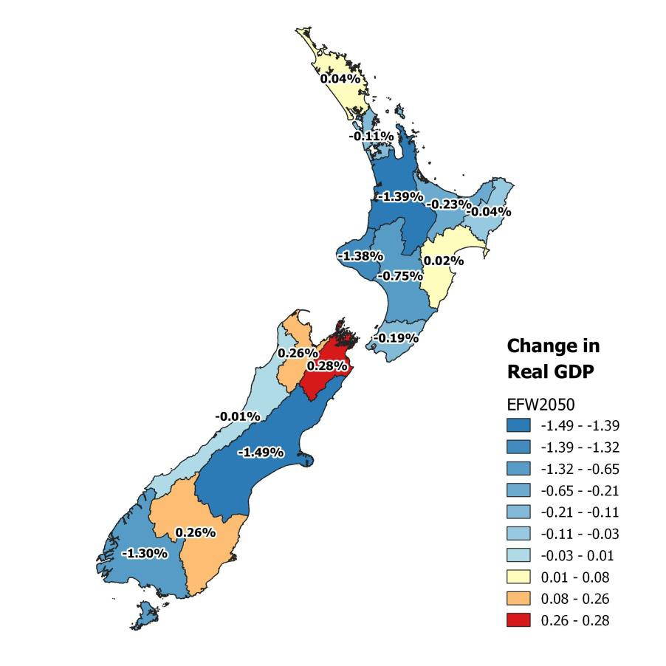

Source: NZIER

We have also calculated other indicators by region and by scenario. This is illustrated in Table 4, this time showing the effect of the EFW II 2050 scenario across all the regions.

Table 4 Regional impacts
EFWII 2050: scenario, percent of regional GDP change from BAU

Economic indicator | Consumption | Investment | Exports | Imports | Real GDP | GDP  price Index | Nominal GDP | Employment | Real wage
Northland | -0.02 | 0.24 | 0.5 | -0.01 | 0.1 | -0.03 | 0.07 | 0.14 | -0.08
Auckland | 0.08 | 0.28 | 0.65 | -0.06 | 0.23 | -0.14 | 0.1 | 0.2 | -0.03
Waikato | -0.14 | 0.07 | 0.38 | -0.33 | -0.02 | 0 | -0.02 | 0.08 | -0.14
Bay of Plenty | 0.09 | 0.32 | 1.54 | -0.11 | 0.21 | -0.08 | 0.13 | 0.2 | -0.02
Gisborne | 0.06 | 0.47 | 0.28 | -0.02 | 0.22 | 0.08 | 0.31 | 0.19 | -0.04
Hawke’s Bay | -0.03 | 0.28 | -1.16 | -0.04 | -0.03 | 0.1 | 0.07 | 0.14 | -0.08
Taranaki | -0.89 | -0.81 | -1.09 | -1.31 | -0.99 | 0.23 | -0.76 | -0.32 | -0.49
Manawatu- Wanganui | -0.4 | -0.25 | -0.81 | -0.55 | -0.4 | 0.09 | -0.31 | -0.06 | -0.26
Wellington | -0.09 | 0.15 | 0.66 | -0.16 | 0.1 | -0.17 | -0.08 | 0.11 | -0.11
Tasman/Nelson | 0.34 | 0.6 | -0.01 | 0.16 | 0.37 | 0.04 | 0.4 | 0.33 | 0.09

Marlborough | 0.21 | 0.53 | -0.13 | 0.18 | 0.39 | -0.02 | 0.37 | 0.26 | 0.03
West Coast | -0.07 | 0.35 | 0.26 | -0.08 | 0.07 | 0.07 | 0.15 | 0.11 | -0.1
Canterbury | -1.68 | -1.49 | -2.76 | -1.06 | -1.67 | 0.14 | -1.53 | -0.73 | -0.87
Otago | 0.02 | 0.31 | -0.83 | -0.01 | 0.05 | 0.08 | 0.13 | 0.17 | -0.06
Southland | -1.62 | -1.72 | -3.48 | -0.93 | -2.37 | 0.65 | -1.75 | 0.07 | -0.11
Source: NZIER

Why are these impacts so low?
Commentary by several stakeholders has suggested that the impact of the Government’s
proposals will have a significant economic impact. Why are we suggesting different effects? There are three main reasons:
- We are showing the effects of farmers seeking a least-cost response to the policy changes, while other studies have assumed that the main response is to limit production.
- We have imposed a pattern of land use change on the model, based on work by Resource Economics and officials.
- We are only modelling the effects of the Government’s freshwater policies, rather than
adding in climate change.

Contents

- Introduction 1
- The proposed reforms 1
  - Interaction with other policies 2
- The modelling logic 2
- CGE modelling: the basics 3
  - Modelling a scenario 4
  - The closures 4
  - The results 4
  - The modelling database 4
  - Incorporating water into our model 4
- The model and set-up 5
  - The model 5
  - Scenarios we tested 5
  - Shock design 6
  - Land use 6
  - Technological change 7
- Our results 7
  - Exports 8
  - Regional results 9
- Other studies 13
- Conclusion 14
- References 15
Appendices
Appendix A Our model 16
Appendix B Scenarios details 19
Appendix C Regional results 28
Appendix D Industry results 34

Figures
Figure 1 The regional impact is varied iii
Figure 2 The modelling architecture 2
Figure 3 NPS (2017) 2030: change in regional GDP, percentage change 10
Figure 4 EFWI 2030: change in regional GDP, percentage change 11
Figure 5 NPS (2017) 2050: change in regional GDP, percentage change 12
Figure 6 EFWI 2050: change in regional GDP, percentage change 13
Figure 7 CGE models show the whole economy 17

Tables
Table 1 Economic effects of the scenarios ii
Table 2 The proportional effects of the scenarios ii
Table 3 Major economic indicators iii
Table 4 Regional impacts iv
Table 5 National economic indicators 7
Table 6 Exports of primary products 8
Table 7 Real GDP in each region 9
Table 8 Closures in the model 18
Table 9 Mitigation costs 19
Table 10 Reduced profits from land use change 19
Table 11 Increased profit from land use change 20
Table 12 Land use change 21
Table 13 Mitigation costs 21
Table 14 Reduced profits from land use change 22
Table 15 Increased profit from land use change 23
Table 16 Land use change 23
Table 17 Mitigation costs 24
Table 18 Reduced profits from land use change 25
Table 19 Increased profit from land use change 26
Table 20 Land use change 26
Table 21 NPS (2017) 2030: regional economic indicators 28
Table 22 EFWI 2030: regional economic indicators 29
Table 23 EFWII 2030: regional economic indicators 30
Table 24 NPS (2017) 2050: regional economic indicators 31
Table 25 EFWI 2050: regional economic indicators 32
Table 26 EFWII 2050: regional economic indicators 33
Table 27 NPS (2017) 2030 34
Table 28 EFWI 2030 36
Table 29 EFWII 2030 37
Table 30 NPS (2017) 2050 38
Table 31 EFWI 2050 39
Table 32 EFWII 2050 40

Introduction

The Government is proposing a series of changes to the rules around fresh water in New Zealand. These proposals are set in a discussion document that was released in 2019 (Ministry for the Environment 2019).
Resource Economics Ltd is studying the economic effects of the Government’s proposed reforms for the Ministry for the Environment (MfE). As part of this, they have asked us to use a computable general equilibrium (CGE) model to estimate the effects of the proposals on national and regional economies.
The analysis presented in this report estimates the impact of the policy changes on the New Zealand economy. It relies on data concerning land-use changes provided by Resource Economics Ltd; we have not independently assessed that data. The impacts are summarised by common metrics used for economic analysis. The analysis does not provide a holistic assessment of the proposed policy. In particular, it does not address the potential benefits of reducing nutrient emissions to water, including potential provisioning, regulating, cultural and support ecosystem services.

The proposed reforms

The Government has set three objectives for its Essential Freshwater work programme:
  - Stopping further degradation and loss
  - Reversing past damage
  - Addressing water allocation issues.
These objectives will be delivered through a range of legislative, policy and administrative actions, including:
  - Amendments to the Resource Management Act to introduce a new freshwater planning process, requiring councils to put in place new plans by 2025.
  - Significant changes to the current National Policy Statement on Freshwater Management.
  - Improving ecosystem health by improving farm practices, delivered through a new National Environmental Standard on Freshwater (Ministry for the Environment 2019).
In this report, we are focusing on the proposals that impact on farm practices. The Government is proposing a number of measures. The focus here are requirements related to stock exclusion, freshwater modules in farm plans and nitrogen toxicity. While not the focus in this report the Government is also proposing to restrict further intensification of rural land use that can degrade water quality and set new standards for high-risk activities.

2.1 Interaction with other policies
The government is pursuing a range of policies seeking to transform the economy to a more sustainable footing. The move to a low carbon future is an important example, which will have a direct impact on the sectors we have modelled.1
Due to constraints of time and scope, we have not incorporated any effects of climate change mitigation policies on the economy, specifically the entry of agriculture into the Emissions Trading Scheme or targeted methane reductions by 2030 and 2050, into our modelling. How water and climate policies and their timing interact are complex issues. It is not clear, for example, whether the effects of the policies will be cumulative or complementary. That is, for example, changes in farm practice to meet climate change policies might also have positive impacts on water quality. If this is the case, then the cost of water polices might be less than we have modelled here.

The modelling logic

The logic of the modelling is as follows:
  - The Government is setting new rules for land use in New Zealand.
  - As a result of these changes, farmers may need to change some of their on-farm practices.
  - Those practices will have an effect on the inputs into farming and the outputs.
  - Those changes in inputs and outputs will flow through to the rest of the economy. This logic is set out in schematic form in Figure 2 The modelling architecture

Figure 2 The modelling architecture

Farmers respond
- National Policy
Statement
- Essential Freshwater Package
- On-farm practices
- Different land use
- More arable
farming
- More forestry
- Less dairy
Flowing to the rest of the economy
- Regional impacts
- National impacts

New policies
Changes in inputs and outputs

Source: NZIER

1 We have also not included any effects from Covid19, since the pandemic broke out after we were commissioned to do this work.

Ideally, to determine the economic effects of these policy changes, we would have models that give us a clear picture of:
  - The farm-level response (what individual farms would do to comply with the new rules), which would include both ways to continue their current operations and changes in what is farmed.
  - The changes in all the inputs into farming and all the outputs.
  - The regional and national impacts of these changes.
While NZIER does have a suite of models that can model the wider economic effects, due to data and other limitations, no models exist in New Zealand, as far as we know, that can fully model the on-farm effects of the policy changes or how those changes will impact on inputs to farming and the outputs from farming at the national level. There are, however, models that link on-farm changes to regional economies.2 Insights from these models have informed our thinking.
What we have done, therefore, is take the results of separate work undertaken by Resource Economics Ltd, officials and others (included in this report as Appendix B) to develop a series of scenarios that we have used as inputs into our CGE model. This allows us to provide robust and plausible estimates of the likely effects of the policy changes. They are, however, estimates of the effect of a scenario, rather than being our predictions of exactly what will happen. They are intended to give the Government and stakeholders an idea of the size of the likely effects and their distribution, as a valuable input into the policy-making process.
We are confident, within the normal bounds of modelling uncertainty, that we can calculate the economic effects of each scenario if it were to come to pass. We have not been asked, however, to independently validate the scenarios.

CGE modelling: the basics

CGE models are our preferred method for assessing economic impacts and are used extensively in New Zealand and internationally. One researcher noted “a well-designed model that is used by skilled practitioners to shed light on issues the model was designed to illuminate can make a significant contribution to policy debates and decision making” (Dennis 2012).
A CGE model consists of equations which describe model variables. It also uses detailed data on the structure of the economy that is consistent with these model equations.
This data provides a snapshot of the economy in a particular year, which is used as a starting point for a baseline (or BAU) against which to compare policy simulations or economic changes.
The model data is linked together through a set of equations which capture how the economy responds to external changes. These equations, which are based on the economic theory of general equilibrium, ensure supply and demand for goods, services and factors of

2 Examples included RF-MAS: Rural Futures Multi-Agent Simulation, developed by staff of NZIER; NZ–FARM: New Zealand Forest and Agriculture Regional Model and ARLUNZ: Agent-Based Rural Land Use New Zealand Model operated by Landcare Research and LURNZ: Land Use in Rural New Zealand, operated by Motu Economic and Public Policy Research.

production in the economy are balanced, and determine how firms and households react in response to changes in the relative prices of factors of production and intermediate inputs.

Modelling a scenario
To estimate the effect of some change (referred to as a ‘shock’), the modeller:
    - specifies a starting position for the economy based on data in which supply is equal to demand in all markets (known as being ‘in equilibrium’)
    - changes parts of the data to reflect the shock and then,
    - using a highly detailed model of the economy and specialised software,3 determines what needs to happen to return the economy to a new equilibrium.

The closures
To allow the model to achieve a new equilibrium, some aspects of the economy must remain fixed, and these are known as exogenous variables. Together, the selected set of exogenous variables is known as the closures for the model. The rest of the model can change. These parts are termed the endogenous variables, because they are produced within the model itself. This what we are most interested in with a modelling exercise, since they represent the model’s predictions of the economy’s reaction to the shock.
Common closures, for example, are population and the labour force, the exchange rates, interest rates or export prices.
Where we draw the line between endogenous and exogenous variables, and which ones can vary or have to remain fixed, depends on a number of factors, including the purpose for which the model simulations are to be used. Modellers should be very transparent about what is a result of the modelling and what has been imposed via the closure.

The results
The difference between the old and the new equilibrium can then be analysed to determine the effect of the shock on a range of economic indicators, like gross domestic product (GDP), employment, wages and living standards.

The modelling database
The database has been sourced initially from Stats NZ’s 2013 Inter-industry tables. We prepared regional input-output tables using regional employment data and regional population estimates.
We updated the 2013 Input-Output table to 2019 using the latest national accounts data for the year ended March 2019.

Incorporating water into our model
Our model does not specifically include water as an input used into any industry.

3 In our case, GEMPACK the General Equilibrium Modelling PACKage: https://www.copsmodels.com/gempack.htm.

In essence, we treat water as an unobserved factor of production and capture the effects of changes in the availability of water through other measured inputs. This is a common approach (Damania 2020).

The model and set-up

In this section, we present high-level details about the set-up of the modelling exercise. More details are in Appendix A.

The model
We used our NZ-TERM (‘The Enormous Regional Model’) CGE model of the New Zealand economy and its regions for this economic impact analysis.

Scenarios we tested
Costs are estimated for three scenarios compared to a ‘do nothing’ counterfactual in which concentrations and discharge levels remain at current levels.
The first scenario, entitled NPS (2017), is based on an estimate of council requirements for meeting the objectives of the current National Policy Statement for Freshwater Management. The discharge reduction requirements are estimated by NIWA using its CLUES model, building on assumptions provided by MfE.
The second scenario – Essential Freshwater Package (EFWI) – includes:
    - modelled requirements of bottom lines for nitrogen (N) and phosphorus (P)
    - the estimated costs of the stock exclusion policy
    - the estimated costs of acquiring freshwater modules in whole farm plans. The third scenario (EFWII) --
    - modelled requirements of strengthening the nitrogen toxicity attribute to provide protection for 95% of species (up from 80% in the status quo), which essentially replace the bottom lines for N and P used in EFWI.
    - the estimated costs of the stock exclusion policy
    - the estimated costs of acquiring freshwater modules in whole farm plans.
The costs of the NPS (2017), EFWI’s N and P bottom lines and EFW II’s new toxicity attributes were estimated by Resource Economics Ltd, which analysed the farm-level costs of reducing discharges to the limits modelled by NIWA. This analysis assumed discharge reductions at least cost within each of over 11,000 catchments, through a mix of on-farm mitigations and land use changes. The costs of the stock exclusion policy and for whole farm plans were estimated by MfE and the Ministry for Primary Industries (MPI).
The costs assume that both the NPS (2017) and the two EFW scenarios are fully implemented by 2050. The EFW is assumed to be introduced rapidly from 2025 so that it is 35% implemented by 2030. It is then introduced in a straight line to achieve full implementation in 2050. Up to 2025, the assumption is that the same effort (and costs) accrue as assumed under the NPS (2017). Costs are assumed to increase in proportion to

the level of implementation. Costs are assumed to increase in proportion to the level of implementation.
The mitigation costs, profits changes and land use changes of the three scenarios are listed in a series of tables in Appendix B..

Shock design
We have used mitigation costs and land use change values provided by Resource Economics Ltd to shock the cost of production of selected commodities and changes in the quantity of land used as an input factor of production for relevant industries.
To translate the mitigation costs to the effects on the economy that could be modelled, we increased the difference between the cost of production and the price of delivered commodities at the regional level by adjusting a variable within the model. By imposing a negative shock to this variable, we increased the cost of producing that commodity to the economy. This is similar to imposing an ad-valorem tax on products but without any income being collected by the government.4 We used mitigation costs as a percentage increase in the cost of production for those commodities.

Land use
Our model includes how land is used as one of the variables that change when prices and profits change (that is, it is an endogenous variable). Changes in land use, in terms of both intensity of activity and type of activity, is one of the Government’s key policy goals.
However, like most other CGE models of its type, TERM does not explicitly include the water policy settings that we are studying.5 If it did, then our task would have been relatively simple: we could have adjusted those policy settings and run the model to determine the effects. We therefore need to develop a mechanism for showing how water policy changes impact on land use.6
In developing the scenarios to be modelled, Resource Economics Ltd has separately calculated land use change and used these changes as inputs in other parts of its work. We have, therefore, imposed those modelled land use changes, converting land use into an exogenous variable, where relative prices are not the driver of behaviour. We consider this to be appropriate, given the way the shock has been designed. To do otherwise risks producing illogical results: the shock requiring one pattern of land use, while the model would produce another. As a result, we are not making an independent assessment of those land use changes.

4 This technique is commonly referred to as studying “iceberg” trade costs: costs that are hidden below the surface. For an example using the Indonesian version of TERM, see Horridge (2016).
5 See Wittwer (2012) for a discussion of how the developers of the original Australian TERM model have incorporated water policy into a dynamic version of the model.
6 Given the importance pf water policy in New Zealand, developing a better capacity to model its effects should be considered. We note that the Climate Commission has commissioned the development of a new CGE model for climate policy.

Technological change
The other exogenous variables we have assumed are the technological coefficients in the model. These describe the relationship between different factors of production (labour, capital, intermediate inputs) and outputs. In effect, we are assuming that technology does not change. While we are testing a scenario where farm practices are expected to change as a result of the new water quality standards, we consider that keeping all the technology coefficients unchanged is an appropriate modelling strategy.7
The purpose of this modelling exercise is to show how the effects of the changes in water quality policy will flow through the rest of the economy, rather than estimating what those changes will be.
Technological change is a challenge for all modellers. While a key driver of economic and social progress, our understanding of how to model the innovation process is still developing. NZIER’s CGE models, like many others operated in New Zealand and elsewhere, keeps technology fixed as a default. Any changes in technology are modelled as an exogenous shock, with the extent of the change imported into the model as an assumption. Modelling what is often referred to as ‘induced technological change’ or ‘endogenous technological growth’ within CGE models is becoming more common, in part because of the extreme interest in the effects of climate change mitigation policies on economies.8 We are not aware of any models of the New Zealand economy that include such features.

Our results

At the national level, the impacts of the scenarios on production are uniformly negative: the benefits of improved water quality come at an economic cost.
The results are, however, modest within the context of a $300 billion economy, measured in points of a percent. Under the most stringent scenario, EFWI-2050, real GDP will be 0.3% lower than the no-policy status quo.

Table 5 National economic indicators
Percentage change from BAU

Economic Indicator | NPS (2017)-  2030 | EFWI- 2030 | EFWII- 2030 | NPS (2017)-  2050 | EFWI- 2050 | EFWII- 2050
Consumption | -0.09 | -0.2 | -0.11 | -0.23 | -0.38 | -0.28
Investment | -0.03 | -0.07 | -0.03 | -0.08 | -0.14 | -0.1
Exports | -0.11 | -0.28 | -0.13 | -0.31 | -0.58 | -0.37
Imports | -0.09 | -0.23 | -0.10 | -0.24 | -0.46 | -0.29
Real GDP | -0.06 | -0.15 | -0.08 | -0.17 | -0.28 | -0.21
GDP price Index | -0.01 | -0.02 | -0.01 | -0.02 | -0.03 | -0.03

7 This is another example of the benefits that might come from having the capacity to model water policy changes directly within a more specialised model.
8 See Faehn et al. (2020) for a recent review of developments.

Nominal GDP | -0.07 | -0.17 | -0.09 | -0.19 | -0.32 | -0.23
Real wage | -0.05 | -0.15 | -0.06 | -0.17 | -0.3 | -0.21
Source: NZIER

  - Exports
As noted in Table 5, total exports fall across all the scenarios. In Table 6, we show the change in value of exports across a range of industries for the three scenarios for 2030 and 2050.
Exports of agricultural products naturally fall in value. But exports of 30 commodities, out of 72, increase, due to a combination of movements in resources and prices. This is an example of the richness of the CGE approach, because it allows us to investigate the complex impacts on the economy better than a single-sector, partial equilibrium model. For example, there are increases in exports of wood and wood products. The reduction in the forestry industry represents a reduction in the export of raw logs, but this is offset by increases in exports of wood, timber and wood products because domestic (intermediate) demand for forestry products has increased as a result of change in relative prices.

Table 6 Exports of primary products
Percentage change from BAU

Commodity | NPS (2017)-  2030 | EFWI-2030 | EFWII-2030 | NPS (2017)-  2050 | EFWI-2050 | EFWII-2050
Horticulture | 0.61 | -0.86 | 0.48 | -2.34 | -1.8 | -2.43
Sheep & beef | -0.4 | -1.84 | -1.37 | -0.83 | -3.39 | -3.56
Other livestock | -0.34 | 0.08 | -0.13 | -0.47 | 1.09 | 0.23
Raw milk | -2.32 | -5.98 | -2.51 | -6.56 | -12.04 | -7.2
Wool | -0.21 | -0.32 | -0.37 | -0.16 | -0.23 | -0.58
Other animal products | -0.42 | -0.54 | -0.55 | -0.64 | -0.28 | -0.94
Wood production | 1.11 | 4.25 | 1.16 | 2.89 | 8.04 | 3.06
Timber | 1.61 | 6.98 | 1.42 | 4.65 | 13.97 | 4.2
Fish | 0.29 | 0.79 | 0.36 | 0.88 | 1.62 | 1.08
Forestry | -1.96 | -8.07 | -2.09 | -6.99 | -16.1 | -7.49
Meat | -0.12 | -0.52 | -0.57 | -0.27 | -0.71 | -1.27
Bacon and ham | -0.31 | -1.08 | -0.87 | -0.48 | -1.78 | -2.05
Hides and skins | -0.12 | -0.45 | -0.45 | -0.27 | -0.64 | -1.03
Prepared fish | 0.46 | 1.29 | 0.57 | 1.44 | 2.72 | 1.77

Milk dairy | -1.57 | -4.23 | -1.66 | -4.49 | -8.77 | -4.83
Drinks | 0.58 | 1.55 | 0.7 | 1.68 | 3.15 | 2.03
Wood | 0.75 | 2.07 | 0.86 | 2.13 | 4.08 | 2.46
Pulp and paper | 0.48 | 1.38 | 0.57 | 1.41 | 2.75 | 1.68
Source: NZIER

Regional results
Given the diverse nature of the New Zealand economy, the results at a regional level are much more varied. Naturally, regions with the highest level of dairy farming feel the largest impacts.
Table 7 shows the results for the three scenarios, for 2030 and 2050, for one output of the model – real DGP - across all regions. Comprehensive tables, showing the results across a wider range of measures are in Appendix C.

Table 7 Real GDP in each region
Percentage change from BAU

Region | NPS (2017)  2030 | EFWI 2030: | EFWII 2030 | NPS (2017)  2050 | EFWI 2050 | EFWII 2050
Northland | 0.05 | 0.11 | 0.03 | 0.15 | 0.22 | 0.1
Auckland | 0.07 | 0.16 | 0.08 | 0.20 | 0.32 | 0.23
Waikato | 0.01 | -0.31 | -0.01 | 0.03 | -0.73 | -0.02
Bay of Plenty | 0.07 | 0.14 | 0.08 | 0.19 | 0.26 | 0.21
Gisborne | 0.07 | 0.18 | 0.08 | 0.19 | 0.36 | 0.22
Hawke’s Bay | -0.02 | 0.03 | -0.02 | -0.04 | 0.07 | -0.03
Taranaki | -0.33 | -0.49 | -0.33 | -0.98 | -1.02 | -0.99
Manawatu- Wanganui | -0.11 | -0.22 |  | -0.32 | -0.46
Manawatu- Wanganui |  |  | -0.14 |  |  | -0.4
Wellington | 0.03 | 0.09 | 0.03 | 0.09 | 0.17 | 0.1
Tasman/Nelso n | 0.11 | 0.28 |  | 0.34 | 0.56
Tasman/Nelso n |  |  | 0.12 |  |  | 0.37
Marlborough | 0.14 | 0.32 | 0.14 | 0.38 | 0.61 | 0.39
West Coast | 0.07 | 0.13 | 0.03 | 0.18 | 0.26 | 0.07
Canterbury | -0.58 | -1.23 | -0.66 | -1.47 | -2.17 | -1.67
Otago | 0.09 | 0.22 | 0.02 | 0.24 | 0.41 | 0.05
Southland | -0.44 | -1.50 | -0.57 | -2.03 | -3.19 | -2.37

The following figures show the distribution of the real GDP results measured across the regions

Figure 3 NPS (2017) 2030: change in regional GDP, percentage change
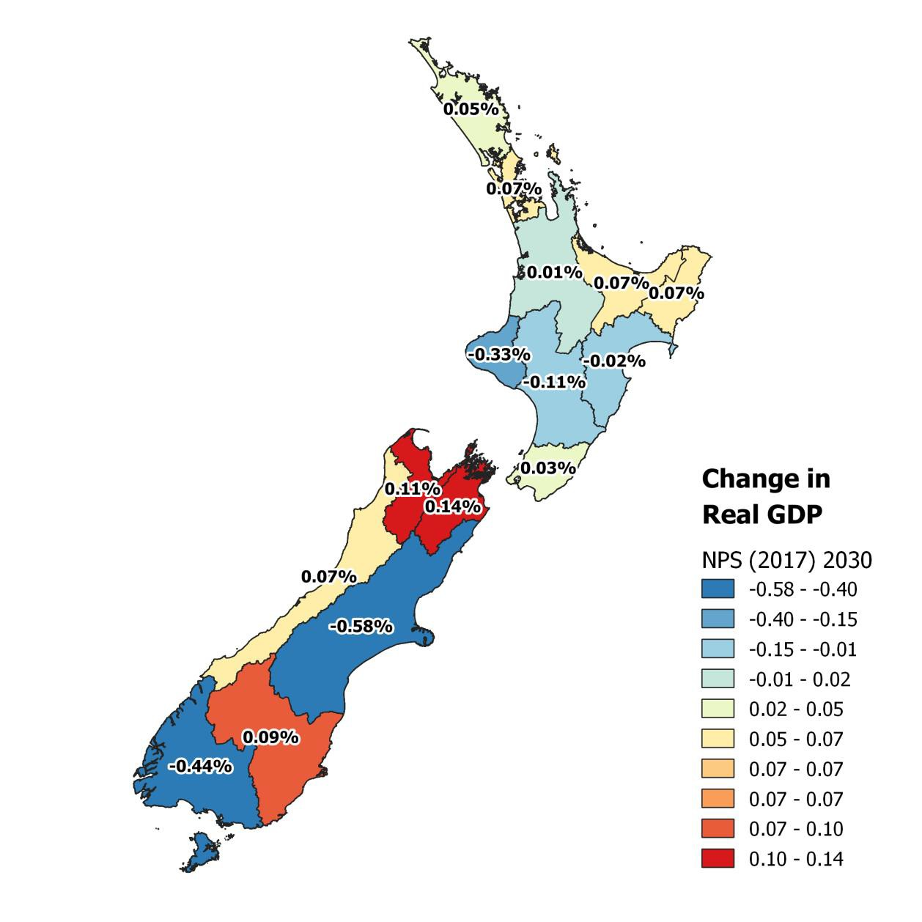
Source: NZIER

Figure 4 EFWI 2030: change in regional GDP, percentage change
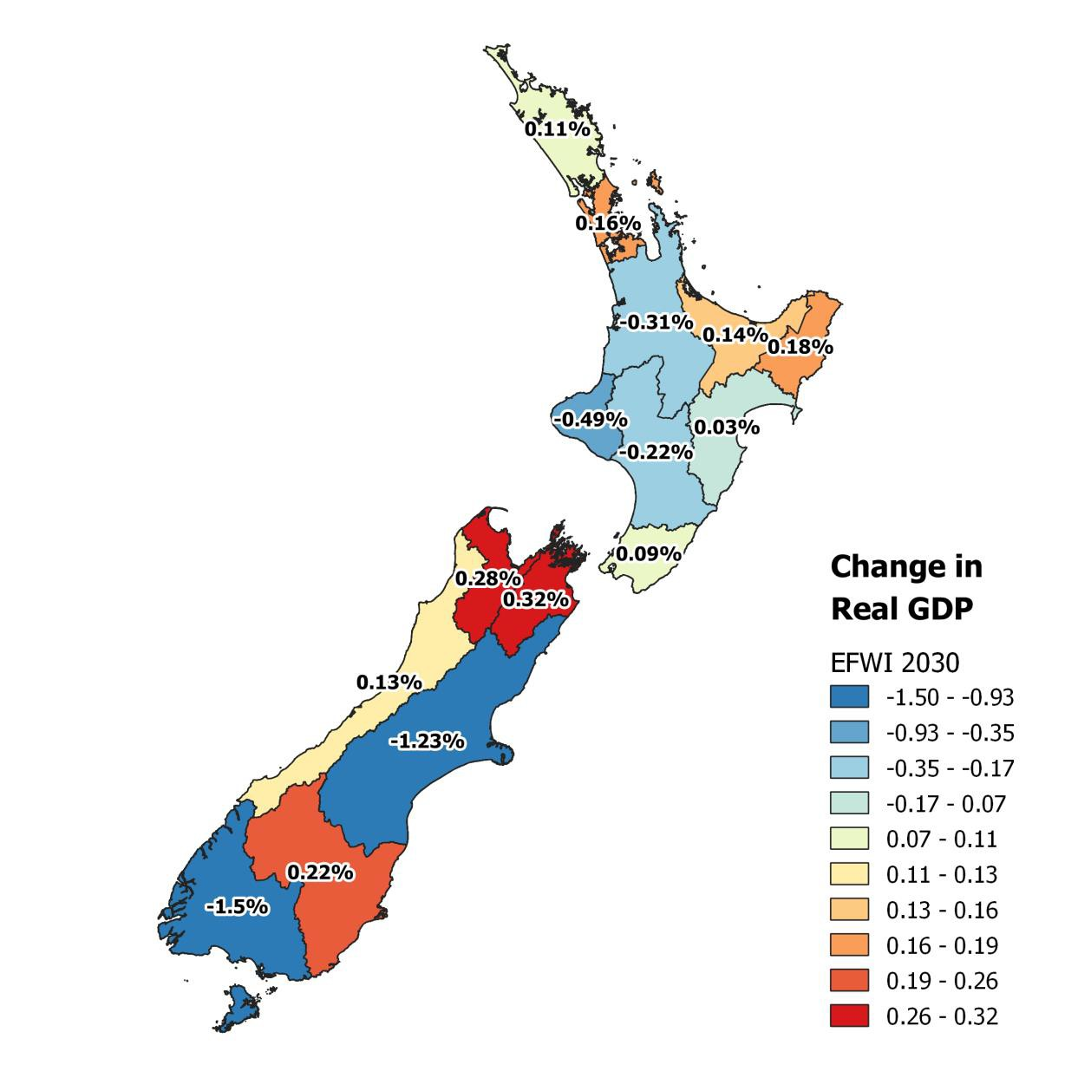

Source: NZIER

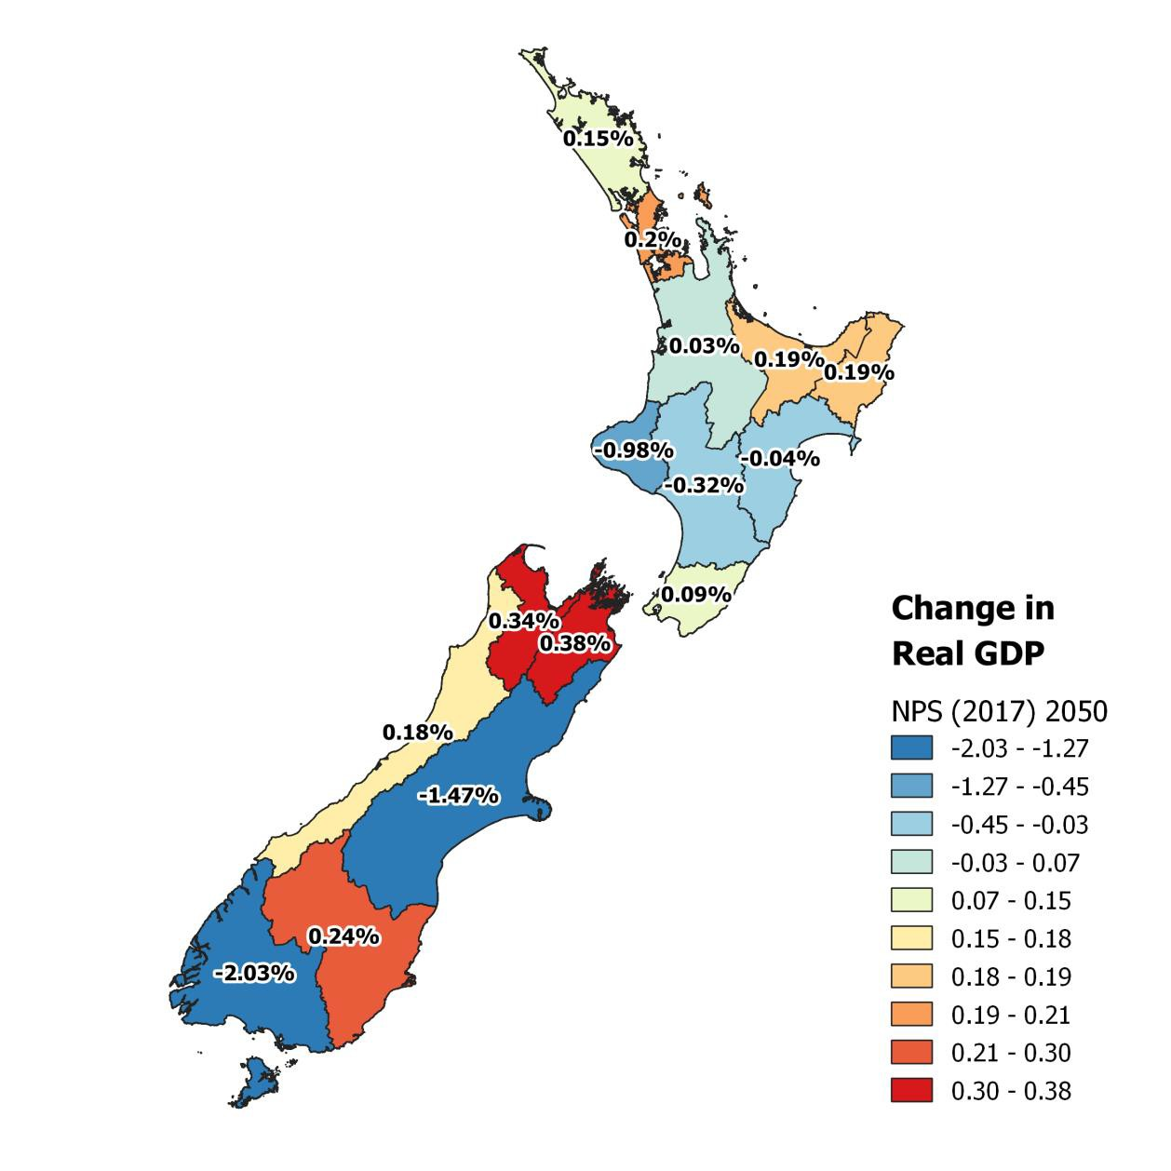
Figure 5 NPS (2017) 2050: change in regional GDP, percentage change
Source: NZIER

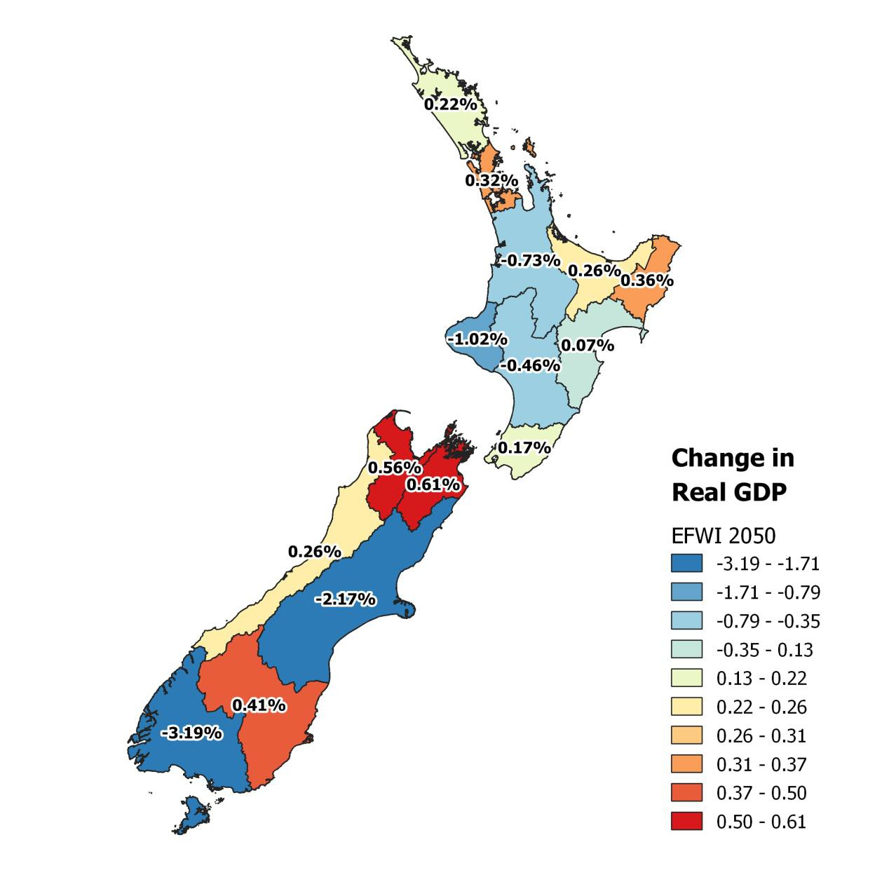
Figure 6 EFWI 2050: change in regional GDP, percentage change
Source: NZIER

Other studies

In a recent submission to MfE, DairyNZ said that analysis that it had commissioned showed that, when combined with proposed climate change polices, the freshwater reforms would:
- Reduce milk output by 30%.
- Reduce the number of full-time equivalent positions across the dairy sector by 15-20%.
- Reduce the tax take from the dairy sector by 50%.

- Increase the number of insolvent farms from 2% to 11%.
- Reduce long-term, economy wide GDP by $6 billion on an annual basis (DairyNZ 2019b).
Why are our results so different? There are three main reasons.
- We are showing the effects of farmers responding to the policy changes in several ways, while other studies have assumed that the main response is to limit production.
- We have imposed a pattern of land use change on the model, based on work by officials.
- We are only modelling the effects of the Government’s freshwater policies, rather than adding in climate change.
The scenarios we have tested are based on farmers seeking a least-cost response to the policy changes, which might include changes in on-farm practices, land use changes and changes in production levels. One of studies DairyNZ commissioned has dairy farms always staying as dairy farms.9 This means that if a farm becomes insolvent, ownership is transferred to a new dairy farmer, rather than any change in land use. Land that is taken out of dairy production is not offset through a land use change. We have imposed a pattern of land use change on the model, based on work by officials. It is based on analysis of other options for using land that will become relatively more profitable once the water quality rules in scenarios are put in place.
The scenarios we have tested include a larger range of changes in on-farm techniques. This lessens the reduction in production needed to comply with the new rules.
Finally, as noted above, we are only modelling the effects of the Government’s freshwater policies, rather than adding in climate change.10

Conclusion

Our results show that whatever benefits come from the Government’s reform proposals (and measuring those benefits is outside our brief), come at an economic cost.
The cost is likely to be between 0.06% of GDP (NPS (2017) – 2030) to 0.28% of GDP (EFWI- 2050). Costs will fall more heavily on some industries and some regions, especially the dairy industry and regions with more dairy farming. Other industries and regions show positive economic impacts from the policies. Costs will fall more heavily on some industries and some regions, especially the dairy industry and regions with more dairy farming. Other industries and regions show positive economic impacts from the policies.
This is to be expected. The proposals place new conditions on farming and those will, in some cases, either reduce outputs or increase the costs of inputs. Determining exactly how farmers respond to the new rules is a difficult exercise and we have been constrained in what we can model by data.

9 Doole (2019)
10 While DairyNZ (2019) reports the effects of the combined packages, the underlying commissioned studies present results for the freshwater policy changes in isolation and those results are also smaller. See: Ballingall (2019) and Stroombergen (2019).

We are confident, however, that within the normal limitations of CGE modelling, we have produced results that will help guide the Government in its policy development processes.

References

Ballingall, John. 2019. ‘The Economywide Effects of Proposed Environmental Policies’. Sense Partners. https://www.dairynz.co.nz/media/5792287/1-the-economywide-effects-of- proposed-environmental-policies_30oct2019.pdf.
DairyNZ. 2019a. ‘Essential Freshwater Package’. 2019.
https://www.dairynz.co.nz/environment/essential-freshwater-package/.
———. 2019b. ‘Proposed Freshwater Policies Could Cost NZ $6 Billion’. 2019. https://www.dairynz.co.nz/news/latest-news/proposed-freshwater-policies-could-cost-nz-6- billion/.
Damania, Richard. 2020. ‘The Economics of Water Scarcity and Variability’. Oxford Review of Economic Policy 36 (1): 24–44. https://doi.org/10.1093/oxrep/grz027.
Dennis, Richard. 2012. ‘The Use and Abuse of Economic Modelling in Australia’. Technical Brief No
- Canberra: The Australia Institute. https://www.tai.org.au/sites/default/files/TB%2012%20The%20use%20and%20abuse%20of
%20economic%20modelling%20in%20Australia_4.pdf.
Doole, Graeme. 2019. ‘Economic Impacts of the Essential Freshwater Proposals on New Zealand Dairy Farms’. Dairy NZ.
Faehn, Taran, Gabriel Bachner, Robert H. Beach, Jean Chateau, Shinichiro Fujimori, Madanmohan Ghosh, Meriem Hamdi-Cherif, et al. 2020. ‘Capturing Key Energy and Emission Trends in CGE Models: Assessment of Status and Remaining Challenges’. SSRN Scholarly Paper ID 3535282. Rochester, NY: Social Science Research Network. https://papers.ssrn.com/abstract=3535282.
Horridge, Mark, Arief Anshory Yusuf, and Edimon Ginting. 2016. ‘Improving Indonesia’s Domestic Connectivity: An Inter-Regional CGE Analysis’. Metro Manila: Asian Development Bank. https://www.adb.org/publications/improving-indonesia-domestic-connectivity.
Ministry for the Environment. 2019. ‘Action for Healthy Waterways: A Discussion Document on National Direction for Our Essential Freshwater’. Wellington: Government of New Zealand. https://www.mfe.govt.nz/publications/fresh-water/action-healthy-waterways-discussion- document-national-direction-our.
Stroombergen, Adolf. 2019. ‘Regional and National Impacts of Proposed Environmental Policies on the New Zealand Dairy Sector’. Infometrics.
Wittwer, Glyn, ed. 2012. Economic Modeling of Water: The Australian CGE Experience. Global Issues in Water Policy. Springer Netherlands. https://doi.org/10.1007/978-94-007-2876-9.

Appendix A Our model
We used our NZ-TERM (‘The Enormous Regional Model’) CGE model of the New Zealand economy and its regions for this economic impact analysis.
NZIER’s NZ-TERM has been built in consultation with CGE experts at the Centre of Policy Studies (COPS) which is now based at Victoria University, Melbourne. COPS is well-regarded internationally and recognised as a world leader in CGE modelling. For more details, see their website.
The TERM model includes 106 industries, 201 commodities and 15 regions, including the Auckland regional economy. For the reporting purposes, we aggregate the 106 industries into 52 broader industries and 73 commodity groups, as this makes the presentation easier to follow.
NZ-TERM is a bottom-up regional CGE model which treats each region as a separate economy. All regions are linked via inter-regional trade in commodities and movements in labour and capital. The model captures the various inter-linkages between sectors, as well as their links to households (via the labour market), the government sector, capital markets and the global economy (via imports and exports). Key features of the model are:
  - Each industry can produce a number of different commodities.
  - Production inputs are intermediate commodities (domestic and imported) and primary factors (labour, land and capital). Industry demand for factors of production follows the same structure for all regions in the model11.
  - The demand for primary factors and the choice between imported and domestic commodities are determined by Constant Elasticity of Substitution (CES) production nests. This means an increase in price of one input shifts sourcing towards another input.
  - Intermediate goods, primary factors and other costs are combined using a Leontief production function. This means the proportion of production inputs is held constant for all levels of output. Therefore, an industry cannot substitute capital or labour instead of land for their production.
  - The production mix of each industry is dependent on the relative prices of each commodity. The proportion of output exported or consumed domestically is also dependent on relative prices.

11Industry demand for land is determined by the following linearized equation in TERM model. xlnd(i,d) - alnd(i,d) = xprim(i,d) - SIGMAPRIM(i)*[plnd(i,d) + alnd(i,d) - pprim(i,d)].
Where i and d are industries and regions respectively and: xlnd(i,d) = Land usage
alnd(i,d) = Land-augmenting technical change xprim(i,d) = Primary factor composite
SIGMAPRIM(i) = Constant Elasticity of Substitution, primary factors plnd(i,d = Rental price of land
pprim(i,d) = Effective price of primary factor composite

  - Within each region, any changes to the economy have multiple direct and indirect (flow-on) impacts, including beyond the sectors initially affected. So, for example, changes to the Waikato economy due to changes in land use patterns will flow on to other regions.
  - Price changes (e.g. wage increases, shifts in the exchange rate) as a result of a change to the regional economy in one sector also affect all other sectors, both within the region and across the rest of the country.
A visual representation of NZ-TERM is shown in Figure 7 It highlights the complex and multidirectional relationships between the various parts of each regional economy and how they interact with other New Zealand regions and rest of the world.

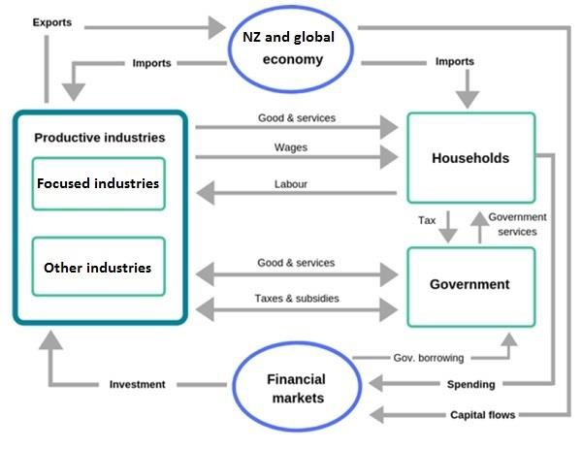
Figure 7 CGE models show the whole economy
Source: NZIER

- 1Closure
As we noted above, in any CGE model, it is important to understand which factors have been allowed to vary and which remain fixed by assumption (also known as exogenous variables). The particular combination of fixed factors is known as the closure.

    - Long run closure
We have used a static CGE model, but with a closure that allows us to capture investment decisions typically employed in long run dynamic models. We do this by implementing a ‘long run’ closure wherein economic agents and resources fully adjust as the economy moves towards a new equilibrium.

The long run closures12 include:
      - Labour market adjustment – we hold national employment fixed to base levels, but allow for employment to vary by industry and region via adjustment in real wages. This labour market representation allows us to analyse how `laid-off’ labour moves from one industry or region to another in search of employment and higher regional wages.
      - Capital mobility – we allow capital to move across industries and regions based on rates of return (i.e. profitability). Investment by industry and regions also vary by following movements in capital stocks. This mechanism allows us to capture investment and capital changes as investors search for industries and regions with higher returns.
We also include two standard welfare-neutral closures to prevent over- or under- estimation of economic impacts:
      - Changes in current account and capital account – we hold the current and capital account as a fixed proportion of base GDP. This prevents New Zealand from infinitely borrowing from abroad to finance a recurring current and/or capital account deficit without worrying how to pay for debts incurred.
      - Government consumption – we hold aggregate real government consumption as a percentage of the economy fixed at base levels. This prevents the government from buying more goods and services (at the aggregate level but allows for compositional changes in government consumption) to stimulate demand in response to output contraction in New Zealand industries.
Together, these four closure mechanisms allow us to use aggregate household consumption results as a consistent measure of New Zealand’s overall welfare. A downward movement in aggregate household consumption points to a reduction in discretionary income.
We also assumed land usage and technological change are exogenous for this modelling exercise.
In Table 8, we list the main variables included in the closure in the modelling underlying this report.

Table 8 Closures in the model

 | Fixed items
Taxes on production | Gross rate of return on capital | Import prices, foreign currency
Technological change | Number of households | Foreign demand for New Zealand exports
Government demand | National population
Gross growth rate of capital | National labour supply
Source: NZIER

12 In this section variables being fixed to base levels means relative to future pre-simulation levels.

Appendix B Scenarios details

1NPS (2017)

Table 9 Mitigation costs
$ millions per year

 | Dairy | Sheep & beef | Horticulture | Other
Northland | $0.3 | $0.4 | $0.0 | $1.2
Auckland | $0.1 | $0.4 | $0.0 | $1.3
Waikato | $0.0 | $0.1 | $0.0 | $0.4
Bay of Plenty | $0.6 | $0.1 | $0.0 | $2.0
Gisborne | $0.0 | $0.5 | $0.0 | $0.7
Hawke's Bay | $0.2 | $2.2 | $3.0 | $16.2
Taranaki | $0.1 | $0.0 | $0.0 | $5.1
Manawatu-Wanganui | $0.1 | $1.7 | $0.3 | $3.6
Wellington | $0.0 | $0.4 | $0.0 | $1.1
Tasman | $0.0 | $0.0 | $0.0 | $0.0
Nelson | $0.0 | $0.0 | $0.0 | $0.0
Marlborough | $0.0 | $0.0 | $0.0 | $0.1
West Coast | $0.0 | $0.0 | $0.0 | $0.1
Canterbury | $3.3 | $5.4 | $67.2 | $75.5
Otago | $3.6 | $3.2 | $0.0 | $0.3
Southland | $6.7 | $8.0 | $0.0 | $21.0
Total | $15.1 | $22.4 | $70.5 | $128.7
Source: Resource Economics Ltd

Table 10 Reduced profits from land use change
$ millions per year

 | Dairy | Sheep & beef
Northland | $2.3 | $0.0
Auckland | $4.5 | $1.0
Waikato | $39.0 | $0.0
Bay of Plenty | $0.9 | $0.0
Gisborne | $0.0 | $0.0
Hawke's Bay | $0.0 | $0.0
Taranaki | $49.1 | $0.0
Manawatu-Wanganui | $28.4 | $0.0
Wellington | $1.6 | $0.0

Tasman | $0.0 | $0.0
Nelson | $0.0 | $0.0
Marlborough | $0.0 | $0.0
West Coast | $0.1 | $0.0
Canterbury | $87.7 | $0.0
Otago | $0.4 | $0.0
Southland | $33.8 | $0.0
Total | $247.9 | $1.0
Source: Resource Economics Ltd

Table 11 Increased profit from land use change
$ millions per year

 | Arable | Horticulture | Deer | Forestry
Northland | $0.00 | $0.00 | $0.00 | $1.49
Auckland | $0.00 | $0.00 | $0.00 | $1.10
Waikato | $0.00 | $0.00 | $0.00 | $7.84
Bay of Plenty | $0.00 | $0.00 | $0.00 | $0.25
Gisborne | $0.00 | $0.00 | $0.00 | $0.00
Hawke's Bay | $0.00 | $0.00 | $0.00 | $0.00
Taranaki | $0.00 | $0.00 | $0.00 | $9.90
Manawatu- Wanganui | $0.00 | $0.00 | $0.00 | $7.63
Wellington | $0.00 | $0.00 | $0.00 | $0.44
Tasman | $0.00 | $0.00 | $0.00 | $0.02
Nelson | $0.00 | $0.00 | $0.00 | $0.00
Marlborough | $0.00 | $0.00 | $0.00 | $0.00
West Coast | $0.00 | $0.00 | $0.00 | $0.04
Canterbury | $42.26 | $0.00 | $0.00 | $0.00
Otago | $0.24 | $0.00 | $0.00 | $0.00
Southland | $20.30 | $0.00 | $0.00 | $0.00
Total | $62.79 | $0.00 | $0.00 | $28.71
Source: Resource Economics Ltd

Table 12 Land use change
Percentage change from BAU

 | Dairy | Sheep & beef | Arable | Horticult ure | Other pasture | Deer | Other animal | Forestry
Northland | -1.1% | 0.0% | 0.0% | 0.0% | 0.0% | 0.0% | 0.0% | 1.0%
Auckland | -7.9% | -2.5% | 0.0% | 0.0% | 0.0% | 0.0% | 0.0% | 11.4%
Waikato | -4.1% | 0.0% | 0.0% | 0.0% | 0.0% | 0.0% | 0.0% | 7.4%
Bay of Plenty | -0.5% | 0.0% | 0.0% | 0.0% | 0.0% | 0.0% | 0.0% | 0.2%
Gisborne | 0.0% | 0.0% | 0.0% | 0.0% | 0.0% | 0.0% | 0.0% | 0.0%
Hawke's Bay | 0.0% | 0.0% | 0.0% | 0.0% | 0.0% | 0.0% | 0.0% | 0.0%
Taranaki | -14.5% | 0.0% | 0.0% | 0.0% | 0.0% | 0.0% | 0.0% | 103.8%
Manawatu- Wanganui | -10.7% | 0.0% | 0.0% | 0.0% | 0.0% | 0.0% | 0.0% | 11.1%
Wellington | -2.5% | 0.0% | 0.0% | 0.0% | 0.0% | 0.0% | 0.0% | 1.2%
Tasman | -0.2% | 0.0% | 0.0% | 0.0% | 0.0% | 0.0% | 0.0% | 0.0%
Nelson | 0.0% | 0.0% | 0.0% | 0.0% | 0.0% | 0.0% | 0.0% | 0.0%
Marlboroug h | 0.0% | 0.0% | 0.0% | 0.0% | 0.0% | 0.0% | 0.0% | 0.0%
West Coast | -0.1% | 0.0% | 0.0% | 0.0% | 0.0% | 0.0% | 0.0% | 0.1%
Canterbury | -16.0% | 0.0% | 80.4% | 0.0% | 0.0% | 0.0% | 0.0% | 0.0%
Otago | -0.2% | 0.0% | 5.8% | 0.0% | 0.0% | 0.0% | 0.0% | 0.0%
Southland | -9.6% | 0.0% | 2837.9% | 0.0% | 0.0% | 0.0% | 0.0% | 0.0%
Total | -6.8% | 0.0% | 99.1% | 0.0% | 0.0% | 0.0% | 0.0% | 3.9%
Source: Resource Economics Ltd

EFWI

Table 13 Mitigation costs
$ millions per year

 | Dairy | Sheep & beef | Horticulture | Other
Northland | $1.7 | $4.2 | $0.0 | $1.4
Auckland | $0.5 | $1.4 | $0.0 | $1.7
Waikato | $4.4 | $3.8 | $0.0 | $0.6
Bay of Plenty | $1.1 | $1.3 | $0.0 | $2.4
Gisborne | $0.0 | $1.9 | $0.0 | $0.8
Hawke's Bay | $0.4 | $6.7 | $3.0 | $23.5
Taranaki | $2.3 | $1.4 | $0.0 | $8.3
Manawatu-Wanganui | $1.3 | $9.0 | $0.3 | $4.4
Wellington | $0.2 | $3.4 | $0.0 | $1.4

Tasman | $0.2 | $0.6 | $0.0 | $0.1
Nelson | $0.0 | $0.0 | $0.0 | $0.0
Marlborough | $0.1 | $1.4 | $0.0 | $0.1
West Coast | $0.5 | $1.2 | $0.0 | $0.2
Canterbury | $5.1 | $15.1 | $93.8 | $141.2
Otago | $5.6 | $21.0 | $0.0 | $0.6
Southland | $7.8 | $18.6 | $0.0 | $33.1
Total | $31.1 | $91.0 | $97.1 | $219.6
Source: Resource Economics Ltd

Table 14 Reduced profits from land use change
$ millions per year

 | Dairy | Sheep & beef
Northland | $3.0 | $0.0
Auckland | $8.0 | $1.0
Waikato | $187.7 | $0.0
Bay of Plenty | $6.3 | $0.0
Gisborne | $0.0 | $0.0
Hawke's Bay | $0.0 | $0.0
Taranaki | $52.4 | $0.0
Manawatu-Wanganui | $41.6 | $0.0
Wellington | $1.6 | $0.0
Tasman | $0.0 | $0.0
Nelson | $0.0 | $0.0
Marlborough | $0.0 | $0.0
West Coast | $0.1 | $0.0
Canterbury | $143.8 | -$0.2
Otago | $2.3 | $0.0
Southland | $50.7 | $0.0
Total | $497.7 | $0.8
Source: Resource Economics Ltd

Table 15 Increased profit from land use change
$ millions per year

 | Arable | Horticulture | Deer | Forestry
Northland | $0.00 | $0.00 | $0.00 | $0.00
Auckland | $0.00 | $0.00 | $0.00 | $0.00
Waikato | $0.00 | $0.00 | $0.00 | $0.00
Bay of Plenty | $0.00 | $0.00 | $0.00 | $0.00
Gisborne | $0.00 | $0.00 | $0.00 | $0.00
Hawke's Bay | $0.00 | $0.00 | $0.00 | $0.00
Taranaki | $0.00 | $0.00 | $0.00 | $0.00
Manawatu- Wanganui | $0.00 | $0.00 | $0.00 | $0.00
Wellington | $0.00 | $0.00 | $0.00 | $0.00
Tasman | $0.00 | $0.00 | $0.00 | $0.00
Nelson | $0.00 | $0.00 | $0.00 | $0.00
Marlborough | $0.00 | $0.00 | $0.00 | $0.00
West Coast | $0.00 | $0.00 | $0.00 | $0.00
Canterbury | $42.26 | $68.38 | $0.00 | $0.00
Otago | $0.24 | $1.39 | $0.00 | $0.00
Southland | $20.30 | $30.41 | $0.00 | $0.00
Total | $62.79 | $100.19 | $0.00 | $0.00
Source: Resource Economics Ltd

Table 16 Land use change
Percentage change from BAU

 | Dairy | Sheep & beef | Arable | Horticul ture | Other pasture | Deer | Other animal | Forestry
Northland | -1.4% | 0.0% | 0.0% | 0.0% | 0.0% | 0.0% | 0.0% | 1.3%
Auckland | -14.1% | -2.6% | 0.0% | 0.0% | 0.0% | 0.0% | 0.0% | 17.1%
Waikato | -19.7% | 0.0% | 0.0% | 0.0% | 0.0% | 0.0% | 0.0% | 35.7%
Bay of Plenty | -3.9% | 0.0% | 0.0% | 0.0% | 0.0% | 0.0% | 0.0% | 1.4%
Gisborne | 0.0% | 0.0% | 0.0% | 0.0% | 0.0% | 0.0% | 0.0% | 0.0%
Hawke's Bay | 0.0% | 0.0% | 0.0% | 0.0% | 0.0% | 0.0% | 0.0% | 0.0%
Taranaki | -15.5% | 0.0% | 0.0% | 0.0% | 0.0% | 0.0% | 0.0% | 110.8%
Manawatu- Wanganui | -15.7% | 0.0% | 0.0% | 0.0% | 0.0% | 0.0% | 0.0% | 16.2%
Wellington | -2.5% | 0.0% | 0.0% | 0.0% | 0.0% | 0.0% | 0.0% | 1.2%
Tasman | -0.2% | 0.0% | 0.0% | 0.0% | 0.0% | 0.0% | 0.0% | 0.0%
Nelson | 0.0% | 0.0% | 0.0% | 0.0% | 0.0% | 0.0% | 0.0% | 0.0%

Marlborough | 0.0% | 0.0% | 0.0% | 0.0% | 0.0% | 0.0% | 0.0% | 0.0%
West Coast | -0.1% | 0.0% | 0.0% | 0.0% | 0.0% | 0.0% | 0.0% | 0.1%
Canterbury | -26.2% | 0.1% | 130.0% | 0.0% | 0.0% | 0.0% | 0.0% | 0.0%
Otago | -1.0% | 0.0% | 34.3% | 0.0% | 0.0% | 0.0% | 0.0% | 0.0%
Southland | -14.3% | 0.0% | 4252.3% | 0.0% | 0.0% | 0.0% | 0.0% | 0.0%
Total | -13.8% | 0.0% | 158.2% | 0.0% | 0.0% | 0.0% | 0.0% | 9.0%
Source: Resource Economics Ltd

EFWII

Table 17 Mitigation costs
$ millions per year

 | Dairy | Sheep & beef | Horticulture | Other
Northland | $1.7 | $4.2 | $0.0 | $1.2
Auckland | $0.5 | $1.4 | $0.0 | $1.4
Waikato | $4.4 | $3.8 | $0.0 | $0.5
Bay of Plenty | $1.1 | $1.3 | $0.0 | $2.1
Gisborne | $0.0 | $1.9 | $0.0 | $0.7
Hawke's Bay | $2.3 | $1.4 | $0.0 | $5.2
Taranaki | $1.3 | $9.0 | $0.3 | $3.8
Manawatu-Wanganui | $0.4 | $6.7 | $3.0 | $16.5
Wellington | $0.2 | $3.4 | $0.0 | $1.1
Tasman | $0.2 | $0.6 | $0.0 | $0.0
Nelson | $0.0 | $0.0 | $0.0 | $0.0
Marlborough | $0.1 | $1.3 | $0.0 | $0.1
West Coast | $0.5 | $1.2 | $0.0 | $0.2
Canterbury | $4.5 | $15.0 | $74.6 | $89.6
Otago | $5.0 | $20.1 | $0.0 | $0.5
Southland | $7.8 | $18.6 | $0.0 | $22.4
Total | $29.9 | $89.9 | $77.8 | $145.2
Source: Resource Economics Ltd

Table 18 Reduced profits from land use change
$ millions per year

 | Dairy | Sheep & beef
Northland | $2.3 | $0.0
Auckland | $4.5 | $1.0
Waikato | $42.8 | $0.0
Bay of Plenty | $0.9 | $0.0
Gisborne | $0.0 | $0.0
Hawke's Bay | $49.1 | $0.0
Taranaki | $28.4 | $0.0
Manawatu-Wanganui | $0.0 | $0.0
Wellington | $1.6 | $0.0
Tasman | $0.0 | $0.0
Nelson | $0.0 | $0.0
Marlborough | $0.0 | $0.0
West Coast | $0.1 | $0.0
Canterbury | $96.9 | $0.0
Otago | $0.4 | $0.0
Southland | $33.8 | $0.0
Total | $260.8 | $1.0
Source: Resource Economics Ltd

Table 19 Increased profit from land use change
$ millions per year

 | Arable | Horticulture | Deer | Forestry
Northland | $0.00 | $0.00 | $0.00 | $1.49
Auckland | $0.00 | $0.00 | $0.00 | $1.11
Waikato | $0.00 | $0.00 | $0.00 | $8.59
Bay of Plenty | $0.00 | $0.00 | $0.00 | $0.25
Gisborne | $0.00 | $0.00 | $0.00 | $0.00
Hawke's Bay | $0.00 | $0.00 | $0.00 | $9.90
Taranaki | $0.00 | $0.00 | $0.00 | $7.63
Manawatu- Wanganui | $0.00 | $0.00 | $0.00 | $0.00
Wellington | $0.00 | $0.00 | $0.00 | $0.44
Tasman | $0.00 | $0.00 | $0.00 | $0.02
Nelson | $0.00 | $0.00 | $0.00 | $0.00
Marlborough | $0.00 | $0.00 | $0.00 | $0.00
West Coast | $0.00 | $0.00 | $0.00 | $0.04
Canterbury | $46.68 | $0.00 | $0.00 | $0.00
Otago | $0.24 | $0.00 | $0.00 | $0.00
Southland | $20.30 | $0.00 | $0.00 | $0.00
Total | $67.21 | $0.00 | $0.00 | $29.47
Source: Resource Economics Ltd

Table 20 Land use change
Percentage change from BAU

 | Dairy | Sheep & beef | Arable | Horticul ture | Other pasture | Deer | Other animal | Forestry
Northland | -1.1% | 0.0% | 0.0% | 0.0% | 0.0% | 0.0% | 0.0% | 1.0%
Auckland | -7.9% | -2.6% | 0.0% | 0.0% | 0.0% | 0.0% | 0.0% | 11.5%
Waikato | -4.5% | 0.0% | 0.0% | 0.0% | 0.0% | 0.0% | 0.0% | 8.1%
Bay of Plenty | -0.5% | 0.0% | 0.0% | 0.0% | 0.0% | 0.0% | 0.0% | 0.2%
Gisborne | 0.0% | 0.0% | 0.0% | 0.0% | 0.0% | 0.0% | 0.0% | 0.0%
Hawke's Bay | -14.5% | 0.0% | 0.0% | 0.0% | 0.0% | 0.0% | 0.0% | 103.8%
Taranaki | -10.7% | 0.0% | 0.0% | 0.0% | 0.0% | 0.0% | 0.0% | 11.1%
Manawatu- Wanganui | 0.0% | 0.0% | 0.0% | 0.0% | 0.0% | 0.0% | 0.0% | 0.0%
Wellington | -2.5% | 0.0% | 0.0% | 0.0% | 0.0% | 0.0% | 0.0% | 1.2%
Tasman | -0.2% | 0.0% | 0.0% | 0.0% | 0.0% | 0.0% | 0.0% | 0.0%
Nelson | 0.0% | 0.0% | 0.0% | 0.0% | 0.0% | 0.0% | 0.0% | 0.0%

Marlborough | 0.0% | 0.0% | 0.0% | 0.0% | 0.0% | 0.0% | 0.0% | 0.0%
West Coast | -0.1% | 0.0% | 0.0% | 0.0% | 0.0% | 0.0% | 0.0% | 0.1%
Canterbury | -17.7% | 0.0% | 88.8% | 0.0% | 0.0% | 0.0% | 0.0% | 0.0%
Otago | -0.2% | 0.0% | 5.8% | 0.0% | 0.0% | 0.0% | 0.0% | 0.0%
Southland | -9.6% | 0.0% | 2837.9% | 0.0% | 0.0% | 0.0% | 0.0% | 0.0%
Total | -7.1% | 0.0% | 106.1% | 0.0% | 0.0% | 0.0% | 0.0% | 4.0%
Source: Resource Economics Ltd

Appendix C Regional results

Table 21 NPS (2017) 2030: regional economic indicators
Percentage change from BAU

Economic indicator | Consumption | Investment | Exports | Imports | Real GDP | GDP price Index | Nominal GDP | Employment | Real wage
Northland | 0.00 | 0.09 | 0.28 | 0.01 | 0.05 | -0.01 | 0.04 | 0.05 | 0.00
Auckland | 0.01 | 0.08 | 0.19 | -0.02 | 0.07 | -0.04 | 0.03 | 0.06 | 0.01
Waikato | -0.05 | 0.03 | 0.14 | -0.10 | 0.01 | 0.00 | 0.00 | 0.02 | -0.03
Bay of Plenty | 0.03 | 0.10 | 0.73 | -0.03 | 0.07 | -0.02 | 0.05 | 0.06 | 0.02
Gisborne | -0.01 | 0.13 | 0.14 | -0.03 | 0.07 | 0.01 | 0.07 | 0.05 | 0.00
Hawke’s Bay | -0.04 | 0.07 | -0.32 | -0.03 | -0.02 | 0.02 | -0.01 | 0.03 | -0.02
Taranaki | -0.31 | -0.28 | -0.37 | -0.44 | -0.33 | 0.08 | -0.25 | -0.11 | -0.15
Manawatu-Wanganui | -0.13 | -0.07 | -0.23 | -0.17 | -0.11 | 0.02 | -0.09 | -0.02 | -0.06
Wellington | -0.03 | 0.05 | 0.19 | -0.04 | 0.03 | -0.05 | -0.02 | 0.03 | -0.02
Tasman/Nelson | 0.09 | 0.18 | 0.12 | 0.04 | 0.11 | 0.00 | 0.12 | 0.09 | 0.04
Marlborough | 0.07 | 0.17 | -0.02 | 0.06 | 0.14 | -0.01 | 0.13 | 0.08 | 0.03
West Coast | 0.01 | 0.15 | 0.13 | 0.00 | 0.07 | 0.02 | 0.09 | 0.06 | 0.01
Canterbury | -0.57 | -0.50 | -1.03 | -0.33 | -0.58 | 0.07 | -0.51 | -0.25 | -0.28
Otago | 0.05 | 0.16 | -0.16 | 0.04 | 0.09 | 0.01 | 0.10 | 0.08 | 0.02
Southland | 0.44 | -0.23 | -1.03 | 0.08 | -0.44 | 0.12 | -0.32 | 0.28 | 0.22
Source: NZIER

Table 22 EFWI 2030: regional economic indicators
Percentage change from BAU

Economic indicator | Consumption | Investment | Exports | Imports | Real GDP | GDP price Index | Nominal GDP | Employment | Real wage
Northland | 0.01 | 0.22 | 0.43 | 0.02 | 0.11 | -0.02 | 0.09 | 0.12 | -0.04
Auckland | 0.05 | 0.19 | 0.37 | -0.06 | 0.16 | -0.11 | 0.06 | 0.14 | -0.02
Waikato | -0.37 | -0.29 | 0.37 | -0.65 | -0.31 | 0.02 | -0.29 | -0.08 | -0.22
Bay of Plenty | 0.06 | 0.22 | 1.37 | -0.11 | 0.14 | -0.06 | 0.08 | 0.14 | -0.02
Gisborne | 0.05 | 0.35 | 0.19 | -0.03 | 0.18 | 0.04 | 0.22 | 0.14 | -0.02
Hawke’s Bay | 0.01 | 0.26 | -1.00 | -0.04 | 0.03 | 0.06 | 0.09 | 0.12 | -0.04
Taranaki | -0.47 | -0.35 | -0.58 | -0.67 | -0.49 | 0.15 | -0.35 | -0.14 | -0.27
Manawatu-Wanganui | -0.23 | -0.11 | -0.54 | -0.37 | -0.22 | 0.06 | -0.15 | -0.02 | -0.15
Wellington | -0.05 | 0.13 | 0.41 | -0.10 | 0.09 | -0.12 | -0.03 | 0.09 | -0.07
Tasman/Nelson | 0.25 | 0.45 | 0.12 | 0.12 | 0.28 | 0.02 | 0.30 | 0.24 | 0.08
Marlborough | 0.18 | 0.41 | -0.12 | 0.14 | 0.32 | -0.02 | 0.30 | 0.21 | 0.04
West Coast | 0.02 | 0.35 | 0.20 | -0.01 | 0.13 | 0.08 | 0.21 | 0.12 | -0.04
Canterbury | -1.23 | -1.08 | -2.13 | -0.76 | -1.23 | 0.13 | -1.10 | -0.54 | -0.63
Otago | 0.21 | 0.41 | -0.51 | 0.12 | 0.22 | 0.04 | 0.26 | 0.22 | 0.05
Southland | 0.17 | -1.00 | -2.50 | -0.52 | -1.50 | 0.45 | -1.05 | 0.20 | 0.06
Source: NZIER

Table 23 EFWII 2030: regional economic indicators
Percentage change from BAU

Economic indicator | Consumption | Investment | Exports | Imports | Real GDP | GDP price Index | Nominal GDP | Employment | Real wage
Northland | -0.02 | 0.08 | 0.25 | 0 | 0.03 | -0.01 | 0.02 | 0.05 | -0.02
Auckland | 0.01 | 0.1 | 0.23 | -0.02 | 0.08 | -0.05 | 0.03 | 0.07 | 0
Waikato | -0.06 | 0.02 | 0.15 | -0.12 | -0.01 | 0 | -0.01 | 0.03 | -0.04
Bay of Plenty | 0.03 | 0.12 | 0.77 | -0.04 | 0.08 | -0.03 | 0.05 | 0.07 | 0.01
Gisborne | 0 | 0.16 | 0.14 | -0.02 | 0.08 | 0.02 | 0.1 | 0.06 | 0
Hawke’s Bay | -0.04 | 0.08 | -0.35 | -0.03 | -0.02 | 0.03 | -0.01 | 0.04 | -0.03
Taranaki | -0.31 | -0.26 | -0.36 | -0.44 | -0.33 | 0.08 | -0.25 | -0.1 | -0.16
Manawatu-Wanganui | -0.15 | -0.09 | -0.28 | -0.2 | -0.14 | 0.03 | -0.11 | -0.02 | -0.08
Wellington | -0.04 | 0.06 | 0.23 | -0.05 | 0.03 | -0.06 | -0.03 | 0.04 | -0.03
Tasman/Nelson | 0.09 | 0.2 | 0.09 | 0.04 | 0.12 | 0.01 | 0.13 | 0.11 | 0.04
Marlborough | 0.07 | 0.19 | -0.05 | 0.06 | 0.14 | -0.01 | 0.13 | 0.09 | 0.02
West Coast | -0.03 | 0.13 | 0.09 | -0.03 | 0.03 | 0.03 | 0.06 | 0.05 | -0.02
Canterbury | -0.66 | -0.57 | -1.15 | -0.38 | -0.66 | 0.07 | -0.58 | -0.29 | -0.32
Otago | 0 | 0.11 | -0.3 | -0.01 | 0.02 | 0.03 | 0.05 | 0.06 | -0.01
Southland | 0.34 | -0.32 | -1.17 | -0.13 | -0.57 | 0.15 | -0.41 | 0.24 | 0.16
Source: NZIER

Table 24 NPS (2017) 2050: regional economic indicators
Percentage change from BAU

Economic indicator | Consumption | Investment | Exports | Imports | Real GDP | GDP price Index | Nominal GDP | Employment | Real wage
Northland | 0.05 | 0.27 | 0.58 | 0.03 | 0.15 | -0.03 | 0.12 | 0.15 | -0.03
Auckland | 0.08 | 0.24 | 0.55 | -0.05 | 0.20 | -0.12 | 0.09 | 0.17 | -0.02
Waikato | -0.10 | 0.08 | 0.37 | -0.27 | 0.03 | 0.00 | 0.03 | 0.07 | -0.10
Bay of Plenty | 0.10 | 0.28 | 1.45 | -0.08 | 0.19 | -0.07 | 0.12 | 0.18 | -0.01
Gisborne | 0.05 | 0.38 | 0.12 | -0.04 | 0.19 | 0.03 | 0.23 | 0.15 | -0.03
Hawke’s Bay | -0.09 | 0.27 | -1.04 | -0.07 | -0.04 | 0.07 | 0.07 | 0.12 | -0.06
Taranaki | -0.88 | -0.83 | -1.10 | -1.28 | -0.98 | 0.23 | -0.75 | -0.34 | -0.47
Manawatu-Wanganui | -0.32 | -0.20 | -0.66 | -0.48 | -0.32 | 0.07 | -0.25 | -0.04 | -0.21
Wellington | -0.06 | 0.14 | 0.57 | -0.12 | 0.09 | -0.15 | -0.05 | 0.10 | -0.08
Tasman/Nelson | 0.32 | 0.54 | 0.08 | 0.15 | 0.34 | 0.03 | 0.37 | 0.29 | 0.10
Marlborough | 0.21 | 0.48 | -0.08 | 0.18 | 0.38 | -0.03 | 0.34 | 0.24 | 0.05
West Coast | 0.03 | 0.42 | 0.36 | 0.00 | 0.18 | 0.06 | 0.24 | 0.14 | -0.04
Canterbury | -1.47 | -1.31 | -2.46 | -0.92 | -1.47 | 0.13 | -1.33 | -0.65 | -0.76
Otago | 0.18 | 0.47 | -0.41 | 0.12 | 0.24 | 0.04 | 0.28 | 0.22 | 0.03
Southland | -1.37 | -1.46 | -3.07 | -0.78 | -2.03 | 0.56 | -1.48 | 0.18 | 0.03
Source: NZIER

Table 25 EFWI 2050: regional economic indicators
Percentage change from BAU

Economic indicator | Consumption | Investment | Exports | Imports | Real GDP | GDP price Index | Nominal GDP | Employment | Real wage
Northland | 0.05 | 0.43 | 0.64 | 0.04 | 0.22 | -0.02 | 0.20 | 0.23 | -0.09
Auckland | 0.11 | 0.38 | 0.70 | -0.11 | 0.32 | -0.21 | 0.11 | 0.26 | -0.06
Waikato | -0.78 | -0.70 | 0.57 | -1.39 | -0.73 | 0.07 | -0.66 | -0.21 | -0.49
Bay of Plenty | 0.12 | 0.41 | 2.20 | -0.23 | 0.26 | -0.11 | 0.15 | 0.27 | -0.06
Gisborne | 0.12 | 0.70 | -0.19 | -0.04 | 0.36 | 0.10 | 0.46 | 0.27 | -0.06
Hawke’s Bay | 0.08 | 0.54 | -2.18 | 0.02 | 0.07 | 0.15 | 0.22 | 0.24 | -0.08
Taranaki | -0.94 | -0.74 | -1.21 | -1.38 | -1.02 | 0.32 | -0.71 | -0.29 | -0.56
Manawatu-Wanganui | -0.45 | -0.25 | -1.17 | -0.75 | -0.46 | 0.14 | -0.32 | -0.03 | -0.33
Wellington | -0.07 | 0.26 | 0.79 | -0.19 | 0.17 | -0.23 | -0.06 | 0.17 | -0.15
Tasman/Nelson | 0.54 | 0.91 | -0.22 | 0.26 | 0.56 | 0.04 | 0.63 | 0.49 | 0.14
Marlborough | 0.36 | 0.79 | -0.26 | 0.28 | 0.61 | -0.03 | 0.58 | 0.39 | 0.06
West Coast | 0.05 | 0.69 | 0.38 | -0.01 | 0.26 | 0.17 | 0.43 | 0.23 | -0.09
Canterbury | -2.17 | -1.98 | -3.74 | -1.49 | -2.17 | 0.18 | -1.99 | -0.94 | -1.15
Otago | 0.44 | 0.83 | -1.06 | 0.26 | 0.41 | 0.08 | 0.50 | 0.43 | 0.12
Southland | -2.41 | -2.35 | -4.60 | -1.30 | -3.19 | 0.95 | -2.28 | -1.07 | -1.27
Source: NZIER

Table 26 EFWII 2050: regional economic indicators
Percentage change from BAU

Economic indicator | Consumption | Investment | Exports | Imports | Real GDP | GDP price Index | Nominal GDP | Employment | Real wage
Northland | -0.02 | 0.24 | 0.5 | -0.01 | 0.1 | -0.03 | 0.07 | 0.14 | -0.08
Auckland | 0.08 | 0.28 | 0.65 | -0.06 | 0.23 | -0.14 | 0.1 | 0.2 | -0.03
Waikato | -0.14 | 0.07 | 0.38 | -0.33 | -0.02 | 0 | -0.02 | 0.08 | -0.14
Bay of Plenty | 0.09 | 0.32 | 1.54 | -0.11 | 0.21 | -0.08 | 0.13 | 0.2 | -0.02
Gisborne | 0.06 | 0.47 | 0.28 | -0.02 | 0.22 | 0.08 | 0.31 | 0.19 | -0.04
Hawke’s Bay | -0.03 | 0.28 | -1.16 | -0.04 | -0.03 | 0.1 | 0.07 | 0.14 | -0.08
Taranaki | -0.89 | -0.81 | -1.09 | -1.31 | -0.99 | 0.23 | -0.76 | -0.32 | -0.49
Manawatu-Wanganui | -0.4 | -0.25 | -0.81 | -0.55 | -0.4 | 0.09 | -0.31 | -0.06 | -0.26
Wellington | -0.09 | 0.15 | 0.66 | -0.16 | 0.1 | -0.17 | -0.08 | 0.11 | -0.11
Tasman/Nelson | 0.34 | 0.6 | -0.01 | 0.16 | 0.37 | 0.04 | 0.4 | 0.33 | 0.09
Marlborough | 0.21 | 0.53 | -0.13 | 0.18 | 0.39 | -0.02 | 0.37 | 0.26 | 0.03
West Coast | -0.07 | 0.35 | 0.26 | -0.08 | 0.07 | 0.07 | 0.15 | 0.11 | -0.1
Canterbury | -1.68 | -1.49 | -2.76 | -1.06 | -1.67 | 0.14 | -1.53 | -0.73 | -0.87
Otago | 0.02 | 0.31 | -0.83 | -0.01 | 0.05 | 0.08 | 0.13 | 0.17 | -0.06
Southland | -1.62 | -1.72 | -3.48 | -0.93 | -2.37 | 0.65 | -1.75 | 0.07 | -0.11
Source: NZIER

Appendix D Industry results
The following tables show the effect of the various scenarios on industry output across a range of industries, by region.

Table 27 NPS (2017) 2030
Percentage change in industry output from BAU

Industry | Horticulture | Sheep & beef | Dairy cattle | Poultry | Forestry | Fishing | Meat manufacturing | Seafood processing | Dairy production | Fruit processing | Beverage and tobacco Manufacturing | Textiles | Wood manufacturing | Paper and print
Northland | -0.45 | 0.20 | 0.15 | 0.36 | 0.26 | 0.06 | 0.13 | 0.60 | -0.32 | 0.63 | 0.19 | 0.12 | 0.26 | -0.49
watermark | -0.18 | -0.44 | -1.69 | 0.37 | 2.53 | 0.03 | 0.08 | 0.45 | -1.05 | 0.45 | 0.25 | 0.03 | 0.38 | 0.23
Waikato | -0.11 | 0.28 | -0.57 | 0.42 | 1.89 | 0.07 | 0.22 | 0.61 | -0.83 | 0.91 | 0.30 | 0.13 | 0.47 | 0.68
Bay of Plenty | -0.14 | 0.23 | 0.25 | 0.50 | 0.08 | 0.04 | 0.23 | 0.52 | -0.43 | 0.67 | 0.26 | 0.13 | 0.28 | 0.51
Gisborne | 0.23 | 0.26 | 0.54 | 0.55 | 0.03 | 0.05 | 0.18 | 0.54 | -0.92 | 0.80 | 0.30 | 0.02 | 0.22 | -0.44
Hawke’s Bay | -0.20 | 0.17 | 0.45 | 0.16 | 0.04 | 0.12 | 0.06 | 0.88 | -0.50 | 0.21 | 0.25 | 0.17 | 0.16 | 0.33
Taranaki | -5.13 | 0.19 | -3.18 | -0.37 | 22.49 | 0.19 | 0.12 | 1.57 | -2.43 | 0.49 | 0.91 | 0.05 | 1.49 | -0.37
Manawatu- Wanganui | -0.28 | 0.26 | -2.32 | 0.22 | 2.70 | 0.08 | 0.13 | 0.55 | -1.62 | 0.37 | 0.17 | 0.17 | 0.57 | 0.78
Wellington | -0.34 | 0.24 | -0.19 | 0.36 | 0.30 | 0.09 | 0.19 | 0.83 | -0.46 | 0.41 | 0.19 | 0.13 | 0.19 | 0.00
Tasman/Nelson | 0.93 | 0.27 | 0.36 | 0.56 | 0.04 | 0.07 | 0.27 | 0.59 | -0.31 | 0.54 | 0.29 | 0.03 | 0.17 | -0.58
Marlborough | 0.96 | 0.30 | 0.61 | 0.62 | 0.03 | 0.06 | 0.23 | 0.53 | -1.29 | 0.74 | 0.38 | 0.17 | 0.09 | -0.67
West Coast | -2.99 | 0.12 | 0.46 | 0.34 | 0.07 | 0.05 | 0.15 | 0.54 | -0.22 | 1.16 | 0.34 | 0.05 | 0.15 | -0.55

Industry | Horticulture | Sheep & beef | Dairy cattle | Poultry | Forestry | Fishing | Meat manufacturing | Seafood processing | Dairy production | Fruit processing | Beverage and tobacco Manufacturing | Textiles | Wood manufacturing | Paper and print
Canterbury | 0.21 | -0.68 | -3.92 | -3.64 | 0.01 | 0.20 | -0.66 | 0.36 | -2.78 | -2.71 | -0.67 | -0.45 | 0.23 | 0.19
Otago | 3.10 | 0.23 | 0.32 | 0.48 | 0.09 | 0.05 | -0.05 | 0.61 | -0.75 | 0.56 | 0.26 | 0.21 | 0.10 | -0.10
Southland | 153.50 | -1.64 | -2.49 | -4.57 | 0.08 | 0.11 | -0.91 | -0.24 | -2.34 | 2.66 | 1.49 | -0.74 | 0.49 | -0.23
Source: NZIER

Table 28 EFWI 2030
Percentage change in industry output from BAU

Industry | Horticulture | Sheep & beef | Dairy cattle | Poultry | Forestry | Fishing | Meat manufacturing | Seafood processing | Dairy production | Fruit processing | Beverage and tobacco Manufacturing | Textiles | Wood manufacturing | Paper and print
Northland | -0.24 | 0.31 | 0.72 | 0.72 | 0.38 | 0.17 | -0.80 | 1.57 | -1.03 | 1.57 | 0.48 | 0.31 | 0.67 | -1.47
Auckland | 0.24 | -0.42 | -4.12 | 0.87 | 5.06 | 0.08 | 0.41 | 1.19 | -3.08 | 1.09 | 0.64 | 0.34 | 0.96 | 0.57
Waikato | 0.98 | 0.86 | -5.89 | 1.39 | 12.12 | 0.20 | 0.46 | 1.90 | -3.79 | 3.12 | 1.14 | 0.31 | 2.22 | 2.96
Bay of Plenty | 0.39 | 0.50 | -0.29 | 1.15 | 0.47 | 0.12 | 0.17 | 1.37 | -1.50 | 1.56 | 0.63 | 0.42 | 0.83 | 1.41
Gisborne | 1.12 | 0.71 | 1.53 | 1.26 | 0.01 | 0.14 | 0.19 | 1.40 | -2.24 | 1.85 | 0.75 | 0.16 | 0.59 | -1.27
Hawke’s Bay | 0.23 | 0.43 | 1.33 | 0.41 | 0.03 | 0.28 | -0.11 | 2.24 | -1.32 | 0.59 | 0.67 | 0.47 | 0.43 | 0.81
Taranaki | -10.58 | 0.14 | -4.46 | -1.05 | 32.06 | 0.47 | 0.33 | 3.72 | -4.02 | 0.60 | 1.47 | 0.19 | 2.37 | -1.38
Manawatu- Wanganui | 0.88 | 0.60 | -4.66 | 0.59 | 5.51 | 0.18 | -0.12 | 1.42 | -3.54 | 1.16 | 0.49 | 0.43 | 1.27 | 1.71
Wellington | 0.13 | 0.53 | 0.40 | 0.79 | 0.40 | 0.24 | 0.14 | 2.15 | -0.94 | 0.94 | 0.45 | 0.39 | 0.41 | -0.06
Tasman/Nelson | 2.67 | 0.58 | 1.00 | 1.16 | 0.02 | 0.19 | -0.04 | 1.50 | -0.82 | 1.20 | 0.71 | 0.30 | 0.44 | -1.59
Marlborough | 2.87 | 0.58 | 1.58 | 1.29 | 0.02 | 0.15 | -0.89 | 1.40 | -3.02 | 1.70 | 0.94 | 0.46 | 0.26 | -1.84
West Coast | -5.31 | -0.16 | 1.26 | 0.44 | 0.08 | 0.14 | -0.36 | 1.39 | -0.74 | 2.34 | 0.71 | 0.17 | 0.39 | -1.51
Canterbury | -4.26 | -1.19 | -8.98 | -6.96 | -0.03 | 0.46 | -1.48 | 1.16 | -6.48 | -5.21 | -1.22 | -0.80 | 0.55 | 0.44
Otago | 13.86 | 0.12 | 0.66 | 0.58 | 0.15 | 0.12 | -1.66 | 1.59 | -1.86 | 1.74 | 0.73 | 0.45 | 0.30 | -0.36
Southland | 216.10 | -1.89 | -4.79 | -7.29 | 0.16 | 0.35 | -1.77 | 1.16 | -4.64 | 0.82 | 1.87 | -1.20 | 0.98 | -0.43

Table 29 EFWII 2030
Percentage change in industry output from BAU

Industry | Horticulture | Sheep & beef | Dairy cattle | Poultry | Forestry | Fishing | Meat manufacturing | Seafood processing | Dairy production | Fruit processing | Beverage and tobacco Manufacturing | Textiles | Wood manufacturing | Paper and print
Northland
 | -0.37 | 0.07 | 0.18 | 0.28 | 0.28 | 0.08 | -0.72 | 0.73 | -0.51 | 0.82 | 0.24 | 0.07 | 0.33 | -0.53
Auckland
 | -0.32 | -0.49 | -1.68 | 0.37 | 2.56 | 0.04 | 0.12 | 0.54 | -1.06 | 0.50 | 0.29 | -0.01 | 0.42 | 0.26
Waikato
 | 0.11 | 0.24 | -0.65 | 0.40 | 2.06 | 0.08 | 0.10 | 0.74 | -0.90 | 1.03 | 0.34 | 0.08 | 0.54 | 0.78
Bay of Plenty
 | -0.21 | 0.17 | 0.29 | 0.48 | 0.10 | 0.05 | -0.05 | 0.62 | -0.45 | 0.75 | 0.30 | 0.12 | 0.33 | 0.60
Gisborne | 0.32 | 0.33 | 0.58 | 0.55 | 0.06 | 0.07 | -0.05 | 0.65 | -0.88 | 0.88 | 0.35 | -0.02 | 0.27 | -0.50
Hawke’s Bay
 | -0.25 | 0.16 | 0.50 | 0.13 | 0.06 | 0.14 | -0.23 | 1.07 | -0.61 | 0.29 | 0.32 | 0.16 | 0.21 | 0.39
Taranaki
 | -5.06 | 0.08 | -3.11 | -0.41 | 22.26 | 0.22 | 0.12 | 1.84 | -2.48 | 0.59 | 0.97 | 0.03 | 1.51 | -0.45
Manawatu- Wanganui | -0.15 | 0.23 | -2.26 | 0.14 | 2.70 | 0.09 | -0.26 | 0.67 | -1.68 | 0.47 | 0.22 | 0.13 | 0.62 | 0.84
Wellington | 0.08 | 0.21 | -0.13 | 0.33 | 0.32 | 0.11 | -0.05 | 1.00 | -0.51 | 0.48 | 0.22 | 0.10 | 0.22 | 0.01
Tasman/Nelson
 | 1.12 | 0.26 | 0.38 | 0.53 | 0.06 | 0.09 | -0.18 | 0.71 | -0.38 | 0.63 | 0.34 | 0.00 | 0.22 | -0.65
Marlborough
 | 1.17 | 0.24 | 0.63 | 0.56 | 0.05 | 0.07 | -0.74 | 0.65 | -1.36 | 0.86 | 0.45 | 0.15 | 0.12 | -0.76
West Coast
 | -4.39 | -0.28 | 0.48 | -0.05 | 0.10 | 0.07 | -0.42 | 0.65 | -0.31 | 1.23 | 0.36 | -0.10 | 0.20 | -0.60
Canterbury
 | -0.36 | -0.85 | -4.28 | -4.16 | 0.03 | 0.23 | -1.04 | 0.47 | -3.03 | -3.04 | -0.74 | -0.58 | 0.27 | 0.22
Otago
 | 3.53 | 0.03 | 0.36 | 0.27 | 0.12 | 0.07 | -1.26 | 0.81 | -0.93 | 0.72 | 0.33 | 0.18 | 0.15 | -0.10
Southland | 152.52 | -1.91 | -2.43 | -4.87 | 0.11 | 0.13 | -1.41 | -0.06 | -2.37 | 2.49 | 1.59 | -0.92 | 0.55 | -0.25

Table 30 NPS (2017) 2050
Percentage change in industry output from BAU

Industry | Horticulture | Sheep & beef | Dairy cattle | Poultry | Forestry | Fishing | Meat manufacturing | Seafood processing | Dairy production | Fruit processing | Beverage and tobacco manufacturing | Textiles | Wood manufacturing | Paper and print
Northland | -0.56 | 0.58 | 0.43 | 0.90 | 0.71 | 0.19 | 0.36 | 1.73 | -0.92 | 1.53 | 0.50 | 0.44 | 0.76 | -1.39
Auckland | 0.36 | -1.25 | -4.87 | 1.02 | 6.97 | 0.09 | 0.27 | 1.31 | -3.01 | 1.17 | 0.70 | 0.45 | 1.06 | 0.64
Waikato | 0.82 | 0.82 | -1.64 | 1.19 | 5.24 | 0.19 | 0.68 | 1.79 | -2.40 | 2.52 | 0.86 | 0.45 | 1.33 | 1.94
Bay of Plenty | 0.22 | 0.64 | 0.73 | 1.25 | 0.20 | 0.14 | 0.65 | 1.50 | -1.23 | 1.59 | 0.67 | 0.52 | 0.82 | 1.45
Gisborne | 1.36 | 0.74 | 1.53 | 1.45 | 0.08 | 0.17 | 0.52 | 1.57 | -2.64 | 2.04 | 0.82 | 0.18 | 0.65 | -1.26
Hawke’s Bay | 0.11 | 0.49 | 1.28 | 0.40 | 0.09 | 0.34 | 0.18 | 2.54 | -1.39 | 0.48 | 0.70 | 0.56 | 0.49 | 0.91
Taranaki | -11.89 | 0.72 | -9.25 | -0.69 | 54.32 | 0.61 | 0.47 | 4.83 | -7.11 | 1.54 | 2.69 | 0.31 | 3.63 | -1.04
Manawatu- Wanganui | 0.69 | 0.80 | -6.69 | 0.68 | 7.49 | 0.24 | 0.42 | 1.64 | -4.68 | 1.04 | 0.51 | 0.58 | 1.61 | 2.19
Wellington | 1.04 | 0.71 | -0.52 | 1.01 | 0.84 | 0.28 | 0.57 | 2.45 | -1.28 | 1.03 | 0.51 | 0.54 | 0.54 | 0.00
Tasman/Nelson | 3.44 | 0.78 | 1.02 | 1.45 | 0.07 | 0.22 | 0.81 | 1.68 | -0.87 | 1.30 | 0.80 | 0.43 | 0.49 | -1.71
Marlborough | 3.73 | 0.88 | 1.76 | 1.72 | 0.05 | 0.17 | 0.72 | 1.59 | -3.69 | 1.87 | 1.05 | 0.61 | 0.32 | -1.95
West Coast | -4.86 | 0.48 | 1.34 | 0.90 | 0.17 | 0.15 | 0.56 | 1.59 | -0.62 | 2.38 | 0.78 | 0.44 | 0.46 | -1.60
Canterbury | -5.94 | -1.20 | -11.11 | -7.78 | 0.01 | 0.54 | -1.35 | 1.36 | -7.95 | -6.03 | -1.41 | -0.80 | 0.66 | 0.55
Otago | 10.55 | 0.72 | 0.96 | 1.36 | 0.20 | 0.18 | -0.08 | 1.91 | -2.08 | 1.40 | 0.72 | 0.71 | 0.32 | -0.39
Southland | 260.49 | -1.62 | -6.64 | -8.02 | 0.24 | 0.45 | -1.61 | 1.50 | -6.32 | 0.46 | 2.27 | -1.25 | 1.17 | -0.29

Table 31 EFWI 2050
Percentage change in industry output from BAU

Industry | Horticulture | Sheep & beef | Dairy cattle | Poultry | Forestry | Fishing | Meat manufacturing | Seafood processing | Dairy production | Fruit processing | Beverage and tobacco Manufacturing | Textiles | Wood manufacturing | Paper and print
Northland | -0.87 | 0.62 | 1.48 | 1.30 | 0.77 | 0.34 | -1.61 | 3.14 | -2.16 | 2.88 | 0.87 | 0.69 | 1.35 | -2.91
Auckland | 1.06 | -0.84 | -8.55 | 1.70 | 9.85 | 0.16 | 0.84 | 2.39 | -6.39 | 2.07 | 1.26 | 0.85 | 1.86 | 1.09
Waikato | 2.49 | 1.79 | -12.37 | 2.85 | 23.40 | 0.42 | 0.97 | 3.90 | -7.93 | 6.42 | 2.33 | 0.68 | 4.30 | 5.87
Bay of Plenty | 1.22 | 1.00 | -0.62 | 2.09 | 0.94 | 0.25 | 0.31 | 2.74 | -3.11 | 2.83 | 1.17 | 0.96 | 1.66 | 2.81
Gisborne | 2.66 | 1.43 | 3.12 | 2.33 | 0.02 | 0.30 | 0.38 | 2.82 | -4.65 | 3.49 | 1.46 | 0.43 | 1.20 | -2.50
Hawke’s Bay | -0.14 | 0.87 | 2.72 | 0.70 | 0.07 | 0.57 | -0.22 | 4.49 | -2.72 | 1.02 | 1.31 | 1.01 | 0.89 | 1.60
Taranaki | -18.10 | 0.51 | -9.22 | -1.58 | 56.49 | 0.98 | 0.78 | 7.80 | -8.33 | 1.62 | 3.11 | 0.54 | 4.26 | -2.73
Manawatu- Wanganui | 2.27 | 1.25 | -9.68 | 1.20 | 10.82 | 0.38 | -0.22 | 2.90 | -7.36 | 2.31 | 0.97 | 0.95 | 2.53 | 3.44
Wellington | 2.44 | 1.07 | 0.83 | 1.49 | 0.80 | 0.48 | 0.27 | 4.33 | -1.95 | 1.70 | 0.85 | 0.92 | 0.83 | -0.12
Tasman/Nelson | 5.66 | 1.15 | 2.04 | 2.11 | 0.03 | 0.39 | -0.08 | 2.98 | -1.69 | 2.13 | 1.37 | 0.78 | 0.89 | -3.20
Marlborough | 6.17 | 1.18 | 3.23 | 2.43 | 0.04 | 0.31 | -1.75 | 2.84 | -6.18 | 3.15 | 1.85 | 1.04 | 0.57 | -3.65
West Coast | -7.47 | -0.19 | 2.60 | 0.75 | 0.16 | 0.28 | -0.58 | 2.80 | -1.57 | 3.82 | 1.24 | 0.51 | 0.80 | -3.03
Canterbury | -15.49 | -1.32 | -18.42 | -9.97 | 0.01 | 0.84 | -2.21 | 2.78 | -13.40 | -7.31 | -1.56 | -0.95 | 1.14 | 0.94
Otago | 28.63 | 0.28 | 1.39 | 1.02 | 0.26 | 0.27 | -3.25 | 3.28 | -3.77 | 3.16 | 1.38 | 0.99 | 0.64 | -0.77
Southland | 14.36 | -1.69 | -9.36 | -9.69 | 0.35 | 0.76 | -2.65 | 3.15 | -9.22 | -9.36 | 2.85 | -1.67 | 1.83 | -1.38

Table 32 EFWII 2050
Percentage change in industry output from BAU

Industry | Horticulture | Sheep & beef | Dairy cattle | Poultry | Forestry | Fishing | Meat manufacturing | Seafood processing | Dairy production | Fruit processing | Beverage and tobacco Manufacturing | Textiles | Wood manufacturing | Paper and print
Northland
 | -0.33 | 0.19 | 0.51 | 0.66 | 0.78 | 0.23 | -2.05 | 2.11 | -1.48 | 2.05 | 0.62 | 0.30 | 0.94 | -1.53
Auckland
 | 0.53 | -1.39 | -4.91 | 1.02 | 7.12 | 0.11 | 0.40 | 1.57 | -3.10 | 1.31 | 0.82 | 0.33 | 1.16 | 0.73
Waikato
 | 1.02 | 0.71 | -1.88 | 1.12 | 5.80 | 0.23 | 0.34 | 2.16 | -2.64 | 2.87 | 0.98 | 0.34 | 1.55 | 2.23
Bay of Plenty
 | 0.42 | 0.47 | 0.82 | 1.16 | 0.27 | 0.17 | -0.17 | 1.79 | -1.30 | 1.81 | 0.76 | 0.48 | 0.97 | 1.71
Gisborne | 1.65 | 0.95 | 1.67 | 1.43 | 0.14 | 0.20 | -0.13 | 1.88 | -2.59 | 2.27 | 0.96 | 0.13 | 0.80 | -1.43
Hawke’s Bay
 | 0.43 | 0.46 | 1.42 | 0.30 | 0.16 | 0.40 | -0.64 | 3.09 | -1.75 | 0.69 | 0.87 | 0.54 | 0.63 | 1.09
Taranaki
 | -11.77 | 0.42 | -9.18 | -0.83 | 54.45 | 0.70 | 0.46 | 5.65 | -7.34 | 1.83 | 2.86 | 0.24 | 3.75 | -1.27
Manawatu- Wanganui | 1.08 | 0.70 | -6.64 | 0.44 | 7.58 | 0.28 | -0.70 | 1.98 | -4.91 | 1.33 | 0.62 | 0.46 | 1.77 | 2.37
Wellington | 1.49 | 0.64 | -0.37 | 0.92 | 0.90 | 0.33 | -0.13 | 2.95 | -1.45 | 1.21 | 0.59 | 0.47 | 0.64 | 0.02
Tasman/Nelson
 | 3.98 | 0.73 | 1.10 | 1.38 | 0.13 | 0.26 | -0.49 | 2.04 | -1.09 | 1.52 | 0.93 | 0.35 | 0.62 | -1.95
Marlborough
 | 4.35 | 0.72 | 1.83 | 1.54 | 0.11 | 0.21 | -2.05 | 1.93 | -3.92 | 2.20 | 1.25 | 0.58 | 0.40 | -2.22
West Coast
 | -8.15 | -0.62 | 1.43 | -0.12 | 0.24 | 0.20 | -1.03 | 1.92 | -0.89 | 2.55 | 0.85 | -0.12 | 0.59 | -1.78
Canterbury
 | -8.52 | -1.55 | -12.29 | -8.79 | 0.07 | 0.62 | -2.36 | 1.73 | -8.80 | -6.53 | -1.50 | -1.11 | 0.78 | 0.65
Otago
 | 11.82 | 0.14 | 1.09 | 0.77 | 0.28 | 0.24 | -3.46 | 2.50 | -2.62 | 1.83 | 0.90 | 0.63 | 0.47 | -0.38
Southland | 261.74 | -2.38 | -6.53 | -8.82 | 0.34 | 0.52 | -3.00 | 2.00 | -6.50 | 0.06 | 2.57 | -1.77 | 1.36 | -0.35

