Collective action success in New Zealand

Published in November 2012
by the Ministry for the Environment,

Wellington, New Zealand
Publication No: ME 1104

Abstract

This paper analyses the likelihood of collective action success in New Zealand for managing natural resources. To assess collective action a wide range of cases of collective action in New Zealand were analysed. From case study research of individual cases, meta-analysis of success factors developed from the literature and the analysis of costs and benefits were performed. We judge from these analyses that collective action holds promise for natural resource management. We further propose five enabling principles to allow authentic collective action to develop.

Introduction
Until recently, New Zealand’s abundance of natural resources made management simple. It is not difficult to allocate and manage abundant resources. But times are changing as natural resources that we take for granted are becoming increasingly scarce because of pressure from human economic activity. Compounding the problems of scarcity are the competing objectives and values held by an increasing number of stakeholders. This situation is made more complex by the interaction between natural resource systems (eg, the relationship between land erosion and water quality).

These challenges of increasing scarcity and complexity for the management and allocation of natural resources have led to much conflict (Land and Water Forum, 2010). Hence, we need a regime that can overcome conflict and deal with change. However, New Zealand’s current legislated regime – the Resource Management Act 1991 – by itself is unsuitable to meet these challenges. Under this regime stakeholders express their objectives and values through submissions on plans and notified resource consents. The result can be a complicated and time-consuming planning process, where unresolved conflicts invariably end up in the Environment Court for those that can afford it.

These inadequacies with the current regime have led government to advocate for the use of collaborative rather than adversarial processes for the management of natural resources. Collaborative processes emphasise the sharing of knowledge and working together through ongoing dialogue. These processes can reduce conflict through the development of novel and widely acceptable solutions (Innes & Booher, 2010). The intended result is less time spent by stakeholders in the Environment Court and fewer competing voices lobbying government.

With the benefits of collaboration in mind, we became interested in whether collective action should play an increasing role in New Zealand’s regime for natural resource management. Collective action is when a group of stakeholders follow rules they develop and agree through collaboration to manage a shared natural resource. Because collective action is undertaken by stakeholders, it can develop rules that match the complexities of local natural resource systems (Ostrom, 1990; Smith, 2002). Furthermore, stakeholders adhering to collective action can use feedback from rule compliance and monitoring to ensure the management of natural resources is resilient and adaptive to a complex and rapidly changing environment.

Despite these advantages of collective action, environmental policy-makers have traditionally been cautious of it (Poteete & Ostrom, 2007; Prager & Nagel, 2008). This caution is largely because conventional theories about collective action emphasise that those who use a shared natural resource will, in time, over-exploit and degrade it (‘the tragedy of the commons’) (Olson, 1965; Hardin, 1968). The standard regimes offered to resolve this problem are either to encourage the formation of a market or to regulate.

Empirical evidence, however, has challenged these conventional theories. Research has found a large number of cases from a wide range of settings where collective action is successful over the long term for the management of shared natural resources (Baland & Platteau, 2000; Ostrom & Nagendra, 2006; Poteete & Ostrom, 2007).

There is evidence of successful collective action for natural resource management from around the world. These tend to be around natural resources with common-pool characteristics and among homogeneous sets of stakeholders with similar objectives and values. But the New Zealand context is different. Here there are many natural resources with public good characteristics and multiple stakeholders, including iwi, operating at different scales with potentially competing objectives and values. This complexity may lead to collective action failure (Kallis et al, 2009). Indeed, stakeholders may be unable to develop and agree on rules or they follow a confusing mix of weakly understood and poorly enforced rules (Memon & Selsky, 1998).

In spite of these concerns, the promise of collective action warrants its analysis in New Zealand. To assess the likelihood of collective action success this paper examines a wide range of cases of collective action. The sampling of a wide range of cases of collective action within a single country is rare (Poteete et al, 2010). This means there is limited evidence to confidently assert or refute its benefits. Findings from this analysis provide an opportunity to determine the promise of collective action in New Zealand and inform environmental policy.

Factors for collective action success
Collective action emerges for a number of reasons. These include a flashpoint (ie, an abrupt change in the natural resource or socio-political system) and a hurting stalemate where adversarial conditions develop that frustrate all stakeholders. However, the motivation for collective action ultimately depends on whether stakeholders foresee net benefits from taking part (Varughese & Ostrom, 2001). Substantial upfront transaction costs (eg, travel costs, public consultation, meetings, facilitation), high discount rates and a shortage of financial resources may be obstacles to the emergence of collective action.

Regardless of how stakeholders are motivated to collaborate, debate continues as to the success factors that sustain collective action. The Nobel laureate Elinor Ostrom (1990) highlighted eight success factors that she considers from her experience to be present in enduring collective action. Our interpretations of Ostrom’s eight success factors are:
- The boundaries of the natural resource system and the stakeholders that have rights to use the natural resource are clearly defined;
- The rules formed are congruent with the local natural resource conditions;
- The rule arrangements for collective-choice are locally developed;
- The protocols of monitoring exist both for the state and use of the natural resource and for the rules developed by the collective action group;
- The stakeholders who violate operational rules are assigned a graduated sanction commensurate with their rule violation;
- The mechanisms of conflict resolution are available for stakeholders;
- The stakeholders have the right and autonomy to form their own rules, which are not challenged by external government authorities; and
- The rules, monitoring, sanctions and conflict resolution, especially for larger and more complex natural resource systems, are organised as nested systems.

Although the validity of Ostrom’s eight success factors is established (Cox et al, 2010), they have been criticised for being incomplete. For example, these success factors lack an account of the size and condition of the natural resource managed. But, it is social success factors that has been the greatest omission; as now acknowledged by Ostrom herself (Ostrom, 2007; Poteete et al, 2010). Social relationships provide the means for stakeholders to coordinate their activity towards collective action. Researchers consider leadership and trust as critical social success factors that are necessary for such coordination (Harkes, 2008; Berkes, 2009).

Leaders can provide an intimate understanding of the rules presently and historically followed. This allows leaders to: one, act as hubs which stakeholders can self-organise around; two, motivate and champion efforts towards collective action success; and three, provide resilience to the rules for natural resource management. However, collective action is vulnerable to failure if leaders either leave or ‘burn out’ because of the large commitments required of them.

While leaders are hubs for self-organising processes, it is trust that lowers transaction costs and binds stakeholders together for successful collective action (Ostrom, 2007; Crona et al, 2011). Fostering trust depends largely on stakeholders communicating face to face, reciprocating on intentions and following through with these commitments. Accordingly, trust is best fostered initially in collective action through undertaking a number of activities that are considered ‘easy wins’ at an early stage.

Mancur Olson (1965) reasoned larger groups would be less likely to achieve collective action success because of the increased difficulty of face to face communication and the increased propensity to free-ride. However, a means to aid collective action success for larger groups is by partially decomposing them into smaller nested groups (Ostrom, 1990; Marshall, 2008). For this reason, nesting is especially important for collective action undertaken on larger systems and scales (eg, regional and national scales).

A related success factor to group size is the degree of homogeneity in the group. However, it is not cultural, locational or socio-economic homogeneity that correlates with collective action success. Rather, research indicates it is heterogeneity in the rules held by different stakeholders which can stymie collective action (Varughese, 1999). Nevertheless, the convergence towards more homogeneous rules can be achieved through collaborative processes. In particular, social learning through respectful information sharing can promote widely acceptable solutions and rule convergence (Gibson & Koontz, 1998; Ostrom, 1999; Keen et al, 2005).

Method
We embarked on an analysis of 23 case studies of collective action, across a wide range of natural resource settings, governance arrangements and scales. In an effort to avoid excessive selection biases towards analysing only officially recognised cases of collective action (Poteete & Ostrom, 2007), an effort was made to establish and incorporate informal cases into our analysis. However, it should be noted that it is difficult to analyse cases where collective action failure (ie, widespread rule breaking and group disintegration) has occurred, given that these cases are often left undocumented. Figure 1 indicates the location, size and primary purpose of each collective action group within the final sample.

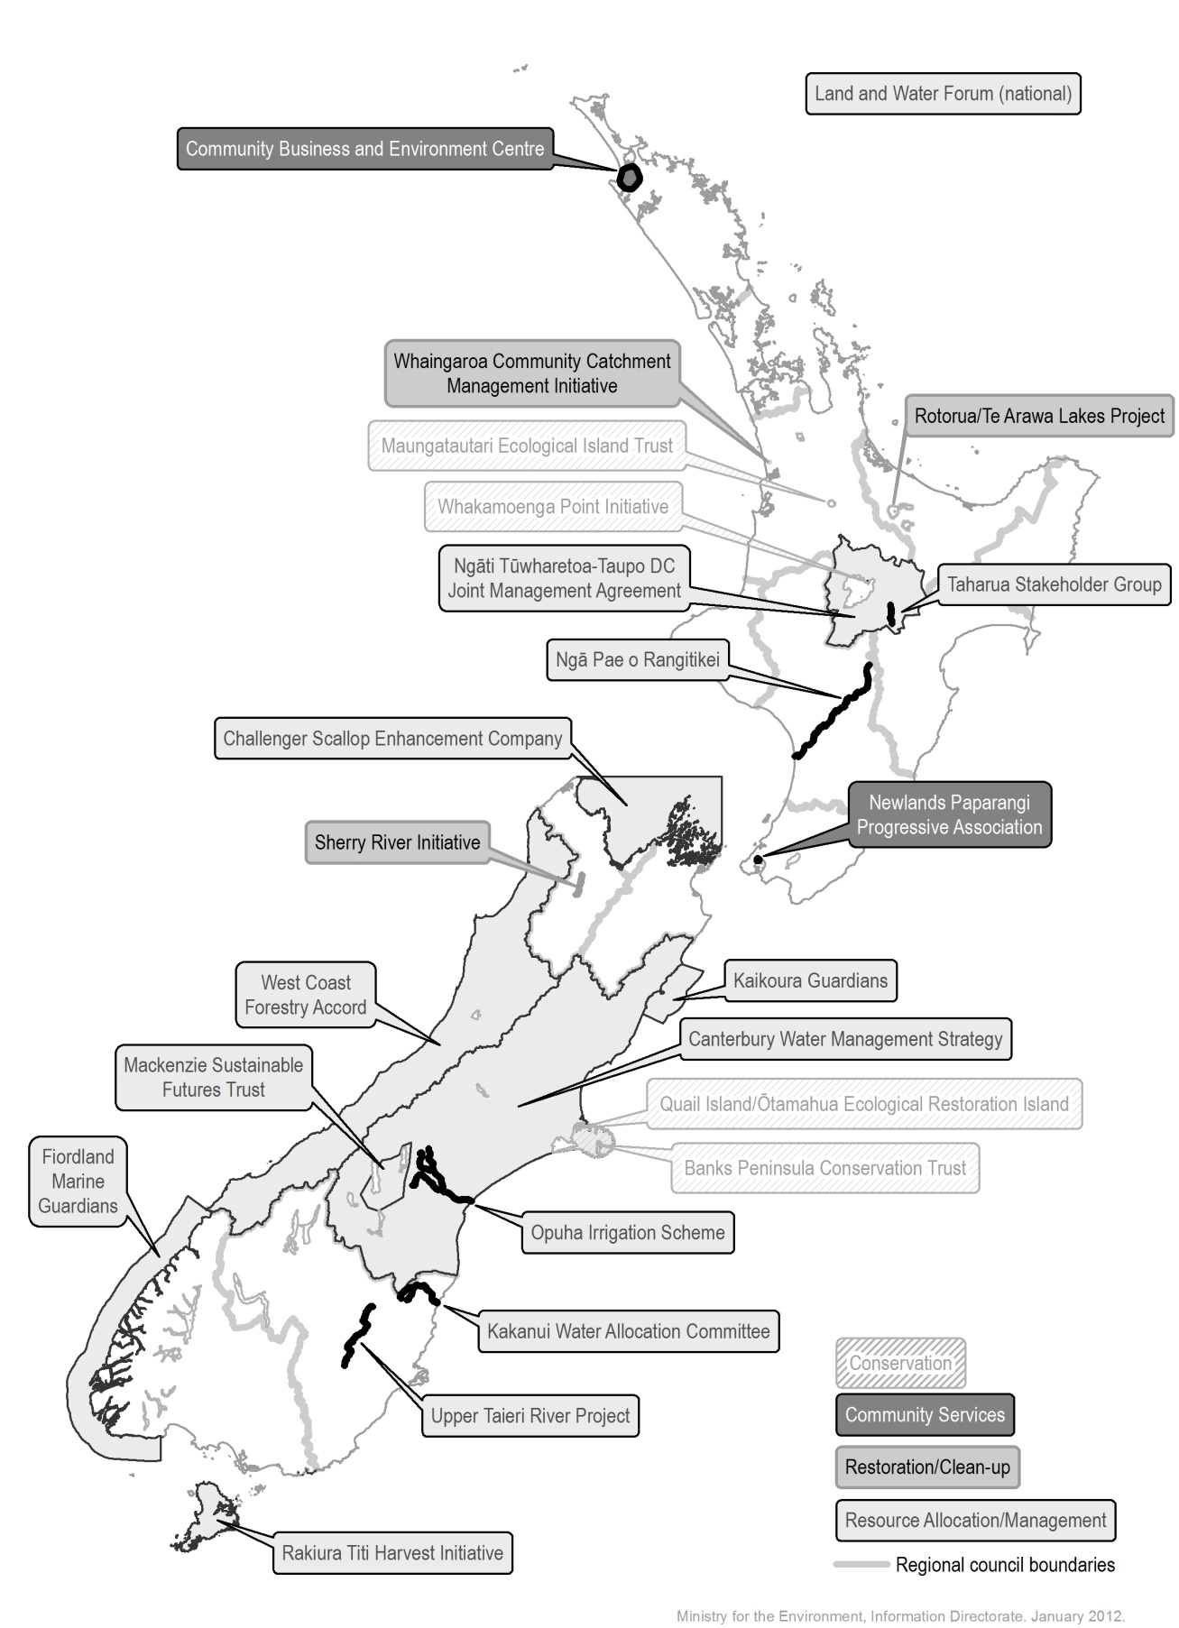
Figure 1: Map indicating the location, size and primary purpose of natural resource management for each collective action group sampled.

We initially examined the 23 collective action groups by case study analysis. This method has been applied extensively for the analysis of collective action elsewhere (Poteete et al, 2010). The case study analysis was broadly guided by the well-established Institutional Framework for Policy Analysis and Design (Polski & Ostrom, 1999). This framework provides a rule-based lens to analyse collective action. To avoid overly generalised research undertaken at the desktop, a more intensive level of analysis with an effort to link analysis to on the ground experience was performed for a smaller number of cases.

We performed a meta-analysis across the individual cases to gauge the likelihood of collective action success in New Zealand. We scored each case study against a number of success factors for collective action developed from the literature. The scoring system used a zero-to-four point scale for each success factor, anchored to an absolute, extreme position for the ‘zero’ and ‘four’ scores. For example, for the success factor ‘Sanctions’ a score of zero represented a collective action group with no sanctions developed and agreed on, while a score of four represented a collective action group with explicit graduated sanctions developed and agreed on. For the purposes of scoring, at least two analysts agreed each score on the weight of the available evidence for the case analysed. Given the subjectivity of these judgments, the scores given were also validated by others familiar with the each collective action group.

In addition to the case study research, an analysis of the costs and benefits from collective action was also performed. We assessed the costs and benefits of collective action across three categories: transaction costs (eg, meetings, facilitation, monitoring, compliance, litigation), the cost of physical works (eg, fencing, pest control) and the change in values accrued from the natural resource. The latter was assessed using the Total Economic Value framework. This accounts for all natural resource values including direct use values (eg, marketable goods), indirect use values (eg, many ecosystem services), option values and non-use values (eg, cultural and existence values).

Given the limited capacity to monetise the costs and benefits of collective action, changes were assessed by the subjective judgement of analysts based on the weight of available evidence from the analysed cases. Like the meta-analysis, these judgements were validated by others familiar with the collective action groups. We assessed increases or decreases in each category by comparing the management of the natural resource under collective action to the previous regime. The scale used runs from a ‘high’ change (●●●), which represents an order magnitude larger than a ‘medium’ change (●●), which is in-turn an order of magnitude greater than a ‘low’ change (●). Although a ‘low’ change is relatively minor, it still can be differentiated from ‘no’ (0) change. These changes were categorised into ‘cost’ and ‘benefit’ columns which were are not ‘netted’ off at any stage. Given that an order of magnitude separates each scale point, it is inappropriate to aggregate by summation. Rather, the aggregated cost and aggregated benefit for each case is revealed by applying the rule that the highest change be used as a proxy for the total change. Collective action was judged to provide net benefits where the aggregated benefit equalled or exceeded the aggregated cost. We note that costs and benefits may not necessarily accrue during the same period of time. To account for this asymmetry in time between costs and benefits we judged net benefits over the short term and the long term.

Results

Analysis of costs and benefits
In many of the cases analysed it was observed that collective action emerged without government intervention or the need for special legislation to provide it with legitimacy. However, almost all cases received public funding soon after their emergence, either directly or via the support of an intermediary such as the Landcare Trust, a non-governmental organisation involved in the facilitation of many collective action groups. The requirement for public funds is not surprising given the public goods character of the natural resources managed by the groups. The analysis of costs and benefits was performed on only ten cases, as many cases were deemed too immature with no tangible benefits evident on the ground or too difficult to judge from the limited evidence available.

Table 1 indicates the net benefits (or net costs) in the short and long term for the cases analysed. Four cases were judged to result in short term net costs. On the other hand, six cases were judged to provide net benefits in the short term. There are numerous examples of short term benefits being provided since collective action began. Examples include the increased number of tourists visiting Quail Island/Ōtamahua, the increased amount of recreational swimming on the Sherry River and the improved harbour health, better pasture and improved milk yield due to changed farm management practices in the Whaingaroa catchment.

Table 1: Analysis of costs and benefits for collective action in the short and long term.
Collective Action Group | Net benefits in short term? | Likely net benefits in long term? | Magnitude of change in transaction costs in short term
Banks Peninsula Conservation Trust | Yes | Yes | ●
Canterbury Water Management Strategy | --- | --- | ---
Challenger Scallop Enhancement Company | Uncertain | --- | ●●
Community Business and Environment Centre | --- | --- | ---
Fiordland Marine Guardians | No | Yes | ●●
Kaikoura Guardians | Immature | --- | ●
Kakanui Water Allocation Committee | --- | --- | ---
Land and Water Forum | --- | --- | ---
Mackenzie Sustainable Futures Trust | --- | --- | ---
Maungatautari Ecological Island Trust | Uncertain | --- | ●
Newlands Paparangi Progressive Association | Immature | --- | ●●
Ngā Pae o Rangitikei | Immature | --- | ●
Ngāti Tūwharetoa and Taupo District Council Joint Management Agreement | Immature | --- | ●
Opuha Irrigation Scheme | Yes | --- | ●●
Quail Island/Ōtamahua Ecological Restoration Trust | Yes | Yes | ●
Rakiura Titi Harvest Initiative | No | Yes | ●●
Rotorua/Te Arawa Lakes Project | No | Yes | ●●
Sherry River Initiative | Yes | Yes | ●
Taharua Stakeholder Group | --- | --- | ---
Upper Taieri River Project | Immature | --- | ●●
West Coast Forestry Accord | No | N/A | ●●●
Whaingaroa Community Catchment Management Initiative | Yes | Yes | ●
Whakamoenga Point Initiative | Yes | --- | ●

Note: Examples of ‘high’ transaction costs (●●●) include making multiple forms of legislation and significant conflict in the Environment Court, ‘medium’ transaction costs (●●) include making legislation, regulation and regular meetings between stakeholders requiring significant travel, ‘low’ transaction costs (●) include regular meetings between local (co-located) stakeholders, facilitation of meetings and the preparation of reports.

Despite evidence of benefits, collective action also generates large initial transaction costs, due to the need for numerous meetings and particularly if government makes new legislation or regulation to empower a group. We found large initial transaction costs were associated with heterogeneous sets of stakeholders with competing objectives and values. In three cases we judged from the weight of available evidence that the large initial ‘investment’ was likely to payoff in the long term as transaction costs decreased through collaboration and the benefits of new management practices on the ground were realised.

Our finding of long term net benefits with collective action, despite large initial costs in the short term, is consistent with the projections of other researchers (eg, Carlsson & Sandström, 2008). Evidence of long term net benefits also indicates that collective action should be seen as an investment. An example of this in our findings is the Fiordland Marine Guardians. This group had special legislation created to empower it, which has resulted in significant upfront transaction costs. However, this empowerment has allowed the group to implement its strategy of ‘marine management measures’. A recent Ministerial review found that although it was too early to judge the effectiveness of the strategy, it gained strong local awareness and understanding (Allen and Clarke Policy and Regulatory Specialists, 2010). Furthermore, this review highlighted that “...the number of people spoken to as part of the Ministry’s compliance patrols had increased since the management regime involving the [Fiordland Marine Guardians] had begun, but the number of people found in breach had decreased” (p. iv).

The expected benefit of a reduction in multiple stakeholders each lobbying government was difficult to validate in most cases. Furthermore, measuring a reduction in Environment Court cases was also difficult as the ‘counterfactual’ case is near impossible to establish. Nevertheless, anecdotally collaborative processes have led to a single ‘voice’ addressing government through the Fiordland Marine Guardians, Kaikoura Guardians, Canterbury Water Management Strategy and the Land and Water Forum.

Figure 2 shows the age distribution of the collective action groups that we studied. Two groups had been operating for over 30 years (ie, Kakanui Water Allocation Committee, Rakiura Titi Harvest Initiative), which further indicates the likely long-term net benefits of collective action to stakeholders. One of these enduring groups, the Rakiura Tiki Harvest Initiative, is a contemporary legislative incarnation of traditional Māori collective action. It, and many other rules for natural resource management underpinned by the Māori concept of kaitiakitanga, has endured and evolved over generations prior to the arrival of Europeans in New Zealand, much like some of the enduring international cases examined by Ostrom (1990).

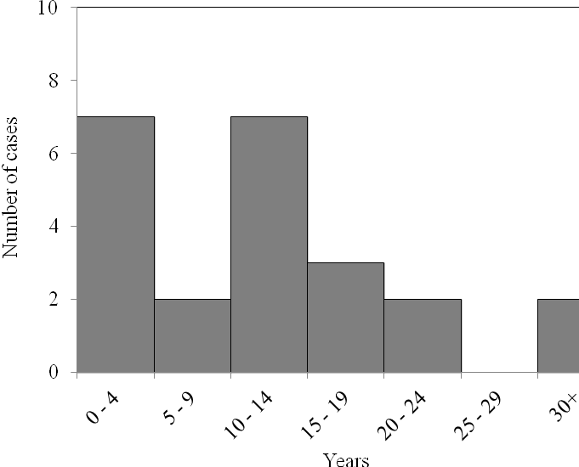
Figure 2: The endurance (years) of collective action in New Zealand for all cases.

Given evidence of the enduring nature of collective action in New Zealand, we expected that adaptive behaviour would be apparent and there is limited evidence to support this. Adaptive behaviour, for example, was demonstrated in the Opuha Irrigation Scheme as it evolved from an initial narrow focus on extractive resource use (ie, water takes for irrigation purposes), to encompass a wider range of stakeholder values (eg, minimum river flows set to maintain fish stocks). Similarly, the Challenger Scallop Enhancement Company has through information-sharing mechanisms demonstrated resilience to external shocks and adaptive behaviour by decreasing catch sizes as oceanic conditions change. This finding is supported by Loranzen (2008, p. 15), who concluded that Challenger Scallop’s rule “arrangements have proved sustainable and resilient and are being continuously developed and adapted.”

Meta-analysis of success factors
During the meta-analysis, each collective action group was scored against a range of success factors. Despite efforts to capture all success factors mentioned earlier, some (eg, trust) were not scored because of the inherent difficulty in effectively measuring them. The distribution of scores across all cases for each success factor is shown in Figure 3. An immediate observation from Figure 3 is that there is a wide distribution of scores for many success factors.

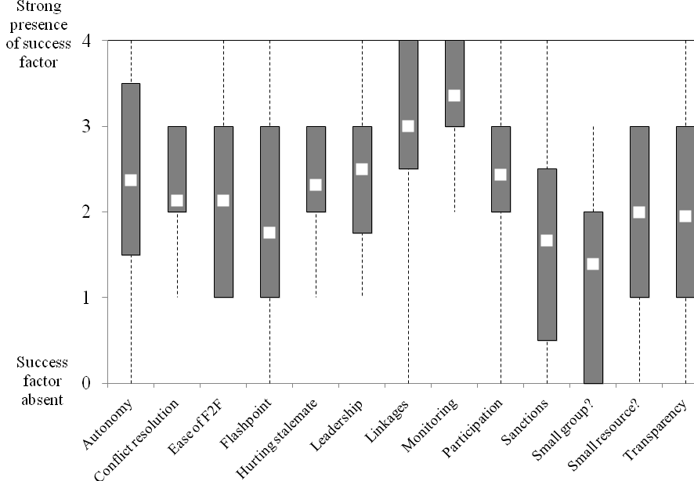
Figure 3: The distribution of scores for each success factor analysed. Note that the white point indicates the average score, the wide grey bars indicate the distribution of scores between the 25th and 75th percentile and the dashed black lines indicate the distribution between minimum and maximum scores for all cases analysed.

The highest scoring success factors are ‘Monitoring’ and ‘Linkages’. Half of the groups that were scored for the ‘Monitoring’ success factor had in place formal monitoring of both rules and the condition of the natural resource managed. A further one-third formally monitored either the rules or the natural resource. A number of collective action groups (eg, Sherry River Initiative, Rotorua/Te Arawa Lakes Project) used scientific agencies for the monitoring of the natural resource managed.

With regards to ‘Linkages’, the high score highlights that collective action in New Zealand is nested and is, therefore, not operating in isolation. However, despite this evidence of nesting, vertical linkages with government authorities were more prominent than horizontal ones with non-government organisations (eg, Landcare Trust) and other collective action groups. We found only a few cases where a horizontal linkage existed between collective action groups. One notable example of this interaction between groups is that of Fiordland Marine Guardians, which has formed a relationship with the Kaikoura Guardians. The result of this is that the Kaikoura Guardians has adopted rules originally developed by the Fiordland Marine Guardians (eg, gifts and gains rules).

In general, the success factor ‘Leadership’ also scored highly in the cases analysed. This finding indicates collective action in New Zealand does have leaders who can provide a platform for collective action and champion its success. From the analysis a number of strong leaders have been identified for the Rakiura Titi Harvest Initiative, the Land and Water Forum and the Banks Peninsula Conservation Trust. These leaders have all made some commitment to their respective groups on a pro bono basis.

An acknowledged risk to collective action is where leaders leave or ‘burn out’. While it was difficult to determine this risk, we were aware that despite the loss of two founding participants of the Fiordland Marine Guardians there was no evidence of a breakdown of collective action. Nevertheless, to avoid the possibility of this risk the promotion of succession planning would contribute to the resilience of such groups by reducing the likelihood of collective action failure where leaders leave.

A final success factor that scored highly in the cases analysed was ‘Participation’. This finding indicates that the participation of multiple stakeholders is occurring with collective action in New Zealand. However, a number of cases had stakeholders ‘shut out’ while collective action emerged. Iwi participated in collective action in a number of cases that we studied. In some cases they are the instigators of collective action (eg, Ngā Pae o Rangitikei) or involved closely in a joint management agreement with government (ie, Ngāti Tūwharetoa and Taupo District Council Joint Management Agreement). However, in seven cases iwi were not active participants. There is anecdotal evidence that the anticipation of new natural resource rights and governance arrangements being achieved through ongoing Treaty settlement claims have discouraged iwi from participating in some collective action groups.

The poorest scoring success factor was ‘Small group?’, meaning the groups were larger than considered ideal for reaching an agreed set of rules. One-third of the groups which were scored had 16 or more participants. The difficulties of face-to-face dialogue with such large groups can be overcome by nesting efforts into a number of smaller groups rather than one large group. The Canterbury Water Management Strategy offers an example of successful nesting from a regional to smaller catchment scale.

Other low-scoring success factors include ‘Transparency’ and ‘Sanctions’. The low score for ‘Transparency’ reflects the low profile that collective action currently has in New Zealand. While the low scores for these success factors are a concern and indicate areas of vulnerability for collective action, other factors could also be at play. For example, the low score for the success factor ‘Sanctions’ may reflect that the current regime provides enforcement mechanisms which act as a ‘backstop’ in case the informal sanctions of collective action groups fail.

Figure 4 indicates the distribution of average scores across all success factors for all cases analysed. It is evident that all cases have some ingredients for success. Most cases have average scores above two, which we postulate indicates the likelihood of collective action success in New Zealand. Notably, 15 cases had average scores for all success factors greater than two on the zero-to-four scoring system. This provides confidence that collective action success can be achieved for these groups. It is also noteworthy that many of the lower-scoring cases had undertaken little management on the ground. This validates, to some extent, that the success factors derived from the literature do have explanatory power.

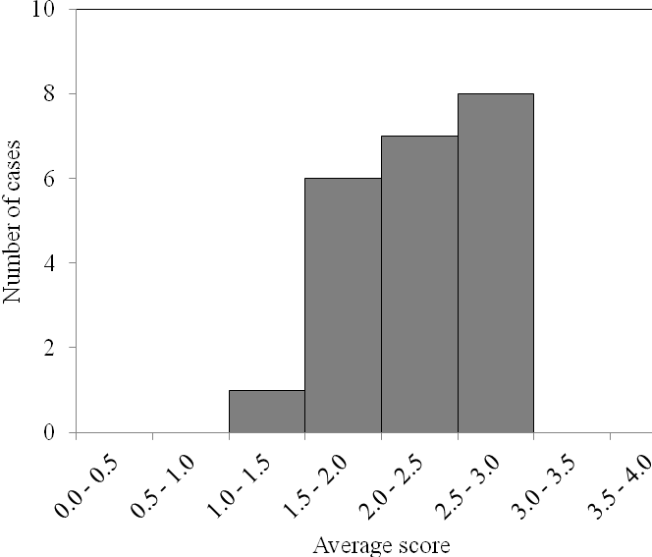
Figure 4: The distribution of average scores across all success factors for the collective action groups analysed. Note ‘Flashpoint’ and ‘Hurting Stalemate’ were excluded from the average scores as they represent factors relevant to the emergence of collective action only.

The endurance of these more vulnerable groups suggests that deficiencies in some areas may be offset by strong scores in others, meaning failure is not inevitable. Nonetheless, even one deficient area may make groups vulnerable. For example, difficulty meeting face to face may make adaptive changes harder for large groups, while a lack of conflict resolution mechanisms could mean stakeholders defect when pressures on the natural resource increase.

Enabling collective action success
We judge from the analyses performed that collective action holds promise for the management of natural resources. Indeed, there are numerous cases in New Zealand where locally-appropriate rules have been followed for managing natural resources. Collaborative processes have brought together former adversaries to develop and agree on rules. The analysis leads us to suggest that collective action should play an increasing role in New Zealand’s regime for natural resource management. Our meta-analysis has also allowed us to identify how New Zealand collective action groups could improve their likelihood of success. We propose a number of policies to support and enable collective action so that it can emerge and operate in accordance with the success factors.

Research indicates that to enable collective action government should avoid active interference and regulation in the development of rules for collective action groups (Polski & Ostrom, 1999; Borrini-Feyerabend et al, 2004). Hence, government should allow groups time to develop and agree their own rules and be prepared to delegate or devolve some rule-making power and functional roles to such groups. For government to enable collective action, we propose a principled approach is used.

Five ‘enabling principles’ are proposed (see Table 2). These principles or meta-rules provide the means for stakeholders to develop and follow their own rules, but in an informed and democratic way. As such, the enabling principles provide the foundations for collective action groups to promote authentic collective action where ‘good’ and adaptive governance is fostered. Without these principles being considered, inauthentic collective action has a greater likelihood of occurring, where a single stakeholder interest captures power despite the outward appearance of collaborative processes being present.

Table 1: The enabling principles for collective action success.
Enabling Principle | Description
Inclusive | This enabling principle indicates that for collective action success the participation of all stakeholders should be represented including those that suffer from negative externalities and iwi. The inclusive enabling principle also applies to knowledge in that all forms of knowledge should be represented (ie, scientific knowledge, local knowledge and mautauranga Māori).
Transparent | This enabling principle indicates that the decision-making, information and procedures of collective action are open to scrutiny to the public at large. The transparent enabling principle also indicates that all stakeholders involved have equal access to information with regards to the natural resource and the operation of the collective action group.
Deliberative | This enabling principle indicates that members of a collective action group discuss the management of the natural resource. Deliberative dialogue should: one, be face to face, where possible; two, be sincere, truthful and comprehensible; three, exclude coercion or domination of other stakeholders; four, enable all stakeholders to be heard and treated equally in deliberations; five, enable all stakeholders involved to question rules and assumptions behind the development of rules; and six, not have anyone restricting the agenda.
Accountable | This enabling principle indicates that the legitimacy of collective action is established when stakeholders are accountable for their actions taken. This includes stakeholder representatives being accountable to both their wider stakeholder community and to the public at large. In order to maintain the public’s interest, collective action groups should be accountable, either directly or indirectly, to government for the outcomes of any rules which they have followed.
Adaptive | This enabling principle indicates that where unexpected changes in the natural resource or socio-political system occurs that no longer can be accommodated by the rules developed and agreed upon, that the collective action group are willing to develop new rules and ignore old rules. To be aware of changes groups adhering to this enabling principle should collect data about natural resource outcomes and have the capacity to analyse and learn from this information.

Government can incentivise adoption of the enabling principles by a number of means. These arise from government’s power to change regulation and legislation, to delegate or devolve authority and to access public funds. However, critical to the adoption of the enabling principles by collective action groups is that government demonstrates them in its own development of environmental policy.

Our enabling principles can be operationalised to create evaluation criteria for collective action groups seeking government funding or devolution of authority. We recommend that the activities funded include impartial facilitators (eg, Landcare Trust) who provide collective action groups with access to decision-making tools and promote and apply the enabling principles during their engagement.

Through facilitators acting as intermediaries, a formal national learning network could be developed which enables improved relationships between collective action groups and, in turn, with government. This proposed network would allow groups to share information, experiences and expertise. It would provide researchers with an invaluable data source to evaluate the performance of collective action groups versus standard regimes over time. It would also allow government to coordinate a consistent effort to understand and manage relationships with collective action groups and their interaction with the current regime. We intend to investigate how such a network could operate effectively and what influence it might have.

The opportunities the current regime offers for stakeholders to influence management will affect their incentives to engage in authentic collective action. If some stakeholders see adversarial processes, like the Environment Court, to be a more effective route to their objectives then this is likely to be the route taken. Furthermore, the ability of one or more stakeholders to ‘defect’ from collective action to this route during or after collaborative processes is likely to undermine commitment by all group members to the process. One novel proposal to mitigate this risk is the removal of Environment Court appeal rights where the enabling principles have been demonstrated in the development and agreement of rules for collective action.

Conclusion
The management of natural resources in New Zealand faces the challenges of increasing scarcity and complexity. Collective action is proposed as a means to meet these challenges. Our analysis found many examples of groups who are successfully collaborating to develop, agree and follow rules tailored to the complexity of their local natural resource system. This stands in marked contrast to the adversarial processes commonly applied under the current regime. Furthermore, many groups strongly displayed many of the success factors for collective action. Thus, while we do not see collective action as a panacea for natural resource management, it is seen as a promising supplement to the current regime. Environmental policy-makers can support and enable collective action by promoting the enabling principles, which makes its success more likely.

Despite this paper indicating that collective action holds promise, there are a number of limitations with the analysis undertaken. In particular, the analysis is limited by its use of subjective, albeit validated, judgements, the limited time-series of the data available and the lack of data on natural resource conditions. Indeed, with regards to the last concern, the success factors scored considered the ingredients for collective action success, rather than specifically measuring the change in the natural resource system with collective action. This limitation is also noted by Koontz and Thomas (2006), who indicate that no empirical study has shown categorically a positive relationship between collective action and improved natural resource systems. Nonetheless, a number of cases in our analysis indicated clear biodiversity gains for the natural resource system since collective action began (eg, Maungatautari Ecological Island Trust, Quail Island/Ōtamahua Ecological Restoration Trust, Whaingaroa Community Catchment Management Initiative). Moreover, we have also found that Ngā Pae o Rangitikei now actively protects the mauri (ie, life-supporting capacity) of the natural resource system.

We consider future research should investigate the effectiveness of processes that exist under the current regime for delegating and devolving power to collective action groups. We intend to investigate whether there are unforeseen barriers to collective action with the current regime. We will also explore the potential of other relatively ‘novel’ means that may support collective action including shared resource consents and ‘audited self-management’. Both of these opportunities may afford the capacity of stakeholders to commit to collective action and take collective responsibility for the management of natural resources. In particular, they are likely to benefit issues around non-point source pollution (eg, nutrient run-off from agriculture), where the identification of the individual source of pollution remains difficult.

Acknowledgements
This paper was produced by the Strategic Policy Team at the Ministry for the Environment. Members of the team during the period of the project were: David Karl, Edward Hearnshaw, Sam Holmes, Rebecca Maplesden, Andrew Schollum, Michaela Simms, Doug Watt and Jacqui Yeates. We would also like to acknowledge and thank Ross Cullen of Lincoln University for his input.

References
Allen and Clarke Policy and Regulatory Specialists 2010, ‘Review of the effectiveness of the management of the Fiordland marine area’, www.fmg.org.nz/documents/management-review-fiordland-marine-area.pdf
Baland, JM & Platteau JP 2000, Halting Degradation of Natural Resources: Is There a Role for Rural Communities? Oxford University Press, New York.
Berkes, F 2009, ‘Evolution of co-management: Role of knowledge generation, bridging organizations and social learning’, Journal of Environmental Management, vol. 90, pp. 1692-1702.
Borrini-Feyerabend, G, Pimbert, M & Farvar, M 2004, Sharing Power: Learning-by-Doing in Co-management of Natural Resources Throughout the World, IIED and IUCN, Tehran.
Carlsson, L & Sandström, A 2008, ‘Network governance of the commons’, International Journal of the Commons, vol. 2, pp. 33-54.
Cox, M, Arnold, G & Tomas, SV 2010, ‘A review of design principles for community-based natural resource management’, Ecology and Society, vol. 15, www.ecologyandsociety.org/vol15/iss4/art38/
Crona, B, Ernstson, H, Prell, C, Reed, M & Hubacek, K 2011, ‘Combining social network approaches with social theories to improve understanding of natural resource governance’, in O Bodin & C Prell (eds.), Social Networks and Natural Resource Management: Uncovering the Fabric of Environmental Governance, Cambridge University Press, Cambridge, pp. 1-61.
Gibson, CC & Koontz, T 1998, ‘When ‘community’ is not enough: Institutions and values in community-based forest management in Southern Indiana’, Human Ecology, vol. 26, pp. 621-647.
Hardin, G 1968, ‘The tragedy of the commons’, Science, vol. 162, pp. 1243-1248.
Harkes, IHT 2006, Fisheries co-management, the role of local institutions and decentralisation in Southeast Asia: With specific reference to marine sasi in Central Maluku, Indonesia. Unpublished dissertation, Leiden University, Leiden.
Innes, J & Booher, D 2010, Planning with Complexity: An Introduction to Collaborative Rationality for Public Policy, Routledge, New York.
Kallis, G, Kiparsky, M & Norgaard, R 2009, ‘Collaborative governance and adaptive management: Lessons from California's CALFED Water Program’, Environmental Science and Policy, vol. 12, pp. 631–643.
Keen, M, Brown, VA & Dyball, R 2005, Social Learning in Environmental Management: Towards a Sustainable Future, Earthscan, London.
Koontz, TM & Thomas, CW 2006, ‘What do we know and need to know about the environmental outcomes of collaborative management?’, Public Administration Review, vol. 66, pp. 109-119.
Land and Water Forum, 2010, Report of the Land and Water Forum: A fresh start for freshwater, www.landandwater.org.nz
Loranzen, K 2008, ‘Understanding and managing enhancement fisheries system’, Reviews of Fisheries Sciences, vol. 16, pp. 10-23.
Marshall, GR 2008, ‘Nesting, subsidiarity, and community-based environmental governance beyond the local level’, International Journal of the Commons, vol. 2, pp. 75-97.
Memon, PA & Selsky, JW 1998, ‘Institutional design for the co-management of an urban harbour in New Zealand’, Society and Natural Resources, vol. 11, pp. 587-602.
Olson, M 1965, The Logic of Collective Action: Public Goods and the Theory of Groups, Harvard University Press, Cambridge.
Ostrom, E 1990, Governing the Commons: The Political Economy of Institutions and Decisions, Cambridge University Press, Cambridge.
Ostrom, E & Nagendra, H 2006, ‘Insights on linking forests, trees, and people from the air, on the ground, and in the laboratory’, Proceedings of the Academy of Sciences of the United States of America, vol. 103, pp. 19224-19231.
Ostrom, E 2007, ‘A diagnostic approach for going beyond panaceas’, Proceedings of the National Academy of Science, vol. 104, pp. 15181-15187.
Pahl-Wostl, C 2007, ‘Requirements for adaptive water management’, in C Pahl-Wostl, P Kabat & J Möltgen (eds.), Adaptive and Integrated Water Management: Coping with Complexity and Uncertainty, Springer Verlag, Heidelberg, pp. 1-22.
Polski, MM & Ostrom, E 1999, An institutional framework for policy analysis and design, Workshop in political theory and policy analysis working paper, Indiana University, Bloomington.
Poteete, AR & Ostrom, E 2007, ‘Fifteen years of empirical research on collective action in natural resource management: Struggling to build large-N databases based on qualitative research’, World Development, vol. 36, pp. 176-195.
Poteete, AR, Janssen, MA & Ostrom, E 2010, Working Together: Collective Action, the Commons, and Multiple Methods in Practice, Princeton University Press, Princeton.
Prager, K & Nagel, UJ 2008, ‘Participatory decision making on agri-environmental programmes: A case study from Sachsen-Anhalt (Germany)’, Land Use Policy, vol. 25, pp. 106-115.
Smith, VL 2002, Constructivist and ecological rationality in economics, Nobel Prize Lecture, Interdisciplinary Center for Economic Science, George Mason University, Fairfax.
Varughese, G 1999, Villagers, bureaucrats and forests in Nepal: Designing governance for a complex resource, Unpublished dissertation, Indiana University, Bloomington.
Varughese, G & Ostrom, E 2001, ‘The contested role of heterogeneity in collective action: Some evidence from community forestry in Nepal’, World Development, vol. 29, pp. 747-765.

For supplementary information on the individual cases contact the corresponding author.
The West Coast Forestry Accord only ran from 1986 to 2000
‘Autonomy’ represents the degree the group has in developing its own rules without external influence; ‘Conflict resolution’ represents the degree the group has mechanisms to resolve conflicts; ‘Ease of F2F’ represents the degree the group can deliberate through face to face communication; ‘Flashpoint’ represents the degree the group emerged from an abrupt environmental/socio-political change; ‘Hurting stalemate’ represents the degree the group emerged from adversarial processes between stakeholders; ‘Leadership’ represents the degree the group has leaders to coordinate collective action; ‘Linkages’ represents the degree the group is nested horizontally with other groups or vertically with government; ‘Monitoring’ represents the degree the group has monitors its own rules and the natural resource system; ‘Participation’ represents the degree the group has included all stakeholders including iwi in collective action; ‘Sanctions’ represents the degree the group has graduated sanctions available to punish rule-breaking; ‘Small group?’ represents the degree the group is small; ‘Small resource?’ represents the degree the group manages a small natural resource; and ‘Transparency’ represents the degree the group reveals information to the public at large.

