January

15

Business case:

Simplifying the regulation of Aerial 1080 under the resource management act

08

**Fall**

## Foreword

The following business case has been prepared in partnership between the Department of Conservation, Ministry for Primary Industries and TBfree New Zealand Limited (the partners). The case has been developed in response to the Parliamentary Commissioner for the Environment’s 2011 evaluation of 1080 which supported its continued use as a vital biosecurity tool and recommended that the Minister for the Environment investigate ways to simplify and standardise its management under the Resource Management Act (RMA) and other legislation.

The purpose of the case has been to explore this recommendation further by examining whether there is a need for standardisation and/or simplification and what the benefits and costs of achieving this might be. The assessment has identified a strong case to simplify the current regulatory system for 1080 under the RMA and recommends the future management of the substance be provided for solely under the nationally consistent Hazardous Substances and New Organisms Act (HSNO) and Agricultural Compounds and Veterinary Medicines Act (ACVM) framework.

This recommendation is based on an extensive review of the evidence that has found the adverse effects and risks of aerial 1080 use are being comprehensively managed under the HSNO/ACVM framework and that these requirements are being duplicated under the RMA. This duplication is not improving the management of risks and effects and has been found to impact the timely and cost effective delivery of pest control operations. The analysis has further found that the regulation of aerial 1080 operations varies significantly by region under the RMA and that this inconsistency undermines opportunities to standardise operations to improve efficacy and efficiency.

Based on these findings, the partners consider that if the areas of duplication can be minimised through simplification, and cost savings put into improving operations, the likely benefits will include greater control of bovine tuberculosis (TB) in key vector areas, and biodiversity gains. Achieving consistency is also likely to improve the effectiveness of operations long term as it will provide opportunities to improve the way pest management agencies manage and deliver operations by allowing technical teams to work within nationally consistent standards.

The case has considered the range of policy options and approaches to achieve standardisation and has assessed the costs, benefits and risks of each option. This assessment has concluded that a national policy approach is most likely to achieve greater consistency and generate the largest net benefits to society over the long term. The preferred policy approach is a regulation under section 360(1)(h) of the RMA, which would exempt aerial 1080 operations from section 15 of the RMA and leave their continued management under the HSNO/ACVM framework.

Preparation of this business case has been overseen by the partners and the findings have been developed in consultation with Regional Councils, the Ministry for the Environment and the Environmental Protection Authority. We would like to acknowledge the work of independent external providers in assisting the development of the case including Latitude Planning Services for project management and resource management planning advice, Sapere Group Limited for cost-benefit analysis and Atkins Holm Majurey for legal advice.

It is intended that the findings of this case will be utilised in the generation of the technical policy documents necessary to support the process for implementing a section 360(1)(h) regulation. The partners welcome the opportunities a regulation would provide to deliver enhanced biosecurity and biodiversity outcomes for New Zealand and build on the significant improvements to the delivery and management of aerial 1080 operations made in the last 10 years.

|  |  |
| --- | --- |
|  |  |
|  |  |

**TABLE OF CONTENTS**

Foreword i

Executive Summary 1

Purpose 1

Key findings 2

Duplication 3

Regional Inconsistency 3

Costs of Compliance 4

Future Pressures 5

Case for Change Summary 5

Investment objectives and Critical Success Factors 6

Options Assessment 6

Cost-Benefit Analysis 7

Preferred Option 8

Delivery arrangements 8

Conclusion 8

1 Overview 2

2 Business Case Framework 3

3 Case Scope 4

4 Strategic Context and Drivers 6

4.1 Drivers for aerial 1080 use 6

4.1.1 Threat of bovine tuberculosis to agriculture 6

4.1.2 Conservation, biodiversity and natural heritage 7

4.1.3 Impacts of pests on biodiversity 8

4.2 Parliamentary Commissioner for the Environment 10

4.2.1 Parliamentary Commissioner for the Environment Report - 1080 10

4.2.2 Update on PCE Report 10

4.3 Strategic Objectives – the Partners 11

4.3.1 TBFree New Zealand Limited 11

4.3.2 Department of Conservation 12

4.3.3 Ministry for Primary Industries 13

4.3.4 Regional Councils 13

4.4 Operational Pressures 14

4.4.1 Response to Mast Events 14

4.4.2 Commitment to increase coverage 14

4.4.3 TBfree NZ operations 15

5 Analysis of Existing Arrangements 15

5.1 Aerial 1080 use in New Zealand 15

5.2 Scale of use 15

5.3 Location of operations 16

5.4 Regulation of aerial 1080 18

5.5 Regulation under the HSNO Act 18

5.5.1 Reassessment of 1080 19

5.5.2 HSNO management regime 19

5.5.3 HSNO Regulations and Controls 20

5.5.4 Permissions 22

5.5.5 Monitoring and review of controls 23

5.5.6 Five yearly review 24

5.5.7 Reassessment recommendations 25

5.6 Regulation under ACVM 27

5.7 Regulation under the Health Act 1956 27

5.8 Standard Operating Procedures and Best Practice Guidance 28

5.9 Summary 28

6 Analysis of RMA system 29

6.1 Regulation of Aerial 1080 under the RMA 29

6.2 HSNO and RMA interface 30

6.3 Regional Plan Assessment 31

6.3.1 Regional Plan rule framework 31

6.3.2 Rule framework and consenting requirements 31

6.4 Consenting Overview 32

6.4.1 Consents by Region 32

6.4.2 Consent term 33

6.4.3 Consent conditions 34

6.5 Areas of Duplication 34

6.5.1 Process duplication 34

6.5.2 Regional Plan Rules 35

6.5.3 Resource consents conditions 36

6.5.4 Conditions not covered by regulations 37

7 Direct and Indirect Costs 37

7.1 Analysis of Costs 38

7.2 Resource Consent Costs 38

7.3 Plan Review Costs 40

7.4 Opportunity Costs 40

7.5 Future Consent Costs 40

7.6 Operational Risks and Impacts 41

8 Case for Change Conclusions 42

9 Options Analysis 45

10 Assessment Methodology 45

10.1 Analysis Process 46

10.2 Workshops 47

11 Investment Objectives 47

11.1 Critical Success Factors 47

12 Long List of Options 48

13 Long List Assessment 51

14 Short List Summary 52

15 Cost Benefit Analysis Findings 52

15.1.1 Benefit Cost Ratio 52

15.1.2 National vs Regional 53

15.1.3 Sensitivity testing 54

15.1.4 Operational benefits 55

16 Analysis of Short List 56

16.1 Regional Option 56

16.2 National Option 57

16.2.1 National Environmental Standard – Assessment against Criteria 57

16.2.2 Section 360(1)(h) Regulation – Assessment against Criteria 58

16.2.3 Summary of assessment 58

17 Disadvantages of Preferred Option 59

18 Preferred option 60

19 Delivery arrangements 62

20 Regulation process 62

21 Project Approach 62

22 Project Structure and Resourcing 63

23 Milestones and Deliverables 64

24 Risks 65

25 Communications Plan 67

26 Delivery Costs 67

27 Implementation and Monitoring 67

28 Summary and Conclusions 68

29 References 70

**APPENDICES**

APPENDIX A: Evaluating the use of 1080: Predators, Poisons, and Silent Forests (*Parliamentary Commissioner for the Environment)*

APPENDIX B: Five yearly report for aerial 1080

*(Environmental Protection Agency)*

APPENDIX C: Cost benefit analysis of options to streamline Resource Management Act compliance for aerial 1080 operations

*(Sapere Group Limited)*

APPENDIX D: Summary of 1080 reassessment

*(Environmental Risk Management Authority)*

APPENDIX E: HSNO controls for 1080

APPENDIX F: Aerial 1080 products registered for use under Hazardous Substances and New Organisms Act

*(Latitude Planning Services)*

APPENDIX G: Regional Plan activity status for aerial 1080 operations

*(Latitude Planning Services)*

APPENDIX H: Analysis of duplication

*(Latitude Planning Services)*

APPENDIX I: Examples of DOC and MOH permission conditions

*(Department of Conservation, Ministry of Health)*

APPENDIX J: Summary of Standard Operating Procedures

*(Department of Conservation, TBfree New Zealand Limited)*

APPENDIX K: Summary of Tennyson Inlet costs and summary of consents for Battle for our Birds operations.

*(Department of Conservation)*

APPENDIX L: Description of short list

*(Latitude Planning Services)*

APPENDIX M: Summary of options assessment

*(Latitude Planning Services)*

# Executive Summary

Agriculture and tourism are key drivers of New Zealand’s economy comprising some 16% of the national Gross Domestic Product. The significance of these sectors to the nation’s prosperity is reflected in the Government’s Business Growth Agenda, which is focussed on growing the value of exports and the efficient stewardship of New Zealand’s natural resources to sustain growth.

New Zealand’s substantial natural resource base is integral to the value generated from both sectors, and our extensive biosecurity system plays a critical role in protecting and enhancing this base. Its purpose is twofold: to stop invasive pests from entering the country, and to manage established pests within the country. This dual role supports our agricultural and tourism sectors and enhances New Zealand’s unique biodiversity and landscapes, which are fundamental to our national identity, international image and branding, and lifestyle.

The vertebrate toxic agent sodium fluoroacetate (1080) is a key component of the biosecurity toolkit. The aerial use of 1080 for animal pest control is critical for controlling the threat of bovine tuberculosis (TB)to the $14 billion per year beef, dairy and deer export industries, and reducing the impacts of animal pests on productive land.

Aerial application of 1080 also provides effective control of vertebrate pests to protect and enhance our unique natural heritage, which is the cornerstone of a $23.9 billion dollar tourism industry. Providing for the safe, efficient and effective use of 1080 is therefore important for maintaining biosecurity and protecting New Zealand’s unique biodiversity and landscapes.

## Purpose

This business case has been prepared in partnership between the Department of Conservation (DOC) TBfree New Zealand Limited (TBfree NZ) and the Ministry for Primary Industries (MPI) in consultation with Regional Councils, the Ministry for the Environment (MfE) and the Environmental Protection Authority (EPA).

The case is a direct response to the findings of the Parliamentary Commissioner for the Environment’s (PCE) review of 1080 in 2011 which supported its continued use and recommended *“The Minister for the Environment investigate ways to simplify and standardise the way 1080 and other poisons for pest mammal control are managed under the Resource Management Act and other relevant legislation.”*

The purpose of the case has been to explore this recommendation in detail by examining whether there is a need to simplify the regulation of 1080 under the Resource Management Act (RMA), and, if so, what the benefits, costs and risks of this might be.

## 

## Key findings

The business case has involved an extensive review of the regulatory system for 1080, including a detailed examination of the national regulatory framework for 1080 under the Hazardous Substances and New Organisms Act (HSNO), Agricultural Compounds and Veterinary Medicines Act (ACVM) and the Health Act, along with an analysis of compliance requirements under regional plans and resource consents pursuant to the Resource Management Act (RMA).

This analysis has found that the potential adverse effects of 1080 use are being robustly managed at a national level under the HSNO, ACVM and Health Act framework. Independent monitoring completed by the EPA within the last five years confirms that the HSNO system is effective at managing the risks of operations and that the management of operations has improved significantly.

The analysis has also revealed that the further regulation of 1080 at a regional level under the RMA is affording no extra protection to the environment or public health and that there is compelling case to simplify the RMA system due to the following:

* There are high levels of duplication and replication between RMA and HSNO requirements. Duplication and replication occurs between regional plan rules and HSNO controls. The environmental effects and risks that are managed under resource consent conditions are also managed under HSNO requirements. This duplication can be costly and does not improve the management of effects and risks.
* The regional plan rule framework for aerial 1080 is complex and varies by region. There are 13 regions with regional plan standards that require resource consent for aerial 1080 operations. There is significant regional variability in the types of consent conditions and in the way consents are managed. This inconsistency can adversely impact the effectiveness of operations as it acts against development of nationally standardised operating procedures.
* Regional variance and duplication can create operational difficulties for compliance. Variable consent conditions make it more difficult for operators to ensure that best practice is always achieved, which increases the risk of breaching consent conditions. Even if the effects of such breaches are minor, they are treated as adverse incidents in EPA monitoring reports. The recurrence of incident reports could lead to further controls on the use of 1080 being imposed under the HSNO Act, potentially resulting in the loss or reduced availability of 1080 as a pest management tool for biosecurity and biodiversity programmes.
* The current RMA regime imposes needless costs on both the users of 1080 and regional ratepayers. The compliance costs for resource consents in the last ten years have been estimated at $10.7M. Future costs could be reduced significantly through removing the need for resource consent and managing 1080 operations solely under HSNO.

## 

## Areas of Duplication

The business case analysis has examined a range of regional plans and resource consents and has revealed high levels of duplication between RMA requirements and HSNO requirements. Key areas of duplication include:

* Direct duplication of HSNO requirements in Regional Plan rules. Many Regional Plan rules specify the need for compliance with HSNO and repeat requirements already set out in HSNO controls and permission conditions.
* Duplication of process, where a single operation can require three separate approvals - resource consent under the RMA, a DOC permission, and MOH permission under HSNO. All three approvals require preparation of the same substantive effects assessment and supporting technical data. All three processes also require input from technical and planning staff or contractors, and often necessitate duplicate reports to meet like conditions.
* Significant duplication and cross over between resource consent conditions, HSNO Act controls, and MOH and DOC permission conditions. For aerial 1080 consents granted from 2003 - 2013, approximately 90% of resource consent conditions imposed simply duplicate or are managed by equivalent controls under the HSNO and ACVM Acts. Those 10% of conditions not covered by HSNO or ACVM are addressed within SOPs which all commercial 1080 contractors are bound to comply with. Resource consent conditions are not managing any potential adverse effects that are not already managed under the HSNO Act.

## Regional Inconsistency

The analysis has found that all regional plans regulate the aerial application of 1080 in different ways and there is also significant regional variance in the way resource consents are considered, processed and conditioned.

Notable areas of inconsistency identified include:

* Some Regional Plans treat the aerial application of 1080 as a permitted activity with only a few conditions, while others treat exactly the same activity as controlled, discretionary or non-complying, and thus requiring resource consent. Even in those regions (or parts of regions) where Plans permit aerial 1080 application, formal consent requirements are often still triggered by permitted activity rule conditions, which often relate to proximity to waterways or significant natural areas.
* The Regional Plan framework is further complicated by varying interpretation and administration of Plan rules, and notable variance in technical definitions for vertebrate toxic agents within and between Plans.
* Rules within regional plans and consent conditions can be contrary to the considerable body of technical evidence that supports the comprehensive risk management framework established for aerial 1080 under HSNO.
* Between 2003 and 2013 the RMA planning framework required the issue of some 270 resource consents for aerial 1080 operations. Consents were processed in all regions except for Taranaki, Otago and Manawatu-Wanganui, where more permissive frameworks exist. The complexity and length of these resource consent processes varied significantly during the period. Excluding consents that were withdrawn or not yet issued, approximately 83% of the consents were non-notified and 17% were notified or limited notified, with two of these consent applications reaching the Environment Court. Despite this varying complexity, all of the consents processed were approved subject to conditions.
* The type and number of conditions imposed on operations varied significantly between regions. For example, consents granted by West Coast Regional Council contain an average of 22 conditions, whilst consents in Marlborough District contain an average of 8 conditions.

The above issues create a very complex operating environment for those partners who undertake operations pan-regionally, with a national strategic focus. This inconsistent approach to the management of 1080 under the RMA is in contrast to the nationally consistent management regime under HSNO.

## Costs of Duplication and Inconsistency

The regional plan framework generated 270 resource consents for aerial 1080 operations in New Zealand from 2003 to 2013. The cost to applicants in obtaining these consents has been estimated at $10.7M. This includes costs for preparing and managing consent applications and compliance with conditions, and Council fees for processing and compliance monitoring. Third party costs have not been included in the estimated costs, but are a component of all notified or limited notified consents, and most non-notified consents where affected party approvals are required.

The current system of consenting also generates opportunity costs. Because of seasonal or biological factors, timeliness of operations can often be critical. Time delays to operations from lengthy resource consent processes can result in failure to meet operational timeframes, setting pest control programs back with potential adverse pest management outcomes. The risks and uncertainties around consent processes and conditions can also affect the efficiency and effectiveness of operations. Inconsistent consent conditions add further compliance risk where operations may span two or more regions, requiring multiple resource consents which may impose differing conditions. Delays to operations, and reduced efficiency and effectiveness resulting from consenting processes and conditions, can have adverse flow-on impacts for biodiversity and natural heritage protection and can result in increased risk of TB infection.

A recent DOC aerial 1080 operation over the Tennyson Scenic Reserve provides an example of the opportunity costs associated with a complex consent process. This was a notified resource consent process followed by an appeal to the Environment Court, mediation and negotiated settlement. The total cost of the Tennyson operation has been estimated at $149,000 with almost 40% of the cost related to RMA compliance. In addition, the planned operation was delayed by one year due to the appeal process. This in turn set back an associated $500,000 multi-year research programme in the same location.

The partners have also incurred costs in pursuing initiatives to improve the consistency of Regional Plans. Most recently DOC engaged on the Canterbury Land and Water Plan review and sought amendments to the rules for aerial 1080. A team of DOC planners, legal and technical staff prepared evidence that resulted in a change from controlled activity status to a permitted activity for aerial 1080. The costs of DOC involvement in this process have been estimated at $25,000-$30,000, exclusive of any costs associated with Council and third party involvement in the process. TBfree NZ and Federated Farmers of New Zealand also incurred costs in preparing and presenting submissions on this matter. DOC is currently involved in a similar review process on the Auckland Unitary Plan.

## Future Pressures

There are currently 110 active resource consents for 1080 use nationally and 98% of these consents are due to expire within the next 10 years. In locations where operations are set to continue, consent renewals will be required. In addition, an indeterminate number of consents are likely to be required for new operational areas over the next 10-year period. Key operations that will drive the need for consents include:

* DOC’s commitment to increase its aerial 1080 programme by 50,000 hectares per year for five years contributing to the on-going protection of native species.
* The likely need to repeat DOC’s significant response to the 2014 South Island beech mast and predator irruption event - the “Battle for our Birds” operation. In 2014 this required DOC to increase its aerial 1080 protection in the South Island by approximately 500,000 hectares, and required 16 separate resource consents.
* By 2026, TBfree NZ aims to have reduced the extent of the existing TB vector risk area (where TB is present in possums and other wildlife) by at least 2.5 million ha. The key regions targeted for reduction include Waikato, Hawkes Bay, Manawatu, Tasman, West Coast, Canterbury, Otago and Southland, and consents will be required in most regions. Further possum control operations will also be required in these and other regions to prevent disease spread and minimise livestock infection rates.

If a timely solution that achieves national consistency can be delivered, this has the potential to realise significant cost savings for the partners in the short term and potentially allow the further reallocation of resources into operational areas of need.

## Case for Change Summary

Given the above findings, the partners consider there is a compelling need to simplify the management of 1080 use under the RMA to reduce duplication, provide greater consistency, reduce compliance costs and minimise operational risks.

This simplification will assist the partners in achieving their strategic objectives and thereby generate significant national benefits through the protection of New Zealand’s livestock industries and exports from the effects of bovine TB, and the continued protection and enhancement of our biodiversity for its intrinsic, economic and recreational values.

This change can be made while still providing for the safe use of aerial 1080, as the risks and effects of the substance are already comprehensively managed under the HSNO framework.

## Investment Objectives

Based on the findings of the case for change, the partners are seeking to achieve the following key objectives from simplification;

1. Improve the effectiveness of aerial pest control operations by establishing nationally consistent environmental compliance measures within the next two years (ie by December 2016).
2. Improve the efficiency of aerial pest control operations by reducing unnecessary RMA compliance costs by 80% within the next five years (ie by December 2019).

## Options Assessment

The partners have explored the full range of potential options to achieve these objectives as summarised below.

|  |  |
| --- | --- |
| National Options |  |
|  | * Regulation under the RMA * New National Policy Statement. * National Environmental Standard (NES) * Legislation Change * New Act * Plan change at National Level * National Consent |
| Regional Options |  |
|  | * Regional Approach –comprising a mix of Regional Plan review and comprehensive resource consents * Comprehensive Consents * Private Plan Changes * Council led Plan Changes |
| Advocacy |  |
|  | * Improved systems approach * Best Practice Guidance |

The options have been qualitatively assessed against the investment objectives to determine a short list of three options. The final short list includes two national options and a regional option as follows;

1. A new National Environmental Standard (NES) – permitting the use of 1080 nationally subject to HSNO controls.
2. A new Regulation under Section 360 (h) of the RMA - exempting 1080 from the discharge controls set out in Section 15.
3. Regional Approach – comprising a mix of Regional Plan reviews and comprehensive resource consents to permit the use of 1080 subject to HSNO controls.

## Cost-Benefit Analysis

The short list has been subjected to an independent cost benefit analysis by Sapere Research Group. The results of this analysis pointed strongly towards the two national options, as opposed to the regional option. The analysis found little differentiation between the benefits and costs of the two national options.

The benefits of the national options – with a benefit-cost ratio of 11 to 1 - were assessed as being significantly higher than the regional options. Other benefits not readily quantifiable in the cost benefit analysis would also accrue from the implementation of a national option, including:

* Enhanced opportunities for the partners to standardise internal processes allowing for more specialised planning and operational functions that enable more efficient use of staff time.
* Reduced uncertainty potentially leading to lower contract pricing, to the extent that contractors currently factor in price premia for consenting risk. There may be scope for national standardisation to allow these premia to be waived and costs of operations to be reduced.
* Standardisation and a single set of rules may reduce cases of consent non-compliance when conducting aerial 1080 operations.
* Improved timeliness of operations with national standardisation meaning that operations could be planned an implemented more quickly than under the current framework, thereby being more responsive to on-the-ground changes.
* Reduction in suboptimal consents; whereby operations are constrained for the sake of meeting consent requirements, resulting in reduced pest control benefits.
* Increases in area covered by aerial 1080 operations if organisations can realise operational savings from a streamlined consent process. Freed-up resources could be reallocated to additional pest management operations. This could lead to an expansion in the area covered by aerial 1080 operations, with consequent gains for biodiversity protection and bovine TB control.
* Improved public confidence where the introduction of a national standard and single set of rules may improve overall public confidence in the conduct of aerial 1080 activities.

## Preferred Option

The pros and cons of the two national options were further assessed by the partners and the preferred option has been assessed as a regulation under Section 360 of the RMA, for the following reasons:

* It is a more directly applicable and appropriate policy tool than a NES to address the case for change.
* There is a risk that an NES would create a new set of conditions or standards which would once again needlessly duplicate HSNO standards and controls.
* A regulation is likely to have a higher chance of success overall.

## Delivery arrangements

The proposed delivery arrangements for the preferred option have been scoped and will be completed in six key stages including:

1. Preparation stage – including confirming the project plan and resourcing, preparing a public discussion document, regulatory impact statement and legal drafting of the regulation.
2. Securing Ministerial/Cabinet approval to consult with Central and Local Government on the proposed regulation.
3. Consulting with Central and Local Government on the proposal and making revisions.
4. Securing Cabinet approval to release a discussion document for formal consultation.
5. Releasing the discussion document and analysing submissions.
6. Revising the regulation for promulgation.

The option is to be delivered by a project team that includes resources from within the partners with independent project management and communications support. The delivery of the option has been assessed as being affordable within the context of the benefits it is likely to generate. The aim of the partners is to deliver the preferred option by August 2015.

## Conclusion

The business case analysis has found a compelling case for aerial application of 1080 to no longer be treated as a discharge to be managed under the RMA. The preferred option is an efficient and cost effective solution that is likely to realise significant economic and environmental benefits for the partners and New Zealand, whilst still enabling robust management of any environmental risks or adverse effects. The potential benefits of the preferred option of a section 360(1)(h) regulation are therefore considered to significantly outweigh any potential disadvantages.

PART 1 – OVERVIEW AND SCOPE

# Overview

The following business case has been prepared by TBfree New Zealand Limited (TBfree NZ) in partnership with the Department of Conservation (DOC) and the Ministry for Primary Industries (MPI). The case has been developed in consultation with Regional Councils, the Ministry for the Environment (MfE) and the Environmental Protection Authority (EPA). These organisations have all been involved in the case for change assessment and the options analysis, including the determination of the preferred option.

The case has been prepared in response to the Parliamentary Commissioner for the Environment’s (PCE) Report of June 2011 which identified a need to simplify and standardise the management of 1080 under the Resource Management Act 1991 (RMA) and other legislation, stating *“the labyrinth of laws, rules and regulations that govern 1080 and the other poisons used to control introduced pests creates unnecessary complexity and confusion.”*.

The purpose of the case has been to explore the PCE’s conclusions further by assessing whether a compelling argument exists for greater standardisation and simplification of the regulatory system. This analysis has concluded that the environmental effects and health risks of the aerial discharge of 1080[1] are robustly managed under the Hazardous Substances and New Organisms Act 1996 (HSNO), Agricultural Compounds and Veterinary Medicines Act 1997 (ACVM) and the Health Act 1956 in all aspects.

It has further found that there are very high levels of duplication between the HSNO requirements for 1080 use, and regional plan standards and resource consent conditions under the RMA. It has also found that there are inconsistencies in how aerial 1080 is regulated through regional plans under the RMA.

The evidence reviewed suggests that these issues are impacting the effective and efficient delivery of aerial pest management operations and are imposing needless costs on public good pest management programmes.

Based on this evidence the partners consider there is a compelling case to change the system by simplifying the regulation of aerial 1080 under the RMA. The likely benefits of this change will be a reduction in unnecessary compliance costs (with the potential to reinvest cost savings into pest management operations and research), significant operational benefits and efficiencies, and lower risks of operational non-compliance. These benefits may in turn lead to improved biodiversity outcomes for New Zealand and greater protection from the effects of bovine tuberculosis (TB) for the New Zealand meat and dairy industries.

The changes sought will not adversely impact the safe use of aerial 1080, as the environmental effects and risks of the substance are already comprehensively managed under the HSNO framework.

# Business Case Framework

This business case is based on New Zealand Treasury’s National Infrastructure Unit Better Business Case framework.[2] The business case analysis has followed the five case model (refer Figure 1) comprising:

* Strategic case - is the proposal supported by a compelling case for change that fits within the strategic context/drivers and meets the business needs?
* Economic case - does the preferred option optimise value?
* Commercial case - is delivery of the preferred option viable?
* Financial case - is the proposed spend affordable and how can it be funded?
* there is a compelling case for change, 'Strategic case'; the way forward optimises value for money, 'Economic case';
            the potential deal with the market is commercially viable, 'Commercial case'; the proposal is affordable, 'Financial case';
                                       the proposal can be delivered successfully, 'Management case'Management case – is the proposal achievable and can it be delivered successfully?

Figure 1: Better Business case five stage model

Within this framework the report is structured as follows:

* Part 1 provides an overview of the case, a summary of analysis framework used and case scope.
* Part 2 contains the strategic case; setting out the strategic drivers and context for the business case, the analysis of the existing regulatory system for aerial 1080, the issues identified with the current system and whether there is a compelling case to change the current system.
* Part 3 contains the economic case detailing the options for change, the options assessment and the preferred way forward.
* Part 4 contains the management, financial and commercial cases setting out the recommended delivery arrangements for the preferred option including its proposed implementation, monitoring and review.

# Case Scope

The use of aerial 1080 in New Zealand is regulated primarily under the following legislation:

* Hazardous Substances and New Organisms Act 1996 (HSNO).
* Agricultural Compounds and Veterinary Medicines Act 1997 (ACVM).
* Resource Management Act 1991 (RMA).
* Health Act 1956 (the Health Act).

The analysis undertaken for this business case has focussed on the regulation of aerial 1080 under section 15 of the RMA and the interaction of this regulatory system with the requirements of the HSNO/ACVM/Health Acts. The key area of focus is highlighted in Figure 2 below. Whilst the case analysis has involved an extensive review of the HSNO framework, it has not focussed on the need for any changes to this system as the evidence reviewed has revealed it is operating effectively.

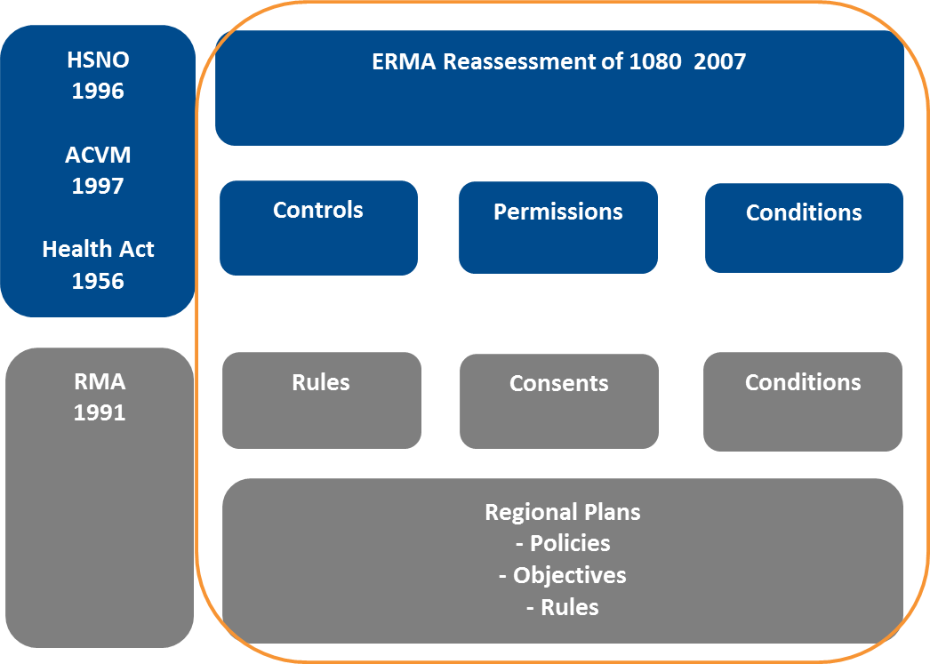

Figure 2: Business Case Focus

This business case relates to all 1080 products that are registered for aerial application in New Zealand under both HSNO and ACVM. A full list of the applicable products is contained within Appendix F.

PART 2 – STRATEGIC CASE

# Strategic Context and Drivers

The primary drivers for the development of this business case include:

* The ongoing strategic need for aerial 1080 use in New Zealand.
* The findings of the Parliamentary Commissioner for the Environment (PCE) on the regulation of 1080 under the RMA.
* The strategic objectives of the partners to deliver effective and efficient pest control for biodiversity gains, and to protect agriculture from bovine tuberculosis (TB)
* The immediate and ongoing operational needs of the partners.

## Drivers for aerial 1080 use

### Threat of bovine tuberculosis to agriculture

Agriculture is a key driver of New Zealand’s economy, and together with the food and forestry sectors, generates 70% of New Zealand's merchandise export earnings and around 12% of Gross Domestic Product.[3] The importance of the agricultural sector to the economy is reflected in the Government’s Business Growth Agenda where sustained growth in agricultural exports is a key priority of the plan.[4] The nation’s significant natural resource base is integral to the value generated by the sector.

Rising international animal health standards and growing concerns about food safety are major factors that govern and threaten access to overseas export markets for agricultural goods. New Zealand’s extensive biosecurity system plays a critical role in protecting and enhancing our natural resource base and our productive agricultural sector. Its purpose is twofold: to stop invasive pests from entering the country, and to manage established pests within the country. This dual role underpins the competitiveness of the agricultural industry in international markets.

1080 is a key component of the biosecurity toolkit and its use is critical for controlling the significant threat of TB to a $14 billion per year deer, beef and dairy export industry[5], and reducing the impacts of vertebrate pests on productive land. Many of New Zealand’s trading competitors, including Australia, are classed as being free of TB and an effective TB control programme is essential for New Zealand to maintain the productivity and reputation of our cattle and deer industries.

TB control in New Zealand is fundamentally reliant on effective control of the brush-tailed possum, which acts as a host and vector of the disease, and aerially applied 1080 is the key tool for TB-related possum control over large and inaccessible areas.[6]

In the absence of an effective TB control strategy, the number of infected herds and animals would escalate to unacceptable levels and may reach a point where there is a degree of risk to New Zealand’s overseas trade in beef, dairy and venison products in some markets. The potential damage to export trade resulting from reduced consumer preference for food products from a country with high TB prevalence rates is a very significant economic factor.

1080 is also a key tool in the ongoing control of rabbits, which are now becoming resistant to rabbit haemorrhagic disease (RHD). Farmers and land managers are returning to aerial 1080 to protect pastoral land from rabbits and preserve the gains made in recent years through the use of RHD.[7]

### Conservation, biodiversity and natural heritage

New Zealand is renowned for its high level of biodiversity and endemic species, and it is this uniqueness that underpins our identity as a nation. Many of the New Zealand’s national emblems, such as the koru, silver fern and kiwi,[8] are based on our indigenous biological world. The conservation and enhancement of our biodiversity and natural heritage is one of New Zealand’s major priorities[9] and is key to our national identity.

Due to New Zealand’s long geographic isolation from other land masses, indigenous species have evolved without terrestrial mammalian species (with the exception of bats), meaning that many lack natural defences against introduced destructive mammalian predators and competitors. As a result, many of our indigenous and endemic species have either become extinct or are now threatened. [10]

Endemic New Zealand species are of high conservation importance as they are unique to our country and the survival of natural populations can only be ensured in New Zealand.[11] The uniqueness of much of New Zealand’s indigenous biodiversity means that responsibility for its continued existence is entirely ours. It cannot be conserved in nature anywhere else in the world.[12]

Conservation of our biodiversity and natural heritage is also important for the economy. At a fundamental level, all economies and all businesses depend, directly or indirectly, on biodiversity and its component resources.[13] Indigenous biodiversity provides a variety of often unrecognised ecosystem services. These services, which can be provided directly or indirectly, include (among others); [14]

* habitat for native species and taonga,
* protection of soil and water resources (and their quality)
* catchment and coastline protection and mitigation of floods and storm damage
* carbon sequestration
* provision of resources for cultural use,
* opportunities for recreational activities,
* provision of a backdrop for and essence of much of New Zealand’s tourism industry, and
* natural character, aesthetic values and a sense of place.

A 1997 study by Massey University economists suggested that the total annual value provided by New Zealand’s native terrestrial biodiversity to the country’s economy could be more than half the value of our gross domestic product. They estimated the annual value of native biodiversity on land in 1994 at $46 billion, compared with gross domestic product (GDP) that year of $84 billion.[15]

The protection of New Zealand’s biodiversity and natural heritage also plays a key role in supporting our established primary production and tourism industries, and our growing film industry.

To many people biodiversity also has ‘intrinsic value’ – the idea that biodiversity has value in its own right, and is not something that should simply be viewed for its usefulness to humans. Human responsibility toward other living things, and obligations to future generations, provide strong grounds for conservation, and underlie the International Convention on Biodiversity[16] of which New Zealand is a signatory.[17]

### Impacts of pests on biodiversity

A major cause of biodiversity loss is introduced animals which directly affect biodiversity through predation and browsing of indigenous species, and seed consumption. Browsing and seed consumption can have major effects on regeneration of vegetation, and species composition. Predation of pollinators and seed dispersal agents have additional effects on ecosystem functioning.

New Zealand has a very large number of introduced, highly destructive mammalian pests, including possums, rabbits, mice, rats, stoats, ferrets and feral cats.[18] These pests (with the exception of rabbits) all kill adult birds and chicks, and raid nests for eggs. They also compete for, and can wipe out, critical food sources for birds such as supplies of berries, flowers, fruits and invertebrates.[19] Predators are blamed for an estimated 61% of chick and egg losses every year.[20] All of these pests have devastating effects on New Zealand's native plants, animals and ecosystems.

Pests threaten species that are icons of our natural heritage, including:[21]

* Mōhua, southern New Zealand dotterel and kākāriki which arein immediate danger of extinction.
* Rowi (Okarito brown kiwi) kākā and North Island kokako – which are acutely threatened
* Nationally critical species of giant New Zealand snail, Powelliphanta, and common species such as tui, bellbird, fantail and whitehead.

Introduced pests also devastate forest canopy and strip vast tracts of native bush. Rata, kamahi, pohutukawa, mistletoe and fuchsia are particularly badly affected.[22]

Over the past 50 years, possums have emerged as one of the major threats to the health and wellbeing of forests throughout New Zealand.[23] Many of these impacts are subtle and indirectly affect native birds and insects. [24] Possums cause damage to native forests from the ground level to the canopy where, by concentrating on individual plants of their preferred species, they can kill trees by defoliation over several years.[25] Possums preferentially feed on some of the tall canopy species – such as tawa, northern rata, kohekohe, southern rata, kamahi, pohutukawa and Hall’s totara – while ignoring others. They also prefer some of the smaller trees, such as tree fuchsia and wineberry, along with mistletoe, forest herbs, some ferns, and a number of endangered shrubs.[26]

Possum populations have now modified many New Zealand forests. The rate and extent of these changes vary widely between different types of forests. Beech forests are the least affected, but in the vulnerable southern rata-kamahi forests of Westland many valleys have lost between 20% to 50% or more, of their canopy trees. [27] In severe situations, possums have caused the complete collapse of the canopy within 15–20 years of their arrival. Tall forest is then replaced by shrublands.[28]

While the impact of possums is most visible and dramatic when it involves canopy trees, their most pervasive impacts are often less visible. Possums have recently been described as “reluctant folivores”. This means that possums prefer to eat other forest foods than the leaves of trees. Flowers, fruit, leaf buds, fungi and insects are all highly favoured. The consumption of these foods has the largest impact on the healthy functioning of forests and the animals that rely on them.[29]

Pest control is now a major focus for most biodiversity management programmes within New Zealand. Conservation of our natural heritage is therefore a major motive for the use of aerial 1080.

1080 is very effective in controlling introduced animal pests (particularly possums) and is well suited to New Zealand conditions. It can be safely applied by air and it is the most cost-effective method of providing landscape scale pest control over difficult terrain.[30] Aerial 1080 operations involving pre-feeding of baits are increasingly reliable in achieving high kills not only of possums but also rats and stoats via secondary poisoning. This ‘triple hit’ of the three major bird predators over a large area provides a breeding ‘window’ that is crucial to increasing female and chick survival.[31]

## Parliamentary Commissioner for the Environment

TheParliamentary Commissioner for the Environment’s Report on 1080 is a key driver for the development of this business case and the key conclusions and recommendations from the report relevant to the case are set out below.

### Parliamentary Commissioner for the Environment Report - 1080

In June 2011, the Parliamentary Commissioner for the Environment (PCE) released a report titled *“Evaluating the use of 1080: Predators, poisons and silent forests”* (refer Appendix A). The report represents a comprehensive review and analysis of 1080 use in New Zealand and draws on some 200 individual references to reach its conclusions.

The primary conclusion of the report is:

*“It is my view based on careful analysis of the evidence that not only should the use of 1080 continue (including in aerial operations) to protect our forests, but that we should use more of it.”*

The report also noted issues with the regulation of 1080 stating *“a labyrinth of laws and regulations govern the use of vertebrate toxic agents, resulting in unnecessary complexity, confusion, and potential duplication of costs.”[32]*

In reference to RMA regulation specifically, the report noted the differences in the way Councils control aerial 1080 use, with the status of the activity differing between regional plans. Concerns were also noted that as a result, operations may be restricted and it may be potentially difficult to respond to urgent events such as beech mast seasons, which may require pest population control at short notice or within narrow timeframes.[33]

In light of these findings, the report recommended:

*“The Minister for the Environment investigate ways to simplify and standardise the way 1080 and other poisons for pest mammal control are managed under the Resource Management Act and other relevant legislation.”*

### Update on PCE Report

In June 2013, the PCE issued an update report summarising progress on its 2011 recommendations and noted;

*“although there are other methods that are effective in particular situations, the only practical and cost-effective option that is available for controlling possums, rats and stoats in large and inaccessible areas is an aerially delivered poison. And there is no alternative poison available now or in the near future that could be used aerially and would be preferable to 1080.”[34]*

In reference to the recommendations on simplifying RMA regulation, the Commissioner noted that the Ministry for the Environment had provided updated guidance to Councils encouraging them to avoid duplication on matters already covered under HSNO.[35] However, the report also noted that this guidance did not mention 1080 or refer to any tangible examples of duplication.[36]

In reference to the development of this business case the update report also noted the following;

*“The other aspect of enquiry was whether any work is being done to develop a National Environmental Standard (NES) to make aerial 1080 a permitted activity in all regions. The Commissioner also raised this question with the Minister of Conservation, Hon Nick Smith, after he took up the portfolio. The pros and cons of an NES on aerial 1080 are being explored by the Department of Conservation, Environment Waikato and the Animal Health Board (TBfree NZ), and a meeting with Ministry for the Environment officials is imminent.”*

## Strategic Objectives – the Partners

### TBFree New Zealand Limited

TBfree NZ is a fully owned subsidiary of Operational Solutions for Primary Industries New Zealand Ltd (OSPRI) and has responsibilities to the Minister for Primary Industries.[37] TBfree NZ is the management agency for the National Bovine Tuberculosis Pest Management Plan pursuant to the Biosecurity Act 1993. This plan is funded by Central and Local Government, and through levies on beef, dairy and deer farmers.[38]

TBfree NZ’s overall strategic aim is to eradicate TB from New Zealand by testing all cattle and deer, regulating stock movement, and controlling the wild animals that carry and spread the disease.

The primary objectives of the TB Pest Management Plan are to:

* Establish the feasibility of eradicating bovine TB from wildlife populations by:
* Eradicating the disease from two extensive bush areas.
* Maintaining freedom from TB in areas already eradicated.
* Eradicate TB from wildlife over at least 2.5 million ha of Vector Risk Areas by June 2026.
* Prevent establishment of TB in possum populations in Vector Free Areas during the strategy period.

The secondary objective of the Pest Management Plan is to:

* Maintain national TB infected annual period prevalence at its lowest possible level and at no greater than 0.4% during the strategy.

The use of 1080 as an efficient and effective means of controlling possum populations is fundamental to achieving the overall strategic aims and objectives of TBfree NZ and its Pest Management Plan.

### Department of Conservation

The Department of Conservation is the leading Central Government agency responsible for the conservation of New Zealand’s natural and historic heritage.[39] Its legislative mandate is the Conservation Act 1987 and other key statutes such as the National Parks Act 1980 and Reserves Act 1977.[40]

DOC’s strategic vision is *“New Zealand is the greatest living space on Earth. Kāore he wāhi i tua atu i a Aotearoa, hei wahi noho i te ao.”*[41] This vision is further expanded upon below:

*“New Zealand’s unique wildlife and spectacular landscapes and coastline are critical to our sense of national identity and our lifestyle, as well as our economy. Supporting this natural capital is the area of focus for the Department over the next 4 years. The state of our native species and the health of New Zealand’s land and waters is core work for the Department, but the quality and quantity of that natural capital is critical to the country’s ability to prosper.”*

The efficient and effective control of invasive animals is fundamental to achieving this vision and underpins a of number key outcome areas adopted by the Department as follows:

* *Outcome - The diversity of our natural heritage is maintained and restored*

New Zealand’s native species face constant pressure from introduced plant and animal pests; a pressure that will be further exacerbated by the impact of climate change. Managing these pressures, in order to avoid extinctions and maintain ecosystem services, is a major challenge.

* *Outcome – More people participate in recreation*

International tourism is one of New Zealand’s biggest export earners. To help build economic prosperity, the Department has a focus on having more people participating in outdoor recreation, and spending their leisure time and money in these places.

### Ministry for Primary Industries

The Ministry for Primary Industries (MPI) has the vision of *“Growing and Protecting New Zealand”* and its core business is focussed on three major systems; biosecurity, food safety and primary production.

MPI is responsible for pest management oversight and leadership within New Zealand and administers the Biosecurity Act 1993. MPI works to prevent harmful pests and diseases from entering New Zealand, manages systems to detect and respond to incursions and established pests, facilitates trade and encourages co-operation and participation in the system.[42]

MPI is also responsible for the co-ordination of partnerships needed to successfully contain or eradicate pest species, the development of national pest management plans and priorities, and monitoring the effectiveness of pest management measures across the public and private sectors.[43]

MPI has adopted the Pest Management National Plan of Action (NPA) which commits those involved in pest management to:

* adhere to firm principles of public accountability in decision making;
* align efforts around shared outcomes;
* ongoing development of people, knowledge, tools and systems;
* implementing a co-ordinated improvement programme.

Key changes in the pest management improvement programme under the NPA are to:

* clarify roles and accountabilities;
* improve and simplify processes;
* develop better and more accessible tools;
* improve capacity for collective action.

The NPA has identified the ongoing availability of pest control tools as a major risk to the future of pest management in New Zealand.[44] Streamlining the regulatory barriers that unnecessarily restrict access to critical tools and the development of a national biosecurity toolkit are key strategic objectives for MPI.

### Regional Councils

Regional Councils have a key role in animal pest management and use aerial 1080 in a range of biodiversity projects and programmes. Under the Resource Management Act 1991, Regional Councils are also responsible for maintaining native biological diversity and controlling the adverse effects of activities on biodiversity through regional and district plans. Regional Councils also manage native biodiversity values on regionally-managed public land, for example regional parks.

The Biosecurity Act 1993 gives Regional Councils power to undertake monitoring and surveillance to determine whether or not pests are present, as well as the ability to prepare Regional Pest Management Plans and provide for the assessment and eradication or management of pests in accordance with these plans.

Regional Councils produce pest management plans that establish varying levels of control for a range of vertebrate pests. Aerial 1080 is a key part of the control toolkit for some Regional Councils in meeting the objectives of pest management plans and fulfilling their responsibilities to regional/local communities.

## Operational Pressures

The need to respond efficiently and effectively to operational pressures is a key driver for DOC and TBfree NZ in preparing this business case.

### Response to Mast Events

Beech mast events are cyclical, occurring every 2 – 6 years, and are seasons when high levels of seed production in forests trigger rodent and stoat population explosions. When seed supplies run out these predators turn on endangered birds such as mōhua, kākā, kea, whio and kiwi along with other at risk species like bats and land snails.[45]

A significant beech mast event occurred in 2014. It has been estimated that with no pest control response, approximately 75% (or more than 3500 birds) of the remaining mōhua population could be lost[46] and other native bird species could also suffer major losses. In 2000, a widespread beech mast and resulting predator plague caused the local mōhua population in the Marlborough Sounds to become extinct.

In response DOC implemented the “Battle for our Birds” pest control programme, which required DOC to increase its aerial 1080 protection in the South Island by approximately 500,000 hectares. This programme involved the acquisition of 16 separate resource consents within the South Island in 2014.[47]

The cyclical nature of mast events means that this will remain an ongoing operational pressure for the Department.

### Commitment to increase coverage

To supplement its response to the predicted 2014 mast event, DOC has also committed to increasing its national aerial 1080 programme by approximately 50,000 hectares per year for the next five years (250,000 hectares total).

This means that DOC will be supporting the 2014 beech mast response by routinely treating approximately 400,000 hectares of public conservation land with 1080 by 2019.

### TBfree NZ operations

TBfree NZ’s aim is to reduce the overall extent of the existing TB vector risk area by 25% by 2026.**[48]** The key regions targeted for reduction include Waikato, Hawkes Bay, Manawatu, Tasman, West Coast, Canterbury, Otago and Southland. Further possum control operations will also be required in these and other regions to prevent disease spread and minimise livestock infection rates.

# Analysis of Existing Arrangements

## Aerial 1080 use in New Zealand

The primary entities responsible for vertebrate pest control operations within New Zealand are TBfree NZ, DOC and Regional Councils.[49] In monetary terms, DOC spends about $22 million annually[50] controlling animal pests. TBfree NZ spends approximately $46 million annually[51] on animal pest control and management, including approximately $10-13 million per annum on aerial 1080 operations, out of a total TB control budget of $80 million per annum. The overall spend on possum control across the 17 Regional and Unitary Authorities in New Zealand is conservatively estimated at $35 million annually.[52]

Key vertebrate pests targeted by these organisations include possums, rats, stoats, rabbits and wallabies. Aerial application of 1080 is undertaken to manage these pests on both small and large scales, ranging from drops on individual farms, to individual operations over tens of thousands of hectares across TB vector control areas and the conservation estate. In large, steep, and inaccessible areas, aerial application of 1080 is vastly more effective in knocking down pests compared with ground-based methods.[53]

## Scale of use

From 2008 to 2012 TBfree NZ, DOC and Regional Councils were responsible for the operations on 97% of the land area treated with aerial 1080 nationally (refer Figure 3). TBfree NZ and DOC were by far the greatest users within this period and aerially applied the substance to 2.3 million hectares of land during this period.

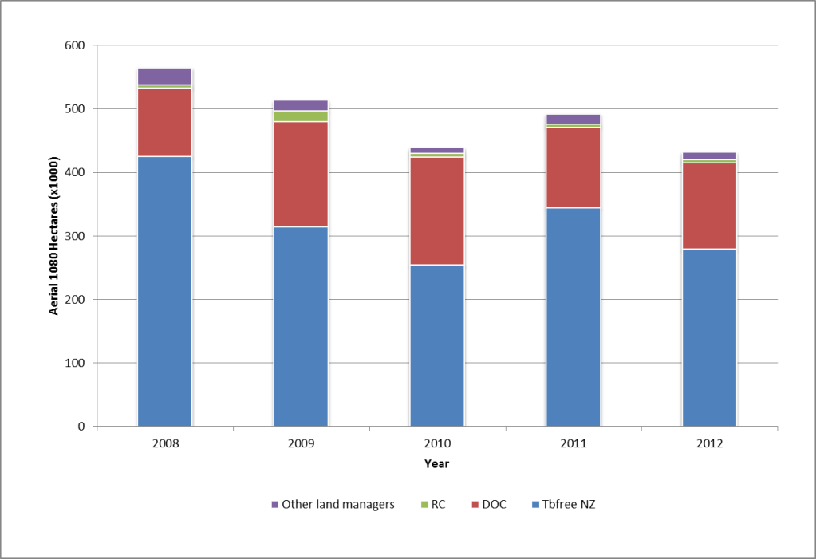

Figure 3: Aerial 1080 operations by land area by operator[54]

Farmers, private land owners and forestry and land managers, such as Land Information New Zealand, use various combinations of aerially applied 1080, shooting and ground-laid poisons to control pests.[55] This is done to meet the requirements of regional pest management plans or for pest control on individual properties to protect crops, pasture or plantations. This group of “other land managers” aerially applies 1080 to approximately 15,000 hectares of land annually.

## Location of operations

Aerial 1080 operations are undertaken in almost all regions in New Zealand. Table 1 shows the locations of all aerial 1080 operations by region from 2008 to 2012. DOC and TBfree NZ undertook operations in all of the regions listed during this five year period. The highest numbers of operations were in the West Coast, Canterbury, Otago and Waikato regions.

|  |  |  |  |  |  |  |  |
| --- | --- | --- | --- | --- | --- | --- | --- |
| Region | 2008 | 2009 | 2010 | 2011 | 2012 |  | TOTAL |
| Bay of Plenty | 2 | 1 | 1 |  | 1 |  | 5 | |
| Canterbury | 11 | 14 | 7 | 7 | 6 |  | 45 | |
| Hawkes Bay | 5 | 4 | 3 | 3 | 4 |  | 19 | |
| Manawatu | 8 | 3 | 1 | 4 | 3 |  | 19 | |
| Marlborough | 3 | 4 | 2 |  |  |  | 9 | |
| Northland |  | 1 |  | 1 |  |  | 2 | |
| Otago | 7 | 9 | 9 | 11 | 7 |  | 43 | |
| Southland | 1 |  | 1 |  |  |  | 2 | |
| Taranaki | 2 |  | 1 |  | 2 |  | 5 | |
| Tasman | 6 | 4 |  | 3 | 2 |  | 15 | |
| Waikato | 9 | 6 | 6 | 8 | 9 |  | 38 | |
| Wellington | 1 | 3 | 1 |  | 2 |  | 7 |
| West Coast | 20 | 15 | 13 | 12 | 12 |  | 72 |
|  |  |  |  |  |  |  |  |
| Grand Total | **75** | **64** | **45** | **49** | **48** |  | **281** |

Table 1: Aerial 1080 operations by Region[56]

Table 2 shows the size of operations by year and region. The West Coast and Waikato regions had the largest area of land treated during the five year period. Otago and Canterbury both had a large number of operations over smaller areas, reflecting a preponderance of rabbit control operations on private land.[57].

|  |  |  |  |  |  |  |  |
| --- | --- | --- | --- | --- | --- | --- | --- |
| Region | 2008 | 2009 | 2010 | 2011 | 2012 |  | TOTAL |
| Bay of Plenty | 47 | 11 | 4 | 0 | 7 |  | 69 |
| Canterbury | 25 | 24 | 9 | 10 | 37 |  | 105 |
| Hawkes Bay | 52 | 81 | 24 | 17 | 73 |  | 247 |
| Manawatu | 48 | 44 | 3 | 119 | 42 |  | 256 |
| Marlborough | 49 | 28 | 26 | 0 | 0 |  | 103 |
| Northland | 0 | 2 | 0 | 14 | 0 |  | 16 |
| Otago | 13 | 33 | 4 | 13 | 3 |  | 66 |
| Southland | 7 | 0 | 25 | 0 | 0 |  | 32 |
| Taranaki | 2 | 0 | 35 | 0 | 21 |  | 58 |
| Tasman | 65 | 64 | 0 | 47 | 38 |  | 214 |
| Waikato | 71 | 27 | 77 | 64 | 75 |  | 314 |
| Wellington | 3 | 19 | 29 | 0 | 32 |  | 83 |
| West Coast | 183 | 181 | 203 | 208 | 105 |  | 880 |
|  |  |  |  |  |  |  |  |
| Grand Total | **565** | **514** | **439** | **492** | **433** |  | **2443** |

Table 2: Aerial 1080 applied to land by Region[58]

## Regulation of aerial 1080

The aerial application of 1080 within New Zealand is managed primarily under the following legislation:

* Hazardous Substances and New Organisms Act 1996 (HSNO)
* Agricultural Compounds and Veterinary Medicines Act 1997 (ACVM)
* Resource Management Act 1991 (RMA).
* The Health Act 1956 (The Health Act).

HSNO provides the basis for approving the importation, manufacture and use of all vertebrate toxic agents (VTAs) in New Zealand, and is administered by the New Zealand Environmental Protection Authority (EPA). The Act sets out the overarching framework for the management of hazardous substances but the details that guide the management of VTAs are all contained in regulations. In addition to regulations, specific approvals for VTAs under HSNO also include a range controls to manage the environmental effects and risks of substance use.

ACVM is administered by the New Zealand Food Safety Authority and Ministry for Primary Industries and VTAs such as 1080 need to be registered for use within the New Zealand under ACVM. Product labels, which include conditions to manage use of the products, are developed under ACVM.

Under the RMA a hazardous substance includes, but is not limited to, any substance defined in section 2 of HSNO. Pest control operations that use 1080 and other poisons must comply with the RMA and relevant council plans. Regional Councils are responsible for managing the effects of discharges to freshwater, land, air and coastal waters and produce a range of regional plans to manage these effects. Territorial local authorities are responsible for the management of any adverse effects from the storage and use of hazardous substances on land, and the protection of the surfaces of lakes and rivers.

The Health Act is used to regulate 1080 to protect public health. Restrictions are set by local health authorities, and generally include measures to protect public drinking water supplies and measures to mitigate human health risks, such as establishing buffer zones around poisoning operations. Health authorities can also set requirements for the removal of any carcasses that may contain poison residues. The Ministry of Health (MOH) operates under this Act when setting conditions on HSNO permissions for 1080 use. In practice, the issue and conditioning of permissions is delegated to the public health units of District Health Boards.

## Regulation under the HSNO Act

HSNO focusses on controlling hazardous substances throughout all aspects of their existence and, for the management of VTAs, the Act is a regulation based regime. The details that guide the management of VTAs are contained within a range of regulations and controls which are essentially rules to prevent and/or manage the adverse effects of hazardous substances.

These controls and regulations are the basis for regulating 1080 use under HSNO.[59] Compliance with HSNO regulations and controls is mandatory for all 1080 operations undertaken within New Zealand.

### Reassessment of 1080

In 2006-07 the EPA (formerly the Environmental Risk Management Authority) completed a significant reassessment of 1080.[60] The application was initiated by TBfree NZ (formerly the Animal Health Board) and DOC, driven by the following:

* The need for both agencies to increase the use of 1080 to meet Government targets for reducing the levels of TB in cattle and deer herds and support strategies on sustaining biodiversity.
* The completion of significant research on 1080 since it was first registered in 1964.
* The considerable public concerns about the use of 1080, including concerns about the management of its use and its environmental effects.

The application was five years in the preparation, was assessed over a two year period and involved the consideration of more than 1400 public submissions.[61] The process included an extensive analysis of the costs, benefits and risks of using 1080 in reference to the market economy, the environment, society and communities, the relationship of Maori to the environment and human health and safety[62].

The EPA’s assessment of the application concluded that the benefits of 1080 use far outweighed the costs and that there are no practical alternatives to 1080 for the preservation of native bush, biodiversity and the protection of agriculture.[63] The EPA determined to approve the application subject to controls as follows;

*Application HRE05002 to import, manufacture and use sodium fluoroacetate (1080) and formulated substances containing 1080 in New Zealand is approved with controls in accordance with the relevant provisions of the Hazardous Substances and New Organisms (HSNO) Act, the relevant regulations made under the Act and the HSNO (Methodology) Order 1998.[64]*

### HSNO management regime

The reassessment decision established a tighter management regime for 1080 use, and aerial use in particular, based on the identified risks and adverse effects of the substances, the concerns raised by submitters during the reassessment process and issues with the historic management of some aerial 1080 operations.

This regime has been in place since 2007 and comprises four main elements:

1. Strengthened controls to mitigate the range of risks associated with 1080 use and 1080 aerial drops. The controls cover a range of measures to avoid and mitigate potential adverse effects from 1080 use and manage the risks from operations.
2. The establishment of a public watch list that requires annual reporting on all aerial 1080 operations to the EPA. This reporting is publically available.
3. Promotion of best practice amongst all users of 1080 in relation to pre-operation planning, consultation and notification as well as the management of 1080 aerial operations.
4. Recommendations for further research to be undertaken both into alternatives to 1080 for pest control, and areas where there remains a lack of knowledge about the effects of 1080.

A summary of each of these components of the system is provided below, along with the key areas of focus.

### HSNO Regulations and Controls

The focus of the reassessment controls and the existing regulations is on the management of the risks and adverse effects associated with the aerial 1080 operations including (but not limited to):

* Impacts on non-target native and introduced species – these are managed through a range of controls specifying maximum application rates, bait types, composition of formulations and restrictions around sensitive areas.
* Water quality impacts – managed through controls requiring buffer zones around waterways, especially drinking water sources. Controls may require pre and post operation water quality monitoring.
* Human health – potential human health impacts are managed locally through permissions conditions which require operators to avoid sensitive areas (ie houses and public accessways) and drinking water supply catchments.
* Cultural values, including iwi values – controls require a range of notification and consultation procedures and include specific requirements to consult with local iwi. Consultation can result in changes to operations to manage any risks and or potential impacts.

Table 3 provides a summary of the key controls for the aerial application 1080 use under HSNO as an example of the range of risks and effects that are managed. A full list of the controls and regulations for 1080 is contained in Appendix E to this business case.

|  |  |
| --- | --- |
| Area of control | Summary of controls (Source ERMA) |
| Formulations, application rates, bait types and packaging | The use of the pure active ingredient of 1080, sodium fluoroacetate, is restricted to research and the development and manufacture of 1080 products. This means that 1080 can be used only in approved formulations.  Maximum application rate for aerially dropped 1080 is 30 grams of 1080 per hectare.  Carrot baits (except when used for rabbit control) must be of a specified minimum size. This is because smaller pieces tend to increase the chances of non-target species eating the bait. Some carrot chaff is allowed, but the amount is restricted.  Any changes to the composition or proposed use of 1080 formulations must be notified to the Authority in writing. This is because changes in formulations, bait size, colour, etc could change the risk profile of the bait and endanger non-target species.  The packaging of 1080 formulations must allow for individual packages to be uniquely labelled in order for it to be able to be traced in the event of an incident. |
| Controlled substances licences | Anyone selling, supplying or using 1080 must have a controlled substances licence. |
| Public notification | Public notification requirements for any operation including newspaper notices and signage.  Signs marking areas where 1080 is used must contain a statement warning the public, including dog owners, about the danger from possum carcasses. This must be readable from a distance of 10 metres.  Signs must remain in place for six months after a 1080 operation or until the earlier of either retrieval of the bait or demonstration that the bait and any poisoned carcasses are no longer toxic. |
| Permissions | MOH permission is required before using 1080 in a drinking water catchment area or in areas where there may be a risk to the public, for example near dwellings.  DOC permission is required before using 1080 on the conservation estate to ensure operations comply with DOC standard operating procedures and risks to the public areas are avoided. |
| Notification and consultation | Owners and occupiers of land or dwellings within or immediately next to the target site must be given sufficient prior notification of the operation, including details such as location of the operation, approximate date and the name and nature of the substance to be used. This notification is to be repeated closer to the time of the operation. The public must also be informed by way of newspaper advertisements.  Those using 1080 aerially must consult in good faith with local iwi/hapu. This recognises the principles of the Treaty of Waitangi (Tiriti o Waitangi) and seeks to ensure the role of Maori as kaitiaki is protected. This will be implemented through permissions granted for 1080 use under the Hazardous Substances and New Organisms Act. |
| Reporting | Reporting of any incident, such as a spill or usage error, to the relevant regional council and the Environment Protection Authority (EPA). |
| Post operational reports | Post-operation reports are to be submitted to the Authority on all aerial applications of 1080. These are to cover public notification and consultation, complaints received about the operation, any incidents that occurred and the outcome of any post-operation monitoring. These reports will be summarised in an annual report from the Authority. |
| Requirements for aircraft | Aerial operations require the decontamination of aircraft and loading sites once the drop has been completed.  Aircraft involved in aerial 1080 operations must use a navigational guidance system (e.g. differential GPS) to ensure the accuracy of drops. |

Table 3: Summary of controls (Source: EPA Summary of Reassessment)

### Permissions

The HSNO controls require permissions for operations where 1080 is applied aerially:

* In a catchment area from which water is drawn for human consumption, or in any area where there is a risk to public health, for example in places where the public has access as of right (eg parks).
* On land administered or managed by DOC.

Permissions are assessed, issued and monitored by the Public Health Unit of the local District Health Board and DOC regional offices respectively.

The purpose of MOH permissions is to manage potential for human health impacts from 1080 operations. The purpose of DOC permissions is to ensure that all 1080 operations undertaken on public conservation land are in accordance with DOC’s standard operating procedures and that the risks to the public and sensitive sites are appropriately managed.

Applications for both DOC and MOH permissions require the submission of an assessment of potential effects on human health and the environment, alongside information on the location of the treatment (operational) area, proposed control methods and outcomes of any consultation. A risk assessment is also required to be provided for MOH permissions.

Permissions allow agencies to manage localised risks of operations and require specific consultation or monitoring of operations. Permissions can be refused or granted subject to a range of conditions that are imposed to manage the risks of operations. DOC permission conditions are based on standard HSNO controls, but may be augmented to take account of local variations or site specific risks. Examples standard MOH and DOC permission conditions and the effects managed by these conditions are provided in Appendix I.

All aerial 1080 operations undertaken within the last 3 years have required MOH permission[65] and in most cases both a DOC permission and MOH have been required.

It is possible that 1080 operations can be undertaken without the need for permission, and this may apply to operations on private land where there is no risk to human health. As outlined above, such operations are unlikely to pose any risk to human health or sensitive conservation areas. These operations still remain subject to HSNO controls which manage the risks from operations and potential adverse effects on the environment.

### Monitoring and review of controls

The EPA monitors the performance of HSNO controls and aerial 1080 operations on an annual basis. Operational reports are provided to the EPA by operators and are made available to the public on the 1080 watchlist[66]. The purpose of the annual monitoring reports is to:

* enable members of the public to register concerns about current and future aerial operations and have those concerns monitored and actioned as appropriate by operators;
* enable the EPA to undertake an audit of aerial operations to monitor best practice and consistency;
* ensure that the EPA has the information it needs for any future reassessment it may wish to undertake.

All operational reporting must include the following detail:

* the reasons for the operation;
* details of the notification and consultation undertaken;
* details of the operation – location, dates etc;
* possum numbers before and after the operation;
* incident reports;
* details of pre- and post-operation monitoring of fauna, including species of particular importance to Māori;
* details of post operation monitoring of water quality; and
* an overall assessment of the outcome of the operation.

### Five yearly review

Annual reporting is used by the EPA for the production of a five yearly review that involves an independent analysis of the efficacy of the management regime for 1080, monitoring of the key changes/improvements to the system since the reassessment and assesses whether there is a need to further reassess the use of 1080.

The latest review covered the period 2008 to 2012 and the EPA concluded the following in reference to the current HSNO management regime;

*“Analysis of data from the past five years shows that the tighter management regime is being followed and there have been significant improvements in the use of aerial 1080. Operators show a willingness to continually improve and learn from past mistakes and communications about 1080 operations have improved substantially. Incidents and complaints have dropped and water quality remains unaffected. The tighter management regime is working and at this stage there is no indication that a further reassessment of 1080 is required.”*

The review noted a trend for fewer complaints about 1080 operations as shown in Figure 4 and noted that improved consultation and communication around operations was the likely cause of this trend.

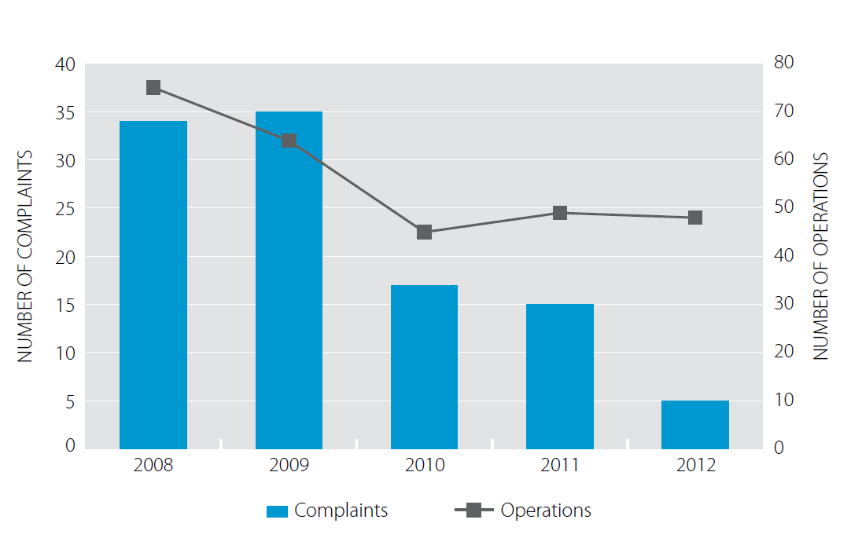

Figure 4: Number of complaints v number of operations[67]

In reference to consultation and communication initiatives, the review further noted;

*“The most important improvement in the use of 1080 relates to communications. Operators are using the communication guidelines to engage and inform communities. Local iwi, community groups and regulators are now much better informed about 1080 operations. Regular notifications, consultation and public meetings are carried out. Today there are fewer complaints about 1080 operations – evidence that improved communication is working well.”*

Overall, the EPA is currently satisfied that the current management regime comprehensively manages the risks and potential adverse effects of aerial 1080 use and has resulted in improvements to the management of operations over time. The system will be subject to further review in 2017.

### Reassessment recommendations

In addition to the controls and monitoring requirements, the 2007 reassessment decision included a number of recommendations aimed at improving the understanding of the impacts of 1080, ensuring greater transparency around operations and improving the understanding of alternatives to 1080.

These recommendations included:

* Undertaking additional research into alternatives to the use of 1080, methods of application and application rates;
* Research to be carried out on the effects of 1080, including:
  + its persistence in soil and water; and
  + effects on taonga species, traditional Maori medicinal plants and valued foods.
* Public consultation processes be further improved;
* Management practices around aerial drops of 1080 be standardised around best practice to ensure consistency; and
* Agencies review their policies and processes relating to the involvement of Maori in the planning and implementation of pest management programmes.

The recommendations have resulted in a range of initiatives by key 1080 users since the decision, including the establishment of the “1080 the facts” website, the provision of information to the public through agency websites, and regular engagement with iwi stakeholders on operations.

Pre operational and post operational monitoring has also been applied to most large scale operations to provide further information about the impacts and effectiveness of 1080 operations. Figure 5 provides a summary of the percentage of total operations that have been subject to species impact monitoring from 2008 to 2012.

The reassessment revealed that many people had concerns around the impact of 1080 on water quality. However, there was no evidence that 1080 adversely affected aquatic species or persisted in water. While there are still some complaints about the possible impact on water quality, monitoring data show that 1080 was detected in only two percent of all samples and has never been detected in drinking water catchments. Where it has been detected, concentrations of 1080 are far below the levels set to protect human health.



Figure 5: Operations with pre and post operational species monitoring - percentage of total (source: Environmental Protection Agency)

Research projects have been also been initiated by 1080 users since the reassessment, including assessment of alternatives, improvements to operations such as optimum sowing rates and distribution, impacts on non-target and taonga species, impacts on soil, water and animal welfare. Figure 6 provides a summary of the number of research projects undertaken on 1080 from 2008 to 2012.



Figure 6: Numbers of new and ongoing research project per year (source: Environmental Protection Agency)

## Regulation under ACVM

The Agricultural Compounds and Veterinary Medicines Act 1997 (ACVM) regulates substances used in the management of plants and animals, including pesticides, fertilisers, stock food, pet food, and veterinary medicines. The Act covers importation, manufacture, sale, and use of agricultural compounds.

Under ACVM, the ACVM Group of the New Zealand Food Safety Authority imposes controls on the use of 1080 products. These controls primarily relate to trade name registration, labelling and signage requirements for all vertebrate toxic agents, including 1080. ACVM controls are supplementary to HSNO controls. The specific ACVM requirements for 1080 include:

* Restrictions on the sale and manufacture of 1080.
* Provision of annual summary reports to MPI on adverse events and advice to MPI on findings from new research into 1080.
* Product labelling controls that:
  + Restrict the sale of 1080 to persons holding a controlled substances licence issued by a test certifier who has been approved by the ACVM Group.
  + Require a register of sales to be kept, recording who the product was sold to and the container(s) serial identity.
  + Require secure storage of 1080.
  + Require public notification of operations when applying 1080 aerially.
  + Set out requirements for signage in prominent places around the perimeter of the treated area.
  + Ensuring the security, identity and application of the product is under the control of a specified person who also holds a controlled substances licence from a test certifier approved by the ACVM Group.

All operations are required to comply with relevant ACVM controls which supplement the extensive regulation of 1080 under HSNO.

## Regulation under the Health Act 1956

The Health Act 1956 (the Health Act) is also used to regulate 1080 and restricts its use to protect and safeguard public health.

The Ministry of Health (MOH) operates under this Act when setting conditions on HSNO permissions for aerial 1080 use. Restrictions are set by local health authorities, and generally include measures to protect public places, households and drinking water supplies.

Restrictions generally include establishing buffer zones around or within poisoning operations, notification requirements, avoidance of times and places of high public use, and in some cases requirements for the removal of any carcasses that may contain poison residues. A list of standard conditions on MOH permissions is contained in Appendix J.

## Standard Operating Procedures and Best Practice Guidance

DOC, TBfree NZ and Regional Councils all have adopted standard operating procedures[68](SOPs) that respond to HSNO, ACVM, RMA and Health Act requirements and controls for 1080. Regional Council SOPs are developed and held by the National Pest Control Agencies (NPCA) as part of the industry best practice.

SOPs include a range of best practice procedures to ensure compliance with relevant legislation, optimal conduct of operations and to manage the risks and effects of 1080, including:

* Specifications for consultation and notification.
* Setting of industry best practice standards.
* Detailed risk management practices.
* Internal and external audit procedures.

DOC also uses SOPs to assess permissions applications and set conditions on all operations undertaken within the Conservation Estate. A summary of the relevant SOPs and standards is provided in Appendix J.

Private contractors who undertake operations for the partners and Regional Councils are contractually obliged to comply with their SOPs.

It is noted that aerial 1080 operations undertaken by private landowners on private land may not be subject to the SOPs developed by the partners, however these operations are subject to general HSNO controls.

## Summary

The national framework of controls and regulations established under the HSNO/ACVM Acts and the Health Act, the monitoring procedures in place, along with a range of best practice guidance and SOPs developed by the partners and Regional Councils together ensure that the risks and potential adverse effects of the discharge of aerial 1080 are comprehensively managed as part of operations.

This framework includes requirements for avoiding and managing off-target impacts, continued stakeholder engagement in operations, public notification of aerial operations, landowner/affected party approvals and consultation with iwi or hapu and other affected parties.

The HSNO framework has further resulted in significant research to advance the understanding of 1080 use, its impacts and improve its efficacy. This has included research into a range of alternative methods. To date this research has not found an effective alternative to the substance.

The EPA monitors the use of aerial 1080 on a national basis and its most recent five yearly review of operations has concluded that the HSNO system of regulation is working well, with complaints and incidents dropping over time. Operators have shown a real willingness to develop and maintain best practice standards.

# Analysis of RMA system

The following section sets out the key findings of the analysis of the RMA system for the regulation of aerial 1080. The assessment has focussed on two key areas:

* A review of regional plans throughout New Zealand to determine how aerial 1080 operations are regulated on a region by region basis, whether there is inconsistency in the system, and what if any issues this creates.
* A review of all consents for aerial 1080 within the last 10 years (2003 to 2013) to analyse the outcomes of consent processes, explore the way consents are managed from region to region and what if any issues this creates.

The analysis has revealed significant variance in the way regional plans manage aerial 1080 and in the way in which 1080 is managed through resource consent process and conditions of consent. Significant duplication has been identified between regional plan requirements and consents, and HSNO/ACVM requirements.

Section 7 provides an analysis of the impact of these issues in terms of direct and indirect costs.

## Regulation of Aerial 1080 under the RMA

Section 30(f) of the RMA provides Regional Councils with the function to control the discharge of contaminants into or onto land, air, or water and discharges of water into water. Section 15 of the RMA requires Regional Councils to manage the discharge of contaminants to the environment through regional plans. The aerial application of 1080 is regarded as a discharge under Section 15.

Regional plan objectives, policies and rules establish the framework for the control of aerial 1080 operations under the RMA. Rules may require resource consents for operations. Resource consent can be refused or granted and, if granted, potential adverse effects may be managed through conditions on consents. Where no plan rules exist for a particular discharge or where the interpretation of rules is ambiguous, resource consent can be required under Section 15 of the RMA.

## HSNO and RMA interface

The RMA and HSNO Acts have very similar purposes and principles (refer Table 4) and have an interface in the management of hazardous substances. The key difference in relation to hazardous substance management is that HSNO focuses on controlling the specific substance throughout all aspects of its existence (i.e. from cradle to grave) whereas the RMA is primarily concerned with where the substance is in the environment (for example, where it is manufactured, used, transported and disposed of).

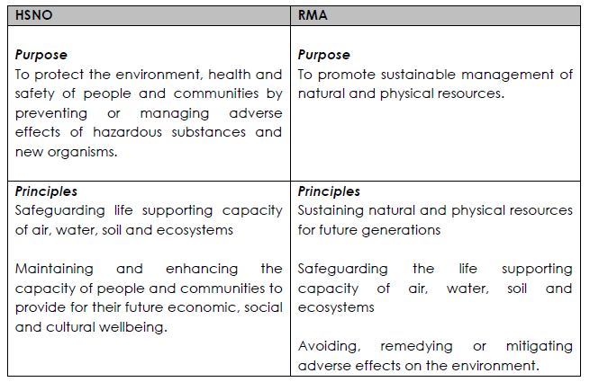

Table 4: Summary of purpose and principles of HSNO and RMA

Under the RMA a hazardous substance includes, but is not limited to, any substance defined by section 2 of HSNO. For hazardous substances that are controlled under HSNO the interface between that regime and RMA is set out in section 142 of HSNO.

When managing the effects of hazardous substances in regional plans, section 142 of HSNO must be read in conjunction with the RMA. This section provides that RMA instruments can only include more stringent requirements than HSNO when they are considered ‘necessary’ for the purposes of the RMA.

What section 142 means for plan and policy development is that it is permissible for the Council to impose more stringent controls on hazardous substances for RMA purposes. Council’s rationale for doing so must be properly considered and justified in terms of section 32 of the RMA.

The provisions of section 142 are relevant to this business case in terms of whether any potential adverse effects from aerial 1080 operations are being regulated under the RMA that are not being regulated under HSNO (or in legislation elsewhere). This is an important test as to whether there is a case to change or simplfy the RMA framework.

The analysis set out below has found that the RMA is not managing any adverse effects that are not already being managed elsewhere under HSNO or other legislation.

## Regional Plan Assessment

Detailed analysis of current regional plans and resource consents has revealed that a complex regulatory environment currently exists for aerial 1080 operations under the RMA. The analysis has further revealed that there is considerable variance in way aerial 1080 operations are managed on a region by region basis under the RMA.

### Regional Plan rule framework

All 17 Regional Councils in New Zealand have regional plans that contain objectives, policies and rules that regulate the aerial application of 1080. A summary of relevant regional plan rules, along with an assessment of the activity status of aerial 1080 operations under regional plans is provided in Appendix G.

Each regional plan contains a different rule framework for managing aerial 1080 discharges.[69] Regional plans also contain a range of different terms related to the discharge. In some regional plans, 1080 is included under the wider term “vertebrate toxic agents” and in other plans it is referred to in rules as a poison, contaminant or agrichemical[70]. These terms are often defined differently across region plans and there is scope for ambiguity in the interpretation of plan rules. Where ambiguity exists, consent may be required under Section 15 of the RMA.

### Rule framework and consenting requirements

Regional plan rule frameworks result in a range of consent outcomes at three broad levels:

* Plans that require resource consent for aerial 1080 operations as either a controlled, restricted discretionary, discretionary or non-complying activity.
* Plans that require resource consent despite having permitted activity rules for the aerial discharge of 1080.
* Plans that contain permitted activity rules that do not result in the need for resource consent.

The regional plans for Northland, Waikato, Bay of Plenty, Gisborne, Greater-Wellington, Tasman, West Coast and Southland all require resource consents for aerial 1080 operations. With the exception of the Gisborne region, aerial 1080 operations were undertaken in all of these regions between 2008 and 2012[71].

The Auckland, Hawkes Bay, Marlborough, Canterbury and Otago regional plans all permit the aerial discharge of 1080, subject to conditions related to use the substance around water and within sensitive natural environments such as wetlands and/or the Conservation Estate.

Operations were undertaken in all of these regions between 2008 and 2012, with the exception of Auckland. Between 2003 and 2013, 96 resource consents were required for operations in the Hawkes Bay, Canterbury and Marlborough regions. Consents in these regions were triggered by conditions related to the proximity of operations to watercourses and natural areas.

The Taranaki, Manawatu-Wanganui, Nelson City and Chatham Islands regional plans permit the use of aerial 1080 subject to conditions that do not generally result in resource consents. Aerial 1080 operations occurred in both Taranaki (5) and Manawatu-Wanganui (19) between 2008 and 2012. No consents were recorded in these regions from 2003 to 2013. There were no aerial operations undertaken in the Nelson City or in the Chathams between 2008 and 2012.

## Consenting Overview

From 2003 to 2013, there were 270 consents processed for aerial 1080 operations within New Zealand. A summary of these consents, along with the relevant process pathways is provided in Table 5. The complexity and length of these resource consent processes varied significantly during the period. Approximately 80% of these consents were processed on a non-notified basis. The total number of publicly notified consents during this period was 44, with two of these consents reaching the Environment Court on Appeal. All of the consents processed were approved subject to conditions.

|  |  |  |  |  |
| --- | --- | --- | --- | --- |
| Total Consents | Non-Notified | Limited Notified | Publicly Notified | Withdrawn/ awaiting decision |
| 270 | 221 | 15 | 29 | 5 |
| 100% | 81.8% | 5.5% | 10.7% | 1.8% |

Table 5: Overview of Consents by type

### Consents by Region

Consents were processed in 10 regions in New Zealand during the 10 year period analysed (refer Figure 7). During this same period, 1080 operations occurred in 13 regions. No consents were required in the Taranaki, Otago and Manawatu-Wanganui regions. As discussed above, the plan framework for these regions essentially avoids the need for resource consent. The regions with the largest number of consents processed were Tasman, Canterbury and West Coast.

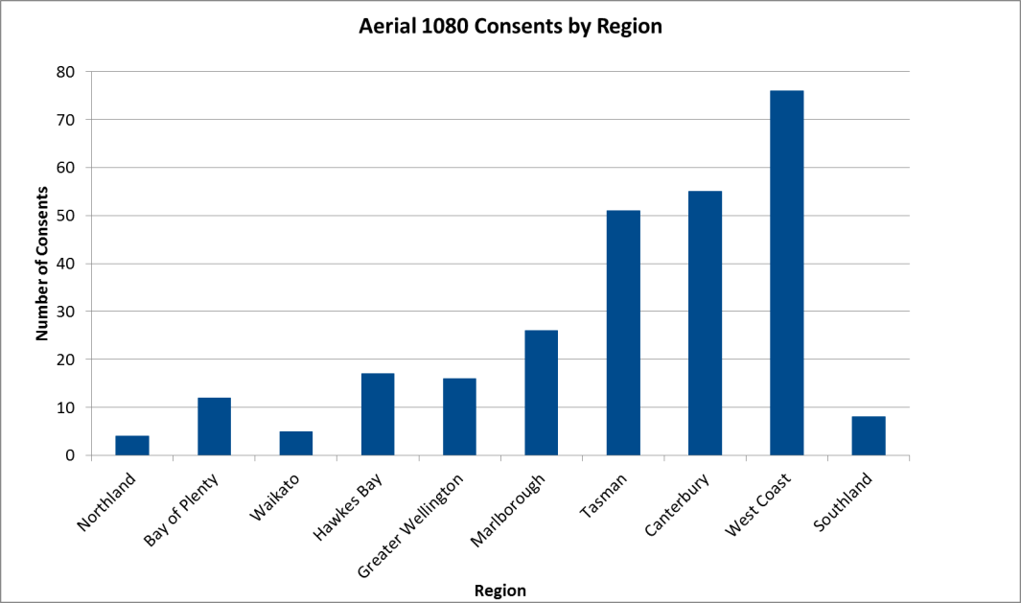

Figure 7: Consents issued in each Region between the years 2003 and 2013 inclusive.

### Consent term

Within the 270 consents analysed there is significant variance in the term of consent. Figure 8 shows that most consents are granted for either a longer term (ie 6 to 10 years) or a shorter term (ie less than two years).

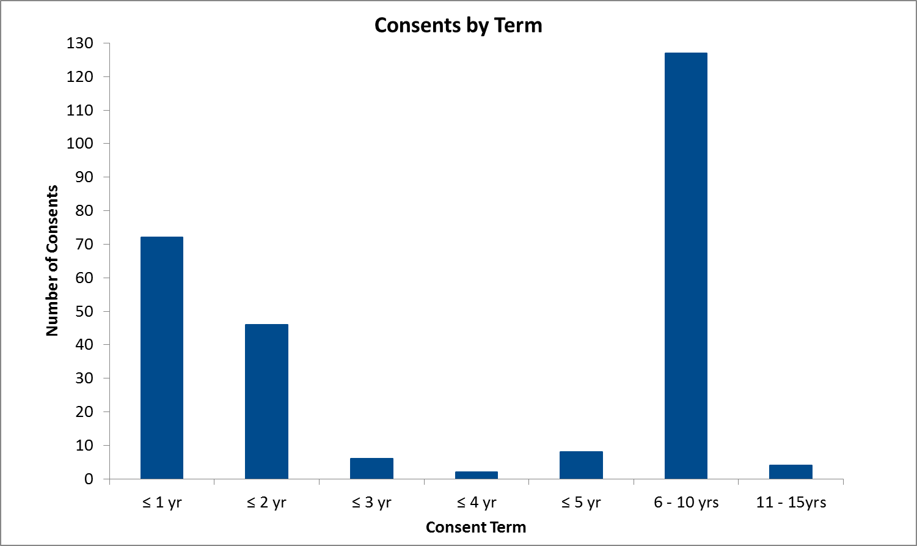

Figure 8: Consents by consent term

The variation in consent term is related to range of factors including;

* the approach taken by applicants when applying for consent (e.g. consent for one operation versus a consent that covers multiple operations);
* the consent term requested by the applicant and/or issued by the Council; and
* Varying consenting practices as Council must publicly notify an application under s95A RMA if the activity is likely to have adverse effects on the environment that are more than minor. This has led to some applicants requesting shorter terms to avoid notification.[72]

### Consent conditions

Analysis of consent conditions has revealed there is a wide variation in the number and complexity of conditions that may be imposed on consents. Some consents contain a relatively small number of conditions (ie less than 10), whilst other consents can contain in excess of 21 conditions. Analysis by region has shown the average number of conditions ranges from 4 conditions (Marlborough) to 38 conditions (Canterbury), with a national average of 18 conditions as summarised in Table 6.

|  |  |  |  |  |
| --- | --- | --- | --- | --- |
| Region | Average number of conditions | | | |
| Northland | <10 | 11-15 | 16-20 | 21> |
| Bay of Plenty |  |  |  |  |
| Waikato |  |  |  |  |
| Hawkes Bay |  |  |  |  |
| Greater Wellington |  |  |  |  |
| Marlborough |  |  |  |  |
| Tasman |  |  |  |  |
| Canterbury |  |  |  |  |
| West Coast |  |  |  |  |
| Southland |  |  |  |  |

Table 6: Average number of conditions on aerial 1080 resource consents by region.

## Areas of Duplication

The analysis has revealed significant areas of duplication between regional plans and consents conditions and HSNO, ACVM, and Health Act requirements. The key areas of cross over and duplication include:

* Duplication of permitting and consenting processes.
* Duplication of regional plan requirements with HSNO/ACVM requirements.
* Replication between consent conditions and HSNO/ACVM requirements, notaby controls.

### Process duplication

There is significant duplication of permitted processes for 1080 operations between the RMA and HSNO. When undertaken on the Conservation Estate, aerial operations can (and often do) require three separate approvals: resource consent, DOC permission and Ministry of Health (MOH) permission under HSNO.

Examples of these applications have been reviewed in the development of this business case and all three approvals necessitate the preparation of the same substantive effects assessment and supporting technical data. All three processes also require input from technical and planning staff/contractors and often necessitate the duplication of reports to meet like conditions.

### Regional Plan Rules

A full review of regional plan rules has found that many regional plan rules repeat the requirements of HSNO controls and ACVM legislation unnecessarily. Key examples of rules that duplicate or have equivalent controls under the HSNO Act, ACVM Act, or Ministry of Health (MOH) permission conditions are provided in Table 7.

| Regional Plan | Rule | Legislation | | Permits/ Permissions |
| --- | --- | --- | --- | --- |
|  |  | **HSNO** | **ACVM** | **MOH** |
| Hawkes Bay Regional Resource Management Plan - Excerpt from Rule 10 | *The discharge shall be undertaken in a manner which does not exceed any rate, or contravene any other requirement, specified in the agrichemical manufacturer's instructions.* | **** | **** |  |
| *Every pilot undertaking the aerial application of agrichemicals shall hold a GROWSAFE® Pilot Agrichemical Rating Certificate.* | **** |  | **** |
| West Coast Proposed Land and Water Plan  Excerpt from Rule 89 | *All residents and occupiers of school buildings within the application area or immediately adjoining the application area are notified at least 48 hours prior to the commencement of the aerial operation.* |  |  | **** |
| *A 100 metre buffer is maintained between the area of application and the boundary of the subject property and between the area of application and any house site.* |  |  | **** |
| *Notification of the aerial operation in the local paper occurs at least 14 days prior to the work commencing.* | **** | **** | **** |
| *Signs are posted notifying the public of the application of agrichemicals in public access areas including roads, walking tracks and access along creeks and river.* | **** | **** | **** |
| Greater Wellington Regional Plan for Discharges to Land  Excerpt from Rule 17 | *There shall be no application of pesticides into open surface water bodies or onto any roof or other structures used as a catchment for water supply.* | **** |  | **** |
| *The operator shall ensure that the bucket distributing the bait is covered when flying to the extent necessary to minimise the risk of bait spilling from the top due to air currents.* | **** |  |  |

Table 7: Examples of Regional Plan rules that duplicate or have equivalent controls under the HSNO Act, ACVM Act, or Ministry of Health Permission Conditions.

### Resource consent conditions

A qualitative assessment of 166 consents has revealed significant duplication between conditions of consent and the regulations and controls set under the HSNO and ACVM and conditions contained within Ministry of Health and Department of Conservation Permissions.

For aerial 1080 consents granted from 2003 - 2013, approximately 90% of resource consent conditions are duplicated, or are managed by, equivalent controls under the HSNO and ACVM Acts. The intent of those resource consent conditions and the subsequent duplication is summarised in Table 8. A full assessment of the extent of duplication is contained in Appendix H.

| Intent of RMA condition | Other Acts/Processes where controls with equivalent intent are set | | | |
| --- | --- | --- | --- | --- |
|  | **Legislation** | | **Permits/Permissions** | |
| **HSNO** | **ACVM** | **MOH** | **DOC** |
| Public notification prior to operation commencement | **** | **** | **** | **** |
| Pilot certification | **** |  | **** |  |
| GPS of flight lines | **** |  | **** |  |
| Notification of accidental discharge to authorities | **** | **** | **** | **** |
| Bait type | **** |  |  | **** |
| Protection of waterways from pesticides | **** | **** | **** |  |
| Warning signage | **** | **** | **** | **** |
| Complaints and incidents log | **** | **** | **** |  |
| Operation monitoring and sampling | **** |  | **** | **** |

Table 8: Examples of key resource consent condition themes and duplications with other Acts and processes.

### Conditions not covered by regulations

The assessment has also found a small number of conditions on consents where there is no direct duplication with any regulations or controls under HSNO or ACVM.

The aspects covered by these conditions are however either addressed elsewhere in the HSNO system (ie through recommendations on the reassessment) or through the SOPs adopted by the partners and Regional Councils. The specific conditions identified, along with a commentary on where they are otherwise addressed are as follows:

* Having a safety officer present on site – this is addressed through SOPs which set out health and safety procedures and security requirements for all operations.
* Requirements for cultural impact monitoring and reporting. HSNO controls address the need for iwi involvement in operations. Cultural impact monitoring may be undertaken in response to consultation with iwi carried out according to the reassessment recommendations.
* Analysis of cause of death of any by-kill. By-kill of indigenous and introduced species has been assessed through research over time and may or may not be monitored or analysed according to DOC permission requirements. By-kill of other valued non-target species (such as game, livestock or domestic animals) is analysed as needed on a case by case basis.

Overall this demonstrates that resource consent conditions are not managing any potential adverse effects that are not already managed elsewhere.

# Direct and Indirect Costs

The following section details the estimated direct costs of RMA regulation of 1080 within the last 10 years, along with examples of estimated indirect costs. The purpose of the analysis has been to assess the cost impact of duplication and regional inconsistency.

## Analysis of Costs

Costs are analysed in three parts below:

* Resource consent costs – including costs for the preparation, processing and monitoring of all resource consents processed between 2003 and 2013. The detailed methodology for deriving costs is outlined in the independent cost-benefit analysis prepared by Sapere Group and contained in Appendix C.
* Plan review costs – costs for partners for involvement in plan change/plan review processes. A case study of the Canterbury Land and Water plan has been used as indication of the costs of involvement in policy processes.
* Opportunity costs – resulting from time delays to pest control operations, cancellation of operations and changes to operations due to resource consent requirements – for example, reductions in operational areas and restrictions on areas that may be treated. A case study of the Tennyson Inlet has been used to provide an indication of opportunity costs.

## Resource Consent Costs

The current RMA management framework has resulted in the processing and approval of 270 consents for aerial 1080 in New Zealand from 2003 - 2013. The cost to the partners in obtaining these approvals is conservatively estimated to be $10.7M.[73]

Figure 9 summarises these costs by year and full details of the analysis are set out in the independent cost-benefit analysis prepared by Sapere Group Limited (Appendix C). It should be noted that all consent costs exclude third party costs incurred by submitters and other stakeholders involved in consent processes and are therefore considered conservative.

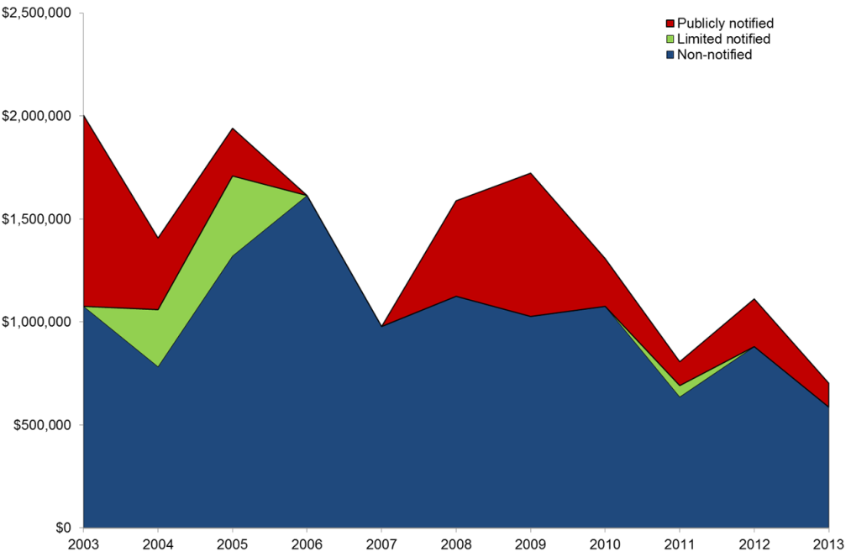

Figure 9: Estimate of compliance costs year 2003 to 2013 - source Sapere Group

Figure 10 provides a summary of the average costs to applicants and Councils by consent type and the key areas of cost, including consent preparation, consultation and monitoring.

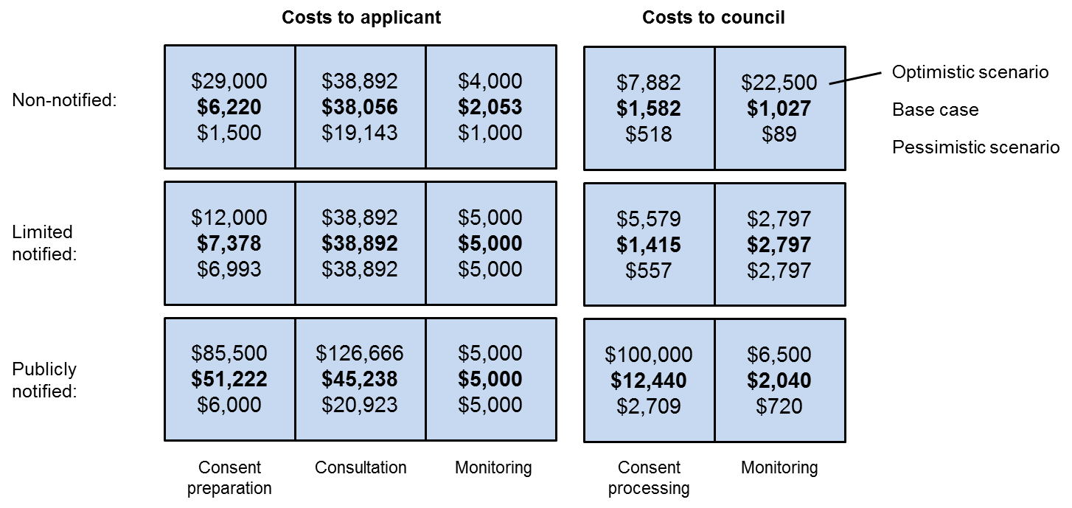

Figure 10: Average costs to applicant and Councils by consent type source Sapere Group

The average cost of a publically or limited notified consent is significantly higher than the average cost for a non-notified consent, reflecting the greater complexity of these consent processes.

The total cost of compliance noted above provides an indication of the potential direct cost savings that could be achieved by removing RMA consent requirements for aerial 1080 operations. Translated into operations, where the average cost of an aerial 1080 operation is estimated at $17/hectare (refer Figure 11), the reallocation of savings equates to additional 63,000ha of aerial 1080 operations annually.

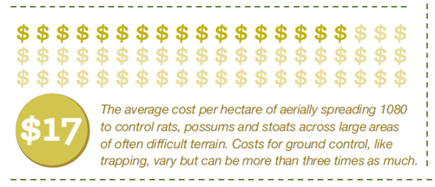

Figure 11: Average cost per hectare of aerial 1080 application[74]

## Plan Review Costs

In addition to consent costs, DOC and TBfree NZ have been involved in plan reviews to seek amendments to aerial 1080 rules and policy.

The most recent Plan review, undertaken in Canterbury, sought amendments to the rules for aerial VTAs proposed under a new Land and Water Plan. A team of DOC planners, legal and technical staff, prepared evidence that resulted in permitted activity status for aerial 1080, with the Council originally proposing controlled activity status. The estimated costs of DOC involvement in this process are $25,000. TBfree NZ and Federated Farmers of New Zealand also incurred costs in preparing and presenting submissions on this matter. This excludes any costs associated with Council consideration of the changes.

DOC has embarked on a similar process for the proposed Auckland Unitary Plan and is seeking to lift the restriction around the use of aerial 1080. The costs for this process are unknown at this stage.

## Opportunity Costs

Consent processes can result in significant opportunity costs to the partners. Opportunity costs arise when consents – and thus operations - are significantly delayed due to drawn out public notification and/or appeal processes.

A recent aerial 1080 operation over the Tennyson Scenic Reserve is an example of the opportunity costs associated with a consent process. The overall costs of the operation have been estimated at $149,000, with almost 40% of the entire cost of the operation related to resource consent process.[75] The consent for this operation was notified and followed by appeal, mediation and negotiated settlement. The consent process both delayed operations and set back a $500,000 multi-year research program in the area.[76] This does not include the opportunity cost of the biological impact of delayed operations.

## Future Consent Costs

Of the 270 consents issued between 2003 – 2013 inclusive, 149 consents have expired and 78 consents are due to expire in the next 5 years, and the remaining 38 consents will expire post 2018 (refer Figure 12).

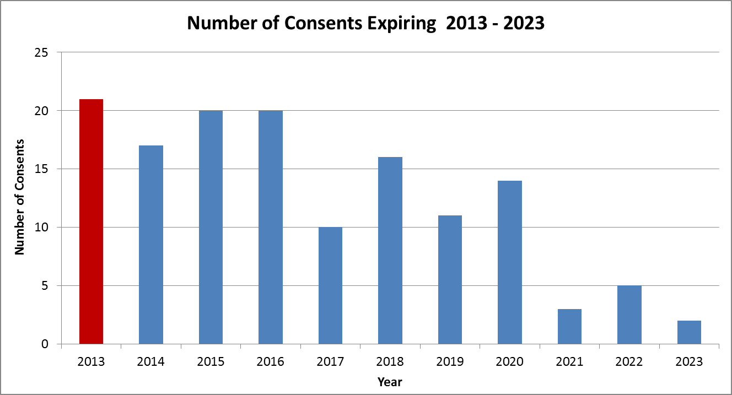

Figure 12: Consent expiry by year. Note that the bar in red indicates consents already expired.

In existing locations where operations are set to continue, consent renewals will be required. In addition, an indeterminate number of consents are likely to be required for new operational areas over the next 10-year period. Key planned operations that will trigger further consents include:

* To increase its ongoing protection for native species DOC is committed to increasing its aerial 1080 programme by about 50,000 hectares per year for five years.
* The likely need to respond to further beech mast events. The 2014 beech mast required DOC to increase its aerial 1080 protection in the South Island by approximately 500,000 hectares, requiring 16 RMA consents.[77]
* TBfree NZ’s aim is to reduce the extent of the existing vector risk area by 25% by 2026. The key regions targeted for reduction include Waikato, Hawkes Bay, Manawatu, West Coast, Canterbury, Otago and Southland. Further possum control operations will also be required in these and other regions to prevent disease spread and minimise livestock infection rates.

The potential forward compliance cost of responding to these pressures within the next 5 years is estimated to be $5M which is an indication of the potential cost savings that could be achieved through simplifying RMA requirements for aerial 1080 application.

## Operational Risks and Impacts

Regional inconsistency and duplication also increases the risk of technical breach of consent conditions. Even if the effects of such breaches are minor, they are treated as adverse incidents in EPA reports. Having variable consent conditions reduces the ability of operators to ensure that best practice is always achieved. The recurrence of such incident reports could lead to imposition of further controls on the use of 1080 under the HSNO Act, potentially resulting in loss or reduced availability of 1080 as a pest management tool for biosecurity and biodiversity programmes. This would have significant environmental, economic, social and cultural impacts for New Zealand.

Regional inconsistency and duplication has the potential to compromise operations and delay response times, ultimately risking both biodiversity values and TB control outcomes. Furthermore, delays to operations and sub-optimal consents have the potential to compromise the strategic objectives of the partners.

# Case for Change Conclusions

It is considered that there is a compelling case to change the existing arrangements and seek to simplify the management of aerial 1080 under the RMA, for the following key reasons:

* The risks and effects of 1080 are robustly and effectively managed under the HSNO, ACVM and Health Act. The regulation of 1080 under the RMA is not affording any extra protection to the environment or public health, nor is it managing risks outside those already managed under HSNO.
* There are high levels of unnecessary duplication between the RMA and HSNO. Significant levels of duplication occur between RMA consent conditions and HSNO controls. There is also duplication between plan rules and HSNO requirements. This duplication is costly and does not improve the management of effects and risks.
* The analysis presented in this business case has found the sustainable management purpose and principles of the RMA are being sufficiently achieved under HSNO. The further management of 1080 under the RMA is not affording additional environmental protection, due to 100% duplication with HSNO permissions and standard operating procedures.
* The management of 1080 through regional plans is inconsistent, and this can adversely impact the effectiveness of operations. There are 13 Regions with varying Regional Plan rules/standards that trigger the need for resource consent for aerial 1080 operations. Over 200 such resource consents have been issued in the last ten years in 10 Regions. There is significant regional variability in consent conditions and in the way consents are managed.
* Inconsistency and duplication increases the risk of compliance failure. Having variable consent conditions reduces the ability of the operators to ensure that best practice is always achieved. Regional inconsistency and duplication also increases the risk of breaching consent conditions. Even if the effects of such breaches are minor, they are treated as adverse incidents in EPA reports. The recurrence of such incident reports could lead to imposition of further controls under the HSNO Act, potentially resulting in the loss or reduced availability of 1080 as a pest management tool for biosecurity and biodiversity programmes.
* There is a need to reduce unnecessary RMA compliance costs to Regional Councils, DOC, TBFree NZ and private contractors/landowners. The compliance costs for resource consents in the last ten years have been estimated at $10.7M. Future costs could be reduced significantly through removing the need for resource consents, and managing 1080 operations under HSNO, ACVM and the Health Act.
* Benefits from greater consistency include the potential direct cost savings for aerial 1080 operations. If estimated compliance costs could be put into operations, where the average cost of an aerial 1080 operation is estimated at $17/hectare, this reallocation would equate to additional 63,000ha of aerial 1080 operations annually. The benefits of this are likely to be significant.

PART 3 – ECONOMIC CASE

# Options Analysis

The partners have explored and assessed the full range of regional and national policy and consenting options to address the case for change, including potential advocacy approaches.

The following section summarises the assessment methodology, the options assessed and the short list options assessment process including the rigorous analysis of benefits, risks and costs of the short list of options to determine a preferred option.

The preferred option determined through this analysis process is a regulation under section 360(1)(h) of the RMA which would exempt aerial 1080 operations from section 15 of the RMA and leave their continued management under the HSNO/ACVM framework.

# Assessment Methodology

The better business case model[78] has been used as a framework for the assessment of the options.

The determination of the preferred option was completed through a series of workshops undertaken by two key groups within the project structure (refer Figure 13);

1. The Project Delivery Group – responsible for reviewing and critiquing the case for change, determining the investment objectives and critical success factors, undertaking the qualitative assessment of the long list of options and recommending a short list of options to the Project Steering Group.

Membership of this group included representatives from Regional Councils, the Environmental Protection Authority, Ministry for the Environment, TBfree New Zealand Limited, Department of Conservation, and the Ministry for Primary Industries.

1. The Project Steering Group - responsible for reviewing the case for change, reviewing the analysis of the short list of options and confirming the short list for cost benefit analysis. This Group then determined a preferred option considering the results of the cost-benefit analysis and relevant risks of each option.

Membership of this group included representatives from the Department of Conservation, Ministry for the Environment, Ministry for Primary Industries, TBfree New Zealand Limited, and Regional Council.

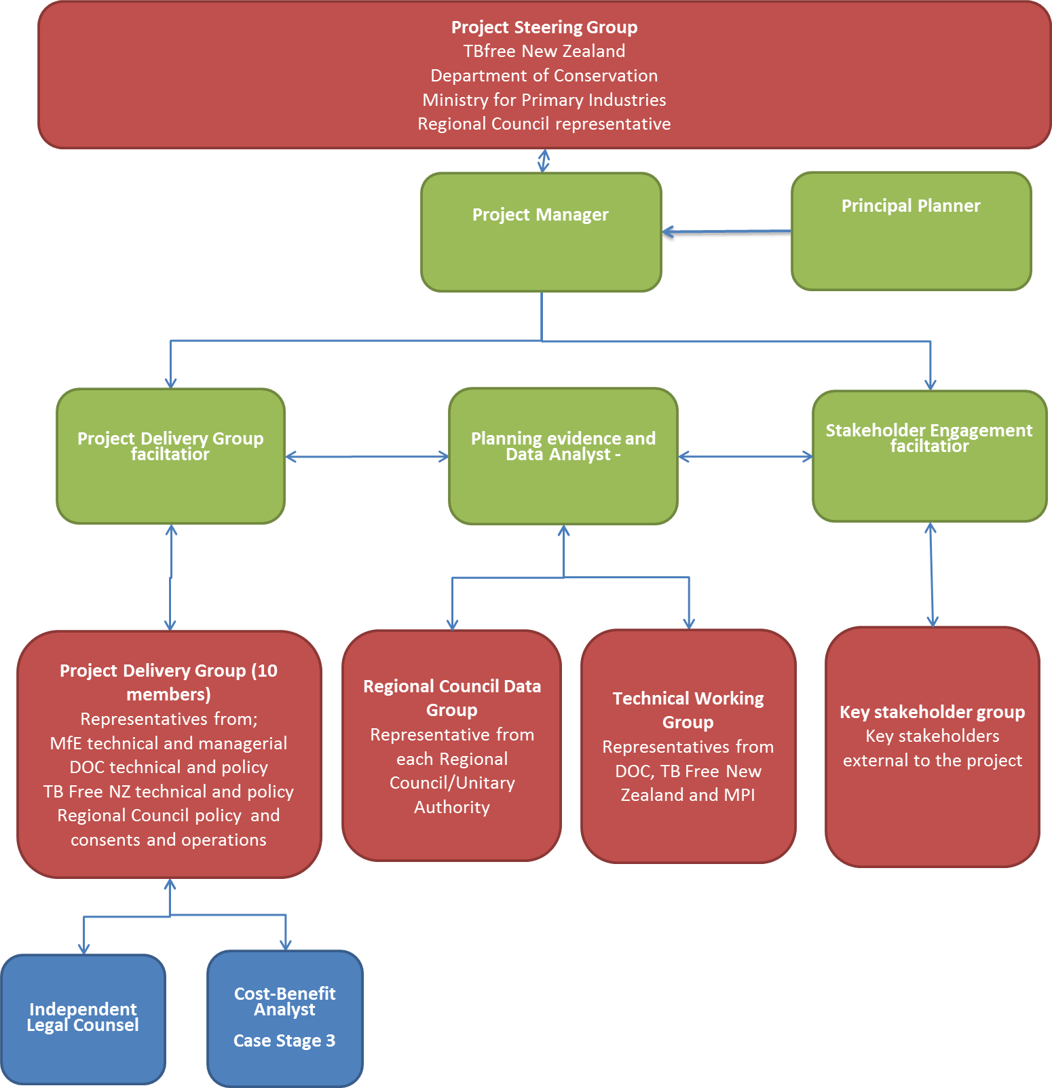

Figure 13: Summary of Project Structure

## Analysis Process

The options analysis process involved the following key steps:

1. Assessing and critiquing the case for change and determining the investment objectives and critical success factors.
2. Determining a long list of all possible policy and consenting options to improve consistency in the RMA regulation of aerial 1080 on a national basis.
3. Assessing the long list of options as to how well each option meets the agreed investment objectives and the critical success factors for the project, including an assessment of the risks of each option.
4. Determining a short list of three options based on this qualitative analysis.
5. Assessing the costs, benefits and risks of the three short list options, including an independent cost-benefit analysis.
6. Determining a preferred option based on the findings of the cost-benefit analysis and an assessment of the cost, benefits and risks of implementing the preferred option.

## Workshops

The above process was completed through three facilitated workshops with the Project Delivery Group as follows:

* Workshop 1:

Reviewing the case for change, determining the investment objectives, critical success factors and confirming the long list.

* Workshop 2:

Qualitatively assessing the long list and determining a short list.

* Workshop 3:

Reviewing the cost-benefit analysis of the short list options and determining a preferred way forward.

At the conclusion of each workshop the recommendations and findings were reviewed and confirmed by the Project Steering Group before proceeding to the next stage.

# Investment Objectives

Based on the findings of the case for change, the Project Steering Group determined the following investment objectives to inform the options analysis:

1. Improve the effectiveness of aerial pest control operations by establishing nationally consistent environmental compliance measures within the next two years (i.e. by December 2016).

This objective recognises the importance of achieving national consistency and the implementation of a timely solution given the operational pressures within the next five years.

1. Improve the efficiency of aerial pest control operations by reducing unnecessary RMA compliance costs by 80% within the next five years (i.e. by December 2019).

This objective recognises that any preferred option should achieve a reduction of unnecessary RMA compliance costs overtime.

Any preferred option must be able to deliver on these investment objectives.

## Critical Success Factors

The assessment of options was supplemented by the inclusion of the following critical success factors (CSFs) set out in Table 9 below. The CSFs are key components that are required to successfully achieve the investment objectives.

|  |  |  |
| --- | --- | --- |
| Critical Success Factors | In a word | Description |
| Strategic fit and business needs | NEEDS | How well the option meets the operational requirements of the partners in short, medium and long terms.  How well the option meets the strategic intent of the partner’s business strategies. |
| Potential value for money | BENEFITS | How well the option generates benefits and optimises potential value for money for the partners and the public good pest management programmes which they deliver. |
| Capacity and capability | DELIVERY | How well the option can be technically delivered by Central Government and/or Regional Councils. |
| Potential affordability | COSTS | How well the option can be met within likely available funding. |
| Potential achievability | RISKS | How well the option can be implemented with due regard to the associated risks and uncertainties. |

Table 9: Critical Success Factors

# Long List of Options

Table 10 summarises the long list of options considered in the assessment. The list included policy tools and advocacy approaches at both a national and regional level.

|  |  |
| --- | --- |
| Option | Description |
| Business As Usual | * Regional Councils set rules on aerial 1080 through Plan Reviews. * Requirements for resource consent vary by region. * Complexity of complying with consent conditions varies by region. * Continued possibility that applications will be notified. * Possibility of further constraints on 1080 use being introduced through Regional Plan reviews |
| National Options |  |
| New National Policy Statement | * Set objectives and policies for the aerial use of 1080 as a matter of national significance, providing clearer national direction. * Consent authorities must have regard to any relevant national policy statement when considering an application for resource consent. |
| National Environmental Standard | * Set rules for the adoption of consistent standards at regional level for aerial 1080 as a permitted activity. |
| Legislation Change | * Amend section 15 of the RMA to state that it does not apply to 1080 products that have approval under HSNO. |
| Regulation under the under s360(1)(h) of the RMA | * A regulation exempting the use of aerial 1080 from Section 15 of the RMA. * The Governor-General, by Order in Council, makes a regulation under s360(1)(h) of the RMA that;   *“Prescribes exemptions from any provision of* [*section 15*](http://www.legislation.govt.nz/act/public/1991/0069/latest/whole.html#DLM231978)*, either absolutely or subject to any prescribed conditions, and either generally or specifically or in relation to particular descriptions of contaminants or to the discharge of contaminants in particular circumstances or from particular sources, or in relation to any area of land, air, or water specified in the regulations”* |
| New Act | * Drafting of a new Act that exempts the use of aerial 1080 from the requirements of the RMA. |
| Plan change at National Level | * Lodge a “plan change” application with the EPA to amend all relevant regional plans simultaneously to permit the aerial use of 1080. * Likely that a Board of Inquiry would process the application as a matter of national significance. |
| National Consent | * Lodge a multi-region comprehensive consent application with the EPA to secure consent for all 1080 operations over a 35 year term. * Likely that Board of Inquiry would process the application as a matter of national significance. |
| Regional Options | |
| Regional Approach | Establishment of a centralised team to manage a rolling multi-year programme comprising:   * Submissions on the scheduled Regional Plan reviews within the next two years, with the objective of securing permitted activity status for aerial 1080 operations; and * Preparation of comprehensive resource consents in eight other regions, to secure long-term consents for all operational areas with consistent conditions.   Possibility of further constraints on 1080 use being introduced through Regional Plan reviews. |
| Comprehensive Resource Consents | * Preparation of comprehensive resource consents across 13 Regions to secure long-term consents for all operational areas with consistent conditions. |
| Private Plan Changes | * Partner led private plan changes with the objective of making the aerial use of 1080 permitted activity subject to HSNO requirements. * Possibility of further constraints on 1080 use being introduced through Regional Plan reviews. |
| Council Led Plan Changes | * Council led plan changes with the objective of making the aerial use of 1080 a permitted activity subject to HSNO requirements. * Possibility of further constraints on 1080 use being introduced through Regional Plan reviews. |
| Advocacy Options | |
| Improvements to current systems | * Advocacy for improvements in the way consents are processed i.e. establishing standard decision criteria and protocols around affected parties. * An example of this is the Hawkes Bay Regional Council which has dedicated staff to process 1080 consent applications. This has resulted in a more consistent approach to consenting and better relationships between the Council and applicant. |
| Best Practice Guidance | * Develop guidance in conjunction with Regional Councils to improve consistency in the implementation of VTA regulation. * Voluntary guidance only. |

Table 10: Long list options

# Long List Assessment

The Project Delivery Group (PDG) assessed the long list of options at a facilitated workshop and the assessment involved a qualitative analysis of each of the long list options against the investment objectives and critical success factors. A summary of the outcome of this assessment is provided in Table 11.



Table 11: Summary of long list assessment

# Short List Summary

The following short list of options was determined for further analysis;

1. National Environmental Standard.

2. Regulation under section 360 of the Resource Management Act.

3. Drafting of a new Act.

The short list options were recommended to the Project Steering Group and a decision was made to replace the new Act option with a "regional approach" option comprising a mix of;

1. Regional Plan Reviews.

2. Comprehensive resource consents.

The new Act option was replaced as the Project Steering Group considered there was a very high level of risk and uncertainty regarding its potential development and implementation. The potential outcome of the new Act option was also considered to be very similar to both the NES and regulation options. Value was seen in including the regional approach option, which would not require national regulatory or legislative change, to provide a comparison with the national level options.

A detailed description of the final short list of options is contained within Appendix L.

# Cost Benefit Analysis Findings

Sapere Research Group (Sapere) were commissioned to undertake an independent cost-benefit analysis of the three short-listed options to inform the final decision on the preferred option. A summary of the key findings of this analysis is set out as follows.

### Benefit Cost Ratio

Sapere developed a cost-benefit model to assess the three options against the status quo. The two national options (NES and s360(1)(h)) were treated the same way within the cost-benefit model, as Sapere considered the implementation of both options would result in similar outcomes.

Overall, the analysis concluded that although society would be better off under either approach, the net benefits of the national approach ($10.5million) far outweighed those of the regional approach ($2.6million) with benefit-cost ratios of 11 to 1 and 3.2 to 1 over a twenty year period respectively.

A summary of this analysis is provided in Table 12 and the final model results are set out in Figure 14.

|  |  |  |  |
| --- | --- | --- | --- |
| Measure | | National approach  ($ million) | Regional approach  ($ million) |
| **Benefits** (present value) | **Total** | **$11.5 m** | **$3.8 m** |
| Councils – avoided costs | $0.8 m | $0.3 m |
| Applicants – avoided costs | $10.7 m | $3.6 m |
| **Costs**  (present value) | **Total** | **$1.1 m** | **$1.2 m** |
| Development costs | $0.8 m | $0.6 m |
| Implementation costs | $0.2 m | $0.6 m |
| **Net benefit (net present value)** | | **$10.5 m** | **$2.6 m** |
| **Benefit-cost ratio** | | **11.0** | **3.2** |

Table 12: Summary of cost and benefits – source Sapere Group

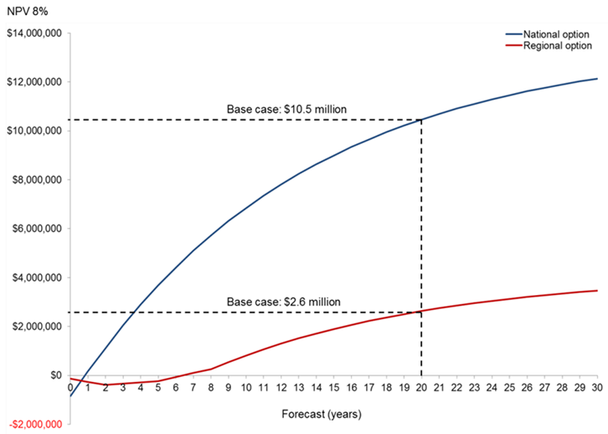

Figure 14: Summary of modelling results – source Sapere Group

### National vs Regional

The analysis further identified that the strength of the national approach lies in annual benefits being fully realised upon implementation of national regulatory change, with resource consent costs being avoided. A further strength of this approach is the relatively low cost to develop the regulation and minimal ongoing implementation costs.

In contrast, Sapere noted the benefits accrued under the regional approach are lower with the roll out of a region-by-region work programme supported by staff from partner organisations with the aim of either Regional Councils granting ‘permitted activity’ status (via a regional plan review) or a comprehensive long-term consent.

Of the 12 Regional Councils that do not already permit the aerial use of 1080, the model assumed 6 of these Regional Councils would adopt a streamlined consenting process early on, with a further two Regional Councils adopting this approach every three years. Whilst this gradual uptake occurs, resource consents were modelled as still being required. The benefits under the regional approach were therefore modelled to increase gradually, without reaching the level arising from a nationwide regulatory change under the national approach.

### Sensitivity testing

Sensitivity testing of the base case for the national and regional approaches was undertaken. Tests included varying the discount rate, time period, consent cost assumptions, consent volume assumptions, and mix of consents (in terms of notification status). Tables 13 and 14 below summarise the results of this sensitivity testing.

The uncertainty of the regional approach was specifically tested by varying the number of ‘uptake’ councils and the adoption timeframe. The results of these tests showed that the net benefit of the national approach remained substantially higher than the regional approach in all scenarios.

|  |  |  |  |  |
| --- | --- | --- | --- | --- |
|  | Net benefit  (present value, $ million) | | Benefit-cost ratio | |
| **Discount rate** | National approach | Regional approach | National approach | Regional approach |
| 4% | $15.4 m | $4.6 m | 14.5 | 4.0 |
| 6% | $12.6 m | $3.5 m | 12.6 | 3.6 |
| **8% (base case)** | **$10.5 m** | **$2.6 m** | **11.0** | **3.2** |
| 10% | $8.8 m | $2.0 m | 9.6 | 2.9 |
| 12% | $7.5 m | $1.5 m | 8.6 | 2.6 |
|  |  |  |  |  |

Table 13: Application of discount rate overtime – source Sapere Group

|  |  |  |
| --- | --- | --- |
| Cost assumption | National approach | Regional approach |
| Low cost (minimum observed) | $4.1 m | $0.5 m |
| **Base case** (average) | **$10.5 m** | **$2.6 m** |
| High cost (maximum observed) | $24.0 m | $7.1 m |

Table 14: Sensitivity testing of compliance cost estimates – source Sapere Group

### Operational benefits

The Sapere analysis also explored the potential operational benefits of achieving national consistency. These benefits were not able to be quantified in monetary terms but were considered to be potentially significant. A summary of these benefits as set out in the Sapere report is included in Table 15.

| Benefit | Assessment |
| --- | --- |
| Applicants standardise internal processes | DOC and TBfree NZ manage aerial 1080 operations from multiple offices, given the differences regional plan requirements and procedures. A nationally consistent approach may allow for more specialised planning and operational functions that enable more efficient use of staff time. |
| Reduced uncertainty leading to a lower contract price | A national approach to the consent process may provide contractors with greater certainty about what to expect for aerial 1080 operations. To the extent that contractors factor in price premia for consenting risk, there may be scope for national standardisation to allow these premia to be waived and the price of operations to be lower than otherwise would be the case  The efficiency gains take the form of time savings and/or reduced costs for aerial 1080 operations. They generally arise from reductions in time and uncertainty as a result of a more streamlined consent process and increased standardisation of operational consents/rules. |
| Reduced risk of operational non-compliance | Standardisation and a single set of rules may reduce cases of consent non-compliance from contractors conducting aerial 1080 operations. This is because current consent conditions differ across regions, which requires contractors and operational staff to comply with multiple sets of conditions. A reduction in lost time from non-compliance may increase operational efficiency. This gain may be possible under the regional option, albeit to a lesser extent, as some differences between regions would likely remain. |
| Improved timeliness of operations | The national standardisation of rules for aerial 1080 operations is expected to simplify operational planning and consent processes. Operations could thus be planned an implemented more quickly than under current conditions, thereby being more responsive to on-the-ground changes. |
| Reduction in suboptimal consents | The complexity of rules under the current consenting environment can lead to suboptimal operational design in order to ensure consent conditions are met, or to avoid costly and time consuming consent process . This in turn can lead, for example, to the area of coverage being less than optimal for the desired pest management outcome. Under a more standardised approach, it is plausible that these suboptimal consents will be less likely. |
| Increases in area covered by aerial 1080 operations | If the major applicant organisations can realise operational savings from a streamlined consent process, it is plausible that these freed-up resources could be reallocated into in additional pest management operations. This could lead to an expansion in the area covered by aerial 1080 operations, with commensurate gains in the protection of New Zealand’s biodiversity and in the management of bovine tuberculosis. |
| Improved public confidence | The introduction of a national standard and single set of rules may improve overall public confidence in the conduct of aerial 1080 activities. |

Table 15: Summary of benefits of national consistency (source: Sapere Group)

# Analysis of Short List

The cost-benefit analysis results were used to inform the refinement of the short list to a preferred option. The key considerations in process are summarised below.

## Regional Option

The Sapere cost-benefit analysis confirmed a benefit cost ratio of 3.2 to 1 for the regional approach, this being significantly lower than both the national options. The regional approach was discounted on the basis of lower potential benefits and the following other factors:

* Whilst regional plans could be changed to permit the use of aerial 1080, such changes may not endure, as plans are subject to review. There is an ongoing risk that standards may change through future plan and/or consent reviews.
* There would be significant costs and risks associated with the regional approach. Changes to plans and/or consents would be required in 13 regions to achieve national consistency and there would be significant time and costs associated with this.
* The regional plan change and consent processes would run separately in each region and therefore is a real risk that consistency may not be achieved and as such there may still be potential for duplication with the HSNO and ACVM Acts.

## National Option

The two national options were assessed in the cost-benefit analysis as having the same net benefits to society. The final decision on the preferred option involved a finer level assessment of the national options against the following criteria:

* **Perception -** is there any benefit to be gained in choosing one option over another in terms of how the regulation will be perceived and regarded by the general public;
* **Process** - is there any advantage in process terms around one regulation over another;
* **Timing** - is the timing of one form of regulation better than the other;
* **Cost -** is there any difference in cost to process and implement the option (in terms of monetary cost);
* **Outcome** - is there any difference in outcome.
* **Political** - are there any political risks relating to the choice of regulation (related to the perception risks noted above).

### National Environmental Standard – Assessment against Criteria

The NES option was assessed against this range of criteria and was discounted mainly because under Section 43A(3) of the RMA, an NES cannot permit any activity with significant adverse effects on the environment as follows;

*43A (3) If an activity has significant adverse effects on the environment, a national environmental standard must not, under subsections (1)(b) and (4),—*

*(a) allow the activity, unless it states that a resource consent is required for the activity; or*

*(b) state that the activity is a permitted activity*.

The aerial discharge of 1080 can potentially have significant adverse effects on the environment when operations are not managed appropriately. Therefore there is a risk that an NES may not be able to provide for the discharge as a permitted activity, unless the NES itself included sufficiently detailed conditions under which aerial 1080 could be applied without causing adverse effects. Such conditions could ultimately end up duplicating the HSNO regime, creating further complexity within the system. It is also likely that an NES would need to be regularly amended to keep up with any changes to the HSNO conditions, potentially duplicating the regulatory and consultation processes that already exist nationally. This additional complexity and costs would be contrary to the investment objectives of the partners, and would amount to a public disbenefit from such a management regime.

### Section 360(1)(h) Regulation – Assessment against Criteria

In contrast to the above, Section 360(1)(h) provides for regulations exempting specified discharges from section 15 of the RMA as follows;

*360(1)(h)*Regulations

*(1) The Governor-General may from time to time, by Order in Council, make regulations for all or any of the following purposes:*

*(h) prescribing exemptions from any provision of**section 15* (of the RMA)*, either absolutely or subject to any prescribed conditions, and either generally or specifically or in relation to particular descriptions of contaminants or to the discharge of contaminants in particular circumstances or from particular sources, or in relation to any area of land, air, or water specified in the regulations.*

By its very nature, a Section 360(1)(h) Regulation is unlikely to face the potential complications that may arise from the development and implementation of an NES. Furthermore, the analysis presented in this business case has shown that the aerial discharge of 1080 is well managed under the HSNO framework and that further duplication or regulation is not warranted. The exemption of 1080 as a discharge from Section 15 of the RMA under Section 360(1)(h) is therefore considered appropriate.

### Summary of assessment

A summary of this final assessment is provided in Figure 15.



Figure 15: Summary of risk analysis of short list options

This finer analysis concluded that regulation of a **regulation under s360(1)(h) as the preferred option**.

# Disadvantages of Preferred Option

The potential disadvantages of implementing a section 360(1)(h) regulation have been considered by the partners.

A possible objection to a national regulation is the denial of a local democratic process under the RMA by “removing” the need for resource consent and the ability to manage the adverse effects of operations through localised conditions.

In respect of this it may be noted that not all Regional Plans currently require resource consent for the discharge of aerial 1080, so in these regions there would be no change from the status quo. In regions where consent is currently required, the evidence reviewed confirms that 100% of resource consent applications in the last 10 years were granted.

The partners further consider that the public interest is well served on an ongoing basis through HSNO requirements for annual public reporting on all aerial 1080 operations, incidents and outcomes. This public monitoring is further assessed every five years and consideration is given to the need for any further review of HSNO controls and conditions of use.

A further disadvantage of a regulation would be the potential for the regulation to leave gaps in the system that manages the effects and risks of aerial 1080 use. The analysis of the evidence in reference to this has confirmed that the regional plans and/or resource consents are not managing any adverse effects (localised or otherwise) that are not already managed under the HSNO/ACVM framework. Locally specific controls relevant to human health risks would still be able to be applied through permissions from local public health authorities, and from DOC where operations involve public conservation land.

Further analysis of this issue has confirmed that all 1080 operations within the last 3 years were subject to either a DOC or MOH permission. In addition, most private operations are undertaken for rabbit control, predominantly in Canterbury and Otago regions, where resource consent is in any case not required. These operations have not been subject to any significant incident reports and have been undertaken in accordance with the overall HSNO framework. A regulation would not affect the status quo in this context.

Overall of the potential benefits of the preferred option are considered to significantly outweigh the potential disadvantages and resource consents are considered to be an unnecessary further process.

# Preferred option

Based on the qualitative analysis of all options, the findings of the cost-benefit analysis and the assessment of overall benefits, disadvantages and risks of each of the shortlisted options, the Project Steering Group proposes a **regulation under s360(1)(h) as the preferred option**. A full summary of the options analysis is provided in Appendix M.

The key reasons for choosing the regulation option are;

* The cost-benefit analysis confirms that a national policy option is likely to generate four times the benefit of a regional option.
* A national environment standard may result in the further duplication of requirements and there is a risk it could increase the complexity of the current system. This is contrary to findings of the case for change and contrary to the investment objectives of this business case.
* The option will address the current issues of duplication and inconsistency with the current system.
* The option is most likely to achieve the investment objectives and responds best to the critical success factors.
* The potential disadvantages of the preferred option are considered to be significantly outweighed by the benefits.

The following sections of this business case set out the delivery arrangements for the preferred option.

PART 4 – COMMERCIAL, FINANCIAL AND MANAGEMENT CASES

# Delivery arrangements

The following sections set out the recommended delivery arrangements for the preferred option, including the implementation, review and monitoring of the regulation. This section has been reviewed and confirmed by the Project Steering Group as the preferred delivery pathway.

# Regulation process

The process for a 360 regulation will involve the following key decision steps:

1. Ministerial/Cabinet approval to consult with Central and Local Government and develop the regulation.
2. Cabinet approval to issue a public discussion document.
3. Analysis of submissions and a decision by the Minister for the Environment on whether to proceed with a regulation.
4. Drafting, Order in Council processes (i.e. Cabinet agreement to recommend the making of the regulation and then consideration by the Governor-General) and gazettal.
5. Promulgation - The regulation would come into effect 28 days after being promulgated.

# Project Approach

The delivery of the preferred option is proposed in six key stages as follows:

1. Preparation – including confirming the project plan and resourcing, preparing the discussion document and legal drafting for the regulation.
2. Securing Ministerial/Cabinet approval to consult with Central and Local Government on the proposed regulation.
3. Undertaking consultation on the proposal.
4. Securing Cabinet approval to release a discussion document for formal consultation.
5. Releasing the discussion document and analysing submissions on discussion document.
6. Promulgation and gazetting of the regulation.

Each of the key stages is summarised within Figure 16 below along with indicative timings for completion of each stage.

Figure 16: Proposed key project stages

# Project Structure and Resourcing

The following structure (Figure 17) is proposed to manage the delivery of next project phase.

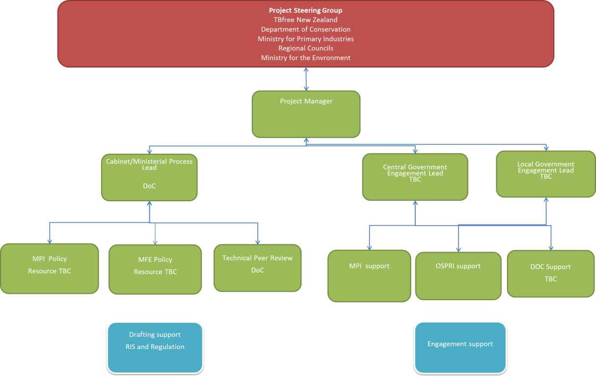

Figure 17: Proposed Project Structure

The key roles within the project structure are:

1. **Project Steering Group (PSG)** – responsible for project oversight and key decisions on project direction, advising and leading key stakeholder engagements and allocating resources to key project tasks.
2. **Project Manager** – responsible for the preparation, confirmation and management of the project plan, day to day co-ordination of the project and reporting to the project steering group.
3. **Regulation process lead** – responsible leading the regulation process, developing the discussion document and regulation including co-ordinating supporting resources.
4. **Central Government engagement lead** – responsible for co-ordinating and leading all engagement with Central Government and reporting to the project manager on progress and risks.
5. **Regional Council engagement lead** – responsible for leading all engagement with Regional Councils and reporting to the project manager.
6. **Support roles –** responsible for providing support and assistance to area leads as required. Likely roles will include drafting of relevant policy papers and co-ordination of key engagements.

# Milestones and Deliverables

The key deliverables and milestones of each project stage are summarised in Table 16 below.

| Project Stage | Objectives | Key Deliverables |
| --- | --- | --- |
| STAGE ONE:  PREPARATION  January 2015 | Confirm all project resourcing and project plan.  Prepare draft Discussion document and Regulatory Impact Statement.  Liaise with supporter groups to confirm support for business case. | Confirmed project plan, structure and communications plan.  Policy material for briefings to incoming Ministers (BIMs).  Draft discussion document and regulatory impact statement. |
| STAGE TWO:  CABINET/MINISTERIAL APPROVAL  February 2015 | Secure approval to consult on draft discussion document. | Briefings to relevant Ministers.  Cabinet paper on proposal to consult if required. |
| STAGE THREE:  CONSULTATION  March 2015 | Consult with Central Government and key stakeholders on discussion document. | Summary of proposal.  Draft discussion document and regulatory impact statement.  Summary of consultation and proposed changes. |
| STAGE FOUR:  CABINET APPROVAL FOR RELEASE  April 2015 | Secure cabinet approval to release discussion document. | Final draft discussion document and regulatory impact statement.  Cabinet paper requesting release of discussion document. |
| STAGE FIVE:  DISCUSSION DOCUMENT AND PUBLIC CONSULTATION  May 2015 | Complete formal submissions stage.  Complete analysis and summary of submissions. | Final discussion document, regulatory impact statement and proposed regulation.  Independent summary and analysis of submissions.  Legal analysis on changes to regulation. |
| STAGE SIX:  PROMULGATION  August 2015 | Regulation drafted, promulgated and gazetted. | Briefing to Minister for decision on adoption. |

Table 16: Key Milestones and Deliverables

# Risks

Table 17 outlines the substantive risks to implementing the preferred option, along with proposed mitigation. The risks have been assessed on the basis that the project will proceed as set out above.

|  |  |  |  |
| --- | --- | --- | --- |
| Delivery Risks | Probability (H, M, L) | Impact (H, M, L) | Mitigation |
| Lack of available resources within the project partners. | L | H | Ensure early briefing on expectations.  Scope and confirm delivery arrangements early.  Regulation itself should be simple to draft. |
| Cannot secure support of Local Government for project. | H | M | Ensure consistent messaging around business case including CBA findings.  Provide regular updates on project progress and key points of engagement.  Communication to Local Government on public process and where input is required. |
| Cannot secure Ministerial support for project. | L-M | H | Early briefing to high level management within MFE, DOC and MPI.  Early briefing to Minister of Conservation, Minster for Primary Industries and Minister for Environment to determine appropriate lead Minister.  Determine process in conjunction with lead Minister |
| Cannot secure support in Cabinet for project. | M | H | Scope cabinet process and timings with Minister of Environment, Minister of Primary Industries and Minister of Conservation. |
| Lack of support from potential support groups. | M | M | Ensure consistent messaging around business case including CBA findings.  Early communication to potential supporters on business case and findings of strategic case.  Provide regular updates on project progress and key points of engagement.  Communication to stakeholders on public process and where input is required. |
| Significant public opposition to regulation such that political support is lost. | L-M | H | Ensure robust understanding of issues politically.  Manage public consultation  Ensure key messaging |
| Personal Risk | **Probability (H, M, L)** | **Impact (H, M, L)** | **Mitigation** |
| Personal Safety | L | H | Manage external communications in accordance with agreed communications plan.  Limit face to face engagement with potential opposition groups. Manage security arrangements if necessary. |
| Financial Risk | **Probability (H, M, L)** | **Impact (H, M, L)** | **Mitigation** |
| Underestimate project management tasks. | L | M | Confirm scope and resourcing with project team early. |
| Underestimate regulation process tasks. | L | M | Confirm scope and resourcing with project team early. |

Table 17: Identified project Risks

# Communications Plan

The development of a communications plan will be critical to managing the key project risks and this will be produced as part of the first stage of delivery. The communications plan will include agreed key messaging around the project and protocol to manage information. The contents of the plan will be further scoped in conjunction with the Project Steering Group.

# Delivery Costs

The costs to deliver the preferred option will be estimated following confirmation of the proposed project structure, staging, timing, and resourcing by the Project Steering Group. The remaining budget from phase 1 could be utilised to initiate the second phase of the project if deemed necessary or appropriate.

# Implementation and Monitoring

Once promulgated, the implementation of the regulation under s360 would involve the preparation of guidance for Regional Councils to set out the scope of the regulation, when the regulations would apply and details on the administration of the regulation.

The regulations would apply automatically to all regional plans, consent applications and applications which have not yet been processed within timeframes set under the Act. Exemptions under the regulations would likely be restricted to Central and Local Government agencies, and to agencies with approved Pest Management Plans under the Biosecurity Act 1993. Promulgation of the regulation would not require changes to regional plans. The Ministry for the Environment would need to formally advise Councils of regulations. This could be undertaken through written communications with Councils, and face to face workshops with Councils if necessary.

It is proposed that the effectiveness of the regulation would be monitored through existing statutory reporting to the EPA on aerial 1080 use. These reports are submitted to the EPA by operators for each operation, and include a range of criteria for assessing the impacts of operations. Further questions could be added to existing EPA reporting templates to assess the effectiveness of the regulation over time and whether any changes are needed.

# Summary and Conclusions

This business case has explored the evidence for greater standardisation and simplification of the regulatory system for the aerial application of 1080 and what the costs and benefits of this might be. The business case analysis has established a clear case for change from the status quo. The key reasons for change include:

* The risks and effects of 1080 are robustly and effectively managed under the HSNO and ACVM Acts. The further regulation of 1080 under the RMA is not affording any extra protection to the environment or public health.
* There are high levels of unnecessary duplication between the RMA and HSNO. Significant levels of duplication occur between RMA consent conditions and HSNO controls. There is also duplication between plan rules and HSNO requirements. This duplication is costly and does not improve the management of effects and risks.
* The management of 1080 through regional plans is inconsistent, and this can adversely impact the effectiveness of operations. There are 13 Regions with varying Regional Plan rules/standards that trigger the need for resource consent for aerial 1080 operations. Over 200 such resource consents have been issued in the last ten years in 10 Regions. There is significant regional variability in consent conditions and in the way consents are managed.
* Inconsistency and duplication increases the risk of compliance failure. Having variable consent conditions reduces the ability of the operators to ensure that best practice is always achieved. Regional inconsistency and duplication also increases the risk of breaching consent conditions. Even if the effects of such breaches are minor, they are treated as adverse incidents in Environmental Protection Authority (EPA) reports. The recurrence of such incident reports could lead to imposition of further HSNO Act controls on the use of 1080, potentially resulting in its loss or reduced availability as a pest management tool for biosecurity and biodiversity programmes.
* There is a need to reduce unnecessary RMA compliance costs to Regional Councils, DOC, TBfree NZ and private contractors/landowners. The compliance costs for resource consents in the last ten years have been estimated at $10.7M. Future costs could be reduced significantly through removing the need for resource consent and managing 1080 operations under the HSNO/ACVM and Health Act requirements.
* The potential benefits of greater consistency are likely to be significant. The avoided costs of compliance from the implementation of national consistency generate a benefit-cost ratio of 11 to 1. Benefits may include the potential to divert cost savings into research and operations, leading to improved biodiversity and biosecurity outcomes. There is also potential for technical teams to operate on a national basis within consistent standards.

A rigorous assessment of the options to address the case for change has been undertaken through a series of facilitated workshops involving the partners, Regional Councils and the Ministry for the Environment. The short listed options have been subjected to cost-benefit analysis and an assessment to determine a preferred option.

The preferred option is a regulation under s360(1)(h) of the RMA that will exempt the aerial application of 1080 from being a discharge under section 15 of the RMA.

The delivery pathway for the preferred option has been set out within the business case and has been confirmed by the partners.

# References

Animal Health Board. (2010). *Animal Health Board Submission to Local Government and Environment Select Committee.* Retrieved from <http://www.parliament.nz/resource/0000121168>

Bishop, J., Kapila, S., Hicks, F., Mitchell, P. and Vorhies, F. (2008). *Building Biodiversity Business*. Shell International Limited and the International Union for Conservation of Nature: London, UK, and Gland, Switzerland. Retrieved from <https://portals.iucn.org/library/efiles/documents/2008-002.pdf>

Convention on Biological Diversity. (2014). *New Zealand – Country Profile.* Retrieved from <http://www.cbd.int/countries/default.shtml?country=nz>

Department of Conservation. (2014) 1080 poison for pest control. Retrieved from <http://doc.govt.nz/conservation/threats-and-impacts/animal-pests/methods-of-control/1080-poison-for-pest-control/>

Department of Conservation. (2014). *Overview of DOC’s role – Statutory mandate.* Retrieved from <http://www.doc.govt.nz/about-doc/role/overview-of-docs-role/statutory-mandate/>

Department of Conservation. (2013). *Department of Conservation Statement of Intent 2013 – 2017.* New Zealand Department of Conservation. Retrieved from <http://www.doc.govt.nz/Documents/about-doc/statement-of-intent-2012-2017/statement-of-intent-2013-2017.pdf>

Department of Conservation (2014). *Battle for our birds: Beech mast 2014.* Retrieved from <http://www.doc.govt.nz/conservation/restoration-projects/battle-for-our-birds-beech-mast-2014/>

Department of Conservation (2014). *Beech mast and the predator explosion.* Retrieved from <http://www.doc.govt.nz/conservation/restoration-projects/battle-for-our-birds-beech-mast-2014/beech-mast/>

Environmental Protection Authority. (2014). *HSNO Controls.* Retrieved from <http://www.epa.govt.nz/hazardous-substances/about/HSNO-controls/Pages/HSNO%20controls.aspx>

Environmental Protection Authority (2014). *1080 Watch List.* Retrieved from <http://www.epa.govt.nz/about-us/monitoring/1080/1080-Watchlist/Pages/default.aspx>

Environmental Protection Authority. (2012). *Five year review of the aerial use of 1080 2008 – 2012.* Wellington, New Zealand: New Zealand Government.

Environmental Risk Management Authority (Environmental Protection Authority). (2007). *The reassessment of 1080: an informal guide to the August 2007 decision of the Environmental Risk Management Authority.* Wellington, New Zealand: New Zealand Government.

Environmental Risk Management Authority (Environmental Protection Authority). (2008). *Environmental Risk Management Authority Decision* (Amended Reassessment of 1080).Wellington, New Zealand: New Zealand Government. Retrieved from <http://www.epa.govt.nz/publications/1080-decision-document-with-amendments.pdf>

Gear. I. (2010). *Future of pest management – physical control and monitoring tools.* *Working paper 3 – Final report for work stream E.* Wellington New Zealand: Ministry for Primary Industries (New Zealand Government).

Green, W. (2004).The use of 1080 for pest control – A discussion document. Department of Conservation and Animal Health Board. Retrieved from <http://www.doc.govt.nz/conservation/threats-and-impacts/animal-pests/methods-of-control/1080-poison-for-pest-control/the-use-of-1080-for-pest-control/3-why-we-use-1080-for-pest-control/3_3-possum-damage-to-native-forests/>

Landcare Research. (2011). *Discovery Issue 34 – Rabbits on the rise.* Retrieved from <http://www.landcareresearch.co.nz/__data/assets/pdf_file/0019/73900/DiscoveryIssue34.pdf>

Ministry of Agriculture and Forestry (Ministry for Primary Industries). (2011). *Pest management national plan of action.* Wellington, New Zealand: New Zealand Government.

Ministry of Business, Innovation & Employment. (2012). *The Business Growth Agenda Progress Reports – Building Export Markets.* Retrieved from <http://www.mbie.govt.nz/pdf-library/what-we-do/business-growth-agenda/bga-reports/building-export-markets-bga-progress-report-august-2012.pdf>

Ministry of Business, Innovation & Employment. (2012). *The Business Growth Agenda Progress Reports – Building Natural Resources.* Retrieved from <http://www.mbie.govt.nz/pdf-library/what-we-do/business-growth-agenda/bga-reports/BGA-Natural-Resources-report-December-2012.pdf>

Ministry of Business, Innovation & Employment. (2013). *The Business Growth Agenda Progress Report 2013.* Retrieved from <http://www.mbie.govt.nz/pdf-library/what-we-do/business-growth-agenda/bga-reports/bga-progress-report.pdf>

Ministry of Business, Innovation & Employment. (2014). *The Business Growth Agenda Future Direction 2014.* Retrieved from <http://www.mbie.govt.nz/pdf-library/what-we-do/business-growth-agenda/bga-reports/future-direction-2014.pdf>

Ministry for the Environment. (2009). *Biodiversity*. Retrieved from <http://mfe.govt.nz/issues/biodiversity/>

Ministry for Primary Industries. (2013). *Agriculture*. Retrieved from <http://www.mpi.govt.nz/agriculture>

Ministry for Primary Industries. (2014). *Ministry for Primary Industries Statement of Intent 2014 – 2019.* Wellington, New Zealand: New Zealand Government.

Ministry for Primary Industries. (2013). *Pest management.* Retrieved from <http://www.biosecurity.govt.nz/pests/surv-mgmt/mgmt>

National Infrastructure Unit (The Treasury). (2014). *Better Business Cases – Investing for Change for Better Value*. Retrieved from <http://www.infrastructure.govt.nz/publications/betterbusinesscases>

New Zealand Biodiversity. (2000). *The New Zealand Biodiversity Strategy.* Retrieved from <https://www.biodiversity.govt.nz/pdfs/picture/nzbs-whole.pdf>

New Zealand Biodiversity. (2014). *Why we value biodiversity.* Retrieved from <https://www.biodiversity.govt.nz/picture/biodiversity/why.html>

OSPRI New Zealand Limited. (2014). *Governance.* Retrieved from <http://www.ospri.co.nz/Governance.aspx>

Personal communication. (August 2014). Department of Conservation.

Personal communication. (August 2014). TBfree New Zealand Limited.

Pest Control Education Trust. (2014). *Feathers or Fur?* Retrieved from <http://www.1080facts.co.nz/>

Pest Control Education Trust. (2014). *1080 and the protection of our natural environment.* Retrieved from <http://www.1080facts.co.nz/conservation.html>

Pest Control Education Trust. (2014). The science of how 1080 works. Retrieved from <http://www.1080facts.co.nz/the-science-of-how-1080-works.html>

TBfree New Zealand Limited. (2014). *Bovine TB Facts*. Retrieved from <http://www.tbfree.org.nz/bovine-tuberculosis-information.aspx>

TBfree New Zealand Limited. (2014). *Pest management – how are we doing it?* Retrieved from <http://www.tbfree.org.nz/pest-management-%E2%80%93-how-are-we-doing-it-2.aspx>

TBfree New Zealand Limited. (2014). *Governance and Funding.* Retrieved from <http://www.tbfree.org.nz/governance-and-funding.aspx>

TBfree New Zealand Limited. (2014). *TBfree programme overview.* Retrieved from <http://www.tbfree.org.nz/strategy-overview.aspx>

The RMA Quality Planning Resource. (2014). *What is Biodiversity?* Retrieved from <http://www.qualityplanning.org.nz/index.php/planning-tools/indigenous-biodiversity/what-is-biodiversity>

The Treasury. (2014). *Better Business Cases: Guide to developing the programme business case.* Wellington, New Zealand: New Zealand Government.

Wright, J. (2011). *Evaluating the use of 1080: Predators, Poisons, and Silent Forests*. Wellington, New Zealand: Parliamentary Commissioner for the Environment, New Zealand Government.

Wright, J. (2013). *Evaluating the use of 1080: Predators, Poisons, and Silent Forests* *Update Report.* Wellington, New Zealand: Parliamentary Commissioner for the Environment, New Zealand Government.

1. Full list of 1080 products, refer Appendix F
2. http://www.infrastructure.govt.nz/publications/betterbusinesscases
3. http://www.mpi.govt.nz/agriculture
4. Business Growth Agenda
5. http://www.tbfree.org.nz/bovine-tuberculosis-information.aspx
6. http://www.tbfree.org.nz/pest-management-%E2%80%93-how-are-we-doing-it-2.aspx
7. <http://www.landcareresearch.co.nz/publications/newsletters/discovery/discovery-issue-34/rabbits-on-the-rise>
8. http://www.qualityplanning.org.nz/index.php/planning-tools/indigenous-biodiversity/what-is-biodiversity
9. https://www.biodiversity.govt.nz/pdfs/picture/nzbs-whole.pdf
10. http://www.qualityplanning.org.nz/index.php/planning-tools/indigenous-biodiversity/what-is-biodiversity
11. http://www.qualityplanning.org.nz/index.php/planning-tools/indigenous-biodiversity/what-is-biodiversity
12. http://www.qualityplanning.org.nz/index.php/planning-tools/indigenous-biodiversity/what-is-biodiversity
13. https://portals.iucn.org/library/efiles/documents/2008-002.pdf
14. http://www.qualityplanning.org.nz/index.php/planning-tools/indigenous-biodiversity/what-is-biodiversity
15. https://www.biodiversity.govt.nz/pdfs/picture/nzbs-whole.pdf
16. https://www.biodiversity.govt.nz/
17. http://www.cbd.int/countries/default.shtml?country=nz
18. http://www.1080facts.co.nz/
19. http://www.1080facts.co.nz/conservation.html
20. http://www.parliament.nz/resource/0000121168
21. http://www.1080facts.co.nz/conservation.html
22. http://www.1080facts.co.nz/conservation.html
23. http://www.doc.govt.nz/conservation/threats-and-impacts/animal-pests/methods-of-control/1080-poison-for-pest-control/the-use-of-1080-for-pest-control/3-why-we-use-1080-for-pest-control/3_3-possum-damage-to-native-forests/
24. ibid
25. ibid
26. ibid
27. ibid
28. ibid
29. ibid
30. <http://doc.govt.nz/conservation/threats-and-impacts/animal-pests/methods-of-control/1080-poison-for-pest-control/>
31. http://www.1080facts.co.nz/the-science-of-how-1080-works.html
32. Parliamentary Commissioner for the Environment Report – Evaluating the use of 1080: Predators, Poisons, and Silent Forests. June 2011, Appendix A
33. Ibid
34. Parliamentary Commissioner for the Environment update report on the original investigation – Evaluating the use of 1080: Predators, Poisons, and Silent Forests. June 2013
35. Ibid
36. Ibid
37. http://www.tbfree.org.nz/governance-and-funding.aspx
38. http://www.ospri.co.nz/Governance.aspx
39. http://www.doc.govt.nz/about-DOC/role/vision-role-overview-and-statutory-mandate/statutory-mandate/
40. Ibid
41. http://www.doc.govt.nz/Documents/about-doc/statement-of-intent-2012-2017/statement-of-intent-2013-2017.pdf
42. Ministry for Primary Industries, Statement of Intent 2014-2019
43. http://www.biosecurity.govt.nz/pests/surv-mgmt/mgmt
44. http://www.biosecurity.govt.nz/files/pests/surv-mgmt/pmp-working-paper-3.pdf
45. http://www.1080facts.co.nz/
46. Ibid
47. Per comms August 2014
48. http://www.tbfree.org.nz/strategy-overview.aspx
49. Five year review of the aerial of 1080, Environmental Protection Authority, Appendix B
50. Parliamentary Commissioner for the Environment Report – Evaluating the use of 1080: Predators, Poisons, and Silent Forests. June 2011, Appendix A
51. Ibid
52. National Pest Management Plan of Action, Ministry for Primary Industries
53. Parliamentary Commissioner for the Environment Report – Evaluating the use of 1080: Predators, Poisons, and Silent Forests. June 2011, Appendix A
54. Figure5 – EPA Five Year Review of the Aerial Use of 1080, Appendix B
55. EPA Five Year Review of the Aerial Use of 1080, Appendix B
56. EPA Five Year Review of the Aerial Use of 1080, Appendix B
57. ibid
58. ibid
59. http://www.epa.govt.nz/hazardous-substances/about/HSNO-controls/Pages/HSNO%20controls.aspx
60. Summary of reassessment, ERMA NZ, Appendix D
61. Ibid
62. Ibid
63. Ibid
64. http://www.epa.govt.nz/publications/1080-decision-document-with-amendments.pdf
65. http://www.epa.govt.nz/about-us/monitoring/1080/1080-Watchlist/Pages/default.aspx
66. http://www.epa.govt.nz/about-us/monitoring/1080/1080-Watchlist/Pages/default.aspx
67. EPA Five Year Review of the Aerial Use of 1080, Appendix B
68. Refer summary of SOPs, Appendix J
69. Refer summary of Regional Plans, Appendix G
70. Refer summary of Regional Plans, Appendix G
71. Refer Table 2, page 5.
72. Pers comm TBfree New Zealand Limited.
73. Refer Sapere Group cost benefit analysis, Appendix C
74. http://doc.govt.nz/conservation/threats-and-impacts/animal-pests/methods-of-control/1080-poison-for-pest-control/
75. Refer Department of Conservation summary of costs and consents, Appendix K
76. Per comms, Department of Conservation
77. Refer Department of Conservation summary of costs and consents, Appendix K
78. http://www.infrastructure.govt.nz/publications/betterbusinesscases/files/bbc-prgbus-gd.pdf