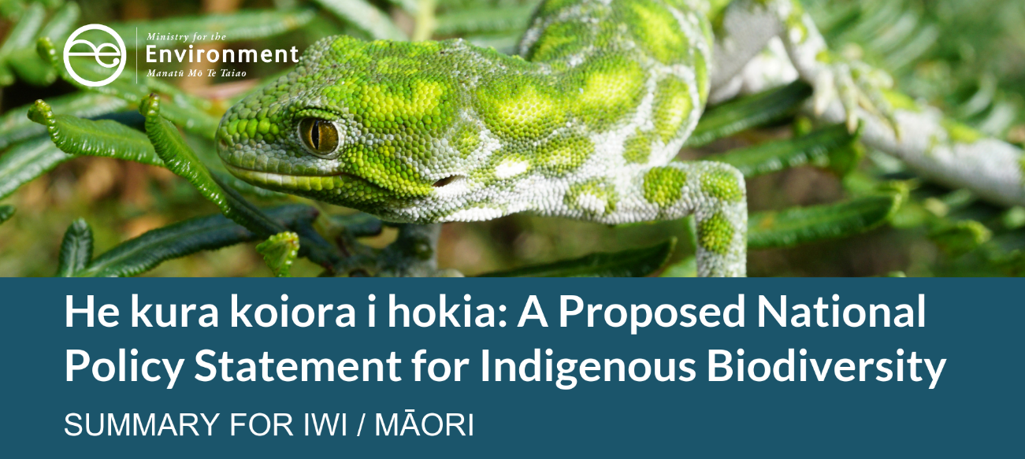

Protecting our native plants, birds and animals
In Aotearoa New Zealand, we have a special relationship with our environment. Whether accessing areas for mahinga kai or gathering rongoā, te taiao is important
to us all.
As New Zealanders, biodiversity is a part of our identity. However, our nature is facing a crisis. The indigenous plants and animals of Aotearoa are in serious decline. Around 4000 of our native species have been identified as threatened with or at risk of extinction. Some of these native plants and animals will disappear forever if we don’t work together to increase our national efforts to reverse the decline and restore what has been lost.
Indigenous biodiversity is the variety of native plants and animals and the habitats they live in which are found nowhere else in the world. In Aotearoa this includes forests, regenerating bush, native scrub and grasslands, streams and rivers, and native insects and animals.

The context for a National Policy Statement
The proposed National Policy Statement for Indigenous Biodiversity (the proposed NPS) sits in a wider context of the vision and goals for biodiversity in Aotearoa.
Recently, the Government consulted on an updated Biodiversity Strategy for Aotearoa. The strategy, which is non-regulatory, proposes five system shifts. Actions proposed under these system shifts include:
- a review of current biodiversity monitoring systems
- a data commons for biodiversity information
- increased collaboration with treaty partners
- Māori conservation training programmes
- biodiversity hubs around Aotearoa
- incentives for covenants.
The new Biodiversity Strategy will provide the overarching direction for biodiversity – while the proposed NPS will be one of its regulatory tools.
The main objective of the proposed NPS is to maintain indigenous biodiversity under the Resource Management Act 1991 (RMA). Managing significant natural areas and other provisions will ensure biodiversity is maintained overall, including no reductions in the following:
- the size of populations of indigenous species
- indigenous species occupancy across their natural range
- the function of ecosystems and habitats
- the full range and extent of ecosystems and habitats
- connectivity between, and buffering around, ecosystems
- the resilience and adaptability of ecosystems.
The proposed NPS is consistent with the purpose of the RMA, which is to promote the sustainable management of natural and physical resources.
The Government is undertaking a comprehensive review of the RMA, which began in July 2019. The intention is that this proposed NPS is implemented regardless of the possible changes to the RMA.

Creating a National Policy Statement
The first draft of the proposed NPS was developed by the stakeholder-led Biodiversity Collaborative Group. The group comprises industry representatives, environmental groups, and an iwi advisor to the Iwi Chairs’ Forum. The Ministry for the Environment and the Department of Conservation have worked together, with advice from our Treaty Partner, to further develop the Biodiversity Collaborative Group’s draft proposed National Policy Statement.

What would the proposed policy mean for Māori?

Te ao Māori and the Treaty of Waitangi provide a foundation
The proposed policy has Hutia te Rito as a fundamental concept to achieve an integrated and holistic approach to maintaining indigenous biodiversity. The concept of Hutia te Rito recognises that the health and wellbeing of our environment – its ecosystems and unique indigenous plants and animals – have intrinsic value. Our dependence on the environment comes with a responsibility to look after it. This concept filters through all parts of the proposed policy and how it would be led and implemented by councils with guidance from hapū, iwi and communities.
Having Hutia te Rito at the heart of the proposed NPS recognises the importance of te ao Māori in the environmental management system of Aotearoa. The proposed NPS takes into account the Treaty of Waitangi and its principles by providing for greater involvement for iwi/Māori as kaitiaki in council activities that plan for, protect and manage indigenous biodiversity processes.

All land tenures are covered
The proposed policy will affect the management of indigenous biodiversity on all types of land including Māori owned land and public and private land. A lot of valuable indigenous biodiversity in Aotearoa is on privately owned and managed land. This includes ecosystems that are poorly, if at all, represented within public conservation land, such as lowland ecosystems.
There is a much higher proportion of Māori land covered in indigenous forest than other land types (except public conservation land). Due to historical restrictions to development on Māori land, this land is much more likely to be identified as a Significant Natural Area under the proposed NPS. The Government acknowledges that this could unfairly impact Māori land owners and Māori Land Trusts. The proposed NPS includes provisions which aim to address this. The goal is not to limit any aspirations for land development but to ensure these aspirations are balanced with the need to maintain the flora and fauna that is unique to Aotearoa. The intension of the proposed NPS, with respect to Māori land, is to ensure the productive use of Māori land will enhance the social, cultural or economic wellbeing of tangata whenua.

Identifying taonga
There is no clear RMA process for hapū and iwi to proactively identify their kaitiaki responsibility to taonga species and ecosystems. The process is applied differently between regions and relies on a good relationship between councils and tangata whenua.
The proposed provisions will require identification of ecological taonga by hapū and iwi to be achieved through describing and mapping, or simply describing the taonga and its values. They will then require adverse effects on taonga to be avoided if the taonga is also a Significant Natural Area or contained in a Significant Natural Area. For taonga not within a Significant Natural Area, a management approach will need to be decided between tangata whenua and councils.
This provision gives tangata whenua the option of making taonga species known, or not, to the public and establishes appropriate management for taonga. By not publicly identifying taonga, the risk of taonga ecosystems becoming widely known, disturbed and lost would be reduced. The proposed process for identifying and managing taonga is set out in figure 1.
Figure 1: Process for considering and protecting taonga species or ecosystems
Tangata whenua decide whether to identify taonga species or ecosystems
↓
Council and tangata whenua work together to manage taonga species and ecosystems
↙ |  | ↘
Identify and map taonga and values in district and regional plans. | OR | Describe taonga and values (eg, where tangata whenua prefer for the location of the taonga to remain undisclosed).
↘ |  | ↙
If the taonga is also a Significant Natural Area or within a significant natural area, adverse effects on the taonga must be managed, as per Part 3.9 of the proposed National Policy Statement. Adverse effects on taonga that are not significant natural areas or in significant natural areas are to be managed, as necessary, to protect the identified taonga and its values. Councils are also required to work with iwi/Māori to identify opportunities to restore and enhance identified taonga and their values.

Other parts of the proposed NPS
Other parts of the proposed policy that may be of interest to you include specific provisions for:
- creating biodiversity strategies by regional councils
- forestry and farming activities
- how the proposed policy will work in geothermal areas
- monitoring indigenous biodiversity
- restoring and enhancing priority areas.
More detail on these provisions can be found in the full discussion document and the proposed National Policy Statement on the Ministry for the Environment’s website.

What iwi/Māori have already told us
Staff from the Ministry for the Environment and the Department of Conservation undertook early engagement on the proposed policy with hapū and iwi at 23 hui nationwide between November 2018 to April 2019. Early conversations have helped us develop the proposal currently being consulted on. Key themes included:
- People and the environment are inextricably linked. It is important to tell this story and to ensure biodiversity is integrated across domains and into wider government policy.
- Local perspectives and empowerment are important. Any national policy statement needs to allow for local priorities and knowledge to be applied. This includes exploring the use of mātauranga Māori in biodiversity monitoring and reporting, noting the sensitivities around gathering and using this knowledge.
- While the approach to working with councils is supported, most hapū and iwi lack capacity to be fully involved in resource management decision-making. The challenge of resourcing has been a consistent message through early engagement.
- Some whānau, hapū and iwi raised concerns that criteria for Significant Natural Areas would inequitably disadvantage Māori land owners who may want to develop and gain economic benefit from these lands. The approach needs to allow for some land-use change but have incentives to support biodiversity protection.
- As Treaty partners, iwi need to be actively included at every level of the decision-making process. It was recommended that we should incorporate the findings of the Waitangi Tribunal Wai 262 report into the proposed policy.

Implementation support
Timely and effective implementation is essential to deliver the objectives of the proposed NPS and realise positive outcomes for indigenous biodiversity.
Hapū and iwi, councils and land owners are all at different stages of their indigenous biodiversity work programmes and the proposed NPS could be a big change for some groups. Implementation is likely to take time and be costly; however, the short-term costs of implementation are necessary to realise long-term intergenerational benefits. Tangata whenua are likely to see an increase in time and monetary costs in resourcing their increased involvement in resource management decision-making.
We want to know what support would be most useful for iwi/Māori to effectively resource this involvement and to implement provisions of the proposed policy on Māori land and within each rohe.

Next steps
The consultation on the proposed National Policy Statement for Indigenous biodiversity opened on 26 November 2019 and will run until 14 March 2020. We will seek your advice and guidance at hui being led by the Ministry. In addition, there will be testing of provisions in the proposed policy with councils and workshops with stakeholders.
After the consultation period closes, staff from the Ministry and the Department of Conservation will summarise and analyse submissions before providing advice to the Ministers. Following this, Ministers will make final policy decisions about the National Policy Statement for Indigenous Biodiversity. The National Policy Statement is anticipated to be in place in 2020.

A few questions you might like to think about
Below are some questions from our discussion document that might guide your whakaaro on this proposal. You can find additional consultation questions in our discussion document.
- Hutia te Rito recognises that the health and wellbeing of te taiao is vital to our own health and wellbeing. This will be the underlying concept of the proposed NPSIB. Does the proposed policy provide enough information on Hutia te Rito and how it should be implemented? Is there anything else that should be added to reflect te ao Māori in managing indigenous biodiversity?
- What opportunities and challenges do you see for the way in which councils would be required to work with tangata whenua when managing indigenous biodiversity?
- What information and resources would support the enhanced role of tangata whenua in indigenous biodiversity management?
- Local authorities will need to consider opportunities for tangata whenua to exercise kaitiakitanga over indigenous biodiversity, including by allowing for sustainable customary use of indigenous flora. Do you think the National Policy Statement for Indigenous Biodiversity appropriately provides for customary use?
- Territorial authorities will need to identify, map and schedule Significant Natural Areas in partnership with tangata whenua, landowners and communities. What logistical issues do you see with mapping these areas and what has been limiting this mapping from happening?
- Do you think the proposed NPS adequately provides for the development of Māori land?

Make a submission
You can submit your feedback during the consultation period using one of the following options:
- Use our submission tool available at www.mfe.govt.nz/consultations/nps-indigenous-biodiversity. You do not need to answer all these questions.
- Read the questions in the discussion document and email your views to indigenousbiodiversity@mfe.govt.nz.
- Or post your answers to the Biodiversity Team, Ministry for the Environment,
PO Box 10 362, Wellington 6143.
The deadline for submissions is 5.00pm 14 March 2020.

Find out more
Formal consultation runs from 26 November 2019 to 14 March 2020.
- Access the full discussion document and make a submission online at: www.mfe.govt.nz/consultations/nps-indigenous-biodiversity.
- Contact us by email with any queries at: indigenousbiodiversity@mfe.govt.nz.
- Attend a hui in your area.

Published in January 2020 by
Manatū Mō Te Taiao
Publication number: INFO 925

