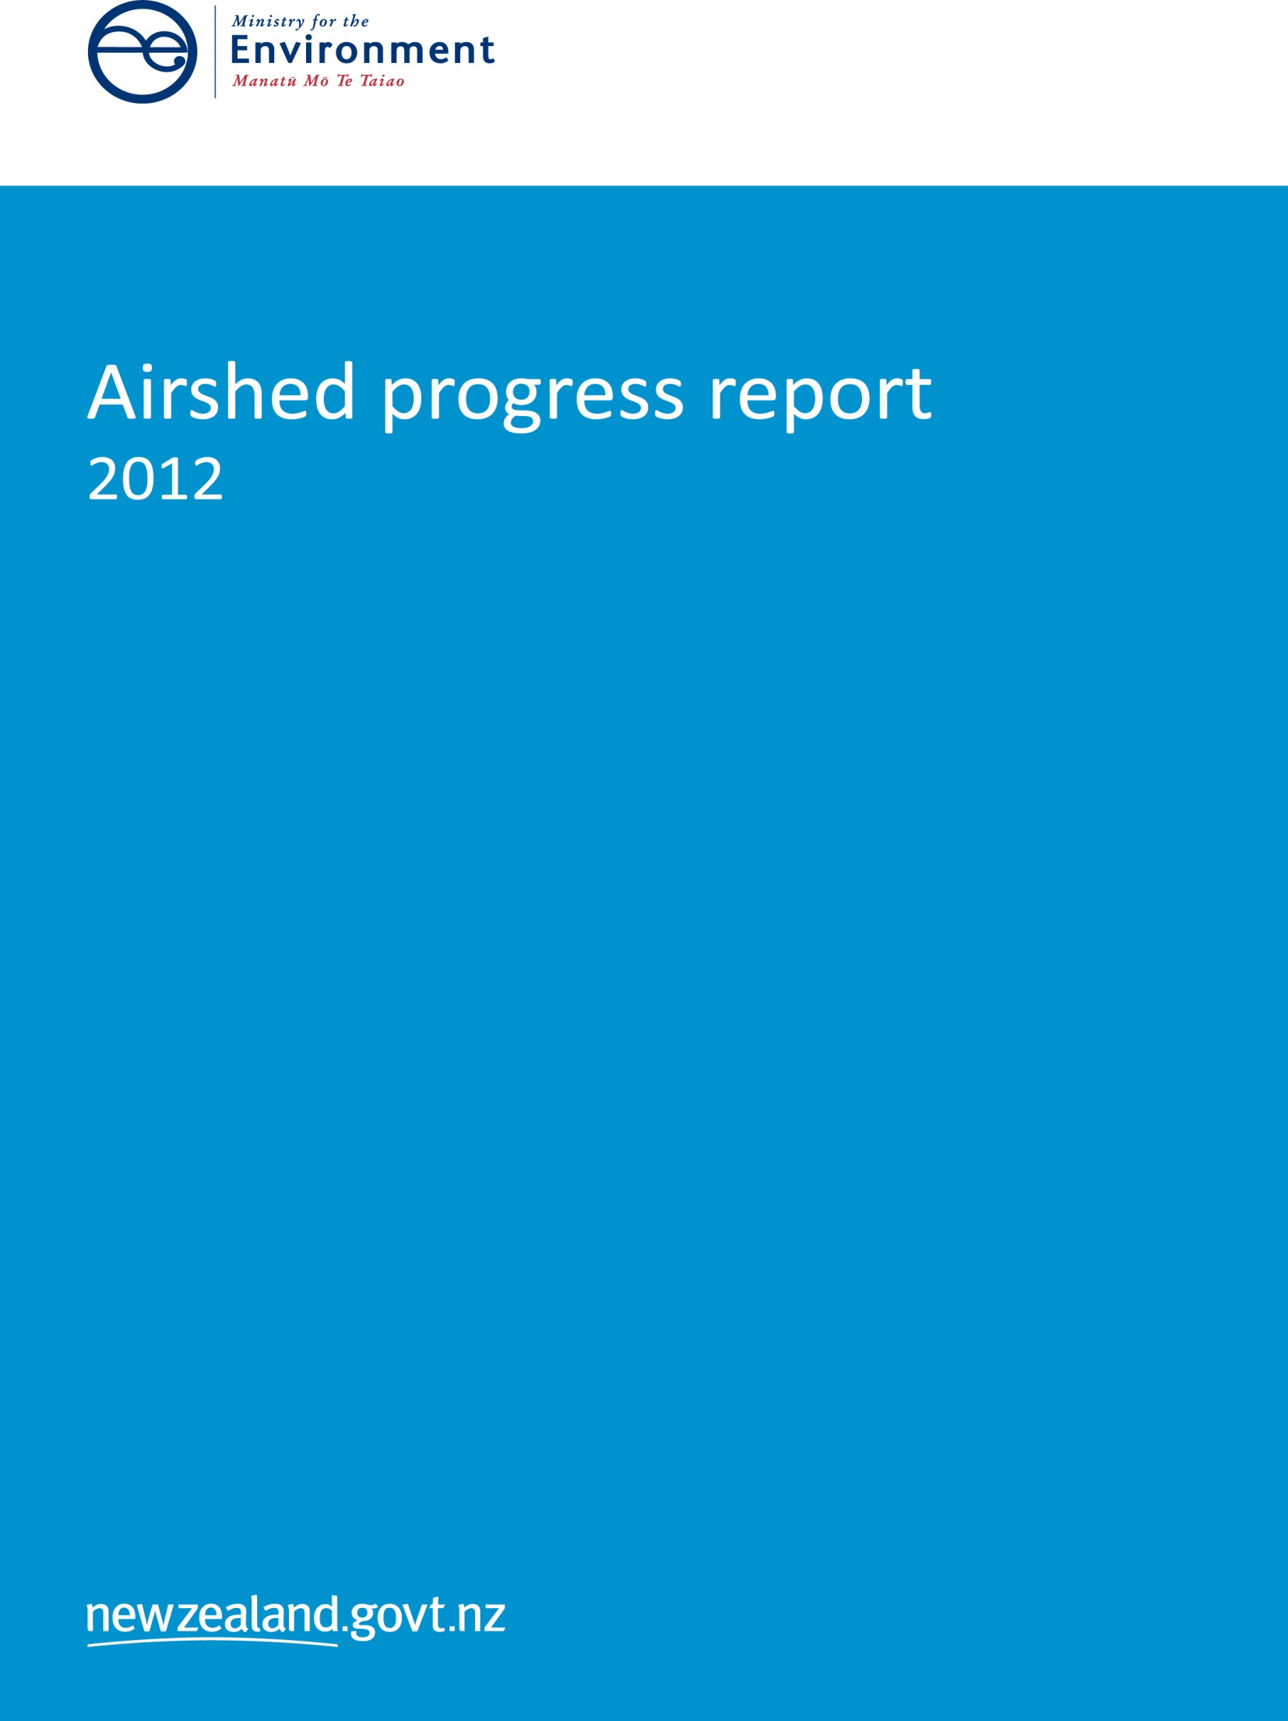

This report may be cited as:

Ministry for the Environment. 2014. *Airshed Progress Report 2012*. Wellington: Ministry for the Environment.

Published in December 2014 by the  
Ministry for the Environment   
Manatū Mō Te Taiao  
PO Box 10362, Wellington 6143, New Zealand

ISBN: ISBN-978-0-478-41253-6  
Publication number: ME 1160

© Crown copyright New Zealand 2014

This document is available on websites of the Ministry for the Environment [www.mfe.govt.nz](http://www.mfe.govt.nz).



# Contents

1 Introduction 5

2 Airshed description 6

3 Emissions profile 7

Introduction 7

Domestic heating 7

Transport 8

Industrial and commercial activities 8

4 Monitoring air quality 9

Introduction 9

Monitoring results 9

5 Managing air quality 12

Introduction 12

Ambient air quality standard for PM10 13

6 Regional air plans 15

Introduction 15

Summary of regional rules 15

7 Impacts of air quality management programmes 19

Introduction 19

Air quality impacts on pollution 19

Community awareness 26

The costs to councils of managing air quality 27

Appendix A: Airshed description by region 28

# Tables

Table 1: Compliance timeframes for airsheds monitored in 2012 9

Table 2: Airsheds with the highest annual number of exceedances of the PM10 standard, 2006–2012 10

Table 3: Implementation of the prohibited activity provisions of the National Environmental Standard for Air Quality 14

Table 4: Summary of more stringent regional air plan rules 16

# Figures

Figure 1: Number of exceedances of the PM10 standard, by airshed (2012) 10

Figure 2: Airsheds monitored in New Zealand (2012) 11

Figure 3: Example of a breach notification (Otago) 13

Figure 4: Timeline showing councils’ work on regional air plans 17

Figure 5: Number of exceedances by region in the North Island (2008–2012) 20

Figure 6: Number of exceedances by region in the South Island (2008–2012) 21

Figure 7: Highest 24-hour average PM10 concentration by region in the North Island   
(2008–2012) 22

Figure 8: Highest 24-hour average PM10 concentration by region in the South Island   
(2008–2012) 23

Figure 9: Total number of exceedances (2010–2012) 24

Figure 10: PM10 levels of exceedances (2010–2012) 24

Figure 11: Reductions in air pollution in Nelson A airshed 25

# 1 Introduction

In 2004, New Zealand adopted the National Environmental Standards for Air Quality (NES) to set acceptable levels for air quality.

The Ministry for the Environment published the *National Air Quality Compliance Strategy to Meet the PM10 Standard* to help councils achieve compliance with the standard for ambient PM10 (particulate matter 10 micrometres or less in diameter). This sets out a toolkit of activities, ranging from education through to action, which regional councils and unitary authorities may adopt to meet the ambient PM10 standard.

The Standards provide three dates by which councils need to comply with the PM10 standard.

* Airsheds with one or fewer exceedances had to achieve no more than one exceedance from 1 September 2011.
* Those airsheds below 10 exceedances (averaged over 5 years) but above one must achieve one or fewer by 2016.
* All airsheds with more than 10 exceedances must achieve three or fewer by 2016, and one or fewer by 2020.

Monitoring against the 2011 compliance strategy began in September 2013. This is the first report on councils’ progress in implementing the NES and whether they are on track to meet the standards within it. It presents information collected by regional councils and unitary authorities in 2012.

This report is structured as follows:

* *Chapter 2 Airshed description*: includes information on the location, scope and socio-economic profile of gazetted airsheds across New Zealand.
* *Chapter 3 Emissions profile*: provides an overview of the main emission sources in airsheds based on emissions inventory results provided by councils.
* *Chapter 4 Monitoring air quality*: provides PM10 monitoring results for the 38 airsheds monitored in 2012.
* *Chapter 5 Managing air quality*: discusses the implementation of key provisions of the Standards, including the prohibited activity standards, notification of breaches and the industry offset provision.
* *Chapter 6 Regional air plans*: provides a summary of the development of regional air plans and rules within these plans, and a relevant case study.
* *Chapter 7 Impacts of air quality management programmes*: discusses air quality trends from 2008 to 2012, together with air quality management costs, community awareness and the challenges councils faced in implementing and complying with the Standards. Case studies are included.
* *Appendix Airshed description by region*: provides a description of gazetted airsheds by region.

# 2 Airshed description

In New Zealand, air quality is managed by ‘airsheds’ (also known as ‘gazetted airsheds’). In this context, the term ‘airshed’ can be considered to mean an ‘air quality management area’ (ie, an area delineated by the regional council for the purposes of managing air quality). The term airshed is analogous to ‘catchments’ or ‘watersheds’ used in the management of rivers.

Councils have identified and made public (through the *New Zealand Government Gazette*) populated areas that are known, or have the potential, to have air quality which exceeds the national air quality standards. Some airsheds are also identified based on factors such as the number of people living in the airshed, its unique weather patterns and geography, or because local air emissions (eg, local industrial activity) need to be managed separately. These cover about one and a half per cent of New Zealand’s total land area, and are where an estimated two-thirds of New Zealanders live.

Following the introduction of the NES for Air Quality Standards, 71 airsheds have been identified and gazetted. Thirty-eight of these were monitored in 2012.

Identifying the geographic and socio-economic characteristics of the airsheds within each region gives an insight into some of the factors that may affect air quality management decisions.

Councils managing airsheds that breach the PM10 standard must plan to improve air quality and take into account the unique characteristics of each airshed.

The location of each of the 71 airsheds is shown by region in the appendix.

# 3 Emissions profile

## Introduction

Air quality is affected by emissions from different sources, particularly domestic heating. Adverse health impacts around the country are attributed to air pollution from all sources. Identifying the sources of emissions to air means that air quality management can be focused to more effectively manage air pollution.

Regional councils and unitary authorities were asked to provide information on the emission sources in their airsheds and include summary results of emission inventories. Fifteen out of 16 councils provided information on the emission profiles for either their region as a whole, or for each of their airsheds.

This chapter looks at the sources that regional councils and unitary authorities have identified as emission sources, particularly for PM10. There is a range of emission sources, which include:

* domestic heating
* transport
* industrial and commercial activities
* outdoor burning.

The extent to which each of these sources contributes to air pollution varies significantly between winter and the rest of the year. For example, in winter, 72 per cent of emissions in Auckland come from domestic heating, compared with four per cent of emissions during summer.

## Domestic heating

Domestic heating was identified by all 15 councils as a major source of emissions to air, and it makes up a significant proportion of PM10 concentrations in particular. Thirteen councils identified domestic heating as the main source of PM10 emissions in all of their airsheds, and the other two councils identified domestic heating as the main source of PM10 in some of their airsheds.

Of the 15 councils, two provided information on emissions for both the winter season and for the rest of the year. For these two councils, the proportion of emissions from domestic heating in winter (May to August) ranged from 72 per cent to 92 per cent, and through the rest of the year it ranged from zero per cent to 59 per cent.

Three councils provided information on emissions for the winter season only. For these councils, the proportion of emissions from domestic heating ranged from 67 per cent to 99 per cent.

Ten councils did not identify which season, if any in particular, their emissions profile related to. Two of these councils did not provide data on the proportion of emissions specifically from domestic heating, while the remaining eight councils identified that the proportion of emissions from domestic heating ranged from 43 per cent to 96 per cent.

## Transport

Transport was identified by the majority of councils as another major source of PM10 emissions. Eleven councils stated that transport was in the top three most significant sources of PM10 for at least one of their airsheds.

The two councils that provided information on emissions for the whole year stated that the proportion of emissions from transport in winter could go up to 16 per cent, while for the rest of the year it ranged from 8 per cent to 85 per cent.

Councils that provided information only on winter emissions stated that the proportion of emissions from transport in winter ranged between one per cent and 14 per cent.

Councils that did not identify which season their emissions related to stated that the proportion of emissions from transport ranged between less than one per cent and   
17 per cent.

## Industrial and commercial activities

Industrial and commercial activities are also a major source of PM10 emissions. Ten councils stated that industrial and commercial activities were in the top three most significant sources of PM10 for at least one of their airsheds.

Airsheds where industrial and commercial activities are the primary emission sources are typically industrial. As with other sources, the proportion of total emissions varies between winter and the rest of the year.

The two councils that provided information on emissions for the whole year stated that the proportion of winter emissions from industrial and commercial activities ranged from two per cent to 19 per cent, and could rise to 22 per cent during the rest of the year.

Councils that provided information only for winter stated the proportion of emissions from industrial and commercial activities ranged between one per cent and 22 per cent.

Councils that did not identify which season their emissions related to stated that the proportion of emissions from industrial and commercial activities ranged from one per cent to 39 per cent.

Emission sources for PM10 included a mix of domestic heating, transport and industrial activities. Emission inventory data have shown that domestic heating makes up a significant proportion of PM10 emissions in all regions, particularly during winter.

# 4 Monitoring air quality

## Introduction

The NES for PM10 is exceeded whenever daily PM10 concentrations in an airshed are above the limit of 50μg/m3. When this happens people are exposed to short-term air quality worse than that allowed under the PM10 standard. Monitoring air quality allows us to know the number of times this exposure occurs.

The compliance timeframes for each of the 38 airsheds monitored in 2012 is shown in table 1. The staggered timeframes reflect the extent of air quality issues experienced across the airsheds in recent years and the varying degrees of effort required to meet the PM10 standard of no more than one exceedance per year.

## Monitoring results

All 13 airsheds required to comply with the PM10 standard by 2011 did so. Of the remaining 25 airsheds monitored in 2012, 12 need to meet the standard by 2016 and 13 have a timeframe of 2020 (table 1). Of these 25 airsheds, six had levels that met the standard in 2012.

The number of exceedances for all airsheds monitored in 2012 is shown in figure 1. The three airsheds that exceeded the PM10 standard most often in 2012 were Otago 1 (50 exceedances of the standard), Timaru (34), and Reefton (27). The highest number of exceedances in 2012 was lower than in 2011, continuing the declining trend begun in 2010. Eight of the 10 airsheds that recorded the highest number of exceedances in New Zealand are in the South Island.

The 10 airsheds with the highest number of annual exceedances in each of the seven years from 2006 to 2012 are shown in table 2.

The airsheds monitored in 2012 are shown in figure 2.

Table 1: Compliance timeframes for airsheds monitored in 2012

|  |  |  |
| --- | --- | --- |
| 2011 | 2016 | 2020 |
| Hamilton City | Auckland | Ashburton |
| Kumeu | Blenheim | Christchurch |
| Lower Hutt | Geraldine | Hastings |
| Matamata | Gore | Invercargill |
| Ngaruawahia | Napier | Kaiapoi |
| Porirua | Nelson B | Nelson A |
| Taihape | Otago 3 | Otago 1 |
| Taumarunui | Putaruru | Reefton |
| Turangi | Rangiora | Richmond |
| Upper Hutt | Taupo | Rotorua |
| Wainuiomata | Te Kuiti | Timaru |
| Wellington | Wairarapa | Tokoroa |
| Whangarei |  | Waimate |

Figure 1: Number of exceedances of the PM10 standard, by airshed (2012)

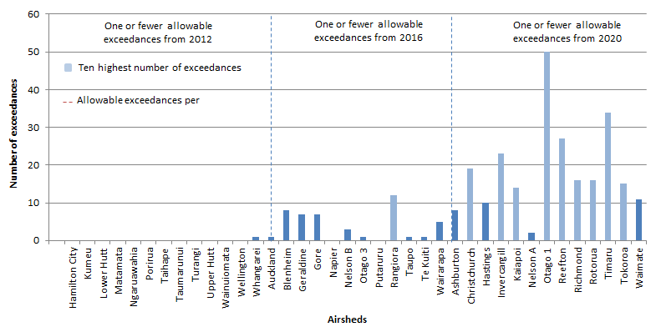

Table 2: Airsheds with the highest annual number of exceedances of the PM10 standard, 2006–2012

|  |  |  |  |  |  |  |  |
| --- | --- | --- | --- | --- | --- | --- | --- |
| **Rank** | **2006** | **2007** | **2008** | **2009** | **2010** | **2011** | **2012** |
| 1 | Nelson A (51) | Otago 1 (55) | Otago 1(1) (91) | Otago 1 (60) | Otago 1 (76) | Otago 1 (61) | Otago 1 (50) |
| 2 | Otago 1 (50) | Timaru (36) | Otago 2(2) (46) | Timaru (36) | Otago 2 (47) | Christchurch (34) | Timaru (34) |
| 3 | Richmond (37) | Rotorua (29) | Rotorua (39) | Otago 2(35) | Timaru (39) | Timaru (30) | Reefton (27) |
| 4 | Timaru (36) | Nelson A (26) | Timaru (37) | Nelson A (34) | Invercargill (35) | Otago 2 (25) | Invercargill (23) |
| 5 | Christchurch (29) | Reefton (25) | Hastings (28) | Rotorua (27) | Kaiapoi (23) | Kaiapoi (23) | Christchurch (19) |
| 6 | Kaiapoi (28) | Richmond (21) | Nelson A (25) | Kaiapoi (23) | Reefton (22) | Otago 3 (17) | Richmond 16) |
| 7 | Ashburton (26) | Kaiapoi (20) | Christchurch (22) | Richmond (21) | Rotorua (16) | Rotorua (16) | Rotorua (16) |
| 8 | Nelson B (24) | Christchurch (17) | Richmond (20) | Tokoroa (17) | Tokoroa (16) | Ashburton (15) | Tokoroa (15) |
| 9 | Rotorua (23) | Ashburton (13) | Kaiapoi (19) | Reefton (16) | Christchurch (15) | Nelson A (15) | Kaiapoi (14) |
| 10 | Hastings (18) | Hastings (13) | Reefton (18) | Christchurch (15) | Hastings (15) | Invercargill and Hastings (12) | Rangiora (12) |

1 From 2008, results represent the consolidation of Alexandra, Arrowtown, Clyde and Cromwell data.  
2 From 2008, results represent the consolidation of Mosgiel and Milton.

Figure 2: Airsheds monitored in New Zealand (2012)

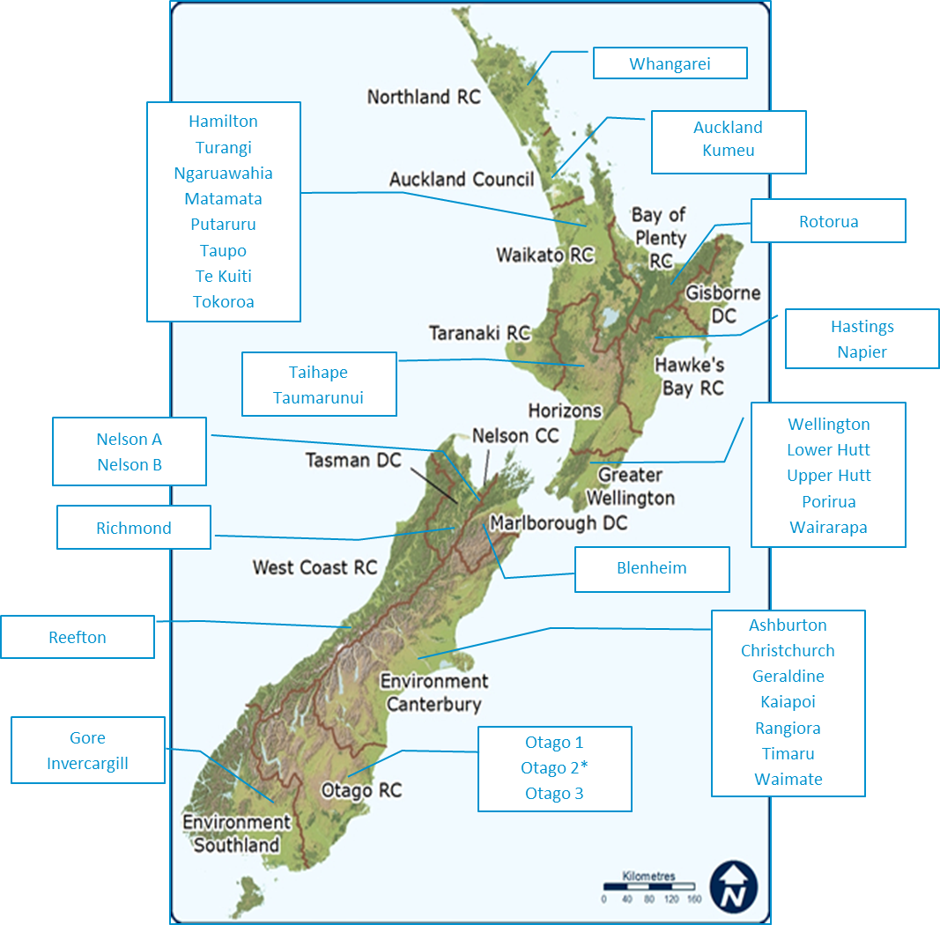

* Although this airshed was monitored in 2012, there was insufficient valid data to determine annual exceedances and highest daily levels for PM10.

# 5 Managing air quality

## Introduction

In October 2004, the Government introduced the National Environmental Standards for air quality (the air quality standards). These air quality standards were issued as regulations in accordance with sections 43 and 44 of the RMA.

This section discusses the implementation of the seven standards banning activities that discharge significant quantities of dioxins and other toxics into the air, the notification of breaches of the ambient air quality standards, and the industry offset requirements.

### Prohibited activity standards

The National Environmental Standard for Air Quality (NESAQ) requires regional councils and unitary authorities to ban seven activities which discharge dioxins and other toxics into the air. These bans came into effect on 8 October 2004 and are covered by the following regulations:

* Regulation 6: Lighting of fires and burning of waste at landfill
* Regulation 7: Burning of tyres
* Regulation 8: Burning of bitumen
* Regulation 9: Burning of coated wire
* Regulation 10: Burning of oil
* Regulation 11: Incinerators at schools and healthcare institutions
* Regulation 12: High-temperature hazardous waste incinerators.

Councils have previously identified that it was fairly simple to implement these bans. Most have already incorporated them in their air plans or would do so during the next review of their plan.

### Breaches in 2012

There were 29 breaches of these bans in 2012, with 72 per cent involving the burning of tyres. The burning of coated wire and oil in open air made up 20 per cent of breaches, with the remaining eight per cent due to the lighting of fires and burning of wastes at landfills, and the operation of an incinerator at a school or healthcare institution.

Of the 16 existing resource consents for activities covered by the regulations, 63 per cent were for operating incinerators in schools. Council implementation of the prohibited activity bans is shown in table 3.

## Ambient air quality standard for PM10

### Notification of breaches

Regulation 16 requires councils to give public notice if the Standards are breached in an airshed within their regions. This notice needs to be made at least once a month and must include the name of the contaminant, the date, place, and extent to which the Standards were breached.

Most councils notified breaches on a monthly basis. Breaches were also notified daily during winter, annually or within 30 days of the breach occurring. Some councils notified breaches in multiple ways. A third of councils published notices in both the local newspaper and on the council website. Overall, the most widely used medium for notifying breaches was the local newspaper. An example of a breach notification is shown in figure 3.

Figure 3: Example of a breach notification (Otago)

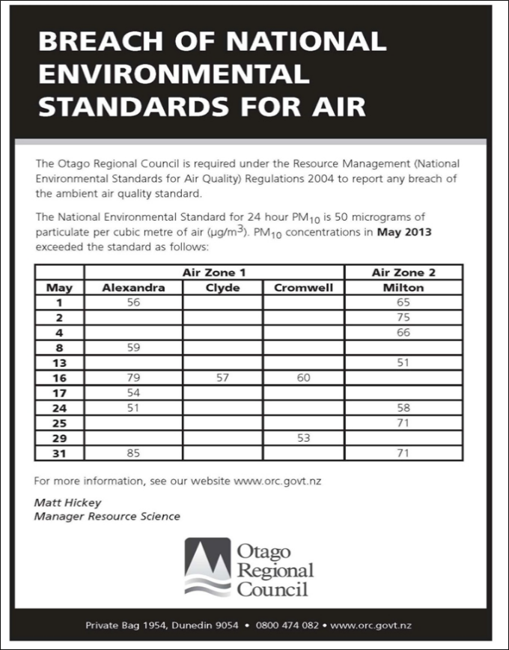

Source: Otago Regional Council.

### Industry offset provisions

The offsets provisions in the Standards require new industry in a polluted airshed to offset its discharge if the effects of this discharge exceed the set limits. The offsets provisions came into effect in September 2012.

So far, no resource consent applications have required the offsetting of discharges. However, it has been reported that, to avoid the costs of complying with the offsets provisions, applicants have opted to either modify their plans (eg, limiting production, altering emission points) or not pursue the development or future expansion.

Table 3: Implementation of the prohibited activity provisions of the National Environmental Standard for Air Quality

| Regulation | | NRC | AC | WRC | HBRC | TRC | BOPRC | Horizons | GDC | GWRC | NCC | MDC | TDC | ECan | ORC | ES | WCRC | Total |
| --- | --- | --- | --- | --- | --- | --- | --- | --- | --- | --- | --- | --- | --- | --- | --- | --- | --- | --- |
| Reg 6 | Included in air plan? | No | Yes | Yes | No | Yes | Yes | Yes* | No | No | Yes | No | No | Yes | No | No | Yes |  |
| Breaches | 0 | 0 | 0 | 0 |  | 0 |  |  | 0 |  |  | 0 | 0 | 1 | 0 | 0 | 1 |
| Consents | 3 | 0 | 0 | 0 |  | 0 |  |  | 0 |  |  | 0 | 0 | 0 | 0 | 0 | 3 |
| Reg 7 | Included in air plan? | Yes | Yes | Yes | Yes | Yes | Yes | Yes | No | No | Yes | Yes | Yes | Yes | Yes | No | Yes |  |
| Breaches | 2** | 1 | 8 | 2 |  | 4 |  |  | 2 |  |  | 0 | 1 | 0 | 0 | 0 | 20 |
| Consents | 0 | 1 | 0 | 0 |  | 0 |  |  | 0 |  |  | 0 | 0 | 0 | 0 | 0 | 1 |
| Reg 8 | Included in air plan? | No | Yes | Yes | No | Yes | Yes | Yes | No | No | Yes | Yes | Yes | Yes | Yes | No | No |  |
| Breaches | 0 | 0 | 0 | 0 |  | 0 |  |  | 0 |  |  | 0 | 0 | 0 | 0 | 0 | 0 |
| Consents | 0 | 0 | 0 | 0 |  | 0 |  |  | 0 |  |  | 0 | 0 | 0 | 0 | 0 | 0 |
| Reg 9 | Included in air plan? | Yes | Yes | Yes | Yes | Yes | Yes | Yes | No | No | Yes | Yes | Yes | Yes | Yes | No | Yes |  |
| Breaches | 2** | 0 | 0 | 2 |  | 0 |  |  | 0 |  |  | 0 | 1 | 0 | 0 | 0 | 5 |
| Consents | 0 | 0 | 0 | 0 |  | 0 |  |  | 0 |  |  | 0 | 0 | 0 | 0 | 0 | 0 |
| Reg 10 | Included in air plan? | No | Yes | *** | No | Yes | Yes | Yes | No | No | Yes | Yes | Yes | Yes | Yes | No | Yes |  |
| Breaches | 0 | 0 | 0 | 0 |  | 0 |  |  | 0 |  |  | 0 | 2 | 0 | 0 | 0 | 2 |
| Consents | 0 | 0 | 0 | 0 |  | 0 |  |  | 0 |  |  | 0 | 0 | 1 | 0 | 0 | 1 |
| Reg 11 | Included in air plan? | No | Yes | No | No | Yes | Yes | Yes | No | No | Yes | No | No | No | Yes | No | No |  |
| Breaches | 0 | 0 | 0 | 0 |  | 0 |  |  | 0 |  |  | 0 | 1 | 0 | 0 | 0 | 1 |
| Consents | 7 | 0 | 13**** | 0 | 1 | 0 |  | 4**** | 0 |  |  | 0 | 2 | 0 | 0 | 0 | 10 |
| Reg 12 | Included in air plan? | No | Yes | ++ | No | Yes | No | Yes | No | No | Yes | No | No | No | Yes | No | No |  |
| Breaches | 0 | 0 | 0 | 0 |  | 0 |  |  | 0 |  |  | 0 | 0 | 0 | 0 | 0 | 0 |
| Consents | 0 | 0 | 0 | 0 | 1 | 0 |  |  | 0 |  |  | 0 | 0 | 0 | 0 | 0 | 1 |

* This relates to the Proposed One Plan. ** Median of range provided. *** Only waste oil and other waste petroleum products are specifically prohibited. **** Resource consents for 13 school incinerators and four rural schools within the region. ++ While high-temperature incinerators are not specifically addressed, the incineration of pathological waste and other hazardous wastes are prohibited.

# 6 Regional air plans

## Introduction

Regional councils and unitary authorities are required to manage discharges of contaminants into air, under the Resource Management Act. By 2003, most had developed ‘first generation’ air plans, or included a section in their regional plans, which included polices and rules for discharges to air.

After the Standards were introduced in 2004, councils updated their plans to give effect to them. This led to some councils changing their plans, while other councils developed ‘second generation’ plans.

Because councils must review their plans every 10 years (RMA section 79), a number of councils are currently doing so. Some councils have also undertaken monitoring of the efficiency and effectiveness of their policies under section 35(2A). Reviewing their plans has provided these councils with the opportunity to align them with the Standards, which were amended in 2011.

Figure 4 shows the timeline of councils’ work on regional air plans from 1997 to 2013.

## Summary of regional rules

Some regional councils and unitary authorities have established more stringent regulatory frameworks because of the scale of improvements needed for their airsheds to comply with the air quality standards. These particularly apply to domestic heating emissions. Councils that have established more stringent rules include Environment Canterbury, Nelson City Council, Otago Regional Council, Hawke’s Bay Regional Council, Tasman District Council, Bay of Plenty Regional Council (through Rotorua District Council), and Auckland Council.

Examples of more stringent regional rules also include bans on backyard burning in urban areas, rules covering all types of solid fuel burners in specific airsheds, phased bans on the use of open fires, coal and multi burners in urban areas, and bans on the installation of solid-fuel burners in homes that previously did not have a burner. A summary of more stringent regional rules is in table 4.

In 2010, Bay of Plenty Regional Council and Rotorua District Council collaborated to establish an Air Quality Control Bylaw. This enabled them to establish and implement rules faster than at the regional level, and to target the rules within the Rotorua airshed. Auckland Council and Waikato Regional Council are also exploring the introduction of by-laws. Wellington Regional Council has favoured a non-regulatory approach in addressing the problem of PM10 from domestic fires, as the problem was confined to one area within the airshed.

Table 4: Summary of more stringent regional air plan rules

| Council | Regional rules |
| --- | --- |
| Auckland Council | Applies the National Environmental Standard for Air Quality (NESAQ) emission and efficiency limits to all solid-fuel burners (eg, multi-fuel burners, cookers). |
| Bay of Plenty Regional Council (through the Rotorua District Council) | Established an Air Quality Control Bylaw in 2010, which includes requiring only pellet burners and compliant wood burners to be installed within the airshed, requiring solid-fuel burner upgrades when homes are sold and banning indoor open fires. |
| Hawke’s Bay Regional Council | More stringent solid-fuel burner emission in effect in Hastings Airzone 1 (1.0 g/kg).  Applies the NESAQ emission and efficiency limits to all solid-fuel burners.  Staged bans on the use of older, non-compliant solid-fuel burners (1 January 2014, 2016, 2018, 2020).  Requirement to comply with solid-fuel burner standards extended to burners installed in properties greater than two hectares. |
| Nelson City Council | Applies the NESAQ emission and efficiency limits to all solid-fuel burners.  Staged bans on the use of older solid-fuel burners.  Ban on the installation of new burners in new homes and where none previously existed.  Open fires can only be replaced with non-polluting heating appliances (eg, heat pump, flued gas heater, authorised pellet fire). |
| Tasman District Council | Ban on the installation of new burners in new homes and where none previously existed.  Ban on the use of non-compliant burners after a house is sold. These fires may be replaced with a compliant fire.  Requiring burner operation without the creation of excessive smoke. |
| Environment Canterbury | Refer to case study 1. |
| Otago Regional Council | More stringent solid-fuel emission rule in effect in Airshed 1 (0.7 g/kg).  Requirement to replace existing non-compliant burners before January 2012.  Setting a regional PM10 goal level of 35 ug/m3 as an objective standard. |

Figure 4: Timeline showing councils’ work on regional air plans

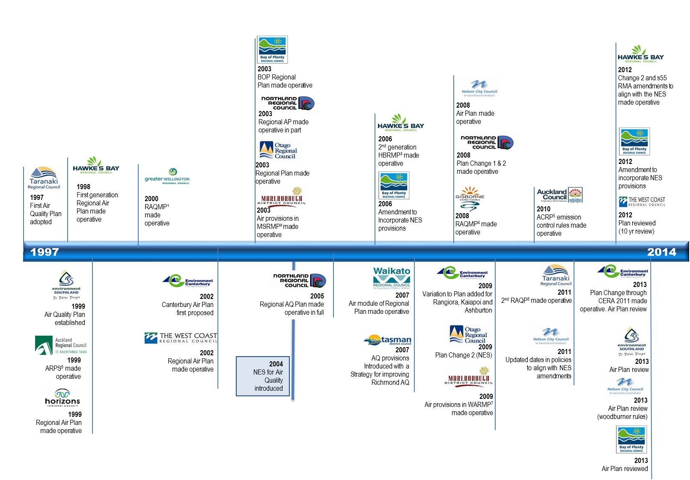

1 Regional Air Quality Management Plan

2 Marlborough Sounds Resource Management Plan

3 Hawke’s Bay Regional Resource Management Plan

4 Regional Air Quality Management Plan

5 Auckland Council Regional Plan: Air Land and Water

6 Auckland Regional Policy Statement

7 Wairau/Awatere Resource Management Plan

8 Regional Air Quality Plan

NES – National Environmental Standards

Case study 1: Environment Canterbury Regional Council’s Air Plan and strategy (Christchurch)

The introduction of the Standards has provided more clarity on the need for effective air quality management and has supported Environment Canterbury’s efforts to improve air quality through the Canterbury Air Quality Plan (the Air Plan) introduced in 2002 and becoming fully operative in 2011.

The Air Plan includes regulatory and non-regulatory measures for activities that may affect Canterbury’s air quality including emissions from home heating, outdoor burning, and industrial discharges. Home heating continues to be the largest source of PM10 emissions in polluted airsheds. Regulatory measures to address these emissions under the current Air Plan include:

* phase out on the use of open fires in Christchurch (since 2006)
* an emission standard of one gram of particulate per kilogram of fuel burnt (g/kg) for small scale fuel burning devices to be installed on properties less than two hectares in size and within polluted airsheds (since 2002 but not operative until 2009)
* an emission standard of 0.5 g/kg for pellet fires (since 2009)
* an emission standard of 0.5 g/kg for ultra-low burners, tested to “real life” conditions applying to Christchurch Clean Air Zone 1 (since 2013).

Environment Canterbury has also developed a new test method for authorising these burners. This method (Canterbury Method 1) aims to reflect how a wood burner is used in real life, thereby assisting in more effectively managing domestic heating emissions. Applicants may also provide an alternative test method for consideration providing that this alternative method meets the key criteria for real life outlined in the Canterbury method. The intent of this standard and test method is to encourage the development of new cleaner wood burning technology and a test method approach that more accurately reflects emissions produced in real life.

Another initiative that Environment Canterbury has implemented is the Let’s Clear the Air campaign. This collaborative initiative with district councils, iwi, and district health boards in the region is the public face of engaging the wider community in helping to clean up the winter time air pollution problem in Canterbury. The website created for the campaign includes messages that tell the Canterbury Air Quality story, raise awareness on the importance of air quality, and prompt household behavioural changes that reduce wood burner emissions through burning better, upgrading to a new cleaner appliance or replacing heating with a non-emitting heating appliance.

This campaign has run since 2012 and more recently has focused on smoke free burning through improved wood burner operation including fuel use (www.letscleartheair.co.nz). Each year the tools and tips have evolved and now include video, the *More Heat No Smoke* Facebook page, smoke free burning brochure, and a flyer that residents can leave in the letterbox of households with a smoky chimney. The campaign also encourages the community to become active participants in air quality management.

Environment Canterbury’s Clean Heat Project in Christchurch operated from 2002 to 2011. This project provided funding assistance for insulation and change-outs to cleaner heating options linking with the Government’s wider insulation subsidies through the Warm Up New Zealand programme. It assisted over 19,000 homeowners to insulate their homes and convert to cleaner forms of heating before it was wound up in 2011.

# 7 Impacts of air quality management programmes

## Introduction

Councils were asked to discuss the impacts of their air quality management activities for the pollutants covered in the Standards. This section focuses on the management of PM10 levels because this is the pollutant of concern in New Zealand airsheds. Councils have carried out a number of activities to improve air quality. The chapter discusses:

* the impact of managing air quality on pollution
* community awareness
* the costs to councils of managing air quality management.

## Air quality impacts on pollution

Air quality monitoring results have shown an overall improvement in air quality. However, the rate of this improvement varies between councils.

Improvements were seen in airsheds where councils have implemented integrated programmes that include more stringent rules, schemes that incentivise a shift to cleaner heating options, and enforcement regimes.

While some airsheds had improved levels of air quality in 2012, a number of airsheds have had fluctuating, or no, reductions in PM10 since 2008. Figures 5 – 8 show the 5-year trends for exceedances and PM10 levels in airsheds with more than one exceedance of the PM10 standard.

Figure 9 shows the progress councils have made since 2010. It shows the reductions in the total number of exceedances of the Standards from 2010 to 2012. While the South Island has experienced improved air quality, as expected, its exceedances are significantly higher than the North Island. The North Island’s PM10 levels, on the other hand, increased slightly in 2012, but were just over a fifth of the total South Island exceedances for that year.

The PM10 levels of exceedances across the country have improved and are shown in figure 10. The proportion of PM10 concentrations closer to the 50 micrograms per cubic metre standard has steadily increased between 2010 and 2012.

Figure 5: Number of exceedances by region in the North Island (2008–2012)

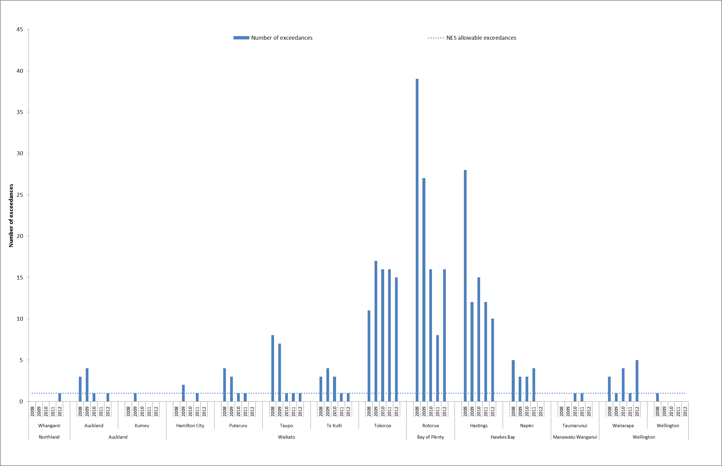

Source: Regional councils’ and unitary authorities’ air quality monitoring data.

Figure 6: Number of exceedances by region in the South Island (2008–2012)

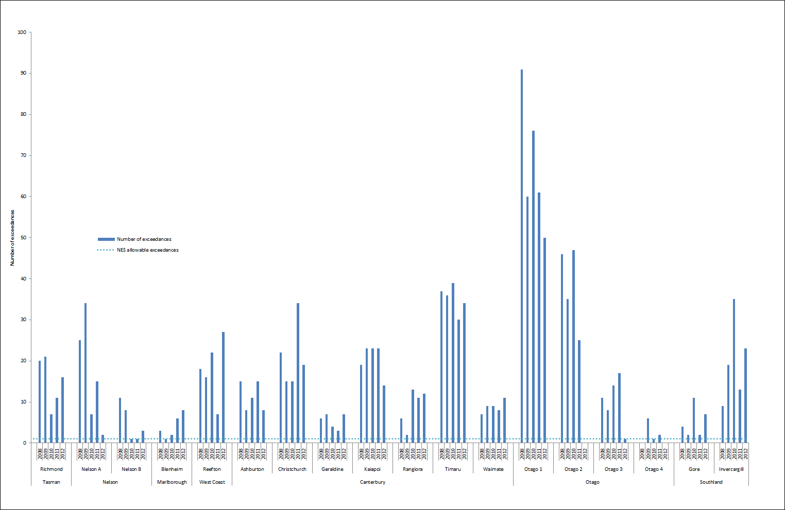

Source: Regional councils’ and unitary authorities’ air quality monitoring data. Note: There was insufficient valid data for the Otago 2 airshed for 2012.

Figure 7: Highest 24-hour average PM10 concentration by region in the North Island (2008–2012)

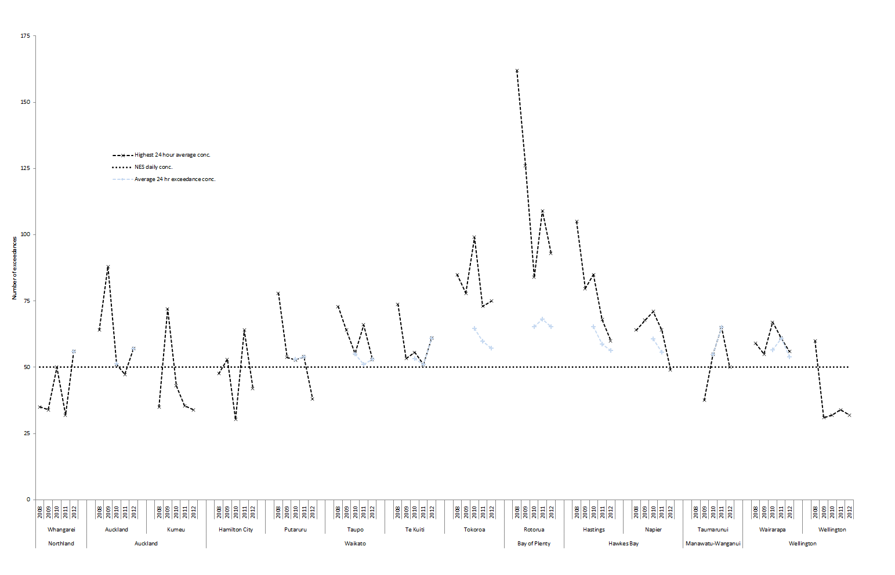

Source: Regional councils’ and unitary authorities’ air quality monitoring.

Figure 8: Highest 24-hour average PM10 concentration by region in the South Island (2008–2012)

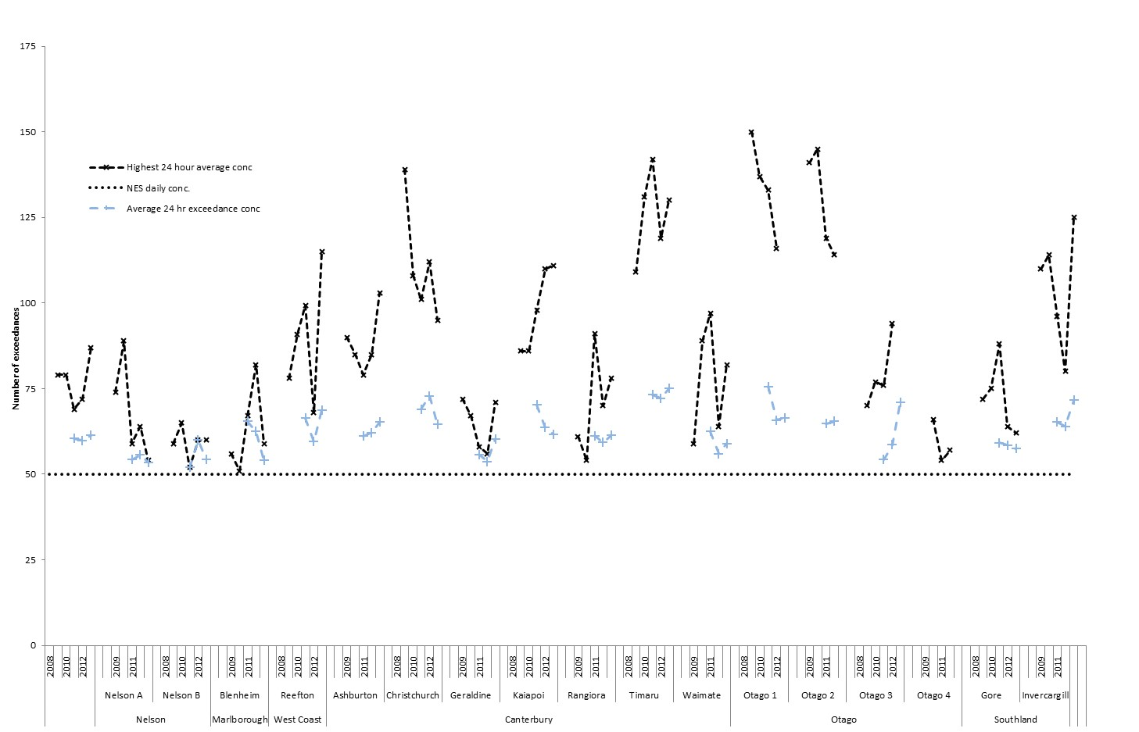

Source: Regional councils’ and unitary authorities’ air quality monitoring data. Note: There was insufficient valid data for the Otago 2 airshed for 2012.

Figure 9: Total number of exceedances (2010–2012)

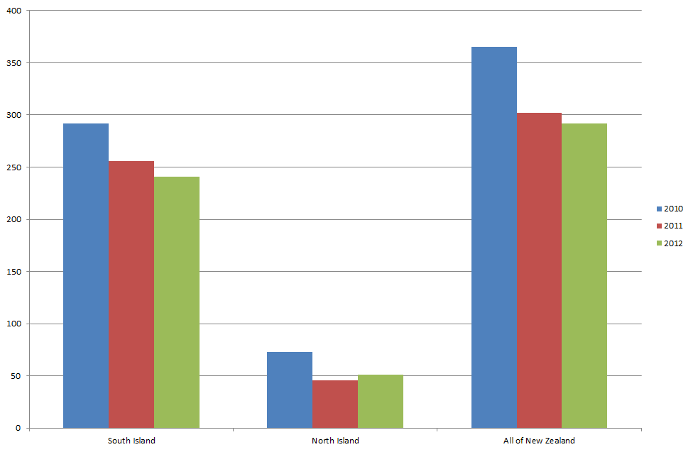

Figure 10: PM10 levels of exceedances (2010–2012)

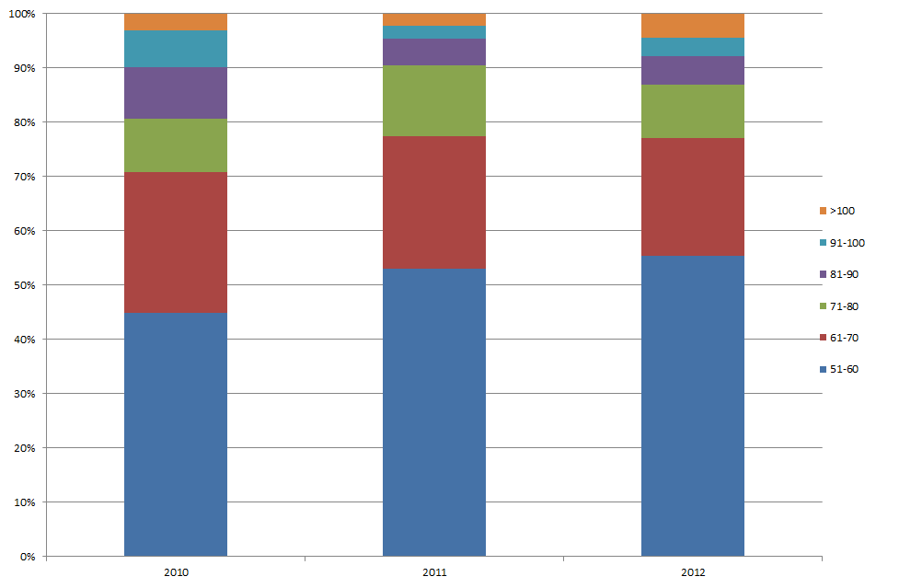

|  |
| --- |
| **Case study 2: Nelson City Council**  Nelson has experienced some of the most significant improvements in air quality. The Council received two Green Ribbon Awards in 2012 for its achievements in managing air quality. The extent of reductions in PM10 levels and exceedances of the PM10 standard in the Nelson A airshed is shown in figure 11.  Nelson’s improved air quality is attributed to various Council programmes, particularly its controls on domestic heating. The Nelson Air Quality Plan set in place the phasing out of all open fires in the urban area and certain enclosed solid fuel burners in the airsheds with the most pollution.  Nelson City Council provided financial assistance to help homeowners upgrade to more modern, lower emitting fires or to other non-polluting heating appliances. The Good Wood Scheme was also established, which involved firewood retailers agreeing to sell either seasoned wood or green wood that is sold well in advance of it being used.  As the concentration of pollution has fallen, so too has the number of times the Standards were breached in any year. Exceedances in Nelson’s most polluted area (Airshed A – Victory Square) have fallen from 81 in 2001, to two in 2012, the lowest number since monitoring began.  Nelson City Council considers that the environmental benefit will continue indefinitely because the major source of pollution (open fires and old domestic fires) has either been removed or replaced.  Figure 11: Reductions in air pollution in Nelson A airshed    Source: Nelson City Council. |

## Community awareness

Education to raise awareness about local air quality problems, and council policies and rules, has been the main non-regulatory approach taken by 77 per cent (10 out of 15) of councils to reduce PM10 levels. Councils also promoted alternative ways for the public to get involved in reducing PM10 levels, such as encouraging or supporting the public to install cleaner domestic heating appliances or use existing heating appliances more efficiently.

Education has included the following activities:

* preparing an education or communication plan
* releasing discussion documents, newsletters, pamphlets, leaflets and information sheets
* regularly publishing newspaper, magazine and newsletter articles
* reporting state of the environment results online
* providing information on airshed emissions, policies and rules online
* visiting the public, including schools, and holding expos.

These initiatives have led to greater community awareness of local air quality problems, with many communities upgrading to cleaner heating appliances or insulating their homes. The direct effects of these initiatives on air quality are not clear, overall. However, many councils consider that these initiatives, together with policies and rules, have contributed to reduced pollution.

Case study 3: Tasman District Council

Tasman District Council conducted a survey in 2009 to find out what people thought about air quality issues and how the community would like these issues to be addressed. The survey found a high level of community awareness and that a mix of approaches to address air quality was preferred.

The survey found that:

* 61 per cent of participants believed domestic heating was the main cause of winter pollution
* 29 per cent felt domestic heating did not contribute a lot to winter pollution
* 79 per cent considered winter air pollution in Richmond contributes to health problems.

To address air quality issues, the survey found that:

* 87 per cent of participants preferred people to operate wood burners better
* 77 per cent would like the buying and selling of wood to be regulated
* 62 per cent believed that banning all open fires and wood burners over 15 years old was acceptable
* Only 14 per cent felt all wood burners should be banned.

People were aware of the need to reduce air pollution. Most survey participants preferred to do so by properly operating wood burners and having access to wood of sufficient quality.

## The costs to councils of managing air quality

Councils were asked to provide the costs to date, and any foreseen future costs, to implement their air quality programmes to meet the targets set out in the Standards.

Targeted rates, grants and subsidies for clean heat retrofits represented the biggest council investment. This approach involved providing loans to ratepayers to insulate their homes and replace old burners, which they repay through their rates for a period of up to 10 years. At least 33 per cent (five out of 15) of councils have used this approach, with one council investing $15,000 to set up its programme, while another council invested $46 million over nearly a decade to fund its programme.

Councils that have established rules in their plans which are stricter than the Standards required resources to develop, consult on and implement these rules. One council reported spending around $650,000 in research, staffing, hearing and appeal costs to establish its current air quality policies and rules. Another council was reviewing its air plan and has set aside around $360,000 for this work (2012 to 2014).

Annual air quality monitoring costs ranged from $10,000 for one monitoring station to $1.3 million for 12 monitoring stations. Costs depended on the type of monitoring equipment used, the number of pollutants monitored and the number of monitoring sites in an airshed.

Education campaigns also incurred costs ranging from over $1000 for regular local newspaper articles on reducing burner emissions, to $1.5 million for a comprehensive media campaign.

Other costs included conducting research studies to better understand the composition of emissions, the impact of user behaviours on wood burner performance, and options for managing air quality in their region.

# Appendix: Airshed description by region

### Northland

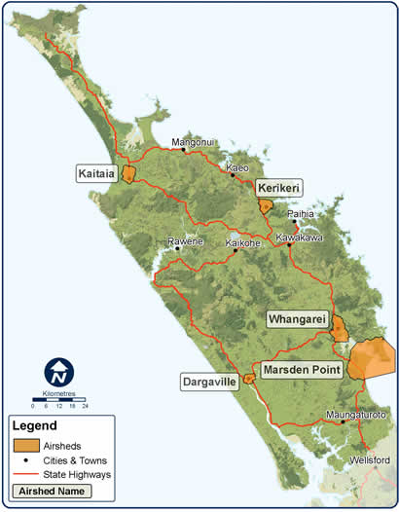

#### Location and features of Northland airsheds

There are five gazetted airsheds in Northland.

|  |  |
| --- | --- |
| Airshed (location) | Features |
| Whangarei (Whangarei District) | The Whangarei airshed is situated at the head of a drowned river valley. The geographical extent of the airshed is limited by elevated terrain to the north, south and west. The eastern boundary extends part way down the harbour and includes the Onerahi Peninsula. |
| Marsden Point  (Whangarei District) | The Marsden Point airshed covers a number of elevated terrain features located on Bream Head Peninsula. These features are important, both because of the potential for elevated pollutant concentrations to occur on them, and for the effects they have on local meteorological conditions. Both land and sea breeze circulation and coastal fumigation phenomena are features of the area. |
| Dargaville  (Kaipara District) | The Dargaville airshed covers most of the residential areas of Dargaville as well as some light industrial areas to the east and west of the town centre. Katabatic flow drainage under cool, calm conditions tends to transport emissions towards the centre and south of the airshed. |
| Kaitaia (Far North District) | The Kaitaia airshed’s eastern and southern boundaries are defined by elevated terrain, with the western boundary extending to the Awanui River. |
| Kerikeri (Far North District) | The Kerikeri airshed includes the residential and commercial areas of Kerikeri, in addition to a significant amount of local horticultural properties. The airshed broadly encompasses the catchment area of the lower Kerikeri River and extends out to the northwest to include the light industrial area in Waipapa. |

### Auckland

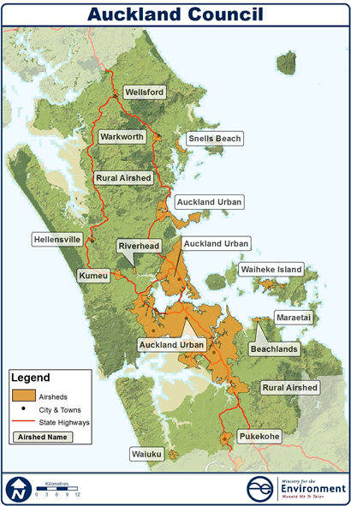

#### Location and features of Auckland airsheds

There are 12 gazetted airsheds in Auckland, located across the region:

* Auckland Urban
* Beachlands
* Hellensville
* Kumeu
* Maraetai
* Pukekohe
* Riverhead
* Snells Beach
* Waiheke Island
* Waiuku
* Warkworth
* Wellsford.

Auckland Council monitored two airsheds in 2012:

* Auckland Urban (including Auckland central, North Shore, Whangaparaoa)
* Kumeu.

Eighty-nine per cent of Auckland’s population resides in the Auckland Urban airshed.

### Waikato

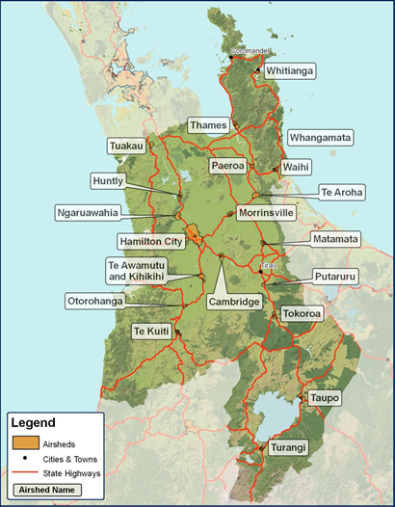

#### Location and features of Waikato airsheds

There are 20 airsheds in Waikato. The Waikato Regional Council monitors air quality in eight urban airsheds:

* Hamilton City
* Matamata
* Ngaruawahia
* Putaruru
* Taupo
* Te Kuiti
* Tokoroa
* Turangi.

Genesis Energy is required to monitor the Huntly Airshed.

### Bay of Plenty

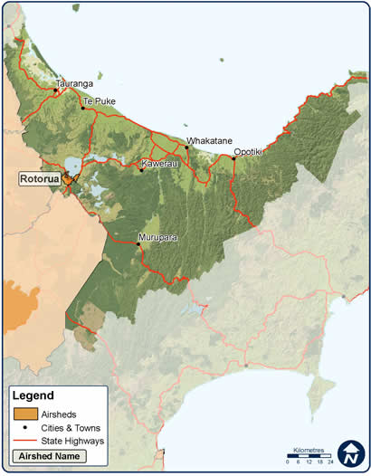

#### Location and features of the Rotorua airshed

The Rotorua airshed covers the city of Rotorua and is the only gazetted airshed in the Bay of Plenty region. The airshed’s scope has not been changed since it was first designated and there are no re-gazetting plans for the future.

### Hawke’s Bay

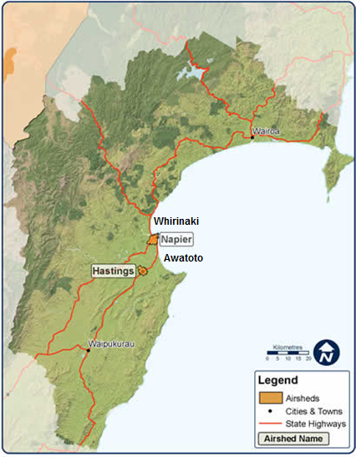

#### Location and features of Hawke’s Bay airsheds

There are four airsheds in the Hawke’s Bay region:

* Napier
* Hastings
* Awatoto
* Whirinaki.

The activities in these airsheds are similar, including a mix of commercial, residential and industrial activities. However, in the Awatoto Airshed, activities are largely industrial.

|  |  |
| --- | --- |
| Airshed (location) | Features |
| Napier (Napier City) | The Napier airshed is divided into two airzones. Airzone 1 covers the urban areas of Napier, while Airzone 2 includes the surrounding rural areas that are designated for future residential growth. |
| Hastings (Hastings District) | The Hastings airshed includes the urban areas of Hastings, Havelock North and Flaxmere as well as a considerable area of rural land and smaller urban centres affected by the ‘downwind’ trajectory of the modelled PM10 plume arising from these centres. The Hastings airshed contains two airzones: Airzone 1 which covers the urban areas of Hastings, Havelock North and Flaxmere, and Airzone 2, covering the surrounding rural areas and smaller urban centres. |
| Awatoto and Whirinaki | The Awatoto and Whirinaki airsheds are small airsheds that are mainly industrial areas. |

### Taranaki

#### Location and features

There are no gazetted airsheds in the Taranaki region. This is because the region is relatively windy and exposed, has a dispersed population and lacks heavy industrialisation or high motor vehicle densities.

However, the Taranaki Regional Council manages air quality in the following areas:

* New Plymouth and Bell Block Urban Area
* Mount Egmont National Park
* Eastern Hill Country
* Pastoral Land.

The New Plymouth and Bell Block Urban Area refers to the region’s primary urban centres, while Mount Egmont National Park is limited to the national park. The Eastern Hill Country refers to the hills and valleys to the east of Mount Taranaki. The Pastoral Land area refers to the rest of the region.

### Manawatu-Wanganui

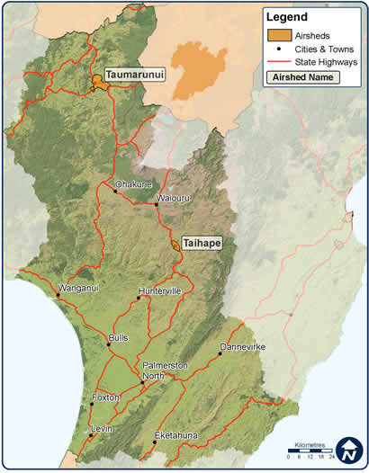

### Location

#### Location and features of Manawatu-Wanganui airsheds

There are two airsheds in the Manawatu-Wanganui region that are monitored by the Horizons Regional Council:

* Taihape
* Taumarunui.

Both these airsheds have not breached the PM10 standard since monitoring began in 2006 (Taihape) and 2009 (Taumarunui).

### Greater Wellington

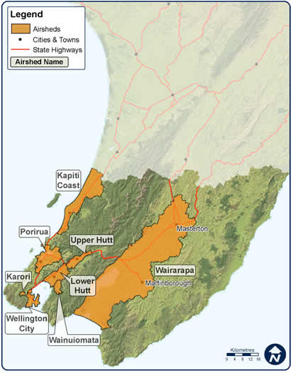

#### Location and features of Greater Wellington airsheds

There are eight gazetted airsheds in the Wellington region:

* Kapiti Coast
* Karori
* Lower Hutt Valley
* Porirua Basin
* Upper Hutt Valley
* Wainuiomata
* Wairarapa Valley
* Wellington City.

All airsheds are monitored by the Council, apart from the Kapiti Coast and Karori airsheds.

The Wairarapa airshed is currently being re-gazetted to revise its scope.

### Nelson

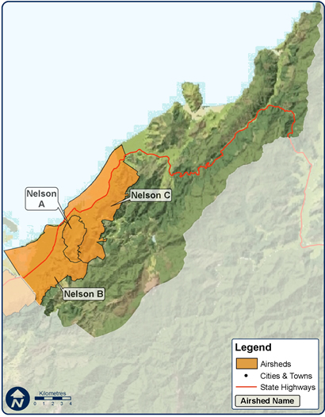

#### Location and features of Nelson airsheds

There are three airsheds in Nelson City, of which the first two are monitored:

* Nelson A – Victory Square
* Nelson B – Tahunanui and Stoke
* Nelson C.

The landscape and activities in Nelson’s three airsheds vary in scope. The landscape within the airsheds is largely defined by the coast and bounded by hills. All three airsheds cover residential areas, although Nelson B includes the city’s light industrial area, major roads, and the airport. Houses range in age but are generally older and require greater heating, which often comes from old solid fuel fires.

| Airshed (location) | Features |
| --- | --- |
| Nelson A – Victory Square | Nelson A –Victory Square is located within a broad valley centred on the Victory Square and Nelson Hospital areas. It is bounded by the Port Hills, Grampians and the coast. It contains mainly older residential housing located on the valley bottom or lower hill slopes. It also contains a small light industrial area in the lower valley. |
| Nelson B – Tahunanui | Tahunanui is a coastal flat bounded by the Port Hills on one side and Tasman Bay on the other. The area was developed for housing early in Nelson’s settlement and contains a range of housing ages. Tahunanui also contains the city’s largest light industrial area, which has a number of industrial boilers burning wood and coal. It also has transport emissions from vehicles on State Highway 6 and main roads (Nayland Road and Annesbrook Drive), along with aircraft from Nelson Airport. The variety of PM10 sources in Nelson B require a greater range of management responses. |
| Nelson B – Stoke | Stoke is located on the coastal fan between the foothills of the Barnicoat Range and the Waimea Inlet. Land use is mainly residential housing developed between the 1960s and the present day. The area also contains a number of main roads, including Nayland Road. The area is prone to elevated PM10 resulting from the density of houses, many with solid fuel heaters, and traffic on local roads. |
| Nelson C | Nelson C covers the remainder of the Nelson urban area. Land use is mainly residential housing and accommodation. The area is complex in geography, with valleys and coastal flats. The common characteristic of Nelson C is that it has sufficient air movement created by drainage air flowing out of valleys and coastal breezes to disperse PM10, which prevents high concentrations occurring. There is currently no monitoring of air quality in Nelson C as no breaches of the Standards have been recorded during the past few years. |

### Marlborough

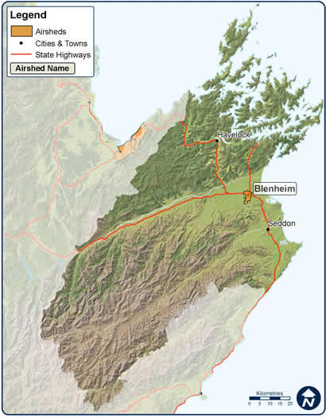

#### Location and features of the Blenheim airshed

Marlborough District has one designated airshed that covers the urban Blenheim area. The scope of this airshed has not changed since it was gazetted.

This Council has monitored this airshed since 2005.

### Tasman

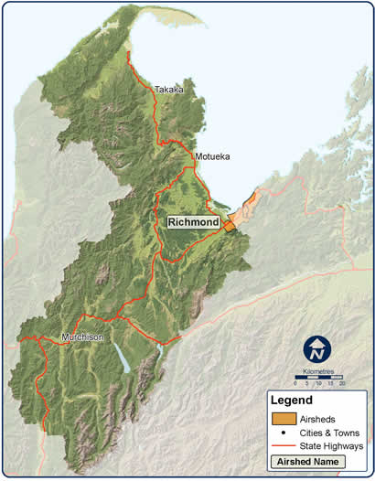

#### Location and features of the Richmond airshed

Tasman District has one designated airshed that covers the Richmond township. The scope of this airshed has not changed since it was gazetted.

The Council has monitored this airshed since 2005.

### Canterbury

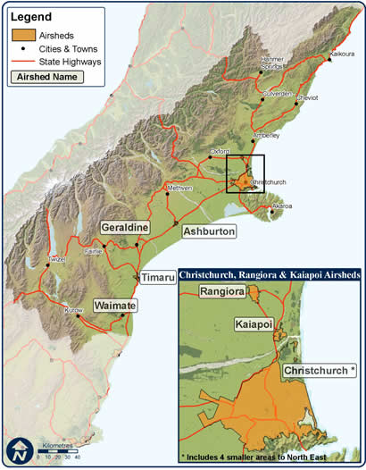

#### Location and features of Canterbury airsheds

There are seven gazetted airsheds in the Canterbury region, all of them monitored by Environment Canterbury:

* Rangiora
* Kaiapoi
* Christchurch
* Ashburton
* Geraldine
* Timaru
* Waimate.

Nearly all of the airsheds are located along the region’s central and southern coastlines.

### Otago

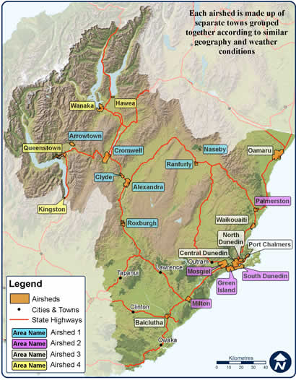

#### Location and features of Otago airsheds

The Otago region has four airsheds covering 22 towns.

These airsheds are located across the region, with Airsheds 1 and 2 located toward the centre of the region, and Airsheds 3 and 4 located near the coast.

| Airshed | Features (included towns) |
| --- | --- |
| Otago 1 | * Alexandra * Clyde * Arrowtown * Cromwell * Naseby * Ranfurly * Roxburgh |
| Otago 2 | * Green Island * Milton * Mosgiel * South Dunedin * Palmerston |
| Otago 3 | * Balclutha * Central Dunedin * North Dunedin * Oamaru * Port Chalmers * Waikouaiti |
| Otago 4 | * Hawea * Kingston * Queenstown * Wanaka |

### West Coast

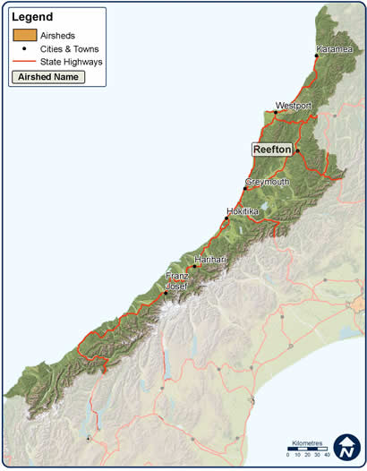

#### Location and geographical scope

The West Coast region has one designated airshed, the Reefton airshed. The scope of this airshed has not changed since it was gazetted.

The Council has monitored this airshed since 2006.

### Southland

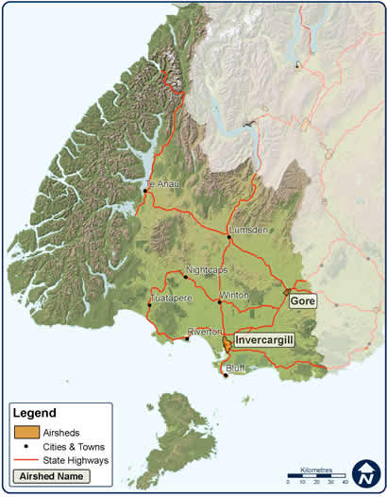

#### Location and geographical scope

There are two airsheds in Southland, which are both monitored by the Environment Southland Regional Council:

* Gore
* Invercargill.