

Administrative Costs of Proposed Essential Freshwater Package on Regional Councils

Report to Ministry for the Environment

March 2020

Copyright Castalia Limited. All rights reserved. Castalia is not liable for any loss caused by reliance on this document. Castalia is a part of the worldwide Castalia Advisory Group.

Acronyms and Abbreviations

DIN | Dissolved Inorganic Nitrogen
DRP | Dissolved Reactive Phosphorous
EFW | Essential Freshwater
FTE | Full time equivalent employee
LGNZ | Local Government New Zealand
MFE | Ministry for the Environment
NPV | Net present value
NPS | National Policy Statement
NES | National Environmental Standard
RIS | Regulatory Impact Statement
RMA | Resource Management Act
STAG | Science and Technical Advisory Group

Table of Contents

Executive Summary i
- Introduction 1
- New Requirements on Regional Councils from the Essential Freshwater Package 2
- Administrative Costs of New Requirements on Regional
Councils 8
  - Costs of the New Requirements 9
    - Directing clearer ecological outcomes for river
flows and water levels 12
    - Improving water quality through better farm
practice 13
    - Measuring and reporting water takes 13
    - Maintaining or improving water quality 14
    - Restrictions on agricultural intensification 15
    - Requirements for intensive winter grazing on
forage crops 15
    - Stock exclusion requirements 16
    - Sediment management 17
    - Reporting on the five components of
ecosystem health 17
    - Preventing further loss of streams 18
    - Māori involvement in freshwater
management 19
    - Wetlands requirements 19
    - Cost of nutrient attributes for managing
ecosystem health 20
    - Reducing excessively high nitrogen leaching 20
    - Requirements for stock holding areas and
feedlots 21
    - Recognising all components of ecosystem
health 21
  - Costs of the New Requirements Vary by Council 23
  - Variable costs change according to regional
characteristics 24
  - The Costs of the New Requirements are Uncertain 28

Costs Will Be Incurred Progressively in the Lead Up to Full Implementation 30
  - Estimates of Current Regional Council Expenditure on Freshwater Management 30
  - Some 2017 NPS Requirements are Replicated in 2020
Package 32
  - Regional Councils Will Incur Costs Prior to
Implementation Date 33

Tables
Table 1.1: Total Per-Annum Cost of Implementing the New Requirements | i
Table 1.2: Total Annual Costs of Each Requirement for Regional Councils Nationally | ii
Table 2.1: Table of New Requirements on Regional Councils | 3
Table 3.1: Full Per-Annum Cost of Implementing the New Requirements | 8
Table 3.2: Proportion of the Costs of Each Requirement that Varies by Regional Characteristics | 11
Table 3.3: Uncertainty Classifications and Lower and Upper-Bound
Adjustments Used in this Analysis | 12
Table 3.4: Cost of Directing Clearer Ecological Outcomes for River Flows and Water Levels | 12
Table 3.5: Cost of Improving Water Quality through Better Farm Practice | 13
Table 3.6: Costs of Measuring and Reporting of Water Takes | 13
Table 3.7: Costs of Maintaining or Improving Water Quality | 14
Table 3.8: Cost of Restrictions on Agricultural Intensification | 15
Table 3.9: Cost of Requirements for Intensive Winter Grazing on Forage Crops | 15
Table 3.10: Cost of Stock Exclusion Requirements | 16
Table 3.11: Cost of Sediment Management | 17
Table 3.12: Cost of Reporting on the Five Components of Ecosystem Health | 17
Table 3.13: Cost of Preventing Further Loss of Streams | 18
Table 3.14: Cost of Māori Involvement in Freshwater Management | 19

Table 3.15: Cost of Wetlands Requirements 19

Table 3.16: Cost of Nutrient Attributes for Managing Ecosystem

Health 20

Table 3.17: Cost of Reducing Excessively High Nitrogen Leaching 20

Table 3.18: Cost of Requirements for Stock Holding Areas and

Feedlots 21

Table 3.19: Costs of Recognising All Components of Ecosystem

Health 22

Table 3.20: One-off Costs for Nutrient Benchmarking and Mapping

of Wetlands 22

Table 3.21: Range of Reasonable Uncertainty for the Overall Cost

Estimate 29

Table 4.1: Reported Regional Council Expenditure on Freshwater

(or Catchment) Management 2018/19 30

Table 4.2: Requirements in Package that Replicate 2017 NPS 32

Figures
Figure 1.1: Annual Costs of the New Requirements by Regional Council | iii
Figure 1.2: Uncertainty of the Cost Estimates of Each New
Requirement | iv
Figure 3.1: Total Costs of Each Requirement for Regional Councils Nationally | 9
Figure 3.2: Annual Costs of the New Requirements by Regional Council | 24
Figure 3.3: Regional Characteristics Determine how much each council will Face | 24
Figure 3.4: Fixed and Variable Components of the Costs of Each New Requirement | 25
Figure 3.5: Costs per Region of Directing Clearer Ecological Outcomes for River Flows | 26
Figure 3.6: Cost Per Region of Improving Water Quality Through Better Farm Practice | 27
Figure 3.7: Costs per Region of the Requirement to Measure and Report on Water Takes | 28
Figure 4.1: Estimated Total Regional Council Expenditure on Freshwater Management Over 5 Years with Package | 34

Executive Summary
The Government is proposing to introduce a range of legislative and regulatory measures aimed at improving the quality and management of New Zealand’s freshwater resources. This is a wide-reaching and ambitious regulatory programme that will address multiple facets of freshwater management. The package of changes is titled Essential Freshwater Package (Package).
The Ministry for the Environment (MFE) has carried out consultation on the Package and is preparing advice for the Minister for the Environment. The Package is likely to be considered by Cabinet with a regulatory impact statement (RIS). The Package will impact on a range of parties in the economy and the RIS will attempt to quantify the impacts (positive and negative) of the Package on affected parties.

Regional Councils have the primary regulatory functions for freshwater resources
Regional Councils and Unitary Authorities (Regional Councils1) are tasked with integrated management of the natural and physical resources of a region under the Resource Management Act 1991 (RMA). The Package proposes a range of new requirements that will lead to additional functions, tasks, and roles for Regional Councils. These new requirements will impose administrative costs on Regional Councils.
Castalia has been engaged by MFE to estimate the administrative costs imposed under the Package for the 16 Regional Councils. We have not considered the benefits of the Package, or the compliance costs (for example incurred by parties regulated under the Package), and therefore we do not consider the net benefits of the Package. We do not consider the options that councils have to fund the new package, be that through fees, rates, or other mechanisms.

The full costs to Regional Councils of implementing the new requirements is $210 million per annum
The total administrative cost to regional councils of implementing all of the 20 new requirements under the Package is shown in Table 1.1. On average, each Regional Council will incur costs of approximately $13 million per annum. This equates to 5.8 percent of Regional Councils’ total operating expenditure in 2018.

Table 1.1: Total Per-Annum Cost of Implementing the New Requirements

 |  | Base-Case Estimate
 | Total Cost of the Package for Regional Councils Nationally | $210,220,000
 | Total Cost of the Package for the Average Regional Council | $13,139,000
 | Proportion of Regional Councils’ Total Operating Expenditure in 2018 | 5.8%

1 The term Regional Councils in this report refers to the 16 Regional Councils and Unitary Authorities that are tasked with the integrated management of the natural and physical resources of a region under the Resource Management Act 1991 (RMA)

There are 16 new requirements with material costs
The 16 new requirements with material costs are set out in Table 1.2 below in descending order. The requirement to direct clearer ecological outcomes for river flows is the highest at $42 million. This reflects high staffing requirements leading to high staffing costs (including overheads and resourcing) for the planning and monitoring exercises relating to improving ecological outcomes from river flows and water levels. These costs will depend on the level of extractive water use in each region. We estimate that improving water quality through better farm practice will cost $38 million per annum nationally. This reflects the high costs of auditing farm plans and the large number of farms nationwide.

Table 1.2: Total Annual Costs of Each Requirement for Regional Councils Nationally

 | New Requirement | Additional National Cost
 | Directing Clearer Ecological Outcomes for River Flows | $42,033,000
 | Improving Water Quality through Better Farm Practice | $38,266,000
 | Measurement and Reporting of Water Takes | $26,997,000
 | Maintaining or Improving Water Quality | $16,520,000
 | Agricultural Intensification | $12,906,000
 | Intensive Winter Grazing on Forage Crops | $11,143,000
 | Stock Exclusion | $10,080,000
 | Sediment Management | $10,080,000
 | Reporting on the Five Components of Ecosystem Health | $8,877,000
 | Preventing Further Loss of Streams | $8,260,000
 | Maori Involvement in Freshwater Management | $6,686,000
 | Wetlands | $5,623,000
 | Nutrient Attributes for Managing Ecosystem Health | $4,457,000
 | Reducing Excessively High Nitrogen Leaching | $3,900,000
 | Stock Holding Areas and Feedlots | $2,391,000
 | Recognising All Components of Ecosystem Health | $2,000,000

Costs are significantly higher for some Regional Councils
The administrative costs of the new requirements are higher for some councils than others. Environment Canterbury is estimated to have the highest costs, followed by Waikato Regional Council and Otago Regional Council. Figure 1.1 illustrates the costs by Regional Council, as well as the average for all Regional Councils. This provides a council-centric view of the costs of the Package. It does not reflect costs per ratepayer, the costs per area of agricultural land, or the costs per waterbody.

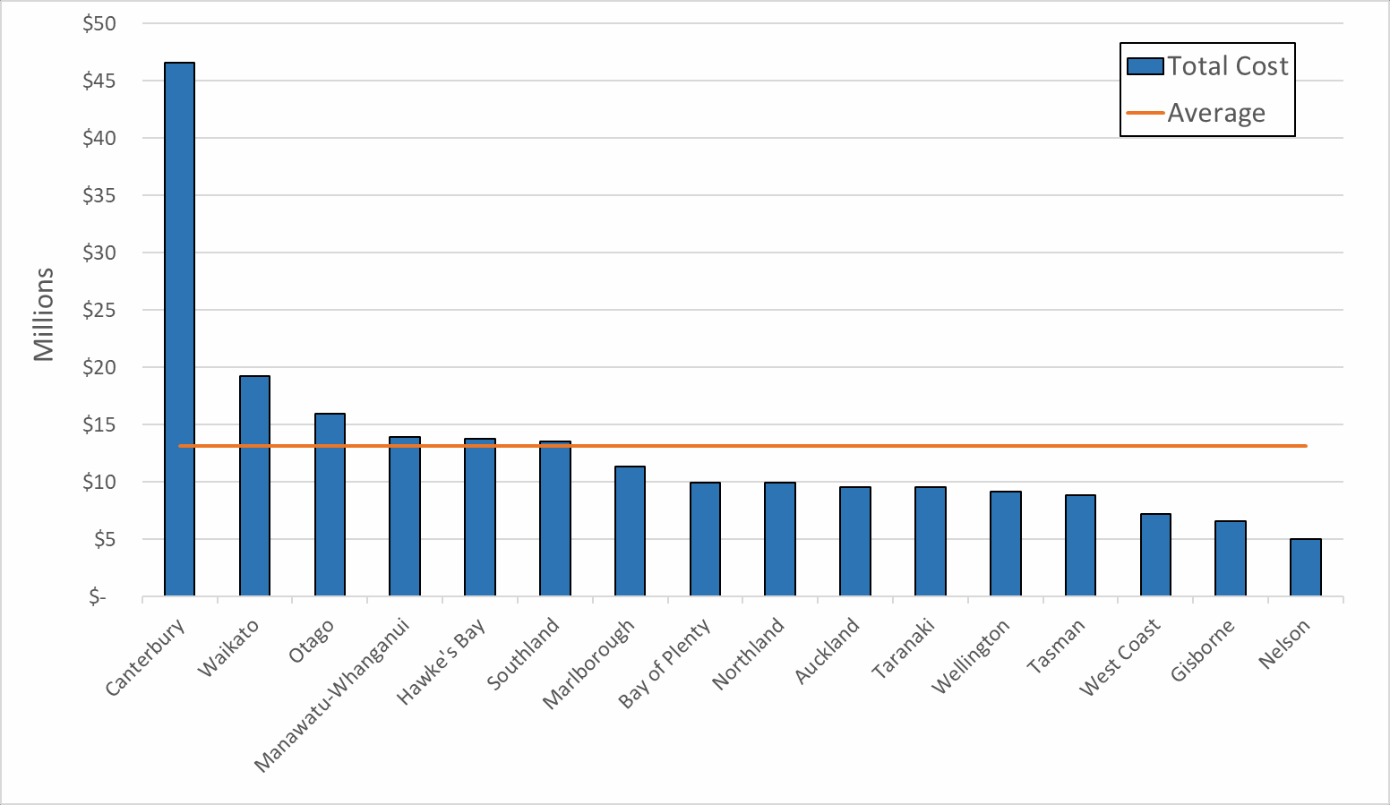
Figure 1.1: Annual Costs of the New Requirements by Regional Council

Regional characteristics create an uneven distribution of costs per council
The costs of each new requirement have fixed and variable components. Fixed components are unavoidable aspects of the requirements such as standard planning, evaluation and reporting tasks which are incurred by each Council in a similar manner. Variable components change according to regional environmental, geographic, and economic characteristics.
Most of the new requirements have a high variable cost component. The requirement to direct clearer ecological outcomes for river flows (the highest cost requirement) has an 80 percent variable cost component that depends on the proportion of consented freshwater takes in a region. The highest cost region is Canterbury, due to the high proportion (63 percent) of national consented water takes.
New requirements with low variable cost components include the requirement to maintain or improve water quality and the requirement to report on the five components of ecosystem health. This is due to the nature of the requirements, with more unavoidable planning and monitoring functions, independent of regional characteristics.

The administrative cost estimates are uncertain
The uncertainty margins associated with these categories for each of the individual cost estimates is shown in Figure 1.2. The level of uncertainty associated with each estimate is characterised as low, medium, or high.

Figure 1.2: Uncertainty of the Cost Estimates of Each New Requirement

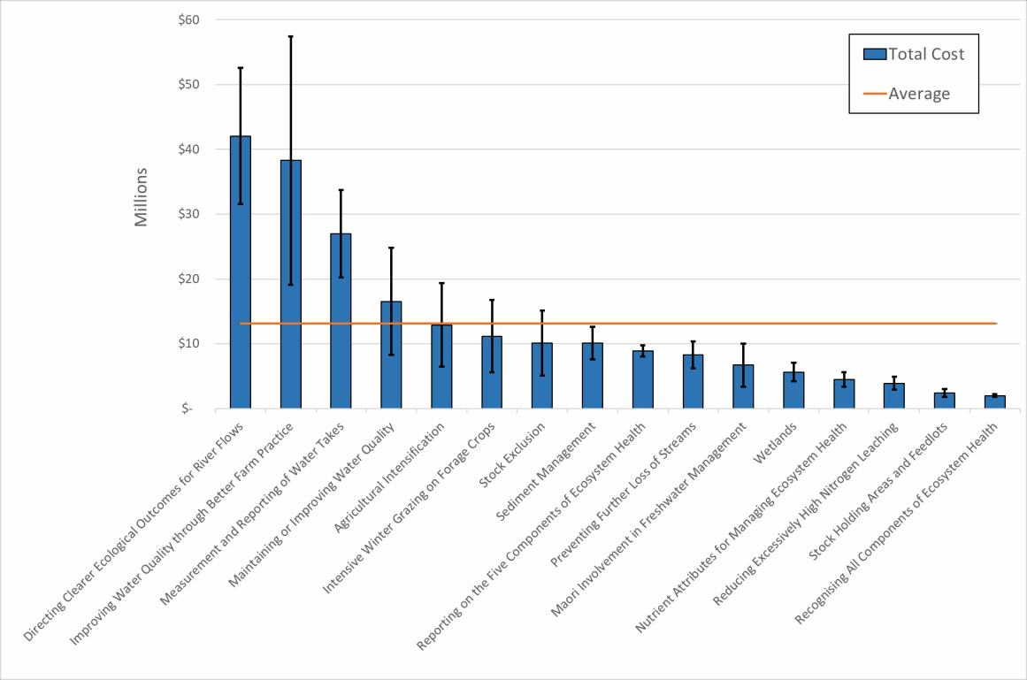

The uncertainty of these estimates is highest at the level of individual requirements. However, we view it as likely that the errors in our estimates are normally distributed (meaning they are as likely to be high as they are low), therefore the uncertainty of the total cost estimate is also normally distributed. Some of these overestimates and underestimates are likely to cancel out when aggregated. The margin of reasonable uncertainty is therefore likely to be smaller (in relative terms) for our estimate of the overall cost of the package than it is for the estimates of some of the costs of individual requirements.

The costs of new requirements will be progressively incurred over the next five years until the full per annum cost is faced on an ongoing basis
Regional Councils will incur costs for the new requirements progressively up to the implementation date of 31 December 2025. The new requirements are likely to involve monitoring, engagement, benchmarking and planning costs in the first years before the full monitoring, scientific, consenting and other activity costs are incurred from 1 January 2026.
Regional Councils’ total annual reported freshwater and relevant environmental management expenditure is $310 million. The true expenditure on freshwater management is likely to vary from this amount due to the different ways that Regional Councils report freshwater management expenditure. However, it provides an indication of the scale of costs of the new requirements (on the assumption all are fully implemented by all Regional Councils) relative to current expenditure.
There is some replication of the 2017 NPS in the 2020 Package. At least two requirements from the 2017 NPS are carried forward to the 2020 Package. Another two requirements in the 2017 NPS are partially replicated in the 2020 Package. This

means that at least $59 million of costs will not be additional costs arising from the 2020 Package.

Introduction
This report is structured as follows:
  - We describe the new requirements on Regional Councils from the Essential Freshwater Package (section 2)
  - We estimate the total administrative costs to all Regional Councils to implement the new requirements in full compliance with the Essential Freshwater Package (section 3)
  - We estimate when the additional costs of the new requirements are likely to be incurred including the current expenditure on freshwater management, (section 4).
This report estimates the total administrative costs that Regional Councils are likely to face as a result of the Package. It does not consider the benefits of the Package, or the compliance costs, and therefore it does not consider the net benefit of the Package.
The final costs to ratepayers will depend on the funding mix that each Regional Council uses—rates, fees, or other2. This paper does not comment on the funding mix that Regional Councils may adopt to implement the regime.

2 Most council pass on at least a proportion of administrative costs through a fee or charge of one sort or another.

New Requirements on Regional Councils from the Essential Freshwater Package
The new requirements imposed on Regional Councils are described in the draft Regulatory Impact Statement (RIS) and proposed National Policy Statement (NPS). We have assessed these new requirements to identify the requirements for new resources that are to be imposed on Regional Councils.
Table 2.1 below sets out the new requirements and how these provide for new or additional actions by Regional Councils. We then describe the additional costs that these requirements will impose on Regional Councils.
In some situations, there are a range of options that may be implemented. The MFE RIS outlines various options for achieving the policy aims behind each proposed new requirement. The RIS identifies preferred options for each new requirement, some of which comprise multiple individual options. We have assumed that the new requirements will be consistent with MFE’s preferred set of options for implementation. We have used the information provided on each of the preferred options to define and estimate the costs of each requirement.

Table 2.1: Table of New Requirements on Regional Councils

Requirement | New/additional Actions Required of Regional Councils | Description of Additional Costs
Recognising all components of ecosystem health | - Regional Councils must provide for ecosystem health in all freshwater management units  - Regional Councils must improve the integrated management of fresh water, with regard to the five components of ecosystem health  - Regional Councils must identify the interactions with environments connected to freshwater and manage cumulative effects. | - These requirements impose additional planning, science, and management costs on Regional Councils
Preventing further loss of streams | - Regional Councils must discourage stream loss where it can be practically avoided  - Where stream loss cannot be avoided, Regional Councils must require developers to remediate or mitigate impacts  - Where stream loss cannot be avoided, remediated, or mitigated, Regional Councils must require developers to offset and compensate for the residual adverse impacts. | - These requirements impose additional consenting, monitoring, and compliance costs on Regional Councils.
Directing clearer ecological outcomes for river flows and water levels | - Regional Councils must set freshwater objectives and limits for the compulsory values (aquatic life, water quality, habitat, and ecological processes) and any other relevant values. | - This requirement imposes additional scientific and planning costs on Regional Councils
Nutrient attributes for managing ecosystem health | - Regional Councils must incorporate attribute tables for Dissolved Inorganic Nitrogen (DIN) and Dissolved Reactive Phosphorous (DRP) agreed by the Science and Technical Advisory Group (STAG) in their regional plans. | - This requirement imposes planning and monitoring costs on Regional Councils
Reporting on the five components of ecosystem health | - Regional Councils must report on the five components of ecosystem health in a way that is transparent about monitoring gaps and accessible to the public  - Regional Councils must report on routinely collected data, categorise these under the five components of ecosystem health, and note data gaps | - This requirement imposes additional scientific monitoring and reporting costs on Regional Councils

 | - Regional Councils must produce a synthesis report every five years that integrates the five components of ecosystem health to form a single ecosystem health score.
Sediment management | - Regional Councils must incorporate thresholds for in-stream sediment in their regional plans  - Regional Councils must develop rules and apply methods to ensure that in-stream sediment levels reduce, or at least do not increase further  - Where bottom lines are currently breached (with the exception of naturally high sediment areas) Regional Councils will require improvements in in-stream sediment concentrations  - Regional Councils will also be required to monitor in-stream deposited sediment in wadable streams. | - These requirements will impose additional planning, scientific, and monitoring costs on Regional Councils.
Improving water for contact recreation | - Regional Councils must set objectives for E. coli that are above newly established national bottom lines for all sites identified as primary sites for contact recreation  - Councils must also monitor E coli levels at all primary sites for contact recreation. | - The costs of these requirements are seen as immaterial because councils already monitor water quality at primary sites for contact recreation.
Māori involvement in freshwater management | - Regional Councils must elevate the status of mahinga kai from an ‘other national value’ to a ‘compulsory national value’  - This will require Regional Councils to incorporate mahinga kai into regional freshwater planning and provide sufficient regulatory strength to safeguard this compulsory value  - Regional Councils will also be required to create a new category in the National  Objectives Framework for ‘tangata whenua freshwater values’  - Regional Councils must support hapū/iwi to identify and develop the information necessary for effective management of mahinga kai and tangata whenua freshwater values. | - These requirements will impose engagement, co-governance support, planning, and monitoring costs on Regional Councils.

Te Mana o Te Wai: overarching management framework | - Regional Councils must clarify how the overarching principles of Te Mana o Te Wai will influence their management plans and decision making through discussion with tangata whenua  - Regional Councils must work with tangata whenua to develop a long-term vision that gives effect to Te Mana o Te Wai in their regional policy statements. | - The small incremental costs of these requirements are immaterial because Regional Councils are already required to work with hapū/iwi to set priorities and develop plans.
Providing for hydro generation infrastructure | - Regional Councils in areas with significant hydro-generation infrastructure would have the ability to set freshwater objectives below national bottom lines. | - This would add additional planning and consultation costs on Regional Councils; however, we expect these are likely to be immaterial
Maintaining or improving water quality | - Regional Councils must set more specific, measurable, and time-bound objectives that seek to maintain the current state of water quality from a specified date.  - Regional Councils’ objectives must be set at or above the current state of water quality, be explicit about the site(s) to which they apply, be explicit about when they will be achieved, and be explicit about how success will be measured  - Regional Councils must regularly report on whether water quality has been maintained or improved using (1) a narrow assessment of whether freshwater objectives have been achieved, and (2) a broader assessment of whether water quality has been, or is likely to be, maintained (considering likely future changes in human influence). | - These requirements will impose additional planning, scientific, monitoring, and reporting costs on Regional Councils
Direction to territorial authorities to support integrated management | - Regional Councils must require territorial authorities to manage the effects of land use for urban development on fresh water in their district plans. | - The costs to Regional Councils of this task are expected to be immaterial.
Wetlands | - Regional Councils must provide direction in their regional plans to avoid the loss or degradation of the extent, function, values, or quality of natural inland wetlands  - Regional Councils must also identify, map, and maintain an inventory of inland wetlands | - These requirements will impose additional scientific monitoring, planning, and resource management administration costs on Regional Councils.

- Regional Councils must also provide for activities necessary for the intended purpose of constructed wetlands
- Regional Councils must also monitor inland wetland condition and encourage inland wetland restoration
- Where these efforts conflict with nationally important infrastructure or renewable energy, Regional Councils must require developers to follow a hierarchy of avoid, remedy, mitigate, and/or offset impacts on wetlands.
Improving water quality through better farm practice | - Regional Councils must require, collect, and monitor the content and accuracy of freshwater modules in farm plans. | - These requirements will impose additional compliance, monitoring, and enforcement costs on Regional Councils.
Reducing excessively high nitrogen leaching | - Regional Councils must collect Overseer results from farms on low slope land in high nitrate-nitrogen catchments and use the information to benchmark leeching- rate thresholds  - Regional Councils must then set these thresholds in regional plans to remediate the impacts of high nitrate-nitrogen in vulnerable catchments  - Regional Councils must also set fertilizer cap thresholds based on national standards. Farmers and growers could apply for consents to exceed these limits  - Regional Councils also must manage and monitor water quality in high N catchments, and process resource consents for discretionary activities. | - These requirements will impose additional scientific, planning, monitoring, and consenting costs on regional councils.
Stock holding areas and feedlots | - Regional Councils must set consent requirements and permitted activity standards for land use relating to stock holding areas and feedlots  - Regional Councils must also monitor the compliance of landowners who have been granted consent to develop stock holding areas and feedlots. | - These requirements will impose additional consenting, monitoring, compliance, and enforcement costs on Regional Councils.
Intensive winter grazing on forage crops | - Regional Councils must establish permitted activities and consenting conditions for intensive winter grazing on forage crops based on technical standards and levels of risk. Where these conditions cannot be met, intensive winter grazing on forage crops will require a consent. | - These requirements will impose additional planning, monitoring, resource management

 |  | administration, and enforcement costs on Regional Councils.
Agricultural intensification | - Regional Councils must require consents for key intensification activities.  - Regional Councils must also monitor compliance and carry out enforcement duties for discretionary intensification activities. | - These requirements will impose additional consenting, monitoring and enforcement costs on Regional Councils.
Measurement and reporting of water takes | - Regional Councils must collect and store electronically transmitted data on water takes of 5l/s or more  - Regional councils must also monitor data collection and carry out enforcement activities when methods do not comply with the new requirements. | - This requirement will impose additional data management costs, and monitoring and enforcement costs on Regional Councils.
Stock exclusion | - Regional Councils must monitor compliance with national standards for stock exclusion  - Regional Councils would also have to process consent applications for exemptions from stock exclusion regulations. | - These requirements would impose additional consenting, monitoring and enforcement costs on Regional Councils.

Administrative Costs of New Requirements on Regional Councils
This section describes the estimated administrative costs to Regional Councils from implementing the full requirements under the Essential Freshwater Package. In this section we identify the total administrative costs that Regional Councils will theoretically face to fully implement and operate the new regulations.
How funding of the new regulations may be achieved in each council is not considered explicitly. Funding will vary by Council and will need to be a combination of fees and/or rates.
We have not fully estimated the costs that might have been incurred by Regional Councils in implementing regulatory requirements that predate the Package, such as National Policy Statement for Freshwater Management 2017 (2017 NPS) which has some requirements that are consistent with requirements in the Package. Regional Councils have made different levels of progress implementing current regulations, and the additional costs of the new regulations for each Council will vary depending on the progress made already. In Section 4 we discuss where the Package replicates some of the 2017 NPS requirements.

The full costs to Regional Councils of implementing the new requirements is $210 million per annum
The total administrative cost to regional councils of implementing all of the 20 new requirements under the Package is shown in Table 3.1. On average, each Regional Council will incur costs of approximately $13 million per annum. This equates to 5.8 percent of Regional Council’s total operating expenditure in 2018.

Table 3.1: Full Per-Annum Cost of Implementing the New Requirements

 |  | Base-Case Estimate
 | Total Cost of the Package for Regional Councils Nationally | $210,220,000
 | Total Cost of the Package for the Average Regional Council | $13,139,000
 | Proportion of Regional Councils’ Total Operating Expenditure in 2018 | 5.8%

The total annual costs of sixteen material requirements, and the uncertainty associated with these estimates, are illustrated in Figure 3.1. We estimate that the requirements for Regional Councils to direct clearer ecological outcomes for river flows and water levels will cost $42 million per year at a national level. These costs reflect staffing costs (including overheads and resourcing) for the planning and monitoring exercises relating to improving ecological outcomes from river flows and water levels. These costs will depend on the level of extractive water use in each region.
We estimate that improving water quality through better farm practice will cost $38 million per annum nationally. This reflects the high costs of monitoring and verifying

audited farm plans and the large number of farms nationwide. We view this estimate as highly uncertain, and we expect the true cost of this requirement to depend on the degree of on-farm monitoring necessary to verify farm plans.
We estimate the costs of measurement and reporting of water takes will cost $27 million. This reflects the labour costs of monitoring and enforcement, the large number of consented water takes nationally, and the costs of data management.

Figure 3.1: Total Costs of Each Requirement for Regional Councils Nationally

Costs of the New Requirements
We have estimated the administrative costs of the 16 material requirements under the Package. Estimates of the national administrative costs of each new requirement, and descriptions of the methods used to estimate these are given in the following 16 tables. We have ordered the tables by cost from largest to smallest.

The fully loaded Regional Council staff cost is a key assumption
A key assumption underpinning many of the estimates is the fully loaded Regional Council staff cost. Where additional personnel costs are estimated, we used a fully loaded staffing cost measure which includes salaries and all associated overheads (office space and support resources). We estimated the fully loaded council staff cost at $145 per hour, which is the average of fully loaded staff costs reported by all Regional Councils in New Zealand and charged to resource consent applicants.
We derived the average from the hourly staff costs for a range of Regional Council consenting roles (including Director, Senior Planner, Senior Scientist, Planner, Scientist, and Administration) in all Regional Councils. We also tested our assumptions about the time (and therefore resource costs) associated with each new requirement against the average time across all Regional Councils charged to applicants for non-

notified and notified freshwater-related resource consents. We recognise that not all consent processes are the same, and the issues are different, but nevertheless it is analogous in so far as it is an administrative process operated within all councils utilising skilled and unskilled staff, implementing legislation and regulatory processes.
The hourly charges are the best representation of the marginal additional cost of providing regulatory services. These are reasonably uniform across all Regional Councils (with one or two outliers at the high and low end). Sometimes Regional Councils may not pass on the full costs of consenting in fees (to reflect some public good functions of consents). However, we think this is more likely to occur with fixed sum fees and charges for consents, rather than in the hourly rates for additional work.

Regional characteristics vary the amount of resources needed and the split between fixed and variable costs
Several cost estimates relied on adjusting judgements about the additional resources required by an example council based on factors reflecting regional characteristics. The factors that determine this variance, as well as the split between fixed and variable components of each cost category, are shown in Table 3.2. Some requirements, including standard planning, evaluation, and reporting tasks, are likely to impose similar costs across all regional councils. The costs of meeting other requirements are likely to vary by regional characteristics such as river length or the demand for water abstraction. The proportional split between fixed and variable costs, and the specific factors for each requirement, are based on professional judgement, and contribute additional uncertainty to the distribution of costs by Regional Council described in Figure 3.2.

Table 3.2: Proportion of the Costs of Each Requirement that Varies by Regional Characteristics

EFW Package Requirement | Proportion Variable Cost | Regional Characteristic Factors
Recognising All Components of Ecosystem Health | 50% | River length on land with a mean slope of up to 10 degrees
Preventing Further Loss of Streams | 90% | Annual rate of land use intensification between 2012 and 2016
Directing Clearer Ecological Outcomes for River Flows and Water Levels | 80% | Proportion of national consented freshwater takes by volume
Nutrient Attributes for Managing Ecosystem Health | 50% | Stock units per hectare of agricultural land
Reporting on the Five Components of Ecosystem Health | 10% | Proportion of the overall costs of the Package (estimated in Castalia’s report to LGNZ, November 2019).
Sediment Management | 70% | River length on land with a mean slope of up to 10 degrees
Maori Involvement in Freshwater Management | 50% | Maori population in region
Maintaining or Improving Water Quality | 15% | Annual rate of land use intensification between 2012 and 2016
Wetlands | 20% | Number of wetlands per region
Improving Water Quality through Better Farm Practice | 90% | Number of farms per region
Reducing Excessively High Nitrogen Leaching | 100% | Number of high nitrate-nitrogen catchments identified per region in the EFW discussion document
Stock Holding Areas and Feedlots | 90% | Beef and dairy cattle per region
Intensive Winter Grazing on Forage Crops | 100% | Regions with high usage of winter forage crops identified in MFE‘s Draft RIS (Southland Canterbury and Otago) were assumed to account for 15% of the national total each, while all other regions apart from Auckland and Northland were assumed to account for 5% of the national total each
Agricultural Intensification | 80% | Annual rate of land use intensification between 2012 and 2016
Measurement and Reporting of Water Takes | 70% | Number of extractive water takes per region
Stock Exclusion | 90% | River length on land with a mean slope of up to 10 degrees

We applied uncertainty levels to each new requirement of low, medium, and high
We estimated the level of uncertainty underlying our cost estimates for each new requirement. Uncertainty was broken into three categories, described in Table 3.3.

Table 3.3: Uncertainty Classifications and Lower and Upper-Bound Adjustments Used in this Analysis

 | Uncertainty Classification | Adjustment
 | Low | +/- 10 percent
 | Medium | +/- 25 percent
 | High | +/- 50 percent

    - Directing clearer ecological outcomes for river flows and water levels
This new requirement imposes additional scientific and planning personnel costs on Regional Councils. We estimated the additional staffing requirements for an example Council using the method described in Table 3.4.

Table 3.4: Cost of Directing Clearer Ecological Outcomes for River Flows and Water Levels

Requirement | Directing clearer ecological outcomes for river flows and water levels
Method for Estimating Administrative Cost | We estimated the number of additional staff the ‘average’ regional council would need to meet this requirement. To do this, we evaluated the business structure of an example council, and made judgements about the additional staffing requirements in each division based on the output (productivity) of that division currently.  In this case, we estimated that the example council would need a total of five additional FTEs, comprising one extra FTE in an Environmental Data team that currently consists of seven, one extra FTE in a Hydrology team that currently consists of 10, two extra FTEs in a Water Policy team that currently consists of six, and one extra FTE in an Integrated Catchment Management team that currently consists of eight.  We then adjusted this estimate based on the regional characteristic defined in Table 3.2 to scale the estimate from the example council to an estimate for an ‘average’ council and for the estimate for all other councils. This produced an estimate of 9.43 additional FTEs for a hypothetical ‘average’ council. We then multiplied this by the fully loaded FTE cost which we based on the fully loaded hourly rate for Regional Council staff, reported above to obtain the cost of this requirement.
Total Cost to Councils Nationally Using Base Case Estimates | $42,033,000
Level of Uncertainty | Medium

    - Improving water quality through better farm practice
This new requirement imposes additional compliance, monitoring, and enforcement costs. We understand that auditing of farm plans will be undertaken by third parties, and the costs of this auditing would be placed on landowners. We expect that regional councils would be required to verify these audited farm plans through farm visits and ground truthing.

Table 3.5: Cost of Improving Water Quality through Better Farm Practice

Requirement | Improving water quality through better farm practice
Method for Estimating Administrative Cost | We estimate that each farm verification visit will take one Regional Council staff member 8 hours to complete and 2 hours of desktop reporting work to close.  Therefore, we anticipate 10 hours of Regional Council staff time per farm plan verification visit.  We multiplied the staff costs for this time by the number of farms in the average region. We then divided this cost by two because we do not anticipate these visits occurring every year, rather, we expect they will occur every second year, on average3.
Total Cost to Councils Nationally Using Base Case Estimates | $38,266,000
Level of Uncertainty | High

    - Measuring and reporting water takes
This new requirement imposes additional data management costs as well as monitoring, compliance, and enforcement costs. The data management costs were estimated for the Manawatu-Whanganui region. The costs for computer systems to process marginal additional data from telemeters in areas with different numbers or water takes is likely to be close to zero. Therefore, we think the Manawatu-Whanganui estimate can apply to all 16 Regional Councils. In addition to this, we estimated the additional staffing requirements for an example Council using the method described in Table 3.6.Table 3.4

Table 3.6: Costs of Measuring and Reporting of Water Takes

Requirement | Measurement and reporting of water takes
Method for Estimating Administrative Cost | We reviewed the ex post estimate of the cost of managing telemetry data in the Manawatu-Whanganui region ($180,000) reported in the evidence in MFE’s draft RIS. This equates to an additional 0.65 FTEs per council, which we see as reasonable.

3 We expect that some farms may be visited more frequently (particularly those that fail to comply with standards) while others will be visited less frequently. We also expect that some councils will introduce a level of randomness in their verification activities or adopt a ‘spot check’ approach. However, the precise business models adopted by each council are not knowable in advance, so we use two year checks as a simplifying assumption.

We then estimated the number of additional staff the ‘average’ regional council would need to undertake monitoring, compliance, and enforcement responsibilities. To do this, we evaluated the business structure of an example council, and made judgements about the additional staffing requirements in each division based on the output (productivity) of that division currently.
In this case, we estimated that the example council would need a total of three additional FTEs, comprising one extra FTE in an Environmental Data team that currently consists of seven, one extra FTE in a Resource Use team that currently consists of eight, and one in a Water Allocation team that currently consists of six. We then used the regional characteristic defined in Table 3.2 to scale the estimate from the example council to an estimate for an ‘average’ council and for the estimate for all other councils. This produced an estimate of 5.41 additional FTEs for a hypothetical ‘average’ council. We then multiplied this by the fully loaded FTE cost which we based on the fully loaded hourly rate for Regional Council staff, reported above to obtain the cost of this requirement.
Total Cost to Councils Nationally Using Base Case Estimates | $26,997,000
Level of Uncertainty | Medium

Maintaining or improving water quality
This new requirement imposes additional planning, scientific, monitoring, and reporting costs. We estimated the additional staffing requirements for an example Council using the method described in Table 3.7.

Table 3.7: Costs of Maintaining or Improving Water Quality

Requirement | Maintaining or improving water quality
Method for Estimating Administrative Cost | We estimated the number of additional staff the ‘average’ regional council would need to meet this requirement. To do this, we evaluated the business structure of an example council, and made judgements about the additional staffing requirements in each division based on the output (productivity) of that division currently.  In this case, we estimated that the example council would need a total of eight additional FTEs comprising one additional FTE in a Science and Strategy Management team that currently consists of 11, two additional FTEs in a spatial analysis and monitoring team that currently consists of seven, two additional FTEs in a Water Quality, Coast and Ecology team that currently consists of 11, one additional FTE in an Environmental Data team that currently consists of seven, and two additional FTEs in a Water Policy team that currently consists of six. We then used the regional characteristics defined in Table 3.2 to change the estimate from the representative council to an estimate for a hypothetical ‘average’ council. This produced an estimate of 9.43 additional FTEs for a hypothetical ‘average’ council. We then multiplied this by the fully loaded FTE cost which we based on the fully loaded hourly rate for Regional Council staff, reported above to obtain the cost of this requirement.

Total Cost to Councils Nationally Using Base Case Estimates | $16,520,000
Level of Uncertainty | High

    - Restrictions on agricultural intensification
This new requirement imposes additional consenting, monitoring, and enforcement costs. We estimated the number of affected farms based on historical land use intensification and number of farms per region. We then assumed the time required for council staff to carry out the required functions for the affected farms.

Table 3.8: Cost of Restrictions on Agricultural Intensification

Requirement | Agricultural intensification
Method for Estimating Administrative Cost | We estimated this cost by first estimating the number of farms per region that could intensify further. We took this to be the average historical land use intensification rate in New Zealand between 2012 and 2016 (0.074 percent), multiplied by the average number of farms per region (3,297) which equals 244 farms per year. We then estimated the proportion of non-compliant intensification activities at 10 percent. We then multiplied the proportion of non- compliant conversions by the cost per investigation (which we estimated to be  $20,000).  We assumed that each compliant intensification takes council staff 16 hours to process. The total cost is the sum of the cost of compliant and non-compliant intensification costs.
Total Cost to Councils Nationally Using Base Case Estimates | $12,906,000
Level of Uncertainty | High

    - Requirements for intensive winter grazing on forage crops
This new requirement imposes additional planning, monitoring, resource management administration and enforcement costs. We estimated the additional staffing requirements for an example Council using the method described in Table 3.9.

Table 3.9: Cost of Requirements for Intensive Winter Grazing on Forage Crops

Requirement | Intensive winter grazing on forage crops
Method for Estimating Administrative Cost | This cost is highly regionally specific. We formed an estimate as a national average to fit the framework used for other costs. We estimated the number of additional staff the ‘average’ regional council would need to meet this requirement. To do this, we evaluated the business structure of an example council, and made judgements about the additional staffing requirements in each division based on the output (productivity) of that division currently.

 | In this case, we estimated that the example council would need a total of two additional FTEs, comprising one additional FTE in a Land Management Advisory Services team that currently consists of 10, and one additional FTE in an Environmental Compliance team that currently consists of four. We used the regional characteristic defined in Table 3.2 to scale the estimate from the example council to an estimate for an ‘average’ council and for the estimate for all other councils. This produced an estimate of 2.5 additional FTEs for a hypothetical ‘average’ council. We then multiplied this by the fully loaded FTE cost which we based on the fully loaded hourly rate for Regional Council staff, reported above to obtain the cost of this requirement.
Total Cost to Councils Nationally Using Base Case Estimates | $11,143,000
Level of Uncertainty | High

    - Stock exclusion requirements
This new requirement imposes additional consenting, monitoring, and enforcement costs. We estimated the additional staffing requirements for an example Council using the method described in Table 3.10.

Table 3.10: Cost of Stock Exclusion Requirements

Requirement | Stock Exclusion
Method for Estimating Administrative Cost | We estimated the number of additional staff the ‘average’ regional council would need to meet this requirement. To do this, we evaluated the business structure of an example council, and made judgements about the additional staffing requirements in each division based on the output (productivity) of that division currently.  In this case, we estimated that the example council would need a total of five additional FTEs, comprising one extra FTE in an Environmental Compliance team that currently consists of four to manage consent applications for exemptions, two extra FTEs in a Monitoring team that currently consists of four to monitor compliance, one extra FTE in a Policy Implementation team that currently consists of six, and one extra FTE in a Land Development team that currently consists of seven.  We used the regional characteristic defined in Table 3.2 to scale the estimate from the example council to an estimate for an ‘average’ council and for the estimate for all other councils. This produced an estimate of 2.26 additional FTEs for a hypothetical ‘average’ council. We then multiplied this by the fully loaded FTE cost which we based on the fully loaded hourly rate for Regional Council staff, reported above to obtain the cost of this requirement.
Total Cost to Councils Nationally Using Base Case Estimates | $10,080,000
Level of Uncertainty | High

    - Sediment management
This new requirement imposes additional planning, scientific, and monitoring costs. We estimated the additional staffing requirements for an example Council using the method described in Table 3.11.

Table 3.11: Cost of Sediment Management

Requirement | Sediment management
Method for Estimating Administrative Cost | We estimated the number of additional staff the ‘average’ regional council would need to meet this requirement. To do this, we evaluated the business structure of an example council, and made judgements about the additional staffing requirements in each division based on the output (productivity) of that division currently.  In this case, we estimated that the example council would need a total of five additional FTEs, comprising two additional FTEs in a Monitoring team that currently consists of five, to monitor suspended and deposited sediment, one additional FTE in an Integrated Catchment Management team that currently consists of eight to develop regional responses to sedimentation, one additional FTE in a Farming Services - Plan Implementation team that currently consists of five to guide better on-farm sediment management actions, and one additional FTE in a Land Development team that currently consists of eight to deal with compliance issues.  We used the regional characteristic defined in Table 3.2 to scale the estimate from the example council to an estimate for an ‘average’ council and for the estimate for all other councils. This produced an estimate of 2.26 additional FTEs for a hypothetical ‘average’ council. We then multiplied this by the fully loaded FTE cost which we based on the fully loaded hourly rate for Regional Council staff, reported above to obtain the cost of this requirement.
Total Cost to Councils Nationally Using Base Case Estimates | $10,080,000
Level of Uncertainty | Medium

    - Reporting on the five components of ecosystem health
This new requirement imposes additional scientific monitoring and reporting costs. We estimated the additional staffing requirements for an example Council using the method described in Table 3.12.

Table 3.12: Cost of Reporting on the Five Components of Ecosystem Health

Requirement | Reporting on the five components of ecosystem health
Method for Estimating Administrative Cost | We estimated the number of additional staff the ‘average’ regional council would need to meet this requirement. To do this, we evaluated the business structure of an example council, and made judgements about the additional staffing requirements in each division based on the output (productivity) of that division currently.

In this case, we estimated that the example council would need a total of five additional FTEs, comprising one additional FTE in an Environmental Data team that currently consists of seven, two additional FTEs in a Water Quality, Coast and Ecology team that currently consists of 11, and two additional FTEs in a Water team of Science and Strategy that currently consists of eight.
We used the regional characteristic defined in Table 3.2 to scale the estimate from the example council to an estimate for an ‘average’ council and for the estimate for all other councils. This produced an estimate of 1.99 additional FTEs for a hypothetical ‘average’ council. We then multiplied this by the fully loaded FTE cost which we based on the fully loaded hourly rate for Regional Council staff, reported above to obtain the cost of this requirement.
Total Cost to Councils Nationally Using Base Case Estimates | $8,877,000
Level of Uncertainty | Low

    - Preventing further loss of streams
This new requirement imposes new consenting, monitoring, and compliance costs on Regional Councils. We estimated the additional staffing requirements for an example Council using the method described in Table 3.13.

Table 3.13: Cost of Preventing Further Loss of Streams

Requirement | Preventing further loss of streams
Method for Estimating Administrative Cost | We estimated the number of additional staff the ‘average’ regional council would need to meet this requirement. To do this, we evaluated the business structure of an example council, and made judgements about the additional staffing requirements in each division based on the output (productivity) of that division currently.  In this case, we estimated that the example council would need a total of four additional FTEs, comprising one extra FTE in a Hydrology team that currently consists of 10, one extra FTE in an Integrated Catchment Management team that currently consists of eight, and two more resource officers to manage consents in an Inland Waters team that currently consists of six.  We used the regional characteristic defined in Table 3.2 to scale the estimate from the example council to an estimate for an ‘average’ council and for the estimate for all other councils. This produced an estimate of 1.85 additional FTEs for a hypothetical ‘average’ council. We then multiplied this by the fully loaded FTE cost which we based on the fully loaded hourly rate for Regional Council staff, reported above to obtain the cost of this requirement.
Total Cost to Councils Nationally Using Base Case Estimates | $8,260,000
Level of Uncertainty | Medium

    - Māori involvement in freshwater management
This new requirement imposes additional engagement, co-governance support, planning, and monitoring costs. We adjusted MFE’s estimate of the FTEs needed to meet this requirement and evaluated this against the hours we estimated as necessary to complete the tasks, including based on submissions from LGNZ.

Table 3.14: Cost of Māori Involvement in Freshwater Management

Requirement | Māori involvement in freshwater management
Method for Estimating Administrative Cost | We adopted MFE’s estimate that the average council will require 1.5 additional FTEs to meet these requirements and multiplied this by the fully loaded cost of an FTE for an average council in New Zealand.
Total Cost to Councils Nationally Using Base Case Estimates | $6,686,000
Level of Uncertainty | High

    - Wetlands requirements
This new requirement imposes additional scientific, monitoring, planning and resource management administration costs. We estimated costs by adding MFE’s estimate of annual monitoring costs and an estimate of the FTE cost of processing additional resource consent applications.

Table 3.15: Cost of Wetlands Requirements

Requirement | Wetlands
Method for Estimating Administrative Cost | We estimated annual costs by adding the monitoring costs estimated by MFE ($100k per year) to an estimate of the number of FTEs required to process applications for exemptions. We estimated the number of additional staff the ‘average’ regional council would need to undertake this processing requirement. To do this, we evaluated the business structure of an example council, and made judgements about the additional staffing requirements in each division based on the output (productivity) of that division currently.  In this case, we estimated that the example council would need three additional FTEs in total, comprising one extra FTE in a Water Quality, Coast and Ecology team that currently consists of 11 to monitor wetland health, and two extra FTEs in an Environmental Compliance team that currently consists of four to process consent applications for wetland disturbance.  We used the regional characteristic defined in Table 3.2 to scale the estimate from the example council to an estimate for an ‘average’ council and for the estimate for all other councils. This produced an estimate of 0.9 additional FTEs for a hypothetical ‘average’ council. We then multiplied this by the fully loaded FTE cost which we based on the fully loaded hourly rate for Regional Council staff, reported above to obtain the cost of this requirement.
Total Cost to Councils Nationally | $5,623,000

Using Base Case Estimates
Level of Uncertainty | Medium

Cost of nutrient attributes for managing ecosystem health
This new requirement imposes additional planning and monitoring costs. We examined LGNZ’s estimate of the costs to Regional Councils and adjusted this to take into account the other new requirements. This means that the personnel tasked with carrying out the new functions benefit from economies of scope.

Table 3.16: Cost of Nutrient Attributes for Managing Ecosystem Health

Requirement | Nutrient attributes for managing ecosystem health
Method for Estimating Administrative Cost | We reviewed LGNZ’s estimate that the average council would require two additional FTEs to meet this requirement. We expect that this number is likely too high because monitoring staff would be used for many of the new tasks under the Package, so we would expect staff members to be able to manage multiple monitoring functions. We therefore revised this to 1 FTE for a hypothetical ‘average’ council.
Total Cost to Councils Nationally Using Base Case Estimates | $4,457,000
Level of Uncertainty | Medium

    - Reducing excessively high nitrogen leaching
This new requirement imposes additional scientific, planning, monitoring, and consenting costs. We estimated the additional staffing requirements for an example Council using the method described in Table 3.18.

Table 3.17: Cost of Reducing Excessively High Nitrogen Leaching

Requirement | Reducing excessively high nitrogen leaching
Method for Estimating Administrative Cost | We estimated the number of additional staff the ‘average’ regional council would need to meet this requirement. To do this, we evaluated the business structure of an example council, and made judgements about the additional staffing requirements in each division based on the output (productivity) of that division currently.  In this case, we estimated that the example council would need a total of two additional FTEs to manage monitoring and consenting tasks, comprising one additional FTE in a Water Quality, Coast and Ecology team that currently consists of 11, and one additional FTE in a ‘Resource use’ team that currently consists of eight to cover consenting issues .  We used the regional characteristic defined in Table 3.2 to scale the estimate from the example council to an estimate for an ‘average’ council and for the estimate for all other councils. This produced an estimate of 0.88 additional FTEs

 | for a hypothetical ‘average’ council. We then multiplied this by the fully loaded FTE cost which we based on the fully loaded hourly rate for Regional Council staff, reported above to obtain the cost of this requirement.
Total Cost to Councils Nationally Using Base Case Estimates | $3,900,000
Level of Uncertainty | Medium

Requirements for stock holding areas and feedlots
This new requirement imposes additional consenting, monitoring, compliance, and enforcement costs. We estimated the number of relevant new consent applications per year and multiplied this by an estimate of number of farms affected and administrative time required.

Table 3.18: Cost of Requirements for Stock Holding Areas and Feedlots

Requirement | Stock holding areas and feedlots
Method for Estimating Administrative Cost | We estimated the number of applications for new feed-pad or stock holding areas per year (taken as 5% of the total number of dairy and beef & sheep farms per region. This implies that the average farm applies for a new consent once every 20 years. We then multiplied the number of farms applying for a new resource consent each year by an estimate of the time it takes the council to process each application (we assumed this would take 4 hours per application – given the parameters of the NES are prescriptive). In addition, we estimated the number of additional staff the ‘average’ regional council would need to meet this requirement. To do this, we evaluated the business structure of an example council, and made judgements about the additional staffing requirements in each division based on the output (productivity) of that division currently.  In this case, we estimated that the example council would need two additional FTEs in a Farming Services team that currently consists of four. We used the regional characteristic defined in Table 3.2 to scale the estimate from the example council to an estimate for an ‘average’ council and for the estimate for all other councils. This produced an estimate of 0.27 additional FTEs for a hypothetical ‘average’ council. We then multiplied this by the fully loaded FTE cost which we based on the fully loaded hourly rate for Regional Council staff, reported above to obtain the cost of this requirement.
Total Cost to Councils Nationally Using Base Case Estimates | $2,152,000
Level of Uncertainty | Medium

    - Recognising all components of ecosystem health
This new requirement imposes additional planning, science, and management personnel costs. We evaluated MFE’s estimate of the additional costs of this

requirement by calculating the implied additional staffing resource for the average regional council.

Table 3.19: Costs of Recognising All Components of Ecosystem Health

Requirement | Recognising all components of ecosystem health
Method for Estimating Administrative Cost | We estimated the additional cost to an ‘average’ council by dividing the estimate of the total cost of this requirement reported in MFE’s draft RIS by the number of Regional Councils in New Zealand. We then divided the cost for an ‘average’ Council by the fully loaded cost of an additional council FTE. This showed that MFE’s national estimate implies that the ‘average’ council would require 0.45 additional FTEs to meet this requirement. MFE’s estimate reflects the actual cost when cross overs between requirements are managed efficiently, in our view.  Therefore, we adopt this number as a cost estimate.
Total Cost to Councils Nationally Using Base Case Estimates | $2,000,000
Level of Uncertainty | Low

Councils also face one-off costs for nutrient benchmarking and mapping of wetlands
In addition to the annual costs listed above, councils face one-off costs for nutrient benchmarking and mapping of wetlands. These costs, and the methods used to estimate them, are described in Table 3.20.

Table 3.20: One-off Costs for Nutrient Benchmarking and Mapping of Wetlands

Requirement | Reducing excessively high nitrogen leaching
Method for Estimating Administrative Cost | We estimated this one-off cost by taking the mid-point estimate of the cost of benchmarking per farm estimated in LGNZ's submission on the Package ($6,000 per farm), and multiplying this by the number of farms requiring benchmarking (assumed to be 10 percent of the total number of farms in the region in the base case). We assumed the costs of this requirement apply exclusively to the benchmarking task, and that the monitoring costs are covered under the "Nutrient Attributes for Managing Ecosystem Health" field. These monitoring  ▪costs are not re-counted here.
Total Cost to Councils Nationally | $31,651,000
Requirement
Method for Estimating Administrative Cost | The costs of wetland mapping for the average council were taken as the mid- point of the range of wetland mapping costs estimated in MFE’s draft RIS ($0.5-  2.1 million). This was then multiplied by the number of Regional Councils nationally.
Total Cost to Councils Nationally | $24,000,000

In total, the one-off costs of the package amount to $56 million, or slightly more than a quarter of the additional annual costs of the package. Councils are likely to spread these one-off costs over multiple years, meaning they will cause less financial strain than many of the annual costs described in this section. We expect these costs to be immaterial relative to the major annual cost categories. We focus on the major annual costs for the remainder of this report.

Councils will require many more staff to implement the Essential Freshwater Package
Based on the methods described above, the average Regional Council will need roughly 47 more staff to implement the Essential Freshwater Package. This is likely to impose additional costs including new office space, expanded management systems, recruiting and training. It is also likely that competition for new employees with relevant water, catchment, and land management skills will result in higher salary costs of these employees nationally. This may also result in councils investing in significant in-work training programmes to develop the skills required to implement the new regulations. This will increase the costs to councils and may lead to delays in compliance. While it is not possible to estimate these additional costs in this assignment, they are likely to add upper-bound uncertainty to the cost estimates described in this report.
  - Costs of the New Requirements Vary by Council
Some Regional Councils are likely to incur substantially higher costs than others. The variance arises from the geographic and economic characteristics of the different regions. Environment Canterbury will incur more than three times the costs of the average council, while the Nelson City Council Unitary Authority will incur less than half of the costs of the average council. Figure 3.2 shows the variance by Regional Council.

Figure 3.2: Annual Costs of the New Requirements by Regional Council

  - Variable costs change according to regional characteristics
The fixed and variable components of the total costs to each Regional Council are shown in Figure 3.3. The variable costs of the Package exceed the fixed costs for most Regional Councils.

Figure 3.3: Regional Characteristics Determine how much each council will Face

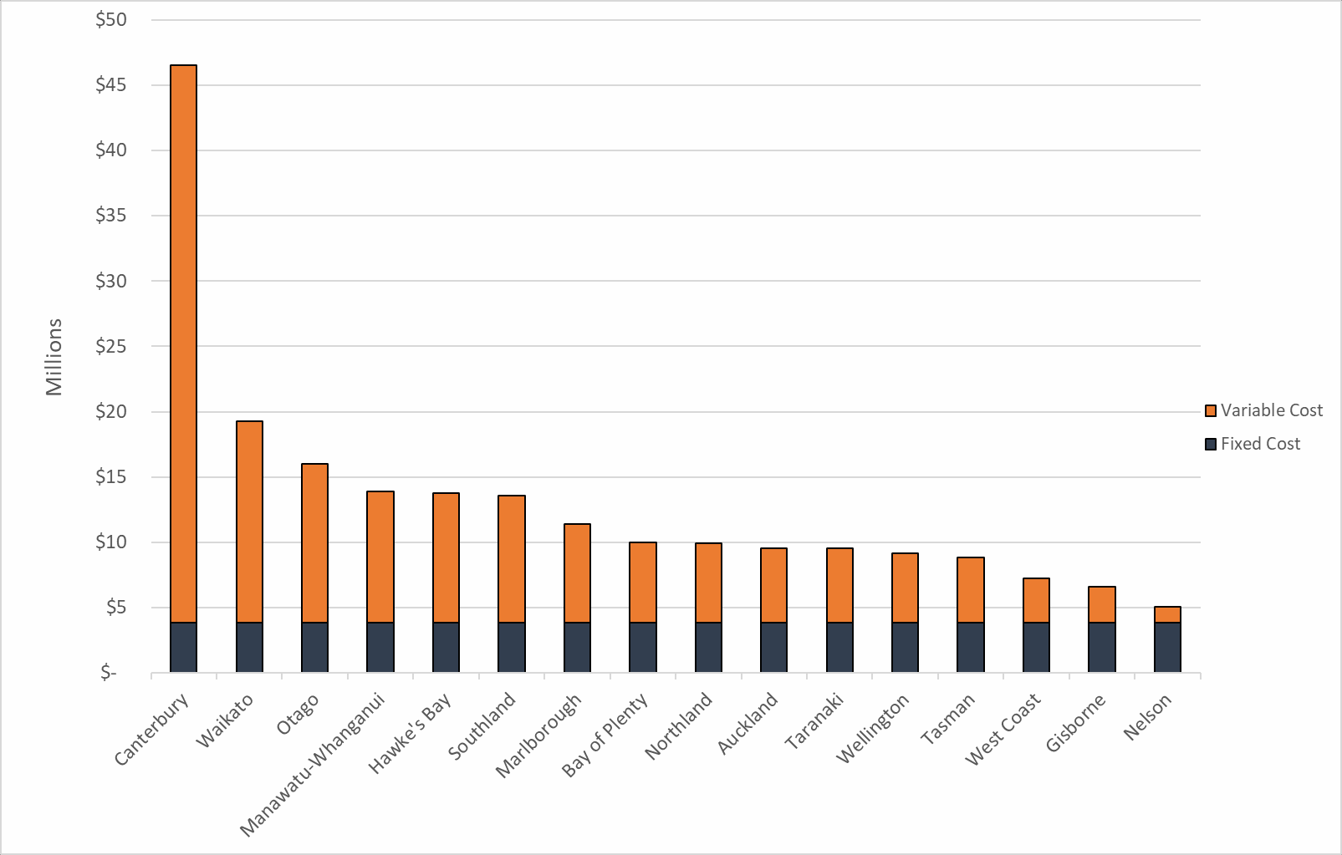

The fixed and variable components of the costs of each new requirement are shown in Figure 3.4.

Figure 3.4: Fixed and Variable Components of the Costs of Each New Requirement

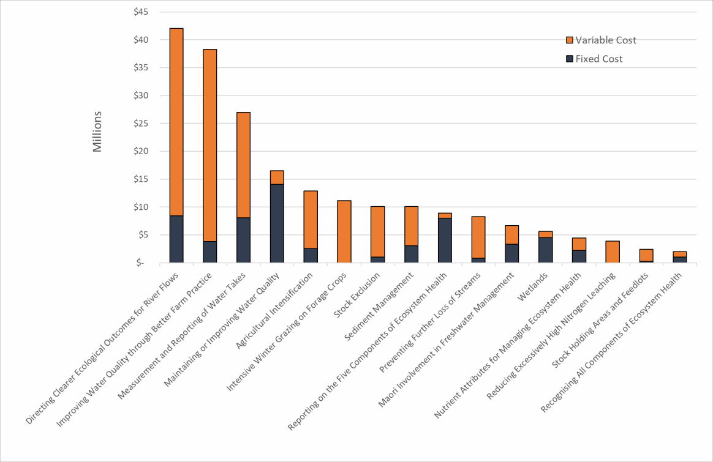

Costs of directing clearer ecological outcomes for river flows change according to the proportion of national consented water takes and significant impacts occur in Canterbury
Consented water takes in Canterbury make up roughly 63 percent of the national total by volume. While 20 percent of the costs of the requirement to direct clearer ecological outcomes for river flows is fixed and applies evenly across councils,

Canterbury’s share of the variable costs mean that it still accounts for more than half
to the total national costs of this requirement.

Figure 3.5: Costs per Region of Directing Clearer Ecological Outcomes for River Flows

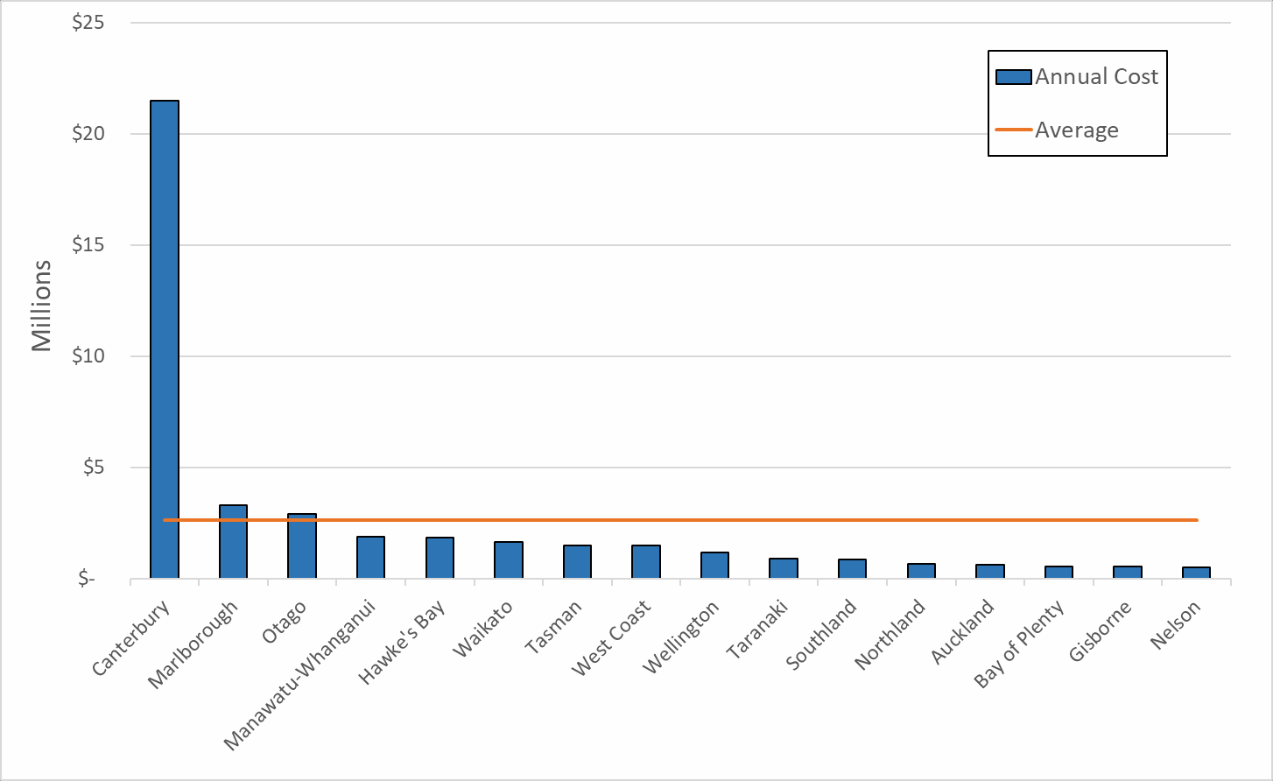

Costs of improving water quality through better farm practice change according to the number of farms in each region and significant impacts occur in Waikato and Canterbury
The costs of auditing farm plans are largely variable and scale with the number of farms per region. Waikato and Canterbury have the largest numbers of farms, and the requirement to audit farm plans on a biennial basis will impose costs more than $5 million per annum. By contrast, there are only slightly more than 100 farms in the Nelson City Council Unitary Authority area, meaning the costs of auditing farm plans are less than the costs of one additional FTE.

Figure 3.6: Cost Per Region of Improving Water Quality Through Better Farm

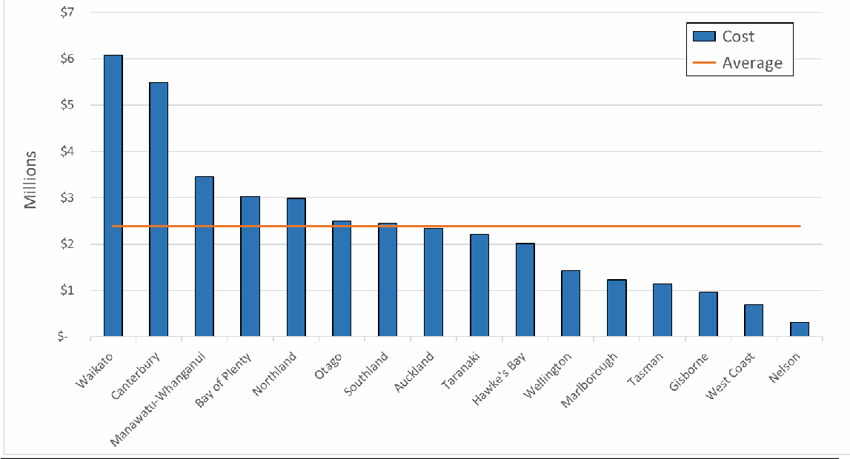
Practice

The cost of measurement and reporting of water takes change according to the proportion of national consented water takes and significant impacts occur in Canterbury
Similar to the requirement to direct clearer ecological outcomes for river flows, the requirement to measure and report on water takes is driven primarily by the proportion of nationally consented water takes in each region. Only 70 percent of this cost category was defined as variable cost, so the regional differences are not as pronounced as they are for the requirement to direct clearer ecological outcomes for water flows. Despite this, the costs in Canterbury are still likely to be roughly four times higher than the costs to the average council.

Figure 3.7: Costs per Region of the Requirement to Measure and Report on Water Takes

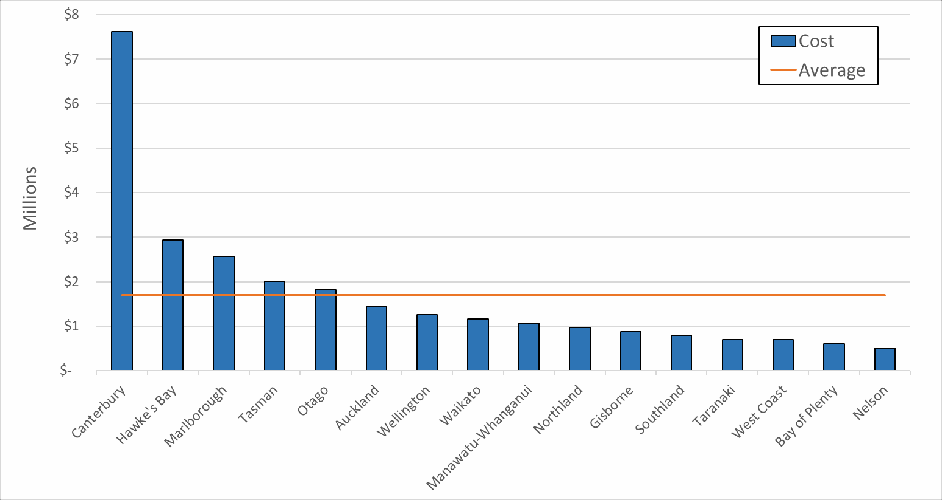

The Costs of the New Requirements are Uncertain
We assessed the uncertainty of our cost estimates using the categories defined in Table 3.3. The adjustments defined in these categories are large because the uncertainties associated with many of the individual cost items is high. However, we expect these uncertainties to be random rather than systematic, meaning that the chances of our estimate being lower than the actual value or higher than the actual value are roughly equal. Therefore, we expect some of these uncertainties to cancel out when we aggregate these individual cost items to form an overall cost estimate. Furthermore, we expect the uncertainty of our estimates to be normally distributed, meaning there will be a greater likelihood that the true value will be reasonably close to our base case estimate, and a much smaller likelihood that it will be at either extreme end of our uncertainty range.
Following this logic, we do not see it as reasonable to expect that all of the true costs will fall at the lower or the upper ends of our aggregate uncertainty distribution. While we calculate these upper and lower-bound uncertainty estimates, we think that a reasonable assessment of the uncertainty of our estimate of the cost of the package spans the central third of this overall distribution. The lower and upper boundaries of this central third are shown in Table 3.21. Even within this truncated distribution, we expect there to be a higher likelihood that the real cost will be closer to the middle ‘base case’ estimate than it is to the upper or lower bound estimates. It would therefore be misleading and inappropriate to cite either the upper or lower-bound estimates in isolation from the other two estimates.

Table 3.21: Range of Reasonable Uncertainty for the Overall Cost Estimate

 | Lower Bound Estimate | Base Case Estimate | Upper Bound Estimate
 | $181,776,000 | $210,220,000 | $235,162,000

Costs Will Be Incurred Progressively in the Lead Up to Full Implementation
The costs of implementation will be incurred as Regional Councils prepare for the deadline for implementation.
Regional Councils already spend money on freshwater management. This is likely to include some expenditure on activities that are consistent with the Package because Regional Councils have been working to implement the 2017 NPS. We can estimate the current freshwater expenditure from published financial reports and annual plans where expenditure on environmental monitoring is disclosed.
We can also make broad assumptions about when Regional Councils will incur costs in implementing the Package.

Estimates of Current Regional Council Expenditure on Freshwater Management
There is inconsistent public information on the actual current expenditure of Regional Councils on freshwater management. Regional Councils use different definitions, and group expenditure differently in annual reports.
Estimates are possible from annual reporting on environmental management, and assumptions in Annual Plans. However, these require careful examination of how each Regional Council reports its expenditure. Significant variations exist in how expenditure is grouped. Definitional issues mean a like-with-like comparison is difficult. Most Regional Councils do not specify current expenditure on freshwater management as a portion of environmental management expenditure or the expected increase in costs resulting from the Package.

Table 4.1: Reported Regional Council Expenditure on Freshwater (or Catchment) Management 2018/19

Regional Council (and link to relevant document) | Reported 2018/19  expenditure | Comment on treatment of expenditure
Auckland Council (link) | $41,000,000 | No separate reporting of freshwater expenditure. Auckland Council does collect a targeted rate for water quality ($41 million in 2018/19), which we assume relates to freshwater.
Bay of Plenty Regional Council (link) | $26,665,000 | Long-term plan reported expenditure on Integrated Catchment Management (reported on Page 22).
Environment Canterbury (link) | $31,703,000 | 2018/19 reported expenditure of operating funding for freshwater management.
Gisborne District Council (link) | $4,160,000 | This sum reports on total environmental services and protection expenditure. This includes “action to preserve soil quality and productive capacity” and “preserve natural environments, biodiversity and ecosystem function”. Annual Report pages 53.

Hawke’s Bay Regional Council (link) | $24,677,000 | Total operating ($19,935,000) and capital ($4,7410) expenditure on integrated catchment management (which includes biodiversity conservation and other activities) for the 2018/19 year. See page 42.
Horizons Regional Council (link) | $12,300,000* | There is no separate line item for catchment or freshwater management in the annual report.  *In 2017/18 the Horizons Long-Term Plan 2018- 2028 reported expenditure on water quality improvement projects of $12,300,000 (in the text on Page 45).
Marlborough District Council (link) | $16,681,000 | Sum of expenditure of operating funding for environmental management, environmental policy, and Science and Monitoring for 2018/19. Pages 94- 103 in the Annual Report. Note: this includes all ‘environment’ related policy, management and monitoring, not just fresh water.
Nelson City Council (link) | $12,961,000 | Total application of operating funding in 2018/2019 (planned and actual) for ‘environment’. This includes management, policy and monitoring across several domains, of which fresh water is one. Pages 56 to 64 in the Annual Report.
Northland Regional Council (link) | $12,899,000 | Total applications of operating funding in 2018/19 (planned and actual) for “environmental services”. This includes management, policy and monitoring across several domains, of which fresh water is one. Pages 36 to 42 in the Annual Report.
Otago Regional Council (link) | $11,574,000 | Total application of operating funding in 2018/19 (planned and actual) for ‘Environment’. This includes management, policy and monitoring across several domains, of which fresh water is one. Pages 14 to 22 in the Annual Report.
Environment Southland (link) | $18,000,000 | Expenditure on environmental stewardship in 2018/19. This again includes elements of water management and policy alongside other aspects of environmental management (such as resource consent processing).
Taranaki Regional Council (link) | $19,918,000 | Sum of resource management, biodiversity and biosecurity line items on the council’s financial statement. Page 86 of the Annual Report.
Tasman District Council (link) | $11,297,000 | Line item expenditure on environmental management in 2018/19. This includes elements of water management and policy alongside other aspects of environmental management (such as resource consent processing). Annual Report Page 186.
Waikato Regional Council (link) | $23,474,000 | Expenditure on integrated catchment management in 2018/19. This appears to be related to similar

 |  | activities to the environmental management line item, that is, it is broader than freshwater management. Annual report page 102.
Greater Wellington Regional Council (link) | $39,444,000 | Application of operating funding on “Environment” (that is, beyond just freshwater) in 2018/19 (planned and actual). Page 82 of the Annual Report.
West Coast Regional Council (link) | $3,895,000 | Application of operational funding for “Resource Management” in 2018/19. This also includes expenditure on again seems to be similar to the activities called 'environmental management' or 'integrated catchment management' by other councils. Annual report page 54. WCRC also spent  $2,331,000 in 2018/19 on “River, Drainage and Coastal Protection”
Estimated total | $310,650,000

Source: Regional Council Annual Reports, Long-Term Plans and Websites

Some 2017 NPS Requirements are Replicated in 2020 Package
The 2020 Package replicates some requirements in the 2017 NPS. This means that the actual total cost to implement the 2020 Package will include some costs that would have also resulted from implementation of the 2017 NPS. The amount of costs from the 2017 NPS that is replicated in the 2020 Package will be at least $58,553,000 and likely more.
The Package replicates four out of the 16 material requirements either in part or in full. These four requirements are set out in Table 4.2 below.

Table 4.2: Requirements in Package that Replicate 2017 NPS

Requirement in 2020 Package | Estimated cost | Comment
Directing Clearer Ecological Outcomes for River Flows | $42,033,000 | Replicates requirements of 2017 NPS which required Regional Councils to set river flows. The 2020 Package provided more specific requirements, but these are mainly clarifying in nature.
Maintaining or Improving Water Quality | $16,520,000 | Replicates requirement in 2017 NPS. The 2020 Package refines when and what the start point for maintaining water quality is and clarifies that maintaining water quality can occur within a band.
Maori Involvement in Freshwater Management | Uncertain but significantly less than  $6,686,000 | The 2017 NPS introduced obligations on Regional Councils to discuss the values for freshwater

bodies with communities (including tangata whenua).4 The 2020 Package requires Regional Councils to provide for the involvement of iwi and hapū in the management of freshwater, and to identify and reflect tangata whenua values in the management of freshwater and decision-making regarding freshwater planning.
The 2020 Package imposes more wide-reaching requirements than the 2017 NPS so there will be a marginal increase in cost above the 2017 NPS requirements.
Nutrient Attributes for Managing Ecosystem Health | Uncertain but less than  $4,457,000 | The NPS 2017 requires Regional Councils to set in-stream concentrations for DIN and DRP to help them meet objectives for periphyton as well as related requirements.  The periphyton requirement is replicated in the 2020 Package along with setting objectives for ammonia and nitrate.

Source: Ministry for the Environment

Regional Councils Will Incur Costs Prior to Implementation Date
Regional Councils will need to build capacity and invest in some data and information collection prior to the proposed implementation date. Some Regional Councils have already taken steps to implement some of the requirements of the 2017 NPS, which reflect some of the Package requirements. The 2017 NPS also imposed a 31 December 2025 deadline, with the option to extend to 2030. Most Regional Councils had advised MFE that the 2025 deadline for the 2017 NPS would not be met.5
We estimate that Regional Councils will have to incur some costs in earlier years before the implementation date. Early implementation costs are likely to include:
- Preparation of an evidence base for new compulsory values
- Increased engagement with Tangata Whenua

4 MFE, Changes to Freshwater NPS 2017, Te Mana o Te Wai factsheet, available at: https://www.mfe.govt.nz/sites/default/files/media/Te%20Mana%20o%20te%20Wai.pdf
5 Regional Councils’ reported timeframes for implementation of 2017 NPS on MFE website: https://www.mfe.govt.nz/fresh-water/national-policy-statement/regional-councils-implementation- programmes

- Establishing systems for consenting and compliance monitoring
- IT systems costs and other fixed costs
- Collection and evaluation of the first tranche of freshwater farm plan modules.
Closer to the deadline of 2025, costs will be incurred in:
- Tangata Whenua engagement
- Monitoring new attributes
- Processing submitted farm plans
- Plan-drafting and notification.
Many costs will only be incurred once the Package has been implemented from 1 January 2026, for example:
- Monitoring and scientific personnel costs associated with directing clearer ecological outcomes for river flows and water levels
- Farm plan monitoring associated with the requirement to improve water quality through better farm practice
- Monitoring of overseer results associated with the requirement to reduce excessively high nitrogen leaching
- Consenting costs that arise from the additional consent requirements for stock holding and feedlots.
Figure 4.1 illustrates the estimated approximate current expenditure on freshwater management by Regional Councils (derived from Table 4.1 above) and our estimate of when the costs of the new requirements are likely to be incurred prior to the full implementation from 1 January 2026.

Figure 4.1: Estimated Total Regional Council Expenditure on Freshwater Management Over 5 Years with Package

$600,000,000

$500,000,000

$400,000,000

$300,000,000

$200,000,000

$100,000,000

$-
2021
2022
2023
2024
2025
2026
Current estimated expenditure
Estimated costs of new requirements



T: +1 (202) 466-6790
F: +1 (202) 466-6797
1747 Pennsylvania Avenue NW Suite 1200
Washington, DC 20006 United States of America

T: +61 (2) 9231 6862
Suite 19.01, Level 19
227 Elizabeth Street
Sydney NSW 2000 Australia

T: +64 (4) 913 2800
F: +64 (4) 913 2808
Level 2, 88 The Terrace
Wellington 6011 New Zealand

T: +64 (4) 913 2800
F: +64 (4) 913 2808
74 D France St Newton Auckland 1010 New Zealand

T: +33 (0)1 84 60 02 00
F: +33 (0)1 84 10 49 39
64-66 Rue des Archives Paris 75003
France

T: +57 (1) 508 5794
Calle 81 #11-08
Piso 5, Oficina 5-127 Bogotá
Colombia

------------- www.castalia-advisors.com

