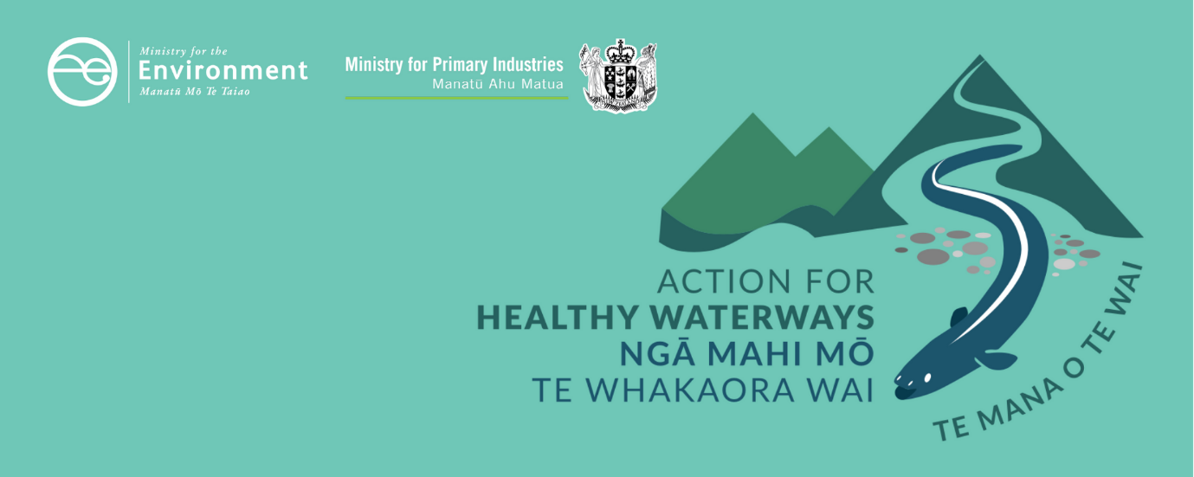

Modelling that supports this package
This information sheet is one of a series outlining requirements as part of a new approach to managing the health of freshwater in New Zealand. These actions will see us start making immediate improvements where needed and set us on a path to healthier freshwater within a generation.
These requirements have been developed following consultation with New Zealanders. In 2019, the Government asked for feedback on proposed regulations – an updated National Policy Statement for Freshwater Management, new National Environmental Standards for Freshwater, and regulations under section 360 of the Resource Management Act 1991. To support the decisions, officials carried out an extensive programme of impact analysis supported by dozens of expert reports from New Zealand’s leading research institutes, universities and private sector firms. As a result of more than 17,500 submissions, and in the light of COVID-19, the Government has made several changes to what was proposed.
This information sheet for provides an overview of some of the key pieces of modelling that supported decisions on this package. You can find more information sheets and access further information on the models and assumptions used on the Ministry for the Environment’s website at www.mfe.govt.nz/action-for-healthy-waterways.

Overview of the impact analysis
Officials have carried out a significant amount of environmental and economic analysis of the Action for healthy waterways package. Analysis included farm and catchment-level case studies, detailed analysis of the costs and benefits of sediment and nutrient bottom lines, assessments of the impact on key groups (Māori, farmers and regional councils), and assessments of industry, regional, and national costs and benefits.
This analysis was done in two phases. Eleven reports were commissioned to inform the interim Regulatory Impact Analysis (RIA) provided for public consultation in October 2019.
In addition to this analysis, further work, including an additional 22 reports, were produced to inform the final RIA and policy decisions. A list of the reports produced to inform decisions is provided at the end of this document and the reports are available on the Ministry for the Environment’s website.
The second tranche of analysis to inform final decisions post-consultation was undertaken to:
- provide monetised estimates of costs and benefits where possible, but not to be constrained to report only monetised impacts
- provide estimates of the likely impacts of nutrient limits (nitrogen and phosphorous) and, in particular, arriving at monetised estimates of the costs of these policies to the agricultural sector
- provide estimates of the impact of the package on local authority costs
- review impact assessments done before October 2019, referring to feedback provided by submitters and others.
All the impact analysis undertaken after October 2019 considered the marginal impact of the proposals (or the package) – the additional impact that is beyond existing policies when those are fully complied with. This is important because the current (2017) National Policy Statement Freshwater Management (2017 NPS-FM) is yet to be reflected in regional council plans. The 2017 NPS-FM is expected to require significant reductions in pollution, from both urban and rural land uses, bringing sizeable benefits and costs. However, because the requirements are not yet implemented, the likely impacts are yet to be seen. The impacts of the proposals (and subsequent final policy package) have been assessed assuming full compliance with the 2017 NPS-FM has been achieved. Only in this way, can the contribution of the new policies be clearly seen.

What impacts were monetised?
Monetised estimates could be provided for some but not all benefits (swimming-related human health, water clarity, ecosystem health, and wetland ecosystem services) and for some but not all costs (impacts on farm profits and administrative costs for local authorities).
Benefits that could only be assessed qualitatively included giving effect to cultural values, enhanced recreational opportunities, avoided risks due to nitrogen toxicity of water aquifers, and increasing the economic value of New Zealand’s ‘green’ brand – a significant benefit from greater international recognition of New Zealand’s food and fibre produced with improved environmental outcomes. These are all considered to be very important benefits from the package.
Costs that could not be monetised included the opportunity cost of slowing the intensification of agriculture, the impact on the value of new housing developments in greenfield sites and the opportunity cost of the moratorium on wetlands.
The monetised benefits were estimated to exceed the monetised costs by $193 million a year (in current dollars). In addition, the non-monetised benefits were considered to outweigh the non-monetised costs. More information about monetised benefits and costs is provided in the Action for healthy waterways costs and benefits information sheet on the Ministry for the Environment’s website at www.mfe.govt.nz/action-for-healthy-waterways.

Who did the analysis?
Eleven reports were commissioned to inform the interim Regulatory Impact Analysis (RIA) provided for public consultation in October 2019. A further 22 reports were produced to inform final decisions.
A number of expert consultants and agencies were contracted including NIWA, Maanaki Whenua Landcare Research, Agfirst, Macfarlane Rural Business, Boffa Miskell, Resource Economics, NZIER, Sapere Research, Tuia Group, Infometrics, Our Land And Water, Perrin Ag, Castalia, and Lincoln University.
Further reports were produced on the wider social, cultural and environmental impact of the Action for healthy waterways package.
Not all of these reports are currently published but the ones that are available can be found on the Ministry for the Environment’s website at www.mfe.govt.nz/action-for-healthy-waterways.

Nutrient bottom lines
The first step of the analysis related to the economic impact of the nutrient bottom lines was to estimate how much nutrient pollution loads would need to reduce to meet proposed bottom lines (in kilograms per hectare per year). This was done for each sea-draining catchment in New Zealand, with the analysis undertaken by NIWA. The analysis distinguished between the pollution load reductions that will need to occur for catchments to comply with the 2017 NPS-FM, as well as the proposed bottom lines enabling marginal impacts to be assessed.
The environmental modelling we conducted was a static analysis. In other words, a simple before and after comparison assuming full compliance was assumed. Static analysis was necessary because it was not possible to identify the rate of soil transfer of nutrients and of water quality improvement for each individual catchment, or to generate a ‘no policy’ forecast for pollution loads in the future, which could be used as a baseline for comparison purposes.
The use of static analysis continued in the economic impact work.
The second step of the nutrient bottom line analysis was to create core data sets. This data related to:
- the spatial location of different farm or land use types
- the climate and terrain characteristics of these spatial locations
- the effectiveness of different categories of on-farm actions at reducing pollution loads, for different land-use types
- the costs of different on-farm actions
- profits from different land uses.
While data like this is collected in surveys administered by industry groups, the data has the status of private intellectual property. Industry-owned data was not available to officials for the purpose of the impact assessment.
Three consulting firms were contracted to work towards developing these data sets. Sapere and Resource Economics were contracted to undertake an economic impact assessment more generally, whilst agricultural consulting firm Perrin Ag was engaged to provide mitigation cost advice. As well, advice was provided by Professor Richard McDowell from AgResearch, who was a member of the Freshwater Leader’s advisory group, and Manaaki Whenua Landcare Research. Manaaki Whenua Landcare Research also provided an in-depth impact assessment of the sediment proposals.
Environmental modelling was undertaken by NIWA to estimate current pastoral nitrogen loads, and the reductions that would be required to meet the new limits. Using the core data sets, the cost of mitigation options that could be used by farm type to meet the necessary load reductions estimated by NIWA were calculated. Where the mitigation options could not meet the load reductions necessary, land-use change was assumed. This gave the total cost to meet the bottom lines.
The environmental modelling approach applied by NIWA and relied on by officials has been extensively peer-reviewed by independent groups and found to be appropriate. Similarly, the economic analysis undertaken has been extensively peer-reviewed and deemed appropriate.

Modelling to determine impacts on GDP and employment
In addition to estimates of the monetised and non-monetised benefits and costs of the package, NZIER’s regional computable general equilibrium (CGE) model was used to estimate the combined impact on GDP of three key policies in the package (stock exclusion, farm plans, and nitrogen toxicity). The impact of these three policies on farm profits and land-use change were inputs into the CGE modelling. The CGE model estimated the flow-on effects on other areas of the economy including production, employment and prices.
NZIER concluded that, assuming all else is unchanged, the package will mean the economy is approximately $190 million smaller than if no package was put in place. To put this figure in context, New Zealand’s GDP in 2019 was approximately $300 billion, meaning the impact is to reduce annual GDP by 0.06%. In reality, the primary sector may innovate in response to the package, coming up with new types of products and new land uses. Innovation like this would lessen the impact of the package, and could potentially increase GDP.
NZIER reported regional differences in the impact on GDP with the three most affected regions being Southland, Canterbury and Otago. While the CGE model constrains employment to remain constant, jobs can move within New Zealand as a result of the policy. The NZIER estimated that employment would fall in six regions and increase in nine, with the most adversely impacted region being Southland with a decline in employment of 0.11 percent.
NZIER noted that the impacts on GDP were lower than those suggested by some submitters:
“Commentary by several stakeholders has suggested that the impact of the Government’s proposals will have a significant economic impact. Why are we suggesting different effects? There are three main reasons:
- We are showing the effects of farmers seeking a least-cost response to the policy changes, while other studies have assumed that the main response is to limit production.
- We have imposed a pattern of land use change on the model, based on work by Resource Economics and officials.
- We are only modelling the effects of the Government’s freshwater policies, rather than adding in climate change.” (NZIER Final Report).

Impacts on regional councils
A report on likely council cost impacts of the proposals was commissioned from consulting firm Castalia. The brief was initially interpreted by Castalia as comparing future costs with those incurred today, with no allowance being made for how council costs may be impacted by the 2017 NPS-FM. Castalia provided revisions to their initial report but officials believe the final estimates do not sufficiently capture the marginal impacts and thus overstate the costs of the package. In addition, Castalia’s analysis reflected the initial proposals, not the final package.
Therefore, when reporting the results from Castalia’s analysis, officials have reported the sum of the lower bounds of Castalia’s itemised estimates. This leads to an annual marginal cost of $76 million per annum, in contrast to the $151 million reported by Castalia.

Review of 2019 impact estimates
A comprehensive programme of reviewing earlier estimates in light of submissions, feedback from advisory group and new information was undertaken. The results of this analysis are detailed in the Regulatory Impact Assessments that accompany the package and can be found on the Ministry for the Environment’s website at www.mfe.govt.nz/action-for-healthy-waterways.

Disclaimer
The information in this publication is, according to the Ministry for the Environment’s best efforts, accurate at the time of publication. The information provided does not alter the laws of New Zealand and other official guidelines or requirements. Users should take specific advice from qualified professional people before undertaking any action as a result of information obtained from this publication.
The Ministry for the Environment does not accept any responsibility or liability whether in contract, tort, equity or otherwise for any action taken as a result of reading, or reliance placed on the Ministry for the Environment because of having read any part, or all, of the information in this publication or for any error, or inadequacy, deficiency, flaw in or omission from the information provided in this publication.




Published in May 2020 by the
Ministry for the Environment and Ministry for Primary Industries
Publication number: INFO 945

A similar issue arises with recently-passed legislation related to reducing greenhouse gas emissions. The long-term implications of this legislation are likely to include a change in land use from agriculture to forestry on erosion-prone land. This changing context meant the costs and benefits of the sediment bottom line policy, while able to be identified and monetised, could not be confidently described as marginal contributions. Hence, unlike other components of the proposals (or final package) the estimated impacts of the sediment bottom line (which were estimated to be net positive) have not been included in reported aggregate ‘net benefits’ (instead they are reported on a standalone basis).

