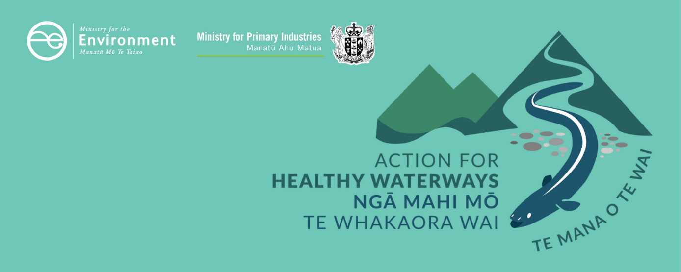

# Information for iwi/Māori

## This information sheet is one of a series outlining requirements as part of a new approach to managing the health of freshwater in New Zealand. These actions will see us start making immediate improvements where needed and set us on a path to healthier freshwater within a generation.

## These requirements have been developed following consultation with New Zealanders. In 2019, the Government consulted on new regulations and a new risk-based approach for improving farm environmental practices through mandatory farm plans in the document *Action for healthy waterways.* The Government asked for feedback on proposed regulations – an updated National Policy Statement for Freshwater Management, new National Environmental Standards for Freshwater and regulations under section 360 of the Resource Management Act 1991. As a result of more than 17,500 submissions, and in the light of COVID-19, the Government has made several changes to what was proposed.

This information sheet outlines aspects most relevant to iwi/Māori as kaitiaki, including those that we had feedback on during consultation. There is more information available for farmers, including Māori landowners and farmers, on the Ministry for the Environment’s website at www.mfe.govt.nz/action-for-healthy-waterways.

## Overview

Freshwater is precious and limited, a taonga of huge significance, and is of particular importance to Māori.

The Treaty of Waitangi/Te Tiriti o Waitangi is the underlying foundation of the Crown–iwi/ hapū relationship with regard to freshwater resources. Addressing tangata whenua values and interests across all of the wellbeings and including the involvement of iwi and hapū in the overall management of freshwater are key to giving effect to the Treaty of Waitangi. The new requirements in the NPS-FM and NES are about strengthening Te Mana o te Wai and improving ecosystem health and water quality to provide further protection for freshwater taonga. Achieving this requires a balance between setting policies and rules nationally and providing flexibility locally.

The new NPS-FM and NES require and encourage further engagement between tangata whenua and councils and require further protection of Māori values. These policies may further contribute to upholding the intrinsic values and objectives of existing Treaty settlement commitments.

## Long-term changes

The new NPS-FM drives long-term change and enables iwi/hapū and Māori organisations, councils, communities and farmers to plan now for changes across the next 30 years and beyond.

### Te Mana o te Wai

Te Mana o te Wai is a concept and framework which is derived out of Te Ao Māori and reflects the recognition of freshwater as a natural resource whose health is integral to the social, cultural, economic and environmental wellbeing of communities. The framework of Te Mana o te Wai, as developed by the Iwi Leaders Group, has been a key part of the current NPS-FM since 2014.

It establishes a set of guiding principles and a hierarchy of obligations, and refers to the essential value of water, and the importance of sustaining the health and wellbeing of water before providing for human health needs, and then to other uses.

The new NPS-FM strengthens and clarifies Te Mana o te Wai through requiring councils:

* to set a long-term vision (intergenerational) for the water that is informed by aspirations of tangata whenua and communities for what the waterbodies should look like in the future, an understanding of current pressures and an understanding of the waterbodies’ history
* to report on progress towards the long-term vision
* to investigate options for tangata whenua involvement such as joint management agreements, and publicly report on decisions around whether to use these options.

The Government has worked collaboratively with Te Kāhui Wai Māori on how to strengthen and clarify Te Mana o te Wai in the NPS-FM. The Government also acknowledges that further embedding the full scope of Te Mana o te Wai in the freshwater system is a longer-term issue that will require discussions between the Crown and iwi/hapū on issues such as governance and decision-making in freshwater management.

### Māori values in freshwater (including mahinga kai)

The new NPS-FM elevates and emphasises mahinga kai as a priority measure of freshwater health (you can read more about compulsory values and the National Objectives Framework in our [Guide to the National Policy Statement for Freshwater Management](https://www.mfe.govt.nz/sites/default/files/media/Fresh%20water/nps-fm-guide-2017-final.pdf)), alongside the other biophysical values and attributes specified in the NPS-FM.

The new NPS-FM requires all regional councils work with tangata whenua to identify measures of freshwater health in their local contexts by requiring that councils provide for the compulsory mahinga kai value. In some regions, councils and tangata whenua may also agree to identify additional Māori freshwater values, for which councils will also work with tangata whenua to identify measures of freshwater health. This acknowledges that tangata whenua are the expert knowledge holders for the values they hold about their waterbodies. These measures of health will then be reflected and incorporated into regional freshwater planning processes.

### Other key long-term changes

The new NPS-FM also:

* establishes new environmental bottom lines for attributes of freshwater health that indicate for all regions the standards they will need to work towards over coming decades (see separate information sheet on attributes [here](https://www.mfe.govt.nz/publications/fresh-water/guide-attributes-appendix-2-national-policy-statement-freshwater))
* prevents further destruction of wetlands and stream loss and requires that new structures provide for fish passage.

## Medium-term, faster freshwater planning

Regional councils will have to notify new or updated regional policy statements and plans by 31 December 2024 that set out how the region will implement the new NPS-FM over coming decades. Final decisions on plans are due in 2026. This is earlier than the current deadline. Regional councils may choose to apply tougher requirements than those set out in the national regulations.

To help in meeting this deadline, the RMA is being amended to apply a new streamlined freshwater planning process. This new process will also apply to all new policy statements or plans (including changes) that otherwise relate to freshwater.

This new process includes an independent hearing panel (‘freshwater hearings panel’) to hear submissions and make recommendations to the regional council.

Each panel will consist of five members:

* two freshwater commissioners appointed by the Minister for the Environment
* two members nominated by the relevant regional council
* one member with an understanding of tikanga Māori and mātauranga Māori who is nominated by local tangata whenua.

The panel will be convened in a manner consistent with any iwi participation legislation, Mana Whakahono ā Rohe, or joint management agreement that exists within a region. As part of the training for freshwater panel members, there will be a Te Mana o te Wai module that will support panel members to understand the framework as it applies to the NPS-FM.

The regional council must make decisions on the panel’s recommendations within 40 working days. Appeal rights are limited compared to the standard plan-making process under the RMA.

More detail will be provided after the amendments are enacted in mid-2020.

## Medium-term changes – farm planning

Many farmers are already using farm plans, which map out the environmental risks on a specific farming property and identify on-farm mitigations that can be used to improve freshwater, biodiversity and climate-related environmental outcomes. Through an amendment to the RMA, the Government will make it mandatory to have a farm plan, phased in with a focus on early and targeted rollout to highly nitrogen-impacted catchments.

This is not required immediately, but over the next 12+ months, the Government will work with primary sector representatives, iwi/Māori, regional councils and other interested groups to develop new regulations which will set out the exact requirements for mandatory freshwater modules of farm plans. It is the intention to build on existing industry body or agribusiness farm plans. We will prioritise this work in catchments most in need of improvement or protection.

## Short-term changes

In the short term, the new National Environmental Standards for Freshwater (NES) include:

* immediate measures to prevent further loss of natural wetlands and streams
* immediate measures to preserve connectivity of fish habitat
* immediate measures to reduce high-risk farming activities including allowing livestock near waterways, intensive winter grazing, agricultural intensification and nitrogen use.

## Implementation support

The Ministry for the Environment and the Ministry for Primary Industries are working closely with regional councils, iwi and stakeholder groups to scope and prioritise support initiatives to help successful implementation. It is an ongoing and collaborative process that will adapt in response to issues as they arise.

## Alignment with existing Treaty settlements

Many Treaty of Waitangi settlements, relationship and governance agreements, mātauranga Māori freshwater projects, and iwi and hapū planning documents are providing leadership by influencing freshwater management and community attitudes to water. These sit alongside the rules set by central and regional government.

When the NPS-FM and NES come into effect, councils will continue to be required to comply with their Treaty settlement obligations when implementing these requirements. The Crown has a commitment to continue to engage with iwi/Māori in implementing the Action for healthy waterways package.

## Alignment with Wai 2358

On 28 August 2019, the Waitangi Tribunal issued a report on its inquiry into freshwater and geothermal resources (Wai 2358). This had a focus on whether the current law concerning freshwater and the Crown’s freshwater reforms (both completed and proposed) were consistent with the principles of the Treaty.

The Tribunal’s report does not comment substantially on the Government’s current work programmes. The Government considers the Action for healthy waterways requirements are consistent with Tribunal recommendations on a number of issues including:

* requiring regional councils to ‘give effect to’ Te Mana o te Wai
* introducing a compulsory mahinga kai value
* introducing measures to protect wetlands
* taking urgent action on stock exclusion and native fish habitat protection
* including more stringent bottom lines to protect the freshwater environment
* introducing interim measures to halt degradation of waterbodies.

## Water allocation and Māori rights and interests

During consultation on the Action for healthy waterways package, we heard from Māori partners and major stakeholders (including councils, environmental groups and primary sector organisations) that there is a need for progress and certainty about water allocation and Māori rights and interests in freshwater. The new NPS-FM and NES do not address these important issues.

The Crown intends to conduct further engagement with Māori on freshwater policy more broadly.

### Disclaimer

The information in this publication is, according to the Ministry for the Environment’s best efforts, accurate at the time of publication. The information provided does not alter the laws of New Zealand and other official guidelines or requirements. Users should take specific advice from qualified professional people before undertaking any action as a result of information obtained from this publication.

The Ministry for the Environment does not accept any responsibility or liability whether in contract, tort, equity or otherwise for any action taken as a result of reading, or reliance placed on the Ministry for the Environment because of having read any part, or all, of the information in this publication or for any error, or inadequacy, deficiency, flaw in or omission from the information provided in this publication.

Published in May 2020 by the  
Ministry for the Environment and Ministry for Primary Industries  
Publication number: INFO 940

